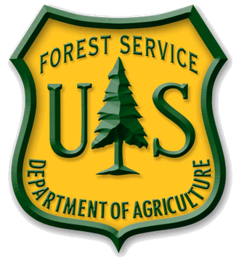
News Release

USDA Forest Service

Coronado National Forest
http://www.fs.usda.gov/coronado/

Effective Immediately CONTACT: Heidi Schewel (520) 388-8484
For News Media Use Only

Coronado National Forest to host workshop May 17
Wilderness and draft land management plan will be discussed

TUCSON, AZ (May 6, 2014) – The Coronado National Forest will host a workshop regarding recommended wilderness and the recently released draft land management plan at the Udall Recreation Center, 7200 E. Tanque Verde Road on May 17, 2014 from 1:00 to 3:00 p.m.

The draft land management plan and draft environmental impact statement have been distributed for public review and comment. Interested parties are invited to share ideas with personnel from the Coronado on specific areas under consideration for recommendation for wilderness designation. The Forest seeks input on individuals’ and organizations’ priorities for recommended wilderness, potential problems resulting from recommendations for the specific areas, and identification of conflicts with resolution as the objective.

Public participation and input continues to be an integral component of forest planning on the Coronado. For further information please contact Yolynda Begay, Forest Planner at (520) 388-8370 or yolyndabegay@fs.fed.us .

The USDA Forest Service is an equal opportunity provider and employer.

