EngineerTalk Tutorial

TO SUBSCRIBE to the EngineerTalk Listserv, send a blank message to this address: engineertalk-subscribe-request@newsbox.usda.gov

After you click the “subscribe” link above, you will receive a confirmation message from the listserv.

Next, go to https://newsbox.usda.gov/wa.exe?A0=ENGINEERTALK&X=4739D14095A2392A06&Y (you will have to log in with your LincPass to get to that page).

You will reach a page that tells you nothing’s available to you. Click on the “Log In” button near the top right of the page or the “Login Required” link.


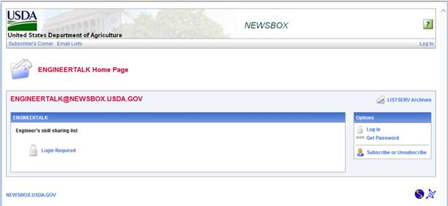

A screen will appear that asks you to sign in – but, wait! First you have to create a password, so click on the “get a new LIST SERV password” link within the “Login Required” message shown below.

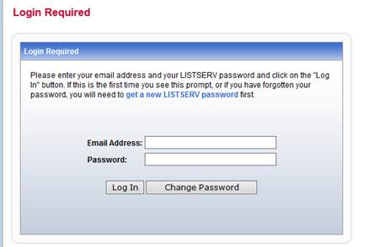

After you create a password, the ListServ will send a message to your in-box confirming that your password has been created.
Go back to https://newsbox.usda.gov/wa.exe?A0=ENGINEERTALK&X=4739D14095A2392A06&Y.

Click on the “Log In” link at the top right to get the sign in page again, only this time enter your FS e-mail address and your new password, then click the “Log In” button.

You should now be able to see the site content, including new and past messages, similar to this:

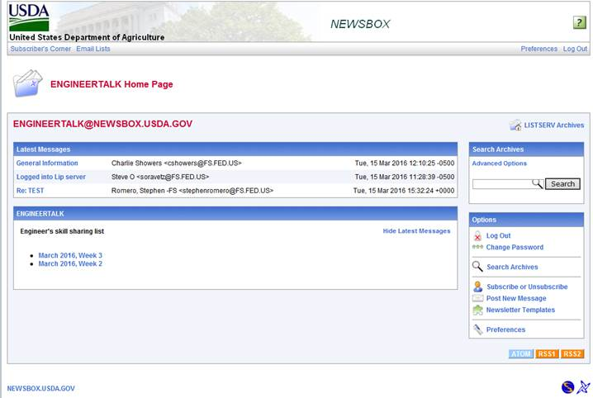

You can also use this page to search, post new messages, change your password, set the page up in a newsletter format, or log out. You may learn all sorts of interesting things by reading messages at this site, once it gets going!

Here are other links for the new ListServ:

ARCHIVE: https://newsbox.usda.gov/wa.exe?A0=ENGINEERTALK&X=4739D14095A2392A06&Y

TO SEND A MESSAGE to all EngineerTalk subscribers, use this address: engineertalk@newsbox.usda.gov or use the “Post New Message” link in the box on the right of the EngineerTalk page.

TO UNSUBSCRIBE: Send a blank message to this address: engineertalk-signoff-request@newsbox.usda.gov

