NFS Briefing Paper

### Groundwater Inventory, Monitoring

### and Assessment Technical Guide Review

### Date: November 21, 2013

**Topic:** Groundwater Inventory, Monitoring and Assessment Technical Guide Evaluation and Review

**Issue:** Internal agency and conservation partner review of the draft Groundwater Inventory, Monitoring and Assessment Technical Guide will begin in early January 2014 and conclude in mid-March 2014.

**Key Points**:

* Evaluation and Review procedures are detailed in the project’s Technical Guide Evaluation and Review Plan (v3.1 - 2/29/12).
* Third-party technical review, including external partners, was conducted from February 4 to March 29, 2013. Technical review comments have been reviewed and reconciled.
* Upcoming internal FS and other agency and organization reviews provide expanded opportunities for improved awareness and participation.

**Background**: Development and refinement of the Technical Guide has been facilitated by a series of reviews involving other agency and conservation partner staff. The following diagram depicts this process and the current status of the development effort.

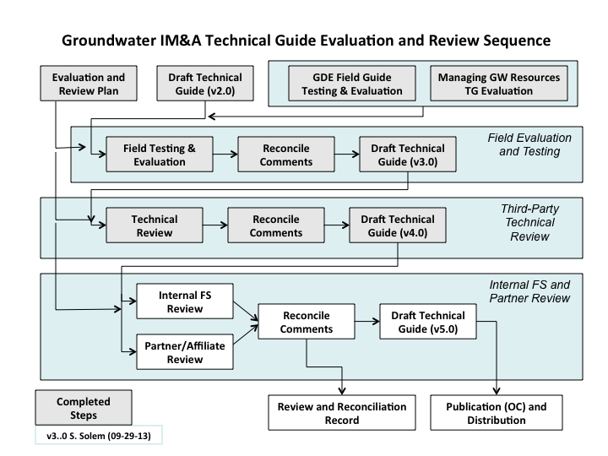

Members of the project’s Steering and Core Teams are engaging with cooperators to notify them of the GW IM&A Technical Guide’s objectives, upcoming review opportunity, and to secure their continued involvement and participation in the review.

**Contacts**:

Rob Harper, Acting Director, Watershed, Fish, Wildlife, Air and Rare Plants, 202-205-1676

Nick Douglas, Director, Minerals and Geology Management, 703-605-4785.