Using Oziexplorer Software to Download Garmin GPS Data and Export to ArcView Shapefile

To load the Oziexplorer software, go to http://www.oziexplorer.com. Choose the “OziExplorer” option under “Software”.
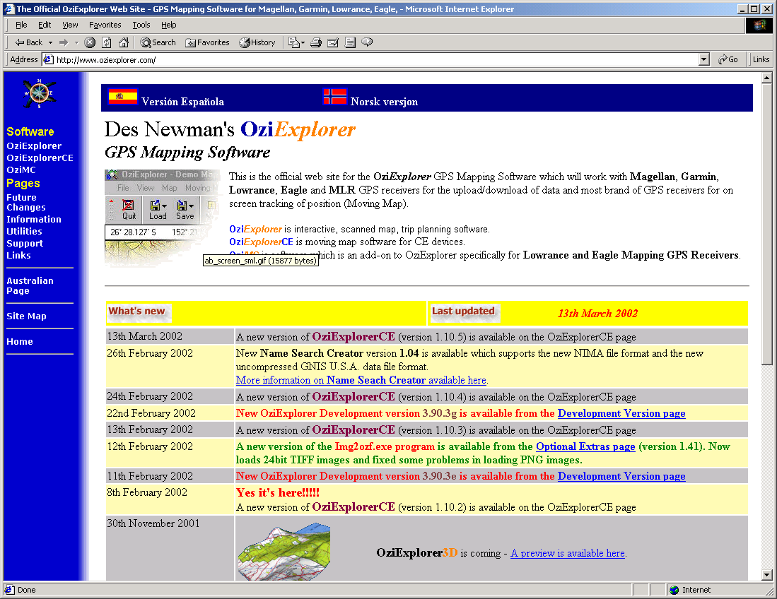

Then scroll down and pick the “ OziExplorer Software (5.7 MBytes)” option. You will save the .exe file to a temporary folder on your PC. Then you will click on “Start” on your PC, then “Run” and browse to the location you saved the ozisetup3.exe file.
Once the program is loaded – it is for demonstration only. You will start the program by clicking on “Start”, then “Programs” and selecting “Oziexplorer” from the programs list. To register the software, you will click on “Help” then “Enter Registration Code”. The “User Name” will be *U. S. Forest Service* - you need to use the asterisks. The “Key #” will be $09C22533.
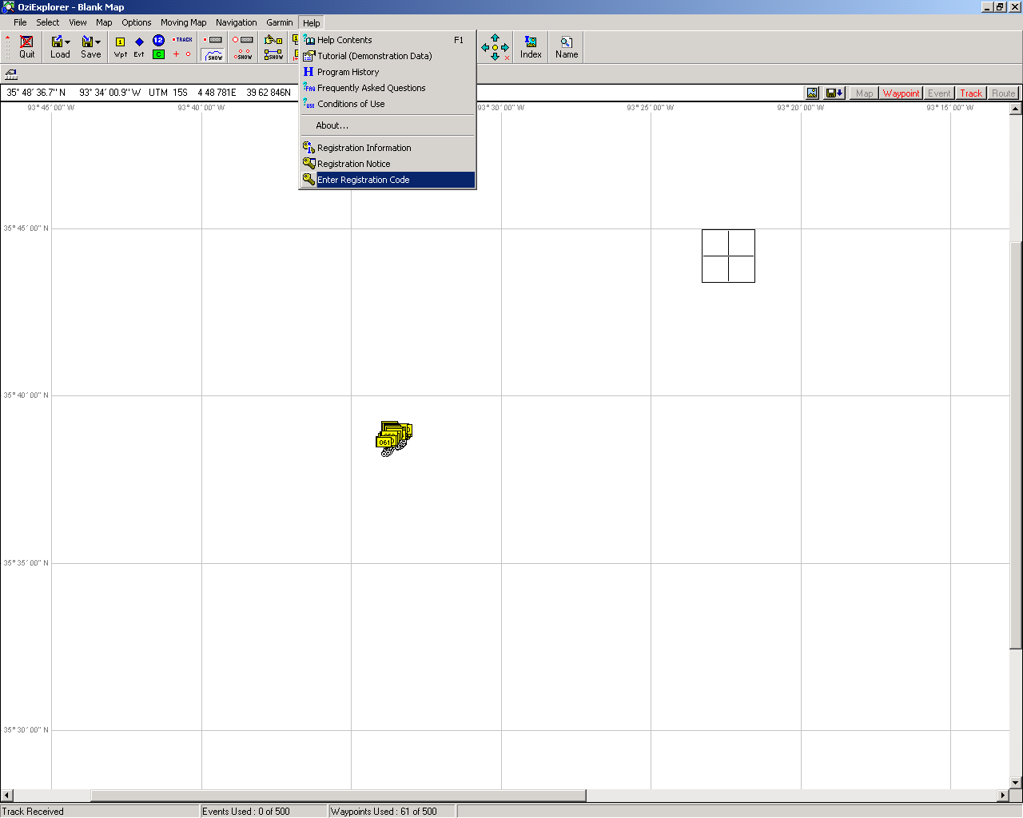

You now have a registered version of Oziexplorer.

You now need to change the configuration of the software so that it will download from Garmin GPS units.

Click on “File” then “Configuration”.

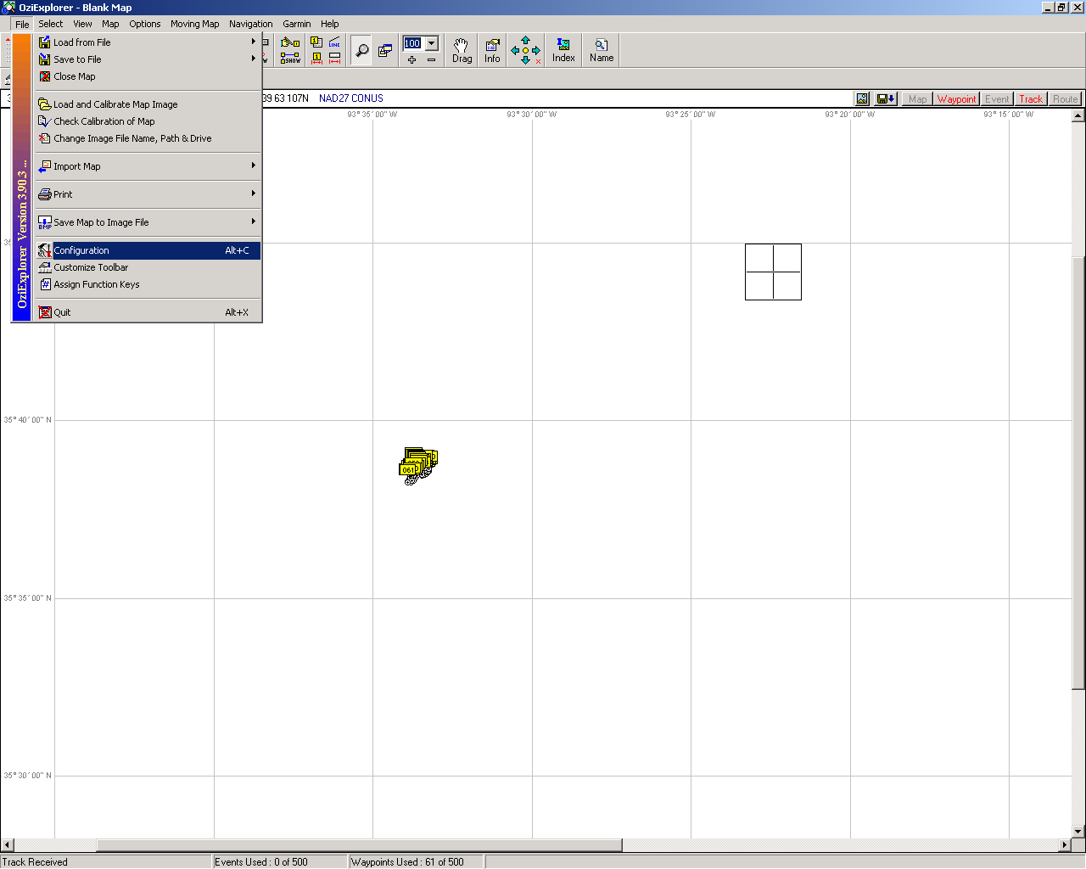

You will then click on the “GPS” tab. Under “GPS Make” select “Garmin”. Select the “GPS Type” – for example – “Garmin III+”. ALWAYS leave the “GPS Upload/Download Datum” on “WGS 84”.
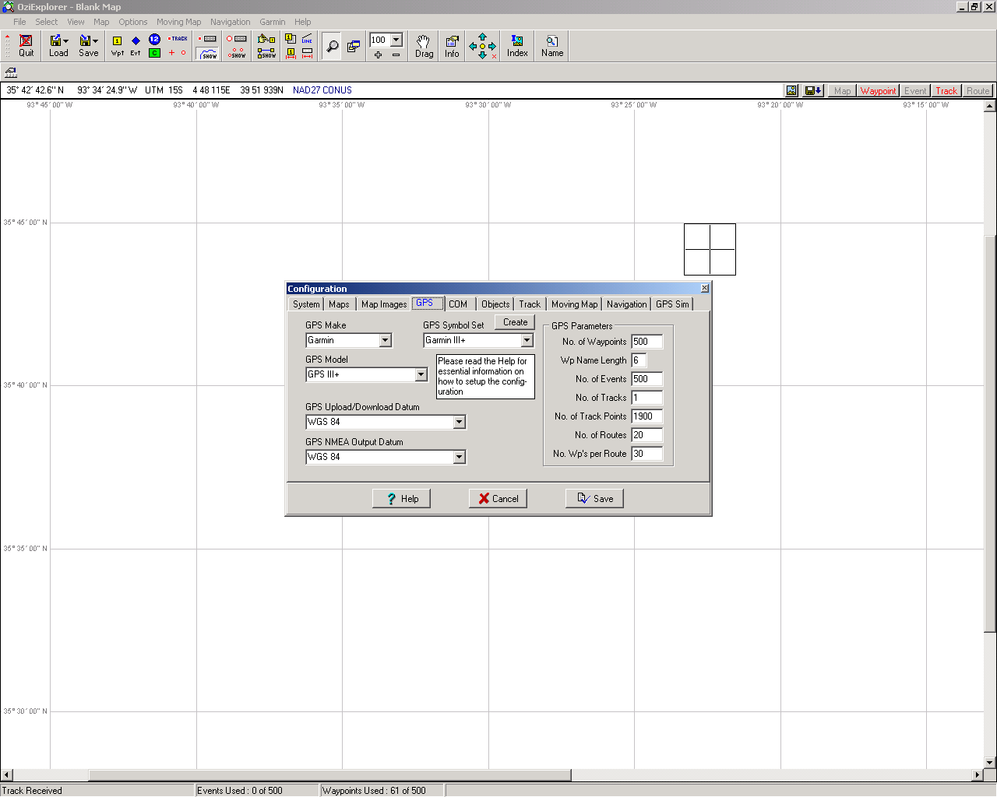
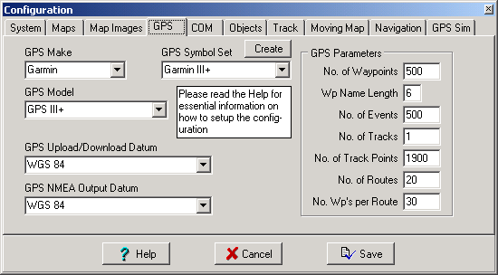
Click on the “Com” tab and make sure the “Upload/Download Baud Rate” is 9600. You are now ready to use Oziexplorer to upload and download from your GPS unit.

To do this, hook your download/upload cable to the COM1 serial port on the back of your PC. Turn your GPS unit on.

You will then click on the “Garmin” menu item and select the option you would like – for example, you want to download waypoints from your Garmin GPS unit and display on your screen. You will pick the “Get Waypoints from GPS” on the menu options. Watch the very bottom left of your Oziexplorer window and you will see the number of waypoints it is downloading.

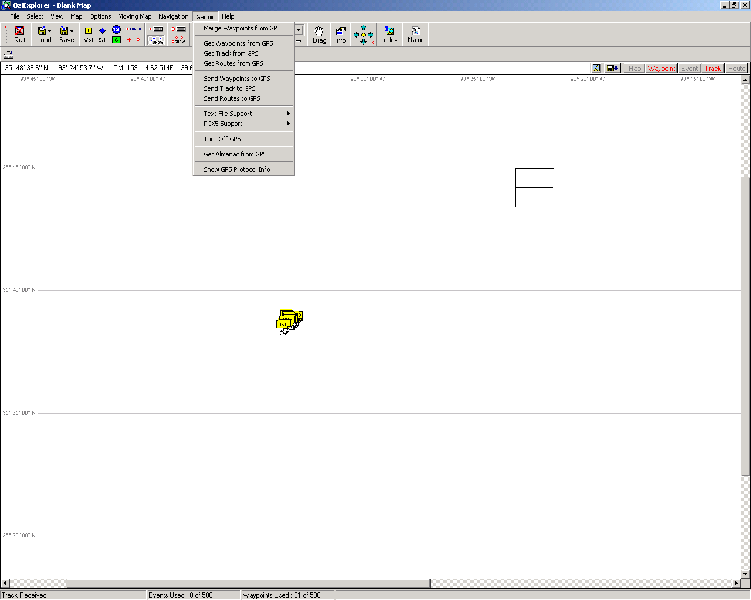

You can then export your GPS file to an ArcView shapefile by selecting the “Save” button, then “Export to ESRI shapefile”, then the option you need.
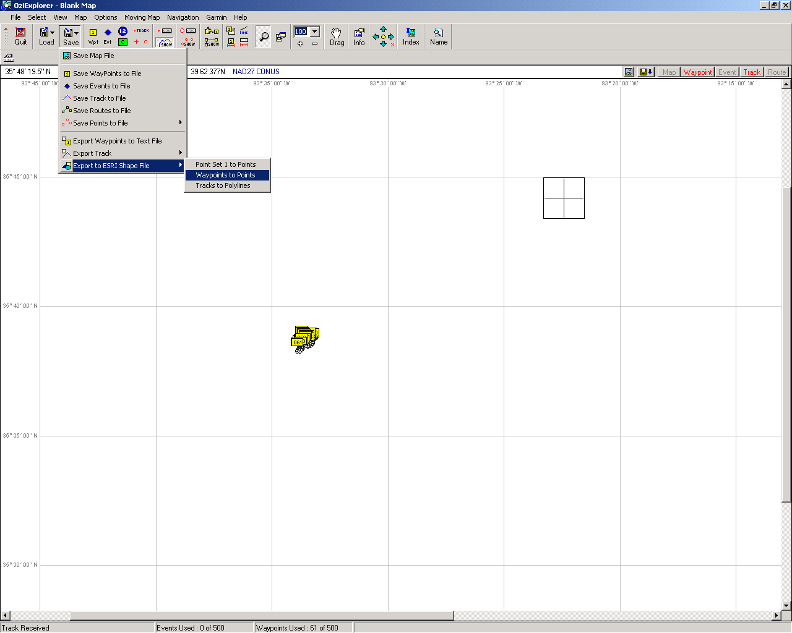

The only shortcoming in this process is that you cannot export in Arkansas Stateplane projection. You will have to export to UTM Zone 15 NAD27. If you want the data in Arkansas Stateplane, you can reproject the data in ArcView. So to finish this process from Oziexplorer, your export screen should look like the screen below:

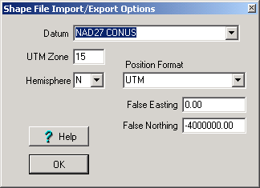
If you want the data to be re-projected to Stateplane so that it will overlay on the forests’ data, then do the following:

Start ArcView

Click on “File”, then “Extensions”

Select the “Projection Utility Extension”.

Add the new shapefile to a View.

Click on “File”, then “ArcView Projection Utility”

The following screen will appear:
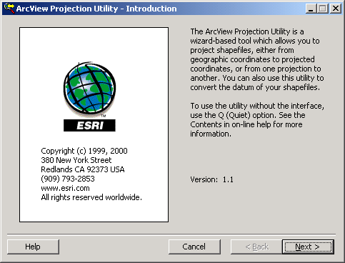

Click the “Next” button.

If the new shapefile is the only shapefile in your View, then it will show up in the window. If it is now, you will click on the “Browse” button and browse to the shapefile you exported out of Oziexplorer and select it and click the “Next” button.
You will then see the window below:

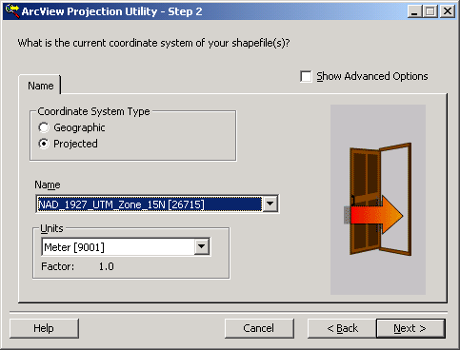

You will select “Projected” under “Coordinate System Type”.

You will then select “NAD_1927_UTM_Zone_15N [26715]” for “Name”.

Then select “Meter [9001]” for “Units”. Then click the “Next” button.

You will be asked if you want to save the projection information with the file – click “Yes”.
You will then see the following window:
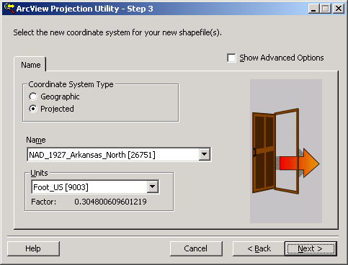

You will again selection “Projected” under “Coordinate System Type”.

Then select “NAD_1927_Arkansas_North [26751]” under “Name”.

Select “Foot_US [9003]” under “Units”. Then click the “Next” button.
The following window will appear:
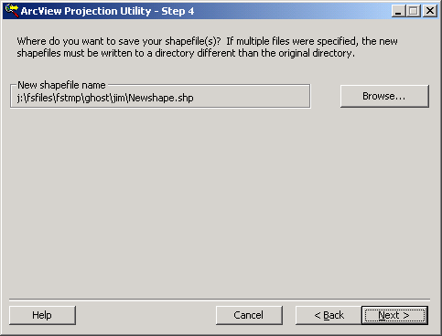

DO NOT let the new shapefile name default to “Newshape.shp”. Please click on the “Browse” button and navigate to the location you want to store the new shapefile and give it a name. Then click the “Next” button.

The following window will appear:
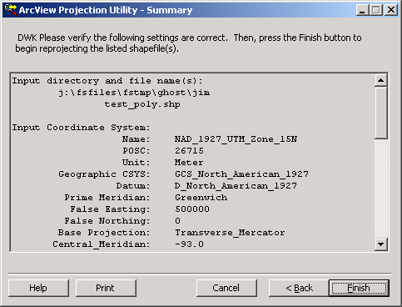

The window gives you the settings you just defined. Click the “Finish” button. Be patient – a window will appear that tells you it is processing the file.

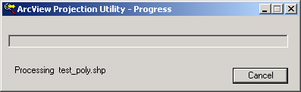
Then you will get the following window:
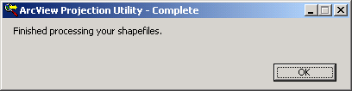

Click “OK”

Then you will get the following window:
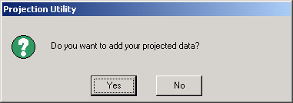

Click “Yes”. You will get a browse window – select the new shapefile.

Then you will see a window wanting to know which View to add the shapefile to:

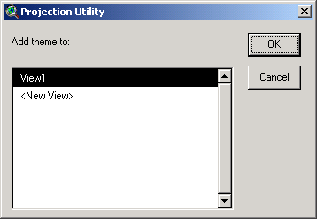

You are done – you should be able to display the GPS file over any other forest library data.

