GPS DEVICES FOR POCKET PC

Product Description

Several manufacturers make low-cost GPS devices that will work with Pocket PCs. The most common applications for using a PPC in combination with a GPS involve the use of product-specific cabling from the GPS unit to serial ports. Nearly any recreational-grade GPS can be “hooked-up” to a PDA if you have the right cable. More recent GPS equipment have utilized Pocket PC Compact Flash (CF) slots or expansion sleeves for GPS applications. The newest of GPS devices utilize “blue-tooth” wireless technology eliminating the need for either cabling or other direct connection.

CF GPS

CF GPS hardware generally “plugs” directly into the Pocket PC via a Type II CF slot (some PDAs offer multiple CF expansion slot add-ons). If only one CF slot is available, the amount of mapping software viewable is limited to internal memory (generally 32MB to 64MB). If an additional expansion slot is available, more mapping can be made available (up to 5GB). Currently1GB, 2GB and 5 GB cards are available. Depending on the Pocket PC mapping software, 1GB of storage will hold up to three million acres of DRGs, or about one million acres of imagery.

The following is a list of sleeved or jacket GPS hardware along with a short product description:

PreTec Compact GPS http://www.expansys.us/product.asp?code=CFI-GPS&asource=

Compact GPS provides robust performance in applications that require high vehicle dynamics and high signal blockage operations. This specially designed GPS card is suitable for integration in a variety of OEM products.
Software included: TomTom CityMaps Europe and AutoRoute 2002.

Costs $209.01 (Type I CF…would require an adapter to retrofit to a Type II - slot $21.47) http://www.expansys.us/product.asp?code=CFCAD
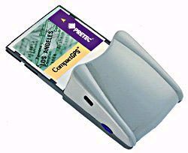This device was not tested.
TeleType http://www.teletype.com/Merchant2/merchant.mv?Screen=CTGY&Store_Code=GPS&Category_Code=13000

Costs $199.

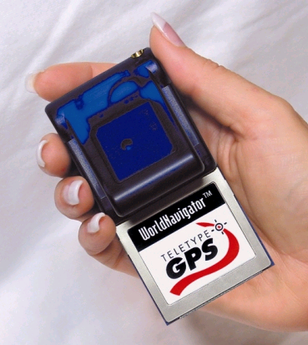

Remarks: I have tested a similar CF Teletype GPS, The product worked well. Usually uses Com4 in PocketPC. Software interaction with unlimited free Terraserver downloads is a unique and cost-effective feature. As purchased it included an external antenna (with magnet) and port atop the CF GPS to cable to.

NAVMAN 1000 CF card http://www.maptech.com/products/pocketnavigator/index.cfm?infopg=buy
Costs $349*

Sentinel http://www.anywheremap.com/pages/awm_ac_gps.htm
Costs $249.
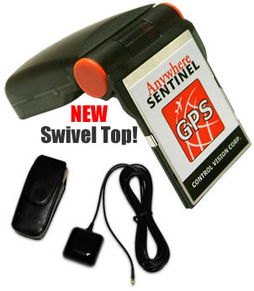
Remarks: Note swivel top application and external antenna

NeoGPS CF http://www.universalgis.com/products_services_neogps_detail.htm
Costs $285.

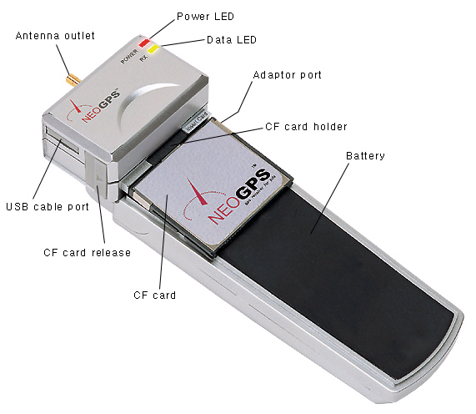

Remarks: Unique configuration is a CF application with an attached battery pack similar to an expansion sleeve application. Includes a USB cable port

Transplant GPS http://www.transplantcomputing.com/

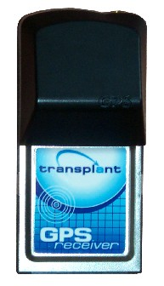
Transplant says its newest unit uses 60% less power than their previous models and is fully compatible with any software that can handle standard NMEA output. It is the lowest priced CF GPS I found on the internet ($159. and $189. for the WAAS version). It lists PalmOS and PocketPC software it will work with and includes OziExplorerCE and MapTech.

Pocket Map Store
http://www.pocketmapstore.com/gps.html
Costs $ 169
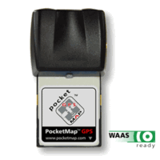

Remarks: Pocket Map Store sells other models of CF GPS units (as cheap as $149) along with blue-tooth enabled GPS

Expansion Sleeves and Jackets

Sleeved applications are designed so the PDA slips into a separate device (similar to an expansion pack).

Copilot Live (jacket) http://www.mobileplanet.com/product.asp?cat%5Fid=101&cat%5Fname=Pocket+PC+Devices&pf%5Fid=MP730726&dept%5Fid=2310
Costs $349.95*

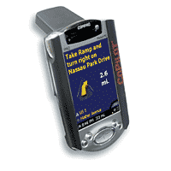

Remarks: Image is from advertisement and does not show jacket separate from PocketPC

Navman Expansion Sleeve
http://www.maptech.com/products/pocketnavigator/index.cfm?infopg=buy
Costs $249.
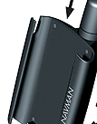

Remarks: Includes a CF card slot on the side of the sleeve (hidden in this advertisement).

Blue-toothed-enabled (based) GPS receivers

Wireless communication between GPS and PocketPCs is a new technology. Users can receive GPS signals remotely up to around 30 feet and multiple users could receive the signals simultaneously. These devices are often marketed with software. The following are known sources of this type of equipment along with a short description:

Socket http://www.socketcom.com/product/GP0804-405.asp
Costs $399.
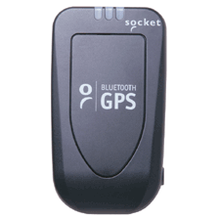

EmTac http://www.maptech.com/products/pocketnavigator/index.cfm?infopg=buy
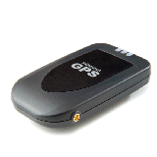
Remarks: I tested this device with different software. It seemed to work well. I had a couple of hours of battery life. The Sirf technology allows for quick acquisition of satellites. It would be nice to have an external battery to go along with the basic unit. The device seems to always be at COM8 in PocketPC mapping programs.
Costs $399*

NavMan GPS 4400 http://www.navman.com/corp/news/gps4400.html
Costs $499.

Fortuna GPSmart (bluetooth) http://www.expansys.us/product.asp?code=GPSMART&asource=

Costs $265.
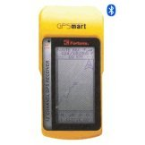

BTGPS http://mightygps.com/bluetoothcard.htm

Costs $350.

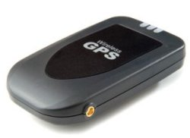

Pocket Map Store http://www.pocketmapstore.com/bluetoothgps.html

Costs $330.
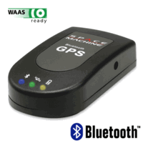

Tomtom http://www.tomtom.com/products/platform/products.php?ID=55&Language=1
&http://www.tomtom.com/products/platform/products.php?ID=55&Language=1#section4 (not available in US yet)

http://www.tomtom.com/
TomTom Navigator USA Wireless GPS adds further flexibility by offering the smallest and lightest GPS device on the market. It’s so compact, you can even carry it around in your pocket or mount it discreetly in your car.  TomTom Navigator doesn’t need wires because it uses the latest Bluetooth technology. This is a wireless technology that does the work of connecting cables, in this case between the GPS receiver and the Pocket PC. It works with Bluetooth-enabled Pocket PCs:  - Compaq iPaq 3870, 3970 and 5450  - Fujitsu-Siemens Pocket LOOX  - Toshiba e740 BT and e750 BT  - All Bluetooth enabled Pocket PCs |  | 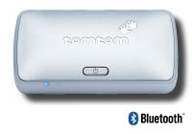
Using Bluetooth technology, the Wireless GPS receiver makes TomTom Navigator a neat solution. Various mounting options add flexibility and make it possible to fix it to the dashboard, windscreen or wherever is convenient in your car. The receiver is powered by a rechargeable battery, which ensures five hours’ continuous operation. Cables are included to recharge the battery.

Teletype http://www.teletype.com/Merchant2/merchant.mv?Screen=PROD&Store_Code=GPS&Product_Code=1758
Costs $359.* and http://www.teletype.com/Merchant2/merchant.mv?Screen=CTGY&Store_Code=GPS&Category_Code=13000
Costs $309.

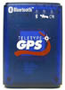Remarks: Quality product (see earlier comment)

Pharos http://www.mobileplanet.com/private/pharos/product.asp?dept%5Fid=2310&pf%5Fid=MP730930&mscssid=KDTAD9HNHAQ29NSGWQXVBWA7C1DV7S65
Costs $349.95*

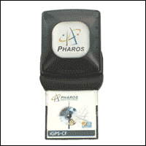

Bluetooth Pocket GPS Navigator
http://www.pharosgps.com/products/hp/iPAQ5450/PT200.htm

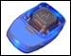
The Pharos Bluetooth Pocket GPS Navigator is the first modular Bluetooth GPS that wirelessly connects your Pharos GPS receiver to your Bluetooth-enabled Pocket PC. Place your GPS receiver anywhere in your car and enjoy the benefits of Pharos' Ostia navigation software, with intelligent route calculation and voice-prompted, turn-by-turn navigation instructions. Just place your Bluetooth GPS receiver on the dash, and go, door-to-door or point-to-point anywhere in the U.S. Part Number - PT200
Costs $369.95*

Mapopolis http://www.mobileplanet.com/product.asp?cat%5Fid=101&cat%5Fname=Pocket+PC+Devices&pf%5Fid=MP731384&dept%5Fid=2310

Costs $349.95*

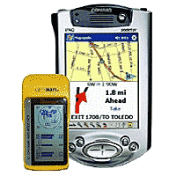

Remarks: Mobileplanet.com has other blue-tooth enabled GPS along with a world of other high-tech gizmos and gadgets.

DeLorme Earthmate

http://www.delorme.com/earthmate/ and http://www.delorme.com/earthmate/configurations.asp

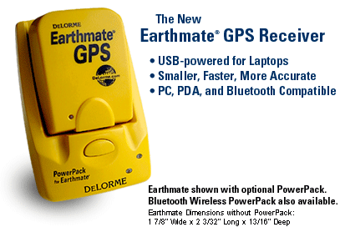

Cost for GPS receiver alone is (no blue-tooth) $129.95 (serial) to $159.95 (USB). No cost information on battery pack and Blue-tooth enabled configuration (by itself)
Remarks: Current plans are to test this product

Cables for GPS devices

There are two methods available for connecting GPS devices to PDAs. One is to use a null 9-pin adapter to join serial plugs i.e., join the serial plug used in serial syncing to your PC with the serial plug used to sync your GPS to a PC. An example of this can be found on Teletype GPS accessories page
http://www.teletype.com/Merchant2/merchant.mvc?Screen=CTGY&Category_Code=903
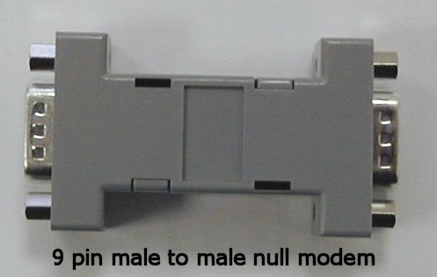
Cost for connector is $14.50 from Teletype GPS.

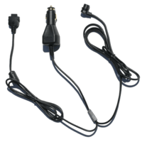
Customized cabling is also available from a GPS to a product-specific PDA. There are relatively few sources for these cables.

https://www.bluehillsinnovations.com/index.php?action=category&id
http://www.memory-map.co.uk/acatalog/accessories_cables.html (British)
http://www.pocketmapstore.com/garmincables.html (they offer cables for several PDA models with E-type and round plug Garmin GPS) All their custom cables cost $35.
http://www.thesupplynet.com

Remarks: The company advertises a large selection of custom cables (including power cables). I am sorry to say I did not receive good service when I ordered a cable from these folks (it has taken over fours months to get delivery).

Some companies also offer “powered cables” that hook up cigarette lighter power cable to GPS and PDA. Examples include: http://www.pocketmapstore.com/poweredcables.html
http://www.teletype.com/Merchant2/merchant.mvc?Screen=CTGY&Category_Code=903

Other PDA and GPS Accessories

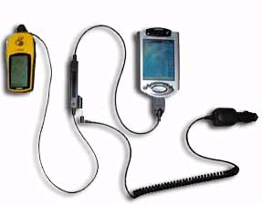

A few other PDA and/or GPS accessories are worthy of mention. They include waterproof cases or storage devices for PDAs and external antennas for GPS devices.

Voyager PDA (waterproof) case http://www.maptech.com/products/pocketnavigator/index.cfm?infopg=buy
Costs $24.95

Otter cases http://www.mobileplanet.com/product.asp?cat%5Fid=101&cat%5Fname=Pocket+PC+Devices&pf%5Fid=MP289630&dept%5Fid=3716
Costs $49.95

Summary and Conclusions

Low-cost GPS equipment, PocketPCs, digital mapping software, accessories and information on how to use them are available from a variety of sources. A manufacturer’s software may be designed to work with only product-specific proprietary maps. Some companies offer mapping software products that provide the flexibility of using “public domain” mapping independently or in combination with their own. Others are designed strictly for user-provided map image inputs. The variety of new digital mapping software products, GPS devices, PDA equipment, accessories and information on applications are ever-expanding as new technologies emerge. The capabilities of some of the least expensive of equipment and software are impressive. For map users that are interested in using GPS in concert with DRGs and DOQs in a PDA, there are numerous low-cost possibilities. Because of the ever-changing nature of these technologies, there is a continuing need to test and evaluate some of the newer equipment and software, particularly the blue-tooth enabled GPS devices and PocketPC-compatible mapping software.

