Low-cost Recreational-Grade GPS equipment, Topographic Mapping Software and Accessories for Pocket PCs

Disclaimer – The equipment, products and services reviewed do not include everything currently available or marketed, but only those readily accessible to this author. The reviews are somewhat subjective and are not intended to be either a product endorsement or a critical assessment of how well devices or products reviewed actually performed when tested.

Introduction

The use of PocketPCs with Global Position System (GPS) devices has dramatically increased over the last few years. As PocketPCs have become faster, more versatile and powerful, GPS hardware and software have also expanded to interface with all types of Personal Digital Assistants (PDAs) and perform a variety of mapping functions including the use of marine and aviation charts, topographical maps, aerial photos and routing with street-level mapping applications.

GPS units can interface with PDAs in a variety of ways. Methods for attaching GPS units to PocketPC devices include:

- serial cables with serial null 9-pin connector
- special interface cables custom-built for individual makes and models of GPS and PocketPCs
- sleeved (or jacketed) applications,
- compact flash (CF) slot devices
- blue-tooth enabled GPS units that communicate wirelessly with similarly enabled PDAs

Along with the devices, cables and software come with a variety of accessories to help facilitate and/or enhance their use.

To provide a more condensed overview of available products, only software and hardware applications specific to PocketPCs were reviewed. The software reviewed was limited to only those capable of handling scanned topographic maps and/or other imagery (DRGs and DOQs ). All equipment and software reviewed was relatively easy to procure (i.e. primary marketing was via the internet).

Methods

The method I used to review and test products was cursory at best. For products I actually purchased, I simply opened up the box and started loading software or turning on switches. I referred to manuals as a last resort (not a recommended practice!). I was already familiar with the PC side of some of the digital mapping software (notably DeLorme, National Geographic TOPO! and MapTech). I also had had some experience with OziExplorer, Teletype GPS and Fugawi software. The net result of this approach to testing is probably a bias toward recommending software and equipment I had some previous experience with and being a bit more negative for products I hadn’t used and couldn’t quickly figure out how to use without digging through manuals and tutorials. Having said this, I think I was fair in the remarks section for describing things I liked and didn’t like about the products.

Background

Cost versus Accuracy and Computing Power

New PocketPC devices range in cost at between $300 to $700. The ability to carry these relatively small, lightweight devices using maps displayed on high-quality color screens has become increasingly popular among many varied user groups including natural resource managers. Cost of GPS hardware ranges from $100.00 to around $500.00 (e.g. recreational-grade GPS devices). Available mapping software typically utilizes1:24,000 scale topographic mapping or Digital Raster Graphics (DRGs) and cost from $100.00 to $300.00 per state coverage when bought “packaged” by vendors. In many states, DRGs are free or can be purchased on-line at reasonable prices at sites like Chartiff’s http://www.charttiff.com/. Vendors such as Charttiff and others also sell higher resolution (250dpi+) aerial photos and/or Digital Orthophoto Quads and/or quarter-quads (DOQs and DOQQs). Prices vary, but generally DRGs cost one to two dollars per quad whereas DOQQs cost about $10.00 each (this varies by the resolution of imagery, color versus black and white, the number of DOQQs ordered and vendor). Application software normally involves a PC mapping program and PocketPC (PPC) with companion program. Special hard plastic cases are available to help waterproof and protect PDA units (these cost around $100.00). Connectors can be used to link serial cables from PDAs to serial cables on GPS units. Special cables are also available to directly connect various GPS units to PDAs. Other GPS devices are marketed for PPCs as non-cabled attachments for PocketPC devices (CF slot GPS, expansion sleeves and jackets). More recently, devices that connect wirelessly (blue-toothed enabled GPS) are now available.

For around $500 to $1500 a PocketPC, the necessary GPS hardware (device), and mapping software to view DRGs and DOQs with a GPS moving-map program can be procured. Both the equipment and software are relatively easy to learn how to use. This “user-friendly” technology is at some contrast to the more expensive (and powerful) survey-grade GPS equipment and sophisticated Geographic Information System (GIS) programs. Survey-grade GPS and corporate GIS products are fully integrated and highly functional (e.g. Trimble GPS/PDA combinations and ESRI ArcGIS, ArcView and ArcPad and Terrasync). They also cost in the magnitude of three to ten times as much as low-cost alternatives. This having been said, users need to identify how they want to use the technology available and to what end the data will be extracted and analyzed. The more expensive hardware and software may be needed for applications where accuracy and full integration with corporate GIS are overriding concerns. On the other hand, if reasonably accurate GPS (Approx. 45 feet) is “good enough” and users are primarily interested in using GPS for viewing DRGs and DOQs, there are many easy-to-use, low-cost alternatives.
SOFTWARE MAPPING PRODUCTS FOR POCKET PC

Product Description

A number of companies make low-cost software capable of enabling Pocket PC users to view Digital Raster Graphics (DRGs) and/or Digital Orthophoto Quads (DOQs) while connected to a low-cost GPS producing a “moving map” display. Some mapping software will only run with a certain set of mapping specific to a manufacturer (e.g. National Geographic’s Topo! Sync USA, Maptech Pocket Navigator). Other mapping software programs allow users to furnish map images (usually as .bmp, .jpg, or .tif formats) and/or will work with their digital mapping software also (OziExplorer, Fugawi 3 and DeLorme XMap). User-furnished image files are often manually calibrated or georeferenced by providing three or more map locations (Latitude and Longitudes) per image. Some software (e.g OziExplorer CE and Fugawi 3), will automatically handle georeferenced mapping that contains appropriate image files and world files. At least one manufacturer’s software is designed specifically to work with a web-based free on-line mapserver (Teletype GPS and Microsoft’s Terraserver).

Smart Map (software descriptions are taken from website advertisements)

The software package includes MapManager - a freeware program for a desktop PC, running under Win98/Me/2000/XP, designed as a tool for the SmartMap users. MapManager allows a user to make a digital map from various data sources: ESRI Shape File format, scanned maps in the JPEG format, and the tracks recorded by SmartMap. These source data will be transformed to geographic coordinate system and can be saved like a high-performance color digital map of user-defined content. Thus you can scan and prepare color vector electronic maps for PocketPC. It is a convenient instrument for handling large archives of electronic maps. MapManager imports maps in the ESRI Shape file format, and converts them to VTM format, which is specifically developed by VITO Technology to accelerate the work with maps on Pocket PC with its limited resources.

http://www.vito-tech.com/products/product_25.html

full version $30.00

Remarks: The demo version doesn’t seem to allow for much experimentation. I couldn’t get either the PC or PPC software to do much. I was able to determine that the software seems to accept bluetooth-enabled (BT) GPS inputs but not CF GPS. Otherwise little testing was done with this software. Other reviews of this product from the internet have been positive (http://www.digitalgrove.net/Toolbox_GPS.htm#usa

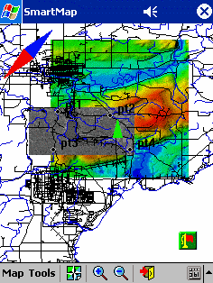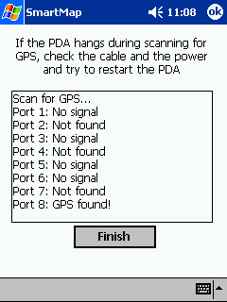
Fig. 1 – From link at digitalgrove.com Fig.1a - Emtac Bluetooth GPS found at Com 8 on SmartMap software

.
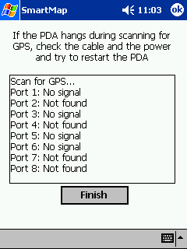

Fig.2 Testing for Teletype CF GPS (not found by SmartMap)

MapTech Pocket Navigator (software descriptions are taken from website advertisements)

Pocket Navigator software displays Maptech Terrain Navigator topo maps, Maptech digital marine charts and AeroPack charts (each sold separately) on Pocket PC computers.

http://www.maptech.com/products/pocketnavigator/index.cfm

Remarks: Pocket Navigator costs about $100. (but only runs with MapTech Terrain Navigator software – state coverages are approximately $75 to $150 per state depending on whether individual states or Regional mapping is purchased). Maptech partnered with Memory-map software (UK) to create this product. Memory-map has its own product line of software for mapping in parts of Europe and Canada. MapTech’s software works with Terrain Navigator’s high-quality enhanced DRGs that produce very good screen displays. It is relatively easy to use and is technically well supported. The PC version is one of the most powerful of desktop mapping packages currently available with many features specifically designed for users needing topographic mapping. The Pocket PC software has several features including waypoint and route generation (draw features) and full zooming and map scrolling functions. Unfortunately, Pocket Navigator software doesn’t work with their Terrain Navigator Pro. MapTech may eventually remedy this and add the option of adding aerial photo downloads (currently aerial photos can’t be downloaded into MapTech Pocket Navigator). I tested their software with CF GPS and attempted with a blue-tooth enabled GPS. The CF GPS worked OK (Fig 4), but not the blue-tooth device. Generally any of the PocketPC software that doesn’t include up to 8 COM ports won’t accommodate blue-tooth (BT) GPS.

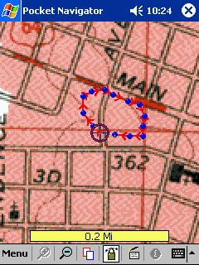

Fig. 3 _ MapTech Pocket Navigator with GPS on and a route generated on screen (used with a Teletype CF GPS)

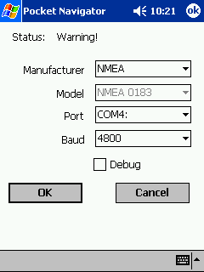Fig. 4 – CF GPS at COM4

Fugawi 3 (software descriptions are taken from website advertisements)
- Fugawi 3 GPS Mapping Software
FUGAWI is a complete navigational system that makes powerful use of the extraordinary GLOBAL POSITIONING SYSTEM. With FUGAWI, you easily create accurate digital maps from any scanned map or existing map database (ie. BSB MARINE CHARTS or USGS TOPOGRAPHIC MAPS). Then, in real-time navigation mode, your exact position is displayed on the map as you move and new maps are automatically loaded as you travel to new areas. North American customers receive detailed street maps of the entire USA as well as the nautical Region 1 Planning Charts on CD. Customers outside of Europe and North America receive a World Geographic Names CD with over 6.7 million names.
FUGAWI also brings you all the convenience of computer mapping without having to carry it on your travels. You simply position waypoints and routes on your map with a click of the mouse and then upload them to your GPS receiver for use out in the field. Upon returning to your base, you can download added waypoints, routes and tracks onto the digital maps for analysis.
NEW FEATURE Fugawi 3 can upload any map from your PC to a Pocket PC (such as an iPAQ) or a Palm device (O.S. 3.5+). Just select an area of a map and press a button. Fugawi does the rest. Enjoy compact real-time GPS navigation with your Pocket PC or Palm. Fugawi also synchronizes waypoints, routes and tracks with the Palm or Pocket PC! Palm Details | Pocket PC Details

http://www.fugawi.com/indexcom.html

FUGAWI Complete Navigation System: US$99.

Remarks: Fugawi 3 is the PocketPC offering of an earlier program that ran in PalmOS. The software will handle a variety of GPS inputs including blue-tooth enabled and CF GPS. The software has good zoom features, and on-screen waypoint generation. There seemed to be no way to draw features (routes or tracks) on-screen (although route and track waypoints could be generated, a “line” could not be drawn. Fugawi mapping software includes street-level mapping that is ready to be downloaded into PocketPC devices. They also sell some stand-alone digital mapping. Their maps were very slow to load and the software seemed to generate a lot of errors and lock-ups in my PPC. The software seemed to handle different GPS devices with relative ease however.

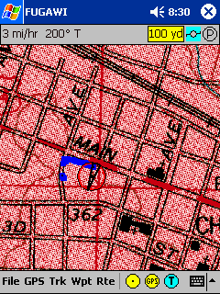

Fig. 5 – Fugawi example tracking with BT GPS

OziExplorerCE (software descriptions are taken from website advertisements)
OziExplorerCE is moving map software for PocketPC and Window CE devices (PDA's), it uses raster map images which are either scanned or purchased in digital format. It allows you to track your position received from a GPS on a map.
OziExplorerCE is not automatic route planning software, you cannot request the best way to get from point A to point B, if you require this type of software then OziExplorerCE is not for you. However OziExplorerCE will allow you to create your own routes on the map and navigate along those.
The design philosophy is you plan your trip using the full PC OziExplorer on you PC and then transfer your waypoints and other data to your PDA for use by OziExplorerCE.
OziExplorerCE runs on PocketPC and Windows CE devices but it relies on map calibrations etc to be provided by the full PC version of OziExplorer, in this respect OziExplorerCE can be considered an add-on to the full Oziexplorer software, you also need the full OziExplorer to calibrate maps, plan trips by adding waypoints etc.
The unregistered OziExplorerCE will work with the unregistered OziExplorer but the limitations of both packages will apply.
To get the full use of OziExplorerCE you must have a registered copy of OziExplorerCE and a registered copy of the full PC OziExplorer.
CE Devices Supported
These are the types of devices supported.
- Handheld - HPC (CE version 2) , HPC Pro (CE Versions 2.11,2.12) and HPC 2000 (CE version 3.0+)
- Palm sized - PPC (CE version 2.0 and versions 2.11,2.12)
- PocketPC - PC2000 (CE version 3.0+) , PC2002 (CE version 3.0+)
ARM , MIPS , SH3 , SH4 , and Intel PXA2xx cpu's are supported for all platforms where applicable.

http://www.oziexplorer.com/

Costs $100. (includes $75. for OziExplorer PC software plus $25 for OziExploreCE)

Remarks: OziExplorerCE is a well-known product and is particularly well-supported by users and it’s inventor Des Newman. It interfaces well with blue-tooth enabled GPS and CF applications as tested. It has a feature that allows users to export created or GPS-generated waypoints, routes or tracks directly as .shp files to ESRI GIS. It has many of the same features as FUGAWI. Additionally it has drawing functions (PocketPC) by means of track and route create features. Users can record their tracklogs and store them. The satellite page includes HDOP accuracy information.

Both Fugawi and OziExplorer can utilize DRGs in nearly any format as long as there is a corresponding world file. If no world files are available users can calibrate an image of a DRG and use them. The same is true for DOQs (or DOQQs).

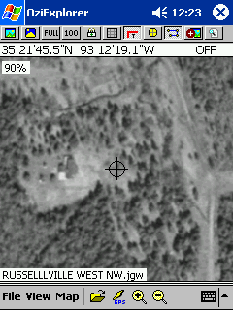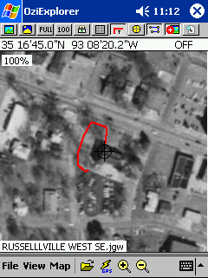
Fig. 6 – OziExplorerCE view of Fig. 7 – OziExplorerCE tracking via a BT
downloaded 1M aerial photography GPS device

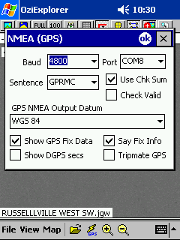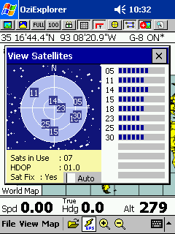
Fig. 8 – OziExplorerCE Settings for Fig. 9 – OziExplorerCE satellite
BT GPS page with HDOP information

Topo! Sync USA (software descriptions are taken from website advertisements)

http://maps.nationalgeographic.com/topo/sync.cfm

TOPO! Sync was National Geographic’s PDA software. It only runs with National Geographic TOPO! State series mapping that costs approximately $100. per state)

TOPO! Sync is no longer available for purchase from National Geographic, but can still be purchased from some vendors (e.g. http://www.gps4fun.com/topo_sync.php) for $35.

Remarks: National Geographic’s digital mapping software product was once Wildflower Productions software. National Geographic expanded the map coverage to include all the United States and added new products and features. The 3-D shaded relief is particularly attractive in the PocketPC. The DRGs are “enhanced” (scanned at higher dpi) and look very good on PPC screens. The software has some unique features that include nice on-screen draw features, text labeling, coordinate locator, full zooming, screen drag, notes, routing feature, distance measurement and profile generation. As tested, Topo! Snyc is a quality product with many features. The current version is not compatible with blue-tooth enabled GPS. Map downloads from PC to PocketPC are not quite as easy to do as with MapTech or OziExplorerCE in my opionion. In my experience, getting support for the product (on-line) has not been as simple as with MapTech or OziExplorer.

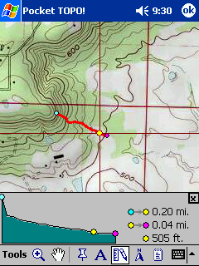

Fig. 10- National Geographic’s TOPO!Sync software on my PPC (created route and profile generated on-screen)

NavPak PE (software descriptions are taken from website advertisements)
This edition runs on handheld computers using the Pocket PC operating system. NavPak Pocket Edition (PE) will load a whole nautical chart or topographical map and it is very fast and stable. It is compatible with Softchart, NDI, BSB, MapTech, USGS DRG Topographical maps, and scan-your-own charts or maps. This first edition has been tested on the Compaq iPaq 38xx Pocket PCs, and various GPS units. It will probably run on any type of handheld using Windows CE, or the Pocket Pc operating system. As we continue development on the Pocket Edition, it will be tested on a wide variety of handheld computers and GPS units. The demo copy of NavPak PE can be used to test your GPS and Pocket PC for compatibility.
http://www.mrmarine.com.au/navpak_pe.htm

$500. (requires full PC version)

Remarks: Briefly tested demo. Product appears to be primarily marketed for coastal navigation. Generally is too expensive to compare favorably with other products reviewed.

DeLorme XMap (software descriptions are taken from website advertisements)
- Includes street-level maps for the entire U.S., from rural roads to detailed city streets
- Create address-to-address routes directly on your handheld computer.
- Quickly locate on detailed maps your address book contacts, plus 4 million points of interest. Includes restaurants, hotels, attractions, and much more
- Connect to the DeLorme Earthmate GPS receiver (available separately) and track yourself in real time on street-level maps anywhere in the U.S.
- Store the maps on removable-media devices
- Beam maps to family and friends – it’s amazing!
- Bring topographic maps with you using new Topo USA 4.0® software (available separately)
- Zoom in and out through 12 levels of map detail on your handheld

http://www.delorme.com/xmaphandheld/default.asp

Remarks: XMap HH costs $39.95 when purchased with other software. It interfaces with other DeLorme mapping products, i.e., Street Atlas and TOPO USA 4.0. XMap HH Pro is sold as a module with XMap tools and runs as a handheld tab in XMap 4.0. DeLorme’s products are well-supported. They are now marketing a low-cost blue-tooth-enabled GPS designed to work with XMap (http://www.delorme.com/earthmate/). Plans have been to make this product compatible with a sub-meter post-processing software product (so far this is hasn’t been offered however). DeLorme has marketed PalmOS products earlier including post-processing software (Solus Pro and GPS post-pro). This is their first PocketPC software. XMap Handheld Pro was tested. It has numerous features but doesn’t seem as “intuitive” to learn how to use as other PocketPC products. The DRGs from 3-D TopoQuad are not scanned at the same dpi as National Geographics, MapTech’s or Chartiff’s DRGs, hence they tend to “pixelate” at high zooming. XMap HH Pro has some interesting features apparently tied to the potential post-processing software functions including detailed recording of tracklog (Fig. 14). I attempted (several trys) to download aerial photos from XMap Pro to XMap HH Pro and failed. I can only assume this feature isn’t part of XMap HH Pro or XMap 4.0. Xmap HH Pro has some useful on-screen routing (draw features) see Fig.15.

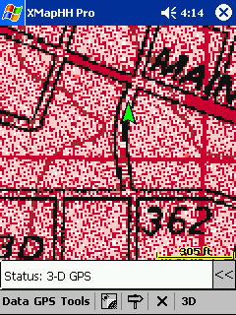

Fig. 11 – DeLorme’s XMap HH Pro tracking using a CF GPS ( Background is 3-D TopoQuad zoomed )

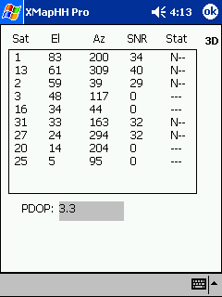

Fig. 12 – DeLorme’s XMap HH Pro satellite page with PDOP and SNR output display
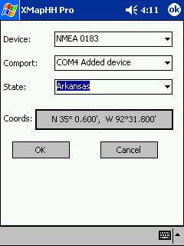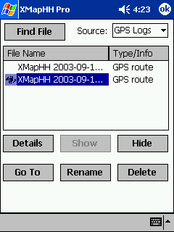
Fig 13 – DeLorme’s XMap HH Pro Fig. 14 – DeLorme’s XMap HH GPS
CF GPS settings log files screen

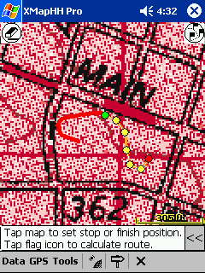

Fig. 15 – DeLorme’s Xmap HH Pro on-screen routing (draw) tool

GPSeasyCE (software descriptions are taken from website advertisements)
- Easy navigation to your marked end station (position) using GPS receiver, CE device and GPSeasyCE software.
- Save your traveled track into the file. (Save/Load)
- Report from traveled track (for each point date,time,velocity and traveled distance).
- Display/Play your traveled track on the screen of CE device.
- Voice distance from target is spoken by CE device (in miles, kilometers)
- Display air distance from your marked end position and moving velocity
- Automatic loading of the next most suitable map
- Check for the best map at 10s interval
- Very easy to calibrate with CE devices directly in situ or from maps coordinates
- Five Map Zoom levels
- Support for 16 colors BMP files (reduce map size)
- Create waypoints
- Add nautical miles
- Draw, Load and Save plan way
- Display direction arrow
- Display Actual and Target position in earth coordinates
- Moving map with keyboard
- Add support for CF/PCMCIA GPS receivers.
- map size limited to 400 x 400 pixels
- Automatic disconnection GPS receiver from CE device after 10 minutes
- Every 2 minutes announcement about unregistered version
- No automatic loading of the next most suitable map
http://www.pdawin.com/GPSeasyCE.html

Cost $30.

Remarks: Inexpensive, but requires users to get the needed image compression work accomplished. Had problems loading this product on my PocketPC. I have not really tested the demo version yet.

Teletype GPS Software

http://www.teletype.com/Merchant2/merchant.mvc

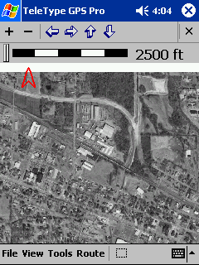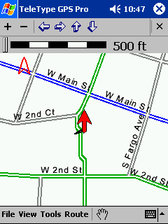

Fig. 15a – Aerial photo from Microsoft Fig 15b – Teletype GPS streets

Terraserver downloaded into Teletype GPS software with CF GPS receiving
Pro software (screenshot from hp 5450 PPC)

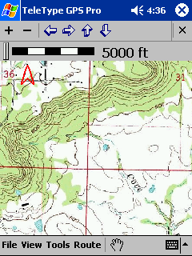
Fig 15c – Teletype GPS Pro DRG download from Microsoft Terraserver

Remarks: Teletype sells add-ons and utilities that enhance their basic mapping program. In use, Teletype software seems to require a bit more knowledge about computers in general and PDAs as compared to National Geographic or MapTech. The ability to use a free internet webserver for downloading DOQs and DRGs is the real advantage. The PPC software is not as user-friendly (in my opinion) nor as powerful (for the lower-priced option) as programs like OziExplorerCE. You have to buy (as an add-on some features) like drawing and marking waypoints. The software is not compatible with every make and model of GPS (see the manufacturer’s list ). The company does seem to provide fairly good customer support and has good tutorials on how to use the product. For reasons I haven’t figured out yet, I got a lot of “lock-ups” on my PPC when trying to download DOQs. As the PPC is new and memory wasn’t a problem, I believe it to be inherent with the software (but I could be wrong!). At any rate, overall it wasn’t as easy to use as others I reviewed.

Other web-based mapping software sites and mapservers of interest

Be sure to read the copyright information at these sites before you start doing screen captures and downloads. The legal use of their images is not all the same.

USAphotomap http://jdmcox.com/

Remarks: Currently this product doesn’t’ directly work with PocketPC. It has features however that facilitate its use in programs like Fugawi3 and OziExplorerCE. Interestingly, it uses Microsoft Terraserver to get mapping. There are some excellent tutorials available on using this free product.

Terraserver (Microsoft) http://terraserver-usa.com/

Remarks: Terraserver is used in software like Teletype and USAphotomap. There are .jpw (world) files associated with their images that can be downloaded along with the .bmp image files.

Topozone http://www.topozone.com/

Remarks: Topozone is a free mapserver with customized mapping downloads available at reasonable prices. Topozone downloads will automatically calibrate in Fugawi3 software.

MapTech http://mapserver.maptech.com/homepage/index.cfm?CFID=15050&CFTOKEN=71105707

Remarks: along with MapTech, DeLorme and National Geographic have web mapservers

Topoweb
http://www.cis.ksu.edu/~dha5446/topoweb/

Remarks: Good site with links to web mapservers and other map-related information

Topowest http://www.topowest.com/

Remarks: DRGs for sale by state

Digital Grove http://www.digitalgrove.net/Toolbox.htm and http://www.digitalgrove.net/Toolbox_GPS.htm#usa

Remarks: Reviews and sells low-cost GIS software programs, a lot of information on GIS in general

Other Useful Web sites or software of interest to mappers

- gpsinformation.net
Remarks: Best site on the web for GPS and related mapping information
- Oziphototool
Remarks – free to individuals ($15. for government users) software works with OziExplorer and digital cameras to automatically watermark Lat./Long information on images

OmniMap Resources
Remarks – supplier of hardcopy and digital mapping (worldwide)

Summary and Conclusions

Low-cost GPS equipment, PocketPCs,digital mapping software, accessories and information on how to use them are available from a variety of sources. A manufacturer’s software may be designed to work with only product-specific proprietary maps. Some companies offer mapping software products that provide the flexibility of using “public domain” mapping independently or in combination with their own. Others are designed strictly for user-provided map image inputs. The variety of new digital mapping software products, GPS devices, PDA equipment, accessories and information on applications are ever-expanding as new technologies emerge. The capabilities of some of the least expensive of equipment and software are impressive. For map users that are interested in using GPS in concert with DRGs and DOQs in a PDA, there are numerous low-cost possibilities. Because of the ever-changing nature of these technologies, there is a continuing need to test and evaluate some of the newer equipment and software, particularly the blue-tooth enabled GPS devices and PocketPC-compatible mapping software.

