
Third Party Agreement
(Timber Sale or Integrated Resource Timber Contract)
(Ref. 36 CFR 223.114)

FS-2400-0012 (REV09/2018) OMB 0596-0225 Exp 9/30/2021

Timber Sale Contract Integrated Resource Timber Contract
National Forest Ranger District

Contract Name Contract No. Award Date / /

This Agreement by and between: , Address
(hereinafter referred to as the Transferor And Address

(hereinafter referred to as the Third Party or Transferee)

Recitals
WHEREAS, the Transferor entered into a contract, with the United States of America, acting through the Forest Service, United States Department of Agriculture, hereinafter called Forest Service, for the purchase of timber as shown above,
WHEREAS, the Transferor desires to arrange for performance of said contract by the Third Party, and
WHEREAS, the Forest Service has determined that a Third Party Agreement between the Transferor and Transferee is appropriate and in the government's interest.
Terms and Conditions
NOW, THEREFORE, in consideration of the Transferee hereby assuming all of said obligations and receiving said rights and benefits under said contract it is agreed as follows:
- The Transferor agrees and asserts:

  - That the Forest Service may, if it approves of this agreement, deal solely thereafter with the aforesaid Transferee in the Transferor's stead and without notice to the Transferor, in all matters pertaining to the aforesaid Contract, including any modifications thereof.

  - To request the Forest Service to transfer any balance on deposit with the United States to the Transferor's credit in connection with such contract to the credit of the Transferee.

  - That the Transferor is not released from any obligations and liabilities to the United States under said Contract.

  - That upon approval of this agreement by the Forest Service the Transferor waives all rights under said Contract against the government.

  - That the Transferor will comply with all applicable laws pertaining to this agreement.

- The Transferee agrees and asserts:

  - That the Transferee, its heirs, executors, administrators, successors, and assigns will complete the performance of said Contract in accordance with the terms thereof.
  - To furnish the Forest Service with an acceptable bond assuring the performance of said Contract, or consent by the surety on the performance bond heretofore furnished by the Transferor which in effect will continue the bond with respect to any liability of the Transferor and will extend the provisions of the said bond to the Transferee as a principal thereunder.

  - That the Transferee will comply with all applicable laws pertaining to this agreement.

  - That the Transferee has no conflicts of interest with the Transferor which would affect performance under said Contract.
We hereby request the Forest Service recognize and approve this agreement.

The Transferor authorizes the Forest Service upon its approval of this application to deal solely thereafter with the aforesaid Transferee in the Transferor's stead and without notice to the Transferor in all matters pertaining to the aforesaid contract, including any modification thereof, and requests that any balance on deposit with the United States to the Transferor’s credit in connection with such contract be transferred to the credit of the Transferee.

The Transferor agrees that it shall not by reason of the requested recognition and approval be released from any obligation to the United States under the aforesaid contract.
The Transferee in consideration and approval by the Forest Service of this agreement hereby accepts the rights and assumes all uncompleted obligations and requirements of the Transferor under the aforesaid contract and hereby binds its heirs, executors, administrators, successors, and assigns in the same manner as if the Transferee were the original signer of the aforesaid contract.

FS-2400-0012 (REV09/2018)
OMB 0596-0225 Exp 9/30/202

New Bond Consent of Surety 1
And as a further guarantee of the performance of the aforesaid contract and the obligations thereunder, the Transferee delivers herewith:
A performance bond in the sum of Dollars ( )

Consent of surety for continuance of a bond in the sum of
Dollars ($ ) executed

by Transferor as principal and

as surety, and extending provisions of said bond to Transferee as a principal thereunder.
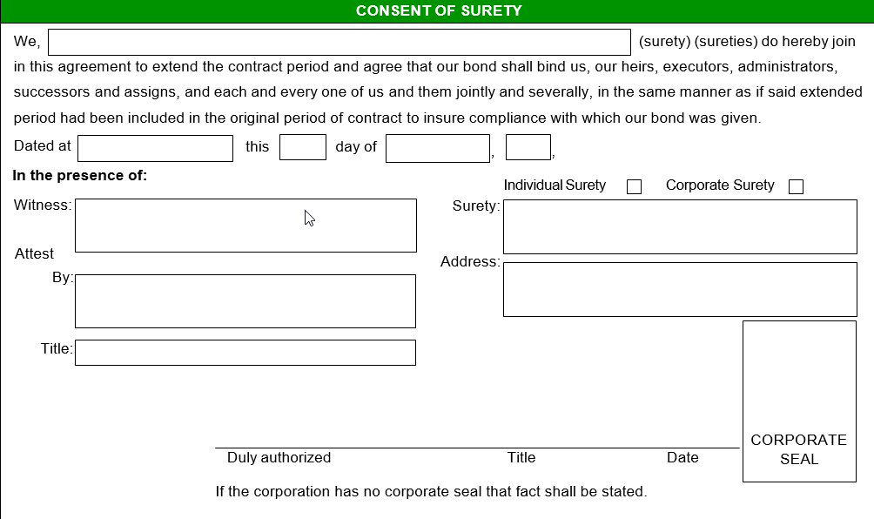
Transferor and Transferee Approvals
IN WITNESS WHEREOF, the parties hereto have executed this Third Party Agreement as of the day of ,
1/ Witness (two)  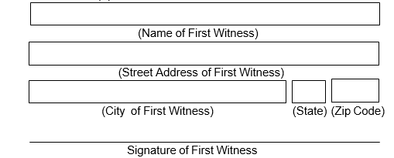 |  |  | Name of Transferor 2/  BY (Signature)  Title
1/ Witness (two) |  |  | Name of Transferee 2/  BY (Signature)  Title
1/ Witness required if party is other than a corporation |  |  | 2/ execute applicable certificate below if party is a corporation
CERTIFICATION OF TRANSFEROR  I, certify that I am the  Secretary of the corporation named as the Transferor herein; that  who signed this agreement on behalf of the Transferor was then  of said corporation; that said agreement was duly signed for and in behalf of said corporation  by authority of its governing body and it within the scope of its |  |  | CERTIFICATION OF THIRD PARTY  I, certify that I am the  Secretary of the corporation named as the Transferee herein; that  who signed this agreement on behalf of the Transferee was then  of said corporation; that said agreement was duly signed for and in behalf of said corporation  by authority of its governing body and it within the scope of its
corporate powers.  (Signature)  (Signature) | Corporate Seal |  | corporate powers.  (Signature)  (Signature) | Corporate Seal
Approval
The aforesaid agreement between the Transferor and Transferee is hereby recognized and approved
under the conditions stated herein this day of ,
Signature of Contracting Officer |  |  | Title
FS-2400-0012: Public burden for this collection is estimated to be 2 hours per response, including time for reviewing instructions, searching existing data sources, gathering and maintaining data needed, and completing and reviewing the collection of information. Under the Paperwork Reduction Act of 1995, an agency shall not conduct or sponsor, and no persons are required to respond to, a collection of information unless it displays a valid OMB control number. The valid OMB control number for this collection of information is 0596-0225.

