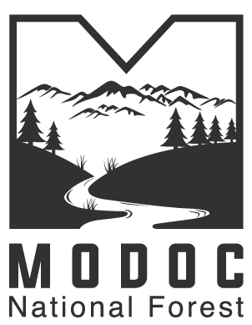

**Modoc County Resource Advisory Committee Meeting Minutes**

Modoc National Forest 225 W 8th St Alturas, CA 96101

08/28/2023

Called to order: 1510

**Committee Members Present**: Alan Cain, Glen Zane, Shane Starr, Sean Curtis, Carol Carey, Rosemary Nelson, Stacey Hafen, Bruce Ross, Neneekah Forrest, Jim Carvasso,

*FS Representatives*: Chris Christofferson, Samantha Jager

*Presenters*: Michelle Hommerding, Madeleine Levy, Chris Bielecki

**Project Proposals**

1. Madeleine Levy Presented: **Horse Bait Trapping Program**, Request for Cameras. These cameras are operational by use of mobile device. Request is for $5,000 for 2 new cameras based off of a model that has been trialed with successful.
2. Chris Bielecki with Updates for Joshua Mefford: **Gabion Basket Removal and Trail Maintenance** **Project**. Images shown of trail damage and maintenance needed. Proposal to add requested funding into the Farm Bureau agreement in order to implement trail repairs and remove the safety hazards. Emphasis on implementing the work next season.

* **Comments from the public**: Fixing this trail will increase equine use. Modoc has a lot to offer and showcasing these trails would be beneficial. It’s good that the trails will be returned to a more natural state.

1. Glen Zane Presented: Addendum read aloud asking that the funds previously requested be applied to the building sprinkler system instead of the well pump that supplies the sprinkler system. This is due to the fact that the well pump will be needed prior to the availability of the funds, if approved.
2. Michelle Hommerding advised that she was available for questions about her well project if there were any.

*Motion Made to take $10,000 from the Spring Exclosure and add it to the Trails Project*

* Discussion about project timelines and when funding would be needed for each and how each project would be affected.
* ***Motion carried by Roll Call.***

**Project Statuses:**

* Horse Bait Trap Cameras – Passed by Roll Call Funded at $5,000
* Gabion Basket Trail Project – Passed by Roll Call $45,000
* Fire Sprinkler System – Passed by Roll Call $50,000
* Spring Exclosure – Passed by Roll Call Funded at $75,000
* Well Project – Passed by Roll Call $45,000

Suggestion by Stacey to have past awardees attend a meeting to present work that has been accomplished. Sean suggested doing field trips to some of the locations.

* In response, Chris B advised that 6 abandoned vehicles were removed from the forest last year and one camper this year with funding previously provided by the RAC program. One more removal is scheduled as it will take more planning.

*Adjourned 1636.*

**Action Items for Forest Service:**

* Send Meeting Minutes
* Send Project Long Forms as Single Packet
* Update Official Roster
* Create Binder with RAC Minutes and Agendas
* Send New Member Info to group (Member Recruitment)
* Inquiry: How often do ethics and code of conduct need to be done and signed?
* Info about renewal of charter and length of member terms