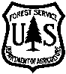
Wallowa-Whitman National Forest
Fuelwood Guide
2024 Season May 1st through November 30th

ATTENTION:
Firewood permittees will follow the same system as commercial operations and will be affected by Industrial Fire Precaution Levels (IFPL).

Fuelwood Authorized to be Removed:
Only dead trees (standing or down, without any green needles) less than 24 inches across the stump, may be cut and removed, except for ponderosa pine trees, or Whitebark Pine trees or cones. No standing or down ponderosa pine trees, or Whitebark Pine trees are to be cut or removed nor are Whitebark Pine cones allowed to be harvested. Trees (standing or down) with signs, tags or paint are not to be removed. * Whitebark Pine information available on request*

Remember it is illegal to cut and remove a live tree. Even though a tree is down or standing without any green needles, it may still be alive. Western larch (tamarack) loses its needles every fall and is still a live tree. A wind-blown tree may take several months or years to die. When in doubt… do not cut the tree.

Dead or down trees less than 24 inches across the stump (measured outside the bark), and with no signs, tags or paint, may be cut and removed for fuelwood.

Diameter

No larger than 24”

Stump Height:
When cutting down a dead tree for fuelwood, you should measure 12 inches up from the base of the tree on the uphill side. This will ensure that you are meeting the stump height requirement of no more than 12 inches.

Stump Diameter:

12” Stump
Height
DIAMETER
No larger than 24”

To validate your load ticket:

- Completely remove the month and day on the colored load ticket, corresponding with the day you are removing your fuelwood.

- Firmly staple, nail or tack one ticket on the back of the load for each ½ cord or portion thereof, on the truck.

- All load tickets must be clearly visible. Do not stack tickets on top of each other.

Below is an example of a properly validated load ticket.

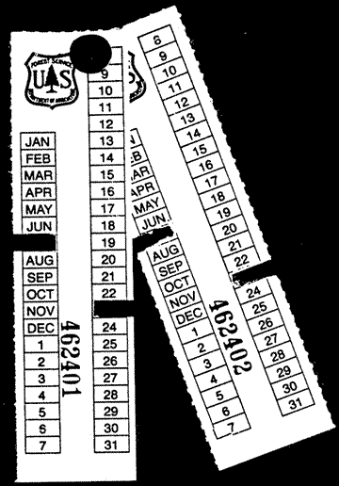


BOUNDARY
PARTIAL CUT
________Sale, Unit No. _____

This sign faces the partial cut unit.
BOUNDARY
CUTTING AREA
_________SALE

This sign faces sale area.
Remarks:__________________

Sign Language

You will encounter signs, ribbons and markings while cutting your fuelwood. The signs shown here are important for woodcutters to be aware of as they pertain to Conditions listed on your fuelwood permit.

Fuelwood Cutting is allowed when these signs are posted:

*******************************************

Fuelwood Cutting is NOT allowed in areas where this sign is posted:

TIMBER
SALE AREA
NO FIREWOOD
CUTTING ALLOWED
**************************************
Fuelwood Cutting is NOT allowed in areas where these signs are posted:

Reminder:

Remember, firewood cutters are required to keep a record of the date, time, and amount of firewood removed off National Forest lands on the Product Quantity Removal Record located on the front of the firewood permit. This requirement is being enforced.

When you obtain a firewood permit, you sign and agree to all terms and conditions of the permit. General condition #15, located on the back of the firewood permit, states:

“Permittee shall complete the Product Quantity Removal Record in ink prior to transporting products. When load tickets are issued, the Permittee is required to complete load tickets when Permittee moves between collection sites or leaves a permit area. Load tickets must be securely attached to the load and clearly visible from the rear of the vehicle.”

Example:

Please remember to carry an ink pen in your vehicle for filling in the Product Quantity Removal Record information before leaving each woodcutting site.

Where can you cut fuelwood??

Your personal use fuelwood permit is valid for all

ranger districts on the Wallowa-Whitman National

Forest. There are areas on the Forest however,

where this permit is not valid:

Areas excluded from cutting:
*Designated old growth areas
*Wilderness Areas
*North Powder Wild & Scenic River Corridor
*Wild & Scenic Lostine River Corridor
*Wild & Scenic Snake River Corridor
*Wild & Scenic Eagle Creek
*Wild & Scenic North Fork John Day
*Wild & Scenic Imnaha River
*Native vegetation areas on the HCNRA
*Research Natural Areas
*Starkey Experimental Forest
*Designated Scenic Byways
*Baker City Watershed
*La Grande Watershed
*Spring Creek Winter Range Area

*Falling and cutting of fuelwood is not allowed
on either side of Forest Road 39, within 100
feet of the road, the entire length of the road.

*Fuelwood is not to be removed from developed
campgrounds, picnic areas, trail heads,
administrative sites (such as guard stations
and cabins), within timber sale cutting units or
other posted contract areas.

*Trees with signs, tags, or paint are not to be removed.

Fire Requirements & Restrictions:
You are required to have the following equipment while cutting and transporting your fuelwood:

Saw: Exhaust system in good repair. Screen-type spark arrestor of 0.023” mesh or less, qualified under US Forest Service standards.
Axe: Minimum 2 lb. head and 26” length.
Shovel: Long-handled, round point with 8 inch blade.
Extinguisher: Charged with pressurized chemical. Not less than 8 oz. Capacity by weight. Type AB.

After your chainsaw is shut off, remain in the immediate area for a minimum of one hour to watch for and suppress any fires or smoldering duff.

During periods of high fire danger, restrictions may be enacted that include prohibiting all fuelwood cutting activity under this permit, as well as other activities such as off-road travel and campfires.

The telephone numbers you may call to hear a recorded message regarding the Industrial Fire Precaution Levels on the forest are:

Baker City: (541) 523-1234

You may still call the local ranger district office if you have additional questions regarding fuelwood cutting.

Frequently Asked Questions About Fire Restrictions and IFPL:
- Level I Closed Season – 1 hour fire watch required at the end of saw operations (May 1 to Nov. 30)
- Level II Partial Hootowl – no internal combustion engine operation between hours of 1:00 PM and 8:00 PM and a 1 hour fire watch
- Level III No firewood Cutting
- Level IV – No Firewood Cutting
It is your responsibility to know and
comply with IFPL levels. If you have a question, please call your local Forest Service Office.

Why did the Wallowa-Whitman National Forest change the fire rules for the firewood permits to coincide with the Industrial Fire Precaution Level (IFPL)?

To provide more consistency and less confusion to personal use firewood permittees. Woodcutters will follow the same system as commercial operations and be affected by the IFPL.

Does this mean that there will no longer be firewood cutting restrictions because the fire danger is high?

No, there will still be periods when the fire danger is so high that restrictions will be needed. The periods when fire restrictions on firewood operations are imposed will be consistent with the restrictions on public use activities, such as campfires.

Sometimes I cut firewood on private lands, will this affect the rules for that permit also?

No, permits for firewood on private lands are issued by each landowner. Private land woodcutting is regulated by the Oregon Department of Forestry (ODF).

Do I need to monitor the IFPL Fire Signs to know when cutting is prohibited?

Yes, personal use firewood cutting will be consistent with commercial operations (timber sale contracts, etc.) regulated by the IFPL.

If a fire starts from my chain saw operations, am I liable for firefighting costs?

If a wildfire starts from firewood gathering operations, you could be billed for all damages and the entire cost of suppressing the fire. Firefighting costs can reach several thousand dollars per acre and be very dangerous to suppress.

Are Commercial Logging chainsaw operation restrictions affected?

The IFPL system used for “industrial” operations will remain in effect for commercial operations.

The IFPL methodology was part of a system derived from a group of private logging contractors and insurance/bonding agents working with State and Federal fire managers, to reduce fire risk and liabilities from timber harvest operations in Oregon and Washington. Many of these “industrial” operations involve long-term contracts, with expensive equipment, and commonly are in areas with fresh logging slash and/or heavy downed timber fuels. Part of the IFPL system is a waiver process, which has been utilized in many areas, that allows for continued operations when fire danger increases, provided additional fire prevention measures are taken. This waiver process is not used for personal firewood permittees.

There may be times when the IFPL system reaches Level II and chainsaw operations are restricted from 1:00 PM to 8:00PM on “industrial” operations and personal firewood permittee’s chainsaw operations.

How do I dispose of “slash” from firewood cutting?

Remove all limbs, branches, and treetops from the road surface or ditches and either pile them in an open area or scatter on the forest floor. Preferably on the downhill slope of the road.



Wallowa-Whitman National Forest
2024 Fuelwood Cutting Season

 |  |  |  |  | May 2024 |  |  |  |  |  |  |  |  |  |  |  |  |  |  |  | June 2024
 |  |  |  |  | S |  | M |  | T |  | W |  | T |  | F |  | S |  |  |  | S |  | M |  | T |  | W |  | T |  | F |  | S
 |  |  |  |  |  |  |  |  |  |  | 1 |  | 2 |  | 3 |  | 4 |  |  |  |  |  |  |  |  |  |  |  |  |  |  |  | 1
 |  |  |  |  | 5 |  | 6 |  | 7 |  | 8 |  | 9 |  | 10 |  | 11 |  |  |  | 2 |  | 3 |  | 4 |  | 5 |  | 6 |  | 7 |  | 8
 |  |  |  |  | 12 |  | 13 |  | 14 |  | 15 |  | 16 |  | 17 |  | 18 |  |  |  | 9 |  | 10 |  | 11 |  | 12 |  | 13 |  | 14 |  | 15
 |  |  |  |  | 19 |  | 20 |  | 21 |  | 22 |  | 23 |  | 24 |  | 25 |  |  |  | 16 |  | 17 |  | 18 |  | 19 |  | 20 |  | 21 |  | 22
 |  |  |  |  | 26 |  | 27 |  | 28 |  | 29 |  | 30 |  | 31 |  |  |  |  |  | 23 |  | 24 |  | 25 |  | 26 |  | 27 |  | 28 |  | 29
 |  |  |  |  |  |  |  |  |  |  |  |  |  |  |  |  |  |  |  |  | 30
July 2024 |  |  |  |  |  |  |  |  |  |  |  |  |  | August 2024 |  |  |  |  |  |  |  |  |  |  |  |  |  |  |  | September 2024
S | M | T |  | W |  | T |  | F |  | S |  |  |  | S |  | M |  | T |  | W |  | T |  | F |  | S |  |  |  | S |  | M |  | T |  | W | T | F | S
 | 1 | 2 |  | 3 |  | 4 |  | 5 |  | 6 |  |  |  |  |  |  |  |  |  |  |  | 1 |  | 2 |  | 3 |  |  |  | 1 |  | 2 |  | 3 |  | 4 | 5 | 6 | 7
7 | 8 | 9 |  | 10 |  | 11 |  | 12 |  | 13 |  |  |  | 4 |  | 5 |  | 6 |  | 7 |  | 8 |  | 9 |  | 10 |  |  |  | 8 |  | 9 |  | 10 |  | 11 | 12 | 13 | 14
14 | 15 | 16 |  | 17 |  | 18 |  | 19 |  | 20 |  |  |  | 11 |  | 12 |  | 13 |  | 14 |  | 15 |  | 16 |  | 17 |  |  |  | 15 |  | 16 |  | 17 |  | 18 | 19 | 20 | 21
21 | 22 | 23 |  | 24 |  | 25 |  | 26 |  | 27 |  |  |  | 18 |  | 19 |  | 20 |  | 21 |  | 22 |  | 23 |  | 24 |  |  |  | 22 |  | 23 |  | 24 |  | 25 | 26 | 27 | 28
28 | 29 | 30 |  | 31 |  |  |  |  |  |  |  |  |  | 25 |  | 26 |  | 27 |  | 28 |  | 29 |  | 30 |  | 31 |  |  |  | 29 |  | 30

October 2024 |  |  |  |  |  |  |  | November 2024
S | M | T | W | T | F | S |  | S | M | T | W | T | F | S
 |  | 1 | 2 | 3 | 4 | 5 |  |  |  |  |  |  | 1 | 2
6 | 7 | 8 | 9 | 10 | 11 | 12 |  | 3 | 4 | 5 | 6 | 7 | 8 | 9
13 | 14 | 15 | 16 | 17 | 18 | 19 |  | 10 | 11 | 12 | 13 | 14 | 15 | 16
20 | 21 | 22 | 23 | 24 | 25 | 26 |  | 17 | 18 | 19 | 20 | 21 | 22 | 23
27 | 28 | 29 | 30 | 31 |  |  |  | 24 | 25 | 26 | 27 | 28 | 29 | 30
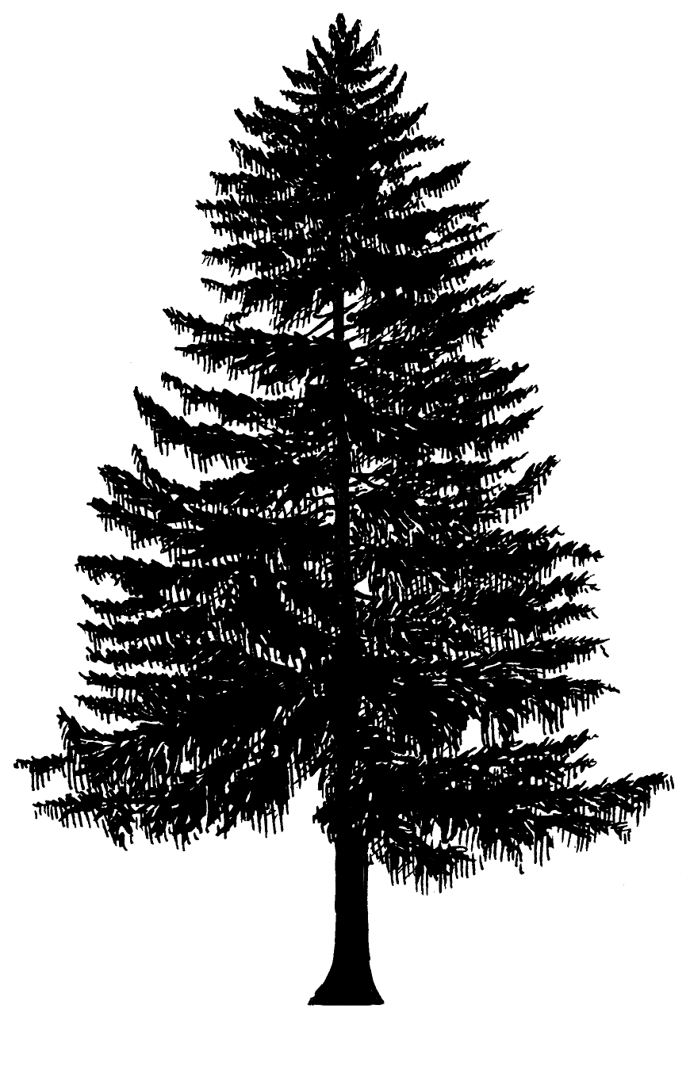
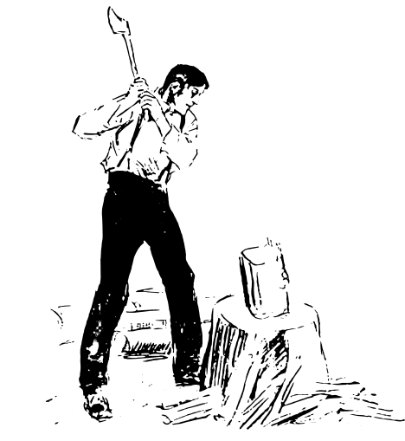
Load Tickets:
How many do you need?

Cords |  | Tickets
½ cord |  | 1 ticket
1 cord |  | 2 tickets
2 cords |  | 4 tickets

Use the following formula for determining how many cords of wood you have in your load or woodpile. Measure the length, width and height and divide by 128:
 | Length*x |  | Width*x |  | Height*= |  | ÷128**= |  | Cords

* Round your measurements to the nearest 1/4 foot and express it as a decimal. For example, if the length of your load is 7’5” round to 7’6” and express as 7.50 in the formula.

** There is 128 Cubic ft./cord.

For example:
Your load of wood measures: 6’3”x4’1”x3’8”
Round to nearest 1/4 foot expressed as decimal: 6.25x4.0x3.75
Multiply these three together and divide by 128: 93.75÷128=.73 cord, which is 2 tickets

*****************************************************************************************
Use the guidelines below or the above formula to estimate the size of your load. If you have a truck without racks and you stack your wood higher than the sides of the truck bed, you will have exceeded
1/2 cord and your load will require two tickets.

One cord = 128 cu. ft. or a stack 4’ x 4’ x 8’

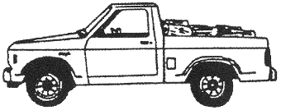 | 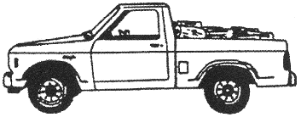 | 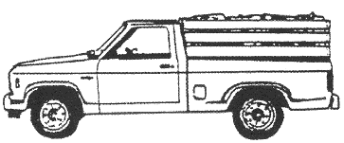 | 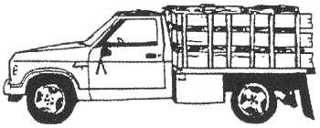
Small pickup  (1/4 ton)  Without racks = 1/2 cord  With racks = 3/4 cord | Long bed pickup  (1/2 or 3/4 ton)  Without racks = 1/2 cord  With racks = 1 cord | Short bed pickup  (1/2 or 3/4 ton)  Without racks = 1/2 cord  With racks = 1 cord | Standard 1 ton  Flat bed truck  With 4’ racks and 8’ bed =  Approx. 2 cords

Don’t overload your truck with firewood. Check your owner’s manual for your vehicle’s weight restriction.

Wallowa-Whitman National Forest Firewood Permits Are Available from The Following Locations:

Forest Service Offices:

Whitman Ranger District
Baker Office
1550 Dewey Ave.
Baker City, OR 97814
(541) 523-6391

La Grande Ranger District
3502 Highway 30
La Grande, OR 97850
(541) 962-8500

Whitman Ranger District
Pine Office
38470 Pine Town Road
Halfway, OR 97834
(541) 742-7511

Wallowa Mountains Office
201 East 2nd Street
Joseph, OR 97846
(541) 426-5546

Local Business Offices:

Burnt River Market
304 Main Street
Unity, OR 97884
(541) 446-3660

Gold Post
150 N. Mill Street
Sumpter, OR 97877
(541) 894-2362

D & B Supply
3515 Pocahontas Road
Baker City, OR 97814
(541) 523-6442

Halfway Mercantile
117 South Main Street
Halfway, OR 97834
(541) 742-6171

Hometown Hardware
206 S. Main Street
Union, OR 97883
(541) 562-5472

Wallowa Spirits and Snacks
202 E. First St. Suite A
Wallowa, OR 97885
541-886-2271

Island City Market and Deli
10101 W 1st Street
Island City, OR 97850
(541) 963-7140

Miller’s Home Center
3109 May Lane
La Grande OR 97850
(541) 963-3113

Wallowa County Ace Hardware
101 W North St.
Enterprise, OR 97828
541-426-3622

Members of Congress or resident Commissioner shall not be admitted to any share or part of this permit, or any benefit that may arise therefrom, unless it is made with a corporation of its general benefit (18 USC 431, 433). The United States Department of Agriculture (USDA) prohibits discrimination in its programs on the basis of race, color, national origin, sex, religion, age, disability, political beliefs, and marital or familial status. (Not all prohibited bases apply to all programs.) Persons with disabilities who require alternative means of communication of program information (Braille, large print, audiotape, etc.) should contact the USDA Office of Communications at (202) 720-2791. To file a complaint, write the Secretary of Agriculture, US Department of Agriculture, Washington, DC, 20250, or call (202) 720-7327 (voice) or (202) 720-1127 (TDD). USDA is an equal opportunity employer.

