W Washington: Snoquera Landscape Analysis. MBS NF
Targets: Timber -- 63 MMBF, Aquatic & Terrestrial Restoration, Fire Resiliency
E Washington: Mission Project. OK-WEN NF
Monitoring and reporting for Tapash CFLRP


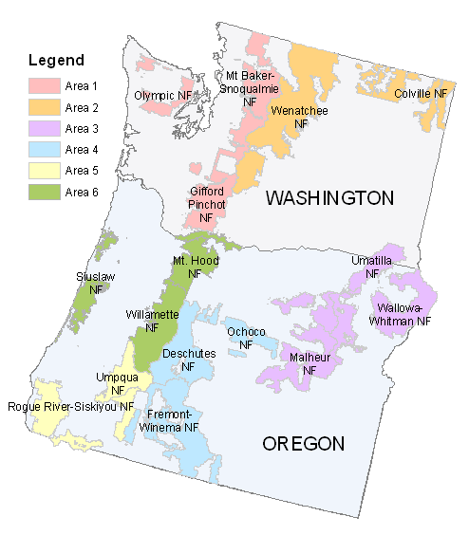
Central Oregon: DES NF Monitoring support to Deschutes Skyline CFLRP
NE Oregon: UMA NF Long-term vegetation and habitat monitoring
NE Oregon: WAW NF Range soil disturbance monitoring in Hell’s Canyon
E Washington: COL NF
Monitoring and reporting for Northeast Washington CFLRP
NW Oregon: North Clack Integrated Resource Project. MTH NF
Targets: Timber - 50 MMBF, Aquatic and Terrestrial Restoration, Fire Resiliency
NW Oregon: Oregon Dunes Restoration Project. SIU NF
Targets: Terrestrial Restoration

NW Oregon: Young’s Rock RIgdon EIS. WNF NF
Targets: ~65MMBF, Aquatic and Terrestrial Restoration, Fuels/WUI

SW Oregon: Calf-Copeland Restoration Project. UMP NF
Timber – 42 MMBF
Watershed Restoration – Aquatics, Wildlife, Weeds, Roads, Fire Resiliency/WUI

SW Oregon: Upper Applegate Watershed Restoration Project EA. RRS NF
Target: ~8 MMBF, Terrestrial & Aquatic Restoration, Fuels/ Fire Resiliency
Central OR: Fre-Win NF Monitoring of ecological status for Rangeland Allotment Management Plan renewal NEPA process
W Washington: Gifford Pinchot Huckleberry Management Strategy. GP NF
Targets: Terrestrial Restoration

- Finalized Gifford Pinchot Huckleberry Management Strategy

W Washington: Mountain Goat Management Plan & FEIS. OLY NF
Targets: Terrestrial Restoration
NE Oregon: Blue Dollar Complex Grazing Allotment. MAL NF
Targets: AUM’s – 2,200, Aquatic and Terrestrial
Restoration
Central Oregon: Big Summit Wild Horse EIS & Management Plan. OCH NF.

Ochoco NF

R6 Ecology Program Areas – Examples of Support to Targets/ NEPA Decisions FY 19/20

