2019 Ecology Program Yearbook:
Support to the NEPA Process
USDA Forest Service, Pacific Northwest Region

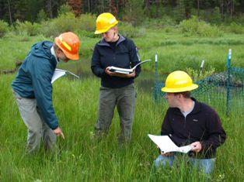

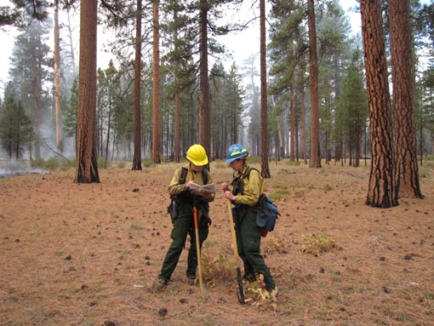

Cover photos: Range and fire monitoring are some of the ways ecologists support other disciplines and the NEPA process.
Contents
Ecology Program Mission Statement 3
Ecology Program in the Pacific Northwest Region 3
Core Services (the “Seven Pillars”) 5
Landscape assessment 5
Technology Transfer 5
Monitoring 6
Mentoring 6
Products (Maps, Presentations, Publications, Databases) 7
Presentations and Publications by Ecology Area 7
Western Washington 7
Eastern Washington 7
Northeast Oregon 8
Central Oregon 8
Southwest Oregon………………………………………………………………...………………………………9
Northwest Oregon 9
Regional Office…………………………………………………………………………………………………...9
Support to Planning………………………………………………………………………………………...………10
Partnerships……………………………………………………………………………………………...…………10
What's New in 2020…………………………………………………………………………………...…………...11
Western Washington Ecology Program (Area 1) 14
Eastern Washington Ecology Program (Area 2) 16
Northeast Oregon Ecology Program (Area 3) 18
Central and South Central Oregon Ecology Program (Area 4) 20
Southwest Oregon Ecology Progam (Area 5)………….……………………………………………………………..23
Northwest Oregon Ecology Program (Area 6)………………………………………………,,,……………………..25
In Memoriam: Fred Hall 1927-2019…………………………………………………………………………...……..27

Pacific Northwest Region Ecology Areas

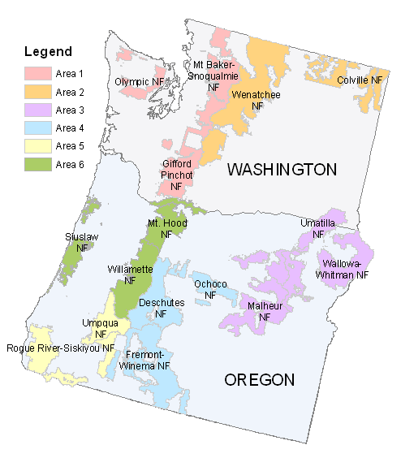
The Ecology Program in the Pacific Northwest Region is organized into six areas comprised of two to three National Forests each. Ecologists’ annual program of work is drawn up jointly with the Forest natural resource staff officers for that area.

Ecology Program Mission Statement
The Ecology Program is a network of ecologists applying science to serve the National Forests in the Region through core services of landscape assessment, technology transfer, monitoring, mentoring, products (maps, publications, and databases), support to planning, and science-management partnerships. The ecologists work as equal partners with other disciplines on an Area basis to serve multi-forest needs and provide a landscape perspective. Ecologists are based on National Forests and are hence accountable to Forest leadership.

Ecology Program in the Pacific Northwest Region
The Regional Ecology Program today has a terrestrial emphasis and is organized by Areas. Six areas cover the Region, as shown on page 2. Ecologists in these areas carry out a program of work crafted according to the National Forests’ needs. Those ecologists covered by the program’s Pacific Northwest regional commitment are indicated in the table below. The Ecology Program is well-integrated with other disciplines. One of our ecologist positions is also a half-time botanist and two others are half-time with the Forest Health Protection program. The program has a strong emphasis on networking, integration, and support to other disciplines.
Ecologists serving the six ecology areas:
Area | Area Name | Ecologists
1 | Western Washington | Jessica Hudec, Kevin James (with Botany), Kimberly Crider
2 | Eastern Washington | James Dickinson, Monique Wynecoop
3 | Northeast Oregon | Area Ecologist Upekala Wijayratne, Vacant (vice Michael Jennings) (with Forest Health), Nathan Poage, Christal Johnson
4 | Central Oregon | Gregg Riegel, Cristina McKernan, Mike Simpson (with Forest Health), Vacant (range ecologist)
5 | Southwest Oregon | Bill Kuhn, Pat Hochhalter, Summer Kemp-Jennings (on detail to Team21), Paul Chisholm (on detail to Area)
6 | Northwest Oregon | Vacant (vice Jane Kertis), Steve Acker, Doug Glavich

The program is built on a social contract between National Forest leadership, ecologists on the ground, and the Regional Office. The program of work is crafted annually with Forest Leadership Team and Staff Officer guidance. A high degree of accountability of performance is characteristic of the program.
Beginning in FY20, with the support of the Forest staff officers, ecologists are now fully funded, with funding held in a central Regional Office account and drawn on by the Area programs. The Regional commitment has been a decision of Forest Supervisors collectively as an investment in the multi-Forest landscape perspective, continuity, and the many other services the ecologists provide.
At the Regional Office, Tom DeMeo serves as the Regional Ecologist. Two student interns from De La Salle North High School, Ricardo Isais-Perez and Justin Thomas, work on data management on a part time basis.

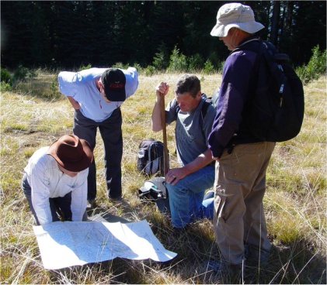

We’re lost but we’re making good time.

--Yogi Berra

Core Services (the “Seven Pillars”)

Landscape assessment

In 2019 the new potential natural vegetation (PNV) zone/subzone map went through a rigorous review by Forest personnel on all six ecology areas. We are working closely with a team at Washington’s Department of Natural Resources, led by Derek Churchill, to support their work with the PNV map, and are currently working to resolve differences between this and other maps in eastern Washington. Feedback from the review, as well as further refinements in methods, will result in a Version 2 of the maps, due in June 2020.

A companion product of the PNV maps is the forest structural restoration map (Haugo et al. 2015, DeMeo et al. 2018), and in 2019 this was expanded to include the entire area for the BioRegional Assessment (Ringo et al. unpublished). This assessment constitutes the 24 million ac of the Northwest Plan area, as well as the Ochoco National Forest in Oregon, and the Modoc and Lassen National Forests in California. We collaborated with our ecologist colleagues in northern California to develop this product. Formal rollout of the Assessment is directed by the Regional Planning unit, and is expected soon.

The ecologist cadre is supporting use of Haugo/DeMeo methods for the Eastside Screens revision as well as Washington DNR’s 20 Year Forest Health Strategy in eastern Washington (Derek Churchill). It is also now being used for a western Washington assessment conducted by DNR (Andrew Spaeth).

At the area level, ecologists conduct landscape assessments to support restoration and other projects in western Washington, eastern Oregon, central Oregon, and northwest Oregon. The landscape aspects of CFLRPs are also addressed by ecologists.

Finally, late successional reserves (LSRs) in fire-prone ecosystems are presenting challenges not foreseen when the Northwest Plan was written over 25 years ago. Ecologists, notably in eastern Washington and southwest Oregon, are working to resolve these issues.

Technology Transfer

Plant association trainings by the ecologist cadre continue to be well received by silviculturists, botanists, wildlife biologists, and other practitioners. In 2019 trainings were held on the Siuslaw, Umatilla, and Malheur National Forests. They provide an ideal field opportunity to connect ecology with everyday issues on the ground, and to help specialists understand the environment better and apply this to problem-solving.

In Central Oregon, ecologist Gregg Riegel serves as present of the Northwest Scientific Association, and is on the training cadre for Indicators of Rangeland Health.

In October we held our annual meeting of ecologists in the Region, hosted by the Western Washington Ecology Area and held at Skamania Lodge in the Columbia River Gorge. This meeting was held jointly with the USFS Forest Health Program, a meeting of minds and sharing of ideas we have been trying to get together for years. Ecologists and plant pathologists/entomologists met by Area and identified specific opportunities and strategies for collaboration going forward. The meeting also included a number of our partners, including Washington DNR, and the Pacific Northwest Research Station.

The program continues to host a variety of activities to promote science-management partnerships and science sharing, including webinars, facilitated by Cheryl Friesen. Cheryl provides invaluable facilitation services to the Ecology Program and is our key liaison with the Pacific Northwest Research Station. She set up and ran the webinar on the Terrestrial Condition Assessment, in cooperation with the Washington Office. Cheryl also helped facilitate our annual meeting

Monitoring

Monitoring continues as a significant part of ecologists’ workload in the Region. Ecology program ecologists are uniquely positioned to support the Forests in meeting their monitoring needs because of their strong scientific background, applied mission and outlook, and direction by Forest leadership to develop practical, effective monitoring efforts. Monitoring, conducted efficiently and effectively, completes the NEPA triangle and facilitates adaptive management. Monitoring, moreover, is a way to build trust and social license with stakeholders so that we can implement a program of work.

We continue to work closely with Regional range program manager, Robert Garcia to develop a more efficient, integrated range monitoring effort. In October we held a major workshop in Tonasket, Washington on Multiple Indicator Monitoring (MIM), seeking to better coordinate efforts both among the Districts on the Okanogan-Wenatchee NF, and also among Forests. This was followed a few days later at a follow up meeting in Pendleton.

Specific monitoring efforts on the ecology areas include: revisiting ecology plots to track changes over time (Western Washington); post-wildfire monitoring using FEAT-FIREMON Integrated protocols (eastern Washington); range monitoring efforts include revisiting and remeasuring soil disturbance on range allotments in Hell’s Canyon (Northeast Oregon); riparian data at Big Creek on the Malheur NF to support a CFLRP project (Northeast Oregon); CFLRP monitoring (eastern Washington, Northeast Oregon, and Central Oregon); range monitoring (Northeast and Central Oregon); huckleberry monitoring on the Rogue-Umpqua Divide (Southwest Oregon); and fuels and vegetation monitoring in the Mt. Washington Wilderness (Northwest Oregon).

Mentoring

Since 2011 we have been hosting student interns from De La Salle North High School in Portland. Students work one day per week, plus an additional Monday per month, for a total of five days per month. This is designed to teach them basic job skills and also technical skills useful for career development. In the ecology unit, students work on basic data management skills, such as scanning slides and photos, and developing associated Excel spreadsheets for metadata.

This school year our students Ricardo Isais-Perez, a senior, and Justin Thomas, a junior, again returned. Their tenure this year was cut short by covid restrictions, as the schools closed in March. Ricardo will graduate this June and we wish him well. We hope to have Justin return in the fall, along with a new student.

Ecologists are good mentors because of our long tenure in place. We can help introduce new silviculturists, wildlife biologists, and other specialists to an area through plant association and other trainings. We are a resource to get questions answered and to help solve problems, functioning much like agricultural extension agents.

We also encourage a wide variety of mechanism to insure cross-training and mentoring opportunities, such as detail assignments. Currently Paul Chisholm is serving on detail with the Southwest Oregon ecology team, and plans are forming for Denine Schmitz of the BLM to return to Central Oregon on a detail.

Products (Maps, Presentations, Publications, Databases)

Review and refinement of the potential vegetation map, at both vegetation zone and subzone scales, was the big ecology program product accomplishment during the past year. Work also proceeded in landscape departure and restoration needs assessments. See the preceding Landscape Assessment section for more details.

Presentations and Publications by Ecology Area

Western Washington
Presentations
- Hudec, J.L.; James, K.M. 2019. Forest Management and Climate Change. Presentation at Pacific Northwest Collaboratives Workshop. Hood River, OR.
- Hudec, J.L.; Acker, S.M.; DeMeo, T.D. 2019. Natural Range of Variability and Its Applications. Presentation at Regional Wildlife Program Meeting. Hood River, OR.
- Hudec, J.L.; A Collaborative Approach to Landscape Analysis and Design in the Wind River Watershed, Gifford Pinchot National Forest. Presentation at Regional Ecology Program Meeting. Florence, OR.
- James, K.M. 2019. Developing a Landscape Restoration Strategy for Western Washington. Westside Restoration Workshop co-hosted with Conservation Northwest. Seattle, WA.

Publications
- Hudec, J.L.; Halofsky, J.E.; Peterson, D.L.; Ho, J.J., eds. 2019. Climate change vulnerability and adaptation in Southwest Washington. Gen. Tech. Rep. PNW-GTR-977. Portland, OR: U.S. Department of Agriculture, Forest Service, Pacific Northwest Research Station. 249 p.

Eastern Washington
Publications
- Colville National Forest Fire, Fuels, & Aviation Management 2018 Annual Monitoring Report
- Wynecoop, M.D., P. Morgan, E.K. Strand, & F.S. Trigueros. 2019. Getting back to fire suméŝ: exploring a multi-disciplinary approach to incorporating traditional knowledge into fuels treatments. Fire Ecology, 15(1), 17.
- Wynecoop M. and T. Goicoechea. 2019. Working Across Boundaries to Implement the Cohesive Strategy in the Northern Rockies Field Tour. Northern Rockies Field Trip Summary 16, in press.
- Wynecoop M. 2019. Tribal Fire and Forest Management: Confederated Salish-Kootenai fire history, philosophy, and resource management strategies. Northern Rockies Field Trip Summary 13, www.nrfirescience.org/resource/19687
- Wynecoop M. 2019. Western Rx Fire Science Research Burn: Extending Southeastern Prescribed Fire Lessons and Science to the West. Northern Rockies Field Trip Summary 15, www.nrfirescience.org.Fire Experience

Presentations
- Wynecoop M. 2019. Northwest Scientific Association Special Session on Northwest Native Foods: Tribal perspectives, recommendations, and research needs for promoting tribal food sovereignty and responsible management of traditional foods and places. (www.northwestscience.org)
- 3rd Annual Cohesive Strategy Workshop, Plymouth MA-Monique was invited to participate in a tribal panel discussion led by Frank Lake and present on the collaborative work done with the Spokane and Confederated Colville Tribes (CCT) and how it ties to the Cohesive Strategy goals.
- Whitebark Pine Conference, Pablo, MT- “More than Trees: the importance of making our science delivery culturally and socially relevant”
- Western Cohesive Strategy Field Tour, Missoula, MT-” Incorporating Tribal Values into Fuels and Wildfire Management”

Northeast Oregon
Presentations

- Poage, N. 2019. Stand measurements (basal area and SDI). Presented to the Harney County Restoration Collaborative
- Wijayratne, U., M. Jennings, N. Poage, R. Brunner, D. Luoma, E. Martin. 2019. Global Observation Research Initiative in Alpine Environments (GLORIA): First Year Data, Wallowa Mountains of Oregon. Presented at the Northwest Science Association Conference. Lewiston, Idaho.

Central Oregon
Publications
- Case, M.J., B.K. Kerns, J.B. Kim, M. Day, A. Eglitis, M.L. Simpson, J. Beck, K. Griener, G. Riegel. Climate Change, Vegetation, and Disturbance in South Central Oregon. In: Halofsky, J.E. and D.L. Peterson. Editors. Climate Change Vulnerability in Central and South Central Oregon. Gen. Tech. Rep. PNW-GTR-974. September 2019.
- Pellant, M.L, D.A. Pyke, J. Herrick, P.L. Shaver, F. Busby, G. Riegel, N. Lepak, B.A. Newingham, E.Kachergis, and D. Toledo. In press. Interpreting Indicators of Rangeland Health. Interpreting Indicators of Rangeland Health-Version 5. USDI Bureau of Land Management, Denver, CO. ITR XXXX-X. In Review.

Presentations
- Riegel, G. Development and utilization of a Riparian Ecological Type Classification for monitoring long term livestock grazing effects in Central Oregon. Presentation at Northwest Scientific Association Meeting. Lewiston, ID. 03/28/2019.
- Simpson, M. and Oblinger, B. Data sources and methods to improve Root Disease Risk Models for broad scale assessments. Presentation at Western International Forest Disease Work Conference. Estes Park, CO. 06/07/2019.
- Hanavan R. P., B. D. Cook, L. A. Corp, B. W. Oblinger, M.L. Simpson and R.W. Flowers. Improved stress detection in trees using NASA Goddard’s LiDAR, Hyperspectral and Thermal Imaging System (G-LiHT). Presentation at Western International Forest Disease Work Conference. Estes Park, CO. 06/07/2019.
- Simpson, M. Shared Area Ecology and Forest Health Protection positions: Success Stories and Lessons Learned. Presentation at Joint R6 Regional Ecology and Forest Health Protection Technical Meeting Stevenson, WA. 10/30/2019.

Southwest Oregon

Presentations
- “Southwest Oregon Wildfire: Trends and Drivers.” Presented to the Jackson-Josephine Counties Small Woodlands Association. Medford, February 2019 (B. Kuhn)
- Climate Change, Wildfire, and Forest Management: Adaptation Tools and Strategies. Forest Restoration and Wildfire Management workshop. Medford, April 2019. (B. Kuhn)
- Umpqua Forest Restoration and Prioritization. Presentation to members of the Umpqua Forestry Coalition, October 2019. (B. Kuhn & S. Kemp-Jennings)

Northwest Oregon
Publications

- Kauffman, J.B., L.M. Ellsworth, D.M. Bell, S. Acker, and J. Kertis. 2019. Forest structure and biomass reflects the variable effects of fire and land use 15 and 29 years following fire in the western Cascades, Oregon. Forest Ecology and Management 453:117570. https://doi.org/10.1016/j.foreco.2019.117570.

Regional Office
Map

- Ringo, C., T. DeMeo, M. Simpson, J. Kertis, P. Hochhalter, and R. Butz. 2019. Ecological departure map for the BioRegional Assessment. Portland, OR: USDA For. Serv.

Presentations

- Hudec, J.L.; Acker, S.M.; DeMeo, T.D. 2019. Natural Range of Variability and Its Applications. Presentation at Regional Wildlife Program Meeting. Hood River, OR.

Support to Planning

The Ecology Program in 2019 launched a major initiative to collate, refine, and add to the Region’s set of state and transition models. Developed first in VDDT software, and now in STSim, these models are the underpinning of much landscape assessment, habitat, and forest growth models to support Forest Plan revision but ultimately support much project work as well.

In February, we held a major training in STSim methods, led by Leonardo Frid of Apex Resource Management Solutions, Vancouver, BC. Ecologists from all the Areas attended, as well as our partners at The Nature Conservancy, Washington DNR, and other agencies.

Since then Nathan Poage has been leading an effort to collate all existing modeling work done over the past 20+ years in the Region, standardize model descriptions, and identify where refined or new models are needed. Recently this work has taken on new currency as Planning has indicated the Rogue River-Siskiyou National Forest, as well as the Klamath, Six Rivers, Trinity, and Mendocino NFs in northern California are slated next for Plan revision.

See accompanying infographic “R6 Ecology Program Areas Support to NEPA” for an illustration of how the Ecology Program is directly contributing to the success of projects through the NEPA process.

Partnerships

Collaborative Forest Landscape Restoration Projects (CFLRPs)

We continue to show leadership in supporting the Collaborative Forest Landscape Restoration Projects (CFLRPs) in the Region and are considered a national leader in CFLRP monitoring. This was an important transition year in the CFLRP projects. 2010 projects (Tapash and Deschutes) are nearing the end of their 10-year horizon. 2012 projects (Lakeview, Southern Blues, and Colville) will receive automatic two-year extensions with funding in order to complete their 10 years. In addition to each project submitting their annual reports in December, this was also the due date for their 10-year ecological indicator monitoring reports.
Anticipating a new round of 10-year projects, the Agency called for proposals. A Regional team led by Tom DeMeo shepherded these through two rounds of evaluation and in the end recommended five proposals for national evaluation: Tapash, Deschutes (a five-year extension request), Southwest Oregon, the Northern Blues, and Colville. Regional Forester Glenn Casamassa has indicated that successful Forests securing CFLRPs will have this become their main program of work. At this writing the national review team has begun their work and is expected to make recommendations during the week of June 22nd. From there the recommendations go to the Secretary of Agriculture for approval. We do not expect any new projects to be implemented in the Region before FY21.
Ecologists at the Area level also contributed significantly to the development of proposals, notably in Southwest Oregon where Bill Kuhn led the team developing the CFLRP proposal for the Rogue Valley project.

The Nature Conservancy (TNC)

We participate in the TNC fire TREX (training exchange) efforts held each spring. In 2019 Tom DeMeo was a participant and mentor at both the Bend and Ashland TREX.

Partnerships with Other Science Partners

Recently we lost the services of Chris Ringo, our longtime GIS programming partner at Oregon State University, as he was assigned to other work. To transition from this loss we are building a new agreement with the University of Washington’s College of the Environment, specifically the team of Brian Harvey and Jon Bakker, who have identified a doctoral student to aid in building future iterations of the regional restoration map. We are also building bridges with Meg Krawchuk and her students at Oregon State University (OSU), and with the OSU extension foresters.

What’s New in 2020

In 2020 the program is strengthening and expanding our support to planning, through a major effort to collate and update state and transition models. Our work to standardize and upgrade state and transition models will form the underpinning to support planning efforts for years to come. Nathan Poage is coordinating efforts. He is currently working with ecologists in Southwest Oregon and Northern California (the Klamath Ecological Province) to prepare models for Plan revision. We have also engaged Max Wahlberg, fire ecologist on an Enterprise Team to assist in this effort.

This work for the Klamath Ecological Province is intended to serve as a pilot for the Region. Lessons learned here will refine our approach and gradually build to Region-wide coverage. The goal is to have state and transition models in place, and a cadre of trained ecologists built up, to support plan revision and other assessment needs for years to come.

CFLRP monitoring

Collaborative Forest Landscape Restoration Projects (CFLRPs) began in the Region in 2010 and are now nearing the end of their 10-year life. The Ecology Program had a significant role in developing the monitoring plans for these projects. Lessons learned were documented at a meeting in Bend in 2018.

In the first round of CFLRP projects, good work was done on the monitoring process. Stakeholders were engaged in shaping questions; questions selected were feasible and addressed key issues; data were collected; results were reported (DeMeo et al. 2015). Where improvements can be made is in closing the adaptive management loop by timely reporting of results, so that line officers can use the information to verify work on the ground, or change course as needed. We have also heard from the field that the entire monitoring process, notably data management and reporting out, is burdensome, and some centralization and standardization would be appropriate.

Accordingly, the ecology program is launching a monitoring initiative for the next round of CFLRP projects, expected to be implemented in FY21. Working closely with the national level, this effort will seek to standardize certain core indicators, more consistently assess change at the landscape scale, provide support through centralized data management for some attributes, and assist with rapid reporting.

Team21

This Regional team, led by Emily Platt, has been charged with revising the Eastside screens, specifically to remove the 21 inch rule. Ecology has been assisting this effort, as ecologist Summer Kemp-Jennings (Southwest Oregon Ecology Area) is serving on the team. Moreover, the program has been providing data, structural rule sets, and map layers to support the Team’s analysis. Our ecological departure method will be used as a landscape background for this.

Partnership with the University of Washington

Our ecological departure work (Haugo et al. 2015, DeMeo et al. 2018, Ringo et al. 2019) is strengthened by continual updating with new map layers and methods. Accordingly, we are entering into an agreement with the University of Washington—specifically Brian Harvey and Jon Bakker in the College of the Environment—to further this work. A doctoral student will begin work on this in September 2020 and over time build up a skill set to work on this effectively, with the advantage of working in a research setting where cutting edge techniques can be explored. This will also serve as effective networking, since the Harvey-Bakker group is also supporting Washington DNR’s landscape assessment work in the eastern part of the state, building on methods we developed in cooperation with The Nature Conservancy.

Support to Washington Department of Natural Resources

We are currently supporting the State of Washington’s 20-Year Forest Health Strategy with technical support to Derek Churchill’s team working on landscape assessment for this effort. We are working to have the new potential vegetation map we developed become the standard for this work. This will be strengthened by an accuracy assessment to be done on our work, conducted by Dave Bell and colleagues at the PNW Station, Corvallis.

Potential Natural Vegetation (PNV) Map, Second Iteration

The broad-scale PNV map, at vegetation zone and subzone scales, was completed in 2018. In 2019 extensive review in all six Ecology Areas in the Region was conducted by the PNV mapping team. Information from this work, as well as ongoing feedback from Washington DNR for eastern Washington, is being used to develop the next version of the map. This iteration is expected in June 2020. Moreover, Dave Bell and his group at the PNW Station/OSU in Corvallis will be conducting an accuracy assessment on the map shortly thereafter.

Data Management Work

To support planning and monitoring work, and serve as a focal point to find efficiencies, Ecology is advocating coordinated data management work at the Regional level to serve multiple needs in inventory, landscape assessment, CFLRP and other monitoring, and communication. This is intended to support CFLRP monitoring (see above), Forest plan revision, range monitoring, and other applications as needed.

We currently have secured some time with Julia Olszewski, working in cooperation with The Fremont-Winema National Forest and Lake County Resources Initiative (a key player in the Lakeview CFLRP) to meet this data management need, specifically for coordinating CFLRP monitoring in the Region. We are seeking other opportunities to build on this, in cooperation with Marin Palmer, Robyn Darbyshire, and Barb Garcia in the Regional Office’s natural resources staff.

With the current covid emergency, at the request of the field we are looking for data management opportunities for idled field staff. The first opportunity we are presenting is work on Research Natural Area (RNA) establishment records, as requested by RNA Coordinator Todd Wilson.

Pacific Northwest Region Ecology Program

Photos courtesy Western Washington Area Ecology Program, 2019 Monitoring Report

Western Washington Ecology Program (Area 1)
Gifford Pinchot, Mount Baker-Snoqualmie, and Olympic National Forests
Accomplishments
Western Washington Ecology Program has selected a subset of our focal projects from 2019 to highlight.
- Monitoring
Annual Monitoring Report
The focus of our 2019 report is ecoplots- a network of intensively monitored plots that were initially established in the late 1970s as one of the founding projects of the Pacific Northwest Ecology Program. The initial ecoplots formed the basis for developing field guides to forested plant associations for each national forest. Additional re-measurements of these plots continued through 2012, resulting in a long-term dataset intended to characterize forest stand dynamics over time. These ecoplot data provide sound, field-based information that can help address management concerns at multiple scales and support restoration efforts across Western Washington.
Ecology Monitoring Plots in Western Washington- File Package
This file package is a compilation of information related to ecology plot monitoring in Western Washington. This work identifies a base set of ecology monitoring plots that represent the dominant plant associations on the Mt. Baker-Snoqualmie and Olympic National Forests. This set of plots will be proposed for continued re-measurement in future years. Additional ecology plot information is provided in both tabular and spatial files. Ecology plot monitoring data for Gifford Pinchot National Forest is currently being digitized and will be added to this file package when that effort is complete.
- Support for Planning
Ecologists facilitated the use of condition-based analysis in NEPA planning to address integrated restoration of 160,000 acres on Mt. Baker-Snoqualmie National Forest. Ecologists also provided landscape ecology context and climate change analysis for Environmental Assessments and participated in numerous public meetings and field trips in support of proposed projects.
- Support for LSR Management
The LSR land use allocation is intended to maintain or increase functioning habitat for late successional old-growth species (most notably northern spotted owl and marbled murrelet). Terrestrial vegetation management within LSRs is currently focused on accelerating the development of old-growth characteristics in previously managed stands. Identifying those managed stands within LSRs that can contribute to increasing patch size or connectivity is the aim of this work. We provide a summary of stands within LSRs in Western Washington Area National Forests (Gifford Pinchot, Mt. Baker-Snoqualmie and Olympic) with a focus on interspersion of mature and managed stands. Accompanying this report is a collection of GIS files arranged in an ArcGIS map package to allow specialists on Interdisciplinary Teams to identify specific stands at the project scale.

Program Priorities
In 2019, Natural Resource Staff Officers, Area Ecologists, and the Regional Ecologist agreed on the following priorities for Western Washington:
- Support for planning
  - Lead landscape assessments.
  - Contribute to project level planning by providing landscape context and climate change considerations.
- Monitoring
  - Release annual report, focusing on legacy ecoplot data.
  - Compile existing tabular and spatial ecoplot data into a single file package. Propose method for systematic identification of a subset of plots for future re-measurement.
  - Support ongoing fire and huckleberry monitoring projects.
- Support for Late Successional Reserve (LSR) management
  - Identify managed stands within LSRs that could contribute to increased patch size or connectivity.
  - Interface with LSR Working Group and U.S. Fish and Wildlife Service, as needed.
- Collaboration
  - Cooperate with partners and collaborative groups on project planning, monitoring, and public outreach.
  - Work with Washington Department of Natural Resources on state-and-transition model development.
  - Participate in PNW Research Station workshops to identify research needs around carbon and westside fire.

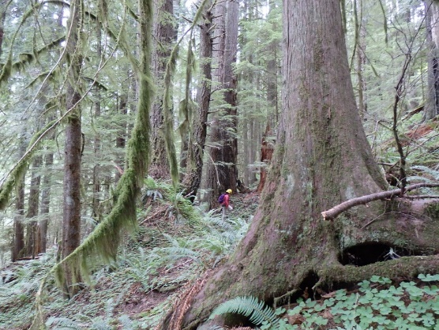
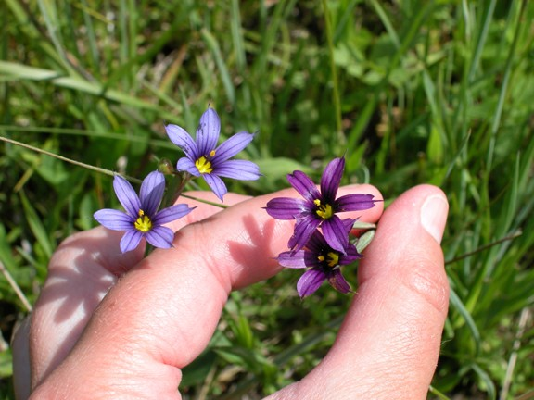
Permanent ecology plots that are intermittently re-measured provide insight into how forest stands change over time.
Western Washington Area Ecology Program Team
Jessica Hudec
Kevin James
Kim Crider

Publications and Presentations
- Hudec, J.L.; Halofsky, J.E.; Peterson, D.L.; Ho, J.J., eds. 2019. Climate change vulnerability and adaptation in Southwest Washington. Gen. Tech. Rep. PNW-GTR-977. Portland, OR: U.S. Department of Agriculture, Forest Service, Pacific Northwest Research Station. 249 p.
- Hudec, J.L.; James, K.M. 2019. Forest Management and Climate Change. Presentation at Pacific Northwest Collaboratives Workshop. Hood River, OR.
- Hudec, J.L.; Acker, S.M.; DeMeo, T.D. 2019. Natural Range of Variability and Its Applications. Presentation at Regional Wildlife Program Meeting. Hood River, OR.
- Hudec, J.L.; A Collaborative Approach to Landscape Analysis and Design in the Wind River Watershed, Gifford Pinchot National Forest. Presentation at Regional Ecology Program Meeting. Florence, OR.
- James, K.M. 2019. Developing a Landscape Restoration Strategy for Western Washington. Westside Restoration Workshop co-hosted with Conservation Northwest. Seattle, WA.

Continued from previous page
Western Washington Ecologists regularly participate in field trips in support of integrated forest management.
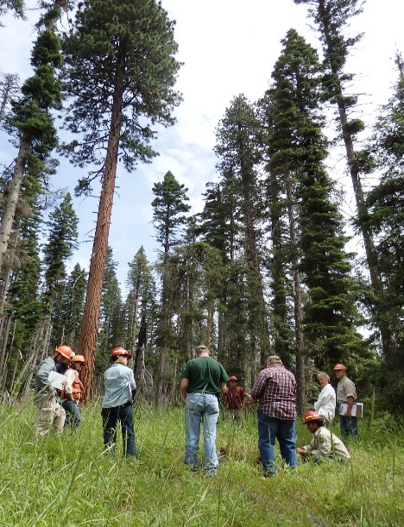
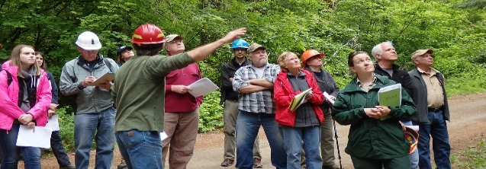
Responding to Future Needs
In 2020, planning, monitoring, and partnerships will continue to be a major focus area for the Western Washington Ecology Program. Our work is integral to all levels of planning including the development of broad landscape management strategies, mid-level resource management plans, specific project implementation, and monitoring. We plan to re-measure a subset of long-term monitoring plots and make progress on a comprehensive, user-friendly ecoplot database for both internal use and for sharing to the public domain. Finally, Western Washington ecologists will serve as liaisons to connect the Forest Service with collaborative groups, scientists and research institutions, tribes, non-profit groups, State and Private Forestry, Washington DNR, and other entities. In 2020 we will specifically focus on our partnership with DNR through the development of state-and-transition models, a Westside Restoration Strategy, and shared stewardship.

Eastern Washington Ecology Program (Area 2)
Okanogan Wenatchee and Colville National Forests
Accomplishments
The Eastern Washington Zone (EWZ) continues to deliver services to the Colville and Okanogan-Wenatchee National Forests. Effort was most focused on creating monitoring strategies and protocols to better support the expanded pace and scale of restoration work that is the focus on both forests. We worked with collaborative partners to develop a multiparty monitoring strategy that supports monitoring on both Federal and State land, with potential to be applied across all the EWZ. Our zone established post-wildfire FFI
monitoring plots to assess fire affects from a 2018 fire. We collected tree survival data collection for a three-year post fire study. Our ecologists attended a workshop with district and national leads in order to help introduce the national Groundwater Dependent Ecosystem inventory and monitoring protocol to the National Forests and Bureau of Land Management units of eastern Washington.

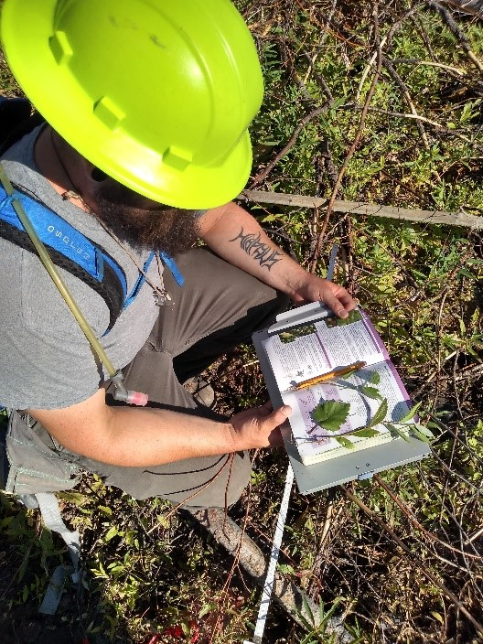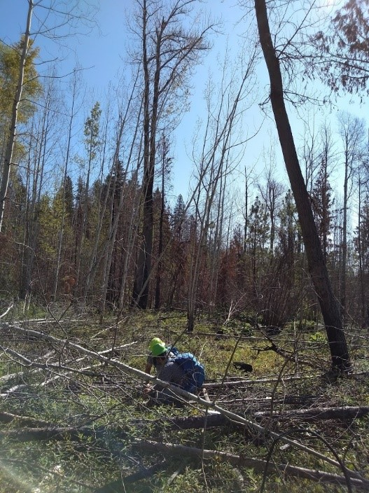

Our work with CFLRPs included more than monitoring, we also participated heavily in the development of the annual reports for both of the CFLR projects. Part of that work included coordinating with partners to capture the amount of work already accomplished and to determine the future direction of projects. We also supported the development of new (2020) CFLR project proposals by helping to select the landscapes, describe the ecological conditions, and facilitate efforts between partners within the collaboratives.

Our team coordinated or participated in several science and tech transfer opportunities to audiences ranging from research technicians, to high school students, to national program managers, scientists and district implementation teams. These efforts included the Western Cohesive Strategy Field Tour to share how our collaborative projects address the goals of the Cohesive Strategy; the White bark Pine Conference was coordinated to share about current and future threats to WBP restoration and the cultural and spiritual importance of the tree to area tribes; Ventenata dubia detection and coordination workshop; Decision Making in Natural Resources workshop to inform senior leadership about the challenges of seamless science and management integration.

Being located at the unit is an opportunity to provide opportunities and support to the Forest Service Family and local communities. Our zone participated in helping develop and implement a native plant and pollinator garden at the Colville SO. In addition, the Colville National Forest is the home of a FireWorks Fire Education Trunk that is being used to educate the local communities in the ecology and traditional tribal knowledge of regional Native American Tribes related to fire in the ecosystems. Finally, the zone is proud to have participated in interactions with local schools to teach resource management skills to the next generation of Forest Service Employees.

Groundwater Dependent Ecosystem Inventory Fieldtrip, Naches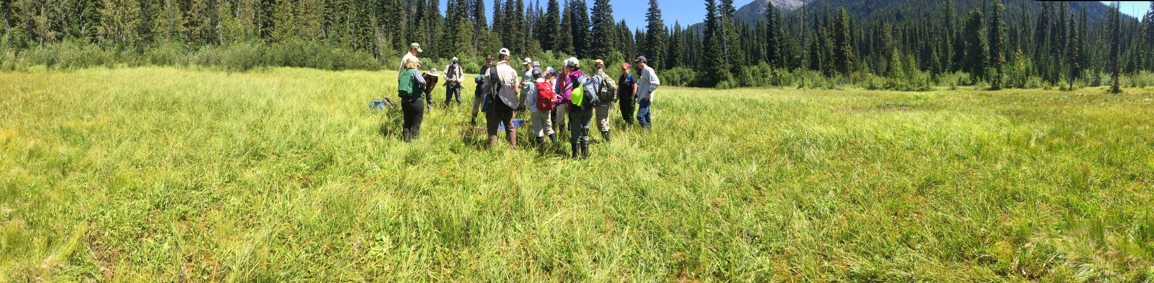
Products, Papers, Publications
- Colville National Forest Fire, Fuels, & Aviation Management 2018 Annual Monitoring Report
- Wynecoop, M.D., P. Morgan, E.K. Strand, & F.S. Trigueros. 2019. Getting back to fire suméŝ: exploring a multi-disciplinary approach to incorporating traditional knowledge into fuels treatments. Fire Ecology, 15(1), 17.
- Wynecoop M. 2019. Northwest Scientific Association Special Session on Northwest Native Foods: Tribal perspectives, recommendations, and research needs for promoting tribal food sovereignty and responsible management of traditional foods and places. (www.northwestscience.org)
- Wynecoop M. and T. Goicoechea. 2019. Working Across Boundaries to Implement the Cohesive Strategy in the Northern Rockies Field Tour. Northern Rockies Field Trip Summary 16, in press.
- Wynecoop M. 2019. Tribal Fire and Forest Management: Confederated Salish-Kootenai fire history, philosophy, and resource management strategies. Northern Rockies Field Trip Summary 13, www.nrfirescience.org/resource/19687
- Wynecoop M. 2019. Western Rx Fire Science Research Burn: Extending Southeastern Prescribed Fire Lessons and Science to the West. Northern Rockies Field Trip Summary 15, www.nrfirescience.org.Fire Experience
- 3rd Annual Cohesive Strategy Workshop, Plymouth MA-Monique was invited to participate in a tribal panel discussion led by Frank Lake and present on the collaborative work done with the Spokane and Confederated Colville Tribes (CCT) and how it ties to the Cohesive Strategy goals.
- Whitebark Pine Conference, Pablo, MT- “More than Trees: the importance of making our science delivery culturally and socially relevant”
- Western Cohesive Strategy Field Tour, Missoula, MT-” Incorporating Tribal Values into Fuels and Wildfire Management”
- Northwest Scientific Association Annual Meeting Special Session on NW Native Foods- Moderated and presented recent work with the Spokane and Colville Tribes and how it relates to tribal food sovereignty.
- Fire Strong Communities: Okanogan, Tonasket, Winthrop – presented to three fire affected communities: “Managing for Resilient Landscapes”.
- Forest Health Protection Annual meeting, Portland, OR – “Creating Context for Resilient Landscapes”.
- Warm Springs Confederated Tribes, OR – “Climate Vulnerability Assessment”.

Program Priorities
The priorities for 2019:
- Support expanded pace and scale of restoration.
- Develop shared knowledge, tools, and processes with Washington Department of Natural Resources.
- Communicate current science, including traditional ecologic knowledge (TEK), to managers and partners.
- Create research and management partnerships to address new issues.

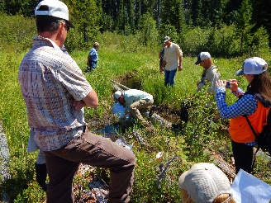
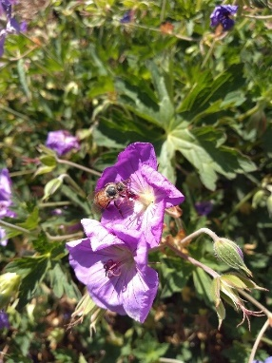

Clockwise: Honey bees enjoying part of the native plant and pollinator garden at the Colville Supervisors Office; Groundwater Dependent Ecosystem Workshop attendees measuring flow rates; post-fire FFI plot data collection.

Area 2 Ecology
Program Team
James Dickinson, Landscape Ecologist
Monique Wynecoop, Fire Ecologist

Responding to Future Needs
The Colville National Forest has increased the implementation of restoration work so significantly that it risks out-pacing the ability to monitor and adapt its management needs. The EWZ will be working closely with all resource areas to develop a monitoring program that is capable of informing the ongoing CFLRP as well as the adaptive management of the newly signed land management plan. One goal of this effort will be to maximize applicability and processes across the both forests and across ownerships, in support of the 20-year strategy of the Washington Department of Natural Resources.
Expanding the application of traditional knowledge, landscape principles, science transfer, and management efficiencies will be an important emphasis in the upcoming year.

Northeast Oregon Ecology Program (Area 3)
Malheur, Umatilla, and Wallowa-Whitman National Forests
Accomplishments
- Reviewing and compiling state-and-transition models across the region.
- Conducted first post-restoration riparian data collection on Big Creek, Malheur NF to support the work being done through CFLRP.
- Provided support to the Malheur NF Range NEPA team.
- Continued soil disturbance monitoring in range allotments with the endangered Spalding’s Catchfly in Hells Canyon NRA.
- Demonstrated the predictive habitat distribution model for Spalding’s Catchfly to the Idaho Fish and Game technical team for the species.
- Continued to provide technical assistance, vegetation data, and geospatial analytical products to natural resources specialists, leadership teams, and collaborative groups on all three Area NFs.
- Conducted plant association trainings on Umatilla and Malheur NFs.
- Whitebark Pine cone reconnaissance, caging, and collection coordination.
- Collected data from 41 long-term whitebark pine blister rust plots in the Wallowa and Elkhorn mountains and surveyed for blister rust resistant trees using and validating the habitat distribution model produced the previous year – found two candidate trees.

Program Priorities
The Northeast Oregon Ecology Team meets annually with all natural resource staff officers and other natural resource specialists to discuss program priorities, respond to assistance requests from Forest units, and to jointly build the annual program of work and focus on the following priorities:

- Support Collaborative Forest Landscape Restoration (CFLR) on the Malheur National Forest and other collaborative groups
- Develop tools and strategies for landscape-level restoration
- Provide assistance to Interdisciplinary Teams for Allotment Management Plan Revisions on the Malheur NF
- Support Malheur and Wallowa-Whitman NFs with Climate Change Coordination
- Assist in developing silvicultural approaches to meet restoration needs of Area NFs
- Assist with long-term vegetation and habitat monitoring on Malheur, Umatilla, and Wallowa-Whitman NFs
- Provide field visit support to specialists
- Manage ecology legacy data

Michael Jennings, who supported both the Ecology and Forest Health Protection programs in the Blue Mountains, retired at the end of the summer – we wish him well on his new adventures.

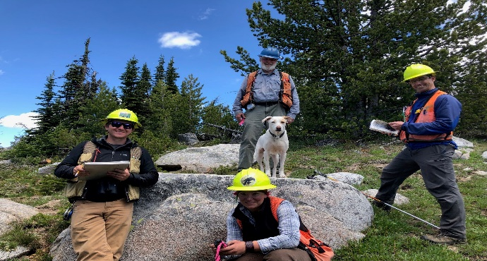
Whitebark pine blister rust survey crew
Area 3 Ecology Program Team:
Team Members: Collaborators:
Vacant (vice Michael Jennings) Kerry Kemp
Nathan Poage Susan Geer
Upekala Wijayratne Mike McWilliams
Rebecca Braisted
Kevin Lash

- Acquired 499 square miles (319,360 acres) of LIDAR for the Wallowa-Whitman NF.
- Continued collaboration with University of Washington researchers to develop LIDAR-based tools.
- PNW Carbon Dynamics workshop and continued biweekly involvement.
- Collected baseline data in an invaded native plant community prior to prescribed burning on the Umatilla NF.
- Facilitated review of Potential Natural Vegetation map by local specialists.
- Participated on silviculturist certification panel (Poage).
- Riparian Drone Observation Project flight over Meadow Creek on the Wallowa-Whitman NF successfully conducted and data currently being processed.
- Ongoing stand exam consultation for the Malheur NF.
- Collected 30-year post fire data at Dooley Mtn., Wallowa-Whitman NF.
- Continued moving riparian existing condition framework forward.
- Provided legacy ecology plot data and analysis.

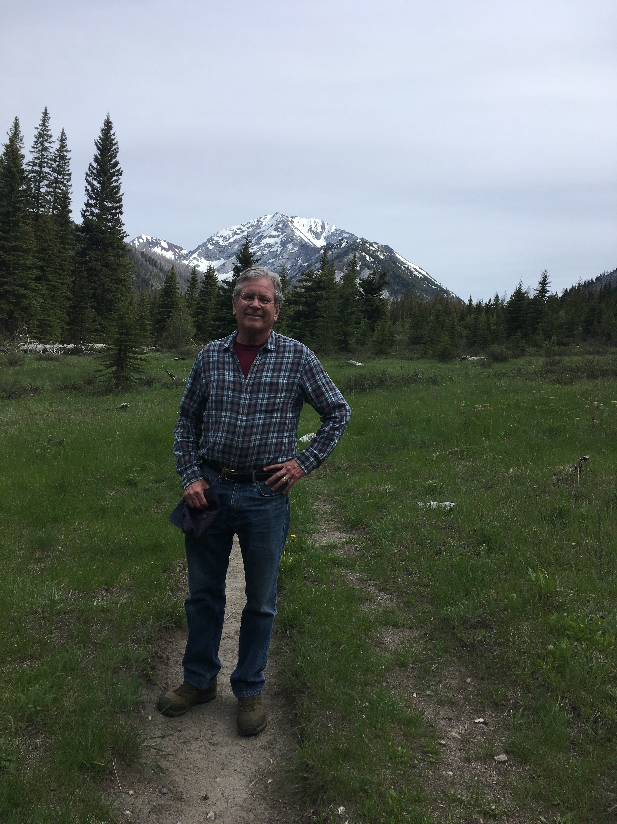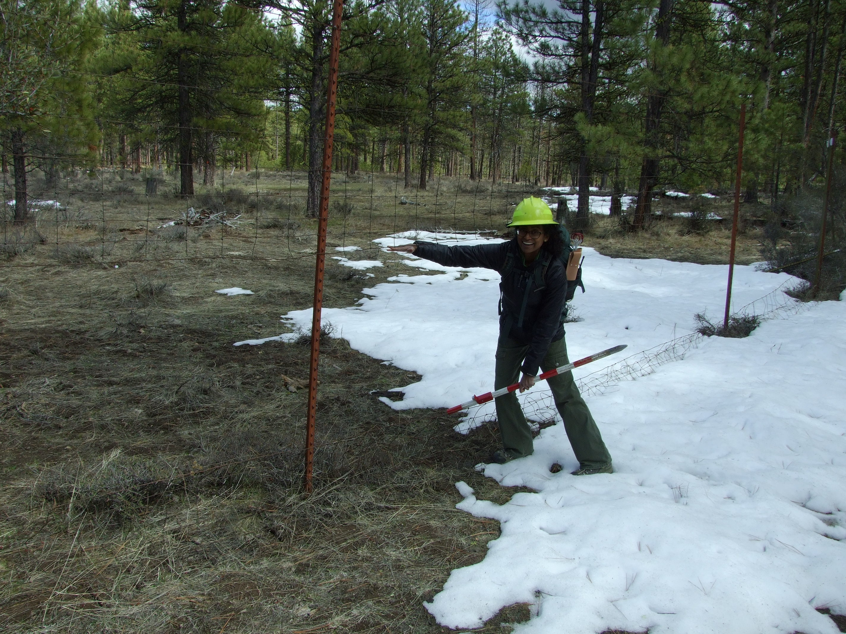
Field day - Elkhorns Checking elk exclosure fence

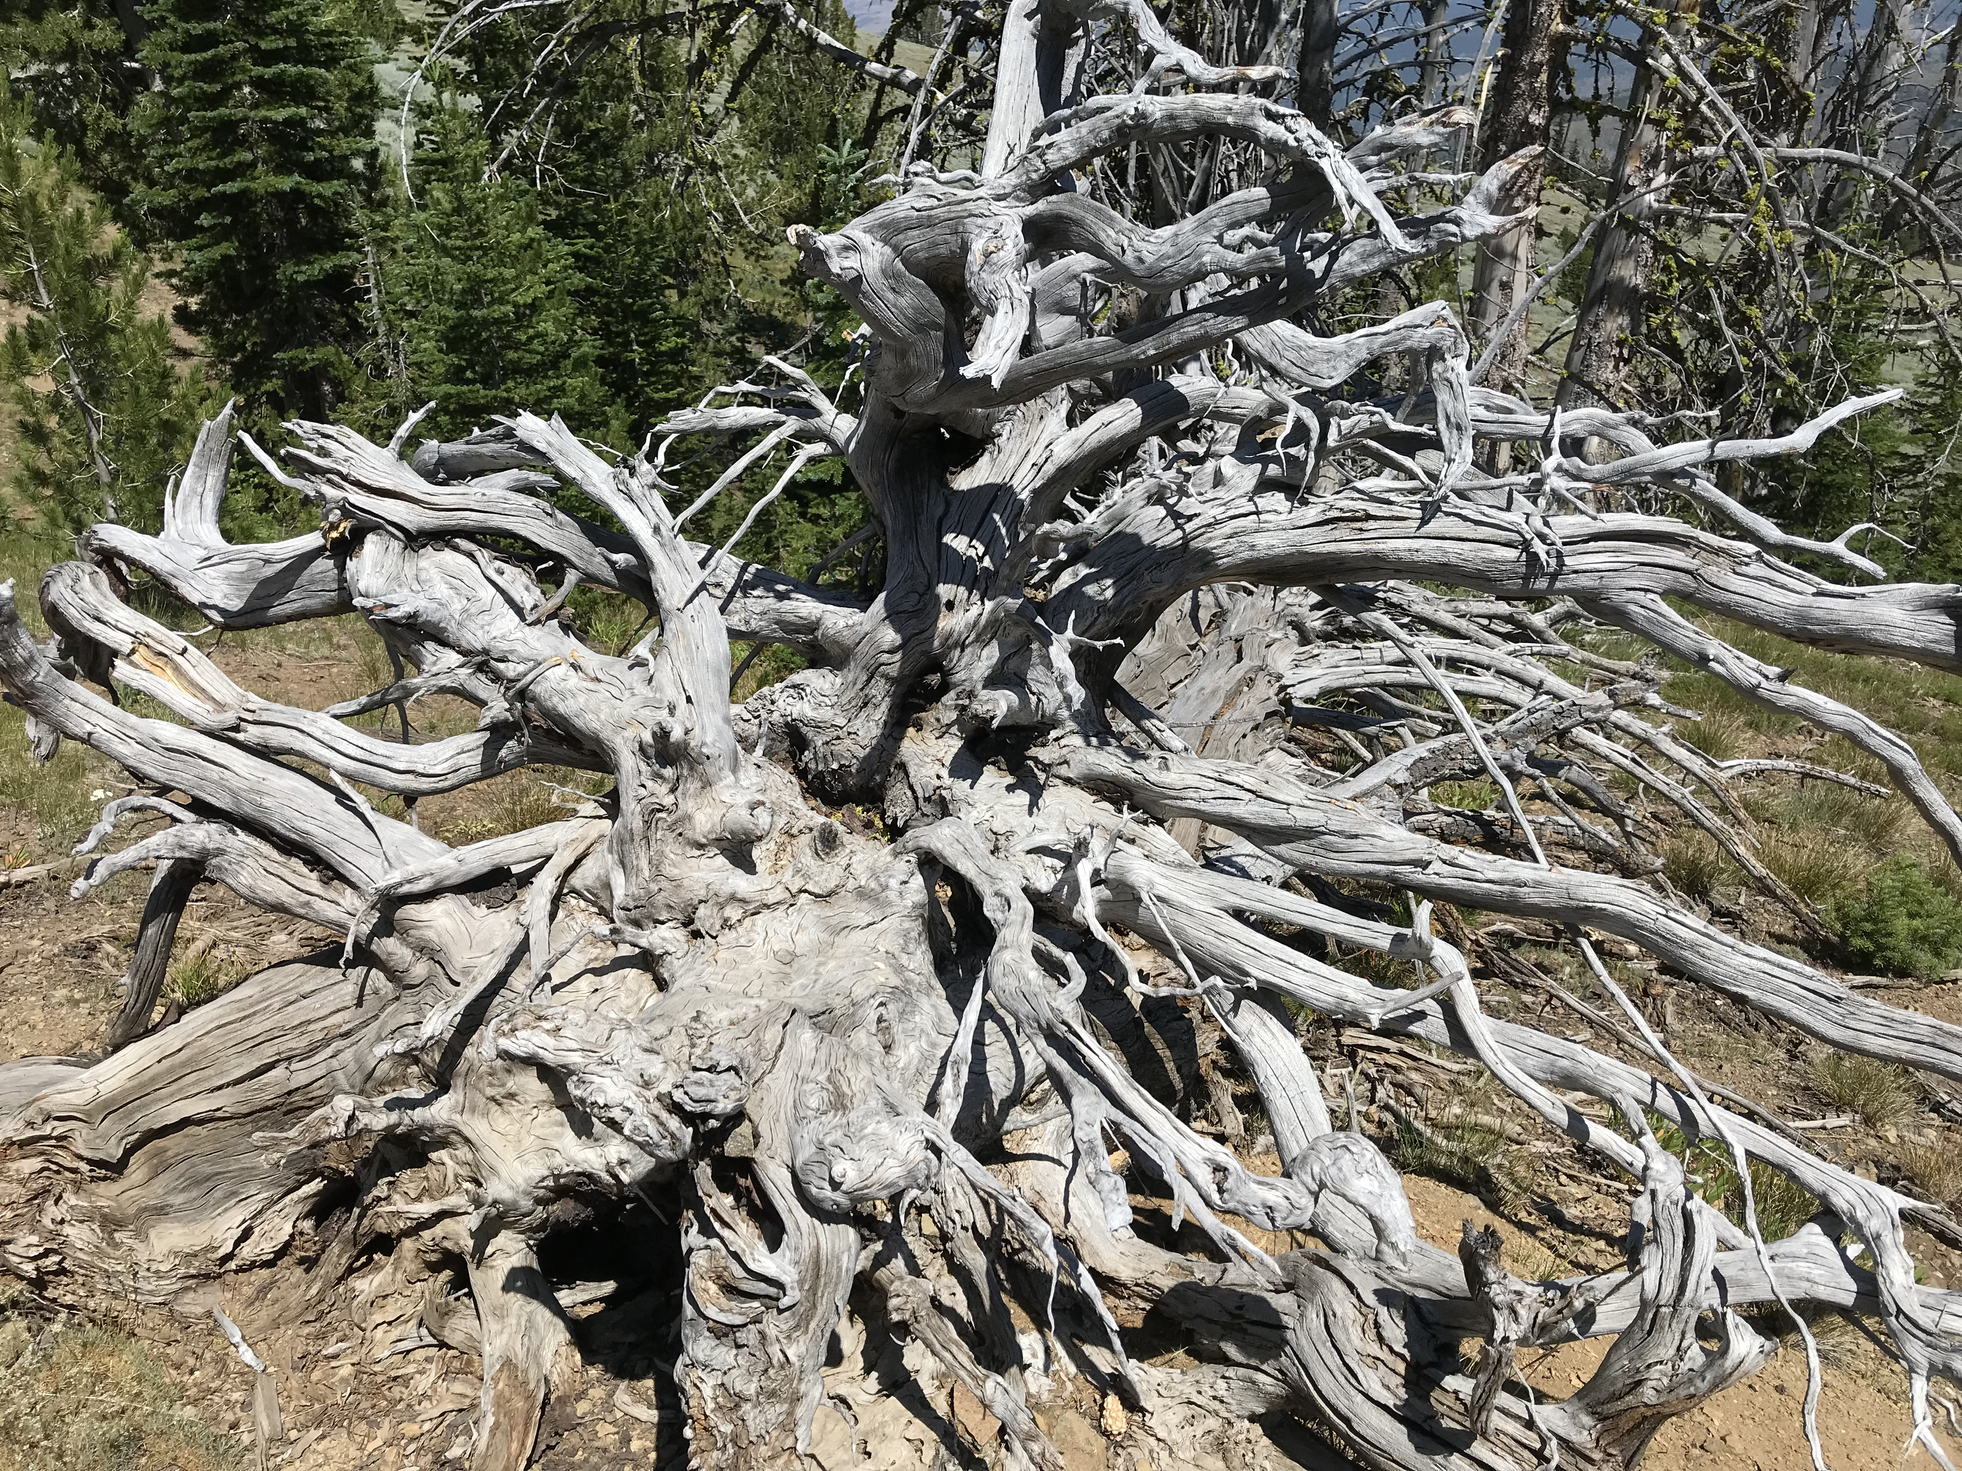

Products, Papers, and Publications
- Poage, N. 2019. Stand measurements (basal area and SDI). Presented to the Harney County Restoration Collaborative
- Wijayratne, U., M. Jennings, N. Poage, R. Brunner, D. Luoma, E. Martin. 2019. Global Observation Research Initiative in Alpine Environments (GLORIA): First Year Data, Wallowa Mountains of Oregon. Presented at the Northwest Science Association Conference. Lewiston, Idaho.
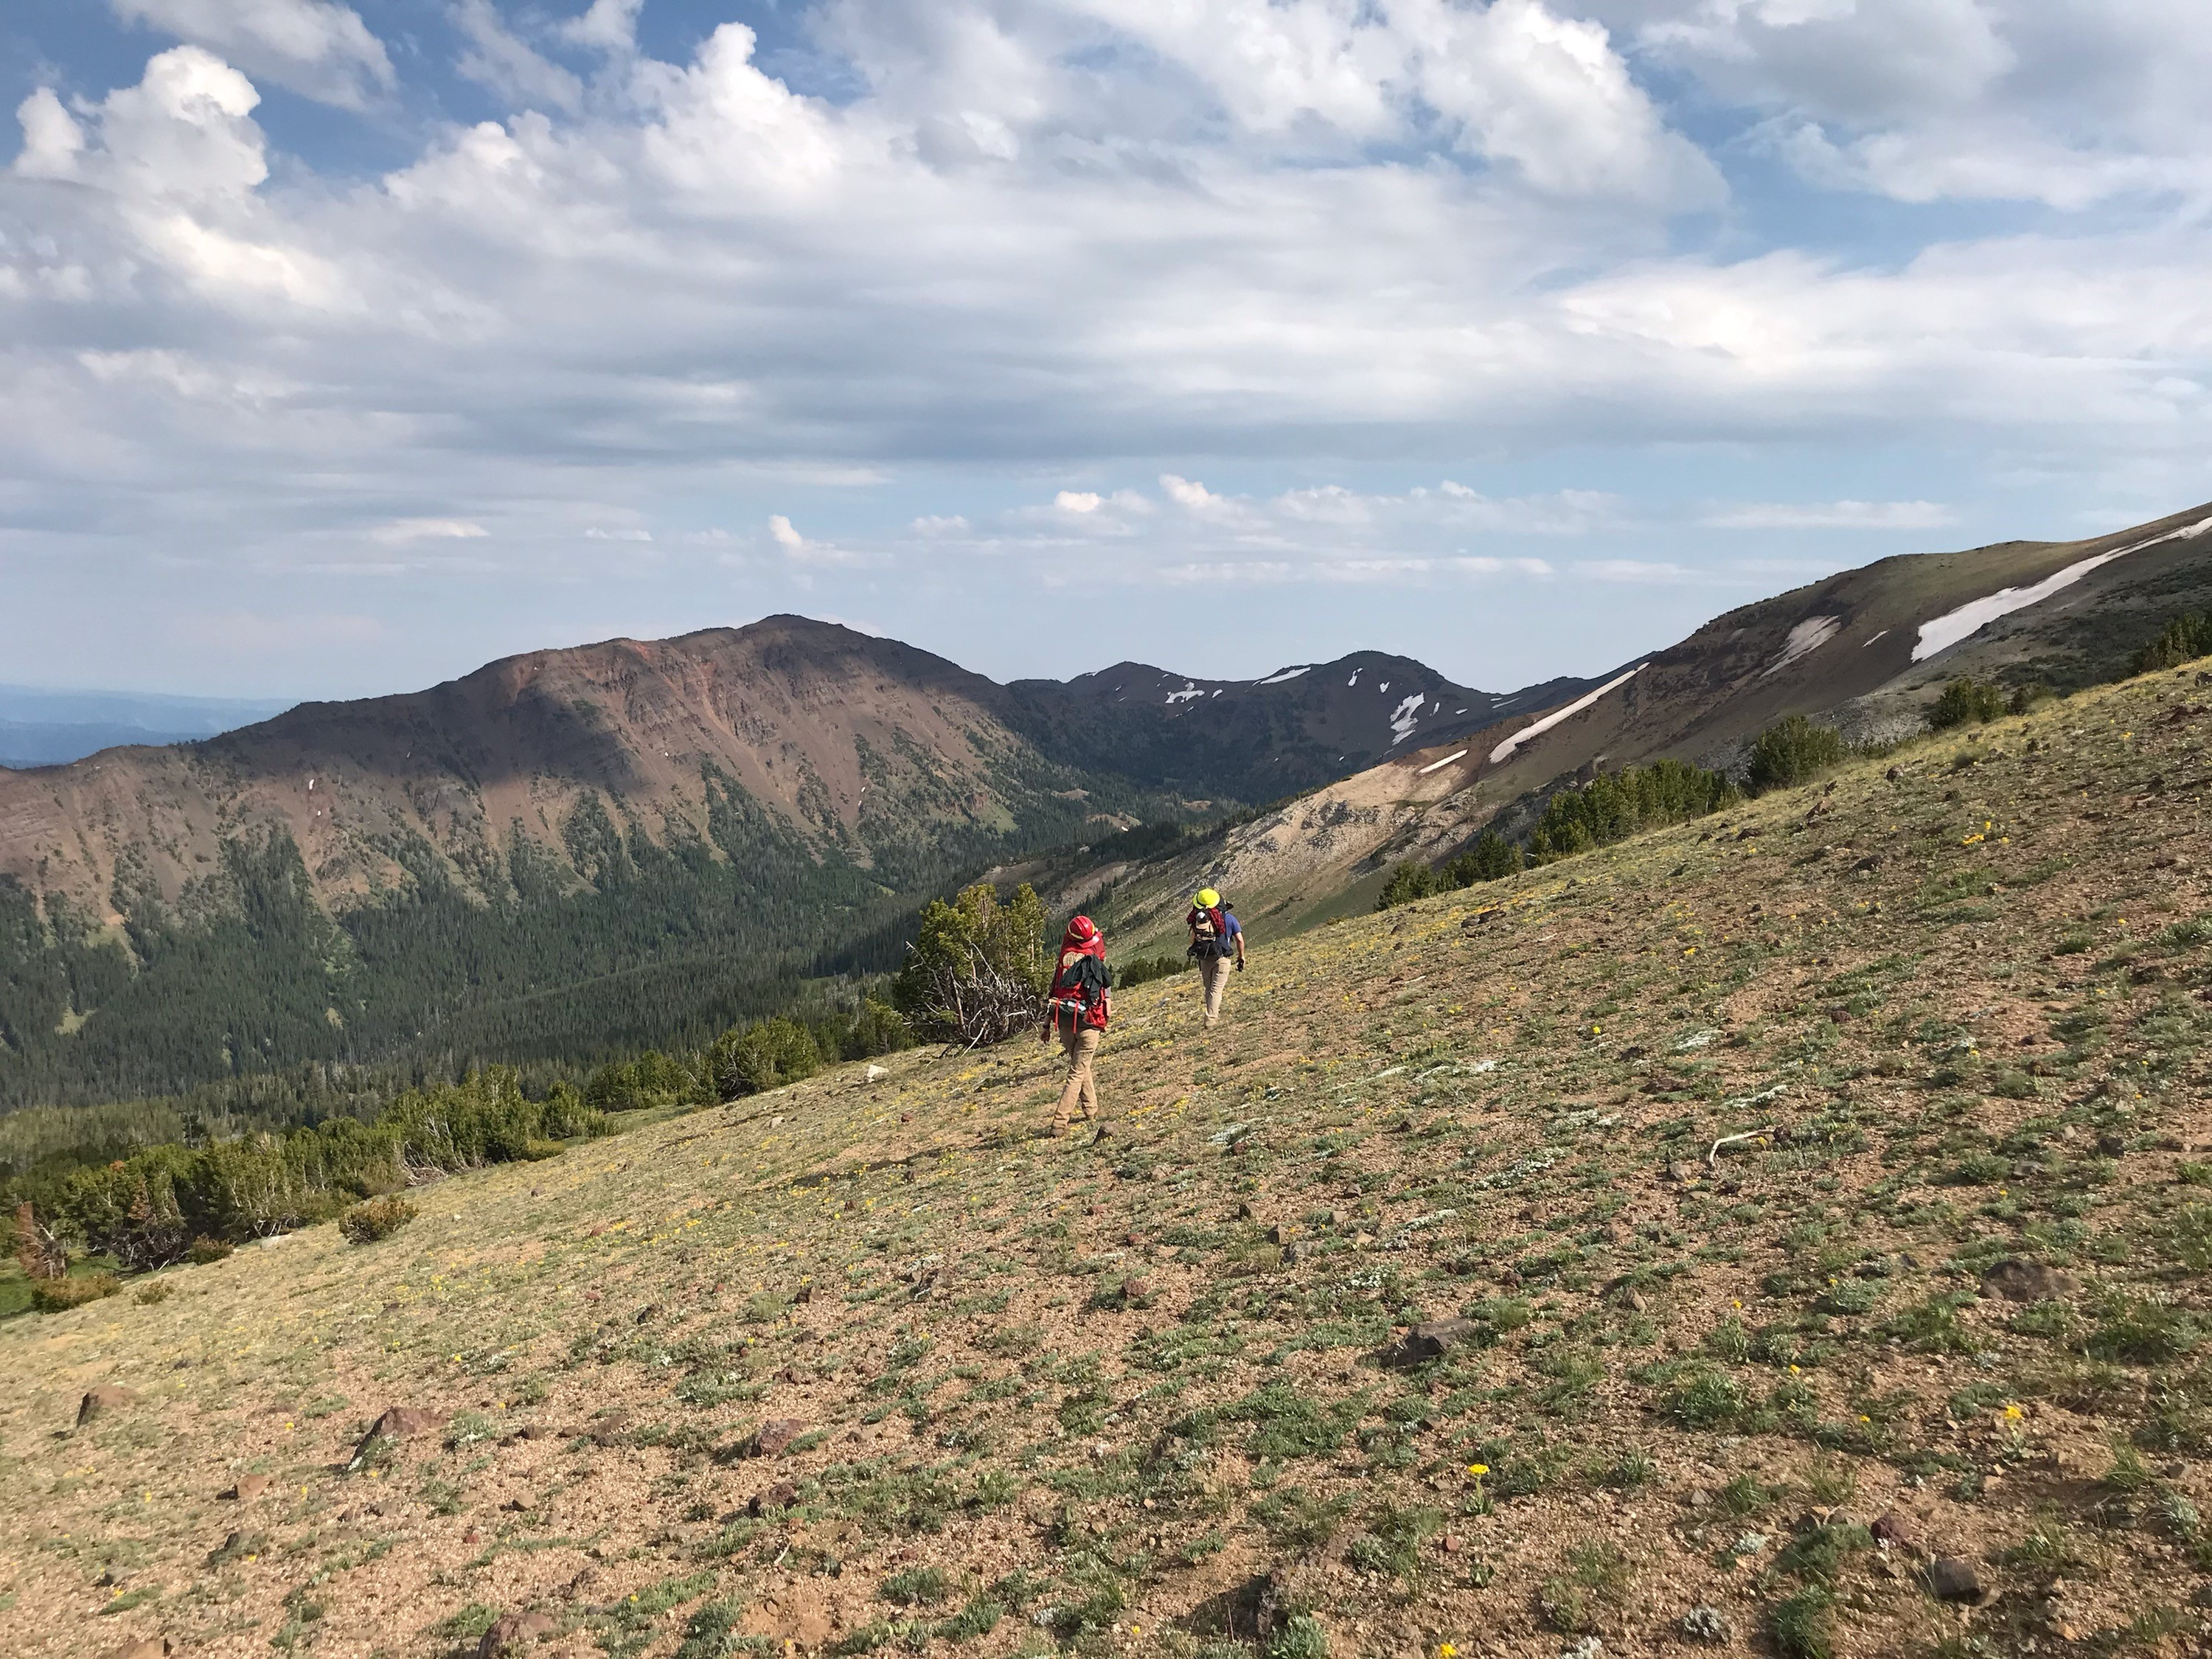
Backpacking in the Wallowas

Responding to Future Needs:
Riparian management continues to be a major challenge for all three forests. It remains our long-term vision to develop spatially explicit future desired conditions within riparian valley bottoms and describe appropriate management actions.
- Advance riparian management consensus by providing a science review to assist with project planning
- Develop a process to evaluate existing ecological conditions of riparian corridors

As the Malheur NF continues implementation of projects under CFLRP funding, and with the Umatilla and Wallowa-Whitman potentially following suit, we anticipate a bigger role for our team within the context of multi-party monitoring.

We also anticipate playing a key role in landscape assessments as the forests engage in strategic and landscape scale planning.

Central Oregon Ecology Program (Area 4)
Deschutes, Fremont-Winema, and Ochoco National Forests;
Crooked River National Grasslands
Area 4 Ecology Program Team:

Gregg Riegel, PhD Cooperators
Mike Simpson Steve Gibson
Kelly Smith Ben Goodin
Kristen McBride Christina Veverka
Cristina McKernan Jim David
Jennifer Ferriel
Joe Washington

Program Priorities
The Central and South Central Area Ecology Team met priorities for 2019 which included several long-term projects:
- Provide riparian and meadow ecological expertise, conduct monitoring of ecological status attributes for Rangeland Allotment Management Plan renewal NEPA process.
- Develop understory and fuel profile development models for Central Oregon ponderosa pine forests to assist restoration and fuel treatment planning through our Alternative Fuel Treatment and the Repeated Fire Return Interval Administrative Studies.
- Assistance with Ecological Site Descriptions for the Crooked River National Grassland.
- Provide support for invasive weed management and monitoring.
- ID Team Members and Analyst Support for the Ochoco NF Big Summit Wild Horse EIS and Management Plan.
- Provide program support, training, and mentoring at all agency levels.
- Provide Landscape Assessment-Departure Analysis support for vegetation to Area 4 National Forests & Grasslands.

Accomplishments
- Effectiveness Monitoring
- Re-measured riparian monitoring plots that were initially established up to 20 years ago on the Fremont-Winema and Ochoco NF’s.
- Assisted installation of vegetation plots on the Ochoco National Forest to support FHP-WWETC-NASA Goddard G-LiHT remote sensing project.
- Measured vegetation attributes to determine production estimates for Ecological Site Descriptions (ESD) on the Crooked River National Grasslands
- Updated Forest Vegetation and Riparian Vegetation attributes to support Watershed Condition Framework update on Deschutes National Forest.
- Documented landscape changes in S-Class and Vegetation Condition Class due to Restoration treatments and wildfires that occurred 2009-2019 for the Deschutes Skyline CFLRP 10 year monitoring report.
- Delivered a Plant Association training session on the Ochoco National Forest July 2019.
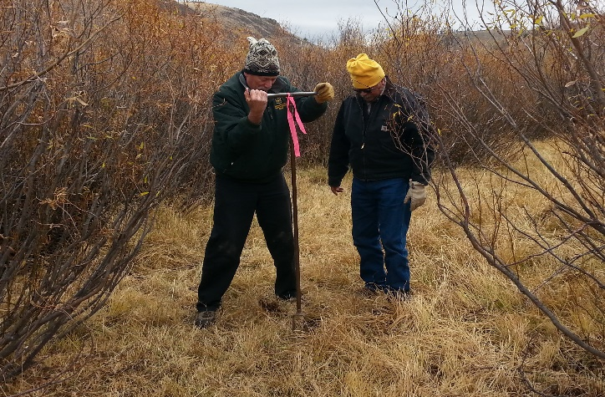
Photo: Gregg Riegel (l) and Desi Zamudio (r),retired USFS Soil Scientist take a soil core to determine rooting depth on a riparian monitoring plot in the headwaters of 12 mile Creek in the South Warner Mountains, Fremont-Winema National Forest. Rooting Depth is an important indicator for determining Ecological Status and Function. Photo by Denine Schmitz 10/10/2018.

Planning
- Delivered R5/R6 (OR-WA-CA) Potential Natural Vegetation (PNV) mapping and Assisted with the Landscape Departure – Restoration Needs Assessment to support R5/R6 Bio-Regional Assessment.
- Completed a Landscape Departure Assessment using Viable Ecosystems methodology and LOS Update using Lidar derived tree data for 266,000 acres within Blue Mountain Resiliency Project planning areas on the Ochoco National Forest
- Updated Viable Ecosystems Departure Assessment for Blue Mile Project on the Fremont-Winema National Forest

Technology Transfer
- President of the Northwest Scientific Association. Continuing the Scientific Legacy of the Corps of Discovery: A confluence of the Northwest’s past, present, and future. 90th Annual Meeting, Lewiston, ID. March 26-29, 2019.
- Developed new set of input variables from GNN 1984-2012 time series imputed vegetation layers that improve detection of Armillaria and Laminated root disease centers for use in Root Disease Risk models.
- Cadre Instructor: Implementing Indicators of Rangeland Health. Las Vegas, NV; and Boise, ID.
Cadre Instructors: Rx 310 Fire Effects Flora and Weeds modules, PNW Training Center.
- Courtesy Faculty Member, OSU: Trent Seager PhD Defense and Rangeland Analysis class lecture.
- Presenter Forest Ecosystems of Mt. Bachelor Ski Area, USFS Ski and Snow Ranger Volunteers, and Bend Ski Club.
Products, Papers, and Publications
Case, M.J., B.K. Kerns, J.B. Kim, M. Day, A. Eglitis, M.L. Simpson, J. Beck, K. Griener, G. Riegel. Climate Change, Vegetation, and Disturbance in South Central Oregon. In: Halofsky, J.E. and D.L. Peterson. Editors. Climate Change Vulnerability in Central and South Central Oregon. Gen. Tech. Rep. PNW-GTR-974. September 2019.
Pellant, M.L, D.A. Pyke, J. Herrick, P.L. Shaver, F. Busby, G. Riegel, N. Lepak, B.A. Newingham, E.Kachergis, and D. Toledo. In press. Interpreting Indicators of Rangeland Health. Interpreting Indicators of Rangeland Health-Version 5. USDI Bureau of Land Management, Denver, CO. ITR XXXX-X. In Review.

Responding to Future Needs:
Long-term fire effects monitoring and administrative studies examining the effects of various fuels treatments and historic return intervals.
Effectiveness monitoring of livestock grazing on rangeland and riparian vegetation. Discerning grazing effects from hydraulic flux is key to understanding management induced change.
Assistance with developing management strategies to address invasive annual grass concerns.
Assistance with Ecological Site Descriptions for the Crooked River National Grassland.
ID Team member and analyst support for the Ochoco NF Big Summit Wild Horse EIS and Management Plan.
Support Districts on Project-level NEPA.

Presentations
Riegel, G. Development and utilization of a Riparian Ecological Type Classification for monitoring long term livestock grazing effects in Central Oregon. Presentation at Northwest Scientific Association Meeting. Lewiston, ID. 03/28/2019.
Simpson, M. and Oblinger, B. Data sources and methods to improve Root Disease Risk Models for broad scale assessments. Presentation at Western International Forest Disease Work Conference. Estes Park, CO. 06/07/2019.
Hanavan R. P., B. D. Cook, L. A. Corp, B. W. Oblinger, M.L. Simpson and R.W. Flowers. Improved stress detection in trees using NASA Goddard’s LiDAR, Hyperspectral and Thermal Imaging System (G-LiHT). Presentation at Western International Forest Disease Work Conference. Estes Park, CO. 06/07/2019.
Simpson, M. Shared Area Ecology and Forest Health Protection positions: Success Stories and Lessons Learned. Presentation at Joint R6 Regional Ecology and Forest Health Protection Technical Meeting Stevenson, WA. 10/30/2019.
Continued from previous page

Art and Science

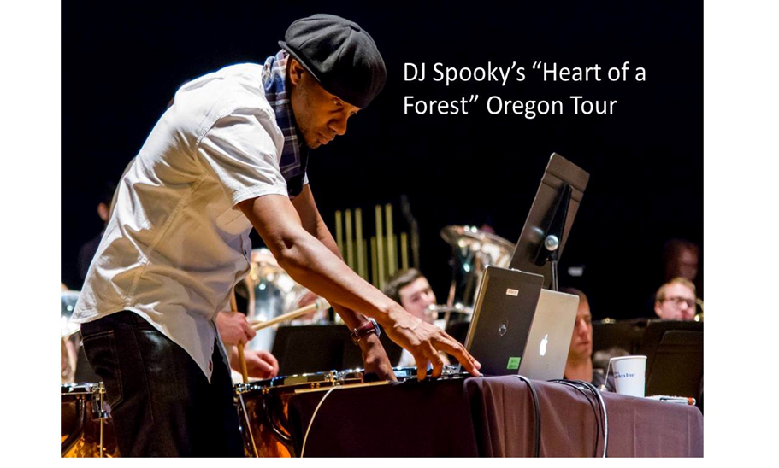

Heart of Forest tour, High Desert Museum, Bend. DJ Spooky”, Paul Miller, mixed live music with the Oregon State University Wind Ensemble and recorded electronic music with aerial video of Oregon forests, along with an on-stage
conversation with a forest ecologist Gregg Riegel.

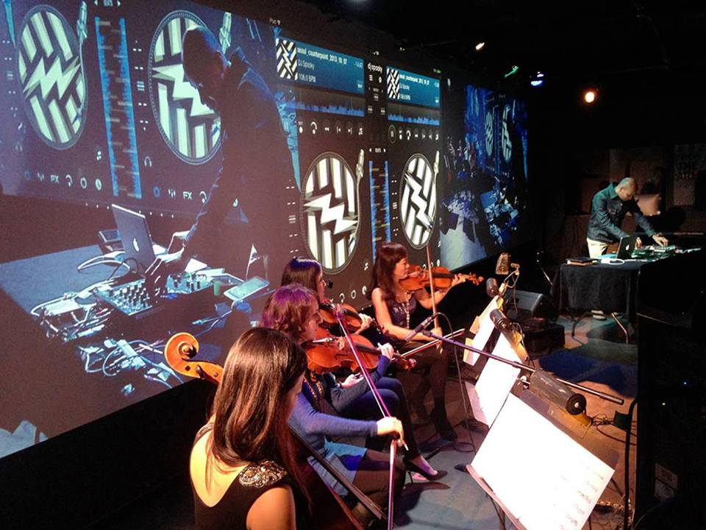
Oregon Community Foundation awarded a grant to the High Desert Museum in Bend to create Water in the West an interdisciplinary exhibition that will connect artists from multiple mediums including visual arts, music and spoken word with ecologist Gregg Riegel to creatively approach the topic of water in Oregon and explore the relationship between art and science. The exhibition was on display from May 2019 to November 2019.

Southwest Oregon Ecology Program (Area 5)
Rogue River-Siskiyou and Umpqua National Forests
Program Priorities
The Southwest Oregon Ecology Program works with the forest Natural Resources Staff Officers and Forest Supervisors to develop a program of work and determine priorities. We worked closely with both Forest Leadership Teams so that we were aligned for forest priorities. Throughout the year we worked closely with forest program managers and specialists as well as our local collaboratives to strengthen our support for forest planning and restoration. In addition, we also responded to requests for help from program managers, planners, and ID teams as needed. Both forests have continued to experience some leadership transitions, but communications with forest leadership and working relationships continue to expand and imporove.
Program priorities for 2019 included:
- Continuing our support of large scale forest restoration projects on both forests
- Coordinating with the Southwest Oregon Climate Adaptation Partnership (SWOAP) team to organize and run a two-day workshop and to complete a draft of the climate adaptation assessment.
- Supporting Regional Ecology Program priority to refine state and transition vegetation models for SW Oregon.
- Work closely with Forest Leadership Teams to support ecological concerns
- Support the region to complete the new R6 Potential Natural Vegetation (PNV) map
- Maintain strong working relationships with the local collaboratives, interested stakeholders, and other agency staff to further shared understanding and goals.

Accomplishments
Area 5 Ecology Program Team:
Bill Kuhn
Patricia Hochhalter
Summer Kemp-Jennings (on detail to Team21)
Paul Chisholm (detail)
Successful grant award from OWEB to the Rogue Forest Restoration Initiative OWEB grant. Contributed to monitoring plan and data management plan for RRS.
Helped to organize, plan, and conduct a forum and two workshops on forest restoration and wildfire management in the Rogue River Basin.
Continued our close involvement as a member (Pat) of the team working on developing a new Region 6 potential natural vegetation (PNV) map. Pat attended many working meetings to review and discuss methods and draft map products, and improved data quality. Pat also participated in many review and feedback sessions across all Forests within the Region to improve map accuracy.
We are assisting with an update to the Southern Cascades LSR Assessment to improve understanding of current vegetation conditions, magnitudes of structural departure, climate change impacts, and changes in fire regimes and wildfire risks.
We continued to support the development of the Calf-Copeland restoration project on the Umpqua National Forest.
Pat and Bill assisted with vegetation departure analysis, wildfire departure analysis, and DecAID analysis for the Stella landscape restoration project on the Rogue River Siskiyou National Forest.
Vegetation monitoring. We initiated monitoring of big huckleberry populations within the Huckleberry Special Interest Area on the Rogue-Umpqua Divide, and monitoring post-treatment vegetation response in the Ashland Forest Resiliency (AFR) project on the RRS.

response in the Ashland Forest Resiliency (AFR) project on the RRS.
We continued our involvement in the implementation and monitoring of the Ashland Forest Resiliency (AFR) project within the Rogue River-Siskiyou National Forest.
We hosted Swedish student intern Elias Bergstrom for eight weeks through the USDA Forest Service International Forestry Fellows Program. Elias assisted with vegetation monitoring.
We continued to act as climate change vegetation coordinators for both forests. We reviewed sections and assisting in writing some sections of the draft Southwest Oregon Climate Change Adaptation final report.
We continued to promote the Rogue Basin Cohesive Forest Restoration Strategy to managers and specialists on the Rogue River-Siskiyou NF.
Conducted downed wood and snag analyses (DecAID) for both forests to assist with forest planning and restoration goals
We assisted in the development of a proposal to the Oregon Watershed Enhancement Board to support forest-wide restoration implementation, monitoring, and public outreach for the Rogue River-Siskiyou NF and surrounding lands.
In response to requests, we have begun a process to improve the modeled existing vegetation map for planning areas within southwest Oregon so that wildlife habitat and restoration needs can be more accurately reflected.
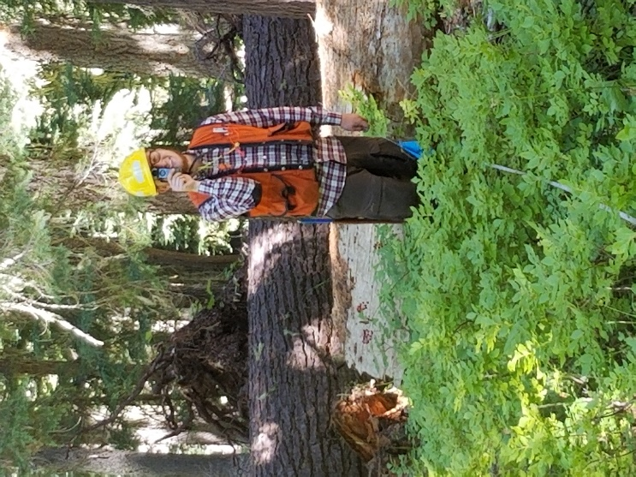
Products, Papers, and Publications
Presentations:
“Southwest Oregon Wildfire: Trends and Drivers.” Presented to the Jackson-Josephine Counties Small Woodlands Association. Medford, February 2019 (B. Kuhn)
Climate Change, Wildfire, and Forest Management: Adaptation Tools and Strategies. Forest Restoration and Wildfire Management workshop. Medford, April 2019. (B. Kuhn)
Umpqua Forest Restoration and Prioritization. Presentation to members of the Umpqua Forestry Coalition, October 2019. (B. Kuhn & S. Kemp-Jennings)

Northwest Oregon Ecology Program (Area 6)
Mt. Hood, Willamette and Siuslaw National Forests and Columbia River Gorge National Scenic Area

Accomplishments
- Special habitat mapping/classification: Coast Range Special Habitats plant community guide draft completed and submitted for review. Development of a more efficient remote sensing method employing an image classification algorithm tool on NAIP spectral intensity – mapped ¾ of 3D planning area, Willamette NF to test methodology.
- Historical range of variability: Completed analysis for west Cascades (westside Mt. Hood NF and most of Willamette NF) using state and transition modeling. Box and whisker plots for potential vegetation type seral stage distribution ranges for entire study area, as well as sub-basin scale available. Draft white paper available December 2019.
- Deadwood analysis: Conducted all-day roll-out meeting for Siuslaw deadwood white paper, with attendees representing Silviculture, Wildlife, Fisheries, Planning, Line, and Regional Office. Delivered draft report on Distribution Analysis to NW Oregon BLM. Delivered draft of updated Distribution Analysis, incorporating recent wildfires, and draft Wildlife Tolerance Level Analysis to Mt. Hood and Willamette. Provided data on trends in snag density from 1985 to 2016 to Willamette. Prepared for new version of DecAID dataset, and provided consultation to users in Region 6.

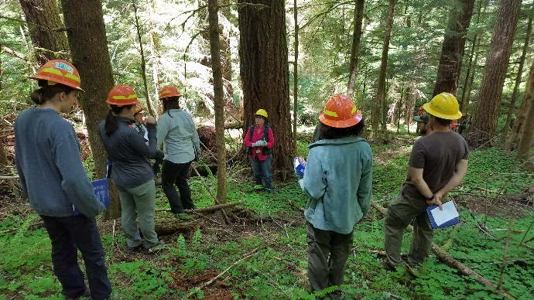
Oregon Coast Plant Association Training

Program Priorities
The Northwest Oregon Ecology Program meets yearly with its working group (natural resource specialists from Forests, the Scenic Area, and Northwest Oregon BLM) to discuss ecological issues and develop potential program of work ideas. Ideas are vetted, proposal are written and work is prioritized with the steering committee of Forest Natural Resource staff, Regional Ecologist, and BLM representatives.
Program priorities for 2019 included:
- Continuing long-term, landscape projects:
  - Special habitat mapping and classification
  - Historical range of variability
  - Deadwood analysis
  - Continuing to facilitate climate change information exchange
  - Post-fire vegetation and CWD trajectories
  - Tools for riparian vegetation management
- Providing technology transfer
- Assisting Forests with high priority issues:
  - Dunes restoration
  - Landscape analyses
  - Meadow management
  - Huckleberry restoration and management
- Assisting with the completion of the R6 Potential Natural Vegetation (PNV) map as well as Bioregional Assessment Area including portions of R5
- Collaborating with NRCS, Regional soils program
Area 6 Ecology Program Team:
Steve Acker
Doug Glavich
Vacant (vice Jane Kertis)

Accomplishments
- Climate Change information exchange: Climate change coordinators for Mt. Hood and Siuslaw National Forests. Management core team co-lead, vegetation/disturbance and ecosystem services group members for Columbia River Gorge, Mt. Hood, Willamette and Coast Range vulnerability assessments; assisted in workshop logistics and helped with chapter writing and review.
- Completed entry and verification of fuels and vegetation data from monitoring plots in Mt. Washington Wilderness; produced draft report emphasizing wildfire fuels and wildlife habitat and distributed to collaborators at USGS, Oregon State University, Willamette NF, and R6 Ecology for review.
Tools for riparian vegetation management: Completed first version of vegetation reference conditions for West Cascades and current conditions for Quartzville-Middle Santiam and Divide (Willamette) planning areas. Assembled set of relatively unmanaged areas in Coast Range for calculation of reference conditions. Continued work on manuscript for submission to scientific journal.
Technology transfer:
- Plant Association Training– Coast Range; 30+ attendees participated in classroom and field exercises focused on how to use plant associations to read and manage the landscape. ODFW attendance broadened tech transfer to partners.
- Bioregional Assessment–provided draft potential vegetation layer and feedback on potential themes, data and analysis methods.
Forest high priority issues:
- Dunes restoration–member of Oregon Dunes Restoration Collaborative; Interdisciplinary team member for large scale restoration planning project. Contributed to draft EA.
Responding to Future Needs:
The NW Oregon Ecology group will continue to engage with our working group and steering committee to ensure we deliver timely and relevant products. We will continue to make progress on long term landscape projects. We will assist in Regional products and tools. We will promote applied ecological principles while consulting, partnering and serving our Area and Region.
- Landscape Analyses-Co-landscape assessment lead for Rigdon analysis–worked internally and with Collaborative on assessment. Beginning application to Young’s Rock Rigdon planning area. Began 3D Landscape Analysis with McKenzie River IDT.
- Meadow Butterfly Habitat: Developed butterfly oviposition site selection initial model for overall vegetation structure and food source density; method developed for estimating food source leaf area; fieldwork completed for Winter 2020 model runs. The model is applied to the Oregon Silverspot butterfly on the Siuslaw NF; designed burning and steaming treatment block test for non-native pasture grass eradication.
- Huckleberry restoration and management: Worked with East Zone Silviculture and Botany staff (Mt. Hood) and western WA Ecologist (Hudec) to develop and test monitoring protocol; worked with team to train field crew and initiate collection of pre-treatment data.
Regional Potential natural vegetation mapping—Finalized R6 vegzone and subzone layer. Vetted products with Region Forests. Provided layer to Bioregional Assessment team.
Collaborated with Natural Resource Conservation Service (NRCS) to develop updated Land Resource Units (LRU) for Major Land Resource Area (MLRA)3 Worked with Willamette Soil Scientists and NRCS staff, to hone plant association skills in soil mapping efforts. Developed state and transition model prototype for use in provisional Ecological Site Description product.
Numerous presentations and field tours to college classes, collaborative groups, and internal natural resource groups.
Products, Papers, and Publications
Publications
Kauffman, J.B., L.M. Ellsworth, D.M. Bell, S. Acker, and J. Kertis. 2019. Forest structure and biomass reflects the variable effects of fire and land use 15 and 29 years following fire in the western Cascades, Oregon. Forest Ecology and Management 453:117570. https://doi.org/10.1016/j.foreco.2019.117570.

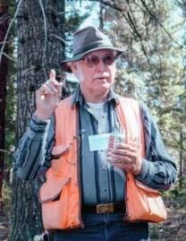

In Memoriam

Fred Hall

1927-2019

Some ecologists publish a lot of papers. Some become famous. Most of us work day in and day out and hope that we are making some impact.

Fred Hall was a legend. He transformed the Forest Service in the Pacific Northwest and affected countless lives and careers. When he started in the 1950s, the National Forest Management Act (NFMA) was twenty years in the future, and there were few ologists on the ground. Timber and range were king, and our understanding of ecosystems was far simpler than today.

Fred began collecting data on the ground, first in rangeland ecosystems and then in forests. With his charisma people gradually began to listen, and realize things were more complicated than they first seemed.

With concern over forest regeneration that resulted in NFMA, Fred was ready with a way to classify stands by plant communities—plant associations that could be used for management implications for timber, silviculture, wildlife, and other disciplines. But especially for forest regeneration. Here was a way to concisely, and with data, match species to site and avoid regeneration failures. Here was a way to categorize ecosystems by productivity so that growth and yield models came more sharply into focus. Here was a way to support the fledgling NEPA process, finding its way in the 1970s and 1980s.

Along the way he trained a generation of ecologists that did superb work, and built an esprit de corps that is unmatched. To be an ecologist in Region 6 is not just a job with a GS level, but a special calling and mission. This has resulted in over 60 publications of plant association guides, plant identification guides, monitoring reports, and other work. With new generations it has resulted in state of the art landscape assessments, monitoring, and other products that support the planning effort in myriad ways.

And we owe it all to Fred.

Like all larger-than-life figures, Fred’s life was deep and had many dimensions. For more on his life that you may not know, following is the obituary written by his wife Ginger:

Frederick Columbus Hall (age 92) died in his home on December 5, 2019. He was born to Nelson Clarence and Carol Conlee Hall on April 19, 1927 in Whitefish Bay, Wisconsin. He is survived by his spouse of 35 years Ginger Potter-Hall, his two children Wayne F. Hall and Connie A. Hatley, four stepchildren, 14 grandchildren and 12 great-grandchildren.
Fred was a Marine's Marine; he joined the Marine Corps as soon as he turned 17 towards the end of WWII; was trained as a Raider, and continued to serve in the USMC through Korea and Vietnam. He was released from active duty in 1954, but stayed active in the Reserves until his retirement as Major in April 1987. Starting as a lowly 17-year- old recruit at Camp Pendleton, he served his country through three wars. Between wars, he was a member of the armed forces equestrian team and trained horses for a number of years. His WWII Raider training led to him becoming the OIC (Officer In Charge) of developing and implementing USMC helicopter air assault processes and procedures during the Korean War. His college education positioned him to take an integral part in building the first golf course on Quantico.
He didn't stop there. His personal life also reflected his dedication to the Marine Corps Hymn "in the Air, on Land, and Sea." In the AIR Fred was an accomplished pilot with commercial and instructor's licenses and he taught his son to fly.
On the LAND, Fred developed the first ecology program for the U.S. Forest Service, and was a prominent range ecologist in eastern Oregon. His pioneering work on forest ecosystems, grazing/browsing monitoring, photo monitoring, and forest health have stood the test of time and are still being used today. Fred was a scientist and earned dual doctorates in Plant Ecology and Range Management. He was also a creative innovator, and inventor with a passion for "getting it done." To fully document his theories, he designed, tested, and perfected the photo point monitoring system still in use today. He also gathered extensive data for over 50 years throughout the Pacific Northwest Region to support his ecosystem classification and succession model, as well as his growth basal area calculations. Both are still standards in the Forest Service. When he needed a means of determining slope angles back in the 60s, he created his own inclinometer. Notably, Fred continued his research and publications, unpaid and unassisted, long after his retirement from the Forest Service.
In establishing and developing the Forest Service Ecology Program in the Northwest, Fred hired and mentored many excellent ecologists who have made significant contributions for decades. Many ecologists, on learning of his passing, have remarked on how important he was in developing their careers. The Ecology Program remains among the best applied science efforts in the Forest Service, in large part because of the legacy Fred provided.
As a teacher and mentor, Fred was unparalleled. He was a colorful and dynamic presence in the lecture hall, camp or field. His talks were often illustrated with humorous drawings and stories. He taught his kids plant identification, how to walk a trail in the dark with no flashlight, how to do a 100-point plot, dig deep holes and test soil, along with respect for, and fascination with, the high country. An evening around the campfire with Fred was an event to remember … not only for his insights into ecological circumstances, but also for the humor and robust enthusiasm he brought to his subject.
On the SEA Fred was a blue water sailor and navigator, finding his way across the open ocean with a sextant and celestial navigation. He loved to cruise the San Juan Islands and lived aboard his sailboat for a number of years. He taught his children, stepchildren and grandchildren to love sailing as much as he did.
Semper Fi Marine. Bravo Zulu.
Some testimonials to Fred:

Fred was a strong influence on my early career as a forester with the US Forest Service. His work in plant community classification and in forest & rangeland productivity were innovative, and ground-breaking in many ways. Fred, I still have my GBA slide rule!
~
Jim White,
Trout Lake, Washington

In 1973 Fred bucked decades of USFS tradition and hired me (a woman) to do ecological work, which turned into a career full of adventure, challenges and satisfaction. I am so grateful for his friendship and mentoring over the years - he was an innovator ahead of his time, and a champion for good land management. Plus, a very entertaining guy! He truly left a legacy that will outlast us all. Rest in peace, my friend.
~
Nancy Molina,
Gresham, Oregon

Fred made a big impact on my life both personally and professionally. The work that he did in the USFS Ecology Program was ground-breaking and enduring. His observations of disturbance and succession have be instrumental in informing our discussions about fire regimes and restoration of eastern OR forests. I will miss him but know that every time I'm out in the forest, he is with me!! Stephen Fitzgerald
~
Stephen Fitzgerald,
Albany, Oregon

Fred's influence on me began when I was in high school and studied his initial soil site correlation on the Blue Mountains in Oregon. His work motivated me to pursue a career in soil science/ecology. Since then I worked in northern California, Nevada and Oregon with the last 30 years on the Ochoco National Forest and Crooked River National Grassland. Fred was an important mentor to me and I spent many days in the field with him over the years. He taught me how to think, out of the box, and helped make me a better soil scientist/ecologist. Semper fi.
~
Jim David,
Prineville, Oregon

I will always remember Fred's passion and enthusiasm for ecology. His vision and leadership got the program off the ground, and kept it around. After I got over my fear, I came to love my conversations with Fred, as we wound our way up a mountain slope. His accomplishments live on! Jane Kertis
~
Jane Kertis,
Corvallis, Oregon

If you would like to add your own comments to Fred’s obituary page, please use this link:
http://www.legacy.com/obituaries/neptune-society/obituary.aspx?n=Frederick-Hall&lc=1901&pid=194689338&mid=8955129

A memorial service is planned for July 2020.

