LASSEN NATIONAL FOREST PERSONAL USE
FUELWOOD CUTTING REQUIREMENTS

These requirements are for use when cutting on the Lassen National Forest.
This attachment is made part of the personal use fuelwood permit.

Failure to abide by the conditions of the attached permit may result in permit cancellation, and civil and/or criminal prosecution. Fuelwood harvested under the attached permit is intended for personal use only and is not for resale. An individual or combination of members of a household may not have more than a maximum of ten cords during any calendar year. Multiple permits can be purchased up to the ten-cord limit with a minimum purchase of two cords per permit.

A. The attached permit authorizes cutting and removal of fuelwood from the Lassen National Forest except for areas covered by the following restrictions:
1. In areas closed to fuelwood cutting or restricted on Zone maps.
2. Where "Cutting Prohibited" or similar signs are posted.
3. In Timber Sale areas or other commercial operations signed ‘‘No Woodcutting’’.
4. In Forest Service Recreation Sites, Trailhead Parking areas, or Wild & Scenic River Areas.

The attached permit does not authorize cutting fuelwood on private land.
It is the permittee’s responsibility to determine ownership of the land before cutting begins.

PERMIT MUST BE SIGNED TO BE VALID

B. Within authorized cutting areas you may only cut the following standing (snags) species of wood:
1. Ponderosa Pine, Jeffrey Pine, Sugar Pine, White Fir, Red Fir, Douglas Fir, or Incense Cedar.
2. All species of standing (snags) must be 20 inches in diameter (63 inches circumference) or less measured 4½ feet above the ground.
3. Dead Lodgepole Pine may be felled regardless of size.
4. Hardwood species that are dead and on the ground may be cut.

EXCEPTIONS:
- Where zone map restricts or prohibits it.
- Standing (snags) that are marked with paint or wildlife signs.
- Dead wood that has other official signs.
- Any tree with paint except down lodgepole.
- No standing hardwood species, live or dead, may be felled.
- Green Juniper (Hat Creek - Zone III ONLY) may be felled if they are 20 inches in diameter (63 inches circumference) or less measured 4½ above the ground.
CAUTION: Baker Cypress closely resembles Juniper. Baker Cypress is a protected species and must not be cut!! Ask at your local district office for areas where this species grows. See page 4 for Juniper - Cypress comparison example.
- Any snag within 100 feet of a paved road or highway, or within 200 feet of a railroad or powerline may not be cut. This also applies to green Juniper in Hat Creek - Zone III.

NOTE: If windthrown trees are excessive, a temporary cutting restriction of down trees may be necessary to capture the commercial value.

Permittee is required to call 530-257-9553, a 24-hour number for current restrictions by zone as
identified on the Lassen NF Personal Fuelwood and Christmas Tree Cutting Map.

A CONIFER SNAG HAS NO GREEN NEEDLES. CUTTING LIVING TREES FOR ANY
REASON EXCEPT WHERE SPECIFICALLY AUTHORIZED BY THE PERMIT
IS PROHIBITED.

C. Fire Danger:
1. During periods of high fire danger, chainsaw use may be restricted or prohibited. Fuelwood maybe gathered without the use of chainsaws during periods when chainsaw use is prohibited.
2. It is the responsibility of the permittee to obtain a chainsaw use status from the Forest Service for the day of use. See zone map for office locations and telephone numbers.
3. You are required to equip your chainsaw with an approved spark arrester.
4. An approved fire extinguisher or shovel, with an overall length of not less than forty-six (46) inches, is required to be within 25 feet of the point of saw operation.
5. Unless otherwise restricted, smoking is allowed only within areas cleared of flammable material to mineral soil three feet in diameter.

D. Permittee shall comply with the following resource protection measures:
1. Keep vehicles off meadows, wet dirt roads, or any other area that may be damaged by vehicle use.
2. Repair any water bars or other erosion control structures that you drive over or otherwise damage.
3. Remove slash, limbs, and other debris created by permittee's cutting activities from roads, roadside ditches, culvert inlets and outlets, meadows, and stream courses.
4. Follow utilization standards and slash treatment as specified on woodcutting map to reduce the fire danger associated with fuel buildup.
5. Use of tractors, skidders, loaders, yarders, or similar heavy equipment is prohibited under this permit.

E. Permit must be in possession of permittee while cutting and transporting fuelwood. Permittee shall promptly display this permit upon request of any Peace Officer, Forest Service Officer, or California Department of Forestry Officer.

F. Fuelwood obtained under this permit shall be cut and removed personally by the permittee unless written authorization has been granted by the Forest Service for a third-party to cut and haul fuelwood for the permittee's personal use and is not for resale. This permit and the written third-party authorization to cut must be in the cutter’s possession at all times when cutting or transporting wood obtained under this permit.

G. Permittee shall fill out the load accountability portion of the permit for each load of wood obtained. Required information shall be entered in ink on the permit at the point of loading, and fee tag(s) filled out and affixed to load per instructions on the tag prior to transporting wood from cutting location.

NOTE: Fuelwood cutting maps specific to the forest indicated on the
permit are also made part of the attached permit.

FIRE PREVENTION AND EQUIPMENT CHECK LIST

- Shovel (Mandatory-PRC-4431) | - Permit | - Wedges
- Axe | - Tags | - Fire Extinguisher
- Water | - Nails (for tags) | - Pen (for permit)

HOW TO MEASURE FUELWOOD

A standard cord is a well-stacked pile, 4 x 4 x 8 feet. This is 128 cubic feet of wood. To help you estimate how much wood your truck will hold, please note the following:

TRUCK BED | BED SIZE  LxDxW | MAX VOLUME  (Cubic feet) | CORD SIZE  (Approx)
Mini  (Loaded Cab High) | 6 x 1½ x 4¾ ft  6 x 3 x 4¾ ft | 37.25  80.00 | 29%  63%
Mini Longbed  (Loaded Cab High) | 8 x 1½ x4¾ ft  8 x 3 x 4¾ ft | 51.50  108.50 | 40%  85%
1/2 or 3/4 Ton  (Loaded Cab High) | 6 x 2 x 4½ ft  6 x 4 x 4½ ft | 48.50  102.50 | 38%  80%
1/2 or 3/4 Ton Longbed (Loaded Cab High) | 8 X 2½ x 5 ft  8 x 4 x 5 ft | 94.50  154.50 | 74%  120%

HEATING VALUES OF LOCAL WOOD

TREE TYPE | B.T.U./  Cord million | Weight-lbs/  Cord dry | Weight-lbs./  Cord green
Ponderosa Pine | 19.3-21.7 | 1960-2520 | 3370-4270
Jeffrey Pine | 19.3-21.7 | 1960-2520 | 3370-4270
Lodgepole Pine | 19.7-22.3 | 2000-2580 | 3320-4270
Douglas Fir | 23.5-26.5 | 2400-3075 | 3930-5050
Incense Cedar | 17.8-20.1 | 1800-2350 | 3020-3880
White Fir | 18.0-21.1 | 1900-2450 | 3190-4100
Juniper | 23.4-26.4 | 2400-3050 | 4225-5410

Weights:
- Lower value of range assumes 70 cu. ft. of solid wood/cord.
- Higher value of range assumes 90 cu. ft. of solid wood/cord.
- Dry weight at 12% moisture content.
- Green weight at 40-60% moisture content.

POINTS OF IMPORTANCE IN THE LASSEN WOODCUTTING PROGRAM

- Falling Snags: Falling dead trees within 100 feet of a paved road or within 200 feet of a railroad or powerline is prohibited.
- Diameter Limits: With the exception of Lodgepole Pine, the falling of snags is limited to trees 20 inches in diameter or smaller.
- Downed Trees: No restrictions, unless otherwise signed or marked. See Section B. above for exceptions.
- Third Party Permits: Individual may be cutter/transporter for up to 2 third-party permits per year. Permit does not have to be returned to receive an additional third-party permit.

Juniper - Cypress Comparison
(Reference B)

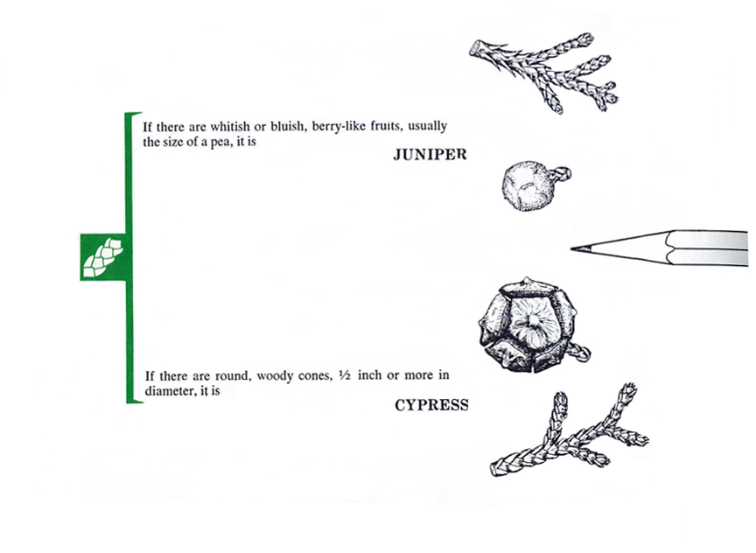

DO NOT CUT!

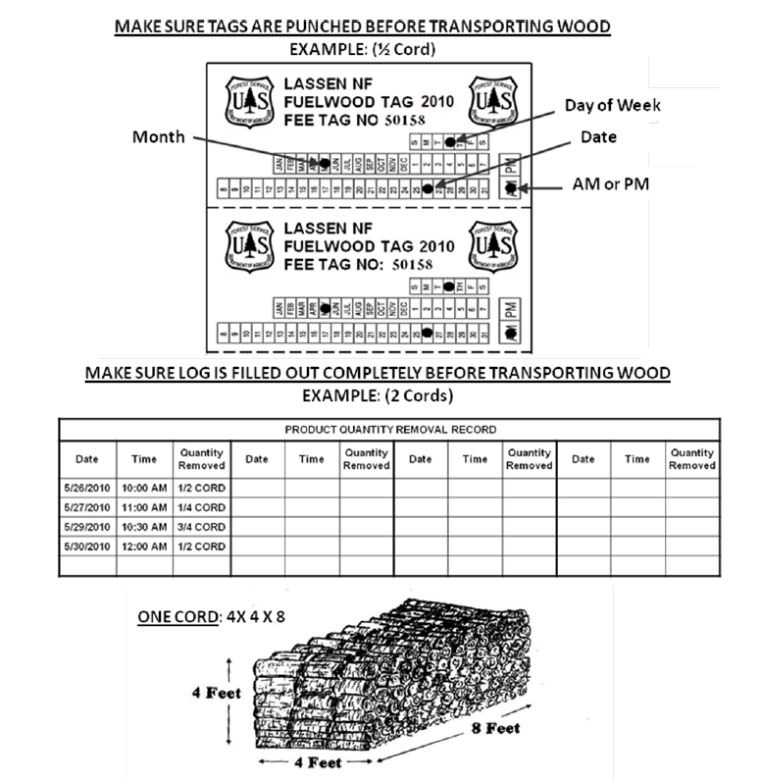
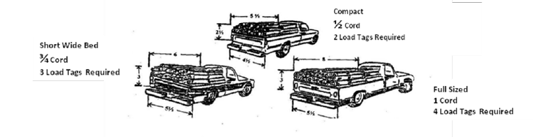
A full-sized pickup with an 8-foot bed will hold a cord if it is stacked about to the top of the cab. These illustrations demonstrate the relative volume of a cord of wood and are not recommendations of how much your truck is capable of hauling safely. The weight of a load your truck can safely haul can be found in your owner’s manual.

CALIFORNIA CODES
PUBLIC RESOURCES CODE C-#4
(Reference General Condition C4 of Permit)

PRC-4431 - During any time of the year when burning permits are required in an area pursuant to this article, no person shall use or operate or cause to be operated in the area any portable saw, auger, drill, tamper, or other portable tool powered by a gasoline-fueled internal combustion engine on or near any forest-covered land, brush-covered land, or grass-covered land, within 25 feet of any flammable material, without providing and maintaining at the immediate locations of use or operation of the saw or tool, for firefighting purposes one serviceable round point shovel with an overall length of not less than 46 inches, or one serviceable fire extinguisher.

The Director of Forestry and Fire Protection shall by administrative regulation specify the type and size of fire extinguisher necessary to provide at least minimum assurance of controlling fire caused by use of portable power tools under various climatic and fuel conditions. The required fire tools shall at no time be farther from the point of operation of the power saw or tool than 25 feet with unrestricted access for the operator from the point of operation.

NOTICE

A violation of the terms of this permit may result in a citation of up to $5,000 for an individual or $10,000 for an organization, or imprisonment for not more than six months, or both.

