

SAMPLE COMMUNICATIONS SITE MANAGEMENT PLAN

YOURNF NATIONAL FOREST
YOURRD RANGER DISTRICT
YOURCITY, YOURSTATE

(User Note: Use the Find/Replace function for all – Sample, YourNF, YourRD, YourCity, YourCounty, YourState)

(User Note: This version is dated 7/2023)

(User Note: The Table of Contents page numbers can be automatically updated in the following manner: 1) Left click once anywhere within the Table, 2) Right click once, and select "Update Field", 3) Select "Update Page Numbers Only", and click "OK". The table is now updated with the correct page numbers.)

(User Note: Keep text red for ease of internal review. Upon final review, remove ALL “User Notes” and change all text to black before sending to authorization holders for review.)

(User Note: Check the Delegation of Authority to determine who has authority to approve this Communications Site Management Plan (Forest Supervisor or Regional Forester)).

(User Note: Insert a photo here if you have a nice one that represents the overall site.)

(User Note: Region 2 requires Regional Forester signature block/approval.)

Submitted By: ________________________ _______________
District Ranger Date

Approved By: ________________________ _______________
Forest Supervisor Date

Table of Contents

I. DEFINITIONS 3

II. NARRATIVE 4

A. Site Description 4

B. Existing Site Development 4

C. Objectives 5

III. AUTHORITY AND JURISDICTION 6

A. Authority 6

B. Jurisdiction 7

IV. RIGHTS AND RESPONSIBILITIES 7

A. The Forest Service 7

B. Authorization Holders 8

C. Occupants 10

V. USE OF THE COMMUNICATIONS SITE 10

A. Multiple-Use Facilities 10

VI. RENTAL FEES 11

VII. CONDITIONS FOR NEW CONSTRUCTION AND MODIFICATION OR EXPANSION OF A FACILITY 11

A. New Construction, Modification, and Expansion Responsibilities 11

B. Construction Methods and Resource Protection 12

C. Construction Inspection 13

D. New or Remodeled or Expanded Buildings 14

E. New or Remodeled/Expanded Towers 15

VIII. GENERAL OPERATION AND MAINTENANCE 16

A. Special Environmental and/or Biological Considerations 16

B. Wiring and Grounding 16

C. Communications Equipment 17

D. Cables and Transmission Lines 20

E. Radio Frequency Radiation 20

F. Utilities 21

G. Sanitary Facilities 22

H. Security and Law Enforcement 22

I. Site Maintenance 23

J. Inspections 24

K. Fire Prevention and Hazard Reduction Requirements 24

L. Access 25

M. Unmanned Aerial Systems 26

IX. SITE ASSOCIATION AND ADVISORY GROUP 26

X. APPENDICES 28

APPENDIX A – Location Map 28

Site Map 29

APPENDIX B – Authorized Facilities 30

APPENDIX C – Facility Photographs 31

APPENDIX D – Inspection Checklist 35

APPENDIX E – Unmanned Aerial System Flight Request 36

I. DEFINITIONS

Authorization. A Special Use Permit or Communications Use Permit (“Permit”) or Communications Use Lease (“lease”).

Authorization Holder. An individual, business, organization, or an agency that has been issued a Communications Use Lease or Special Use Permit which allows occupancy, use, rights, or privileges of National Forest System land.

Authorized Officer. The Forest Service employee with the delegated authority to issue authorizations and manage communications uses. The authorized officer is usually the District Ranger or Forest Supervisor of the unit on which the communications site is located.

Co-location. Installation of communications equipment in or on an existing communications facility or other structure.

Communications Site. An area of National Forest System lands approved for communications uses in the land management plan or separate National Environmental Policy Act decision document. A communications site may be limited to a single communications facility, but most often encompasses more than one. Each site is identified by name, usually denoting a local prominent landmark.

Facility. A building, tower, or other physical improvement (buildings and towers do not have to be combined to be considered a facility) that is built or installed to house and/or support authorized communications equipment.

Facility Manager. The holder of a Forest Service authorization who (1) owns a communications facility on National Forest System lands, (2) provides space in or on their facility to other communications users, but (3) does not own or operate their own communications equipment and they do not directly provide communications services to third parties. Persons or entities that manage a communications facility on National Forest System lands for a Facility Owner or a Facility Manager are not considered Facility Managers for purposes of this Communications Site Management Plan.

Facility Owner. The holder of a Forest Service authorization who (1) owns a communications facility on National Forest System lands, (2) may or may not be providing space or equipment to other communications users in or on their facility, and (3) owns and operates their own communications equipment in their facility.

Multiple-Use Facility. A communications facility that has multiple communications users operating in or on the facility.

Occupant. An individual or entity that is co-located in or on a facility.

Ranally Metro Area. Geographic areas in the United States identified by Rand McNally in its Commercial Atlas and Marketing Guide that define population centers of 50,000 or more. There are approximately 450 Ranally Metro Areas (RMAs) in the United States.

Senior Use. A communications use that predates another communications use. The most senior use or uses form the basis for the communications site designation.

Single-Use Facility. A communications facility that only involves the communications use of the facility owner and has no occupant uses in or on the facility.

II. NARRATIVE

A. Site Description

The Sample Communications Site is located on the YourRD Ranger District, YourNF National Forest, YourCounty County, State of YourState, in Section 2, T.23 N., R.9 E., Mt. Diablo Meridian, at approximately Latitude 39° 53’ 1” North, Longitude 120° 56’ 46” West. The elevation at Sample Communications Site is approximately 6990 feet above mean sea level (msl). The area for development is approximately 0.50 acres in size. Sample Communications Site is / is not road accessible.

This communications site does / does not serve a Ranally Metro Area (RMA). The population is currently less than 25,000 / between x and y and is therefore a Zone [X]. The population identified for this Zone is updated annually by the Forest Service, Washington Office, Director of Lands, and is used to determine the annual rental fee due the Forest Service.

The most senior use at this communications site is [insert senior use] and the communications site is designated as Forest Service only / Government Only / Low Power Non-Broadcast / Low Power / High Power [User Note: Choose one designation description phrase]. This designation OR communications site was established in the YourNF National Forest Land Management Plan approved in [insert YEAR] within prescriptions which allow communications sites AND/OR [Insert DATE and Name of NEPA decision document that approved the communications site]. The maximum power output for the Sample Communications Site is based on the maximum output allowed for two-way radio under the Federal Communications Commission’s rules at Title 47, Code of Federal Regulations, Part 90. [User Note: Use with all designations except High Power]

This Communications Site Management Plan supersedes the Sample Electronic Site Plan / Communications Site Management Plan approved August 1, 1968. [User Note: Delete this sentence if no previous communications site management plan exists.]

B. Existing Site Development

Sample Communications Site was first developed for communications purposes in 1968 under special use permit to the Community TV Association. Community TV Association no longer operates equipment at this site and the facility was sold to ABC County in 2017. The current authorization was issued to ABC County on May 13, 2019.
Big Railroad was issued a permit for microwave communications services on February 2, 1978. The name was changed to Big Two Railroad and a new permit was issued on July 17, 1980. The current authorization was issued on November 21, 2002.

Cellular Company installed a prefabricated communication building in 2006. Cellular Company is also co-located on the tower owned by Big Two Railroad. The current authorization for the building was issued on July 16, 2009.

The USDA Forest Service owns and maintains a building and self-supporting tower for radio repeater and microwave equipment.

See Appendix B for a current list of authorized facilities.

C. Objectives

The primary objectives of the Sample Communications Site Management Plan are to:

- Document site management policy, procedures and standards, which are not already specified in the authorization(s).

- Manage for high-power uses including FM and television transmission. In managing for such high-power use, the Forest Service will attempt to make reasonable accommodations for low power uses such as two-way radio, microwave, cellular, and broadcast translators so long as those uses do not interfere with existing users. [User Note: This is for a communications site that is designated as High Power. For all other designations use the paragraph below.]

OR Manage for low power communications uses only. The maximum power output expressed as Effective Radiated Power (ERP) is typically based on height above average terrain (HAAT) to set the maximum radiated power levels allowed for two-way radio under the Federal Communications Commission’s (FCC) rules at Title 47, Code of Federal Regulations, Part 90. As of the 2003 regulation, Part 90 levels are limited to 500 watts ERP. Each use must operate at or below the power level authorized by their respective FCC license as long as it does not exceed the communications site limitation of 500 watts ERP. Cellular Mobile Data Service is exempt from this site ERP limitation as long as the use does not exceed the ERP limitations as described in the applicable FCC regulations at Title 47, Code of Federal Regulations, Part 22, Subpart H or Part 27, Subpart C. In addition, point to point microwave (FCC Part 101) is exempt from this site ERP limitation as long as non-occupational human radiation exposure levels do not exceed limits set by FCC regulation. Continuously transmitting uses (other than FCC Part 101) shall be limited to 500 watts ERP. [User Note: Delete this last sentence for Forest Service Only, Government Only, and Low Power Non-Broadcast designations.]

- No continuously transmitting uses are authorized at this communications site, excluding point to point microwave and controller channels used in support of mobile radio equipment. [User Note: Include this paragraph only in Forest service only, Government Only and Low Power Non-Broadcast designations, do not include it in broadcast designations.]

- All uses must be designed, operated and maintained so as not to physically or electronically interfere with the senior uses. If new uses deteriorate the receiving/transmitting operation of existing uses, the new uses shall be required to institute at their expense: additional studies, equipment upgrades, frequency isolation, or physically separate themselves from the existing uses.

- Help fulfill the public need for adequate communication services.

- Protect the interests of authorization holders and site users by preserving a safe and an electronically "clean" environment.

- Encourage the efficient development and use of space and facilities within the approved communications site, subject to the Forest Service goal to provide the best possible public service at a reasonable cost.

- Maintain visual resource objectives by requiring design standards that are unobtrusive and by using earth tone colors and non-reflective surface material consistent with the direction in the applicable land management plan.

- Amend this Communications Site Management Plan as necessary to be consistent with future land management plans. The Forest Service will provide authorization holders with proposed amendments to this Communications Site Management Plan and will allow a reasonable period of time for the authorization holders to review and comment on the proposed changes. Authorization holders are responsible for coordinating the requirements of this Communications Site Management Plan with occupants in or on their communications facilities.

III. AUTHORITY AND JURISDICTION

A. Authority

Forest Service authority to authorize and manage communications uses on National Forest System (NFS) lands derives from section 501(a)(5) of the Federal Land Policy and Management Act, 43 U.S.C. 1761(a)(5) and Title 36, Code of Federal Regulations (CFR), part 251, subpart B (36 CFR 251, subpart B); Forest Service Manual (FSM) 2700; and Forest Service Handbook (FSH) 2709.11, Chapter 90.

B. Jurisdiction

The Forest Service has jurisdiction over the occupancy and use of NFS lands for communications purposes under the National Forest Management Act (NFMA) of 1976 (16 U.S.C. 1600 et seq.); the Federal Land Policy and Management Act (FLPMA) of 1976 (43 U.S.C. 1701 et seq.), and Title 36, Code of Federal Regulations, part 251, Subpart B (36 CFR part 251, subpart B).

The Federal Communications Commission (FCC) has jurisdiction over the use of non-Federal channels of radio and television transmission under licenses granted by the FCC. The National Telecommunications and Information Administration (NTIA) has jurisdiction over the use of Federal channels of radio transmission under authorizations granted by the NTIA.

The issuance of an FCC license or NTIA authorization does not authorize the occupancy and use of NFS lands. A Forest Service special use authorization is required for the occupancy and use of NFS lands for communications purposes.

The Forest Service has jurisdiction over resolution of conflicts associated with the occupancy and use of NFS lands, such as those involving location and re-radiation. The FCC and NTIA are not responsible for resolving conflicts associated with the occupancy and use of NFS lands or the resolution of other conflicts when entities are operating within the limits of their FCC license or NTIA authorization. However, the FCC or the NTIA may be useful in assisting in the resolution of interference problems or other frequency conflicts.

IV. RIGHTS AND RESPONSIBILITIES

A. The Forest Service
The Forest Service retains the responsibility for issuing and amending authorizations. The issuance of an FCC license, or frequency assignment, does not authorize occupancy and use of NFS lands. Granting occupancy and use of NFS lands rests exclusively with the Forest Service. This includes:
1. Amending or modifying this Communications Site Management Plan as deemed appropriate.
2. Approving new facilities and ancillary improvements.
3. Approving an assignment of a Communications Use Lease.
4. Providing authorization holders with 5 business days to review new proposed frequencies and an opportunity to comment. A completed form FS-2700-10 Technical Data Sheet must be sent with the notice to allow for comment of potential interference.
5. Determining whether or not a proposed use is consistent with this Communications Site Management Plan and compatible with existing uses.

B. Authorization Holders Are Responsible for:
1. Complying with the terms and conditions of their authorization and this Communications Site Management Plan.
2. Ensuring that all new facilities, expansions, or improvements are consistent with the YourNF National Forest Land Management Plan, environmental documentation and decisions affecting the use of this site, and the provisions of this Communications Site Management Plan.
3. Submitting to the Forest Service a completed form FS-2700-10, Technical Data Sheet, for any new frequencies proposed in or on their facility.
4. Providing building and tower space to occupants without written approval from the Forest Service, as long as that occupant use is determined to be consistent with the management objectives of this Communications Site Management Plan and does not interfere with other existing uses at the communications site. Form FS-2700-10, Technical Data Sheet, must be completed by prospective occupants seeking to co-locate in or on an existing communications facility and submitted by the authorization holder to the Forest Service for coordination with other site users. If there is a reply to the request for comments that suggests that there may be physical interference, electronic incompatibility, or potential radio frequency interference to existing uses, the authorization holder must address those concerns with a sufficiently detailed response that the existing user will withdraw its objections to the new use, or special terms and conditions must be created to address those concerns.
5. Not placing any unreasonable restrictions on potential or existing occupants.
6. Ensuring that facilities and equipment not complying with Federal, State, and local laws, regulations, and ordinances will be removed or modified within one year of approval of this Communications Site Management Plan. Modifications may require prior approval of the authorized officer.
7. Keeping all improvements within the established limits of the authorization. The authorization holder may not, for itself or for an occupant, authorize construction of any equipment shelter (e.g., building, cabinets, etc.), tower, or other ancillary improvement or manipulate the site or vegetation in any way.
8. Providing to the authorized officer, the name, address, and telephone number of a local contact. The authorization holder and the local contact person may be the same individual. The local contact must be available for emergencies and must have the authority to make decisions about construction issues, facility maintenance, and all equipment in or on the facility.
9. Notifying the authorized officer as soon as practicable, but no later than 24-hours, after the following incidents occur on NFS lands covered by their authorization:
a. An incident resulting in death, permanent disability, or personal injuries that are life-threatening or that are likely to cause permanent disability;
b. A structural, mechanical, or electrical malfunction or failure of a component of a facility or any operational actions that impair the function or operation of such a facility in a way that could affect public safety;
c. Any incident that has high potential for serious personal injury or death or significant property, environmental, or other natural resource damage, including, landslides, flooding, fire, structural failures, and release of hazardous materials.
The authorization holder must promptly abate as completely as possible and in compliance with all applicable laws and regulations any physical or mechanical procedure, activity, event, or condition that causes or threatens to cause a hazard to workers’ safety or to public health or safety or harm to the environment.
The authorization holder must notify the authorized officer of any such incident by calling the YourNF National Forest Emergency Communication Center [User note: or insert other emergency center name] at [insert emergency # (e.g., dispatch center) here] and providing detailed information, including when, where, and how the incident occurred and who was present or affected by the incident. In addition, a point of contact must be provided in the incident report.
10. Ensuring that all communications facilities and equipment are properly installed, operated, and maintained in accordance with industry standards such as Motorola R-56. These standards may be waived by the Forest Service authorized officer when recommended by a Site Association or similar technical committee or upon request of an authorization holder when equivalent measures would achieve similar results.
11. Treating and controlling noxious weeds on and immediately adjacent to their authorized area, and access and parking areas. Treatment requirements and standards must follow applicable regulations. Standards and application procedures may be obtained from the authorized officer.
12. Notifying the authorized officer of any hazard trees and obtaining Forest Service approval prior to felling.
13. Providing to the authorized officer (c/o National Billing Team) by October 15 of each year, a completed form FS-2700-10a Facility Owner and Occupant Inventory of Communications Uses, listing their type(s) of communications uses they provide and the business names of all occupants and their type(s) of communications uses in or on the facility on September 30 of that year.
C. Occupants
May co-locate in or on an existing facility after the Forest Service has determined that the proposed use is (1) consistent with the management objectives for this communications site and (2) compatible with existing uses (see section IV. B.). Occupants who co-locate in or on a Forest Service administratively controlled facility must obtain a special use permit from the authorized officer.

V. USE OF THE COMMUNICATIONS SITE

A. Multiple-Use Facilities

Co-location, when practical, shall be required. Proponents for new facilities will take the lead in this area and must design their proposals to accommodate multiple uses of facilities and ancillary improvements. This includes the multiple use of buildings, towers, solar generating systems, back-up generators, grounding systems, fuel containers, access ways, and parking areas.

New facilities or major modifications to existing facilities must be designed to accommodate additional users even if other users are, or could be, competitors.

Authorization holders are not required to provide facility space to others if they can demonstrate to the authorized officer that:
1. Space is not available; or
2. The use is incompatible with the existing communications uses at the communications site; or
3. Additional space is needed by the authorization holder; or
4. Additional users would compromise security of the facility or communications systems located in that facility.

VI. RENTAL FEES

The Forest Service will charge all authorization holders and occupants in or on a Forest Service administratively controlled facility, an annual rental fee based on the current year fee schedule for communications uses posted at https://www.fs.usda.gov/managing-land/special-uses/communications-uses. Rent shall be adjusted annually using the Consumer Price Index for All Urban Consumers, and the population figures are adjusted annually based on the 2010 Rand McNally Commercial Atlas and Marking Guide (for RMAs) or the Rand McNally Road Atlas for non-RMA communities.
Fees that authorization holders may charge occupants must be:
1. Reasonable and commensurate with the occupancy and use of the facilities and services provided to the occupant; and
2. Consistent with other fees charged for similar facilities.

VII. CONDITIONS FOR NEW CONSTRUCTION AND MODIFICATION
OR EXPANSION OF A FACILITY

A. New Construction, Modification, and Expansion Responsibilities
Construction space at the communications site is extremely limited and additional facilities may not be authorized / available and additional facilities may be authorized / limited and additional facilities may not be authorized. [User Note: Choose one phrase as applicable] If new facilities are proposed, or if existing facilities need modification, the following guidelines will apply.
In addition to the responsibilities listed in Section IV, proponents and authorization holders seeking to construct a new facility or modify or expand an existing facility are responsible for:
1. Submitting a complete proposal or application to the authorized officer prior to any new construction, modification, or expansion of a facility. The proposal or application must include:
a. A copy of the approved site plan base map showing all the proposed new, modified, or expanded facilities, including structures, towers, and auxiliary equipment;
b. Completed drawings or plans prepared by a professional engineer or architect currently licensed in the State of the project location;
c. Identification of any proposed point-to-point microwave paths, a plot of their azimuth, and their proposed elevation on the tower; and
d. Documentation showing that the proposed facilities or proposed modification to an existing facility, will not obstruct or interfere with any existing uses, including fixed point-to-point antennas, omni-directional radiating antennas, or point-to-point microwave paths.
2. Demonstrating that the proposed facility or proposed modification to an existing facility, will make the most efficient use of the limited amount of space at the communications site and will provide for future uses without additional construction.
3. Providing engineering and geotechnical investigations for development of specific foundation designs and grading plans.
4. Providing an erosion control plan prior to construction. At a minimum, the erosion control plan must include sediment control; stipulations that cut and fill slopes will be graded and contoured to prevent erosion and excessive runoff, and recommendations for temporary erosion control measures, such as netting, silt fences, swales, sediment collection areas, and so forth.
5. Coordinating with other Federal and local governments and securing all pertinent permits and approvals from those agencies.

B. Construction Methods and Resource Protection
Plans submitted by a proponent or an authorization holder for construction, modification, or expansion of a facility must provide for soil rehabilitation measures, including soil replacement and stabilization and proper handling of runoff from buildings, parking areas, access roads, and undeveloped common areas. The authorized officer must approve all cutting or trimming of vegetation necessary to accommodate new construction.
During construction, modification, or expansion of facilities, authorization holders must, at a minimum:
1. Identify, avoid, and protect sensitive resource areas as directed by the Forest Service.
2. Comply with the erosion control plan.
3. Notify the authorized officer prior to commencing any approved ground-disturbing activities.
4. During construction and/or maintenance, paintbrushes will not be cleaned off on rocks. No marks of any kind, including survey marks, are permitted on rocks.
5. Minimize, to the greatest extent possible, ground disturbance and vegetation removal.
6. Re-vegetate extensive cut and fill slopes with native vegetation as soon as possible after construction. All re-vegetation must have prior written approval of the authorized officer.
7. Not cast off grading material. Excess soil can be used as fill material for roads, buildings and towers or disposed of at an approved off-site facility.

8. Obtain prior written approval from the authorized officer for temporary, on-site storage of construction materials.

9. Not leave hazardous materials, including fuels, oils, and lubricants unattended at the communications site at any time. Hazardous materials must be removed from the communications site at the end of each workday or temporarily stored inside a locked and posted building until the following workday. Construction materials and supplies other than hazardous materials may be left unattended at the construction site at the end of each workday at the owner’s risk.

10. Remove surplus construction materials and waste debris from the NFS lands no later than 30 days after construction has been completed.

11. Prevent the spread of noxious weeds into the area, by power washing any earth-moving or heavy equipment, such as dozers, graders, cranes, backhoes, and so forth, before it is brought onto NFS lands.

C. Construction Inspection
1. All new construction, modification, and expansion of facilities must conform to established technical standards and accepted engineering practices, such as the International Building Code (IBC), Occupational Safety & Health Administration (OSHA), National Fire Protection Association (NFPA), National Electrical Code (NEC), Electronic Industries Alliance/Telecommunication Industries Association (EIA/TIA) codes and standards, and state regulations.
2. Any construction inspections required by other agencies are the responsibility of the authorization holder. Copies of completed inspections must be provided to the authorized officer, either as they occur or as part of the final as-built plan. Inspection information will become a permanent part of the Forest Service’s file.
3. Corrective work required as a result of Forest Service or other agency inspections must be completed by the date specified in the inspection report to the satisfaction of the inspecting official.
4. A final set of as-built plans must be submitted to the authorized officer within 90 days of acceptance of a structure (if the construction was contracted) or of its completion date (if the construction was not contracted).

D. New or Remodeled or Expanded Buildings
- Any new buildings must be designed to accommodate multiple users and must be consistent with a site-specific environmental analysis conducted at the time of the proposal.
- Building height will be restricted to a single story unless specifically authorized for two stories or with a snow vestibule. The roof must be non-reflective metal, concrete, corrosion resistant metal (if painted to eliminate shiny surfaces), or other non-reflective fire-resistant material approved by the Forest Service. Roofs can be equipped with antenna support structures, such as poles and railings that can extend up to 25 feet above ground level.
- Facility owners are encouraged to construct the interior of their buildings in a modular fashion, so that they can:
a. Provide space to others;
b. Provide occupants with internal separation and security;
c. Reduce physical interference; and
d. Increase management effectiveness.
- The following materials are approved for construction of new buildings:
a. Floors: Concrete slab with drainage or as part of a non-flammable pre-fabricated structure.
b. Walls: Concrete block, metal, or pre-fabricated fiberglass, aggregate, or stick frame with fire resistant covering.
c. Roofs: Concrete, corrosion resistant metal (if painted to eliminate shiny surfaces), or other fireproof material approved by the authorized officer. Proposals for wooden roofs will not be approved.
d. Partitions: Fire resistant material, such as reinforced concrete block, framed walls with studs and sheetrock, or properly grounded chain link cages.
e. Color: Color used on all exterior building surfaces must have prior written approval of the authorized officer. The goal of color selection is to make buildings as inconspicuous as possible when viewed from a distance. The intent is to reduce or eliminate glare from reflective and/or illuminated surfaces such as windowpanes, sheeting, and reflective paints. Non-reflective, Forest Service approved dark gray to green or brown colors must be used on equipment buildings.
f. Building entry lights must:
    - Only light the immediate area in the vicinity of the door;
    - Be motion-activated and have a limited time duration of 3 to 5 minutes; and
    - Have a shielded beam that is pointed at the building door.
Requests for all-night (dusk-to-dawn) lighting or entry lighting that would be visible from outside the communications site will not be approved.

E. New or Remodeled/Expanded Towers
- All construction, modification, and expansion of towers must have the prior written approval of the authorized officer.
- It is the applicant or authorization holder’s responsibility to ensure that new, modified, or expanded towers will not unduly interfere electronically or physically with any existing equipment at the communications site. Towers must be spaced to prevent ground level radiation and interference problems. Compliance with these requirements must be demonstrated in writing to the authorized officer prior to issuance of an authorization or amendment to an authorization.
- All new towers must comply with current structural and safety specifications and design standards, including safety-climbing devices. Towers will be as narrow and “open” as safety and structural integrity allow. Design new towers using maximum wind, snow, and tower loading anticipated for the communications site.
- Existing tower height limitation is [insert tower height], any new tower heights must be approved through a separate National Environmental Policy (NEPA) decision, and this plan would be amended. All new towers will be self-supporting unless specifically authorized. [User Note: The tower height should generally be the height of the tallest authorized tower listed in Appendix B or documented in a NEPA decision.]
- To avoid possible impacts to birds or bats, structures under this section must comply with the most current version of the U.S. Fish & Wildlife Service’s Recommended Best Practices for Communication Tower Design, Siting, Construction, Operation, Maintenance, and Decommissioning.
- All towers will be left unpainted if they are made of dull, galvanized steel. Paint is required only if the tower has a shiny or reflective surface. Non-reflective, Forest Service approved dark gray to green colors will be used unless the Federal Aviation Administration (FAA) requires red and white tower striping.
- No lights, beacons, signs, or strobes will be allowed on new towers unless specifically required by the FCC/FAA.

VIII. GENERAL OPERATION AND MAINTENANCE

A. Special Environmental and/or Biological Considerations

There are no unique environmental or resource coordination requirements at this communications site. If issues arise in the future, this Communications Site Management Plan will be amended in accordance with the applicable decision or direction.

OR There are unique environmental or resource coordination requirements at this communications site. They include [User Note: Include considerations which have been identified in other approved documents and directly impact the communications site such as construction closures for nesting or rearing of sensitive species, road closures, location within experimental forest, national monument, Inventoried Roadless Area or other significant land designation.]

If additional issues arise in the future, this Communications Site Management Plan will be amended in accordance with the applicable decision or direction.

B. Wiring and Grounding

1. All equipment must be installed in metal cabinets or open frame equipment racks that are grounded. Grounding is to be installed following manufacturer’s recommendations and accepted industry standards.
2. All building electrical wiring and grounding must meet the NEC and applicable state and local codes. All permanent wiring must be installed in metallic conduit and must include a separate safety ground conductor. Electrical metallic tubing (EMT) raceway in and of itself will not be used as a ground return. Exception: If galvanized rigid conduit (GRC) is employed, it must be acceptable for use as a ground return.
3. Every effort will be made to protect the equipment from lightning damage. Use lightning protectors on all coaxial cable connections to equipment enclosures. Use inert gas gap or metal oxide varistor (MOV), silicon avalanche diode (SAD), or transient voltage surge suppressor (TVSS) on all control, audio, and power lines. Failsafe modes will be employed in the TVSS to protect wiring and shelter from fire damage. All TVSS equipment must be UL1449 listed or approved.
4. All new building or tower structures must have its own separate station ground mat system for all users in that site and be solidly bonded such as exothermic weld, not brazing, to the electrical service entrance grounding conductor or grounding electrode. With any new grounding systems that are buried, interconnection of individual station ground mats or the simultaneous placement of large sized copper ground wire, must be encouraged, wherever practical.
5. Grounding will be installed in accordance with accepted practices and standards, such as but not limited to, Motorola, Inc. “Standards and Guidelines for Communications Sites R-56 Issue B”, and NEC Articles 250, 810, and 820. Ground enhancement materials using bentonite clay is currently the only approved method for chemical grounding. Other types of chemical grounding will require completion of environmental analysis prior to approval by the authorized officer.

C. Communications Equipment
1. Equipment Ownership
All equipment shall be labeled with:
- The owner’s name;
- Applicable transmitter frequencies;
- The applicable FCC license or NTIA authorization;
- Transmitting power outputs; and
- A current 24-hour telephone contact number.
2. Transmitting Equipment
All transmitters shall have protective devices built into them or externally installed to prevent interference with other uses. All transmitters shall meet FCC/NTIA requirements and be FCC type accepted for use in the licensed (or license exempt) application.

The re-radiation of intercepted signals from any unprotected transmitter and its associated antenna system shall be prevented by using appropriate filters, typically bandpass filters, circulators (isolators), and/or 2nd harmonic filters.
The direct radiation of out-of-band emissions (noise or spurious harmonics) shall be reduced to a level such that it may not be identified as a source of interference as defined in Title 47 of the FCC Telecommunication regulations. If site noise (electromagnetic noise) becomes an issue, noise threshold limits will be established, and amended into this Communications Site Management Plan.
All transmitters not in immediate use and not specifically designated as standby equipment will be removed. Loads connected to circulators shall be capable of dissipating the total power output of the transmitter.
Where duplexing is used, a notch-type filter device by itself shall be avoided. In situations where a notch-type device is used, a bandpass filter shall be used on both the receiver and transmitter. Transmitter multi-channel hybrid combining equipment should be avoided unless additional protection is provided to ensure hybrid balance and minimize the chance for intermodulation products being produced. A post combining bandpass or lowpass filter is required after the basic hybrid combiner to block undesired 2nd harmonics from being radiated.
3. Receiving Equipment
A bandpass device, such as a cavity or crystal filter, is recommended at the input of all receiving devices. Cavity filters or other protective devices may be used at receiver inputs to reduce interference.

Where duplexing is used, a notch-type device should be avoided. In situations where a notch-type device is used, a bandpass filter shall be used on both the receiver and transmitter.
4. Antennas
- Microwave (dish) antennas and other than ground-mounted satellite dishes must not exceed [insert diameter of largest microwave at the communications site] feet in diameter, unless specifically authorized to meet path performance and reliability criteria. [User Note: The diameter is generally the size of the largest microwave at the communications site or documented in a NEPA decision]
- All antennas must meet all OSHA safety standards. All facilities must operate in accordance with the Federal Communications Commission (FCC) radio frequency exposure regulations. Facilities discovered to allow exposure in excess of applicable public or occupational limits will be remediated within 24 hours to bring it into compliance. Ground measurements of Radio Frequency Radiation (RFR) levels will be taken before mitigation measures are implemented. All radiating antenna must be located on a tower or other structure at a height which does not violate on-the ground RFR levels that exceed appropriate FCC standards. This includes antenna mounted on structures used by occupants or the public. These situations include but are not limited to lookout towers, railings on buildings, walls, and roofs.
- Colors for dish antennas or covers must be pre-approved by the authorized officer. White dish antennas and covers will not be approved. Existing white dishes and covers must be painted or replaced as repairs or replacement become necessary. [User Note: Delete the last sentence if authorizing a use at a brand-new communications site]
- Antennas must be treated to reduce or eliminate reflected glare.
5. Interference
The responsibility for correcting interference problems lies with the authorization holder, the user causing the interference, and the affected parties. Generally, the first users at a site have seniority with respect to resolution of interference complaints. Senior users have an obligation to maintain their equipment to current industry standards, to operate their systems in accordance with the terms of their FCC license or Director of Telecommunications Management/Interdepartmental Radio Advisory Committee (DTM/IRAC) authorization, and to comply with the terms and conditions of their Forest Service authorization. New users at a site must correct, at their expense, interference problems they create. If it can be demonstrated that the senior user’s equipment is at fault because of poor technical performance (does not meet, for instance, current Association of Public-Safety Communications Officials (APCO) or EIA/TIA technical standards for receiver performance), it will be necessary for the senior user to bring the poor performing receiving equipment up to current standards. The new user, in any event, must cease operation of the suspect equipment until the problem is corrected, or as in the case of a poorly performing senior user receiver, the senior user must formulate an action plan, which is acceptable to all parties, for correcting the deficiency as soon as possible. If interference problems cannot be resolved or corrected within a reasonable time, the new use that is causing the interference will be terminated and the equipment removed.
All users must cooperate with the Forest Service in the identification and correction of any interference. The Forest Service does not have any responsibility for correcting interference problems but can act as a mediator to help all affected parties. Interference problems, whether theoretical, calculated, or measured (before and after licenses are granted) should be coordinated and resolved with the FCC or NTIA, as appropriate.
Interference with public safety, critical infrastructure, and any other emergency communications use must be corrected immediately. Operation of equipment covered by this Communications Site Management Plan must not interfere with any federal government radio or electronic operations already in existence on NFS lands within two miles of the Sample Communications Site. The user causing this interference must, at their own expense, take all actions necessary to prevent or eliminate the interference within ten (10) days after receipt of notice from the authorized officer.
If electromagnetic noise becomes an issue, noise thresholds must be established and incorporated as an amendment to this Communications Site Management Plan. The cost of such analysis is the responsibility of the authorization holders.

D. Cables and Transmission Lines
All new outdoor cabling must be jacketed and 100 percent shielded and shall either be flexible or semi-rigid. Cables will be properly installed, strapped, and fastened down. Cable runs should be consistent with applicable engineering standards when attaching cables onto a tower.
All transmission lines (including wave guide) must be supported following manufacturer’s specifications. Unjacketed transmission lines or unjacketed cables of any type are prohibited. No transmission lines will be left unterminated. Lightning protection down conductors on towers must be insulated from the tower steel and considered no different than transmission lines. Bonding of this down conductor to tower steel must be done with NEC approved connectors that are also galvanically compatible (bronzed or tin plated) with the structural galvanized steel of the tower.

Double-shielded braided (98 percent or better) or solid-shielded cable must be used inside of buildings. No non-double-shielded RG-8 or RG-58 type class of cable will be allowed. No connector-type adapters will be used on transmitter lines. Only correct connectors that will mate to connected devices may be used. All category 5 and above cable types, or ethernet cabling in general, that is used in the outdoor environment must provide a foil type shield and/or wire braid type shield and may additionally be placed in a metallic conduit or equivalent for environmental protection. The cable must be terminated using connectors appropriate for this shielded cable type.

Conduits must be shared, as allowed for under the NEC, when they service common areas and will be buried where possible.

Existing cables and transmission lines that do not meet the above requirements must be upgraded as repairs or replacement become necessary.

E. Radio Frequency Radiation
All communications uses must meet FCC, NTIA, and OSHA regulations, policy, guidelines, and standards concerning radiation limitations.
Radio frequency radiation (RFR) warning or alerting signs shall be used to provide information on the presence of RF radiation or to control exposure to RF radiation within a given area. Standard radiofrequency hazard warning signs are commercially available from several vendors. Appropriate signs should incorporate the format recommended by the Institute for Electrical and Electronics Engineers (IEEE) and as specified in the IEEE standard: IEEE Std C95.2-1999 (Web address: http://www.ieee.org). Guidance concerning the placement of signs can be found in the IEEE Standard: IEEE Std C95.7-2005 (available for free through the IEEE Get Program). When signs are used, meaningful information should be placed on the sign advising affected persons of: (1) the nature of the potential hazard (e.g., high RFR fields), (2) how to avoid the potential hazard, and (3) whom to contact for additional information. In some cases, it may be appropriate to also provide instructions to direct individuals as to how to work safely in the RF environment of concern. Locate signs prominently in areas that will be readily seen by those persons who may have access to an area where high RF fields are present.
All antenna radiation zones must meet OSHA safety standards. If an antenna radiation zone is operating in excess of FCC public or occupational standards, steps will be taken, within 24 hours to bring the zone into compliance such as fencing, posting of signs, relocation, or lowering of power levels. Ground measurements of RFR levels will be taken before mitigation measures are implemented. It is required that each authorization, in accordance with FCC regulations 47 CFR sections 1.1307(b), 1.1310 and 2.1093, properly monitor Maximum Permissible Exposure (MPE) to electromagnetic fields for their facility.
Monitoring radiation levels at the communications site is the responsibility of all site users and must occur at intervals to comply with FCC regulations and guidelines. A copy of any monitoring report must be provided to the authorized officer within 30-days of its completion.
Security fences with RFR notice signs are required around areas that exceed public use levels. All fencing location and designs require prior approval by the authorized officer.

Any identified RFR problems that are, or could be, a public health hazard must be corrected within 24 hours after measurement tests have been completed or be removed from the communications site by the site user(s). If the proposed corrective action involves any new ground disturbance, it must be pre-approved by the Forest Service.

F. Utilities
Site users must pay for the cost to install and maintain utilities, including any resource surveys and reports needed for environmental compliance. For visual reasons, new overhead utility poles may not be authorized.
1. Commercial Electrical Power

Commercial power is provided by [Enter Company Name]. / Commercial Power is not available at this communications site.
- Telephone Service
Commercial telephone lines service this communications site and are provided by [Enter Company Name]. / Commercial telephone lines do not service this communications site.
- Fiber
Fiber optic lines service this communications site and are provided by [Enter Fiber optic provider name]. / Fiber optic lines do not service this communications site.
- Fuel Storage
Fuel storage facilities on this site must be designed, installed and maintained according to NFPA standards, federal, state and local laws and ordinances. All fuel storage tanks must be grounded to the station ground mat.
Due to the hazardous nature of oil products (e.g., diesel fuel, gasoline or oil), storage and containment of these products is regulated by the Environmental Protection Agency and the Spill Prevention, Control and Countermeasure standards. These rules require containment of hazardous materials so that they do not contaminate surrounding areas or waterways.
If additional service is ever deemed necessary, a separate authorization will be issued to the owner of the service following the appropriate level of environmental analysis and decision in compliance with NEPA. The applicant must pay the cost of necessary resource surveys, reports and construction costs including appropriate mitigation.

G. Sanitary Facilities
No / Limited sanitation facilities exist at this site. If needed, any new sanitary facilities must be approved by the authorized officer. If it is determined by the authorized officer that the user needs such facilities, they will be provided by the authorization holder in a manner and location satisfactory to the authorized officer and the requirements of the local health department.

H. Security and Law Enforcement
The YourState Highway Patrol / State Police / State Patrol and YourCounty County Sheriff’s Department are the principal law enforcement agencies for the area in which the Sample Communications Site is located. In general, the Highway Patrol / State Police / State Patrol and County Sheriff are responsible for civil and criminal law enforcement. The Forest Service is responsible for enforcing Federal laws applicable to NFS lands, such as resource protection. Patrol and policing for security purposes is the responsibility of the authorization holders.
Several / None / All of the facilities at Sample Communications Site are fenced. If additional fencing is deemed necessary at the communications site / If fencing is deemed necessary for security purposes at the communications site, it must meet the following criteria:

- All fences must meet health and safety requirements.

- All fence locations and designs require Forest Service pre-approval.

- The standard fencing type will be chain-link (i.e. cyclone).

- The standard fence height will be eight (8) feet.

- Fencing will be designed, maintained, and of a type to minimize interference issues. All fencing materials must be hot-dip galvanized coated to minimize corrosion and dissimilar metal contacts.

- Fencing must be grounded to the station ground mat at regular intervals not to exceed 20 feet. The purpose of this requirement is to lower its conductivity to RF signals and shunt those RF signals to the ground and prevent re-radiation.

- Fences will be signed with RFR notices as required in Section VIII., E. Radio Frequency Radiation above.

Facilities must be posted with 24-hour contact phone number(s) on the facility or on the main door(s) or gate(s) into the facility.

I. Site Maintenance

The objectives of site maintenance are to present a clean, neat, and orderly appearance at the communications site and to have all the authorized improvements at the communications site be safe for workers and the public. All users are responsible for maintaining the overall appearance of the communications site.

Miscellaneous debris remaining after any construction, installation, removal or modification of equipment is not only a hazard but can cause interference or intermodulation problems. All loose debris must be removed from the communications site within 30 days after completing construction, reconstruction, or other activities. In particular, all loose wire or metal objects must be removed from the communications site.

Site users must remove graffiti within thirty (30) working days of finding it. If graffiti is on natural features, such as rocks and trees, site users will remove graffiti using a method approved by the authorized officer.

Site users may not leave or dispose of trash, garbage, or cut brush on NFS lands. No trash or litter containers are allowed outside. Site users must remove all trash and litter from NFS lands as it is produced. Policing of litter in common areas, such as areas between buildings and developed areas, is the shared responsibility of all site users.

Peeling paint on buildings and towers must be re-painted within thirty (30) days of discovery or as soon as possible as allowed by weather conditions.

J. Inspections

Unless waived in writing by the authorized officer, the authorization holder must have a certified inspection conducted annually of the facilities and equipment covered by the authorization. The inspection must include a technical review that ensures all equipment is operating in accordance with requirements of this Communications Site Management Plan, the applicable FCC license or NTIA authorization, ANSI standards, and the manufacturer’s specifications. In addition, the inspection must ensure that the equipment is secure, free of rust, properly grounded, and otherwise properly operated and maintained. A copy of the inspection report, certified by a communications specialist, must be provided to the authorized officer within 30 days of completion of the inspection.

The Forest Service may also conduct periodic reviews to monitor for compliance with the authorization.

K. Fire Prevention and Hazard Reduction Requirements

Authorization holders will be required to control vegetation within the fenced or immediate area around their facilities. Gravel/mineral soil i.e., bare ground or mowed vegetation must be maintained to a minimum of thirty (30) feet clearance around buildings and propane tank. Identified threatened, endangered, or sensitive plant species must remain within the minimum clearance areas.

Smoking is prohibited in flammable vegetation areas.

Roof structures must be kept reasonably clear of debris at all times.

No explosives will be stored at this communications site. Flammable materials must be stored in conformance with the requirements of local fire regulations. Flammables will be placed in closed containers and stored away from sources of ignition and combustible materials. If flammables are stored within a building, the building will be locked, properly signed and well ventilated.

Approved spark arresters will be required and maintained on all internal combustion engines.

At least one (1) UL rated 20 lb. A:B:C dry chemical fire extinguisher must be available when personnel are on site. Fire extinguishers will be maintained according to manufacturers’ recommendations and NFPA standards.

Any fire will be immediately reported to 911.

Forest Service personnel may make periodic fire prevention inspections. They will call to the authorization holder’s attention any lack of compliance with the above requirements, plus any other existing hazards. Compliance with these inspections is required within the time limits specified in the inspection report.

All fire protection standards must be accomplished by the beginning of fire season unless otherwise agreed to, and then maintained throughout the fire season.

For new construction, the Forest Service may provide the authorization holder with a separate Construction Fire Plan. State and local laws and regulations must be followed for any fuel tank installation.

L. Access
1. Road
Site users who damage the access road, or any of its associated improvements, such as ditches, culverts, roadside vegetation, signs, gates and underground utilities and facilities, shall be required to repair the road to conditions equal to or superior to those prior to any damage or disturbance. Access road and gate maintenance is the individual and collective responsibility of each authorization holder. [User Note: delete if not road accessible]

Directions to Sample Communications Site are from [User Note: Give starting point from known landmark, community, or public highway or road and then describe driving distances and directions to the communications site. Also describe the access restrictions to the communications site if any across private lands and the nature of access deeds, grants, or rights-of-way. Is the access road gated and where? Who maintains the road? If not road accessible, describe the access.]

The Sample Communications Site is located approximately [xx] air miles [describe cardinal/intercardinal direction from town that is used for the starting point] of the town of [starting point] and driving time is approximately [x hours / x minutes.]

- Internal Roads and Parking Areas

Internal roads and parking areas within the communications site are the responsibility of the site users. Interior roads and parking areas shall be planned and approved by the authorized officer in conjunction with establishment of new facilities. Interior roads shall be maintained to allow only one entrance to the communications site. The intent is to discourage off-road vehicle use in and around the communications site. Off-road vehicle use outside of designated roads and parking areas within the communications site is not permitted. [User Note: delete if not road accessible]

- Road Closures

Forest Service roads are subject to periodic closures to entry during periods of extreme fire danger, inclement weather, or wetness. Site users may access the communications site during these closures if they have prior written approval from the authorized officer. [User Note: delete if not road accessible]

M. Unmanned Aerial Systems
Unmanned Aerial Systems (UAS) or drone operations may be approved at the Communications Site provided that:

- The authorization holder contacts the YourNF National Forest and submits a completed UAS Flight Request form (in Appendix E).
- The operator is a holder of a Communications Use Lease or Special Use Permit for a facility at the communications site or is an assignee, agent, employee, or contractor of an authorization holder or an occupant of the authorization holder.
- The operator holds a current FAA Part 107 remote pilot certificate.
- The UAS aircraft is registered.
- Notification of approval by the Forest Service must be in writing and may be either by e-mail or signed letter. The UAS operator must this have written documentation with them while conducting UAS operations.
- If approved by the Forest Service, the operator must contact the [insert name of dispatch or aviation center, at ###-###-####] 48-hours in advance to file the flight plan, and the morning of the flight to confirm forest conditions are suitable for flight operations.

IX. SITE ASSOCIATION AND ADVISORY GROUP

A Site Association is recommended / may be desirable in the future at the Sample Communications Site. The objective of a sanctioned Site Association would be to maximize the effective use of the communications site and to represent all site users as a group when dealing with the Forest Service on matters relating to the overall management of the communications site. If formed, leadership would need to come from one of the site users and all authorization holders would be encouraged to join the association. The goal of the Site Association would be to:

      - Coordinate access, and perform maintenance and upkeep of the access road, internal roads, and parking areas / the helicopter landing pad and area.

      - Ensure cooperation between users for on-tower access.

      - Identify a Safety Officer within the Site Association.

      - Develop a Radio Frequency Radiation Plan/Agreement and recommend measures to reduce interference issues.

The Site Association would be able to work in cooperation with the Forest Service to identify problems or opportunities and make recommendations to the Forest Service for any changes in management strategies at the communications site. The Site Association could also provide input to the Forest Service regarding the future addition of equipment and facilities at the communications site. While the advice and recommendations of the Site Association would not be binding on the Forest Service, the Forest Service could use the input for administration of the communications site. The Forest Service would be a member of such a group and would help jointly develop the charter (i.e., the ground rules). [User Note: If the communications site is immediately adjacent to private land (with or without active communications uses) we can incorporate language in this section to include cooperation/coordination with the private landowner(s), or a representative for the private landowner(s).]

X. APPENDICES

APPENDIX A – Location Map

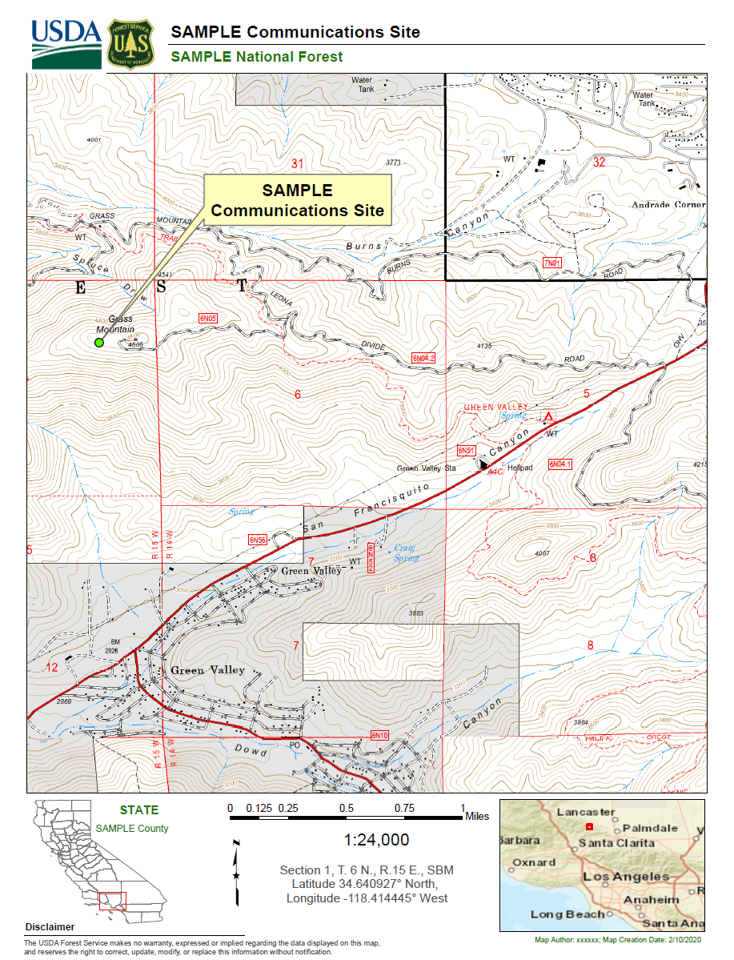

Site Map
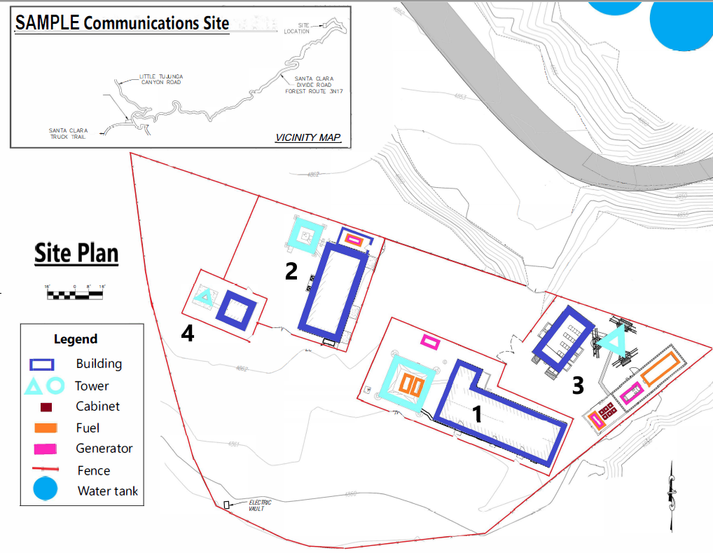

APPENDIX B – Authorized Facilities

Facility | Auth ID | Use | Building | Tower | Other
Facility #1  [Authorization Holder from SUDS/Auth] | ABC1 | PMRS | 24’ x 38’ Concrete Block;  8’ x 16’ Concrete block | Wooden structure located 300’ SW from building | 500-gallon Propane Tank
Facility #2  [Authorization Holder from SUDS/Auth] | ABC2 | CEL | 12’x 20’ Prefab | N/A | 500-gallon Propane Tank
Facility #3  [Authorization Holder from SUDS/Auth] | ABC3 | MIC | 14’ x 22’ Concrete | 100’ Self-supporting | (2) 500-gallon Propane tanks; 20’ x 20’ Chain Link Fence
Facility #4  [Authorization Holder from SUDS/Auth] | ABC4 | PMRS | 10’ x 14’ Metal | 20’ Self-supporting | 250-gallon Propane Tank

APPENDIX C – Facility Photographs

[User Note: include multiple photos from various angles or to show all facility components. If a view shows multiple facilities add arrows or circles or crop the photo so it is clear which facility is whose.]
Facility #1 – [Authorization Holder from SUDS/Authorization]

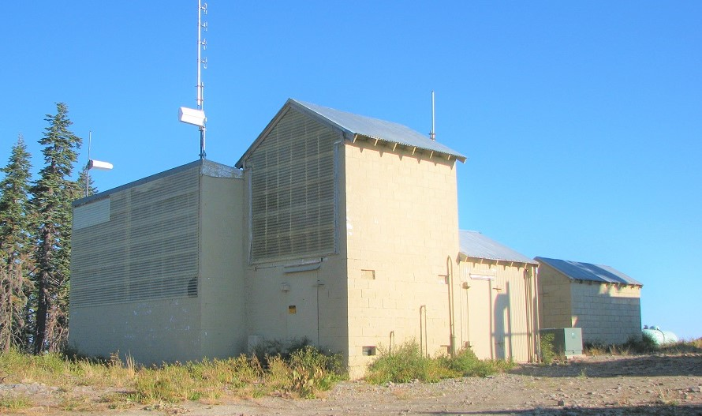

Facility #2 – [Authorization Holder from SUDS/Authorization]

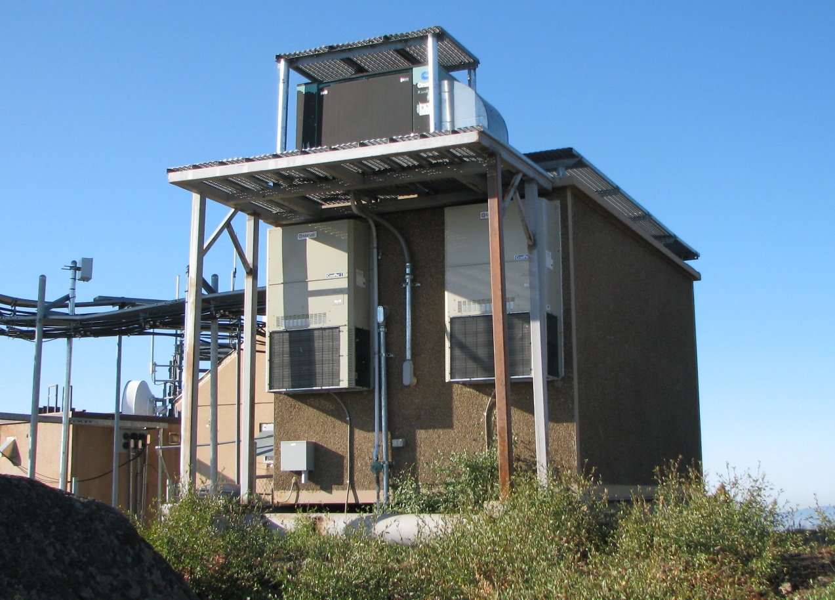

Facility #3 – [Authorization Holder from SUDS/Authorization]

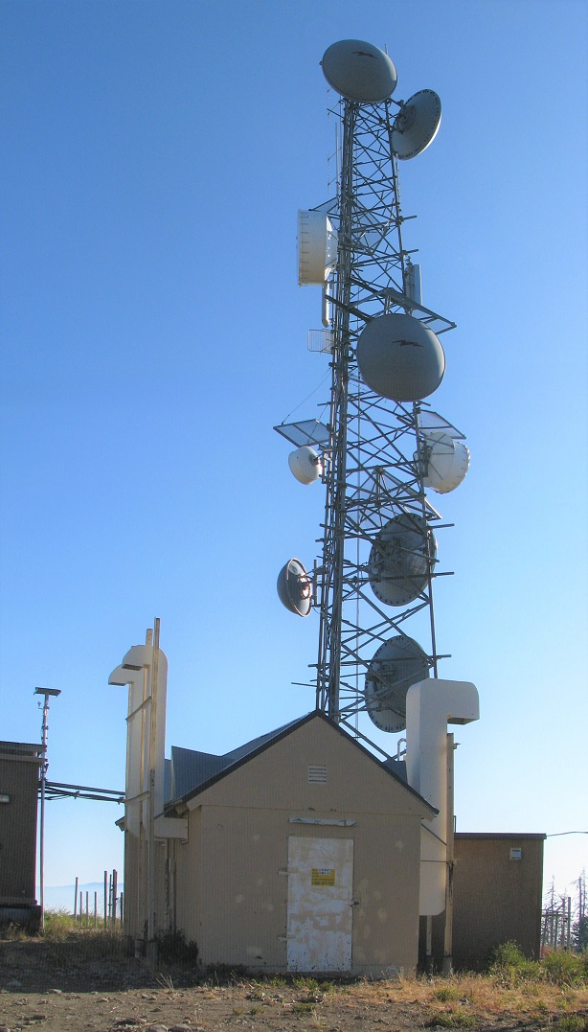

Facility #4 – [Authorization Holder from SUDS/Authorization]

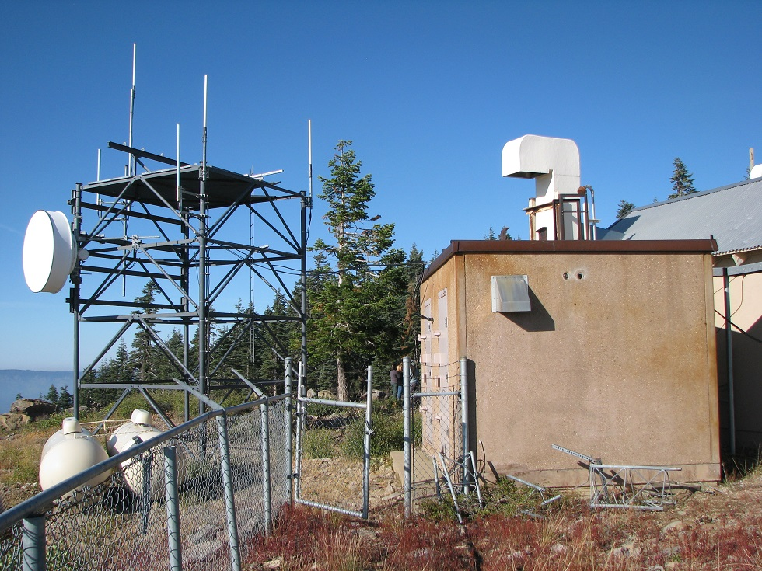

APPENDIX D – Inspection Checklist
“Sample Annual Technical Inspection”

Date Inspected: _____________________________ Authorization Holder:

Authorization ID: Holder Site Reference ID:

Site Technician: Phone #:

Number of Transmitters ______________________ FCC Call Sign(s):

Mark the following Items as Acceptable (A) or Unacceptable (U).

Electrical Wiring ------------------- (A) (U) Grounding --------------------- (A) (U)

Equipment Installation ------------ (A) (U) Housekeeping ----------------- (A) (U)

Building Repair -------------------- (A) (U) Tower Repair ------------------ (A) (U)

Mark the following Items as Yes (Y) or NO (N) or (N/A)

Isolators ---------------------------- (Y) (N) (N/A) Circulators --------------------- (Y) (N) (N/A)

Cavities ----------------------------- (Y) (N) (N/A) Terminators -------------------- (Y) (N) (N/A)

Filters ------------------------------- (Y) (N) (N/A) Lightning Protection ---------- (Y) (N) (N/A)

FCC License or NTIA Authorization Posted ….. (Y) (N)

Equipment Labeled with (please check all that apply):

Owner’s Name Transmitter Frequencies Transmitting Power Outputs
Current 24-hour Telephone Number

Comments:

Recommended Corrective Action:

Corrective Action To Be Taken (may require prior approval from the Forest Service):

I certify that to the best of my knowledge the information provided is true, correct, and complete.

Site Technician Signature Date

All corrective actions must be completed within 120 days of this site inspection, unless otherwise agreed to in writing by the Forest Service.

Make a written report of corrective action taken and submit to the Forest Service. If you should have any questions, call the Forest Service office.

This form is just one option that may be used, it outlines basic items to be covered in any inspection. The authorization holder may use a different form if desired.

APPENDIX E – Unmanned Aerial System Flight Request
Submit to Local Forest Service Unit and Local Dispatch Center

Authorization Holder
Holder Reference
(Communications Site Name / Site/Tower Number / State)
Authorization ID Number /
Forest Service Communications Site Name, if different than above
Latitude / Longitude (decimal degrees)
Forest / District Dispatch and Phone Number
Name of Pilot
Remote pilot certificate with a UAS rating
Pilot and Flight Center (if applicable) emergency contact info
Type of UAS / equipment to be used
Aircraft registration number
Anticipated duration of flight
Date range for flight
Reason for flight
FAA reference information.
Part 107 Airspace Authorizations | Federal Aviation Administration (faa.gov)

