Colorado Parks and Wildlife Off-Highway Vehicle Registrations

Off-highway vehicles must be registered with Colorado Parks and Wildlife. Off-highway vehicles (OHVs) include motorcycles, dirt bikes, three-wheelers, ATVs, and dune buggies that are operated on public land or trails in Colorado. To register your OHV in your name for the first time, complete the OHV Registration Form and return it to:
Colorado Parks and Wildlife - Registration Unit
13787 South Highway 85
Littleton, CO 80125
303-791-1920

You may also register your vehicle at various OHV dealers or many Colorado Parks and Wildlife offices. View our OHV Registration Agent Locations List to find the registration location nearest you. Always call ahead to ensure services are available.

Effective July 1, 2014, Title is required for all power sports vehicle dealers and auctioneer sales. OHV titling is optional for private party to private party sales. For titling information, see Titling Off Road Vehicles SB13-280 on the Department of Revenue website.

Who Needs to Register

Colorado OHV Registration requirements:
"All OHVs owned and operated in Colorado (including motor vehicles and motorcycles that are not licensed for public road access) must display current Colorado OHV registration stickers when in a person’s possession in an OHV staging area or operated on designated OHV trails or routes in Colorado.

Colorado OHV Use Permit requirements:
“All OHVs and motor vehicles (including motorcycles) that display a valid Colorado or out-of-state license plate must also display a current Colorado OHV use permit sticker when operated on designated OHV trails in Colorado."

“All out of state OHVs (including OHVs that display an out of state OHV registration) must also display a current Colorado OHV use permit sticker when operated on designated OHV trails or routes in Colorado.”

Registration Fees

The annual registration fee is $25.25. Registrations are valid from April 1 through March 31 each year. This is a flat administrative transaction fee – it cannot be prorated for a partial year's registration, and will not be subject to refund if the vehicle is sold or stolen.
OHV Registration Renewals

Registration renewal cards for OHVs are mailed to currently registered owners each March. You may also renew your registration online. You MUST have your registration number to renew online. If you need your registration number or more information, call 303-791-1920.

Purchasing an OHV

Dealers are required by law to complete the registration application for you and collect the registration fee before the vehicle leaves their premises. The dealer will forward the application to our office where we will process the request. Colorado residents who purchase an OHV from a private party may use their dated bill of sale as a temporary registration for 30 days during the registration application process. The Bill of Sale must be carried on the OHV while riding until the decals and registration card get to you in the mail.
Sorry, at this time, on-line registrations for a new machine is not available.

Out-of-state OHVs

Out-of-state residents who bring OHVs into Colorado must purchase a Colorado Non-Resident OHV permit which is valid from the date of purchase through the following March 31. These permits can be purchased anywhere you get your hunting/fishing licenses in Colorado, via mail-in request, or you can order one online.

Once purchased, this sticker should be placed on the vehicle's outside face of the right front fender or fork. Since this is only a use permit, no renewal notice will be sent to non-resident permit holders; you must purchase a new permit each year you come to Colorado with your OHV.

Decal Placement

Registration decals must be affixed permanently on the upper forward-half of the OHV in a location where the decal can be easily seen. Suggestions: On ATVs the decals could be placed on the outer side of the fenders, on the tank or on the cowling. On bikes, place a decal on each of the outside faces of the upper end of the forks or on the tank. OHV operators must carry their registration card and show it to any peace officer on request. For general decal placement instructions for all types of OHVs and boats, see the Registrations Decal Placement Brochure. View the specific decal placement illustrations for these vehicles:
- All-Terrain Vehicle (ATV)
- 3-Wheeler
- Dirt Bike
- Jeep
- Dune Buggy

Where the money goes: Benefits of the OHV Program

The Colorado OHV Registration Program fees fund trail maintenance, construction, trailheads, parking areas, trail signs, maps, and land acquisition. It also enables law enforcement personnel to identify and return stolen vehicles, encourages safe and responsible OHV use, and promotes respect for public lands.

Many groups benefit from OHV registration, including:
- OHV owners and operators;
- Towns and counties that want to attract OHV recreators to enhance their local economies; and
- The general public; educated OHV enthusiasts are more conscientious and better stewards of the land.

Registration funds also enable local, state and federal land managers to better manage our natural resources.

Annually, this direct benefit to enthusiasts funds over $4 million in trail opportunities and improvements. Read more about the OHV grants program.

OHV Permits
Whether you purchase your non-resident OHV permit through the E-Store or through the Total Licensing System, it covers your vehicle in the same way. However, the OHV permit will look different.
If you purchase your non-resident OHV permit from the E-Store, it will look like:
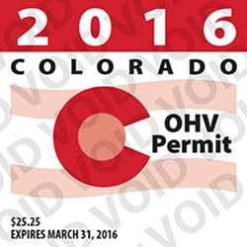​​​

If you have any questions or concerns about an OHV permit purchased through the E-Store, please call 303.866.3203 x4656
If you purchase your non-resident OHV permit through the Total Licensing System, it will come with a clear sticker and will look like:
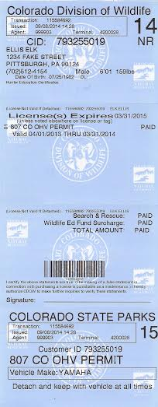
If you have any questions or concerns about an OHV permit purchased through the Total Licensing System, please call 303.297.1192

