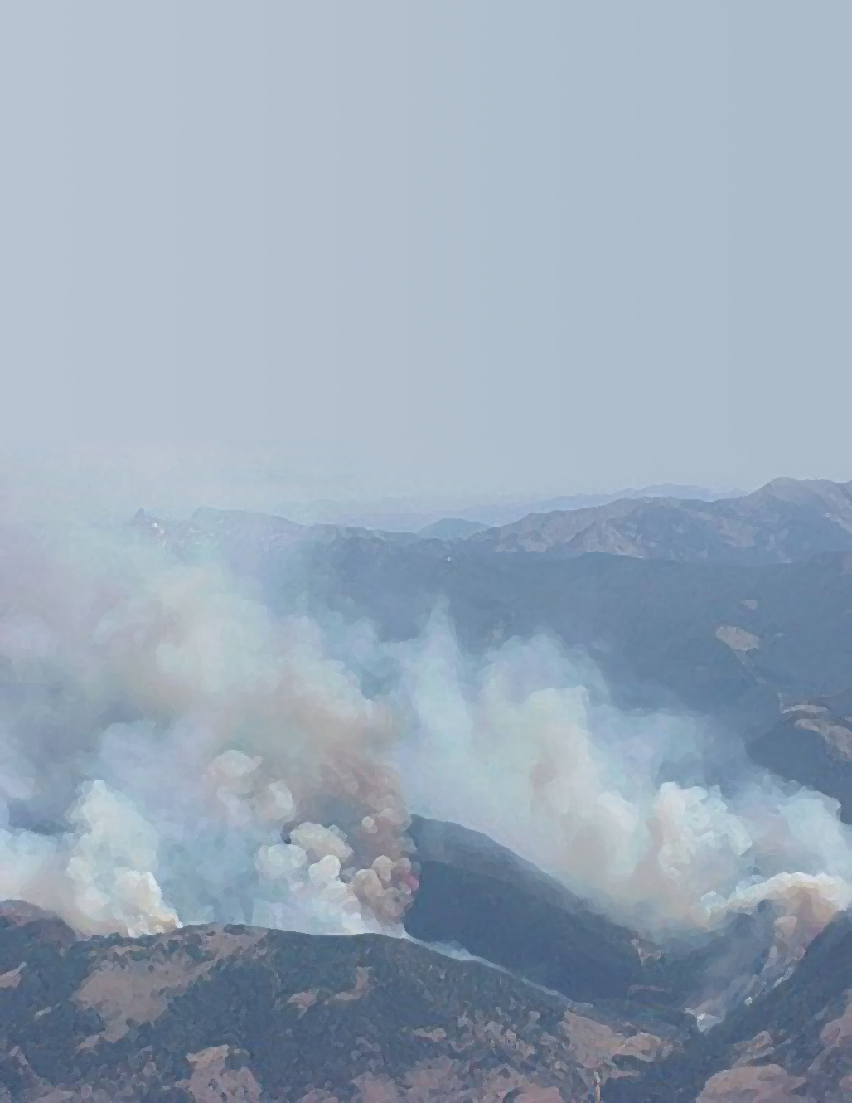
Smoke
NEPA
Guidance

Describing Air Resource Impacts From Prescribed Fire on National Forests & Grasslands of Montana, Idaho, North Dakota, & South Dakota in Regions 1 & 4

Prepared by:
Mark Story
Thomas Dzomba

USDA Forest Service

Missoula, MT

www.fs.fed.us/r1/gallatin/resources/air/index.shtml
November 2005
Acknowledgements

The authors would like to acknowledge the contributions of Joan Dickerson and Pete Zimmerman of the U.S. Forest Service Region 1 NEPA Planning staff, who provided valuable editing of this document to ensure conformity with current NEPA policies and procedures.

The authors also acknowledge the following individuals and agencies who reviewed and provided valuable commentary on this document:

Ann Acheson, U.S Forest Service Region 9
Barbara Schuster, Patricia Koppenol, and Stephen Solem, U. S. Forest Service Region 4
Lori Clark, U. S. Forest Service Region 1
Idaho Department of Environmental Quality
Montana Department of Environmental Quality
North Dakota Department of Health
South Dakota Department of Environmental and Natural Resources
U.S. Environmental Protection Agency Region 8
Table of Contents

Table of Acronyms 4
Introduction 5
About this NEPA Guidance Document 5
Document Organization 5
Section I – Overview 6
Relationship to Other Documents 6
Smoke Management Programs in MT, ID, ND, and SD 6
Section II - Air Quality Considerations 7
Alternatives 7
Design criteria and/or mitigation measures 7
Monitoring 8
Affected Environment 9
Air Quality Regulatory Framework 10
The Clean Air Act 10
Ambient Air Quality Standards 10
Regional Haze Regulations 12
Airshed Monitoring 13
Conformity Determinations 13
Interim Air Quality Policy on Wildland and Prescribed Fire 13
Idaho Emergency Episode Rule 14
Analysis Area 14
Existing Meteorology and Air Quality 15
Other Sources of Air Pollution 16
Environmental Consequences 16
Fuel Loadings 17
Fuel Consumption, Emission Production 17
Smoke Dispersion - CALPUFF and SIS 17
Smoke Generation Potential of Each Alternative 19
Direct and Indirect Effects 19
Cumulative Effects 19
Literature Cited 21
Appendix A – Smoke Management Techniques 22
Appendix B – Federal Class I Areas in the United States 23
Appendix C – Nonattainment Areas in Montana and Idaho 24
Appendix D – Montana and Idaho Airsheds 26
Appendix E – Montana/Idaho State Airshed Group 27
Appendix F – FOFEM5 and SIS Spreadsheet Examples 28

Table of Acronyms

AQI | Air Quality Index
BACM | Best Available Control Methods
CAA | Clean Air Act
CE | Categorical Exclusion
DOI BLM | Department of the Interior Bureau of Land Management
EA | Environmental Assessment
EIS | Environmental Impact Statement
EPA | Environmental Protection Agency
FOFEM5 | First Order Fire Effects Model
IDDEQ | Idaho Department of Environmental Quality
IMPROVE | Interagency Monitoring of Protected Visual Environments
MTDEQ | Montana Department of Environmental Quality
NAAQS | National Ambient Air Quality Standards
NEPA | National Environmental Policy Act
NRCS | Natural Resource Conservation Service
PM_{2.5} | Fine Particulate Matter (less than 2.5 microns in diameter)
RAWS | Remote Automated Weather Stations
SIP | State Implementation Plan
SIS | Smoke Impact Spreadsheet
SNOTEL | Snow Telemetry
USFS | USDA Forest Service
VCIS | Ventilation Climatology Information System
WESTAR | Western States Air Resources Council
WFU | Wildland Fire Use

Introduction
Smoke from prescribed fire may affect air quality and potentially the health and well being of human populations. Prescribed burning emissions can also cause visibility impacts - especially with regard to transportation - even if air quality standards are not violated. The Clean Air Act (CAA), the Regional Haze Rule, and National Ambient Air Quality Standards (NAAQS) constrain prescribed fire smoke, even as prescribed fire use is increased to reduce fuel loadings and restore ecosystems.
The effects to air quality from prescribed burning is subject to National Environmental Policy Act (NEPA) analysis and disclosure.

About this NEPA Guidance Document
This document is intended to guide the user in selecting and preparing the appropriate level of air quality anlaysis related to prescribed fire activities.
It targets USDA Forest Service (USFS) personnel in Montana, Idaho, North Dakota and South Dakota responsible for preparing the air quality sections for a NEPA document. It replaces the previous Smoke NEPA Guidance (Acheson et. al., 2000) and supplements the Desk Reference for NEPA Air Quality Analysis (CH2MHill, 1995) and will be enhanced periodically with examples at the USFS Northern Region Air Quality Website

Document Organization
Section I describes the relationship to other smoke management guidance documents. Section II outlines the air quality considersations including suggestions for reducing impacts, the regulatory framework, suggestions for describing the affected environment and environmental consequences of prescribed fire on air quality. The appendices provide useful references and background information about smoke and air quality. This document assumes the user works in conjunction with a NEPA expert and has some NEPA experience.
Districts and Forests are encouraged to work closely with their local and state air quality regulators in planning, preparing and reviewing the air quality sections of their NEPA documents.

Section I – Overview

Relationship to Other Documents
The national Smoke Management Guide for Prescribed Fire and Wildland Fire (Hardy et. al, 2001) is a comprehensive document describing all aspects of smoke management including policies, techniques, documentation, and communication. This R1/R4 guidance document builds on the national guide by describing requirements or situations more specific to Montana, Idaho, North Dakota and South Dakota.
The Wildland Fire on Ecosystems: Effects of Fire on Air (Sandberg et. al, 2002) is state of knowledge review about the effects of fire on air quality and can assist resource managers with fire and smoke planning. It describes air quality regulations, smoke chemistry, smoke dispersion, smoke impacts and monitoring.
The Environmental Protection Agency (EPA) Interim Air Quality Policy on Wildland and Prescribed Fire (1998) (Interim Policy) requires air quality and visibility impact evaluations of fire activities to include recent historic fire and projected emissions. Environmental analysis should identify applicable regulations, plans or policies, sensitive areas - with descriptions of measures planned to reduce smoke impacts and intrusions into sensitive areas and, when possible, modeling of air quality and visibility impacts as well as descriptions of ambient air monitoring plans. This Guide should help meet the intent of the Interim Policy - discussed later - and meet most concerns of air quality regulators.
The Forest Service requires burn plans for prescribed burning projects. Specific prescription parameters, monitoring, safety contingencies, and contacts, are documented in a burn plan. Thus any monitoring, mitigations, or other commitments made in a NEPA document needed to be incorporated into the project’s burn plan.

Smoke Management Programs in MT, ID, ND, and SD
Both Montana and Idaho have coordinated smoke management programs to meet the intent of the Interim Policy. These programs have been certified to the Administrator of the EPA. The operations of the Montana/Idaho Airshed Group (www.smokemu.org) are the foundation of this certification. Additional information about the smoke management program in Idaho can be found at http://www.deq.state.id.us/air/prog_issues/burning/wildland.cfm. Additional information about the smoke management program in Montana can be found at http://www.deq.state.mt.us/FireUpdates/index.asp.

North Dakota and South Dakota do not currently have coordinated smoke management programs - as is recommended by EPA Interim Policy – but likely will, as they implement the Regional Haze Rule and PM_{2.5} National Ambient Air Quality Standards (NAAQS). The North Dakota Department of Health open burning provisions are outlined in http://www.state.nd.us/lr/information/acdata/pdf/33-15-04.pdf. The South Dakota Department of Environmental and Natural Resources open burning program is described in http://www.state.sd.us/denr/DES/AirQuality/openburn.htm#WILDLAND
These programs are designed to minimize smoke impacts from prescribed fire conducted for silvicultural and range purposes.

Section II - Air Quality Considerations

Alternatives
An environmental assessment (EA) or environmental impact statement (EIS) describes issues, alternative development process, alternatives considered in detail, alternatives considered but not given detailed study, and alternative comparison. The alternatives considered in detail should include a description of any specific design criteria or mitigation measures.

Design criteria and/or mitigation measures
Design criteria/mitigation measures can be used to reduce the effects of smoke on air quality and human health. Techniques may include reducing fuel loading and/or consumption, reducing smoke incursions and smoke concentrations in sensitive areas, as well as notifying smoke sensitive individuals of planned burns. Emission reductions should be quantified if possible. Design criteria/mitigation measures should be included in the burn plan to ensure they are implemented. Design criteria/mitigation measures should also include those commonly discussed in a burn plan, e.g., general prescription windows, list of contacts, contingency measures, etc.
Other sources of information for design criteria/ mitigation measures include:
- Page 152 of the Smoke Management Guide for Prescribed Fire and Wildland Fire discusses the use and effectiveness of smoke emission and redistribution techniques. Appendix A is a duplication of a table from the Guide. Emission redistribution, rather than emission reduction, is the most commonly used smoke management technique
- The operations of the Montana/Idaho State Airshed Group (http://www.fs.fed.us/r1/fire/nrcc/Smoke_web_pages/OpGuide.pdf) will be emphasized to reduce smoke impacts of prescribed burning - officially recognized as the Best Available Control Methods (BACM) by the Montana Department of Environmental Quality (MTDEQ) (see Appendix E, State Smoke Management Program, for summary operations of the Montana/Idaho State Airshed Group). Prescribed burning following these procedures meets the EPA Interim Policy as certified by Montana and Idaho.
- Unit 12 of the National Wildfire Coordinating Group (NWCG) training class RX-410 – Smoke Management Techniques discusses NEPA requirements in relationship to fire and air quality.

Monitoring
Monitoring is a post decision action used to determine whether the implemented alternative met the site-specific objectives, contributed towards the desired condition, and validated the assumptions used to develop the implemented alternative. Only include those monitoring activities necessary or required and that will be preformed. “Nice to do” activities that will not be done or funded should not be included or if included should be noted that they will be done only if funded – and they are not “required”.
In addition, reference may be made to any existing, pertinent ambient air monitoring data. Smoke impacts to air quality are typically measured by fine particulate (PM_{2.5}) monitors. State and local air regulators perform most fine particulate monitoring to determine compliance with air quality standards. The following web pages provide additional information concerning state ambient air monitoring activities:

Idaho: http://www.deq.state.id.us/air/data_reports/monitoring/overview.cfm
Montana: http://www.deq.state.mt.us/AirMonitoring/index.asp
North Dakota: http://www.health.state.nd.us/AQ/AmbientMonitoring.htm
South Dakota: http://www.state.sd.us/denr/DES/AirQuality/Monitoring/state-mo.htm

EPA and the National Park Service have developed the IMPROVE (Interagency Monitoring of PROtected Visual Environments) network to monitor fine particulates and visibility near Class I wilderness areas. Many IMPROVE sites in Region 1 and Region 4 are operated by the USFS. Table 1 lists all current IMPROVE Class I monitoring locations in Idaho, Montana, North Dakota, and South Dakota. For more information about the IMPROVE monitoring network, go to http://vista.cira.colostate.edu/improve/.

Portable particulate matter samplers, are available through the Region 1 Air Program Manager or the Washington Office Air Program Manager to monitor communities and smoke sensitive areas downwind from wildfire and prescribed burning (see also “When and Where to Monitor Prescribed Fire Smoke: A Screening Procedure,” 1997, USFS, R6, by CH2M Hill, Portland, OR).

Affected Environment
A description of the affected environment is required in an EIS, but not an EA. An EIS shall succinctly describe the environment of the area(s) to be affected or created by the alternatives under consideration. The descriptions shall be no longer than is necessary to understand the effects of the alternatives. Data and analyses in a statement shall be commensurate with the importance of the impact, with less important material summarized, consolidated, or simply referenced. (40 CFR 1502.15)

This section builds on the discussion in the fire and fuels section of the environmental document. The fire/fuels section should set the stage by describing the historicial disturbance processes and existing condition, including existing fuel loads. The air quality section should discuss components specific to air quality including the regulatory framework, analysis area, sensitive areas, including times of high public use, and existing meteorology and air quality.
Table 1. IMPROVE Air Quality Monitoring Sites in ID, MT, ND, and SD
State | Site Name | Site Code | Class I Area(s) Represented | Operating Agency
ID | Craters of the Moon NM | CRMO1 | Craters of the Moon | NPS
ID | Sawtooth NF | SAWT1 | Sawtooth | USFS  (Sawtooth NF)
MT | Cabinet Mountains | CABI1 | Cabinet Mountains | USFS  (Kootenai NF)
MT | Gates of the Mountains | GAMO1 | Gates of the Mountains | USFS  (Helena NF)
MT | Glacier National Park | GLAC1 | Glacier National Park | NPS
MT | Medicine Lake | MELA1 | Medicine Lake | USFWS
MT | Monture | MONT1 | Bob Marshall, Mission Mountains, Scapegoat | USFS  (Lolo NF)
MT | Sula Peak | SULA1 | Selway-Bitterroot, Anaconda-Pintler | USFS  (Bitterroot NF)
MT | UL Bend | ULBE1 | UL Bend | USFWS
ND | Lostwood | LOST1 | Lost Wood | USFWS
ND | Theodore Roosevelt | THRO1 | Theodore Roosevelt | NPS
SD | Badlands National Park | BADL1 | Badlands | NPS
SD | Wind Cave | WICA1 | Wind Cave | NPS

As noted above, a section on the affected environment is not required for an EA; however its inclusion may be beneficial. If it is not included enough information should be included in the project description, location, purpose and need, no action alternative, and effects comparison to give the reader the sense of the affected environment. Resource reports should be referenced in the NEPA document so readers may refer to them if desired.

Air Quality Regulatory Framework

The Clean Air Act
The basic framework for controlling air pollutants in the United States is mandated by the 1970 Clean Air Act, as amended in 1977 and 1990. The CAA was designed to “protect and enhance” air quality. Section 160 of the CAA requires measures “to preserve, protect, and enhance the air quality in national parks, national wilderness areas, national monuments, national seashores, and other areas of special national or regional natural, recreation, scenic, or historic value.” Stringent requirements are therefore established for areas designated as “Class I” areas. Class I areas include Forest Service and Fish and Wildlife Service wilderness areas over 5,000 acres that were in existence before August 1977 and National Parks in excess of 6,000 acres as of August 1977. Designation as a Class I area allows only very small increments of new pollution above already existing air pollution levels. Class II areas are currently all other areas of the country that are not Class I. To date, there are no class III areas. Appendix B contains a map of the Federal Class I areas in the United States.

Ambient Air Quality Standards
The EPA has established NAAQS for specific pollutants emitted in significant quantities that may be a danger to public health and welfare. These pollutants are called criteria pollutants (Table 2). The NAAQS are designed to protect human health and the public welfare. The CAA defines public welfare effects to include, but not be limited to, “effects on soils, water, crops, vegetation, man-made materials, animals, wildlife, weather, visibility and climate, damage to and deterioration of property, and hazards to transportation, as well as effects on economic values and on personal comfort and well-being.”
If a community or area does not meet or “attain” the standards, it becomes a non-attainment area and must demonstrate to the public and EPA how it will meet standards in the future. This demonstration is done through the State Implementation Plan (SIP). Non-attainment areas for Montana and Idaho are listed in Appendix C. There are currently no nonattainment areas in North Dakota nor South Dakota.

Criteria pollutants such as sulfur dioxide and nitrogen dioxide are of concern because of their potential to cause adverse effects on plant life, water quality, aquatic species, and visibility. However, sources of these pollutants are generally associated with urbanization and industrialization rather than with natural resource management activities or wildfire. Wildfire and natural resource management activities such as timber harvest, road construction, site preparation, mining, and fire use can generate ozone, carbon monoxide, and particulate matter. While ozone is a byproduct of fire, potential ozone exposures are infrequent (Sandberg and Dost 1990). Carbon monoxide is rapidly diluted at short distances from a burning area, as fires are generally spatially and temporally dispersed, and pose little or no risk to public health (Sandberg and Dost 1990).
The pollutant of most concern to public health and visibility within and downwind of the area is particulate matter. Even though particulate matter has no serious effects on ecosystems because fire and smoke are natural processes (ICBEMP SDEIS 2000), it does affect human health and visibility. Because of its smaller size, PM_{2.5} poses greater health risks than PM₁₀. Large volumes of particulate matter can be produced from fire and, depending on meteorological conditions, may affect large areas for extended periods of time.
Each day, concentrations of various air pollutants are measured in areas throughout the United States . The concentrations are then compared to local, state and federal standards. In order to compare all the different pollutants and determine relative air quality, the EPA (2000) developed the Air Quality Index (AQI), which relates all criteria pollutants to the same scale or index. Table 3 displays the 24-hour AQI breakpoints for PM₁₀ and PM_{2.5}. When concentrations reach “Unhealthy for Sensitive Groups,” cautionary statements are issued to suggest that people with respiratory conditions or heart disease, the elderly and children, and those who work, exercise, or spend time outdoors, should limit prolonged exertion.

Table 2. National and State Ambient Air Quality Standards
Pollutant | Time Period Average | Federal | Idaho and Utah
Carbon Monoxide (CO) | One hour  8 hour | 35 ¹ppm  9 ppm | 35 ppm  9 ppm
Lead (Pb) | Calendar Quarter  90-day | 1.5 ²μg/m³  ⁻⁻ | 1.5 μg/m³
Nitrogen Dioxide (NO₂) | Annual Arithmetic Mean  Hourly Average | 0.053 ppm  ------------- | 0.053 ppm  -------------
Sulfur Dioxide (SO₂) | Annual Arithmetic Mean  24-hour  3-hour  Hourly Average | 0.03 ppm  0.14 ppm  0.50 ppm  ------------- | 0.03 ppm  0.14 ppm  0.50 ppm  ------------
Ozone | 8 hour  Hourly Average | 0.12 ppm  0.08 ppm | 0.12 ppm  0.08 ppm
PM₁₀ | Annual Arithmetic Mean  24-hour | 50 μg/m³  150 μg/m³ | 50 μg/m³  150 μg/m³
PM_{2.5} | Annual Arithmetic Mean  24-hour | 15 μg/m^{3,4}  65 μg/m^{3,4} | ³-------  -------
¹ppm=parts per million
²micrograms per cubic meter
³As of November 2002, Idaho had not adopted PM 2.5 standards different than the federal standard.
⁴ EPA is currently developing revised NAAQS for PM_{2.5}. Revised standards will be proposed by December, 2005 and finalized by September, 2006.
While the NAAQS can evaluate smoke impacts related to public health, smoke often causes public concern at levels below the NAAQS. Complaints about smoke concentrations often start when PM_{2.5} concentrations are as low as 30 µg/m³. The 24-hour threshold for the PM_{2.5} NAAQS is 65 µg/m³ (Table 2). The Air Quality Index for a concentration of 30 µg/m³ would be rated as “Moderate,” indicating no health concerns (Table 3).
In July 1997, the EPA issued revised the NAAQS for ozone and developed a new standard for PM_{2.5}. The EPA proposed the following implementation plan for the new standards which took effect on September 18, 1998:
  - Nationwide fine particulate monitors in place.
  - States and EPA collect data from nationwide network.
  - States submit their SIPs to EPA, describing how they’ll meet and enforce the new standards.
  - States implement their Plan to assure they attain the standards.

Regional Haze Regulations
Visibility impairment is a basic indicator of air pollution concentrations and was recognized as a major air quality concern in the Clean Air Act Amendments of 1977. Visibility variation occurs as a result of the scattering and absorption of light by particles and gases in the atmosphere. Without human-caused pollution effects, a natural visual range is approximately 90 to 140 miles in the western United States (EPA, 1999).
EPA’s 1980 visibility rules (40 CFR 51.301-307) were developed to protect mandatory Class I areas from human-caused impairments reasonably attributable to a single or small group of sources. In 1999, EPA promulgated the Regional Haze Rule (40 CFR 51.308-309), which calls for states to establish goals for improving visibility in mandatory Class I areas and to develop long-term strategies for reducing the emissions of air pollutants that cause visibility impairment.
The regional haze regulations apply to all states, including those states that do not have any Class I areas. Plans in states without Class I areas must address the emissions from any sources that may reasonably be anticipated to cause or contribute to visibility impairment of any Class I area outside that state. The Regional Haze regulations require states to demonstrate reasonable progress for improving visibility in each Class I area over a 60-year period during which visibility should be returned to natural conditions.
Table 3. Air Quality Index (AQI) and Particulate Matter PM₁₀ and PM_{2.5} Breakpoints
AQI Value | Health Concern | PM₁₀ Breakpoints  ¹μg/m³  24-Hour average | PM_{2.5} Breakpoints  24-Hour average μg/m³
0 – 50 | Good | 0 – 54 | 0 – 15.4
51 – 100 | Moderate | 55 – 154 | 15.5 – 40.4
101 – 150 | Unhealthy for Sensitive Groups | 155 – 254 | 40.5 – 65.4
151 – 200 | Unhealthy | 255 – 354 | 65.5 – 150.4
201 – 400 | Very Unhealthy | 355 – 424 | 150.5 – 250.4
> 400 | Hazardous | > 424 | > 250.5
¹micrograms per cubic meter

Idaho, Montana, North Dakato, and South Dakota are in preliminary stages of developing SIPs for Regional Haze, which must be submitted to EPA by 2008.
At this point, it is not feasible to quantitatively address impacts to Regional Haze in a project level NEPA document. It is appropriate, however, to state that the USFS will be actively involved with the states as they develop their Regional Haze SIPs.
More information concerning Regional Haze can be found at http://www.epa.gov/oar/visibility/index.html.

Airshed Monitoring
The majority of the legal entities in Montana and Idaho (including the Forest Service) which create particulates as a result of their burning activities have formed the Montana/Idaho State Airshed Group. Through a Memorandum of Understanding, this group has established a smoke monitoring system that provides air quality predictions restrictions to its members. In Montana, the MTDEQ issues an annual burn permit to the Forest Service. Issuance of this permit is based on participation and compliance with burning restrictions set by the Montana/Idaho Airshed Group.
All prescribed burning implemented within the analysis area will comply with the State Requirements of the State Implementation Plan and the Smoke Management Plan (USFS 1987a, p. II-26). Prescribed burning is reported to the Airshed Coordinator on a daily basis. If ventilation problems are forecast by the monitoring unit, prescribed burning is either restricted by elevation or curtailed until good ventilation exists.

Conformity Determinations
The general conformity provisions of the CAA (Section 176(c)) prohibit federal agencies from taking any action within a non-attainment area that causes or contributes to a new violation of the standards, increases frequency or severity of an existing violation, or delays the timely attainment of a standard as defined in the area plan. Federal agencies are required to ensure their actions conform to applicable State Implementation Plans. Burning projects outside a non-attainment area are not subject to the conformity provisions. It should be stated in the NEPA document whether or not a conformity determination is necessary – depending upon whether the project is within or outside the non-attainment area. If prescribed burning is planned in a non-attainment area, local and state air quality regulatory managers as well as regional USFS air resource managers must be involved. In the NEPA document, however, it is prudent to discuss potential air quality impacts upon a non-attainment area regardless of whether or not a conformity determination is needed.

Interim Air Quality Policy on Wildland and Prescribed Fire
On May 15, 1998, the EPA issued the Interim Air Quality Policy on Wildland and Prescribed Fire to address impacts to public health and welfare. This policy was prepared in response to anticipated increases in fire use that were expected to occur as a result of implementing the 1995 Fire Management and Policy Review, which outlined a need to restore fire as an ecosystem process. The Interim Policy was prepared in an effort to integrate the goals of allowing fire to function in an ecological role for maintaining healthy ecosystems balanced with protecting public health and welfare by mitigating the impacts of air pollutant emissions on air quality and visibility. The policy was developed with the active involvement of stakeholders including the U.S. Department of Agriculture. The Interim Policy reconciles the competing needs to use fire and maintain clean air to protect public health. The Interim Policy is interim only because it does not yet address agricultural burning or regional haze (EPA 1998). It is not interim with regard to how States, Tribes, and Federal land managers are expected to address smoke from prescribed fires.
The Interim Policy suggests that air quality and visibility impact evaluations of fire activities on Federal lands should consider several different items during planning (EPA 1998). In a project level NEPA document, it is appropriate to consider and address to the extent practical, a description of applicable regulations, plans, or policies, identification of sensitive areas (receptors), and the potential for smoke intrusions in those sensitive areas. Other important disclosure items include applicable smoke management techniques, participation in a basic smoke management program, and potential for emission reductions. Typically ambient air quality, visibility monitoring, and cumulative impacts of fires on regional and subregional air quality are not explained to the same level of detail. Ambient air quality and visibility monitoring (for Class I areas) are typically done collaboratively with the states. Impacts to regional and subregional air are addressed operationally through a coordinated smoke management program. The EPA urges states to develop, implement and certify smoke management programs that meet the recommended requirements of the Interim Policy. If a “certified” program is in place and smoke exceeds the particulate standard, it may not be considered a violation by EPA.

Idaho Emergency Episode Rule
The Idaho Department of Environmental Quality (IDDEQ) has an Air Pollution Emergency Rule to protect human health in all areas, regardless of their attainment status. The Air Pollution Emergency Rule outlines criteria that enable IDDEQ to take appropriate action when levels of regulated air pollutants cause or are predicted to cause a health emergency. The rule identifies four stages or levels of an emergency, with each stage addressing a progressively more serious air quality event. When ambient air conditions for PM_{2.5} reach or exceed 80 micrograms per cubic meter for the one-hour average – or 50 micrograms per cubic meter for the 24-hour average - all open burning can be prohibited.

Analysis Area
The analysis area for air resource impacts will be the airshed the activity is occurring in, downwind airsheds within 100 kilometers that could be impacted. Sensitive areas, like population centers, non-attainment areas, schools, hospitals, highways, and airports should be considered. For instance, for fire activity on the Kootenai NF, the analysis area would generally be in Montana Airshed 1 and part of Airshed 2. Airsheds as established by the Montana/Idaho State Airshed Group are displayed in Appendix D. Identify the distance and direction of estimated smoke drift and potential areas affected which are associated with each alternative.
Times of high public use for sensitive areas (Class I areas, non-attainment areas, downwind communities, campgrounds, major highways, etc.) should also be identified. Region 1 wilderness areas and campgrounds receive most of their use in summer and fall and may not be affected by spring burns.

Existing Meteorology and Air Quality
Existing air quality should be described with available air quality information. Air quality and airshed characteristics are based on climate, prevailing wind, atmospheric inversions, and local weather patterns influenced by topography and air pollution sources. Local knowledge and observations are often obtained from USFS and DOI BLM Remote Automated Weather Stations (RAWS), National Resource Conservation Service (NRCS) Snow Telemetry (SNOTEL) stations, and National Weather Service stations. The National Weather Service’s web site map of all weather observation stations in Montana and Idaho is at http://www.wrh.noaa.gov/mso/newrgl.php. Wind roses showing prevailing wind directions and speed are helpful as are atmospheric mixing heights and inversion conditions. The Ventilation Climatology Information System (VCIS) web page provides useful GIS maps of transport wind and mixing height, at http://web.airfire.org/vcis/index.html.
Background particulate levels of 5 -10 µg/m³ per 24-hour average can usually be assumed for remote, non-developed areas. Wildfire particulate levels may exceed NAAQS for PM₁₀ and PM_{2.5}, reaching levels of hundreds of µg/m³ per day during intense wildfires - like the year 2000 wildfires in Montana and Idaho. Some historical particulate level concentrations, especially for the Bitterroot National Forest of southwestern Montana, are available on the Northern Region Air Quality Web Page. The EPA Air Quality System (AQS) database and other fine particulate matter databases can be used to calculate a 5 - 10 year average. Most particulate monitoring occurs in valley communities. Other potential sources of information include:
- Existing NEPA documents in the proximity of the project area.
- Air quality and meteorology monitoring associated with mining operations, industrial plants, and power generating stations.
- Municipal air quality data collected by the MTDEQ or IDDEQ. Much of the DEQ data is for non-attainment areas. Municipal areas usually have much higher levels of particulate concentrations than wildland airsheds.
- Particulate data available from the IMPROVE monitoring network (See Table 1 for a list of monitoring locations). The most current IMPROVE data is available at http://vista.cira.colostate.edu/improve/. There is usually a six to nine month delay in posting IMPROVE data to the website.
The Montana/Idaho State Airshed Group Annual Reports can be downloaded from http://www.smokemu.org/links.php. This web page also contains links to information about current smoke levels, daily operations and restrictions of the Montana/Idaho State Airshed Group, meteorology, and the Montana/Idaho State Airshed Group Operating Guide.
- The Northern Rockies Coordination Center webpage contains information about current fire incident and fire danger conditions for the USFS Northern Region. Information for Southern Idaho can be found at the Easter Great Basin Coordination Center web page.
- Climate information at the Western Regional Climate Center web Site.
- The Program for Climate, Ecosystem and Fire Applications website provide information on climatology, vegetation and fuels, fire forecasts, and wildland fire assessments.
- The Ventilation Climatology Information System at the Pacific Northwest Forest Experiment Station.
- The Western States Air Resources Council (WESTAR) promotes the exchange of information between the States, serve as a forum to discuss western regional air quality issues of common concern and share resources for the common benefit of the member states.

Other Sources of Air Pollution
Areas of substantial road dust, agricultural burning, wildfire variability, and fire use activity (e.g. ecosystem burns, pile burns, broadcast burns) should be disclosed. A key component of the disclosure is the potential for project emissions to cumulatively combine with existing emissions. Ambient air quality data is considered as background for wildland fire use (WFU) smoke emissions additions.
Industrial particulates from stationary sources in R1 may be sufficiently concentrated to add significant cumulative effects. Burn proposals within 25 km (15 miles) of stationary facilities that emit more than 100 tons/yr of particulates should disclose the stationary sources. Coal burning electrical power generation plants, pulp mills, wood products processing mills, cement and lime plants, sugar refineries, oil refineries, mining, and ore processing smelters are a few of the sources of fine particulate matter in Montana and Idaho which exceed 100 tons per year. A list of major stationary sources in Idaho and Montana are listed in the USFS Northern Region Air Quality web site or directly from the EPA AIRData web site.

Environmental Consequences
Smoke from fire contains air pollutants, including PM_{2.5}, which can cause health problems, especially for people suffering from cardiopulmonary illnesses. Particulate concentrations that exceed health standards may occur for several miles downwind of prescribed burns. Smoke from prescribed burns may impact Class I wilderness areas and national parks, diminishing scenic vistas.
The purpose of the environmental consequences section is to disclose the emissions and potential impact from prescribed fire associated with the proposal and to consider their significance relative to USFS responsibilities under the CAA and other mandates. The analysis considers cumulative effects of other existing and planned activities on public and private land in the airshed.
The level of disclosure will vary depending on the type of NEPA document (Categorical Exclusion (CE), EA, or EIS). This document describes the disclosure appropriate for an EA or EIS. A qualitative description of emissions and effects may be adequate for a CE, although some modeling may be appropriate and model runs may be filed in the project folder.

Fuel Loadings
Describe fuel types and fuel loadings in the proposed burn areas relative to calculated smoke emissions in the Environmental Consequences section. Fuel loadings should be discussed and modeled in terms of past, present and future conditions based upon the specific alternative’s treatments. Fuel types, moistures, and loadings are important to fire behavior and fuel consumption, which is important to atmospheric smoke emissions discussion.

Fuel Consumption, Emission Production
Quantify fuel consumption and amounts, acreage, and types of material to be burned in order to estimate smoke emissions, in tons per year. Smoke particles from the combustion of woody biomass are small, with about 80% of smoke particulates being less than 2.5 microns. Smoke particulates less than 10 microns are mostly PM_{2.5}. The smoke models recommended are the First Order Fire Effects Model (FOFEM5) and CONSUME 2.1 for emissions, and CALPUFF for concentrations; all are part of the Smoke Impact Spreadsheet (SIS) described below.
FOFEM5 is an emissions production model for wildfire, underburns, and broadcast burns, The FOFEM5 model inputs include fuel loading by size class, vegetation, density (herbaceous, shrub, and tree regeneration), anticipated fire intensity, fuel moisture, duff, depth, and season of burning. The CONSUME 2.1 model is also an emissions production model and can be used within the SIS model for estimating pile burn emissions and resulting concentrations.

Smoke Dispersion - CALPUFF and SIS
Modeling smoke dispersion is more complex than estimating emissions, since atmospheric stability and winds influence downwind concentrations. Dispersion modeling gives estimates of smoke concentrations in µg/m³ per 24-hour average at various distances downwind of the burn. CALPUFF is an approved EPA dispersion model which is simplified in an Excel spreadsheet model, called SIS – and can be run with either FOFEM5 or CONSUME 2.1 models. The SIS model is a simple to use, screening level model system for estimating PM_{2.5} emissions and concentrations downwind of natural or managed wildland fires. SIS includes emissions modeling based on the choice of CONSUME 2.1 for pile burns or FOFEM5 for broadcast burns or wildfires. The SIS model estimates smoke concentrations at various distances downwind based upon the CALPUFF dispersion model. Examples of input and output spreadsheets from FOFEM5 and SIS are shown in Appendix F. The SIS model can be downloaded from the Air Sciences’ website at http://www.airsci.com/SIS.html. FOFEM5 can be downloaded from the USFS Fire Sciences Laboratory Fire Management Tools website: http://fire.org /.
A useful output of the SIS model is downwind projections of PM_{2.5} concentrations. The NAAQS for PM_{2.5} is 65 μg/m³ for the 24-hour average period. Both tables and graphs of PM_{2.5} estimated concentrations and plumes are displayed using SIS at distances downwind of the modeled burn. Smoke concentration estimates are added to estimated background particulate matter concentrations. Results of the FOFEM5 and SIS modeling efforts can be displayed in tables by alternative. It may be useful to also include fine particulate matter emissions from a potential wildfire resulting from implementation of a no action alternative. These emissions could be estimated using FOFEM5 and SIS projections of wildfire burns in the project area. Typical inputs would be low fuel and duff moistures, high burn intensities, and high fuel consumptions. “No action” wildfire alternatives typically have much greater emissions than the action prescribed fire alternatives. Examples are posted on the USFS Northern Region Air Quality web site in the Reports section.
Extreme visibility reduction and sensory discomfort occur at PM₁₀ concentrations considerably less than 150 µg/m³. The Missoula City/County Health Department issues “stage 1 alerts” when PM₁₀ concentrations exceed 80 µg/m³ per 8-hour standard period. At this stage, residents are restricted from using wood burning stoves. Relatively low PM₁₀ concentrations can substantially reduce visibility. This can cause public concerns even if there is no health risk as compared to the ambient air quality standards. Bitterroot PM₁₀ and visibility camera monitoring data indicates the following general guidelines:
Table 4. PM₁₀ particulates relation to public reaction
Concentrations  (averaged over 24 hrs) | Public Reaction
0 - 15 µg/m³ | Clean air, good visibility, no complaints
15 - 30 µg/m³ | Some haze, inversions are common, a few complaints
30 - 60 µg/m³ | Reduced visibility, complaints increase
60+ µg/m³ | Vistas are obscured, many complaints

Page 36 of the 2001 Smoke Management Guide has a useful comparison of expressions of visibility measurement: visual range in kilometers or miles, deciviews, and extinction coefficient. Page 37 presents regional haze at four smoke concentrations, drawn from years of monitoring prescribed fire and distant wildfire ranging from 7.6 to 65.3 µg/m³ per 24 hour standard, for a Glacier National Park vista.
The MTDEQ created a wildfire smoke categorization for human health and visibility with a PM_{2.5} pollutant standard index. The approximate relationship between visibility and fine particulate matter concentration is useful for NEPA discussion. SIS tables and graphs of smoke concentrations at various distances may be related to visibility at any sensitive receptor at whatever distance (Table 5).
After the appropriate level of modeling is completed, air quality and visibility impacts can be described qualitatively including the expected duration of impacts. This can be based on meteorology and best professional judgment regarding the transport of pollutants to Class I areas, downwind communities, and other sensitive areas. Appendix F gives an example of SIS model output of smoke concentration estimates at varying distances downwind of modeled burns and is useful for describing air quality and visibility impacts. It also compares the frequency and timing of burning with times of high public use in sensitive areas. This section should provide qualitative discussion of the fugitive emissions generated from road construction and traffic associated with the project. Generally these impacts will be minimal and confined to the immediate project area.
Table 5. Visibility and PM particulates
Categories | 24hr PM_{2.5}  (µg/m³) | 8hr PM_{2.5}  (µg/m³⁾) | 1hr PM_{2.5}  (µg/m³⁾ | Visibility  (miles)
Good | 0-15 | 0-22 | 0-40 | >11
Moderate | 15-40 | 22-58 | 40-80 | 6-11
Unhealthy for sensitive people | 40-65 | 58-93 | 80-175 | 3-6
Unhealthy for all people | 65-150 | 93-215 | 175-300 | 1.5-3
Very unhealthy | 150-250 | 215-358 | 300-500 | 0.9-1.5
Hazardous | >250 | >358 | >500 | <0.9

For a CE, concentrations discussion may only state that the NAAQS will be met and air quality related values – e.g. visibility - would not be diminished by burning within the Montana/Idaho Airshed Group Smoke Management Guidelines.

Smoke Generation Potential of Each Alternative
Potential smoke generation variables unique to each alternative need to be described. This includes the 1) location, type, size and amount of fuels, 2) the acres to be treated in a specific manner, 3) time frames, and general meteorological and fuel moisture conditions under which burning would occur, 4) the amount of PM_{2.5} (in tons) or the downwind concentrations of PM_{2.5} (micrograms per cubic meter per 24-hours), by each alternative - if estimated for environmental consequences.

Direct and Indirect Effects
The direct and indirect effects of air quality build on the effects analysis in the fire and fuels section. Describe the direct and indirect effects of alternatives on air quality. Table 6 describes some common direct and indirect effects of a burn and no burn alternative.

Cumulative Effects
This section discloses past, present, and reasonably foreseeable effects from federal, state, tribal, and private land fire use activities. The cumulative air resource analysis is unique in that past impacts to air quality are not usually evident. However, present and foreseeable effects could include impacts from other prescribed forestry burning, agricultural burning and dust from agricultural lands, residential wood combustion, traffic exhaust, fugitive road dust, or point sources of pollution. Ambient air quality or pollution source data from state agencies may help determine or predict when cumulative impacts could occur. For example, most exceedences of the PM₁₀ 24-hour standard for non-attainment areas in Montana and Idaho occur from September through February when fall and winter inversions trap emissions from automobiles, residential wood burning stoves, and industrial point sources.
Present and foreseeable effects can qualitatively describe the potential smoke that could occur from a large, long-term wildfire if no fuel treatment occurred. Wildfire can occur with fuel treatment options, especially in drought years. Relative comparison and quantification of prescribed fire and wildfire smoke emissions is readily available using appropriate emission factors (pounds of emissions per ton fuel consumed) - see page 100 of the 2001 Smoke Management Guide. The year 2000 wildfire smoke concentrations in Montana were many times higher than monitored previously – including nearly a decade of prescribed fire smoke and wildfire smoke. This data is available on the USFS Northern Region Air Quality web page. Based upon 2000, PM_{2.5} concentrations can be expected to range between 100 and 600 μg/m³. (24-hour average) up to 100 miles from the fire. Also, smoke concentration can increase during the night due to inversions but may decrease during the afternoons due to dispersion. Wildfire smoke may last for several weeks depending on fire behavior and meteorology.

Table 6. Direct and indirect effects of a burn and no-burn alternative
 | Burn Alternative | No Burn Alternative
Direct Effects | - increased levels of particulates | - no immediate impact on air  quality or human health
 | - impact local, regional air quality
 | - impact human health
 | - reduced visibility
Indirect Effects | Temporarily affect public use in sensitive areas | increase future potential for smoke generated from wildfire
 | Impact human health
The operations of the Montana/Idaho State Airshed Group are critical to minimizing cumulative air quality impacts within Idaho and Montana. The purpose of the coordinated operations of the Airshed Group is to minimize the cumulative impacts of smoke from all prescribed fire conducted by its members. This requires considering other sources of smoke including wildland fire use, wildfire, private citizen burning and other air pollution sources.

Literature Cited

Acheson, A., C. Stanich, M. Story. 2000. Describing Air Resource Impacts from Prescribed Fire Projects in NEPA Documents for Montana and Idaho in Region 1 and Region 4. USFS, R1, Missoula, MT.
CH2M Hill, 1998. Introduction to Smoke Emissions and Dispersion Modeling. USFS, R1, Missoula, MT.
CH2M Hill, 1997. When and Where to Monitor Prescribed Fire Smoke, USFS, R6, Portland, OR.
CH2M Hill, 1995. A Desk Reference for NEPA Air Quality Analysis. USFS, R6Portland, Oregon.
Environmental Protection Agency. 1998. Interim Air Quality Policy on Wildland and Prescribed Fires. Office of Air Quality Planning and Standards. Research Triangle Park, NC.
Hardy, C.E., R.D. Ottmar, J.L. Peterson, J.E. Core, P Seamon, 2001. Smoke Management Guide for Prescribed Fire and Wildland Fire, 2001 Edition. National Wildfire Coordinating Group, Fire Use Working Team. Boise, ID.
Natural Background Task Team of the Fire Emissions Joint Forum. 2001. Policy for Categorizing Fire Emissions. Western Regional Air Partnership. Fire Emissions Joint Forum. Seattle, WA.
Ottmar, Roger D.; Alvarado, Ernesto; Hessburg Paul F. 1996. "Linking Recent Historical and Current Forest Vegetation Patterns to Smoke and Crown Fire in the Interior Columbia River Basin," Proceedings of 13th Conference on Fire and Forest Meteorology, Lorne, Australia, p 523-532.
Sandberg, David V.; Ottmar, Roger D; Peterson, Janice L.; Core, John. 2002. Wildland Fire On Ecosystems: Effects of Fire on Air. Gen. Tech. Rep. RMRS-GTR-42-vol. 5. Ogden, UT: U.S. Department of Agriculture, Forest Service, Rocky Mountain Research Station. 79 p.
Schaaf, M., K. Norville, 2002. Users Guide Smoke Impact Spreadsheet (SIS). Air Sciences, Inc. Portland, OR.

Appendix A – Smoke Management Techniques

From Hardy, C.E. et al. 2001. 2001 Smoke Management Guide for Prescribed and Wildland Fire, Table 8.2, Relative Effectiveness of Various Smoke Management Techniques

Smoke Management Technique | General Emission Reduction Potential | Can Eliminate or Delay Need to Burn | Effective for Local Smoke Impact Reduction (if burned)
1. Reduce the Area Burned
- Burn Concentrations | High |  | X
- Isolate Fuels | High |  | X
- Mosaic Burning | High
2. Reduce Fuel Load
- Mechanical Removal | High | X
- Mechanical Processing | Low | X
- Firewood Sales | Low | X
- Biomass for Electrical Generation | High | X
- Biomass Utilization | Low | X
- Ungulates | High | X
3. Reduce Fuel Production
- Chemical Treatment | Moderate | X
- Site Conversion | High | X | X
- Land Use Change | High | X
4. Reduce Fuel Consumed
- High Moisture in Large Woody Fuels | High |  | X
- Moist Litter & Duff | High |  | X
- Burn Before Precipitation | High |  | X
- Burn Before Large Fuels Cure | High |  | X
5. Schedule Burning Before New Fuels Appear
- Burn Before Litter Fall | Low
- Burn Before Green-up | Low
6. Increase Combustion Efficiency
- Burn Piles & Windrows | Low |  | X
- Backing Fires | Moderate |  | X
- Dry Conditions | Low
- Rapid Mop-up | Low |  | X
- Aerial Ignition / Mass Ignition | Low |  | X
- Air Curtain Incinerators | High |  | X
7. Redistribute Emissions
- Burn when Dispersion Is Good | None |  | X
- Share the Airshed | None |  | X
- Avoid Sensitive Areas | None |  | X
- Burn Smaller Units | None |  | X
- Burn More Frequently | None |  | X

Appendix B – Federal Class I Areas in the United States

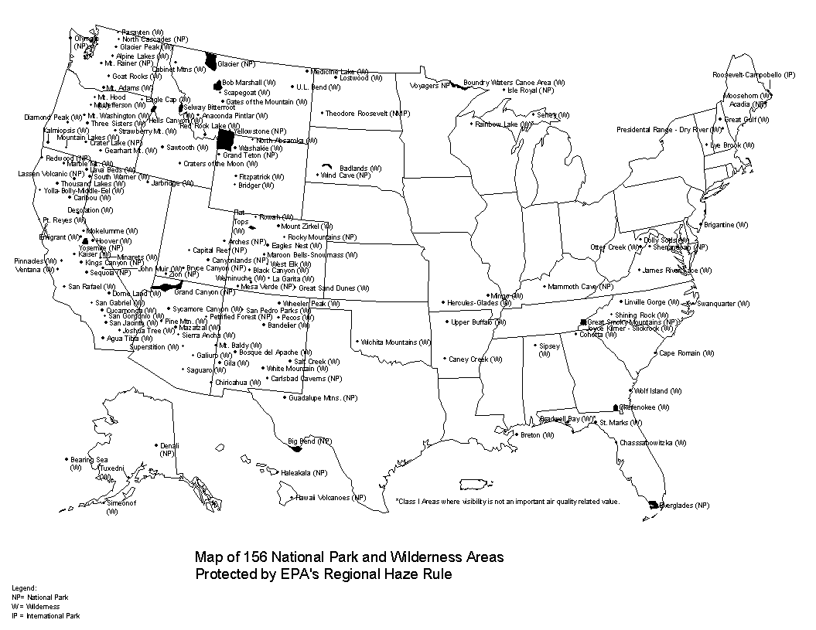

Appendix C – Nonattainment Areas in Montana and Idaho

Maps depicting current nonattainment areas for Montana can be found at the MTDEQ Nonattainment Area web page. In addition to the nonattainment areas listed there, the Libby area has been designated as nonattainment for PM_{2.5}. The State of Montana is required to submit a SIP for the Libby PM_{2.5} nonattainment area by 2008.

A map showing nonattainment areas for Idaho is depicted on the following page.
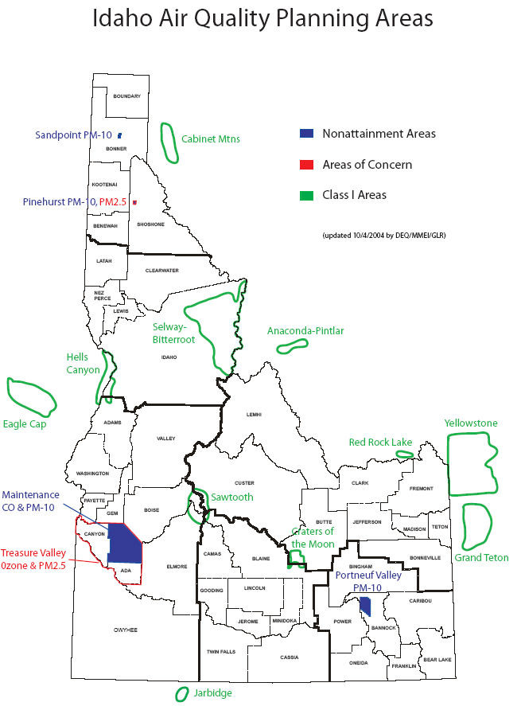

More information concerning Idaho nonattainment areas can be found at the IDDEQ Air Monitoring web site.

Appendix D – Montana and Idaho Airsheds

These Airsheds are those identified and used by the Montana / Idaho State Airshed Group for their operations. Areas bordered in yellow indicate airshed impact zones. Appendix E contains more information about the Montana/Idaho Airshed Group.

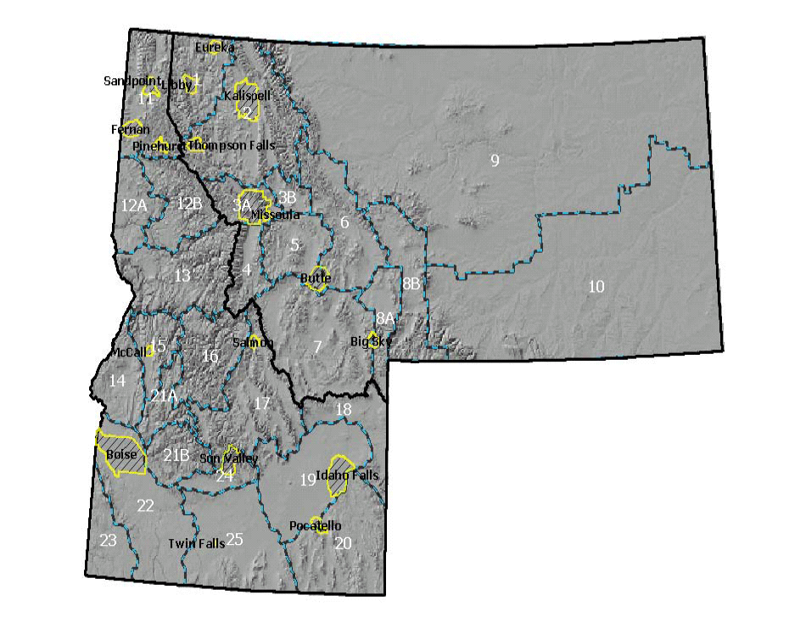

Appendix E – Montana/Idaho State Airshed Group

The Montana/Idaho State Airshed Group (www.smokemu.org) is composed of both public and private members who conduct extensive prescribed burning as well as the regulatory health agencies. The intent of the group is to minimize smoke impact to communities while using fire to accomplish land management objectives – e.g. reducing fuel hazards - and to comply with state laws. USFS Forests in Idaho and Montana are members of this organization.
The Montana/Idaho State Airshed Group is committed to a smoke management plan for reporting and coordinating burning operations on all forest and range lands throughout Montana and Idaho, developing alternative methods to open burning when possible, and improving the smoke management plan – based on its review at the end of each burning season. The Montana/Idaho State Airshed Group Operating Guide describes the current procedures followed by group members.
The Airshed Group is comprised of three units: Montana, North Idaho and South Idaho. The Montana Unit (formerly called the Montana State Airshed Group) was formed in 1978, The North Idaho Unit (formerly called the North Idaho State Airshed Group) in 1990, and The South Idaho Unit in 1998. The entities combined in December of 1998. Each unit has a Memorandum of Agreement and its own Smoke Management Plan. The three Units also have a joint operating plan detailing policies and procedures. Members agree to abide by the policies and procedures of the Airshed Group and their individual Unit plans.
The Smoke Monitoring Unit Coordinator, based in Missoula, Montana, coordinates the prescribed burning activities of the group. The Monitoring Unit Coordinator analyzes all available information for proposed burns, meteorology, and air quality to decide whether any restrictions are necessary. Restrictions can be: statewide, by individual airshed(s), by elevation within an airshed(s), by individual burn number, by impact zone, by time periods, by DEQ authority, or any combination of the above.
The operations of the Montana / Idaho State Airshed Group are critical to minimizing cumulative air quality impacts within Idaho and Montana.

Appendix F – FOFEM5 and SIS Spreadsheet Examples

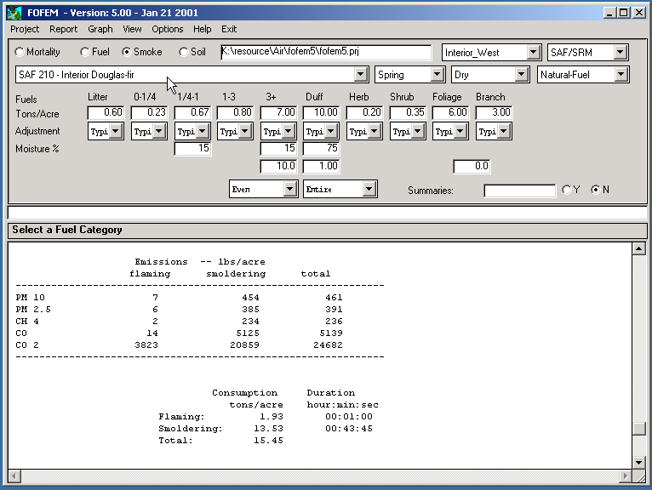

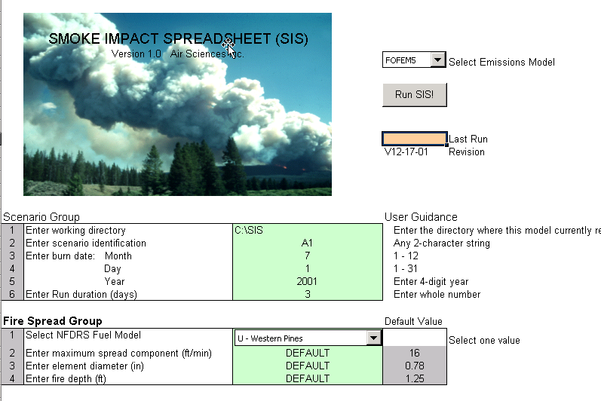
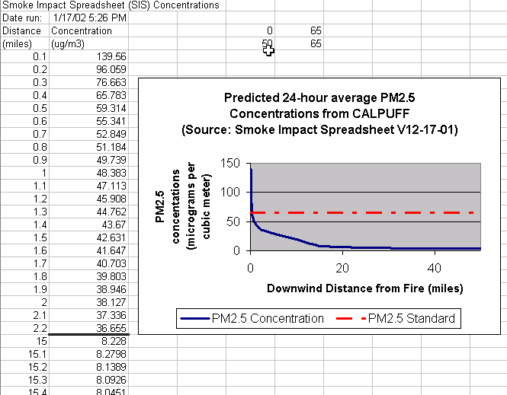

Design criteria are actions used to reduce effects on a resource of concern and are included in the “design” of the project. Generally they are the same as “mitigation measures” but are included in the design; where as mitigation measures may be identified in response to an issue or concern.
Mitigation measures are actions used to reduce effects on a resource of concern; they include avoiding the impact, minimizing the impact by limiting the degree or magnitude of the action; rectifying the impact by repairing, rehabilitating, or restoring the affected environment, reducing or eliminating the impact over time by preservation or maintenance operations during the life of the project; and compensating the impact by replacing or providing substitutite resources or environments. (40 CFR 1508.20)

