Lakeview Stewardship Landscape

A Proposal from the

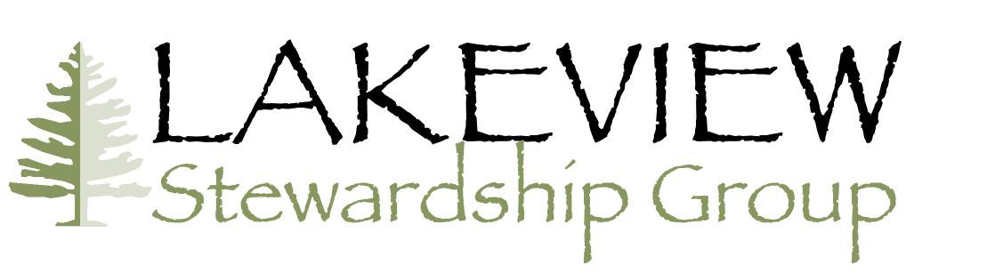

and
Fremont-Winema National Forests
for the
Collaborative Forest Landscape Restoration Program

February 11, 2011

For more information, contact:

Jim Walls | Mike Anderson
Lake County Resources Initiative | The Wilderness Society
100 North D Street Suite 202 | 720 Third Ave., Suite 1800
Lakeview, Oregon 97630 | Seattle, WA 98105
541-947-5461 | 206-624-6430 x227
Jim.walls@lcri.org | manderson@twsnw.org
Fred Way | Rachelle Huddleston-Lorton
Forest Supervisor | Acting District Ranger
Fremont-Winema National Forests | Lakeview Ranger District
1301 South G Street | 18049 Hwy 395
Lakeview, Oregon 97630 | Lakeview, Oregon 97630
541-947-6201 | 541-947-6385
fway@fs.fed.us | rhuddlestonlorton@fs.fed.us

Executive Summary

Dominant Forest Types: dry ponderosa pine, dry mixed conifer

Total Acreage of the Landscape: 662,289 Total acreage to receive treatment: 150,000
Total number of NEPA ready acres: 49,000 Number of acres in NEPA process: 46,000

Description of the most significant restoration needs and actions on the landscape:
Reduction of fuel levels to allow reintroduction of fire to the landscape. Thinning from below to help older trees maintain their vitality and sustain old-growth ecosystems.

Description of the highest priority desired outcomes of the project at the end of the 10-year period: A healthy, diverse, and resilient forest ecosystem that can accommodate human and natural disturbances. Opportunities for people to realize their material, spiritual, and recreational values and relationships with the forest.

Description of the most significant utilization opportunities linked to this project:
Removal of excess fuels will supply the local biomass plant that is currently under construction. Small-tree thinning will feed the new small-log sawmill.

Name of the National Forest, collaborative groups and other major partner categories involved in project development: Fremont-Winema National Forests and the Lakeview Stewardship Group that includes non-profit groups, commercial entities, state and local government, and individuals.

Describe the community benefit including number and types of jobs created:
The overall impact of the CFLR funding requested in the proposal is estimated at: 88.4 jobs and $3,389,744 in income. Additional impacts are associated with restoration on lands outside the Unit that support the local sawmill and cogen plant that were made possible by support for this proposal.

Total dollar amount requested in FY 11 $3,500,000
Total dollar amount requested for life of project $28,100,000.

Total dollar amount provided as Forest Service match in FY11: $3,558,022
Total dollar amount provided as Forest Service match for life of project: $39,272,343.

Total dollar amount provided in Partnership match in FY11: $217,500
Total dollar amount provided in Partnership match for life of project: $1,813,750

Total in-kind amount provided in Partnership match in FY11: $90,000
Total in-kind amount provided in Partnership match for life of project: $1,859,300

Time frame for the project (from start to finish): 2011 - 2020
Table of Contents

1. Ecological, Social and Economic Context 2
2. Summary of Landscape Strategy 5
3. Proposed Treatment 7
4. Collaboration and Multi-party Monitoring 11
5. Utilization 15
6. Benefits to Local Economies 16
7. Funding Plan 18
Attachments 21
Attachment A: Planned Accomplishment 22
Attachment B: Reduction of Related Wildfire Management Costs 27
Results – Cost Savings 27
Documentation of Assumptions and Data Sources 27
Attachment C: Members of the Collaborative 32
Attachment D: Letter of Commitment 33
Attachment E: Predicted Jobs Table 34
Attachment F: Funding Estimates 34
Attachment G: Maps 44

1. Ecological, Social and Economic Context

Ecological context: The Lakeview Federal Stewardship Unit (the Unit) defines the landscape for this proposal. The Unit’s eastern boundary includes part of the Warner Mountains, a fault-block mountain range overlooking Nevada’s Great Basin Desert. The Unit is bounded by National Forests to the north, south and west and BLM rangelands to the east. It is within the aboriginal lands of the Klamath Tribes. Lying within the rain shadow created by the Cascades, this forest is characterized by drought-tolerant tree species such as juniper and ponderosa pine, with abundant stands of white fir and lodgepole pine at high elevations. About 88% of Forest Service lands within the Unit are forested. The remainder is composed of sagebrush/steppe ecosystems.

The area receives about 15 inches of precipitation per year, except for the higher mountain locations. Highest monthly precipitation is generally in the winter months in the form of snow; summers are generally quite warm, and winters cold. Even with low precipitation, the Unit is an important source of water for the agricultural lands and municipalities located in the surrounding, relatively arid valleys. The Unit contains numerous small lakes, wetlands, springs, stock ponds and reservoirs.

Threatened, endangered and sensitive species found on the Unit include bald eagle, Warner sucker, Modoc sucker, redband trout, northwest pond turtle, Oregon spotted frog, Columbia spotted frog, bufflehead, pacific pallid bat, wolverine, gray flycatcher, blue-leaved penstemon, prostrate buckwheat, green buckwheat and green-tinged paintbrush.

Other major animal species include sage grouse, mule deer, black bear, mountain lion, Rocky mountain elk, and pronghorn. The Unit includes one of five Oregon initiatives for mule deer habitat improvement and Lake County has been identified as a priority area for sage grouse habitat improvement.

Ownership Patterns: The 662,289-acre Unit encompasses 174,652 private acres that include two large blocks of forested lands managed by The Collins Companies and many smaller blocks of rangelands and forestlands managed by others (see Attachment G - Vicinity Map).

Current Vegetation: People have substantially changed the landscape with construction of roads and dams, exclusion of fire, and with timber management. These landscape modifications led to the scientific findings of the Interior Columbia Basin Ecosystem Management Project that this area has low forest integrity and low or moderate aquatic integrity. A 1999 third party review commissioned by Sustainable Northwest and Lake County concluded that past practices had caused loss of habitat diversity leading toward management-created homogeneity across the landscape, soil compaction, high road densities, loss of mature forest structure, increased density and risk of fire, conversion from pine-associated to fir-associated types and loss of habitat for threatened and endangered species.

Extensively roaded, dry forests dominate the area. The majority of the roads in the Unit were constructed between 1960 and 1990, primarily to accommodate logging systems that required a significantly denser road network than is needed today. Road densities vary from watershed to watershed, generally in the range of 2.4 to 2.9 miles per square mile. Road construction and grazing activities have changed stream flows, altered riparian vegetation and degraded stream banks. Watershed analyses recommend road mileages in the range of 1 to 2 miles per square mile. Consequently, the Forest Service rarely builds new roads and instead has begun to close and decommission many roads in order to restore hydrological function and reduce maintenance costs, since funding for road maintenance is no longer sufficient to properly maintain these roads. The Long-Range Strategy for the Lakeview Federal Stewardship Unit (the Strategy) calls for continuation of this approach as incorporated into this proposal, consistent with the Travel Management Plan that was developed with public participation.

Juniper trees and invasive plants, like cheatgrass, are spreading rapidly to the detriment of native grasses, aspen groves, meadows and other important habitats. Forest structure and composition have been substantially altered from historical conditions. Drought, fire suppression, grazing, and intensive logging of large-diameter ponderosa pine all contributed to these changes. Unnaturally dense young forests, several years of drought and an intense pine beetle attack led to thousands of acres of dead lodgepole and ponderosa pine across the landscape in the last few years. This portion of the Unit is known locally as “the red zone” due to the number of dead trees. The combination of human activity and natural response has led to unhealthy, stressed stands with excessive fuel loads and a risk for severe fire over an exceptionally large area.

Desired Vegetation: Our goal for restored vegetation would more closely correspond to historic conditions, focusing on ponderosa pine, juniper, and shrub-steppe communities. Historically, the ponderosa pine forests were typically open and park-like, maintained by relatively frequent, low-intensity surface fires at 1 to 25 year intervals. Lodgepole pine forests were often maintained by infrequent, intense insect attack followed by high-severity stand-replacing fire. At higher elevations, mixed conifer and white fir stands saw fire and insect disturbances that varied in frequency and intensity, resulting in a wide range of conditions.

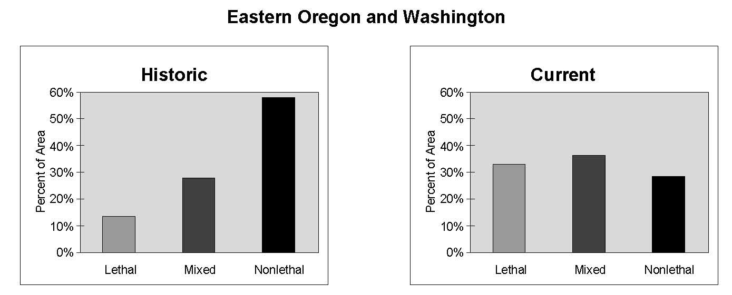Current Wildfire Conditions: The past practices described above are leading to increasing severity and burned acreages. Lake County Resources Initiative has collected data on the number and acreage of wild fires that burned within and adjacent to the Unit for the period 1980-2005. Notably, in the first decade the fires averaged about 430 acres, but between 1995 and 2005 the average exceeded 6,000 acres. Over the 25-year period, most of the acreage burned in 2002 due to the large Grizzly, Toolbox, and Winter Rim fires. Even omitting the 2002 fires, average acreage in the past decade exceeds 1500 acres, triple the previous decade. Climate change is likely contribution to warmer and drier weather, making Forest conditions even more susceptible to large-scale wildfire. The above graphics from the Integrated Scientific Assessment in the Interior Columbia Basin display these trends at a larger scale that includes the Unit.

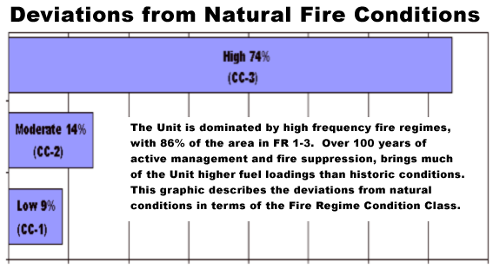
Desired Wildfire Conditions: Treatment by thinning and prescribed burning will reduce fuel loadings and break up vertical and horizontal continuity of fuels within stands and across the landscape. This will produce conditions where wildfires will have less damaging effects and can be more readily controlled.

Threats to Sustainability: Current vegetation and the various supported habitats are not sustainable in the face of extensive, uncharacteristically severe wildfire, drought and climate change. Without the vegetation changes we propose, fire could kill large areas of vegetation and old-growth ponderosa pine would remain vulnerable to drought and climate change. In the lodgepole pine, the unusually large extent of beetle-killed stands presents a risk of uncharacteristically large fire that could adversely affect regeneration, soils and watersheds.

Current Socio-Economic Conditions: Although the economy of this area is being temporarily buoyed by a major pipeline construction project, the most recent data from the Oregon Employment Department (Central Oregon Labor Trends · January 2011) indicates that the county’s seasonally adjusted unemployment rate at 15.7 percent in November 2010, was up from October’s rate of 15.0 percent. In November 2009, the rate was 12.9 percent. The county lost 70 jobs in November.

Future Socio-Economic Conditions: The only significant economic development underway in this area is the construction of a 26.8MW biomass plant by Iberdrola Renewable Resources – an investment of $70 million. The long-term success of this investment, and the 328 direct jobs the Oregon Business Development Department associates with it, hinges upon removal of biomass from this area as a by-product of restoration treatments proposed in the landscape strategy. A small-log sawmill was opened by Collins Companies in 2007. It too is dependent for its long-term viability on management of the Unit in accordance with the Strategy. These two local investments will help us meet our Trust obligations and result in long-term benefits to the Klamath Tribes.

2. Summary of Landscape Strategy

Hyperlink to the Long-Range Strategy: tinyurl.com/2011LFSUStrategy

Summary of the Strategy: The “Long-Range Strategy for the Lakeview Federal Stewardship Unit” (the Strategy) is the guiding document for the decade-long collaborative effort to help restore the ecological health of the Unit and provide economic and social benefits for the local community. The Strategy is based on a common vision and set of goals and objectives developed by the Lakeview Stewardship Group and adopted by the U.S. Forest Service. Originally released in November 2005, the Strategy was updated in 2010 and again in 2011.

The fundamental goals of the Strategy are to:
- Sustain and restore a healthy, diverse, and resilient forest ecosystem that can accommodate human and natural disturbances.
- Sustain and restore the land’s capacity to absorb, store, and distribute quality water.
- Provide opportunities for people to realize their material, spiritual, and recreational values and relationships with the forest.

To achieve the collaborative vision and goals of the Unit, the Strategy takes a holistic and scientific approach toward restoration. The Strategy builds on regional ecosystem assessments and local watershed analyses by the Forest Service and BLM, as well as independent scientific and university studies. It is also informed by the results of an intensive seven-year monitoring program conducted by Lakeview-area high school graduates under the supervision of experienced scientists.

The Strategy recognizes that restoration of the Unit will require comprehensive solutions to a variety of often inter-related problems. To address the risks associated with climate change, altered forest structure, and altered fire regimes, the collaborative has developed a strategic approach that prioritizes treatments based on restoration of key values and fuels reduction. The Strategy recommends an accelerated thinning and prescribed burning program, focused on the relatively dry, low-elevation ponderosa pine and mixed conifer forests. Where appropriate, proposed treatment areas may extend onto adjacent BLM administered lands. The remaining large, fire-resistant, old-growth trees should be retained wherever possible. Considerable care must be taken to monitor watershed processes, so management actions can be modified as needed. These modifications are intended to reduce or eliminate hydrologic and geomorphic concern and to protect the soil from excessive disturbance, compaction, erosion, loss of nutrients, and invasive plants. Restoration treatments will require no new permanent roads, and any temporary roads will be promptly decommissioned.

The Strategy calls for continuing and expanding the Lakeview monitoring program to ensure that management actions are having the intended effect and can be quickly modified based on locally relevant, new information. It also points out the need to upgrade logging equipment and develop new affordable equipment in order to minimize roads, soil compaction, and other potential impacts of an expanded thinning program.

Additional actions are needed to restore high-quality habitat and healthy populations of fish and wildlife. Closing unnecessary roads will benefit big game populations as well as improve water quality and stream habitats. Native riparian vegetation such as willows and aspen should be restored, and barriers to fish passage removed. Recognizing that the landscape is not equally in need of restoration work, the strategy recommends keeping roadless areas free of road building and logging.

Social, ecologic and economic significance of the landscape. The Unit provides important social and economic benefits to the nearby communities, including timber processed by the local Fremont Sawmill and many recreational resources that contribute to the enjoyment and quality of life for local residents and visitors alike. The Collins Companies’ addition of a $6.8 million small-log mill in 2007 has been an important investment in the Lakeview community and a turning point for restoration forestry in the Unit. In order to promote steady supply and utilization of small-diameter trees in the Unit, Collins and the Forest Service created the first ten-year stewardship contract in the Pacific Northwest.

The Collins Companies owns and manages 90,000 acres of the Collins Lakeview Forest within the Unit in accordance to the Principles and Criteria set by the Forest Stewardship Council (FSC). Collins forest management was certified in 1998 for demonstrating that their forest management meets the principles as required by the FSC. Principles include being good stewards of the land, reducing the environmental impacts that logging activities may have on the land, maintaining and enhancing the ecological functions of the forest, promoting restoration of the forest and respecting and supporting the local community. Collins Companies continue to demonstrate a commitment to forest health and sustainability within the Unit and share in that responsibility with the Forest Service. The Collins Companies’ long-standing tenure as natural resource stewards demonstrates a commitment to maintaining the health of the forest ecosystem, supporting the production of renewable forest products on a sustainable basis and providing social and economic benefits to the surrounding community.

In November 2010, Iberdrola Renewables began construction of a 26.8 megawatt biomass cogeneration plant in Lakeview. Under the terms of a biomass memorandum of understanding signed in 2007 by numerous public and private entities, the Forest Service has committed to producing biomass as a product of restoration treatments from at least 3,000 acres per year from the Unit. The biomass plant is key to improving the local economy and helping accomplish ecologically beneficial thinning projects within the Unit.

3. Proposed Treatment

Landscape Definition: The landscape is defined by the collaborative as the lands within the boundaries of the Lakeview Federal Stewardship Unit. The Unit was established in 1950 by the Secretary of Agriculture under the authority of the Sustained Yield Forest Management Act of 1944. The purpose of the Unit is to maintain economic stability for the communities of Lakeview and Paisley, Oregon. The Unit’s boundaries were designed to incorporate lands east of the Klamath Basin divide, within the Goose Lake basin, and a portion of the Warner Mountains, to the east, that had the potential to support community sustainability through forest management activities. (See attached maps.)

Forested National Forest System lands: There are 433,087 acres of forested National Forest System lands in the 662,289 acre Unit, and 373,834 of those acres are subject to active vegetative management (i.e. not Wilderness, etc).

Ecological restoration goals, treatment objectives and types of treatments proposed: The goals of the Strategy are listed in Section 2, above. The desired outcomes and typical treatments that promote the goals of the Strategy include:

DESIRED OUTCOMES  From the Long-Range Strategy | TYPICAL TREATMENTS  and ACTIVITIES
Restore forest health and conditions that approximate historical species composition and stand ages  Restore stand-maintenance fire regimes | Commercial thinning down to 7” dbh, removal of small trees for biomass (less than 7” dbh), prescribed fire, mechanical slash treatment – mastication, planting, juniper removal
Maintain and improve aquatic and riparian habitat for native species by lowering stream temperatures and sediment loads  Eliminate and control spread of noxious weeds  Reduce road density while improving remaining roads to minimize impacts on water quality and flow | Aspen enhancement; in-stream placement of large wood; culvert removal; headcut treatment; enhancement of movement for aquatic organisms  Road maintenance actions including clearing brush and trees from the travel-way, ditch and culvert cleaning, slough and slide removal, blading and watering  Installation of waterbars, dips, and earthen berms and/or cross ditches, decommissioning, and re-contoured to minimize erosion potential  Road closures
Improve opportunities to fish, hunt and view nature by maintaining and restoring habitats for focal species  Promote environmentally responsible recreation | Through forest and riparian treatments described above and implementing the Travel and Access Management Plan.
Enhance the local economy and community wellbeing thru innovative contractual mechanisms and technologies focused on linking stewardship activities and community well-being  Pursue compensation of local workers at a state-average family wage or higher to accomplish ecosystem management  Promote a local business environment that can take advantage of the products and services of ecosystem management that produces small diameter and under-utilized species | Design contracts to promote opportunities for year-round, long-duration, stable employment. Design product sales and service contracts to promote participation by local vendors, purchasers and contractors  Use stewardship authorities to provide for retained receipts, goods for services, multi-year contracts, and HUB Zone contracting.  Continued adherence to the Memorandum of Understanding for a sustainable supply of forest products
Manage upland vegetation to maintain and restore water and moisture absorption, retention, and release-capacity over time  Improve the biophysical structure of soils | Implement mountain mahogany enhancement and other vegetative treatments (listed above), while using best management practices for soil conservation
Protect and maintain areas of cultural significance within the forest | Through consultation with the Klamath Tribes and others with monitoring and adjustments to activities as needed

Past restoration activities: Restoration activities in the Unit began in earnest in 2001. From 2001 through 2009, an average of 2,991 acres of commercial treatments; 3,976 acres of non-commercial fuel reduction; and 5,515 acres of prescribed burning occurred each year (some acres overlap). Through 2005 the acres of commercial treatment primarily consisted of fire salvage treatments. Since then, commercial treatments have focused on green tree thinning and will be followed by under-burning. The series of activities needed to achieve desired conditions is underway and beginning to have an effect, but since they are not complete, very little of the Unit can be considered to be in a desired condition. Within the “red zone” creation of safety zones along roads and around other critical areas provide the opportunity to manage for increased heterogeneity on the landscape.

Schedule of treatments: In the coming ten years, given adequate funding, the Forest Service and partners should be able to plan and conduct various forms of restorative treatments on about 200,000 acres in and around the Unit. Major landscape-scale projects on the drawing board include Deuce in the Paisley District and East Drews in the Lakeview District. See Attachment A for the detailed ten-year schedule of planned treatments.

Strategic implementation: Treatment priorities are based upon:
- The relationship to private lands and the wildland urban interface (South-Central Lake County Community Wildfire Protection Plan);
- Threatened, endangered and sensitive species’ habitat (e.g. Warner and Modoc suckers, bald eagle, red band trout and many others);
- Results of the Southern Oregon/Northern California Coordinated Resource Offering Protocol (CROP) analysis (biomass loading);
- Values Assessment developed by The Nature Conservancy;
- Priority watersheds
Within the “red zone” (see Attachment G) treatments are strategically placed to make the remaining green stands more resistant to insect attack and wildfire. The strategy recognizes that the lands of the Unit are not equally in need of restoration. Part of the Unit is within the Gearhart Mountain Wilderness (7,207 acres in the Unit) and six inventoried roadless areas (63,962 acres in the Unit). These lands would remain roadless and free of logging activities.

Desired conditions and strategy for achieving them: The goal is to return fire to the role it historically filled and thus return sustainability to the forested lands within the Unit. The desired result is an ecosystem within its natural range variability. Proposed treatments will change fuel strata, resolve the extreme threat of severe fire over a broad area, promote healthy forest conditions and allow fire to take a more natural role. Treatments are planned, developed and implemented on a watershed basis as displayed on the attached Landscape Map. Where appropriate, treatment areas will be expanded to incorporate adjacent BLM lands.

Old growth stands and large trees: An analysis of current conditions found 199,707 acres of old-growth on Federal lands within the Unit. Third-party monitoring of the ponderosa pine old-growth reveals that it is in very late seral condition and will need thinning from below in order to maintain a strong presence of old ponderosa pine trees and restore appropriate site capacity. There are a few sites with heavy ponderosa pine reproduction, but these sites will also need management to maintain the health of the old ponderosa pine. Where lodgepole pine occurs with ponderosa pine stands, the lodgepole pine is reproducing very heavily and may replace ponderosa pine if left alone. Watershed analyses support this in finding that overstocked understories in many stands are causing overstory mortality of large trees and an unraveling of late/old seral forest characteristics. Proposed treatments will enhance the health of remaining old trees and allow the reintroduction of fire, where appropriate, to help sustain old growth conditions for the long term.

Best available science: The assessment of the conditions in this area is based upon work published as scientific findings of the Interior Columbia Basin Ecosystem Management Project. A third party review commissioned by Sustainable Northwest and Lake County, in 1999, confirmed the findings of the Interior Columbia Basin work. In 2003 the University of Washington Rural Technology Center evaluated fuel conditions across the Unit and the effectiveness of various treatments in reducing fire risk. From 2007 to 2009 a collaborative group under the auspices of The Nature Conservancy’s Fire Learning Network developed a treatment prioritization map for the Unit. The Conservancy then assessed the stakeholder-designed priority map with a Treatment Optimization scenario to describe the effects of balancing social preferences. In addition, The Conservancy analyzed focal wildlife species habitat, identified species representative of each plant community and evaluated historic and current habitat conditions. Habitat assessments identified species and areas where management would best meet ecological requirements (see: http://nw.firelearningnetwork.org/projects/27 ). In light of this science, watersheds were carefully examined as part of the Forest’s watershed assessment program. The field data collected and the recommendations developed in that effort were then used to develop alternative treatment scenarios and evaluate them as part of the public NEPA process.

NEPA status: The following Environmental Assessments and decisions have been completed in recent years: Jakabe Watershed Restoration (2006), Second Jakabe (2007), Abe Vegetation Management (2007), Launch Integrated Fuels and Vegetation Management (2008), Red Zone Safety Project (2009), and West Drews Vegetation Management (2009). Implementation is underway for a number of projects that were developed from these decisions including: Kava Stewardship, Abe Stewardship, Launch Stewardship, Rip Salvage, Lil Red, Doc Salvage, Dent North Stewardship, Dent Stewardship, and Stack Stewardship. Further Environmental Analysis is under way for the Deuce Fuels Reduction and Vegetation Management Project and the East Drews Project. NEPA decisions are in place for 2011 and 2012 activities and under development for the years beyond.

Wildfire: Treatments in the Unit are intended to restore fire regimes, especially fire dependent regimes, by treating the entire fuels strata. This will include reduction of surface fuel loadings to reduce flame lengths and rates of spread using prescribed fire, raising the canopy base height to reduce crown fire initiation by thinning from below, pruning, and small tree thinning. Finally, thinning from below and multi-story thinning will be used to reduce canopy bulk density and reduce crown fires. In combination, these treatments should reduce the effects of wildfire on soils to more natural levels.

After the initial treatments, maintenance of the area will be determined on an ecologically appropriate rotation schedule. Field surveys will be conducted and appropriate treatments will be prescribed. Generally treatments will involve broadcast burning as much of the excess biomass will be removed from timber stands before under-burning and used as biomass fuel for generation of electricity. Unplanned ignitions will take a role as an ecological process as well. This will create a healthier ecosystem, higher public and firefighter safety, and lower costs.

Wildland/Urban interface: Portions of the area are in the wildland/urban interface. This area is addressed in the South-Central Lake County Community Wildfire Protection Plan.

Cost reductions in management of uncharacteristic wildfire: The R-Cat spreadsheet was used to calculate the net change in anticipated fire program costs for the full proposal. It showed a savings of $8,080,140. Fire behavior modeling and recent wildfire events demonstrate that average fire size will be 41% smaller on the treated landscape. The reduction in average annual burned acreage (3529 acres untreated; 2082 acres treated) was the most important factor in the projected cost savings. Another factor was the reduction in cost due to reduced fire intensity. More details are provided in Attachment B.

4. Collaboration and Multi-party Monitoring

Collaborative efforts within the Lakeview Federal Stewardship Unit have been recognized as a national model by The Wilderness Society (Success Story and Video), Sustainable Northwest , the Redlodge Clearinghouse, the High Desert Museum of Bend, Oregon, The Forest Service PNW Region (2003 Caring for the Land and Serving People Award) and the U.S. House of Representatives (Congressional Record, November 1, 2007).

Members of the collaborative: Collaborators that make up the Lakeview Stewardship Group (the Group) represent most potential collaborators on the landscape. They include The Collins Companies, Concerned Friends of the Fremont-Winema, Defenders of Wildlife, Fremont-Winema National Forest, Lake County Chamber of Commerce, Lake County Resources Initiative, Lakeview High School, Lakeview Ranger District, Oregon Department of Economic and Community Development, Oregon Wild, Paisley Ranger District, Sustainable Northwest, The Nature Conservancy, The Wilderness Society, and local citizens (see Attachment C). Lake County Resources Initiative is currently seeking funds to further expand public participation and attract more collaborators. The Klamath Tribes are routinely consulted on projects in the Unit on a government to government basis.

Origin and Operations of the Collaborative: The Group was formed in 1998 to examine the policies tied to the Lakeview Federal Sustained Yield Unit and generally improve management of the unit. Their leadership and support resulted in the Unit being re-authorized in 2001 as the Lakeview Federal Stewardship Unit (the Unit) with a new restoration-focused policy statement (http://www.fs.fed.us/r6/frewin/projects/cert/syupolicy.pdf) The collaborative meets four times a year and stays in touch the remaining part of the year using conference calls and e-mail. Two of the meetings are held in the summer and fall so the LSG can review treatments and make recommendations if changes need to be made in the future. The group operates in a consensus mode.

Additional accomplishments: In 2005, the Group completed a long-range management strategy for the LFSU that was developed with the assistance of the Forest Service and is now being implemented. The Group completed a revision in 2010. It is this 2010 Long-Range Strategy for the Lakeview Federal Stewardship Unit that is the basis for this proposal.

The Group:
- formed Lake County Resources Initiative (LCRI), a non-profit corporation to promote local workforce training and sustainable economic development in 2002.
- in partnership with the University of Washington, explored the feasibility of addressing invasive juniper stands in the Unit, using the biomass removed and geothermal energy to generate electricity
- was instrumental in bringing together partnerships that led to the Unit being one of five units in the National Forest System evaluated in a 2006 certification study.
- identified the need to remove small timber and biomass for forest restoration and the associated need to find a market for these products and:
  - completed a biomass utilization study in 2004
  - in cooperation with the Forest Service and BLM had Mater Engineering conduct a Coordinated Resource Offering Protocol (CROP) for a biomass plant for electrical generation – a project now being constructed by Iberdrola Renewables, the world’s fourth largest electric utility.
  - focused attention on the need for a small log mill in the area. A $6.8 million small-log mill was put into operation by The Collins Companies in late 2007 – three national environmental groups were represented at the ribbon cutting.
- Fully supported the 2008 signing of a Memorandum of Understanding by the Forest Service, BLM, Oregon Department of Forestry, Collins Companies, Marubeni Sustainable Energy, Lake County, LCRI, Town of Lakeview, and the City of Paisley to provide a framework for restoration that would ensure, to the extent possible, a sustainable flow of biomass materials from Federal lands in the Unit.
- Formed a Biomass Implementation Team in 2006 and developed a framework for planning and implementing fuels reduction projects. The framework has been adopted, and the Team continues to meet monthly to stay informed on progress
- identified the need for better understanding of ecosystem processes within the Unit and:
  - brought together expertise and developed a long-term monitoring program as discussed below.
  - engaged with The Nature Conservancy to make the Unit a “participating landscape” in Northwest Fire Learning Network program to implement “a process that accelerates the restoration of landscapes that depend on fire to sustain native plants and animals.”
- recognizes that the depressed economy has reduced the value of materials being removed under the 10-year Stewardship Contract and has thus reduced funding available for non-commercial components of restoration. The Group has been extremely supportive of this project proposal and is working on other funding options including the possibility of offsetting some of the costs of Unit management.
- is supporting field tests to validate the forest carbon model (developed by the University of Washington and Yale University).
- Received, through the Wilderness Society, a $25,000 grant from The Liz Claiborne and Art Ortenberg Foundation for climate change work that will further enhance site-specific, science-based recommendations and produce a paper on resiliency.

Development of Monitoring Framework, Objectives and Implementation: The Group developed the Chewaucan Biophysical Monitoring Project, which has operated continuously since 2002. The project was designed to answer questions about current conditions and effects of management on the Chewaucan watershed within the Unit. One of the goals of the monitoring plan was to create a link with local schools, and that was accomplished by recruiting and training, each year, a monitoring field staff composed of high school and college students either currently or previously enrolled in Lake County schools (a social aspect of the effort). Hundreds of permanent transects were established in areas identified as characteristic of the Chewaucan sub-watersheds. These baseline transects were designed to be used as controls in future studies and as indicators of change.

In 2006, the project expanded into the rest of the Unit. Emphasis has been placed on matched-pair studies, using the initial sites for comparison. Some of the studies performed include: the effects of juniper treatments on soil, water availability, plant communities and erosion; the effects of prescribed burning on soil chemistry, and vegetation response; the impact of conifer removal in aspen stand enhancement; factors affecting mountain pine beetle infestations; the effects of culvert replacements on stream characteristics and fish migration; and a comparison of the recovery of roads decommissioned by sub-soiling, scarification, and blockage.

Tracking Indicators: The monitoring program allows public access to its processes and results through a website, http://www.lcri.org/monitoring/default.htm. The project goals are to collect relational indicator information from the landscape, from tree top to below ground on the same site; using equipment and methodologies that are relevant, sensitive, relatively inexpensive, standardized, repeatable, and usable; and to create a relational database that allows anyone to query inventory information from the watershed, in order to gauge rates of watershed repair over time.

Types of Monitoring: Effectiveness monitoring has been in place for seven years, assessing restoration projects such as prescribed burning, meadow repair, soil compaction, road density, wildfire, insect and disease and habitat fragmentation. The monitoring examines relationships and observes trends over time. For example, past monitoring examined areas that had been mechanically sub-soiled (ripped). The monitoring found that sub-soiled areas, while initially showing reduced soil compaction, ultimately become more compacted than their immediate surroundings. The furls formed by the rippers also become beds for invasive plants. As a result the Forest Service has significantly reduced use of this treatment. Other monitoring has confirmed the effectiveness of past treatments and their placement in the reduction of wild fire risk. Still other monitoring has identified the need for additional analysis of potential runoff increases in the Chewaucan watershed from the massive pine mortality in the area.
Ecological, Economic, and Social Dimensions: Ecological monitoring involves recording data collected in four main areas: aquatics, canopy, vegetation, and soils. That data is then analyzed and applied as discussed above. In addition to the ecological aspects, the monitoring program is designed to produce its own social and economic benefits, through its partnership with the local schools, and track the results. To date, two students who worked on monitoring in the Unit during high school have completed their PhD’s. Members of the monitoring teams have earned over $525,000 in scholarships by presenting papers at local, national and international science fairs. The Collaborative also tracks the socio-economic impacts that derive from its activities, including the opening of a small-log mill and the construction of Iberdrola Renewables’ $70 million biomass plant.

In addition to data being used locally, the monitoring program contributed information – a carbon analysis of prescribed fire treatments – to the West Coast Regional Carbon Sequestration Partnership. That partnership is assessing regional options for reducing CO₂ in the atmosphere. The program also collects data for Winrock International for a study on the effects of landscape treatments on carbon dioxide emissions.

Importance of the Collaborative Process: The collaborative has been absolutely essential in establishing the groundwork to make this proposal successful. The Group formulated the science into a workable strategy. It developed and is operating the monitoring program. In addition, the work that led to the 2007 opening of Collin’s small-log sawmill and the upcoming opening (2012) of Iberdrola’s biomass generating facility makes these treatments plausible and affordable. The collaborative also brings together a diverse collection of groups that were, in the past, taking conflicting positions that made developing supportable projects nearly impossible. Since developing the strategy and testing treatments through monitoring, the groups have helped the Forest Service develop projects that serve common interests. NEPA analyses that were often appealed are now developed in close cooperation with the collaborative and no longer face administrative appeals.

5. Utilization

With the opening of a small log mill in Lakeview, sawlogs down to 7” dbh are being utilized. Iberdrola Renewables is now constructing a plant for electrical generation in Lakeview (current estimated investment: $70 million) that will provide greater use of biomass.

Restoration Strategy and Treatments: The Forest Service has agreed, via the 2008 Memorandum of Understanding (MOU), to make available at least 3,000 acres of biomass-producing treatments on the Unit each year within the context of the Strategy. Past treatments under the MOU brought biomass to around 300 landings with an average of about 100 tons per landing awaiting utilization. The immediate availability of this material made Iberdrola’s biomass plant feasible. The BLM is currently issuing a new stewardship contract that will allow for multiple task orders to be issued over the next 10 years, making additional biomass available.

Material to be Utilized: Implementation of this proposal will accelerate biomass removal and lead to the following supportive treatments on NFS lands (acres partially overlap):

YEAR | BIOMASS REMOVAL  ACRES | SAWTIMBER REMOVAL  ACRES
2011 | 11,038 | 8,619
2012 | 7,295 | 3,600
2013 | 13,991 | 8,000
2014 | 12,440 | 5,600
2015 | 8,030 | 5,600
2016 | 13,280 | 7,200
2017 | 8,950 | 5,200
2018 | 6,330 | 4,800
2019 | 5,800 | 5,000
2020 | 5,780 | 3,500
Total | 92,934 | 57,119

Products Created and Their Value: Over the course of ten years, these treatments are expected to produce 123,740 mbf (241,293 ccf) of sawlogs and 465,000 green tons of biomass (6 tons/ac average). Merchantable logs above 7” dbh are now being processed at Collins Companies’ small log mill in Lakeview. Logs in the 5 to 7 inch range, larger cull logs and tops are currently being brought to landings for use as biomass. This is expected to continue under this proposal until the Lakeview biomass plant becomes operational. At that point this material will be sold as biomass and hauled from the landings to the plant.

Due to the lack of competition for biomass materials, those materials are expected to sell at base rates, $0.25/ccf. This amounts to less than $35,000 over the ten-year period of this proposal. However, selling the biomass creates a variety of benefits including the reduced cost of pile burning, reduced air pollution and the value of generated electricity. Sawlog sales will return $18/ccf in 2011 and an average of around $28/ccf for the remainder of the ten-year period. This totals to $6,192,000 over this ten-year proposal. These amounts will be used to help offset the costs of moving the non-commercial materials to landings under the stewardship contract that resulted in the removals ($210/ac or $16,259,000 over 10 years). Approval of this proposal will cover more of these costs and allow completion of the other ecological restoration work outlined elsewhere in this proposal.

If this material were left on the ground after sawlog removal, the cost of underburning to meet the goals for the treatments would be about $300 per acre, spread over 3 entries, and would be a higher risk operation. Once materials are removed to landings underburning can be completed in one entry at around $25 per acre for a savings of $275 per acre treated. Smoke management issues would also reduce the ability to treat the number of acres proposed. The biomass plant will be equipped with the latest pollution control equipment, allowing the material to be burned there without smoke issues.

Associated Industry: The biomass will ultimately be used to produce electricity. This adds considerable value to the raw biomass and contributes to the country’s energy independence. Due to biomass-fueled power plants qualifying for various state Renewable Power Standards (RPS), the output of a power plant in Lakeview fueled by biomass will earn a premium price. Information provided by the developer indicates the market price should be around $90/MWhr, including the renewable attributes. The plant being constructed in Lakeview is designed to produce 26.8 MW and operate 8,100 hours per year (92.5% availability). Thus, this plant should generate about 217,000 MWh/yr of electricity with a wholesale value in the vicinity of $19 million per year. Biomass from the Unit combined with biomass from other sources is making this plant possible. The availability of this power is clearly a benefit to the people of the U.S.

Sawlogs will be processed into lumber at the Lakeview sawmill, again adding considerable value to the raw materials. Once converted to boards at the Lakeview sawmill the wholesale value would be nearly $40 million at current wholesale lumber prices. The availability of this lumber is clearly a benefit to the people of the U.S.

6. Benefits to Local Economies

The Collins Companies invested approximately $6,700,000 in a small-log sawmill in Lakeview that is now processing logs from private and federal lands down to 7” dbh. Lakeview Co-Generation LLC, a subsidiary of Iberdrola Renewable Resources, is constructing a 26.8MW biomass plant and plans to invest $70 million in it. These two investments create a huge increase in restoration capacity. The following tables, developed by the Oregon Business Development Department, display the job and income impacts associated with the biomass plant and the small log mill.

Employment:
Impact Type | Direct | Indirect | Induced | Total
Small log mill | 65 | 29 | 15 | 109
Biomass Plant | 328 | 59 | 47 | 434
Total | 393 | 88 | 62 | 543

Labor Income (Wages):
Impact Type | Direct | Indirect | Induced | Total
Small log mill | $4,267,046 | $1,598,825 | $388,000 | $6,253,871
Biomass Plant | $14,234,517 | $2,811,562 | $1,188,328 | $18,234,407
Total | $18,501,563 | $4,410,387 | $1,576,328 | $24,488,278

Of the 434 jobs associated with the biomass plant, 316 are linked to construction over the next two years, 92 are associated with logging and 27 are associated with plant operations jobs. The non-construction jobs are expected to continue well beyond the 10-year duration of this project. The Forests’ ability to provide materials to these facilities is critical to their development and continued operation. When focusing only on the economic impacts associated with this proposal, the Treatments for Restoration Economics Analysis Tool revealed the following total employment and income effects:

Average Annual Impacts | Employment  (Part and Full-time Jobs) | Labor Income  (2010 Dollars)
Commercial Forest Products | 23.5 | $1,307,681
Other Project Activities | 41.8 | $1,785,380
FS Implementation and Monitoring | 23.1 | $323,682
Total Project Impacts | 88.4 | $3,389,743

Lake County Resources Initiative (LCRI), a non-profit corporation, provides training opportunities to better equip local contractors to compete for work in the woods. The Forest Service has been setting aside contracts for HUB Zone contractors to encourage local employment. LCRI administers a program (see Collaboration and Monitoring sections) that trains and employs local high school and college students to perform a wide range of monitoring activities within the LFSU.

LCRI asked the South Central Oregon Economic Development District to calculate the estimated yearly taxes that the biomass plant would provide to the county. The District found that Lake County taxing districts will receive $2.2 million/year for the full array of public services.

Oregon Business estimates every job created in rural Lake County is equivalent to 100 jobs in the Portland Metropolitan area. The current economic recession in the United States is similar to the Lake County experience over the past two decades. However, this recession has had far less of an impact in Lake County than other places in the country because of the sawmill, biomass plant and other renewable energy projects that are being implemented.

7. Funding Plan

The Forest Service is currently planning 71 projects over the 10-year term of this proposal. Forest Service investment in these projects is estimated at a total of $67,372,343. Of that, funding obtained from this proposal would contribute $28,100,000. These projects would achieve the goals of the Strategy within a 10-year period. This proposal is scalable so that funding at any level will move the landscape toward desired conditions. Reduced funding will cause the effort to take longer. Details of funding sources by year may be found in Attachment F.

Multi-party monitoring budget: Multiparty monitoring has been underway in the Unit since 2002 as described above. All parties are committed to the effort and have obtained needed funding from a variety of sources. The scale of this project is quite large, however the monitoring protocols have been carefully developed to focus on the most critical aspects of the Strategy. In addition, a partnership with the local high school has helped reduce costs considerably. It is expected that this monitoring will continue well beyond the next 15 years. The 2000 renewal of the Policy for the Unit, as signed by the Chief of the Forest Service, requires annual monitoring of socio-economic indicators including local labor and local contractors used. Purchasers of timber within the Unit are required to supply this information.

Federal and Non-Federal Investments: The Regional Forester has been using appropriated funds for planning, implementation, and monitoring of ecological restoration treatments on NFS lands in the Unit since the Long-Range Strategy was initially developed in 2005. The Regional Forester expects to continue funding at levels as listed in Attachment F. In addition, the Regional Forester will be providing approximately $300,000 per year for planning activities in support of these projects. A ten-year stewardship contract is in place for the Unit. CFLRP funds for 2011 and beyond can be immediately obligated to this contract via task orders and work can begin at once. These funds will combine with product value generated from restoration activities to insure that the full strategy is implemented more quickly.

This proposal includes no action under the jurisdiction of the Secretary of the Interior, however, some USDI funding is incorporated in this proposal as partner funding in 2011 and beyond. It is U.S. Fish and Wildlife Service funding for restoration activities on National Forest Lands. The BLM actively manages lands adjacent to the Unit. The activities on BLM ground continue to complement and supplement the work occurring on NF and other lands.

Several external partners have committed funds and in-kind work for restoration on National Forest lands, often in concert with work on adjacent private lands. Since 2002, the Fremont-Winema Resource Advisory Committee has allocated $2,933,795 of Title II funds for restoration projects in the Unit. These projects address juniper control, small-tree thinning, fuels treatments, noxious weed control, fish passage, and monitoring. More than $500,000 has been allocated to third-party monitoring efforts developed by the Lakeview Stewardship Group. RAC-funded projects underway in 2010 included 774 acres of small-tree thinning and fuels treatments for a total cost of $200,500 plus $395,537 for projects that will improve trail conditions, enhance wildlife and fish habitat, restore watershed conditions and treat thousands of acres for noxious weeds. Similar funding is expected in 2011.

The Oregon Watershed Enhancement Board (OWEB) has been focusing restoration funding on private lands within the Goose Lake watershed that are both within the boundaries of the Unit and hydrologically connected to it. From 2001 through 2009 OWEB provided $753,491 (plus match) for a variety of restoration projects in the Unit including juniper thinning, stream bank stabilization, and road. For 2011, the OWEB contribution is estimated at $1,039,807 (plus $13,200 match) primarily for the Goose Lake Wetland Enhancement and Riparian Restoration Project. This project is outside the Unit, but receives runoff from the Unit.

The Lake County Watershed Council has been working closely with the Forest Service and private landowners to return an important native desert redband trout fishery to the Chewaucan River, with dramatic results. Funding from Title II, OWEB, Oregon Department of Fish and Wildlife (ODF&W), private landowners and Forest Service appropriated funds led to a number of restoration projects since 2002 including the removal of most barriers to the passage of aquatic organisms. Efforts are underway to remove the final barriers on private lands toward the mouth of the river, to return the trout fishery. Additional investments from OWEB, ODF&W and others, for aquatic and upland habitat improvements as well as data collection, will total nearly $1 million between 2011 and 2012.

The Lake County Weed Management Area expects to provide over $100,000/year for noxious weed control on public and private lands within and adjacent to the Unit. Lake County will receive an estimated $2.5 million in mitigation funds from the Ruby Pipeline Project (construction underway). This will be spent on habitat improvement work on public and private lands within and adjacent to the Unit.

Funding from the National Forest Foundation, ODF&W and others will be used to treat 1,745 acres to improve mule deer habitat. Funding under Oregon’s mule deer initiative is estimated at $30,000 per year. ODF&W expects to provide $80,000 for sagebrush-juniper treatments in the Warner Mountains (eastern part of the LFSU). NRCS and others are funding sage grouse habitat improvements on nearly 2,000 acres between 2010 and 2012. Lake County Resources Initiative received a National Forest Foundation grant of $42,700 to be spent on habitat improvements within the LFSU in 2010 and 2011.

2011 | Partner | Contribution
 | USFWS - Thomas Creek Tributary Headcut Stabilization | $6,000
 | OWEB-Upper Chewaucan Habitat Enhancement | $46,500
 | JWTR,OWEB - Howard Creek Restoration | $50,000
 | ODFW - Mule Deer Initiative | $30,000
 | USFWS, NAWCA, EQUIP - Hay Creek Meadow/West Drews upland treatment | $70,000
 | National Forest Foundation | $15,000
 | CASH TOTAL | $217,500
 | Pacific Northwest Consortium for Science Delivery and Adoption | $50,000
 | The Wilderness Society Wildlife Habitat Resiliency Grant | $25,000
 | Third-party monitoring | $15,000
 | IN KIND TOTAL | $90,000

2012 | Partner | Contribution
 | ODFW - Mule Deer Initiative | $30,000
 | ODFW,Watershed Council,OWEB – Remove 2 culverts on Buck Creek | $30,000
 | National Forest Foundation | $15,000
 | Expected OWEB & USFWS | $100,000
 | CASH TOTAL | $175,000
 | Pacific Northwest Consortium for Science Delivery and Adoption | $50,000
 | Lake County Weed Management | $50,000
 | Third-party monitoring | $70,000
 | IN KIND TOTAL | $170,000

Abbreviations used in the above table:
OWEB = Oregon Watershed Enhancement Board (State)
JWTR = Jeld-Wen Timber Resources (Private)
ODFW = Oregon Department of Fish and Wildlife (State)
USFWS = U.S. Fish and Wildlife Service (Federal)
NAWCA = North American Wetlands Conservation Act (USFWS program)
EQUIP = Environmental Quality Incentives Program (USDA-NRCS program)

Beyond 2012, partnerships are estimated to continue with the ongoing programs as listed for 2012.

Attachments

Attachment A: Planned Accomplishment
Projected Accomplishments Table
Performance Measure | Code | Number of units to be treated over 10 years using CFLR funds | Number of units to be treated over 10 years using other FS funds | Number of units to be treated over 10 years using Partner Funds | CFLR funds to be used over 10 years | Other FS funds to be used over 10 years | Partner funds to be used over 10 years
Acres treated annually to sustain or restore watershed function and resilience | WTRSHD-RSTR-ANN | 7,506 | 7,494 | 680 | 1,738,918 | 1,573,000 | 136,050
Acres of forest vegetation established | FOR-VEG-EST |  | 802 |  |  | 280,700
Acres of forest vegetation improved | FOR-VEG-IMP | 75,064 | 74,936 | 6,800 | 17,389,180 | 15,730,000 | 1,360,500
Manage noxious weeds and invasive plants | INVPLT-NXWD-FED-AC | 650 | 250 | 403 | 226,000 | 100,000 | 126,000
Highest priority acres treated for invasive terrestrial and aquatic species on NFS lands | INVSPE-TERR-FED-AC | -- | -- | -- | -- | -- | --
Acres of water or soil resources protected, maintained or improved to achieve desired watershed conditions. | S&W-RSRC-IMP | 75,064 | 74,936 | 6800 | 17,389,180 | 15,730,000 | 1,360,500
Acres of lake habitat restored or enhanced | HBT-ENH-LAK | -- | -- | -- | -- | -- | --
Miles of stream habitat restored or enhanced | HBT-ENH-STRM | 33 | 7 | 25 | 3,500,000 | 700,000 | 2,601,250
Acres of terrestrial habitat restored or enhanced | HBT-ENH-TERR | 14,000 | 6,000 | 6,800 | 2,800,000 | 1,200,000 | 1,360,500
Acres of rangeland vegetation improved | RG-VEG-IMP | 10,000 | 5,000 | 4,500 | 2,000,000 | 1,000,000 | 907,000
Miles of high clearance system roads receiving maintenance | RD-HC-MAIN | 200 | 182 | -- | 90,000 | 81,900 | --
Miles of passenger car system roads receiving maintenance | RD-PC-MAINT | 500 | 444 | -- | 230,000 | 200,000 | --
Miles of road decommissioned | RD-DECOM | 269 | 125 | -- | 1,076,000 | 500,000 | --
Miles of passenger car system roads improved | RD-PC-IMP | -- | 50 | -- | -- | 2,250,000 | --
Miles of high clearance system road improved | RD-HC-IMP | -- | 11 | -- | -- | 750,000 | --
Number of stream crossings constructed or reconstructed to provide for aquatic organism passage | STRM-CROS-MTG-STD | 60 | 30 | 30 | 1,600,000 | 800,000 | 800,000
Miles of system trail maintained to standard | TL-MAINT-STD | -- | -- | -- | -- | -- | --
Miles of system trail improved to standard | TL-IMP-STD | -- | -- | -- | -- | -- | --
Miles of property line marked/maintained to standard | LND-BL-MRK-MAINT | -- | -- | -- | -- | -- | --
Acres of forestlands treated using timber sales | TMBR-SALES-TRT-AC | -- | 57,119 | -- | -- | 10,600,000 | --
Volume of timber sold (CCF) | TMBR-VOL-SLD | -- | 261,303 | -- | -- | 10,600,000 | --
Green tons from small diameter and low value trees removed from NFS lands and made available for bio-energy production | BIO-NRG | 147,252 | 31,554 | 31,554 | 9,450,000 | 2,100,000 | 2,100,000
Acres of hazardous fuels treated outside the wildland/urban interface (WUI) to reduce the risk of catastrophic wildland fire | FP-FUELS-NON-WUI | 77,088 | 74,936 | -- | 4,625,262 | 11,187,000 | --
Acres of hazardous fuels treated inside the wildland/urban interface (WUI) to reduce the risk of catastrophic wildland fire | FP-FUELS-NON-WUI | Xx | Xx | Xx | Xx | Xx | Xx
Acres of wildland/urban interface (WUI) high priority hazardous fuels treated to reduce the risk of catastrophic wildland fire | FP-FUELS-WUI | 8,565 | 8,326 | -- | 513,918 | 1,243,000 | --
Number of priority acres treated annually for invasive species on Federal lands | SP-INVSPE-FED-AC | -- | 860 | 1,700 | -- | 260,000 | 510,000
Number of priority acres treated annually for native pests on Federal lands | SP- NATIVE –FED-AC | -- | -- | -- | -- | -- | --

Attachment B: Reduction of Related Wildfire Management Costs

Results – Cost Savings

R-CAT Results
Lakeview Stewardship Landscape Restoration Proposal
Start Year | 2011
End Year | 2021
Total Treatment Acres | 150,000.00
Average Treatment Duration | 20
Discounted Anticipated Cost Savings - No Beneficial Use | $(5,835,052)
Discounted Anticipated Cost Savings - Low Beneficial Use | $(6,583,415)
Discounted Anticipated Cost Savings - Moderate Beneficial Use | $(8,080,140
Discounted Anticipated Cost Savings - High Beneficial Use | $(10,325,227)

Documentation of Assumptions and Data Sources
R-Cat computes the net change in the cost of fire management on untreated and treated landscapes. In general, fuel treatments result in a reduced cost of fire management operations (a negative net change), as displayed above. Reduced fire intensity and reduced resistance to control are the major factors that lowed costs. Inputs to R-Cat include average size of fires pre-treatment and post-treatment. Fire behavior modeling and recent wildfire events demonstrate that average fire size will be 41% smaller on the treated landscape. This is close to the 32% fire size reduction as modeled by Cathcart et al 2010 for Drew’s watershed. Fire size reduction is similar to that found on the Deschutes National Forest. Compared to the Deschutes National Forest, fuels treatments on the Unit are generally larger and more intensive. In addition, understory species are slower to revegetate following treatment.

The reduction in average annual burned acreage (3529 acres untreated; 2082 acres treated) was the most important factor in the projected cost savings. Another factor was the reduction in cost due to reduced fire intensity. The cost per acre to control a fire on the treated landscape is, conservatively, only 13% less than on the untreated landscape.

Treatments on the Unit generate about $26 - $65 per acre. The cost for treatments in the Unit was estimated at $250 per acre. More details about this analysis are provided in the table below.

This analysis was prepared by:

Ken Boucher, Fire modeling FSim/Stratified Cost Index - Telephone: 541-576-7520
Jesse Plummer, R-Cat cost savings and projections – Telephone 541-947-6160

Duration of treatments rationale: | Typically, our treatments within the proposed area reliably modify fire behavior for 20+ years.
All dollar amounts entered should reflect undiscounted or nominal costs, as they are discounted automatically for you in the R-CAT spreadsheet tool? Did you provide undiscounted costs, and in what year data are your costs and revenues provided. | Costs are Undiscounted.
Average treatment cost per acre rationale: | We Averaged our recent costs ($300-400 Mechanical; $180-333 for PCT; $100-200 Rx Fire)
Rationale for actual costs per acre of treatment by year is used: | Average of mechanical and prescribed fire implementation costs. Includes the cost of planning, sale prep, and sale administration.
Average treatment revenue per acre rationale: | Divided yearly Estimated Forest Product Value (Appendix A; line 5) by estimated annual acres treated.
This tool is intended to be used to estimate Forest Service fire program costs only, did you conduct your analysis this way or have you taken an all lands approach? | Forest Service Program costs only.
Total treatment acres calculations, assumptions: | Anticipated treatment acres in the proposal area to be available in the next 10 years
Treatment timing rationale with NEPA analysis considerations: | Completed and in-progress NEPA analyses will allow for 15,000 or more acres of treatment per year
Annual Fire Season Suppression Cost Estimate Pre Treatment, Assumptions and Calculations | FSim and SCI
Did you use basic Landfire Data for you Pretreatment Landscape? | Yes
Did you modify Landfire data to portray the pretreatment landscape and fuel models? | No, the defaults adequately described the fuels in the area
Did you use ArcFuels to help you plan fuel treatments | No
Did you use other modeling to help plan fuel treatments, if so which modeling? | Landfire data, FRCC maps, previous wildfire behavior and previous fire behavior/fuels treatment planning efforts were used to check estimates
Did you model fire season costs with the Large Fire Simulator? | No
If so, who helped you with this modeling? | N/A
If not, how did you estimate costs, provide details here: | Used Stratified cost index in WFDSS
Did you apply the stratified cost index (SCI) to your FSim results? | Yes
Who helped you apply SCI to your FSim results? | Forest Fuels Specialist colaboration
Did you filter to remove FSim fires smaller than 300 acres and larger than a reasonable threshold? | Yes
What is the upper threshold you used? | Fire size was set at 30,000 ac (Winter Fire 2002, Paisley RD)
Did you use median pre treatment costs per fire season? | Pre treatment costs were calculated using a weighted mean (same as for post treatment). Current conditions are 10% of the brush cost and 90% of the timber cost for fire management.
Did you use median post treatment costs per fire season? | Post-treatment costs were calculated using a weighted mean, assuming treatments will reduce the cost of fire management to 40% of the brush cost and 60% of the timber cost. Very conservative estimate (13% reduction in fire cost)
Did you test the statistical difference of the fire season cost distributions using a univariate test? | No
What were the results? | I expect significantly different fire sizes and costs pre and post treatment.
Did you estimate Burned Area Emergency Response (BAER) costs in you analysis? | Yes
Did you use H codes or some other approach to estimate these costs? | Used 5% of Fire Management Costs for pre treatment, and 3% post treatment per CFLRP Manual. I would assume that our pre treatment costs would be significantly higher based on recent fires.
Did these cost change between pre and post treatment? | Yes
Did you estimate long term rehabilitation and reforestation costs in your analysis? | No
How did you develop these estimates, and did these cost change between pre and post treatment? | 5% of Pre-treatment differed from 3% of Post-treatment. Both very conservative estimates considering the BAER for Winter Fire of 2002.
Did you include small fire cost estimates in your analysis? | Yes
If so, how did you estimate these costs, what time period is used as a reference, and did these cost change between pre and post treatment? | We estimated mean annual small fire costs by using recent severity funding and local fire (<300 ac) costs. Conservative estimate.
Did you include beneficial use fire as a cost savings mechanism in your analysis? | Yes
How did you estimate the percent of contiguous area where monitoring is an option for pretreatment landscape? | Reviewed aerial photos and property maps for amount of contiguous area that may be available for less intensive tactics. I increased the cost of Fire Management to 50% of normal suppression costs for his area because these fires on our Forest will be managed more intensively than 100% monitoring.
How did you estimate the percent of contiguous area where monitoring is an option for post treatment landscape, and why did you select the percentage of your landscape for low, moderate, and high? | These were rough estimates of land area based on a review of ownership maps, recent fuels treatments, identified areas of opportunity, and identified priority treatments.
How did you derive an estimate for the percentage of full suppression costs used in fire monitoring for beneficial use? | Our fires will be managed more intensively than monitoring, but should take fewer resources than full suppression. Long-term benefits from managing fires were not included in this exercise.
Did you make any additional modifications that should be documented? | Published modeling of fire size reductions in one watershed of this area due to fuel treatments was 32% (Cathcart et al. 2010).

Attachment C: Members of the Collaborative
Organization Name * | Contact Name | Phone Number | Role
Retired FS | Chuck Graham | 541-947-4406 | Resources
Concerned Friends of Fremont-Winema | Chuck Wells | 541-783-2866 | Environment
The Wilderness Society | Mike Anderson | 206-624-6430 | Environment
Collins Pine Company | Paul Harlan | 541-947-2018 X 23 | Forest Products
OECDD | Larry Holzgang | 541- 882-9600 | Economy
LCRI & SNW | Jane O'Keeffe | 503-530-6202 | Process
SNW | Martin Goebel | 503-221-6911 | Process
None | Mark Gaffney | 541-783-2309 | Citizen
City of Paisley | Mark Douglas | 541- 943-3341 | Government
Action Realty | Deanna Walls | 541-219-1811 | Business
None | Clair Thomas | 503-801-4272 | Monitoring/Science
Town of Lakeview | Sandy Wenzel | 541-947-2076 | Government
Retired Defenders of Wildlife | Rick Brown | 503-869-7384 | Environment
Retired FS | Terry Sodorff | 541-947-5911 | Resources
None | Mark Valens | 541-533-2313 | Citizen
Fremont Sawmill | Lee Fledderjohann | 541-947-2018 | Forest Products
LCRI | Arlene Clark | 541-947-3032 | Process
LCRI | Jim Walls | 541-947-5461 | Process
Lake County | Dan Shoun | 541-947-6002 | Government
Iberdrola Renewables | Steve Jolley | 530-356-8626 | Biomass
The Larch Company & Oregon Wild | Andy Kerr | 503-701-6298 | Environment
Lake County | Brad Winters | 541-947-6005 | Government
Lake County | Ken Kestner | 541-947-6004 | Government
TNC | Mark Stern | 503-802-8133 | Environment
TNC | Craig Bienz | 541- 273-0789 | Environment
ODF | Dustin Gustaveson | 541-947-3313 | Forestry
Retired FS | Karen Shimamoto | 530-640-0649 | Resources
FS | Fred Way | 541-947-6201 | Forest Supervisor
FS | Allan Hahn | 541-947-6205 | Acting DFS
FS | Rachelle Huddleston-Lorton | 541-947-6328 | Acting Lakeview District Ranger
FS | Barbara Machado | 541-943-4401 | Paisley District Ranger
FS | Jody Perozzi | 541-353-2723 | SE Zone Planning

Abbreviations: LCRI: Lake County Resources Initiative SNW: Sustainable Northwest
OECDD: Oregon Economic and Community Development Department FS: Forest Service ODF: Oregon Department of Forestry

Attachment D: Letter of Commitment

To Whom It May Concern:

We, the undersigned members of the Lakeview Stewardship Group (LSG), are pleased to express our commitment to work collaboratively together to implement the Collaborative Forest Landscape Restoration Program (CFLRP) proposal for restoration work in the Lakeview Federal Stewardship Unit of the Fremont-Winema National Forests.

Formed in 1998 to restore the 500,000-acre Lakeview Unit, the LSG is a collaborative effort that includes conservationists, timber workers, local government officials, and other civic leaders. Our goals for the Unit are to:
• Sustain and restore a healthy, diverse, and resilient forest ecosystem that can accommodate human and natural disturbances.
• Sustain and restore the land’s capacity to absorb, store, and distribute quality water.
• Provide opportunities for people to realize their material, spiritual, and recreational values and relationships with the forest.

The Lakeview CFLRP proposal is solidly based on these goals and on the Long-Range Strategy for the Lakeview Federal Stewardship, which the LSG developed in 2005 and updated in 2010. Funding of the CFLRP proposal will greatly aid our efforts to achieve the goals of the Unit and implement the Long-Range Strategy.

Sincerely,
The Lakeview Collaborative Group
/s/ Jim Walls, LCRI
/s/ Andy Kerr, The Larch Company & Oregon Wild
/s/ Paul Harlan, Collins Companies
/s/ Rick Brown, Defenders of Wildlife (Retired)
/s/ Jane O’Keefe, LCRI, Sustainable Northwest
/s/ Deanna Walls, Action Realty
/s/ Mike Anderson, Senior Analyst, The Wilderness Society
/s/ Dan Shoun, Lake County Commissioner
/s/ Craig Bienz, The Nature Conservancy
/s/ Fred Way, US Forest Service
/s/ Allan Hahn, US Forest Service
/s/ Jody Perozzi, US Forest Service
/s/ Rachelle Huddleston-Lorton, US Forest Service
/s/ Clair Thomas, Citizen

Attachment E: Predicted Jobs Table

Predicted Jobs Table from Treat Spreadsheet: | Employment (# Part and Full-time Jobs) |  |  | Labor Inc (2010 $)
 | Direct | Indirect and Induced | Total | Direct | Indirect and Induced | Total
Thinning-Biomass:Commercial Forest Products
Logging | 8.3 | 13.3 | 21.6 | 540,403 | 608,572 | 1,148,976
Sawmills
Plywood and Veneer Softwood
Plywood and Veneer Hardwood
Oriented Strand Board (OSB)
Mills Processing Roundwood Pulp Wood
Other Timber Products
Facilities Processing Residue From Sawmills
Facilities Processing Residue From Plywood/Veneer
Biomass--Cogen | 1.1 | 0.7 | 1.8 | 104,998 | 53,707 | 158,706
Total Commercial Forest Products | 9.5 | 14.0 | 23.5 | 645,402 | 662,280 | 1,307,681
Other Project Activities
Facilities, Watershed, Roads and Trails | 10.1 | 6.4 | 16.6 | 562,772.3 | 311,222.3 | 873,994.6
Abandoned Mine Lands
Ecosystem Restoration, Hazardous Fuels, and Forest Health | 21.3 | 4.0 | 25.3 | 712,684.1 | 171,702.0 | 884,386.1
Commercial Firewood
Contracted Monitoring
FS Implementation and Monitoring | 20.9 | 2.2 | 23.1 | 233,640 | 90,042 | 323,682
Total Other Project Activities & Monitoring | 52.3 | 12.6 | 64.9 | $1,509,097 | $572,966 | $2,082,062
Total All Impacts | 61.7 | 26.6 | 88.4 | $2,154,498 | $1,235,245 | $3,389,744

Attachment F: Funding Estimates

FY-2011

Funds to be used on NFS lands for ecological restoration treatments and monitoring that would be available in FY 2011 to match funding from the Collaborative Forested Landscape Restoration Fund
Fiscal Year 2011 Funding Type | Dollars/Value Planned
FY 2011 Funding for Implementation | 3,513,022
FY 2011 Funding for Monitoring | 45,000
1. USFS Appropriated Funds | 1,197,350
2. USFS Permanent & Trust Funds | 23,700
3. Partnership Funds | 217,500
4. Partnership In-Kind Services Value | 90,000
5. Estimated Forest Product Value | 930,972
6. Other (specify)RAC Title II, Ruby Pipeline Mitigation | 1,098,500
FY 2011 Total (total of 1-6 above for matching CFLRP request) | 3,558,022
FY 2011 CFLRP request (must be equal to or less than above total) | 3,500,000
Funding off NFS lands associated with proposal in FY 2011 (does not count toward funding match from the Collaborative Forested Landscape Restoration Fund)
Fiscal Year 2011 Funding Type | Dollars Planned
USDI BLM Funds
USDI (other) Funds | 70,000
Other Public Funding | 250,000
Private Funding | 200,000

FY-2012

Funds to be used on NFS lands for ecological restoration treatments and monitoring that would be available in FY 2012 to match funding from the Collaborative Forested Landscape Restoration Fund
Fiscal Year 2012 Funding Type | Dollars/Value Planned
FY 2012 Funding for Implementation | 4,608,603
FY 2012 Funding for Monitoring | 103,000
1. USFS Appropriated Funds | 848,154
2. USFS Permanent & Trust Funds | 28,480
3. Partnership Funds | 180,250
4. Partnership In-Kind Services Value | 175,100
5. Estimated Forest Product Value | 389,619
6. Other (specify) RAC Title II, Ruby Pipeline Mitigation, CIP | 3,090,000
FY 2012 Total (total of 1-6 above for matching CFLRP request) | 4,711,603
FY 2012 CFLRP request (must be equal to or less than above total) | 4,000,000
Funding off NFS lands associated with proposal in FY 2012 (does not count toward funding match from the Collaborative Forested Landscape Restoration Fund)
Fiscal Year 2012 Funding Type | Dollars Planned
USDI BLM Funds
USDI (other) Funds | 50,000
Other Public Funding | 106,000
Private Funding | 206,000

FY-2013

Funds to be used on NFS lands for ecological restoration treatments and monitoring that would be available in FY 2013 to match funding from the Collaborative Forested Landscape Restoration Fund
Fiscal Year 2013 Funding Type | Dollars/Value Planned
FY 2013 Funding for Implementation | 2,859,287
FY 2013 Funding for Monitoring | 95,400
1. USFS Appropriated Funds | 1,138,440
2. USFS Permanent & Trust Funds | 59,360
3. Partnership Funds | 159,000
4. Partnership In-Kind Services Value | 169,600
5. Estimated Forest Product Value | 760,487
6. Other (specify) Ruby Pipeline Mitigation, CIP | 667,800
FY 2013 Total (total of 1-6 above for matching CFLRP request) | 2,954,687
FY 2013 CFLRP request (must be equal to or less than above total) | 2,900,000
Funding off NFS lands associated with proposal in FY 2013 (does not count toward funding match from the Collaborative Forested Landscape Restoration Fund)
Fiscal Year 2013 Funding Type | Dollars Planned
USDI BLM Funds
USDI (other) Funds | 50,88
Other Public Funding | 50,88
Private Funding | 212,000

FY-2014

Funds to be used on NFS lands for ecological restoration treatments and monitoring that would be available in FY 2014 to match funding from the Collaborative Forested Landscape Restoration Fund
Fiscal Year 2014 Funding Type | Dollars/Value Planned
FY 2014 Funding for Implementation | 2,838,179
FY 2014 Funding for Monitoring | 109,000
1. USFS Appropriated Funds | 1,171,042
2. USFS Permanent & Trust Funds | 39,949
3. Partnership Funds | 163,500
4. Partnership In-Kind Services Value | 185,300
5. Estimated Forest Product Value | 766,088
6. Other (specify) Ruby Pipeline Mitigation | 621,300
FY 2014 Total (total of 1-6 above for matching CFLRP request) | 2,947,179
FY 2014 CFLRP request (must be equal to or less than above total) | 2,900,000
Funding off NFS lands associated with proposal in FY 2014 (does not count toward funding match from the Collaborative Forested Landscape Restoration Fund)
Fiscal Year 2014 Funding Type | Dollars Planned
USDI BLM Funds
USDI (other) Funds | 54,500
Other Public Funding | 54,500
Private Funding | 218,000

FY-2015

Funds to be used on NFS lands for ecological restoration treatments and monitoring that would be available in FY 2015 to match funding from the Collaborative Forested Landscape Restoration Fund
Fiscal Year 2015 Funding Type | Dollars/Value Planned
FY 2015 Funding for Implementation | 2,850,349
FY 2015 Funding for Monitoring | 113,000
1. USFS Appropriated Funds | 1,126,633
2. USFS Permanent & Trust Funds | 36,815
3. Partnership Funds | 169,500
4. Partnership In-Kind Services Value | 192,100
5. Estimated Forest Product Value | 794,201
6. Other (specify) | 644,100
FY 2015 Total (total of 1-6 above for matching CFLRP request) | 2,963,349
FY 2015 CFLRP request (must be equal to or less than above total) | 2,900,000
Funding off NFS lands associated with proposal in FY 2015 (does not count toward funding match from the Collaborative Forested Landscape Restoration Fund)
Fiscal Year 2015 Funding Type | Dollars Planned
USDI BLM Funds
USDI (other) Funds | 56,500
Other Public Funding | 56,500
Private Funding | 232,000

FY-2016

Funds to be used on NFS lands for ecological restoration treatments and monitoring that would be available in FY 2016 to match funding from the Collaborative Forested Landscape Restoration Fund
Fiscal Year 2016 Funding Type | Dollars/Value Planned
FY 2016 Funding for Implementation | 2,450,233
FY 2016 Funding for Monitoring | 116,000
1. USFS Appropriated Funds | 1,123,924
2. USFS Permanent & Trust Funds | 36,076
3. Partnership Funds | 174,000
4. Partnership In-Kind Services Value | 197,200
5. Estimated Forest Product Value | 977,033
6. Other (specify) CIP | 58,000
FY 2016 Total (total of 1-6 above for matching CFLRP request) | 2,566,233
FY 2016 CFLRP request (must be equal to or less than above total) | 2,500,000
Funding off NFS lands associated with proposal in FY 2016 (does not count toward funding match from the Collaborative Forested Landscape Restoration Fund)
Fiscal Year 2016 Funding Type | Dollars Planned
USDI BLM Funds
USDI (other) Funds | 58,000
Other Public Funding | 58,000
Private Funding | 232,000

FY-2017

Funds to be used on NFS lands for ecological restoration treatments and monitoring that would be available in FY 2017 to match funding from the Collaborative Forested Landscape Restoration Fund
Fiscal Year 2017 Funding Type | Dollars/Value Planned
FY 2017 Funding for Implementation | 2,230,824
FY 2017 Funding for Monitoring | 119,000
1. USFS Appropriated Funds | 1,191,160
2. USFS Permanent & Trust Funds | 37,515
3. Partnership Funds | 178,500
4. Partnership In-Kind Services Value | 202,300
5. Estimated Forest Product Value | 740,349
6. Other (specify) | 0
FY 2017 Total (total of 1-6 above for matching CFLRP request) | 2,349,824
FY 2017 CFLRP request (must be equal to or less than above total) | 2,300,000
Funding off NFS lands associated with proposal in FY 2017 (does not count toward funding match from the Collaborative Forested Landscape Restoration Fund)
Fiscal Year 2017 Funding Type | Dollars Planned
USDI BLM Funds
USDI (other) Funds | 59,500
Other Public Funding | 59,500
Private Funding | 238,000

FY-2018

Funds to be used on NFS lands for ecological restoration treatments and monitoring that would be available in FY 2018 to match funding from the Collaborative Forested Landscape Restoration Fund
Fiscal Year 2018 Funding Type | Dollars/Value Planned
FY 2018 Funding for Implementation | 2,299,526
FY 2018 Funding for Monitoring | 123,000
1. USFS Appropriated Funds | 1,094,913
2. USFS Permanent & Trust Funds | 32,628
3. Partnership Funds | 184,500
4. Partnership In-Kind Services Value | 209,100
5. Estimated Forest Product Value | 864,485
6. Other (specify) Legacy Roads | 36,900
FY 2018 Total (total of 1-6 above for matching CFLRP request) | 2,422,526
FY 2018 CFLRP request (must be equal to or less than above total) | 2,400,000
Funding off NFS lands associated with proposal in FY 2018 (does not count toward funding match from the Collaborative Forested Landscape Restoration Fund)
Fiscal Year 2018 Funding Type | Dollars Planned
USDI BLM Funds
USDI (other) Funds | 61,500
Other Public Funding | 61,500
Private Funding | 246,000

FY-2019

Funds to be used on NFS lands for ecological restoration treatments and monitoring that would be available in FY 2019 to match funding from the Collaborative Forested Landscape Restoration Fund
Fiscal Year 2019 Funding Type | Dollars/Value Planned
FY 2019 Funding for Implementation | 2,394,638
FY 2019 Funding for Monitoring | 127,000
1. USFS Appropriated Funds | 1,160,145
2. USFS Permanent & Trust Funds | 46,863
3. Partnership Funds | 190,500
4. Partnership In-Kind Services Value | 215,900
5. Estimated Forest Product Value | 844,730
6. Other (specify) CIP | 63,500
FY 2019 Total (total of 1-6 above for matching CFLRP request) | 2,521,638
FY 2019 CFLRP request (must be equal to or less than above total) | 2,500,000
Funding off NFS lands associated with proposal in FY 2019 (does not count toward funding match from the Collaborative Forested Landscape Restoration Fund)
Fiscal Year 2019 Funding Type | Dollars Planned
USDI BLM Funds
USDI (other) Funds | 63,500
Other Public Funding | 63,500
Private Funding | 254,000

FY-2020

Funds to be used on NFS lands for ecological restoration treatments and monitoring that would be available in FY 2020 to match funding from the Collaborative Forested Landscape Restoration Fund
Fiscal Year 2020 Funding Type | Dollars/Value Planned
FY 2020 Funding for Implementation | 2,146,282
FY 2020 Funding for Monitoring | 131,000
1. USFS Appropriated Funds | 1,065,685
2. USFS Permanent & Trust Funds | 48,339
3. Partnership Funds | 196,500
4. Partnership In-Kind Services Value | 222,700
5. Estimated Forest Product Value | 744,058
6. Other (specify) CIP | 0
FY 2020 Total (total of 1-6 above for matching CFLRP request) | 2,277,282
FY 2020 CFLRP request (must be equal to or less than above total) | 2,200,000
Funding off NFS lands associated with proposal in FY 2020 (does not count toward funding match from the Collaborative Forested Landscape Restoration Fund)
Fiscal Year 2020 Funding Type | Dollars Planned
USDI BLM Funds
USDI (other) Funds | 65,500
Other Public Funding | 65,500
Private Funding | 260,000

Attachment G: Maps

Vicinity Map

Project Map

Collaborators Restoration Projects

The Nature Conservancy Values Map

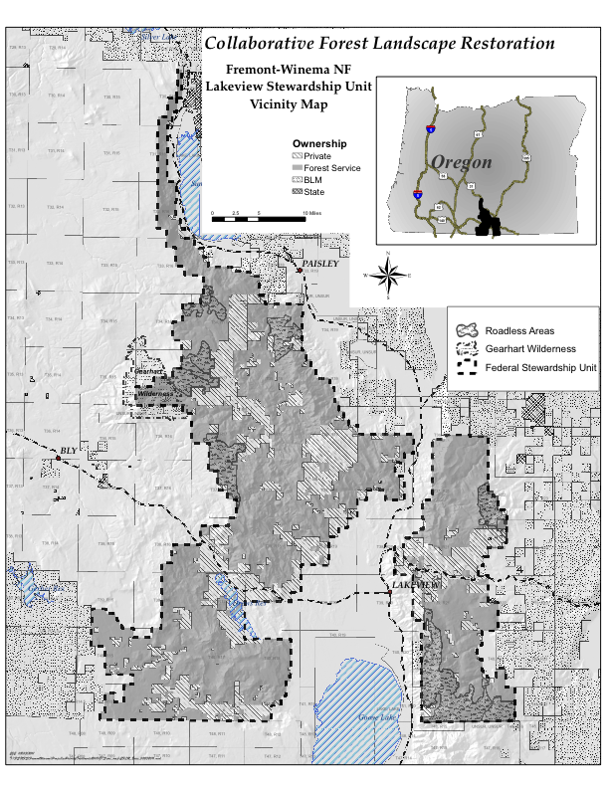
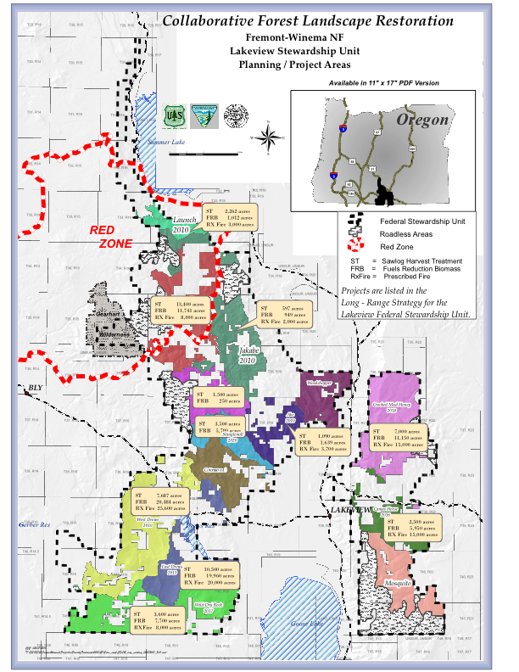
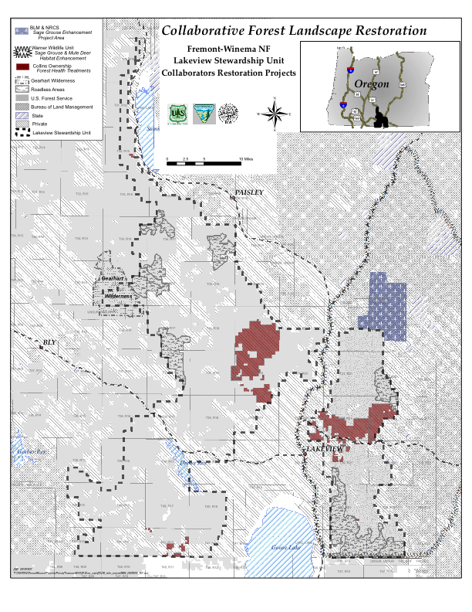

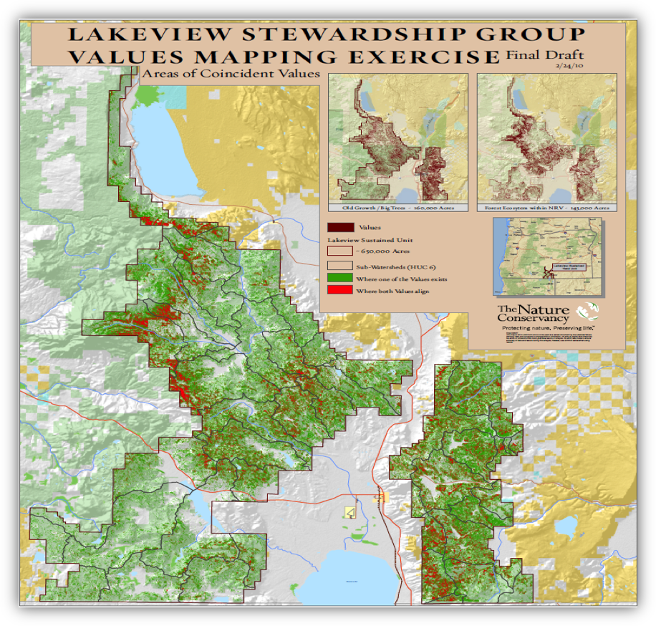
The Lakeview Stewardship Group chose the values below for the final draft

Old Growth / Large Trees
- Assumes that Trees with Large and X-Large structure are Old Growth.
- Based on new Forest Structure Classification process.
- Classification process – we used the Interagency Mapping Assessment Protocol Classes.

Forest Ecosystem within Natural Range of Variability
- Value assumes that areas identified require treatments to restore Natural Range of Variability within the Forest Ecosystem.
- Based on USFS Regional (Plant Association Guide) and LANDFIRE (Structural and FRCC) data.
- Identifies stands that are in a Frequent Fire Regime that are in the Mid and Late Successional Stage and are also highly Departed based on FRCC.

These values should reflect only units treated on National Forest System Land
Matching Contributions: The CFLR Fund may be used to pay for up to 50 percent of the cost of carrying out and monitoring ecological restoration treatments on National Forest System (NFS) lands. The following BLI’s have been identified as appropriate for use as matching funds to meet the required minimum 50% match of non-CFLR funds: ARRA, BDBD, CMEX, CMII, CMLG, CMRD, CMTL, CWFS, CWKV, CWK2, NFEX, NFLM (Boundary), NFMG (ECAP/AML), NFN3, NFTM, NFVW, NFWF, PEPE, RBRB, RTRT, SFSF, SPFH, SPEX, SPS4, SSCC, SRS2, VCNP, VCVC, WFEX, WFW3, WFHF. The following BLI’s have been identified as NOT appropriate for use as matching funds to meet the required minimum 50% match of non-CFLR funds: ACAC, CWF2, EXEX, EXSL, EXSC, FDFD, FDRF, FRRE, LALW, LBLB, LBTV, LGCY, NFIM, NFLE, NFLM (non-boundary), NFMG (non-ECAP), NFPN, NFRG, NFRW, POOL, QMQM, RIRI, SMSM, SPCF, SPCH, SPIA, SPIF, SPS2, SPS3, SPS5, SPST, SPUF, SPVF, TPBP, TPTP, URUR, WFPR, WFSU.

