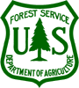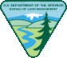

Northern Spotted Owl Prey Ecology --
What’s for Dinner?

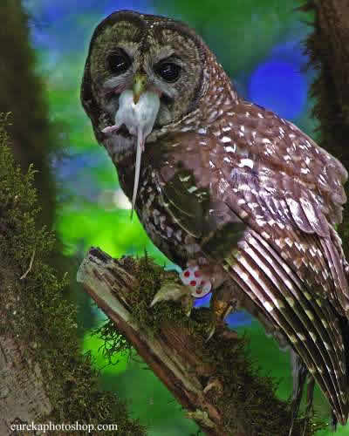 When: May 17, 2012
Purpose: To increase understanding of Northern Spotted Owl prey ecology to help land managers more effectively conserve this threatened species.

Open To: All State/Federal Resource Managers. RSVP by May 1, 2012 cfriesen@fs.fed.us

Where: Room 215, USFS and BLM Interagency Office Building, 3106 Pierce Parkway, Springfield, Oregon

Sponsors: The NW Oregon Ecology Group (Eugene and Salem BLM, Mt. Hood, Siuslaw, and Willamette National Forests, and Columbia River Gorge National Recreation Area), and the
Central Cascades Adaptive Management Partnership (Willamette National Forest, H.J. Andrews Experimental Forest, Eugene BLM, PNW Research Station, and Oregon State University)

Agenda
TIME | TOPIC | SPEAKER
9:15 – 9:20 | Welcome and Logistics | Facilitator – Cheryl Friesen, Science Liaison, Willamette National Forest
9:20 – 9:50 | Spotted Owl Prey Overview: Diet Composition and Biomass AND Overview of Small Mammal Trapping Study at HJA Experimental Forest  AGENDA CONTINUED | Eric Forsman, Wildlife Ecologist, PNW Research Station
TIME | TOPIC | SPEAKER
9:50 – 10:15 | Habitat Use and Ecology of the Northern Flying Squirrel | Todd Wilson, Wildlife Ecologist, PNW Research Station
10:15 – 10:30 | Young Stand Thinning and Diversity Study: Effects of Thinning and Gaps on the Northern Flying Squirrel | Joan Hagar, Wildlife Ecologist, USGS
10:30 – 10:40 | Break
10:40 – 11:05 | Ecology and Habitat Management for the Woodrats Dusky and Bushy-Tailed | Jim Heaney, Wildlife Biologist, Coos Bay BLM
11:05 – 11:35 | Ecology and Habitat Management for the Red Tree Vole | Eric Forsman, Wildlife Ecologist, PNW Research Station
11:35 – 12:00 | Effects of Thinning Young Douglas-fir Forests on Northern Flying Squirrels and Townsend’s Chipmunks | Bob Anthony, Dept. of Fisheries and Wildlife, Oregon State University (Formerly with the U.S. Geological Survey, Oregon Cooperative Fish & Wildlife Research Unit)
12:00 – 1:00 | Lunch
1:00 – 1:30 | Ecology and Habitat Management for Snowshoe Hare, Western Red Backed Vole, Deer Mice, and Pocket Gophers | Aaron Wirsing, Assistant Professor, School of Environmental and Forest Sciences, University of Washington
1:30 – 2:00 | Habitat Overlap Between the Northern Spotted Owl and Barred Owl | David Wiens, USGS
2:00 – 2:15 | Break
2:15 - 2:35 | Stand-Level Niches: How Does Everybody Fit In? | Todd Wilson, PNW Research Station
2:35 – 3:00 | Spotted Owl Prey in a Landscape Mosaic: Implications for Conservation | Brenda McComb, Dean, OSU Graduate School
3:00 - | General discussion for those who want to stay and viewing of pellet material

