Central Cascades Adaptive Management Partnership
Administrative Study Portfolio
Status and Funding Needs, November 2014
Studies listed herein are located on the Willamette NF. However, their findings are relevant beyond the WNF, and synthesis of their findings link with many other studies installed throughout the Pacific Northwest.. A 2006 GTR compiled by Anderson et al. displays the context for many of these studies in the Region.
On-Going Investments
Blue River Landscape Strategy
Tests the idea that historical fire information can be used as a framework for landscape and stand management.
Principle Investigator: Dr. Andy Gray, PNW Corvallis
Installations:
3 timber sales, all on MRRD:
N. Fork Quartz (50% retention in a >100 year old stand),
Blue River Face (30% retention in a >100 year old stand)
Trapper (would have been 15% retention in a >100 year old stand)
Status:
Challenges of harvest in older stands has halted the landscape experiment. Stand-level learning still possible from treatments implemented.

Trapper: Sale modified. Acreage of plots no longer available for post-harvest
monitoring. We collected pre-treatment data on the original sale.

N. Fork Quartz: 10 years of post-treatment data has been collected and analyzed.
If want to gather 20 year interval, need 20 plots in 2021.

Blue River Face: The units were NOT harvested all at the same time. Most have >10y
Unit BT2 will not have 10 years of data until 2022.
7 plots in 2015 ($800, Tim Fox)
23 plots in 2016 ($42,000 crew of 4 + Gary)
19 plots in 2017 ($42,000 crew of 4 + Gary)
3 plots in 2019 ($400, Tim Fox)
23 plots in 2021 ($42,000 crew of 4 + Gary)
7 plots in 2022 ($800, Tim Fox)

Future Opportunities:
We have a pretty solid data set to track how these stands develop over time with different retention levels. I don’t know of another study that is tracking change in this 140 year age class. The contrary point is that nobody is harvesting stands of this age class in the foreseeable future, so what would the data be used for? Their might be interest in looking at lichens and bryophytes recovery over time or some other social questions. We need a meeting to discuss.

Alternative 1:
I would recommend staying on track and getting NFQ through its 20 year interval and BRF through its 10 year interval. That will take until 2021, and cost what you see above. After that, we could moth ball the project for 20 years and go back in to measure NFQ and BRF’s 30 and 40 year interval, respectively.

Alternative 2:
Stay on track to get 10 year post-treatment data for all BRF units and moth ball NFQ now (it had a 10 year data interval accomplished in 2011). The cost would be $800 in 2015, 2016, 2017, and 2022.

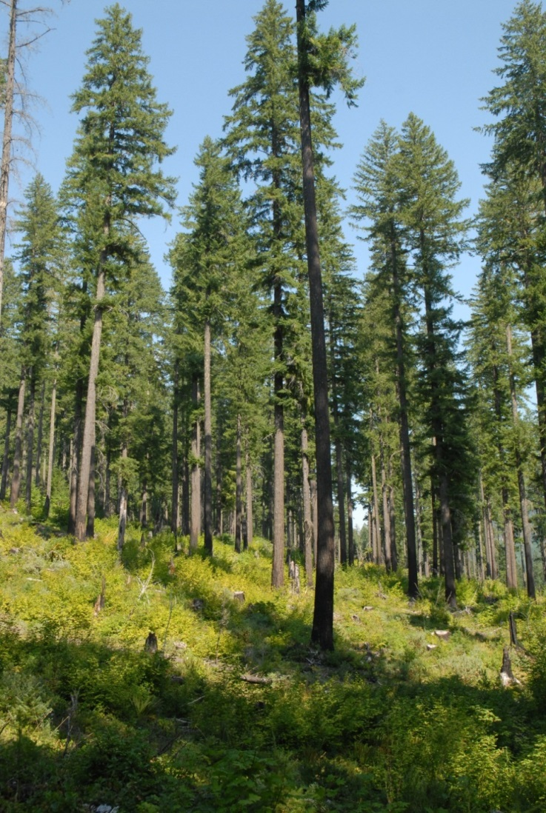 | 30% Retention  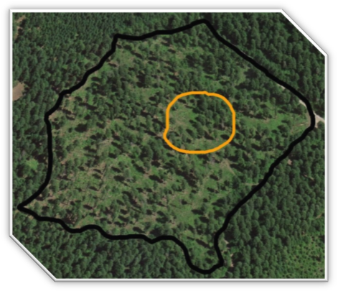

Young Stand Thinning and Diversity Study
Principle Investigator: Dr. Klaus Puettman, OSU and Dr. Todd Wilson, PNW Corvallis
A management study evaluating the ecological, operational, social, and economic consequences of managing ~50 year old plantations. Monitoring occurred for small mammals, amphibians/reptiles, birds, vegetation, logging costs, soil impacts, snags/down wood, stand damage, public perceptions, arthropods, chanterelles.
Installation:
4 timber sales on MRRD and MFRD. Each sale contains a control (261tpa), heavy thin (55tpa), light thin with gaps (105tpa + .5 ac gaps over 20% of area), and light thin (105tpa).
Mill Thin (MRRD)
Tap Thin (MFRD)
Flat Thin (MFRD)
Walk Thin (MFRD)

Status:
All stands originally clearcut in 1946
Thinned for experiment 1996-97
15 years of post-treatment data collected
20 year re-measurement opportunity in 2015/16
Establishment Report posted to CCAMP website and distributed
Participant Reunion held to formulate ideas for future.

Future Funded Plans:
- Obtained $50k (x3) from PNW competitive process in 2014 and $8k from BLM to fund a graduate student looking at drought stress in thinned and un-thinned stands. YSS offers control and 2 thinning intensities.

Future Opportunities:
- There is a strong interest to determine if the flying squirrel population has rebounded. The treated stands still had significantly fewer flying squirrels after 11-13 years of recovery compared to controls. If thinning is a treatment to promote late successional forest for spotted owls, but it reduces their primary prey base for a substantial amount of time, we may want to think differently about how we manage for flying squirrel populations across a landscape. Principle Investigators already obtained w/OSU and USGS. Study Plan Developed.
  - Funding need: One season of flying squirrel work would cost up to $101,000. To capture variability between years, it would be best to do this for 2-3 years in a row.
- There is an opportunity to determine if chanterelles and other mushrooms have recovered in the thinned stands. Their population was studied for 3-5 years after treatment, and they had not recovered. These are species of interest for many ecological as well as economic reasons. We’d like to know how long it will take for recovery following thinning. Principle investigators are available and interested at OSU. Study plan would replicate what was previously done.
  - Funding need: $ 24,000 field work/ one season. Best to do at least 2. $25,000 analysis and supervision. TOTAL: $73,000
The control stands in the YSS offer an opportunity to gather data on suppression mortality in un-thinned stands. This type of plot data can be used to fine-tune the mortality functions in models like FVS. Principle investigators with PNW and OSU are still on board.
  - Funding need: This could be offered as a graduate experience class.

- The PI’s were interested in following up on vegetation change every 5 years, shifting to every decade as change slows. 2015/2016 would give us an opportunity to capture 20 year post-treatment data.
  - Funding need: $90,000 for crew of 10.

- The PI’s were interested in continuing surveys of bird responses to the thinning treatments, with point count surveys every 5 years. 2015/2016 would give us an opportunity to capture 20 year post-treatment data.
  - Funding need: $79,500 per year

- The PI’s were interested in repeating the survey of nesting activity in the artificial snags, concurrent with the point counts, combining this with a survey of wildlife use of the trees damaged during harvest.
  - Funding need: $43,800 per year

- The PI’s were interested in continuing the salamander surveys every 6 months (May and November), but consider cutting back to spring checks only. 2012 was the last year measured.
  - Funding need: $10,900 per year
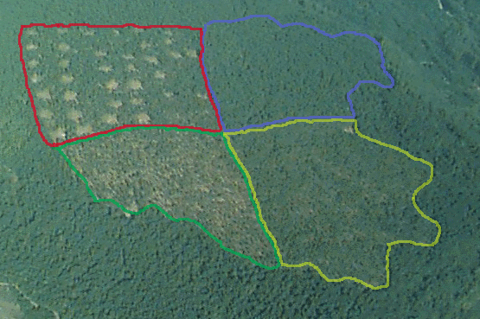
Uneven-Aged Management Project (UAMP)
Principle Investigator: Dr. Paul Anderson, PNW Corvallis
Tests silvicultural approach that would manage stands for continuous cover while extracting timber. There is no real rotation age with this approach.
Installation:
1 timber sale on MRRD/HJA. Sale name -- Thin Within. 304 acres.
4 replicates:
Control
light thin: thin from below to a RD of 30
light thin with small gaps: convert 10% of stand to a gap at every entry. Gaps ~ 1 tree
height
heavy thin: thin mostly from below to a RD of 20.

Threshold for re-entry for light thin and light thin with gaps is RD 50.
Threshold for re-entry for heavy thin is RD 40

Status:
All harvested at the same time in 2000
Last measured in 2010 (10 years post-treatment).
Intent was to re-enter within 10-15 years, which would be 2015.

Future Opportunities:
- There are challenges to continued implementation of the study plan as written in terms of economic feasibility and the goal of Douglas-fir regeneration. Light thinning and very small gaps do not carry the volume needed to re-enter. We may want to re-size the gaps and reschedule entry frequency.
- The District is meeting with the PI winter 2015 to re-configure the study to more accurately reflect contemporary group selection harvest practices.

  - Funding need: Crew of 6 plus crew leader = $60,000 to collect post/pre-treatment data (summer of FY15 if want to re-enter in 2017). PNW has put in for $30k to cover ½ of the costs. RO has suggested we could use pre-sale funds to collect the data.
  - If harvest in 2017/2018, would want to collect post-harvest data in 2019, then again 5 years later.
- 2015 $30-60k  - 2019 $30-60k  - 2024 $30-60k | 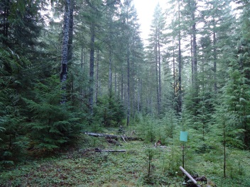

Bunchgrass Ridge Restoration Project
Principle Investigator: Dr. Charlie Halpern, University of Washington
Tests alternatives for restoring conifer-invaded montane meadows using tree removal with contrasting methods of fuel reduction

Installation:
1 timber sale on MRRD. Sale name – Bunchgrass Thin. 15 acres, 3 thousand board feet

There are three, 1-hectare replicates of each of three treatments, established on a mosaic of variously aged forests and residual-meadow openings:

1. Control (no tree removal)
2. Tree removal without broadcast fire (slash burned in small piles)
3. Tree removal with fire (slash broadcast burned)

Status:
Pre-treatment data collected in 2003/2004
Trees removed in Jan-Feb 2006
Treatments burned in Sep-Nov 2006
Post-treatment data collected in 2007, 2009, 2013

Future Opportunities
- Periodic sampling will provide information on changing rates and patterns of meadow community reassembly and how these are influenced by the nature of fuel treatments and conditions at the time of tree removal. The PI recommends a re-measurement interval of 4-5 years: 2017/2018 would be the next re-measurement.

  - Funding needs: 2017 and 2022 Re-measurement crew and data analysis = $63,800 each re-measurement

- The Management Plan for the Bunchgrass 9d needs to be re-written/updated. Dave Kretzing has volunteered to work on that for us over the next couple years. That work will help us determine future entry dates for continued meadow management. Cost=free.

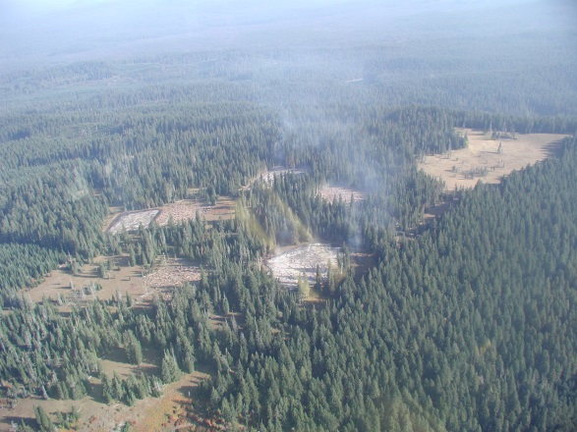 | 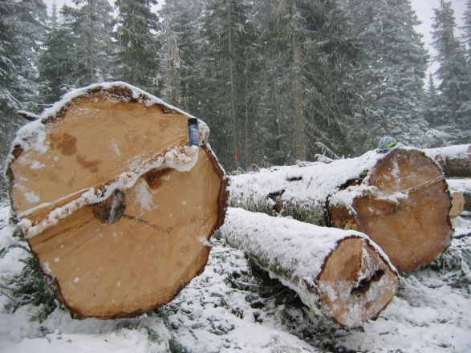

Long Term Ecosystem Productivity Study
Principle Investigator: Dr. Bernard Bormann, PNW Corvallis
A study to test the hypotheses that long term productivity is directly affected by influencing successional patterns, and by the amount of organic matter left on site during forest management activities. There are 3 main treatments: one emphasizes early seral species; another mid seral species, and a third late seral species and forest structure.
Installation:
1 timber sale on MRRD. Sale name – LTEP

The LTEP FSEIS changed the land allocation in the Isolation Block area (1500 acres) from MA 14a (general forest) to MA-3b: Integrated Research Area. The area is to be jointly managed by the WNF and the PNW Research Station. Although the primary emphasis will no longer be to produce an optimum yield of timber, activities proposed for the site are consistent with the production and harvest of timber on a sustained yield basis. For that reason, it was decided that the MA 3b would be maintained in the land base suitable for timber harvest.

There are 3 replicates:
  - Control
  - >80 year old stands clearcut and planted with DF (H, L down wood reps) 94 ac, 15% retention left outside of unit
  - >80 year old stands clearcut and planted with a mix of early seral, pioneer species (H, L down wood reps) 95ac 15% retention left outside of unit
  - >80 year old stand thinned and underplanted (H, L down wood reps) (pre 144 tpa, post-74 TPA >7” dbh)

Status:
Pre-treatment data collected in 1993
Treatment in 1998
2000, 2012 Trees and snags and understory vegetation measured*
2012 course and fine woody debris; soils, and soil respiration measured*
*data isn’t complete for any of the above.
PCT’D in 2011/2012

Future Opportunities
- Consolidating future commercial thinning in the early, mid and late seral stands within the same year was seen as desirable in the study plan to avoid a wide range of treatment dates. However, the early seral units will not be ready for a commercial thinning until 2020-2030, depending on site index. The late seral stands are ready to be commercially thinned now, as they have a stocking level that is about 60% of maximum Stand Density Index (SDI) and beginning to experience competition mortality. Since the stands are progressing along varying trajectories, the timing of treatments should be assessed by LTEP researchers and the McKenzie River Ranger District specialists.
  - Funding need: It has been 17 years since the stands were treated. Re-measuring the plots at year 20 (2018) would help determine timing of future entries into the thinned mature stands and would capture change following PCT in the clearcut units. The first entry into the mature stands was targeted for 2028 (30 years post-thin). The first entry into the early and mid seral treatments was targeted for 2033.

  - The post-treatment data collection for all the treatments is currently incomplete and not fully analyzed or published. It would make the most strategic sense at this time to halt additional data collection until 2018: then develop a plan for future treatments; what to re-measure; and new data collection for new questions.

  - Funding need: To fully re-measure all treatments at year 20 it would require $240,000- $273,000
- There are class III/IV riparian reserves that were treated as part of this study that could lend themselves to new avenues for inquiry.
Early .39 stream miles
Mid .45 stream miles
Late 1.05 stream miles

In units with class III’s that have plots, all deciduous trees and shrubs were to be maintained within 50’ horizontal distance on each side of the channel. We do have stream survey data before the treatment in 1992. This might be an opportunity to see if the habitat recovered. {2 mid, 8 early, 10 early, 18 early}. Funding need is unknown.

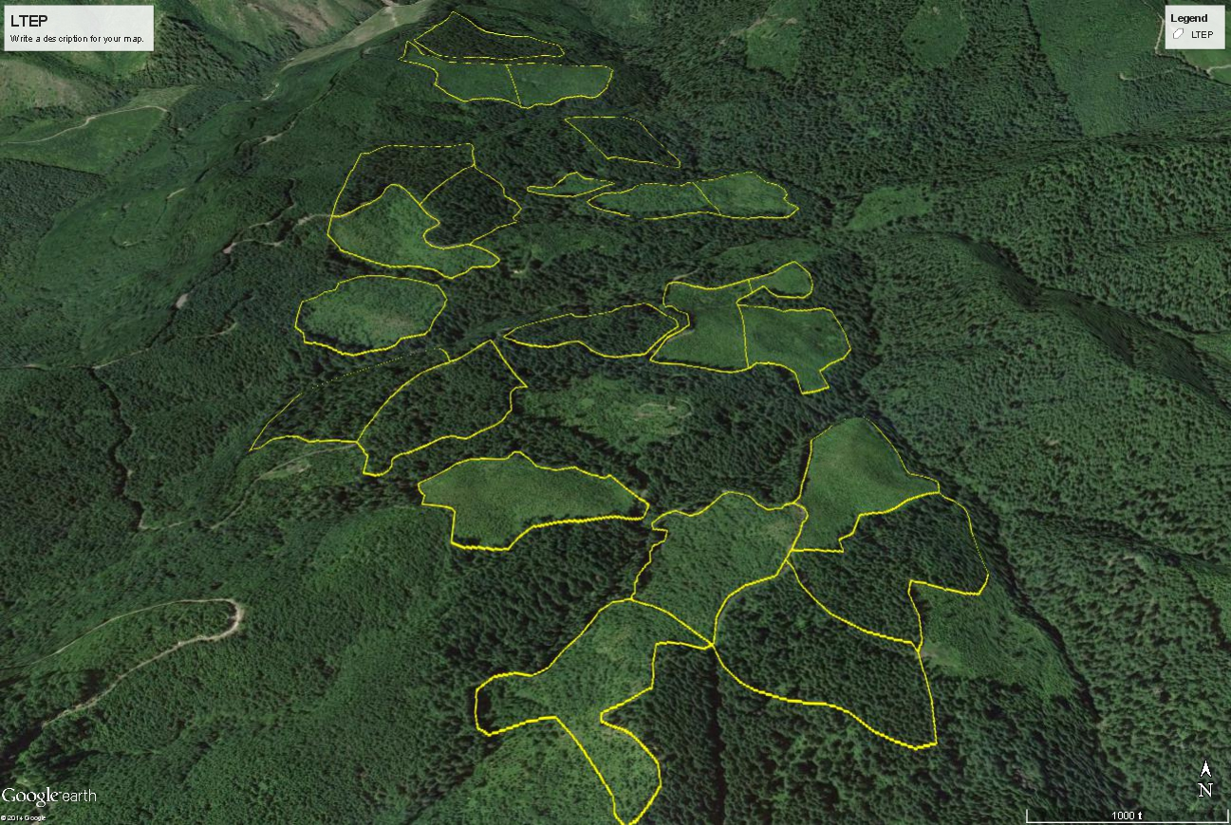
Riparian Reserve Gap Study
Principle Investigator: Dr. Dana Warren, OSU
A study to test the hypotheses that canopy gaps, which create moderate increases in the amount of light that reaches a stream, can increase stream productivity of algae, invertebrates, and ultimately the fish. We have planned a study that will explicitly address two alternative hypotheses around the potential importance of riparian forest complexity (gaps and other forms of complex structure): (2) more light in reaches with frequent canopy gaps (old-growth reaches) have increased primary production, which in-turn increased food for young-of-year trout, and (1) more large wood in old-growth reaches enhanced habitat for young-of-year trout, which promoted growth and survival.
Installation:
1 timber sale on MRRD. Covered in the Green Mountain DEIS (unit 5030 is 40 years old and unit 5390 is 34 years old)

Treatment:
There are two units in Green Mountain where we propose gap research. In the DEIS we analyzed up to a ½ acre gap per unit. immediately adjacent to two cutthroat streamsWe are proposing to cut nearly all the trees in a given gap area in creating canopy opening that mimics the size of those observed in nearby old-growth forest streams. Tree boles will be left next to the stream and for two years OSU will monitor the stream and community. Then, we would pull the trees felled into the stream channel and OSU would monitor for an additional two years. They have already conducted two years or pre-treatment data from the creeks.

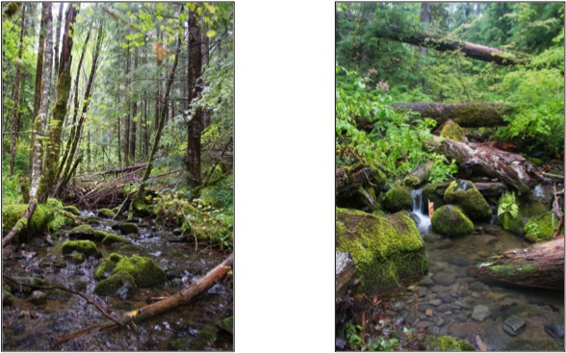

Status:
The DEIS will be out for public review in 2014/2015. Funding was obtained through an OSU Fish and Wildlife in Managed Forests Grant in 2013 that has allowed pre-treatment data collection ($78,500). We will collect another year of pre-treatment data in summer 2015 (based on Ray's 2016 estimate for when we will likely implement the cuts) and then post-treatment data collection will require additional funding (an amount comparable to the pre-treatment assessment funding).
Future Opportunities
- There are opportunities being explored to replicate the concept in stands proposed for thinning by the BLM in the lower part of the McKenzie Watershed. The treatments may differ in the size and location of the gaps or in the density of overstory trees retained after thinning but the fundamental question of how small changes in light associated with thinning outside the no-touch buffer or limited direct gap creation over streams has relevance to management and ot understanding how aquatic ecosystems respond to changing riparian forest structure in general. BLM will be funding OSU to do this project.
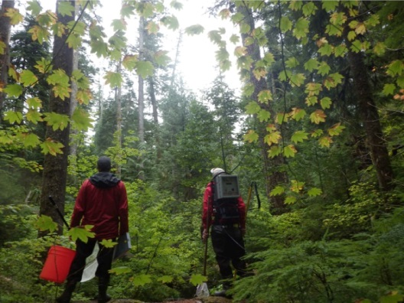

Augusta
Principle Investigator: Dr. Fred Swanson, PNW Corvallis, retired

This project implements a case study to test the hypotheses that historic disturbance information can be used to develop landscape objectives and prescriptions. This was an EIS, entirely located within an inventoried roadless area. The Augusta Landscape Study as published in a GTR. Additional treatments from the study were never implemented. The RO recommended that future case studies be carried out in the newly proposed AMA.
Installation:
1 timber sale on MRRD. Sale name – Augusta, 6 units. 309 acres. Age 130-180.
There were 6 units planned, 4 were implemented:
- 3 blocks have 50% variable retention with the highest retention near the riparian areas.
- 1 block has 15% retention 32tpa
Variable riparian reserves widths were retained: class IV 50-100’; class III 50-250’; class II 360’.

Status:
  - Treatment in 1996
  - No records of pre-treatment or post-treatment data collected. One of the units (66) that was treated with this sale is proposed for harvest in Green Mountain. Two other units that were dropped (78 and 83) were also proposed for harvest in Green Mountain.

Future Opportunities
- The Landscape Study was not incorporated into the new planning effort for that area (Green Mountain). There may be opportunities to retrospectively look at the riparian reserve management. As with the BRLS, this study offers an opportunity to study the change over time when stands >100 years old are partially harvested.

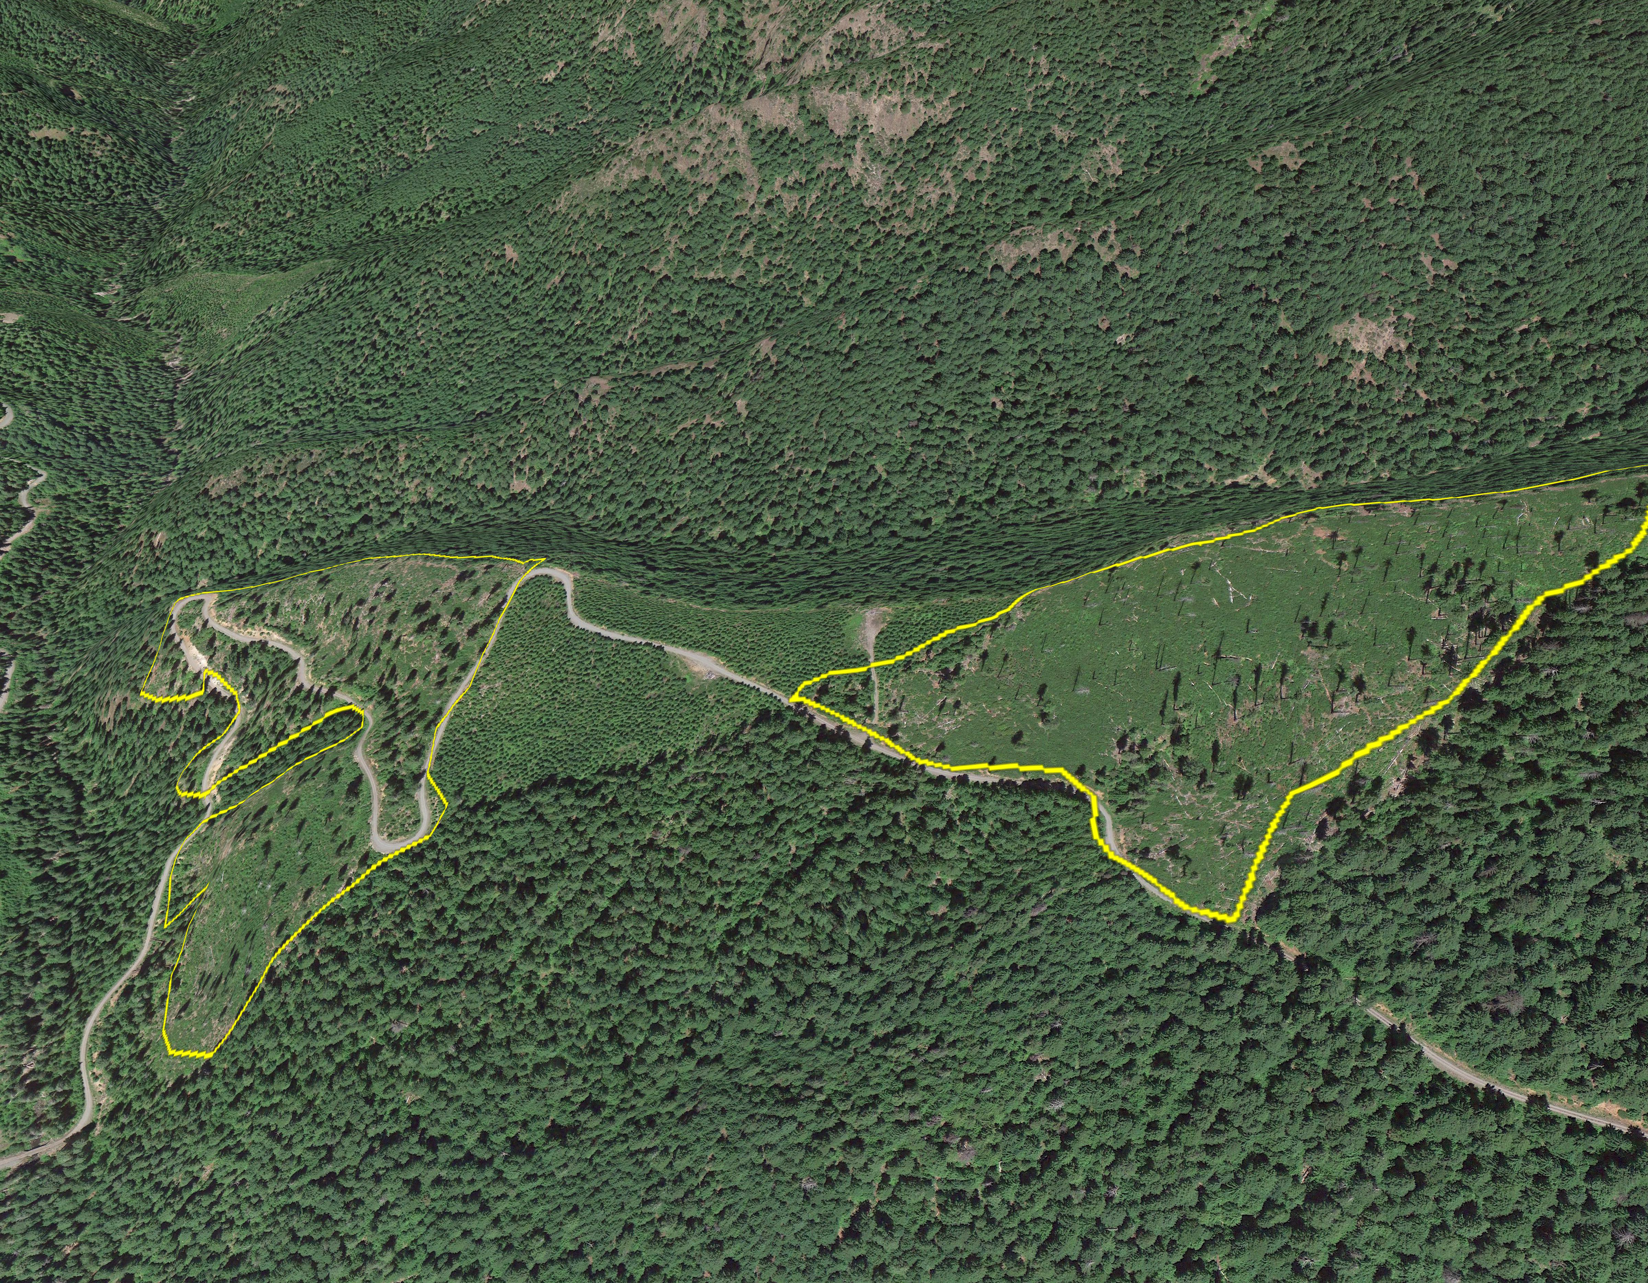

Mature Stand Thinning Study
Principle Investigator: Dr. John Bailey, OSU
The goal of this study is to characterize the understory vegetation as it is relates to overstory tree density management action (thinning) in older Douglas-fir dominated forests of the W. Oregon Cascades (80- 150 years old).
Installation:
Timber sales on MRRD, MFRD, SHRD and DET. Age at time of commercial thin:
80-100
100-120
120-140

Status:

Data was collected in 2011. The CCAMP program funded a field crew and masters student for this work. A draft thesis was completed in spring 2014.

Future Opportunities
- We are currently trying to find a student to convert the draft thesis into a publication.

Wilderness Prescribed Fire Project
Principle Investigators: Dr. Joan Hagar, USGS; Jane Kertis, WNF/SNF; Dr. Mark Schulze, HJA/OSU; and a PhD student, OSU
The study proposes to install birdsong meters and vegetation plots in the Mt. Washington Wilderness area to gather data on the presence of the black-backed woodpecker, a species strongly associated with high elevation forest systems: the devices automatically record bird songs and calls, providing data on phenology and daily activity patterns; and to gather data on habitat in high elevation wilderness areas where the woodpeckers occur.
Status: Birdsong meters were installed in the summer of 2014, and removed in the fall of 2014 with a combination of WNF, SNF, USGS, HJA, and USGS employees. Vegetation plot locations were strategized, and will be deployed in the summer of 2015.
Funding Needs: We are looking for funding to support the PhD student. CCAMP is coordinating with USGS and NCASI to combine parallel interest and efforts.

Low Density Precommercial Thinning Demonstration
Principle Investigator: Norm Michaels
This study demonstrates how stands would develop with very low stocking levels.

Installation:

6 stands were selected in 2007 to thin to a lower stocking level. Four of these stands were precommercially thinned to 100 TPA, and the fifth stand was divided with about one half thinned to 100 TPA, and the other half thinned to 60 TPA.

A trail was built into the stand with the dual spacing to provide a visual demonstration area where we can take people and discuss the merits of different stocking levels. The YCC crew on the McKenzie River Ranger District built the trail in the summer of 2007 using a rough flag line as a guide. This group did an excellent job at constructing the trail and providing a nice facility to access the site.

Future Opportunities: unknown
Funding Needs: TBD

Studies with Proposals Developed Searching for Funding
Gap Study: Integrating gaps into commercial thinning operations on the WNF: the influence of gap size on early-seral plant and wildlife communities.
Principle Investigators: Dr. Joan Hagar, USGS; Dr. John Bailey, OSU; Dr. Matt Betts, OSU; Dr. Mark Schulze, HJA/OSU
Tests the effectiveness of creating gaps during commercial thinning to provide habitat for early seral plant and wildlife species. Key question is how large of a gap is sufficient? Is the total acres of gap per area most influential, and size of an individual gap does not matter?
Installation:
NEPA would be required on at least 12 stands 35-55 years old with rx’s for commercial thinning and gaps. We would install gaps from 1-5 acres in size (bigger if possible) to study responses of vegetation and wildlife.
Funding Needs: $260k over 4 years.
(NOTE: we looked at implementing this with the Big Blue EA on the MRRD. We were not able to secure funding for this study before the sales began to be implemented. There may be an opportunity with a future planning area)

Early Seral Forest/Ecological Forestry Demonstration
Principle Investigators: Dr. Mark Schulze, OSU/HJA; Dr. Jerry Franklin, UofW, Dr. Hannah Gosnell, OSU Social Scientist; Dr. Michael Nelson, OSU Social scientist.
Could be used to test public perceptions around creating openings in young forests for the purpose of diversifying available habitat and producing timber.
Installation:
We have already identified 2-3 units on HJA for treatment. NEPA would be required. The MRRD District has agreed to work this into their outyear planning, with an EA done by winter 2016.
Funding Needs: not determined.

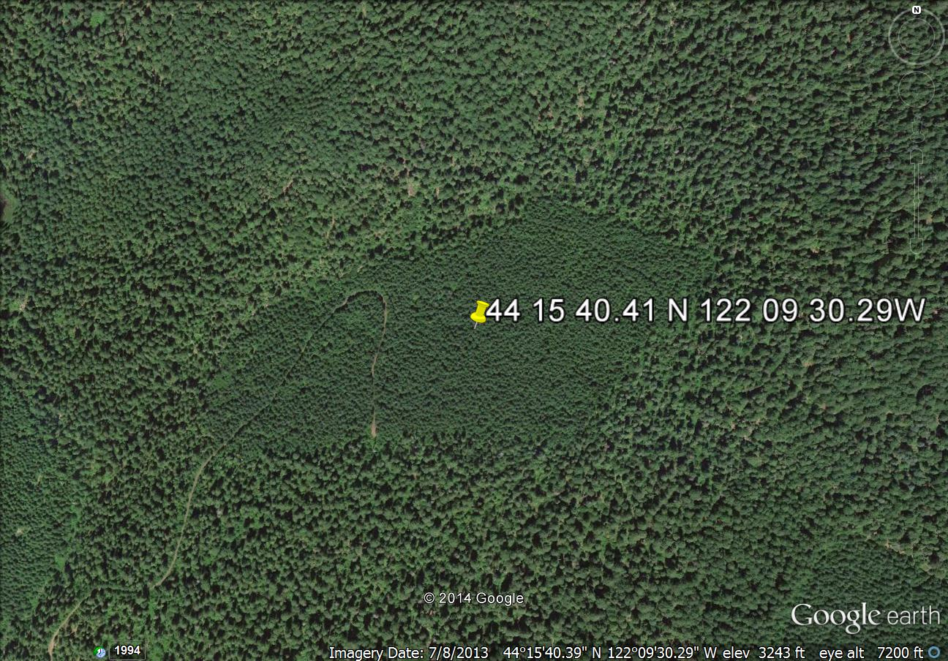

Dispersed Recreation
Principle Investigator: Interest from Dr. Troy Hall, OSU.
Investigates the growing challenge of managing dispersed recreation. This type of Forest use appears to be growing, and growing impacts parallel that trend. With limited staffing to patrol, monitor, do cleanup, and encourage appropriate behavior, some of the highly used areas are seeing unacceptable resource damage, as well as becoming unsanitary and unsafe for the forest visitor.
Installation:
Would require a study plan and student. The Forest already developed the key questions.
Key questions were developed by the recreation staff.
- What are the motivations behind this type of national forest use? i.e. is it a specifically desired experience, or is it tied to perceived high fees in managed campgrounds?
- What values do these visitors hold around the dispersed creation experience?
- Do these users recognize the impacts of this recreation experience and their role in creating those impacts ? (i.e. awareness of consequences)
- What do these users believe about their behavior? i.e. someone will be along to pick up the trash; human waste disappears over the winter around here; everybody is noisy in these kinds of sites, so it’s okay, etc.”
- We know we can’t really change basic values, but can we influence the attitudes with targeted information: what would that information look like> Is here any trust in an agency message?
- What efforts would be entailed in changing a dispersed recreation “user” into a forest steward?
- Where do dispersed recreationists get their information? How do they find sites?
- What are people willing to pay for? If some of the more highly used dispersed recreation corridors were set up on a fee system for basic maintenance/sanitation/ etc, would people be willing to pay?
- Is the Respect the River Program having the desired results in terms of changed user behavior?
Funding needs: $15,000 to help support a graduate student to do the survey work and analysis.
WNF’s Economic Contribution to local communities, state, and county
Principle Investigator: TBD
Investigates the direct and indirect economic value from having a national forest in a community’s backyard.
Installation:
Would require a study plan and student. The information probably already exists in various sources: it needs to be collated. We have been talking with PPPM classes at UofO for potential interest.
Funding needs: $15,000 to help support a graduate student or free if we can make it a class project.

Visitor Use on the Willamette National Forest
Principle Investigator: TBD
Investigates the profile of recreation users the WNF. This would be modeled after the McKenzie River Use study done in 2013/14.
Installation: Would require a study plan and student. The survey would require GAO approval.
Funding needs: $30,000 to help support a graduate student or free if we can make it a class project.

Studies Coordinated and Funded by Others
Very Young Stand Study
Principle Investigator: Dr. Connie Harrington, PNW, Olympia
Five plots installed in 3 clearcut units to study development of non-pct’d Douglas-fir.
Installation:
1 sale on MRRD: Blue River Extension. Harvested 1998.
Plots are at least 15 acres in size to allow future sampling of small mammals, amphibians, and birds.

A: an untreated control (8 x 8 ft. spacing),
B: a treatment aimed at maintaining high timber production (thinning to a 12 foot
spacing),
C: a treatment to increase species diversity (thinning to a 12 foot spacing, plus 8
uniformly distributed 0.05 acre gaps per acre, and interplanting with tolerant
conifer and hardwood tree species),
D: a treatment designed to increase stand structure heterogeneity (thinning to a 12 foot spacing, plus variable-sized gaps of 0.02, 0.04, and 0.05 acre in size), and
E: a treatment intended to increase both species and structural diversity (thinning to a 12 foot spacing, plus variable-sized gaps of 0.02, 0.04, and 0.05 acre in size, and interplanting with tolerant conifer and hardwood tree species). Five plots have been established representing one replication of each treatment.

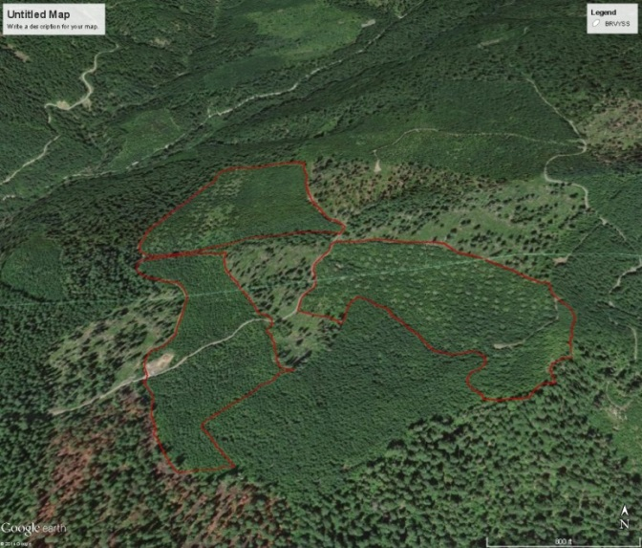

Status:
Sampled last in 2007, eight years after implementation. The CCAMP program provided the field crew for this measurement ($5k) and PNW provided the analysis/reporting ($6k).
Future:
Proposed duration = 2019. I’m contacting the PI to see what her future intentions ar. This is part of a larger study that includes additional units on the GP.

Starrbright Long-term Succession Study
Principle Investigator: Dr. Charlie Halpern, University of Washington
Long-term study of species’ interactions during secondary forest succession. Examines species- and community-level responses to removal of potentially dominant understory species.

Installation:
1 timber sale on MRRD. Sale name – Starrbright. 10 acres

The original design included 9 species-removal treatments replicated in each of 25 blocks. Removals occur in 2 x 2 m quadrats; the center 1 x 1 m area is used to sample vegetation response. Of the original treatments, 3 remain (A, H, and I, below) because the removal species are no longer present.
Species removed Response variables
A. Control (none) All species
B. Senecio sylvaticus Epilobium angustifolium + Community*
C. Epilobium angustifolium Senecio sylvaticus + Community*
D. Senecio sylvaticus + Epilobium angustifolium Community*
E. Senecio sylvaticus + Community Epilobium angustifolium
F. Epilobium angustifolium + Community Senecio sylvaticus
G. Community Senecio sylvaticus + Epilobium angustifolium
H. Rubus ursinus Community in the absence of Rubus ursinus
I. Berberis nervosa/Gaultheria shallon Community in the absence of Berberis/Gaultheria
*Community = all species other than Senecio sylvaticus or Epilobium angustifolium

Status:
Pre-treatment data: 1990
Logging: ` late May/early June 1991
Broadcast burned: 11 Sep 1991
Study area not planted
Post-treatment data: 1992 to present (collected annually)

Future Opportunities
- This is one of the longest and most intensive studies of forest understory development in our region and, to our knowledge, it is the only such study of natural regeneration processes (no planting). Continued annual sampling will provide insight into species’ interactions during canopy closure at fine spatial and temporal scales. The PI recommends continued annual sampling.
- Funding needs: currently unfunded (and has not been previously supported by the Forest). Any amount of funding could aid with analysis and publication of a large backlog of data.

Studies Coordinated and Funded by NW Oregon Ecology Program
Warner Creek Fire permanent plots—sampled 3 times since 1991, CWD, regeneration, live trees, understory

Waldo Lake fire (Charlton)permanent plots—sampled 11 times so far since 1996, same components as above

Torrey Charlton Fen transects

Jim’s Creek Restoration – collaboration with UofO to measure vegetation response over time

