2002 and 2003 Monitoring Report for Trees Inoculated with Stem Decay Fungi in 1997
Siuslaw National Forest, Alsea Ranger District

Diane Hildebrand, Westside Forest Insect and Disease Service Center
Dwayne Guthrie and Doug Middlebrook, Siuslaw National Forest

In December 1997, Martha Jensen inoculated 180 Douglas-firs with stem decay fungi to create cavity-nesting habitat in 12 stands on Alsea Ranger District. All trees were inoculated with two dowels of different fungi. According to the plan, the upper dowel was to be Fomitopsis cajanderi (FOCA) placed within the crown, and the lower dowel either Fomitopsis pinicola (FOPI) or Phellinus pini (PHPI), placed below the crown. Inoculation points were to be at least 5 ft apart. All fungi were cultured by Diane Hildebrand from conks found on trees on the Alsea District with the help of Dwayne Guthrie.

In October 2002, Dwayne Guthrie selected a stratified random sample of 36 trees for long term monitoring. In September 2003, Doug Middlebrook had an additional 11 trees monitored and then felled and sectioned to observe decay development. One of the cut trees could not be safely dissected. Diane Hildebrand took samples of the other 10 trees to the Forest Health Protection lab in the Regional Office to isolate the decay fungi present.

Table 1 summarizes information for the 36 trees monitored in October 2002. Average radial growth, 58 months after inoculation, was 1.5 inches. Table 2 summarizes information for the 11 trees selected for destructive sampling in September 2003. These 11 trees were not the larger trees, and their average radial growth, 69 months after inoculation, was 1.1 inches. No wildlife use was observed on any of the monitored trees.

Table 3 summarizes information on fungal re-culturing and decay development for the 10 trees cut and dissected. Destructive sampling revealed decay at 90% (18/20) of dowels. Culturing of samples revealed that the inoculated fungus was present and viable for 90% of FOCA dowels (9/10), 20% of PHPI dowels (1/5), and 100% of FOPI dowels (5/5). Apparently FOCA out-competed PHPI, especially when inoculated less than 5 ft apart. For three of the trees cut and dissected, actual inoculation points were less than 5 ft apart and both points were placed in the crown (all three had PHPI as lower fungus). In most trees, the extent of the advanced decay was not yet sufficient to accommodate a cavity nest. A few inoculation points of FOPI and FOCA had more extensive decay. See Figures 1 and 2. Detailed descriptions follow the Tables.

PHPI is a white rot and a very common stem decay fungus. The decay caused by PHPI is a white pocket rot, also called white speck, that retains some structural strength. FOCA and FOPI are brown rots that more thoroughly decay wood into crumbly cubical fragments. FOCA is a common stem decay that often enters through broken tops. FOPI is a fast-growing and efficient general decay that can act as a stem decay in a living tree when it enters through a wound.

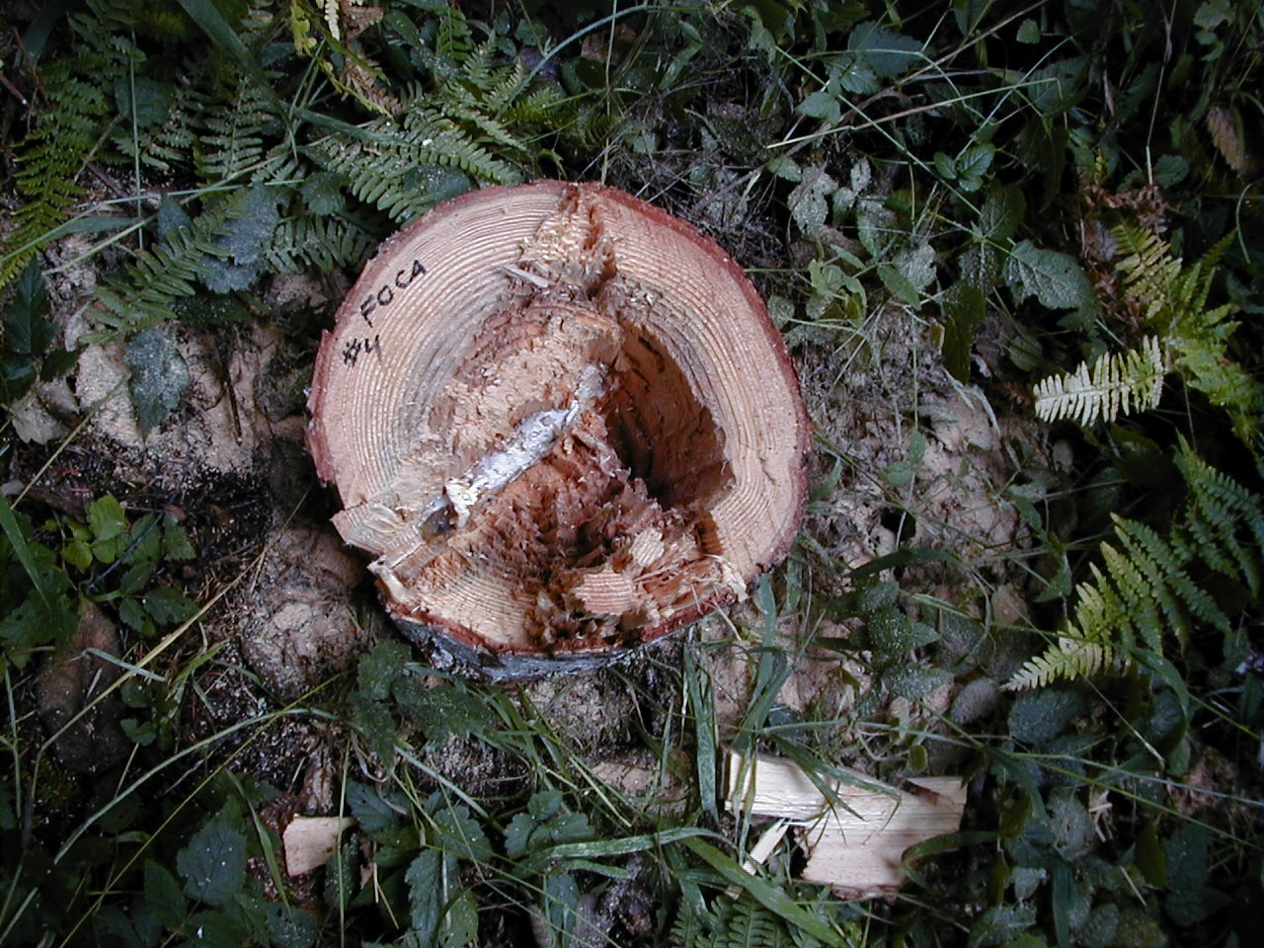
Figure 1. Extensive decay near inoculation point of Fomitopsis cajanderi in 17.5” DBH Douglas-fir (tree number 4), 69 months after inoculation at height of 60 ft.

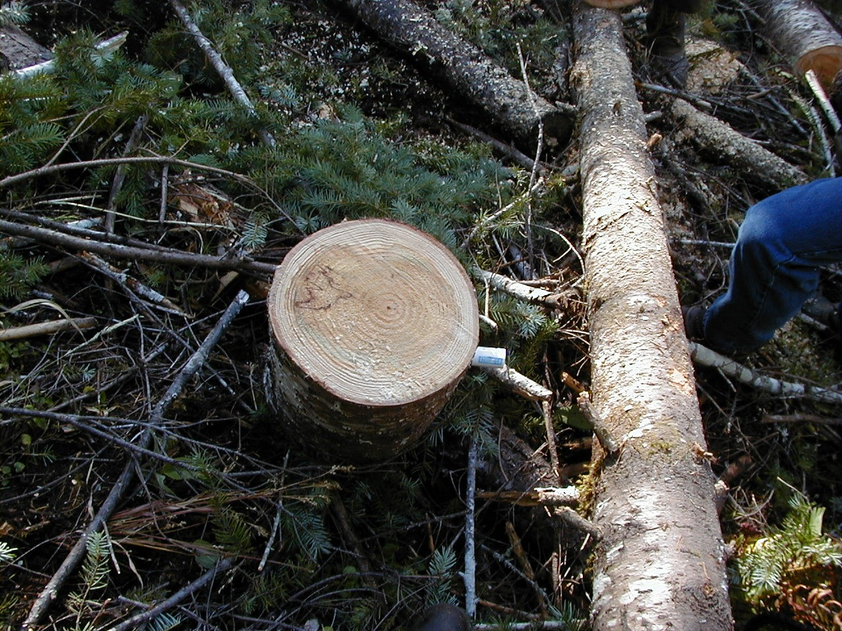
Figure 2. Decay and stain at one of the PHPI inoculation points, 69 months after inoculation. Dark zone lines may indicate competition between fungi
Table 1. Douglas-fir diameter at time of inoculation (1997) and in October 2002, radial growth, height in October 2002, species of fungi inoculated, wildlife use, and tree condition, Siuslaw NF, Alsea RD.
Tree  # | DBH  Dec-97 | DBH  Oct-02 | Radial  Growth | Height  Oct-02 | Lower  Fungus | Upper  Fungus | Forage  Use | Cavity  Nest | Tree  Health
1 | 17.5” | 18.8” | 1.3” | 115 ft | FOPI | FOCA | NO | NO | GOOD
9 | 21.2 | 22.6 | 1.4 | 123 | FOPI | FOCA | NO | NO | GOOD
18 | 24.4 | 25.8 | 1.4 | 96 | PHPI | FOCA | NO | NO | Crown dieback
20 | 18.2 | 20.3 | 2.1 | 122 | PHPI | FOCA | NO | NO | GOOD
25 | 24.5 | 26.7 | 2.2 | 135 | PHPI | FOCA | NO | NO | GOOD
29 | 23.9 | 26.6 | 2.7 | 135 | PHPI | FOCA | NO | NO | GOOD
31 | 24.8 | 27 | 2.2 | 133 | PHPI | FOCA | NO | NO | GOOD
40 | 22.4 | 24 | 1.6 | 129 | PHPI | FOCA | NO | NO | GOOD
43 | 19.4 | 20.5 | 1.1 | 136 | PHPI | FOCA | NO | NO | GOOD
55 | 19.5 | 21 | 1.5 | 138 | PHPI | FOCA | NO | NO | GOOD
56 | 18.3 | 19.1 | 0.8 | 139 | PHPI | FOCA | NO | NO | GOOD
57 | 21.9 | 24.7 | 2.8 | 124 | PHPI | FOCA | NO | NO | GOOD
65 | 25.4 | 27.1 | 1.7 | 142 | PHPI | FOCA | NO | NO | GOOD
68 | 24.5 | 25.8 | 1.3 | 146 | PHPI | FOCA | NO | NO | GOOD
70 | 31.5 | 33.8 | 2.3 | 140 | PHPI | FOCA | NO | NO | GOOD
77 | 17.9 | 18.5 | 0.6 | 135 | PHPI | FOCA | NO | NO | GOOD
84 | 15.6 | 15.7 | 0.1 | 148 | PHPI | FOCA | NO | NO | GOOD
88 | 21.3 | 22.7 | 1.4 | 138 | PHPI | FOCA | NO | NO | GOOD
92 | 23.4 | 25.7 | 2.3 | 129 | PHPI | FOCA | NO | NO | GOOD
94 | 28.4 | 30.5 | 2.1 | 145 | PHPI | FOCA | NO | NO | GOOD
97 | 20.2 | 21 | 0.8 | 149 | PHPI | FOCA | NO | NO | GOOD
112 | 23.8 | 25.2 | 1.4 | 138 | PHPI | FOCA | NO | NO | GOOD
115 | 27 | 28.2 | 1.2 | 147 | PHPI | FOCA | NO | NO | GOOD
119 | 26.9 | 29.2 | 2.3 | 138 | PHPI | FOCA | NO | NO | GOOD
131 | 12.9 | 14.1 | 1.2 | 56 | PHPI | FOCA | NO | NO | GOOD
132 | 12.4 | 12.5 | 0.1 | 70 | PHPI | FOCA | NO | NO | GOOD
134 | 15.1 | 16.7 | 1.6 | 79 | PHPI | FOCA | NO | NO | GOOD
139 | 15.2 | 17 | 1.8 | 50 | PHPI | FOCA | NO | NO | GOOD
140 | 14.2 | 16.3 | 2.1 | 59 | PHPI | FOCA | NO | NO | GOOD
145 | 14 | 15.1 | 1.1 | 55 | PHPI | FOCA | NO | NO | GOOD
152 | 17.1 | 19 | 1.9 | 75 | FOPI | FOCA | NO | NO | GOOD
156 | 12.4 | 13.5 | 1.1 | 60 | FOPI | FOCA | NO | NO | Good, Forked
157 | 16.4 | 18.4 | 2 | 67 | FOPI | FOCA | NO | NO | GOOD
166 | 16.4 | 16.8 | 0.4 | 89 | PHPI | FOCA | NO | NO | GOOD
170 | 14.7 | 15.4 | 0.7 | 84 | PHPI | FOCA | NO | NO | GOOD
172 | 14 | 15.1 | 1.1 | 107 | PHPI | FOCA | NO | NO | GOOD
Table 2. Douglas-fir diameter at time of inoculation (1997) and in September 2003 when trees were cut, radial growth, species of fungi inoculated, wildlife use, and tree condition, Siuslaw NF, Alsea RD.
Tree  # | DBH  Dec-97 | DBH  Sept 03 | Radial  Growth | Lower  Fungus | Upper  Fungus | Forage  Use | Cavity  Nest | Tree  Health
2 | 20 | 21.7 | 1.7 | FOPI | FOCA | NO | NO | GOOD
4 | 17.5 | 18.3 | 0.8 | FOPI | FOCA | NO | NO | GOOD
6 | 23.3 | 25.4 | 2.1 | FOPI | FOCA | NO | NO | GOOD
10 | 18.8 | 19.4 | 0.6 | FOPI | FOCA | NO | NO | GOOD
11 | 19.4 | 20.6 | 1.2 | FOPI | FOCA | NO | NO | GOOD
12 | 16.7 | 16.9 | 0.2 | FOPI | FOCA | NO | NO | GOOD
16 | 17.7 | 18.5 | 0.8 | PHPI | FOCA | NO | NO | GOOD
27 | 14.8 | 16.5 | 1.7 | PHPI | FOCA | NO | NO | GOOD
168 | 13.2 | 14.5 | 1.3 | PHPI | FOCA | NO | NO | GOOD
171 | 12.1 | 13 | 0.9 | PHPI | FOCA | NO | NO | GOOD
180 | 12.3 | 13 | 0.7 | PHPI | FOCA | NO | NO | GOOD

Table 3. Type of decay and success of re-culturing of inoculated fungi in 10 Douglas-fir trees dissected 69 months after inoculation, Siuslaw NF, Alsea RD.
Tree  # | Lower  Fungus | Inoculation  Height | *Cultured  2003 | Decay  2003 | Upper  Fungus | Inoculation  Height | *Cultured  2003 | Decay  2003
2 | FOPI | 70 | yes | brown cubical | FOCA | 75 | yes | brown cubical
4 | FOPI | 50 | yes | brown cubical | FOCA | 60 | yes | brown cubical
10 | FOPI | 75 | yes | brown cubical | FOCA | 84 | yes | brown cubical
11 | FOPI | 54 | yes | brown cubical | FOCA | 60 | yes | brown cubical
12 | FOPI | 83 | yes | brown cubical | FOCA | 90 | yes | brown cubical
16 | PHPI | 76 | yes | white speck | FOCA | 84 | no | incipient only
27 | PHPI | 38 | no | brown cubical | FOCA | 47 | yes | brown cubical
168 | PHPI | 35 | no | brown cubical | FOCA | 37 | yes | brown cubical
171 | PHPI | 44 | no | brown cubical | FOCA | 46 | yes | brown cubical
180 | PHPI | 48 | no | pale soft | FOCA | 50 | yes | brown cubical
* Successful re-culturing of inoculated fungus indicated by ‘yes.’

Details of Dissected Trees

Tree #2. Dowels 5’ apart.
At FOPI dowel, stain and brown crumbly decay. Samples yielded FOPI.
At 5’ below, stain and incipient decay. yielded FOPI.
At 10’ below, faint stain. Samples yielded no fungus.
At FOCA dowel, stain and yellow brown crumbly decay—samples yielded FOCA. Patch of dark brown crumbly decay at dowel—samples yielded no decay fungus.
At 10’ above, stain. Samples yielded no fungus.
Tree # 4. Dowels 10’ apart.
At FOPI dowel, yellow brown crumbly advanced decay extended further vertically. Samples yielded FOPI.
At 5’ below, some soft wood. Samples yielded FOPI.
At 10’ below, some soft wood. Samples yielded nothing.
At FOCA dowel, yellow brown crumbly decay, some darker brown, some cottony mycelium. Samples yielded FOCA.
At 5’ above, stain and softened wood. Samples yielded nothing.
At 10’ above, stain. Samples yielded nothing.
At 15’ above faint stain. Samples yielded no fungus.
At 20’ above, faint stain. Samples yielded nothing.

Tree #6. Dowels 7’ apart. Tree rolled downhill and became lodged in a position that made dissection too dangerous.

Tree # 10. Dowels 9’ apart.
At FOPI dowel, yellow brown crumbly decay. Samples yielded FOPI.
At 10’ below, stain and incipient decay. Samples yielded nothing.
At 15’ below, faint stain. Samples yielded nothing.
At FOCA dowel, yellow brown crumbly decay—samples yielded FOCA, and very crumbly dark brown decay—samples overgrown by contaminant fungus. Fingers and pockets of stain appear discontinuous. Adjacent firm wood yielded nothing.
At 10’ above, pink stain. Samples yielded nothing.
At 15’ above, yellowish and pink stains. Samples yielded nothing
At 20’ above, yellowish stain and brown flecks near pith. Samples yielded nothing.
At 25’ above, pinkish and yellowish wood. Samples yielded nothing.

Tree #11. Dowels 6’ apart.
At FOPI dowel, stain and small area of brown crumbly decay. Outer brownish stain, brown decay, and pink wood near decay all yielded FOPI.
At 5’ below, faint stain. Samples yielded nothing.
At 10’ below, faint stain. Samples yielded nothing. Wood had puddles of resin.
At FOCA dowel, yellow brown crumbly decay and smooth yellow soft wood. Samples yielded FOCA.
At 10’ above, pocket of incipient decay. Samples yielded no fungus.
At 15’ above, fingers/pockets of incipient decay. Samples yielded nothing.

Tree #12. Dowels 7’ apart.
At FOPI dowel, stain and yellow brown crumbly decay yielded FOPI. Dark brown yielded FOPI.
At 5’ below, faint stain. Outer brownish stain yielded FOPI. Brown fleck near pith yielded nothing.
At 10’ below, faint stain. Samples yielded nothing.
At FOCA dowel, stain and yellow brown crumbly decay. Samples yielded FOCA.
At 5’ above, stain. Samples yielded nothing.
At 10’ above, faint stain. Samples yielded no fungus.

Tree # 16 Dowels 8’ apart.
At PHPI dowel, fingers of stain, mostly resinous. Samples yielded no decay fungus.
At 5’ below, fingers of stain.
At 10’ below, patch of stain and white speck in outer sapwood. Samples yielded PHPI.
At 15’ below, no trace.
At FOCA dowel, stain and incipient decay. Samples yielded no fungus.
At 5’ above, finger of stain. Samples yielded no fungus.
At 10’ above, no trace.

Tree # 27. Dowels 9’ apart.
At PHPI dowel, stain and yellow brown crumbly decay . Thick pink mycelium in drill hole. Samples yielded FOCA.
At 3’ below, stain fingers into sapwood. Samples yielded FOCA.
At 5’ below, less stain.
At 8’ below, no trace.
At FOCA dowel, stain and yellow/pinkish brown cubical decay with mycelium. Samples yielded FOCA.
At 3’ above, stain and decay.
At 5’ above, no trace.

Tree # 168. Dowels 2’ apart.
At PHPI dowel, yellow brown cubical crumbly decay, with some mycelial felts, and dark reddish brown zone lines beyond dowel. Pinkish mounds of mycelium on dowel itself. Samples yielded FOCA.
At 10’ below, prominent stain. Samples yielded no fungus.
At FOCA dowel, stain and yellow brown and brown crumbly decay. Smells like honey. Samples yielded FOCA.
At 5’ above, stain. Samples yielded FOCA.

Tree #171. Dowels 2’ apart.
At PHPI dowel, yellow brown cubical crumbly decay in center of tree, then a pinkish gray layer, then gray outer sapwood. All areas yielded FOCA.
At 5’ below, stain. Samples yielded FOCA.
At 10’ below, stain. Samples yielded no fungus.
At 20’ below, stain. Samples yielded nothing.
At 25’ below, stain. Samples yielded no fungus.
At 30’ below, stain. Samples yielded no decay fungus.
At FOCA dowel, yellow brown cubical crumbly decay. Samples yielded FOCA.
At 5’ above, faint stain. Samples yielded FOCA.

Tree #180. Dowels 2’ apart.
At PHPI dowel, pale advanced decay in outer sapwood. Samples yielded FOCA.
At 10’ below, stain. Samples yielded no decay fungus.
At 30’ below, faint stain. Samples yielded no decay fungus.
At FOCA dowel, stain and yellow brown crumbly decay. Samples yielded FOCA.
At 5’ above, stain. Samples yielded FOCA.

