The Young Stand Thinning & Diversity Study (YSTDS)

Establishment Report, Study Plan, and Key Findings
July 17, 2013

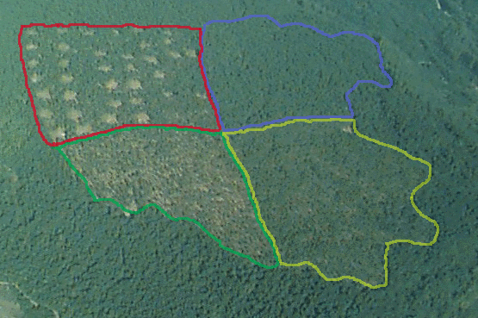

Editors: Tom Manning, Research Assistant, Oregon State University and
Cheryl Friesen, Science Liaison, Willamette National Forest

Produced in 2013 under Cost Reimbursable Agreement No. 07-CR-11061800-018 between USDA-Forest Service and Oregon State University.

Available on-line at http://ecoshare.info/projects/central-cascade-adaptive-management-partnership/forest-studies/young-stand-thinning-and-diversity-study/
Establishment Report for
The Young Stand Thinning & Diversity Study

Abstract

The US Forest Service (USFS), Pacific Northwest Research Station (PNW), and Oregon State University (OSU) established the Young Stand Thinning and Diversity Study (YSTDS) in 1990 to demonstrate and test options for young stand management in western Oregon. The YSTDS is designed to determine if different thinning, underplanting, and snag creation treatments can accelerate the development of late-seral conditions in 35-50 year-old plantations.

The study was implemented on 4 replicate blocks, each consisting of an untreated Control stand and 1 each of the following stand-level thinning treatments: (1) a Light Thin treatment, approximating the timber industry standard, with about 260 residual trees per hectare (tph; 100/acre); (2) a Heavy Thin treatment leaving approximately 130 tph (50/acre) and underplanted with native conifer seedlings; and (3) a Light Thin with Gaps (hereafter simply “Gaps”) treatment, again with 260 tph plus an additional 20% of the stand area harvested to leave 0.2 ha (0.5-acre) openings underplanted with native conifer seedlings.

Pre-thinning baseline data (documenting vegetation, fungi, wildlife, and photopoints) were gathered in 1992-1994, and the thinning treatments were implemented through timber sale contracts from late 1994 through early 1997, with most logging occurring during 1995-96. During the thinning harvests, detailed analyses were carried out to examine pre-sale planning and layout costs, comparative productivity and costs of various harvesting alternatives, residual stand damage, and soil disturbance and compaction. A considerable body of publications on these operational aspects of the YSTDS constitutes one of the largest portions of the study’s results so far.

Much science has been accomplished in the 15 years since the YSTDS thinning treatments were installed. Vegetative response to the thinning has been measured at frequent intervals, in 1996, 1999, 2001, and 2006. Changes in volumes of coarse woody debris and the responses of fungi, arthropods, amphibians, birds, and small mammals have also been assessed, and are intended to continue into the future. Five years after thinning (2001), snag densities in the YSTDS were artificially increased by topping trees and inoculating some with fungal mycelia, in an effort to increase the abundance of dead trees for cavity-nesting birds and mammals; long-term monitoring of these artificial snags is underway. The study also included a social science component exploring the public’s response to visual changes in the forest from the thinning operations.

Keywords: forest management, thinning, biodiversity, wildlife, late-seral habitat, young forests, public perceptions, residual stand damage, soil compaction, mushroom harvest.

Table of Contents Page

Abstract | 2
List of Tables, Figures, and Maps | 4
Acknowledgements | 5
Conversion Tables | 6
Introduction | 7
Objectives | 8
Study Design | 8
General Study Area Description | 9
Pre-treatment Stand Conditions | 16
Assignment of Treatments to Study Units | 18
Implementation of Thinning Treatments | 18
Slash Treatment | 19
Planting | 19
Component Studies
- Vegetation Response | 21
- Economics of Alternative Thinning Operations | 28
- Residual Stand Damage from Thinning Operations | 31
- Soil Compaction from Thinning Operations | 33
- Small Mammal Responses to Young Stand Thinning | 36
- Bird Responses to Young Stand Thinning | 40
- Amphibian Responses to Young Stand Thinning | 43
- Arthropod Responses to Young Stand Thinning | 48
- Effects of Thinning on Chanterelle Mushroom Productivity | 51
- Wildlife Use of Created Snags | 55
- Public Perceptions of Young Stand Thinning Practices | 59
- Coarse Woody Debris Surveys | 61
Appendix 1: List of Protocols available July 2013 | 64
Appendix 2: Future Investigations | 65

Bibliography 66

Tables | Page
Table 1: YSTDS Thinning Treatment Prescriptions | 9
Table 2: Pre-Thinning Conditions | 16
Table 3: Site Characteristics for each Treatment Unit. | 17
Table 4: Harvest Methods and Completion Dates | 19
Table 5: Layout of Vegetation Subplots In and Near Gaps | 24
Table 6: Planning and Layout Costs Recorded by the Forest Service | 30
Figures | Page
Figure 1: Graphical Representation of the Thinning Treatments | 8
Figure 2: Timeline of YSTDS Treatments and Samplings | 20
Figure 3: Sampling Design and Plot Layout in Gaps Treatment | 23
Figure 4: Northern Flying Squirrel Density, by Treatment, 2007-08 | 39
Figure 5: Avian Species Richness, by Treatment, 1992-2007 | 42
Figure 6: Artificial Cover Object for Sampling Salamanders | 44
Figure 7: Salamander Captures, 2009-2012 | 46
Figure 8: Ensatina Salamander Captures, 2009-2012 | 47
Figure 9: Sampling salamanders from an artificial cover object. | 47
Figure 10: Density of Litter Arthropods by Treatment, 2000-2001 | 52
Figure 11: Number and Weight of Chanterelles/Acre by Treatment | 50
Figure 12: Sapsucker Feeding Young at a Created Snag, July 2010 | 58
Maps | Page
Map 1: Location of the Willamette National Forest | 10
Map 2: Locations of the YSTDS Blocks | 11
Map 3: YSTDS Block 1 (Cougar) | 12
Map 4: YSTDS Block 2 (Mill Creek) | 13
Map 5: YSTDS Block 3 (Christy Flat) | 14
Map 6: YSTDS Block 4 (Sidewalk Creek) | 15
Acknowledgements

Many individuals have contributed time, energy, and support to the Young Stand Thinning & Diversity Study. We thank Loren Kellogg, Brenda McComb, and John Tappeiner for their scientific leadership and vision as the initiators of the study. Jim Mayo and John Cissel provided the leadership and support needed from the USFS to get the study implemented. Interdisciplinary teams at the McKenzie, Blue River, and Oakridge Ranger Districts on the Willamette National Forest conducted the necessary NEPA analysis and contract administration. Fred Swanson from the PNW’s HJ Andrews Experimental Forest and Cheryl Friesen at the Willamette National Forest currently provide leadership for the project. We benefited from our interactions with scientists who participated in collaborative studies and field tours. Field crews and research assistants spent countless hours clambering over steep slopes collecting data in weather both ideal and miserable. Still others have cleaned up the data and created large, complex databases. To each of these folks, and to all who have helped move the Young Stand Thinning & Diversity Study forward, we extend our thanks. Specific individuals that have contributed significantly to the study include:
Study plan development - Loren Kellogg, Brenda McComb, and John Tappeiner.
Collaborating scientists – Paul Adams, Jim Boyle, Steve Garman, Joan Hagar, Andy Moldenke, Randy Molina, Eldon Olsen, Dave Pilz, Klaus Puettmann, Rob Ribe, and Gabe Tucker.
Planning and implementation - Jim Mayo and John Cissel.
Site coordinators - Bob Obedzinski, John Dewitz, Iden Asato, Matt Hunter, and Jim Mayo.
Research Assistants – Carrie Berger, Sean Bohac, Chad Davis, Mike Lattig, Tom Manning, Mark Miller, Ginger Milota, Ben Stringham, and Mark Taratoot.
Field crew leadership – Gary Rost, Tim Fox, Matt Hunter, and Luther Skeels.
Graduate students – Marganne Allen, Liane Davis, Susie Dunham, Anne Fiala, Han-sup Han, Mohammad Hossain, Andrew Neill, Stephen Pilkerton, Ben Spong, Svetlana Yegorova, and Hoonbok Yi.
Database management -- Suzanne RemilIlard and Gody Spycher.
Soil sample processing -- David Murdough.

Graphic support – Pam Druliner.
GIS support – Mike Gebben.
Statistical analysis and consulting - Maureen Duane, Lisa Ganio, Manuela Huso, Rob Pabst.
Conversion Factors

English to Metric

Multiply | By | To obtain
Length
inch (in.) | 2.54 |  | centimeter (cm)
inch (in.) | 25.4 |  | millimeter (mm)
foot (ft.) | 0.3048 |  | meter (m)
mile (mi) | 1.609 |  | kilometer (km)
yard (yd.) | 0.9144 |  | meter (m)
Area
acre | 4,047 |  | square meter (m²)
acre | 0.4047 |  | hectare (ha)
acre | 0.004047 |  | square kilometer (km²)
square foot (ft²) | 929.0 |  | square centimeter (cm²)
square foot (ft²) | 0.09290 |  | square meter (m²)
square inch (in²) | 6.452 |  | square centimeter (cm²)
square mile (mi²) | 259.0 |  | hectare (ha)
square mile (mi²⁾ | 2.590 |  | square kilometer (km²)

Metric to English

Multiply | By | To obtain
Length
centimeter (cm) | 0.3937 | inch (in.)
millimeter (mm) | 0.03937 | inch (in.)
meter (m) | 3.281 | foot (ft.)
meter (m) | 1.094 | yard (yd.)
kilometer (km) | 0.6214 | mile (mi)
Area
square meter (m²) | 0.0002471 | acre
hectare (ha) | 2.471 | acre
square kilometer (km²) | 247.1 | acre
square centimeter (cm²) | 0.001076 | square foot (ft²)
square meter (m²) | 10.76 | square foot (ft²)
square centimeter (cm²) | 0.1550 | square inch (ft²)
hectare (ha) | 0.003861 | square mile (mi²)
square kilometer (km²) | 0.3861 | square mile (mi²)
Introduction

Since the mid-20th century, several million hectares of mature and old-growth forests in western Oregon and Washington have been converted to young plantations. The proportion of older forest in the landscape has steadily decreased over time, while the amount of young managed forests has vastly increased. These plantations often lack the broader range of habitat features found in older forests, or in young stands resulting from natural disturbances. These missing features include large live trees, large dead wood in the form of snags and logs, vertical and horizontal variation in tree canopy structure, and a significant component of broadleaf trees. As objectives for federally managed lands have changed during the last several decades, concern has increased about low biodiversity in the wake of “traditional” thinning practices. These concerns were further heightened in 1994, when federal agencies were mandated by The Northwest Forest Plan to protect and restore late-successional forest habitat and species, while simultaneously providing for a sustainable level of timber production (USDA and USDI 1994). The Plan relied heavily on the application of new silvicultural systems to hasten development of late-successional habitat from homogeneous young plantations, but the efficacy and side-effects of the new techniques were largely untested on the ground. In addition to unanswered questions concerning timber growth, soil and stand damage, harvesting systems, and economics, new questions arose concerning maintenance of biological diversity and ecological processes. In particular, managers, scientists, and members of the public needed to know if plantations could be altered through management activities to more closely resemble naturally-initiated young stands, and to accelerate development of structural characteristics of older forests.

Responding to currents of change in federal forest management, and anticipating the changes mandated a few years later, John Tappeiner, Loren Kellogg, and Brenda McComb from OSU met in 1990 with silviculturists and wildlife biologists from the Willamette National Forest at the Lowell Ranger District office. The Forest Service managers wished to explore development of a manipulative study designed to test the hypothesis that active management of young, even-aged plantations in the Oregon Cascades would set the stands on a developmental trajectory toward late-seral conditions sooner than if they were left to develop unmanaged. This hypothesis was an outcome of similar experiments that had been initiated in older stands at the OSU McDonald-Dunn Research Forests, and studies that were being initiated at that time in the Oregon Coast Range on the Siuslaw National Forest and nearby BLM lands. Further, the hypotheses were supported by modeling simulations (McComb et al. 1993, Carey 2003), and some of those involved in the Lowell meeting had been inspired by a continuing education course at OSU which demonstrated the potential effects of thinning on stand development to produce certain habitat elements. Thus began the Young Stand Thinning and Diversity Study (YSTDS).

Objectives

The overall objective of the Young Stand Thinning and Diversity Study (YSTDS) is to evaluate the tradeoffs between timber production, biodiversity, and the development of late-seral habitat features among different silvicultural management approaches and to better understand how to provide wood fiber while enhancing biodiversity.

Specific objectives include:

1. Evaluate effects of alternative thinning treatments on important stand-level processes, such as the development of large trees, recruitment of standing and down dead wood, development of understory trees, shrubs, and herbs, conifer seedling regeneration, and development of vertical and horizontal diversity in the tree canopy structure.

2. Evaluate effects of alternative thinning treatments on abundance and diversity of selected plant and animal taxa, including hardwood trees and shrubs, fungi, arthropods, salamanders, birds, forest floor mammals, and northern flying squirrels.

3. Evaluate how creation of artificial snags by topping and fungal inoculation of relatively small-diameter trees interacts with thinning treatments to influence the abundance of cavity-nesting birds and mammals.

4. Compare the planning and layout costs of different harvesting systems.

5. Compare the productivity and costs of harvesting systems for small-diameter trees.

6. Compare soil compaction and residual stand damage among harvest systems used for thinning.

7. Evaluate public acceptance of the visual changes created by the alternative thinning treatments, and how these perceptions change when information about the intent of
forest management is provided to the respondents, especially regarding snags and down wood.

Study Design

The YSTDS was designed as a randomized block experiment composed of 4 replicate blocks, each consisting of an unthinned control stand and 1 stand each of the following thinning treatments: (1) a Heavy Thin treatment resulting in a regular spacing of 125-137 trees per hectare (tph; 50-55 tpa) and planted with native conifer seedlings; (2) a Light Thin treatment, approximating the timber industry standard, with 250-275 residual tph (100-110 tpa); and (3) a Light Thin with Gaps (hereafter simply “Gaps”) treatment, again with 250-275 tph (100-110 tpa) but with an additional 20% of the stand area harvested to create 0.2-ha (1 acre) gaps planted with native conifer seedlings. If hardwood trees were present in the gaps they were retained. See Fig. 1 and Table 1 for a comparison of these treatments. Thinnings were conducted from below, i.e., by removing suppressed trees of relatively small diameter.

Though only one set of stands (Control) received no thinning treatment in the experiment, in a sense there was a second control treatment, the Light Thin stands, because this condition represents the timber industry standard at the time of the project’s initiation, and thus is a benchmark against which novel approaches (the Heavy Thin and Light Thin with Gaps treatments) could be compared.

Figure 1: Schematic diagram of treatments applied in the YSTDS. Residual tree densities shown are as prescribed by the study plan.
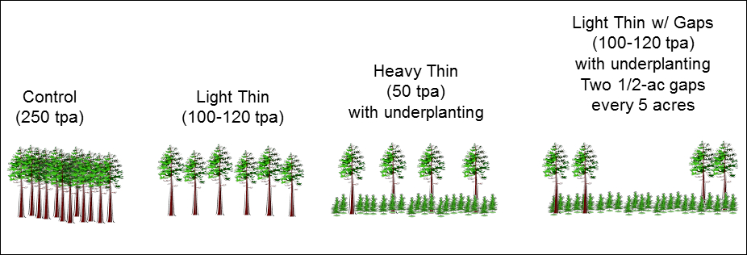

Table 1: YSTDS Thinning Treatment Prescriptions. Each treatment was replicated 4 times. Residual tree densities shown are as measured post-treatment.

Treatment designation | Residual  Tree  Density | Pattern of  Residual Trees | Prescription | Post-Treatment Planting
Unthinned Control | 706/ha  282/acre | N/A | No treatment | N/A
Light Thin | 303/ha  121/acre | Regularly spaced; approximates the industry standard. | Small diameter trees removed, with regularly spaced residual trees at 275/ha (110/acre). | 500 seedlings/ha (200/acre), mix of Douglas-fir, western hemlock, cedar, and western white pine.
Heavy Thin | 183/ha  73/acre | Regularly spaced; less dense than the industry standard. | Small diameter trees removed, with regularly spaced residual trees at 130/ha (52/acre). | 500 seedlings/ha (200/acre), mix of Douglas-fir, western hemlock, cedar, and western white pine.
Gaps | 248/ha  99/acre | Regularly spaced, but with 0.2-ha (0.5 acre) gaps covering 20% of area. | Thinned matrix as in Light Thin, but with an additional 20% of stand area harvested to leave 0.2 ha (0.5 acre) gaps. | 500 seedlings/ha (200/acre), mix of Douglas-fir, western hemlock, cedar, and western white pine.

General Study Area Description

All YSTDS study units (stands) are located on the Willamette National Forest, on the west slope of the Cascade Range in western Oregon. Two blocks are located on the McKenzie River District (former Blue River and McKenzie Ranger Districts combined), and two on the Middle Fork District near Oakridge (Map 1) (former Oakridge, Lowell, and Rigdon Ranger Districts combined). All sites are within the western hemlock (Tsuga heterophylla) forest zone (Franklin and Dyrness 1988) and were established after clearcutting mature/old growth stands followed by a broadcast burn, planting, and pre-commercial thinning. The stands were between 35-50 years old when the study was implemented in 1994. The plantations were pre-commercial thinned at approximately 15 years of age. Slopes range from 0 to 24%, and elevation ranges from 430-920 meters. Mean stand area is 31 ha, ranging from 15 to 53 ha.

Map 1: Location of the Willamette National Forest within Oregon.
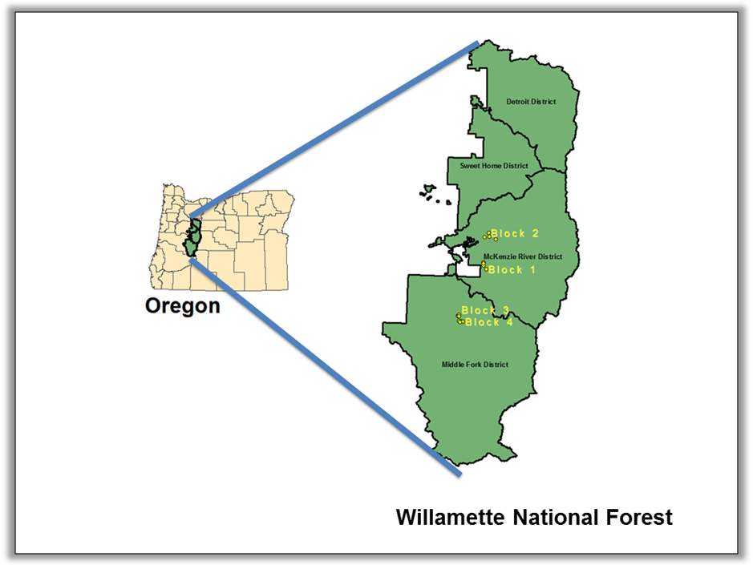
Map 2: Locations of the YSTDS Blocks. Imagery from July 2005.

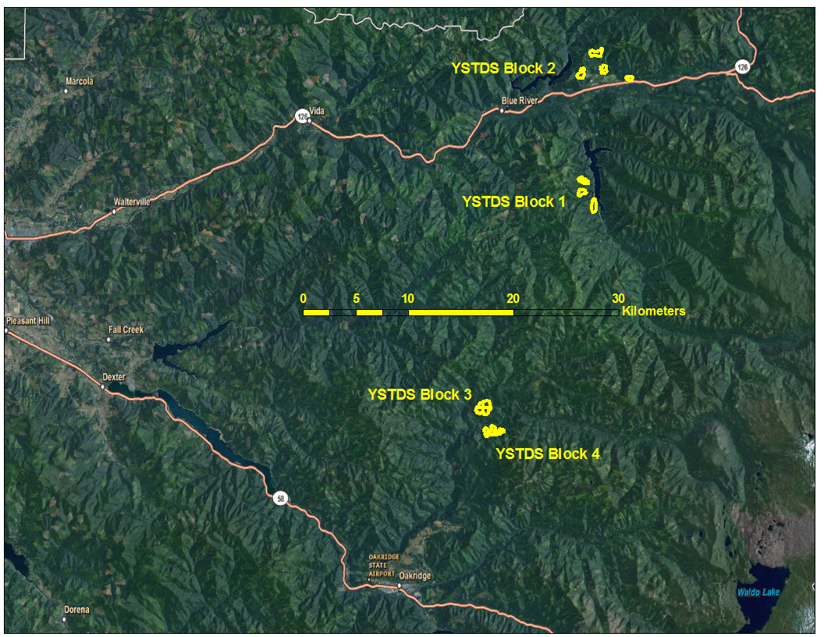

Distances between blocks range from 2.5 km to 21 km. Distances among stands within Blocks 1 & 2 (Maps 3 & 4 below) average 1.6 km, and do not exceed 4 km within any block. Within Blocks 3 & 4 (Maps 5 & 6 below), stands are directly contiguous with each other or separated only by relatively narrow riparian corridors or roads.

Map 3: YSTDS Block 1 (Cougar). This block includes TACs 1 through 4. Imagery from July 2005.

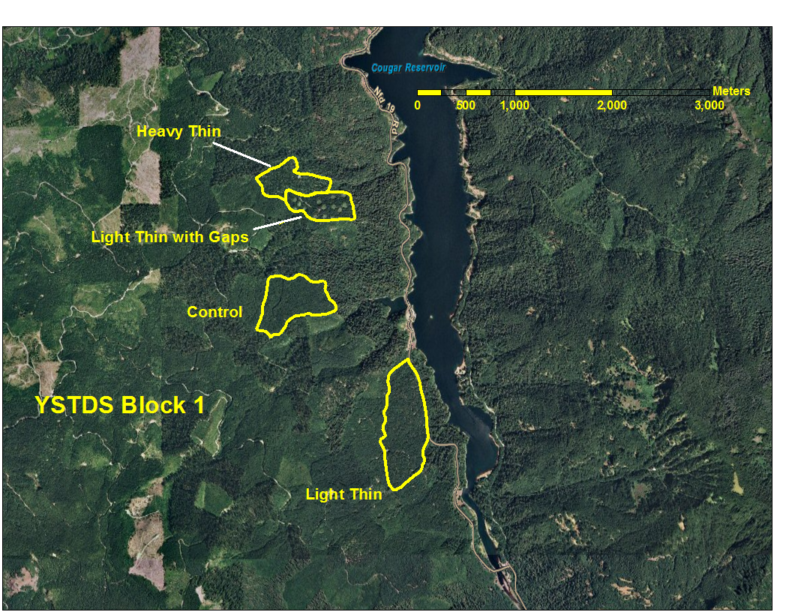

Map 4: YSTDS Block 2 (Mill Creek). This block includes TACs 5 through 8. Imagery from July 2005.

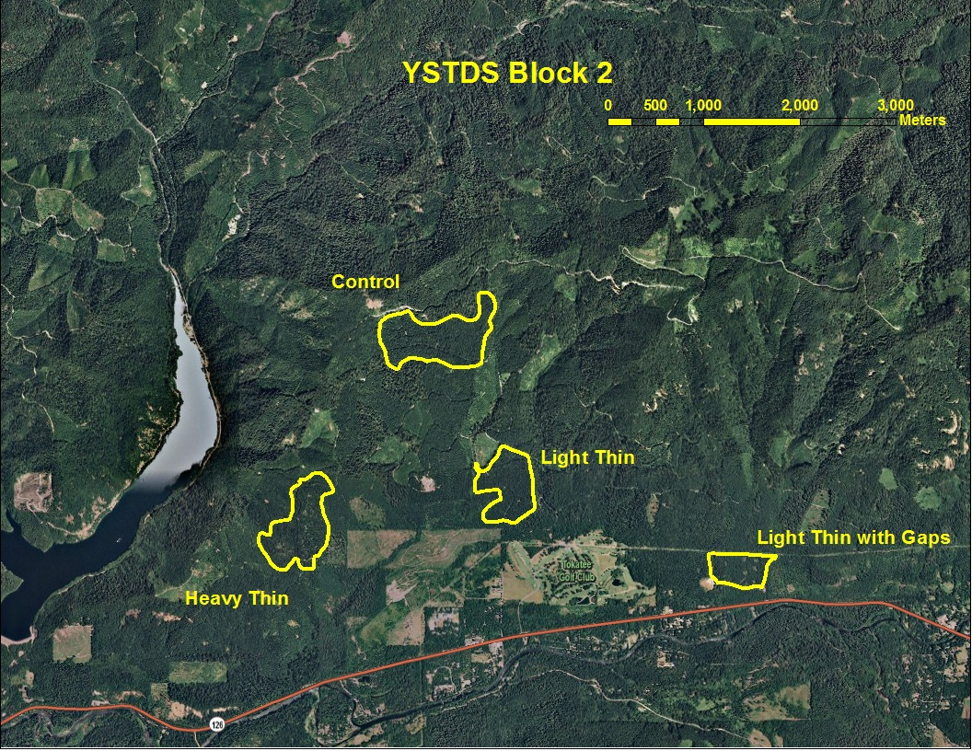
Map 5: YSTDS Block 3 (Christy Flat). This block includes TACs 9 through 12. Imagery from July 2005.

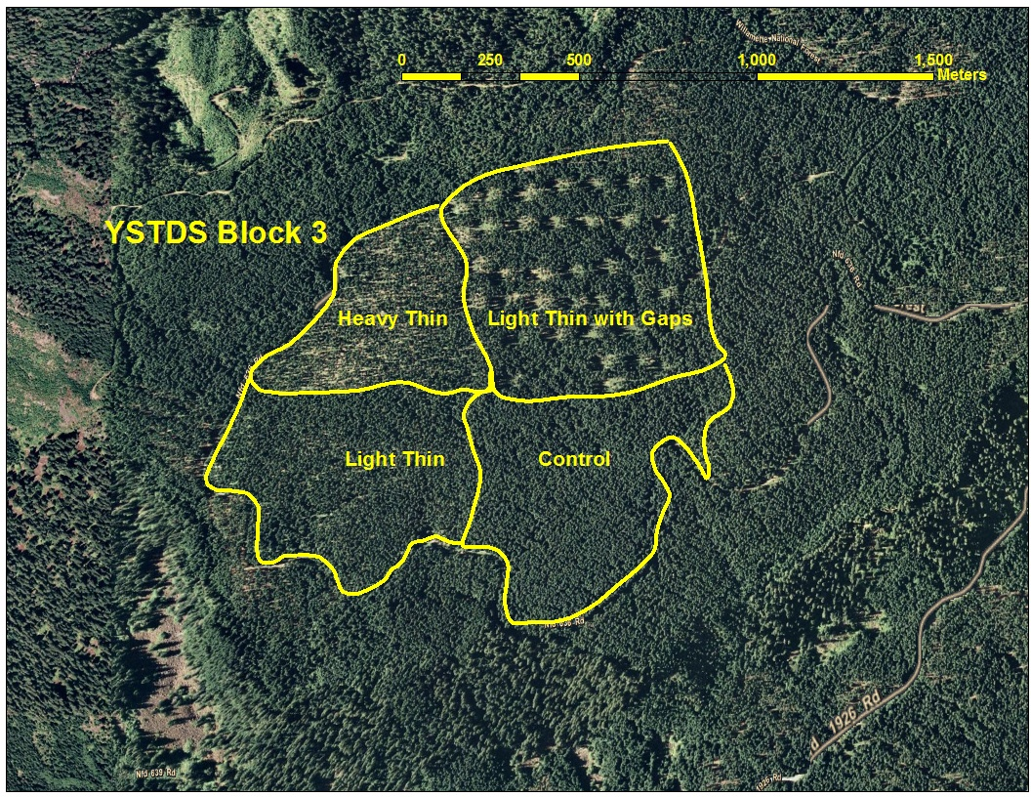

Map 6: YSTDS Block 4 (Sidewalk Creek). This block includes TACs 13 through 16. Imagery from July 2005.

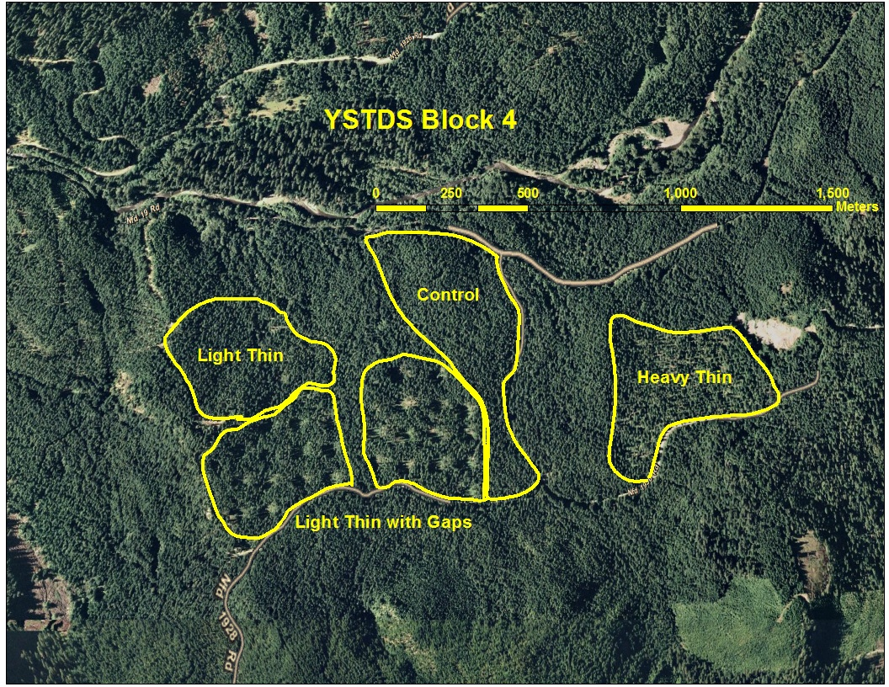
Pre-treatment Stand Conditions

Before thinning, Douglas-fir (Pseudotsuga menziesii) was the dominant overstory tree species with varying amounts of western hemlock (Tsuga heterophylla), western redcedar (Thuja plicata), and hardwoods including bigleaf maple (Acer macrophyllum), and golden chinquapin (Chrysolepis chrysophylla). The understory consisted primarily of vine maple (Acer circinatum), cascara buckthorn (Rhamnus purshiana), bitter cherry (Prunus emarginata), Oregon-grape (Mahonia nervosa), salal (Gaultheria shallon), and swordfern (Polystichum munitum).

Pre-treatment sampling (1994) revealed that stands within each block were similar (Table 2) with respect to tree basal area (overall mean 34.8 m²/ha; average CV for 4 blocks = 8.7%) and tree density (overall mean density 718 trees per ha; average CV over 4 blocks = 10.1%; Davis et al. 2007).

Table 2: Pre-Thinning Conditions in YSTDS Stands

Block | Treatment | Pre-Thinning Trees per ha | Pre-Thinning Basal Area m²/ha
Cougar | Control | 929 | 30
Cougar | Heavy | 800 | 27
Cougar | Light | 865 | 39
Cougar | Gaps | 891 | 36
Mill Creek | Control | 402 | 35
Mill Creek | Heavy | 466 | 36
Mill Creek | Light | 339 | 40
Mill Creek | Gaps | 335 | 36
Christy Flat | Control | 737 | 42
Christy Flat | Heavy | 880 | 48
Christy Flat | Light | 871 | 39
Christy Flat | Gaps | 855 | 40
Sidewalk Creek | Control | 756 | 28
Sidewalk Creek | Heavy | 820 | 25
Sidewalk Creek | Light | 800 | 26
Sidewalk Creek | Gaps | 743 | 30
 | Means | Pre-Thinning Trees per ha | Pre-Thinning Basal Area m²/ha
 | Control | 706 | 33.8
 | Heavy | 742 | 34.0
 | Light | 719 | 36.0
 | Gaps | 706 | 35.5

TABLE 3. Site characteristics for each treatment unit.
Block | Treatment | Area (ha) | Age (yrs) | Elev. (m) | Slope (%) | Aspect | Site Index¹ | Dominant Plant Association² | Total # of Plots
Cougar | Control | 30.0 | 40 | 805 | 18.8 | E | 107 | Tshe/Gash | 23
Cougar | Heavy Thin | 19.4 | 40 | 792 | 24 | E | 105 | Tshe/Bene | 13
Cougar | Light Thin | 37.2 | 38 | 610 | 17.1 | E | 107 | Tshe/Bene | 26
Cougar | Gaps | 14.6 | 40 | 792 | 16 | ENE | 105 | Tshe/Bene | 29³
Mill Crk | Control | 52.6 | 42 | 902 | 21.1 | SSE | 105 | Tshe/Bene | 25
Mill Crk | Heavy Thin | 34.8 | 42 | 658 | 22.9 | SE | 105 | Tshe/Bene | 23
Mill Crk | Light Thin | 37.2 | 43 | 524 | 20 | S | 105 | Tshe/Bene | 30
Mill Crk | Gaps | 19.8 | 42 | 439 | 8.9 | SSW | 106 | Tshe/Bene | 29³
Christy Flat | Control | 30.8 | 39 | 878 | 6.2 | SE | 117 | Tshe/Bene | 23
Christy Flat | Heavy Thin | 20.2 | 36 | 905 | 0 | SE | 120 | Tshe/Bene | 15
Christy Flat | Light Thin | 32.0 | 39 | 902 | 5.3 | SE | 117 | Tshe/Bene | 24
Christy Flat | Gaps | 38.9 | 40 | 905 | 5.3 | SSE | 118 | Tshe/Bene | 30
Sidewalk Creek | Control | 51.0 | 37 | 634 | 11.4 | N | 114 | Tshe/Rhma-Gash | 17
Sidewalk Creek | Heavy Thin | 19.0 | 35 | 652 | 16 | NW | 115 | Tshe/Rhma-Gash | 13
Sidewalk Creek | Light Thin | 22.3 | 33 | 646 | 21.8 | NNE | 122 | Tshe/Rhma-Gash | 15
Sidewalk Creek | Gaps | 30.4 | 39 | 671 | 14.5 | N | 111 | Tshe/Rhma-Gash | 30

¹Dominant tree height at 50 years, King’s Site Index Tables
²Tshe = western hemlock (Tsuga heterophylla); Bene = Oregon grape (Berberis nervosa); Rhma = western rhododendron (Rhododendron macrophyllum); Gash = salal (Gaultheria shallon)
³One stand matrix plot was removed from study because it was located out of study area.
Assignment of Treatments to Study Units

Despite initial hopes of assigning the treatments within each block so as to minimize variance among blocks, in practice a number of other criteria were used. The following description is based on notes from lead silviculturist Jim Mayo (Mayo 2002).

Block 1 (Cougar Block or Tap Thin): Treatments were assigned to match stand development conditions and to mitigate social concerns.

Control: Located directly upslope from Terwilliger Hot Springs, an area of high recreational use. Also, this stand had the smallest average stem diameter, a fact that was used to determine its treatment assignment.

Heavy Thin: Lightest stand density and therefore best candidate for heavy thin.

Light Thin: Highest stand density and therefore greater risk for windfall damage resulting from thinning; also, visible from the Aufderheide Scenic Highway.

Gaps: Moderately high stand density.

Block 2 (Mill Creek or Mill Thin): Treatments were reportedly assigned randomly. This is according to the recollections of silviculturist Bob Obedzinsky.

Block 3 (Christy Flat or Flat Thin): Treatments were reportedly assigned randomly. This seems very likely since the pre-treatment units formed one contiguous, relatively uniform stand.

Block 4 (Sidewalk Creek or Walk Thin): Treatments mostly random.

Control: Located so as to avoid earlier roadside treatments.

Heavy Thin: Topography was a factor.

Light Thin: Logging system (skyline) was a factor.

Gaps: Logging system (skyline) was a factor.

Implementation of Thinning Treatments

Thinning began in late 1994, and was completed by February 1997. Most harvest activity occurred simultaneously on all blocks between February 1995 and September 1996 and with no particular pattern to order of treatments (Table 3).

The individual districts planned the timber sales, delineated sale boundaries, and marked residual leave trees. Each block’s thinning sale was purchased by a different timber company and harvested by fellers contracted by that company.

Three harvest systems were used to accomplish the thinning. As part of the study design, costs of planning, unit layout, and logging production were quantified and compared among the 3 harvest systems. Soil compaction and damage to residual trees were also documented and compared among systems. The harvest systems used on each stand are shown in Table 3.

Table 4: Harvest Methods and Completion Dates for the YSTDS Thinning Treatments

Block | TRT | Harvest Method(s) | Completed
Cougar | Heavy | Tractor & Skyline | November 1995
Cougar | Light | Tractor & Skyline | September 1995
Cougar | Gaps | Tractor & Skyline | October 1995
Mill Creek | Heavy | Tractor & Skyline | February 1997
Mill Creek | Light | Tractor & Skyline | September 1996
Mill Creek | Gaps | Tractor | September 1996
Christy Flat | Heavy | Harvester-Forwarder | February 1997
Christy Flat | Light | Harvester-Forwarder | February 1997
Christy Flat | Gaps | Harvester-Forwarder | August 1996
Sidewalk Crk | Heavy | Skyline | April 1995
Sidewalk Crk | Light | Skyline | November 1995
Sidewalk Crk | Gaps | Skyline | August 1995

Slash treatment

Treatment of slash (residual logging debris) was not uniform across the study, but varied with logging system and contractor. In Block 1, tree tops were left in the units and hand piled along the roads. In Block 2, tops were left where they fell and slash treatment consisted of hand piling along roads and concentrations in the Gaps treatment. In Block 3, use of a mechanized harvester-forwarder meant that trees were limbed in skid trails, and some machine piling was done in areas of high slash concentration. In Block 4, tops were yarded with the last log, so slash accumulations were sparse and there was only minor hand piling along the road and in the Gaps.

Planting

Planting prescriptions called for 500 seedlings per hectare, with a species mix evenly divided between Douglas-fir (Pseudotsuga menziesii), western hemlock (Tsuga heterophylla), western redcedar (Thuja plicata) and western white pine (Pinus monticolus). Because of supply shortages, some stands received lesser amounts of western hemlock. It was felt by managers at the time that this was not a problem, because hemlock regenerates abundantly from natural seed sources and is shade tolerant.

Figure 2: Timeline of YSTDS Treatments and Sampling. Red bars indicate timing and duration of different YSTDS components.

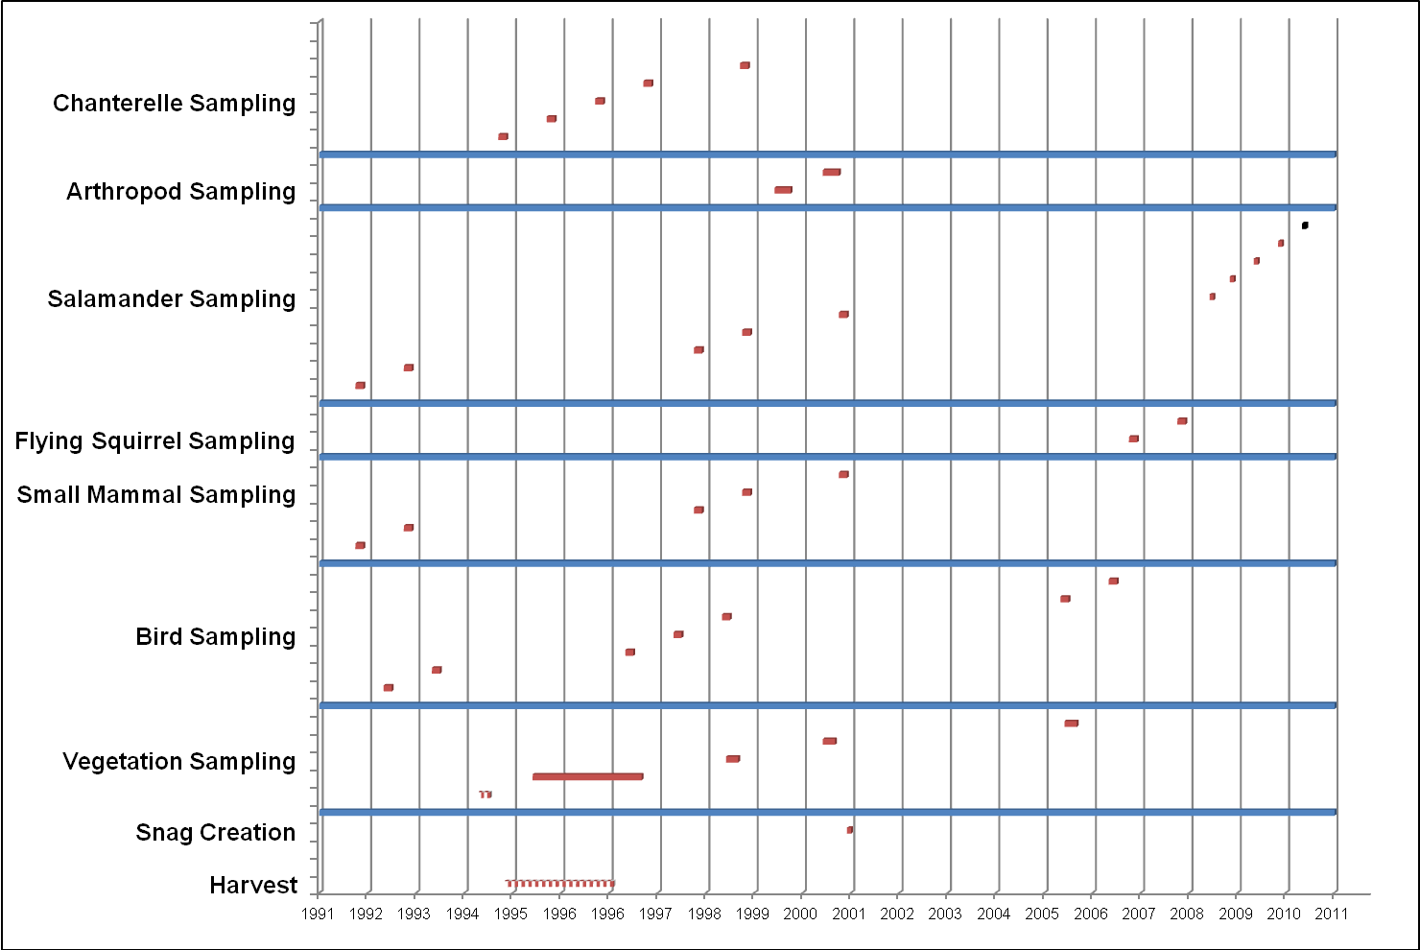
Component Studies

- Vegetation Response

Introduction

Measurement of changes in vegetation structure at various scales and strata are central to the YSTDS, not only because manipulation of fundamental vegetative elements of the forest are the medium through which the desired changes are applied, but also because these are the elements to which other taxa (birds, mammals, arthropods, fungi, humans) presumably respond. Thus, by measuring the changes in forest structure and diversity caused by the thinning treatments of the YSTDS, we are able to: 1) assess the degree of immediate structural alteration caused by implementation of the thinning treatments; 2) gauge the subsequent succession and silvicultural development of the experimental stands; and 3) provide information potentially useful for explaining changes in abundance and diversity of the many species that use this habitat.

Objectives

In general, the objective is to characterize overstory and understory responses following alternative thinning treatments in the YSTDS stands.

An essential part of quantifying such responses is establishing the conditions prior to treatment. Accordingly, stand-level forest structural characteristics were measured before thinning, including live tree densities, snag density, tree diameter, basal area, percent canopy cover, percent cover of understory components (herbs, low shrubs, tall shrubs), volume of coarse woody debris, conifer regeneration, and canopy tree community composition. A full detailed protocol is on file as “Pre-trt veg survey.doc”.

Overstory responses quantified in the first decade after treatment consisted of comparing the YSTDS treatments in terms of:

- Changes in overstory canopy cover;

- Changes in vertical crown structure;

- Growth of all Douglas-fir trees > 8 cm dbh;

- Growth of the largest 10 to 30 Douglas-fir trees per ha, which may eventually provide the dominant component of late-successional habitat in the stand matrix and near gaps;

- Differences in mortality of individual tree species due to stand instability, harvesting damage, and competition.

Understory responses quantified in the first decade after treatment consisted of comparing the YSTDS treatments by measuring the effects of thinning on:

- understory vegetation structural components, including cover of forest floor bryophytes, herbs, low shrubs, and tall shrubs;

- plant community composition;

- invasion by exotic plant species;

- enhancement of within-stand heterogeneity by creating gaps within the thinned matrix.
Sampling Design

Pre-Treatment Stand Exams (1994)

Before the YSTDS thinning treatments were initiated, the USFS conducted pre-harvest stand exams within the units designated to be part of the experiment. These exams were not designed to provide pre-treatment data for comparison with post-treatment conditions. However, these data were used to determine whether the assignment of treatments had been biased.

Stand-level characteristics measured were: (1) abundance and distribution of understory vegetation (shrubs and herbs), (2) abundance of advance conifer regeneration, (3) coarse woody debris and other significant structural components such as snags and nest trees > 25 cm dbh, (4) overstory gaps caused by root disease pockets, old skid trails, blowdown, etc., and (5) anomalies such as ponds, swampy areas, stream channels and rock outcrops.

Sampling was conducted 15 April-15 July 1994. On units sampled prior to 29 April 1994, every plot was sampled; thereafter, every 3rd plot was omitted from sampling.

Post-Treatment Vegetation Sampling (1996-2006)

Because of the fundamental difference in pattern between Gaps stands and the other treatments, post-thinning vegetation sampling followed 2 different sampling schemes.

Sampling in Control, Heavy Thin, and Light Thin treatments:

In these stands with uniform treatment pattern, approximately 7.5% of the area was sampled using circular 0.1 ha (17.8-m radius) permanent plots. Transects were systematically placed through treatment units and sampling plots were located randomly along each transect. Within each permanent plot, overstory cover and the presence of all understory species were recorded. At subplots nested within each plot, percent cover was visually estimated for various understory components: herbs, low shrubs, graminoids, bryophytes, exposed mineral soil, coarse litter, and fine. Graminoids and bryophytes were identified only as taxonomic groups. Along each transect, the line intercept method was used to estimate understory tall shrub and small tree (dbh < 5 cm) cover (for plot diagram and full details, see Beggs 2005).

Sampling in Gaps treatment:

As in the other YSTDS treatments, all Gaps stands were sampled using 0.1 ha (17.84 m radius) circular plots. However, plots in Gaps stands were of 3 types, depending on their location with respect to the gap edges. Edges were defined as the circular zone extending 7.5 m into the gap and 28m into the forest (see Fig. 2 below). One “gap plot” was placed at the center of each of 10 randomly chosen gaps in each Gaps stand; one “edge plot” straddled the boundary of each of 10 randomly chosen gaps in each stand; and “matrix plots” were randomly located in the non-gap matrix, at least 53 m from any gap center. Each Gaps stand was sampled using 10 gap plots, 10 edge plots, and 9 or 10 matrix plots.

Slightly less than 10% of the area in each stand was actually sampled in the “gap” plots (see proportions below). The exception to this was the Mill Creek block where, due to a miscommunication, irregularly shaped gaps were cut instead of circular gaps; at that block, approximately 7.6% of the area was sampled by gap plots (see Table 4 below).
Figure 3: Schematic of sampling design and plot layout in Gaps treatment. Not drawn to scale. Adapted from Davis et al. 2007.

25.4 m
7.5 m

Edge Plot
Edge Plot
17.8 m
10.3 m
Gap Plot
GAP
Matrix Plot
MATRIX
EDGE
Matrix Plot
Matrix Plot
Edge Plot
MATRIX

EDGE

GAP
Gap Plot
Gap Plot
To assess an overall treatment effect for the Gaps treatment, weighted averaging was used. For each Gaps stand, averages for each plot were calculated. Averages of the 10 plots for each “sub-treatment” (i.e., gap, edge, and matrix) were then added together and averaged to obtain an average value for each sub-treatment. Then sub-treatment averages were multiplied by the proportional area of each sub-treatment in the stand, as shown in Table 4. These values were then summed to provide a weighted average treatment value. For independent analysis of variation within the Gaps treatment, the sub-treatment averages were kept separate and never combined into an overall treatment effect (that is, no weighted averaging was done).

Table 5: Percent area sampled by matrix, edge, and gap plots for each Gaps stand in post-treatment vegetation sampling of the YSTDS.

Block | Sub-treatment | Percentage of area in treatment unit
1 | Matrix | 20.2
1 | Edge¹ | 70.1
1 | Gap¹ | 8.8
2 | Matrix | 31.7
2 | Edge¹ | 60.7
2 | Gap¹ | 7.6
3 | Matrix | 19.2
3 | Edge¹ | 71.8
3 | Gap¹ | 9.0
4 | Matrix | 11.2
4 | Edge¹ | 78.9
4 | Gap¹ | 9.9
¹ Gaps covered approximately 20% of each treatment unit, but only the interior of the gap was sampled by Gap plots (the exterior of the gap was sampled by Edge plots); therefore, the proportion of total gap area represented by Gap sampling is less than the area actually covered by gap.

Measurement Schedule

In general, measurement of vegetation structure in the YSTDS has occurred at 5 year intervals after treatment. Because installation of the thinning treatments occurred over a period of slightly more than 2 years (late 1994-early 1997), initial post-treatment sampling of vegetation was also staggered, occurring mainly during the first summer after application of thinning treatments (1995-1997), with a few exceptions occurring during the 2nd summer. Subsequent samplings were carried out in 2001 and 2006.

Post-treatment changes in vegetation

Measurements of vegetation 5-7 years after treatment revealed that thinning created substantial differences in overstory cover, tree density, and tree basal area among the treatments (Davis, et al. 2007; Davis and Puettmann 2009). Percent cover of low shrubs (< 2 m high), was reduced about 40% (P < 0.001) by harvest damage in thinned stands; a corresponding reduction in tall shrubs (> 2 m high) was also significant (55% reduction; P = 0.002), but by 5-7 years after thinning both low and tall shrub cover in thinned treatments had recovered to levels lower but statistically indistinguishable from Controls (Davis and Puettmann 2009).

In 2006, 10 years after thinning, percent cover of overstory, basal area, and tree density were still lower in all thinned treatments than in Control stands (all P < 0.01). Percent cover of low shrubs in 2006 was significantly lower in Control stands than in thinned stands (P = 0.0004). Though high variability among blocks masked statistical differences, percent cover of tall shrubs in 2006 was marginally greater (P = 0.0702) in Control stands than in thinned stands.

Post-treatment changes in coarse woody debris

Density of large (> 30 cm dbh) snags was low (mean 8.1 per ha), and in 2006 treatments and controls could not be distinguished by snag density (P = 0.54), though there was a large difference among blocks (P = 0.0193). Volume of coarse woody debris (CWD) > 10 cm diameter ranged from a mean of 107 m³/ha in Light Thin stands to a mean of 270 m³/ha in Heavy Thin stands, and though thinning increased CWD volume, high variability among replicates severely compromised our ability to detect statistical differences among treatments (B. McComb, unpublished data).

Key Findings

- Thinning created major differences in canopy cover relative to Control stands. Though canopies in thinned stands had recovered substantially in the first 10 years following thinning, Control stands still had greater average canopy cover than all thinned treatments.

- Mean growth of all Douglas-fir increased in all thinning treatments relative to Controls, but the growth of the largest Douglas-fir was accelerated only in the Heavy Thin treatment.

- At 5-7 years post-treatment, vertical structure was not significantly differentiated as a result of thinning.

- Thinning resulted in initial declines in bryophyte and shrub layers of the understory, but those strata recovered strongly by 5-7 years post-treatment, and by 10 years post-thinning shrub cover was higher in all thinning treatments relative to controls.

- Herbaceous plants were not initially significantly affected by thinning, but by 5-7 years post-treatment there was evidence for a release of early-seral herbaceous plants in thinned stands. By 10 years post-thinning, percent cover and richness of early seral herbaceous species were significantly greater in the thinned stands than in control stands, but there were no differences for late seral species as a group.

- Lower overstory densities and thinning were associated with improved ecosystem functions, specifically the provision of wildlife habitat, as evident by higher cover of plants producing flowers, fleshy fruits, and palatable leaves. Greater cover of drought-resistant, fire-resistant, and heat tolerant species in low density stands and after thinning suggested that these ecosystem functions are more likely to be maintained under climate change conditions, indicating higher resilience.

Data Storage and Management

Pre-thinning stand exam and stand diversity data for the YSTDS are not yet available publicly. Metadata can be accessed from the old Forest Science Data Base (FSDB) at the H.J. Andrews Experimental Forest (http://www.fsl.orst.edu/fsdb/data/studies/fs114/fs114fmt.htm) under Datacode FS114.

Post-thinning vegetative response data for the YSTDS are not yet available publicly. Metadata can be accessed from the old Forest Science Data Base (FSDB) at the H.J. Andrews Experimental Forest (http://www.fsl.orst.edu/fsdb/data/studies/fs118/fs118fmt.htm) under Datacode FS118.

For more information about YSTDS vegetation data, contact Klaus Puettmann, Department of Forest Ecosystems and Society, Oregon State University. The data will be made available to authorized users through the Forest Science Data Base.

Products

Ares, A., K. Puettmann, and C. Berger. 2009. Can thinning be effective in altering overstory and understory vegetation dynamics and accelerate the development of late-successional features in temperate coniferous forests? Poster presented at the 13th World Forestry Congress in Buenos Aires, Argentina, October 18-23, 2009.

Beggs, L. 2004. Vegetation response following thinning in young Douglas-fir forests of western Oregon: can thinning accelerate development of late-successional structure and composition? M.S. thesis, Oregon State University. 115 pp.

Beggs, L., and K. Puettmann. 2003. Stand structure and vegetation changes five years after applying three thinning treatments and control: preliminary results. Website.

Beggs, L., and K. Puettmann. 2004. Understory vegetation response to alternative thinning treatments in young Douglas-fir stands. Presented at the annual meeting of the Ecological Society of America, Portland, OR. Aug 5, 2004.

Beggs, L., K. Puettmann, and G. Tucker. 2005. Vegetation response to alternative thinning treatments in young Douglas-fir forests. In C. E. Peterson, D. A. Maguire (Eds.), Balancing ecosystem values: innovative experiments for sustainable forestry (pp. 243-248). General Technical Report PNW-635, USDA Forest Service, Portland, OR.

Bohac, S., M. Lattig, and G. Tucker. 1997. Initial vegetative response to alternative thinning treatments in second-growth Douglas-fir stands of the central Oregon Cascades. Unpublished report.

Davis, L., K. Puettmann, and G. Tucker. 2007. Overstory response to alternative thinning treatments in young Douglas-fir forests of western Oregon. Northwest Science 81:1-14.

Davis, L., and K. Puettmann. 2009. Initial response of understory vegetation to three alternative thinning treatments. Journal of Sustainable Forestry 28(8):904-934.

Fiala, A. 2003. Forest canopy structure in western Oregon: characterization, methods for estimation, prediction, and importance to avian species. M.S. thesis, Oregon State University. 362 pp.

Fiala, A., S. Garman, and A. Gray. 2006. Comparison of five canopy cover estimation techniques in the western Oregon Cascades. Forest Ecology and Management 232:188-197.

Kuehne, C. and K. Puettmann. 2008. Natural regeneration in thinned Douglas-fir stands in western Oregon. Journal of Sustainable Forestry 27(3):246-274.

Neill, A.R. 2012. Overstory density and disturbance impacts on the resilience of coniferous forests of western Oregon. M.S. thesis, Oregon State University.

Puettmann, K. J., Dodson, E. K., Ares, A., and Berger, C.A. 2013. Short-term responses of overstory and understory vegetation to thinning treatments: a tale of two studies. In: Anderson, P. D. and Ronnenberg, K.L., editors. Density management for the 21st Century: west side story. General Technical Report PNW-GTR-880. Portland, OR: U.S. Department of Agriculture, Forest Service, Pacific Northwest Research Station: 41-55.

Wilson, D.S., Anderson P.D., and K.J. Puettmann. 2009. Evaluating the consistency of understory vegetation response to forest thinning through synthetic analysis of operational-scale experiments. Forestry 82: 583-596.

Wilson, D. and K. J. Puettmann. 2007. Density management and biodiversity in young Douglas-fir forests: Challenges of managing across scales. Forest Ecology and Management. 246:123-134.
- Economics of Alternative Thinning Operations

Introduction

Because widespread thinning of young stands was relatively new in the early 1990’s, little information was available to assess the comparative costs of various techniques for the layout and harvest of thinning sales. To accomplish a comparison of costs for 3 alternative methods of thinning, YSTDS investigators designed a protocol to track and compare all costs, from planning and layout through the end of harvest. This protocol did NOT include Forest Service planning steps prior to approval for sale; it did include work done to prepare selected thinning sales for advertisement and bidding, layout activities completed by the contractor after reward of the contract, and the actual harvest of the sale units. The 3 logging systems compared for this study were: 1) a mechanized cut-to-length system, combining a single-grip harvester and forwarder; 2) a conventional ground-based skidding system (crawler-tractors); and 3) a skyline yarding system. These economic studies were carried out in conjunction with studies of residual stand damage and soil compaction/disturbance, which are discussed in subsequent sections of this report.

Objectives

- Determine the Forest Service’s time and costs for planning and layout of the thinning sales;

- Determine the logging contractors’ time and costs for layout of harvester tracks, skid trails and skyline corridors;

- Determine productivity rates and costs per hour for felling, skidding, and yarding;

- Determine productivity rates and logging costs per unit volume for each component of each logging system (felling and skidding) and for each logging system as a whole;

- Obtain information on delays for use in harvesting simulation;

- Create regression equations to predict delay-free cycle times from significant independent variables;

- Determine if harvesting system costs differ significantly among thinning treatments.

Methods/Sampling Design

Planning and Layout Cost

Data for this part of the comparison came from 2 sources: 1) the US Forest Service, responsible for preparation of the sales for bid, and 2) the contractors, who were responsible for layout of the skyline trails and/or designated equipment trails. Forms were provided to Forest Service and contractor personnel to track time spent on each activity, and costs were based on wage and salary information provided by each entity.

Procedures tracked as part of the Forest Service planning were: reconnaissance planning (office and field); logging design; marking and traversing unit boundaries; flagging haul roads and landings; ground profile surveys (for skyline systems only); computer analysis; marking leave trees and flagging patch perimeters; timber cruising; and preparing the sale contract,
appraisal, and prospectus. Procedures tracked as part of the contractor’s layout were layout of harvester/forwarder trails, skid trails, and skyline corridors.

Harvesting

Individual trees were identified by painted numbers before felling began. Data recorded for each tree included species, diameter at breast height (DBH), total height, and whether the tree
was in a skidtrail corridor.

Detailed time-study and shift-level data were collected during harvest for the 3 different logging systems, to compare costs and productivity of felling and handling of logs. Times for various parts of the harvest cycle were recorded in centimin (0.01 minute) by observers using hand-held computers, and shift-level data were recorded by the logging crews. Delays of various kinds were also recorded. Using these time data, regression models with indicator variables were developed for predicting delay-free cycle times for each logging system and silvicultural thinning treatment, and validation of the regression models was accomplished by comparing with a reserved portion of the original data.

Response Variables/Analysis

Measured variables for the analysis of planning and layout were: hours spent on each activity; labor costs per hour for each activity; acreage of each sale; and millions of board-feet of timber produced. Variables derived from these were: millions of board-feet per acre, hours per acre, costs per acre, and costs per million board-feet produced. No statistical analysis was applied to these data, but mean values for costs were computed and compared among 3 silvicultural treatments and 3 logging systems.

Measured variables for the logging systems were times spent on various components of the harvest cycle; short (< 10 min) delay times during the harvest cycle; longer (> 10 min) delays during the work shift; volumes of timber produced per cycle and shift; owning, operating, and labor costs per hour. Variables derived from these data were: effective hours (min/hr); delay-free cycle time (min/cycle); volume per cycle (CCF/cycle, where CCF = 100 cubic feet of timber); and net:gross timber scale.

Measurement Schedule

Forest Service planning and layout took place between November 1992 and November 1993. Contractor layout occurred as the units were harvested, between November 1994 and April 1997. All the studies of logging system economics were by their nature one-time measurements, occurring before and during the thinning operations which implemented the YSTDS design. Thus, no repeat measurements were possible.

Data Storage and Management

None of the data concerning logging system economics have yet been made available to the public. For more information on these data, contact Loren Kellogg, Department of Forest Engineering, Resources and Management, Oregon State University. .

Key Findings

- Forest Service planning and layout costs varied by a factor of 2.5, and contractors varied by a factor of 10, but neither showed any consistent relationship to thinning treatment.
- Forest Service costs directly related to logging system accounted for only 7% of total costs.
- In contrast, contractor layout costs varied by logging system, with the mechanized system costing least and the skyline system costing most.
- Differences among thinning treatments in total cost of mechanized (harvester-forwarder system) thinning were relatively small, but costs were higher in the Gaps treatment than in the Light or Heavy thin treatments.
- Differences in initial tree densities among replicates made it impossible to draw firm comparisons or conclusions about cost effects of the 3 thinning treatments for the tractor and skyline logging systems.

Table 6. Planning and layout costs recorded by the Forest Service.
Hourly labor costs are in 1994 dollars and include fringe benefits.

Component of Planning and Layout | Average cost ($/hr)
Reconnaissance planning, maps, photos | $18.5
Logging design, feasibility, costs, etc. | $20.05
Computer analysis | $20.05
Marking unit boundaries (flagging boundaries, posting signs, etc.) | $18.42
Flagging haul roads and landings | $19.33
Ground profile surveys | $18.7
Flagging harvester/forwarder trails, skidding trails, skyline corridors | $21.62
Marking leave trees and flagging patch perimeters | $14.88
Timber cruising | $16.18
Preparing contract (includes contract, appraisal, and prospectus) | $18.71
Miscellaneous | $17.33

Products

Hossain, M. 1998. Young stand thinning in western Oregon: cost comparison of harvesting alternatives and comparison of time study techniques. Ph.D. dissertation, Oregon State University.

Kellogg, L., and C. Davis. 2006. Tractor thinning productivity and costs: experience from the Willamette Young Stand Project. Research Contribution 48, Forest Research Laboratory, Oregon State University.

Kellogg, L., M. Miller, Jr., and E. Olsen. 1999. Skyline thinning production and costs: experience from the Willamette Young Stand Project. Research Contribution 21, Forest Research Laboratory, Oregon State University.

Kellogg, L., G. Milota, and B. Stringham. 1998. Logging planning and layout costs for thinning: experience from the Willamette Young Stand Project. Research Contribution 20, Forest Research Laboratory, Oregon State University.

Kellogg, L., and M. Reed. 1998. Thinning young stands. 31-minute VHS video available at Forestry Media Center, Catalog # 1089. College of Forestry, Oregon State University.

- Residual Stand Damage from Thinning Operations

Introduction

A frequent by-product of thinning operations in young stands is wounding of residual trees, producing potential entry points for disease and decay organisms, and consequent reduction in future economic value of the trees. In addition, scarring of trees during thinning may have negative aesthetic effects on public or private resources.

To investigate the effects of different silvicultural treatments and logging systems on potential for residual stand damage, data on residual tree damage were collected during the implementation of the YSTDS thinning prescriptions.

Objectives

- Characterize and compare residual stand damage left by 3 different logging systems (skyline, tractor, & mechanized cut-to-length);

- Quantify damage levels related to thinning treatment and logging system, and discuss variables affecting wounding amounts;

- Compare damage caused by harvester and forwarder in a mechanized cut-to-length thinning operation;

- Recommend practices and strategies to reduce thinning damage.

Methods/Sampling Design

Sampling of tree damage was conducted in fixed-radius circular plots, except for one stand which underwent a 100% survey of all residual trees.

Three types of stand damage were recorded: scarring of boles (exposure of sapwood by removal of bark); crown removal greater than 50% including broken top; and obvious scarring or severing of root systems. For scarring damage on boles, tree diameter, scar length & width, and height from the ground level to scar were measured. Scar area was measured using a planimeter on a paper tracing of each scar. If gouging into the wood occurred, its depth was measured. Also, position of each scar relative to the skid trails or yarding corridors was categorized. In the case of stands harvested with the mechanized (harvester-forwarder) system, 2 separate surveys on a 3.9 ha (9.7 ac) light thinning unit were conducted to distinguish damage caused by the harvester from damage caused by the forwarder.

Response Variables/Analysis

Multiple linear regression, using logging system and thinning treatment as indicator variables, was employed to determine differences in residual damage levels. Analysis-of-variance was used to compare mean scar heights among thinning intensities and logging systems.

Measurement Schedule

The YSTDS units were harvested between November 1994 and April 1997. The measurements of residual tree damage were by their nature one-time measurements, occurring immediately after the thinning operations which implemented the YSTDS design. No repeat measurements are planned.

Data Storage and Management

None of the data concerning residual stand damage have yet been made available to the public. For more information on these data, contact Loren Kellogg, Department of Forest Engineering, Resources and Management, Oregon State University. Data will be made available to authorized users through the Forest Science Data Base.

Key Findings

- Scarring was the most frequent damage to residual trees, accounting for 90% of total damage.

- Frequency of scars was inversely proportional to scar size.

- Scarring by ground-based systems (tractor and cut-to-length) was more severe than with skyline thinning systems.

- Ground-based systems also created more severe root damage due to repeated passes of equipment and dragged logs on the skidding and forwarding trails.

- Damaged trees were highly concentrated near skid trails or skyline corridors.

- In the cut-to-length system, the harvester caused more wounding (70% of total scars) to leave trees than did the forwarder (30%), but forwarder scars were larger and sustained severe gouging.

- Residual stand damage can be effectively minimized by careful harvest planning, layout and thinning operations. Skid trails or skyline corridors should be located to minimize wounding of trees in harvest operations, and trees adjacent to trails or corridors can be wrapped using a tree pad to prevent damage.

Products

Han, H. 1997. Damage to Young Douglas-fir Stands from Commercial Thinning with Various Timber Harvesting Systems and Silvicultural Prescriptions: Characteristics, Sampling Strategy for Assessment and Future Value Loss. Ph.D. dissertation, Oregon State University.

Han, H. and L. Kellogg. 2000. A comparison of sampling methods for measuring residual stand damage from commercial thinning. Journal of Forest Engineering 11(1): 63-71.

Han, H. and L. Kellogg. 2000. Damage characteristics in young Douglas-fir stands from commercial thinning with four timber harvesting systems. Western Journal of Applied Forestry 15(1): 27-33.

Kellogg, L., and M. Reed. 1998. Thinning young stands. 31-minute VHS video available at Forestry Media Center, Catalog # 1089. College of Forestry, Oregon State University.

Kellogg, L., and H. Han. 1999. Residual stand damage from thinning: Young Stand Thinning & Diversity Study. Cascade Center for Ecosystem Management pamphlet. 2 pp.
- Soil Compaction from Thinning Operations

Introduction

Recent shifts toward mechanized harvesting of second-growth timber in the Pacific Northwest have heightened interest in the degree of soil compaction and soil disturbance associated with mechanized harvesting. Forest soils in the Pacific Northwest are typically very prone to compaction. Soil compaction has been shown to have negative effects on establishment, growth, and survival of seedlings and saplings, as well as reducing water infiltration and increasing erosion.

It is possible that overall effects on forest soils may be reduced by the use of newer mechanized logging systems, including skyline systems and the harvester-forwarder system, in which both harvester and forwarder travel over slash deposited on skid trails by the harvester. But verification of this postulated lessening of soil compaction was not available in the mid-1990s when the YSTDS was implemented. To assess the effects of skyline and harvester-forwarder systems on compaction of forest soils during thinning operations, YSTDS investigators compared soil bulk density and penetrometer measurements from soils before and after logging traffic over 3 different slash depths, as well as measuring effects of 50-yr-old skid trails from the previous harvest.

Objectives

- Characterize the areal extent of soil disturbance throughout experimental stands thinned with a smallwood skyline system and a cut-to-length (harvester-forwarder) system.

- Determine whether significant differences in mineral soil bulk density exist between samples taken in the center, at the edge, and halfway between cable-skidding trails.

- Determine whether significant differences in mineral soil bulk density exist among undisturbed soils, soils in old skid trails, soils subjected to recent harvester traffic alone, and soils subjected to recent traffic from both harvester and forwarder;

- Determine if and how slash ameliorates compaction from the harvester-forwarder system;

- Determine if penetrometer measurements provide an adequate assessment of soil
bulk density;

- Compare conclusions from the bulk density and penetrometer data analyses
regarding the significance of logging equipment traffic and slash treatments.

Methods/Sampling Design

Soil disturbance, soil moisture, slash depth and average diameter, duff depth, soil bulk density, and penetrometer (cone index) measurements were taken before harvest in 4 of the treated stands. Two stands at the Christy Flats block were harvested with the cut-to-length harvester-forwarder system, and 2 stands at the Sidewalk Creek block were harvested with a trailer-mounted smallwood cable yarding (skyline) system. Measurements were taken again during and immediately after thinning harvest in each location.

The combined effect of harvester and forwarder traffic on soils was measured at non-random plots on designated skid trails. Impacts of the forwarder alone were measured along short side loops off the designated trails. Slash depth was manipulated by asking the harvester operator to create a prescribed amount of slash (zero, low, moderate or high) through modifying the number of trees processed directly over the plots. The average slash depth after one harvester pass was measured for each plot.

Response Variables/Analysis

Variables measured were number of equipment passes, slash depth and average diameter, duff depth, soil moisture content, bulk density or penetrometer reading and location within the skid trail (tire rut or center). These variables were tested for significance in predicting post-treatment bulk density or cone index with multiple linear regression.

Measurement Schedule

The 4 YSTDS units used for the soil compaction research were harvested between November 1994 and November 1995. These measurements occurred immediately before and after the thinning operations which implemented the YSTDS design. No repeat measurements were planned.

Data Storage and Management

None of the data concerning residual stand damage have yet been made available to the public. For more information on these data, contact Paul Adams, Department of Forest Engineering, Resources and Management, Oregon State University. The data will be made available to authorized users through the Forest Science Data Base.

Key Findings

- At Christy Flat, approximately 13-27% of the area studied had visible disturbance by harvest 50 years before the YSTDS thinning operations, and bulk density of 50-year-old skid trails was statistically different from that of undisturbed soil. However, differences in bulk density were not consistent across the trails, and may have been the result of scalping rather than compaction. Evidence of historical soil disturbance and compaction was not visible at the Sidewalk Creek stands.

- The cut-to-length harvester alone did not significantly increase bulk density of previously undisturbed soil, nor did it increase bulk density of soils in 50-yr-old skid trails;

- The combination of the cut-to-length harvester and forwarder significantly increased bulk density of previously undisturbed soil by an average of 12% (4 inch depth) and 11% (8 inch depth), but did not increase bulk density of soils in 50-yr-old skid trails;

- Compaction did not occur in the center of harvester-forwarder trails until very high traffic levels at the 4-inch depth and not at all at 8 inches;

- Skyline thinning at the Sidewalk Creek stands created very limited soil disturbance or compaction. Disturbance did not exceed 2 % of the harvest unit area and there was no statistically significant difference in bulk density between disturbed and undisturbed areas.

Products

Allen, M. 1997. Soil compaction and disturbance following a thinning of second-growth Douglas-fir with a cut-to-length and a skyline system in the Oregon Cascades. M.S. thesis, Oregon State University.

Allen, M., P. Adams, and L. Kellogg. 1997. Soil bulk density and penetrometer measurements after harvester and forwarder traffic over different slash depths in the Oregon Cascades, research project completion report, June 30, 1997. Forest Engineering Department, Oregon State University. 87 pp.

Allen, M., M. Taratoot, and P. Adams. 1999. Soil compaction and disturbance from skyline and mechanized partial cuttings for multiple resource objectives in western and northeastern Oregon, USA. Proceedings of the International Mountain Logging and 10th Pacific Northwest Skyline Symposium.

Kellogg, L., and M. Reed. 1998. Thinning young stands. 31-minute VHS video available at Forestry Media Center, Catalog # 1089. College of Forestry, Oregon State University.

- Small Mammal Responses to Young Stand Thinning

Introduction

Terrestrial and arboreal rodents and insectivores are key fauna of forest ecosystems. They serve as prey for larger vertebrates (voles and mice), can be predators on bird eggs and nestlings (squirrels and mice), and play an important role in the dispersal of hypogeous mycorrhizal fungi (voles and squirrels). Attempts to relate the various thinning treatments of the YSTDS to changes in the abundance and diversity of small terrestrial mammals have been a central component since the beginning of the project.

This component of the YSTDS, like several others, was originally conceived as a Before-After Control-Impact (BACI) design. Unfortunately, the opportunity to follow through with the BACI design was lost in the early years, as research priorities changed, certain methods of collection (pitfall traps) became ethically unacceptable, and the high labor costs of rigorous experimental protocol became apparent. As a result, studies of small mammal responses to the YSTDS thinning treatments have suffered from inconsistent sampling protocols and inability to draw conclusions based on temporal trends. More recent efforts have concentrated on comparisons of treatments to control stands, rather than contrasts of pre- and post-treatment conditions.

It should be noted that in early years (1991-2001) efforts to quantify the abundance and diversity of forest-floor amphibians were coupled with mammal sampling. More recently, these taxa were sampled separately, and amphibians are therefore covered in a separate section of this report.

Objectives

- Determine effects of the YSTDS thinning treatments on the relative abundance of particular species of small mammals;

- Determine effects of the YSTDS thinning treatments on small mammal community diversity;

- Determine which habitat features are associated with changes in relative abundance of particular species;

- Determine whether there are detectable microhabitat characteristics or evidence of structural niche segregation for particular species.

Methods/Sampling Design

Methods for sampling the mammal fauna on the YSTDS changed over the course of the study. In the 1990’s, pre-treatment and immediate post-treatment sampling was focused on sampling of forest floor vertebrates using Sherman live-traps and pitfall traps. In later years, efforts to measure densities of northern flying squirrels (Glaucomys sabrinus) were gradually increased, because of the squirrel’s importance as prey for spotted owls and its larger role as an indicator of forest health generally.

Before thinning, in Oct-Nov of 1991 and 1992, the mammal fauna on the YSS sites was sampled for 8 consecutive nights annually in each stand using conventional square grids of Sherman live-traps (10x10 with 20 m inter-trap spacing) and pitfall traps (5x5 with 20 m spacing; Garman 2001). This effort sampled only a small portion of each YSTDS stand.

The YSTDS sites were trapped again for several years soon after thinning, in 1998, 1999, and 2001 (Garman 2001). To better sample the spatial variability in these post-treatment stands, square trapping grids were replaced by variable-length transects that covered more of each stand. Number of transects per stand varied from 4 to 11 depending on stand shape, but each stand included a total of 100 trapping stations. Distance between traps on each transect was 30 m. Transects were spaced 30 m apart and >50 m from a stand edge. In 1998-99, 1 Sherman live-trap (Model LFATDG) was placed at each station (total of 100 traps per stand), and 1 pitfall trap was installed at every 2nd station (total of 50 pitfalls per stand). In 2001, Tomahawk live-traps (Model 201) were added to the design to specifically target flying squirrels; in each treatment stand, 1 Tomahawk trap was placed on the ground at every 2nd station on alternating transects, so that traps were evenly distributed through the treatment unit (total of 25 Tomahawk traps per stand). In each year of the 1998-2001 sampling effort, all 4 stands within a block were trapped simultaneously for 6-8 consecutive nights during late September to mid-November. It should be noted that these early efforts (1991-2001) also sampled forest floor amphibians, though captures were sparse. More recently, efforts to quantify abundance and diversity of amphibians have been made separately from mammal sampling, and are covered in a separate section of this report.

In 2007-08 (11-13 years after thinning), all stands were resampled, using the same variable-length transects established in 1998 (Manning et al. 2012). Trapping occurred for 4 consecutive nights in each stand between late September and late November. Two stands in each block were sampled simultaneously and the other 2 stands in the same block were sampled in the following week. The order for sampling stands within blocks was randomized, and blocks were sampled sequentially. Considerations for the order of sampling among blocks included elevation, seasonal road closures, and proximity to other blocks. One trap was placed at each station. In this phase of the study, we increased efforts to capture flying squirrels by doubling the number of Tomahawk traps deployed. In each stand, Sherman traps alternated with Tomahawk traps along each transect, so that 50 of each were evenly distributed throughout the 100 stations in each stand. Half of the Tomahawk traps were attached to the boles of trees (approx. 1.5 m high), and the rest were placed on the ground; tree and ground placements of Tomahawk traps alternated along transects. To increase capture rates, all traps were locked open and pre-baited once 10 days before the trap session began. During the trapping session, traps were checked twice daily to minimize mortality of trap-prone diurnal species (e.g., chipmunks). Traps were set in the afternoon on the 1st day of each trap session, checked twice each day for 3 days, then checked and closed on the morning of the 5th day; thus, each trap session included 4 nights and 7 capture occasions.

In all years, traps were baited with a mixture of peanut butter, oats, and sunflower seeds. Polyester or cotton fiber insulation was placed in each trap, and traps were placed within weather-resistant covers. Pitfall traps (not used after 2001) were provided with a small shelter, insulation, and food, and were operated as live-traps. All traps were checked daily (twice daily in 2007-2008). Captured rodents were identified to species, weighed, sexed, marked with individually-numbered eartags, and immediately released at the point of capture. Trap mortalities were frozen for later necropsy to confirm species and sex. After trapping was completed, pitfall traps were made inoperable and box traps were removed. All procedures were conducted under protocols approved by the Institutional Animal Care and Use Committee at Oregon State University.

Response Variables/Analysis

In pre-treatment and early post-treatment sampling, response variable was captures per unit effort for each species. In other words, data were insufficient to estimate abundance or density of any species, so comparisons of treatments were based on a relative index (captures per 100 trap nights). Garman (2001) analyzed for inter-treatment differences in this index using a mixed-effects repeated measures ANOVA. He also used regression analysis to determine the key habitat features associated with capture rates of particular species, and principal component ordination to explore whether there was overlap in microhabitat-use among small mammal species.

In 2007-2008, relatively high capture rates and individual marking of animals allowed the estimation of density (individuals per hectare) for northern flying squirrels (Glaucomys sabrinus). Repeated measures ANOVA was then used to test for differences in flying squirrel density among YSTDS thinning treatments, and habitat associations of flying squirrels were explored using correlation and multiple regression analyses (Manning et al., in review).

Measurement Schedule

Pre-treatment sampling of the small mammal community in the YSTDS stands occurred in 1991-92. Immediate post-treatment sampling occurred in 1998-2001, and was repeated in 2007-08. It has been suggested that future sampling occur for 2 consecutive years at 10-yr intervals (McComb 2007). More recently, it has been suggested that sampling for flying squirrels occur for at least 3 consecutive years, the minimum to obtain estimates of survival, an important demographic parameter (Manning et al., in review).

Data Storage and Management

Small mammal capture data from all phases of the YSTDS (1991-2008) are on-line at the FSDB catalog (http://andrewsforest.oregonstate.edu/data/mastercatalog.cfm?topnav=97). Datacode WE008. Included are capture data, and the number and location of trapping transects and trap stations. For more information, contact Tom Manning, Department of Forest Ecosystems & Society, Oregon State University.

Key Findings

- Thinning caused a highly significant decrease in densities of northern flying squirrels (Glaucomys sabrinus), though there were no significant differences among the 3 thinning treatments in terms of flying squirrel density (See Fig. 4 below).

- Flying squirrels were strongly positively associated (all P < 0.001) with variables related to the density of overstory (percent canopy cover, tree density, and tree basal area) and the abundance of snags with dbh > 30 cm.

- Thinning caused significant increases in relative abundances of deer mice (Peromyscus maniculatus) and chipmunks (Neotamias townsendii).

- There was a significant decrease in relative abundance of Trowbridge’s shrew (Sorex trowbridgii) in Heavy Thin treatment relative to Controls in 1998-99.

- A non-significant trend toward decreased abundance with thinning was apparent for red-backed voles (Myodes californicus).

- There was a non-significant trend towards increased abundance with thinning for creeping voles (Microtus oregoni).

- In early post-treatment sampling (1998-99), small mammal diversity increased significantly in the Light Thin treatment relative to Controls.
- Red-backed voles (Myodes californicus) and creeping voles (Microtus oregoni) were positively associated with the volume of large logs.

Figure 4: Mean density (individuals per ha) of northern flying squirrels in treatment stands of the Young Stand Thinning and Diversity Study, 2007 and 2008. Each treatment was replicated 4 times. Error bars represent + 1 SE.

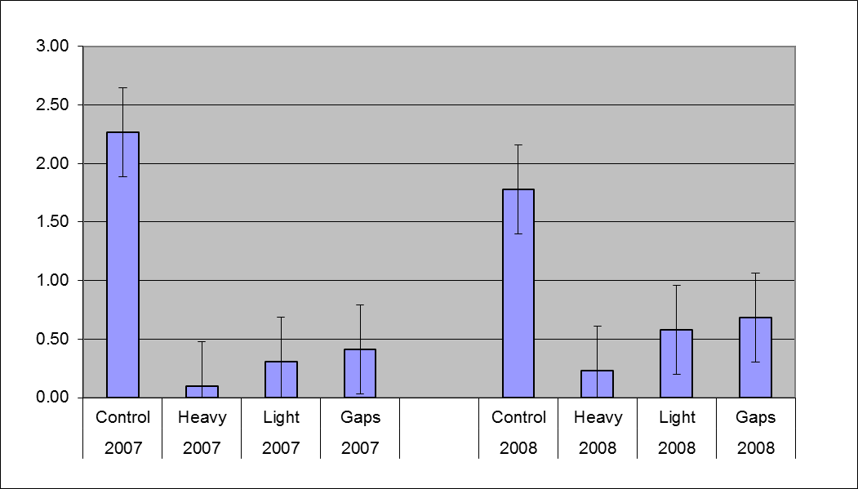

Products

Garman, S.L. 1998. Young Stand Thinning and Diversity Study: Post-treatment assessment of ground-dwelling vertebrates. Unpublished report.

Garman, S. 2001. Response of ground-dwelling vertebrates to thinning young stands: The Young Stand Thinning and Diversity Study. Unpublished report. 27 pp.

Manning, T., J. Hagar, B. McComb. 2012. Thinning of young Douglas-fir forests decreases density of northern flying squirrels in the Oregon Cascades. Forest Ecology and Management 264:115-124.

McComb, B. 2007. Initial responses of forest floor vertebrates to thinning in the Oregon Cascades. Unpublished report. 13 pp.

McComb, B., R. Pabst, T. Manning, and C. Jordan. 2009. Dead wood and small mammal reponses to three alternative thinning strategies in young Douglas-fir forests. Unpublished draft report. 58 pp.

- Bird Responses to Young Stand Thinning

Introduction

Sampling methodology of forest birds in the YSTDS has been consistent from the outset of the project. Because the research design incorporates both spatial (unthinned vs. thinned treatments) and temporal (pre- vs. post-treatment) controls, this study has been able to assess stand-level changes in the occurrence and density of forest bird species in response to thinning treatments.

Objectives

- Quantify changes in songbird response to thinning treatments over time, in relation to stand structural development.

- Evaluate the influence of intensity and pattern of thinning on the timing of transitions in bird abundance and community composition over the long-term.

Methods/Sampling Design

Standard point count methodology was used to sample breeding birds at 3-5 point count stations in each of the 16 YSTDS stands. Stations were separated by at least 150 m, and were > 75 m from stand edges, road buffers, or riparian buffers. All surveys were conducted between 0.5 h before and 6 h after sunrise. Surveys were not conducted during periods of heavy rain or strong wind.

Pre-harvest bird counts (1992-93) were conducted by a single observer 5 times each year from early May to late June. The pre-harvest observer waited 2 min at each station before recording the species and estimated distance to each bird detected during an 8-min count period.

Post-harvest bird counts (1997–1999, 2001, 2006-07) were conducted by 4 observers. Each station was sampled in 3 visits from late May to late June in 1997-98, and during 4 visits from late May to early July thereafter. Observers recorded the species and estimated distance to each bird detected during a 10-min count period at each station for all post-harvest surveys.

Response Variables/Analysis

Response variables were species richness and estimates of breeding density (birds/40 ha) for 23 bird species. Species richness was calculated as the number of species per stand per year.

We also assessed treatment effects for cavity nesters as a group. Species included in the cavity-nesting group were chestnut-backed chickadee, red-breasted nuthatch, brown creeper, red-breasted sapsucker, hairy woodpecker, northern flicker, and pileated woodpecker.

Three phases of the study were defined for analysis: pre-harvest (1992–1993), post-harvest phase 1 (1997–1998), post-harvest phase 2 (1999, 2001), and post-harvest phase 3 (2006–2007). Repeated measures ANOVA for a completely randomized block design was used to test for effects of thinning treatments on species richness and density for species with a sufficient number of observations. Bird densities were averaged across the 2 years within each phase for each stand.

Measurement Schedule

Pre-treatment sampling occurred in 1992–1993. Post-treatment sampling has occurred in 1997–2001, and 2006–2007. Future sampling is expected to occur at 5-year intervals.

Data Storage and Management

Bird data from all phases of the YSTDS (1992-2007) are on-line at the FSDB catalog (http://andrewsforest.oregonstate.edu/data/mastercatalog.cfm?topnav=97). Datacode WE008. For more information, contact Joan Hagar, USGS-Forest & Rangeland Ecosystem Science Center, Corvallis, OR.

Key Findings

- Within the first 5 years, density of birds commonly associated with open forest conditions increased in response to thinning, and density of some species associated with closed canopy conditions decreased;

- A positive effect of thinning on bird species richness was consistent throughout all post-treatment years of the study;

- All 14 of the most common forest bird species indicated a statistically significant response to thinning by either an increase or decrease in density in thinned treatments relative to Controls;

- We found both ephemeral and delayed effects of thinning that we would not have detected within 5 years of harvest, the time frame of most published research from the Pacific Northwest.

- Some species that reach their highest densities in late-seral forest had not recovered to or exceeded pre-thinning densities by the time of the most recent sampling period. Therefore, continued sampling will be necessary to reveal the time frame necessary to develop functional late-seral habitat structure for these species, and to evaluate which thinning treatment most accelerates the process.

- Over the first 10 years post-thinning, high variability of vegetation effects on bird occurrence or abundance over time suggests a greater uncertainty of results of vegetation-related wildlife management efforts than has previously been suggested by shorter-term studies.

Figure 5: Average avian species richness in the 4 YSTDS treatments over 8 non-consecutive years of bird surveys (1992 and 1993 were pre-treatment). Taken from Hagar & Friesen 2009.

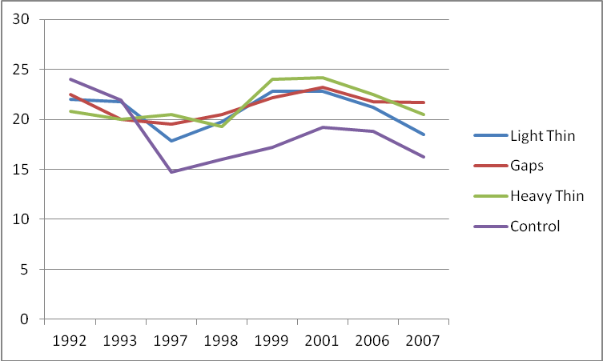

Products

Hagar, J. 1996. Pre-treatment analysis of wildlife-habitat relationships in young managed stands in the Oregon Cascade Range. Report prepared for USDA Forest Service, Willamette N.F. Unpublished report. 35 pp.

Hagar, J. 1999. Songbird community response to thinning of young Douglas-fir stands in the Oregon Cascades - second year post-treatment results for the Willamette N.F. Young Stand Study. Unpublished report. 7 pp.

Hagar, J. and S. Howlin. 2001. Songbird community response to thinning of young Douglas-fir stands in the Oregon Cascades. Third year post-treatment results for the Willamette NF Young Stand Thinning and Diversity Study. Unpublished report. 7 pp.

Hagar, J., S. Howlin, and L. Ganio. 2004. Short-term response of songbirds to experimental thinning of young Douglas-fir forests in the Oregon Cascades. Forest Ecology and Management 199: 333-347.

Hagar, J. and C. Friesen. 2009. Young stand thinning and diversity study--response of songbird community one decade post-treatment. U.S. Geological Survey Open-File Report 2009-1253. 20 pp.

Hansen, A.J., W.C. McComb, R. Vega, M.G. Raphael, and M.G. Hunter. 1995. Bird habitat relationships in natural and managed forests in the west Cascades of Oregon. Ecological Applications 5(3):555-569.

Yegorova, S., M. Betts, J. Hagar, and K. Puettmann. 2011. If you build it will they come?
Associations between birds and vegetation structure during ten years after thinning. Poster presented at North American Forest Ecology Workshop, Roanoke, Virginia, USA.

Yegorova, S. 2012. Bird-vegetation relationships ten years after thinning in young thinned and unthinned Douglas-fir forests. Master’s thesis, Oregon State University.

- Amphibian Responses to Young Stand Thinning

Introduction

Though not frequently encountered by the casual observer, amphibians (and particularly salamanders) represent an abundant and ecologically important group of vertebrates in many forest ecosystems, including the Pacific Northwest. Estimates of salamander abundance for the hardwood forests of the eastern US indicate that these animals comprise twice as much biomass as birds and equal to that of small mammals (Burton and Likens, Copeia 1975:541-546). Terrestrial salamanders are exclusively predaceous and presumably consume vast numbers of soil and forest-floor invertebrates. Despite their abundance and ecological importance, as well as concern over the conservation status of amphibians in the face of global declines, salamanders are rarely considered in evaluations of forest management practices.

Because selection of the YSTDS experimental stands largely avoided substantial riparian areas, emphasis has been on terrestrial species, primarily plethodontid salamanders, which have no aquatic stage in their life cycle. These terrestrial species are by far the most commonly encountered in the YSTDS stands. However, some aquatic species are wide-ranging (northwestern salamanders, rough-skinned newts, frogs) and have been encountered irregularly in YSTDS sampling.

Field surveys for amphibians were a part of the YSTDS from the beginning of pre-treatment sampling (1991), but until recently there has been little success during the post-treatment years getting adequate samples of salamanders to compare thinning treatments. Initial efforts to sample amphibians were coupled with terrestrial small mammal sampling, and relied on pitfall trapping. When the small mammal sampling protocol changed (see Component Study E above), amphibian sampling changed from reliance on incidental captures to an approach more focused specifically on capture of salamanders.

Objectives

- Determine effects of the YSTDS thinning treatments on the relative abundance of particular species of terrestrial amphibians.

- Determine effects of the YSTDS thinning treatments on terrestrial amphibian community diversity.

Methods/Sampling Design

During pre-treatment sampling (1991-1992), pitfall trapping was used to sample both small mammals and amphibians. A 5x5 grid of pitfall traps, with 20-m spacing between traps, was deployed for 8 nights in each of the 16 YSTDS experimental stands. This design yielded a total of 53 individuals of 6 species of salamanders and no frogs or toads (Garman 2001). This amounts to a capture rate of 0.8 salamanders per 100 trap-nights.

During an initial bout of post-treatment sampling (1998-2001), the number of pitfalls was doubled and more evenly distributed throughout each YSTDS stand. This yielded 151 captures of 5 species of salamanders (2.7 captures/100 trapnights), as well as 4 individual frogs and a single toad (Garman 2001).

At the beginning of a second period (2007-2009) of post-treatment sampling, we attempted to continue pitfall sampling using the same design as in 1998-2001. After 3 days of simultaneous mammal and amphibian sampling in Oct 2007, it became clear that we had underestimated the resources required to do the work. Since the capture rate of salamanders was very low (0.67 captures per 100 trap nights), pitfall trapping was halted to concentrate on mammal live-trapping. In lieu of pitfalls for sampling amphibians, time-constrained searches (TCS) were attempted. In each stand, 3 strip plots measuring 50 m by 4 m were laid out. Each plot was searched intensively for one person-hour, by turning over logs, bark, and other debris to expose salamanders. After sampling 12 of these plots, and capturing only 4 salamanders, this work was discontinued because 3 person-hours per salamander was not considered an efficient use of human resources. Another attempt was made by Joan Hagar and Brenda McComb to implement the same TCS design in June 2008, again with disappointing results (2 salamanders in a day of work for 2 people).

It was after this setback that the idea of using artificial cover objects (ACOs) was advanced. ACOs provide a standardized method for sampling of terrestrial salamanders. The board design used is detailed in:

Davis, T.M. 1997. Non-disruptive monitoring of terrestrial salamanders with artificial cover objects on southern Vancouver Island, British Columbia. In Amphibians in decline: Canadian studies of a global problem, D.M. Green, editor. Society for Study of Amphibians and Reptiles, Salt Lake City, UT.

Figure 6: The ACO design, from Davis 1997 (with permission from the publisher).

Fig. 6a shows the measurements for placing the cedar laths on the baseboard of the assembly.

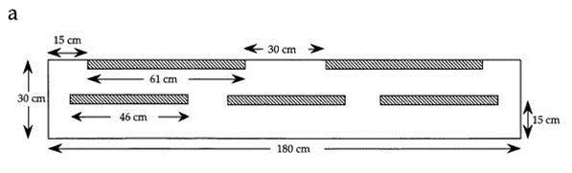

Fig.6b shows a cross-section through the assembly to show how the placement of the smaller top boards on the laths creates tapering spaces within the assembly.

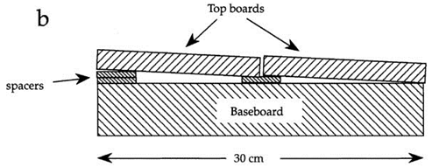

The ACOs were constructed of freshly milled Douglas-fir without any sort of anti-fungal treatment. The thickness of the baseboard was about 5 cm, and the top boards were about 3 cm thick. Three of these devices were deployed within each YSTDS stand in October of 2008 at randomly chosen locations within the mammal trapping transect arrays. Each location was marked with bright orange flagging, and GPS coordinates were recorded and stored.

Sampling from ACOs involves removing the top boards one at a time, and examining any salamanders thus exposed. Next the main (bottom) board is lifted and the ground underneath examined for salamanders. Each salamander is placed in a small plastic bag for weighing and measuring. Weight is measured with a 50-g Pesola spring scale to the nearest 0.5 gram. Snout-vent length (SVL) is measured to the nearest millimeter with a small plastic ruler. These data, along with location, species, and sex (when it can be determined) are recorded on a field sheet printed on water resistant paper.

During the November 2009 checks, salamanders were photographed in order to attempt to later determine sex, but this was not successful. In practice, few salamanders captured on the YSTDS stands have been sexed, other than larger Ensatina which are relatively easy to sex based on lip and vent morphology, and the occasional appearance of visible ova within the females’ abdomens.

After handling, each salamander is carefully placed back into the re-assembled ACO in approximately the position it was found, through the side openings created by the lengths of lath attached to the main board.

Response Variables and Analysis

The amphibian response variable in all phases of the YSTDS has been numbers of animals captured per unit effort. During pre-treatment and initial post-treatment phases, this has been expressed as numbers of salamanders (and a few frogs/toads) per pitfall-night (one pitfall trap set for one night). During the short period when time-constrained searches were attempted, the response variable could be expressed as salamanders captured per person-hour. Since the installation of the Artificial Cover Objects, the response variable has been number of salamanders captured per season in each stand. Complete randomized one-way analysis of variance with repeated measures was used to analyze ACO capture data for differences among thinning treatments and blocks.

Measurement Schedule

Data collection using the ACOs began in June 2009, 6 months after their initial deployment, and occurred at 6 month intervals through spring of 2011. Since then, data collection has occurred during the first week of May; November checks were discontinued due to low capture rates. Entire blocks are sampled on the same day to minimize confounding effects of weather on salamander activity.

Data Storage and Management

The GPS system and coordinates for the ACOs are stored permanently in the Forest Science Data Base (Study Data Base Code = WE008, Entity 12).

Amphibian capture data from pitfall traps in the early years of the YSTDS are stored permanently in the Forest Science Data Base (Study Data Base Code = WE008, Entity 1).

For more information, contact Tom Manning, Department of Forest Ecosystems & Society, Oregon State University.

Key Findings

- Thinning appears to have a generally negative impact on salamander abundance. Relative abundance of salamanders as a group, and of the most common species (Ensatina) are lower in thinned stands than in unthinned Controls.

- Ensatina salamanders, by far the most commonly encountered species on the YSTDS stands, were most frequently detected in Control stands, and least frequently in the Heavy Thin treatment (Fig 8).

- Block differences in salamander abundance, particularly of Ensatina, contributed to high variability in the data.

- More salamanders were captured in the YSTDS ACOs in 3 days’ effort (Spring 2010) than in all of the pre-treatment sampling in 1991-1992. Similar results were seen in 2011 and 2012. Thus, ACOs appear to be an effective method for sampling salamanders with minimal effort.

Figure 7: Salamander captures on the YSTDS stands, 2009-2013.
Means computed over 6 seasons for 4 replicates of each treatment.

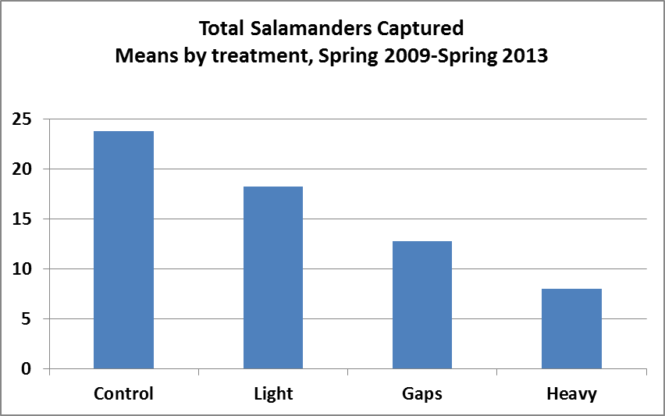

Figure 8: Ensatina eschscholtzii captures on the YSTDS stands, 2009-2013. Means computed over 6 seasons for 4 replicates of each treatment.

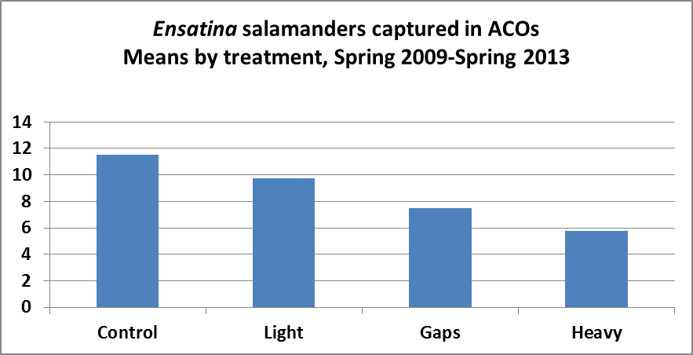

Products

Garman, S. 2001. Response of ground-dwelling vertebrates to thinning young stands: The Young Stand Thinning and Diversity Study. Unpublished report. 27 pp.

Manning, T. 2013. Salamander captures in artificial cover objects, spring 2009-spring 2013. Unpublished report. 8 pp.

McComb, B. 2007. Initial responses of forest floor vertebrates to thinning in the Oregon Cascades. Unpublished report. 13 pp.

Figure 9: Sampling salamanders from an artificial cover object (ACO).
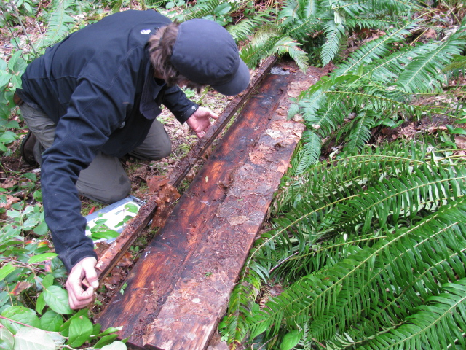

- Arthropod Reponses to Young Stand Thinning

Introduction

Through removal of vegetation, and through effects on the litter layer and other soil horizons, thinning can be expected to have impacts on the abundance and diversity of arthropods, and consequently on the predators of arthropods, including birds, small mammals, and amphibians. The short generation time of most arthropods, and the relative vagility of many species, means that these animals can exhibit quick responses to changing conditions. While previous studies of arthropod response to thinning had been published at the time of this work, there was a gap in knowledge concerning effects on litter-dwelling taxa in particular.

In 2000-2001, roughly 4 years after thinning, arthropod communities were studied to examine differences among the YSTDS treatments. Because of the taxonomic complexity of arthropods, a guild-centered approach was employed, and samples were taken from 3 forest strata: shrub vegetation, ground surface, and litter layer.

Objectives

Generally, to compare diversity and abundance of arthropods among thinning treatments.
More specifically:

- Test the hypothesis that folivorous insect abundance and diversity on shrubs and understory trees decreases in response to thinning.

- Test the hypothesis that arthropod predators of folivores also decrease in response to thinning, because of declines in prey species.

- Test the hypothesis that ground-dwelling arthropod abundance and diversity increases due to increased cover of slash and ground vegetation in thinned stands.

- Test the hypothesis that litter-layer arthropod abundance and diversity will decrease in thinned stands, due to decreased litter moisture.

- Test the hypothesis that abundance and diversity of rooting zone arthropods will increase in thinned stands, due to increased soil moisture resulting from decreased transpiration.

Methods/Sampling Design

Arthropods were collected from shrub branches near the center of each stand and avoiding any special microhabitat features such as logs, snags, etc. In the Gaps treatment stands, shrubs at the edge of the gaps were sampled, to minimize the effect of the gap openings. Samples were also collected from understory saplings of 2 Douglas-fir, 2 western hemlock, and 3 vine maple, haphazardly chosen within each stand. Samples were collected by quickly enclosing entire foliate branches (approx. 50 cm long by 50 cm wide) in a large plastic bag, then clipping the branch and sealing the bag. Bags were then placed into cold storage at 5° C until processing in the laboratory. Larvae were reared to facilitate identifications. The collected plant materials were dried at 50°C to a constant weight and then weighed to estimate plant biomass. Arthropod numbers were divided by plant biomass to obtain a standard unit of comparison (number/ kg plant biomass) among tree or shrub species and treatment.

Ground-dwelling arthropods were sampled using pitfall traps partially filled with propylene glycol for killing and preserving specimens. Traps were covered with an elevated platform to prevent rain from diluting the preservative. Five pitfall traps per stand were maintained for 2 weeks per sampling period. To minimize edge effects, each trap was located close to the center of the stand with 5-meter intervals between traps.

Litter-dwelling arthropods were collected from 2 combined litter and humus samples collected from each YSTDS stand in each year (2000 and 2001), avoiding any special microhabitat features such as logs, snags, etc. Samples were taken from 0.25 m² quadrats. In the Gaps treatment stands, samples were taken from the edge of the gaps, to minimize the effect of the gap openings. All samples were chilled at 5°C until animals were extracted using a Berlese funnel. Litter arthropod samples were identified to the lowest possible taxonomic level. For comparison among treatments, abundances were expressed as densities per m². Moisture content (%) of the litter was measured in 5 sub-samples (20 g each) from each treatment, dried at 50° C and then weighed.

All arthropod taxa were combined at a family or ecological guild level (functional groups: e.g., defoliators, plant feeders, predators, detritivores, and miscellaneous) to allow a thorough statistical analysis of abundance patterns. All specimens were verified against H.J. Andrews Long-Term Ecological Research Collection and the Oregon State University Arthropod Collection at Corvallis, Oregon.

Response Variables/Analysis

Shrub/tree arthropod samples were expressed as “intensity” (numbers per kg of plant biomass) for each family or functional guild. Litter-dwelling arthropod samples were also expressed as intensity (numbers per square meter of forest floor) for each family or functional guild.

Analysis of variance was used to compare responses among thinning treatments and controls. Data were pooled across seasons for inter-treatment comparisons. Community ordination analyses were used to determine the factors structuring the complex arthropod community and to qualitatively summarize the overall distribution of species assemblages across the gradients of soil moisture created by the different thinning levels.

Measurement Schedule

No pre-treatment data were collected. Post-treatment sampling of arthropods occurred over 2 summer seasons, June-Oct of 2000 and 2001. No other sampling is planned.

Data Storage and Management

Arthropod data are not yet publicly available.

Voucher arthropods were deposited at the Oregon State University Arthropod Collection.

Key Findings

- Abundance of shrub-dwelling arthropods decreased with thinning intensity on deciduous shrubs and small trees, but did not change on coniferous saplings.

- Species richness and diversity of shrub-dwelling arthropods was higher on coniferous foliage than on deciduous shrubs, but abundance was greater on deciduous shrubs.

- Deciduous shrubs had more plant-sucking arthropods and conifers had more predators and detritivores.

- Abundance and diversity of ground-dwelling arthropods were higher in Heavy Thin and Gaps treatments than the Control and Light Thin.

- Abundance of litter-dwelling arthropods decreased in proportion to thinning intensity.

- Non-metric multidimensional scaling indicated that, for some of the more abundant ground-dwelling and litter-dwelling groups, thinning effects were outweighed by seasonal effects (rainy vs. dry season).

Figure 10: Mean density of litter-dwelling arthropods in the YSTDS treatments, 2000-2001. Taken from Yi & Moldenke 2008.

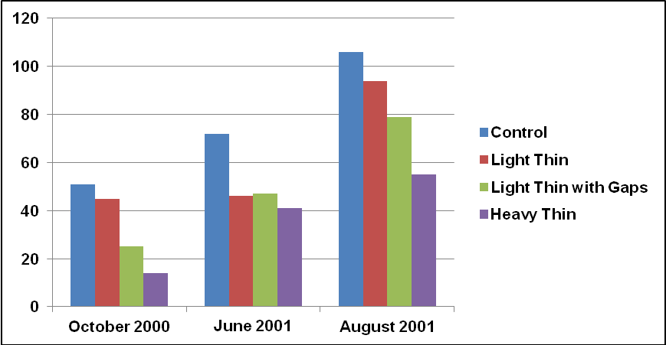

Products

Yi, H. 2003. Response of arthropods to different Intensities of thinning in Oregon. PhD. dissertation. Oregon State University.

Yi, H., and A. Moldenke. 2008. Responses of litter-dwelling arthropods to four different thinning densities in Douglas-fir forests of the Pacific Northwest, USA. Ann.Zool.Fennici 45:229-240.

Yi, H. 2009. Effect of thinning on flying insect communities using window traps in young Douglas-fir (Pseudotsuga menziesii (Mirb.) Franco) forests in the Pacific Northwestern America. Journal of Plant Biology 50(2):190-197.

- Effects of Commercial Thinning on Chanterelle Mushroom Productivity

Introduction

During the 1990s, commercial mushroom harvesting expanded dramatically as international markets developed and forest workers sought means to supplement their income. Federally-managed forestlands in the Pacific Northwest provide ideal habitat for many types of edible forest mushrooms, and federal agencies have begun to manage commercial harvesting.

Chanterelles are perhaps the most frequently harvested mushrooms in our National Forests. The Pacific golden chanterelle, Cantharellus formosus, and the white chanterelle, C. subalbidus, are the 2 most common chanterelles in the low elevation forests on the west side of the Cascade Range. Both occur abundantly in young forests regenerated from earlier logging, and both are mycorrhizal fungi; that is, they form symbiotic associations with the roots of certain conifers, especially Douglas-fir and western hemlock. Mycorrhizal fungi form a web of “hyphae” (microscopic filaments collectively known as “mycelium”) in the soil and colonize the young root tips of their arboreal hosts. The fungus functions as an extended fine root system, absorbing water and minerals that are translocated to the tree. In return, the tree provides the fungus with food, in the form of photosynthetic carbohydrates. The chanterelle mushrooms harvested by people are the fruiting bodies of these Cantharellus species.

Many of the forests where chanterelles occur are densely stocked young stands scheduled for commercial thinning in the coming decades. Young stand thinning will likely affect chanterelle productivity by altering:

- density and health of host trees (food supply for the fungus);

- environmental conditions near the forest floor that affect fruiting (temperature, humidity, and light levels);

- soil conditions (compaction, summer and early autumn moisture levels, distribution of rotted wood and organic matter in the soil profile, litter layer thickness, slash burning, and microbial population shifts).

Understanding of the effects of young stand thinning on chanterelle productivity should help managers to provide better opportunities for sustainable chanterelle harvest.

Objectives

- Determine how chanterelle productivity changes as an immediate response to different thinning treatments.

- Establish a long-term monitoring protocol to track changes in chanterelle productivity as succession proceeds in the thinned and control stands.

- Develop efficient and practical methods for sampling edible mushroom productivity under a variety of field conditions.

- Analyze how mapped chanterelle patches respond to removal of nearby host trees.

- Analyze the genetics of mapped fruiting bodies to determine the number and distribution of genetically unique mycelial colonies.
Methods/Sampling Design

For this work on chanterelles, the Gaps treatment of the YSTDS design was not sampled.

Pre-thinning chanterelle productivity was sampled in the autumn of 1994. Previously established vegetation sampling plots were used to avoid expense of laying out new transects. Chanterelle transects were 5 m wide, extending 2.5 meters to either side of the vegetation transect. To obtain estimates of variation within stands, transects within each stand were subdivided into 5 plots. Because the treatment stands varied in size, the total length of all transects per stand varied considerably. Practical considerations during plot establishment resulted in several instances where plots differed in length.

All chanterelles found within plots were collected, counted, and weighed by plot. Sub-samples from each plot were dried to determine moisture content. An effort was made to collect all the chanterelles that grew during the fruiting season. Crews began sampling when autumn rains elicited the first flush of chanterelles (typically mid-September) and continued until snow made sampling impractical (typically mid-November). Usually 2 complete rounds of sampling were conducted, occasionally 3 were completed. The sequence of sampling was left to the crew leader’s discretion each year and varied by logistical considerations such as crew travel time, not by observed patterns of fruiting.

Response Variables/Analysis

Numbers and fresh weight of chanterelles per acre per year were calculated for each plot and then averaged across the 5 plots within each stand. To compensate for the baseline (1994) differences in productivity among stands and thereby reduce extraneous variation, analyses were based on the change in numbers (∆#) or weight (∆wt.) of chanterelles from the baseline year of 1994. These increases or decreases in productivity were calculated for each treatment stand during 3 post-treatment years (1996, 1997, and 1999). This analytical approach assumes that chanterelle fruiting within each of the YSTDS stands within a replicate site responded uniformly to annual variation in weather patterns. To calculate ∆# and ∆wt, absolute values were used (baseline productivity minus post-thinning productivity) rather than ratios or percent difference, thus avoiding fallacious calculations resulting from division by zero, and normalizing the distribution of values for analysis of variance (ANOVA).

Treatment effects were examined with repeated-measures ANOVAs. Because one replicate was not logged until 1996, it was excluded from analyses. In order to determine whether chanterelle productivity was recovering in thinned stands during the 4 years following logging, the annual percent difference between control and thinned treatments was calculated for ∆# and ∆wt. A repeated-measures ANOVA was used to ascertain whether the percent difference varied significantly by year.

Measurement Schedule

Productivity data were collected on all stands 1 year prior to logging (1994) and 4 years afterwards (1996, 1997, 1999, and 2001). Control stands were also sampled in 1995. Sampling occurred from mid-September through mid-November of each year. Despite original plans to re-sample at 5-year intervals, no re-sampling has occurred since 1999.

Data Storage and Management

Data for the chanterelle productivity study are stored permanently in the Forest Science Data Base (Study Data Base Code = TP110, Entities 1-6).

Data include: locations of mushrooms on circular plots; disturbance on circular plots; fresh weight of chanterelles on circular plots; live trees and stumps on circular plots; disturbance on strip plots; and fresh weight of chanterelles on strip plots.

For more information, contact David Pilz, Natural Resource Planner, Lassen National Forest, 2550 Riverside Dr., Susanville, CA 96130. dpilz@fs.fed.us (530) 252-6659

Key Findings

- Chanterelle productivity declined significantly immediately after thinning, but was not eliminated.

- Decline was greater in the Heavy Thin treatment than in the Light Thin treatment.

- Nearly all evidence of differences among thinning treatments disappeared within 6 years.

- Long, narrow strip plots worked well for sampling spatially clustered chanterelles and for keeping track of the area searched, especially in dense brush. Total sample areas should be large (~ 0.4 ha) to derive useful estimates.

- Spatial and genetic analyses of chanterelle individuals and populations revealed relatively small clonal patches (5 to 20 m diameter).

- A new species of yellow chanterelle was found, now named Cantharellus cascadensis.

Products

Dunham, S. 2003. Population genetics, systematics, and habitat associations of chanterelles in the Pacific Northwest. PhD. Dissertation, Department of Forest Science, Oregon State University, Corvallis, OR.

Dunham, S., A. Kretzer, and M. Pfrender. 2003. Characterization of Pacific golden chanterelle (Cantharellus formosus) genet size using co-dominant microsatellite markers. Molecular Ecology 12: 1607-1618.

Dunham, S., T. O’Dell, and R. Molina. 2003. Analysis of nrDNA sequences and microsatellite allele frequencies reveals a cryptic chanterelle species Cantharellus cascadensis sp. nov. from the American Pacific Northwest. Mycological Research 107(10):1163-1177.

Dunham, S., T. O’Dell, and R. Molina. 2006. Forest stand age and the occurrence of chanterelle (Cantharellus) species in Oregon’s central Cascade Mountains. Mycological Research 110:1433–1440.

Dunham, S., T. O’Dell, and R. Molina. 2006. Spatial analysis of within-population microsatellite variability reveals restricted gene flow in the Pacific golden chanterelle (Cantharellus formosus). Mycologia 98(2):250-259.

Pilz, D. 1998. Chanterelle mushroom productivity: response to young stand thinning. Cascade Center for Ecosystem Management pamphlet. 2 pp.

Pilz, D., R. Molina and J. Mayo. 2006. Effects of thinning young forests on chanterelle mushroom production. Journal of Forestry 104(1): 9-14.
Figure 11: Number (A) and weight (B) of chanterelle sporocarps per acre per year by thinning treatment and year. From Pilz et al. 2006.

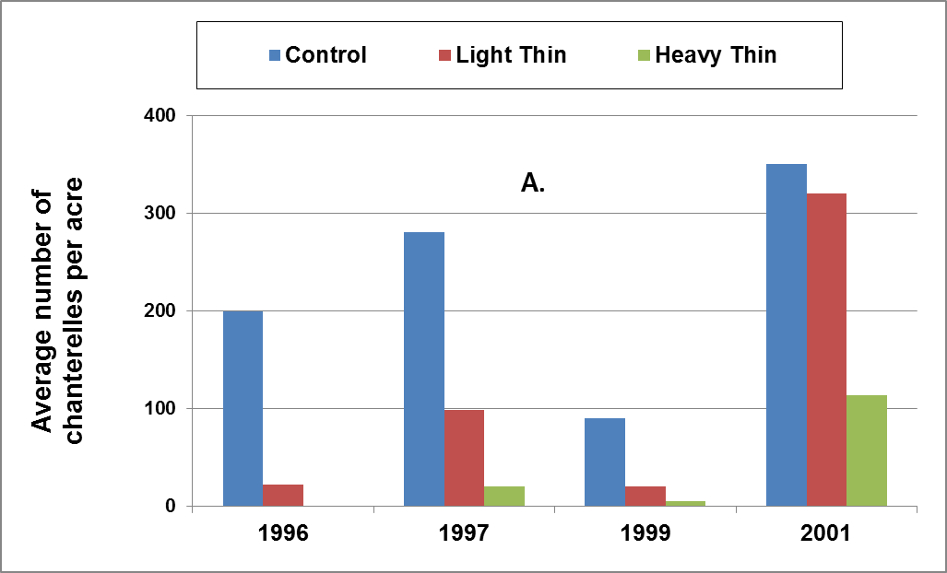

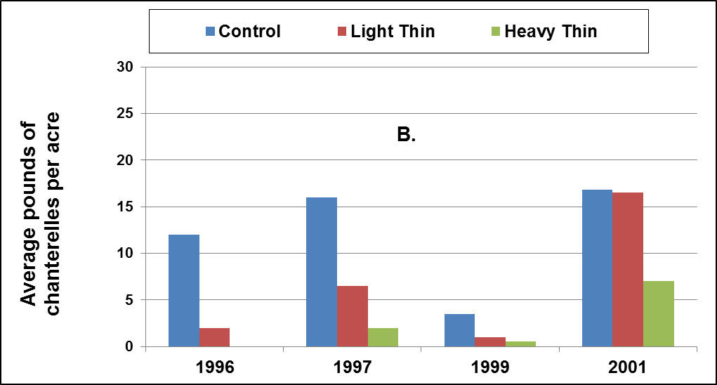

- Wildlife Use of Created Snags

Introduction

Large snags (for our purposes defined as standing dead trees with diameter at breast height (dbh) > 50 cm) are considered particularly valuable as habitat for cavity-nesting birds and mammals. Initial densities of large snags in the YSTDS stands were quite low; mean density was 0.12 snags/ha in 1996-97, immediately after thinning. Presumably this is because at the time of the previous harvest in the mid-20th century, large snags were typically removed either for commercial value or to remove potential safety hazards.

In December of 2000, 5 years after thinning treatments had been completed, Joan Hagar and Jim Mayo met with personnel from the 3 Districts involved in the YSTDS, as well as a representative from the Supervisor’s Office of the Willamette National Forest to discuss a plan to augment the density of snags in the stands by killing a small proportion of the largest residual trees. Because of the relatively young age of the YSTDS stands, and because legacy snags from the previous stands did not exist, the largest trees available for snag creation were approximately 35-45 cm dbh. While snags of this size are thought to be only rarely used for roosting or nesting by cavity-nesting birds and mammals, some species (e.g., hairy woodpeckers) have been shown to increase in abundance after thinning of forests in this age/diameter range. Creating and monitoring snags in the YSTDS presented the opportunity to test hypotheses about the usefulness of mid-sized snags for bird and mammal species that use dead trees for foraging, roosting, and nesting.

Objectives

A study design was proposed to answer the following questions:

- Do snags created from trees in young stands (e.g., 35 to 45 cm dbh) provide habitat for wildlife?

- Which species (particularly birds and mammals) use these snags for foraging?

- Which species (particularly birds and mammals) use these snags for nesting?

- How long after creation do the snags remain useful for wildlife?

- How does the period of usefulness for these snags vary with creation method?

- How does the frequency of occurrence of decay agents (fungi and insects) vary with creation method?

- Does snag density interact with silvicultural (thinning) treatment to influence the abundance of any wildlife species? The hypothesis here would be that nest cavity density will be greater in stands with greater residual tree density (Control > Light Thin > Heavy Thin).

Implementation of Snag Creation

To increase the density of snags with dbh > 30 cm to at least 2.5 snags/ha in all 16 YSTDS stands, a small percentage (0.13-1.42% of trees > 8 cm dbh) of Douglas-fir distributed through each stand were killed by chainsaw topping in late 2001. Only Douglas-fir were used to create snags, since densities of other species in these stands was too low to provide adequate samples for statistical analysis.

Closely-spaced pairs of trees were designated for topping. These trees were topped above 15 meters height, and the minimum top diameter allowed was 15 cm. The cuts were notched (“rough-cut”) to promote decay from above, and one snag of each pair was also inoculated with a mycelium dowel of heart-rot fungus (Phellinus pini) to accelerate decay. Tops were left to decay where they fell.

All created snags were tagged with a metal tree tag, and basic location and measurement data were recorded. In total, 722 trees were topped within the boundaries of the YSTDS stands. The work was done from September 1 through December 15 of 2001.

Methods/Sampling Design

To date, there has been no standard sampling design for assessing the created snag component of the YSTDS, but several small-scale field efforts have been launched to evaluate the project.

In 2007, about 5.5 years after topping and inoculating, the created snags were surveyed to assess general condition (living, dead, or fallen), extent of decay (presence of insects and fungus, decay class), and presence of foraging and nesting cavities. Snags showing evidence of nesting activity were re-visited twice between 7 June and 5 July 2007. At each of these return visits, each snag was observed for 20 minutes to determine whether nest cavities were in current use. The same snags were re-visited in 2008, again to document nesting activity. In all, 77 created snags were identified as having nest cavities in 2007; among these, 2 active nests were confirmed in 2007 and 2 others were confirmed in 2008. In addition to these nests in created snags, an additional 5 nests were found in natural snags and stumps. Conclusions from this monitoring were that: the created snags were used for foraging and nesting; inoculation of snags with heart-rot fungi increased the frequency of bark beetle and pouch fungus, and foraging use by birds was greater than for snags created by topping alone; and that the usefulness of snags < 50 cm dbh for nesting is likely marginal, as demonstrated by the low detection rate of active nests.

In 2009, a brief pilot project was fielded to try to find evidence that mammals were using the created snags. In particular, there was interest in whether northern flying squirrels were using the snags as summer or maternity dens. All snags were examined visually for cavities, and those with cavities large enough were probed with a Tree-Top Peeper, essentially a video camera on a telescoping pole. No mammals were detected using the Peeper. In fact, only a few cavities were large enough to insert the camera; small cavities such as these are not likely to be used by flying squirrels, but may have been used by smaller mammals such as mice or shrews. As a corollary to this work, the condition (live, dead, or fallen) and location of all snags was updated and added to the Forest Science Data Base, and several missing tree tags were replaced.

In 2010, another round of nest activity monitoring was accomplished. In this assessment, all YSTDS stands were systematically surveyed for the presence of cavity-nesting birds between May 15 and July 15, and detected birds were followed in an attempt to locate nest cavities. The protocol combined passive listening and periodic playbacks of 9 cavity-nesting bird species and covered all areas of each stand. Each morning that weather permitted, 2 stands were surveyed for 3 hours each, and each stand was surveyed twice during the season. Actual search time per survey varied from 2.6 to 2.8 hours because a portion of each 3-hour survey was spent following birds to nests and recording data, so results were standardized as nests found per unit of time actively searching. In all, 20 active cavity nests were found. These 20 nests were rechecked every few days to assess nesting success as well as possible; however, most nests were already far advanced when first discovered, and nestlings were gone from most before they were revisited; thus, conclusions about nest success could not be made. Analysis-of-variance provided weak statistical evidence of differences among thinning treatments in terms of numbers of active nests (P = 0.0982). More active nests were found in thinned treatments than in unthinned control stands.

Data Storage and Management

A database of all created snags on the YSTDS is maintained within a larger Forest-wide database by Penny Harris at the McKenzie River Ranger District, Willamette National Forest. Also, data for the created snags in the YSTDS can be found in the Forest Science Data Base (FSDB) at the H.J. Andrews Experimental Forest (http://andrewsforest.oregonstate.edu/data/) under Datacode WE008, Entity 13.

Key Findings

- Inoculation of saw-topped trees with fungal mycelium increased frequency of occurrence of decay organisms (Douglas-fir beetles and pouch fungus) and was associated with greater foraging use by birds, compared to saw-topping without inoculation.

- Within 6 years of snag creation, cavity-nesting birds were foraging on and nesting in mid-sized snags created by saw-topping.

- We found weak evidence that use of created snags by cavity-nesting birds was greater in thinned stands compared to unthinned control stands. More data are needed to confirm this trend.

Products

Blue River Ranger District. 2000. Young Stand Study snag creation research, 12/12/00. Unpublished meeting minutes, 2 pages.

Garman, S. 1999. Assessing potential development of snags: Young Stand Thinning and Diversity Study. Unpublished report.

Hagar, J. 2000. Young Stand Study post-thinning snag creation study plan. 2pp.

Hagar, J. 2007. Notes on YSS Wildlife Trees. 5 pp.

Hagar, J. 2008. Wildlife use of created snags in young conifer stands. Draft manuscript. 10 pp.

Manning, T. 2009. Snag data memo, Aug-Oct 2009. 1 p.

Manning, T. 2010. Cavity-nesting bird activity in the YSTDS Stands, Spring 2010. Unpublished report. 16 pp.
Figure 12: Red-breasted sapsucker (Sphyrapicus ruber) feeding young at a cavity in a created snag in the YSTDS, July 2010.
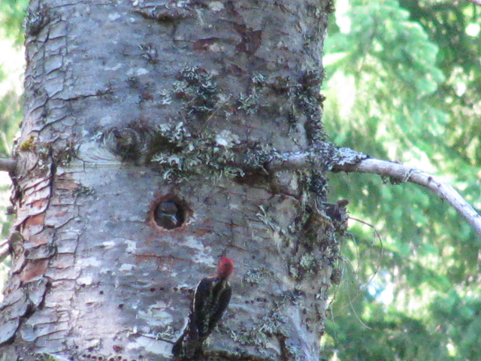
- Public perceptions of young stand thinning practices

Introduction

As forest managers proceed to implement unconventional forestry practices, including those examined by the YSTDS, there is uncertainty regarding whether these new practices will be well-received by the public at large as appropriate and acceptable changes. These uncertainties are of central interest to those deeply involved in forest management debates. These are also issues of importance to those who recreate in or are broadly interested in the health of national forests. Forest managers and planners need to know what kinds of forest practices will gain public acceptance so they can sustain long-term programs to achieve new landscape objectives.

In conjunction with 2 other large-scale silvicultural experiments in the Pacific Northwest (DEMO and LTEP), researchers used social scientific methodology to probe public opinion about alternative forest treatments, measuring how the appearance and descriptions of each treatment match the public’s expectations of “acceptable” national forest management. Perceptions of vista-view and in-stand photographs, before and after treatment, were analyzed to assess this question. Additional questions about peoples’ general opinions of alternative forestry philosophies and policies, as well as reactions to information about the experiments, provided context to interpret results.

Objectives

- Determine which thinning treatments produce the most favorable change in perceived scenic beauty, acceptability as national forest conditions, compatibility with natural processes, and suitability as settings for recreation.

- Determine how perceptions of scenic beauty and acceptability change with the vegetation structure of the forest as measured by other scientists.

- Determine how perceptions change when information about the intentions of forest managers are provided to the respondents, especially regarding coarse woody debris and snags.

- Determine how perceptions vary among people with different philosophies toward forest management, and among people who use national forests in different ways.

Methods/Sampling Design

Several mail surveys and focus groups were conducted with residents of western Oregon and Washington. Surveys included rural areas in order to ensure adequate representation for residents of areas historically dependent on timber resources. In all, 647 randomly-chosen respondents participated in the mail surveys. In addition, 481 respondents participated in surveys conducted during 25 public meetings of special-interest groups (service clubs, higher education classes, outdoor interest groups, and business clubs representing economies significantly dependent on timber harvesting).

Respondents in live-group and mail surveys were shown pairs of before-and-after photographs of the YSTDS thinning treatments, as well as photographs from the DEMO and LTEP studies, and were asked to rate the images in terms of relative beauty. Another mail survey presented respondents with photos of the treatments, explanatory narratives, and resource outputs related to human and wildlife needs. Respondents rated treatments for scenic beauty, service to human needs, service to wildlife needs, and overall acceptability. Post-treatment photographs were taken within 3 months of the completion of harvest. Because down wood left after harvest adversely affects perceptions of scenic beauty, photographs were carefully chosen to represent down wood similarly within all YSTDS treatments’ photo samples.

Response Variables/Analysis

A scenic beauty estimate (SBE) was computed for each scene from all its ratings. This method of averaging ratings removes differences in how respondents distribute their ratings along the scale, and thereby standardizes just their perceptions of relative beauty. In this study, the respondents used a bipolar rating scale, producing SBE values that took on both positive and negative values, scaled to a zero point where the average respondent changed from negative (ugly) to positive (beautiful) ratings. These ratings were analyzed across alternative forest treatments, including those from the YSTDS.

Measurement Schedule

Photographs were taken before treatment and less than 3 months after thinning treatments were implemented on the YSTDS stands. Another set of photographs were replicated 10 years later but have not yet been employed in research studies. Surveys of public opinion occurred within a few years after thinning was completed.

Data Storage and Management

Original photographs of the YSTDS stands are on deposit with the Pacific Northwest Research Station in Corvallis, OR. Digital copies of the photographs may be obtained from the principal investigator, Rob Ribe, Department of Landscape Architecture, Institute for a Sustainable Environment, University of Oregon, Eugene, OR. Survey response data for YSTDS are within data sets shared with the DEMO and LTEP studies.

For more information, contact Rob Ribe, Department of Landscape Architecture, Institute for a Sustainable Environment, University of Oregon, Eugene, OR. The data will be made available to authorized users through the Forest Science Data Base.

Key Findings

- Surveys indicated a broad acceptance of young stand thinning, more so than green-tree retention harvests such as those employed in the DEMO study.

- Surveys indicated broad and passionate opposition to clearcutting.

- The public was highly conflicted over several issues:
harvest of old growth forest;
harvest retaining only small percentages of green trees;
leaving forests in an unmanaged state.

- Modeling of these survey responses found that socially acceptable forestry attends to serving human needs, but not at a high cost to scenic beauty and the needs of wildlife.

Products

Ribe, R. 2001. Public perceptions of alternative forest management practices: testing alternative stand treatments. Cascade Center for Ecosystem Management pamphlet. 2 pp.

Ribe, R. 2005. Comparing changes in scenic beauty produced by green-tree retention harvests, thinnings and clearcuts: Evidence from three Pacific Northwest experiments. In C. E. Peterson, D. A. Maguire (Eds.), Balancing ecosystem values: Innovative experiments for sustainable forestry (pp. 137–145). General Technical Report PNW-635, USDA Forest Service, Portland, OR.

Ribe, R. 2006. Perceptions of forestry alternatives in the US Pacific Northwest: Information effects and acceptability distribution analysis. Journal of Environmental Psychology 26:100-115.

- Coarse Woody Debris Surveys

Introduction

Forest management activities that influence the frequency, severity, and pattern of disturbances in forest systems can have marked effects on the abundance of dead and dying trees and the species that use them. One goal of the YSTDS was to retain and recruit coarse woody debris (CWD) as a habitat element in young thinned stands. CWD is defined as fallen trees or portions of living or dead trees > 10 cm in diameter at the largest end.

CWD serves key ecological functions in forest ecosystems. It stores and supplies nutrients and water to organisms, contributes to soil development, and is used by many species of vertebrates and invertebrates as cover, foraging sites, and sites for attracting mates. In terrestrial environments, the interior of hollow logs, and the spaces beneath a log, provide a stable and often moist micro-environment that is especially important to the survival of some species of amphibians and reptiles. Other species use the space between the bark and the wood, and some (e.g., clouded salamanders, Aneides ferreus) use the interior of well-decayed CWD.

There are several key attributes of CWD that influence its value to vertebrates, including piece size, biomass or areal cover, stage of decay, and the successional stage of the forest in which it occurs. Piece size dictates the area or volume of space available to be occupied. Large CWD (> 10 cm diameter) provides more cover per piece and persists longer than small diameter CWD (2.5-10 cm diameter), which is probably of little value to most vertebrates. For instance, western red-backed voles (Myodes californicus) select large CWD as cover, and CWD provides cover and a substrate for fungi which is a food source for southern red-backed voles (M. gapperi). Areal cover or biomass of CWD may influence the function of wood as cover for amphibians and small terrestrial mammals such as shrews and voles. Stages of log decay are similar to those used to describe snag decay, and each stage provides resources to a different suite of organisms.

Objectives

- Determine how different thinning treatments influence the volume of CWD in young Douglas-fir stands.

- Determine how chronic inputs of CWD change over time in thinned and unthinned young stands.

Methods/Sampling Design

Coarse woody debris (CWD) was sampled using the line intersect method. Each of the 16 YSTDS stands was sampled with multiple line transects, each associated with a sample plot. Data were collected immediately post-thinning (1996-97) and 10 years after thinning (2006). Small CWD was defined as pieces 1-3 inches (2.5-7.6 cm) in diameter; large CWD was defined as pieces greater than 3” (7.6 cm) in diameter. Following the recommendations of S. Kim Mellen, USFS, CWD in the stands was summarized for pieces > 10 cm in diameter that were intersected by the line transect.

In 1996-97, transects were 50 m long (slope distance). The number of transects (plots) per treatment area ranged from 10 to 33. Transect direction was chosen randomly. Small CWD was sampled along 25 m of the 50-m transect (from 25-50 m). The number of intersections with small CWD was tallied along the line transect, but diameters of individual small CWD pieces were not recorded. For large CWD (logs), data were: log diameter at the point of intersection; an estimate of decay (Class1-5); and tree species, if identifiable (about 82% of logs were identifiable to species in 1996-97). Diameters of elliptical- or oddly-shaped logs were measured in 2 dimensions which were then averaged to get a single value. Down wood originating from before thinning (debris type = D) was distinguished from post-treatment slash (debris type = S) for both small and large CWD.

In 2006, CWD was sampled on 2 transects (15.24-m long, slope distance) per plot. Each transect originated at plot center, and 1 transect was oriented due east and the other due west. CWD was sampled on 3 plots in each of the Control, Light Thin and Heavy Thin treatments, and 6 plots in the Gaps treatment. Small CWD was sampled along the entire length of the two 15.24-m transects per plot. Data for large CWD were: diameter at the point of intersection; species if identifiable (about 8% of the logs were identifiable in 2006), and a species/decay category when logs were not identifiable to species (888 = sound and unidentifiable, 999 = or rotten and unidentifiable). Logs identified to species were sound. Debris type (pre- or post-treatment origin) could not be reliably distinguished in 2006.

Response Variables/Analysis

Total CWD volume (m³/ha), total projected area (m²/ha), and total surface area (m²/ha) of small and large CWD were calculated for each YSTDS stand.

Data were summarized for immediate post-treatment (1996-97) and 10 years after treatment (2006).

Dead wood sample plots within stands were considered sub-samples, and replicate stands (n = 4) were considered independent observations for the purposes of analyses. Analysis-of-variance was used to assess differences in dead wood among thinning treatments and controls. Scheffe’s multiple means comparison was used to identify differences among treatment means, with significance level (α) set at 0.05.

Measurement Schedule

Immediate post-treatment measurements of CWD volume and area were conducted in 1996-97. Re-sampling was conducted 10 years after thinning, in 2006.

Data Storage and Management

No woody debris data are available publicly. Data from immediate post-thinning (1996-97) resides on a network drive at Oregon State University (Datacode = FS118). For more information, contact Rob Pabst, Department of Forest Ecosystems & Society, Oregon State University.

Key Findings

- Thinning generated pieces of dead wood that increased CWD volume by nearly 10% in some treatments and increased areal cover by nearly 20% following thinning. Ten year re-measurements indicate a drastic decline in CWD volume and area which may be in part caused by decomposition and in part by inconsistencies in sampling from one time period to the next.

- Spatial distribution of wood is highly variable; for long-term monitoring it may be best to sample 50-70 plots using the same transect length and location as in previous measurements.

- The 25- and 50-m points along the CWD transects in the YSTDS should be marked permanently to facilitate accurate tallies of CWD pieces in the future, and clarification of the original protocol is needed to describe how crews should detect wood pieces.

Products

Buford, T. and J. Boyle. 1998. Young Stand Thinning and Diversity Study (YSTDS) Post-thinning Woody Detritus Inventory Summary Report. 1 pg.

Buford, T. and J. Boyle. 1999. Young Stand Thinning and Diversity Study (YSTDS) Post-treatment Woody Detritus Inventory Final Report. 9 pp.

McComb, B., R. Pabst, T. Manning, and C. A. Jordan. 2009. Dead Wood and Small Mammal Responses to Three Alternative Thinning Strategies in Young Douglas-fir Forests. DRAFT report. 58 pp.
Appendix 1: List of YSTDS protocols available as of July 2011

All are .doc files. All will be available soon on the updated YSTDS website.
Bold font indicates that protocol is represented by metadata in the Forest Science Data Base.
All others were gleaned from publications and unpublished reports.

Amphibians
Ground-Dwelling Vertebrate Protocol, pre-Rx
Ground-Dwelling Vertebrate Protocol, 1998-2001
Artificial Cover Object (ACO) Protocol, 2009

Arthropods
Branch Sample
Litter Sample
Pitfall Sample
Window Sample

Birds
Pre-Thinning Birds
Post- Thinning Year 1 Birds
Post-Thinning Year 2 Birds
Post-Thinning Year 3 Birds

Coarse Woody Debris
Post- Thinning Year 1 CWD survey

Created Snags
Treetop peeper protocol, 2009

Fungi
Chanterelle Surveys

General YSTDS Design and Implementation
Treatment Assignment

Interdisciplinary
Garman’s Path Analysis

Logging, Damage, and Soils
Soil penetrometer protocol

Mammals
Ground-Dwelling Vertebrate Protocol, pre-Rx
Ground-Dwelling Vertebrate Protocol, 1998-2001
10th year post-thinning (2007-08) mammal surveys

Public Perceptions
Public perceptions of thinning treatments

Vegetation
Pre-thinning veg survey
1st year post-thinning veg survey
3rd year post-thinning veg survey
5th year post-thinning veg survey
sasdescript.doc

Appendix 2: Future Investigations

Now that a significant investment has been made into the establishment of this project, it provides options for continued research on a variety of topics. In 2009, we had a “reunion” with as many of the scientists involved with YSTDS to reflect on what we had already learned and discuss the future. The following list contains some of the ideas the group discussed.

1. Continue vegetation surveys every 5 years, eventually moving to once per decade as the rate of change slows.

2. Continue surveys of bird responses to the thinning treatments, with point count surveys every 5 years.

3. Repeat the survey of nesting activity in the artificial snags, concurrent with the point counts (5 year intervals, starting again in 2012?) and combine this with a survey of wildlife use of the trees damaged during harvest.

4. Continue ACO surveys for salamanders every 6 months (May and November), but consider cutting back to spring checks only, based on 2009-2012 data (i.e., do we continue to get far higher numbers in spring?).

5. Repeat the chanterelle productivity survey, and consider a broader survey of mushroom and truffle production (not just chanterelles).

6. Implement a 3-yr survey of flying squirrel abundance and demography, to compare squirrel fitness (reproduction and survival) among the treatments and controls. If resources are limited, could consider doing only controls vs. light thin, which should be meaningful.
Bibliography

NOTE: PDF’s for all of the bibliography materials can be found on-line at: http://ecoshare.info/projects/central-cascade-adaptive-management-partnership/forest-studies/young-stand-thinning-and-diversity-study/

Allen, M. 1997. Soil compaction and disturbance following a thinning of second-growth Douglas-fir with a cut-to-length and a skyline system in the Oregon Cascades. M.S. thesis, Oregon State University.

Allen, M., P. Adams, and L. Kellogg. 1997. Soil bulk density and penetrometer measurements after harvester and forwarder traffic over different slash depths in the Oregon Cascades, research project completion report, June 30, 1997. Forest Engineering Department, Oregon State University. 87 pp.

Allen, M., M. Taratoot, and P. Adams. 1999. Soil compaction and disturbance from skyline and mechanized partial cuttings for multiple resource objectives in western and northeastern Oregon, USA. Proceedings of the International Mountain Logging and 10th Pacific Northwest Skyline Symposium.

Ares, A., S.D. Berryman, and K.J. Puettman. 2009. Understory vegetation response to thinning disturbance of varying complexity in coniferous forests. Applied Vegetation Science 12:472-487.

Ares, A., K. Puettmann, and C. Berger. 2009. Can thinning be effective in altering overstory and understory vegetation dynamics and accelerate the development of late-successional features in temperate coniferous forests? Poster presented at the 13th World Forestry Congress in Buenos Aires, Argentina, October 18-23, 2009.

Beggs, L. 2004. Vegetation response following thinning in young Douglas-fir forests of western Oregon: can thinning accelerate development of late-successional structure and composition? M.S. thesis, Oregon State University. 115 pp.

Beggs, L., and K. Puettmann. 2003. Stand Structure and Vegetation Changes Five Years after Applying Three Thinning Treatments and Control: Preliminary results. Website.

Beggs, L., and K. Puettmann. 2004. Understory vegetation response to alternative thinning treatments in young Douglas-fir stands. Abstract of paper presented at the annual meeting of the Ecological Society of America, Portland, OR. Aug 5, 2004.

Beggs, L., K. Puettmann, and G. Tucker. 2005. Vegetation Response to Alternative Thinning Treatments in Young Douglas-fir Forests. In C. E. Peterson, D. A. Maguire (Eds.), Balancing ecosystem values: Innovative experiments for sustainable forestry (pp. 243-248). General Technical Report PNW-635, USDA Forest Service, Portland, OR.

Blue River Ranger District. 2000. Young Stand Study Snag Creation Research, 12/12/00. Unpublished meeting minutes, 2 pages.

Bohac, S., M. Lattig, and G. Tucker. 1997. Initial Vegetative Response to Alternative Thinning Treatments in Second Growth Douglas-fir Stands of the Central Oregon Cascades. Unpublished report.

Buford, T. and J. Boyle. 1998. Young Stand Thinning and Diversity Study (YSTDS) Post-thinning Woody Detritus Inventory Summary Report. 1 pg.

Buford, T. and J. Boyle. 1999. Young Stand Thinning and Diversity Study (YSTDS) Post-treatment Woody Detritus Inventory Final Report. 9 pp.

Davis, L., and K. Puettmann. 2009. Initial response of understory vegetation to three alternative thinning treatments. Journal of Sustainable Forestry 28(8):904-934.

Davis, L., K. Puettmann, and G. Tucker. 2007. Overstory Response to Alternative Thinning Treatments in Young Douglas-fir Forests of Western Oregon. Northwest Science 81:1-14.

Dunham, S. 2003. Population genetics, systematics, and habitat associations of chanterelles in the Pacific Northwest. PhD. Dissertation, Department of Forest Science, Oregon State University, Corvallis, OR.

Dunham, S., A. Kretzer, and M. Pfrender. 2003. Characterization of Pacific golden chanterelle (Cantharellus formosus) genet size using co-dominant microsatellite markers. Molecular Ecology 12: 1607-1618.

Dunham, S., T. O’Dell, and R. Molina. 2003. Analysis of nrDNA sequences and microsatellite allele frequencies reveals a cryptic chanterelle species Cantharellus cascadensis sp. nov. from the American Pacific Northwest. Mycological Research 107(10):1163-1177.

Dunham, S., T. O’Dell, and R. Molina. 2006. Forest stand age and the occurrence of chanterelle (Cantharellus) species in Oregon’s central Cascade Mountains. Mycological Research 110:1433–1440.

Dunham, S., T. O’Dell, and R. Molina. 2006. Spatial analysis of within-population microsatellite variability reveals restricted gene flow in the Pacific golden chanterelle (Cantharellus formosus). Mycologia 98(2):250-259.

Fiala, A. 2003. Forest canopy structure in western Oregon: characterization, methods for estimation, prediction, and importance to avian species. M.S. thesis, Oregon State University. 362 pp.

Fiala, A., S. Garman, and A. Gray. 2006. Comparison of five canopy cover estimation techniques in the western Oregon Cascades. Forest Ecology and Management 232:188-197.

Garman, S.L. 1998. Young Stand Thinning and Diversity Study: Post-treatment assessment of ground-dwelling vertebrates. Unpublished report.

Garman, S. 1999. Assessing potential development of snags: Young Stand Thinning and Diversity Study. Unpublished report.

Garman, S. 2001. Response of ground-dwelling vertebrates to thinning young stands: The Young Stand Thinning and Diversity Study. Unpublished report. 27 pp.

Hagar, J. 1996. Pre-treatment analysis of wildlife-habitat relationships in young managed stands in the Oregon Cascade Range. Report prepared for USDA Forest Service, Willamette N.F. Unpublished report. 35 pp.

Hagar, J. 1999. Songbird community response to thinning of young Douglas-fir stands in the Oregon Cascades - second year post-treatment results for the Willamette N.F. Young Stand Study. Unpublished report. 7 pp.

Hagar, J. 2000. Young Stand Study Post-Thinning Snag Creation Study Plan. 2pp.

Hagar, J. 2008. Wildlife Use of Created Snags in Young Conifer Stands. Draft manuscript. 10 pp.

Hagar, J. and S. Howlin. 2001. Songbird community response to thinning of young Douglas-fir stands in the Oregon Cascades. Third year post-treatment results for the Willamette NF Young Stand Thinning and Diversity Study. Unpublished report. 7 pp.

Hagar, J., S. Howlin, and L. Ganio. 2004. Short-term response of songbirds to experimental thinning of young Douglas-fir forests in the Oregon Cascades. Forest Ecology and Management 199: 333-347.

Hagar, J. and C. Friesen. 2009. Young stand thinning and diversity study--Response of songbird community one decade post-treatment. U.S. Geological Survey Open-File Report 2009-1253. 20 pp.

Han, H. 1997. Damage to Young Douglas-fir Stands from Commercial Thinning with Various Timber Harvesting Systems and Silvicultural Prescriptions: Characteristics, Sampling Strategy for Assessment and Future Value Loss. Ph.D. dissertation, Oregon State University.

Han, H. and L. Kellogg. 2000. A comparison of sampling methods for measuring residual stand damage from commercial thinning. Journal of Forest Engineering 11(1): 63-71.

Han, H. and L. Kellogg. 2000. Damage characteristics in young Douglas-fir stands from commercial thinning with four timber harvesting systems. Western Journal of Applied Forestry 15(1): 27-33.

Hansen, A.J., W.C. McComb, R. Vega, M.G. Raphael, and M.G. Hunter. 1995. Bird habitat relationships in natural and managed forests in the west Cascades of Oregon. Ecological Applications 5(3):555-569.

Hossain, M. 1998. Young stand thinning in western Oregon: cost comparison of harvesting alternatives and comparison of time study techniques. Ph.D. dissertation, Oregon State University.

Kellogg, L., and C. Davis. 2006. Tractor thinning productivity and costs: experience from the Willamette Young Stand Project. Research Contribution 48, Forest Research Laboratory, Oregon State University.

Kellogg, L., and H. Han. 1999. Residual stand damage from thinning: Young Stand Thinning & Diversity Study. Cascade Center for Ecosystem Management pamphlet. 2 pp.

Kellogg, L., M. Miller, Jr., and E. Olsen. 1999. Skyline thinning production and costs: experience from the Willamette Young Stand Project. Research Contribution 21, Forest Research Laboratory, Oregon State University.

Kellogg, L., G. Milota, and B. Stringham. 1998. Logging planning and layout costs for thinning: experience from the Willamette Young Stand Project. Research Contribution 20, Forest Research Laboratory, Oregon State University.

Kellogg, L., and M. Reed. 1998. Thinning young stands. 31-minute VHS video available at Forestry Media Center, Catalog # 1089. College of Forestry, Oregon State University.

Kellogg, L., and B. Spong. 2004. Production and costs of cut-to-length thinning: experience from the Willamette Young Stand Project. Research Contribution 47, Forest Research Laboratory, Oregon State University.

Kuehne, C. and K. Puettmann. 2008. Natural regeneration in thinned Douglas-fir stands in western Oregon. Journal of Sustainable Forestry 27(3):246-274.

Manning, T. 2009. Snag data memo, Aug-Oct 2009. 1 pg.

Manning, T. 2010. Cavity-Nesting Bird Activity in the YSTDS Stands, Spring 2010. Unpublished report. 16 pp.

Manning, T. 2013. Salamander captures in artificial cover objects, spring 2009-spring 2013. Unpublished report. 8 pp.

Manning, T., J. Hagar, B. McComb. 2012. Thinning of young Douglas-fir forests decreases density of northern flying squirrels in the Oregon Cascades. Forest Ecology and Management 264:115-124.

McComb, B. 2007. Initial responses of forest floor vertebrates to thinning in the Oregon Cascades. Unpublished report. 13 pp.

McComb, B., R. Pabst, T. Manning, and C. Jordan. 2009. Dead Wood and Small Mammal Reponses to Three Alternative Thinning Strategies in Young Douglas-fir Forests. Unpublished draft report. 58 pp.

Neill, A.R. 2012. Overstory density and disturbance impacts on the resilience of coniferous forests of western Oregon. M.S. thesis, Oregon State University.

Pilz, D. 1998. Chanterelle mushroom productivity: response to young stand thinning. Cascade Center for Ecosystem Management pamphlet. 2 pp.

Pilz, D., R. Molina and J. Mayo. 2006. Effects of thinning young forests on chanterelle mushroom production. Journal of Forestry 104(1): 9-14.

Puettmann, K., E. Dodson, A. Ares, and C. Berger. (in press) . Short-term responses of overstory and understory vegetation to thinning treatments: a tale of two studies? Pp 41-55 in Gen. Tech. Rep. PNW-GTR-880. Portland, OR: U.S. Department of Agriculture, Forest Service, Pacific Northwest Research Station.

Ribe, R. 2001. Public perceptions of alternative forest management practices: testing alternative stand treatments. Cascade Center for Ecosystem Management pamphlet. 2 pp.

Ribe, R. 2005. Comparing changes in scenic beauty produced by green-tree retention harvests, thinnings and clearcuts: Evidence from three Pacific Northwest experiments. In C. E. Peterson, D. A. Maguire (Eds.), Balancing ecosystem values: Innovative experiments for sustainable forestry (pp. 137–145). General Technical Report PNW-635, USDA Forest Service, Portland, OR.

Ribe, R. 2006. Perceptions of forestry alternatives in the US Pacific Northwest: Information effects and acceptability distribution analysis. Journal of Environmental Psychology 26:100-115.

Wilson, D.S., Anderson P.D., and K.J. Puettmann. 2009. Evaluating the consistency of understory vegetation response to forest thinning through synthetic analysis of operational-scale experiments. Forestry 82: 583-596.

Wilson, D. and K. J. Puettmann. 2007. Density management and biodiversity in young Douglas-fir forests: Challenges of managing across scales. Forest Ecology and Management. 246:123-134.

Yegorova, S., M. Betts, J. Hagar, and K. Puettmann. 2011. If you build it will they come?
Associations between birds and vegetation structure during ten years after thinning. Poster presented at North American Forest Ecology Workshop, Roanoke, Virginia, USA.

Yegorova, S. 2012. Bird-vegetation relationships ten years after thinning in young thinned and unthinned Douglas-fir forests. Master’s thesis, Oregon State University.

Yegorova, S., Betts, M.G., Hagar, J.C., and K.J. Puettmann. Bird-vegetation associations in thinned and unthinned young Douglas-fir forests ten years after thinning. Forest Ecology and Management. In press.

Yi, H. 2003. Response of Arthropods to Different Intensities of Thinning in Oregon. PhD. Dissertation. Oregon State University.

Yi, H., and A. Moldenke. 2008. Responses of litter-dwelling arthropods to four different thinning densities in Douglas-fir forests of the Pacific Northwest, USA. Ann.Zool.Fennici 45:229-240.

Yi, H. 2007. Effect of thinning on flying insect communities using window traps in young Douglas-fir (Pseudotsuga menziesii (Mirb.) Franco) forests in the Pacific Northwestern America. Journal of Plant Biology 50(2):190-197.

