

Colville National Forest Land Management Plan
Ferry, Pend Oreille, and Stevens Counties, Washington

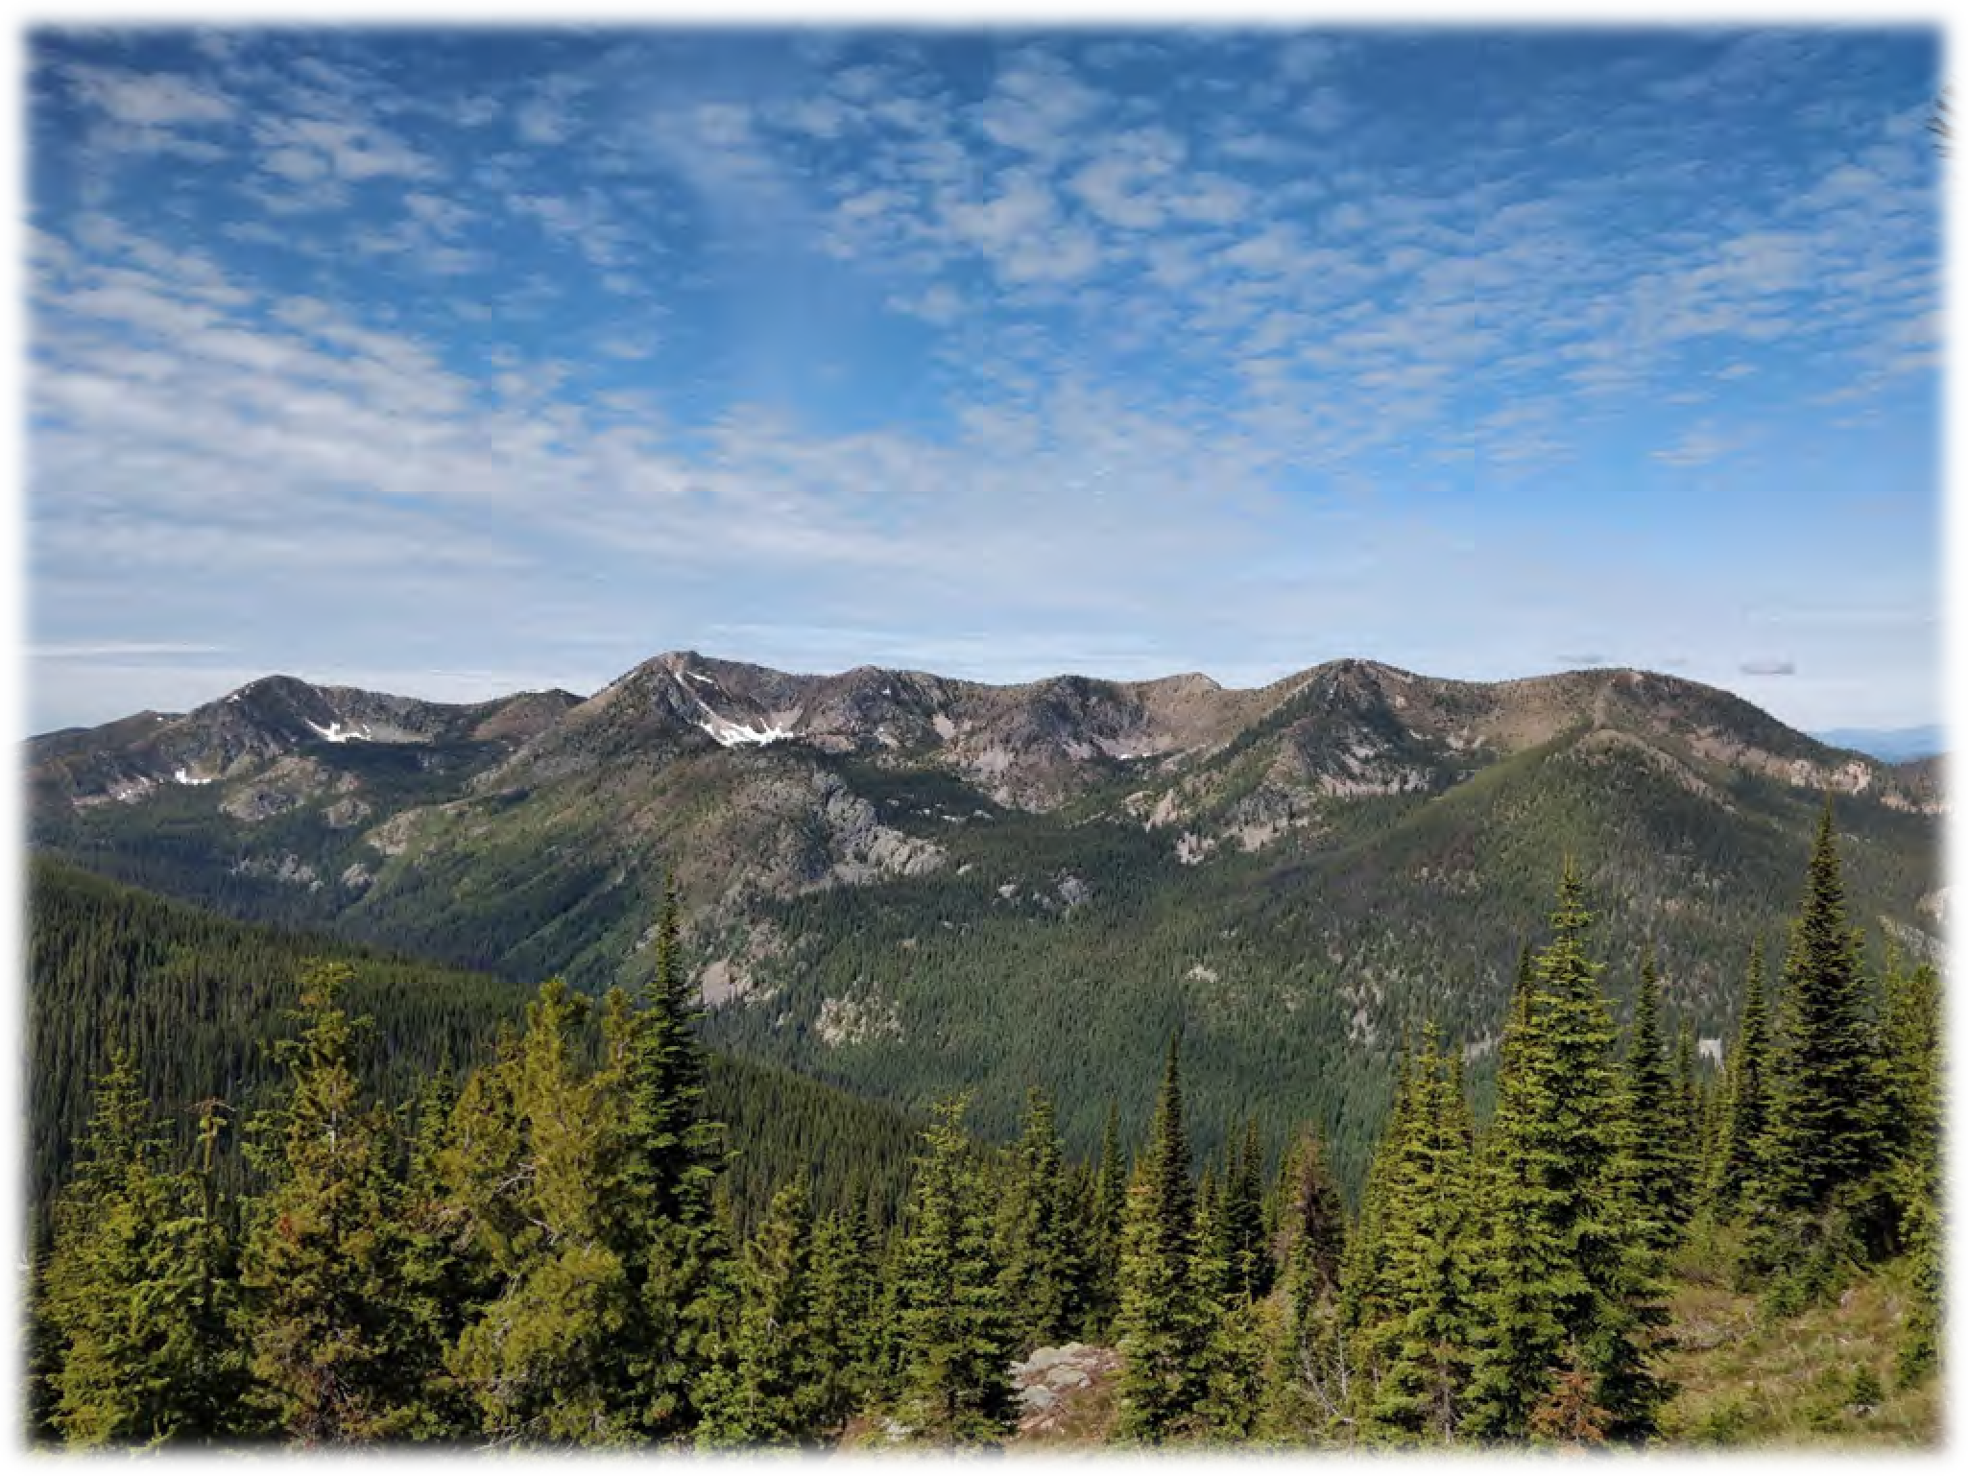

Forest Service Colville National Forest September 2019

Cover photo: View of Gypsy Peak and the Salmo-Priest Wilderness, Sullivan Lake Ranger District (photo courtesy of Jon Day)

In accordance with Federal civil rights law and U.S. Department of Agriculture (USDA) civil rights regulations and policies, the USDA, its Agencies, offices, and employees, and institutions participating in or administering USDA programs are prohibited from discriminating based on race, color, national origin, religion, sex, gender identity (including gender expression), sexual orientation, disability, age, marital status, family/parental status, income derived from a public assistance program, political beliefs, or reprisal or retaliation for prior civil rights activity, in any program or activity conducted or funded by USDA (not all bases apply to all programs).
Remedies and complaint filing deadlines vary by program or incident.
Persons with disabilities who require alternative means of communication for program information (e.g., Braille, large print, audiotape, American Sign Language, etc.) should contact the responsible Agency or USDA’s TARGET Center at (202) 720-2600 (voice and TTY) or contact USDA through the Federal Relay Service at (800) 877-8339. Additionally, program information may be made available in languages other than English.
To file a program discrimination complaint, complete the USDA Program Discrimination Complaint Form, AD- 3027, found online at http://www.ascr.usda.gov/complaint_filing_cust.html and at any USDA office or write a letter addressed to USDA and provide in the letter all of the information requested in the form. To request a copy of the complaint form, call (866) 632-9992. Submit your completed form or letter to USDA by: (1) mail:
U.S. Department of Agriculture, Office of the Assistant Secretary for Civil Rights, 1400 Independence Avenue, SW, Washington, D.C. 20250-9410; (2) fax: (202) 690-7442; or (3) email: program.intake@usda.gov.
USDA is an equal opportunity provider, employer and lender.

Colville National Forest Land Management Plan

Stevens, Ferry, and Pend Oreille Counties of Washington State

Responsible Official: Glen Casamassa Regional Forester Pacific Northwest Region 1220 SW 3rd Avenue Portland, Oregon 97208

For more Information Contact: Rodney Smoldon
Forest Supervisor Colville National Forest 765 South Main
Colville, Washington 99114

This page intentionally left blank

Contents
Acronyms x
Chapter 1 1
Introduction 1
Management Challenges 3
Climate Change 3
Ecosystem Sustainability 4
Insects and Pathogens 4
Invasive Species 5
Fire Management 5
Wildland-urban Interface 6
Recreation 6
Forest Transportation System (Access System) 6
Renewable Forest Products 7
Implementation Challenges 7
Introduction to the Plan 9
Purpose of this Land Management Plan 9
Summary of the Analysis of the management Situation 10
Management Context 10
Consultation, Cooperation and Coordination 11
International Boundary with Canada 11
State and Local Government 11
Federal Trust Responsibility and Tribal Rights and Interests 11
Consistency with Plan Components 12
Plan Structure 16
Other Content – Material that is not a Plan Component 18
Relationship of the Forest Plan to Other Strategic Guidance 18
Forest Service Management Direction 18
National and Regional Direction and Guidance 19
Watershed Analysis 20
Forest Direction 20
Project-level Direction 20
Decisions Made in the Previous Forest Plan 21
Planning Record 21
Environmental Impact Statement 21
Record of Decision 21
Project Record 21
Glossary 21
About the Appendices 21
Appendix A: Consistency with Plan Components 21
Appendix B: Proposed and Possible Management Actions 21
Appendix C: Wildlife, Fish and Plant Species of the Colville National Forest 21
Appendix D: Scenic Integrity Objectives 22
Appendix E: Suitable Uses 22
Appendix F: Recreation Opportunity Spectrum 22

Appendix G: Sites with Administrative Designations and Areas Withdrawn from Mineral Entry 22
Appendix H: Management Area Map 22
Roles and Contributions for the Colville National Forest 23
International Level 23
National Level 23
Pacific Northwest Regional Level 24
State and Local Level 25
Chapter 2 27
Forestwide Direction – Introduction 27
Forestwide Direction – Landscape Features and Dynamics 28
Air (AIR) 29
Desired Condition 29
Standard 29
Soil (SOIL) 29
Desired Conditions 30
Objective 32
Standard 32
Guidelines 32
Vegetation (VEG) 33
Desired Conditions 34
Objectives 39
Standards 39
Guidelines 41
Water Resources (WR) 42
Desired Conditions 50
Objectives 53
Standards 55
Guidelines 56
Wildlife Habitats (WL) 57
Desired Conditions 59
Objectives 61
Standards 62
Guidelines 64
Invasive Species (IS) 67
Desired Condition 68
Objectives 68
Standard 68
Guidelines 69
Forestwide Direction – Social Systems 70
Forest Transportation System - Access System (AS) 71
Desired Conditions 71
Objectives 72
Standard 73
Guidelines 73
Heritage Resources (HR) 74
Desired Condition 75
Standard 75

American Indian Rights and Interest (AI) 75
Desired Conditions 76
Objectives 77
Lands and Special Uses (LSU) 77
Desired Conditions 78
Standards 79
Guidelines 80
Livestock Grazing (LG) 81
Desired Conditions 81
Objectives 82
Standard 82
Guidelines 82
Minerals (MIN) 83
Desired Conditions 83
Standards 84
Guidelines 84
Public Awareness (PA) 84
Desired Conditions 84
Recreation (REC) 85
Desired Conditions 85
Standard 86
Guidelines 86
Renewable Forest Products (RFP) 87
Desired Conditions 87
Guideline 87
Scenery (SCE) 88
Desired Condition 88
Objectives 88
Standard 89
Guidelines 89
Integrated Pest Management (IPM) 90
Desired Condition 90
Objective 90
Standards 91
Guideline 91
Chapter 3 93
Management Areas 93
Management Area Descriptions and Plan Direction 93
Administrative and Recreation Sites (ARS) 95
Desired Conditions 95
Objectives 97
Standards 97
Guidelines 97
Suitable Uses 98
Backcountry (BC) 99
Desired Conditions 99
Standard 100
Guidelines 101

v

Suitable Uses 102
Backcountry Motorized (BCM) 103
Desired Conditions 103
Standards 104
Guidelines 104
Suitable Uses 105
Focused Restoration (FR) 106
Desired Conditions 106
Standard 107
Suitable Uses 108
General Restoration (GR) 109
Desired Conditions 109
Guideline 110
Suitable Uses 110
Nationally Designated Trails (NT) 111
Desired Conditions 112
Objective 113
Standard 114
Guidelines 114
Suitable Uses 115
Research Natural Areas (RNA) 116
Desired Condition 117
Objectives 117
Standard 117
Suitable Uses 118
Riparian Management Areas (RMA) 119
Desired Conditions 120
Objectives 121
Standards 121
Guidelines 125
Suitable Uses 129
Scenic Byways (SB) 130
Desired Condition 131
Objective 131
Standard 131
Guidelines 131
Suitable Uses 132
Kettle Crest Recreation Area (KCRA) 133
Desired Conditions 133
Objectives 134
Standards 134
Guidelines 135
Suitable Uses 136
Wild and Scenic Rivers (WSR) 137
Desired Conditions 138
Standards 138
Suitable Uses 139
Wilderness – Congressionally Designated (WCD) 140
Desired Conditions 140
Objectives 145
Standards 145
Guidelines 146
Suitable Uses 148
Wilderness – Recommended (RW) 149
Desired Conditions 149
Standards 150
Guidelines 151
Suitable Uses 152
Chapter 4 155
Monitoring 155
Introduction 155
Monitoring and Evaluation 157
Forest Plan Monitoring Questions 159
Appendix A – Consistency with Plan Components 169
Appendix B – Proposed and Possible Management Actions 172
Introduction 172
Proposed Management Actions 172
Possible Management Actions 177
Terrestrial Ecosystems 177
Vegetation 177
Fire Management 177
Forest Products 177
Invasive Species 180
Wildlife 180
Aquatic and Riparian Ecosystems 180
Social Systems 181
Access and Recreation 181
Air Quality 182
Heritage Resources 182
American Indian Rights and Interests 182
Lands and Special Uses 182
Livestock Grazing 183
Minerals and Energy 183
Road Construction 183
Scenery 184
Social and Economic Systems 184
Appendix C – Wildlife, Fish, and Plant Species of the Colville National Forest 185
Introduction 185
Appendix D – Scenic Integrity Objectives 193
Scenic Integrity 193
Appendix E – Suitable Uses by Management Area 206
Appendix F – Recreation Opportunity Spectrum 209
Appendix G – Sites with Administrative Designations and Areas Withdrawn from Mineral Entry
. 210
Administrative and Recreation Sites 210
Communication Sites and Energy Corridors 218
Mineral Withdrawals 222
Appendix H – Management Area Map 236

List of Tables
Table 1. Soil ecological functions with attributes and indicators for long-term soil productivity. 30 Table 2. Minimum effective ground cover following any soil-disturbing activity 32
Table 3. Forest vegetation types for the Colville National Forest 33
Table 4. Forest structure classes 33
Table 5. Desired condition for forest structure (HRV) 35
Table 6. Expected patch size by forest vegetation type 35
Table 7. Desired amounts and spatial arrangement of snags by forest vegetation types 36
Table 8. Desired amounts of coarse woody debris (CWD) by forest vegetation types 37
Table 9. Biological legacy categories and examples 37
Table 10. Key watersheds on the Colville National Forest 46
Table 11. Focal Species to be used for monitoring and Management Indicator Species used to assess management activities 59
Table 12. Grizzly bear seasonal habitats objective 61
Table 13. Surrogate species habitat – watersheds for treatment 61
Table 14. Timing standards for protection of land bird species nest sites 62
Table 15. Grizzly bear habitat standards for the shared bear management units of the Colville and Idaho Panhandle National Forests 63
Table 16. Timing guidelines for protection of bird nest sites 66
Table 17. Colville National Forest management areas with special designations 94
Table 18. Suitable uses for Administrative and Recreation Sites Management Areas 98
Table 19. Suitable uses for Backcountry Management Areas 102
Table 20. Suitable uses for Backcountry Motorized Management Areas 105
Table 21. Suitable uses for Focused Restoration Management Area 108
Table 22. Suitable uses for General Restoration Management Area 110
Table 23. Nationally designated trails 112
Table 24. Suitable uses for Nationally Designated Trails Management Areas 115
Table 25. Colville National Forest research natural areas 116
Table 26. Suitable uses for Research Natural Area Management Areas 118
Table 27. Suitable uses for Riparian Management Areas 129
Table 28. Scenic byways within the Colville National Forest 130
Table 29. Suitable uses for Scenic Byways Management Areas 132
Table 30. Suitable uses for Kettle Crest Recreation Area Management Area 136
Table 31. Eligible wild and scenic rivers by segment and classification 137
Table 32. Suitable uses in Wild and Scenic River Management Areas 139
Table 33. Congressionally designated wilderness area in Colville National Forest 140
Table 34. Wilderness resource spectrum class desired condition 142
Table 35. Authorization of developments in congressionally designated wilderness 146
Table 36. Suitable uses for congressionally designated Wilderness Management Area 148
Table 37. Recommended wilderness by name and acreage 149
Table 38. Suitable uses for Recommended Wilderness Management Area 152
Table 39. Monitoring questions 159
Table B-1. List of proposed management actions (plan objectives) 172

Table B-2. Modelled vegetation treatments by management area and vegetation type 179
Table C-1. Wildlife, fish, and plant species found on the Colville National Forest 186
Table D-1. Scenic integrity and condition definitions 194
Table D-2. Scenic integrity objective by management area 194
Table D-3. Republic Ranger District scenic viewsheds 197
Table D-4. Three Rivers Ranger District scenic viewsheds 201
Table D-5. Sullivan Lake Ranger District scenic viewsheds 203
Table D-6. Newport Ranger District scenic viewsheds 205
Table E-1. Suitable uses by management area 206
Table G-1. Administrative sites on the Colville National Forest 210
Table G-2. List of designated communication sites on the Colville National Forest 218
Table G-3. Designated energy and utility corridors on the Colville National Forest 219
Table G-4. Mineral withdrawals 222

List of Figures
Figure 1. Vicinity map of the Colville National Forest 1
Figure 2. Colville National Forest counties and neighboring lands 2
Figure 3. Hierarchy of management direction for all national forests 19
Figure 4. Illustration of watershed hierarchy from the basin to subwatershed scale 43
Figure 5. Key and municipal supply watersheds 46
Figure 6. Current watershed condition class for subwatersheds across the Forest 49
Figure D-1. Colville National Forest scenic integrity objectives 195
Figure D-2. Republic Ranger District scenic integrity objectives 196
Figure D-3. Three Rivers Ranger District scenic integrity objectives (map 1 of 3) 198
Figure D-4. Three Rivers Ranger District scenic integrity objectives (map 2 of 3) 199
Figure D-5. Three Rivers Ranger District scenic integrity objectives (map 3 of 3) 200
Figure D-6. Sullivan Lake Ranger District scenic integrity objectives 202
Figure D-7. Newport Ranger District scenic integrity objectives 204
Figure F-1. Colville National Forest recreation opportunity spectrum 209
Figure G-1. Designated communication sites and energy corridors 221
Figure G-2. Mineral withdrawals on the west side of the Colville National Forest 228
Figure G-3. Mineral withdrawals on the east side of the Colville National Forest 229
Figure G-4. Republic Ranger District mineral withdrawals 230
Figure G-5. Three Rivers Ranger District mineral withdrawals (map 1 of 3) 231
Figure G-6. Three Rivers Ranger District mineral withdrawals (map 2 of 3) 232
Figure G-7. Three Rivers Ranger District mineral withdrawals (map 3 of 3) 233
Figure G-8. Sullivan Lake Ranger District mineral withdrawals 234
Figure G-9. Newport Ranger District mineral withdrawals 235
Figure H-1. Colville National Forest management areas 236

Acronyms

ACS | Aquatic Conservation Strategy | HUC | Hydrologic Unit Code
AEC | Aquatic Ecological Condition | ICBEMP | Interior Columbia Basin
AIS | Aquatic Invasive Species |  | Ecosystem Management
AMS | Analysis of the Management |  | Project
 | Situation | IDT | Interdisciplinary Team
ARCS | Aquatic and Riparian | IGBC | Interagency Grizzly Bear
 | Conservation Strategy |  | Committee
ARS | Administrative and Recreation | INFISH | Inland Native Fish Strategy
 | Sites | KCRA | Kettle Crest Recreation Area
ASQ | Allowable Sale Quantity | LCAS | Lynx Conservation Assessment
ATV | All-terrain Vehicle |  | and Strategy
AUM | Animal Unit Month | LMP | Land Management Plan
BC | Backcountry Non-Motorized | LRMP | Land and Resource
BCM | Backcountry Motorized |  | Management Plan
BLM | Bureau of Land Management | LSOF | Late Structure Old Forest
BMP | Best Management Practice | LTA | Landtype Association
CCF | Hundred Cubic Feet | LTSY | Long-term Sustained Yield
CEQ | Council on Environmental  Quality | MA | Management Area
CFR | Code of Federal Regulations | MMBF | Million Board Feet
CNF | Colville National Forest | MOA | Memorandum of Agreement
CWA | Clean Water Act
CWPP | Community Wildfire | MOU | Memorandum of
 | Protection Plan |  | Understanding
DEIS | Draft Environmental Impact | MUSYA | Multiple Use Sustained Yield
 | Statement |  | Act
DSM | Decision Support Model | MVUM | Motor Vehicle Use Map
EPA | Environmental Protection | NAAQ | National Ambient Air Quality
 | Agency |  | Standard
ESA | Endangered Species Act | NEPA | National Environmental Policy
FEIS | Final Environmental Impact |  | Act
 | Statement | NFMA | National Forest Management
FERC | Federal Energy Regulatory |  | Act
 | Commission | NFS | National Forest System
FR | Focused Restoration | NHD | National Hydrography Dataset
FRCC | Fire Regime Condition Class | NHPA | National Historic Preservation
FSH | Forest Service Handbook |  | Act
FSM | Forest Service Manual | NOA | Notice of Availability
GDE | Groundwater-dependent | NRT | National Recreation Trail
 | Ecosystems | NST | National Scenic Trail
GIS | Geographic Information | NT | Nationally Designated Trails
GR | System  General Restoration | NVUM | National Visitor Use  Monitoring
HRV | Historical Range of Variability | OHV | Off-highway Vehicle

PIBO | PACFISH/INFISH Biological | TES | Threatened, Endangered &
 | Opinion |  | Sensitive (species)
PILT | Payment in Lieu of Taxes | TMDL | Total Maximum Daily Load
PTSQ | Projected Timber Sale | USC | United States Code
 | Quantity | USDA | United States Department of
PUD | Public Utility District |  | Agriculture
PWA | Potential Wilderness Area | USDI | United States Department of
PWSQ | Projected Wood Sale Quantity |  | Interior
RACR | Roadless Area Conservation | USFS | United States Forest Service
 | Rule | USGS | United States Geological
RHCA | Riparian Habitat Conservation |  | Survey
 | Area | WAC | Washington Administrative
RMA | Riparian Management Area |  | Code
RMO | Riparian Management | WAP | Watershed Action Plan
 | Objective | WCD | Wilderness - Congressionally
RNA | Research Natural Area |  | Designated
ROD | Record of Decision | WCF | Watershed Condition
ROS | Recreation Opportunity |  | Framework
 | Spectrum | WDFW | Washington Department of
RW | Recommended Wilderness |  | Fish and Wildlife
SB | Scenic Byways | WADoE | Washington Department of
SIO | Scenic Integrity Objectives |  | Ecology
SMS | Scenery Management System | WQIP | Water Quality Implementation
SPM | Semi-primitive Motorized |  | Plan
SPNM | Semi-primitive Non-Motorized | WRIA | Water Resources Inventory
TEP | Threatened, Endangered, and |  | Areas
 | Proposed (species) | WSR | Wild and Scenic River
 |  | WUI | Wildland-urban Interface

This page intentionally left blank

Chapter 1

Introduction
Located in the northeastern corner of Washington State, the Colville National Forest lies within a remote area of wild beauty and rich history. Encompassing 1.1 million acres, the Colville occupies nearly one-third of the total area of Ferry, Pend Oreille, and Stevens Counties. To the north, the national forest is bordered by British Columbia; to the west by the Okanogan- Wenatchee National Forest; to the east by the Idaho Panhandle National Forests; and to the south by a portion of the Colville Confederated Tribes Indian Reservation. Lincoln and Spokane Counties, though not immediately adjacent, are within the Colville National Forest's area of influence. If these two counties are included, the influence area of the national forest accounts for almost 10 percent of the total state population. Visitation from other areas, such as Okanogan County, may also be substantial and, if considered, would enlarge the Colville’s area of influence.
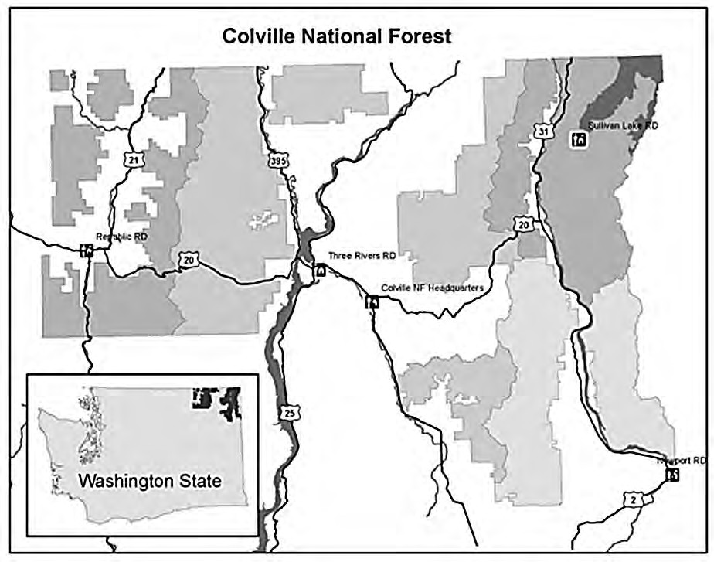
Figure 1. Vicinity map of the Colville National Forest

Visitors access the Colville National Forest from one Federal (U.S. 395) and three State highways (Highways 21, 25, and 31) that mostly follow the north–south drainages, and from State Highway 20, which transects the middle of the national forest in a west–east direction. Three

recognized scenic byways bisect the Colville: Sherman Pass and North Pend Oreille National Scenic Byways and the International Selkirk Loop (designated an All-American Road). Numerous National Forest System (NFS) roads and trails provide access to gathering sites for forest products and a diversity of developed and dispersed, outdoor, rustic recreation opportunities.
Two north−south oriented mountain ranges comprise the bulk of the Colville National Forest: the 7,000-foot Selkirk Range (featuring the outstanding high-country Salmo-Priest Wilderness) and the Kettle River Range. The Pend Oreille River, surrounded by mostly private land, runs along the western edge of the Selkirks. The 130-mile-long Lake Roosevelt National Recreation Area, a segment of the Columbia River reservoir created by Grand Coulee Dam, divides the national forest. The National Recreation Area draws thousands of visitors to this remote corner of Washington State each year.
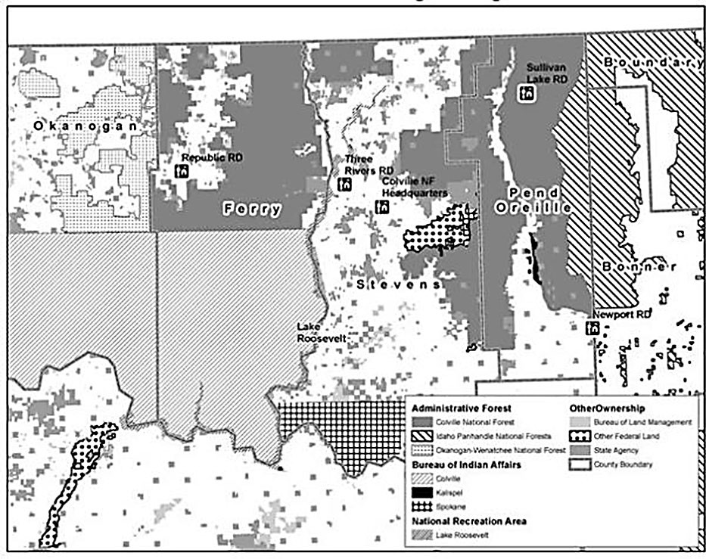
Figure 2. Colville National Forest counties and neighboring lands

Three vegetation zones comprise Colville National Forest, each with a unique climate and topography. Dry forests of ponderosa pine and Douglas-fir dominate the rolling landscape of the Okanogan Highlands west of the Kettle Crest. The subalpine fir types along the Kettle Crest separate the western portion of the national forest from the lush valleys and richly forested mountains to the east where rainfall reaches 50 inches a year in the Salmo-Priest Wilderness.
Western red cedar and western hemlock forests are comparable to those on the west side of the North Cascades Range. Wildlife including bull trout, grizzly bear, woodland caribou, moose, wolf, and bald eagle inhabit regions of the Colville.

All water flowing from the Colville National Forest eventually drains into the Columbia River. Major drainages include the Pend Oreille, Colville, Kettle, and Sanpoil Rivers. The national forest contains approximately 500 miles of fish-bearing streams and about 100 lakes and ponds.
Principal ecosystem services are timber, wildlife, fish, water, forage, and recreation. Timber harvest remains one of the primary ways the Colville National Forest meets economic needs. Between 1988 and 2014, timber harvest levels averaged approximately 47.6 million board feet (MMBF) per year. The amount of timber sold has declined over the life of the 1988 Forest Plan from a high of 134 MMBF in 1989 to a low of 18 MMBF in 2005 (with an average of 49 MMBF per year from 2012-2016). Approximately 10 percent of the annual volume the national forest sells is non-commercial material such as firewood or biomass. During the most recent 10-year period, the Colville supported an average of 29,500 animal unit months of forage for cattle grazing. The national forest currently has a total of 58 grazing allotments that cover
810,000 acres. Grazing on the Colville National Forest generally occurs from June through October.
With an estimated 336,000 visits per year, the Colville National Forest is a popular retreat for activities including camping, winter sports, forest product gathering, off-highway vehicle use, four-season trail use, driving for pleasure, snowmobiling, backcountry travel, hunting, fishing, and wildlife viewing. Combined, day-use and overnight recreation opportunities contribute an estimated $7.5 million (in 2003 dollars) in annual revenues to communities located within
50 miles of the national forest (2009 NVUM Master Report).
Approximately 4,000 miles of National Forest System roads provide access to recreation areas and places to collect renewable forest products such as firewood, berries, mushrooms, and Christmas trees. The Colville National Forest manages 32 campgrounds, 2 eligible wild and scenic rivers, the Salmo-Priest Wilderness, 197 miles of the Pacific Northwest National Scenic Trail, 49 Degrees North Mountain Resort, and 15 recreation residences.

Management Challenges
Managing the Colville National Forest to continue providing public benefits includes making available recreation access, facilities, and services; supplying renewable and non-renewable forest products; and providing roads, services, and accommodations to support local economies. It also encompasses protecting clean water sources, aquatic and terrestrial habitat for species of fish, plants, and wildlife; and preserving heritage resources. And, each year, forest managers focus more on providing quiet, natural places for personal renewal while emphasizing planning and restoration of forest ecosystems to make them more resilient to changing climates.
Challenges forest managers face in providing these benefits include population growth, urbanization, appropriate recreational use, access, climate change, vegetation and wildlife diseases, wildland fire, invasive non-native species management, and protection of natural resources. Discussion of these challenges follows.

Climate Change
Projected climate changes, based on current knowledge, information, and data presents complex challenges in predicting long-term changes. Broad-scale climate change assumptions and potential effects were considered when writing the desired conditions for this plan, including:

- Continued warming in the Pacific Northwest is likely to result in increased water use by vegetation (Hamlet et al. 2007)
- Reduced water available for forest vegetation, wildlife, and humans
- Increased stress on water supplies and water storage facilities throughout the Pacific Northwest
- Redistributed forested and nonforested habitats
Additional information is located in the final Programmatic Land Management Plan EIS.

Ecosystem Sustainability
Our national forests are valued for large areas of naturally functioning ecosystems. However, climate change, spreading invasive plant and animal species, and human activities threaten these same ecosystems. Demand for natural resources, whether for recreation or commodity, places additional pressure on ecosystem sustainability. Fragmentation of plant and wildlife habitat resulting from growth patterns on lands adjacent to national forests, management activities, and increased use of National Forest System lands is affecting our ability to manage for federally protected species, such as the grizzly bear, woodland caribou, and bull trout.

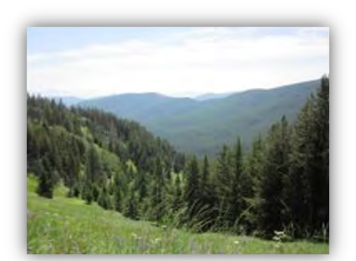

Insects and Pathogens
Hanley Meadow

Insects and pathogens are a natural part of a functioning ecosystem. However, impacts from them can be exacerbated when stands are over stocked and stand structures and species composition favor the insect or pathogens. In addition, the introduction of the non-native white pine blister rust has decreased the presence and regeneration levels of the five needle pines.
Additionally the non-native balsam woolly adelgid is changing some of the true fir species presence.
We have identified wildfire exclusion, historic grazing practices, and historic timber harvesting as the principal factors resulting in increased live tree stocking levels, increased levels of mid and late seral species, and homogenization of spatial patterns. These factors contribute to

uncharacteristic conditions that support larger scale and more persistent insect outbreaks (Hessburg et al. 1994). These factors also lead to stand conditions that cause an increase of tree growth loss and mortality by native root diseases and dwarf mistletoes. Acreage affected by insects and disease has consistently exceeded acreage affected by wildfire in the Colville National Forest.
The interaction of increased tree density, stand structures and species compositions that favor root disease and dwarf mistletoe spread, increased insect levels of both defoliators and bark beetles, increased fuel levels, and climate change impacts such as water stress¹ are influencing the levels of current late forest structures and will continue to influence future late forest structure development. White pine blister rust has widespread impact on forest structure and composition that have forest health consequences beyond the disease itself.

Invasive Species
National invasive species management direction is provided by Forest Service Manual 2900. The objectives for aquatic and terrestrial invasive species management (including vertebrates, invertebrates, plants, and pathogens) in the Forest Plan are based upon an integrated pest management approach on all areas within the National Forest System, and on areas managed outside of the National Forest System under the authority of the Wyden Amendment (P.L. 109- 54, Section 434), prioritizing prevention and early detection and rapid response actions as necessary.
Currently, approximately 20,000 acres of invasive plants exist on the Colville National Forest. Class A² noxious weeds and invasive plants near wilderness, RNAs and other unique areas are a priority for treatment. Invasive animals such as feral pig are a high priority for prevention and early detection and rapid response. Aquatic invasives such as quagga and zebra mussels are also a high priority for prevention and early detection and rapid response. Invasive insects such as Asian longhorned beetle also pose a threat of serious impact to forest conditions. Pathogens such as exotic root diseases may also target a specific species of native tree and result in widespread damage. Funding to treat known invasive populations has not kept pace with their spread, capacity to treat known risks, and fully implement early detection and rapid response.

Fire Management
Wildland fire is an essential disturbance process in dynamic and resilient ecosystems. However, the potential for uncharacteristic wildfire that is more severe, dangerous, and difficult and costly to suppress, concerns forest managers.
Fire played an important role in the historical development of both forested and non-forested vegetation across northeastern Washington. Fire was generally either low or mixed severity across much of the Colville National Forest. It created a mix of structural stages (forested vegetation); removed understory trees in dry forest types; resulted in a mix of opening sizes creating locations for establishment of shade-intolerant tree species and increased ground-level forage; regenerated shrubs and understory plants for wildlife forage; and created snag habitat.

1 Water stress is primarily caused by a water deficit (where there is a lack of water to fully meet the needs of the vegetation).
2 Class A weeds are non-native species whose distribution in Washington State is still limited. Preventing new infestations and eradicating existing infestations are the highest priority. Eradication of all Class A plants is required by law.

However, uncharacteristic wildfire may contribute to the spread of invasive plant species, reduce habitat for federally listed terrestrial and aquatic species, and cause damage to the Forest’s infrastructure and adjacent property values. Uncharacteristic wildfire is often associated with high to moderate fire intensity and burn severity, which could result in accelerated erosion, loss or impairment of soil productivity, potential to increase peak flows, reduce water quality, and decrease aquatic habitat function. Uncharacteristic wildfires are also associated with increasingly high levels of dead and downed fuel, overstocked forests, and drought. Insect outbreaks and diseases can also contribute to (or create additional) fuel loads. Development of structures in the wildland interface areas adjacent to national forest lands adds to the complexity and danger of wildfire suppression.

Wildland-urban Interface
Wildland-urban interface (WUI) will continue to change over the life of the Forest Plan. As communities update their wildfire protection plans, additional WUI area can and will be added. The trend indicates that people will continue to build adjacent to national forest lands. This will affect wildland fire and fuels projects through public input in support of, or against those projects. It will also affect wildland fire limits in some areas because of social and political concerns related to individual perceptions of wildland fire risk and fuel management.
This Forest Plan includes recommended wilderness management area designations that overlap areas identified as WUI by counties. Desired conditions for recommended wilderness include retaining wilderness characteristics. This overlap of management area desired conditions will also affect management of fuels and fire risk.

Recreation
Recreational use of the Colville National Forest is projected to increase due to population growth, more people seeking outdoor activities, and increased participation in popular activities. Increasing numbers of residents of communities surrounding the national forest seek healthful, outdoor-oriented lifestyles. Changing use patterns suggest the need to provide more specific infrastructure, such as facilities for large group use. Some activities such as mountain biking and off-highway vehicle use have surged in popularity since the current plans were approved. As development of private land continues, the Forest Service anticipates a greater dependence on the Colville for nature-based activities and experiences that are becoming less accessible elsewhere. In some locations, resource impacts and crowding associated with recreational use are growing, and damage to riparian areas and unauthorized trail development are of particular concern.
Maintaining recreation infrastructure and providing opportunities for a broad cross-section of the public will strengthen the national forest’s relevancy and contribute to future generations’ appreciation and support of the National Forest System.

Forest Transportation System (Access System)
Issues surrounding access to and through the national forest are complex. The Colville National Forest administers over 4,000 miles of system roads. The cost of managing this extensive transportation system while providing public and administrative access, habitat for fish and wildlife, and preservation and improvement of water quality presents challenging resource trade-offs.

Additional private landowners adjacent to national forests means more neighbors with whom the Forest Service needs to coordinate access for public recreation and other management activities.

Renewable Forest Products
The Colville National Forest provides water and renewable forest products such as timber, firewood, forage, huckleberries, mushrooms, material for floral arrangements, Christmas trees, native plants and seed, and medicinal plants. Managers must effectively communicate with an increasing diversity of people with varying knowledge of national forest management objectives to encourage responsible stewardship of the national forest.

Implementation Challenges
A final challenge is maintaining relevancy of the national forests to the American people. Our success in achieving desired conditions depends on recognizing these challenges, some of which may be beyond our management capability, such as uncertainties around climate change, unforeseen environmental disturbances, and budgetary fluctuations. These challenges may mean it will take longer and more work to achieve the desired conditions. Congress allocates the Forest Service budgets on an annual basis, which may or may not be sufficient to implement proposed annual activities or meet desired conditions.

This page intentionally left blank

Introduction to the Plan
The mission of the United States Department of Agriculture (USDA) Forest Service is to sustain the health, diversity, and productivity of the Nation’s forests and grasslands to meet the needs of present and future generations. The phrase, “Caring for the Land and Serving People” captures the USDA Forest Service mission. As set forth in law, our mission is to achieve quality land management under the sustainable multiple-use management concept to meet the diverse needs of people. The overall goal of managing the National Forest System is to sustain the multiple uses of its renewable resources in perpetuity, while maintaining the long-term productivity of the land.

Purpose of this Land Management Plan
Based on current information and guidance, this Land Management Plan (Plan or Forest Plan) provides responsible land management direction for the Colville National Forest by guiding programs, practices, uses and projects. For ease of discussion throughout this document, the Colville National Forest will be referred to as Forest when referencing the single administrative unit, the staff that administers the unit, or the National Forest System lands within the unit.
On March 23, 2012, the agency established a new planning rule (the 2012 Planning Rule). The 2012 Rule also provides transition language at 36 CFR 219.17(b)(3), allowing the responsible official to elect to use the provisions of the prior planning regulations to prepare plan amendments and revisions. The responsible official has elected to continue to follow the provisions of the planning regulations in effect prior to May 9, 2012, as indicated in the 2011 Notice of Intent.
This Plan provides broad guidance and information for project and activity decision-making for approximately the next 15 years³.
Forest Plan Characteristics
The Plan is strategic in nature. It does not include project and activity decisions. Those decisions are made later, only after specific proposals are made and analyzed and there is the opportunity for public involvement.
The Plan includes plan components. These are desired conditions, objectives, suitability of areas, areas with special designations, monitoring, and standards and guidelines. Plan components are distinguished from other parts of the Plan because they can only be changed by a plan amendment.
The Plan is adaptive. New knowledge and information can be analyzed and the Plan changed, if appropriate, at any time. Changes to plan components are made by a formal amendment process.
The Plan honors the continuing validity of private, statutory, or pre-existing rights.

3May be revised sooner if needed because of important changed conditions.

The Forest Plan provides guidance for project- and activity-level decision-making on the Colville National Forest for approximately the next 15 years. This guidance includes:
- Forestwide multiple-use goals (listed as desired conditions) and objectives, including a description of the desired condition of the Forest and an identification of the quantities of goods and services that are expected to be produced during the planning period.
- Forestwide standards and guidelines applying to future activities and resource integration.
- Management area (MA) direction (multiple-use prescriptions) with associated standards and guidelines, including possible actions (see appendix B).
- Monitoring and evaluation requirements that provide a basis for a periodic determination and evaluation of the effects of management practices.
- Recommendation of wilderness to Congress; and recommendation of rivers eligible for inclusion in the Wild and Scenic River System.
- Determination of suitability and potential capability of lands for resource production (timber and grazing).
Life and safety of forest users is important. However, it is not necessary to provide management direction for safety in a forest plan. Numerous regulations, codes, and policies provide for human health and safety.

Summary of the Analysis of the management Situation
The Analysis of the Management Situation (AMS), required by the 1982 Planning Rule, describes the social, economic, and ecological conditions and trends in and around the Colville National Forest. The AMS notes where the former land management plan (the 1988 plan) does not provide adequate management guidance for the present and future, and it identifies where the conditions and trends indicate a need for change from the 1988 plan. The AMS is located in the planning record.
The AMS identifies three primary areas, or revision topics, where there are priority needs for change in program direction.
- Vegetation and Fuels Treatment
- Aquatic (Fish and Water) Systems
- Wildlife Habitat

Management Context
Management of National Forest System lands occurs in a larger context and geographic landscape. National laws, regulations, and policy guide the Forest’s interaction with local, State and Federal agencies. The Colville National Forest covers a wide geographic landscape and is a neighbor to many entities, ranging from the private landowner, to State and Federal lands, to Tribal lands, and a foreign country to the north (Canada). The management of the Forest is set within this complex regulatory and geographic environment, and is guided by numerous laws, regulations, executive orders, treaties, and agreements. Following is a brief overview of this complex situation.

Consultation, Cooperation and Coordination
The Colville National Forest contains lands adjacent to other national forests, national wildlife refuges, United States Department of Interior (USDI) Bureau of Land Management lands, Tribal lands, and lands managed by the State, in addition to others. Through mandatory requirement or agreement, the Forest consults, cooperates, and/or coordinates with many local governments (especially counties), state agencies (including the Washington State Historic Preservation Office), Washington Department of Ecology (Ecology or WADoE), Washington Department of Fish and Wildlife (WDFW)), Federal agencies (including the USDI Fish and Wildlife Service, Department of Homeland Security, and Federal Energy Regulatory Commission), and American Indian tribes, as well as communities, private entities, individuals, research institutions, and organizations. These relationships help improve management efficiency, achieve management goals, improve overall resource management, foster consistent land management at larger scales, and reduce potential conflicts. If these requirements or agreements change, the Forest will comply with, or adapt to the changes as needed. The Forest considers these consultation, cooperation, and coordination activities as standard operating procedure, and, therefore, they are generally not restated as direction in the Forest Plan.

International Boundary with Canada
The Colville National Forest’s northernmost boundary is the international boundary with Canada. A 60-foot-wide reservation strip, the “Taft Reservation” of May 3, 1912, runs along the border. Activities by the Forest and other Federal agencies within the reservation strip are the subject of numerous agreements and understandings between Federal agencies as well as treaties between the United States and Canada. The Plan does not address management within the 60-foot reservation or activities within the national forest related to the international boundary, as treaties and related agreements and understandings cover those areas.

State and Local Government
State and local government resource management and land use plans provide guidance for management of lands in those jurisdictions. Community wildfire protection plans provide well- defined avenues for coordination. County land use plans describe local government goals and objectives for land management and provide opportunities for coordination between the Forest Service and local governments.

Federal Trust Responsibility and Tribal Rights and Interests
American Indian tribes are sovereign nations. They are government entities with which the Forest Service has established and continues to maintain government-to-government relationships. In government-to-government consultation, the Forest Service acknowledges the sovereignty of federally recognized American Indian Tribes, and the special government-to- government relationship between the Tribes and the United States through Executive Order 13175 (November 6, 2000).
The United States Government has a trust responsibility to federally recognized tribes. While Federal laws apply to all federally recognized American Indian Tribes, each Tribe or confederation of Tribes is different and is recognized as a separate and unique government. There are differences between Tribes and in historic relationships between Tribes and lands on and near their current reservations. In some cases, several Tribes may have legal interests in the same lands because they each may have occupied or otherwise used those lands prior to

relocation on reservations. These factors and others result in unique relationships with each Tribe.
Tribes have reserved rights and privileges for their Tribal members on any off-site reservation lands ceded through executive orders to the United States Government. The Forest Service manages some of those off-reservation lands ceded through executive orders. Therefore, the agency has certain legal responsibilities to American Indian Tribes. The Forest Service is required to manage the lands under their stewardship with full consideration of the Federal trust responsibility and Tribal rights and interests, particularly reserved rights where they exist. In meeting these responsibilities, the agency consults with the Tribes whenever proposed policies or management actions may affect their interests. American Indian access to sites is protected as well as the use and possession of sacred objects, the freedom to worship through ceremonial and traditional rites, and collection of native plant and animal resources for traditional cultural purposes. Appropriate protection of these areas is coordinated with the leaders of the Tribes. On some occasions, access or use by the public may be temporarily denied to allow Tribal members to exercise their reserved rights in privacy and solitude. When such uses or temporary closures occur, participating Tribal members are typically required to verify their membership in a federally recognized tribe.
While this Plan does not attempt to define the legal obligations of the Forest Service under the Federal trust responsibility, the Plan reflects a commitment, whether as a legal obligation or a matter of policy, to address Tribal concerns and interests.
Further, the Plan reflects consideration of Federal legal responsibilities to both Tribes and American Indian people as expressed through executive order, Federal laws (such as Civil Rights Act, National Environmental Policy Act (NEPA), National Historic Preservation Act, and Native American Graves Protection and Repatriation Act), executive orders, and Federal court judgments.
More specifically, government-to-government consultation is ongoing between the Forest Service and the Confederated Tribes of the Colville Reservation, the Kalispel Tribe of Indians, and the Spokane Tribe of Indians.
The tribes and Executive orders are as follows:
- Confederated Tribes of the Colville Reservation: Executive Order of 1872; North-Half Agreement of 1891
- Kalispel Tribe of Indians: Executive Order of 1914
- Spokane Tribe of Indians: Executive Order of 1881

Consistency with Plan Components
Under the National Forest Management Act (NFMA) of 1976, a project or activity must be consistent with plan components as follows and as described in the Consistency with Plan Components Appendix of this Plan. As projects and activities are planned, an interdisciplinary team assesses the potential environmental, physical, biological, aesthetic, cultural, engineering, and economic impacts on the area.
A project or activity must be consistent with the plan by being consistent with applicable plan direction. Direction in this Plan applies to all projects that have decisions made on or after the

effective date of the final record of decision (ROD). The ROD specifies the transition strategy for short- and long-term ongoing actions.
Plans also contain other content (see the “Other Content” section). Projects and activities are not required to be consistent with this other content.
Where a proposed project or activity would not be consistent with a plan decision, the responsible official has the following options:
- To modify the proposal so that the project or activity will be consistent;
- To reject the proposal; or
- To amend the plan at the same time as the approval of the project or activity so that the project or activity is consistent with the plan as amended. The amendment may be limited to apply only to the project or activity.
These plan components apply only to National Forest System lands and are measured at the forestwide scale unless specifically stated otherwise. The timeframe to achieve objectives is 10 to 15 years unless stated otherwise. These plan components do not alter any legal or statutory rights such as mineral development or private lands access or reduce the need to provide public or employee safety. These goals (hereafter identified as desired conditions), objectives, standards and guidelines do not supersede law or regulation in the event of conflict between them. Standards apply only to management actions.

Plan Components
Desired Conditions (Goals) | Social, economic, and ecological attributes toward which management of the land and resources of the plan area is to be directed. Desired conditions are aspirations, not final decisions approving projects and activities, and may be achievable only over a long period of time.  However, projects and activities will be designed to move the forest toward desired conditions.  To be consistent with the desired conditions of the plan, a project or activity, when assessed at the appropriate spatial scale described in the plan (e.g., landscape scale), must be designed to meet one or more of  the following conditions:
− Maintain or make progress toward one or more of the desired conditions of a plan without adversely affecting progress
toward, or maintenance of, other desired conditions; or
− Be neutral with regard to progress toward plan desired
conditions; or
− Maintain or make progress toward one or more of the desired conditions over the long term, even if the project or activity would adversely affect progress toward or maintenance of one
or more desired conditions in the short term; or
− Maintain or make progress toward one or more of the desired conditions over the long term, even if the project or activity would adversely affect progress toward other desired
conditions in a negligible way over the long term.

Plan Components
The project or activity documentation should explain how the project or activity is consistent with desired conditions and describe any short-term or negligible long-term adverse effects the project or activity may have concerning the maintenance or attainment of any desired condition. If a project will adversely affect progress toward one or more desired condition in more than a negligible way or short-term way, a Plan Amendment is required.
Objectives | These are concise projections of measurable, time-specific intended outcomes. Objectives are the means of measuring progress toward achieving or maintaining desired conditions. The objectives represent just some of the expected outcomes or actions required to accomplish movement toward desired conditions.  Variation in achieving objectives may occur during the next 10 to 15 years because of changes in environmental conditions, available  budgets, and other factors. Objectives are strongly influenced by recent trends, past experiences and anticipated staffing levels, and short-term budgets.  A project or activity is consistent with the objectives of the plan if it contributes to or does not prevent the attainment of any applicable objectives. The project or activity documentation should identify any applicable objective(s) to which the project contributes and document that the project or activity does not prevent the attainment of any objectives. If there are no applicable objectives, the project or activity must be consistent with the objectives of the plan, and the project or activity document should state that fact.  The objectives section provides a description of the potential outcomes or results that may be expected to be provided during the planning period.
Standards | Standards are constraints upon project and activity decision making. Standards are established to help achieve desired conditions and objectives and to ensure projects and activities on NFS lands comply with applicable laws, regulations, Executive orders, and agency directives.  A project or activity must be consistent with all standards applicable to the type of project or activity and its location in the plan area. A project or activity is consistent with a standard when its design is in exact accord with the standard; variance from a standard is not allowed except by plan amendment. The project or activity documentation should confirm that the project or activity is consistent with applicable standards.  Standards are explicitly identified in the Plan.

Plan Components
Guidelines | Guidelines provide operational practices and procedures that are applied to project and activity decision making to help achieve desired conditions and objectives, to avoid or mitigate undesirable effects, or to meet applicable legal requirements.  A project or activity is consistent with a guideline in either of two ways:
 | 1. The project or activity is designed exactly in accord with the guideline; or
 | 2. A project or activity design varies from the exact words of the guideline, but it is as effective in meeting the purpose of the guideline to contribute to the maintenance or attainment of the relevant desired conditions and objectives.
 | Guidelines are explicitly identified in the Plan. When a project or activity varies from the exact words of the guideline, the project or activity documentation must specifically explain how the project or activity design is as effective in contributing to the maintenance or attainment of relevant desired conditions and objectives. When deviation from a guideline does not meet the original intent, however, a plan amendment is required.
Suitability of Areas | National Forest System lands are identified as “generally suitable” for various uses. Suitability describes the appropriateness of applying certain resource management practices (uses) to a particular area of land. An area may be identified as generally suitable for uses that are compatible with desired conditions and objectives for that area.  A project with the purpose of timber production may occur only in an area identified as suitable for timber production. The documentation for the project should confirm the project area meets the suitability requirements.  Except for projects with a purpose of timber production, a project or activity must address plan suitability determinations in either of two  ways:
 | 1. The project or activity is a use identified in the plan as suitable for the location where the project or activity is to occur; or
 | 2. The project or activity is not a use identified in the plan as suitable for the location (i.e., the plan is silent on the use or the plan identifies the use as not suitable), but the responsible official determines that the use is appropriate for that location’s desired conditions and objectives. However, if a project or activity is specified in the plan as not suitable for the area, an amendment to the forest plan is required.

Plan Components
The project documentation should describe that the project or activity is either: (1) a use for which the area is specifically identified in the plan as suitable or (2) not a use for which the area is specifically identified in the plan as suitable, but it is, nonetheless, appropriate for that location.
However, if a project or activity is specified in the plan as not suitable for the area, an amendment to the forest plan is required.

Changes such as updates of data and maps, typographical errors, modifications to the monitoring program and monitoring information, and other non-substantive changes in this document, may be made with administrative corrections. The public will be notified of any future amendments or administrative corrections to the plan.

Plan Structure
This Plan is organized into several major divisions: Chapter 1: Introduction; Chapter 2: Forestwide Direction; Chapter 3: Management Area Direction; Chapter 4: Monitoring; Appendices; and References.
A map of management areas can be found in appendix H of this Plan. Other maps can be found in the map packet enclosed with the Final Environmental Impact Statement for the Colville Land Management Plan, and at https://www.fs.usda.gov/main/colville/landmanagement/planning. A glossary and bibliography are also included in the Final Environmental Impact Statement for the Colville Land Management Plan.
The following discussion briefly describes how the plan components are distributed among the parts of this Plan. For a quick preview of the Plan structure, glance at the Table of Contents.

Parts of the Plan
Chapter 1: Introduction | This chapter contains an introduction to the Colville National Forest. It also contains information about the ecological and social challenges associated with managing the forest, and the context for the local, regional, and national laws and policies that guide management.  This chapter also provides an outline for how the Plan is structured.
Chapter 2: Forestwide Direction | This chapter contains direction that applies forestwide unless more stringent or restrictive direction is found in chapter 3. Forestwide direction includes desired conditions, objectives, standards, and guidelines. Other Forest Service direction including laws, regulations, policies, executive orders, and Forest Service directives (manual and handbook), is not repeated in the Forest Plan.
 | The chapter is organized by resource, under the following two major categories:
 | - Landscape Features and Dynamics

Parts of the Plan
 | This section includes components for air; aquatic and riparian components including key watersheds (networks of watersheds that provide crucial habitat for threatened and endangered fish and aquatic species); soil; vegetative systems including vegetation disturbance, biological legacies, plant habitats including habitats for threatened and endangered plant species, and species of concern; and wildlife habitats including habitats for threatened, endangered, surrogate, and species of management interest.
 | - Social Systems
This section includes components for the access system, lands and special uses, commercial livestock grazing, minerals, public awareness, recreation, renewable forest products, scenery, and source water protections areas.

This chapter also includes material that is not a plan component and appears in light gray boxes. This information is background and typically clarifies limits of authority, definitions, application of management guidance, and applicability of analysis. Projects and activities are not expected to be consistent with this material.
Chapter 3: Management Area Direction | Management area (MA) allocations are specific to areas across the Forest that have similar management needs and desired conditions. Each MA has a certain emphasis that will direct management activities on that specific piece of land.  This chapter includes the following for each MA:
 | - A brief description of the management area; and
 | - Management direction in the form of desired conditions, objectives, standards, and guidelines.
 | - Forestwide direction, including desired conditions, objectives, standards, and guidelines also apply to each MA, unless direction for the MA is more stringent or restrictive than the forestwide direction.
 | This chapter also includes tables showing suitable uses that may or may not be authorized within a management area. For each table, an “X” indicates suitability of the management area for that use, when consistent with forestwide and management area direction. Some uses are qualified by constraints or exceptions as shown in the table.
 | This chapter also includes material that is not a plan component and appears in light gray boxes. This information is background and typically clarifies limits of authority, definitions, application of management guidance, and applicability of analysis. Projects and activities are not expected to be consistent with this material

Parts of the Plan
Chapter 4: Monitoring | Monitoring is used to determine the degree to which on-the-ground management is maintaining or making progress toward desired conditions. The monitoring strategy includes questions and performance measures designed to inform implementation and effectiveness of plan decisions. It helps ensure that the plan remains adaptive, in that new knowledge and information can be analyzed and the plan modified as needed. Every monitoring question links to one or more desired conditions, objectives, standards, or guidelines. However, not every plan component has a corresponding monitoring question.

Other Content – Material that is not a Plan Component
This plan also includes material that is not a plan component. This information is background and typically clarifies limits of authority, definitions, management guidance, application of management guidance, and applicability of analysis. Projects and activities are not expected to be consistent with this background material. Changes to this material do not require a Forest Plan amendment. Other content that is not considered plan direction includes roles and contributions, management challenges, possible management actions, strategies and monitoring.
All maps and photos within the Plan are for reference unless otherwise noted as a plan component.

Relationship of the Forest Plan to Other Strategic Guidance

Forest Service Management Direction
Forest Service direction for managing National Forest System lands comes from several levels.
National and regional direction includes laws, executive orders, and regulations. Forest Service policy guides activities on national forests. All forest activities must comply with national direction and reflect national policy, including guidance on safety and response to emergency situations.
The hierarchy of management direction ranges from national and regional direction to site- specific, project-level direction when the Forest Plan is implemented. Figure 3 shows the primary levels of direction.

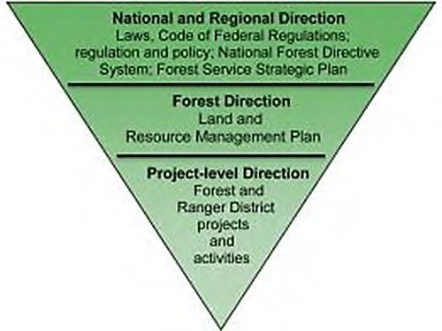
Figure 3. Hierarchy of management direction for all national forests

National and Regional Direction and Guidance
All land management plans must meet the requirements of the National Forest Management Act of 1976. This Plan was revised under the transition provisions of the 2012 Planning Rule (36 CFR 219). Under the 2012 Planning Rule (Title 36, Code of Federal Regulations, Part 219– Planning), the responsible official may complete and approve plan revision in conformance with the provisions of the prior planning regulation, including the transition provisions of the reinstated 2000 rule (36 CFR part 299, published at 36 CFR parts 200 to 299, revised as of July 1, 2010). The transition provisions allow the use of the 1982 planning procedures (see CFR parts 200 to 299, Revised as of July 1, 2000). A paper copy of the 1982 planning procedures is maintained on site at the Colville National Forest Supervisor’s Office in Colville, Washington. See the following hyperlink for the 1982 procedures http://www.fs.fed.us/emc/nfma/includes/nfmareg.html.
Direction for land management plans is to focus on outcomes achieved over time (desired conditions) instead of outputs (products, goods, and services) as in previous plans. In addition, plans must guide development of a budget and project activities that bring about desired outcomes. Rather than making project-level decisions or commitments to implement specific projects, a land management plan provides the context for project development.
Guidance for forest plans is from the USDA Forest Service Strategic Plan. A paper copy of the Strategic Plan is maintained on site at the Colville National Forest Supervisor’s Office in Colville, Washington, and can also be viewed and downloaded here (http://www.fs.fed.us/plan/). This national-level plan is a framework for the National Forest System annual performance plan. It guides units such as individual national forests or ranger districts in proposing project-level work, while considering the opportunities and challenges detailed in their local unit plans. Like individual forest plans, the strategic plan focuses on outcomes or results that are to be achieved over time. Forest plans consider the National Strategic Plan in developing desired conditions and objectives.
As a Federal land management agency, the Forest Service must follow all applicable Federal laws and regulations. If these laws change or are amended, or if new laws are enacted, the Forest administration will comply with the changes or additions. The same situation applies to executive orders and to agency policy, as expressed in Forest Service Manual and Handbook directives. This direction does not need to be restated in the Forest Plan. Wherever the laws,

regulations, or policies have more stringent requirements than forest plan direction, the Forest must and will comply with those requirements.
Examples of Federal laws with which forest plans and revised forest plans must be consistent are the Endangered Species Act (ESA), the National Historic Preservation Act, the Wilderness Act, the Clean Water Act, the Clean Air Act, and the National Forest Management Act (NFMA). Guidance for these laws comes from the Code of Federal Regulations (CFR), and the Forest Service Directive System (the Forest Service Handbooks and Forest Service Manuals). That material is not repeated in the Forest Plan, but a summary of these may be found on the Forest Service national website at http://www.fs.fed.us/biology/planning/index.html.
Overarching national policies, such as the Healthy Forests Initiative or the National Fire Plan, also guide development of forest plans and management activities. These laws, regulations, and policies are not repeated in the Forest Plan, but may be found on the USDA Forest Service website at http://www.fs.fed.us/.

Watershed Analysis
Watershed analysis is intended to guide plan implementation by providing decision-makers and others: (1) information to identify activities that would maintain watershed and aquatic and riparian ecological conditions or move them toward desired conditions; and (2) the context for developing projects and evaluating their consistency with plan direction (i.e., desired conditions, objectives, standards, and guidelines associated with watershed and aquatic resources).
Watershed analysis is also intended to enable protection and recovery of listed species and their habitats and to facilitate efficient project-level conferencing and consultation under section 7 of the Endangered Species Act. Similarly, it should enable protection and restoration of water quality and the full range of beneficial uses of water identified under the Clean Water Act.

Forest Direction
A forest may have a subordinate plan, such as a wilderness management plan, recreation management plan, which serves to implement the forest plan. These plans are consistent with, the forest plan.

Project-level Direction
Project-level plans are on-the-ground projects and activities designed to accomplish management objectives and move the planning area toward desired conditions. Most site- specific projects and activities are designed to meet the objectives of the land management plan while reflecting current local issues and needs. Projects and activities are subject to the National Environmental Policy Act and other applicable laws and regulations. The same situation applies to executive orders and to agency policy, as expressed in Forest Service Manual and Handbook directives. Wherever the laws, regulations, or policies have more stringent requirements than forest plan direction, the Forest must and will comply with those requirements. The level of required environmental analysis and planning to carry out a project is dictated by the scope and complexity of the project, public issues, and the project’s potential effects on the human environment.

Decisions Made in the Previous Forest Plan
Decisions made in the previous Forest Plan, such as resource management standards, will no longer be binding unless they are explicitly carried forward by inclusion in this plan. Note that laws, regulations, and directives are not repeated or summarized in this Plan (unlike the previous Forest Plan), but are still in force.

Planning Record
A variety of documents, including the Forest Plan, make up the planning record. Aside from the land management plan, these include the final environmental impact statement, record of decision, and the project record. Following is a description of the most prominent documents.

Environmental Impact Statement
The preparation of an environmental impact statement (EIS) disclosing a preferred alternative and a range of alternatives is required by the National Environmental Policy Act (1969) and the implementing regulations of NFMA (36 CFR 219). The Final Environmental Impact Statement (FEIS) for the Colville Land Management Plan also provides information on the existing conditions and the environmental effects associated with the alternatives.

Record of Decision
A record of decision (ROD) follows the FEIS. The ROD documents the selection of an alternative and the rationale for that selection to be the Land Management Plan for the Forest. This Forest Plan is based on the preferred alternative selected in the ROD.

Project Record
The project record consists of the relevant decision documentation and pertinent records documenting the planning process. All references used throughout the planning process are included.

Glossary
The glossary is a separate companion document that supports the entire planning record. It also provides definitions of select words from this Forest Plan.

About the Appendices

Appendix A: Consistency with Plan Components
This appendix explains how projects and activities must be consistent with this Forest Plan.

Appendix B: Proposed and Possible Management Actions
Appendix B describes proposed and possible management actions that the staff of the Colville National Forest anticipate to occur over the life of the Plan, which show the variety of multiple- use opportunities or resource management programs that the Forest expects to provide (36 CFR 219.11(b)).

Appendix C: Wildlife, Fish and Plant Species of the Colville National Forest
Appendix C provides a summary of wildlife, fish and plant species known to occur on the Colville National Forest at the time this Plan becomes effective.

Appendix D: Scenic Integrity Objectives
This appendix provides maps displaying scenic integrity objective designations across the Colville National Forest.

Appendix E: Suitable Uses
This appendix provides a table comparing suitable uses across all management area designations across the Colville National Forest.

Appendix F: Recreation Opportunity Spectrum
This appendix provides a map displaying recreation opportunity spectrum designations across the Colville National Forest.

Appendix G: Sites with Administrative Designations and Areas Withdrawn from Mineral Entry
This appendix provides tables and maps with locations of designated administrative sites, designated energy corridors, and areas withdrawn from mineral entry across the Colville National Forest.

Appendix H: Management Area Map
This appendix provides a map displaying management area designations across the Colville National Forest.

Roles and Contributions for the Colville National Forest

International Level
Contains the International Selkirk Loop. This designated All-American Road is one of 31 in the Nation. It winds through northeastern Washington, northern Idaho, and southeastern British Columbia. The loop received the national Rural Community Assistance Action Award from the Chief of the USDA Forest Service for 2000 to 2001.
Shares an international boundary with Canada. The Colville National Forest shares 50 miles of border with Canada. Visitors cross the Unites States and Canada border
through six international gateways that allow access through the national forest (these include, from west to east: Ferry, Danville, Laurier, Frontier, Boundary, and Metaline Falls).
Hydroelectric power production and energy infrastructure. Waters from the Colville National Forest drain to Lake Roosevelt on the Columbia River, which is impounded by the Grand Coulee Dam, the largest power supplying dam in the United States. The Grand Coulee Dam generates 21 billion kilowatt-hours of electricity per year, supplying power to Washington, Oregon, Idaho, Montana, Wyoming, Colorado, California, Nevada, New Mexico, Utah, Arizona, and Canada. In addition, there are two hydropower projects with acreage on the Colville National Forest on the Pend Oreille River. Boundary Dam generates one-third of Seattle City Light’s power, and Box Canyon Dam supplies power for Pend Oreille County. Both dams also supply power to other western states and Canada at times of peak production. Bonneville Power Administration owns, operates, and maintains approximately 85 miles of electric transmission lines on the Colville National Forest.
Traditional Tribal Lands. The Colville National Forest recognizes rights and responsibilities with the following federally recognized Indian Tribes: the Confederated Tribes of the Colville, the Kalispel Tribe of Indians, and the Spokane Tribe of Indians.
Each has a long, rich history and modern ties to the lands and resources of the Colville National Forest. Furthermore, The Colville and Kalispel Tribal reservation lands share boundaries with, or are near Colville National Forest lands. Participation and interest varies among the Tribes depending upon location, issues, and opportunities.
Government-to-government relationships with these Tribes has been maintained through the planning process and will be continued during the implementation of the Plan.

National Level
Provides habitat for three federally protected terrestrial wildlife species. The USDI Fish and Wildlife Service lists the grizzly bear and Canada lynx as threatened species and woodland caribou as an endangered species. The far eastern portion of Colville National Forest is included in the Selkirk Grizzly Bear Recovery area. The recovery area supports a small population of grizzly bears. The Colville contains a recovery area and designated critical habitat for the last remaining herd of woodland caribou in the continental United States. The recovery area for the Selkirk Mountain Woodland Caribou, possibly the most endangered mammal in the continental United States, includes a portion of the Colville National Forest and public lands in northern Idaho and

southern British Columbia. In 2013, only 18 animals were counted in the entire recovery area. The Colville does not contain designated critical habitat for Canada lynx, but follows current science direction for managing Canada lynx habitat (ILBT 2013). The crest of the Kettle River Mountains (known as the Kettle Crest) is part of a Core Area that is important for the recovery of Canada lynx in Washington. While lynx have been occasionally detected within their historical range in Ferry, Stevens, and Pend Oreille Counties, these detections are too few to represent a resident population (Lewis 2016). However, this plan incorporates new science regarding this species.
Contains one of six nationally designated grizzly bear recovery areas. The Selkirk Grizzly Bear Recovery Area is home to a population of approximately 30 grizzly bears. The recovery area is one of two in Washington State and one of six in the Nation. It includes the Selkirk Mountains ecosystem of northern Idaho, southern British Columbia, and northeastern Washington. The northeastern part of the Colville National Forest contains the Washington portion of the recovery area.
Provides habitat for one federally protected species of fish. Bull trout are federally listed as a threatened species under the Endangered Species Act. Bull trout population numbers on the Colville National Forest are very small and local populations may not currently exist, although occasional individuals are observed in streams on the Forest within the Pend Oreille River subbasin. All designated bull trout critical habitat on the Forest is within the Pend Oreille River subbasin. Approximately 98 miles of streams on the Colville National Forest are designated as critical habitat for the recovery of this species.
Contributes one wilderness to the National Wilderness Preservation System. The Salmo-Priest Wilderness (31,400 acres) is an example of the Okanogan Highlands landform and is the only wilderness in the northeastern section of the state.
Contains four national recreation trails (NRT). The Colville National Forest hosts 80 miles of NRTs. Two of the longest trails are the Kettle Crest (44 miles) and the
Shedroof Divide (21.8 miles). The other two NRTs are the Lakeshore Trail, also known as Sullivan Lake (4.3 miles), and Pass Creek-Grassy Top (7.8 miles).
Contains approximately 140 miles of the 1,200-mile Pacific Northwest National Scenic Trail on National Forest System lands. The Pacific Northwest National Scenic Trail crosses seven national forests and ranks among the most scenic trails in the world. The trail begins at the Continental Divide and ends at the Pacific Ocean, passing through the Selkirk and Kettle River Range Mountains on the Colville National Forest.

PACIFIC NORTHWEST REGIONAL LEVEL 4
Provides habitat for regionally rare plant, animal, and fish species. The Colville National Forest provides habitat for 5 fish species, 41 plant species, and 27 wildlife species considered sensitive by the Forest Service.
Supports the most concentrated milling area in the state. The Colville timber processing area (composed of three Washington counties and three northern Idaho counties) includes 22 milling facilities, 11 of which are sawmills. Some of these facilities specialize in using small-diameter timber that is abundant on National Forest System

4 Pacific Northwest Region, or Region 6, refers to all National Forest System lands within Washington and Oregon.

lands in northeastern Washington. This concentration of industrial activity contributes to local economies and to the character of communities.
Contains some of the most highly mineralized areas in the state. The Colville National Forest has a geological environment favorable to the occurrence of mineral deposits. There has been renewed interest in mineral exploration on the Forest over the past several years, in addition to ongoing locatable mining operations on private and other Federal lands adjoining the Forest. These mining operations supply important minerals for industry and provide economic benefits to rural communities and counties through direct employment, direct purchase of goods and services, and increased tax bases. The mining industry has been a major contributor to the tri-county economy, and will continue to do so in the future. There is low potential for oil and gas, or geothermal resources on the Forest. No leasable operations authorized by the Secretary of Interior occur on the Forest at this time.

State and Local Level
Showcases Sherman Pass Scenic Byway and North Pend Oreille Scenic Byway. These national forest scenic byways showcase historical sites, views of rivers and mountains, and offer varied vegetation including stunning fall foliage and views of past burns.
Provides a continuous supply of high quality water. Brown and Froemke (2009) estimated the annual contribution of water supply for all national forests in the contiguous United States based on data from 1953 to 1994. Water supply estimates were calculated as “precipitation minus natural evapotranspiration” with the assumption that water that infiltrates into the soil is not evaporated or transpired is eventually available as surface water (Brown and Froemke 2009). Estimated annual contribution to water supply from lands within the Colville National Forest administrative boundary is 65,100 million cubic feet per year. Estimated annual contribution from lands within the Colville National Forest ownership boundary is 51,500 million cubic feet per year.
Provides an important recreational fishery. Northeastern Washington is popular with recreationists and is a favorite fishing destination. Trout and 31 species or sub-species of fish inhabit Colville National Forest waters. The major sport fishes are cutthroat trout, rainbow trout, Eastern brook trout, German brown trout, ling cod, crappie, sunfish, bass, bullheads, and perch. The Colville National Forest encourages partnerships with local entities and the public to advance resource conservation and enhance recreational fishing opportunities.
Contains an important diversity of wildlife species. Three hundred twenty-three known species of vertebrate wildlife occur in Colville National Forest, including
73 species of mammals, 234 birds, 9 reptiles, and 7 species of amphibians. Unique wildlife species such as red-tailed chipmunk, northern bog lemming, and woodland caribou live on the national forest. The Selkirk Mountains and Kettle River Range are also the only places in America where woodland caribou, moose, elk, mule deer, and white-tailed deer share the same habitat. Northeastern Washington harbors the largest white-tailed deer populations in Washington. White-tailed deer provide an important recreational, economic, and ecological resource, contributing to local economies by attracting hunters to the area. The Washington Department of Fish and Wildlife identifies two areas that are managed for white-tailed deer that include portions of the

Colville National Forest: the Okanogan Highlands is composed of 25 percent National Forest System land and the Selkirks contain 26 percent National Forest System land.
Contains a significant diversity of plant species and communities. Herbaria data include about 2,400 vascular and nonvascular plant and fungi taxa that occur on the Colville National Forest and vicinity. Of those, 41 have been identified as Region 6 sensitive species. The moonwort species, Botrychium lineare, occurs here at the only site in Washington State; the moonwort genus thrives on the Colville National Forest. In addition, there are two wildflower viewing sites documented and described for public recreation opportunities. The wide range of geological and soil types, precipitation, and elevations spanning from warm valley bottoms to cold mountain peaks supports a diverse assortment of plant communities.
Paper copies of the Plan, as well as detailed assessments, evaluations, reports, and documents associated with the Plan, are maintained on site at the Colville National Forest Supervisor’s Office in Colville, Washington. These documents are also available to view and download on the land management plan development website: https://www.fs.usda.gov/main/colville/landmanagement/planning

Chapter 2

Forestwide Direction – Introduction
Desired conditions: A project or activity must be consistent with desired conditions as described in appendix A.
Forestwide desired conditions (chapter 2) apply only to Colville National Forest System lands and are measured at a forestwide scale unless otherwise stated.
Management area desired conditions (chapter 3) are specific to each management area. Forestwide desired conditions apply to these areas. Some management direction, such as Riparian Management Areas, overlays parts of other management areas. The applicability of plan direction is guided by the principle that, where management direction overlaps, and depending on site-specific conditions and the activity or use, the most restrictive plan direction applies. Using the most restrictive plan direction provides guidance and protection for resource- based or socially sensitive functions provided by National Forest System lands.
Objectives: A project or activity must be consistent with objectives as described in the Consistency with Plan Components Appendix (appendix A of this Plan). Objectives do not imply a program of work, a list of projects, or a minimum or maximum amount to be accomplished. Accomplishing the objectives depends on availability of resources, including budget, to complete the work. The amounts shown reflect current budget trends and available resources on the Colville National Forest. Objectives provide information on outcomes and are not mandatory tasks. The national forest engages in tasks beyond those shown in the Plan that also move the Forest toward desired conditions.
Management activities used to accomplish objectives are not included in the plan components, as a variety of tools or techniques may be used by staff of the Colville National Forest and serve to accomplish the objective. A description of tools and techniques likely to be used is found in Appendix B. Proposed and Possible Management Actions. Standards and guidelines found in chapters 2 and 3 of this Plan constrain the range of possible management actions available for use.
Standards and guidelines: Apply to project or activity design and implementation. They are sideboards for projects and activities to help achieve the desired conditions and objectives.
Forestwide standards and guidelines apply in all management areas, unless specifically identified as not applicable. Some management areas, such as Riparian Management Areas, overlap or overlay other management areas.
Combinations of activities or uses are dependent on site-specific conditions, making it unreasonable to include all combinations and the applicable plan direction within the forest plan. Therefore, applicability of plan direction is guided by the principle that where management areas overlap, the most restrictive plan direction applies, depending on site- specific conditions and the activity or use.

Forestwide Direction – Landscape Features and
Dynamics
This section contains desired conditions for the following resources: Air, soil, vegetation, water resources, and wildlife habitats.
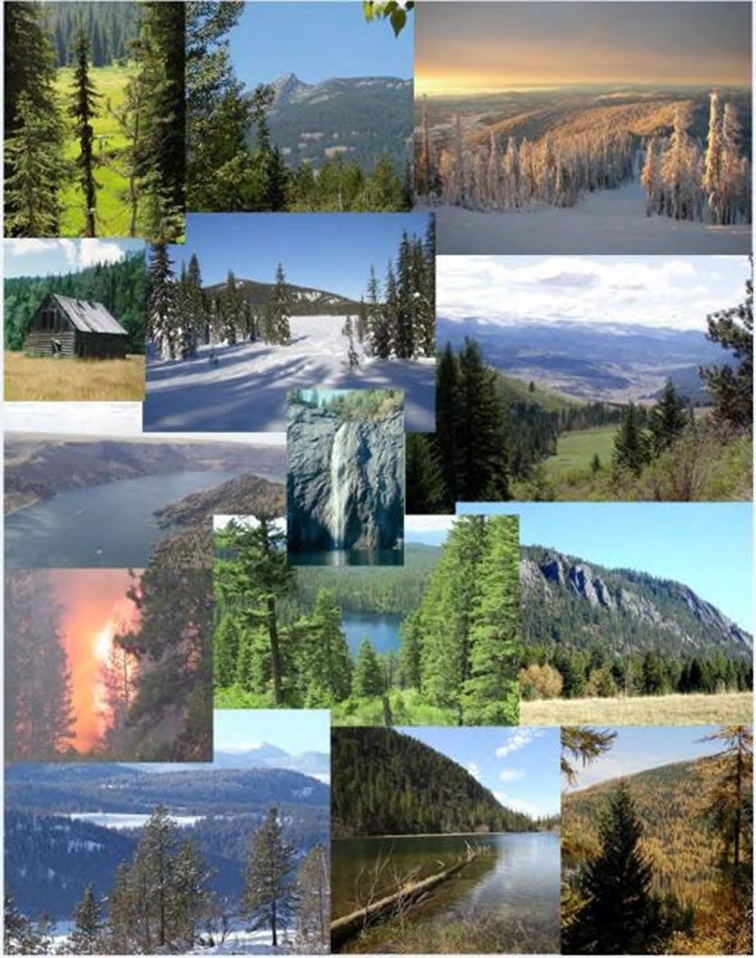

AIR (AIR)
The Forest Service is responsible for protecting air resources on national forests. This includes both protecting national forests from adverse impacts caused by off-forest sources, as well as protecting the national forest and surrounding areas from the adverse effects of air pollution originating on Forest Service land. Smoke from both wildfires and prescribed burns are two of the largest sources of emissions of air pollutants on the forest. When conducting prescribed burns on national forests, the Forest Service will comply with the Washington State Department of Natural Resources Smoke Management Plan.
The most stringent areas for air quality are the Class 1 areas. These are special areas of natural wonder and scenic beauty, such as national parks and wilderness areas, where air quality should be given special protection. These areas are subject to maximum limits on air quality degradation called air quality increments. The Colville National Forest has no Class I wilderness areas.
An illustration of Class I desired conditions can be seen on the following USDA Forest Service air quality image website: http://www.fsvisimages.com/
The National Ambient Air Quality Standards can be found at https://www.epa.gov/criteria- air-pollutants/naaqs-table.

Desired Condition
FW-DC-AIR-01. Air Quality Protection
Air quality on National Forest System lands is protected, maintained and/or improved at the Forest scale over the life of the Plan. Management activities contribute to conditions that meet or exceed National Ambient Air Quality Standards on the Forest.
Forest visitors and/or residents living adjacent to the national forest experience clean air and clear views as would occur under natural conditions. They are aware of short-term impacts to air quality due to wildland fires and prescribed burns.

Standard
FW-STD-AIR-01. Air Quality
Activities comply with the national standards set forth in the Clean Air Act, and any State and local requirements for air pollution control. Planned ignitions shall follow all Washington State smoke regulations to reduce the potential impacts of smoke.
SOIL (SOIL)
Soils are an integral part of ecosystems, their function, and the above and below ground interaction of organisms. These functions all contribute to ecological resilience. Soil conservation and protection is needed to effectively maintain soil quality and productivity and improve or protect watershed conditions. Generally, soil productivity standards and guidelines are not applied to administrative sites or dedicated use areas (such as roads, recreation sites).

Desired Conditions
FW-DC-SOIL-01. Soil Productivity and Function
Soil productivity and function contributes to the long-term resilience of ecosystems. Management activities occur on soils with the inherent capability to support those activities.

Table 1. Soil ecological functions with attributes and indicators for long-term soil productivity
Soil function | Selected  attributes | Soil quality  indicator | Desired condition
Biological | Roots | Root growth and distribution | Root growth, both vertically and laterally, is not impeded by land management actions. Root distribution and depth is at expected levels for vegetation type and successional stage.
Biological | Plant Community Potential and Thermodynamics | Plant Community Composition | The soil is capable of supporting a distribution of desirable plant species by vegetative layer (i.e., trees, shrubs, herbaceous) as identified in the potential  plant community.
Biological | Plant Community Potential and Thermodynamics | Canopy Cover and Soil Cover | Soil temperature and moisture is maintained in conditions to support desired floral and faunal communities.
Hydrologic | Infiltration | Surface Structure | Surface structure is as expected for the site (e.g., granular, subangular blocky, single grain).
Hydrologic | Water Absorption and Storage | Available Water | Site water is as expected for the soil type or has been improved.
Hydrologic | Water Absorption and Storage | Volcanic Ash  Cap | Soil ash cap is intact and as expected for the  site.
Hydrologic | Water Transmission | Subsurface Flow  Connectivity | Maintain subsurface flow connectivity (i.e., subsurface flow is not obstructed or  intercepted).
Nutrient Cycling | Organic Matter Composition | Surface Organic Matter | The amount of organic material on top of the mineral soil is maintained at levels to sustain soil microorganisms and provide for nutrient cycling. The size, amount, and distribution of organic matter maintained on the mineral soil on a long term basis is consistent with the amounts that occur given the local ecological type, climate, and normal wildland fire return interval for the  area.
Nutrient Cycling | Organic Matter Composition | Fine Woody Material | Fine woody material is on site in various stages of decay in amounts appropriate for plant association group.

Soil function | Selected  attributes | Soil quality  indicator | Desired condition
Nutrient Cycling (continued) |  | Coarse Woody Material | See FW-DC-VEG-04. Snags and coarse woody debris
Nutrient Cycling (continued) | Nutrient Availability | Surface (A) horizon or mollic layer | The amount of organic matter within the mineral soil, indicated by the color and thickness of the upper soil horizon, is within the normal range of characteristics for the site, and is distributed normally across the  area.⁵
Nutrient Cycling (continued) | Nutrient Availability | Nutrient Deficiency | Soil nutrients are maintained at levels to support desired vegetation.
Carbon | Carbon Storage  Potential |  | The soil’s ability to store carbon is not  reduced from current levels.
Support and Stability | Stability | Surface erosion (wind,  rill, or sheet) | Erosion is occurring at natural levels or not evident and an adequate level of soil cover is  maintained to prevent accelerated erosion.
Support and Stability | Support | Site support (mass erosion, landslide prone) | Site stability potential is unchanged or stability has been improved. Soil stability varies from minor soil creep to active land flows dependent on soil characteristics, soil moisture, and triggers. Management activities avoid or do not accelerate  underlying soil movement rates.
Support and Stability | Deposition | Soil  deposition | Deposition is at natural levels and recent  depositional material is vegetated.
Filtering and Buffering | Filtering | Soil contamination | The soil acts as a filter and buffer to protect the quality of water, air, and other resources by immobilizing, degrading or detoxifying  chemical compounds or excess nutrients.

FW-DC-SOIL-02. Detrimental Soil Conditions
Surface erosion rates are within the natural range of variation for a given biophysical setting. There is no degradation of aquatic habitat and water quality from surface erosion rates resulting from permitted uses and management actions. Ecological and hydrologic functions are not impaired by soil compaction.
FW-DC-SOIL-03. Soil Stability
Soil stability varies from minor soil creep to active land flows dependent on soil characteristics, soil moisture, and triggers. Management activities do not accelerate underlying soil movement rates.

5 Soil characteristics are defined by Natural Resources Conservation Service SSUGRO (Soil Survey Geographic Database) soil data layer

Objective
FW-OBJ-SOIL-01. Soil Productivity and Function
Within 5 years of plan implementation, annually stabilize, rehabilitate, or restore natural processes that support soil productivity and function on 20 to 30 acres.

Standard
FW-STD-SOIL-01. Effective Ground Cover
Minimum effective ground cover following any soil-disturbing management activity should be as shown in the following table.

Table 2. Minimum effective ground cover following any soil-disturbing activity
 | Minimum percent effective | ground cover
Erosion hazard class | 1st year | 2nd year
Low (very slight-slight) | 20-30 | 30-40
Medium (moderate) | 30-45 | 40-60
High (severe) | 45-60 | 60-75
Very High (very severe) | 60-75 | 75-90
(Source for erosion hazard classes: Forest Service Manual 2520)

Guidelines
FW-GDL-SOIL-01. Total Soil Resource Commitment
The Total Soil Resource Commitment is no more than 5 percent of the Forest. The soil stability and support function is maintained within the Total Soil Resource Commitment.
Total Soil Resource Commitment is the conversion of a productive site to an essentially non- productive site (0 to 40 percent of natural productivity) for a period of more than 50 years. Examples include system roads, administrative sites, developed campgrounds, rock quarries, mine sites, and livestock watering facilities⁶.
FW-GDL-SOIL-02. Native Topsoil
Native topsoil should be used where practical to meet restoration project objectives.

6 Existing condition as of December 2016 is that less than 2 percent of lands managed by the Colville National Forest is dedicated to uses other than soil/vegetation productivity.

Vegetation (VEG)
CONIFER SYSTEMS
Vegetation in the planning area is classified into forest vegetation types that are aggregations of plant association groups. Plant association groups are made up of plant associations defined in the plant association guide developed for the Colville National Forest. The five vegetation types are listed in table 3.

Table 3. Forest vegetation types for the Colville National Forest
Forest vegetation type
Douglas-fir dry
Northern Rocky Mountain mixed conifer
Western hemlock / Western red cedar
Subalpine fir / Lodgepole pine
Spruce / Subalpine fir
Tree structure is classified into five general groups based on diameter and canopy cover as shown in table 4. The diameter is based on the quadratic mean diameter in inches of trees whose heights are in the top 25 percent of all tree heights in the stand. This generally means that the diameters of the larger trees in a stand are used to define the structure class.

Table 4. Forest structure classes
Structure | Definition
Early | Trees less than 10 inches d.b.h or canopy cover less than 10 percent
Mid Open | Trees 10 to less than 20 inches d.b.h, canopy cover 10 percent up to 40 percent
Mid Closed | Trees 10 to less than 20 inches d.b.h, canopy cover 40 percent or greater
Late Open | Trees 20 inches or greater d.b.h, canopy cover 10 percent up to 40 percent
Late Closed | Trees 20 inches or greater d.b.h, canopy cover 40 percent or greater
FEDERALLY THREATENED, ENDANGERED AND PROPOSED SPECIES (TES), AND REGIONALLY SENSITIVE AND STRATEGIC PLANT SPECIES
Federally threatened, endangered, proposed and sensitive plant species in the planning area are those formally listed by the USDI Fish and Wildlife Service under the Federal Endangered Species Act. The R6 Regional Forester Special Status Species List includes federally threatened, endangered and proposed threatened; and regionally sensitive and strategic plant species. Although no federally listed plant species are currently known from the Colville National Forest, 41 regionally sensitive plant species do occur on the Forest.
Locations for many TES plant species include unique habitats that may be rare or represent a small portion of a particular landscape. Meadows, wetlands (marsh, bog, fen, carr, swamp, spring, and seep), riparian areas, alpine fellfields, rock outcrops, cliffs, or talus are suitable TES plant habitat. Appendix C provides a list of the sensitive plant species discussed in this plan.

NON-FORESTED AND DECIDUOUS FOREST SYSTEMS
The ecological character and geographic extent of non-forest communities, deciduous forests, and riparian/wetland vegetation in the planning area and northeastern Washington are as described by Clausnitzer et al. (2006) and literature cited there. Nine vegetation groups are described based upon broad physiognomic and environmental factors related to dominant vegetation lifeform and elevational gradients. This classification served as a framework for vegetation analyses that supported forest plan revision on the Colville National Forest.
VEGETATION WITHIN THE WILDLAND-URBAN INTERFACE (WUI)
Wildland-urban interface (WUI) in the planning area is defined as “the line, area, or zone where structures and other human development meet or intermingle with undeveloped wildland or vegetative fuels” (NWCC 2012).⁷ See glossary for specific definition.
The prioritization of fuels treatments within WUI will follow the National Fire Plan, the Healthy Forests Restoration Act-PL108-148, and individual community wildfire protection plans. Individual fuels reduction projects and their relationships to WUI are defined on a project basis.

Desired Conditions
FW-DC-VEG-01. Plant Species Composition
Native species and native plant communities are the desired dominant vegetation. National Forest System lands contribute to the diversity, species composition, and structural diversity of native upland plant communities. The full range of potential natural vegetation is maintained on the Forest where it supports plant and animal diversity including pollinators and other invertebrates, and robust ecological function.
FW-DC-VEG-02. Insects and Diseases
Native insects, diseases, fungi, bacteria, and viruses engage in their natural (endemic) role in contributing to ecosystem processes such as pollination, food webs, decay and nutrient cycling, providing habitats, and functioning as natural control agents. Landscapes provide a patchwork of varied structural, compositional, and successional stages that ensure the continuation of these processes.
FW-DC-VEG-03. Forest Structure
Forest structural classes are resilient and compatible with maintaining characteristic disturbance processes such as wildland fire, insects, and diseases. Habitat conditions for associated species are present. Structure contributes to scenic quality and contributes to desired landscape character, particularly along scenic byways and highways.
Forest openings would be commensurate with historical conditions for size and distribution to reflect natural disturbance processes. The historical range of variability for forest structure is the desired condition. Historical range of variability will be evaluated on National Forest System lands at the appropriate scale, given vegetation type and natural disturbance history. Table 5 and table 6 contain desired conditions for each vegetation type.

7 National Wildfire Coordinating Group.

Table 5. Desired condition for forest structure (HRV)*
 | Early  % | Mid open  % | Mid closed  % | Late open  % | Late closed  %
Douglas-fir dry | 6−16 | 2−8 | 4−13 | 38−78 | 1−32
Northern Rocky Mountain mixed conifer | 9−25 | 1−3 | 18−30 | 4−6 | 44−60
Western hemlock / Western red cedar | 4−24 | 0 | 7−27 | 0 | 55−83
Subalpine fir / Lodgepole pine | 45−65 | 0 | 33−53 | 0 | 3
Spruce / Subalpine fir | 14−46 | 0 | 13−41 | 0 | 29−57
* ST-Sim state and transition model software was used to provide values for the historical range of variability (HRV)

Table 6. Expected patch size by forest vegetation type
Vegetation type | Patch size | Opening size | Description
Douglas-fir dry | Highly variable | Primarily small (less than 5 acres) with occasional openings greater than 10 acres in very limited circumstances. Openings less than 40 acres in nearly all cases. | Larger patches of open-canopied stands would have included tree clumps and openings at a scale finer than that of an individual stand.
Northern Rocky Mountain Mixed Conifer | Variable (5 to  1,000 acres) | Openings generally less than 40 acres in size, with the majority of patches being less than 5 acres in size. | Mixed severity fire generates variable patches and openings, though most openings in this type would have historically been relatively small.
Western red cedar / Western hemlock | Medium to large (constrained primarily by spatial arrangement) | Generally commensurate with patch sizes. | The primary limiting factor on patch and opening size for this type is the spatial arrangement of the vegetation type itself. Because it does not generally occur in large contiguous areas of the Colville, smaller patches and openings would occur here than typical for this vegetation type.
Subalpine fir / Lodgepole pine | Variable, ranging up to 1,000s of acres | Highly variable, with many small-medium patches (less than 40 acres) and a few larger patches up to 1,000 acres or more in size. | Predominantly smaller patches would have been interspersed with few, larger patches. The larger patches were historically created during extreme fire weather events much as they are today.
Spruce / Subalpine fir | Generally less than 500 acres, with the majority of patches less than 40 acres | Generally commensurate with patch sizes. | Both patch and opening size is primarily limited by spatial arrangement on the Colville National Forest. As a result, smaller patches and openings would occur here than is typical for this vegetation type.

FW-DC-VEG-04. Snags and Coarse Woody Debris
Snags and down wood occur in sizes, amounts, and distributions to provide important wildlife habitat and contribute to ecosystem processes and services. This desired condition for snag and down wood levels applies forestwide within forested habitat types with the exception of the Administrative and Recreation Sites Management Areas. The desired conditions for snags and down wood levels is evaluated on National Forest system lands at the watershed scale (see Table 7 and table 8).

Table 7. Desired amounts and spatial arrangement of snags by forest vegetation types
Forest Vegetation Type | Small1 Snags per acre by Density Class3 | Large2 Snags per acre by Density Class4
Douglas-fir Dry
Low Density Class | <4 | <2
Moderate Density Class | 4-8 | 2-4
High Density Class | >8 | >4
Northern Rocky Mountains Mixed Conifer
Low Density Class | <6 | <4
Moderate Density Class | 6-10 | 5-9
High Density Class | >10 | >9
Western Hemlock/Western Red Cedar
Low Density Class | <8 | <3
Moderate Density Class | 8-15 | 3-6
High Density Class | >15 | >6
Subalpine fir/Lodgepole
Low Density Class | <8 | <3
Moderate Density Class | 8-14 | 3-6
High Density Class | >14 | >6
Spruce/Subalpine fir
Low Density Class | <9 | <3
Moderate Density Class | 9-16 | 3-6
High Density Class | >16 | >6
1/ Small snags = 10-20 inches DBH for Douglas-fir Dry, Northern Rocky Mountains Mixed Conifer, Western Hemlock/Red Cedar, Spruce/Subalpine fir and 8-15 inches DBH for Subalpine fir/Lodgepole.
2/ Large snags = >20 inches DBH for Douglas-fir Dry, Northern Rocky Mountains Mixed Conifer, Western Hemlock/Red Cedar, Spruce/Subalpine fir and >15 inches DBH for Subalpine fir/Lodgepole.
3/ The desired proportions of the snag density classes for small snags measured at a watershed scale are Low Density Class = <50% of the area, Moderate Density Class = 25-45% of the area, and High Density Class = 5-25% of the area.
4/ The desired proportions of the snag density classes for large snags measured at a watershed scale are Low Density Class = <50% of the area, Moderate Density Class = 35-45% of the area, and High Density Class = 5-15% of the area.

Table 8. Desired amounts of coarse woody debris (CWD) by forest vegetation types
Forest Vegetation Type | Coarse Woody Debris1 (tons per acre)
Douglas-fir Dry | 3-7
Northern Rocky Mountains Mixed Conifer | 5-10
Western Hemlock/Western Red Cedar | 25-40
Subalpine fir/Lodgepole pine | 16-40
Spruce/Subalpine fir | 5-12
1/ Log size = minimum-10 inches diameter on large end and over 16 feet long; preferred-16 inches diameter on large end and over 33 feet long

FW-DC-VEG-05. Biological Legacies
Large trees, snags, and down wood are represented across the landscape and large tree habitat is maintained to support wildlife, aquatic and soil resources and support recovery processes in the post disturbance ecosystem.
Examples of biological legacy categories are provided in table 9. Not all components will be present within an individual site-specific project area.

Table 9. Biological legacy categories and examples
Biological legacy category | Examples
Organisms | Sexually mature and intact live trees
Organisms | Tree reproduction (seeding and sapling banks)
Organisms | Vegetatively reproducing parts (e.g., roots)
Organisms | Seed banks
Organisms | Shrub, herb, bryophyte species
Organisms | Mature and immature animals and microbes
Organic matter | Fine litter
Organic matter | Particulate material
Organically derived structures | Downed trees and other coarse woody debris
Organically derived structures | Root wads and pits from uprooted trees
Organically derived structures | Hollow live trees
Organically derived structures | Trees with mistletoe brooms or other features important for wildlife habitat
Organically derived patterns | Soil chemical, physical, microbial properties
Organically derived patterns | Forest understory composition and distribution
(Franklin et al. 2007)

FW-DC-VEG-06. Native Plant Materials
Locally collected native plant materials are incorporated into project planning and implementation when restoration, rehabilitation, and revegetation goals support ecosystem integrity and resilience. Locally adapted plant material inventories are maintained to provide for revegetation project needs.

FW-DC-VEG-07. Native Plant Seeds and Other Genetic Material
Seeds and genetic material from native vascular and non-vascular plants are available for the purposes of genetic or trait testing, climate change provenance trials, species identification, restoration, or rehabilitation activities. Seeds and other genetic materials are stored in both secure off-site facilities and on-site in existing seed orchards, select trees, evaluation plantations, and other established genetic resource test sites.
FW-DC-VEG-08. Threatened, Endangered and Sensitive Plant Species − Special and Unique Habitats
Special and unique habitats support threatened, endangered, and sensitive plant species populations and contribute to high quality suitable habitat for these species. Degraded or diminished special and unique habitats are restored within their natural range of variation.
FW-DC-VEG-09. Threatened, Endangered and Sensitive Plant Species − Management- Related Disturbance
Ecological conditions and processes that sustain the habitats currently or potentially occupied by threatened, endangered, or sensitive plant species are retained or restored. The geographic distributions of sensitive plant species in the Forest Plan area are maintained. This includes sufficient seed or vegetative reproduction to maintain existing plant populations and associated native plant community biodiversity. Soil disturbance is managed to avoid degradation of threatened, endangered and sensitive plant species and their habitat as well as plant community composition, structure, and productivity.
FW-DC-VEG-10. Threatened, Endangered and Sensitive Plant Species − Habitat and Population Trends
Population trends, amount of occupied habitat, and amount of unoccupied suitable habitat are stable or increasing for threatened, endangered, and sensitive plant species.
FW-DC-VEG-11. Fuels Treatments in Wildland-urban Interface
Fuel treatments continue to reduce surface, ladder, and crown fuels that lower the potential for high-severity wildfires in wildland-urban interface areas, providing protection for communities and diversity within the stands. Generally, treated areas consist of open understories with overstory trees (conifers and hardwoods) populated by predominately fire resistant species, with scattered individual or small patches of shrubs and small trees in the understory, maintaining some cover in important wildlife corridors. Surface, ladder, and crown fuels have been treated and maintained to allow low-intensity surface wildland fires (flame lengths of
4 feet or less). Vegetation has been modified (interrupted) to improve community protection and enhance public and firefighter safety.
Crown base heights (height from the forest floor to the bottom most branches of the live tree crown) are managed to avoid crown fires. Crown cover of forest stands allow for adequate spacing between crowns to reduce crown fire potential while minimizing effects on surface wind speeds and drying of surface fuels.
FW-DC-VEG-12. Snags and Coarse Woody Debris in Wildland-urban Interface
Snag levels would follow desired conditions for snags within the specific vegetation type unless there are site-specific safety concerns (for example, within 1.5 to 2 tree lengths of structures). Coarse woody debris levels would generally be at the lower end of desired conditions for the specific vegetation type to reduce fuel load and wildfire risk.

FW-DC-VEG-13. Treatment Priorities in Wildland-urban Interface
Fuel treatments are emphasized in wildland-urban interface and areas that exhibit the potential for high-severity fire behavior that could impact private or other agency lands.
FW-DC-VEG-14. Maintenance in Wildland-urban Interface
A pattern of treatments that are effective in modifying fire behavior, as identified in individual community wildfire protection plans, are established and maintained.

Objectives
FW-OBJ-VEG-01. Restoration
Initiate active management activities on 18,000 to 25,000 acres per year over the next 15 years to move structure toward desired conditions at landscape scales to move the Forest toward desired vegetative conditions and have landscapes dominated by Fire Regime Condition Class I, with the remainder in Fire Regime Condition Class II trending toward Fire Regime Condition Class I.⁸
FW-OBJ-VEG-02. Fuels Treatments
Initiate fuel reduction activities on 5,000 acres per year over the next 15 years to reduce hazardous fuel accumulations in both activity and natural fuels to move toward desired vegetative conditions and have landscapes dominated by Fire Regime Condition Class I.
FW-OBJ-VEG-03. Non-Forest Habitats for Sensitive and Strategic Species
Five to 10 acres of special and unique habitats are treated annually over the 15-year life of the Plan.

Standards
FW-STD-VEG-01. Wildland Fire − Protection of Natural Resources and Property
Protect human life as the single, overriding priority. Set priorities among protecting human communities and community infrastructure, other property and improvements, and natural and cultural resources based on the values to be protected, human health and safety, and the costs of protection. Once people have been committed to an incident, the highest value to be protected is human resources. After protection of human life, all other protection decisions are to be made based on values to be protected, human health and safety, and the costs of protection.
FW-STD-VEG-02. Threatened, Endangered and Sensitive Plant Species − Surveys
Surveys for threatened, endangered, and sensitive plant species shall be conducted in suitable habitat⁹ on National Forest System lands before ground-disturbing activities to identify and protect vulnerable populations. All existing sites are identified and managed to support rare

8 Condition class in this context includes more than just forest structure and density, rather, it also includes ecological legacy considerations shown in Table 9 such as species composition, insect and disease pathogen conditions, invasive species impacts, and other understory and overstory influences.
9 Suitable habitat is defined as the natural environment in which a particular species lives. Best available science is utilized to determine appropriate suitable habitat for each sensitive species.

species recovery on National Forest System lands. Suitable habitat shall be managed to enhance or maintain rare species occurrences on the Forest.
FW-STD-VEG-03. Timber Production
Regulated timber harvest activities shall occur only on those lands classified as suitable for timber production (see suitability tables in chapter 3). Timber harvest on lands not suitable for timber production shall occur only to meet multiple-use purposes other than timber production.
FW-STD-VEG-04. Even-Aged Harvest Openings
If individual harvest openings created by even-aged silvicultural practices are proposed that would exceed 40 acres, then NFMA requirements regarding public notification and approval shall be followed. These opening size limits shall not apply to the size of areas harvested as a result of natural catastrophic conditions such as fire, insect and disease attack, or windstorm.
FW-STD-VEG-05. Restocking
Ensure that timber will be harvested from National Forest System lands only where there is assurance that such lands can be adequately restocked within 5 years after harvest. Restocking level is prescribed in a site-specific silviculture prescription for a project treatment unit and is determined to be adequate depending on the objectives and desired conditions for the Plan area.
FW-STD-VEG-06. Even-aged Management
Even-aged stands shall generally have reached or surpassed culmination of mean annual increment prior to regeneration harvest. This shall not preclude the use of sound silvicultural practices, such as thinning or other stand improvement measures, or salvage or sanitation harvesting of timber stands that are substantially damaged by fire, windthrow or other catastrophe, or that are in imminent danger from insect or disease attack.
FW-STD-VEG-07. Even-aged Management
Ensure that clearcutting, seed tree cutting, shelterwood cutting, and other cuts designed to regenerate an even-aged stand of timber will be used as a cutting method on National Forest System lands only where for clearcutting, it is determined to be the optimum method, and for other such cuts it is determined to be appropriate to meet the objectives and requirements of the Forest Plan.
FW-STD-VEG-08. Harvest Systems
The harvesting system to be used shall not be selected primarily because it will give the greatest dollar return or the greatest unit output of timber.
FW-STD-VEG-09. Timber Harvest
Ensure that timber will be harvested from National Forest System lands only where soil, slope, or other watershed conditions will not be irreversibly damaged and where protection is provided for streams, stream-banks, shorelines, lakes, wetlands, and other bodies of water from detrimental changes in water temperature, blockage of water courses, and deposits of sediment, where harvests are likely to seriously and adversely affect water conditions or fish habitat.

Guidelines
FW-GDL-VEG-01. Threatened, Endangered, and Sensitive Plant Species – Disturbance in Occupied Habitat
Soil and habitat disturbance should be managed within occupied habitat and suitable whitebark pine habitat to the extent practicable to maintain or enhance threatened, endangered, and sensitive plant populations and avoid invasive plant species establishment or spread.
Consequently, occupied habitat should not be used for timber harvest, fuel breaks or developments associated with wildfire suppression, delivery of fire retardant or petroleum products, placement of stock-handling facilities, recreation, or special use developments. A 100-foot buffer between the occupied habitat and these management activities should be maintained, unless habitat restoration activities are designed to benefit threatened, endangered, and sensitive plant species.
Trees in occupied habitat that are felled for safety reasons should be retained on site as needed to maintain, protect, or enhance habitat unless such action is detrimental to the threatened, endangered, and sensitive species population or habitat and represents a threat through physical impacts or potential uncharacteristic wildfire.
All new road and trail construction should be designed to avoid the occupied habitat of threatened, endangered, and sensitive plant species (minimum 100-foot buffer).
Use of prescribed fire should be avoided in occupied habitat except in areas occupied by fire- dependent or fire-tolerant species. Slash piles and other fuels should be managed to avoid the occupied habitat of threatened, endangered, and sensitive species (minimum 100-foot buffer).
Grazing management (including timing, intensity, duration, frequency of use, and type and class of livestock) should allow for completion of threatened, endangered, and sensitive plant species annual life cycle and development and dispersal of reproductive materials like seed and spores. Salting or water developments should not be authorized or allowed such that they reduce threatened, endangered, or sensitive plant populations.
Mining operations shall be conducted to minimize adverse environmental impacts on national forest surface resources. Operations approved in a Plan of Operations shall avoid threatened, endangered, and sensitive plant species and their habitat to the extent practicable.
FW-GDL-VEG-02. Plant Material Collection for Conservation Purposes
Commercial or non-commercial permits or authorizations should generally be issued for collection of seed or plant materials when project objectives are consistent with rare species conservation practices (these practices could include seed storage in recognized seed banks, or collection of plant material for restoration and rehabilitation purposes, or scientific research that benefits species viability).
FW-GDL-VEG-03. Large Tree Management
Management activities should retain and generally emphasize recruitment of individual large trees (larger than 20 inches diameter at breast height) across the landscape. Exceptions where individual large trees may be removed or destroyed include the following:
- Trees need to be removed for public health or safety (such as, but not limited to, danger/hazard trees along roads or in developed or administrative sites).

- Trees need to be removed to facilitate management of emergency situations such as wildfire response.
The following exemptions apply only to situations where removal of smaller trees alone cannot achieve the stated desired conditions:
- Trees need to be removed to meet, promote, or maintain desired conditions for structural stages (see FW-DC-VEG-03. Forest Structure).
- Trees need to be removed to control or limit the spread of insect infestation or disease.
- Trees need to be removed where strategically critical to reinforce, facilitate, or improve effectiveness of fuel reduction in wildland-urban interfaces.
- Trees need to be removed to promote special plant habitats (such as, but not limited to, aspen, cottonwood, whitebark pine).
FW-GDL-VEG-04. Planned and Unplanned Ignitions
Use of planned and management of unplanned ignitions may be authorized. Objectives and strategies for all unplanned ignitions shall be identified at the time of the fire.
FW-GDL-VEG-05. Prohibition on Timber Cutting, Sale, or Removal in Inventoried Roadless Areas
Timber removal activities will comply with requirements of the Roadless Area Rule in effect at the time project-level decisions are made. As of the implementation of this forest plan, the Roadless Area Rule in effect is the 2001 Roadless Area Conservation Rule. In this Rule, direction on timber removal activities can be found in Subpart B of 36 CFR 294.13 (b).
See FEIS Appendix F for maps of inventoried roadless areas.

Water Resources (WR)
This section includes background information and plan components for forestwide aquatic and riparian systems, and management direction specific to source water protection areas, key watersheds, and focus and priority watersheds. Plan components throughout this section are applied at different watershed scales depending on the resource, and are identified in each plan component, where applicable. Generally, Forest planning is at the subbasin scale. The Colville National Forest lies within five subbasins – Upper Columbia, Sanpoil, Pend Oreille, Kettle, and Colville. Project planning is at the smaller watershed or subwatershed scale. Figure 4 illustrates the hierarchy of different watershed scales and terminology used throughout this document.

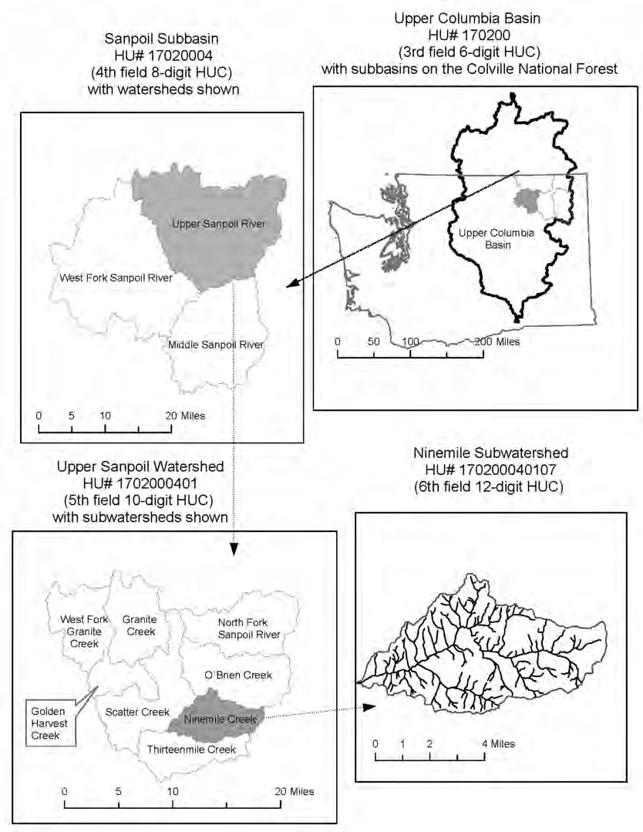
Figure 4. Illustration of watershed hierarchy from the basin to subwatershed scale
AQUATIC AND RIPARIAN SYSTEMS
Aquatic and riparian direction focuses on maintenance and restoration of the ecological processes responsible for creating and sustaining aquatic and riparian ecosystems across National Forest System lands. Aquatic and riparian plan direction is expected to contribute to networks of properly functioning watersheds, recovery of Endangered Species Act (ESA)

listed fish, healthy populations of native fish, and other aquatic and riparian-dependent organisms, and provide a basis for meeting water quality standards.
FISH AND AQUATIC INVERTEBRATES
The Forest Plan focuses on three groups of fish and aquatic invertebrates: threatened, endangered, and proposed (TEP); surrogate species (SS); and management indicator species (MIS)/ focal species (FS). These groups are further described in appendix C.
Threatened and endangered species are those formally listed under the Federal Endangered Species Act of 1973. Surrogate species represent other species that share similar habitat and risk factors and include Region 6 sensitive species, state-listed species, or other species for which the published literature has identified concerns for their viability. Focal species are a subset of the surrogate species that will be used for monitoring.
Threatened and Endangered Species
Plan direction is consistent with existing recovery plans for federally listed species and applies in those areas identified by the USDI Fish and Wildlife Service as recovery areas for each listed species. Bull trout (threatened) is the only listed fish species that occurs on the Forest. Critical habitat for bull trout has been officially designated on a portion of the Colville National Forest. While the Forest manages for threatened and endangered species within recovery zones and designated critical habitat, the listed species may also occur on the Forest but outside of the recovery zones. In those instances, the Forest will still consider effects to the listed species and designated critical habitat in accordance with the Endangered Species Act and in consultation with USDI Fish and Wildlife Service.
Bull trout and Critical Habitat: Spawning population numbers on the Forest are extremely low, and it is currently unknown if any spawning populations present. The Forest includes designated Critical Habitat within the Pend Oreille River subbasin (see https://www.fws.gov/pacific/bulltrout/Habitat.cfm for map of bull trout critical habitat).
Surrogate and Focal Species
Selected surrogate species represent specific habitats and risk factors across the planning area (see appendix C). The viability of surrogate species is enhanced by providing favorable habitats conditions (appropriate mix of cover types and structure stages) and reducing risk factors. Focal species were selected to monitor the potential effects of major forest management activities. These major activities include: grazing, forest vegetation restoration (such as thinning and prescribed fire), and post-fire salvage harvest. Interior redband trout and westslope cutthroat trout were both surrogate and focal species for the Colville National Forest.
Interior redband trout: Redband trout are distributed within the Kettle, Sanpoil, Upper Columbia, and Colville subbasins. The current distribution of redband trout has been significantly reduced from the historic distribution. Lost or degraded habitat within the subbasins and the introduction of non-native fish have had negative impacts on redband trout populations.
Westslope cutthroat trout: Westslope cutthroat trout are the native cutthroat trout within the Colville National Forest. This species is presently found in all five subbasins

on the Forest; however, distribution of this species is extremely limited, and with the exception of annually stocked lowland lakes, the species is generally found in headwater streams. In addition to degraded habitat from human activities, the introduction of non-native salmonids has had a negative impact on the species’ status.
WATER QUALITY
All projects on NFS lands implemented in a manner consistent with meeting State surface water quality standards, and the programs established under the Clean Water Act. This includes moving toward meeting water quality improvement targets established in the Colville National Forest Total Maximum Daily Load and Water Quality Implementation Plan for temperature and fecal coliform. Preservation and improvement of water quality is achieved through implementation of best management practices and Forest Plan components, including desired conditions, objectives, standards, and guidelines, and active restoration.
MUNICIPAL SUPPLY WATERSHEDS AND SOURCE WATER PROTECTION AREAS
A 1996 amendment to the 1974 Safe Drinking Water Act requires identification of both surface and groundwater source water protection areas upstream of drinking water systems that serve more than 25 individuals. Source water protection areas on the Forest are delineated by the Washington Department of Health Office of Drinking Water.
Source water is untreated drinking water from streams, rivers, lakes, springs, and aquifers that provides public drinking water. The goal of source water protection is to provide long- term safe, reliable drinking water. Source water protection areas are those that are delineated and mapped by the State of Washington for each federally regulated public water system. Waters of the Colville National Forest are upstream of surface water systems that service Cusick, Grand Coulee, Ione, Kettle Falls, Metaline, Metaline Falls, Orient, and Riverbend.
Municipal supply watersheds provide water for human consumption where Forest Service management could have a significant impact upon the quality of water at the intake point and that provide water used by a community or other public water system regularly serving at least 25 individuals at least 60 days out of the year or providing at least 15 service connections (FSM 2542). Municipal watersheds on the CNF include East Deer Creek, and North Fork Sullivan Creek, which provide water to the communities of Orient and Metaline Falls, respectively.
Management direction underlying source water protection areas, and municipal supply watersheds is to be followed in addition to providing for water quality. Management guidance for aquatic and riparian ecosystems and key watersheds, and implementation of national best management practices provide for water quality protection.
KEY WATERSHEDS
Key watersheds are a subset of the watersheds across the Colville National Forest and are designated at the subwatershed scale (figure 5 and table 10). They are a network of watersheds that serve as strongholds for important aquatic resources and are crucial to threatened and endangered aquatic species and provide high quality water important for maintenance of downstream populations. Management in key watersheds emphasizes minimizing risk and maximizing passive and active restoration or preservation of watershed function and aquatic and riparian habitat.

Twenty-six subwatersheds are designated as Key Watersheds, 12 of which are designated as a priority for restoration. The plan includes specific objectives for restoration in Key Watersheds that are a priority for restoration. These 12 subwatersheds represent the primary focus areas for active watershed and aquatic restoration through the life of the Forest Plan, based on established national and regional protocols for establishment of priorities, and partnership and funding opportunities.
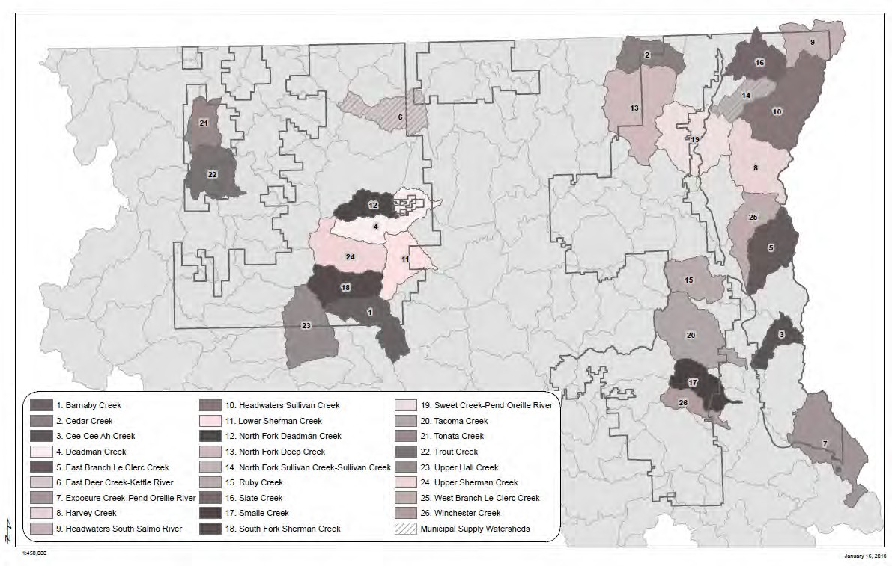
Figure 5. Key and municipal supply watersheds

Table 10. Key watersheds on the Colville National Forest
Key watershed number | Map number | Key watershed name | Total subwatershed acres | Colville National Forest ownership acres
170102160102 | 26 | Winchester Creek | 10,482 | 5,628
170102160103 | 17 | Smalle Creek | 17,754 | 11,058
170102160201 | 7 | Exposure Creek-Pend Oreille River | 41,224 | 14,463
170102160204 | 3 | Cee Cee Ah Creek | 12,063 | 6,500
170102160206 | 20 | Tacoma Creek | 39,519 | 27,182
170102160302 | 25 | West Branch Le Clerc Creek | 21,672 | 15,099
170102160303 | 5 | East Branch Le Clerc Creek | 26,663 | 11,145
170102160304 | 15 | Ruby Creek | 19,597 | 18,385

Key watershed number | Map number | Key watershed name | Total subwatershed acres | Colville National Forest ownership acres
170102160401 | 8 | Harvey Creek | 32,999 | 27,554
170102160402 | 10 | Headwaters Sullivan Creek | 45,516 | 45,417
170102160403 | 14 | North Fork Sullivan Creek | 12,709 | 11,259
170102160702 | 9 | Headwaters South Salmo River | 20,697 | 12,472
170102160902 | 19 | Sweet Creek- Pend Oreille River | 41,832 | 28,890
170102160903 | 16 | Slate Creek | 20,195 | 19,907
170102161003 | 2 | Cedar Creek | 17,209 | 5,359
170200011004 | 13 | North Fork Deep Creek | 49,257 | 26,634
170200011301 | 18 | South Fork Sherman Creek | 22,004 | 21,899
170200011302 | 24 | Upper Sherman Creek | 26,381 | 26,260
170200011303 | 11 | Lower Sherman Creek | 20,987 | 15,998
170200011306 | 1 | Barnaby Creek | 23,108 | 14,299
170200011401 | 23 | Upper Hall Creek | 31,648 | 13,786
170200021301 | 22 | Trout Creek | 23,435 | 14,122
170200021701 | 21 | Tonata Creek | 14,453 | 13,781
170200021907 | 6 | East Deer Creek- Kettle River | 23,385 | 15,443
170200022002 | 12 | North Fork Deadman Creek | 13,450 | 13,185
170200022003 | 4 | Deadman Creek | 26,518 | 22,300
 |  | Total | 654,757 | 458,025

FOCUS AND PRIORITY WATERSHEDS
Watershed, riparian, and aquatic habitat restoration has been a priority in Region 6 for many years. The region recognized that the most efficient and effective way to improve watershed conditions and riparian and aquatic habitat would be to work with partners to target restoration efforts in specific watersheds, identify restoration needs, and focus restoration efforts on the factors degrading watershed, riparian and aquatic habitat conditions within the identified watersheds that were technically feasible and socially acceptable before moving to restore other watersheds. To that end, the region developed the Region 6 Aquatic Restoration Strategy in 2005. The Aquatic Restoration Strategy was

developed to provide guidance for watershed, riparian, and aquatic habitat restoration at a regional scale using both passive and active restoration. ¹⁰
Through implementation of the Aquatic Restoration Strategy, the region prioritized basins for active restoration. Forests identified focus watersheds at the 5th field watershed scale to be priorities for active watershed, riparian, and aquatic restoration. The Colville National Forest identified three focus watersheds: Le Clerc-Pend Oreille River, Upper San Poil and Chewelah Creek-Colville River.
In 2010, the national forests throughout the United States were mandated to assess the current condition of NFS watersheds utilizing the Watershed Condition Framework (WCF). The results of the WCF were used to identify priority subwatersheds where focused management over a 5- to 10-year period would improve impaired watershed condition.
The Colville identified three priority subwatersheds through this process; the West Branch Le Clerc Creek, East Branch Le Clerc Creek, and Ninemile Creek. Once essential projects in existing subwatersheds are completed, additional priority subwatersheds will be identified through the WCF process.
WATERSHED CONDITION
Measurement of improvement in watershed condition in this Forest Plan revision is through improvement in watershed condition class measured through the WCF procedure. The WCF process identified current conditions of subwatersheds on NFS lands. The results of the assessment were used to identify priority subwatersheds where focused management over a 5- to 10-year period could improve constituent elements that impair watershed function.
Subwatersheds are classified by WCF based on geomorphic, hydrologic, and biotic integrity relative to potential natural condition, which relates to geomorphic, hydrologic, and biological watershed function. Integrity is evaluated in the context of the natural disturbance regime and geoclimatic setting and includes aquatic and terrestrial components because water quality and aquatic habitat are related to the integrity and functionality of the upland and riparian areas across the watershed (Potyondy and Geier 2010).
Subwatersheds on the Colville National Forest were classified into three categories (watershed condition classes) through the WCF:
- Class 1: Functioning Properly—subwatersheds that exhibit high geomorphic, hydrologic, and biotic integrity relative to natural potential conditions. High integrity means that the watershed is functioning similar to natural wildland conditions (Karr and Chu 1999, Lackey 2001). There are minimal adverse human impacts on natural physical or biological processes, and the watershed is able to naturally recover to previous condition in response to natural and human disturbance (Yount and Neimi 1990);

10 Passive restoration is the broad-scale natural recovery of the ecosystem and includes coordination, analysis, planning, and design activities to maintain or improve habitat conditions while implementing projects across multiple resource areas.
Active restoration includes management actions with the specific goal of restoring the watershed processes that improve aquatic and riparian habitat function. Active restoration is focused on a more limited scale than passive restoration.

- Class 2: Functioning at Risk—subwatersheds that exhibit moderate integrity. There are more human impacts on natural physical or biological processes than in high integrity subwatersheds, and the watershed may be able to naturally recover to previous condition in response to natural and human disturbance (Yount and Neimi 1990);
- Class 3: Impaired Function—subwatersheds that exhibit low integrity. Adverse human impacts have caused a threshold to be exceeded where the watershed is no longer as resilient to physical and biological processes. The only impaired subwatershed in the planning area is Meadow Creek.
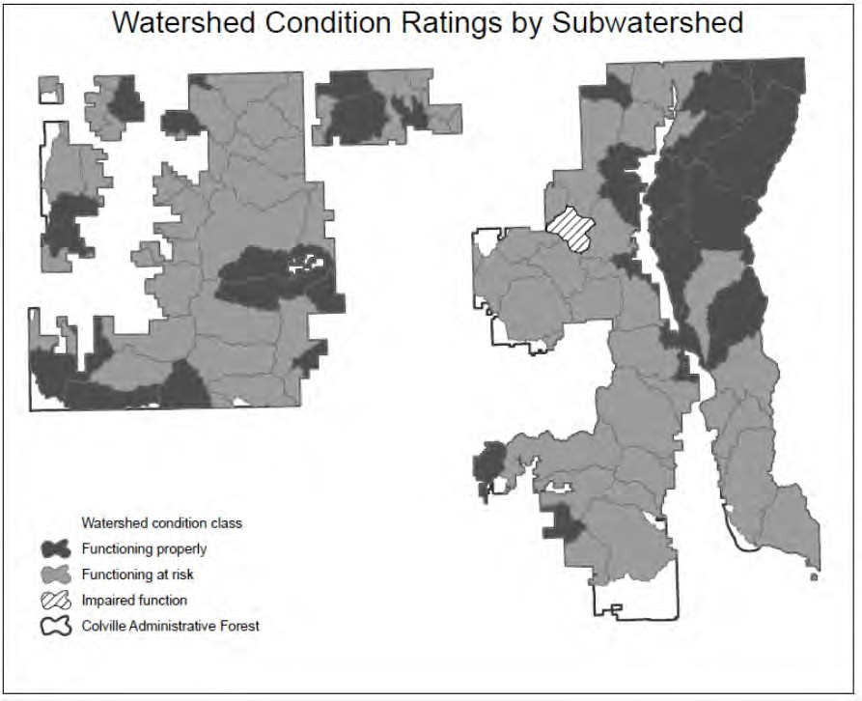
Figure 6. Current watershed condition class for subwatersheds across the Forest
This Forest Plan incorporates by reference the information contained on the WCF map viewer website: https://apps.fs.usda.gov/wcatt/, which contains the current WCF Priority Watersheds and associated information. The responsible official will select Priority Watersheds through WCF based on an interdisciplinary analysis and evaluation. In addition, the responsible official will reach out to local, State, Tribal, other Federal agencies, and interest groups when identifying priority watersheds (FSH 1909.12, chapter 20, section 22.31).
The priorities for watershed, riparian, and aquatic habitat restoration have been further refined through the identification of Key Watersheds during the forest plan revision process. As discussed above, Key Watersheds are identified at the subwatershed scale to

aid the conservation and recovery of aquatic surrogate species. In some cases, Focus Watersheds (e.g., Le Clerc Creek-Pend Oreille River) include Key Watersheds and Priority Watersheds overlap with the identified Key Watersheds (West Branch Le Clerc Creek).
Specific restoration objectives have been identified for Key Watersheds in the Plan and the Key Watersheds are the priority for active restoration. The Focus and Priority Watersheds that are not in the Key Watershed network are used to target implementation of short- term, opportunistic restoration work such as in subwatersheds that are a restoration priority for partners, but not necessarily a priority to benefit the aquatic surrogate species.
WATERSHED ANALYSIS
Watershed analysis is an interdisciplinary analysis of the status and trends of watershed and aquatic ecosystem conditions, State-designated beneficial uses of water (e.g., municipal water supply), and the hydrologic, geomorphic, and biological processes that strongly influence them. Watershed analysis provides consistent, mid-scale information that serves as a foundation for plan implementation through the development of strategic and integrated programs and projects that protect and restore aquatic resources, while enabling informed and sustainable resource use and management. The watershed analysis process is described in detail in the Colville Aquatic and Riparian Conservation Strategy (see FEIS, Appendix H).
Criteria for selecting potential watersheds for analysis should include: (1) Key Watersheds;
(2) watersheds that have been or likely will be identified as Priority Watersheds under the Watershed Condition Framework during the life of the Plan; (3) watersheds that support listed species or contain designated critical habitat; and (4) watersheds wherein management activities are likely to occur that may substantially affect aquatic resources (e.g., due to their inherent nature, location, timing or scale).
Watershed analyses should generally be conducted or updated prior to developing and implementing Watershed Restoration Action Plans for Priority Watersheds.
In addition, watershed analyses shall be conducted or updated prior to: proposing changes to Riparian Management Area (RMA) widths, timber salvage or construction of facilities in RMAs, or construction of permanent system roads in RMAs.

Desired Conditions
FW-DC-WR-01. Natural Disturbance Regime of Aquatic and Riparian Systems
National Forest System lands contribute to the distribution, diversity, and resiliency of watershed and landscape-scale features, including natural disturbance regimes, of the aquatic, riparian, and wetland ecosystems to which plant and animal species, populations, and communities are adapted. Subbasin scale is used for Forest planning and 5th field watershed or subwatershed scale is used for project planning.
FW-DC-WR-02. Hydrologic and Aquatic and Riparian Habitat Connectivity
National Forest System lands contribute to uninterrupted physical and biological processes within and between watersheds. Floodplains, groundwater-dependent systems, upslope areas, headwater tributaries, and intact habitat refugia provide vertical, horizontal, and drainage network connections. These network connections provide chemically and physically unobstructed routes to areas critical for fulfilling life history requirements of aquatic, riparian-

dependent, and many terrestrial species of plants and animals. Subbasin scale is used for Forest planning, and 5th field watershed or subwatershed scale is used for project planning.
FW-DC-WR-03. Self-Sustaining Native and Aquatic and Riparian-Dependent Species
National Forest System lands contribute to habitat and ecological conditions that are capable of supporting self-sustaining populations of native aquatic and riparian-dependent plant and animal species. Subbasin scale is used for forest planning and 5th field watershed or subwatershed scale is used for project planning.
FW-DC-WR-04. Physical Integrity of Aquatic and Riparian Habitat
National Forest System lands provide aquatic habitats in which the distribution of conditions (e.g., bank stability, substrate size, pool depths and frequencies, channel morphology, large woody debris size and frequency) in the population of watersheds on the Forest is similar to the distribution of conditions in the population of similar, reference condition watersheds.
Reference conditions can be drawn from the Forest or Provincial scales. Conditions assessed at the subbasin scale are used for forest and project planning.
FW-DC-WR-05. Water Quality
National Forest System lands contribute to water quality necessary to support healthy riparian, aquatic, and wetland ecosystems. Water quality is within the range that maintains the biological, physical, and chemical integrity and benefits survival, growth, reproduction, and migration of individuals composing aquatic and riparian communities, and meets appropriate Washington State water quality standards. Subbasin scale is used for forest planning and 5th field watershed or subwatershed scale is used for project planning.
FW-DC-WR-06. Sediment Regimes
National Forest System lands contribute to the sediment regime within the natural range of variation. Elements of the sediment regime include the timing, volume, rate, and character of sediment input, storage, and transport. Watershed scale is used for Forest planning and 5th field watershed or subwatershed scale is used for project planning.
FW-DC-WR-07. In-stream Flows
National Forest System lands contribute to instream flows and groundwater sufficient to create and sustain riparian, aquatic, and wetland habitats, retain patterns of sediment, temperature, nutrient, and wood routing, and provide for (permitted or certificated) consumptive uses. The timing, magnitude, duration, and spatial distribution of peak, high, and low flows functions in concert with local geology, valley types, soils and geomorphology. Subbasin scale is used for Forest planning and 5th field watershed or subwatershed scale is used for project planning.
FW-DC-WR-08. Floodplain Inundation
National Forest System lands contribute to the timing, variability, and duration of floodplain inundation that are within the natural range of variation. Fifth field watershed or subwatershed scale is used for both Forest and project planning.
FW-DC-WR-09. Groundwater-dependent Systems: Seeps, Springs, and Groundwater- fed Wetlands (Fens)
National Forest System lands contribute to the timing, variability, and water table elevation in groundwater-fed wetlands, seeps, springs, and other groundwater-dependent systems. These

features are within or moving toward proper functioning condition. Subwatershed scale is used for both Forest and project planning.
FW-DC-WR-10. Water Production for Downstream Uses
National Forest System lands produce high-quality water for downstream ecological communities (including human communities) dependent upon them. Watershed scale is used for both Forest and project planning.
FW-DC-WR-11. Native Plant Communities
National Forest System lands contribute to the species composition and structural diversity of native plant communities in riparian management areas (including wetlands). These contribute to adequate summer and winter thermal regulation, nutrient filtering, appropriate rates of surface erosion, bank erosion, and channel migration; and supply amounts and distributions of coarse woody debris and fine particulate organic matter sufficient to sustain physical complexity and stability. Subbasin scale is used for Forest planning and 5th field watershed or subwatershed scale is used for project planning.
FW-DC-WR-12. Aquatic Invasive and Non-Native Species
Aquatic invasive species do not occur as a component of lake, stream, and other riparian- related ecosystems or compete with native species for critical resources. Subbasin scale is used for Forest planning. Fifth field watershed or subwatershed scale is used for project planning.
FW-DC-WR-13. Aquatic Threatened, Endangered, and Sensitive Species
National Forest System lands contribute to the recovery of federally threatened and endangered aquatic species and conservation of Regional Forester’s sensitive aquatic species. Aquatic habitat supports spawning, rearing, and/or other key life history requirements. Aquatic habitat also is designated as critical habitat for listed species (such as bull trout) in some areas. Subbasin scale is used for Forest planning and 5th field watershed or subwatershed scale is used for project planning.
FW-DC-WR-14. Resiliency to Climate Change
Aquatic and riparian ecosystems are resilient to the effects of climate change and other major disturbances. Subbasin scale is used for Forest planning and 5th field watershed scale is used for project planning.
FW-DC-WR-15. Water Quality Standards in Municipal Supply Watersheds and Source Water Protection Areas
National Forest System lands in municipal supply watersheds (North Fork Sullivan Creek, and East Fork Deer Creek) and ground and surface source water protection areas provide water that meets or exceeds state water quality standards for drinking water with appropriate treatment.
FW-DC-WR-16. Key Watershed Network
Networks of watersheds with functional habitat and functionally intact ecosystems contribute to and enhance conservation and recovery of specific threatened, endangered, and/or sensitive aquatic species and high water quality and natural flow regimes. The networks contribute to short-term conservation and long-term recovery at the Recovery Unit or other appropriate population scale.

FW-DC-WR-17. Roads in Key Watersheds
Roads in key watersheds are not a risk to the function of soil and water resources. Roads do not disrupt hydrologic or aquatic habitat function or threatened and endangered species biological and behavioral attributes.
FW-DC-WR-18. Key Watershed Integrity
Key watersheds have high watershed integrity and contribute to resilient aquatic and riparian ecosystems.
FW-DC-WR-19. Focus and Priority Watershed Network
Focus and priority watersheds contribute to the sustainability of aquatic and riparian systems and species and provide resilient, productive habitat and high water quality.

Objectives
FW-OBJ-WR-01. Aquatic Invasive Species
Within the next 15 years, implement aquatic invasive species prevention measures at all developed recreation sites providing direct and/or indirect access to water bodies, such as boat ramps, campgrounds, and day use areas that provide portal zones for hand carried watercraft. Implement aquatic invasive species prevention measures as part of all aquatic survey and inventory procedures and other management activities that pose high potential for invasion vectors to occur. For guidance on invasive riparian plants see FW-DC-WR-12 and Invasive Species Desired Condition section.
FW-OBJ-WR-02. Aquatic Invasive and Non-Native Species
Within the next 15 years, implement aquatic invasive species control and eradication at
15 waterbodies (streams and lakes) where such invasions have become established and prevent attainment of listed fish recovery plan goals and/or effects to social, economic, and ecological systems are determined to be unacceptable.
FW-OBJ-WR-03. General Watershed Function and Restoration
Within the next 15 years, decrease sediment delivery from management activities on
1,000 acres including but not limited to roads, trails, livestock, unauthorized off-highway vehicle use, vegetation management, and dispersed and developed campsites. Restore hydrologic, aquatic, and riparian processes through activities that stabilize streambank erosion, and other accelerated channel destabilizing processes (i.e., headcutting), improve lateral and vertical hydrologic connectivity, and improve stream channel and floodplain function on 10 miles of streams.
FW-OBJ-WR-04. Fish Habitat Improvement
Within 15 years restore aquatic organism passage for all life stages of native species at 45 road/stream crossings and man-made instream structures such as water diversions and dams outside of key watersheds. Culverts and other passage improvements are to be designed to restore and maintain hydrologic and aquatic habitat function and stream channel resiliency to a range of flows through natural channel design and other acceptable treatment measures.

FW-OBJ-WR-05. Key Watershed Restoration Prioritization
Management in key watersheds focuses on restoration or preservation of watershed, aquatic, and riparian function and recovery of threatened and endangered species. Improve watershed condition class in key watersheds that are a priority for restoration within 15 years of forest plan implementation. Key watersheds that are a priority for restoration include:
East Branch LeClerc Creek, West Branch LeClerc Creek, Deadman Creek, Barnaby Creek, Harvey Creek, North Fork Deadman Creek, North Fork Sullivan Creek, Sullivan Creek, Ruby Creek, Tonata Creek, Upper Sherman Creek, and South Fork Sherman Creek subwatersheds.
Additional key watersheds that are a priority for restoration will be identified, as appropriate, through the life of the plan through the WCF process.
FW-OBJ-WR-06. Key Watershed Road Treatments
Reduce road-hydrologic connectivity and sediment delivery on roads through storm damage risk reduction treatments, full hydrologic decommissioning, and other accepted treatment measures on 116 miles of hydrologically connected road within 15 years of forest plan implementation.
Restore or maintain aquatic organism passage and improve hydrologic and aquatic habitat function at 53 road/stream crossings for all native aquatic species, seasons, flows, and life stages in key watersheds within 15 years of forest plan implementation through culvert replacement or crossing improvement and natural channel design or other acceptable treatment measures that provide for natural stream channel function at all flows.
FW-OBJ-WR-07. Key Watershed Range Infrastructure Improvements
Improve hydrologic and aquatic function through range infrastructure improvements, including riparian fencing, movement and improvement of watering troughs, and other acceptable treatments over 240 acres within 15 years of plan implementation.
FW-OBJ-WR-08. Upland Vegetation Structure in Riparian Management Areas in Key Watersheds
Move upland vegetation within riparian management areas in key watersheds toward historical range of variability (table 10) on 1,500 acres within 15 years of plan implementation.
FW-OBJ-WR-09. Stream Restoration in Key Watersheds
Restore hydrologic, geomorphic, and riparian process and function on 81 miles of stream within 15 years of forest plan implementation through activities including streambank stabilization, restoration of lateral and vertical hydrologic connectivity, and improvement of stream channel and floodplain function.
FW-OBJ-WR-10. Watershed Restoration in Focus and Priority Watersheds
Over 15 years, implement the watershed condition framework through completion of essential projects outlined in watershed action plans in existing focus and priority watersheds to improve watershed condition class. Focus watersheds designated at the 5th field watershed scale include Upper Sanpoil, Chewelah Creek-Colville River, and LeClerc Creek-Pend Oreille River watersheds. Priority watersheds designated at the subwatershed scale include Ninemile Creek and West Branch LeClerc Creek subwatersheds.

FW-OBJ-WR-11. Watershed Analysis
Within 15 years of plan implementation, complete or update watershed analyses for
5 subwatersheds. Criteria for selecting subwatershed for watershed analysis include: Key Watersheds, Priority Watersheds, watersheds that support designated critical habitat, or support listed species, and watersheds where management activities are likely to occur that may affect aquatic resources (due to their inherent nature, location, timing, or scale).

Standards
FW-STD-WR-01. Best Management Practices
All projects shall be implemented in accordance with best management practices, as described in national and regional technical guides.
FW-STD-WR-02. Aquatic Invasive Species − In-Water Work
Implement prevention measures for in-water projects to decrease the potential for aquatic invasive species transference into non-infested water bodies.
FW-STD-WR-03. Aquatic Invasive Species − Aquatic Resource Sampling
Aquatic sampling equipment must be disinfected prior to use in new stream or lake locations.
FW-STD-WR-04. Construction of New Roads, Trails and Developed Recreation Sites
New roads and trails will be designed to minimize disruption of natural hydrologic processes at perennial and intermittent stream crossings, valley bottoms, valley approaches and other over- land drainage features. New roads, trails, and developed recreation sites will integrate features, such as, but not limited to, rocked stream crossings, drain dips, sediment filtration, cross drains and crossings that minimize unnatural stream constriction, bank erosion, channel incision, sedimentation, or disruption of surface and subsurface flow paths.
FW-STD-WR-05. Road Construction and Hydrologic Risk Reduction in Key Watersheds
In Key Watersheds and in subwatersheds with ESA critical habitat for aquatic species that are functioning properly with respect to roads, there will be no net increase (at least one mile of road-related risk reduction for every new mile of road construction) in system roads that affect hydrologic function. In Key Watersheds and in subwatersheds with ESA critical habitat for aquatic species that are functioning-at-risk or have impaired function with respect to roads, there will be a net decrease (for every mile of road construction there would be greater than one mile of road-related risk reduction) in system roads that affect hydrologic function to move toward proper function. Treatment priority shall be given to roads that pose the greatest relative ecological risks to riparian and aquatic ecosystems. Road-related risk reduction will occur prior to new road construction unless logistical restrictions require post-construction risk reduction.
FW-STD-WR-06. Hydroelectric and Other Water Development Authorizations in Key Watersheds
Hydroelectric and other water development authorizations shall include requirements for instream flows and habitat conditions that maintain or restore native fish and other desired aquatic species populations, riparian-dependent resources, favorable channel conditions, and aquatic connectivity.

FW-STD-WR-07. New Hydroelectric Facilities and Water Developments
New hydroelectric facilities and water developments shall not be located in a key watershed unless it can be demonstrated they have minimal risks and/or no adverse effects to fish and water resources for which the key watershed was established.

Guidelines
FW-GDL-WR-01. Properly Functioning Watersheds
When aquatic and riparian desired conditions are being achieved and watersheds are functioning properly,¹¹ projects should maintain¹² those conditions. When aquatic and riparian desired conditions are not yet achieved or watersheds have impaired function¹¹ or are functioning-at-risk¹¹ and to the degree that project activities would contribute to those conditions, projects should restore or not retard attainment of desired conditions.¹² Short-term adverse effects from project activities may be acceptable when they support long-term recovery of aquatic and riparian desired conditions. Exceptions to this guideline include situations where Forest Service authorities are limited. In those cases, project effects toward attainment of desired conditions should be minimized and not retard attainment of desired conditions to the extent possible within Forest Service authorities.
FW-GDL-WR-02. Aquatic Invasive Species − Wildfire Suppression Equipment
During wildfire suppression, cross contamination between streams and lakes from pumps, suction, and dipping devices should be avoided. Dumping water directly from one stream or lake into another should be avoided. Water storage and conveyance components of water tenders, engines, and aircraft should be disinfected prior to use on a new on-forest incident.
FW-GDL-WR-03. Aquatic Invasive Species − Early Detection and Rapid Response
Principles and processes of early detection and rapid response to find, identify and quantify new aquatic invasive species occurrences should be used. Early detection and rapid response should be coupled with other integrated activities to rapidly assess and respond with quick and immediate actions to eradicate, control, or contain aquatic invasive species.
FW-GDL-WR-04. Watershed Restoration
Use the restoration methods that maximize the use of natural ecological processes for long- term sustainability and minimize the need for long-term maintenance.
FW-GDL-WR-05. Hydrologic Function of Roads, Trails, and Developed Recreation Sites
Roads and trails should be maintained to minimize disruption of natural hydrologic processes at perennial and intermittent stream crossings, valley bottoms, valley approaches and other
over-land drainage features. Roads and trails should integrate features, such as, but not limited to, rocked stream crossings, drain dips, sediment filtration, cross drains and crossings that minimize unnatural stream constriction, bank erosion, channel incision, sedimentation, or disruption of surface and subsurface flow paths.

11 Per Watershed Condition Framework Technical Guide, USDA Forest Service (Potyondy & Geier 2010) and/or subsequent versions and/or comparable methods. Other broad-scale or local inventory, assessment and monitoring data and analysis can be used to refine initial classifications made per WCF.
12 See glossary for definitions of the terms “maintain,” “restore,” “degrade,” and “retard attainment.”

FW-GDL-WR-06. Chemical Fire Suppression
Whenever practical, as determined by the fire incident commander, use water or other less toxic wildland fire chemical suppressants for direct attack or less toxic approved fire retardants in areas occupied by riparian and aquatic-dependent threatened, endangered, proposed, candidate, or sensitive species, or their habitats.

Wildlife Habitats (WL)
The Forest Plan focuses on four groups of terrestrial wildlife species: threatened, endangered, and proposed (TEP), surrogate species (SS), management indicator / focal species (MIS/FS), and species of management interest. These groups are further described in appendix C. In addition, some plan components address general wildlife habitat issues and enhance viability of all species.
Threatened and endangered species are those formally listed under the Federal Endangered Species Act of 1973. Surrogate species represent other species that share similar habitat and risk factors and include Region 6 sensitive species, state-listed species, or other species for which the published literature has identified concerns for their viability. Focal species are a subset of the surrogate species that will be used for monitoring.
Species of management interest include big-game species that are of high interest to the public. Several desired condition statements within this Plan refer to ‘habitat effectiveness’ or ‘zone of influence.’ Methods to address habitat effectiveness and zone of influence can be found in Gaines et al. (2003); however, during the life of the Plan these methods may be replaced by new scientific/research developments.
THREATENED AND ENDANGERED SPECIES
Plan direction is consistent with existing recovery plans for federally listed species and applies in those areas identified by the USDI Fish and Wildlife Service as recovery areas for each listed species. Four federally listed wildlife species are found on or near the Forest.
These include grizzly bear (threatened), woodland caribou (endangered), Canada lynx (threatened), and yellow-billed cuckoo (threatened). In addition, critical habitat for the woodland caribou has been officially designated on a portion of the Colville National Forest. While the Forest manages for threatened and endangered species within recovery zones and designated critical habitat, the listed species may also occur on the Forest but outside of the recovery zones. In those instances, the Forest will still consider effects to the listed species and designated critical habitat in accordance with the Endangered Species Act and in consultation with the USDI Fish and Wildlife Service.
Canada lynx: The Canada Lynx Conservation Assessment and Strategy (2013 version) was used to develop management direction. The Colville National Forest includes the Kettle- Wedge core area that is important for the recovery of Canada lynx in Washington. The Forest does not have any designated critical habitat for Canada lynx. Habitat conditions (e.g., current habitat compared to desired conditions) are appropriately assessed at the lynx analysis unit scale. There are 13 lynx analysis units within the Kettle-Wedge Core Area. Core areas are defined by the USDI Fish and Wildlife Service as areas with the strongest long-term evidence of the persistence of lynx populations over time within the contiguous United States.
Grizzly bear: The Selkirk Mountains Grizzly Bear Recovery Area includes a portion of the Colville National Forest located east of the Pend Oreille River. The recovery area is divided

into grizzly bear management units, three of which are shared between the Colville and Idaho Panhandle National Forests. These analysis units are large enough to allow the assessment of seasonal habitats and the cumulative effects of human activities on these habitats. Within bear management units, management is designed to ensure that important seasonal habitats are available to bears within core areas.
Core areas are identified as areas that are more than 500 meters from an open road, restricted-use road, motorized trail, or high-use hiking trail (more than 20 parties per week). Any roads within core areas must be physically un-drivable (e.g., bermed, brushed- in). Evaluation of the potential effects of proposed actions on grizzly bear recovery follows the assessment process developed by the Interagency Grizzly Bear Committee (IGBC 1998).
Woodland caribou: A small population of woodland caribou occurs on the northeastern portion of the Colville National Forest within the Selkirk Mountain Woodland Caribou Recovery Area. The caribou recovery area has been divided into 17 caribou management units, of which 4 occur on the Colville National Forest.
Woodland caribou critical habitat: The USDI Fish and Wildlife Service designated 30,010 acres of Federal land in Boundary County, Idaho, and Pend Oreille County,
Washington, as critical habitat for the southern Selkirk Mountains caribou population. The portion of the critical habitat that occurs in Washington is located on the Colville National Forest (see https://www.fws.gov/idaho/articles.cfm?id=149489582 for map of critical habitat).
Yellow-billed cuckoo: The yellow-billed cuckoo is a threatened species throughout much of the western United States, and the western United States was designated as a distinct population segment. It is unknown if the yellow-billed cuckoo occurs on the Colville National Forest; however, there may be some potential habitat. Cuckoos nest almost exclusively in riparian woodlands 50 acres or larger in size, over 300 feet wide, and dominated by cottonwoods and willows.
SURROGATE SPECIES
Selected surrogate species represent specific habitats and risk factors across the planning area (see appendix C). The viability of surrogate species is enhanced by providing favorable habitat conditions (appropriate mix of cover types and structure stages) and reducing risk factors.
MANAGEMENT INDICATOR / FOCAL SPECIES
Management indicator / Focal species were selected to monitor the potential effects of major forest management activities. These major activities include: grazing, forest vegetation restoration (such as thinning and prescribed fire), and post-fire salvage harvest. The species in table 11 were selected to represent these management activities.

Table 11. Focal Species to be used for monitoring and Management Indicator Species used to assess management activities
Focal / Management Indicator species | Management activity
MacGillivray’s warbler | Grazing, understory effects
Black-backed woodpecker | Post-fire salvage harvest
Northern goshawk | Forest vegetation management
White-headed woodpecker | Forest vegetation management
SPECIES OF MANAGEMENT INTEREST
Deer: Mule deer and white-tailed deer occur widely across the national forest.
Elk: Rocky Mountain elk are less broadly distributed across the Forest. The larger elk populations occur on the eastern half of the Colville National Forest.

Desired Conditions
FW-DC-WL-01. Proper Storage of Human Food, Garbage, and Other Wildlife Attractants
All administrative sites, developed recreation sites, and dispersed recreation sites where garbage disposal services are provided, are equipped with animal-resistant food and waste storage devices so that food, garbage, and other attractants can be made inaccessible to wildlife.
Forest visitors are aware of the need to properly store all wildlife attractants through one-on- one contacts with campground hosts and agency employees, signage, and the media.
Compliance with the Forest’s food storage order is increasing.
FW-DC-WL-02. Habitat Conditions for Threatened and Endangered Species
Habitat conditions (amount, distribution, and connectivity of habitat) are consistent with the historical range of variability (see also FW-DC-VEG-04 and 05) and contribute to the recovery of federally listed threatened and endangered species.
FW-DC-WL-03. Habitat Conditions for all Surrogate Species
Habitat conditions (amount, distribution, and connectivity of habitat) are consistent with the historical range of variability (per FW-DC-VEG-03 and 04) and contribute to the viability of surrogate species and associated species.
FW-DC-WL-04. Habitat Components for Canada Lynx
Forest successional stages within lynx analysis units provide a mosaic of lynx habitat (including foraging, travel and denning components) with landscape pattern that is consistent with the historical range of variability (per FW-DC-VEG-03 and table 5)

FW-DC-WL-05. Grizzly Bear Recovery Area – Key Habitat Components for Grizzly Bear
Key grizzly bear habitat components (such as whitebark pine, riparian habitats, berry-producing shrubfields, natural meadows, and forest cover) are available within core areas and in quantities that contribute toward a recovered bear population.
FW-DC-WL-06. Grizzly Bear Recovery Area – Core Areas
The amount of core areas available to grizzly bears within each grizzly bear management unit meets the standards in table 15. Core areas are expanded where other forest access priorities or obligations can also be met.
FW-DC-WL-07. Woodland Caribou Seasonal Habitat Components
Manage toward the upper 10 percent of the desired conditions for vegetation (see FW-DC-VEG- 03, table 5) in late-successional-closed forest within western hemlock/red cedar and spruce/subalpine fir, measured at the caribou management unit scale.
FW-DC-WL-08. Woodland Caribou Habitat – Forage Availability
Preferred lichens (Bryoria and Alectoria) are present in sufficient quantities for woodland caribou to forage.
FW-DC-WL-09. Woodland Caribou Habitat – Winter Recreation
Winter recreation is managed so that woodland caribou are not displaced from suitable habitat and the caribou can make full use of existing habitat in the recovery area.
FW-DC-WL-10. Risk Factors for all Surrogate Species
Risk factors (such as roads, uncharacteristic wildfire, unregulated livestock use, introduced species, invasive species, and disturbance during critical time periods) for all surrogate species are reduced to contribute to the viability of surrogate species and associated species.
FW-DC-WL-11. Human Activities in Bald Eagle Nesting Areas
Occupied bald eagle nesting areas are not disrupted by management activities.
FW-DC-WL-12. Bald Eagle Habitat in Riparian Management Areas
Riparian management areas along mainstem rivers that provide bald eagle habitat are composed of more than 20 percent late-successional forest. Applicable scale is a stream reach.
FW-DC-WL-13. Deer and Elk Habitat – Summer and Winter Range Cover and Forage
Cover and forage for deer and elk summer and winter range are within historical range of variability for vegetation (per FW-DC-VEG-03 and table 5).
FW-DC-WL-14. Deer and Elk Habitat – Human Activities
Winter ranges for deer and elk provide a high level of habitat effectiveness by having less than 30 percent of the winter range within a zone of influence of an open road or motorized travel route. Summer ranges provide a moderate level of habitat effectiveness by having less than 50 percent of the summer range within a zone of influence of an open road or motorized trail.

Objectives
FW-OBJ-WL-01. Wildlife Habitats – Proper Storage of Human Food, Garbage and Other Wildlife Attractants
Address any food or garbage storage problem areas promptly to avoid habituation of grizzly bears or other wildlife. Maintain the wildlife-resistant garbage storage devices installed in all developed campgrounds on the Colville National Forest, as needed. Within 15 years of plan implementation, install at least 15 wildlife-resistant food storage lockers at developed campgrounds or heavily used dispersed campsites. Priority will be given to sites within or adjacent to the grizzly bear recovery area, or to areas with documented black bear or grizzly bear food or human interactions.
FW-OBJ-WL-02. Canada Lynx Habitat Restoration
During the expected 15 years of plan implementation, restore an average of 100 acres per year of snowshoe hare and/or lynx habitat within the lynx analysis units located in the Kettle-Wedge core area.
FW-OBJ-WL-03. Grizzly Bear Recovery Area – Habitat Restoration
During the expected 15 years of plan implementation, maintain or restore grizzly bear seasonal habitats on 900 acres in the following bear management units (table 12).

Table 12. Grizzly bear seasonal habitats objective
Bear management unit | Number of acres restored
LeClerc | 300
Salmo-Priest | 300
Sullivan Hughes | 300

FW-OBJ-WL-04. Restoration of Late-Successional Forest Habitat and Associated Surrogate Species
During the expected 15 years of plan implementation, restore western hemlock/western red cedar vegetation types within late-successional forest habitats for surrogate wildlife species on 1,400 acres within the following watersheds (table 13). Generally focus activity in previously treated areas that are now early to mid-successional forest to enhance large tree development.

Table 13. Surrogate species habitat – watersheds for treatment
Watershed | Acres
Sullivan Creek | 800
LeClerc | 600

FW-OBJ-WL-05. White-Headed Woodpecker and Associated Species Habitat – Ponderosa Pine Forest
During the expected 15 years of plan implementation, restore or move toward restoration of late structure ponderosa pine forest habitat on 500 acres per year. Restoration projects are emphasized in the following watersheds: Sanpoil, Sherman.

FW-OBJ-WL-06. Deer and Elk Habitat Restoration
During the expected 15 years of plan implementation, restore (i.e., application of prescribed fire, invasive plant management, etc.) habitat on 1,000 acres of deer and elk winter range.

Standards
FW-STD-WL-01. Nest Sites
For forest species listed in table 14, protect all known active nest sites from human disturbance caused by management activities during the following periods to reduce the risk of nest abandonment or decline in productivity.

Table 14. Timing standards for protection of land bird species nest sites
Species | Species status | Timing
Bald eagle | Surrogate – R6 Sensitive Species | January 1–August 15
Peregrine falcon | Surrogate- R6 Sensitive Species | March 1−July 31
Northern goshawk | Surrogate | March 1–August 31
Golden eagle | Surrogate | February 15−August 31

FW-STD-WL-02. Canada Lynx – Vegetation Management within the Kettle-Wedge Lynx Core Area
Management projects shall not reduce horizontal cover (snowshoe hare habitat) in late-closed structure subalpine fir/lodgepole or spruce/subalpine fir vegetation types unless: (1) the subalpine fir/lodgepole pine or spruce/ subalpine fir vegetation types exceed desired conditions (historical range of variability) for late-closed structure, (2) the projects are within 200 feet of administrative sites, dwellings, out buildings, recreation sites and special use permit areas, including infrastructure within permitted ski area boundaries; or (3) for research studies or genetic tree test evaluating genetically improved reforestation stock. Lynx analysis units are used to measure changes to lynx habitat.
FW-STD-WL-03. Canada Lynx – Rate of Change within the Kettle-Wedge Lynx Core Area
Change no more than 15 percent of lynx habitat within any single lynx analysis unit to an unsuitable condition in any 10-year period.
FW-STD-WL-04. Canada Lynx – Groomed and Designated Winter Routes within the Kettle-Wedge Lynx Core Area
Allow no net increase in groomed or designated over-the-snow routes into lynx habitat at the lynx analysis unit scale. Access to non-recreation uses, such as mineral and energy exploration and development sites, will be comprised of designated routes or designated over-the-snow routes. This does not apply to areas within permitted ski area boundaries, winter logging, trails that are rerouted for public safety, or to accessing private in-holdings.

FW-STD-WL-05. Canada Lynx – Vegetation Management within the Kettle-Wedge Lynx Core Area
When conducting vegetation management of coniferous vegetation, do not reduce the suitability of lynx habitat within a lynx analysis unit below 70 percent of the area that is capable of providing suitable lynx habitat (subalpine fir-associated forest types).
FW-STD-WL-06. Canada Lynx – Tree Stem Densities in the Kettle-Wedge Lynx Core Area
Retain a minimum of 20 percent in untreated patches and do not reduce tree stem densities to less than 500 trees per acre in early structure subalpine fir/lodgepole pine or spruce/subalpine fir vegetation types within a lynx analysis unit through mechanical tree removal or prescribed burning, except within 500 feet of structures (i.e., administrative sites, dwellings, out buildings), developed recreation sites and special use permit areas (including infrastructure within permitted ski area boundaries), and along major highways and powerline corridors.
FW-STD-WL-07. Grizzly Bear Recovery Area -Road Densities
Within the grizzly bear recovery area, Federal actions shall not result in a net reduction of core habitat below the levels in the following table. Discrete core areas shall remain in place for a minimum of 10 years for bears to find and use these areas. Federal actions shall not result in a net increase in open or total road densities above the levels in table 15. Total road densities do not include physically undrivable roads (e.g., bermed, brushed-in).

Table 15. Grizzly bear habitat standards for the shared bear management units of the Colville and Idaho Panhandle National Forests
Bear management unit | Maximum open roads  >1 mi/sq. mi. | Maximum total roads  >2 mi/sq. mi | Minimum percent core habitat
Salmo-Priest (99% NFS land) | 33% | 26% | 64%
Sullivan-Hughes (99% NFS land) | 24% | 19% | 61%
LeClerc  (64% NFS land) | 48% | 60% | 27%

FW-STD-WL-08. Proper Storage of Human Food, Garbage, and Other Wildlife Attractants
Forest Service contracts, permits, and agreements that include camping on NFS lands shall incorporate the requirement to follow the current Food Storage Order for the Colville National Forest.
Apiaries shall not be placed where they would increase the potential for human-bear conflicts.
FW-STD-WL-09. Woodland Caribou Recovery Areas – Management Activities
Management activities within lands identified as capable habitat for woodland caribou enhance or facilitate the development of suitable habitat. Management activities within stands identified as suitable habitat are avoided, except when a clear benefit of the activity to habitat conditions can be demonstrated.

FW-STD-WL-10. Woodland Caribou Recovery Area – Management and Caribou Calving
Management activities that cause disturbance shall be avoided in known caribou calving habitat from June 1 to July 15.
FW-STD-WL-11. Woodland Caribou and Snowmobiles
Restrict over-the-snow vehicle use to designated routes within the Selkirk Mountain Woodland caribou recovery area.
FW-STD-WL-12. Large Snag Habitat
Because snags larger than 20 inches diameter at breast height are currently below the desired conditions, they shall be retained unless they pose a safety hazard. This standard does not apply in developed recreation sites, around recreation residences, in administrative sites, and within 200 feet of an open road designated for firewood harvest. An additional exception to this standard can occur in areas that have been identified as candidates for tree faller training sites through consultation with local biologists.
FW-STD-WL-13. Bighorn Sheep and Disease Transmission
Protect bighorn sheep populations from potential disease transmission: (1) Use of recreational pack goats shall not be authorized within or adjacent to source habitat for bighorn sheep to reduce the risk of disease spread, and (2) Grazing of domestic sheep shall not be authorized within or adjacent to bighorn sheep source habitats.

Guidelines
FW-GDL-WL-01. Hiding Cover for Wildlife
Where the opportunity exists, retain clumps or patches of shrubs and trees to provide hiding cover (minimize sight distance) along open roads adjacent to created openings. To the extent feasible, maintain the hiding cover value of these vegetative clumps and patches during post- harvest site preparation and fuels treatments.
FW-GDL-WL-02. Proper Storage of Human Food, Garbage, and Other Wildlife Attractants
Agency employees and the public should be informed about the need to properly store food and other wildlife attractants.
FW-GDL-WL-03. Unique Habitats
Unique habitats, such as cliffs (greater than 25 feet in height below 5,000 feet in elevation), caves (including mines), talus, ponds, marshes, wetlands, deciduous forest (including aspen stands greater than 1 acre in size), natural meadows and areas of colony nesting species should be maintained or protected from activities that result in habitat loss or disturbance.
FW-GDL-WL-04. Federally Listed Species
Habitat for federally listed wildlife species within designated recovery areas that occur on National Forest System lands should be retained in public ownership and managed to support recovery.

FW-GDL-WL-05. Canada Lynx – Vegetation Management within the Kettle-Wedge Core Area
Vegetation management activities in lynx analysis units should be focused in areas of poor snowshoe hare habitat (poorly developed understories that lack horizontal cover between 3 and 10 feet from the ground) to recruit understories that support dense, horizontal cover.
FW-GDL-WL-06. Canada Lynx – Alternative Prey within the Kettle-Wedge Core Area
Habitat for alternate prey species, primarily red squirrel, should be available in each lynx analysis unit by providing cone-bearing late, closed structure conifer forests with coarse woody debris consistent with desired conditions for structure (FW-DC-VEG-03), and snags and downed wood (FW-DC-VEG-04).
FW-GDL-WL-07. Canada Lynx – Recreation and Administrative Facilities within the Kettle-Wedge Core Area
Expansion or new construction of recreation and administrative facilities within a lynx analysis unit should be located in or adjacent to existing areas of development, rather than creating new developed recreation or administrative sites. Recreation developments and operations should be managed so as not to interfere with lynx movement and maintain the effectiveness of lynx habitat.
FW-GDL-WL-08. Canada Lynx – Transportation System within the Kettle-Wedge Core Area
Road reconstruction that results in increased traffic speed and volume should be avoided within lynx analysis units. New permanent roads should not be located on forested ridge-tops, saddles, close to forest stringers, or in other areas important for habitat connectivity.
FW-GDL-WL-09. Canada Lynx – Habitat Connectivity within the Kettle-Wedge Core Area
Large, permanent openings (generally greater than 300 feet wide with less than 10 percent overstory canopy) should not be created in prey habitat within lynx analysis units. When temporary openings (resulting from vegetation management treatments) are proposed, adequate forested habitat should be retained between these openings and natural openings to contribute to habitat connectivity.
FW-GDL-WL-10. Canada Lynx – Kettle-Wedge Core Area - Lynx Analysis Unit Adjustment
Lynx analysis unit boundaries should be adjusted based on scientific literature and coordination with the USDI Fish and Wildlife Service.¹³
FW-GDL-WL-11. Grizzly Bear Recovery Area – Forest Management Activities
Management activities (such as timber harvest, road building, blasting, etc.) and helicopter use that may displace grizzly bears should be scheduled to occur outside of the critical period of den emergence.

13 As of this revised plan, the Canada Lynx Conservation Assessment and Strategy (ILBT 2013) provides guidance for Canada Lynx analysis unit management.

Administrative, motorized vehicle entries on restricted-use roads should be managed to not exceed the levels prescribed by the Interagency Grizzly Bear Committee.
FW-GDL-WL-12. Grizzly Bear Recovery Area – Hiding Cover
Hiding cover for grizzly bears is defined as topography or vegetation capable of screening
90 percent of a bear at a distance of 200 feet. Within the grizzly bear recovery area, no point in a created opening should be farther than 600 feet from forested hiding cover. Blocks of forested cover retained within harvest units specifically for grizzly bears should be at least 600 feet across.
Hiding cover should be maintained where it exists along open roads. Roadside cover can be provided by topography, or by strips / patches of shrubs / trees retained within harvest units.
FW-GDL-WL-13. Mule Deer, White-tailed Deer, and Elk Habitat – Human Activities
Human activities should be restricted to designated routes during the winter period of December 1 to March 31 in winter range. When human activities must occur (i.e., winter logging), adequate displacement areas should be provided for deer and elk to maintain the effectiveness of the wintering area.
FW-GDL-WL-14. Mule Deer, White-tailed Deer, and Elk Forage
Production of browse and other forage should be stimulated within deer winter range. Minimize tree invasion into non-forested, brush-dominated areas to maintain browse condition. Consider treatment when browse species are out of reach or in need of rejuvenation or re- introduction.
FW-GDL-WL-15. Fire-dependent Surrogate Wildlife Species
To provide habitat for fire-dependent surrogate species (e.g., black-backed woodpecker) and associated species, post-fire timber harvest should only be used when the availability of suitable post-fire habitats (refer to Vegetation Desired Conditions FW-DC-VEG-03 and 04 (table 5) for early structure) are above the desired condition measured at the sub-basin scale.
FW-GDL-WL-16. Bat Habitat Protection
Human activities should be managed to protect bat hibernacula from disturbance and exposure of bats to white-nose syndrome.
FW-GDL-WL-17. Nesting Habitat for Common Loon
Human activities should be managed to protect known common loon brood-rearing areas between June 1 and September 1.
FW-GDL-WL-18. Nest Sites
For forest species listed in table 16, all known active nest sites should be protected from human disturbance caused by management activities during the following periods to reduce the risk of nest abandonment or decline in productivity.

Table 16. Timing guidelines for protection of bird nest sites
Species | Timing*
Common loon | April 1−June 15
Cooper’s hawk | April 1−August 31

Species | Timing*
Sharp-shinned hawk | April 1−August 31
Red-tailed hawk | March 1−July 31
Osprey | April 1−August 31
Flammulated owl | April 1−July15
Great gray owl | March 1−July 31
*Timing guidelines may be adjusted based on site-specific conditions.

FW-GDL-WL-19. Northern Goshawk Nesting Sites
Goshawk territories should have the following components:
- A 30-acre nest site (active within the last five years) where no adverse management activities should occur as long as the nest site is active. Dominant trees should be larger than 15 inches d.b.h.
- Post-fledging area (420 acres total), including six nest areas, each 30 acres in size (six nest sites – three nests are suitable and three are replacements).
- Foraging area surrounding the post-fledging area, and
- Total home range size = 6,000 acres.
All active (within the last 5 years) or replacement nest sites for the northern goshawk should provide suitable nesting habitat with more than 50 percent canopy closure. Foraging area habitat can be a combination of late-and mid-seral stages.
FW-GDL-WL-20. Placement of Apiaries
Proposed apiaries should not be placed where they pose a risk to rare species of bees, butterflies and/or other native pollinators, including threatened, endangered, or sensitive pollinator species known to exist within 2 to 5 miles of the proposed site.

Invasive Species (IS)
This section discusses forestwide management direction for all invasive taxa including terrestrial and aquatic plants, vertebrate and invertebrate animals, and insect and disease pathogens. This management direction is based on Forest Service policy codified in FSM 2900 and is intended to provide context for proper invasive species management on the ground. This section includes management for all invasive taxa including fish and wildlife diseases such as white-nose syndrome, viral hemorrhagic septicemia, chytrid fungus, or Batrachochytrium salamandrivorans that are not native to the Pacific Northwest.
Management direction for invasive plant management from the 2005 Record of Decision for the Pacific Northwest Region Invasive Plant Program Preventing and Managing Invasive Plants EIS¹⁴ has been brought forward and updated to increase consistency and reduce redundancy with national policy.
Invasive species management direction applies forestwide; however, more specific management direction for invasive species can be found in the Riparian Management

14 USDA Forest Service, 2005. Pacific Northwest Region Invasive Plant Program Preventing and Managing Invasive Plants and accompanying Record of Decision, US Forest Service, Pacific Northwest Region, Portland, OR.

Areas, Research Natural Areas, Wilderness, and the Kettle Crest Recreation Area sections in chapter 3.

Desired Condition
FW-DC-IS-01. Integrated Management for Invasive Species
Invasive species (including non-native plants, animals, insects, and pathogens in aquatic and terrestrial habitats) do not threaten the capability of the Forest to provide for the desired conditions described throughout the Plan. Impacts of invasive species are minimized through an integrated approach that emphasizes prevention, early detection, and timely treatment and includes cooperative management with neighbors within affected watersheds. In cooperation with partners, proactive invasive response plans are prepared or existing plans reviewed to facilitate rapid response to new invasions.

Objectives
FW-OBJ-IS-01. Invasive Plants
During the expected 15 years of plan implementation, reduce the density or extent of invasive plants by treating an average of 2,000 acres per year. Actively restore an annual average of
50 acres of native vegetation by mulching, seeding, or planting to promote revegetation of native plants to help resist introduction, establishment, and spread of invasive plant species.
FW-OBJ-IS-02. Invasive Terrestrial Vertebrate Species
Address treatment of priority non-native, invasive vertebrate species and their impacts in terrestrial habitats within one year of detection.
FW-OBJ-IS-03. Invasive Insect and Vegetation Disease Pathogens
Address treatment of priority non-native, invasive insect and disease pathogens and their impacts within one year of detection.

Standard
FW-STD-IS-01. Invasive Plant Prevention
Inspect gravel, fill, sand, and rock materials from National Forest System lands and from external sources to ensure it is weed free before using on the national forest. Treat and quarantine materials from infested sources for a period sufficient to observe weed seed germination before use.
Use only pelletized or certified weed-free feed for pack, saddle and livestock on all National Forest System lands.
Use weed-free straw and mulch for all projects conducted or authorized by the Forest Service, on National Forest System Lands.
Clean all heavy equipment, such as bulldozers, skidders, excavators, graders, backhoes, dump trucks and logging equipment that will operate outside the road prism before entering National Forest System lands to remove invasive plant seeds and material. Clean all vehicles authorized by written contract that operate outside of open road (level 2 through 5) prisms before entering National Forest System lands.

All agreements, contracts, or special-use permits that allow vehicles and equipment to operate outside the road prism on National Forest System lands will contain clauses or language that require all vehicles and equipment to be cleaned prior to its use on National Forest System lands to prevent introduction, establishment, and spread of invasive species.

Guidelines
FW-GDL-IS-01. Invasive Species Prevention
The method, timing, and intensity of land use activities should not promote the introduction, establishment, or spread of invasive species. Instruments such as grazing annual operating instructions, special use operating plans, contract clauses, and other specifications, should address site-specific invasive species prevention measures such as vehicle and equipment cleaning, sequencing of activities, and treatment requirements.
FW-GDL-IS-02. Invasive Species – Early Detection and Rapid Response
Conduct surveillance to detect and respond to invasive species in a timely manner. Principles and processes of early detection and rapid response should be used to find, identify, and quantify new invasive species occurrences. Early detection and rapid response should be integrated with all land management activities to eradicate, control, contain or suppress invasive species including plants; vertebrate and invertebrate animals; and fish, wildlife and vegetation disease pathogens.
FW-GDL-IS-03. Invasive Species Treatment and Restoration
Invasive species should be prioritized for treatment at the landscape, watershed, or larger multiple forest/multiple owner scale. Response plans should be prepared or reviewed in coordination with other agencies and landowners. Restoration of ecosystem elements to resist re-infestation should be considered as part of treatment prescriptions. Appropriate seeding, planting, or mulching methods should be used to rehabilitate degraded sites resulting from invasive plants, forest management activities, or other disturbances when necessary to prevent reinvasion and promote ecosystem resiliency.

Forestwide Direction – Social Systems
This section contains desired conditions, objectives, standards, and guidelines for social systems including: access, lands and special uses, livestock grazing, minerals, public awareness, recreation, renewable forest products, and scenery.
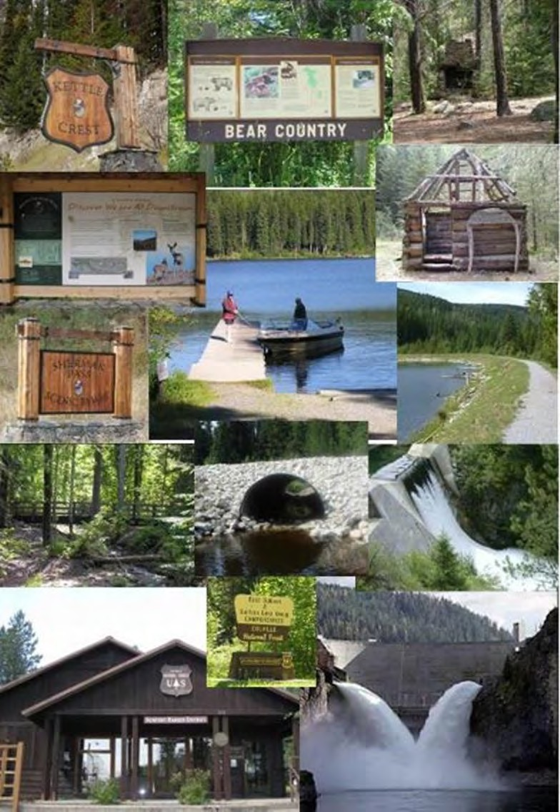

Forest Transportation System - Access System (AS)
All roads, trails, bridges and docks that are managed by the Forest to provide access on National Forest System lands are referred to in this document as the access system.

Desired Conditions
FW-DC-AS-01. Access System
The access system of authorized roads, bridges, trails, and docks is safe and sustainable; responds to administrative and public needs to the extent practicable; meets obligations to public and private cooperators; and is actively managed and adjusted to respond to and balance changing social, ecological, and economic conditions.
The system provides public and administrative access where suitable and supports forest management objectives. Road and trail rights-of-way to access National Forest System lands address public needs and facilitate planned resource activities. All National Forest System roads and trails have legal access for crossing non-National Forest System lands.
The system is maintained commensurate with maintenance levels, levels of use, and available funding. Roads, trails, and areas that are open to motor vehicle use are designated through the motor vehicle use map. The access system (including non-system and unauthorized roads) are assessed at the sub-watershed scale. Determinations regarding excess National Forest System, non-system, and unauthorized roads are made at the project level.
The size of the access system is such that each road and trail can be maintained to its assigned maintenance level and each bridge meets structural standards. Maintenance standards are set considering access needs, use, environmental impacts, and the ability to fund long-term maintenance needs. All commercial users and other authorization holders using National Forest System roads share in the costs of maintaining the roads they use.
FW-DC-AS-02. Trail System − Motorized and Non-Motorized
A variety of summer and winter system trails provide a range of difficulty and seclusion levels for the various user types; are located in diverse ecological, geological, and scenic settings; and minimize user conflicts and impacts to natural and cultural resources. Destination and loop opportunities of various lengths are available for a variety of uses.
Trails are defined, marked, and easily identified on the ground.
A maintained and environmentally sound trail system is in place, providing for user safety and access to locations of interest and the use of the Forest (e.g., recreation, minerals, vegetation treatment, and fire protection) while protecting the natural and cultural resources through which the trail system passes.
Motorized access and travel occurs on a well-designed system of designated National Forest System roads and motorized trails that provide loop-riding opportunities, connect trail systems, access communities, and link with popular dispersed camping areas.
Trails accessible from populated areas are available for non-motorized opportunities in blocks of forest that are free from the sights and sounds of motorized recreation.

The trail system is accessible from local communities, State, county, and local public roads and trails.
FW-DC-AS-03. Trail System – Motorized and Non-Motorized
All system trails, motorized and non-motorized, will be managed for high SIO in the immediate foreground distance zone (up to 300 feet unless no alternatives exist) and would assume the SIO for the management areas for middleground SIO.
FW-DC-AS-04. Connections
Where feasible, Forest Service recreation sites are connected to each other and to adjacent communities through pathways, trails, bike lanes, and waterways providing opportunities for both motorized and/or non-motorized modes of travel.
FW-DC-AS-05. Wilderness Trails
Wilderness trails provide for administrative and public use. They provide for the enjoyment of wilderness in a variety of settings and with varying degrees of challenge and opportunities for solitude. Trails that function as the main arterials to distribute use across the trailed portions of the wilderness or access high-use destinations generally receive regular maintenance. Side trails are typically more primitive and may be maintained less frequently. Loop opportunities of various lengths are available.
FW-DC-AS-06. Developed Recreation Sites
Roads accessing developed recreation sites (such as campgrounds, day use sites, and trailheads) are maintained at a level generally accessible by passenger vehicle.
FW-DC-AS-07. Managing User Conflicts on Multiple-Use Trails
Trail managers should be proactive in identifying potential user conflicts on multiple-use trails, encourage user participation in developing solutions to new and existing sources of conflict, and use the best management practices identified through research to minimize user conflict.

Objectives
FW-OBJ-AS-01. Designated Routes for Off-Highway Vehicle Use
Motorized mixed-use road designations are reviewed and an average of one new off-highway vehicle route is designated annually to achieve one or more of the following objectives: create loop-riding opportunities, connect camping areas, access destination overlooks, move routes away from ecologically or culturally sensitive areas, and connect communities through and to the forest. Coordinate designations with a community collaborative that could include local motorized recreation groups, counties and conservation groups to determine priority areas for selection, designation and monitoring.
FW-OBJ-AS-02. Trail Management
During the expected 15 years of plan implementation, improve drainage, water crossing and trail layout on 5 percent of the Forest’s trail system designed for mountain bikes, motorized use, and pack stock.
FW-OBJ-AS-03. Trail Maintenance
Annually, maintain at least 20 percent of the Forest’s motorized and non-motorized trail system.

Standard
FW-STD-AS-01. Cross-country Over-snow Vehicle Use
Cross-country over-snow vehicle use will be discontinued for the season when areas no longer allow for continuous over-the-snow travel to protect other resources such as soil and vegetation.

Guidelines
FW-GDL-AS-01. Winter Use of Roads
In the winter, when and where specified, over-the-snow recreational use (either motorized or non-motorized) may be accommodated. Roads may be plowed to accommodate management activities such as winter logging or access to winter recreation sites such as Sno-Parks.
FW-GDL-AS-02. Wilderness Trail Structures
Wilderness trail structures should be constructed of native materials when possible. The use of non-native fasteners is an acceptable practice.
FW-GDL-AS-03. Over-snow Vehicle Use on Roads
Over-snow vehicle use should be discontinued for the season when roads no longer allow for continuous over-the-snow travel to protect the road base.
FW-GDL-AS-04. Temporary or Limited Access
Acquire rights-of-way across non-National Forest System lands as needed to meet resource management objectives. Rights-of-way are acquired from landowners using easements, term easements, limited easements, or permits for roads crossing private lands. Temporary or limited rights-of-way may be acquired when landowners are unwilling or unable to grant full public access, or when permanent access is not in the public interest or necessary to address long- term resource management objectives.
FW-GDL-AS-05. Motorized and Non-motorized Trails
New trails or additions to existing trails should include destinations and loops to provide for a variety of opportunities.
New trails should be located to avoid meadows, wetlands, riparian areas, stream bottoms, sacred sites, and areas with high concentrations of significant archaeological sites. The number of stream crossings should be minimized or mitigated to reduce impacts to aquatic species.
Meadow crossings should be designed or redesigned to maintain or restore hydrologic function.
Trail markings (e.g., signs, blazes) should be designed to complement the character of the surrounding lands.
FW-GDL-AS-06. Prohibition on Road Construction and Reconstruction in Inventoried Roadless Areas
Road construction and reconstruction activities will comply with requirements of the Roadless Area Rule in effect at the time project-level decisions are made. As of the implementation of this forest plan, the Roadless Area Rule in effect is the 2001 Roadless Area Conservation Rule. In this Rule, direction on road construction and reconstruction activities can be found in Subpart B of 36 CFR 294.12 (b).

Maintenance of classified roads is permissible in inventoried roadless areas per 36 CFR 294.12 (c).
See FEIS Appendix F for maps of inventoried roadless areas.

Heritage Resources (HR)
Remnants of past and current human activities and events that reflect continuous use by Native peoples and the exploration, settlement, and management by Euro-American cultures can be found throughout the Forest. Cultural resources are nonrenewable with few exceptions. Once the resource has been disturbed, damaged, altered, or removed, nothing can recover the information that could have been gained through analysis or replace the opportunity for individuals to understand and experience the site.
All resources on a national forest are managed in accordance with applicable laws, regulations, executive orders, and agency directives. Management of heritage resources is unique in that management is addressed primarily through law, regulation, executive orders and Forest Service Manual and Forest Service Handbook direction with no need for additional forest plan direction. These include, but are not limited to the following, and, over the life of the plan, there may be changes to these.
LAWS AND EXECUTIVE ORDERS
Antiquities Act of 1906 – Provides for the protection of historic and prehistoric remains or any object of antiquity on Federal lands; establishes sanctions for unauthorized destruction or appropriation of antiquities: and authorizes scientific investigation of antiquities on Federal lands, subject to permit and regulations. Paleontological resources fall under the authority of this Act.
The National Historic Preservation Act of 1966, as amended 2004 – Establishes a program for the preservation of prehistoric and historic properties throughout the Nation. It makes historic preservation national policy. Section 106 of the Act directs that Federal agencies shall take into account the effects of their actions on heritage resources. Section 110 of the Act directs Federal agencies to take responsibility for the preservation and management of heritage resources that are owned or controlled by the agency.
The Archaeological Resources Protection Act of 1979 – Establishes various legal penalties for the unauthorized removal of antiquities or artifacts from Federal property, and /or the damage or destruction of heritage properties on Federal lands.
The Native American Graves Protection and Repatriation Act of 1990 – Defines the rights of lineal descendants and Indian tribes to Indian skeletal remains and items or artifacts of cultural patrimony that may be held by Federal agencies or institutions.
National Environmental Policy Act of 1969 and National Forest Management Act of 1976 – Require Federal agencies to preserve important prehistoric, historic, cultural and natural aspects of national heritage.
Executive Order 11593, Protection and Enhancement of the Cultural Environment – Declares that the Federal Government shall take the lead in preserving, restoring, and maintaining the historic and cultural environment of the Nation; directs the Federal Government to contribute to the preservation and enhancement of non-federally owned sites; directs Federal agencies to locate, inventory and nominate sites to the National

Register of Historic Places; directs Federal agencies to ensure that cultural resources are not inadvertently damaged, destroyed, or transferred from Federal ownership before the completion of inventories and evaluation of sites worthy of National Register nomination
Executive Order 13287, Preserve America – Directs Federal agencies to build partnerships with local governments, Indian tribes, and the private sector to preserve heritage properties, and promote heritage tourism. Agencies are to improve planning and accountability for heritage properties, assess the current status of heritage properties, track progress in managing heritage properties, and improve the stewardship of heritage properties.

Desired Condition
FW-DC-HR-01. Consistency with Law, Regulation, Executive Orders, and Directives
Heritage resources on the national forest, including known Native American sacred sites and traditional cultural properties, are preserved, protected, and/or restored per applicable law, regulation, executive order, and directives. As appropriate, eligible and historically significant heritage properties are listed on the National Register of Historic Places. The Forest’s priority heritage assets are protected and preserved per applicable law, regulation, executive order, and directives. Opportunities to connect people with the heritage of the land are provided.
Forest facilities that are eligible for the National Register of Historic Places are available for continued use, for Forest administration, public recreation and interpretation, and Tribal events, as appropriate. Important archaeological artifacts and sites are protected per applicable law, regulation, executive order, and directives.

Standard
FW-STD-HR-01. Heritage Program Managed to Standard
Continue to follow Forest Service Manual (FSM) 2360 - Heritage Program Management. FSM 2360 provides direction on heritage program management.

American Indian Rights and Interest (AI)
American Indian tribes are sovereign nations. The United States has a fiduciary relationship with Tribal governments as set forth in the United States Constitution, statutes, executive orders, court decisions, and agreements. This relationship is also known as the Federal Trust Duty to American Indians. Therefore, the Forest Service has certain responsibilities to American Indian tribes to fulfill the government’s Federal Trust Duty. In meeting these responsibilities, the Forest Service must administer their programs in a manner that does not interfere with Tribal rights and resources.
Direction includes, but is not limited to the following, and, over the life of the plan, there may be changes to these.
LAWS AND EXECUTIVE ORDERS
The American Indian Religious Freedom Act of 1978, as amended – Legislation passed by Congress intended to protect and preserve the traditional religious rights of American Indians, Eskimos, Aleuts, and Native Hawaiians. The Act requires Federal agencies to

consider the effects of their programs on places and practices of religious importance to American Indians, Eskimos, and Native Hawaiians.
The Native American Graves Protection and Repatriation Act of 1990 – Defines the rights of lineal descendants and Indian tribes to Indian skeletal remains and items or artifacts of cultural patrimony that may be held by Federal agencies or institutions.
Food, Conservation and Energy Act of 2008 (2008 Farm Bill) (Public Law 110-246, 122 Stat.1651) Title VIII – Forestry, Subtitle B – Cultural and Heritage Cooperation Authority. Authorizes the Secretary of Agriculture to provide forest products to Indian tribes for traditional and cultural purposes; to protect the confidentiality of certain information, including information that is culturally sensitive to Indian tribes; to utilize National Forest System land for the reburial of human remains and cultural items, including human remains and cultural items repatriated under the Native American Graves Protection and Repatriation Act; prevent the unauthorized disclosure of information regarding human remains or cultural items reburied on National Forest System land; to ensure access to National Forest System land, to the maximum extent practicable, by Indians and Indian tribes for traditional and cultural purposes; to increase the availability of Forest Service programs and resources to Indian tribes in support of the policy of the United States to promote Tribal sovereignty and self-determination; and to strengthen support for the policy of the United States of protecting and preserving the traditional, cultural, and ceremonial rites and practices of Indian tribes, in accordance with the American Indian Religious Freedom Act (42 United States Code 1996).
Tribal Forest Protection Act of 2004 (Public Law 108-278) – Authorizes the Secretary of Agriculture and the Secretary of the Interior to enter into an agreement or contract with Indian tribes meeting certain criteria to carry out projects to protect Indian forest land.
Executive Order 13175, Consultation and Coordination with Indian Tribal Governments – Directs Federal agencies to establish regular and meaningful consultation and collaboration with Tribal governments prior to taking actions that would affect tribes.
Executive Order 13007, Indian Sacred Sites – Directs Federal agencies to protect sacred sites identified by federally recognized tribes and accommodate access to and ceremonial use of Indian sacred sites where feasible, avoid adversely affecting the physical integrity of such sacred sites and requires consultation with tribes to learn Tribal concerns for sacred sites on public lands.

Desired Conditions
FW-DC-AI-01. Traditional and Cultural Uses
Traditional and cultural use information, as provided by federally recognized tribes, is treated with respect and integrated into natural resource management planning efforts with appropriate sensitivity to the tribe’s views regarding information sharing. American Indian values are fully considered in planning proposed actions on the Colville National Forest. The Forest maintains sustainable products, uses, values, and services that contribute to the American Indians’ way of life and cultural integrity. Access to traditional resources and sacred places is considered in all planning efforts.

FW-DC-AI-02. Tribal Forest Products
The Colville National Forest recognizes and maintains culturally significant species and the habitat necessary to support healthy, sustainable, and harvestable plant and animal populations to ensure that rights reserved by Tribes in treaties are protected or enhanced. The Colville National Forest recognizes, ensures, and accommodates Tribal access to the Forest for the exercise of reserved treaty rights and cultural uses.

Objectives
FW-OBJ-AI-01. Communication Plan
Over the life of the forest plan, a cooperatively developed communication plan establishes coordination with each federally recognized Tribe with historical or treaty interests in Colville National Forest lands.
FW-OBJ-AI-02. Tribal Consultation
Consult with Tribes when forest management activities may impact treaty rights and/or cultural sites and cultural use, according to individual Tribal communication plans, consultation protocols, or policies.

Lands and Special Uses (LSU)
The Forest “Lands” program includes activities such as Landownership Adjustment, Boundary and Title Management (including land exchanges and acquisitions, granting or accepting of easements), and other activities that are primarily real estate-type actions. The goals of this program include: (1) consolidating landownership patterns to meet the objectives of forest land and resource management plans and to improve land management efficiencies; (2) securing and protecting the rights, title, land, and resources of public land from unauthorized use and occupancy; (3) providing legally defensible boundaries and accurate, complete landownership records of National Forest System lands. These program activities will continue and do not change across the action alternatives.
Land acquisition and conveyance contribute to:
- The maintenance, restoration, and enhancement of plant, wildlife, and riparian aquatic and riparian-dependent resources and habitat including aspects of connectivity, foraging and reproduction for threatened and endangered and species of concern.
- The protection of significant historical or cultural resources.
- The enhancement of recreation opportunities and protection of scenic values.
- The protection of congressionally designated areas such as wilderness.
- Obtaining access to public land.
- A reduction in unauthorized use and occupancy.
- A reduction in isolated properties.
- Increased management efficiencies.
All uses of National Forest System lands, improvements, and resources, except those provided for in the regulations governing the disposal of timber, minerals, and the grazing of livestock, are designated “special uses.” The Forest administers a variety of uses under

special-use permits, leases, or easements. Management area direction applies to the location where improvements are authorized by the special-use permit, lease, or easement.
Many administrative sites, recreation areas, seed orchards and other areas with high capital investments or resource values have been withdrawn from some or all of the general land and mining laws. Older withdrawals usually have no expiration or termination date. Withdrawals are now subject to Section 204 of the Federal Land Management Policy Act of 1976, have a maximum term of 20 years, and are subject to renewal. The Forest periodically submits applications for withdrawal renewals, for new areas to be withdrawn, or requests the revocation of a withdrawn area when it is no longer needed or suitable for the reasons withdrawn. The Secretary of the Interior has the authority to grant or revoke withdrawals.

Desired Conditions
FW-DC-LSU-01. Lands and Special Uses
Achieve a land ownership pattern and right-of-way acquisition pattern that improves resource management and administration, and provide for uses that are in the public interest and cannot be provided on private land.
FW-DC-LSU-02. Authorization
All occupancy and use of National Forest System lands is properly authorized.
FW-DC-LSU-03. Utility Corridors and Communication Sites
Utility corridors and communication sites are used and maintained for operating specialized infrastructure. Utility corridors and communication sites provide for the efficient movement and distribution of electricity, petroleum products, water, other lineal special uses, and communication signals across National Forest System lands. Communication sites are designated for private, administrative, and commercial use. Commercial sites are provided, within the ecosystem’s capability, where essential to meet a demonstrated public need. The Forest telecommunications system adequately supports Forest resource management.
Designated utility corridors and communication sites would be developed to maximum capacity before new corridors and communication sites are considered for development.
Infrastructure and vegetation within energy corridors and communication sites are managed to ensure operation of permitted uses blend with the surrounding desired vegetative pattern where possible to meet other resource objectives. Infrastructure and vegetation would be managed to improve safety and resilience to wildland fire, provide screening, and contribute to a natural-appearing landscape character setting appropriate to the surrounding SIO. A map of these sites is included in appendix G.
FW-DC-LSU-04. Water Collection and Delivery Systems
Existing water diversions or developments do not measurably alter natural processes of aquatic ecosystems. Effects to other resources are minimized by incorporation of best management practices and other resource protection measures. New water developments, diversions, or allowance for occupancy to divert water from National Forest System lands generally do not occur in wetlands and their water source areas, and are discouraged in habitats where endangered, threatened, or species of concern reside.

FW-DC-LSU-05. Recreation Special Uses
Approved recreation special use authorizations support activities that enhance or expand the variety of recreational opportunities available on the Forest, are compliant with the Forest’s recreation strategy, and are dependent on the resources and settings found within the Forest’s boundary. National Forest lands where special use activities have occurred show little evidence of impacts.
FW-DC-LSU-06. Withdrawals
The Forest submits applications for withdrawals from the mining laws, after appropriate level NEPA decisions have been made, and where the Forest determines mineral potential is high enough that withdrawal is appropriate and necessary to protect capital investment or sensitive resource values. The Forest requests revocation of withdrawals when the lands are no longer needed for the purpose or programs intended for by the original withdrawal.

Standards
FW-STD-LSU-01. Land Acquisition, Conveyance, and Exchange
The Forest has a consolidated land ownership pattern that contributes to ecosystem resilience, allows reasonable public and/or Forest Service administrative access where suitable, and improves land management efficiencies. There is a downward trend in the number of isolated, non-Federal inholdings that occur within the proclaimed Forest boundaries. Congressionally designated areas lack private inholdings.
FW-STD-LSU-02. Boundary Management
Boundaries are surveyed, posted, and maintained for visibility in support of all resource management activities. Identifiable boundaries and accurate landownership records protect National Forest System lands and reduce unauthorized use and occupancy.
FW-STD-LSU-03. Administration of Authorizations, Trespass and Encroachments
Authorizations are administered to standard. Trespass and encroachments onto National Forest System lands are identified and prioritized for removal.
FW-STD-LSU-04. Communication Site Plans
Each commercial communication site is operated and maintained under an approved Communication Site Plan, and designated low-power, non-broadcast.
FW-STD-LSU-05. Utility and Communications Structures
New structures will be designed to meet prescribed SIOs. Efforts will be made to rehabilitate existing structures that do not currently meet SIOs.
FW-STD-LSU-06. Commercial Services in Wilderness
When authorizing services that have been determined necessary for wilderness purposes ensure that:
- the service provides appropriate wilderness activities such as stock packing, hunting, backpacking, or support of other authorized activities such as research.
- the service can be authorized in locations and times that would not constrain the non- outfitted public.

- activities are consistent with the desired condition and guidelines of the Wilderness Resource Spectrum zone where the service will be provided. Services should be authorized only where the provider can meet the requirements to operate in this Wilderness Resource Spectrum zone.
- services adhere to established party size limitations.

Guidelines
FW-GDL-LSU-01. Boundary Marking in advance of Projects
The need for landline boundary marking is identified during project planning. Marking and posting of Forest Service boundary lines would occur prior to project implementation.
FW-GDL-LSU-02. Authorized Improvements
Private or publicly owned facilities and improvements are authorized through an appropriate special use authorization when they meet forest plan direction and are feasible within resource constraints (examples include roads, utility lines, or communication sites). Site improvements will be removed when they are no longer needed or the authorization terminates.
FW-GDL-LSU-03. Trespass and Encroachment Resolution
Trespass and encroachment cases are resolved at the earliest time possible. Authorizations may be issued for short periods to allow the owner of the improvements time to plan, budget and implement the removal of the trespass or encroachment.
FW-GDL-LSU-04. Energy Corridors and Communication Sites
Designated energy corridors and communication sites are used to maximum capacity, where feasible, before additional corridors and sites are considered to minimize the number of acres encumbered by rights-of-way, leases, permits, or easements. New corridors and sites would be located in a way that minimizes effects to forest resources and values. Forest corridor designations are consistent with such designations on adjacent federal lands. See appendix G for a map of these locations.
FW-GDL-LSU-05. Scenic Integrity: New and Upgraded Facilities
When new facilities or upgrades to existing facilities are proposed, permit and lease holders would meet the intent of the site’s surrounding SIO by using Forest Service approved site designs, building materials, and colors that meet that objective. See SIO map and scenic viewshed tables in appendix D.
FW-GDL-LSU-06. Withdrawal Requests and Revocations
Recommend withdrawals for research natural areas, portions of the Pacific Northwest National Scenic Trail and other areas where the Forest determines mineral potential is high and mining activity could materially affect those areas. Request revocation of withdrawals where they are no longer needed, such as the former location of the Chewelah Ski area.
FW-GDL-LSU-07. Non-commercial Group Use, Recreation Events, and Outfitter and Guide Permits
Use should be authorized on lands where vegetation or species habitat conditions are stable or resilient to potential impacts of the authorized use.

Authorizing use in locations or times that would adversely displace or disrupt other recreating public should be avoided.
Commercial outfitters and guides should not be authorized to use developed campgrounds so those sites remain available to non-commercial forest visitors.
Commercial outfitters and guides may be authorized use of range developments when there is no conflict with allotment management.
Large group and recreation event special uses should not be authorized within wilderness, recommended wilderness, eligible “wild” river corridors, or research natural areas to protect the unique character of these areas.
Constructed features should be maintained to standard or removed when no longer needed.

Livestock Grazing (LG)
COMMERCIAL AND RECREATIONAL
Permitted livestock grazing on National Forest System lands is managed through a permit system that identifies allotments and specific conditions for use of the allotments. The Forest Plan provides overall guidance for grazing, with allotment management plans providing specific guidance for each allotment. Recreational grazing is an activity associated with the recreational use of pack and saddle stock such as horses, mules, llamas, and goats. Plan components apply to both commercial and recreational grazing unless specifically stated otherwise.

Desired Conditions
FW-DC-LG-01. Plant Community Structure and Diversity
The desired structure and diversity of native herbaceous plant communities (including highly palatable forage species) are maintained or enhanced through proper livestock management principles. Rangelands consisting of native plant communities such as open conifer forests, low- elevation grasslands, shrub-steppe plant communities, and meadows are not adversely affected by invasive plant species due to the low coverage present, have stable or improving ecological conditions, and are resilient to disturbance events. Rangelands with significant non-native plant components have stable or improving soil stability.
FW-DC-LG-02. Economic and Social Contributions
Rangelands and forestlands provide forage for use by both livestock and wildlife. Grazing continues to be a viable use of vegetation on the Forest. Availability of lands identified as suited for this use contributes to providing animal products, economic diversity, open space, and promotes cultural values and a traditional local life style. Allotments are generally grazed on an annual basis.
Consistent with sustaining other resource desired conditions, a viable level of forage is available for use under a grazing permit system where use typically occurs on an annual basis, generally between June and October. Riparian and upland areas within allotments reflect ecological conditions supporting the desired conditions, including those described in the Wildlife, Aquatic and Riparian, Soil, and Vegetation Desired Conditions sections in this Forest Plan.

FW-DC-LG-03. Deer and Elk Forage on Grazing Allotments
Adequate browse and forage occurs on deer and elk summer and winter ranges within commercial grazing allotments during the critical winter period of December 15 to April 1.
FW-DC-LG-04. Recreation and Livestock Conflicts
Conflicts between the recreating public and livestock are limited. Management actions are implemented that strive to minimize identified areas of conflict while maintaining financially and operationally viable allotment management systems.

Objectives
FW-OBJ-LG-01. Range Improvement Projects
During the expected 15 years of plan implementation, recondition or reconstruct an average of 1 to 4 percent of the existing range infrastructure on National Forest System lands annually.
Such range infrastructure would include water developments, hardened fords, livestock handling facilities, and fences.
Within 5 years of a decision being made to implement an Allotment Management Plan, relocate or reconstruct, at least 75 percent of the identified range infrastructure (for example, water developments, fences, loading chutes, and holding structures) that has become non-functional or in need of replacement.
FW-OBJ-LG-02. Braided Trails
During the expected 15 years of plan implementation, 75 percent of trails that are difficult to follow as a result of braiding caused by trailing cattle will have reassurance markers installed to ensure trail users are able to follow the established trail tread and decrease an existing source of conflict between recreationists and livestock.

Standard
FW-STD-LG-01. Stock Driveways
Do not authorize stock driveways¹⁵ along nationally designated (Recreation and Scenic) trails.

Guidelines
FW-GDL-LG-01. Threatened and Endangered Species Habitat in Riparian Areas in Grazing Allotments.
If livestock grazing occurs within areas used by threatened and endangered species, manage for conditions for the species or its prey.
FW-GDL-LG-02. Permitted and Recreational Grazing in Congressionally Designated Wilderness
Stock should be managed to discourage congregating on trails, destination areas, cultural sites, and fragile plant communities.

15 A stock driveway is a term that is used specifically for designating a route for “Livestock trailed over an established driveway where there will be no overnight stops on land administered by the Forest Service.” Further clarification for designation of a stock driveway is found in Forest Service Manual 2200 Chapter 2230.

FW-GDL-LG-03. Recreation Conflicts
Braided trails resulting from grazing should have reassurance markers installed at intersections or the non-system trail, where practical, should be restored or blocked if doing so would successfully reduce livestock use and trail braiding over the long term. Salting, water development design, and turn-out/gathering locations should be addressed in the development of annual grazing plans to avoid livestock impacts to system trails, recreation areas, scenic vistas, etc.

Minerals (MIN)
These plan components cover mineral and geological activities that take place within National Forest System lands. The Forest has low potential for coal, oil, gas, and geothermal resource development, and few paleontological resources. The Forest is actively involved in the surface resource management and administration of locatable mineral exploration and development. The Forest Service consents to the development of leasable minerals on National Forest System lands and cooperates with the United States Department of Interior to administer the lawful exploration and development of leasable minerals beneath the national forest. The Forest manages the discretionary disposal of salable minerals from National Forest System lands, which includes the sale or free use of common variety mineral materials such as sand, gravel, and stone, and similar materials.
Abandoned mine sites resulting from historical mining activities are administered by the Forest to provide for public safety, and manage the release or threatened release of hazardous substances. Desired conditions, standards, and guidelines for groundwater are located in the Watershed Analysis section in this Plan. Additional desired conditions, standards and guidelines for mineral resources are found in the Riparian Management Area and Recommended Wilderness Area sections in this Plan.

Desired Conditions
FW-DC-MIN-01. Mineral Materials Availability
Salable mineral materials are available to Federal, State or local governments for public works, and to the public at the discretion of the authorized officer based upon agency needs, public interest and community needs, material availability, resource protection and capability.
Production and administration of mineral material would meet the demand consistent with the management of other surface resources as long as the benefits derived exceed the cost and impacts of resource disturbance.
FW-DC-MIN-02. Reclamation and Extraction
Approved mining operations include concurrent, interim and post-operation reclamation measures to ensure the long-term function and stability of resources including, but not limited to, soil; vegetation; water quality; aquatic, riparian and upland habitats; and scenic integrity objectives.
FW-DC-MIN-03. Abandoned Mine Sites
Abandoned mine land (AML) site inventories will be updated periodically. AML sites are prioritized to implement closures and clean-up based on public safety and environmental risks. Allocated minerals funding will be leveraged with other funding opportunities to conduct AML work.

Standards
FW-STD-MIN-01. Mineral Leasing
Consent decisions to allow mineral leasing will provide Bureau of Land Management (BLM) stipulations for lease management. Once leased, the Forest will actively coordinate and consult with BLM regarding lease exploration and development activities. In consultation with the BLM, the Forest will recommend BMPs and mitigation as Conditions of Approval to support attainment and maintenance of management area desired conditions.
FW-STD-MIN-02. Mining Operations in Wilderness Areas
All Plans of Operations submitted by an operator which propose significant surface disturbing activities in designated Wilderness Areas will require an appropriate examination of validity prior to approval.

Guidelines
FW-GDL-MIN-01. Bat Habitat Surveys or Assessment
Prior to closing abandoned mine land features, bat occupancy surveys or habitat assessments would be conducted to assess whether the feature is or has been occupied, or provides actual or potential habitat. The abandoned mine land closure type would be determined after bat occupancy or habitat potential is determined.
FW-GDL-MIN-02. Mining Claim Corners
Mining claim corners and improvements will be protected during Forest management activities.
FW-GDL-MIN-03. Mineral Withdrawals
Minimize the national forest acreage to be withdrawn from mineral entry to that necessary for protecting dedicated areas such as administrative sites, developed recreation sites, wilderness, research natural areas, seed orchards, wild and scenic rivers, and other areas where capital investment or resource values conflict with potential mineral exploration and development.

Public Awareness (PA)
This guidance covers the information, education, collaboration, and interpretation activities the Forest engages in. Specific methods and materials used to accomplish the desired condition are under the discretion of the Forest and are guided by various rules, regulations, and policies.

Desired Conditions
FW-DC-PA-01. Information, Education, and Participation
A broad range of people in rural, urban, and underserved populations understand the complexities of managing natural resources for the full range of benefits associated with the multiple use mission of the Forest Service. A multi-faceted outreach strategy aims to help the public understand:
- the natural and cultural history of the national forest.
- important themes of ecological processes, including fish, plant, and wildlife species habitat needs and the importance of disturbance processes.

- the human benefits of the National Forest System, including recreational and commodity values.
- forest regulations and resource protection practices.
- safety practices.
- potential impacts of human activity on resources, and how to participate effectively in national forest decision-making activities.
Youth are introduced to the natural world and resource management careers. Outstanding features of the Forest, such as recreation areas, national trails, and scenic byways are interpreted for the public where appropriate. Opportunities for viewing wildlife and plants are present and the public is aware of the opportunities.
FW-DC-PA-02. Cooperation and Community Involvement
Cooperative programs, such as agreements, activities, grants, volunteers, and partnerships, are occurring with Federal, State, and county agencies; other nongovernmental organizations; and individuals to help achieve Forest goals and improve overall resource management.
Information, interpretation, and education programs that communicate forest resource conditions and opportunities are provided.

Recreation (REC)
This guidance applies to recreational settings and natural resource-based recreational activities offered on the Forest, from developed opportunities to those that are primitive. Recreational settings and natural resource-based recreational activities are managed to meet the recreation opportunity spectrum (ROS) classifications in which they occur as identified on the ROS map in appendix F.

Desired Conditions
FW-DC-REC-01. Recreation Settings and Experiences
The Forest provides a spectrum of high quality, nature-based outdoor recreational settings and opportunities varying from primitive to urban and dispersed to developed where visitors can experience the biological, geological, scenic, and cultural resources of the Forest, with an emphasis on the natural-appearing character of the forest.
Dispersed recreation opportunities are available (such as camping, backcountry skiing, boating, mushroom and berry picking, hunting, and fishing) and dispersed recreation sites (such as campsites, vistas, and parking areas) occur in a variety of ROS classes throughout the Forest.
Facilities for developed and dispersed recreation activities are appropriate for the ROS class and scenic integrity objective of the location and are designed to protect natural and cultural resources.
Access, parking, regulations, orientation, and safety information are in place to provide safe and enjoyable developed and dispersed recreation experiences.
Inventoried roadless areas maintain their overall roadless character (see FEIS appendix F for maps of roadless areas).

Recreation activities occur within the ability of the land to support them and with minimal user conflicts.
Recreation enhances the quality of life for local residents (such as social interaction, physical activity, and connection with nature), provides tourist destinations, and contributes monetarily to local economies.
Recreation opportunities provide for a variety of skill levels, needs, and desires in partnership with recreation permit holders, private entities, volunteer groups, community groups, and State, Federal, and Tribal governments.
Visitors can easily access information about recreation activities and safe and proper use of the Colville National Forest.
Recreation use does not negatively affect wildlife habitat and populations. Negative interactions between people and wildlife are minimized.
The Colville National Forest is free from vandalism and refuse. “Leave No Trace” principles are practiced.
FW-DC-REC-02. Built Environment - Structures
The structures associated with the built environment that supports dispersed and developed recreation are planned, designed, constructed, and maintained to meet requirements for accessibility and blend into the surrounding landscape.
FW-DC-REC-03. Sustainable Recreation
The recreation program is enhanced by working with multiple interests and partners who provide funding, expertise and labor to enhance, restore, and maintain recreational opportunities that are aligned with community goals.

Standard
FW-STD-REC-01. Built Environment - Structures
All new structures associated with the built environment blend with the surrounding landscape and meet the ROS class and SIO design elements associated with the natural setting in which they are located. All new structures meet the appropriate regulations for accessibility. Existing facilities are reconstructed or maintained to meet the ROS and SIO design standards for the area in which they are located and to meet requirements for accessibility.

Guidelines
FW-GDL-REC-01. Recreation Opportunities
Recreation-related project-level decisions and implementation activities should be consistent with mapped classes and setting descriptions in the ROS and meet appropriate screening and SIOs.
Food and other items that attract wildlife should be managed to prevent reliance on humans and to reduce human-wildlife conflicts.
Constructed features should be maintained to standard or removed when no longer needed.

FW-GDL-REC-02. Dispersed Recreation
In dispersed areas, the priority for facilities or minor developments should be access and protection of the environment, rather than the comfort or convenience of the visitors.
FW-GDL-REC-03. Site Design
The Rocky Mountain Province architectural style should be incorporated in the design of recreation facilities to remain consistent with the Forest’s existing structures and the direction contained in the Built Environment Image Guide.

Renewable Forest Products (RFP)
Forest products are products collected from the national forest for commercial, personal, Native American Tribal, educational, and/or scientific purposes. This section refers to two categories of forest products: those referred to as “special forest products” as defined by FSH 2409.18-80, 2008, and those considered merchantable wood products.
Examples of special forest products can include but are not limited to bark, berries, boughs, bulbs, burls, Christmas trees, cones, ferns, firewood, forbs, mushrooms, grasses, mosses, nuts, pine straw, roots, sedges, seeds, transplants, tree sap, wildflowers, fence material, posts and poles, shingle and shake bolts, and rails.
Examples of merchantable timber products can include, but are not limited to sawtimber, pulpwood, non-sawlog material removed in log form, biomass and other wood fiber products.

Desired Conditions
FW-DC-RFP-01. Commercial Products
Provide a sustainable level of timber products for current and future generations. Production of timber from National Forest System lands contributes to an economically viable forest products industry and regularly meets the average decadal allowable sale quantity. The Allowable Sale Quantity (ASQ) is 67 MMBF and the Long Term Sustained Yield (LTSY) is 97.4 MMBF¹⁶.
FW-DC-RFP-02. Products Available
A variety of renewable forest products of social, spiritual, and economic value are reasonably available to the public. Special forest products and merchantable timber products are ecosystem services provided to contribute to economic sustainability, social desires, or cultural needs.

Guideline
FW-GDL-RFP-01. Special Permits
Harvest of special forest and botanical products is approved through an appropriate permitting system when such harvest is done in a sustainable manner, while protecting resources and continuing to provide products for current and future generations.

16 The ASQ reflects the quantity of timber that may be sold from lands suitable for timber production, within tree utilization standards, for the first decade of the plan, given an unlimited budget. The LTSY is the highest uniform wood yield that may be sustained given multiple-use objectives on lands managed for timber production.

Scenery (SCE)
Scenery is managed through the scenery management system. The desired conditions for scenery are presented in the plan components below, and in the valued landscape character descriptions, scenic viewshed tables, and scenic integrity objective (SIO) map in appendix D. The map prescribes the range of SIOs for all landscape areas (acres).
The valued landscape character descriptions do not replace other desired conditions, such as vegetation. Rather, the vegetation desired conditions are a key component of the valued landscape character.
SIO zones overlay the management areas. The direction for scenery management applies to all management areas. Applicability of plan direction is guided by the principle that where there is an overlap of scenery management direction with other plan components, the most restrictive plan direction applies. For example, a scenic byway can overlay a Wild and Scenic River and Riparian Management Area, where all sets of forest plan components might appear to apply. However, in this case, the direction for the management area with the most restrictive SIO would apply.

Desired Condition
FW-DC-SCE-01. Maintain and Enhance Scenery
The scenery of the Forest enhances the experience of visitors and contributes to the quality of life of communities whose backdrop is National Forest System lands. The valued landscape character is maintained and enhanced and SIOs are met.
Opportunities exist to view high-quality scenery that represents the natural landscape character of the region and / or a landscape with unusual features. Views from key viewing locations (such as vista points, scenic pullouts, and interpretive sites) are not blocked by vegetation and are not affected by new structures and utilities. Vegetation management contributes to seasonal color and texture, age classes, and a variety of plant communities and maintains long- term vigor and health of the vegetation. Enhancement opportunities exist to increase positive scenic attributes where few currently exist, such as highlighting large tree boles or opening views to geologic features and distant viewpoints along viewsheds.

Objectives
FW-OBJ-SCE-01. Scenic Integrity Objectives
Within 5 years of plan approval, and every 5 years after, evaluate scenery management monitoring results and implement appropriate management adjustments with the emphasis on improving the sustainability of desired landscape character in landscape areas of highest expectations for scenic integrity levels in concern level 1 and concern level 2 scenic viewsheds.
FW-OBJ-SCE-02. Desired Landscape Character
During the expected 15 years of plan implementation, move 10 percent of travel route scenic viewsheds foreground and middleground areas of concern level 1 or concern level 2 toward meeting SIOs.

Standard
FW-STD-SCE-01. Maintain and Enhance Scenery
New structures will be designed to meet prescribed SIOs. Efforts will be made to rehabilitate existing structures that do not currently meet SIOs.

Guidelines
FW-GDL-SCE-01. Scenic Integrity Levels
Project-level activities should be planned and designed to meet the established desired SIOs assigned to the management area (see appendix D).
Short-term deviations (3 to 6 years) to the existing scenic integrity of an area should be limited to the immediate surroundings of the stand, recreation attraction, or feature of concern.
Rehabilitation actions may be taken when scenic integrity is compromised by atypical disturbances, such as uncharacteristic wildfires, insect or disease outbreaks, or floods. Treatments should not diminish the scenic quality more than the anticipated disturbance would have. Enhancement actions may be taken to increase positive scenic attributes in the viewshed, such as exposing large tree boles or geologic features for viewing.
In landscape areas where an ecosystem is out of the historical range of variability, the forest setting may exist at a lower scenic integrity during treatment activity and recovery to restore and sustain the landscape character to the assigned SIO. No more than one-third of project landscape area would be lowered by one scenic integrity level in sensitive scenic viewsheds where the SIO is high or moderate to avoid having too much landscape being altered in a short time frame and to minimize visual effects. Treatments would be implemented in phases over a longer (5 to 15 years or longer) time period if multiple treatments are needed to achieve the desired results. Up to 30 percent of a project area may be lowered from prescribed SIO by one level in a staged time frame (first treatment in 5 years, second treatment 5 to 10 years, third treatment 10 to 15 years, life of plan) depending on scenic concern sensitivity level, viewshed seen area, and scope of project.
FW-GDL-SCE-02. Rustic Architectural Style
Rustic architecture of the Rocky Mountain Province should be used when building new facilities at recreation sites and administrative compounds. Developments should be consistent with the history and landscape character of the site. Choose facility and structure design, color of materials, location, and orientation to meet the scenic integrity objective for the management area.
FW-GDL-SCE-03. Management Activities in Scenic Viewsheds
Management activities will be designed and implemented to achieve, at minimum, the level of scenic integrity assigned to the landscape area. (See appendix D for SIO map and Scenic Viewshed Table.)
FW-GDL-SCE-04. Rehabilitation of Scenic Viewsheds
Rehabilitate existing project areas and other areas that do not meet scenic integrity objectives. See appendix D for definitions of scenic integrity objectives/levels. Set priorities for rehabilitation considering the following:

- Relative importance of the area and amount of deviation from the scenic integrity objectives.
- Foreground of high public use areas has highest priority.
- Length of time it will take natural processes to reduce the visual impacts so that they meet the prescribed scenic integrity objectives.
- Length of time it will take rehabilitation measures to meet the prescribed scenic integrity objectives.
- Benefits to other resource management objectives to accomplish rehabilitation.
FW-GDL-SCE-05. Vegetation Management
Plan, design, and locate vegetation manipulation on a scale that retains the color and texture of the landscape character, borrowing directional emphasis of form and line from natural features.
FW-GDL-SCE-06. Nationally Designated Trails
National recreation trails and the Pacific Northwest National Scenic Trail on National Forest System lands will be managed for high SIO in the seen area from the foreground of the trail zone.

Integrated Pest Management (IPM)
Integrated pest management is needed on the Colville National Forest, often for invasive species and sometimes also for native pest species (for example bark beetles). We plan for response to damaging pests at programmatic and/or project levels to be able to rapidly respond to new outbreaks and infestations before they have the potential for widespread damage. The management direction in this section applies to all management areas forestwide, additional management area direction may be found within other management areas in chapter 3.

Desired Condition
FW-DC-IPM-01. Integrated Pest Management
Unwanted plant, animal (vertebrate and invertebrate), and pathogen species are prevented, suppressed, contained, controlled or eradicated. Native insects and plant and animal disease pathogens exist at endemic levels. Forests are managed for resilience to pests and pathogens and to maintain native plant communities. Proactive pest response plans are prepared, or existing plans reviewed, in cooperation with partners, to facilitate rapid response to new pest outbreaks and infestations.

Objective
FW-OBJ-IPM-01. Integrated Pest Management
Damaging plant, animal, and insect pest outbreaks are prevented, suppressed, contained, controlled, or eradicated in a timely manner in accordance with proactive pest response plans. New outbreaks are addressed within one year of detection through the life of the plan.

Standards
FW-STD-IPM-01. Integrated Pest Management
Use an integrated pest management approach to design projects to minimize or eliminate risks of adverse effects from treatment while effectively responding to the pest. Cooperate with other Federal, State, and county agencies and other citizens to take an all-lands approach to pest management. Intervention may occur when native and non-native pests (insects and disease pathogens) are not operating in their characteristic role or when site-specific objectives (for example, impacts to key watersheds, increased wildfire hazard, potential impacts to the recovery of threatened or endangered species, or maintaining late and old forest structure) are at risk from native or invasive species.
FW-STD-IPM-02. Pesticide Use and Risk Assessment
Pesticides (including herbicides) may be considered, as appropriate, within all management areas, to respond to native and invasive pests as part of an integrated pest management plan. Minimize use of formulations or tank mixes involving plausible harm to human health, soil organisms, water quality, non-target plants, non-target animals (including invertebrates), amphibians, or fish. Use best available science in pesticide risk assessments to inform decisions about pesticide use.
FW-STD-IPM-03. Public Notification
Notify the public prior to using pesticides (including herbicides) within the national forest. Use media such as newspapers, websites, mailings, and/or posting on the ground.

Guideline
FW-GDL-IPM-01. Minimize Reliance on Pesticides
Pest management should be planned and conducted to minimize reliance on pesticides by using a combination of effective treatment options and treating pest outbreaks in a timely manner.

This page intentionally left blank

Chapter 3

Management Areas
This section contains descriptions, desired conditions, objectives, standards and guidelines, and suitable uses for all management areas. A map of these areas is located in appendix H of this Plan.
Colville National Forest management areas:
Administrative and Recreation Sites Backcountry
Backcountry Motorized Focused Restoration General Restoration Nationally Designated Trails Research Natural Areas Riparian Management Areas Scenic Byways
Kettle Crest Recreation Area Wild and Scenic Rivers (eligible)
Wilderness – Congressionally Designated Wilderness – Recommended

Management Area Descriptions and Plan Direction
Management area desired conditions are specific to each management area.
Management areas are broadly described areas where general management intent is similar. The purpose of management areas is to provide consistent guidance for similar portions of National Forest System lands when implementing or continuing management activities. Where not superseded by management area specific direction, forestwide desired conditions, objectives, standards and guidelines apply within management areas (see forestwide direction for air, soils, vegetation, water resources, wildlife, and social systems in chapter 2).
Some management areas, such as Riparian Management Areas, naturally overlap with other management areas. Combinations of activities or uses are dependent on site-specific conditions, making it unreasonable to include all combinations and the applicable plan direction within the forest plan. Therefore, applicability of plan direction is guided by the principle that, where management areas overlap, the most restrictive plan direction applies depending on site-specific conditions and the activity or use.

AREAS WITH SPECIAL DESIGNATIONS
Some management areas also have special designations because of unique or special characteristics and are formally designated by statute or through administrative actions.
The table below lists areas that have existing statutory designations, recommended or eligible areas for new designation by statute, areas with existing administrative designations, as well as areas proposed for new administrative designations.

Table 17. Colville National Forest management areas with special designations
Designation type | Area designation | Administrative location (ranger district)
Nationally Designated Trails | Pacific Northwest National Scenic Trail | Forestwide
Nationally Designated Trails | Kettle Crest National Recreation Trail | Republic/Three Rivers
Nationally Designated Trails | Pass Creek-Grassy Top | Sullivan Lake
Nationally Designated Trails | Shedroof Divide | Sullivan Lake
Nationally Designated Trails | Lakeshore (aka, Sullivan Lake) | Sullivan Lake
Wilderness-Congressionally Designated | Salmo-Priest Wilderness | Sullivan Lake
Wilderness-Recommended | Abercrombie-Hooknose* | Sullivan Lake/Three Rivers
Wilderness-Recommended | Salmo-Priest Adjacent* | Sullivan Lake
Wilderness-Recommended | Bald Snow* | Republic/Three Rivers
Wild and Scenic Rivers- Eligible | Kettle* | Three Rivers
Wild and Scenic Rivers- Eligible | South Fork Salmo* | Sullivan Lake
Research Natural Areas | Bunchgrass Meadows | Sullivan Lake
Research Natural Areas | Fire Mountain* | Republic
Research Natural Areas | Hall Ponds* | Republic
Research Natural Areas | Halliday Fen | Sullivan Lake
Research Natural Areas | Maitlen Creek | Sullivan Lake
Research Natural Areas | Round Top Mountain | Sullivan Lake
Research Natural Areas | Salmo | Sullivan Lake
Scenic Byways | Sherman Pass Scenic Byway | Republic/Three Rivers
Scenic Byways | North Pend Oreille Scenic Byway | Sullivan Lake
Scenic Byways | International Selkirk Loop | Sullivan Lake
Kettle Crest Recreation Area | Kettle Crest Recreation Area* | Republic/Three Rivers
*New, eligible, or recommended designation

Administrative and Recreation Sites (ARS)
This management direction applies to those sites listed as administrative or developed recreation areas and sites in the Forest Service corporate database (INFRA¹⁷). See appendix G.
Administrative sites listed in INFRA can include, but are not limited to, district offices / compounds, remote work centers, warehouse sites, look outs, seed orchards and administrative residence sites. Developed recreation sites listed in INFRA can include, but are not limited to, campgrounds, picnic areas, trailheads, Sno-Parks, alpine ski areas, recreation residence tracts, interpretive sites, and boating sites. Special-use permit areas can include water improvements and other utilities.
Both administrative and developed recreation site management area boundaries are defined by the footprint of the site plus a 300-foot area extending beyond the footprint. This accommodates management activities necessary for the safe use and occupancy of the site. When a special-use authorization defines the site, the special-use permit boundary determines the boundary of the management area.
Note that while all forestwide resource plan components do apply to these areas, certain plan components associated with vegetation, water resources, riparian management areas, wildlife, and soils will need to be integrated into the sustainable design of administrative and recreation sites at a scale where the functionality of each site regarding human health, safety, and usability are maintained while meeting the intent, where possible, of the resource plan components applicable to the area’s natural setting.
These management areas are generally small in scale and occur as a place or feature on the landscape. Exceptions may be areas such as mountain resorts and recreation residence tracts that can cover substantial acreage in comparison to other developed recreation sites.
Most administrative sites, developed recreation areas, recreation sites and other areas have been withdrawn from location and entry under the Mining Law of 1872, as amended (see appendix G). However, sites are not withdrawn under the mineral leasing laws, or laws affecting the disposal of mineral materials (salable).

Desired Conditions
MA-DC-ARS-01. Resource Conditions
Administrative and recreation sites are places where structures and human-caused vegetation changes may be seen but they do not dominate the view or attract attention. The scenic integrity objectives would range from low to moderate to high with seed tree orchards potentially being in the low range and in administrative or developed recreation sites in the moderate to high scenic integrity levels. Ecological conditions (including wildlife, aquatic, soil, and vegetation) and landscape appearances can be outside of their natural range. Human activities in the areas visible for administrative and recreation sites (foreground to middle ground, 300 feet to 4 miles) should not attract attention or stand out, and the landscapes should appear natural (moderate to high scenic integrity). Vegetation can be manipulated to accommodate occupancy and use, and to protect or enhance recreational opportunities.

17 INFRA is a corporate infrastructure database application used by the Forest Service to manage information on national resources such as buildings, trails, roads, wilderness areas, and water systems.

Forest vegetation in administrative and recreation sites is healthy (species, size, and age) and complements administrative and recreational activities, scenery, and human safety.
MA-DC-ARS-02. Setting and Activities
The setting is often, but not always, roaded to facilitate administrative and/or public use of the area. Administrative and recreation sites are designed and managed to meet the Roaded Natural ROS classification and the assigned scenic integrity objective for the area in which they are located.
Recreation sites provide opportunities for people to camp, obtain information, access trails and water bodies, and participate in day-use activities (such as picnic areas, fishing piers, boat launches, scenic overlooks, wildlife viewing sites, interpretive/heritage sites).
Administrative sites provide the facilities necessary to carry out the mission of the Forest Service and can include offices, communication sites, storage areas, housing, stock corrals, pastures, and weather stations.
MA-DC-ARS-03. Developments and Improvements
Facilities for administrative and recreation sites are maintained; accessible; provide for user safety, comfort, and convenience; and complement the Forest’s natural character. Major site modifications and facility installations may be present. Facilities range from primitive to highly developed, with an emphasis on blending the facilities with the landscape.
Trails are well marked and may include features such as loop systems or interpretive information.
MA-DC-ARS-04. Travelways, Roads
A wide spectrum of travelway types are present, ranging from maintenance level 1 through 5 roads (primitive roads to highways) to trails and waterways. Roads are gated, closed by barricade, or seasonally restricted for reasons including resource protection, recreation management, or use and occupancy of the site. The density of National Forest System roads is not limited on administrative or recreation sites.
MA-DC-ARS-05. Winter Recreation Resorts
Special-use authorizations allow the private sector to develop, maintain, and operate highly developed winter recreation facilities where appropriate. Ski areas are able to provide parking, adequate room for skiers on the slopes, and facilities offering restrooms, warmth, and food.
Other outdoor recreation activities permitted by law and compatible in this national forest setting may be authorized to increase the recreational opportunities provided on the Forest and contribute monetarily to local economies.
Ski areas generally have a mix of native vegetation and man-made grassy openings intermixed with forested or partially forested areas and rocky outcroppings. Forested areas may act as cover for wildlife species, or habitat for plant species, contributing to the composition, structure, and pattern typical of the vegetative systems, but are not required to be within their natural range of variability or to meet forestwide habitat requirements.

MA-DC-ARS-06. Group Recreation Sites
The forest’s recreation program meets the increasing public demand for large (100+ people) group sites in developed and dispersed recreation settings.
MA-DC-ARS-07. Recreation Site Improvements
Recreation sites meet current accessibility guidelines and site design standards for modern recreational vehicles that are appropriate for the ROS classification in which the sites are located. Forest recreation staff actively pursue internal and external opportunities for funding to increase the pace of recreation site reconstruction and the updating of major and minor constructed features.

Objectives
MA-OBJ-ARS-01. Large Group Sites
Within 15 years of plan implementation, provide a minimum of one large (100+ person capacity) group site for day or overnight use in a location where there is a demonstrated need identified through public demand.
MA-OBJ-ARS-02. Parking Capacity for Sno-Parks and Trailheads
Within 15 years of plan implementation, increase parking capacity at one Sno-Park and one trailhead where use exceeds designed parking lot capacity on more than 25 percent of weekends.

Standards
MA-STD-ARS-01. Water Drafting Sites
When water drafting sites must be located in developed recreation sites, operational hours must be outside of quiet hour regulations, which are generally 10 pm to 6 am. Water drafting may occur from 6 am to 10 pm.
MA-STD-ARS-02. Vegetation Management
Vegetation, such as hazard trees, that threatens visitor safety at the site must be felled or removed. Vegetation or excess fuels that interfere with the primary use of the site must be treated through methods that retain the primary purpose of the site. This includes, but is not limited to, mechanical vegetation treatments or the use of fire.

Guidelines
MA-GDL-ARS-01. Site Capacity and New Construction
Recreation facilities may be managed at or near full capacity. Areas where recreation demand exceeds capacity should be managed to increase capacity relative to anticipated recreation trends, or alternatively, to limit use or unacceptable social and resource impacts, or a combination of both.
MA-GDL-ARS-02. Resource Management Applicable Guidance
Forestwide desired conditions and design criteria for vegetation (with the exception of the Biological Legacies plan components for snags and coarse woody debris), water resources, riparian management areas, wildlife and soils should be implemented when making

management decisions in administrative and recreation sites. These resource decisions should be integrated into the sustainable design of the site and allow for human health and safety and the full functionality of the site for human use and occupancy. Coarse woody debris may be retained or removed from a site when it contributes to, or interferes with, site design, delineation, or use.
MA-GDL-ARS-03. Winter Recreation Resorts
Dispersed camping is generally not suitable for these areas.
Prescribed fire and wildfire used to achieve resource objectives may be suitable for enhancing area operations or reducing fuel accumulations.
Existing resorts should be retained if they continue to serve the public interest.
MA-GDL-ARS-04. Built Environment - Structures
New developments should blend with the surrounding landscape and should meet the ROS and SIO design elements associated with the area in which the developments are located.
MA-GDL-ARS-05. Water Drafting Sites
Water drafting sites should be located outside of developed recreation sites and managed to minimize adverse effects on the recreating public. Drafting equipment should not restrict access to boat launches, docks, trails, parking areas, or campsites.

Suitable Uses
MA-SU-ARS-01. Suitable Uses

Table 18. Suitable uses for Administrative and Recreation Sites Management Areas
Activity or use | May authorize | May not authorize
Facilities, administrative | X
Facilities, developed recreation | X
Fire, planned ignition | X
Fire, use of unplanned ignition | X
Forest products, commercial use (non-timber harvest) |  | X
Forest products, firewood, commercial use | X
Forest products, firewood, permitted personal use | X
Forest products, personal use | X
Grazing, permitted | X (In recreation sites) | X (In administrative sites)
Infrastructure, above ground infrastructure associated with special use permits, such as communication sites, energy developments, and/or utility lines. | X
Mechanized recreational use, summer | X
Minerals, leasable – surface occupancy | X*

Activity or use | May authorize | May not authorize
Minerals, locatable | X**
Minerals, salable | X
Motorized recreational use, summer, trails or play areas | X  (In campgrounds with designated motorized trails) | X
Motorized recreational use, winter, trails or cross- country | X
Non-motorized recreational use, summer | X
Non-motorized recreational use, winter | X
Road construction, permanent | X
Road construction, temporary | X
Special use permits | X
Timber harvest as a restoration tool | X
Timber harvest, scheduled production |  | X
Utility corridors |  | X
*Forest Service has consent authority for Leasable minerals. The Secretary of Interior holds authority to issue permits and leases.
**Locatable minerals are suitable unless the area is withdrawn from mineral entry

Backcountry (BC)
This section provides management direction for Backcountry Management Areas. Backcountry Management Areas emphasize summer and winter non-motorized recreation opportunities and can include foot, horse, and mechanized (e.g., mountain bikes) modes of travel. Motorized recreation is not allowed in Backcountry Management Areas.
Backcountry Management Areas are spatially defined by the upper reaches of watersheds identified in the 2001 Roadless Area Conservation Rule Inventoried Roadless Areas maps, the roadless areas identified during the plan revision wilderness evaluation process, and include wildlife habitats such as grizzly bear recovery areas, deer/elk winter range, and threatened, endangered, and sensitive plant communities.

Desired Conditions
MA-DC-BC-01. Vegetation
The landscape is natural-appearing. It contributes to the variety of native plant communities and the structure as defined in desired conditions for vegetation, aquatic, and wildlife habitats. The desired conditions for vegetation are achieved through a combination of ecological processes and management activities. While the landscape is predominantly natural-appearing, a few locations have a vegetation structure that is altered to contribute to the recreational setting such as openings created and retained for scenic views. The scenic integrity objective is high.

MA-DC-BC-02. Habitat
These areas contribute to preserving natural behaviors and processes that sustain wildlife populations, provide connectivity and contribute aquatic, plant, and wildlife habitat conditions for species that benefit from low human use (these areas provide a high level of habitat effectiveness).
MA-DC-BC-03. Recreation Setting and Activities
These areas display natural landscapes where generally only ecological changes occur (very high scenic integrity) and provide primitive or semi-primitive non-motorized recreation opportunities. They provide an unroaded setting for a variety of summer and winter recreational opportunities. Seasonal use restrictions occur for the purpose of resource protection and recreation management. Human-caused changes from management actions related to recreation are limited in scale, generally not visibly evident, and reflect a semi- primitive non-motorized recreational opportunity setting.
MA-DC-BC-04. Developments and Improvements
Facilities (whether Forest Service or under permit) are those necessary to protect resources, provide for safety, public benefit, or to enhance semi-primitive recreation experiences. Facilities are few and include such things as fire lookouts, radio repeaters, administrative buildings, trailheads, trails, signs, bridges, and shelters (see direction under Administrative and Recreation Sites Management Area) as well as facilities needed for resource protection such as toilets, stock containment systems, fences, or water developments.
MA-DC-BC-05. Travelways, Roads
There are no National Forest System roads. Other travelways, such as trails, are present.
MA-DC-BC-06. Existing and Proposed Uses
Existing and proposed recreation activities enhance or maintain recreation opportunities that trend toward the semi-primitive non-motorized/primitive end of the ROS.

Standard
MA-STD-BC-01. Motor Vehicle Use
Motor vehicle use is prohibited. The following vehicles and uses are exempt from the motor vehicle use prohibition:
- Aircraft
- Use of any fire, military, emergency, or law enforcement vehicle for emergency purposes
- Authorized use of any combat or combat support vehicle for national defense purposes
- Law enforcement response to violations of law, including pursuit
- Motor vehicle use that is specifically authorized under a written authorization issued under Federal law or regulations
- Limited administrative use by the Forest Service
- With written authorization

Guidelines
MA-GDL-BC-01. Trail Use
Mechanized and non-motorized modes of travel may occur.
MA-GDL-BC-02. Trail Maintenance
Motorized and non-motorized equipment may be used for trail maintenance to preserve the semi-primitive non-motorized character.
MA-GDL-BC-03. Campsite Development
Areas appropriate for camping should only be designated if necessary to resolve resource issues and not to accommodate increasing levels of use. Generally limit recreational site structures to one fire ring and naturally occurring rock or log seats. Authorized recreation developments (such as hitch-racks, high-lines, or site hardening) should only be installed where they would reduce or eliminate a proliferation of resource impacts and only in locations where other less intrusive tactics (i.e., education and enforcement) would not contain the impacts.
Developments should be removed when no longer serviceable or needed.
MA-GDL-BC-04. Pets
Pets (such as dogs or other domestic animals that are not categorized as stock) may be allowed so long as their presence does not interfere with wildlife or contribute to resource impacts or user conflicts. Pets should be fully controlled by their owner through voice commands, a leash, or other restraint (such as a shock collar).
MA-GDL-BC-05. Fire
Wildland fire should generally be allowed to play its natural role of influencing natural processes and scenic values. Trail infrastructure should be protected. Planned ignitions should be considered to create favorable conditions that enable naturally occurring fires to return to their historic role.
MA-GDL-BC-06. Use of Live Trees
Live trees may be cut for administrative purposes such as trail bridge maintenance or construction, in compliance with the 2001 Roadless Area Conservation Rule (RACR) (see FW- GDL-VEG-05).
MA-GDL-BC-07. Invasive Plants
Manual, biological, cultural, or chemical treatments may be authorized to eradicate, reduce, or control populations of invasive plants.
MA-GDL-BC-08. Environmental Clean-up
Environmental clean-up projects (such as mine remediation, chemical spills, aircraft recovery, building removal) should occur promptly following an activity or incident. Project design should provide a greater long-term benefit than long-term impact.

Suitable Uses
MA-SU-BC-01. Suitable Uses

Table 19. Suitable uses for Backcountry Management Areas
Activity or use | May authorize | May not authorize
Facilities, administrative | X
Facilities, developed recreation | X
Fire, planned ignition | X
Fire, use of unplanned ignition | X
Forest products, commercial use (non-timber harvest) |  | X  (Unless consistent with 2001 RACR)
Forest products, firewood, commercial use |  | X  (Unless consistent with 2001 RACR)
Forest products, firewood, permitted personal use |  | X  (Unless consistent with 2001 RACR)
Forest products, personal use |  | X  (Unless consistent with 2001 RACR)
Grazing, permitted | X
Infrastructure, above ground infrastructure associated with special use permits, such as communication sites, energy developments, and/or utility lines. | X
Mechanized recreational use, summer | X
Minerals, leasable – surface occupancy | X*
Minerals, locatable | X**
Minerals, salable |  | X
Motorized recreational use, summer, trails or play areas |  | X
Motorized recreational use, winter, trails or cross-country |  | X
Non-motorized recreational use, summer | X
Non-motorized recreational use, winter | X
Road construction, permanent |  | X
Road construction, temporary |  | X
Special use permits | X
Timber harvest as a restoration tool | X
Timber harvest, scheduled production |  | X
Utility corridors |  | X  (Recommend against)
*Forest Service has consent authority for leasable minerals. The Secretary of Interior holds authority to issue permits and leases.
**Locatable minerals are suitable unless the area is withdrawn from mineral entry

Backcountry Motorized (BCM)
This section provides management direction in Backcountry Motorized Management Areas. Backcountry Motorized Management Areas emphasize summer and winter motorized recreation opportunities and can include off-highway vehicles, motorcycles, jeeps, and over-snow vehicles. Backcountry Motorized Management Areas also provide opportunities for non-motorized recreation activities.
Backcountry Motorized Management Areas are spatially defined by the upper reaches of watersheds in the 2001 Inventoried Roadless Areas, the additional roadless areas identified in the plan revision wilderness evaluation process, and wildlife habitats such as grizzly bear recovery areas, deer/elk winter range, and threatened, endangered, and sensitive plant communities.

Desired Conditions
MA-DC-BCM-01. Vegetation
The landscape is natural-appearing. It contributes to the variety of native plant communities and the structure as defined in desired conditions for vegetation, aquatic, and wildlife habitats. The desired conditions for vegetation are achieved through a combination of ecological processes and management activities. While the landscape is predominantly natural-appearing, a few locations have a vegetation structure that is altered to contribute to the recreational setting such as openings created and retained for scenic views and for existing roads. The scenic integrity objective is high.
MA-DC-BCM-02. Habitat
These areas contribute to preserving natural behaviors and processes that sustain wildlife populations, provide connectivity and contribute aquatic, plant, and wildlife habitat conditions for species that benefit from low human use (these areas provide a high level of habitat effectiveness).
MA-DC-BCM-03. Recreation Setting and Activities
These areas display natural landscapes where generally only ecological changes occur (very high scenic integrity) and provide primitive or semi-primitive recreation opportunities. They provide an unroaded setting for a variety of summer and winter recreational opportunities. Seasonal use restrictions occur for the purpose of resource protection and recreation management.
Human-caused changes from management actions related to recreation are limited in scale, generally not visibly evident, and reflect a semi-primitive motorized recreational opportunity setting.
MA-DC-BCM-04. Developments and Improvements
Facilities (whether Forest Service or under permit) are those necessary to protect resources, provide for safety, public benefit, or to enhance semi-primitive recreation experiences. Facilities are few and include such things as fire lookouts, radio repeaters, administrative buildings, trailheads, trails, signs, bridges, and shelters as well as facilities needed for resource protection such as toilets, stock containment systems, fences, or water developments.
MA-DC-BCM-05. Travelways, Roads
There are no National Forest System roads. Other travelways, such as trails, are present.

MA-DC-BCM-06. Existing and Proposed Uses
Existing and proposed recreation activities enhance or maintain recreation opportunities that trend toward the semi-primitive motorized classification of the ROS.

Standards
MA-STD-BCM-01. Trail Use
Motorized, mechanized and non-motorized modes of travel are allowed on system trails. If conflicts occur between types of trail users, motorized use will be given priority over non- motorized modes of travel.
MA-STD-BCM-02. Off-Trail Use
Off-trail motorized use is limited to those areas shown on the Forest’s current-year motor vehicle use map and over-snow vehicle use map.

Guidelines
MA-GDL-BCM-01. Trail Maintenance
Motorized and non-motorized equipment may be used for trail maintenance to preserve the semi-primitive motorized character.
MA-GDL-BCM-02. Campsite Development
Areas appropriate for camping should only be designated if necessary to resolve resource issues and not to accommodate increasing levels of use. Generally limit recreational site structures to one fire ring and naturally occurring rock or log seats. Authorized recreation developments (such as hitch-racks, high-lines, or site hardening) should only be installed where they would reduce or eliminate a proliferation of resource impacts and only in locations where other less intrusive tactics (i.e., education and enforcement) would not contain the impacts.
Developments should be removed when no longer serviceable or needed (see direction under Administrative and Recreation Sites Management Area).
MA-GDL-BCM-03. Pets
Pets (such as dogs or other domestic animals that are not categorized as stock) may be authorized so long as their presence does not interfere with wildlife or contribute to resource impacts or user conflicts. Pets should be fully controlled by their owner through voice commands, a leash, or other restraint (such as a shock collar).
MA-GDL-BCM-04. Fire
Wildland fire should generally be allowed to play its natural role of influencing natural processes and scenic values. Trail infrastructure should be protected. Planned ignitions should be considered to create favorable conditions that enable naturally occurring fires to return to their historic role.
MA-GDL-BCM-05. Use of Live Trees
Live trees may be cut for administrative purposes such as trail bridge maintenance or construction, in compliance with the 2001 Roadless Area Conservation Rule (RACR) (see FW- GDL-VEG-05).

MA-GDL-BCM-06. Invasive Plants
Manual, biological, cultural, or chemical treatments may be authorized to eradicate, reduce, or control populations of invasive plants.
MA-GDL-BCM-07. Environmental Clean-up
Environmental clean-up projects (such as mine remediation, chemical spills, aircraft recovery, building removal) should occur promptly following an activity or incident. Project design should provide a greater long-term benefit than long-term impact.

Suitable Uses
MA-SU-BCM-01. Suitable Uses

Table 20. Suitable uses for Backcountry Motorized Management Areas
Activity or use | May authorize | May not authorize
Facilities, administrative | X
Facilities, developed recreation | X
Fire, planned ignition | X
Fire, use of unplanned ignition | X
Forest products, commercial use (non- timber harvest) |  | X  (Unless consistent with 2001 RACR)
Forest products, firewood, commercial use |  | X  (Unless consistent with 2001 RACR)
Forest products, firewood, permitted personal use |  | X  (Unless consistent with 2001 RACR)
Forest products, personal use |  | X  (Unless consistent with 2001 RACR)
Grazing, permitted | X
Infrastructure, above ground infrastructure associated with special use permits, such as communication sites, energy developments, and/or utility lines. | X
Mechanized recreational use, summer | X
Minerals, leasable – surface occupancy | X*
Minerals, locatable | X**
Minerals, salable |  | X
Motorized recreational use, summer, trails or play areas | X
Motorized recreational use, winter, trails or cross-country | X
Non-motorized recreational use, summer | X
Non-motorized recreational use, winter | X
Road construction, permanent |  | X
Road construction, temporary |  | X

Activity or use | May authorize | May not authorize
Special use permits | X
Timber harvest as a restoration tool | X
Timber harvest, scheduled production |  | X
Utility corridors |  | X  (Recommend against)
*Forest Service has consent authority for Leasable minerals. The Secretary of Interior holds authority to issue permits and leases.
**Locatable minerals are suitable unless the area is withdrawn from mineral entry

Focused Restoration (FR)
The management emphasis is to restore ecological integrity and ecosystem function at the landscape scale, using both active management (mechanical treatment and prescribed fire) and passive management (natural processes including disturbances and succession) to restore management natural processes and improve resiliency, while emphasizing important fish and wildlife habitats.
Spatially, these areas are defined by the key watersheds and wildlife habitat including recovery areas or other management units for listed species that were not included in Backcountry and Backcountry Motorized Management Areas. Desired habitat conditions for aquatic, plant, and wildlife species are found in these areas.

Desired Conditions
MA-DC-FR-01. Vegetation
The landscape contributes to the variety of native plant communities and the composition, structure, and patterns as defined in desired conditions for vegetative systems, aquatic, plant, and wildlife habitats. The desired conditions for vegetation are achieved through a combination of ecological processes and management activities. While the landscape is predominantly natural-appearing, there are some locations where the vegetation composition, structure, or pattern is slightly or moderately altered. The scenic integrity objectives would range from low to high.
MA-DC-FR-02. Habitat
These areas contribute important habitat for plant, wildlife, and aquatic species that benefit from areas with relatively low road density (see MA-DC-FR-05) and high habitat effectiveness (relatively low level of human disturbances).
Road interaction with surface and sub-surface water is such that it does not result in an increase in drainage density and/or accelerated or abnormal hill slope failure. Roads function in a hydraulic and geomorphic manner that provides watershed-scale aquatic habitat connectivity and contributes to attainment of State water quality standards.
MA-DC-FR-03. Recreation Setting and Activities
These areas provide a setting for a variety of developed and dispersed summer and winter recreation activities and contribute to wildlife-related recreational opportunities (such as wildlife viewing, hunting, etc.). Seasonal use restrictions occur for the purpose of resource protection and recreation management. Human-caused changes from management actions

related to recreation are limited in scale, naturally appearing, and reflect a roaded natural recreational opportunity spectrum setting. There are some locations where the vegetation composition, structure, or pattern is altered to provide a recreational setting such as openings for scenic views.
MA-DC-FR-04. Developments and Improvements
Facilities (whether operated by the Forest Service or under permit) are those necessary to protect resources, provide for safety, public benefit, or to enhance roaded natural ROS experiences. Facilities should reflect the rustic style associated with the Rocky Mountain Province character type by using native materials, earth-toned colors and blend into the natural landscape as much as feasible. Facilities include campgrounds, boat launches, fire lookouts, radio repeaters, administrative buildings, trailheads and trails (see direction under Administrative and Recreation Sites Management Area). Improvements are evident and may include signs, bridges, fences, shelters, campsites, scenic pullouts/overlooks, interpretive displays, stock containment systems and water developments. Concentrated use by the public may occur at facilities associated with developed recreation sites.
MA-DC-FR-05. Travelways, Roads
Road densities vary across the management area; however, there are no more than 1 mile of National Forest System road per square mile within the Focused Restoration Management Area within each subwatershed. Total road density is calculated as miles of National Forest System road per square mile of National Forest System lands¹⁸. This road density calculation does not include roads under another jurisdiction, or roads that have been hydrologically stabilized¹⁹ and impassable to all vehicular traffic, or decommissioned.

Standard
MA-STD-FR-01. Road Construction and Hydrologic Risk Reduction
In subwatersheds that are functioning properly with respect to roads (per the Watershed Condition Framework), there will be no net increase (at least 1 mile of road-related risk reduction for every new mile of road construction) in system roads that diminish hydrologic function. In subwatersheds that are functioning-at-risk or have impaired function with respect to roads, there will be a net decrease (for every mile of road construction there would be greater than 1 mile of road-related risk reduction) in system roads that affect hydrologic function to move toward proper function. Treatment priority shall be given to roads that pose the greatest relative ecological risks to riparian and aquatic ecosystems. Road-related risk

18 Roads included in the calculation can be modified depending on project specifics, i.e. if the FS is working with a county or other cooperator to improve road condition on a road not under FS jusrisdiction on NFS lands it would be included in the calculation.
19 Road storage and stabilization treatments to avoid, minimize, or mitigate adverse effects to water quality, aquatic habitat, and riparian resources. Hydrologically stabilized roads minimize road erosion and road hydrologic connectivity to the stream system. Practices could include, but are not limited to, removal of culverts and fill material that present an unacceptable risk of failure or flow diversion, and suitable measures to ensure the road surface will intercept, collect, and remove water from the road surface in a manner that reduces concentrated flow in ditches, culverts, and over fill slopes and road surfaces without frequent maintenance. Because hydrologically stabilized roads remain on the National Forest System road system, the integrity of the roadway is retained to the extent practicable and measures are implemented to reduce sediment delivery from the road surface and fills and reduce the risk of crossing failure and stream diversion.

reduction will occur prior to new road construction unless logistical restrictions require post- construction risk reduction.

Suitable Uses
MA-SU-FR-01. Suitable Uses

Table 21. Suitable uses for Focused Restoration Management Area
Activity or use | May authorize | May not authorize
Facilities, administrative | X
Facilities, developed recreation | X
Fire, planned ignition | X
Fire, use of unplanned ignition | X
Forest products, commercial use (non-timber harvest) | X
Forest products, firewood, commercial use | X
Forest products, firewood, permitted personal use | X
Forest products, personal use | X
Grazing, permitted | X
Infrastructure, above ground infrastructure associated with special use permits, such as communication sites, energy developments, and/or utility lines. | X
Mechanized recreational use, summer | X
Minerals, leasable – surface occupancy | X*
Minerals, locatable | X**
Minerals, salable | X
Motorized recreational use, summer, trails or play areas | X
Motorized recreational use, winter, trails or cross-country | X
Non-motorized recreational use, summer | X
Non-motorized recreational use, winter | X
Road construction, permanent | X
Road construction, temporary | X
Special use permits | X
Timber harvest as a restoration tool | X
Timber harvest, scheduled production | X
Utility corridors | X
*Forest Service has consent authority for Leasable minerals. The Secretary of Interior holds authority to issue permits and leases.
**Locatable minerals are suitable unless the area is withdrawn from mineral entry

General Restoration (GR)
Spatially, this area includes all areas not included in another management area.

Desired Conditions
MA-DC-GR-01. Vegetation
The landscape is predominantly natural-appearing to slightly altered to moderately altered, and contributes to the variety of native plant communities and the composition, structure, and patterns as defined in desired conditions for vegetative systems, aquatic, plant, and wildlife habitats. The desired conditions for vegetation are achieved through a combination of ecological processes and management activities. While the landscape is natural-appearing, there are locations that have a vegetation composition, structure, or pattern that is altered to provide a recreational setting such as openings maintained for scenic views; or other desired conditions, such as vegetation fuel conditions adjacent to an urban interface. The scenic integrity objectives would range from low to high.
MA-DC-GR-02. Habitat
These areas contribute habitat for plant and wildlife species that are relatively tolerant of human activities/disturbances. Habitat effectiveness is expected to be lower for species that are sensitive to human activities and disturbances. These areas provide wildlife-related recreational opportunities (such as wildlife viewing, hunting, etc.) for species less sensitive to human activities and disturbance.
Road interactions with surface and sub-surface water is such that there is limited potential to increase drainage density and/or accelerated or abnormal hill slope failure. Roads function in a hydraulic and geomorphic manner that provides watershed and sub-basin scale aquatic habitat connectivity and contributes to attainment of State water quality standards.
MA-DC-GR-03. Recreation Settings and Activities
These areas provide settings for a variety of developed and dispersed summer and winter recreation activities. Seasonal use restrictions occur for the purpose of resource protection and recreation management. Recreation use is generally dispersed and/or located at recreation developments, such as campgrounds. Human-caused changes from management actions related to recreation are limited in scale, generally not visually evident, and reflect a roaded natural recreational opportunity setting.
MA-DC-GR-04. Developments and Improvements
Facilities (whether operated by the Forest Service or under permit) are those necessary to protect resources, provide for safety, public benefit, or to enhance roaded natural recreation experiences. Facilities should reflect the rustic style associated with the Rocky Mountain Province character type by using native materials, earth-toned colors and blend into the landscape as much as feasible. Facilities include campgrounds, boat launches, fire lookouts, radio repeaters, administrative buildings, trailheads, and trails. Improvements are evident and may include signs, bridges, fences, shelters, campsites or scenic pullouts/overlooks, interpretive displays, stock containment systems and water developments. Concentrated use by the public may occur at facilities associated with developed recreation sites.

MA-DC-GR-05. Travelways, Roads
Road densities vary across the management area; however, there are no more than 2 miles of National Forest System road per square mile within the General Restoration Management Area within each subwatershed. Total road density is calculated as miles of National Forest System road per square mile of National Forest System lands. This road density calculation does not include roads under another jurisdiction, or roads that have been hydrologically stabilized and impassable to all vehicular traffic, or decommissioned.

Guideline
MA-GDL-GR-01. Roads
Limit potential road interactions with surface and sub-surface water by decreasing drainage density and/or accelerated or abnormal hill slope failure. When constructing or reconstructing roads, do so in a hydraulic and geomorphic manner that provides watershed and sub-basin scale aquatic habitat connectivity and contributes to attainment of State water quality standards.

Suitable Uses
MA-SU-GR-01. Suitable Uses

Table 22. Suitable uses for General Restoration Management Area
Activity or use | May authorize | May not authorize
Facilities, administrative | X
Facilities, developed recreation | X
Fire, planned ignition | X
Fire, use of unplanned ignition | X
Forest products, commercial use (non-timber harvest) | X
Forest products, firewood, commercial use | X
Forest products, firewood, permitted personal use | X
Forest products, personal use | X
Grazing, permitted | X
Infrastructure, above ground infrastructure associated with special use permits, such as communication sites, energy developments, and/or utility lines. | X
Mechanized recreational use, summer | X
Minerals, leasable – surface occupancy | X*
Minerals, locatable | X**
Minerals, salable | X
Motorized recreational use, summer trails, or play areas | X
Motorized recreational use, winter, trails or cross-country | X
Non-motorized recreational use, summer | X
Non-motorized recreational use, winter | X
Road construction, permanent | X
Road construction, temporary | X

Activity or use | May authorize | May not authorize
Special use permits | X
Timber harvest as a restoration tool | X
Timber harvest, scheduled production | X
Utility corridors | X
*Forest Service has consent authority for Leasable minerals. The Secretary of Interior holds authority to issue permits and leases.
**Locatable minerals are suitable unless the area is withdrawn from mineral entry

Nationally Designated Trails (NT)
A national trail system was established by Congress in 1968, through the National Trails System Act. The National Trails System is made up of National Scenic Trails (NST), National Historic Trails (NHT), National Recreation Trails (NRT), and side/connecting trails. NSTs and NHTs may only be designated by Congress. The Secretary of Agriculture may establish NRTs.
Congress designated the Pacific Northwest National Scenic Trail (PNT) in the 2009 Omnibus Public Land Management Act. Approximately 197 miles of the PNT runs through the Colville National Forest and private lands from the Washington/Idaho border west to the Forest’s boundary with the Okanogan/Wenatchee National Forest. Several sections of the PNT use existing trails on the Forest, such as the Kettle Crest National Recreation Trail, the Abercrombie Mountain Trail, and the Shedroof Divide National Recreation Trail. Numerous sections of the trail are also located on State, county, and National Forest System roads. A few sections require cross-country travel. Once the legislatively required Comprehensive Plan (and associated NEPA analysis and decision) for the PNT is complete, work will start to identify trail routes where none exist and, once trail construction is complete, move the trail off its existing road alignments.²⁰ The PNT’s Comprehensive Plan will include direction for the acquisition, management, development, and use of the PNT, and will undergo a separate NEPA evaluation. If this management direction is different from that in the Forest Plan, direction from the Comprehensive Plan will take precedence. While efforts have been taken to ensure management direction in the Forest Plan is consistent with the expected management direction in the Comprehensive Plan, it may be necessary to amend the Forest Plan to include specific direction from the final Comprehensive Plan.
Table 23 displays the trails that are nationally designated on the Colville National Forest.
Management direction is for all nationally designated trails located within the administrative boundaries of National Forest System lands. The corridor where management direction applies consists of the foreground viewing area, which is generally one-half mile in width either side of the centerline of the trail, including viewpoints, water sources, campsites, and spur trails to these features. Where the management area corridor overlaps with other management areas, such as wilderness or national scenic byways, the most protective management direction applies.

20 This plan is consistent with on-going work to develop a Comprehensive Plan for the PNT. If necessary, this Forest Plan may be amended in the future to incorporate a final Comprehensive Plan for the PNT.

Table 23. Nationally designated trails
Trail name | Administrative location (ranger district) | Approximate miles on NFS lands
Pacific Northwest National Scenic Trail (NST) | Forestwide | 140
Kettle Crest National Recreation Trail (NRT) | Republic/Three Rivers | 44
Pass Creek-Grassy Top (NRT) | Sullivan Lake | 7.8
Shedroof Divide (NRT) | Sullivan Lake | 21.8
Lakeshore (aka, Sullivan Lake) (NRT) | Sullivan Lake | 4.3

Desired Conditions
MA-DC-NT-01. National Recreation Trails
National recreation trails administered by the Colville National Forest are predominantly located on National Forest System lands and may cross a number of jurisdictions and private land where the Forest Service may hold legal easements for access and trail protection. The trails outside of wilderness are clearly marked and identified for users with the national recreation or scenic trail service mark, especially at junctions with side trails and each trail’s termini. Access allows for public use, interpretation, and education in a manner that does not impair the feature(s) for which the trails were established. Vistas seen from the trails in areas outside wilderness are retained through the removal of vegetation.
National recreation trails meet the maintenance standards for the designated trail class and managed use, and, where possible, facilitate ease of travel for users with a low to moderate skill level, with some exceptions due to topography and remoteness.
Limited facilities, such as viewing platforms, benches and interpretive signs may be present along the trail. Trailheads may offer amenities such as picnic facilities or interpretive information that enhances the experience of using the trail. These facilities support the outstanding features of the trails and are in harmony with the surrounding environment.
Areas of high value occurring within the corridor, such as rare plant sites, cultural sites, or unique geologic features, are protected.
The immediate foreground (0 to 300 feet) views from the nationally designated trails vary from natural-appearing landscapes where human activities do not stand out (high scenic integrity) to unaltered landscapes where generally only ecological changes occur (very high scenic integrity). The foreground and seen area is prescribed a high scenic integrity objective (up to a half-mile distance zone or seen area, not just the immediate foreground zone).
The Kettle Crest, Lakeshore, Pass Creek-Grassy Top, and Shedroof Divide National Recreation Trails provide a non-motorized trail experience where visitors can experience the scenic qualities of the area.
MA-DC-NT-02. National Scenic Trails
National scenic trails are congressionally designated areas that pass through a variety of physical features, ranging from natural-appearing settings to locations where developments are noticeable or dominant. National scenic trails are accessible by non-motorized means, such as skis or snowshoes, foot, and by pack and saddle stock.

National scenic trails meet pack and saddle stock “more difficult” design and maintenance standards for most of their length. Alternative stock routes may be offered in addition to the designated trail in locations where hazards (such as slides) are difficult to mitigate.
Road crossings as well as motorized trail crossings are the only evidence of motorized use. New road and motorized trail crossings are minimized within the national scenic trail corridor. Where possible, trailhead parking facilities are located outside of the trail corridor and are generally not visible from the trail. Short spur trails connect the trailhead to the main trail. Outside of wilderness, the national scenic trails’ service mark is displayed at road crossings and at junctions with side trails.
Bridges may be present where needed for resource protection or to accommodate those users with a moderate skill level.
Degraded destination areas are restored (vegetation is returned to the natural range of variability) to provide for public use while improving the immediate foreground view from the trail and area focal points such as lakeshores. Outside of wilderness, recommended wilderness and inventoried roadless areas, vistas are retained through the removal of vegetation.
The visible foreground (generally one-half mile from the trail's centerline) views from national scenic trails vary from natural-appearing landscapes where human activities do not stand out (high scenic integrity) to unaltered landscapes where generally only ecological changes occur (very high scenic integrity.) The foreground and seen area is prescribed a high scenic integrity objective (up to a half-mile mile distance zone or seen area, not just the immediate foreground zone).
Easements are in place for those trail segments crossing non-National Forest System lands. Management of national scenic trails is coordinated between the affected managing units.
The Pacific Northwest National Scenic Trail provides a non-motorized trail experience where visitors can experience the scenic, historic, natural, and cultural qualities of the Colville National Forest.
MA-DC-NT-03. Pacific Northwest Scenic Trail Interim Management
Outside of congressionally designated wilderness, the Pacific Northwest National Scenic Trail's Comprehensive Plan will identify the nature and purpose of the trail, along with trail uses. In the interim, uses of the PNT’s corridor must not substantially interfere with its nature and purposes. Where segments of the PNT interim route overlay open National Forest System Roads, the motorized use on the road may continue. Motorized use identified on the motor vehicle use map would continue on open National Forest System roads that are used as sections of the interim PNT route.

Objective
MA-OBJ-NT-01. Pacific Northwest National Scenic Trail
Within 15 years of plan implementation, relocate 10 to 15 percent of the trail miles currently located on roads into a non-motorized trail setting.

Standard
MA-STD-NT-01. Management Actions
Visual impacts from vegetation treatments, planned ignition, recreation uses, and other structures will blend with the overall landscape character along nationally designated trails. The foreground and seen area from the nationally designated trails will be managed as a high scenic integrity objective.

Guidelines
MA-GDL-NT-01. Uses
Where segments of the PNT overlay National Forest System roads open to motorized use, the motorized use on the road may continue.
MA-GDL-NT-02. Campsites
Where possible, campsites should be topographically or vegetatively screened from nationally designated trails.
MA-GDL-NT-03. Wildland Fire Management
Wildland fire should generally be allowed to play its natural role of influencing natural processes and scenic values. Trail infrastructure should be protected. Avoid closures of nationally designated trails unless the safety risk cannot be otherwise mitigated.
MA-GDL-NT-04. Wildland Fire Suppression
Creating obvious lasting signs of suppression activities within the visible foreground up to one- half mile of centerline of nationally designated trails should be avoided. Unavoidable or unintentional suppression activities, such as helispots or cut stumps, should be fully rehabilitated within view of nationally designated trails. Use of a nationally designated trail alignment as a fireline should generally not be authorized. Natural features should instead be used for wildland fire containment lines whenever possible near nationally designated trails. Use of red chemical fire retardants near nationally designated trails where there would be a lasting visual effect should be avoided.
MA-GDL-NT-05. Trail Markings
Trail markings (such as signs or blazes) should be designed to complement the character of the surrounding lands.
MA-GDL-NT-06. Vegetation Management
Vegetation management may be used as a tool for ecosystem restoration and to retain vistas and the desired condition of a natural-appearing landscape. Hauling and skidding along the PNT should not be allowed, to protect trail integrity.
MA-GDL-NT-07. Developments
New developments that do not support use of or enhance a nationally designated trail should not be placed on or within the visual corridor of the trail.

Suitable Uses
MA-SU-NT-01. Suitable Uses

Table 24. Suitable uses for Nationally Designated Trails Management Areas
Activity or use | May authorize | May not authorize
Facilities, administrative | X
Facilities, developed recreation | X
Fire, planned ignition | X
Fire, use of unplanned ignition | X
Forest products, commercial use (non-timber harvest) |  | X
Forest products, firewood, commercial use |  | X
Forest products, firewood, permitted personal use | X
Forest products, personal use | X
Grazing, permitted | X
Infrastructure, above ground infrastructure associated with special use permits, such as communication sites, energy developments, and/or utility lines. | X  (Existing infrastructure) | X  (New infrastructure)
Mechanized recreational use, summer | X  (Except in designated wilderness or if otherwise not permitted in the trail’s comprehensive plan) | X  (New mechanized use in recommended wilderness)
Minerals, leasable – surface occupancy | X*
Minerals, locatable | X**
Minerals, salable | X
Motorized recreational use, summer, trails or play areas |  | X
Motorized recreational use, winter, trails or cross- country | X  (Existing trails and cross-country routes, except in designated wilderness or recommended wilderness) | X  (New trails and cross-country routes)
Non-motorized recreational use, summer | X
Non-motorized recreational use, winter | X
Road construction, permanent | X
Road construction, temporary | X
Special use permits | X  (Must not substantially interfere with the NST's nature and purposes)
Timber harvest as a restoration tool | X
Timber harvest, scheduled production |  | X

Activity or use | May authorize | May not authorize
Utility corridors |  | X
*Forest Service has consent authority for Leasable minerals. The Secretary of Interior holds authority to issue permits and leases.
**Locatable minerals are suitable unless the area is withdrawn from mineral entry

Research Natural Areas (RNA)
Research natural areas (RNA), whether established or proposed, are a part of a national network of ecological areas designated in perpetuity for research and education and/or to maintain biological diversity on National Forest System lands. They are established to provide study and protection of a full range of habitat types and remain in a relatively unaltered condition for non-manipulative research, observation, and study.
Management activities in an RNA must be consistent with the purposes for which it was established (or proposed), or specifically to maintain the values of the RNA. Purposes and values specific to an RNA are identified in establishment reports. In the absence of an establishment report, purposes and values are those identified in the Forest Service directives for RNAs.
Forest plan direction applies, whether the RNA is established or proposed. The Pacific Northwest Research Station director approves or disapproves management activities within the areas in coordination with the Forest Supervisor. Table 25 displays the status of RNAs on the Colville National Forest, including the representative habitats they contribute to the national network of ecological areas for research, education, and maintenance of biological diversity.

Table 25. Colville National Forest research natural areas
Name | Acres | Status | Habitat type represented
Bunchgrass Meadows | 720 | Established | Subalpine fir/Cascade azalea community; subalpine fir/beargrass community; subalpine fir/big huckleberry community; mid-elevation permanent pond and drainage basin; mid-elevation sphagnum bog
Fire Mountain | 1,454 | Proposed | Douglas-fir/pinegrass community; ponderosa pine/pinegrass community; subalpine fir/huckleberry community snowberry phase
Hall Ponds | 628 | Proposed | Mid-elevation freshwater wetland
Halliday Fen | 725 | Established | Western red cedar/queen’s cup community; western red cedar/devil’s club community; western red cedar hemlock/queen’s cup community; marl fen
Maitlen Creek | 653 | Established | Douglas-fir/ninebark forest; Douglas-fir/pinegrass woodland; grand fir/queen’s cup forest; mid-elevation stream; subalpine fir/pinegrass forest; subalpine fir/twinflower forest; western hemlock/queen’s cup forest; western larch forest; western red cedar/queen’s cup forest; mid-elevation stream and riparian system; red alder forest
Round Top Mountain | 213 | Established | Green fescue grassland; subalpine fir/beargrass forest; subalpine fir/Cascades azalea woodland

Name | Acres | Status | Habitat type represented
Salmo | 1,405 | Established | Mid-elevation stream; subalpine fir/beargrass forest; subalpine fir/Cascade azalea woodland; western hemlock/five-leaved red bramble forest; western hemlock/fools huckleberry forest; western hemlock/queen’s cup forest; western red cedar/devil’s club forest; western white pine/queen’s cup forest

Desired Condition
MA-DC-RNA-01. Research Purposes
Native species and natural processes predominate. Research natural areas remain in a relatively unaltered condition for non-manipulative research, observation, and study. Human uses or activities consist mostly of occasional protection or restoration activities and low impact recreational use suited to the semi-primitive non-motorized ROS. The research natural areas are prescribed a high scenic integrity objective.
Uses and activities do not interfere with the objectives for which the research natural area was established. Vegetation, wildland fire, fuels, and recreation management protect, perpetuate, or restore the unique and/or representative ecosystems. Non-motorized, non-mechanized trails protect research natural area attributes. The hydrology of research natural areas is unaltered by water diversions, water developments, or to the extent possible mining-related subsidence in adjacent areas. The area is withdrawn from locatable mineral entry.

Objectives
MA-OBJ-RNA-01. Establishment Record
Within 5 years of plan implementation, complete the establishment record on all proposed research natural areas.
MA-OBJ-RNA-02. Invasive Species
Within 5 years of plan implementation, treat populations of invasive, non-native species on an average of 10 acres annually.

Standard
MA-STD-RNA-01. Research Purposes
Proposed research natural areas will be managed to ensure that the characteristics which make them a good recommendation will be maintained until such time as they are designated.

Suitable Uses
MA-SU-RNA-01. Suitable Uses
Table 26. Suitable uses for Research Natural Area Management Areas
Activity or use | May authorize | May not authorize
Facilities, administrative | X  (Temporary gauging stations and instrument shelters only as needed for research purposes) | X
Facilities, developed recreation |  | X
Fire, planned ignition | X
Fire, use of unplanned ignition | X
Forest products, commercial use (non-timber harvest) |  | X
Forest products, firewood, commercial use |  | X
Forest products, firewood, permitted personal use |  | X
Forest products, personal use |  | X
Grazing, permitted | X  (Existing) | X  (New or additional use)
Infrastructure, above ground infrastructure associated with special use permits, such as communication sites, energy developments, and/or utility lines. | X  (Existing) | X  (New or additional use)
Mechanized recreational use, summer | X  (On existing trails only)
Minerals, leasable – surface occupancy | X *
Minerals, locatable | X**
Minerals, salable | X
Motorized recreational use, summer, trails or play areas |  | X
Motorized recreational use, winter, trails or cross- country |  | X
Non-motorized recreational use, summer | X
Non-motorized recreational use, winter | X
Road construction, permanent |  | X
Road construction, temporary |  | X
Special use permits |  | X
Timber harvest as a restoration tool |  | X  (Unless required for restoration to natural conditions)
Timber harvest, scheduled production |  | X
Utility corridors |  | X
*Forest Service has consent authority for Leasable minerals. The Secretary of Interior holds authority to issue permits and leases.
**Locatable minerals are suitable unless the area is withdrawn from mineral entry

Riparian Management Areas (RMA)
Riparian Management Areas (RMAs) include portions of watersheds where aquatic and riparian-dependent resources receive primary emphasis and where special management direction applies. RMAs are designated for all permanently flowing streams, lakes, wetlands, seeps, springs and intermittent streams, and unstable sites that may influence these areas. RMAs are used to maintain and restore the riparian structure and function of intermittent and perennial streams, confer benefits to riparian-dependent plant and animal species, enhance habitat conservation for organisms that are dependent on the transition zone between upslope and riparian areas, and contribute to a greater connectivity of the watershed for both riparian and upland species.
Fish-bearing streams − RMAs consist of the stream and the area on each side of the stream, extending from the edges of the active stream channel to the top of the inner gorge, or to the outer edges of the 100-year floodplain, or to the outer edges of riparian vegetation, or to a distance equal to the height of two site-potential trees,²¹ or 300 feet slope distance (600 feet total, including both sides of the stream channel), whichever is greatest. It is expected that RMA widths along fish-bearing streams will not be less than described here.
Permanently flowing non-fish-bearing streams − RMAs consist of the stream and the area on each side of the stream, extending from the edges of the active stream channel to the top of the inner gorge, or to the outer edges of the 100-year floodplain, or to the outer edges of riparian vegetation, or to a distance equal to the height of one site-potential tree, or 150 feet slope distance (300 feet total, including both sides of the stream channel), whichever is greatest.
Constructed ponds and reservoirs, and wetlands greater than one acre – RMAs consist of the body of water or wetland and the area to the outer edges of the riparian vegetation, or to the extent of seasonally saturated soil, or the extent of unstable and potentially unstable areas, or to a distance equal to the height of one site-potential tree, or 150 feet slope distance from the edge of the wetland greater than one acre or the maximum pool elevation of constructed ponds and reservoirs, whichever is greatest.
Lakes and natural ponds − RMAs consist of the body of water and the area to the outer edges of the riparian vegetation, or to the extent of seasonally saturated soil, or to the extent of unstable and potentially unstable areas, or to a distance equal to the height of two site-potential trees, or 300 feet slope distance, whichever is greatest.
Seasonally flowing or intermittent streams, wetlands, seeps and springs less than one acre, and unstable and potentially unstable areas − this category applies to features with high variability in size and site-specific characteristics. At a minimum, these RMAs should include:
- The extent of unstable and potentially unstable areas (including earthflows).
- The stream channel and extend to the top of the inner gorge.
- The stream channel or wetland and the area from the edges of the stream channel or wetland to the outer edges of the riparian vegetation or wetland, extending from the edges of the stream channel to a distance equal to the height of one site-potential tree,

21 A site-potential tree height is the average maximum height of the tallest dominant trees for a given site class.

or 100 feet slope distance, whichever is greatest. A site-potential tree height is the average maximum height of the tallest dominant trees for a given site class.
Intermittent streams are defined as any non-permanent flowing drainage feature having a definable channel and evidence of annual scour or deposition. This includes what are sometimes referred to as ephemeral streams if they meet these two physical criteria.
Including intermittent streams, springs, and wetlands within RMAs is important for full implementation of aquatic and riparian plan direction. Accurate identification of these features is critical to the correct implementation of the strategy and protection of the intermittent stream and wetland functions and processes. Identification of these features is difficult at times due to the lack of surface water or wet soils during dry periods. Fish- bearing intermittent streams are distinguished from non-fish-bearing intermittent streams by the presence of any species of fish for any duration. Many intermittent streams may be used as spawning and rearing streams, refuge areas during flood events in larger rivers, and streams or travel routes for fish emigrating from lakes. In these instances, the plan components for fish-bearing streams would apply to those sections of the intermittent stream used by the fish.
RMAs are not “no touch” buffers. Instead, management activities designed to benefit aquatic and riparian-dependent resources and move the landscape toward desired conditions are allowed and encouraged within them. While default RMA widths are uniform, the management of RMAs is not intended to be. Instead, a wide range of management activities, involving highly varied prescriptions, are expected to occur within them. These activities are to be planned and implemented based on watershed and site- scale analyses that lead to project-specific designs that prescribe the types, locations, spatial extent, and timing of the activities. These designs must meet applicable standards and guidelines. This approach recognizes that effective project designs, including identification of both treated and untreated areas, depends on objectives and on local landscape context.
RMAs have no assigned ROS. The underlying management area’s ROS applies in the Riparian Management Area. The scenic integrity objectives assume the underlying management areas and would range from low to high.

Desired Conditions
MA-DC-RMA-01. Composition
Riparian Management Areas consist of native flora and fauna in a functional system and a distribution of physical, chemical, and biological conditions appropriate to natural disturbance regimes affecting the area.
MA-DC-RMA-02. Key Riparian Processes
Key riparian processes and conditions (including slope stability and associated vegetative root strength, capture and partitioning of water within the soil profile, wood delivery to streams and within the Riparian Management Areas, input of leaf and organic matter to aquatic and terrestrial systems, solar shading, microclimate, and water quality) are operating consistently with local disturbance regimes.

MA-DC-RMA-03. Livestock Grazing
Livestock grazing of riparian vegetation retains sufficient plant cover, rooting depth and vegetative vigor to protect streambank and floodplain integrity against accelerated erosional processes, and allows for appropriate deposition of overbank sediment.
MA-DC-RMA-04. Roads
Roads located in or draining to Riparian Management Areas do not present a substantial risk to soil or hydrologic function. Roads do not disrupt riparian and aquatic function.

Objectives
MA-OBJ-RMA-01. Improve Riparian Function at Dispersed and Developed Recreation Sites
Over the next 15 years, restore riparian processes and balance need for occupancy and access to water at 75 dispersed and developed recreation sites, through education, enforcement, and engineering where recreational use results in bank damage, reduction in water quality, and/ or a reduction in stream shade.
MA-OBJ-RMA-02. Restoration of Riparian Habitat and Processes on Roads
Restore hydrologic and riparian habitat function within Riparian Management Areas in non-key watersheds by reducing road-related impacts on 80 miles of road within 15 years.
MA-OBJ-RMA-03. Restoration of Late Forest Structure
Move upland vegetation within Riparian Management Areas outside of key watersheds toward historical range of variability on 500 acres within 15 years of plan implementation.

Standards
MA-STD-RMA-01. Chemical Application
Apply herbicides, insecticides, piscicides and other toxicants, other chemicals, and biological agents only to maintain, protect, or enhance aquatic and riparian resources and/or native plant communities.
MA-STD-RMA-02. Personal Fuelwood Cutting
Personal fuelwood cutting shall not be authorized within Riparian Management Areas or source areas for large woody debris.
MA-STD-RMA-03. Timber Harvest and Thinning
Timber harvest and other silvicultural practices can occur in RMAs only as necessary to attain desired conditions for aquatic and riparian resources. Vegetation in RMAs will not be subject to scheduled timber harvest.
MA-STD-RMA-04. Yarding Activities
Cable yarding activities, if crossing streams, shall achieve full suspension over the active channel.

MA-STD-RMA-05. Road and Trail Construction and Maintenance
There shall be no sidecasting or placement of fill in Riparian Management Areas, except where needed to construct or replace stream crossings. Snowplowing activities shall not allow runoff from roads and trails in locations where it could deliver sediment to streams.
MA-STD-RMA-06. Road and Trail Construction at Stream Crossings
At a minimum, all new or replaced permanent stream crossings shall accommodate at least the 100-year flood and its bedload and debris. The 100-year flood estimates will reflect the best available science regarding potential effects of climate change.
MA-STD-RMA-07. Road and Trail Construction-Fish Passage
Construction or reconstruction of stream crossings shall provide and maintain passage for all life stages of all native and desired non-native aquatic species and for riparian-dependent organisms where connectivity has been identified as an issue. Crossing designs shall reflect the best available science regarding potential effects of climate change on peak flows and low flows.
MA-STD-RMA-08. Management of Livestock Grazing to Attain Desired Conditions
Manage livestock grazing to move toward aquatic and riparian desired conditions. Where livestock grazing is found to prevent or retard attainment of aquatic and riparian desired conditions, modify grazing management. If adjusting practices is not effective, remove livestock from that area using appropriate administrative authorities and procedures.
MA-STD-RMA-09. Recreational and Permitted Grazing Management-Livestock Handling, Management, and Water Facilities
New and replaced livestock handling and/or management facilities and livestock trailing, salting, and bedding are prohibited in RMAs unless they do not prevent or retard attainment of aquatic and riparian desired conditions, inherently must be located in an RMA, or are needed for resource protection.
MA-STD-RMA-10. Permitted Grazing Management − Allotment Management Planning
During allotment management planning, negative impacts to water quality and aquatic and riparian function from existing livestock handling or management facilities located within Riparian Management Areas shall be minimized to allow conditions to move toward the desired condition.
MA-STD-RMA-11. Wildland Fire and Fuels Management − Minimum Impact Suppression Tactics
Use minimum impact suppression tactics during wildland fire suppression activities in RMAs.
MA-STD-RMA-12. Wildland Fire and Fuels Management − Portable Pumps
Portable pump set-ups shall include containment provisions for fuel spills, and fuel containers shall have appropriate containment provisions.
MA-STD-RMA-13. Water Drafting
Fish habitat and water quality shall be protected when withdrawing water for administrative purposes. When drafting, pumps shall be screened at drafting sites to prevent entrainment of aquatic species, screen area shall be sized to prevent impingement on the screens, and shall

have one-way valves to prevent back-flow into streams. Use appropriate screening criteria where listed fish or critical habitat are present.
MA-STD-RMA-14. Aerial Application of Fire Chemicals
Aerial application of chemical retardant, foam, or other fire chemicals is prohibited within 300 feet (slope distance) of perennial and intermittent waterways. Waterways are defined as any body of water (including lakes, rivers, streams, and ponds) whether it contains aquatic life except in cases where human life or public safety is threatened and chemical use could be
reasonably expected to alleviate that threat. This includes open water that may not be mapped as such on avoidance area maps and intermittent streams with surface water at the time of retardant use.
MA-STD-RMA-15. Lands and Special Uses Authorizations
Authorizations for all new and existing special uses that result in adverse effects to habitat conditions and ecological processes essential to aquatic and riparian-dependent resources shall require mitigation that results in re-establishment, restoration, mitigation, or improvement of those conditions and processes. These authorizations include, but are not limited to, water diversion or transmission facilities (e.g., pipelines, ditches), energy transmission lines, roads, hydroelectric, and other surface water development proposals.
MA-STD-RMA-16. Hydroelectric − New Support Facilities
Locate new support facilities outside of RMAs. Support facilities include any facilities or improvements (workshops, housing, switchyards, staging areas, transmission lines, etc.) not directly integral to the production of hydroelectric power or necessary for the implementation of prescribed protection, mitigation, or enhancement measures.
MA-STD-RMA-17. Mineral Operations in RMAs
For operations in RMAs, ensure operators take all practicable measures to maintain, protect, and rehabilitate water quality and habitat for fish and wildlife and other riparian-dependent resources affected by the operations. Ensure operations do not retard or prevent attainment of aquatic and riparian desired conditions. Exceptions to this standard include situations where the Forest Service has limited discretionary authorities. In those cases, project effects shall be minimized and shall not prevent or retard attainment of aquatic and riparian desired conditions to the extent possible within those authorities.
MA-STD-RMA-18. Operating Plans for Existing Activities
Work with operators to adjust their mineral operations to minimize adverse effects to aquatic and riparian-dependent resources in RMAs. Require best management practices and other appropriate conservation measures to mitigate potential mine operation effects.
MA-STD-RMA-19. Structures and Support Facilities
Work with operators to locate structures, support facilities, and roads outside RMAs. Where no alternative exists, work with operators to locate and manage them to minimize effects upon aquatic and riparian desired conditions. When structures, support facilities, and roads are no longer required for mineral activities, reclaim sites to achieve aquatic and riparian desired conditions. Require operations to provide financial assurance adequate for the forest to reclaim disturbed areas in the absence of a financially solvent operator. Bonding will be posted prior to approval of any Plan of Operations.

MA-STD-RMA-20. Mine Waste
Do not locate mine waste with the potential to generate hazardous substances (as defined by the Comprehensive Environmental Response, Compensation, and Liability Act) within RMAs and/or areas where groundwater contamination is possible. The exception is short-term staging of waste during abandoned mine cleanup.
MA-STD-RMA-21. Leasable Exploration and Development
Consent decisions to allow mineral leasing will provide Bureau of Land Management (BLM) stipulations for lease management. Once leased, the Forest will actively coordinate and consult with BLM regarding lease exploration and development activities. In consultation with the BLM, the Forest will recommend best management practices and mitigation as Conditions of Approval to support attainment and maintenance of aquatic and riparian desired conditions.
MA-STD-RMA-22. Salable Minerals
Prohibit salable mineral activities such as sand and gravel mining and extraction within RMAs unless no alternatives exist and if the action(s) will not retard or prevent attainment of aquatic and riparian desired conditions.
MA-STD-RMA-23. Inspection and Monitoring of Mineral Plans, Leases, and Permits
Conduct inspections, monitor, and annually review required monitoring for mineral plans, leases, and permits. Evaluate inspection and monitoring results and require mitigations for mineral plans, leases, and permits as needed to eliminate impacts that retard or prevent attainment of aquatic and riparian desired conditions.
MA-STD-RMA-24. Suction Dredge and Placer Mining
Mineral activities on NFS lands shall avoid or minimize adverse effects to aquatic threatened or endangered species/populations and their designated critical habitat.
- All suction dredge mining activities in occupied habitat for aquatic threatened or endangered species/populations and in their designated critical habitat shall be evaluated by the district ranger to determine if the mining activity is causing or “will likely cause significant disturbance of surface resources.”²² A likelihood that a threatened or endangered species "take" (defined in Section 3[18] of the ESA of 1973 as amended) incidental to the mining activity is an example of a significant resource disturbance. Other significant disturbances that do not involve incidental take might involve effects on channel stability or stream hydraulics.
- If the district ranger determines that placer mining operations are causing or will likely cause significant disturbance to surface resources, the district ranger shall contact and inform the operator to seek voluntary compliance with 36 CFR 228 mining regulations and to cease operations until compliance.

22 The phrase ‘‘will likely cause significant disturbance of surface resources’’ means that, based on past experience, direct evidence, or sound scientific projection, the district ranger reasonably expects that the proposed operations would result in impacts to NFS lands and resources that probably need to be avoided or ameliorated by means such as reclamation, bonding, timing restrictions, and other mitigation measures to avoid or minimize adverse environmental impacts on NFS resources.

Guidelines
MA-GDL-RMA-01. Aquatic and Riparian Conditions
RMAs include portions of watersheds where aquatic and riparian-dependent resources receive primary management emphasis. When RMAs are properly functioning and aquatic and riparian desired conditions are being achieved, projects should maintain¹² those conditions. When RMAs have impaired function¹¹ or are functioning-at-risk¹¹ or if aquatic and riparian desired conditions are not yet being achieved and to the degree that project activities would contribute to those conditions, projects or permitted activities should restore or not retard attainment of desired conditions.¹² Short-term adverse effects from project activities may be acceptable when they support long-term recovery of aquatic and riparian desired conditions.
Exceptions to this guideline include situations where Forest Service authorities are limited. In those cases, project effects toward attainment of RMA desired conditions should be minimized and not retard attainment of desired conditions to the extent possible within Forest Service authorities.
MA-GDL-RMA-02. Fuel Storage
Refueling shall occur with appropriate containment equipment and a spill response plan in place. Wherever possible, storage of petroleum products and refueling will occur outside of RMAs. If refueling or storage of petroleum products is necessary within RMAs, these operations will be conducted no closer than 100 feet from waterways.
MA-GDL-RMA-03. Felling Trees
When trees are felled for safety, they should be retained onsite (channels and adjacent floodplains) to maintain, protect, or enhance aquatic and riparian resources unless otherwise determined that such trees pose a new risk to administrative or developed recreation sites.
MA-GDL-RMA-04. Landings, Skid Trails, Decking, and Temporary Roads
Landings, designated skid trails, staging, or decking should not occur in RMAs, unless there are no other reasonable alternatives, in which case they should:
•
be of minimum size.
  - be located outside the active floodplain.
  - minimize effects to large wood, bank integrity, temperature, and sediment levels.
  - not result in unnatural modification of flow paths.
  - enable the impacted site(s) to be reclaimed as soon as practicable.
Existing infrastructure may be reused with intent of removal and restoration of riparian function as soon as practicable.
MA-GDL-RMA-05. Road Construction
Construction of permanent or temporary roads in RMAs should be avoided except where Forest authorities are limited by laws and regulation, and except where necessary for:
  - stream crossings
  - stream, wetland, riparian restoration, or road relocation
  - mine reclamation
  - employee, contractor, or public safety

MA-GDL-RMA-06. Temporary Road Reconstruction
Temporary roads in RMAs should be avoided. When avoidance is not possible, temporary roads should be managed to protect and restore aquatic and riparian desired conditions.
MA-GDL-RMA-07. Road and Trail Construction – Wetlands and Unstable Areas
Wetlands and unstable areas should be avoided when reconstructing existing roads and trails or constructing new roads, trails, and landings. Impacts should be mitigated where avoidance is not possible.
MA-GDL-RMA-08. Road and Trail Management – Drainage
Road and trail drainage should be routed away from potentially unstable channels, fills, and hillslopes.
MA-GDL-RMA-09. Road and Trail Construction – Passage for Riparian-dependent Species
Construction or reconstruction of stream crossings should allow passage for other riparian- dependent species where connectivity has been identified as an issue.
MA-GDL-RMA-10. Road and Trail Construction—Minimization of Diversion Potential
Where feasible, new or reconstructed stream crossings should be designed to prevent the diversion of streamflow out of the channel and down the road or trail in the event of crossing failure. If avoidance is not possible, minimize the potential effects of crossing failure.
MA-GDL-RMA-11. Fish Passage Barriers
Consider retaining fish passage barriers where they serve to restrict access by undesirable non- native species and are consistent with restoration of habitat for native species.
MA-GDL-RMA-12. Annual Grazing Use Indicators
The purpose of this guideline is to manage livestock grazing to help attain and maintain aquatic and riparian desired conditions over time. Specifically, it is intended to maintain or improve vegetative and stream conditions, help ensure the viability of aquatic species, provide important contributions to the recovery of ESA-listed species, and facilitate attainment of State water quality standards.
The annual livestock use and disturbance indicators described below should be applied to help achieve, over longer timeframes, conditions at site and watershed scales that enable attainment and maintenance of desired conditions. The values specified below are starting points for management. Only those indicators and numeric values that are appropriate to the site and necessary for maintaining or moving towards desired conditions should be applied.²³ Specific indicators and indicator values should be prescribed and adjusted, if needed, in a manner that reflects existing and desired conditions and the natural potential of the specific geo-climatic, hydrologic and vegetative setting in which they are being applied²⁴. Indicators and indicator

23 Not all indicators may apply to a particular site. For example, stubble height is a meaningful indicator for lower gradient streams where herbaceous vegetation plays an important role in stabilizing streambanks. It is generally less useful for steeper channels, where channel morphology is controlled by coarse substrates. Moreover, not all numeric values may apply to a particular site (e.g., sites with short graminoids).
24 Indicator values for specific sites should be determined based on consideration of local conditions including, but not limited to, the degree of departure between existing and desired conditions, the current and desired rate of

values should be adapted over time based on long-term monitoring and evaluation of conditions and trends. Alternative use and disturbance indicators and values, including those in current ESA consultation documents or non-ESA allotment management plans or allotment NEPA decisions, may be used if they are based on best available science and monitoring data and meet the purpose of this guideline.
- Where desired conditions for water quality, aquatic habitat, and riparian vegetation have been attained²⁵ and riparian vegetation is in late-seral conditions²⁶, protect or maintain those conditions by managing annual livestock grazing use and disturbance as follows ²⁷:
  - maintain a minimum of 4-inch residual stubble height ²⁸ of key herbaceous species on the greenline;
  - utilize no more than 30-45 percent of deep-rooted herbaceous vegetation in the active floodplain²⁹ and, as needed, in other critical portions of the Riparian Management Area;
  - limit streambank alteration³⁰ to no more than 20-25 percent; and
  - limit use of woody species to no more than 30-40 percent of current year’s leaders along streambanks and, as needed, in other critical portions of the Riparian Management Area.
- Where desired conditions for water quality, aquatic habitat, and/or riparian vegetation have not yet been attained, but conditions are moving towards those desired conditions²², enable continued recovery by managing annual livestock grazing use and disturbance as follows:
  - maintain a minimum of 4-inch to 6-inch residual stubble height of key herbaceous species on the greenline²³;
  - follow the criteria for utilization of deep-rooted herbaceous vegetation, streambank alteration, and use of woody species described in (1).
- Where desired conditions for water quality, aquatic habitat, and/or riparian vegetation have not been attained and conditions are not moving towards those desired

improvement, site sensitivity to grazing, grazing season, the presence of special status species (e.g., ESA-listed species, Regional Forester’s sensitive species) that are sensitive to grazing, whether or not water quality standards and related requirements (e.g., TMDLs for impaired waters) are being met, and the site’s importance in maintaining or attaining those standards and requirements. Consideration of these conditions is especially important in prescribing specific stubble height values within the 4-inch to 6-inch range and streambank alteration values within the 15-20% range.
25 Assessment of conditions and trends should be based on best available information at a variety of spatial and temporal scales. Site-specific information is particularly important.
26 Late seral conditions means the existing riparian vegetation community is similar to the potential natural community composition (per Winward 2000).
27 Per Pacfish/Infish Monitoring, Multiple Indicator Monitoring (BLM Technical Reference 1737-23) protocols or comparable methods for stubble height, streambank alteration, and use of woody species. Per Bureau of Land Management protocols (BLM/RS/ST-96/004+1730) or comparable methods for herbaceous utilization.
28 Stubble height criteria apply at the end of the grazing period, when that period ends after the growing season. When the grazing period ends before the growing season does, stubble height criteria can be applied at the end of the grazing period or the end of the growing season.
29 Active floodplain is defined as the area bordering a stream inundated by flows at a surface elevation that is two times the maximum bankfull depth (measured at the thalweg).
30 Streambank alteration criteria apply within 1-2 weeks of removal of livestock from each pasture.

conditions²², enable recovery by managing annual livestock grazing use and disturbance as follows:
- maintain a minimum of 6-inch residual stubble height of key herbaceous species on the greenline;
- utilize no more than 30-35 percent of deep-rooted herbaceous vegetation in the active floodplain and, as needed, in other critical portions of the Riparian Management Area;
- limit streambank alteration to no more than 15-20 percent²⁵; and
- limit use of woody species to no more than 20-30 percent of current year’s leaders along streambanks and, as needed, in other critical portions of the Riparian Management Area.
MA-GDL-RMA-13. Recreational and Permitted Grazing Management – Livestock Handling Activities
Livestock trailing, bedding, loading, and other handling activities should be avoided in RMAs, except for those that inherently must occur in an RMA.
MA-GDL-RMA-14. Recreational and Permitted Grazing Management − Fish Redds
Avoid livestock trampling of federally listed threatened or endangered fish redds.
MA-GDL-RMA-15. Recreation Management – New Facilities and Infrastructure
New facilities or infrastructure should not be placed within expected long-term channel migration zones. Facilities that inherently occur in RMAs (e.g., road stream crossings, boat ramps, docks, interpretive trails) should be located to minimize impacts on riparian-dependent resource conditions (e.g., within geologically stable areas, avoiding major spawning sites).
MA-GDL-RMA-16. Recreation Management – Existing Facilities
Consider removing, or relocating, or re-designing existing recreation facilities that are not meeting desired conditions in RMAs or are in active floodplains.
MA-GDL-RMA-17. Wildland Fire and Fuels Management – Temporary Fire Facilities
Temporary fire facilities (such as incident bases, camps, staging areas, helispots, and other centers) for incident activities should be located outside RMAs. When no practical alternative exists, all appropriate measures to maintain, restore, or enhance aquatic and riparian- dependent resources should be used.
MA-GDL-RMA-18. Water Drafting Sites
Water drafting sites should be located and managed to minimize adverse effects on stream channel stability and instream flows needed to maintain riparian resources, channel conditions, and fish habitat.
MA-GDL-RMA-19. Wildland Fire and Fuels Management – Fire Line Construction
Water bars on fire lines should be located and configured to minimize sediment delivery to streams and to minimize creation of new stream channels and unauthorized roads and trails.

MA-GDL-RMA-20. Wildland Fire and Fuels Management – Burning Masticated Fuels
To minimize soil damage when burning masticated fuels within RMAs, burning of masticated fuel beds greater than 3 inches in depth should be accomplished with moist soil conditions.
MA-GDL-RMA-21. Direct Ignition
Direct ignition in RMAs should not be used unless effects analysis demonstrates that it would not retard attainment of aquatic and riparian desired conditions.
MA-GDL-RMA-22. Hydroelectric – Existing Support Facilities
Existing support facilities that are located within RMAs should be operated, maintained, or removed to restore or enhance aquatic and riparian-dependent resources.

Suitable Uses
MA-SU-RMA-01. Suitable Uses

Table 27. Suitable uses for Riparian Management Areas
Activity or use | May authorize | May not authorize
Facilities, administrative | X | X  (New facilities, except those that inherently must be in RMAs⁺)
Facilities, developed recreation | X | X  (New facilities, except those that inherently must be in RMAs)
Fire, planned ignition | X
Fire, use of unplanned ignition | X
Forest products, commercial use (non-timber harvest) | X
Forest products, firewood, commercial use | X
Forest products, firewood, permitted personal use |  | X
Forest products, personal use | X
Grazing, permitted | X
Infrastructure, above ground infrastructure associated with special use permits, such as communication sites, energy developments, and/or utility lines. | X
Mechanized recreational use, summer | X
Minerals, leasable – surface occupancy | X*
Minerals, locatable | X**
Minerals, salable | X
Motorized recreational use, summer, trails or play areas | X | X  (New designated motorized use areas, except road/trail stream crossings)
Motorized recreational use, winter, trails or cross- country | X

Activity or use | May authorize | May not authorize
Non-motorized recreational use, summer | X
Non-motorized recreational use, winter | X
Road construction, permanent | X
Road construction, temporary | X
Special use permits | X
Timber harvest as a restoration tool | X
Timber harvest, scheduled production |  | X
Utility corridors | X
+ In addition, waste and disposal areas are not authorized within RMAs.
*Forest Service has consent authority for leasable minerals. The Secretary of Interior holds authority to issue permits and leases.
**Locatable minerals are suitable unless the area is withdrawn from mineral entry.

Scenic Byways (SB)
Two types of federally designated scenic byways are found on the Forest – an All-American Road and a National Forest Scenic Byway (designated by the Forest Service). The State of Washington also designated many of these byways as state scenic byways. Some roads have multiple designations.
Scenic byway viewsheds are managed to protect the scenic values and recreation use and have a high scenic integrity objective. A one-half mile distance zone on either side of the scenic byway centerline defines the Scenic Byway Management Area. The middleground and seen area would be managed as a backdrop setting with a high scenic integrity objective. Facilities to enhance the opportunities for viewing the scenery with distant vista views and wildlife are present, along with opportunities for accessing year-round recreation and interpretive facilities that promote the history, cultural importance, and ecology of the area.
Management direction applies only to portions of scenic byways within National Forest System lands. The Forest Supervisor authorizes management activities on the scenic byways regardless of designating authority unless especially reserved. The Sherman Highway is withdrawn from mineral entry for 200 feet on either side of centerline of the highway (see appendix G).
Table 28 lists the scenic byways on the Forest and the miles of each byway within the Forest. All scenic byways contain mileage outside of national forest boundaries.

Table 28. Scenic byways within the Colville National Forest
Name | Designation | Intrinsic qualities (apply only to national byways) | Miles on NFS land
International Selkirk Loop | All American Road | Recreational, scenic | 3
North Pend Oreille Scenic Byway | National Forest Scenic Byway | n/a | 12
Sherman Pass Scenic Byway | National Forest Scenic Byway | n/a | 24

Desired Condition
MA-DC-SB-01.Landscape and Developments
Scenic Byway Management Areas provide opportunities to view high-quality scenery, historical, and natural features. Viewsheds along scenic byways provide natural-appearing landscapes and enhance recreation tourism that supports local communities.
Developments and roadwork along scenic byways reflect a design theme unique to each byway.
Scenic byways have facilities to enhance opportunities for viewing scenery, wildlife, or other important features. Recreation sites, such as day-use sites, and related developments, such as signs, viewpoints, and interpretive installations are present. Most developed sites are universally accessible at an easy to moderate difficulty level. Access to features or viewpoints may be provided by facilities and trails.
The intrinsic qualities identified for each scenic byway remain intact.
Scenic byways exhibit natural-appearing landscapes where human activities do not stand out in the foreground, up to one-half mile (high scenic integrity).
Scenic byways provide roaded natural recreation opportunities.

Objective
MA-OBJ-SB-01. Desired Landscape Character
During the expected 15 years of plan implementation, move 10 percent of the foreground and middle ground seen areas of national scenic byways toward meeting scenic integrity objectives. Priority for rehabilitation and enhancement of desired landscape character includes the Sherman Pass Scenic Byway.

Standard
MA-STD-SB-01. Scenic Integrity Objectives
Vegetation management practices and all project-level activities will be planned and designed to meet the high scenic integrity objective (see appendix D).

Guidelines
MA-GDL-SB-01. Vegetation Management
The desired landscape character of the area should be retained or enhanced using appropriate vegetation management treatments including mechanical harvest. Opportunities to increase pollinator habitat along roadways with native plant materials are considered.
MA-GDL-SB-02. Visual Impacts
Visual impacts from vegetation treatments, recreation uses, rangeland developments, and other structures should blend with the overall landscape character along scenic byways.
MA-GDL-SB-03. Education, Interpretation, and Safety Information
Signs, kiosks, and other exhibits should provide interpretive, education, and safety information along scenic byways and in adjacent recreation sites.

Suitable Uses

MA-SU-SB-01. Suitable Uses

Table 29. Suitable uses for Scenic Byways Management Areas
Activity or use | May authorize | May not authorize
Facilities, administrative | X
Facilities, developed recreation | X
Fire, planned ignition | X
Fire, use of unplanned ignition | X
Forest products, commercial use (non-timber harvest) | X | X  (SPNM ROS31 class)
Forest products, firewood, commercial use (if in support of achieving recreation or scenery management needs) | X | X  (SPNM ROS class)
Forest products, firewood, permitted personal use | X
Forest products, personal use | X
Grazing, permitted | X
Infrastructure, above ground infrastructure associated with special use permits, such as communication sites, energy developments, and/or utility lines. |  | X
Mechanized recreational use, summer | X
Minerals, leasable – surface occupancy | X*
Minerals, locatable | X**
Minerals, salable |  | X
Motorized recreational use, summer, trails or play areas | X | X  (SPNM ROS class)
Motorized recreational use, winter, trails or cross-country | X | X  (SPNM ROS class)
Non-motorized recreational use, summer | X
Non-motorized recreational use, winter | X
Road construction, permanent | X | X  (SPNM ROS class)
Road construction, temporary | X | X  (SPNM ROS class)
Special use permits | X
Timber harvest as a restoration tool | X
Timber harvest, scheduled production |  | X
Utility corridors | X | X  (SPNM ROS class)
*Forest Service has consent authority for Leasable minerals. The Secretary of Interior holds authority to issue permits and leases.
**Locatable minerals are suitable unless the area is withdrawn from mineral entry

31 ROS = recreation opportunity spectrum. ROS class referred to in this table is Semi-Primitive Non-Motorized (SPNM). ROS classes are mapped in appendix F.

Kettle Crest Recreation Area (KCRA)
The Kettle Crest Recreation Area consists of 80,300 acres along the east and west slopes of the Kettle River Range located on both the north and south sides of U.S. Highway 20. This area was identified as a recreation area by both motorized and non-motorized recreation interests as well as wilderness supporters and non-wilderness advocates throughout the forest plan revision process. The Kettle Crest was designated as a recreation area for its outstanding four-season motorized and non-motorized trail opportunities located primarily in the higher elevations of the Okanogan Highlands ecoregion. The recreation area’s physical, managerial, and social settings exhibit the undeveloped natural setting and the unconfined opportunities for solitude, exploration, risk, and challenge associated with the unique semi-primitive motorized and semi- primitive non-motorized recreation opportunities available within the management area. The Kettle Crest Recreation Area is prescribed a high scenic integrity objective.
The Kettle Crest Recreation Area overlays other management areas including administrative and recreation sites, backcountry, backcountry motorized, focused and general restoration, nationally designated trails, riparian management areas, and scenic byways. All sets of applicable Forest Plan components apply; however, the direction for the management area with the most restrictive direction takes precedence.

Desired Conditions
MA-DC-KCRA-01. Natural Landscapes
The recreation area displays natural landscapes and features where valued landscape character appears intact in a natural-appearing setting (high scenic integrity) within the semi-primitive non-motorized and semi-primitive motorized ROS classes.
The recreation area provides opportunities to view high-quality scenery, historical and natural features (high scenic integrity) within the roaded natural ROS class.
Viewsheds across the entire recreation area enhance recreation tourism opportunities that support local communities.
MA-DC-KCRA-02. Developments
Recreation developments within the management area reflect a consistent design theme unique to the area, are universally accessible, are necessary for public enjoyment of the area, and support the unique recreational trail opportunities of the area without disturbing the special features of the recreation area.
Developments such as stock tanks, stock corrals, and fences blend in with the natural surroundings or are not visible from primary trail systems and campsites.
MA-DC-KCRA-03. Wildlife
The area contributes to conserving natural habitats and processes that sustain wildlife populations and provides opportunities to observe wildlife in their natural habitats.

MA-DC-KCRA-04. Ecological Processes
Ecological conditions in the semi-primitive non-motorized and semi-primitive motorized ROS classes are affected primarily by natural ecological processes, with the appearance of little human intervention.
Fire functions as a natural ecological process.
The recreation area is generally free of invasive species.
Native species and native plant communities are the desired dominant vegetation throughout the recreation area. Little evidence of human impacts on native vegetation exists outside of high use areas, such as campsites, within the semi-primitive non-motorized and semi-primitive motorized ROS classes.
MA-DC-KCRA-05. Visitor Use
Visitor use does not negatively affect the recreation area’s undeveloped, natural setting or the unconfined opportunities for solitude, exploration, risk, and challenge associated with the semi- primitive recreation opportunities available within the management area.
MA-DC-KCRA-06. Other Forest Uses
Where suitable, other forest uses such as permitted grazing, forest products gathering, and timber harvest is encouraged in a manner compatible with or that enhances the values for which the recreation area was established.

Objectives
MA-OBJ-KCRA-01. Trailhead Management
Within 15 years of plan implementation, construct at least one trailhead for the motorized trail system that accesses the Backcountry Motorized Management Area associated with the Twin Sisters Inventoried Roadless Area.
MA-OBJ-KCRA-02. Trail Management
Within 15 years of plan implementation, design and construct at least one motorized loop trail opportunity within the Backcountry Motorized Management Area associated with the Twin Sisters Inventoried Roadless Area and at least one non-motorized loop trail opportunity within the Backcountry Management Area associated with the Profanity Inventoried Roadless Area.
MA-OBJ-KCRA-03. Sno-Park Management
Within 15 years of plan implementation, move or reconstruct the over-snow vehicle sno-park located on the Albian Hill Road (Forest Road 2030) to accommodate at least twice the existing capacity.

Standards
MA-STD-KCRA-01. Recreation Opportunity Spectrum
Project implementation will meet the recreation opportunity classes as shown on the ROS map for the Kettle Crest Recreation Area in appendix F.

MA-STD-KCRA-02. Scenic Integrity Objectives
Vegetation management practices and all project-level activities will be planned and designed to meet the high scenery integrity objective (see appendix D).

Guidelines
MA-GDL-KCRA-01. Permitted Grazing
Braided trails resulting from permitted grazing that are located near National Forest System trails should be restored or blocked. Rock cairns or signs should be installed in areas with braided trails to reinforce the designated trail route.
MA-GDL-KCRA-02. Communication Facilities
Permanent Forest Service radio repeaters may be authorized in all ROS classes within the recreation area when radio dead zones cannot be serviced by locations outside of the recreation area. Repeaters should be out of sight of trails and destination areas. Communication facilities essential for provisional uses may be co-located with Forest Service repeaters.
MA-GDL-KCRA-03. Fire
Use of planned and management of unplanned fire ignitions may be authorized. Fire should be allowed to play its natural ecological role in the semi-primitive non-motorized and semi- primitive motorized ROS classes of the KCRA. The preferred strategy for managing unplanned fires is to manage for the benefit of resources. A full suppression strategy may be used where or when a fire:
- has a high potential to spread outside national forest boundaries, or into areas with extensive recreation or administrative developments;
- is not meeting resource objectives; or
- would adversely affect the long-term recovery of ESA listed species.
MA-GDL-KCRA-04. Invasive Species
Manual, biological, cultural, mechanical or chemical treatments may be authorized to eradicate, reduce, or control populations of invasive species within all ROS classes of the recreation area.
MA-GDL-KCRA-05. Trail and Facility Maintenance
Motorized (chainsaws, toters, trail machines, motorcycles, etc.) and mechanized (mountain bikes, wheel barrels, etc.) equipment may be used to complete annual trail and facility maintenance tasks as well as trail and facility reconstruction projects in all ROS classes within the recreation area.

Suitable Uses
MA-SU-KCRA-01. Suitable Uses

Table 30. Suitable uses for Kettle Crest Recreation Area Management Area
Activity or use | May authorize | May not authorize
Facilities, administrative | X
Facilities, developed recreation | X
Fire, planned ignition | X
Fire, use of unplanned ignition | X
Forest products, commercial use (non- timber harvest) | X | X  (SPM32 and SPNM  ROS classes)
Forest products, firewood, commercial use | X | X  (SPM and SPNM ROS  classes)
Forest products, firewood, permitted personal use | X
Forest products, personal use | X
Grazing, permitted | X
Infrastructure, above ground infrastructure associated with special use permits, such as communication sites, energy developments, and/or utility lines | X | X  (SPM and SPNM ROS  classes)
Mechanized recreation use, summer | X
Minerals, leasable – surface occupancy | X*
Minerals, locatable | X**
Minerals, salable | X
Motorized recreation use, summer, trails or play areas | X  (RN and SPM ROS classes) | X  (SPNM ROS class)
Motorized recreation use, winter, trails or cross-country | X  (RN and SPM ROS classes) | X  (SPNM ROS class)
Non-motorized recreation use, summer | X
Non-motorized recreation use, winter | X
Road construction, permanent | X  (RN ROS class) | X  (SPM and SPNM ROS  classes)
Road construction, temporary | X  (RN ROS class) | X  (SPM and SPNM ROS  classes)
Special use permits | X
Timber harvest as a restoration tool | X
Timber harvest, scheduled production | X  (RN ROS class) | X  (SPM and SPNM ROS  classes)

32 ROS (Recreation Opportunity Spectrum) classes referred to in this table are Roaded Natural (RN), Semi-Primitive Motorized (SPM), and Semi-Primitive Non-Motorized (SPNM). ROS classes are mapped in appendix F.

Activity or use | May authorize | May not authorize
Utility corridors | X | X  (SPM and SPNM ROS  classes)
* Forest Service has consent authority for Leasable minerals. The Secretary of Interior holds authority to issue permits and leases.
**Locatable minerals are suitable unless the area is withdrawn from mineral entry

Wild and Scenic Rivers (WSR)
Congress designates wild and scenic rivers as part of the Wild and Scenic Rivers System under the authority of the Wild and Scenic Rivers Act, as amended (1968). Currently, there are no congressionally designated rivers on the Forest.
Eligible rivers are free-flowing and have one or more outstandingly remarkable value of regional or national significance. Suitable rivers are those eligible rivers where protection of the outstandingly remarkable values is more important than other resource benefits and congressional designation is determined to be the best option for protecting the values of the river. Rivers found to be both eligible and suitable by the Forest Service may be recommended to Congress for designation. Eligible or suitable rivers are managed to preserve their eligibility. Management direction is the same for eligible, suitable, or recommended rivers. A Responsible Official may authorize site-specific projects and activities on National Forest System lands within legislatively mandated study river corridors, or within Forest Service identified eligible or suitable river corridors when the project and activities are consistent with the protection measures found in the current version of Forest Service Handbook 1909.12 Chapter 80. The river corridor is generally one- quarter mile from either side of the riverbank. However, protection of outstandingly remarkable values may require encompassing a larger area.
The forest is committed to reviewing whether circumstances change sufficiently on Sullivan Creek below Sullivan Lake and above its confluence with the Pend Oreille River (after planned restoration and enhancement work is completed – estimated completion timeline is 8-10 years) to warrant an additional review of Sullivan Creek’s existing eligibility determination. Sullivan Creek was determined to be not eligible for wild and scenic river designation during a similar review completed as part of the forest plan revision process.
However, the wild and scenic river review team determined that this river segment could be found eligible in the future pending the completion of planned restoration projects. This review would determine whether changed circumstances warrant this segment of Sullivan Creek be identified as an eligible wild and scenic river.
Table 31 shows rivers that are eligible. No suitability determinations have been made on eligible rivers on the Colville National Forest.

Table 31. Eligible wild and scenic rivers by segment and classification
River name | Found eligible in 1988 Forest Plan | Eligible classification | Miles
South Fork Salmo River | Yes | Wild | 5
Kettle River | Yes | Recreational | 3

Desired Conditions
MA-DC-WSR-01. Wild, Recreational, or Scenic Rivers
Prior to congressional designation, uses continue that do not compromise wild and scenic eligibility. Eligible rivers and adjacent tributaries remain free-flowing, retain water quality, and preserve their outstandingly remarkable values. These river segments contribute to a diversity of habitats within National Forest System lands.
MA-DC-WSR-02. Wild River Segments
Visitors have the opportunity to interact with a relatively pristine natural environment with low to moderate likelihood of experiencing the sight and sound of other people. Eligible wild river segments display unaltered landscapes where generally only ecological changes occur (very high scenic integrity) and provide pristine, primitive or semi-primitive non-motorized recreation opportunities. Eligible wild river segments may be accessed by trail. Eligible wild rivers within designated wilderness meet the desired conditions for congressionally designated wilderness.
MA-DC-WSR-03. Recreational River Segments
Eligible recreational river segments are readily accessible by roads, display landscapes that vary from moderately altered where human activities are evident (high scenic integrity) to slightly altered where human activities may be seen but do not attract attention (high scenic integrity) and provide a roaded natural or semi-primitive motorized recreation opportunity.
The sights and sounds of other visitors are evident, and the likelihood of encounters with other visitors may be moderate to high. Visitors seeking solitude may find it difficult to achieve, particularly in peak use seasons. Trails and facilities may be highly developed, including hardened trails, campgrounds, and day use sites designed to serve persons of all abilities.

Standards
MA-STD-WSR-01. Outstandingly Remarkable Values
Each eligible river’s free-flowing condition, outstandingly remarkable values, and classification shall be sustained until a suitability study and determination is completed.
MA-STD-WSR-02. Recreation
Proposed new uses, management actions, or facilities on National Forest System lands are not allowed if they alter the recreational characteristics of the land and physical resources, or affect the eligibility, potential classification, or potential suitability of the area.
MA-STD-WSR-03. Recreation
To the extent that the Forest Service is authorized under law to control stream impoundments and diversions, the free-flowing characteristics of the river cannot be modified by new structures that were not part of the conditions when eligibility was determined.

Suitable Uses
MA-SU-WSR-01. Suitable Uses

Table 32. Suitable uses in Wild and Scenic River Management Areas
Activity or use | May authorize | May not authorize
Facilities, administrative | Recreational | Wild
Facilities, developed recreation | Recreational | Wild
Fire, planned ignition | Recreational and Wild
Fire, use of unplanned ignition | Recreational and Wild
Forest products, commercial use (non- timber harvest) |  | Recreational and Wild
Forest products, firewood commercial use |  | Recreational and Wild
Forest products, firewood permitted personal use |  | Recreational and Wild
Forest products, personal use | Recreational and Wild
Grazing, permitted | Recreational and Wild
Infrastructure, above ground infrastructure associated with special use permits, such as communication sites, energy developments, and/or utility lines | Recreational | Wild
Mechanized recreational use, summer | Recreational | Wild
Minerals, leasable - surface occupancy |  | Recreational and Wild
Minerals, locatable | Recreational | Wild
Minerals, salable |  | Recreational and Wild
Motorized recreational use, summer, trails or play areas | Recreational | Wild
Motorized recreational use, winter, trails or cross country | Recreational | Wild
Non-motorized recreational use, summer | Recreational and Wild
Non-motorized recreational use, winter | Recreational and Wild
Road construction, permanent | Recreational | Wild
Road construction, temporary | Recreational | Wild
Special-use permits | Recreational | Wild  (May not authorize except for outfitter and guide permits)
Timber harvest as a restoration tool | Recreational | Wild
Timber harvest, scheduled production |  | Recreational and Wild
Utility corridors | Recreational | Wild

Wilderness – Congressionally Designated (WCD)
The Colville National Forest has one wilderness area, the Salmo-Priest. Wilderness areas are zoned using the Wilderness Resource Spectrum: pristine, primitive, semi-primitive and transition zones offer the spectrum of experiential and bio/physical settings typically found in wilderness. Due to the size, complexity, and use patterns of the Salmo-Priest Wilderness, the area administered by the Colville National Forest is designated as primitive and semi- primitive in the Wilderness Resource Spectrum (see appendix F).

Table 33. Congressionally designated wilderness area in Colville National Forest
Wilderness name | National Forest administrator | Total acres | Percent administered by Colville National Forest
Salmo-Priest | Colville and Idaho Panhandle | 43,348 | 72

Desired Conditions
MA-DC-WCD-01. Wilderness Character
Visitor use does not negatively affect the five qualities of wilderness character (untramelled, undeveloped, natural, opportunities for solitude or a primitive and unconfined type of recreation) or other features of value.
Wilderness boundaries are posted and visible to visitors.
There are unconfined opportunities for exploration, solitude, risk, and challenge. The non- motorized and non-mechanized trail system enhances the wilderness character. To the extent necessary, where there is public demand, outfitters and guides provide services to visitors seeking a wilderness experience.
Wilderness provides outstanding opportunities for solitude and isolation. Encounters with small groups or individuals are infrequent.
Wilderness areas maintain natural landscapes where generally only ecological changes occur (very high scenic integrity) and provide primitive and/or semi-primitive non-motorized and non- mechanized recreation opportunities.
The wilderness areas are generally free of invasive species.
Human-caused impacts are limited to relatively small areas along trails and campsites. The ecological, geological, scientific, educational, scenic, and historical values of wilderness are preserved and perpetuated.
MA-DC-WCD-02. Human Developments
Wilderness is undeveloped except for those facilities deemed necessary for administration of the area as wilderness or essential for accommodating provisional uses.
There is little evidence of human developments (such as signs, stock tanks, stock corrals, and fences).
There is little or no evidence of camping activity, unauthorized trails, trash, or other human impacts on the environment. Most campsites are relatively small and accommodate one to

three small tents or one large tent. Large group campsites accommodate the needs of larger groups up to the maximum group size limit, and these sites are generally out of view of focal areas such as where trails first arrive at a destination.
- Campsites generally have at least partial topographic or vegetative screening from the trail, viewpoints, or other sites.
- Vegetated areas (such as meadows) outside of campsites retain native plant communities that are not impacted.
- Social trails are the minimum necessary to access the system trail, water, other campsites, and viewpoints.
MA-DC-WCD-03. Ecological Processes
Ecological conditions are affected primarily by natural ecological processes, with the appearance of little or no human intervention.
Fire functions as a natural ecological process.
Wilderness contributes to preserving natural behaviors and processes that sustain wildlife populations. Large remote areas with little human disturbance are retained and contribute habitats for species with large home ranges such as wide-ranging carnivores (grizzly bear) and species found primarily in these habitats. Habitat conditions within these management areas contribute to wildlife movement within and across the Forest.
Wilderness areas are free of invasive species.
MA-DC-WCD-04. Air Quality
Air quality is good and the air quality resource values (scenery, aquatic ecosystems, vegetation, and wildlife) are protected.
MA-DC-WCD-05. Historic Properties
Preservation of historic properties may occur, although buildings and other structures are rare.

MA-DC-WCD-06. Wilderness Resource Spectrum

Table 34. Wilderness resource spectrum class desired condition
 | Pristine | Primitive | Semi-primitive | Transition
Environment | Extensive, virtually unmodified natural environment that offers a high degree of isolation from the sights, sounds, and the presence of other wilderness visitors and contributes effective habitat for species requiring large areas with minimal human disturbance. | Substantially unmodified natural environment that offers a remote experience of isolation from sights, sounds, and the presence of other wilderness visitors and contributes effective habitat for species requiring large areas with minimal human disturbance. | Predominantly unmodified natural environment.  Concentrations of visitors are low to moderate and impacts of human use are generally limited to system trails, user- established trails, and sites. | Predominantly unmodified natural environment. Concentrations of visitors are moderate to high at various times and evidence of human use is likely. Encounters with others are likely on trails and at sites.
Degree of Solitude | Encounters with other groups are very infrequent. Visitors have a moderately high likelihood of seeing no other people on a given day. There is a very high degree of privacy and solitude when camped. | Encounters with other groups are infrequent and primarily on trails and at campsites. Overnight visitors have a sense of seclusion from other overnight groups. | Encounters with other groups are fairly frequent. Visitors experience relatively long interludes of solitude in between encountering other groups.  Visitors will likely see and hear other parties when camped. | Encounters with other groups are very frequent. Visitors experience relatively short interludes of solitude in between encountering other groups. Visitors regularly see and hear other parties when camped.
Campsites | Low density of small, discreet campsites, not visible or audible to each other. | Low density of campsites generally not visible or audible to each other. Small discreet sites are available to accommodate smaller group sizes. There may be a few larger resilient sites that can accommodate use from large groups. | Moderate density of campsites that can absorb multiple groups in a given location but still afford a moderate degree of privacy when visitors are camped.  Small discreet sites are available to accommodate smaller group sizes. There may be a few larger resilient sites that can accommodate use from large groups. | Moderate to high density. Sites are likely to be intervisible or interaudible in a given location, however visitors still have a sense of privacy afforded by vegetation, topography, or distance. Campsites are managed to accommodate constant use during peak use periods. Small discreet sites are available to accommodate smaller group sizes. There may be a few larger resilient sites that can accommodate use from large groups.

Colville National Forest Land Management Plan

 | Pristine | Primitive | Semi-primitive | Transition
Trails | No system trails. Destination points accessed by cross-country travel. User established trails discontinuous and not discernable. Social trails at destination areas are almost indiscernible. | System trails present in this class are generally at low density. Main trails may be designed and maintained to facilitate through-travel; however, challenging situations (fording streams and rivers) may exist. Side trails are generally more challenging to travel and receive less frequent maintenance when funding is limited. Some user- developed trails may exist, but are not encouraged for use and are only minimally maintained if essential for resource protection.  Proliferation of social trails at destination areas is minimized through active management. | System trails present in this class are generally at low to moderate density. Trails are generally designed and maintained to facilitate high use levels; however, challenging situations (fording streams and rivers) or more primitive trails may exist. Some user- developed trails may exist, but are not encouraged for use and are only minimally maintained if essential for resource protection. Proliferation of social trails at destination areas is minimized through active management. | System trails present in this class are generally at a moderate to high density. Trails are generally designed and maintained to facilitate very high use levels and are generally less challenging. However in some locations a more primitive trail may be integral to the desired experience.  Some user-developed trails may exist, but are not encouraged for use and are only minimally maintained if essential for resource protection.  Proliferation of social trails at destination areas is minimized through active management.
Structures | Signs seldom used and only for emergency closures or to protect wilderness conditions. Other than cultural sites, there are no structures or visible evidence of management activities or special uses. | Trail junctions are signed. Other signs are seldom used and only for emergency closures or to protect wilderness conditions.  Evidence of other permanent structures is limited to cultural sites, Forest Service administrative structures, and those essential for provisional uses. | Trail junctions are signed. Other signs may be used for emergency closures or to protect wilderness conditions. Evidence of other permanent structures is limited to cultural sites, Forest Service administrative structures, those essential for provisional uses, and recreational structures essential for resource protection. | Trail junctions are signed. Other signs may be used for emergency closures or to protect wilderness conditions.  Evidence of other permanent structures is limited to cultural sites, Forest Service administrative structures, those essential for provisional uses, and recreational structures essential for resource protection.

Chapter 3 – Management Area Direction 143

 | Pristine | Primitive | Semi-primitive | Transition
Natural processes | Natural processes and the native flora and fauna are in pristine condition and function unencumbered and unaltered by human intervention. Unique and rare plant communities are maintained. | Natural processes and the native flora and fauna function generally unencumbered and unaltered by human intervention. Unique and rare plant communities are maintained. Small localized disturbances may occur due to recreational or administrative activities.  Ecosystems with anthropogenic environmental changes are generally restored to desired conditions. | Natural process and the native flora and fauna function generally unencumbered and unaltered by human intervention. Unique and rare plant communities are maintained. Areas surrounding campsites and destination areas may have altered vegetation due to recreational activities, but native groundcover is generally un- impacted outside of sites. Use levels during the summer may be high enough to interfere with those species that require large areas of low human use.  Ecosystems with anthropogenic environmental changes are generally restored to desired conditions. | Natural process and the native flora and fauna function generally unencumbered and unaltered by human intervention. Unique and rare plant communities are maintained. Areas surrounding campsites and destination areas may have altered vegetation due to recreational activities, but native groundcover is generally un-impacted outside of sites. Use levels during the summer may not accommodate those species that require large areas of low human use. Ecosystems with anthropogenic environmental changes are generally restored to desired conditions.

Objectives
MA-OBJ-WCD-01. Human Developments – Primitive Zone
Existing campsites will be inventoried within five years of plan implementation. Campsites that are both visible and audible to each other will be surveyed, and the site that shows the greatest resilience toward future resource disturbance (based on soil and vegetation characteristics) will be retained while the other site will be naturalized.
MA-OBJ-WCD-02. Human Developments – Semi-Primitive Zone
Existing campsites within 200 feet of lakes, rivers, or streams will be inventoried within 5 years of plan implementation. Campsites that can absorb the impact of recurring recreational use will be retained, while those campsites that show low resiliency to repeated use (based on impacts to soil, vegetation, and water quality) will be naturalized within 5 years of plan implementation.

Standards
MA-STD-WCD-01. Site Impacts
Human-caused disturbed areas that negatively affect wilderness character will be rehabilitated to a natural appearance, using species or other materials native to the area.
MA-STD-WCD-02. Group Size
Do not authorize wilderness group sizes that exceed the physical capacity, the number of available campsites or the social capacity of the specific area of use. Keep the network of large group campsites at a minimum necessary to provide for the travel patterns of large groups of up to the standard maximum group size limit. At a minimum, partially screen these sites from focal areas, such as where visitors first arrive at destinations. Allow no net increase in the number of large group sites from the date this plan is implemented.
Group size limit within the Salmo-Priest Wilderness is 12 combined people and stock.
MA-STD-WCD-03. Fire
Objective(s) and strategies for all wildfires shall be identified at the time of the fire.
Fire management activities shall be conducted in a manner compatible with the overall wilderness management objectives (minimum impact suppression tactics).
Use prescribed fire only in situations that meet all of the following criteria:
- There is an unnatural buildup of fuel.
- The treatment would increase the probability of accepting naturally occurring wildfire disturbance in wilderness when treating areas outside the wilderness boundary would not fully achieve this outcome.
- Strategies use minimum suppression techniques and are designed to maintain and restore the vegetation conditions that are characteristic of wilderness.
MA-STD-WCD-04. Minimum Requirements Analysis
The Minimum Requirements Decision Guide or a similar minimum requirements analysis will be used to assist in making decisions regarding administrative actions in wilderness that may

involve the use of one of the “prohibited uses” listed in Section 4(c) of the Wilderness Act (such as motorized equipment, mechanical transport, or structures) to best preserve wilderness character.
MA-STD-WCD-05. Human Developments – Primitive Zone
No user-created human developments (such as game hangers, benches, firepits, tables) may be established in the primitive zone.

Guidelines
MA-GDL-WCD-01. Campsite Development
Areas appropriate for camping should only be designated if necessary in the semi-primitive zone to resolve resource issues and not to accommodate increasing levels of use. Recreational site structures are generally limited to one fire ring and naturally occurring rock or log seats. Authorized recreation developments (such as hitch-racks, high-lines, or site hardening) should rarely be installed. These developments should only be used where they would reduce or eliminate a proliferation of resource impacts and only in locations where other less intrusive tactics (i.e., education and enforcement) would not contain the impacts. Development should be removed when no longer serviceable or needed.

Table 35. Authorization of developments in congressionally designated wilderness
 | Pristine | Primitive | Semi-primitive | Transition
Developments | May not authorize | May authorize with limits | May authorize with limits | May authorize with limits

MA-GDL-WCD-02. Communication Facilities
Permanent repeaters should not be authorized in pristine wilderness resource spectrum zones. Permanent Forest Service radio repeaters may be authorized in the primitive, semi-primitive, and transition wilderness resource spectrum zones when radio dead zones within the wilderness cannot be serviced by locations outside of wilderness, and other communication devices are ineffective options due to forest cover or topography. Installation of radio repeaters should be considered only after other mitigation efforts have been tried and proved to be ineffective. Repeaters should be out of sight of trails and destination areas. Communication facilities essential for provisional uses may be co-located with Forest Service repeaters.
MA-GDL-WCD-03. Pets
Pets (such as dogs or other domestic animals that are not categorized as stock) may be authorized so long as their presence does not interfere with wildlife or contribute to resource impacts or user conflicts. Pets should be fully controlled by their owner through voice commands, a leash, or other restraint (such as a shock collar).
MA-GDL-WCD-04. Research, Studies, and Data Gathering
Non-manipulative research or data gathering may be authorized where such use is reliant on a wilderness setting, and does not detract from wilderness character.
Markings should be unobtrusive and not be viewed from trails or occupied areas. Permanent markings should only be authorized when there is a long-term need to relocate the site with a

high degree of precision where other technologies are not sufficient. Other than unobtrusive markings, permanent research installations should not be authorized.
MA-GDL-WCD-05. Caching
Caching of equipment or supplies should not be authorized in wilderness. Waivers to this guideline may be given when all of the following criteria are met.
- The requested cache is administratively necessary for agency use or to support a scientific study
- The cache location is hidden from public view and is non-damaging
- The cache has an identified date for removal at the completion of the project
MA-GDL-WCD-06. Fish and Wildlife
Wilderness is generally not suitable for the introduction of non-indigenous wildlife species. Fishless waters should not be stocked. Fish stocking can continue where it was an established practice prior to wilderness designation. Stocking should be coordinated with the state to protect wilderness character including preservation of downstream native fish and amphibian populations. Stocked fish that adversely affect native fish and wildlife populations may be removed from lakes, rivers and streams.
MA-GDL-WCD-07. Wildland Fire
Fire camps, helispots, and other temporary facilities should be located outside the wilderness boundary to protect wilderness character.
Firelines and spike camps (i.e., a remote camp usually near a fireline) should not be constructed adjacent to trails or camp areas to protect wilderness character.
Planned ignitions should be considered to create favorable conditions that enable naturally occurring fires to return to their historic role or to achieve wilderness desired conditions.
Wildfires should be managed for the benefit of wilderness resources. A full suppression strategy may be used where or when a wildfire:
- has a high potential to spread outside national forest boundaries, or into areas with extensive recreation or administrative developments.
- is not meeting wilderness objectives.
- would adversely affect an ESA-listed species.
MA-GDL-WCD-08. Use of Live Trees
Live trees that are not listed as a threatened, endangered, or sensitive species may be used for administrative purposes such as trail bridge construction.
MA-GDL-WCD-09. Invasive Plants
Manual, biological, cultural, or chemical treatments may be authorized to eradicate, reduce, or control populations of invasive plants. Treatments would need to be carried out by measures that have the least adverse impact on the wilderness resource and are compatible with wilderness management objectives.

MA-GDL-WCD-10. Environmental Clean-up
Environmental clean-up projects (such as mine remediation, chemical spills, aircraft recovery, building removal) should occur promptly following an activity or incident. Project design should provide a greater long-term benefit than long-term impact.
MA-GDL-WCD-11. Trail Management
New trail construction may be considered if the objective is enhancement of the wilderness character (e.g., increase solitude opportunities, restore naturalness).Trails that have minimal use, detract from the wilderness character, or cannot practically be maintained or reconstructed should be obliterated.

Suitable Uses
MA-SU-WCD-01. Suitable Uses

Table 36. Suitable uses for congressionally designated Wilderness Management Area
Activity or use | May authorize | May not authorize
Facilities, administrative |  | X
Facilities, developed recreation |  | X
Fire, planned ignition | X
Fire, use of unplanned ignition | X
Forest products, commercial use (non- timber harvest) |  | X
Forest products, firewood, commercial use |  | X
Forest products, firewood, permitted personal use |  | X
Forest products, personal use | X
Grazing, permitted | X | X  (Salmo-Priest)
Infrastructure, above ground infrastructure associated with special use permits, such as communication sites, energy developments, and/or utility lines. |  | X  (Except where Forest Service radio repeaters or communication devices necessary for administration of wilderness)
Mechanized recreational use, summer |  | X
Minerals, leasable |  | X
Minerals, locatable | X  (Operations may be approved where valid existing rights are proven)
Minerals, salable |  | X
Motorized recreational use, summer, trails or play areas |  | X
Motorized recreational use, winter, trails or cross-country |  | X
Non-motorized recreational use, summer | X

Activity or use | May authorize | May not authorize
Non-motorized recreational use, winter | X
Road construction, permanent |  | X
Road construction, temporary |  | X
Special use permits, recreational & research | X
Timber harvest as a restoration tool |  | X
Timber harvest, scheduled production |  | X
Utility corridors |  | X

Wilderness – Recommended (RW)
These areas are lands that have been identified and evaluated through the forest planning process as suited for recommendation for addition to the national wilderness preservation system. Wilderness characteristics are protected until Congress either designates the area as part of the National Wilderness Preservation System or the area is released from consideration. If Congress has not acted by the next planning effort, these areas may be further evaluated for wilderness designation.

Table 37. Recommended wilderness by name and acreage
Recommended wilderness area | Acres of recommended wilderness
Abercrombie-Hooknose | 29,330
Bald Snow | 17,400
Salmo-Priest Adjacent | 14,900

Desired Conditions
MA-DC-RW-01. Uses Prior to Congressional Designation
Prior to congressional designation, mountain bike and chainsaw use are allowed to continue on existing trails and as long as their use does not compromise wilderness eligibility.
MA-DC-RW-02. Retention of Wilderness Characteristics
Visitor use does not reduce the quality of wilderness character (untramelled, undeveloped, natural, outstanding opportunities for solitude or a primitive and unconfined type of recreation) or other features of value associated with the existing condition identified in the Forest Plan wilderness evaluations.
There are unconfined opportunities for exploration, solitude, risk, and challenge. The non- motorized trail system enhances the wilderness character. To the extent necessary, where there is public demand, outfitters and guides provide services to visitors seeking a backcountry experience.
Recommended wilderness provides outstanding opportunities for solitude and isolation.

Recommended wilderness areas maintain natural landscapes where generally only ecological changes occur (very high scenic integrity) and provide primitive and/or semi-primitive non- motorized recreation opportunities.
Recommended wilderness areas are free of noxious weed species and other invasive species.
Human-caused impacts are limited to relatively small areas along trails and campsites. The ecological, geological, scientific, educational, scenic, and historical values of recommended wilderness areas are preserved and perpetuated.
MA-DC-RW-03. Natural Landscapes
Recommended wilderness areas display natural landscapes where generally only ecological changes occur (very high scenic integrity) and provide primitive or semi-primitive non- motorized recreation opportunities.
MA-DC-RW-04. Wildlife
Recommended wilderness contributes to preserving natural behaviors and processes that sustain native wildlife populations.

Standards
MA-STD-RW-01. Existing and Proposed Uses
Management actions must maintain the wilderness character of the recommended wilderness areas that were identified in the 2009 wilderness evaluations for the Abercrombie Hooknose, Salmo-Priest Adjacent, and Bald Snow recommended wilderness areas prior to designation or release from wilderness consideration by Congress.
MA-STD-RW-02. Trail Use
No newly constructed National Forest System Trails will be open to uses (mechanized or motorized) that are inconsistent with wilderness designation. User-created trails will be closed and naturalized to prevent resource damage.
MA-STD-RW-03. Site Impacts
Human-caused disturbed areas that negatively affect wilderness character shall be rehabilitated to a natural appearance, using species or other materials native to the area.
MA-STD-RW-04. Fire
Objectives and strategies for all unplanned ignitions shall be identified at the time of the fire.
Fire management activities shall be conducted in a manner compatible with maintaining wilderness characteristics (minimum impact suppression tactics).
Use planned ignitions only in situations that meet all of the following criteria:
- There is an unnatural buildup of fuel.
- The treatment would increase the probability of accepting naturally occurring fire.
- Strategies use minimum suppression techniques and are designed to maintain and restore the vegetation conditions that are characteristic of wilderness.

Guidelines
MA-GDL-RW-01. Wilderness Characteristics
The wilderness characteristics (untramelled, undeveloped, natural, opportunities for solitude or a primitive and unconfined type of recreation) of each recommended wilderness should remain intact until a congressional decision on wilderness designation is made.
MA-GDL-RW-02. Trail Use
Mechanized (on trails existing at the time this plan is signed) and non-motorized travel may occur in recommended wilderness, as long as wilderness characteristics remain intact. Use of National Forest System trails closed to mountain biking or off-trail use by mountain bikes may result in the closure of the affected trail system or the entire recommended wilderness to mountain bike use.
MA-GDL-RW-03. Motorized Equipment
Chainsaws may be used for trail maintenance and reconstruction of existing trails, to retain wilderness character, as long as wilderness character remains intact.
MA-GDL-RW-04. Campsite Development
Areas appropriate for camping should only be designated if necessary to resolve resource issues and not to accommodate increasing levels of use. Recreational site structures are generally limited to one fire ring and naturally occurring rock or log seats. Authorized recreation developments (such as hitch-racks, high-lines, or site hardening) should rarely be installed.
These developments should only be used where they would reduce or eliminate a proliferation of resource impacts and only in locations where other less intrusive tactics (i.e., education and enforcement) would not contain the impacts. Development should be removed when no longer serviceable or needed.
MA-GDL-RW-05. Pets
Pets (such as dogs or other domestic animals that are not categorized as stock) may be allowed in recommended wilderness so long as their presence does not interfere with wildlife or contribute to resource impacts or user conflicts. Pets should be fully controlled by their owner through voice commands, a leash, or other restraint (such as a shock collar).
MA-GDL-RW-06. Fire
Planned ignitions should be considered to create favorable conditions that enable naturally occurring fires to return to their historic role.
MA-GDL-RW-07. Use of Live Trees
Live trees may be cut for administrative purposes such as trail bridge construction.
MA-GDL-RW-08. Invasive Plants
Manual, biological, cultural, or chemical treatments may be authorized to eradicate, reduce, or control populations of invasive plants. Treatments should be carried out by measures that have the least adverse impact on the recommended wilderness resource and are compatible with potential wilderness designation.

MA-GDL-RW-09. Environmental Clean-up
Environmental clean-up projects (such as mine remediation, chemical spills, aircraft recovery, building removal) should occur promptly following an activity or incident. Project design should provide a greater long-term benefit than long-term impact.
MA-GDL-RW-10. Mineral Leasing
Mineral leasing would be subject to stipulations developed by the Forest in a consent analysis. If the decision is made by the Department of the Interior to issue a lease in the recommended wilderness area, a No Surface Occupancy stipulation may be made. Alternatively, the Forest may also recommend a No Leasing consent decision be made by the Department of the Interior for recommended wilderness.
MA-GDL-RW-11. Locatable Minerals
Mining exploration and operations must be conducted to protect and maintain the social and ecological characteristics that provide the basis for wilderness.

Suitable Uses
MA-SU-RW-01. Suitable Uses

Table 38. Suitable uses for Recommended Wilderness Management Area
Activity or use | May authorize | May not authorize
Facilities, administrative |  | X
Facilities, developed recreation |  | X
Fire, planned ignition | X
Fire, use of unplanned ignition | X
Forest products, commercial use (non-timber harvest) |  | X
Forest products, firewood, commercial use |  | X
Forest products, firewood, permitted personal use |  | X
Forest products, personal use | X
Grazing, permitted | X
Infrastructure, above ground infrastructure associated with special-use permits, such as communication sites, energy developments, and/or utility lines. |  | X  (Except where Forest Service radio repeaters or communication devices necessary for administration of recommended wilderness)
Mechanized recreational use, summer | X  (Existing mountain bike use) | X  (New or additional types of mechanized uses)
Minerals, leasable – surface occupancy | X*
Minerals, locatable | X

Activity or use | May authorize | May not authorize
Minerals, salable |  | X
Motorized recreational use, summer, trails or play areas |  | X
Motorized recreational use, winter, trails or cross-country |  | X
Non-motorized recreational use, summer | X
Non-motorized recreational use, winter | X
Road construction, permanent |  | X
Road construction, temporary |  | X
Special use permits, recreational & research | X | X  (mechanized or motorized recreation  events or outfitter/ guide permits)
Timber harvest as a restoration tool |  | X
Timber harvest, scheduled production |  | X
Utility corridors |  | X
*Indicates Forest Service has consent authority for Leasable minerals. The Secretary of Interior holds authority to issue permits and leases.

This page intentionally left blank

Chapter 4

Monitoring

Introduction
Monitoring includes testing assumptions, tracking changes, and measuring management effectiveness and progress toward achieving or maintaining the plan’s desired conditions or objectives. Monitoring information should enable the Forest to determine if a change in plan components or other plan management guidance may be needed, forming a basis for continual improvement and adaptive management. The plan monitoring program identifies the monitoring questions and associated indicators for monitoring the plan. The monitoring program consists of a set of monitoring questions and associated indicators to evaluate whether plan components are effective and appropriate and whether management is effective in maintaining or achieving progress toward desired conditions and objectives for the plan area.
The monitoring program uses two monitoring approaches, implementation and effectiveness. Implementation monitoring determines if the practices, i.e., plan components, we said we would do were implemented. Effectiveness monitoring determines how well a particular practice helps to achieve a project objective and helps to determine the rate at which desired conditions are being achieved. Implementation and effectiveness-type monitoring actions will be used to determine whether the land management plan needs to be changed.
Broader-scale monitoring information is used to address relevant plan monitoring questions that are best answered at a larger geographic scale. Broader-scale monitoring strategies may be comprised of questions and indicators or may include a description of protocols, data management, responsibilities, and partnerships for the questions and indicators.
The plan monitoring program will be coordinated and integrated with relevant broader-scale monitoring strategies to ensure that monitoring is complementary and efficient, and that information is gathered at scales appropriate to the monitoring questions (36 CFR 219.12).
The plan monitoring program addresses the most critical components for informed management of the Forest’s resources within the financial and technical capability of the agency. Every monitoring question links to one or more goals, desired conditions, objectives, standards, or guidelines. However, not every plan component has a corresponding monitoring question.
This monitoring program is not intended to depict all monitoring, inventorying, and data gathering activities undertaken on the Forest; nor is it intended to limit monitoring to just the questions and indicators listed in table 39. Consideration and coordination with broad-scale monitoring strategies, multi-party monitoring collaboration, and cooperation with state agencies where practicable will increase efficiencies and help track changing conditions beyond the Forest boundaries to improve the effectiveness of the plan monitoring program. In addition, project and activity monitoring may be used to gather information for the plan monitoring program if it will provide relevant information to inform adaptive management.
- The monitoring program sets out the plan monitoring questions and associated indicators. It is comprised of a monitoring guide and a biennial evaluation report.

- The monitoring guide provides detailed information on the monitoring questions, indicators, frequency and reliability, priority, data sources and storage, and cost.
Biennial monitoring evaluation reports will document whether a change to the plan or change to the monitoring program is warranted based on new information, whether a new assessment may be needed, or whether there is no need for change at that time. The monitoring evaluation report will summarize plan monitoring results and will incorporate broad-scale monitoring information to answer the relevant monitoring and evaluation questions. The monitoring evaluation report is used to inform adaptive management of the plan area. The monitoring report will be made available to the public.
Some kinds of monitoring indicators will require longer time frames for thorough evaluation of results, but a biennial review of what information has been collected will ensure timely evaluation to inform planning. The biennial monitoring evaluation does not need to evaluate all questions or indicators on a biennial basis, but must focus on new data and results that provide new information regarding management effectiveness, progress toward meeting desired conditions or objectives, changing conditions, or validation (or invalidation) of assumptions.
Table 39 is the monitoring program. This table displays the monitoring questions, the reference to forest plan direction, the indicator(s) for answering the monitoring question and the frequency of measure. Monitoring questions are used to evaluate whether management is moving toward, moving away from, or maintaining desired conditions. The references to forest plan direction provide a link between the monitoring question and the forest plan. The forest plan references may not include all relevant direction, but rather the primary direction that is addressed by the monitoring question. Indicators are the specific resource measures used in answering the monitoring questions. Frequency of measure is the timeframe for collecting data on each indicator. The associated evaluation process determines if the observed changes are consistent with the forest plan and the effectiveness of implementation. Evaluation reports will be produced biennially (as per 2012 Rule, 36 CFR 219.12(d)). Not all questions or indicators will be reported in the biennial Monitoring Evaluation Report.
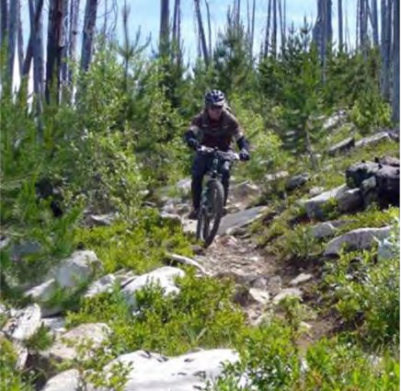
Mountain biking along Kettle Crest

Monitoring and Evaluation
Monitoring Component: this provides a monitoring program that evaluates how the on-the- ground management is maintaining or making progress toward desired conditions and objectives of this plan. The Plan provides the items to be monitored per the monitoring and evaluation requirements found at 36 CFR 219.12 of the 2012 Rule. Details on methodology, data storage, and responsibility are not considered plan components and are not included in the plan.
Information, science, and unforeseen circumstances continually change over the life of a plan. The major mechanism for reacting swiftly and efficiently to new information, science, or circumstances is provided through a monitoring program for the plan. These include:
- Monitoring to determine whether plan implementation is achieving multiple use objectives;
- Monitoring to determine the effects of the various resource management activities within the plan area on the productivity of the land;
- Monitoring of the degree to which on-the-ground management is maintaining or making progress toward the desired conditions and objectives for the plan;
- Adjustment of the monitoring program, as appropriate, to account for unanticipated changes in conditions.
These evaluations are an integral part of answering key planning questions such as the state of social, economic, and ecological conditions and trends, and the need for an amendment or revision.
Specific monitoring items, such as measuring frequencies, methodologies, precision, and reliability are identified in the annual monitoring guide.
MONITORING QUESTIONS
Monitoring questions ask whether management in the plan area is maintaining or progressing toward desired conditions and meeting objectives. Monitoring questions may be designed to pertain directly to desired conditions or to relate to objectives or guidelines. Monitoring information in the plan set of documents may be changed or updated as appropriate. Such changes and updates require a plan amendment or revision.
Monitoring questions can also identify or enumerate the ties between ecosystem resilience and ecosystem services. Ecosystem services are the products of functioning ecosystems that benefit people.
Monitoring questions identify specific Plan direction to monitor and evaluate. The monitoring questions specify the information that is essential for measuring Plan accomplishments and effectiveness. The associated evaluation process determines whether the observed changes are consistent with the desired conditions and what adjustments may be needed, if any.
Monitoring questions are designed to address the requirements at 36 CFR 219.12 (a)(5) which states that monitoring programs must contain one or more monitoring questions to address the following (see table 39):
(i) the status of select watershed conditions.

(ii) the status of select ecological conditions including key characteristics of terrestrial and aquatic ecosystems.
- the status of focal species to assess the ecological conditions required under § 219.9.
- the status of a select set of the ecological conditions required under § 219.9 to contribute to the recovery of federally listed threatened and endangered species, conserve proposed and candidate species, and maintain a viable population of each species of conservation concern.
- the status of visitor use, visitor satisfaction, and progress toward meeting recreation objectives.
- measurable changes on the plan area related to climate change and other stressors that may be affecting the plan area.
- Progress toward meeting the desired conditions and objectives in the plan, including for providing multiple use opportunities.
- The effects of each management system to determine that they do not substantially and permanently impair the productivity of the land
Monitoring identified in this section does not include monitoring conducted in compliance with other laws, policies, and site-specific decisions.
EVALUATION
The information gained through monitoring and evaluation may be the catalyst for plan revisions or amendments.

Forest Plan Monitoring Questions

Table 39. Monitoring questions
Resource | Monitoring question | Reference to Forest Plan direction | Indicator | Frequency of measure
Landscape Features and Dynamics
Vegetation | MON-VEG-01: To what extent are management activities and natural disturbance processes trending toward desired conditions for structure/structural  stage and fire regime condition class (FRCC), and increasing resistance and | FW-DC-VEG-02, FW-DC-VEG-  03, FW-DC-VEG-04, FW-DC-  VEG-05, FW-DC-VEG-11, FW-  DC-VEG-12, FW-DC-VEG-14; FW-OBJ-VEG-01, FW-OBJ- VEG-02, FW-OBJ-SCE-01; | MON-VEG-01-01: Acres treated to meet FW-OBJ-VEG-01  MON-VEG-01-01a: Acres  treated to respond to forest disease pathogens. | Annual
Vegetation | resiliency to disturbance factors including climate change? This includes vegetation size classes, down wood, snags. | MA-DC-FR-01; MA-DC-GR-01 | MON-VEG-01-02: Acres burned through prescribed and wild fire | Every 5 years (review of FRCC across the Forest)
Vegetation |  |  | MON-VEG-01-03: Acres of  forest by structure and vegetation type compared to the desired condition | Every 5 years
Vegetation |  |  | MON-VEG-01-04: Snags and down wood by watershed | Every 5 years
Vegetation |  |  | MON-VEG-01-05: Number of acres influenced by insects | Every 5 years
Vegetation | MON-VEG-02: Have management activities met forest plan objectives and trended toward desired conditions for invasive terrestrial plant species? | FW-DC-VEG-06, FW-DC-VEG-  07, FW-DC-IS-01;  FW-OBJ-IS-01, FW-OBJ-IS-02, FW-OBJ-IS-03;  FW-GDL-IS-01, FW-GDL-IS-02, FW-GDL-IS-03 | MON-VEG-02-01: Acres of non- native invasive plants treated  MON-VEG-02-02: Extent and number of sites of new non- native invasive plant species | Annual Annual
Vegetation | MON-VEG-03: To what extent are management activities moving hazardous fuels toward desired conditions within WUI? | FW-DC-VEG-11, FW-DC-VEG-  12, FW-DC-VEG-13, FW-DC- VEG-14;  FW-STD-VEG-01 | MON-VEG-03-01: Acres of  hazardous fuel treatments within the WUI | Annual

Resource | Monitoring question | Reference to Forest Plan direction | Indicator | Frequency of measure
Vegetation | MON-VEG-04: To what extent is the Forest meeting forest plan objectives and trending toward desired conditions to provide a mix of timber products in response to market demands? | FW-OBJ-VEG-01 | MON-VEG-04-01: MMBF  offered and MMBF sold annually | Annual
Vegetation | MON-VEG-05: To what extent is the Forest meeting NFMA requirements and desired conditions on size of harvest openings? | FW-STD-VEG-03, FW-STD- VEG-04 | MON-VEG-05-01: Number of even-aged regeneration harvest units exceeding 40 acres in size and category for exceeding | Annual
Vegetation | MON-VEG- 06: To what extent are regeneration units restocked to trend toward vegetation desired conditions? | FW-STD-VEG-05 | MON-VEG-06-01: On lands  suitable for timber production, percent of acres with regeneration harvest that are adequately restocked within 5 years of harvest | Annual
Vegetation | MON-VEG-07: Have lands that are not suitable for timber production become suitable? | FW-STD-VEG-03, FW-STD- VEG-06 | MON-VEG-07-01: Acres of  land suitable for timber production. | Every 10 years
Vegetation | MON-VEG-08: Have destructive insects and disease organisms increased to potentially damaging levels following management activities? | FW-DC-VEG-02, FW-DC-VEG-  03, FW-DC-IS-01, FW-DC-IPM-  01;  FW-STD-IPM-01 | MON-VEG-08-01: Acres  affected by insect and disease organisms. | Every 5 years
Vegetation | MON-VEG-09: Are actual outputs and services consistent with those projected by the plan? | FW-OBJ-VEG-01; FW-STD-VEG-03; FW-DC-RFP-02 | MON-VEG-09-01: Acres of  active management.  MON-RFP-01-01: MMBF  offered annually. | Annual

Resource | Monitoring question | Reference to Forest Plan direction | Indicator | Frequency of measure
Watershed | MON-WTS-01: Are management actions contributing to improved watershed condition class within focus, key, and priority watersheds, and other watersheds identified for restoration? | FW-DC-WR-01, FW-DC-WR-02,  FW-DC-WR-03, FW-DC-04, FW-  DC-WR-05, FW-DC-WR-06, FW-  DC-WR-07, FW-DC-WR-08, FW-  DC-WR-18, FW-DC-WR-19;  FW-OBJ-WR-03, FW-OBJ-WR-  04, FW-OBJ-WR-05, FW-OBJ-  WR-06, FW-OBJ-WR-07, FW-  OBJ-WR-08, FW-OBJ-WR-09,  FW-OBJ-WR-10, FW-OBJ-WR- 11;  FW-STD-WR-01, FW-STD-WR-  02, FW-STD-WR-03, FW-STD- WR-04;  MA-OBJ-RMA-01, MA-OBJ- RMA-02, MA-OBJ-RMA-03; MA-STD-RMA-03, MA-STD-  RMA-04, MA-STD-RMA-05, MW- STD-RMA-07, MA-STD-RMA-07, MA-STD-RMA-08;  MA-GDL-RMA-03, MA-GDL- RMA-04, MA-GDL-RMA-05, MA- GDL-RMA-06, MA-GDL-RMA-07, MA-GDL-RMA-08, MA-GDL- RMA-09, MA-GDL-RMA-10 | MON-WTS-01-01: Change in watershed condition class | Every 5 years

Resource | Monitoring question | Reference to Forest Plan direction | Indicator | Frequency of measure
Watershed | MON-WTS-02: Are management actions reducing road impacts to watershed and aquatic habitat function and water quality within all watersheds across the Forest? Within Key, Focus, and Priority Watersheds? | FW-DC-WR-17;  FW-OBJ-WR-03, FW-OBJ-WR- 06;  FW-STD-WR-04, FW-STD-WR- 05;  FW-GDL-WR-04;  MA-DC-RMA-04; MA-OBJ-RMA-02;  MA-STD-RMA-05, MA-STD- RMA-06, MA-STD-RMA-07; MA-GDL-RMA-04, MA-GDL-  RMA-05, MA-GDL-RMA-06, MA- GDL-RMA-07, MA-GDL-RMA-08, MA-GDL-RMA-09, MA-GDL- RMA-10 | MON-WTS-02-01: Miles of  roads treated that are a high risk to watershed and aquatic habitat function. | Annual
Watershed | MON-WTS-03: Are management actions improving key riparian processes within Riparian Management Areas? | MA-DC-RMA-02;  MA-OBJ-RMA-01, MA-OBJ- RMA-02, MA-OBJ-RMA-03;  MA-STD-RMA-01, MA-STD- | MON-WTR-03-01: Acres or  miles of watershed restoration activities accomplished, by  subwatershed | Annual
Watershed |  | RMA-04, MA-STD-RMA-05, MA- STD-RMA-06, MA-STD-RMA-07 | MON-WTR-03-02: Percent of subwatersheds trended toward an improved condition. | Every 5 years (PIBO EM-comparison of reference conditions, WCF)
Watershed | MON-WTS-04: Are water resources and RMA standards, guidelines, and best management practices (BMPs) being implemented at project sites? Are standards, guidelines, and BMPs effective at achieving desired conditions? | All WR and RMA standards and guidelines | MON-WTR-04-01: Number of BMP evaluations completed and identification of BMPs that were implemented correctly and incorrectly, and identification of BMP effectiveness | BMP annual
Watershed | MON-WTS-05-01: What is the status and trend of water quality? | FW-DC-WR-05, All WR and  RMA standards and guidelines | MON-WTR-05-01: Miles of  state-listed impaired waters, miles of waters under an approved TMDL and WQIP. | Annual (WADoE 303(d) list, TMDLs, WQIP implementation and monitoring.)

Resource | Monitoring question | Reference to Forest Plan direction | Indicator | Frequency of measure
Aquatic Habitat | MON-AQH-01: Are management activities across the Forest contributing to the viability of riparian and wetland- dependent TES and focal species? | FW-DC-WR-02, FW-DC-WR-03,  FW-DC-WR-05, FW-DC-WR-12, FW-DC-WR-13;  FW-OBJ-WR-01, FW-OBJ-WR-  02, FW-OBJ-WR-03, FW-OBJ-  WR-04, FW-OBJ-WR-05, FW-  OBJ-WR-06, FW-OBJ-WR-07,  FW-OBJ-WR-08, FW-OBJ-WR-  09, FW-OBJ-WR-10, FW-OBJ- WR-11;  FW-STD-WR-05;  FW-GDL-WR-04;  MA-OBJ-RMA-01, MA-OBJ- RMA-02, MA-OBJ-RMA-03; MA-STD-RMA-07 | MON-AQH-01-01: PIBO EM,  updated Aquatic Ecological Condition (AEC), Stream channel morphology surveys in monumented reaches  MON-AQH-01-02: Acres or  miles of treatments to improve hydrologic, aquatic, and riparian function | Every 5 years (PIBO EM, updated Aquatic Ecological Condition (AEC)), stream channel morphology surveys), invasive species database.  Annual
Aquatic Habitat | MON-AQH-02: Are management actions improving conditions within Riparian Management Areas where livestock grazing is permitted? | FW-OBJ-WR-07;  MA-DC-RMA-03;  MA-STD-RMA-08, MA-STD- RMA-09, MA-STD-RMA-10, MA-GDL-RMA-12, MA-GDL- RMA-13, MA-GDL-RMA-14 | MON-AQH-02-01: Acres of  improvement within designated monitoring area locations.  MON-AQH-02-02: Allotments meeting annual grazing management indicators | Annual, Every 5 years in conjunction with MON-WTR-03-02  above (PIBO EM & R- 6 stream surveys)  Annual (PIBO & Forest monitored designated monitoring areas)
Aquatic Habitat | MON-AQH-03: Are management actions preventing the spread of aquatic invasive species? | FW-DC-WR-12;  FW-OBJ-WR-01, FW-OBJ-WR- 02;  FW-STD-WR-02, FW-STD-WR- 03;  FW-GDL-WR-02, FW-GDL-WR- 03;  MA-GDL-RMA-11 | MON-AQH-03-01: Acres of non- native invasive aquatic habitat treated  MON-AQH-03-02: Number of sites of new non-native invasive aquatic species | Annual (R6 stream WIT);  Every 5 years (PIBO EM)

Resource | Monitoring question | Reference to Forest Plan direction | Indicator | Frequency of measure
Soil | MON-SOIL-01: To what extent have plan components prevented irreversible damage to soil conditions? | FW-DC-SOIL-01, FW-DC-SOIL- 02;  FW-OBJ-SOIL-01; FW-GDL-SOIL-01; | MON-SOIL-01-01: Number of harvest units surveyed and percent that meet the Regional Soil Quality Standard, post- harvest (FSM, R6 Supplement No. 2500.98-1) | Annual
Federally listed species | MON-FLS-01: To what extent is forest management contributing to the conservation of federally listed species and moving toward habitat objectives? | FW-DC-WL-02, FW-DC-WL-03,  FW-DC-WL-04, FW-DC-WL-05,  FW-DC-WL-06, FW-DC-WL-07,  FW-DC-WL-08, FW-DC-WL-09;  FW-OBJ-WL-02, FW-OBJ-WL- 03;  FW-STD-WL-02, FW-STD-WL-  03, FW-STD-WL-04, FW-STD- | MON-FLS-01-01: Grizzly Bear: progress toward achieving and maintaining standards for percent core area, open motorized road density (OMRD) and total motorized road density  (TMRD) within each Grizzly Bear Management Unit. | Annual
Federally listed species |  | WL-05, FW-STD-WL-06, FW-  STD-WL-07, FW-STD-WL-08,  FW-STD-WL-09, FW-STD-WL-  10, FW-STD-WL-11;  FW-GDL-WL-04, FW-GDL-WL-  05, FW-GDL-WL-06, FW-GDL-  WL-07, FW-GDL-WL-08, FW-  GDL-WL-09, FW-GDL-WL-10,  FW-GDL-WL-11, FW-GDL-WL- 12 | MON-FLS-01-02: Canada lynx: changes in lynx habitat as a result of moving toward the desired conditions for vegetation through vegetation management, prescribed fire, or natural disturbance that is consistent with the historical range of variability | Every 5 years by lynx analysis unit
Federally listed species |  |  | MON-FLS-01-03: Woodland caribou: maintenance of seasonal habitat components of well-connected, large blocks of late-successional forest at or above current levels. | Every 5 years by forest management projects proposed in recovery area, measured at the caribou management unit scale
Federally listed species |  |  | MON-FLS-01-04: Woodland caribou: management of motorized winter recreation at or below current levels so that woodland caribou are not displaced from suitable habitat within the caribou recovery area. | Annual (caribou habitat monitoring report)

Resource | Monitoring question | Reference to Forest Plan direction | Indicator | Frequency of measure
Focal species | MON-Focal-01: Are habitat trends for Focal species consistent with the Desired Conditions and objectives? | FW-DC-VEG-03, FW-DC-VEG- 04;  FW-OBJ-WL-05;  FW-STD-WL-01, FW-STD-WL- 12;  FW-GDL-WL-15, FW-GDL-WL-  18, FW-GDL-WL-19; | MON-FOCAL-01-01: White-  headed Woodpecker: number of acres treated to provide large diameter tree habitat and move toward desired vegetation  conditions by providing late- open structure | Annual
Focal species |  | MA-DC-RMA-03;  MA-STD-RMA-08, MA-STD- RMA-09, MA-STD-RMA-10; | MON-FOCAL-01-02: Northern  goshawk: number of acres surveyed and nests located | Annual
Focal species |  | MA-GDL-RMA-12, MA-GDL-  RMA-13 | MON-FOCAL-01-03: Black-  backed woodpecker-Snag habitat: snag densities by size class and vegetation type | Every 5 years by watershed (5th field)
Focal species |  |  | MON-FOCAL-01-04:  MacGillivray’s warbler: condition of riparian habitats within grazing allotments. | Every 5 years by watershed (5th field)
Focal species |  |  | MON-FOCAL-01-05:  Wildlife General: Monitor progress toward meeting road density desired conditions by watershed/grizzly bear management unit. | Every 5 years

Resource | Monitoring question | Reference to Forest Plan direction | Indicator | Frequency of measure
Wildlife | MON-WL-01: Have management activities met forest plan objectives and maintained or improved habitat to achieve desired terrestrial habitat conditions? | FW-DC-WL-02, FW-DC-WL-03,  FW-DC-WL-04, FW-DC-WL-05,  FW-DC-WL-06, FW-DC-WL-07,  FW-DC-WL-08, FW-DC-WL-09,  FW-DC-WL-12, FW-DC-WL-13, FW-DC-WL-14;  FW-OBJ-WL-02, FW-OBJ-WL-  03, FW-OBJ-WL-04, FW-OBJ-  WL-05, FW-OBJ-WL-06;  FW-STD-WL-02, FW-STD-WL-  05, FW-STD-WL-06, FW-STD-  WL-07, FS-STD-WL-08, FW-  STD-WL-09, FW-STD-WL-10, FW-STD-WL-12;  FW-GDL-WL-01, FW-GDL-WL-  04, FW-GDL-WL-05, FW-GDL-  WL-06, FW-GDL-WL-09, FW-  GDL-WL-11, FW-GDL-WL-13,  FW-GDL-WL-14, FW-GDL-WL- 16, FW-GDL-WL-17 | MON-WL-01-01: Acres of terrestrial habitat restored or enhanced. Also see results for MON-VEG-01-01 through MON- VEG-01-05 | Annual

Resource | Monitoring question | Reference to Forest Plan direction | Indicator | Frequency of measure
Social Systems
Access and Recreation | MON-AR-01: What are the trends in visitation forestwide, and are visitors satisfied with the facilities, access, services, and perception of their safety? | FW-DC-AS-01, FW-DC-AS-02,  FW-DC-AS-03, FW-DC-AS-04,  FW-DC-AS-05, FW-DC-AS-06;  FW-OBJ-AS-01, FW-OBJ-AS-02, FW-OBJ-AS-03;  FW-GDL-AS-05;  MA-DC-ARS-01, MA-DC-ARS-  02, MA-DC-ARS-03, MA-DC-  ARS-04, MA-DC-ARS-05, MA-  DC-ARS-06, MA-DC-ARS-07; MA-OBJ-ARS-01, MA-OBJ-ARS- 02;  MA-GDL-ARS-01, MA-GDL- ARS-03 | MON-AR-01-01: Visitor use and trends in use forestwide | Every 5 years (NVUM)
Access and Recreation | MON-AR-02: What is the trend in mountain bike use in recommended wilderness and is that use impacting the wilderness characteristics of the forest’s recommended wilderness areas. | MA-DC-RW-01, MA-DC-RW-02,  MA-DC-RW-03; MA-STD-RW-  01, MA-STD-RW-02, MA-STD-  RW-03, MA-STD-RW-04;  MA-GDL-RW-01, MA-GDL-RW- 02, MA-GDL-RW-03 | MON-AR-02-01: Assess  mountain bike use through trail registration trend analysis.  MON-AR-02-02: Identify new user-created mountain bike trails or impacts (i.e. hill climbs, accelerated growth of banked turns) to natural or special features along existing trail systems in recommended wilderness caused by mountain bike use. | Annual  20% of all trail miles open to mountain bike use within recommended wilderness will be monitored annually for new or recurring impacts from mountain bikes.  Reported cases of user-created routes within recommended wilderness will be investigated annually.

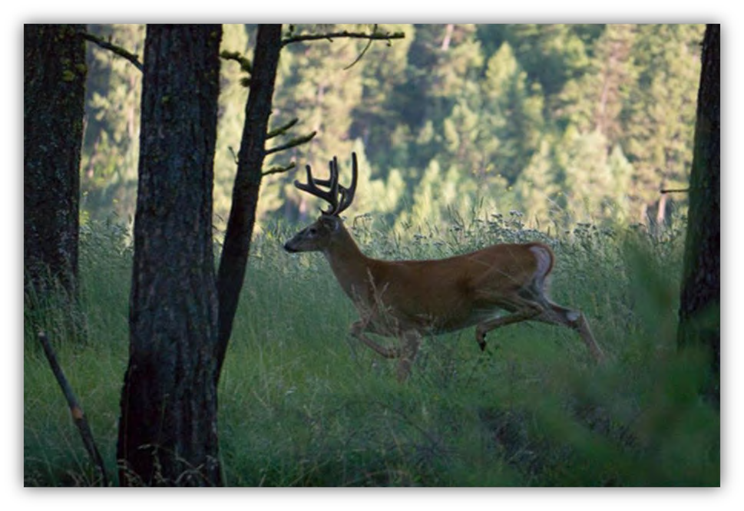
Photo courtesy of Nils Larsen

Appendix A – Consistency with Plan Components
As required by NFMA and the planning rule, all projects and activities authorized by the Forest Service must be consistent with the plan. A project or activity must be consistent with the plan (36 CFR 219.8(e)) by being consistent with applicable plan components (36 CFR 219.7(a)); 36 CFR 219.8(a). Direction in this Plan applies to all projects that have decisions made on or after the effective date of the final record of decision (ROD). The ROD specifies the transition strategy for short- and long-term ongoing actions. Plans may have other content, such as background, collaboration strategies, context, existing conditions, glossary, introduction, monitoring questions, other referenced information or guidance, performance history, performance measures, performance risks, program emphasis, program guidance, program priorities, possible actions, roles and contributions, management challenges, or strategies, but such other content are not matters to which project consistency is required.
Ensuring Project or Activity Consistency with the Plan— A project or activity must be consistent with all applicable plan components; desired conditions, standards and guidelines. Where a proposed project or activity would not be consistent with a plan component the responsible official has the following options:
- To modify the proposal so that the project or activity will be consistent;
- To reject the proposal; or
- To amend the plan contemporaneously with the approval of the project or activity so that the project or activity is consistent with the plan as amended. The amendment may be limited to apply only to the project or activity (36 CFR 219.8(e)).
The following paragraphs describe how a project or activity is consistent with plan components and the requirements for documenting consistency.
Desired conditions (36 CFR 219.7(a)(2)(i)) — Because of the many types of projects and activities that can occur over the life of a plan, it is not likely that a project or activity can maintain or contribute to the attainment of all desired conditions. Most projects and activities are developed specifically to maintain or move conditions toward one or more of the desired conditions of a plan. It should not be expected that each project or activity will contribute to all desired conditions in a plan, but usually to one or a subset. However, it should not be expected that in every instance, a project could clearly point to a specific desired condition as the reason the project was proposed; for example, a powerline right-of-way to a private inholding. There will also be instances when negative effects related to a specific desired condition are appropriate, either for long-term progress toward that same desired condition, or for progress toward or maintenance of another desired condition. It is also important that project consistency with a desired condition be assessed at the appropriate scale. For example, if a desired condition addresses watershed functionality at the scale of a 5th field watershed, then the contribution of any proposal to that desired condition should be considered at that scale.
To be consistent with the desired conditions of the plan, a project or activity, when assessed at the appropriate spatial scale described in the plan, must be designed to meet one or more of the following conditions:
- Maintain or make progress toward one or more of the desired conditions of a plan without adversely affecting progress toward, or maintenance of other desired conditions, or

- Be neutral with regard to progress toward plan desired conditions, or
- Maintain or make progress toward one or more of the desired conditions over the long-term, even if the project or activity would adversely affect progress toward, or maintenance of, one or more desired conditions in the short-term, or
- Maintain or make progress toward one or more of the desired conditions over the long-term, even if the project or activity would adversely affect progress toward other desired conditions in a negligible way over the long-term.
The project documentation should explain how the project is consistent with desired conditions and describe any short-term, or negligible long-term, adverse effects the project may have on the maintenance or attainment of any desired condition. This description of the desired conditions for the Forest fulfills the requirement of section 36 CFR 219.11(b) of the 1982 planning regulations. If a project will adversely affect progress toward one or more desired conditions in more than a negligible way or short-term way, a Plan Amendment is required.
Objectives — A project or activity is consistent with the objectives component of the plan if it contributes to or does not prevent the attainment of any applicable objectives.
The project documentation should identify any applicable objective(s) to which the project contributes and document that the project does not prevent the attainment of any objectives. If there are no applicable objectives, the project is consistent with the objectives components of the plan, and the project documentation should state that fact.
Guidelines — A project or activity must be consistent with all guidelines applicable to the type of project or activity and its location in the plan area. A project or activity can be consistent with a guideline in either of two ways—
- The project or activity is designed exactly in accord with the guideline, or
- A project or activity design varies from the exact words of the guideline but is as effective in meeting the purpose of the guideline to contribute to the maintenance or attainment of relevant desired conditions and objectives.
The project documentation should describe how the project is consistent with the guidelines. When the project varies from the exact words of the guideline, the documentation must specifically explain how the project design is as effective in contributing to the maintenance or attainment of relevant desired conditions and objectives.
Standards—A project or activity is consistent with a standard if the project or activity is designed in exact accord with the standard.
The project documentation should confirm that the project is consistent with applicable standards.
Suitability of areas—A project with the purpose of timber production may only occur in an area identified as suitable for timber production (16 United States Code 1604(k)). The documentation for the project should confirm the project area meets the suitability for timber production criteria set out in FSH 1909.12 section 61.
Except for projects with a purpose of timber production, a project or activity can be consistent with plan suitability determinations in either of two ways:

Appendix A – Consistency with Plan Components

  - The project or activity is a use identified in the plan as generally suitable for the location where the project or activity is to occur, or
  - The project or activity is not a use identified in the plan as generally suitable for the location (the plan is silent on the use), but the responsible official determines that the use to be appropriate for that location’s desired conditions and objectives. If a project or activity is specified in the plan as not suitable for the area, an amendment to the Forest Plan is required.
The project documentation should describe that the project or activity is either (1) a use for which the area is specifically identified in the plan as generally suitable, or (2) not a use for which the area is specifically identified in the plan as general suitable, but is nonetheless appropriate for that location.

Appendix B – Proposed and Possible Management Actions

Introduction
This appendix describes possible actions that may take place on the Colville National Forest at the project or activity-level to help maintain existing conditions or move toward the desired conditions. Because the Plan is a strategic document that provides general management guidance, the following items include program strategies anticipated during the next 15 years. The list of possible actions is not intended to be all-inclusive, nor are they intended to be decisions. They are simply projections of what actions may take place in the future.
This information is not a commitment to take any action and is not a “proposal” as defined by the Council on Environmental Quality regulations for implementing the NEPA (40 CFR 1508.23, 42 United States Code 4322(2)C)). Including this information is done under National Forest Management Act of 1976, 16 United States Code 1604(f).
A Plan amendment is not required to change or modify the proposed or possible management actions. In accord with the National Forest System Land Management Planning Rule these projections can be updated at any time through an administrative change of the Plan.

Proposed Management Actions
The objectives in chapter 2 of the plan represent projects or activities intended to be accomplished during the planning period. The timeframe for completing the objectives varies by objective. These are listed in the table below.

Table B-1. List of proposed management actions (plan objectives)
Category | Project/Activity | Timeframe to complete
Soil | Annually stabilize, rehabilitate, or restore natural processes that support soil productivity and function on 20 to 30 acres. | Within 5 years of plan implementation
Vegetation | Initiate active management activities on 18 to 25 thousand acres per year to move structure toward desired conditions at landscape scales to move the forest toward desired vegetative conditions and have landscapes dominated by Fire Regime Condition Class I, with the remainder in Fire Regime Condition Class II trending toward Fire Regime Condition Class I. | Over the next 15 years
Vegetation | Initiate fuel reduction activities on 5,000 acres per year to reduce hazardous fuel accumulations in both activity and natural fuels to move toward desired vegetative conditions and have landscapes dominated by Fire Regime Condition Class I. | Over the next 15 years
Vegetation | Five to 10 acres of special and unique habitats are treated annually. | Over the 15-year life of the Plan
Water Resources | Implement aquatic invasive species prevention measures at all developed recreation sites providing direct and/or indirect access to water bodies, such as boat ramps, campgrounds, and day use areas that provide portal zones for hand-carried  watercraft. Implement aquatic invasive species prevention measures as part of all aquatic survey and inventory | Within the next 15 years

Category | Project/Activity | Timeframe to complete
 | procedures and other management activities that pose high potential for invasion vectors to occur.
Water Resources | Implement aquatic invasive species control and eradication at 15 waterbodies (streams and lakes) where such invasions have become established and prevent attainment of listed fish recovery plan goals and/or effects to social, economic, and ecological systems are determined to be unacceptable. | Within the next 15 years
Water Resources | Decrease sediment delivery from management activities on 1,000 acres including but not limited to roads, livestock, unauthorized off-highway vehicle use, vegetation management, and dispersed and developed campsites.  Restore hydrologic, aquatic and riparian processes through activities that stabilize streambank erosion, and other accelerated channel destabilizing processes (i.e., headcutting), improve lateral and vertical hydrologic connectivity, and improve stream channel and floodplain function on 10 miles of streams. | Within the next 15 years
Water Resources | Restore aquatic organism passage for all life stages of native species at 45 road/stream crossings and man-made instream structures such as water diversions and dams outside of key watersheds. Culverts and other passage improvements are to be designed to restore and maintain hydrologic and aquatic habitat function and stream channel resiliency to a range of flows through natural channel design and other acceptable treatment measures | Within 15 years
Water Resources | Management in key watersheds focuses on restoration or preservation of watershed, aquatic, and riparian function and recovery of threatened and endangered species. Improve watershed condition class in key watersheds that are a priority for restoration. | Within 15 years of forest plan implementation
Water Resources | Reduce road-hydrologic connectivity and sediment delivery on roads through storm damage risk reduction treatments, full hydrologic decommissioning, and other accepted treatment measures on 116 miles of hydrologically connected road. | Within 15 years of forest plan implementation
Water Resources | Restore or maintain aquatic organism passage and improve hydrologic and aquatic habitat function at 53 road/stream crossings for all native aquatic species, seasons, flows, and life stages in key watersheds through culvert replacement or crossing improvement and natural channel design or other acceptable treatment measures that provide for natural stream channel function at all flows | Within 15 years of forest plan implementation
Water Resources | Improve hydrologic and aquatic function through range infrastructure improvements, including riparian fencing, movement and improvement of watering troughs, and other acceptable treatments over 240 acres. | Within 15 years of forest plan implementation
Water Resources | Move upland vegetation within Riparian Management Areas in key watersheds toward historical range of variability on 1,500 acres. | Within 15 years of forest plan implementation
Water Resources | Restore hydrologic, geomorphic, and riparian process and function on 81 miles of stream through activities including streambank stabilization, restoration of lateral and vertical hydrologic connectivity and improvement of stream channel and floodplain function. | Within 15 years of forest plan implementation
Water Resources | Implement the watershed condition framework through completion of essential projects outlined in watershed action | Over 15 years

Category | Project/Activity | Timeframe to complete
 | plans in existing focus and priority watersheds to improve watershed condition class.
Water Resources | Complete or update watershed analyses for 5 subwatersheds. Criteria for selecting subwatershed for watershed analysis include: Key Watersheds, Priority Watersheds, watersheds that support designated critical habitat, or support listed species, and watersheds where management activities are likely to occur that may affect aquatic resources (due to their inherent nature, location, timing, or scale). | Within 15 years of plan implementation
Wildlife Habitats | Address any food or garbage storage problem areas promptly to avoid habituation of grizzly bears or other wildlife. Maintain the wildlife-resistant garbage storage devices installed in all developed campgrounds on the Colville National Forest, as needed. Install at least 15 wildlife-resistant food storage lockers at developed campgrounds or heavily used dispersed campsites. Priority will be given to sites within or adjacent to the grizzly bear recovery area, or to areas with documented black bear or grizzly bear food or human interactions. | Within 15 years of plan implementation
Wildlife Habitats | Restore an average of 100 acres/year of snowshoe hare and/or lynx habitat within the lynx analysis units located in the Kettle-Wedge core area. | During the expected 15 years of plan implementation
Wildlife Habitats | Maintain or restore grizzly bear seasonal habitats on a total of 900 acres. | During the expected 15 years of plan implementation
Wildlife Habitats | Restore western hemlock/western red cedar vegetation types within late-successional forest habitats for surrogate wildlife species on 1,400 acres. Generally focus activity in previously treated areas that are now early to mid- successional forest to enhance large tree development | During the expected 15 years of plan implementation
Wildlife Habitats | Restore or move toward restoration of late structure ponderosa pine forest habitat on 500 acres per year. | During the expected 15 years of plan implementation
Wildlife Habitats | Restore (i.e., application of prescribed fire, invasive plant management, etc.) habitat on 1,000 acres of deer and elk winter range. | During the expected 15 years of plan implementation
Invasive Species | Reduce the density or extent of invasive plants by treating an average of 2,000 acres per year. Actively restore an annual average of 50 acres of native vegetation by mulching, seeding, or planting to promote revegetation of native plants to help resist introduction, establishment, and spread of invasive plant species. | During the expected 15 years of plan implementation
Invasive Species | Address treatment of priority non-native, invasive vertebrate species and their impacts in terrestrial habitats. | Within one year of detection
Invasive Species | Address treatment of priority non-native, invasive insect and disease pathogens and their impacts. | Within one year of detection
Forest Transportation Access System | Motorized mixed-use road designations are reviewed and an average of one new off-highway vehicle route is designated to achieve one or more of the following objectives: create loop-riding opportunities, connect camping areas, access destination overlooks, move routes away from ecologically or culturally sensitive areas, and connect communities  through and to the forest. Coordinate designations with a community collaborative that could include local motorized | Annually

Category | Project/Activity | Timeframe to complete
 | recreation groups, counties and conservation groups to determine priority areas for selection, designation and monitoring.
Forest Transportation Access System | Improve drainage, water crossing and trail layout on 5 percent of the Forest’s trail system designed for mountain bikes, motorized use, and pack stock. | During the expected 15 years of plan implementation
Forest Transportation Access System | Maintain at least 20 percent of the Forest’s motorized and non-motorized trail system. | Annually
American Indian Rights & Interest | A cooperatively developed communication plan establishes coordination with each federally recognized Tribe with historical or treaty interests in CNF lands. | Over the life of the plan
American Indian Rights & Interest | Consult with Tribes when forest management activities may impact treaty rights and/or cultural sites and cultural use, according to individual Tribal communication plans, consultation protocols, or policies. | Over the life of the plan
Livestock Grazing | Recondition or reconstruct an average of 1 to 4 percent of the existing range infrastructure on National Forest System lands annually. Such range infrastructure would include water developments, hardened fords, livestock handling facilities, and fences. Within 5 years of a decision being made to implement an Allotment Management Plan, relocate or reconstruct, at least 75 percent of the identified range infrastructure (for example, water developments, fences, loading chutes, and holding structures) that has become  non-functional or in need of replacement. | During the expected 15 years of plan implementation
Livestock Grazing | Install reassurance markers on 75 percent of trails that are difficult to follow as a result of braiding caused by trailing cattle, to ensure trail users are able to follow the established trail tread and decrease an existing source of conflict between recreationists and livestock. | During the expected 15 years of plan implementation
Scenery | Evaluate scenery management monitoring results and implement appropriate management adjustments with the emphasis on improving the sustainability of desired landscape character in landscape areas of highest expectations for scenic integrity levels in concern level 1 and concern level 2 scenic viewsheds. | Within 5 years of plan approval, and every 5 years after
Scenery | Move 10 percent of travel route scenic viewsheds foreground and middleground areas of concern level 1 or concern level 2 toward meeting scenic integrity objectives. | During the expected 15 years of plan implementation
Integrated Pest Management | Damaging plant, animal, insect and plant and animal disease pest outbreaks are prevented, suppressed, contained, controlled or eradicated in a timely manner in accordance with proactive pest response plans. | New outbreaks are addressed within one year of detection through the life of the plan
Administrative and Recreation Sites | Provide a minimum of one large (100+ person capacity) group site for day or overnight use in a location where there is a demonstrated need identified through public demand. | Within 15 years of plan implementation
Administrative and Recreation Sites | Increase parking capacity at one Sno-Park and one trailhead where use exceeds designed parking lot capacity on more than 25 percent of weekends. | Within 15 years of plan implementation
Nationally Designated Trails | Relocate 10 to 15 percent of the trail miles currently located on roads into a non-motorized trail setting. | Within 15 years of plan implementation

Category | Project/Activity | Timeframe to complete
Research Natural Areas | Complete the establishment record on all proposed research natural areas. | Within 5 years of plan implementation
Research Natural Areas | Treat populations of invasive, non-native species on an average of 10 acres annually. | Within 5 years of plan implementation
Riparian Management Areas | Restore riparian processes and balance need for occupancy and access to water at 75 dispersed and developed recreation sites, through education, enforcement, and engineering where recreational use results in bank damage, reduction in water quality, and/or a reduction in stream shade. | Over the next 15 years
Riparian Management Areas | Restore hydrologic and riparian habitat function within RMAs in non-key watersheds by reducing road-related impacts on 80 miles of road. | Within 15 years
Riparian Management Areas | Move upland vegetation within Riparian Management Areas outside of key watersheds toward historical range of variability on 500 acres. | Within 15 years of plan implementation
Scenic Byways | Move 10 percent of the foreground and middle ground seen areas of national scenic byways toward meeting scenic integrity objectives. Priority for rehabilitation and enhancement of desired landscape character includes the Sherman Pass Scenic Byway. | During the expected 15 years of plan implementation
Kettle Crest Recreation Area | Construct at least one trailhead for the motorized trail system that accesses the Backcountry Motorized Management Area associated with the Twin Sisters Inventoried Roadless Area. | Within 15 years of plan implementation
Kettle Crest Recreation Area | Design and construct at least one motorized loop trail opportunity within the Backcountry Motorized Management Area associated with the Twin Sisters Inventoried Roadless Area and at least one non-motorized loop trail opportunity within the Backcountry Management Area associated with the Profanity Inventoried Roadless Area. | Within 15 years of plan implementation
Kettle Crest Recreation Area | Move or reconstruct the over-snow vehicle sno-park located on the Albian Hill Road (Forest Road 2030) to accommodate at least twice the existing capacity. | Within 15 years of plan implementation
Wilderness- Congressionally Designated | Existing campsites will be inventoried. Campsites that are both visible and audible to each other will be surveyed and the site that shows the greatest resilience toward future resource disturbance (based on soil and vegetation characteristics) will be retained while the other site will be naturalized. | Within 5 years of plan implementation
Wilderness- Congressionally Designated | Existing campsites within 200 feet of lakes, rivers, or streams will be inventoried. Campsites that can absorb the impact of recurring recreational use will be retained while those campsites that show low resiliency to repeated use (based on impacts to soil, vegetation, and water quality) will be naturalized. | Within 5 years of plan implementation

Possible Management Actions
Chapters 2 and 3 of the Plan describe some of the possible management actions for achieving desired conditions and objectives. These are summarized in the following sections.

Terrestrial Ecosystems

Vegetation
Vegetation management includes those activities that actively move vegetation toward desired conditions. Vegetation management might include activities that would maintain or increase representation of early seral, shade-intolerant, drought and fire tolerant, insect/disease resistant species dominance types. Activities could treat areas to maintain or improve forest resilience, natural diversity, and productivity, and to reduce negative impacts of non-native organisms over the life of the Plan. Specifically, the following types of actions are likely to occur:
- Planting white pine blister rust resistant western white pine or whitebark pine;
- Pruning of western white pine to reduce vulnerability to white pine blister rust;
- Pruning or girdling trees to reduce dwarf mistletoe infections;
- Maintenance or restoration of rare plant habitat and special and unique natural communities;
- Planting shade-intolerant, fire-adapted, drought resistant species;
- Managing stands to retain or move toward late seral structure where the landscape is deficient in late seral structure (below HRV);
- Management or treatment of insects and diseases using integrated pest management techniques;
- Commercial timber harvest to move toward HRV, improve wildlife habitat, and achieve desired conditions.

Fire Management
Actions related to treatment of fuels will include the following:
- Planned ignitions;
- Mechanical treatments, including commercial timber sales and noncommercial treatments; and
- Unplanned ignitions.

Forest Products
Actions include:
- Use timber production and tree cutting to achieve vegetation desired conditions and contribute to the local and regional economy;
- Intermediate timber harvest (commercial thinning, improvement cutting, etc.);
- Regeneration harvest with treatments that are even-age in nature (clearcut, or two-age regeneration), or uneven-age (group selection or single tree selection); and
- Salvage of dead or dying timber.

- Gathering of firewood, huckleberries, and other special forest products.
- Offer the projected wood sale quantity (PWSQ), which is an average of 62 million board feet per year. The PWSQ represents the amount of timber and all other wood products, including firewood, that are expected to be sold during the plan period from harvests for any purpose (except salvage harvest or sanitation harvest) on all lands in the planning area. Actual volume offered in an individual year may vary due to budget or regulatory conditions.
Vegetation treatments as modelled for determination of effects:
Table B-2 shows what treatments were proposed and included by management area for modelling vegetation changes in ST-SIM related to the revised land management plan. If a treatment is not included within a management area, the treatment is not prohibited, but was not considered as a primary management tool.

Colville National Forest Land Management Plan

Table B-2. Modelled vegetation treatments by management area and vegetation type
Management area (model zone) | Vegetation type | Fire |  |  | Stand improvement |  |  |  |  | Final harvest
Management area (model zone) | Vegetation type | Prescribed fire (light) | Prescribed fire (mixed) | Prescribed fire (severe) | Precommercial thinning | Thinning small and medium | Partial harvest poles | Partial harvest small | Partial harvest medium | Variable density thinning | Shelterwood w/ reserves | Regeneration small and medium | Salvage
Focused & General Restoration | Douglas-fir dry | X |  |  | X |  | X |  | X | X
Focused & General Restoration | Northern Rocky Mountain mixed conifer |  | X |  |  |  |  |  |  | X
Focused & General Restoration | Western red cedar / Western hemlock
Focused & General Restoration | Subalpine fir / Lodgepole pine |  |  | X |  |  |  |  |  |  | X
Focused & General Restoration | Spruce / Subalpine fir
Wilderness / Other | Douglas-fir dry | X
Wilderness / Other | Northern Rocky Mountain mixed conifer
Wilderness / Other | Western red cedar / Western hemlock
Wilderness / Other | Subalpine fir / Lodgepole pine |  |  | X
Wilderness / Other | Spruce / Subalpine fir

Appendix B – Proposed and Possible Management Actions 179

Invasive Species
- Use an array of tools (chemical, biological, manual, mechanical, and cultural) to suppress, contain, control or eradicate invasive species. An integrated pest management approach that minimizes adverse effects of treatment will be favored. Integrated pest management is appropriate within all management areas, however there are limitations for mechanical treatment within wilderness.
- Provide education and outreach programs designed to increase awareness of invasive species.
- Implement preventative measures (e.g., pre- and post-work equipment sanitation, requiring certified weed-free seed, hay, and gravel if available, sequencing of activities) through annual operating instructions, permitting, contracting, and other forest administrative processes.
- Collaborate with other agencies and entities to replace non-native aquatic species with natives.
- Cooperate with Washington State agencies, local governments and other organizations to support a successful invasive species management program. Prepare or review proactive invasive species response plans.

Wildlife
Wildlife habitat management involves establishing and maintaining the vegetation diversity necessary to provide food, cover, and security for all wildlife species native to the Forest in cooperation with federal, state, and other organizations. Activities might include:
- maintenance or restoration of wildlife habitat (e.g., burning);
- site-specific improvement of motorized access densities and secure core habitat parameters within Grizzly Bear Management subunits;
- road closures (permanent and/or seasonal) to improve deer/elk winter range.

Aquatic and Riparian Ecosystems
Management activities include both passive and active restoration to maintain and improve habitat and ecological conditions capable of supporting ground & surface hydrologic function and self- sustaining populations of native riparian-dependent plant and animal species. Passive restoration is the broad-scale natural recovery of the aquatic ecosystem and includes implementation of best management practices, key watersheds and designation of riparian management areas. Active restoration includes management activities with the specific goal of restoring the processes that improve aquatic and riparian habitat function.
Activities may include:
- Active stream restoration actions at selected stream reaches to improve degraded conditions and stream channel stability (e.g., adding large woody debris to streams);
- Planting riparian vegetation for bank stability and shade;
- Treating invasive terrestrial plant species in riparian areas to improve riparian community structure;
- Removal, reconstruction, or improved maintenance of roads located in riparian areas to improve watershed health and reduce sediment delivery to the aquatic ecosystem;

  - Treating upland roads to reduce water interception;
  - Culvert replacement or removal to improve passage for native species, where appropriate;
  - Culvert replacement or removal to improve hydrologic function and sediment transport; and
  - Riparian area fencing.

Social Systems

Access and Recreation
Recreation management includes those activities that assist in providing a range of recreation opportunities across the Forest. Specifically, the following types of actions are likely to occur:
  - Trail construction, reconstruction, maintenance, and relocation;
  - Construction of facilities such as parking areas, toilets, trailheads, information kiosks, fishing access, and boating access points;
  - Maintain and upgrade facilities such as campgrounds, picnic areas, toilets, and parking lots; Identification and abatement of natural and human-caused hazards (i.e. removal of stinging insects, removal of exposed nails, replacement of broken infrastructure such as tables or benches) at developed recreation facilities such as campgrounds, day-use areas, trailheads, boat ramps, and rental cabins;
  - Hazard tree removal within developed recreation sites and along roadways;
  - Implement education and signing measures to inform users of potential natural hazards (i.e. seasonal flooding, hazard trees, wildfire), how to identify potentially hazardous conditions, and what to do in an emergency situation (who to contact, egress routes, etc.);
  - Implement environmental education and interpretive programs to encourage youth and families to recreate on their national forests;
  - Maintain and modify dispersed recreation sites to reduce or eliminate resource concerns;
  - Implement the Scenery Management System across the Forest;
  - Maintain (e.g., clearing, grading, brushing, providing functioning water structures) and improve (e.g., realignment, resurface, new bridges and water structures) the existing road and trail system and construct new roads and trails when needed;
  - Manage designations of roads, trails and areas for motor vehicle use;
  - Identify areas and trails for motorized and non-motorized winter uses on the Forest;
  - Implement measures (e.g., education, signage, law enforcement, seasonal road closures) to discourage encroachment of motorized vehicles into non-motorized areas;
  - Use educational techniques (e.g., brochures, signs) to help users understand motorized and non-motorized use etiquette;
  - Issue and administer special use permits for commercial and non-commercial recreation opportunities (e.g., resorts, ski areas, outfitter and guides, special events);
  - Repair and maintenance of administrative facilities including annual maintenance tasks (lawn mowing, brushing, painting, sign replacement, etc.) and deferred maintenance (roof replacement, asphalt patching and sealing, electrical upgrades, etc.);

- Improvements to infrastructure to meet increased health and safety requirements such as those associated with new drinking water or sewage treatment regulations;
- Improvements to reduce operation and maintenance costs of recreation and administrative facilities (improve energy efficiency);
- Emergency repairs caused by natural events; and
- Building and road decommissioning to move toward Desired Conditions.

Air Quality
The main management action taken by the Forest that could affect air quality is fire. Planned ignitions will follow all Washington State smoke regulations to reduce the potential impacts of smoke.

Heritage Resources
Heritage resources activities will likely consist of:
- Conducting surveys to identify significant sites, and follow-up actions necessary to protect, stabilize, or salvage sites;
- Identifying and evaluating heritage resources for the National Register of Historic Places;
- Stabilizing, rehabilitating, restoring, and caring for heritage resources;
- Conducting deferred maintenance to historic facilities;
- Promoting heritage values through public education, outreach, and interpretative programs; and
- Conducting scientific and historic research on heritage sites.

American Indian Rights and Interests
Activities will likely consist of:
- Ongoing government-to-government and staff consultation for each federally recognized tribe with historical or treaty interests in forest land, through a cooperatively established communication policy;
- Develop and maintain effective working relationships and recognize American Indian Tribal viewpoints.

Lands and Special Uses
Lands program actions are likely to include:
- Maintaining landlines and actions associated with adjusting NFS ownership through purchases, exchanges, or other conveyances;
- Conveyance;
- Land exchange;
- Right-of-way and land acquisition;
- Permitting land and recreation special uses (e.g., easements), structures (e.g., communication towers), outfitter/guides, and special events; and

  - Initiating requests for new withdrawals and/or revocations of existing withdrawals.

Livestock Grazing
Management activities relating to livestock grazing on the national forest can include building fences, constructing and maintaining water developments, managing invasive plants, implementing deferred or rest-rotation grazing systems, and improving livestock distribution. Activities will likely consist of:
  - Complete environmental analysis and assess and update allotment management plans to improve allotment management and protect and manage the resources present within them;
  - Consider grazing in the context of timing, intensity, and duration of use and adjust accordingly to respond to changing resource conditions;
  - Work with permittees, the State, tribes, and other organizations to maintain or improve rangeland conditions;
  - Develop, re-develop and maintain range developments (e.g., fence, corrals and water developments).

Minerals and Energy
Management activities relating to mineral activities can include requiring prior authorization for collection of salable minerals, and prior authorization for exploration and development of salable minerals. Activities will likely consist of:
  - Mineral materials development;
  - Abandoned mine reclamation;
  - Locatable and leasable minerals exploration and development;
  - Monitoring approved plans of operation and operating permits for compliance;
  - Take action to ensure plan compliance;
  - Ensure installation and function of best management practices (BMP) and mitigation; and
  - Exercise consent authority in response to mineral leasing applications.

Road Construction
  - Road reconstruction (includes work to implement best management practices (BMP) work);
  - Temporary road construction;
  - Annual road maintenance;
  - Deferred road maintenance;
  - Drainage structure repair and replacement;
  - Road decommissioning; and
  - Emergency repairs caused by natural events.

Scenery
Scenery management tools and techniques are mostly accomplished through:
- Maintenance, restoration, or enhancement of the natural landscape. This is done through use of the vegetation, wildlife and the aquatic and riparian tools and techniques described above.

Social and Economic Systems
- Contribute to and support local jobs and labor income within the counties surrounding the forest through anticipated outputs associated with management activities;
- Coordinate management plans and activities with state, local and Tribal governments.

Appendix C – Wildlife, Fish, and Plant Species of the Colville National Forest

Introduction
Threatened, endangered, and proposed or candidate species are designated under the ESA by the USDI Fish and Wildlife Service. Sensitive species are designated by the Forest Service and based on the Region 6 Regional Forester’s Sensitive Species list for this Forest Plan (USDA Forest Service 2015e). The status of species identified in this appendix may change during the life of the Forest Plan due to changes in ESA listings and periodic updates to the Region 6 Regional Forester’s sensitive species list.
This appendix identifies plant, wildlife, and fish species listed as threatened, endangered, proposed or candidate under the Endangered Species Act (ESA), as well as species classified as Region 6 sensitive, management indicator species/focal, or surrogate species found on the Colville National Forest (Table C-1).
Surrogate species were identified for the Colville National Forest and represent other species that share similar habitat and risk factors, including Region 6 sensitive species, state-listed species, or other species for which the published literature has identified a concern for their viability. Focal species are a subset of the surrogate species that will be used for monitoring (see chapter 4).
Species of management interest are big game species that are of high interest to the public.
Washington State rank (WNHP 2015) characterizes the relative rarity or endangerment of plants within the state of Washington. Factors including, but not limited to, number of known occurrences are considered when assigning a rank. Two codes together represent an inexact range (e.g., S1S2) or different ranks for breeding and non-breeding populations (e.g., S1B, S3N) (Washington Natural Heritage Program State Rank (NatureServe 2017)). Values and their definitions:
- S1 = Critically imperiled in the state because of extreme rarity or other factors making it especially vulnerable to extirpation from the state. (Typically 5 or fewer occurrences or very few remaining individuals or acres)
- S2 = Imperiled in the state because of rarity or other factors making it very vulnerable to extirpation from the state. (Typically 6 to 20 occurrences or few remaining individuals or acres)
- S3 = Rare or uncommon in the state. (Typically 21 to 100 occurrences)
- SNR = Not yet ranked. Sufficient time and effort have not yet been devoted to ranking of this taxon

Table C-1. Wildlife, fish, and plant species found on the Colville National Forest
Species | ESA listing | Surrogate (S) species | Management Indicator Species (MIS)/ Focal (F) | R6 Sensitive species | Management interest | Federal and WNHP State rank
Terrestrial Wildlife
American marten  Martes americana |  | S
Bald eagle  Haliaeetus leucocephalus |  | S |  | Yes
Bighorn sheep  Ovis canadensis |  | S
Black-backed woodpecker  Picoides arcticus |  | S | MIS / F
Canada lynx  Lynx canadensis | Threatened | S
Cassin’s finch  Haemorhous cassinii |  | S
Columbia spotted frog  Rana luteiventris |  | S
Common loon  Gavia immer |  |  |  | Yes
Eared grebe  Podiceps nigricollis |  | S
Eastern tailed blue  Cupido comyntas |  |  |  | Yes
Fir pinwheel  Radiodiscus abietum |  |  |  | Yes
Fox sparrow  Passerella iliaca |  | S
Fringed myotis  Myotis thysanodes |  | S
Golden eagle  Aquila chrysaetos |  | S

Species | ESA listing | Surrogate (S) species | Management Indicator Species (MIS)/ Focal (F) | R6 Sensitive species | Management interest | Federal and WNHP State rank
Gray wolf  Canis lupus |  |  |  | Yes
Great gray owl  Strix nebulosa |  |  |  | Yes
Grizzly bear  Ursus arctos | Threatened
Harlequin duck  Histrionicus histrionicus |  | S |  | Yes
Lark sparrow  Chondestes grammacus |  | S
Lewis’ woodpecker  Melanerpes lewis |  | S
Little brown myotis  Myotis lucifugus |  |  |  | Yes
MacGillivray’s warbler  Oporornis tolmiei |  | S | MIS / F
Magnum mantleslug  Magnipelta mycophaga |  |  |  | Yes
Marsh wren  Cistothorus palustris |  | S
Meadow fritillary  Boloria Bellona toddi |  |  |  | Yes
Mule deer and white-tailed deer Odocoileus hemionus and Odocoileus virginianus |  |  |  |  | Yes
Northern bog lemming  Synaptomys borealis |  | S
Northern goshawk  Accipiter gentilis |  | S | MIS / F | Yes
Northern harrier  Circus hudsonius |  | S

Species | ESA listing | Surrogate (S) species | Management Indicator Species (MIS)/ Focal (F) | R6 Sensitive species | Management interest | Federal and WNHP State rank
Pallid bat  Antrozous pallidus |  | S
Peck’s skipper  Polites peckius |  |  |  | Yes
Peregrine falcon  Falco peregrinus |  | S |  | Yes
Pileated woodpecker  Dryocopus pileatus |  | S
Pygmy shrew  Sorex hoyi |  |  |  | Yes
Red-tailed chipmunk  Neotamias ruficaudus |  |  |  | Yes
Rocky Mountain elk  Cervus canadensis |  |  |  |  | Yes
Rosner’s hairstreak  Callophrys nelsoni rosneri |  |  |  | Yes
Sage thrasher  Oreoscoptes montanus |  | S
Sandhill crane  Grus canadensis tabida |  |  |  | Yes
Tawny-edged skipper  Polites themistocles |  |  |  | Yes
Tiger salamander  Ambystoma tigrinum |  | S
Townsend’s big-eared bat  Corynorhinus townsendii |  | S |  | Yes
Western bluebird  Sialia mexicana |  | S
Western bumblebee  Bombus occidentalis |  |  |  | Yes
White-headed woodpecker  Picoides albolarvatus |  | S | MIS / F | Yes

Species | ESA listing | Surrogate (S) species | Management Indicator Species (MIS)/ Focal (F) | R6 Sensitive species | Management interest | Federal and WNHP State rank
Wilson’s snipe  Gallinago delicata |  | S
Wolverine  Gulo gulo | Proposed | S |  | Yes
Wood duck  Aix sponsa |  | S
Woodland caribou  Rangifer tarandus caribou | Endangered
Yellow-billed cuckoo  Coccyzus americanus | Threatened
Plants
Arctic aster  Eurybia merita |  |  |  | Yes |  | S1S2
Beaked sedge  Carex rostrata |  |  |  | Yes |  | S1
Black snake-root  Sanicula marilandica |  |  |  | Yes |  | S2
Bristly sedge  Carex comosa |  |  |  | Yes |  | S2
Bulb-bearing water-hemlock  Cicuta bulbifera |  |  |  | Yes |  | S2
Cartilage lichen  Ramalina thrausta |  |  |  | Yes |  | S2
Creeping snowberry  Gaultheria hispidula |  |  |  | Yes |  | S2
Crenulate moonwort  Botrychium crenulatum |  |  |  | Yes |  | S3
Crested woodfern  Dryopteris cristata |  |  |  | Yes |  | S2
Drummond’s mountain-avens Dryas drummondii var. drummondii |  |  |  | Yes |  | S2

Species | ESA listing | Surrogate (S) species | Management Indicator Species (MIS)/ Focal (F) | R6 Sensitive species | Management interest | Federal and WNHP State rank
False mountain willow  Salix pseudomonticola |  |  |  | Yes |  | S1
Flat-top pussytoes  Antennaria corymbosa |  |  |  | Yes |  | S1
Green-keeled cottongrass  Eriophorum viridicarinatum |  |  |  | Yes |  | S2
Hair-like sedge  Carex capillaris |  |  |  | Yes |  | S1
Hoary willow  Salix candida |  |  |  | Yes |  | S1
Idaho gooseberry  Ribes oxyacanthoides ssp.  irriguum |  |  |  | Yes |  | S2
Kidney-leaved violet  Viola renifolia |  |  |  | Yes |  | S2
Least bladdery milk-vetch  Astragalus microcystis |  |  |  | Yes |  | S2
McCall’s willow  Salix maccalliana |  |  |  | Yes |  | S1
Mexican muhly Muhlenbergia mexicana var. mexicana |  |  |  | Yes |  | SNR
Northern adderstongue  Ophioglossum pusillum |  |  |  | Yes |  | S1S2
Poor sedge  Carex magellanica ssp. irrigua |  |  |  | Yes |  | S2S3
Prairie cordgrass  Spartina pectinata |  |  |  | Yes |  | S2
Quill sedge  Carex tenera |  |  |  | Yes |  | S1
Sandberg’s desert-parsley  Lomatium sandbergii |  |  |  | Yes |  | S1

Species | ESA listing | Surrogate (S) species | Management Indicator Species (MIS)/ Focal (F) | R6 Sensitive species | Management interest | Federal and WNHP State rank
Slender moonwort  Botrychium lineare |  |  |  | Yes |  | S1
Small northern bog-orchid  Platanthera obtusata |  |  |  | Yes |  | S2
Smoky Mountain sedge  Carex proposita |  |  |  | Yes |  | S2
Sparse flowered sedge  Carex tenuiflora |  |  |  | Yes |  | S1
Spiked muhly  Muhlenbergia glomerata |  |  |  | Yes |  | S1S2
Stalked moonwort  Botrychium pedunculosum |  |  |  | Yes |  | S2
Steller’s rockbrake  Cryptogramma stelleri |  |  |  | Yes |  | S1S2
Strict blue-eyed grass  Sisyrinchium montanum |  |  |  | Yes |  | S1
Treelike clubmoss  Lycopodium dendroideum |  |  |  | Yes |  | S2
Twin-spiked moonwort  Botrychium paradoxum |  |  |  | Yes |  | S2
Upward-lobed moonwort  Botrychium ascendens |  |  |  | Yes |  | S2
Water avens  Geum rivale |  |  |  | Yes |  | S2S3
Western moonwort  Botrychium hesperium |  |  |  | Yes |  | S1
Wheeler’s bluegrass  Poa nervosa |  |  |  | Yes |  | S2
Whitebark pine  Pinus albicaulis | Candidate |  |  | Yes |  | Federal Candidate, not state ranked

Species | ESA listing | Surrogate (S) species | Management Indicator Species (MIS)/ Focal (F) | R6 Sensitive species | Management interest | Federal and WNHP State rank
Yellow lady’s slipper  Cypripedium parviflorum |  |  |  | Yes |  | S2
Fish and Aquatic Invertebrates
Bull trout  Salvelinus confluentus | Threatened | S | MIS / F
Delicate emerald  Somatochlora franklini |  |  |  | Yes
Lake chub  Couesius plumbeus |  |  |  | Yes
Pygmy whitefish  Prosopium coulteri |  |  |  | Yes
Redband/rainbow trout  Oncorhynchus mykiss gairdneri |  | S | MIS / F | Yes
Subarctic blue  Coenagrion interrogatum |  |  |  | Yes
Subarctic darner  Aeshna subarctica |  |  |  | Yes
Umatilla dace  Rhinichthys umatilla |  |  |  | Yes
Westslope cutthroat  Oncorhynchus clarkii lewisi |  | S | MIS / F | Yes
Whitehouse emerald  Somatochlora whitehousei |  |  |  | Yes
Zigzag darner  Aeshna sitchensis |  |  |  | Yes

Colville National Forest Land Management Plan

Appendix D – Scenic Integrity Objectives
This Forest Plan incorporates the Scenery Management System (SMS). SMS presents a vocabulary for managing scenery and a systematic approach for determining the relative value and importance of scenery in a national forest. The system is to be used in the context of ecosystem management to inventory and analyze scenery in a national forest, to assist in the establishment of overall resource goals and objectives, to monitor the scenic resource, and to ensure high-quality scenery for future generations
The SMS provides an overall framework for the inventory, analysis and management of scenery. The system applies to every acre of national forest and national grassland administered by the Forest Service and to all Forest Service activities, including timber harvesting, road building, stream improvements, special use developments, utility line construction, recreation developments, and fuels management.
The SMS is used to support and complement all management activities.

Scenic Integrity
The concept of scenic integrity was developed as a way to measure the amount of visual disturbance that contrasts with and/or detracts from the natural or socially valued appearance in a landscape. It provides a contextual measurement of the presence, intensity and dominance of human-caused visual disturbances in the landscape. Within a natural resources setting, these visual disturbances can include timber harvest, road construction, mining, utilities development, recreational facilities, ski areas, and other special uses.
Scenic integrity changes based on the amount of human caused deviation in form, line, color, and texture of a landscape. It is measured as the amount of deviation a viewer can see from a concern level 1 or concern level 2 route (see figures D-1 through D-7, and tables D-3 through D-6). Scenic integrity serves as a frame of reference for measuring scenic integrity levels based on the valued attributes of the existing landscape character being viewed. The degrees of integrity vary from VERY HIGH to VERY LOW. Scenic integrity also applies to extreme scenic disturbances caused by natural events whenever these events are outside the historical range of variability (HRV) for the landscape character. Large scale or high intensity events, such as catastrophic wildfires, insect and disease disturbances that exceed the HRV are considered negative visual disturbances to the valued landscape character, while those within the HRV are considered neutral or beneficial elements functioning within the ecosystem’s parameters.

Table D-1 displays the six scenic integrity objective (SIO) levels and the landscape conditions associated with each level (how people perceive them, as viewed from a concern level 1 or concern level 2 travel route)(USDA Forest Service 1995c, Landscape Aesthetics, p A-1, 2-4). The Colville National Forest has a full range of scenic integrity objective levels from Very High, to High, Moderate, Low and Very Low; Wilderness and Recommended Wilderness is Very High. Table D-2 shows the SIO level(s) prescribed for each Forest Plan management area.

Table D-1. Scenic integrity and condition definitions
Scenic integrity objective (SIO) | Definition
VERY HIGH (Preservation VQO) | Unaltered. Landscape is intact with only minor changes from the valued landscape character associated with significant scenic landscapes. This SIO is typically (but not exclusively) associated with specially designated areas such as wilderness or other designations that imply the landscape is natural-appearing and only ecological changes occur.
HIGH  (Retention VQO) | Appears Unaltered. Management activities are unnoticed and the landscape character appears unaltered.
MODERATE  (Partial Retention VQO) | Slightly Altered. Management activities are noticeable but are subordinate to the landscape character. The landscape appears slightly altered.
LOW  (Modification VQO) | Moderately Altered. Management activities are evident and sometimes dominate the landscape character but are designed to blend with surroundings by repeating line, form, color, texture of landscape character attributes. The landscape appears altered.
VERY LOW  (Maximum Modification VQO) | Heavily Altered. Management activities create a “heavily altered landscape.” Changes may strongly dominate the landscape.
UNACCEPTABLY LOW  (for inventory purposes only, not a management objective) | Unacceptable Modification. Management activities create an extremely altered landscape. Deviations are extremely dominant and borrow little if any form, line, color, texture, pattern or scale from the landscape character. Landscapes at this level of integrity need rehabilitation.

Table D-2. Scenic integrity objective by management area
Management area (MA) | Scenic integrity objective (SIO)
Focused Restoration (FR) | Low/Moderate/High
General Restoration (GR) | Low/Moderate/High
Backcountry (BC) | High
Backcountry Motorized (BCM) | High
Research Natural Areas (RNA) | High
Kettle Crest Recreation Area (KCRA) | High
Scenic Byways (SB) | High
Wilderness – Congressionally Designated (W) | Very High
Recommended Wilderness (RW) | Very High
Administrative and Recreation Sites (ARS) | Low/Moderate/High
Nationally Designated Trails (NT) | High
Riparian Management Area (RMA) | Low/Moderate/High
Wild and Scenic Rivers (eligible) (WSR) | (see below)
Wild Segment | Very High
Scenic Segment (None Proposed) | High
Recreation Segment | High

Colville National Forest Land Management Plan

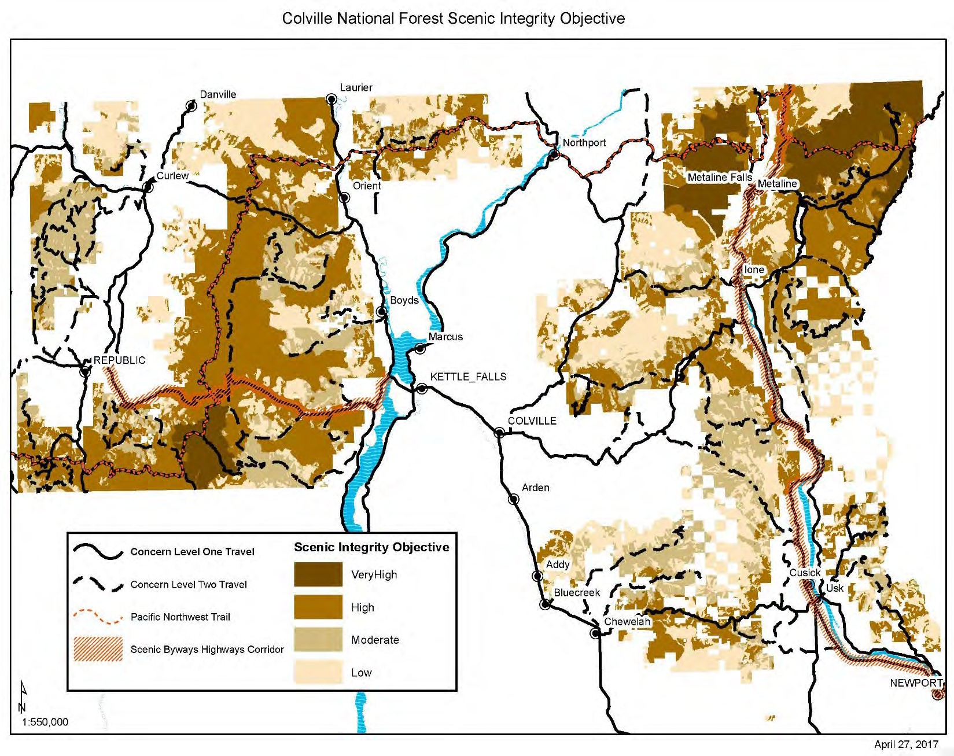
Figure D-1. Colville National Forest scenic integrity objectives

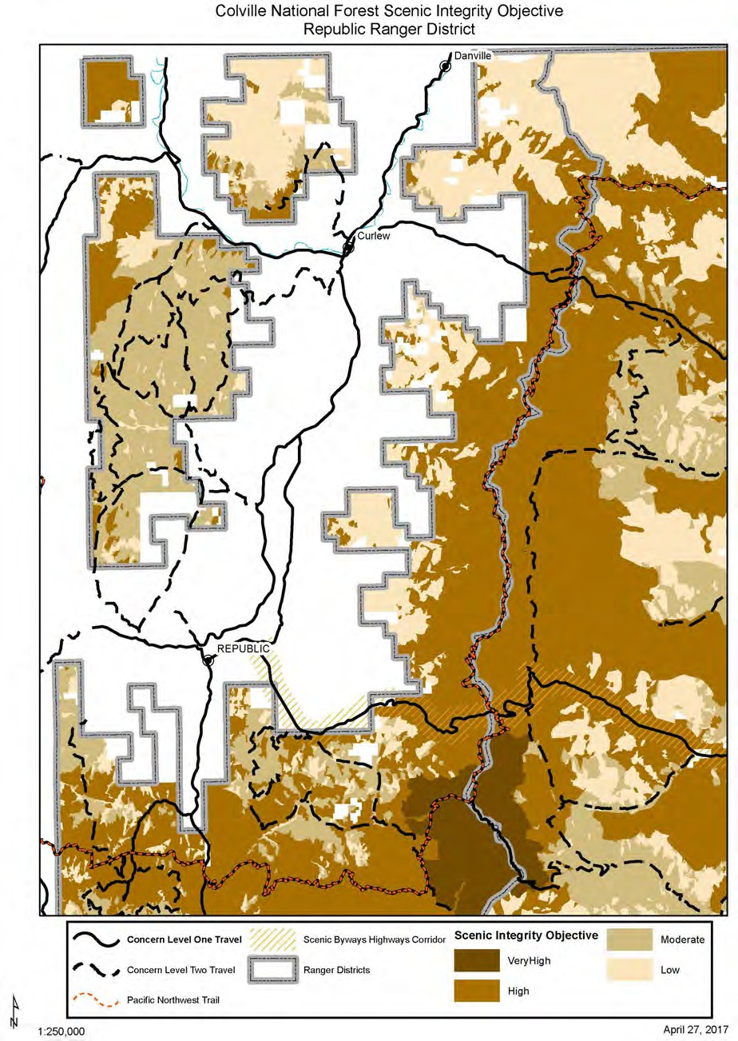
Figure D-2. Republic Ranger District scenic integrity objectives

Table D-3. Republic Ranger District scenic viewsheds

Scenic Viewsheds  Concern level 1 travel route and nationally designated recreation or scenic trail Viewsheds Concern level 2 travel route viewsheds | Scenic Integrity Objectives Prescribed  Very High SIO (Unaltered) High SIO (Appears Unaltered) Moderate SIO (Slightly Altered) Low SIO (Moderately Altered)
Distance Zones
Immediate Foreground High SIO - distance zone is 0 to 300 feet Foreground High SIO (FG) - distance zone is 300 feet to ½ mile Middleground High SIO (MG) - distance zone is ½ mile to 4 miles
Background Moderate SIO (BG) - distance zone 4 miles to horizon
Concern Level 1 Travel Route Viewsheds (High SIO FG, High MG Seen Area)  RTE_NO NAME  C602 BOULDER DEER CREEK/6100 5330130 FERRY LAKE CAMPGROUND C270 KLONDIKE  5300400 LONG LAKE BOAT LAUNCH  5300460 LONG LAKE CAMPGROUND  5330100 OLD SWAN LAKE ROAD  5300000 SCATTER CREEK  WA-20 STATE ROUTE 20/2000  WA-21 STATE ROUTE 21  C502 TORODA CREEK  C501 WEST KETTLE RIVER RD | Concern Level 2 Travel Route Viewsheds (High SIO FG, High to Moderate MG SIO)  RTE_NO NAME 2053000  2086000  2086480  2148000  C201 C212 C514-08.3  C514 2086/WEST FORK TROUT CREEK DEER CREEK SUMMIT NORTH DEER CREEK SUMMIT SOUTH  2050600 EAST FORK HALL CREEK  2150000 EMPIRE  5330000 GAFFNEY  3125000 GARDNER  2149000 GOODRICH C99 HALL CREEK 2149600 HENRY CREEK  2149700 KELLY  2114000 LITTLE VULCAN  C570 LUNDIMO MEADOWS 3575000 NICHOLSON CR  C517 NORTH FORK TROUT CREEK 5320000 RATTLESNAKE  C233 REFRIGERATOR CANYON  C253 SHERIDAN  C257 SWAMP CREEK 5314000 SWAN BUTTE RD  2113000 VULCAN  C615 VULCAN MOUNTAIN  2100500 MCMANN/QUARTZ
Concern Level 1 Nationally Designated Recreation or Scenic Trail Viewsheds  Pacific Northwest Trail Kettle Crest North | Foreground or seen area High SIO Middleground assumes the Forest Wide Management Area SIO

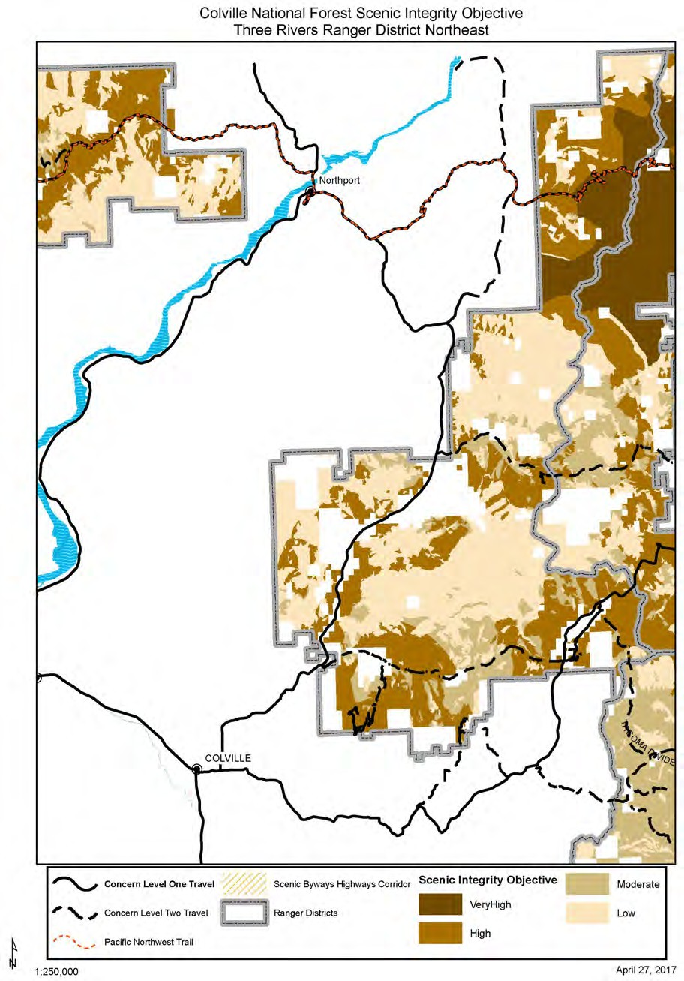
Figure D-3. Three Rivers Ranger District scenic integrity objectives (map 1 of 3)

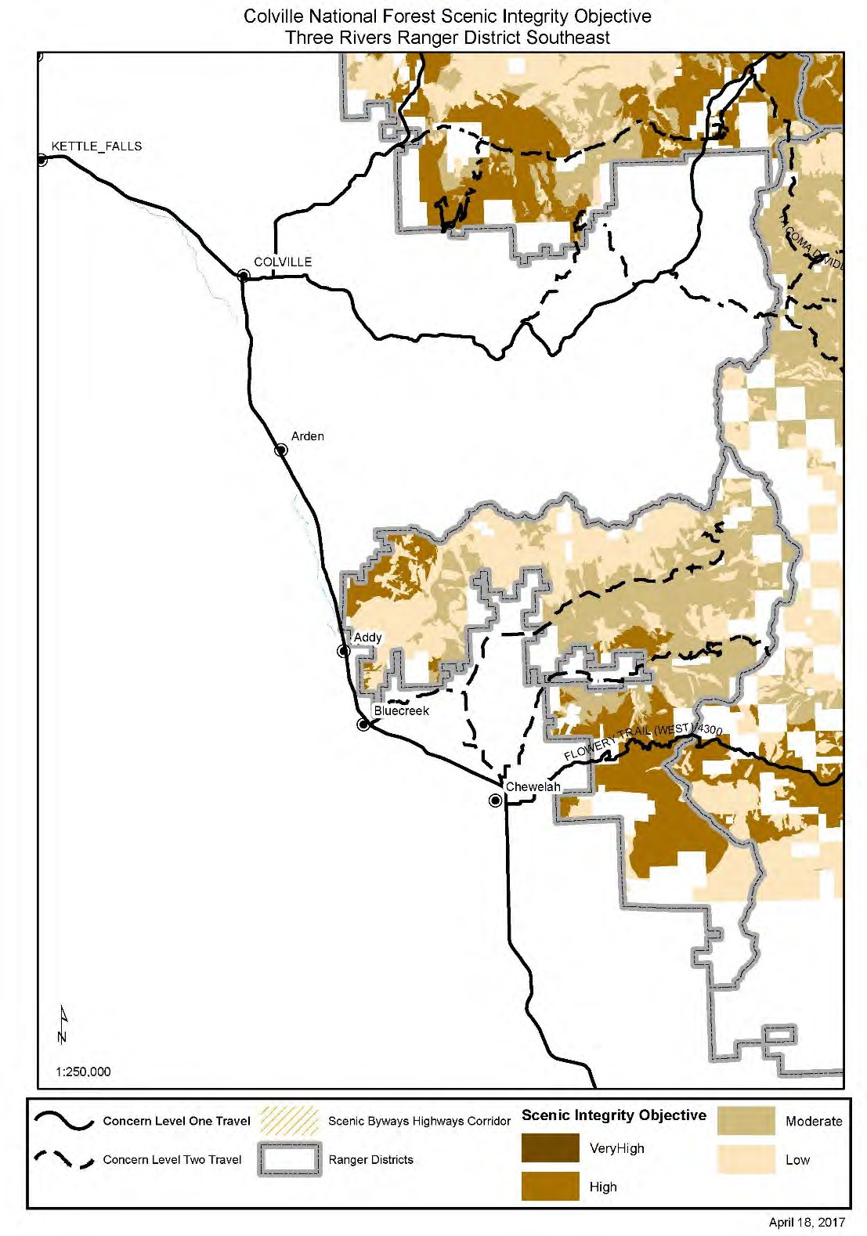
Figure D-4. Three Rivers Ranger District scenic integrity objectives (map 2 of 3)

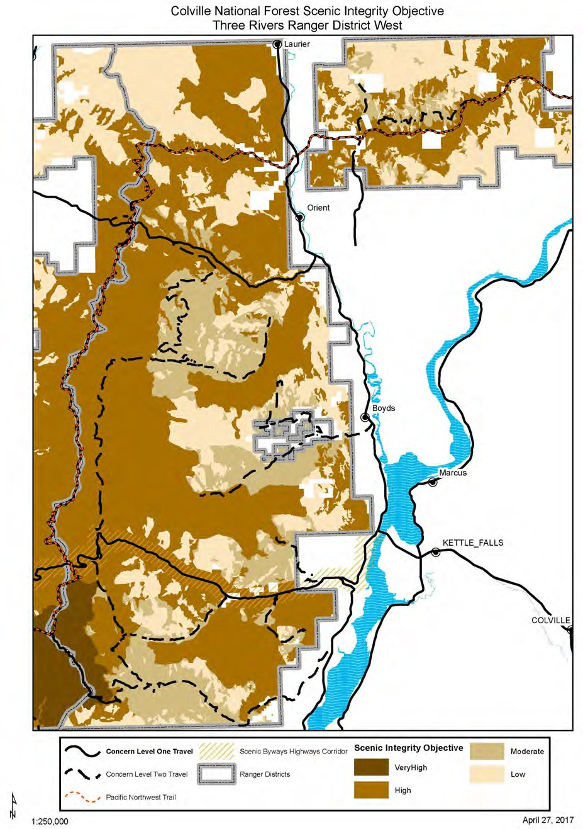
Figure D-5. Three Rivers Ranger District scenic integrity objectives (map 3 of 3)

Table D-4. Three Rivers Ranger District scenic viewsheds

Scenic Viewsheds  Concern level 1 travel route and nationally designated recreation or scenic trail viewsheds  Concern level 2 travel route viewsheds | Scenic Integrity Objectives Prescribed  Very High SIO (Unaltered) High SIO (Appears Unaltered)  Moderate SIO (Slightly Altered) Low SIO (Moderately Altered)
Distance Zones
Immediate Foreground High SIO - distance zone is 0 to 300 feet Foreground High SIO (FG) - distance zone is 300 feet to ½ mile Middleground High SIO (MG) - distance zone is ½ mile to 4 miles Background Moderate SIO (BG) - distance zone 4 miles to horizon
Concern Level 1 Travel Route Viewsheds (High SIO FG, High MG Seen Area) RTE_NO NAME  US-395  C9435 ALADDIN  1700426 BIG MEADOW LAKE BOAT LAUNCH  1700424 BIG MEADOW LAKE BOAT PARKING  1700423 BIG MEADOW LAKE CAMPGROUND  1700425 BIG MEADOW LAKE CAMPGROUND  1700429 BIG MEADOW LAKE CAMPGROUND C602 BOULDER DEER CREEK/6100 2000138 CANYON CREEK CAMPGROUND C9445 DEEP LAKE BOUNDARY  9411130 DOMINION MTN  C2902 FLOWERY TRAIL (WEST)/4300  C3 INCHELIUM HWY  2014017 LAKE ELLEN BOAT WEST AND BOAT  9413160 LITTLE TWIN BEACH  9413165 LITTLE TWIN BOAT LAUNCH  9413170 LITTLE TWIN CAMPGROUND  9413150 LITTLE TWIN CAMPGROUND DRIVE  9400160 LK GILLETTE BOAT LAUNCH  9400170 LK GILLETTE CAMPGROUND  9400165 LK GILLETTE PICNIC CAMPGROUND  2000134 LOG FLUME HERITAGE SITE -ADMIN C4987 PEND ORIELLE LAKE  C4015 PIERRE LAKE  1500020 PIERRE LAKE BOAT LAUNCH  1500016 PIERRE LAKE CAMPGROUND  1500022 PIERRE LAKE CAMPGROUND  2000493 SHERMAN OVERLOOK CAMPGROUND  2000493A SHERMAN OVERLOOK CAMPGROUND WA-20 STATE ROUTE 20/2000  WA-25 STATE ROUTE 25  9400205 THOMAS LAKE CAMPGROUND  9400206 THOMAS LAKE CAMPGROUND C4980 YOUNG | Concern Level 2 Travel Route Viewsheds (High SIO FG, High to Moderate MG SIO)  RTE_NO NAME 2030000 ALBIAN HILL  2000136 BANGS MTN  2014000 BARNABY CREEK C4939 BLACK LAKE 1500030 BOX CANYON  6113000 BULLDOG CABIN C2978 BURNT VALLEY  9565080 DAVIS LAKE CAMPGROUND  9565000 DEADMAN  C460 DEADMAN CREEK  C9445 DEEP LAKE BOUNDARY  9411000 DOMINION  C3630 IMMEL  C465 JACKNIFE  C412 LAKE ELLEN  1500000 LIMESTONE CHURCHILL  LITTLE PEND OREILLE ORV  C4920 LITTLE TWIN LAKES  C2695 MEADOW CREEK/1700  C4702 MEADOW CREEK/1700 9521000 NORTH FORK CHEWELAH CREEK C4015 PIERRE LAKE  RUFUS  C2998 SAND CANYON 6110000 SOUTH BOULDER  C4954 SOUTH FORK MILL CREEK/SR20 2020000 SOUTH SHERMAN  C2389 TACOMA CREEK/2600 2712000 TACOMA DIVIDE  9517000 TOWER  2000020 TROUT LAKE CAMPGROUND  2014250 WHITE MTN
Concern Level 1 Nationally Designated Recreation or Scenic Trail Viewsheds  2000495 Pacific Northwest Trail  Pacific Northwest Trail  C602 Pacific Northwest Trail  WA-25 STATE ROUTE 25 - PNW Trail  KETTLE CREST SOUTH | Foreground or seen area High SIO  Middleground assumes the Forest Wide Management Area SIO

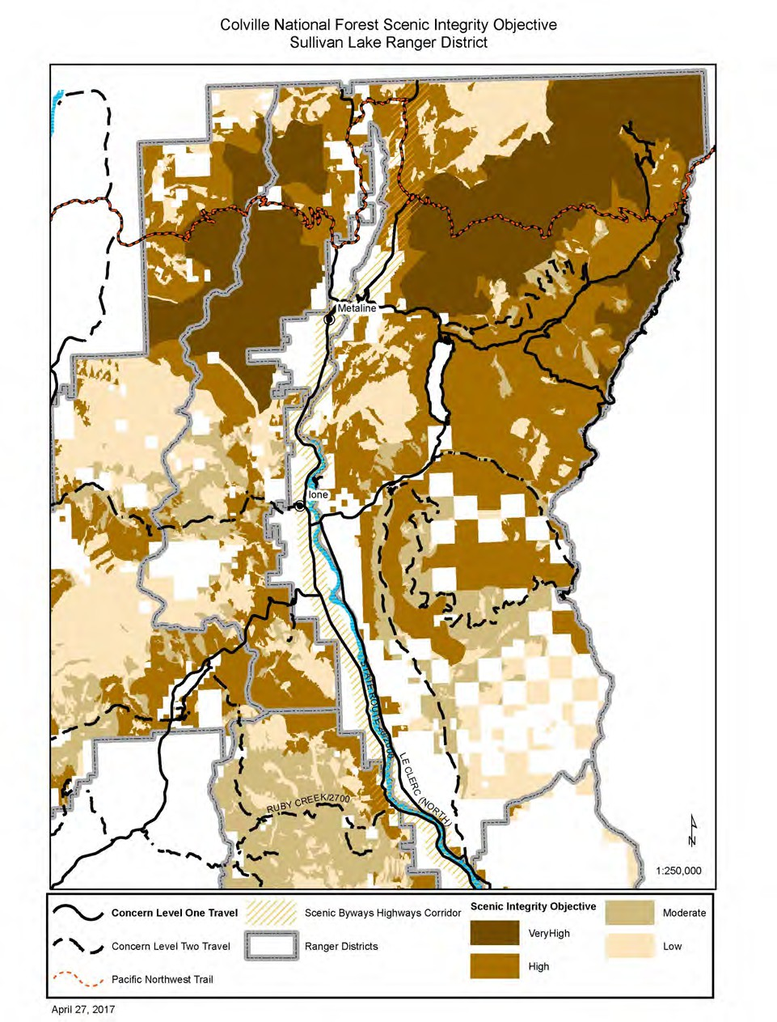

Figure D-6. Sullivan Lake Ranger District scenic integrity objectives

Table D-5. Sullivan Lake Ranger District scenic viewsheds

Scenic Viewsheds  Concern level 1 travel route and nationally designated recreation or scenic trail Viewsheds  Concern level 2 travel route viewsheds |  | Scenic Integrity Objectives Prescribed  Very High SIO (Unaltered) High SIO (Appears Unaltered)  Moderate SIO (Slightly Altered) Low SIO (Moderately Altered)
Distance Zones
Immediate Foreground High SIO - distance zone is 0 to 300 feet Foreground High SIO (FG) - distance zone is 300 feet to ½ mile Middleground High SIO (MG) - distance zone is ½ mile to 4 miles Background Moderate SIO (BG) - distance zone 4 miles to horizon
Concern Level (High SIO FG, H  RTE_NO | 1 Travel Route Viewsheds igh MG Seen Area)  NAME | Concern Level 2 Travel Route Viewsheds (High SIO FG, High to Moderate MG SIO)  RTE_NO NAME  1933000 DRY CANYON  1935000  1936000 PAU PAC TIOGA  2212000 HIGHLINE  9400500  9400509  9400510  C2695 MEADOW CREEK/1700  C2714 SMACKOUT PASS/1715 C3503
C2975
C9345
3310135 | EDGEWATER CAMP BOAT LAUNCH
3310130 | EDGEWATER CAMPGROUND
C9325 | LE CLERC (NORTH)
2200236 | MILL POND - ADMIN
2200233 | MILL POND CAMPGROUND
3300036 | NOISY CAMPGOUND / SHEEP FEEDER
3300040 | NOISY CAMPGOUND/SHEEP FEEDER
3300045 | NOISY CAMPGROUND NE LOOP
3300047 | NOISY CAMPGROUND SE LOOP
3300035 | NOISY CREEK CAMPGROUND
3300032 | NOISY GROUP CAMP - ADMIN
2200000 | NORDMAN-METALINE
2220270 | SALMO LOOKOUT
WA-20 | STATE ROUTE 20/2000
WA-31 | STATE ROUTE 31
3300232 | SULLIVAN CAMPGROUND WEST
2200248 | SULLIVAN GROUP CAMP - ADMIN
2200241 | SULLIVAN LAKE CAMPGROUND
2200247 | SULLIVAN LAKE CAMPGROUND
2200244 | SULLIVAN LAKE CAMPGROUND LOOP
2200246 | SULLIVAN LAKE CAMPGROUND LOOP
3300221 | SULLIVAN LAKE COMPOUND
2200243 | SULLIVAN LK BOAT LAUNCH
2220000 | SULLIVAN SALMO
Concern Level 1 Nationally Designated Recreation or Scenic Trail Viewsheds  3165000 Pacific Northwest Trail  3165305 Pacific Northwest Trail  3165310 Pacific Northwest Trail  6200350 Pacific Northwest Trail Pacific Northwest Trail PASS CREEK - GRASSY TOP SHEDROOF DIVIDE  LAKESHORE |  | Foreground or seen area High SIO  Middleground assumes the Forest Wide Management Area SIO

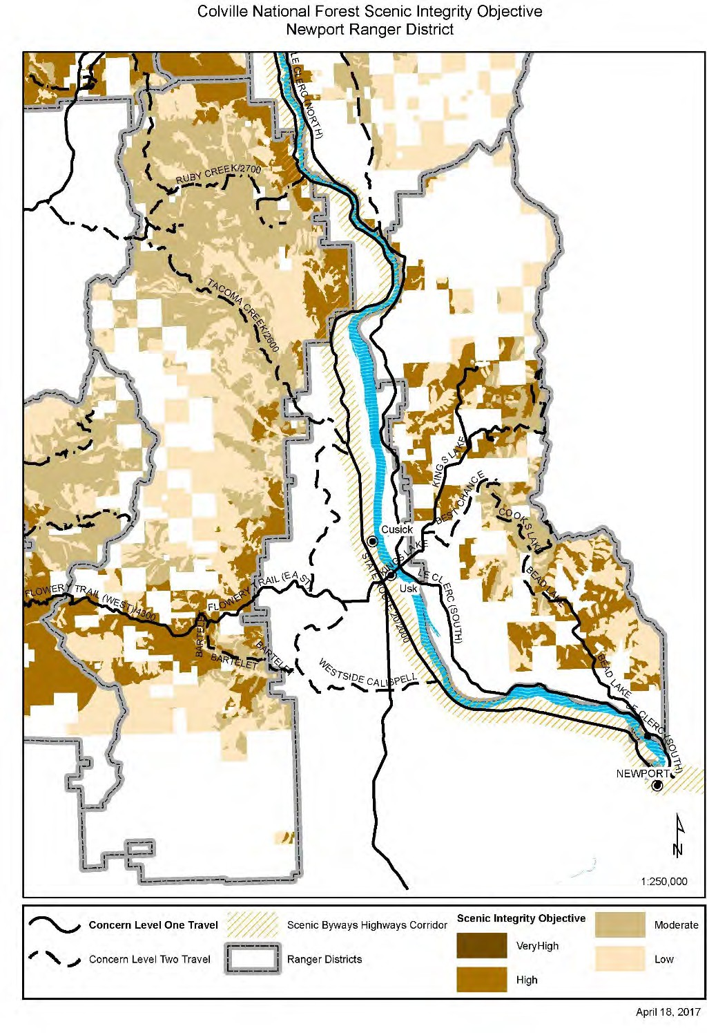
Figure D-7. Newport Ranger District scenic integrity objectives

Table D-6. Newport Ranger District scenic viewsheds

Scenic Viewsheds  Concern level 1 travel route and nationally designated recreation or scenic trail Viewsheds  Concern level 2 travel route viewsheds |  | Scenic Integrity Objectives Prescribed  Very High SIO (Unaltered) High SIO (Appears Unaltered)  Moderate SIO (Slightly Altered) Low SIO (Moderately Altered)
Distance Zones
Immediate Foreground High SIO - distance zone is 0 to 300 feet Foreground High SIO (FG) - distance zone is 300 feet to ½ mile Middleground High SIO (MG) - distance zone is ½ mile to 4 miles Background Moderate SIO (BG) - distance zone 4 miles to horizon
Concern Level (High SIO FG,  RTE_NO | 1 Travel Route Viewsheds High MG Seen Area)  NAME | Concern Level 2 Travel Route Viewsheds (High SIO FG, High to Moderate MG SIO)  RTE_NO NAME  C2022 3500/MIDDLE FORK CALISPELL C2030 BARTELET  C3029 BEAD LAKE  C3318 BEAR PAW  C3407 BEST CHANCE 5000000 BOSWELL KINGS LAKE  5015000 COOKS LAKE  2700005 RUBY CREEK C2489 RUBY CREEK/2700 5080306 SOUTH BALDY  C2389 TACOMA CREEK/2600 2712000 TACOMA DIVIDE  2700625 TIMBER MTN LOOKOUT C9205 WESTSIDE CALISPELL
WA-211
C3029 | BEAD LAKE
5030000 | BROWNS LAKE
C2110 | FLOWERY TRAIL (EAST)
C2902 | FLOWERY TRAIL (WEST)/4300
C3389 | KINGS LAKE
C9325 | LE CLERC (NORTH)
C9305 | LE CLERC (SOUTH)
C9216 | MCKENZIE
1900417 | PIONEER PARK CAMPGROUND
1900415 | PIONEER PARK CAMPGROUND
1900411 | PIONEER PARK CG BOAT LAUNCH
5032360 | SOUTH SKOOKUM BOAT LAUNCH
5032359 | SOUTH SKOOKUM CAMPGROUND
5032370 | SOUTH SKOOKUM CAMPGROUND
5032000 | SOUTH SKOOKUM REC. AREA-  ADMIN
WA-20 | STATE ROUTE 20/2000
C9205 | WESTSIDE CALISPELL

Appendix E – Suitable Uses by Management Area
Table E-1. Suitable uses by management area
Suitable uses | Forest Plan management areas  (May authorize = Y, May not authorize = N)
Suitable uses | Administrative & Recreation Sites | Backcountry | Backcountry Motorized | Focused Restoration | General Restoration | Nationally Designated Trails | Research Natural Areas | Riparian Management Areas | Scenic Byways | Kettle Crest Recreation Area | Wild and Scenic Rivers | Wilderness – Congressionally  Designated | Wilderness – Recommended
Facilities, administrative | Y | Y | Y | Y | Y | Y | Y and N | Y and N | Y | Y | Y and N | N | N
Facilities, developed recreation | Y | Y | Y | Y | Y | Y | N | Y and N | Y | Y | Y and N | N | N
Fire, planned ignition | Y | Y | Y | Y | Y | Y | Y | Y | Y | Y | Y | Y | Y
Fire, use of unplanned ignition | Y | Y | Y | Y | Y | Y | Y | Y | Y | Y | Y | Y | Y
Forest products, commercial use (non-timber harvest) | N | N | N | Y | Y | N | N | Y | Y and N | Y and N | N | N | N
Forest products, firewood, commercial use | Y | N | N | Y | Y | N | N | Y | Y and N | Y and N | N | N | N
Forest products, firewood, permitted personal use | Y | N | N | Y | Y | Y | N | N | Y | Y | N | N | N
Forest products, personal use | Y | N | N | Y | Y | Y | N | Y | Y | Y | Y | Y | Y
For more detailed information on suitable uses for each Management Area, see suitable uses tables in Chapter 3.

Suitable uses | Forest Plan management areas  (May authorize = Y, May not authorize = N)
Suitable uses | Administrative & Recreation Sites | Backcountry | Backcountry Motorized | Focused Restoration | General Restoration | Nationally Designated Trails | Research Natural Areas | Riparian Management Areas | Scenic Byways | Kettle Crest Recreation Area | Wild and Scenic Rivers | Wilderness – Congressionally  Designated | Wilderness – Recommended
Grazing, permitted | Y and N | Y | Y | Y | Y | Y | Y and N | Y | Y | Y | Y | Y and N | Y
Infrastructure, above ground infrastructure associated with special use permits, such as communication sites, energy developments, and/or  utility lines. | Y | Y | Y | Y | Y | Y and N | Y and N | Y | N | Y and N | Y and N | N | N
Mechanized recreational use, summer | Y | Y | Y | Y | Y | Y and N | Y | Y | Y | Y | Y and N | N | Y and N
Minerals, leasable – surface occupancy* | Y* | Y * | Y* | Y* | Y* | Y* | Y* | Y* | Y* | Y* | N | N | Y*
Minerals, locatable | Y*** | Y*** | Y*** | Y*** | Y*** | Y*** | Y*** | Y*** | Y*** | Y*** | Y and N** | Y | Y
Minerals, salable | Y | N | N | Y | Y | Y | Y | Y | N | Y | N | N | N
Motorized recreational use, summer, trails or play areas | Y and N | N | Y | Y | Y | N | N | Y and N | Y and N | Y and N | Y and N | N | N
Motorized recreational use, winter, trails or cross- country | Y | N | Y | Y | Y | Y and N | N | Y | Y and N | Y and N | Y and N | N | N
Non-motorized recreational use, summer | Y | Y | Y | Y | Y | Y | Y | Y | Y | Y | Y | Y | Y
Non-motorized recreational use, winter | Y | Y | Y | Y | Y | Y | Y | Y | Y | Y | Y | Y | Y
Road construction, permanent | Y | N | N | Y | Y | Y | N | Y | Y and N | Y and N | Y and N | N | N
Road construction, temporary | Y | N | N | Y | Y | Y | N | Y | Y and N | Y and N | Y and N | N | N
Special use permits | Y | Y | Y | Y | Y | Y | N | Y | Y | Y | Y and N | Y | Y and N

Suitable uses | Forest Plan management areas  (May authorize = Y, May not authorize = N)
Suitable uses | Administrative & Recreation Sites | Backcountry | Backcountry Motorized | Focused Restoration | General Restoration | Nationally Designated Trails | Research Natural Areas | Riparian Management Areas | Scenic Byways | Kettle Crest Recreation Area | Wild and Scenic Rivers | Wilderness – Congressionally  Designated | Wilderness – Recommended
Timber harvest as a restoration tool | Y | Y | Y | Y | Y | Y | N | Y | Y | Y | Y and N | N | N
Timber harvest, scheduled production | N | N | N | Y | Y | N | N | N | N | Y and N | N | N | N
Utility corridors | N | N | N | Y | Y | N | N | Y | Y and N | Y and N | Y and N | N | N
*Indicates Forest Service has consent authority for Leasable minerals. The Secretary of Interior holds authority to issue permits and leases.
**Indicates May Not Authorize except for valid existing rights.
***Locatable minerals are suitable unless the area is withdrawn from mineral entry.

Appendix F – Recreation Opportunity Spectrum
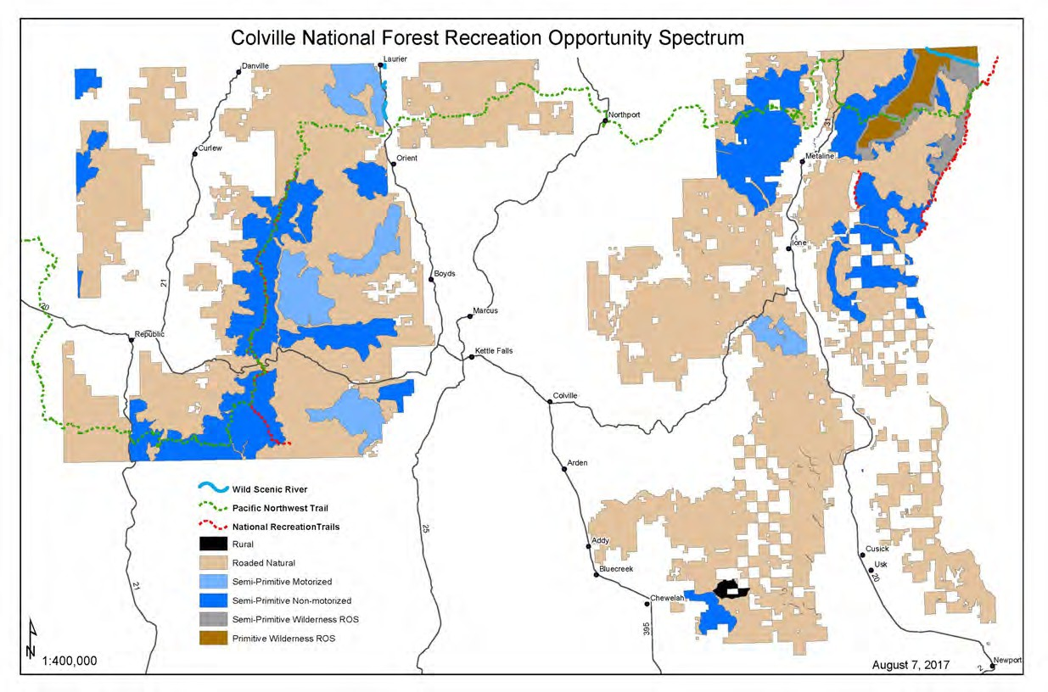
Figure F-1. Colville National Forest recreation opportunity spectrum

Appendix G – Sites with Administrative Designations and Areas Withdrawn from Mineral Entry

Administrative and Recreation Sites

Table G-1. Administrative sites on the Colville National Forest
Site name | Type | County/Ranger District | Township | Range | Section
Barnaby Butte Lookout | Administrative Site | Ferry/Republic RD | T. 35 N. | R. 35 E. | 7,18
Brown Mountain Seed Orchard | Administrative Site | Ferry/Republic RD | T. 35 N. | R. 33 E. | 16,17
Cedar Creek Seed Orchard | Administrative Site | Stevens/Three Rivers RD | T. 40 N. | R. 42 E. | 10
Chewelah Lookout | Administrative Site | Stevens/Three Rivers RD | T. 32 N. | R. 41 E. | 12
Colville NF – Supervisors Office | Administrative Site | Stevens/Three Rivers RD | T. 35 N. | R. 39 E. | 16
Curlew Civilian Conservation Center | Administrative Site | Ferry/Republic RD | T. 40 N. | R. 32 E. | 27
D1 Pal Moore Orchard Storage Shed | Administrative Site | Stevens/Three Rivers RD | T. 33 N. | R. 41 E. | 2
D1 Radio Bldg, Old Dominion | Administrative Site | Stevens/Three Rivers RD | T. 36 N. | R. 40 E. | 34
D4 Bodie Mtn Radio Bldg | Administrative Site | Ferry/Republic RD | T. 38 N. | R. 32 E. | 6
D4 Bodie Mtn Radio Bldg | Administrative Site | Ferry/Republic RD | T. 39 N. | R. 32 E. | 6,31
D4 Quartz Mt Radio Bldg. | Administrative Site | Ferry/Republic RD | T. 35 N. | R. 33 E. | 3
D4 Quartz Mt Radio Bldg. | Administrative Site | Ferry/Republic RD | T. 36 N. | R. 33 E. | 3,33,34
D5 Radio Bldg, Sullivan Mtn | Administrative Site | Pend Oreille/Sullivan Lake RD | T. 39 N. | R. 44 E. | 16
D5 Salmo Mtn. Lookout | Administrative Site | Pend Oreille/Sullivan Lake RD | T. 40 N. | R. 45 E. | 16
Dominion Lookout | Administrative Site | Stevens/Three Rivers RD | T. 36 N. | R. 40 E. | 34
Drycreek Site | Administrative Site | Pend Oreille/Newport RD | T. 33 N. | R. 45 E. | 30
First Thought Lookout | Administrative Site | Stevens/Three Rivers RD | T. 39 N. | R. 37 E. | 7
Flagstaff Lookout | Administrative Site | Stevens/Three Rivers RD | T. 39 N. | R. 39 E. | 5
Flowery Trail Seed Orchard | Administrative Site | Pend Oreille/Newport RD | T. 32 N. | R. 43 E. | 5

Site name | Type | County/Ranger District | Township | Range | Section
Graves Mountain Lookout | Administrative Site | Ferry/Republic RD | T. 36 N. | R. 35 E. | 12
Halliday Fen RNA33 | Administrative Site | Pend Oreille/Sullivan Lake RD | T. 39 N. | R. 43 E. | 1,6
Halliday Fen RNA | Administrative Site | Pend Oreille/Sullivan Lake RD | T. 39 N. | R. 44 E. | 6,31
Halliday Fen RNA | Administrative Site | Pend Oreille/Sullivan Lake RD | T. 40 N. | R. 43 E. | 1,6,31,3  6
Halliday Fen RNA | Administrative Site | Pend Oreille/Sullivan Lake RD | T. 40 N. | R. 44 E. | 6,30,31,  32
Hanlon | Administrative Site | Pend Oreille/Sullivan Lake RD | T. 36 N. | R. 44 E. | 29
Huckleberry Lookout | Administrative Site | Pend Oreille/Sullivan Lake RD | T. 38 N. | R. 42 E. | 29,30
Kettle Range Observation Site | Administrative Site | Ferry/Republic RD | T. 36 N. | R. 35 E. | 19
Lookout Station | Administrative Site | Pend Oreille/Newport RD | T. 36 N. | R. 42 E. | 24
Lookout Station | Administrative Site | Pend Oreille/Sullivan Lake RD | T. 36 N. | R. 43 E. | 24
Marble Lookout | Administrative Site | Ferry/Republic RD | T. 39 N. | R. 35 E. | 4
Martin Creek Administration Site | Administrative Site | Ferry/Republic RD | T. 39 N. | R. 36 E. | 15
Mill Creek Administrative Site | Administrative Site | Stevens/Three Rivers RD | T. 36 N. | R. 41 E. | 20
Newport Geophysical Observatory | Administrative Site | Pend Oreille/Newport RD | T. 32 N. | R. 45 E. | 16,20,2  1,22,28
Newport RD | Administrative Site | Pend Oreille/Newport RD | T. 31 N. | R. 45 E. | 13
Newport RD | Administrative Site | Pend Oreille/Newport RD | T. 31 N. | R. 46 E. | 13
Pal Moore Seed Orchard | Administrative Site | Stevens/Three Rivers RD | T. 33 N. | R. 41 E. | 1,2
Republic RD | Administrative Site | Ferry/Republic RD | T. 36 N. | R. 32 E. | 1
Republic RD | Administrative Site | Ferry/Republic RD | T. 36 N. | R. 33 E. | 1,6
Round Top Mountain RNA | Administrative Site | Pend Oreille/Sullivan Lake RD | T. 38 N. | R. 45 E. | 8
Salmo RNA | Administrative Site | Pend Oreille/Sullivan Lake RD | T. 40 N. | R. 45 E. | 9,10,11,  14,15,1  6, 22
Sullivan Lake | Administrative Site | Pend Oreille/Sullivan Lake RD | T. 39 N. | R. 44 E. | 29,30,3  1,32
Sullivan Lake RD | Administrative Site | Pend Oreille/Sullivan Lake RD | T. 39 N. | R. 44 E. | 31

33 Research Natural Area

Site name | Type | County/Ranger District | Township | Range | Section
Sullivan Mountain Lookout | Administrative Site | Pend Oreille/Sullivan Lake RD | T. 39 N. | R. 44 E. | 16
Teepee Seed Orchard | Administrative Site | Pend Oreille/Sullivan Lake RD | T. 37 N. | R. 42 E. | 34
Three Rivers RD | Administrative Site | Stevens/Three Rivers RD | T. 36 N. | R. 38 E. | 20
49 Degrees North | Recreation Site | Stevens/Three Rivers RD | T. 32 N. | R. 41 E. | 1,6
49 Degrees North | Recreation Site | Stevens/Three Rivers RD | T. 32 N. | R. 42 E. | 6
Abercrombie | Recreation Site | Stevens/Three Rivers RD | T. 40 N. | R. 42 E. | 34
Barnaby Butte | Recreation Site | Ferry/Republic RD | T. 35 N. | R. 34 E. | 35
Barnaby Buttes | Recreation Site | Ferry/Republic RD | T. 35 N. | R. 35 E. | 8,17
Batey-Bould | Recreation Site | Pend Oreille/Newport RD | T. 33 N. | R. 43 E. | 9,10
Bead Lake | Recreation Site | Pend Oreille/Newport RD | T. 32 N. | R. 45 E. | 3,4,9,10  ,33
Bead Lake | Recreation Site | Pend Oreille/Newport RD | T. 33 N. | R. 45 E. | 3,4,27,3  3,34
Bead Lake Boat Launch | Recreation Site | Pend Oreille/Newport RD | T. 32 N. | R. 45 E. | 9,10
Bear Pasture | Recreation Site | Pend Oreille/Sullivan Lake RD | T. 39 N. | R. 45 E. | 5,6
Bear Pasture | Recreation Site | Pend Oreille/Sullivan Lake RD | T. 40 N. | R. 45 E. | 5,6,31,3  2
Bearpot | Recreation Site | Ferry/Republic RD | T. 35 N. | R. 34 E. | 19
Big Lick | Recreation Site | Ferry/Republic RD | T. 38 N. | R. 34 E. | 9,16
Big Meadow Lake Campground | Recreation Site | Pend Oreille/Three Rivers RD | T. 37 N. | R. 41 E. | 1,12
Big Meadow Lake Campground | Recreation Site | Pend Oreille/Sullivan Lake RD | T. 37 N. | R. 42 E. | 1,6,7,12
Boulder Deer Summit | Recreation Site | Ferry/Republic RD | T. 39 N. | R. 35 E. | 20,21
Boundary Lake | Recreation Site | Pend Oreille/Sullivan Lake RD | T. 40 N. | R. 43 E. | 1
Boundary Lake | Recreation Site | Pend Oreille/Sullivan Lake RD | T. 40 N. | R. 44 E. | 1,6
Browns Lake | Recreation Site | Pend Oreille/Newport RD | T. 34 N. | R. 44 E. | 13,14,2  3,24
Browns Lake Campground | Recreation Site | Pend Oreille/Newport RD | T. 34 N. | R. 44 E. | 23,24
Canyon Creek | Recreation Site | Ferry/Republic RD | T. 36 N. | R. 36 E. | 35
Canyon Creek Campground | Recreation Site | Ferry/Republic RD | T. 36 N. | R. 36 E. | 35,36
Chewelah Creek | Recreation Site | Stevens/Three Rivers RD | T. 33 N. | R. 41 E. | 4,9

Site name | Type | County/Ranger District | Township | Range | Section
Chewelah Ski Area | Recreation Site | Stevens/Three Rivers RD | T. 32 N. | R. 41 E. | 2,3,10,1  1
Comstock | Recreation Site | Stevens/Three Rivers RD | T. 37 N. | R. 40 E. | 17,18
Cooks Lake | Recreation Site | Pend Oreille/Newport RD | T. 33 N. | R. 44 E. | 24
Cooks Lake | Recreation Site | Pend Oreille/Newport RD | T. 33 N. | R. 45 E. | 19,24
Cougar | Recreation Site | Ferry/Republic RD | T. 35 N. | R. 33 E. | 28
Crescent Lake | Recreation Site | Pend Oreille/Sullivan Lake RD | T. 40 N. | R. 43 E. | 1,12
Crescent Lake Picnic Area | Recreation Site | Pend Oreille/Sullivan Lake RD | T. 40 N. | R. 43 E. | 1,12
Crowell Ridge | Recreation Site | Pend Oreille/Sullivan Lake RD | T. 39 N. | R. 44 E. | 16
Davis Lake | Recreation Site | Ferry/Republic RD | T. 37 N. | R. 36 E. | 3,34
Davis Lake | Recreation Site | Ferry/Republic RD | T. 38 N. | R. 36 E. | 34
Davis Lake Campground | Recreation Site | Ferry/Republic RD | T. 37 N. | R. 36 E. | 3,34
Davis Lake Campground | Recreation Site | Ferry/Republic RD | T. 38 N. | R. 36 E. | 34
Deer Creek | Recreation Site | Ferry/Republic RD | T. 39 N. | R. 35 E. | 20
Deer Creek Forest Camp | Recreation Site | Ferry/Republic RD | T. 39 N. | R. 35 E. | 20,21
East Sullivan | Recreation Site | Pend Oreille/Sullivan Lake RD | T. 39 N. | R. 44 E. | 31,32
Edds Mtn | Recreation Site | Ferry/Republic RD | T. 35 N. | R. 34 E. | 4,5
Edds Mtn | Recreation Site | Ferry/Republic RD | T. 36 N. | R. 34 E. | 4,5,33
Edgewater Campground | Recreation Site | Pend Oreille/Sullivan Lake RD | T. 38 N. | R. 43 E. | 29,30,3  1,32
Elbow Lake | Recreation Site | Stevens/Three Rivers RD | T. 40 N. | R. 38 E. | 21
Elk Creek | Recreation Site | Pend Oreille/Sullivan Lake RD | T. 39 N. | R. 43 E. | 24,25
Elk Creek | Recreation Site | Pend Oreille/Sullivan Lake RD | T. 39 N. | R. 44 E. | 19,24,2  5,30
Empire Lake | Recreation Site | Ferry/Republic RD | T. 38 N. | R. 32 E. | 12
Ferry Lake | Recreation Site | Ferry/Republic RD | T. 35 N. | R. 32 E. | 21
Ferry Lake Campground | Recreation Site | Ferry/Republic RD | T. 35 N. | R. 32 E. | 16,21
Flume Creek | Recreation Site | Pend Oreille/Sullivan Lake RD | T. 40 N. | R. 43 E. | 31
Frater Lake | Recreation Site | Pend Oreille/Sullivan Lake RD | T. 36 N. | R. 42 E. | 3
Frater Lake | Recreation Site | Pend Oreille/Sullivan Lake RD | T. 37 N. | R. 42 E. | 3,34
Geophysical | Recreation Site | Pend Oreille/Newport RD | T. 32 N. | R. 45 E. | 21,28
Gibraltar | Recreation Site | Ferry/Republic RD | T. 36 N. | R. 33 E. | 20,21,2  8,29

Site name | Type | County/Ranger District | Township | Range | Section
Gillette Campground | Recreation Site | Stevens/Three Rivers RD | T. 36 N. | R. 42 E. | 17,20
Grassy Top North | Recreation Site | Pend Oreille/Sullivan Lake RD | T. 38 N. | R. 45 E. | 17
Grassy Top South | Recreation Site | Pend Oreille/Sullivan Lake RD | T. 38 N. | R. 44 E. | 35
Growden Heritage Interpretive Site | Recreation Site | Ferry/Republic RD | T. 36 N. | R. 36 E. | 28,29
Half Moon Lake | Recreation Site | Pend Oreille/Newport RD | T. 34 N. | R. 44 E. | 26
Hall Creek | Recreation Site | Pend Oreille/Sullivan Lake RD | T. 38 N. | R. 44 E. | 5,6
Hall Creek | Recreation Site | Pend Oreille/Sullivan Lake RD | T. 39 N. | R. 44 E. | 5,6,31,3  2
Hall Mtn | Recreation Site | Pend Oreille/Sullivan Lake RD | T. 38 N. | R. 44 E. | 9,10
Halliday | Recreation Site | Pend Oreille/Sullivan Lake RD | T. 40 N. | R. 43 E. | 36
Hoodoo | Recreation Site | Ferry/Republic RD | T. 37 N. | R. 36 E. | 31,32
Jungle Hill | Recreation Site | Ferry/Republic RD | T. 36 N. | R. 35 E. | 8
Kettle Crest | Recreation Site | Ferry/Republic RD | T. 36 N. | R. 34 E. | 13,18,1  9,24
Kettle Crest | Recreation Site | Ferry/Republic RD | T. 36 N. | R. 35 E. | 18,19
Kings Lake Snopark | Recreation Site | Pend Oreille/Newport RD | T. 33 N. | R. 44 E. | 2
Lake Ellen | Recreation Site | Ferry/Republic RD | T. 35 N. | R. 36 E. | 26,27,3  4,35
Lake Ellen Campground | Recreation Site | Ferry/Republic RD | T. 35 N. | R. 36 E. | 26
Lake Ellen Campground West | Recreation Site | Ferry/Republic RD | T. 35 N. | R. 36 E. | 26,27,3  4,35
Lake Gillette Campground | Recreation Site | Stevens/Three Rivers RD | T. 36 N. | R. 42 E. | 19,20
Lake Leo | Recreation Site | Pend Oreille/Sullivan Lake RD | T. 36 N. | R. 42 E. | 3
Lake Leo | Recreation Site | Stevens/Three Rivers RD | T. 36 N. | R. 42 E. | 3,4
Lake Leo Campground | Recreation Site | Pend Oreille/Sullivan Lake RD | T. 36 N. | R. 42 E. | 3
Lake Leo Campground | Recreation Site | Stevens/Three Rivers RD | T. 36 N. | R. 42 E. | 3,4
Lake Thomas - Lake Gillette | Recreation Site | Stevens/Three Rivers RD | T. 36 N. | R. 42 E. | 17,19,2  0
Lake Thomas Campground | Recreation Site | Stevens/Three Rivers RD | T. 36 N. | R. 42 E. | 17
Lakeshore North | Recreation Site | Pend Oreille/Sullivan Lake RD | T. 39 N. | R. 44 E. | 31,32
Lakeshore South | Recreation Site | Pend Oreille/Sullivan Lake RD | T. 38 N. | R. 44 E. | 17,18

Site name | Type | County/Ranger District | Township | Range | Section
Lambert | Recreation Site | Ferry/Republic RD | T. 37 N. | R. 34 E. | 3,4,9
Lambert Campground | Recreation Site | Ferry/Republic RD | T. 37 N. | R. 34 E. | 4,9
Le Clerc Recreation Area | Recreation Site | Pend Oreille/Sullivan Lake RD | T. 36 N. | R. 44 E. | 19
Leona | Recreation Site | Ferry/Republic RD | T. 38 N. | R. 34 E. | 26,27
Lime Creek | Recreation Site | Pend Oreille/Sullivan Lake RD | T. 40 N. | R. 43 E. | 14
Little Pend Oreille Information Site | Recreation Site | Stevens/Three Rivers RD | T. 36 N. | R. 42 E. | 19
Little Pend Oreille Orv | Recreation Site | Stevens/Three Rivers RD | T. 36 N. | R. 42 E. | 19
Little Twin Lakes | Recreation Site | Stevens/Three Rivers RD | T. 35 N. | R. 41 E. | 4
Little Twin Lakes | Recreation Site | Stevens/Three Rivers RD | T. 36 N. | R. 41 E. | 4,32,33
Little Twin Lakes Recreation Area | Recreation Site | Stevens/Three Rivers RD | T. 36 N. | R. 41 E. | 33
Log Flume Heritage Interpretive Site | Recreation Site | Ferry/Republic RD | T. 36 N. | R. 36 E. | 25,36
Long & Fish Lake | Recreation Site | Ferry/Republic RD | T. 35 N. | R. 32 E. | 28,33
Long Alec | Recreation Site | Ferry/Republic RD | T. 39 N. | R. 35 E. | 31
Long Lake Campground | Recreation Site | Ferry/Republic RD | T. 35 N. | R. 32 E. | 28
Lost Creek | Recreation Site | Pend Oreille/Sullivan Lake RD | T. 36 N. | R. 43 E. | 15,22
Lower Wolf | Recreation Site | Pend Oreille/Newport RD | T. 31 N. | R. 45 E. | 13
Lower Wolf | Recreation Site | Pend Oreille/Newport RD | T. 31 N. | R. 46 E. | 13
Maple Mtn | Recreation Site | Ferry/Republic RD | T. 37 N. | R. 32 E. | 18
Maple Mtn | Recreation Site | Okanogan/Republic RD | T. 37 N. | R. 32 E. | 18
Marcus | Recreation Site | Ferry/Republic RD | T. 37 N. | R. 34 E. | 16,21
Middle Fork Calispell | Recreation Site | Pend Oreille/Newport RD | T. 32 N. | R. 42 E. | 25,30
Middle Fork Calispell | Recreation Site | Pend Oreille/Newport RD | T. 32 N. | R. 43 E. | 30
Mill Pond Campground | Recreation Site | Pend Oreille/Sullivan Lake RD | T. 39 N. | R. 44 E. | 30
Mill Pond Flume Trailhead | Recreation Site | Pend Oreille/Sullivan Lake RD | T. 39 N. | R. 43 E. | 24,25
Mill Pond Flume Trailhead | Recreation Site | Pend Oreille/Sullivan Lake RD | T. 39 N. | R. 44 E. | 19,24,2  5,30
Muddy Creek | Recreation Site | Pend Oreille/Sullivan Lake RD | T. 37 N. | R. 42 E. | 12,32
Mystic Lake | Recreation Site | Pend Oreille/Newport RD | T. 33 N. | R. 45 E. | 29,32

Site name | Type | County/Ranger District | Township | Range | Section
Ninemile Falls | Recreation Site | Ferry/Republic RD | T. 35 N. | R. 33 E. | 11
No Name Lake | Recreation Site | Pend Oreille/Newport RD | T. 32 N. | R. 45 E. | 4,5,8,9
Noisy Creek | Recreation Site | Pend Oreille/Sullivan Lake RD | T. 38 N. | R. 44 E. | 17,18,1  9,20
Noisy Creek Campground | Recreation Site | Pend Oreille/Sullivan Lake RD | T. 38 N. | R. 44 E. | 17,18,1  9
Northeast | Recreation Site | Pend Oreille/Sullivan Lake RD | T. 39 N. | R. 44 E. | 32
Old Stage | Recreation Site | Ferry/Republic RD | T. 37 N. | R. 34 E. | 12,13,1  8
Old Stage | Recreation Site | Ferry/Republic RD | T. 37 N. | R. 35 E. | 18
Outlet Creek | Recreation Site | Pend Oreille/Sullivan Lake RD | T. 39 N. | R. 44 E. | 31
Panhandle Campground | Recreation Site | Pend Oreille/Newport RD | T. 35 N. | R. 44 E. | 29
Parker Lake | Recreation Site | Pend Oreille/Newport RD | T. 34 N. | R. 43 E. | 3,34
Pend Oreille River | Recreation Site | Pend Oreille/Sullivan Lake RD | T. 37 N. | R. 43 E. | 28,33
Pepoon Lake | Recreation Site | Stevens/Three Rivers RD | T. 39 N. | R. 39 E. | 6
Pierre Lake | Recreation Site | Stevens/Three Rivers RD | T. 39 N. | R. 37 E. | 5
Pierre Lake Campground | Recreation Site | Stevens/Three Rivers RD | T. 39 N. | R. 37 E. | 5
Pioneer Park | Recreation Site | Pend Oreille/Newport RD | T. 31 N. | R. 45 E. | 1
Pioneer Park Campground | Recreation Site | Pend Oreille/Newport RD | T. 31 N. | R. 45 E. | 1,12
Profanity | Recreation Site | Ferry/Republic RD | T. 38 N. | R. 34 E. | 12
Red Bluff | Recreation Site | Pend Oreille/Sullivan Lake RD | T. 39 N. | R. 44 E. | 30
Renner Lake | Recreation Site | Ferry/Republic RD | T. 38 N. | R. 36 E. | 24
Rogers Mtn | Recreation Site | Stevens/Three Rivers RD | T. 37 N. | R. 40 E. | 2
Ruby | Recreation Site | Pend Oreille/Newport RD | T. 35 N. | R. 44 E. | 18,19
Rufus | Recreation Site | Stevens/Three Rivers RD | T. 36 N. | R. 42 E. | 17,20
Ryan Cabin | Recreation Site | Ferry/Republic RD | T. 38 N. | R. 35 E. | 30
Salmo | Recreation Site | Pend Oreille/Sullivan Lake RD | T. 40 N. | R. 45 E. | 22
Sand Creek Rd | Recreation Site | Pend Oreille/Sullivan Lake RD | T. 38 N. | R. 43 E. | 1
Sand Creek Rd | Recreation Site | Pend Oreille/Sullivan Lake RD | T. 38 N. | R. 44 E. | 1,6

Site name | Type | County/Ranger District | Township | Range | Section
Shedroof | Recreation Site | Pend Oreille/Sullivan Lake RD | T. 38 N. | R. 45 E. | 17
Sherlock | Recreation Site | Stevens/Three Rivers RD | T. 39 N. | R. 42 E. | 17
Sherman | Recreation Site | Ferry/Republic RD | T. 36 N. | R. 34 E. | 2
Sherman Creek | Recreation Site | Ferry/Republic RD | T. 36 N. | R. 36 E. | 35,36
Sherman Overlook Day Use | Recreation Site | Ferry/Republic RD | T. 36 N. | R. 35 E. | 19,20
Sherman Pass Campground | Recreation Site | Ferry/Republic RD | T. 36 N. | R. 35 E. | 19
Silver Creek | Recreation Site | Stevens/Three Rivers RD | T. 39 N. | R. 42 E. | 8,9
Snow Peak | Recreation Site | Ferry/Republic RD | T. 36 N. | R. 34 E. | 27,34
Snow Peak Shelter | Recreation Site | Ferry/Republic RD | T. 36 N. | R. 34 E. | 36
South Skookum Lake | Recreation Site | Pend Oreille/Newport RD | T. 33 N. | R. 44 E. | 1
South Skookum Lake Campground | Recreation Site | Pend Oreille/Newport RD | T. 33 N. | R. 44 E. | 1
Stickpin | Recreation Site | Ferry/Republic RD | T. 38 N. | R. 35 E. | 30
Sullivan Creek | Recreation Site | Pend Oreille/Sullivan Lake RD | T. 39 N. | R. 44 E. | 25,26,2  9,30,31,  32,33,3  4,35,36
Sullivan Creek | Recreation Site | Pend Oreille/Sullivan Lake RD | T. 39 N. | R. 45 E. | 3,9,10,1  6,17,19,  20,30
Sullivan Lake | Recreation Site | Pend Oreille/Sullivan Lake RD | T. 38 N. | R. 44 E. | 1,6,7,12  ,13,18
Sullivan Lake | Recreation Site | Pend Oreille/Sullivan Lake RD | T. 39 N. | R. 43 E. | 25
Sullivan Lake | Recreation Site | Pend Oreille/Sullivan Lake RD | T. 39 N. | R. 44 E. | 6,31,32,  33
Sullivan Lake Group Campground | Recreation Site | Pend Oreille/Sullivan Lake RD | T. 39 N. | R. 44 E. | 31,32
Summit Lake | Recreation Site | Stevens/Three Rivers RD | T. 40 N. | R. 37 E. | 16,17,2  0,21
Swan Lake | Recreation Site | Ferry/Republic RD | T. 35 N. | R. 32 E. | 19,20,2  9
Swan Lake Campground | Recreation Site | Ferry/Republic RD | T. 35 N. | R. 32 E. | 20,29
Ten Mile | Recreation Site | Ferry/Republic RD | T. 35 N. | R. 32 E. | 19,24
Ten Mile | Recreation Site | Ferry/Republic RD | T. 35 N. | R. 33 E. | 19
Ten Mile Campground | Recreation Site | Ferry/Republic RD | T. 35 N. | R. 32 E. | 19,24
Ten Mile Campground | Recreation Site | Ferry/Republic RD | T. 35 N. | R. 33 E. | 19
Thirteen Mile Campground | Recreation Site | Ferry/Republic RD | T. 35 N. | R. 33 E. | 31
Thirteenmile | Recreation Site | Ferry/Republic RD | T. 35 N. | R. 33 E. | 31

Site name | Type | County/Ranger District | Township | Range | Section
Thunder Creek | Recreation Site | Pend Oreille/Sullivan Lake RD | T. 39 N. | R. 45 E. | 3,10
Timber Ridge | Recreation Site | Ferry/Republic RD | T. 37 N. | R. 34 E. | 27,28
Trout Lake | Recreation Site | Ferry/Republic RD | T. 36 N. | R. 36 E. | 11,12,1  3,14
Trout Lake Campground | Recreation Site | Ferry/Republic RD | T. 36 N. | R. 36 E. | 11,12,1  3,14
Upper Bead Lake | Recreation Site | Pend Oreille/Newport RD | T. 32 N. | R. 45 E. | 9,10
Upper Wolf | Recreation Site | Pend Oreille/Newport RD | T. 31 N. | R. 45 E. | 13
Wapaloosie | Recreation Site | Ferry/Republic RD | T. 37 N. | R. 34 E. | 31,36
Wapaloosie | Recreation Site | Ferry/Republic RD | T. 37 N. | R. 35 E. | 31
West Sullivan | Recreation Site | Pend Oreille/Sullivan Lake RD | T. 39 N. | R. 44 E. | 31
White Mountain Interpretive Site | Recreation Site | Ferry/Republic RD | T. 36 N. | R. 34 E. | 23
White Mtn | Recreation Site | Ferry/Republic RD | T. 35 N. | R. 35 E. | 28

Communication Sites and Energy Corridors
Tables G-2 and G-3 list the communication sites and energy corridors designated on the Colville National Forest. The tables correspond to Figure G-1, which displays the locations of the communication sites and energy corridors.

Table G-2. List of designated communication sites on the Colville National Forest
Communication site name/lease holders | County/Ranger District | Site designation | Location
Bisbee Mountain | Ferry/Three Rivers | Low-power, non-broadcast | NE¼ Sec. 9, T. 36N., R.36E., W.  M., in Ferry County
- Verizon | Ferry/Three Rivers | Low-power, non-broadcast | NE¼ Sec. 9, T. 36N., R.36E., W.  M., in Ferry County
- Washington State Dept.  of Transportation | Ferry/Three Rivers | Low-power, non-broadcast | NE¼ Sec. 9, T. 36N., R.36E., W.  M., in Ferry County
Bodie Mountain | Ferry/Republic | Low-power, non-broadcast | NW¼NW¼ Sec. 6, T. 38N.,  R.32E., W. M., in Ferry County
- Washington State Department of Natural  Resources | Ferry/Republic | Low-power, non-broadcast | NW¼NW¼ Sec. 6, T. 38N.,  R.32E., W. M., in Ferry County
- Forest Service | Ferry/Republic | Low-power, non-broadcast | NW¼NW¼ Sec. 6, T. 38N.,  R.32E., W. M., in Ferry County
Chewelah Peak | Stevens/Newport | Low-power, non-broadcast | SE¼ Sec. 12, T. 32N., R41E.,  W.M., in Stevens County
- SBA Structures | Stevens/Newport | Low-power, non-broadcast | SE¼ Sec. 12, T. 32N., R41E.,  W.M., in Stevens County
Deer Mountain | Pend Oreille/Sullivan Lake | Low-power, non-broadcast | N½ Sec. 13, T. 38N., R.42E., W.  M., in Pend Oreille County
- Pend Oreille PUD #1 | Pend Oreille/Sullivan Lake | Low-power, non-broadcast | N½ Sec. 13, T. 38N., R.42E., W.  M., in Pend Oreille County

Communication site name/lease holders | County/Ranger District | Site designation | Location
Flagstaff Mountain | Stevens/Three Rivers | Low-power, non-broadcast | NE¼ Sec. 5, T. 39N., R.39E., W.  M., in Stevens County
- SBA Structures | Stevens/Three Rivers | Low-power, non-broadcast | NE¼ Sec. 5, T. 39N., R.39E., W.  M., in Stevens County
- Verizon | Stevens/Three Rivers | Low-power, non-broadcast | NE¼ Sec. 5, T. 39N., R.39E., W.  M., in Stevens County
- AT&T | Stevens/Three Rivers | Low-power, non-broadcast | NE¼ Sec. 5, T. 39N., R.39E., W.  M., in Stevens County
- Department of Homeland Security, U.S. Customs  and Border Patrol | Stevens/Three Rivers | Low-power, non-broadcast | NE¼ Sec. 5, T. 39N., R.39E., W.  M., in Stevens County
- Forest Service | Stevens/Three Rivers | Low-power, non-broadcast | NE¼ Sec. 5, T. 39N., R.39E., W.  M., in Stevens County
Flume Creek | Pend Oreille/Sullivan Lake | Low-power, non-broadcast | SE¼ Sec. 31, T. 40N., R.43E., W.  M., in Pend Oreille County
- Pend Oreille County Emergency Management | Pend Oreille/Sullivan Lake | Low-power, non-broadcast | SE¼ Sec. 31, T. 40N., R.43E., W.  M., in Pend Oreille County
- Department of Energy, Bonneville Power  Administration | Pend Oreille/Sullivan Lake | Low-power, non-broadcast | SE¼ Sec. 31, T. 40N., R.43E., W.  M., in Pend Oreille County
Owl Mountain | Ferry/Three Rivers | Low-power, non-broadcast | SW¼SW¼ Sec. 10. T. 40N.,  R.36E., W. M., in Ferry County
Ruby Mountain | Pend Oreille/Newport | Low-power, non-broadcast | Sec. 25, T. 35N., R.43E., W. M.,  in Pend Oreille County
- Pend Oreille Telephone Company | Pend Oreille/Newport | Low-power, non-broadcast | Sec. 25, T. 35N., R.43E., W. M.,  in Pend Oreille County
Sand Ridge | Pend Oreille/Sullivan Lake | Low-power, non-broadcast | SW¼ Sec. 1, T. 38N., R.43E., W.  M., in Pend Oreille County
- Department of Homeland Security, U.S. Customs  and Border Patrol | Pend Oreille/Sullivan Lake | Low-power, non-broadcast | SW¼ Sec. 1, T. 38N., R.43E., W.  M., in Pend Oreille County

Table G-3. Designated energy and utility corridors on the Colville National Forest
Energy type | Ranger District | Line Name/Number | Permit holder
Powerline | Newport | Addy-Cusick - LUGI Supplement* No 28 | Dept Of Energy BPA
Powerline | Newport | Bell-Boundary 1, 2 & 3 - LUGI  Supp. #43 | Dept Of Energy BPA
Powerline | Sullivan Lake | Bell-Boundary #3 - LUGI Supp. #53 | Dept Of Energy BPA
Powerline | Sullivan Lake | Box Canyon Tap - LUGI Supp. #48 | Dept Of Energy BPA
Powerline | Sullivan Lake | Boundary-Cranbrook - LUGI Supp. #47 | Dept Of Energy BPA
Powerline | Sullivan Lake | Bell-Boundary 1, 2 & 3 - LUGI  Supp. #43 | Dept Of Energy BPA
Powerline | Sullivan Lake | Colville-Boundary No. 1 (Spirit- Metaline) - LUGI Supp. #44 | Dept Of Energy BPA
Powerline | Republic | Colville-Republic - LUGI Supp. #45 | Dept Of Energy BPA
Powerline | Three Rivers | Bell-Boundary #3 - LUGI Supp. #53 | Dept Of Energy BPA

Energy type | Ranger District | Line Name/Number | Permit holder
Powerline | Three Rivers | Colville-Republic - LUGI Supp. #45 | Dept Of Energy BPA
Powerline | Three Rivers | Colville-Republic - LUGI Supp. #45 | Dept Of Energy BPA
Powerline | Three Rivers | Colville-Boundary No. 1 (Colville-Spirit) - LUGI Supp. #44 | Dept Of Energy BPA
Powerline | Three Rivers | Colville-Boundary No. 1 (Colville-Spirit) - LUGI Supp. #44 | Dept Of Energy BPA
Powerline | Newport and Sullivan Lake | Distribution voltages | PUD #1 Pend Oreille County
Fiber Optical Cable | Rep/Three Rivers/SL | -- | Northwest Open Access Network
*Land Use Grant Instruments (LUGI) are the authorizing instrument. Each line is authorized under a different Supplement.

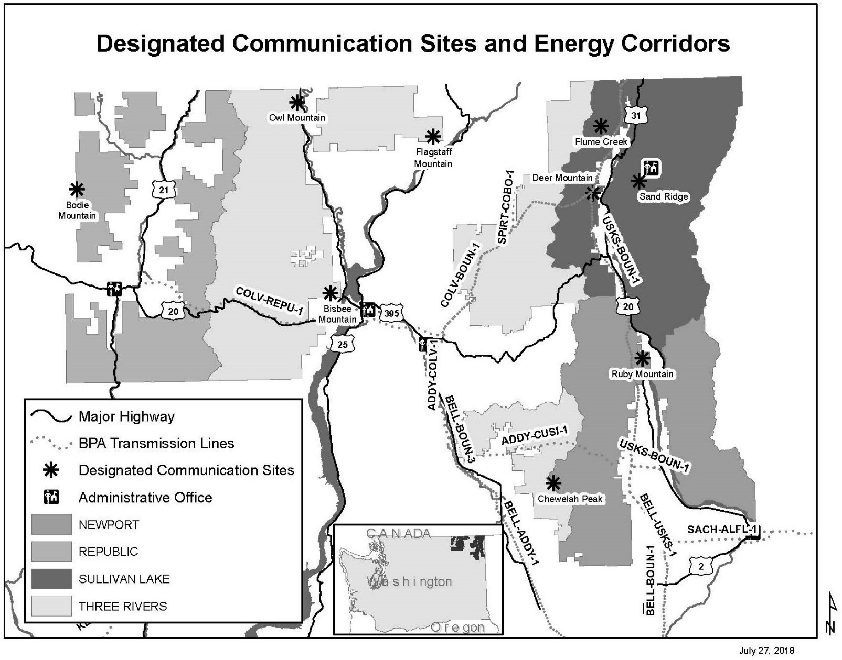
Figure G-1. Designated communication sites and energy corridors

Mineral Withdrawals
The following areas have been withdrawn from one or more of the mining laws and have limits on mineral entry. The map number in table G-4 corresponds to the maps in Figures G-2 through G-9.

Table G-4. Mineral withdrawals
Map # | Area name | Area type | Township | Range | Section (all legal descriptions are in the Willamette Meridian) | Acres
62 | Pioneer Park Recreation  Area | Recreation Site | T. 31 N. | R. 45 E. | Sec. 1, Lot 8 | 37.1
10 | Chewelah Ski Area | Recreation Site | T. 32 N. | R. 41 E. | Sec. 2, W½SW¼SW¼; Sec. 3, S½NE¼, E½SE¼, NE¼NW¼SE¼; Sec. 10 E½NE¼NE¼l Sec. 11, NW¼NW¼NW¼; | 220
10 | Chewelah Ski Area | Recreation Site | T. 32 N. | R. 41 E. | Sec. 11, SW¼NW¼NW¼ | 10
9 | Chewelah Lookout | Administrative Site | T. 32 N. | R. 41 E. | Sec. 12, N½SE¼ M&B³⁴ | 10
31 | Flowery Trail Seed Orchard | Administrative Site | T. 32 N. | R. 43 E. | Sec. 5, E½SW¼SW¼, SE¼SW¼, S½NE¼SW¼ | 80
2 | Bead Lake Recreation Area | Recreation Site | T. 32 N. | R. 45 E. | Sec. 3, Lot 1, W½ Lot 2, Lot 3-8 inclusive; Sec. 4,  Lot 1, 2, and 6; Sec. 9, NE¼NE¼NW¼; Sec. 10 Lot 3  except north 10 acres, Lot 4-6 inclusive, Lot 7 except south 20 acres, and Lot 8 except south 20  acres. | 576
56 | No Name Lake Recreation Area | Recreation Site | T. 32 N. | R. 45 E. | Sec. 8, Lot 1 and NE¼ Lot 2 | 35.74
55 | Newport Geophysical Observatory | Administrative Site | T. 32 N. | R. 45 E. | Sec. 21 | 640
57 | Pal Moore Seed Orchard | Administrative Site | T. 33 N. | R. 41 E. | Sec. 1, W½E½, and W½ Lot 4, W½SW¼NW¼; Sec.  2, S½S½ Lot 1, S½SE¼ Lot 2, S½NE¼ | 146.22
70 | South Skookum Lake Recreation Area | Recreation Site | T. 33 N. | R. 44 E. | Sec. 1, S½NW¼ Lot 1, SW¼ Lot 1, W½SE¼ Lot 1,  SE¼NE¼ Lot 2, E½SW¼ Lot 2, SE¼ Lot 2, E½SW¼NE¼, E½W½SW¼NE¼, W½NE¼SE¼NE¼,  NW¼SE¼NE¼, W½SW¼SE¼NE¼, N½NE¼NW¼SE¼ | 92.5
11 | Cooks Lake Recreation Area | Recreation Site | T. 33 N. | R. 44 E. | Sec. 24, NE¼SE¼ | 40
22 | Drycreek Site | Administrative Site | T. 33 N. | R. 45 E. | Sec. 30, SW¼NE¼SE¼, E½SE¼SE¼, NW¼SE¼SE¼ | 40

34 Metes and Bounds survey was conducted.

Map # | Area name | Area type | Township | Range | Section (all legal descriptions are in the Willamette Meridian) | Acres
2 | Bead Lake Recreation Area | Recreation Site | T. 33 N. | R. 45 E. | Sec. 34, Lot 1 except north 20 acres, Lot 2 except  west 20 acres, Lot 3 except east 20 acres, lot 4  except east 20 acres, lot 5, Lot 6, and  SW¼SW¼NE¼
58 | Parker Lake Recreation Area | Recreation Site | T. 34 N. | R. 43 E. | Sec. 3, W½W½ Lot 2, Lot 3, W½W½SW¼NE¼, SE¼NW¼, N½NE¼NE¼SW¼, NW¼NW¼NW¼SE¼ | 107.75
25 | Federal Power Commission  2042 | Power Withdrawal | T. 34 N. | R. 44 E. | Portions of Secs. 5 and 32
4 | Brown Lake Recreation Area | Recreation Site | T. 34 N. | R. 44 E. | Sec. 14, S½SE¼SE¼; Sec. 23, NE¼NE¼, N½SE¼NE¼; Sec. 24, N½NW¼, N½S½NW¼, NW¼NE¼, N½SW¼NE¼ | 260
35 | Half Moon Lake Recreation  Area | Recreation Site | T. 34 N. | R. 44 E. | Sec. 26, E½W½SW¼SW¼, E½SW¼SW¼ | 30
77 | Swan Lake Recreation Area | Recreation Site | T. 35 N. | R. 32 E. | Sec. 20, Lots 1, 2, 3, NW¼SE¼; Sec. 29, Lots 1 and  2 | 219
28 | Ferry Lake Recreation Area | Recreation Site | T. 35 N. | R. 32 E. | Sec. 21, Lots 1-4 inclusive | 126
40 | Strip Of Land 200 Feet Each  Side Of Centerline | San Poil Hwy Roadside  Zone | T. 35 N. | R. 32 E. | Sec. 24, SE¼SE¼; Sec. 25, E½E½ | 40.2
49 | Long & Fish Lake Recreation Area | Recreation Site | T. 35 N. | R. 32 E. | Sec. 28, Lots 1, 2, 3,S½NE¼; Sec. 33, Lots 1 and 2 | 239
79 | Ten Mile Campground | Recreation Site | T. 35 N. | R. 32 E. | Sec. 24 S½NE¼, NE¼SE¼ | 157.19
5 | Brown Mountain Seed Orchard | Administrative Site | T. 35 N. | R. 33 E. | Sec. 16, NWNW¼, N½SW¼NW¼; Sec. 17,  E½E½NE¼NE¼, E½NE¼SE¼NE¼ | 75
40 | Strip Of Land 200 Feet Each  Side Of Centerline | San Poil Hwy Roadside  Zone | T. 35 N. | R. 33 E. | Sec. 19, Lot 4; Sec. 30, Lot 1; Sec. 31, Lot 4,  SE¼SW¼
79 | Ten Mile Campground | Recreation Site | T. 35 N. | R. 33 E. | Sec. 19, Lot 3
1 | Barnaby Butte Lookout | Administrative Site | T. 35 N. | R. 35 E. | Sec. 7 (Un-surveyed); Sec. 18 (Un-surveyed) M&B | 10
42 | Lake Ellen Recreation Area | Recreation Site | T. 35 N. | R. 36 E. | Sec. 26, Lots 1-4 inclusive; Sec. 27, Lots 1 and 2;  Sec. 34, Lot 1; Sec. 35, NW¼NW¼NW¼ | 288.55
48 | Little Twin Lakes Recreation  Area | Recreation Site | T. 35 N. | R. 41 E. | Sec. 4, Lot 3 | 20.23
25 | Federal Power Commission 2042 | Power Withdrawal | T. 35 N. | R. 43 E. | Portion of Sec. 3 | 190

Map # | Area name | Area type | Township | Range | Section (all legal descriptions are in the Willamette Meridian) | Acres
25 | Federal Power Commission 2042 | Power Withdrawal | T. 35 N. | R. 44 E. | Portions of Secs. 7, 12, 18, 19 and 20
68 | Ruby Recreation Area | Recreation Site | T. 35 N. | R. 44 E. | Sec. 19, Lots 1, 2, 6 and 7 | 113
39 | Sherman Hwy 20 Roadside Zone | Strip Of Land 200 Feet From Centerline | T. 36 N. | R. 33 E. | Sec. 25, NW¼NW¼; Sec. 26, NNE¼, NE¼NW¼ | 1026
16 | Quartz Lookout Admin. Site | Administrative Site | T. 36 N. | R. 33 E. | Sec. 34, SW¼SW¼ M&B | 10
39 | Strip Of Land 200 Feet Each Side Of Centerline | Sherman Hwy 20 Roadside Zone | T. 36 N. | R. 34 E. | Sec. 15, SW¼; Sec. 16. S½; Sec. 21 NE¼; Secs. 22,  23, 24; Sec. 26, N½N½; Sec. 27, NE¼
34 | Graves Mountain Lookout | Administrative Site | T. 36 N. | R. 35 E. | Sec. 12 (un-surveyed), M&B | 10
39 | Sherman Hwy 20 Roadside Zone | Strip Of Land 200 Feet From Centerline | T. 36 N. | R. 35 E. | Un-surveyed Sec. 8 SE¼; Sec. 9, SW¼SW¼; Sec. 13.  SW¼SW¼; Sec. 14 and 15; Sec. 16, N½; Sec 17;  Sec. 18, S½SE¼; Sec 19; Sec. 20, N½; Sec. 23,  NE¼NE¼; Sec. 24
41 | Kettle Range Observation  Site | Administrative Site | T. 36 N. | R. 35 E. | Sec. 19 (Un-surveyed) M&B | 12
7 | Canyon Creek Recreation Area | Recreation Site | T. 36 N. | R. 36 E. | Sec. 35, S½NE¼NE¼, SE¼NE¼ | 60
39 | Sherman Hwy 20 Roadside Zone | Strip Of Land 200 Feet From Centerline | T. 36 N. | R. 36 E. | Sec. 19, S½S½; Sec. 25, S½; Sec. 28, SW¼; Sec. 29; Sec. 30 N½; Sec. 33, NW¼NW¼, S½S½NE¼; Sec. 34, NW¼NE¼, S½NE¼, NW¼; Sec. 35, N½; Sec. 36,  NW¼
80 | Trout Lake Recreation Area | Recreation Site | T. 36 N. | R. 36 E. | Un-surveyed Sec. 11, E½SE¼; Sec. 12, SW¼SW¼; Sec. 13, NW¼NW¼; Sec. 14, NE¼NE¼ | 200
21 | Dominion Lookout | Administrative Site | T. 36 N. | R. 40 E. | Sec. 34, NE¼ M&B | 20
54 | Mill Cr. Administrative Site | Administrative Site | T. 36 N. | R. 41 E. | Sec. 20, SE¼NW¼, NE¼SW¼, N½SE¼ | 160
48 | Little Twin Lakes Recreation Area | Recreation Site | T. 36 N. | R. 41 E. | Sec. 33, Lots 3 and 4, NE¼SW¼ | 100.94
33 | Frater Lake Recreation Area | Recreation Site | T. 36 N. | R. 42 E. | Sec. 2, Lots 1 and 2; Sec. 3, Lots 1 and 2 | 38.85
43 | Lake Leo | Recreation Site | T. 36 N. | R. 42 E. | Sec. 3, Lots 5, 7, SE¼SW¼ | 92.15
45 | Lake Thomas- Lake Gillette | Recreation Site | T. 36 N. | R. 42 E. | Sec. 17, Lot 5, SW¼NE¼, SE¼SW¼, NW¼SE¼ | 137
45 | Lake Thomas- Lake Gillette | Recreation Site | T. 36 N. | R. 42 E. | Sec. 20, Lot 1, SE¼NW¼ | 105
50 | Lookout Station | Administrative Site | T. 36 N. | R. 42 E. | Sec. 24, Lot 1 | 39.24

Map # | Area name | Area type | Township | Range | Section (all legal descriptions are in the Willamette Meridian) | Acres
25 | Federal Power Commission 2042 | Power Withdrawal | T. 36 N. | R. 43 E. | Portions of Sec. 15 and 22
51 | Lost Creek Recreation Area | Recreation Site | T. 36 N. | R. 43 E. | Sec. 15, Lot 5, 8; Sec. 22, Lot 1 | 136
46 | Le Clerc Rec. Area | Recreation Site | T. 36 N. | R. 44 E. | Sec. 19, E½W½SW¼NE¼, E½SW¼NE¼ | 10
37 | Hanlon Administrative Site | Administrative Site | T. 36 N. | R. 44 E. | Sec. 29, E½SW¼NE¼, E½NW¼NE¼, W½W½SE¼NE¼, W½W½NW¼NE¼ | 60
81 | Twin Sisters Lo Admin. Site | Administrative Site | T. 37 N. | R.35E | Un-surveyed Sec. 10, M&B | 10
32 | Frater Lake Recreation Area | Recreation Site | T. 37 N. | R. 42 E. | Sec. 34 S½SE¼ | 80.23
33 | Frater Lake Recreation Area | Recreation Site | T. 37 N. | R. 42 E. | Sec. 34, S½SE¼
78 | Teepee Seed Orchard | Administrative Site | T. 37 N. | R. 42 E. | Sec. 34 E½SW¼NE¼, W½SE¼NE¼, N½NW¼NE¼SE¼,  N½NE¼NW¼SE¼,S½SE¼NW¼NE¼ | 55
25 | Federal Power Commission 2042 | Power Withdrawal | T. 37 N. | R. 43 E. | Portions of Secs. 28 and 33
59 | Pend Oreille River Rec. Area | Recreation Site | T. 37 N. | R. 43 E. | Sec. 33, Lots 1, 4, 5, and 8 | 123.05
15 | Bodie Mountain Lookout | Administrative Site | T. 38 N. | R. 32 E. | Sec.6, Lot 4 M&B | 10
24 | Empire Lake Recreation Area | Recreation Site | T. 38 N. | R. 32 E. | Sec. 12, W½NE¼, NW¼SE¼ | 120
19 | Davis Lake Recreation Area | Recreation Site | T. 38 N. | R. 36 E. | Sec. 34 SE¼SW¼ | 61.76
66 | Renner Lake Recreation Area | Recreation Site | T. 38 N. | R. 36 E. | Sec. 34, SE¼NW¼NW¼, SW¼NE¼NW¼,  NE¼SW¼NW¼, NW¼SE¼NW¼ | 40
38 | Huckleberry Lookout | Administrative Site | T. 38 N. | R. 42 E. | Sec. 29, W½SW¼; Sec. 30 E½SE¼ M&B | 10
25 | Federal Power Commission 2042 | Power Withdrawal | T. 38 N. | R. 43 E. | Portions of Secs. 1, 12, 19, 20, 29, and 32
65 | Powersite Reserve 639 | Power Withdrawal | T. 38 N. | R. 43 E. | Sec. 4, Lots 3, 4, 5 and 15 | 68.7
27 | Federal Power Commission 2225 | Power Withdrawal | T. 38 N. | R. 44 E. | Portions of Secs. 1, 5, 6, 7, 12, 13, 18, 31, and 36 | 522
73 | Sullivan Lake Recreation  Area | Recreation Site | T. 38 N. | R. 44 E. | Sec. 6, Lots 2, 4, 7, and 8; Sec. 7 Lots 2, 3, and 7;  Sec. 18, Lots 2-7 inclusive, Lot 9, S½SE¼; | 624.35
67 | Round Top Mtn. Res. Natural Area | Administrative Site | T. 38 N. | R. 45 E. | Sections 8 and 9 (portions of)
64 | Powersite Classification 373 | Power Withdrawal | T. 39 N. | R. 32 E. | Sec. 12, NE¼SW¼ | 40

Map # | Area name | Area type | Township | Range | Section (all legal descriptions are in the Willamette Meridian) | Acres
20 | Deer Creek Summit Campground | Recreation Site | T. 39 N. | R. 35 E. | Un-surveyed Sec. 20, SE¼NE¼ | 40
52 | Marble Lookout | Administrative Site | T. 39 N. | R. 35 E. | Un-surveyed Sec. 4, M&B | 10
53 | Martin Cr. Admin. Site (Orient) | Administrative Site | T. 39 N. | R. 36 E. | Sec. 10, SW¼SE¼, E½SE¼ except Exchange Survey 282 Comprising 14.91 acres; Sec. 15, NW¼NE¼ | 145
29 | First Thought Lookout | Administrative Site | T. 39 N. | R. 37 E. | Sec. 7, NE¼SW¼ M&B | 10
61 | Pierre Lake | Recreation Site | T. 39 N. | R. 37 E. | Sec. 5, Lots 5-10 inclusive | 27.25
30 | Flagstaff Lookout | Administrative Site | T. 39 N. | R. 39 E. | Sec. 5, SE¼NE¼ | 40
60 | Pepoon Lake Recreation  Area | Recreation Site | T. 39 N. | R. 39 E. | Sec. 6, W½SE¼ | 80
26 | Federal Power Commission 2144 | Power Withdrawal | T. 39 N. | R. 43 E. | Portions of Secs. 2, 3, 10, 11, 15, 22, 24, and 26 | 609.24
36 | Halliday Fen RNA³⁵ | Administrative Site | T. 39 N. | R. 43 E. | Sec. 1, Lot 1 M&B | 646.4
63 | Powersite Classification 328 | Power Withdrawal | T. 39 N. | R. 43 E. | Portion of Sec. 3 | 0.95
73 | Sullivan Lake Reservoir Site | Recreation Site | T. 39 N. | R. 43 E. | Sec. 25, NE¼NE¼ | 40
27 | Federal Power Commission  2225 | Power Withdrawal | T. 39 N. | R. 44 E. | Portions of Secs. 1, 6, 7, 12, 13, 19, 19, 24, 25, 29,  30, 31, and 32
36 | Halliday Fen RNA | Administrative Site | T. 39 N. | R. 44 E. | Sec. 6, Lots 2-5, inclusive M&B
17 | Sullivan Mtn Lookout | Administrative Site | T. 39 N. | R. 44 E. | Sec. 16, NE¼SW¼ | 40
72 | Sullivan Creek Recreation Area | Recreation Site | T. 39 N. | R. 44 E. | Strip of land 3 chains wide (1C on the south side and 2C on the South side) of Sullivan Creek through the following subdivisions: Sec. 25, NE¼SW¼, S½SW¼, N½SE¼; Sec. 26, SE1/14SE¼;  Sec. 31, NE¼; Sec. 32 S½NE¼, N½NW¼, SE¼NW¼, N½SE¼; Sec. 33, NW¼SW¼, S½SW¼, N½SE¼ SW¼SE¼; Sec. 34, SE¼NE¼, N½SW¼, SW¼SW¼, N½SE¼; Sec. 35, N½NE¼, N½NW¼ SW14,NW¼;  Sec. 36, SW¼SW¼ | 104.45
73 | Sullivan Lake Recreation  Area | Recreation Site | T. 39 N. | R. 44 E. | Sec. 31, Lots 3, 6 and 9; Sec. 32, Lots 1 and 2
73 | Sullivan Lake Reservoir Site | Water Reserve Wd | T. 39 N. | R. 44 E. | Sec. 30, Lots 3 and 4, E½NW¼, NW¼SW¼, | 199.78

35 Research Natural Area

Map # | Area name | Area type | Township | Range | Section (all legal descriptions are in the Willamette Meridian) | Acres
74 | Sullivan Lake Administrative Site | Administrative Site | T. 39 N. | R. 44 E. | Section 29, Lot 3, SW14/SW¼; Sec. 30, Lots 6 and  7; S½SE¼; Sec 31, Lots4 and 5, N½NE¼, Sec. 32,  W½NW¼ | 422
75 | Sullivan Mtn Lookout | Administrative Site | T. 39 N. | R. 44 E. | Sec. 16, NE¼SW¼ | 40
71 | Sullivan Creek Recreation Area | Recreation Site | T. 39 N. | R. 45 E. | Sec. 9, SE¼SE¼; Sec. 10, W½NE¼, SE¼NW¼, N½SW¼, SW¼SW¼, NW¼SE¼; Sec. 15, NW¼NW¼; Sec. 16,  N½NE¼, SW¼NE¼, N½SW¼, SW¼SW¼, NW¼SE¼; Sec. 17, SE¼SW¼, S½SE¼; Sec. 19, Lot 8, NE¼NE¼, S½NE¼,  E½SW¼, NW¼SE¼; Sec. 20, N½NW¼; Sec. 30, Lots 1, 2,  3, 4, and 6 | 132
64 | Powersite Classification 373 | Power Withdrawal | T. 40 N. | R. 36 E. | Portions of Sec. 3, 15, 22, 27, 34 | 485.85
76 | Summit Lake Recreation  Area | Recreation Site | T. 40 N. | R. 37 E. | Sec. 17, SE¼SE¼; Sec. 20 NE¼NE¼; Sec.21.  NW¼NW¼ | 120
23 | Elbow Lake Recreation Area | Recreation Site | T. 40 N. | R. 38 E. | Sec. 21, E½E½SW¼, W½SE¼ | 120
8 | Cedar Creek Seed Orchard | Administrative Site | T. 40 N. | R. 42 E. | Sec. 10 W½SW¼, W½E½SW¼, SE¼NE¼SW¼, NE¼SE¼SW¼ | 140
3 | Boundary Lake Recreation  Area | Recreation Site | T. 40 N. | R. 43 E. | Sec. 1, Lot 5 | 70.95
26 | Federal Power Commission 2144 | Power Withdrawal | T. 40 N. | R. 43 E. | Portions of Secs. 2, 3, 10, 11, 14, 23, 26, and 35
12 | Crescent Lake Recreation Area | Recreation Site | T. 40 N. | R. 43 E. | Sec. 12, Lots 1-4 inclusive, E½NE¼NE¼SW¼, W½NW¼NW¼SE¼ | 142.15
47 | Lime Creek Recreation Area | Recreation Site | T. 40 N. | R. 43 E. | Sec. 14, Lot 7, SE¼SE¼ | 76.45
36 | Halliday Fen RNA | Administrative Site | T. 40 N. | R. 43 E. | Sec. 36, SE¼SE¼ M&B
3 | Boundary Lake Recreation Area | Recreation Site | T. 40 N. | R. 44 E. | Sec. 6, Lot 4 | 70.95
36 | Halliday Fen RNA | Administrative Site | T. 40 N. | R. 44 E. | Sec. 30, NW¼SE¼, SE¼SW¼, S½SE¼; Sec. 31, Lots 2, 3, 4, NE¼NE¼, NE¼NW¼, NE¼SE¼, S½SE¼; Sec.  32, W½W½ M&B
36 | Halliday Fen RNA | Administrative Site | T. 40 N. | R. 44 E. | Sec. 31, W½NE¼, SE¼NE¼, SE¼NW¼, E½SW¼, NW¼SE¼
69 | Salmo RNA | ADMINISTRATIVE SITE | T. 40 N. | R. 45 E. | Portions of Sec. 9, 10, 11, 14, 15, 16, and 22
Approximate total acres withdrawn from mineral entry: 11,609 (Does not include the Salmo Priest Wilderness Area) M&B = Metes and Bounds

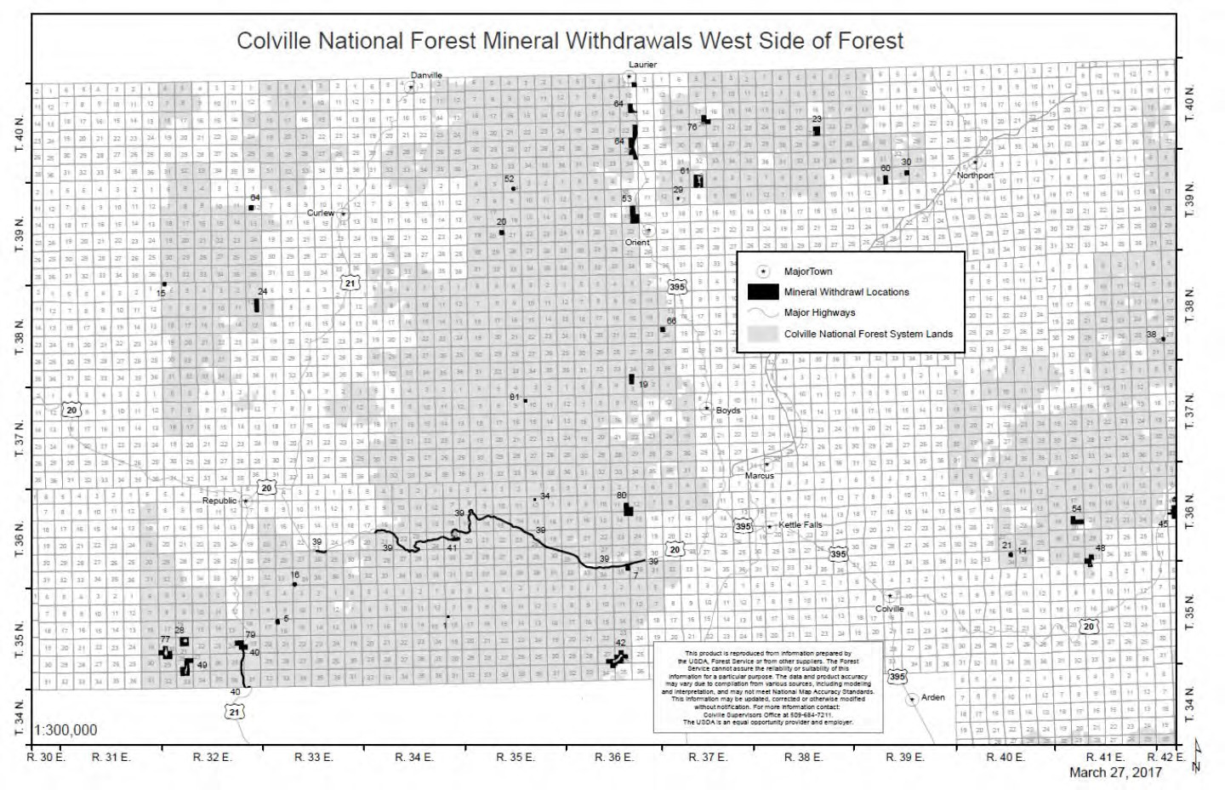
Figure G-2. Mineral withdrawals on the west side of the Colville National Forest

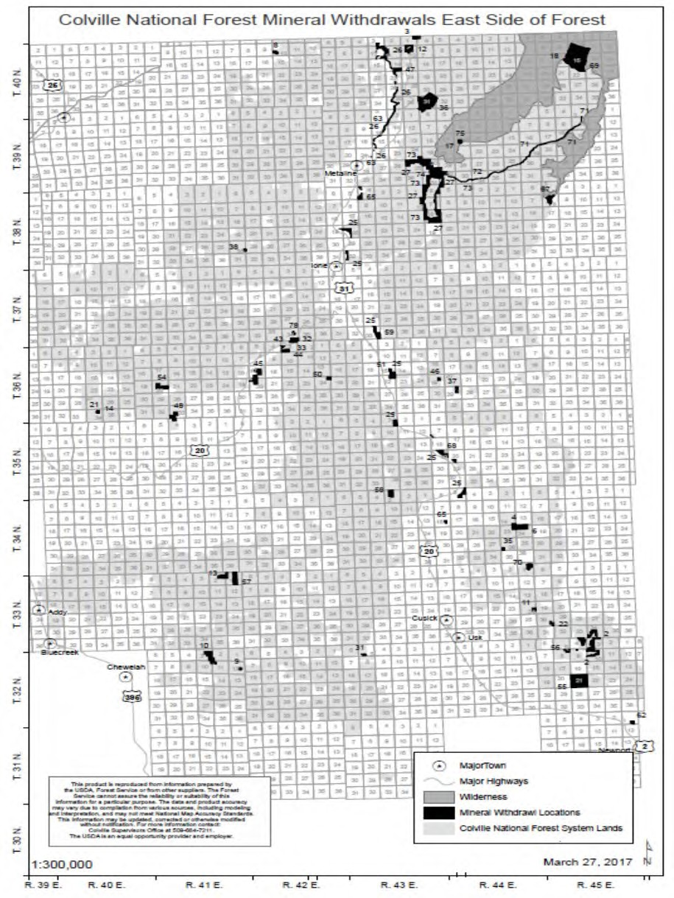
Figure G-3. Mineral withdrawals on the east side of the Colville National Forest

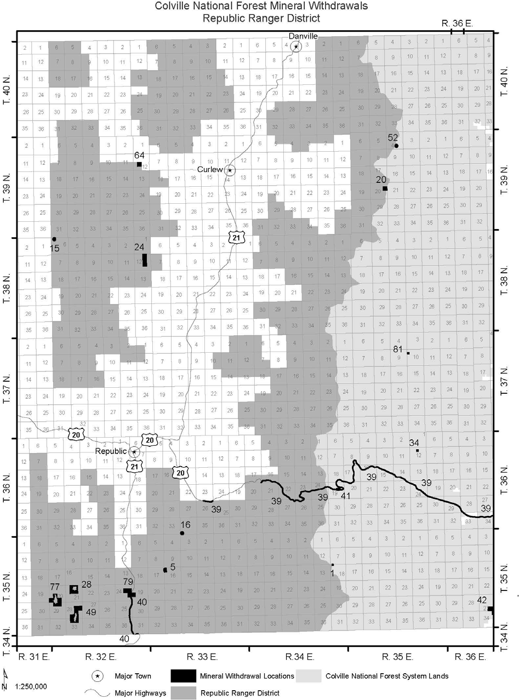
Figure G-4. Republic Ranger District mineral withdrawals

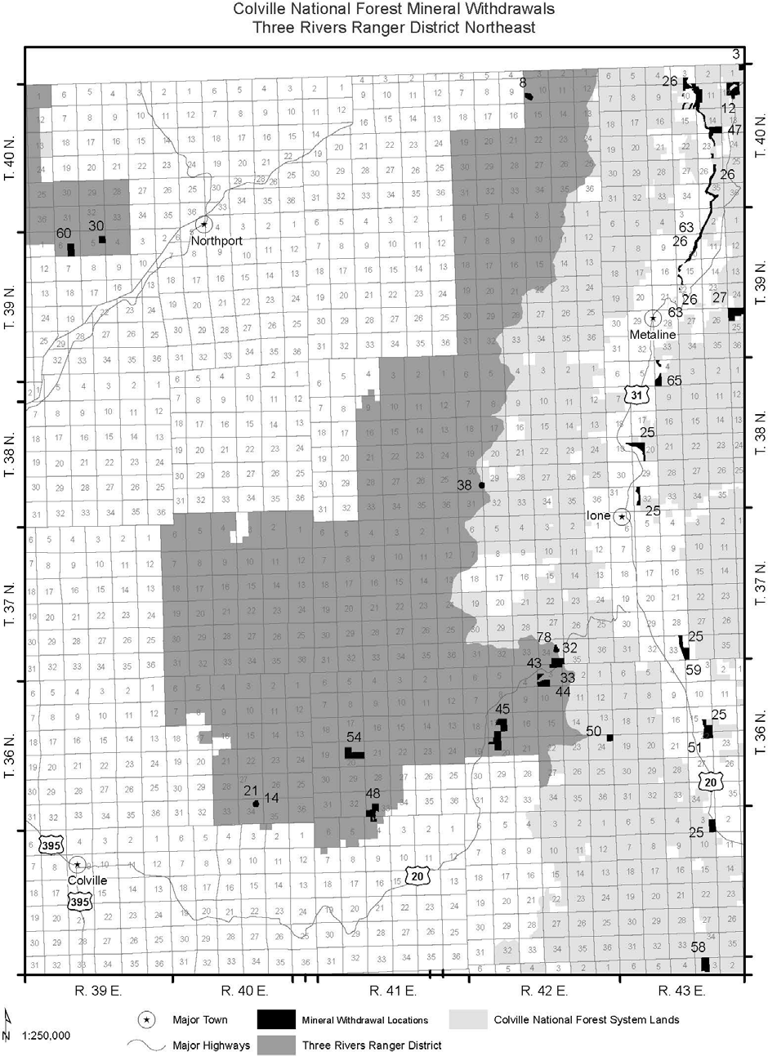

Figure G-5. Three Rivers Ranger District mineral withdrawals (map 1 of 3)

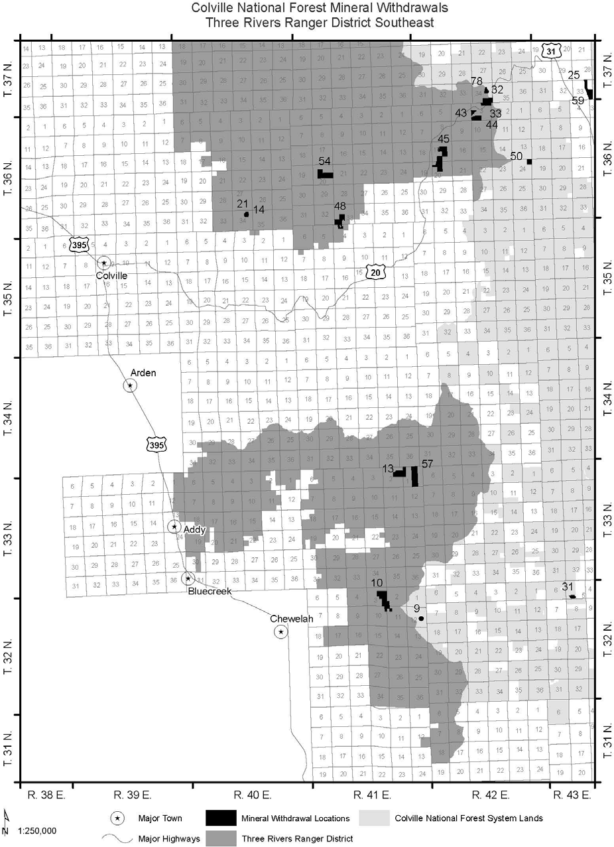

Figure G-6. Three Rivers Ranger District mineral withdrawals (map 2 of 3)

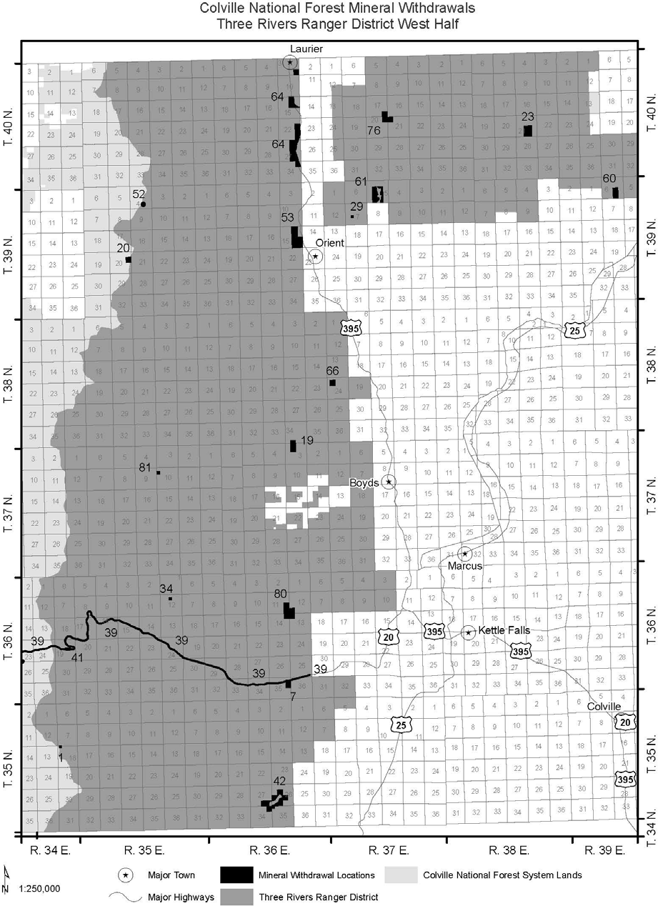
Figure G-7. Three Rivers Ranger District mineral withdrawals (map 3 of 3)

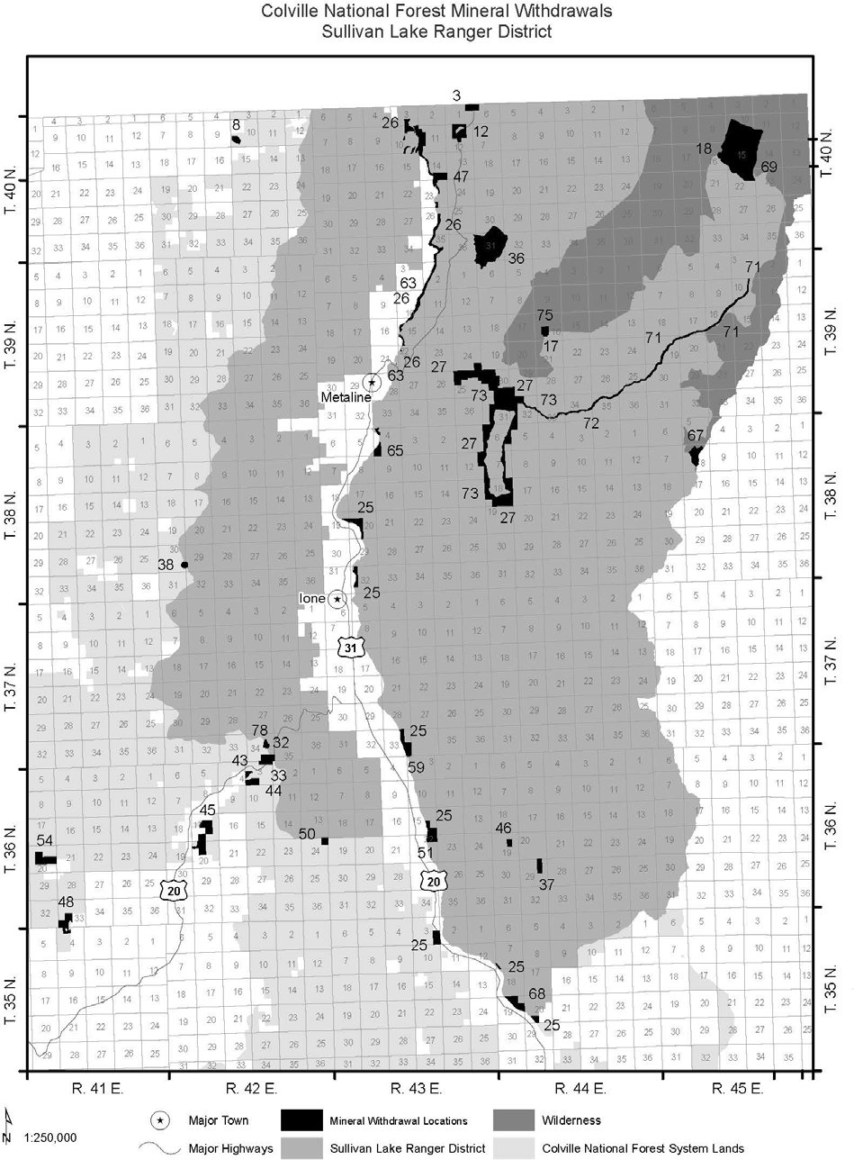
Figure G-8. Sullivan Lake Ranger District mineral withdrawals

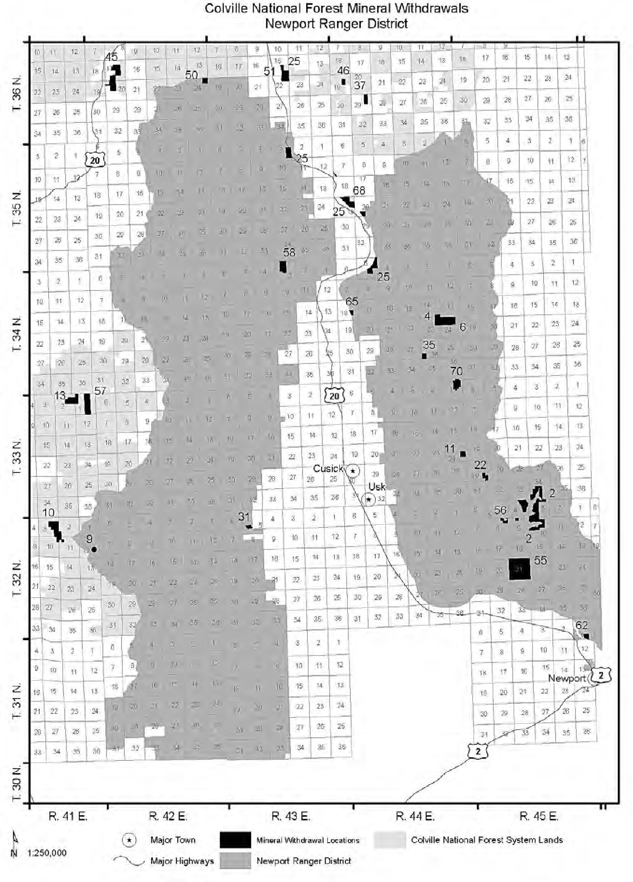
Figure G-9. Newport Ranger District mineral withdrawals

Colville National Forest Land Management Plan

Appendix H – Management Area Map
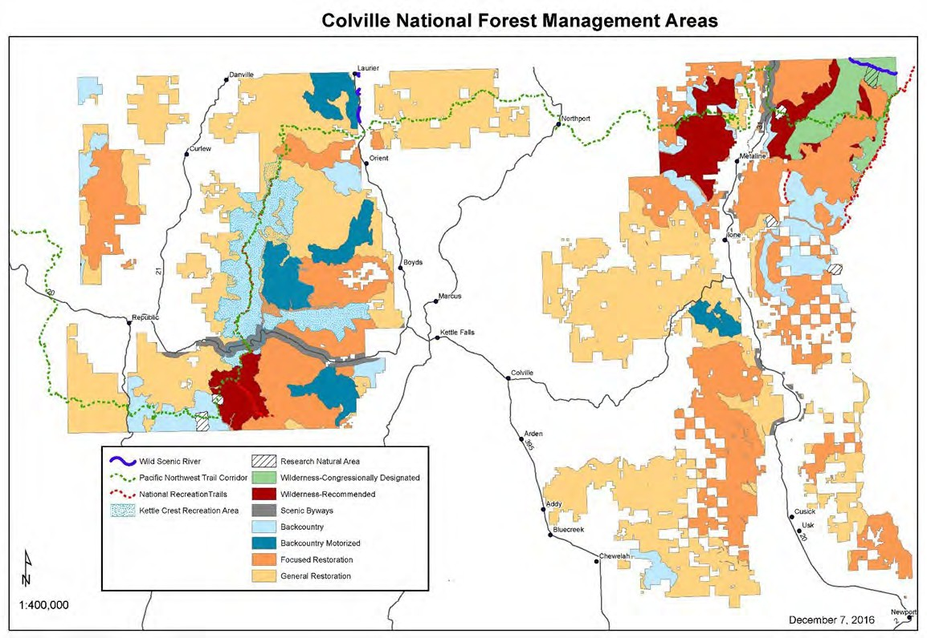
Figure H-1. Colville National Forest management areas

