Apply at USAJobs.gov

For more position information contact:

Todd Murray
Forest AFMO
todd.murray2@usda.gov

Fillmore RD
Ken Wright
Forest AFMO
todd.murray2@usda.gov

Fremont River RD
Jarad Teeples
Forest AFMO
todd.murray2@usda.gov

Beaver RD
Clay Matheson
Forest AFMO
todd.murray2@usda.gov

Richfield RD
Glen Chappell
Forest AFMO
todd.murray2@usda.gov

NOTICE:
Your response is important! The personal touch and outreach response can sometimes set you apart as hiring managers work through hundreds of applications each year!!!
OUTREACH REPLY

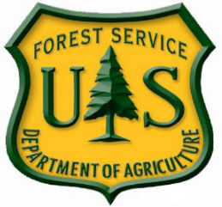

Fishlake National Forest
OUTREACH NOTICE
Fire Hire Positions
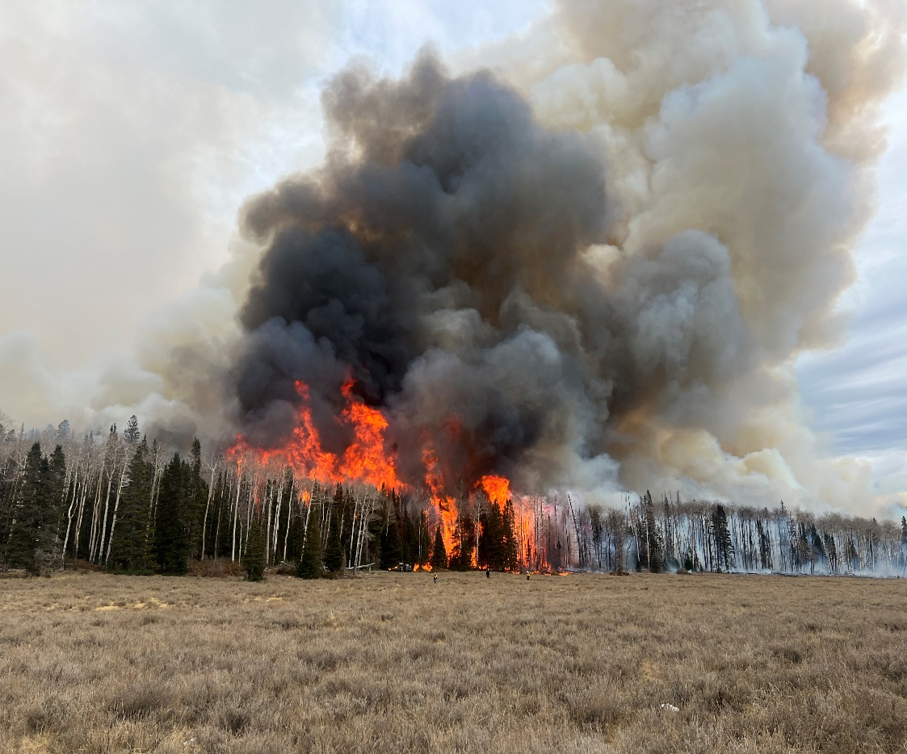
Fishlake National Forest
Multiple Duty Locations

The Fishlake National Forest is looking for a committed, hardworking, highly skilled workforce to manage wildfires and work in fuels management. Both the fire and aviation and fuels management programs are very rewarding and require talented, skilled individuals working safely as part of a team in a variety of specialized positions including engine crews, hand crews, fuels management, fire prevention and dispatch.

The Region 4 Fire Hire program has been implemented to streamline the hiring process for permanent fire positions and provide consistent hiring throughout the Region. This hiring process assists the National Forests in the Intermountain Region (R4) to fill vacancies in an efficient and timely manner. The unique feature of Fire Hire is the ability to immediately backfill positions that have been vacated.

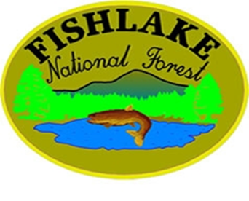
This outreach is for GS-0462-03 through GS-0462-09 current career permanent fulltime and permanent seasonal fire, fuels, and aviation positions. The vacancy announcements for these positions are posted on the U.S. Government's official website for employment opportunities at www.usajobs.gov. These are national vacancy announcements with a specific opening and closing date. The vacancy announcements will be open for applications as noted in the charts below by position.

It is important that applicants understand, although a current position/ location may not be vacant, it could become vacant and filled during the selection period. Interested individuals should apply to ALL positions and locations where you would accept a job offer, whether the position(s) are currently vacant or not.

If you are interested in filling a position on the Fishlake National Forest through the Fire Hire process, please respond to this outreach utilizing the Outreach Reply Notice. Your response is important! The personal touch along with your outreach response can sometimes set you apart as hiring managers work through hundreds of applications each year. Please ensure that you are applying for all the positions you are interested in and willing to accept as positions may become vacant during the fire hire process.
Fishlake Contact Information
Name | Forest Location | Position Type | Contact Information
Todd Murray | Supervisors Office / Richfield UT | All Positions | (435) 896-1614 / todd.murray2@usda.gov
Bryce Monroe | Fillmore RD / Fillmore, UT | Fuels | (435) 896-5721 / bryce.monroe@usda.gov
Ken Wright | Fillmore RD / Fillmore, UT | Fire | (435) 743-4965 / kenneth.wright@usda.gov
Kent Chappell | Fremont River RD / Loa, UT | Fuels | (435) 836-1027 / kent.chappell@usda.gov
Jarad Teeples | Fremont River RD / Teasdale, UT | Fire | (435) 425-9571 / jarad.Teeples@usda.gov
Cory Norman | Beaver RD / Beaver, UT | Fuels | (435) 896-1074 / samuel.norman@usda.gov
Clay Matheson | Beaver RD / Beaver, UT | Fire | 435) 896-1613 / robert.matheson@usda.gov
Kelly Cornwall | Richfield RD / Richfield, UT | Fuels | (435) 896-2326 / kelly.cornwall@usda.gov
Glen Chappell | Richfield RD / Richfield, UT | Fire | (435) 896-1073 / glen.chappell@usda.gov

Tips for applying & what to include in your resume:
- Applying to Forest Service Positions: https://www.fs.usda.gov/Internet/FSE_DOCUMENTS/fseprd534567.pdf
- Tailor your resume to each job announcement
- Spell out acronyms
- Be honest
- Write clear and concise statements
- Use active verbs
- Proofread your resume

Applicant Checklist
- Please ensure you have a copy of Signed Performance Evaluation for each time period worked to meet Land Management Workforce Flexibility Act (LMWFA) eligibility.
- Copy of all SF-50’s (on-boarding and off-boarding) Latest SF-50 will have to be emailed by supervisor or can call HRM Help Desk to have it emailed to you (1-877-372-7248).
- Current IQCS Master Record
Things to keep in mind when applying:
- Vacancy Announcements on USA Jobs will give examples of the specialized experience for each position advertised. Ensure your resume matches the listed specialized experience requirement in plain language. This should be listed under work experience that shows title, series, grade, and show the period of time work was performed so that HR can properly credit.
- Ensure all SF-50’s showing on-boarding /off-boarding and performance for each time period or statement as to why missing that time period is properly loaded into USA Jobs.
- Allow yourself plenty of time to apply for positions. The USA Staffing system closes all announcements at midnight Eastern on closing date.
- Print and read the entire vacancy announcement to ensure you have included all required information and documents.
Other places to have questions answered or get further information:
- FS Videos: Wildland Firefighter Hiring | US Forest Service (usda.gov)
- USA Jobs YouTube Videos: https://www.youtube.com/results?search_query=usa+jobs

The Process and Timeline
August 10th, 2025: Outreach begins. Information is available on the Intermountain Region Fire Hire website. https://www.fs.usda.gov/detail/r4/jobs/?cid=STELPRDB5375168

August 22nd, 2025: Announcements will be activated in USAJobs. Applicants are encouraged to apply for multiple duty locations (where they would accept a position if offered), even if positions for certain locations which you are interested are not currently listed as vacant. Vacancies may occur during the hiring process and could be filled during Selection Week(s).

September 23rd, 2025: Application deadline (11:59 p.m. Eastern Standard time). Applications must be submitted through www.usajobs.gov.

October 27th – November 21st, 2025: Supervisory Reference Checks and Subject Matter Expert evaluations will occur during these weeks. Please ensure your references are notified of this and are available at the email address (preferred) or phone number provided on your application.

November 18th – November 20th, 2025: GS-09 Interviews will be conducted. Applicants that have applied for target grade GS-0462-09 positions should plan to be available for interviews from interested forests.

December 1st – December 17th, 2025: Recommendations and Selections. Representatives from each forest will make recommendations for hiring. Candidates selected will be notified by a Forest Service representative via phone. It is highly encouraged for all applicants to be available via phone during this time period. Those not selected should check their USAJobs account for status updates.
Note:
To qualify for most of these positions, you must meet qualifications requirements as defined by Interagency Fire Program Management (IFPM) and Forest Service – Fire Program Management (FS- FPM) at the time of selection. Because of these qualification requirements, a current copy of your IQCS/IQS Master Record will be required for positions in this outreach. An updated Master Record can be submitted at the time of selection if the IFPM/FS-FPM requirements were not met on the Master Record at the time of application.

You must also meet the eligibility requirements as defined by OPM. For more information on the eligibility requirements for this position, visit the Office of Personnel Management's General Schedule Qualification Standards. Eligibility requirements must be met at the time of application.

Your application and resume must clearly show that you possess the experience requirements. Transcripts must be provided for qualifications based on education. Provide course descriptions as necessary.

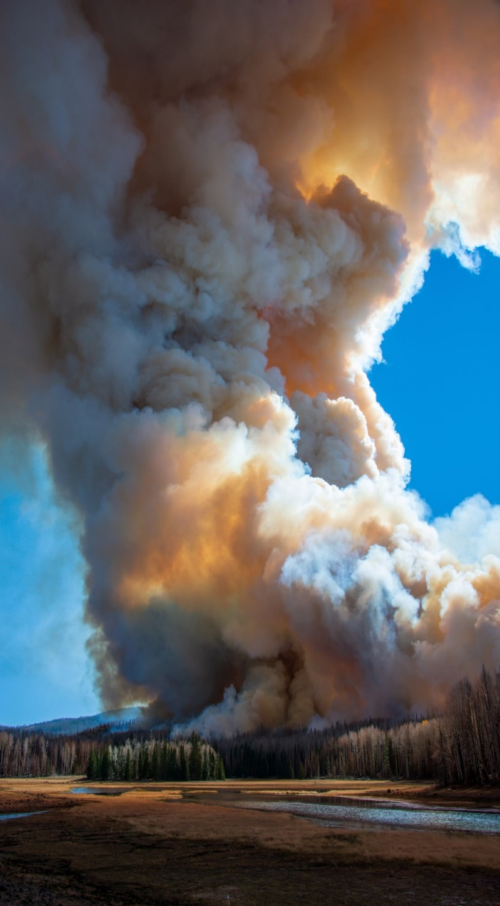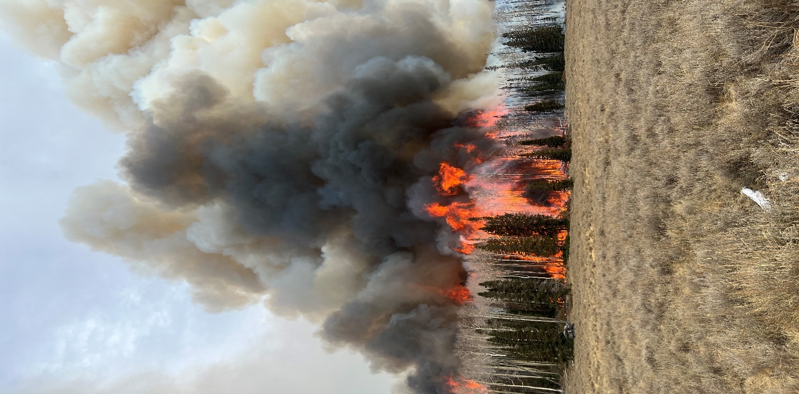

JOB TITLE | GW LEVEL | TOUR | ANNOUNCEMENT # | FOREST DUTY LOCATIONS | CURRENT VACANCIES @
General Firefighter
Forestry Technician | 03/04 | 18/8 | 26-FIRE-P1R14-FFTR-34DH | Beaver  Fillmore  Richfield  Teasdale | Beaver  Fillmore
Wildland Fire Apprentice Position
Forestry Technician (Apprentice) | 03/04/05 | 18/8 | 26-FIRE-P1R14610-WFAP-345DH | Beaver  Fillmore  Richfield  Teasdale | Beaver  Fillmore
Dispatch Positions
Forestry Technician (Fire Dispatch) | 04/05/06/07 | 18/8 | 26-FIRE-P1VA-IADISP-4567DH | Richfield
Forestry Technician (Fire Dispatch – Assistant Center Manager) | 08/09 | PFT | 26-FIRE-P1VA-ADISPCM-89DH | Richfield
Engine Positions
Forestry Technician (Engine) | GS-04/05 | 18-8 | 26-FIRE-P1R146-ENGSFF-45DH | Beaver  Fillmore  Richfield  Teasdale | Fillmore
Lead Forestry Technician (AFEO) | GS-05/06 | 18/8 | 26-FIRE-P1R14610-AFEO-56DH | Beaver  Fillmore  Richfield  Teasdale | Fillmore
Forestry Technician (FEO) | GS-06/07 | 18/8 | 26-FIRE-P1R14610-FEOH-67DH | Beaver  Fillmore  Richfield  Teasdale | Fillmore  Richfield
Supervisory Forestry Technician (SFEO) | GS-07/08 | PFT | 26-FIRE-P1R14610-SFEOH-78DH | Beaver  Fillmore  Richfield  Teasdale | Beaver  Richfield
Handcrew – 5 Person IA Module Positions
Forestry Technician (Hotshot/Handcrew) | 04/05 | 18/8 | 26-FIRE-P1R14610-IHCRW-45DH | Richfield  Teasdale
Forestry Technician (Hotshot/Handcrew) | 05/06 | 18/8 | 26-FIRE-P1R14610-HCREW-56DH | Richfield  Teasdale
Supervisory Forestry Technician (Crew) | 06/07 | PFT | 26-FIRE-P1VA-CREWSUP-67DH | Richfield  Teasdale
Wiland Fire Module Positions
Forestry Technician (Hotshot/Handcrew) | 04/05 | 18/8 | 26-FIRE-P1R14610-IHCRW-45DH | Beaver | Beaver
Forestry Technician (Hotshot/Handcrew) | 05/06 | 18/8 | 26-FIRE-P1R14610-HCREW-56DH | Beaver
Forestry Technician (Type 1 WFM Asst.) | 07/08 | PFT | 26-FIRE-P1VA-HCREWT1-78DH | Beaver
Supervisory Forestry Technician (Type 1 WFM) | 08/09 | PFT | 26-FIRE-P1VA-WFMSUP-89DH | Beaver
Prevention Positions
Forestry Technician (Prevention) | 06/07 | 18/8 | 26-FIRE-P1VA-PREV2-67DH | Beaver  Fillmore  Richfield  Teasdale
Fuel Positions
Forestry Technician (Prescribed Fire/Fuels Tech) | 06/07 | PFT | 26-FIRE-P1R14610-DFUEL-67DH | Beaver  Fillmore  Richfield  Teasdale
Forestry Technician (Supervisory Fuels AFMO) | 08/09 | PFT | 26-FIRE-P1R146-DFLS-89DH | Beaver  Fillmore  Richfield  Teasdale
Fire Management Positions
Supervisory Forestry Technician (DZAFMO) | 08/09 | PFT | 26-FIRE-P1R146-DZAFMOH-89DH | Beaver  Fillmore  Richfield  Teasdale
