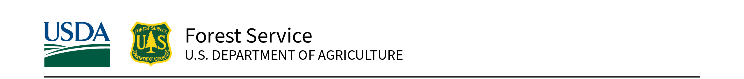
Olympic National Forest | June 2026

  - Title II Project Proposal
Supplement for Non-Forest Service Applicants
Please fill out this supplemental form and submit it, along with the Title II project proposal form to jennifer.garciasantiago@usda.gov
Project Name: Click or tap here to enter text.
Project Applicant: Click or tap here to enter text.
Email: Click or tap here to enter text.
Phone Number: Click or tap here to enter text.
This supplemental information will help the Forest understand the scope and scale of the proposed project and determine whether we have the workforce capacity to support tasks related to implementation. All projects must have regulatory compliance (NEPA) completed and must cost a minimum of $10,000. The agency will review each proposal to ensure it complies with applicable laws, regulations, and Forest Service management policy. If a proposal exceeds the Forest’s capacity to complete required compliance or administrative work, or if it does not align with agency direction, the project sponsor will be contacted by the RAC Coordinator to discuss potential revisions. If updates are not possible the project will not be forwarded to the RAC for review.
- Please identify the Forest Service staff member you have worked with (or are currently working with) during the development or design of the project. If you have not yet connected with a Forest Service staff member, please refer to the contact list below and reach out to the person who best aligns with your project. Applicants must coordinate with the appropriate staff member before submitting an application.
  - Which Olympic National Forest staff member have you coordinated with on this project? Click or tap here to enter text.
  - Will the Forest be involved in implementation? ☐Yes ☐ No
Program Area | Contact | Email
Engineering | Juan Mendoza | Juan.Mendoza@usda.gov
Recreation | Josh Parker | Joshua.Parker3@usda.gov
Natural Resources | Alison Center | alison.center@usda.gov
Youth Crews | Jenni Garcia-Santiago | jennifer.garciasantiago@usda.gov
Archelogy | Kevin Bruce | kevin.bruce@usda.gov

- All non-Forest Service projects require an agreement to enable transfer of funds. Is an agreement currently in place, and if so, what type, and what is the name/number?
Click or tap here to enter text.

- Have you/your organization registered in the SAM.gov program?
☐Yes ☐No

- Can this project be implemented in phases or with less than the requested amount? If yes, by how much and what would not be accomplished with reduced funding (for example – $30,000 (full funding) would result in 50 miles of road maintenance and 50% funding would result in 25 miles of road maintenance; or phase 1 would cost x and result in x miles of road maintenance).
Click or tap here to enter text.

For Forest Service Point of Contact Completion:
I have reviewed the proposal and confirm that:
- I support the project;
- the project provides a direct or indirect benefit to National Forest System lands; and
- NEPA compliance is complete.

The following individual has been designated as the Forest Service point of contact responsible for coordinating work related to this project on National Forest System lands.

Name: Click or tap here to enter text.
Signature:

