United States Department of Agriculture

US Forest Service  
Natural Resource Manager (NRM)

# FSVeg Common Stand Exam User Guide Boring Insects (Category 15)

Version: 2.12  
February 2014

Table of Contents

(15-002) Termite 5

(15-003) Ponderosa Pine Bark Borer 5

(15-004) Bronze Birch Borer 5

(15-005) Twolined Chestnut Borer 7

(15-006) Bronze Poplar Borer 8

(15-007) Carpenter Bees 9

(15-008) Flatheaded Borer 9

(15-009) Golden Buprestid 10

(15-010) Carpenter Ants 10

(15-011) Gouty Pitch Midge 11

(15-012) Pine Needle Scale 12

(15-013) Roundheaded Borer 12

(15-014) Flatheaded Apple Tree Borer 14

(15-016) Columbian Timber Beetle 14

(15-017) Pitted Ambrosia Beetle 15

(15-018) Carpenterworm Beetle 15

(15-019) Poplar and Willow Borer 15

(15-020) Pine Reproduction Weevil 16

(15-021) Douglas-Fir Twig Weevil 16

(15-022) Zimmerman Pine Moth 17

(15-024) Twig Pruner 18

(15-025) Lesser Cornstalk Borer 18

(15-026) Red Oak Borer 19

(15-027) Ponderous Borer 20

(15-028) Eastern Pine Shoot Borer 21

(15-029) Pinyon Needle Scale 22

(15-030) Eucosma Species 23

(15-031) Sugar Maple Boer 24

(15-032) White Oak Boer 24

(15-033) Pine Root Collar Weevil 25

(15-034) Warren’s Collar Weevil 25

(15-035) Powderpost Beetle 26

(15-036) Tarnished Plant Bug 26

(15-037) Magdalis spp. 26

(15-038) White Pine Bark Miner 27

(15-039) Locust Borer 27

(15-040) California Flathead Borer 28

(15-041) Flathead Fir Borer 29

(15-042) Whitespotted Sawyer 30

(15-043) Redheaded Ash Borer 31

(15-044) Western Ash Borer 32

(15-045) Oberea Shoot Borers 32

(15-046) Eucalyptus Longhorned Borer 33

(15-047) Northern Pine Weevil 33

(15-048) Pissodes dubius 34

(15-049) Monterey Pine Weevil 34

(15-050) White Pine Weevil 34

(15-051) Lodgepole Terminal Weevil 36

(15-052) Ambrosia Beetles 36

(15-053) Cottonwood Borer 37

(15-054) Balsam Shootboring Sawfly 38

(15-055) Pine Gall Weevil 38

(15-056) Ash Borer 39

(15-057) Lilac Borer 39

(15-058) Carpenterworm 39

(15-059) Maple Shoot Borers 40

(15-060) Western Subterranean Termite 41

(15-061) Coconut Trunk Weevil 41

(15-062) New Guinea Sugarcane Weevil 41

(15-063) European Pine Shoot Moth 42

(15-064) Western Pine Tip Moth 43

(15-065) Nantucket Pine Tip Moth 44

(15-066) Lodgepole Pine Tip Moth 45

(15-067) Southwestern Pine Tip Moth 46

(15-068) Poplar Borer 47

(15-069) Roundheaded Appletree Borer 48

(15-070) Saperda Shoot Borr 48

(15-071) Clearwing Moths 49

(15-072) Dogwood Borer 49

(15-073) Roundheaded Fir Borer 50

(15-074) Western Larch Borer 50

(15-075) Western Cedar Borer 50

(15-076) Douglas-Fir Pitch Moth 51

(15-077) Sequoia Pitch Moth 51

(15-078) Black Twig Borer 52

(15-079) Pacific Dampwood Termite 52

(15-080) Subtropical Pine Tip Moth 53

(15-081) Asian Ambrosia Beetle 53

(15-082) Asian Longhorned Beetle 53

(15-083) Cottonwood Twig Borer 54

(15-084) Southern Pine Sawyer 54

(15-085) Banded Ash Borer 55

(15-086) Sitka Spruce Weevil 55

## (15-002) Termite

|  |  |
| --- | --- |
| Host: | Mesquite |
| Description: | Termites are a large and destructive group of insects, which feed upon cellulose. Often they mine so extensively that only a paper-thin outer shell of wood remains. They commonly occur in felled woods, snags, stumps, or sections of dead or decaying wood. Rarely do they injure or kill trees. They live in colonies in wood or in the ground. |

## (15-003) Ponderosa Pine Bark Borer

|  |  |
| --- | --- |
| Species: | Ancanthocinus princeps |
| Host: | Ponderosa pine |
| Range: | Washington to California |
| Injury: | Frequently found in pines killed by the western pine beetle. The larvae feed in the inner bark of injured and recently killed pines. |
| Description: | The adults are 14 to 24 mm long, mottled in color and patterns that resemble bark. They have very long antennae with tufts of hair at the lower joints. The larvae pupate in nest-like cells between the bark and the wood. |

## (15-004) Bronze Birch Borer

|  |  |
| --- | --- |
| Species: | Agrilus anxius |
| Secondary host: | Western paper birch, sweet birch, and aspen |
| Range: | Most of the range of birch |
| Injury: | Trees of low vigor and those weakened by drought or by exposure after logging are most susceptible to attack. The damage is caused by the larvae feeding in the phloem and xylem areas, thereby partially girdling the tree. The degree of injury depends on the larval population and its distribution in the tree. Successful attack usually begins in the crown of the tree in branches about three-fourths inch in diameter. From year to year, the location of attack generally progresses downward into the bole. Removal of the bark will show the borer galleries. Although eggs may be deposited in vigorous living trees, the larvae do not complete development; the galleries are healed over, causing sear tissue and ridges in the bark. |
| Description: | The slender adult is an olive-bronze beetle. A female is three-eighths to one-half inch long and has a coppery-colored head; a male is slightly smaller and has a greenish head. The larva has the wide second thoracic segment common to the flat-headed borers. When mature it is pearly white and about 1½ inches long. The pupa in the first stage is creamy white, as it develops, it gradually darkens until it assumes the adult color. The creamy-white oval eggs are about 1.5 millimeters long and 1 millimeter wide. |

Figure : Larva

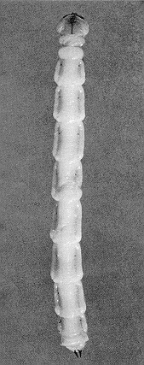

Figure : Adult female

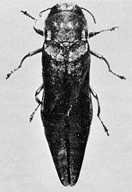

Figure : Mature larvae tunneling

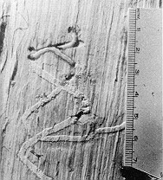

Figure : Healed over galleries

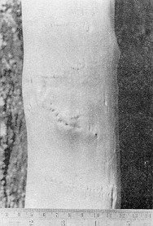

Figure : Stem swellings

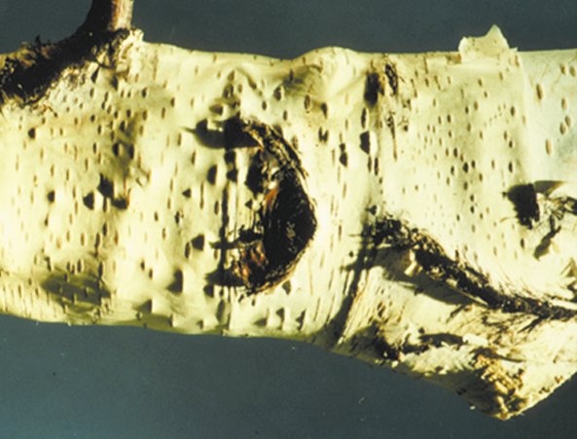

## (15-005) Twolined Chestnut Borer

|  |  |
| --- | --- |
| Species: | Aleurodicus disperses |
| Host: | White oak, scarlet oak, bur oak, chestnut oak, northern red oak, post oak, black oak, live oak, and American hornbeam |
| Range: | Eastern state |
| Injury: | Attacks the crowns and stems of weakened trees. The larvae bore into the inner bark, begin feeding and form meandering galleries in the inner bark and outer wood. The larvae molt three times; and as they grow, they form larger galleries, which cause more damage. The meandering and overlapping feeding galleries of many larvae effectively block movement of food to the roots and water to the shoots. These borers first infest the upper crown; later infestations are lower down and often reach the base of the tree. The combined actions of the borer in the stem and the fungus in the roots can bring about rapid decline and death. As dieback and reduced growth continue, larger branches die and form the characteristic stag-headed crown. Foliage is mainly limited to sprouts on the larger branches and main stem. |

Figure : A stag-headed oak with bole sprouts

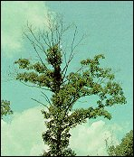

Figure : Adult

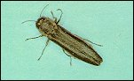

Figure : Feeding galleries

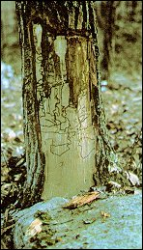

Figure : Larval stages

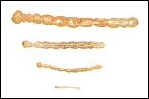

## (15-006) Bronze Poplar Borer

|  |  |
| --- | --- |
| Species: | Argilus liragus |
| Host: | Poplar |
| Range: | Northeastern states southward to Pennsylvania and Arizona, North Dakota, Colorado, Utah, and Oregon |
| Injury: | Trees of low vigor are especially subject to successful attack. Galleries are typically compact and horizontal. Attacks usually begin in the crowns and progress downward into the bole, thereby causing death. Vigorous trees may withstand an attack, healing over the galleries and killing the larvae. |
| Description: | The adults are about ½ inch long and olive-bronze. The larvae are pearly white, slender, flattened, and about one inch long when full grown. |

## (15-007) Carpenter Bees

|  |  |
| --- | --- |
| Species: | Apidae |
| Host: | Pine, eastern white pine, and oak |
| Description: | This is a large and diverse family of bees. The honeybee is occasionally pastured in fireweed on recent burns. They do not damage the growing forest. |

## (15-008) Flatheaded Borer

|  |  |
| --- | --- |
| Species: | Buprestidae |
| Host: | Douglas-fir, grand fir, subalpine fir, maple, hickory, beech, western larch, Englemann spruce, oak, cottonwood, willow, western hemlock; whitebark, lodgepole, limber, western white, longleaf, ponderosa, and loblolly pine |
| Description: | This large family attacks trees. A few species attack and kill healthy trees, but most attack weakened, dead, and recently felled trees. The larvae bore first in the cambium region of the trunk, branches, and roots, and then penetrate the wood. The flattened oval wormholes usually are tightly packed with boring dust arranged in ridges in patterns similar to the tip of a fingerprint. Adults are flattened, compact, often brightly colored beetles with a metallic luster. |

Figure : Larva

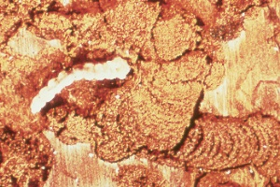

Figure : Larval galleries

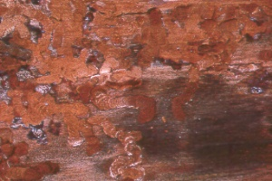

Figure : Adult

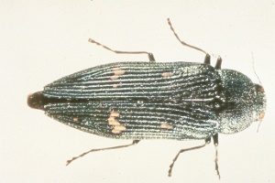

## (15-009) Golden Buprestid

|  |  |
| --- | --- |
| Species: | Buprestis arurlenta |
| Host: | Ponderosa pine, Douglas-fir, spruce, sugar pine, Jeffery pine |
| Range: | Western states |
| Injury: | The larvae mine in and around fire scars and mechanical injuries causing additional defect. They feed on needles before laying eggs. |
| Damage: | Eggs are laid in flat masses wedged in cracks in the wood. Newly hatched larvae have numerous long hairs and the body ends in two sharp projections. The adults are iridescent green or blue green with the margins of the elytra bordered with copper and range from 12 to 20 mm long. |

Figure : Golden busprestid

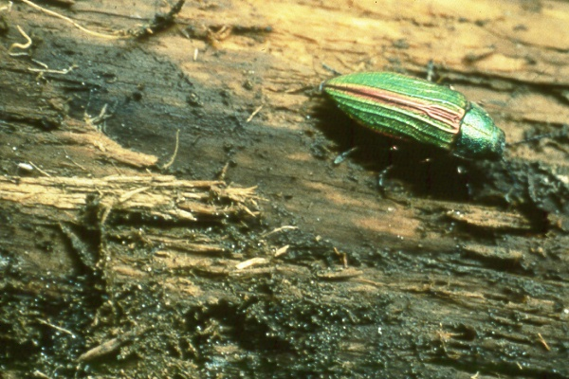

## (15-010) Carpenter Ants

|  |  |
| --- | --- |
| Species: | Camponotus spp. |
| Hosts: | Western hemlock, white spruce, white fir, western juniper, incense cedar, redwood, giant sequoia, Douglas-fir, eastern white pine, scarlet oak, northern red oak, post oak, and black oak |
| Description: | These ants are found in the lower trunk of living trees or logs with unsound heartwood. Wood containing an ant nest is honeycombed with many chambers. Although tunnels may initially be in unsound wood, they are often extended into sound wood. The ants do not eat the wood but simply remove it to construct chambers. |

Figure : Adult

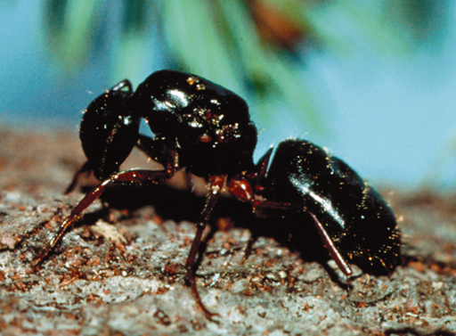

Figure : Damage

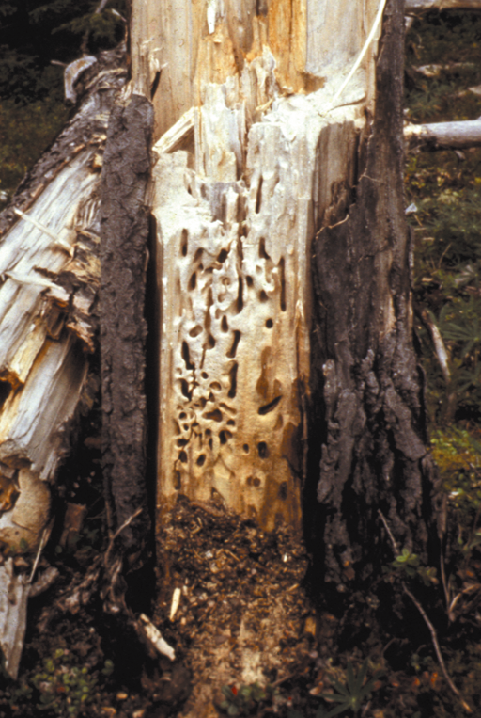

## (15-011) Gouty Pitch Midge

|  |  |
| --- | --- |
| Species: | Cecidomyia piniinopis O.S. |
| Host: | Ponderosa pine, pitch pine, Virginia pine |
| Secondary host: | Lodgepole pine |
| Range: | Coast-to-coast |
| Injury: | Attacks occur near branch tips in early summer. New shoots fade, droop, turn yellow, and die. Repeated attacks, which do not kill the shoots, may twist and stunt branches. Beneath the bark, small resinous pockets are formed by developing larvae. Trees 4-16 feet in height are most heavily infested. Small trees may be killed. |

Figure : Damaged tree

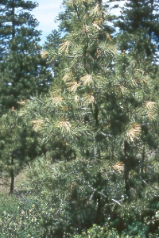

Figure : Damaged twig

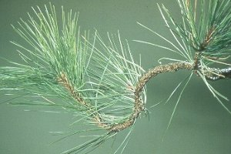

Figure : Larvae

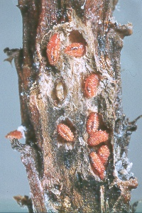

## (15-012) Pine Needle Scale

|  |  |
| --- | --- |
| Species: | Cephidae |
| Description: | The larvae of this family are borers in the tender shoots of trees. Adults are slender bodied and seldom more than 18 mm long. The body is black or dark colored, occasionally marked with narrow yellow bands. The antennae are filiform, with 20 to 30 segments, and are either spindle or club shaped. |

## (15-013) Roundheaded Borer

|  |  |
| --- | --- |
| Species: | Cerambycidae |
| Host: | Grand fir, subalpine fir, western larch, Englemann spruce, Douglas-fir, western hemlock, whitebark pine, lodgepole pine, limber pine, western white pine, and ponderosa pine |
| Injury: | Although some wood borers kill weakened trees, most attack trees that have been recently killed by other agents, such as bark beetles, fire, etc. Local information may be helpful in ascertaining if borers should be considered primary agents. Larval galleries of some species start in the cambium and later move inwards to the sapwood and heartwood; other species construct larval galleries entirely in the cambium. When borers attack after bark beetles, the borer galleries may overrun and obscure the initial bark beetle galleries. |
| Description: | Adults have very long antennae, and make round exit holes. Larval galleries are filled with coarse, excelsior-like frass. |

Figure : Adult

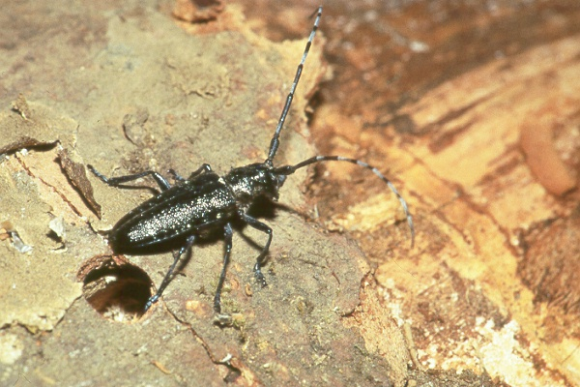

Figure : Adult

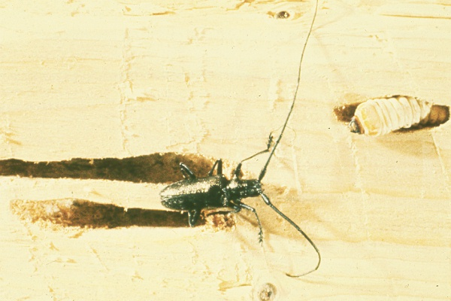

Figure : Larvae devouring phloem and mountain pine beetle brood

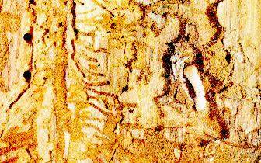

## (15-014) Flatheaded Apple Tree Borer

|  |  |
| --- | --- |
| Species: | Chrysobothris femorata |
| Host: | White oak, black oak, poplar, silver maple, hickory, beech, sycamore, boxelder, and willow |
| Range: | Transcontinental |
| Injury: | Bores in the bark and outer wood of limbs, trunk, and roots of weakened, dying, and dead trees. |
| Description: | Adults medium sized, generally dull colored, rather flattened beetles with sculptured wing covers that often are serrate along the outer edge at the rear. |

Figure : Adult (photo by: James Solomon)

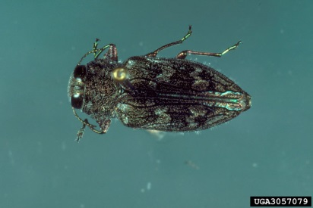

Figure : Larva (photo by: James Solomon)

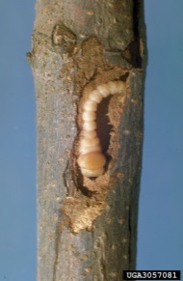

## (15-016) Columbian Timber Beetle

|  |  |
| --- | --- |
| Species: | Corthylus columbianus |
| Host: | Red maple, silver maple, sugar maple, sycamore, boxelder, beech, yellow birch, sweetgum |
| Range: | Michigan to Massachusetts south to Georgia and Arkansas |
| Injury: | Holes, less than 1/10 inch in diameter, are bored straight into the sapwood until the tunnel nears the heartwood, turning right or left. Damage is conspicuous in log ends. Streaks of stain originate from the tunnels. |
| Description: | Adults are black to reddish-brown cylindrical beetles about 1/5 inch long. The larvae are white, legless, and C-shaped. |

## (15-017) Pitted Ambrosia Beetle

|  |  |
| --- | --- |
| Species: | Corthylus punctatissimus |
| Host: | Red maple, sugar maple, dogwood, American hornbeam |
| Range: | Northeast states south to Georgia and west to Great Plains |
| Injury: | The adult bores into the host near the ground line, then excavates a tunnel, which may encircle the stem one, or more times girdling the tree. Small stems, from 3 to 10 mm in diameter are usually attacked. Severe mortality of young sugar maples from 1 to 5 feet tall had occurred. |
| Description: | The adult is rather stout, cylindrical, dark brown or black, and about four mm long. The antennae and legs are rusty red brown. |

## (15-018) Carpenterworm Beetle

|  |  |
| --- | --- |
| Species: | Cossidae |
| Host: | Ash |
| Injury: | Larvae make burrows in the trunks or large limbs of living trees. |
| Description: | Adults have long spindle shaped bodies and lightly banded or spotted translucent wings. |

## (15-019) Poplar and Willow Borer

|  |  |
| --- | --- |
| Species: | Cryptorhynchus lapathi |
| Host: | Willow, poplar |
| Secondary host: | Birch |
| Range: | Washington, Oregon, California, Nevada, Utah, Colorado, Northeastern states south to Virginia |
| Injury: | The larvae mine beneath the bark, then into the wood, making irregular generally cylindrical tunnels that often riddle the wood and cause the stem to break. Wood borings are expelled by larvae through holes in the stem. |
| Description: | The adult is chunky, rough surfaced weevil with a long, curved, shiny snout. It is about 8 mm long and predominately black except for the hind third of the elytra, which is gray or sometimes pinkish. |

## (15-020) Pine Reproduction Weevil

|  |  |
| --- | --- |
| Species: | Cylindrocopturus eatoni |
| Host: | Ponderosa pine, Jeffery pine |
| Secondary host: | Sugar pine, digger pine |
| Range: | Central and northern California |
| Injury: | Damage is greatest in plantations with brush competition. Trees usually fade in the fall. The foliage turns straw colored and progressively darkens to deep reddish brown. Feeding punctures on the twigs and needles are evident upon close inspection. Larval galleries meander between the wood and outer bark and do not originate from a central gallery or chamber. Adult emergence holes in the bark resemble birdshot punctures. |
| Description: | Adults are about 3 mm long and densely covered with nearly circular scales. The larvae are cream colored, legless, curled grubs, about four mm long when mature. |

## (15-021) Douglas-Fir Twig Weevil

|  |  |
| --- | --- |
| Species: | Cylindrocoturus furnissi |
| Host: | Douglas-fir |
| Secondary host: | White fir, grand fir, Pacific silver fir |
| Range: | Washington, Oregon, California |
| Injury: | Attacks and kills small branches on open grown trees. Damage is greatest in drought years and on dry sites. Heavy attacks deform trees and retard their growth. Damage is mostly on trees 5 feet in height or less. |
| Description: | Adults are about 3 mm long and densely covered with nearly circular scales. The larvae are cream colored, legless, curled grubs, about four mm long when mature. |

Figure : Damaged shoots

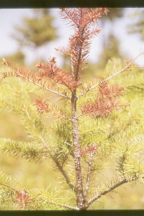

## (15-022) Zimmerman Pine Moth

|  |  |
| --- | --- |
| Species: | Dioryctria zimmermani |
| Host: | Scots pine |
| Secondary host: | Red pine, Austrian pine, pitch pine, loblolly pine, eastern white pine, mugho pine |
| Range: | Northern, southwestern, and eastern states |
| Injury: | Trees of all sizes are subject to attack. Damage results in broken, dead tops and branches and burl-like growths on the trunk above girdled areas. Pitch masses, coarse sawdust, and loose silken webs distinguish this insect.  Adults emerge between the end of June and mid-September and are active at night. The female deposits eggs near edges of wounds, in bark crevices, or on terminal buds. Young larvae enter bark recesses to spin silken hibernaculae for over wintering. |
| Description: | Mature larvae in the northern part of the range have greenish pink bodies covered with small black spots. They are about ¾ inch long. A heavily infested tree may have 20 or more larvae feeding in a single whorl. |

## (15-024) Twig Pruner

|  |  |
| --- | --- |
| Species: | Elaphidionoides villosus |
| Host: | Oak, maple, sweetgum, pecan, hickory |
| Range: | Eastern states |
| Injury: | Injury includes pruning of living branches. Attack begins with egg laying in the axil of a leaf near the tip of a twig; twig mining by the early stage larva follows. As the larva develops it tunnels down the stem, and late in the summer it makes concentric cuts outward from the center except for the bark. It retreats into the severed portion to hibernate, appearing as a beetle in the spring. The severed branches, sometimes 2 inches in diameter, break off in the wind. |
| Description: | The adult is a brownish beetle, about ¾ inch long, with a pair of short spines at the tip of each wing cover. The full-grown shiny white larva is slender and slightly longer than the adult is. The eggs are laid on dead twigs, and the larva feeds beneath the bark during the first season, exuding granular frass. The second season it tunnels in the sapwood. Prior to pupation, it severs the branch. |

## (15-025) Lesser Cornstalk Borer

|  |  |
| --- | --- |
| Species: | Elaphidionoides villosus |
| Host: | Black locust seedlings, loblolly pine seedlings |
| Injury: | Gall-like growths occur at points of injury on the lower stems of locust seedlings, causing them to die or break off at the ground line. |
| Description: | The adult male is ochre yellow to light brown and has a wingspread of 16 to 24 mm. The forewings are long, narrow, and marked with several black spots. Mature larvae are greenish white with interrupted stripes of dark brown. |

## (15-026) Red Oak Borer

|  |  |
| --- | --- |
| Species: | Enaphalodes rufulus |
| Host: | Northern red oak, black oak, Scarlet oak; less commonly: white oak, post oak, pin oak, bur oak, overcup oak, laurel oak |
| Injury: | External signs include: extruded frass, discolored bark patches, wet spots, wood slivers, and exit holes. The fine larval frass is found during the first fall and winter after eggs hatch. Wet spots and medium-sized larval frass can be found during the first spring and early summer. Discolored bark patches and large quantities of larval frass occur in the second fall and winter. Wood slivers are extruded in the spring and early summer just before the adult emerges. The adult exits through an oval hole, which it chews in the bark. |

Figure : Distribution



Figure : Adult

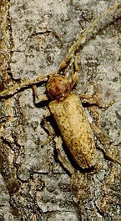

Figure : Larval feeding mine

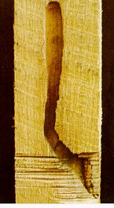

## (15-027) Ponderous Borer

|  |  |
| --- | --- |
| Species: | Ergates spiculatus |
| Host: | Douglas-fir, ponderosa pine |
| Secondary host: | Redwood |
| Range: | Western states |
| Injury: | Larval mines in the heartwood of fire-killed Douglas-fir speed deterioration. Ponderosa pine trees killed by the western pine beetle are often mined at the base. Borer weakened snags fall more quickly than sound snag. The larvae excavate very large, meandering galleries, first in the sapwood, then deep into the heartwood. |
| Description: | The adults are 42 to 65 mm long. The elytra are uniformly reddish brown. The adults lay eggs in the crevices of the bark of dead trees and stumps. Full-grown larvae are thick bodied, 60 to 70 mm long, creamy white with a reddish brown head bearing four tooth-like processes. |
| Defect: | Localized, often to the lower part of the first log only. |

Figure : Ponderous borer damage

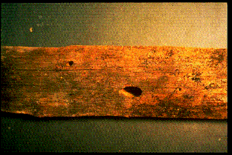

Figure : Ponderous borer damage

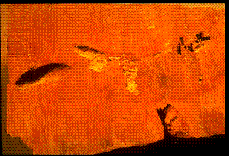

## (15-028) Eastern Pine Shoot Borer

|  |  |
| --- | --- |
| Species: | Eucosma gloriola |
| Host: | Eastern white pine, Scots pine |
| Secondary host: | Jack pine, red pine, Austrian pine, mugho pine, white spruce |
| Range: | Northeastern states from Maine south through the Lake States, northern Ohio, Pennsylvania, and New Jersey |
| Injury: | Although it attacks trees up to 30 ft tall, it is most injurious to trees 3 to 8 ft tall. Injury is seldom noticed until after the larva has left the shoot. Both terminal and lateral shoots are attacked. The first evidence of attack occurs about mid-June when the outer 6 to 8 in. of the shoot begins to droop and turn yellow. Frequently the shoot breaks over or drops off near the base of the attack, leaving a distinctive flat stub. Terminals are more susceptible to breakage than laterals. Some shoots, especially on Douglas-fir, may wilt and droop before yellowing and resemble a shepherd's crook. The pitch of the attacked shoot is hollowed out to form a 6 to 8 in. long gallery. The exit hole made by the larva near the base of the gallery is a characteristic indicator of this insect's damage. Small shoots that die before mid-June are usually those in which the insects have died prematurely. Such shoots contain only a partially excavated gallery filled with hardened pitch. Injury causes trees to become stunted and crooked; crooks and forks develop after terminals are killed. The general crown shape of the tree is ruined when laterals are killed. The wound caused by the broken shoot can be an infection court for disease-causing organisms. |

Figure : Larva exit holes

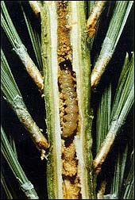

Figure : Larva exit holes

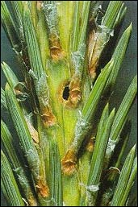

Figure : Adult

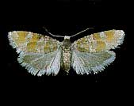

## (15-029) Pinyon Needle Scale

|  |  |
| --- | --- |
| Species: | Eucosma sonomana |
| Host: | Ponderosa pine |
| Secondary host: | Englemann spruce, lodgepole pine |
| Range: | Arizona, California, Oregon, Colorado, Montana |
| Injury: | Larvae feed within the pith of new terminal and lateral shoots from May until August. Terminal shoots become thickened and have shorter needles that are bunched together like a shaving brush; terminal shoot growth is usually reduced, but mortality is not common. Other shoots can turn red and wilt. Infested lateral shoots often die. Exit holes from the pith can be seen on the shoots in late summer. Repeated attacks reduce tree height and may cause deformed crowns. This moth does not leave feeding scars, webbing, or frass on the surface of infested shoots. |

Figure : Damaged shoot

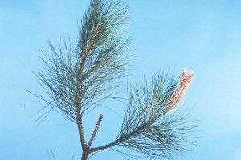

Figure : Damaged shoot

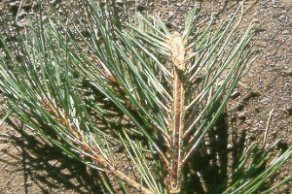

Figure : Damaged shoot cross sections

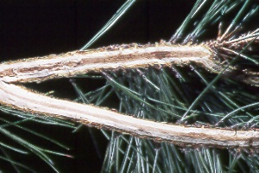

Figure : Cross section with larva

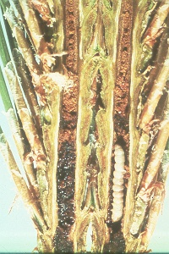

## (15-030) Eucosma Species

|  |  |
| --- | --- |
| Species: | Eucosma spp. |
| Host: | Balsam fir, white fir, Englemann spruce, bristlecone pine, pinyon, limber pine, Jeffery pine, singleleaf pine, ponderosa pine, and hemlock |
| Description: | Adults are variously mottled in tones of orange-brown to gray with a pale background. Larvae of some species are cone borer, their damage being similar to that of *Dioryctria* spp. In contrast to *Dioryctria*, the larvae have a V-shaped structure on the head as opposed to Y-shaped, and is usually smaller, up to about 15 mm long. Pupae have transverse rows of short stout spines on the abdomen. |

Figure : Exit holes

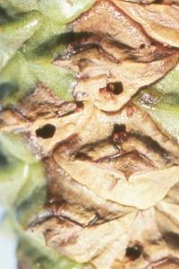

## (15-031) Sugar Maple Boer

|  |  |
| --- | --- |
| Species: | Glycobius speciosus |
| Host: | Sugar maple |
| Range: | Northeast states westward to the Lake States and southward through the Appalacians |
| Injury: | Ridges or raised areas on the trunk and large limbs, frass, and moisture on the bark. |
| Description: | Eggs are deposited in bark crevices, under bark scales or around wounds, during July and August. The larvae feed beneath the bark, and a chamber is formed in the sapwood. As the second winter approaches, the mature larvae bore deep into the wood and construct a pupal cell. Before entering the cell, the larvae cut an exit hole through which it will emerge in the spring. The adult is a robust, velvety-black beetle about one inch long. Its head is covered with fine, yellow hairs. Its back is marked with several yellow bands, those near the front forming a characteristic W-shaped design. |

## (15-032) White Oak Boer

|  |  |
| --- | --- |
| Species: | Goes triginus |
| Host: | White oak, overcup oak |
| Secondary Host: | Hickory |
| Range: | Eastern states |
| Injury: | Oozing of sap and frass production on trunks are the most prominent indications of infestation. The sap often attracts flies, bees, wasps, butterflies, and other insects. |
| Description: | The adult long-horned beetles are rarely seen. They are mottled brown and white, about 1 inch long, with a spine on each side of the thorax and antennae about as long as the body. Larvae are grub-like, pale yellow, robust, and up to 1½ inches long. |

## (15-033) Pine Root Collar Weevil

|  |  |
| --- | --- |
| Species: | Hylobius radices |
| Host: | Scots pine |
| Secondary host: | Eastern white pine, jack pine, red pine, Austrian pine, pitch pine, mugho pine |
| Range: | Northeastern states south to Virginia and west to Minnesota |
| Injury: | Repeated injury results in girdling and death of small trees (2 to 20 feet tall) and stunting and breakage of larger ones, especially those growing in the open. The larvae injure the bark and cambium at the base near the root crown. Adults feed on the bark of twigs, causing flagging of branches. The root collar of an attacked tree often is constricted, and the coil around it pitch soaked and blackened. Eggs are laid from early May to late September in the bark at the base of the tree or in the soil nearby. They hatch in 2 weeks and the grubs feed and tunnel under the bark of primary roots and at the root collar. Galleries are irregular, with occasional mined-out areas the size of half dollars. Sometimes grubs tunnel into the soil. Young adults feed on the branches, over winter under the tree in the duff, and resume activity in the spring. |

## (15-034) Warren’s Collar Weevil

|  |  |
| --- | --- |
| Species: | Hylobius warreni |
| Host: | Lodgepole pine |
| Secondary host: | Spruce, larch, western white pine, Scotch pine |
| Range: | Southeastern Alaska, Washington, northeast states south to North Carolina |
| Injury: | Trees growing on wet ground or in deep layers of humus are most susceptible to attack. Tunnels filled with pitch in the root collar region, with larvae feeding in the cambial or inner bark region, are characteristic of attack by this weevil. Small trees are often girdled and killed whereas feeding on larger trees permits the entrance of wood rots into the wounds. As a result, the trees are susceptible to wind breakage. |
| Description: | Adults live two or more years and lay eggs each year. Since 2 years are required to complete a life cycle, both larvae and adults can be found during the winter. The pupal stage, which is short, occurs in June. The adults, who are flightless, have an extended emergence period. |

## (15-035) Powderpost Beetle

|  |  |
| --- | --- |
| Species: | Lyctidae |
| Host: | Oak, maple, ash, hickory, black walnut, persimmon, sycamore, black locust, cherry |
| Injury: | The larvae bore in the sapwood often reducing it to a flourlike powder, except for a thin surface veneer. |
| Description: | Adults are flattened, slender, dark brown to nearly black beetles generally 3 to 6 mm long. Mature larvae are yellowish white, somewhat curved and about 5 mm long. |

## (15-036) Tarnished Plant Bug

|  |  |
| --- | --- |
| Species: | Lyqus lineolaris |
| Injury: | Mostly attacks nursery trees |
| Description: | Adults are 2 to 9 mm long, and are usually fragile. The antennae and beak are each four segmented, with the second segment of the beak longer than the head. |

## (15-037) Magdalis spp.

|  |  |
| --- | --- |
| Species: | Magdalis spp. |
| Host: | Ponderosa pine, lodgepole pine, Jeffery pine, white alder, sugar pine, hawthorn, Monterey pine, eastern white pine, scotch pine, and willow |
| Injury: | They eat chunks out of needle edges or holes through needles during the spring and early summer. Weevils can infest shoots, roots, twigs, or needles. |
| Description: | Adults are black and have prominent curved beaks. |

## (15-038) White Pine Bark Miner

|  |  |
| --- | --- |
| Species: | Marmara fasciella |
| Host: | Eastern white pine |
| Range: | Throughout the range of the host species |
| Injury: | Young larvae bore through the bark and construct linear mines in the inner bark. |

## (15-039) Locust Borer

|  |  |
| --- | --- |
| Species: | Megacyllene robiniae |
| Host: | Black locust |
| Range: | Throughout the range of the host species |
| Injury: | Larvae tunnel into a tree's trunk and branches, weakening the tree and making it susceptible to wind breakage. The most obvious signs of severe borer attack are the many dead and broken limbs and the knotty swellings on the trunks. Depending on the season, symptoms of attack vary. In the early spring, at about the time of bud swell, wet spots appear on the bark. These wet spots are the result of young larvae tunneling in the inner bark. In late spring or early summer, white-colored wood dust can be seen on the bark; the dust is pushed out of holes in the bark by the developing larvae, which are boring into the sapwood. By late summer, the larvae burrow into the heartwood, and the boring dust on the bark appears yellow. If the tree is heavily infested, the wood dust may accumulate in a ring around the tree's base. |

Figure : Larvae, pupa, adult

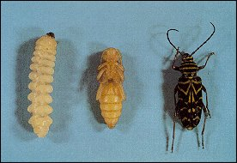

Figure : Top breakage

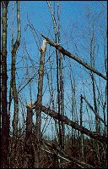

Figure : Trunk damage

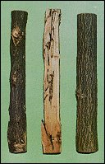

Figure : Adult

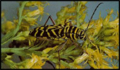

## (15-040) California Flathead Borer

|  |  |
| --- | --- |
| Species: | Melanophila californica |
| Host: | Jeffery pine, ponderosa pine |
| Secondary host: | Sugar pine, coulter pine, digger pine, Monterey pine, knobcone pine |
| Range: | California, Oregon, Washington, Idaho, Nevada |
| Injury: | Attacks pines growing on rocky slopes, in fringe type stands or where soil moisture is low. It most frequently attacks old, decadent, or unhealthy trees. Adults feed on the foliage. |
| Description: | Adults are 7 to 11 mm long, greenish bronze above, and brassy green below. Some have yellow spots on each wing cover. |
| Defect: | Mortality but not volume loss. |

Figure : California flathead borer

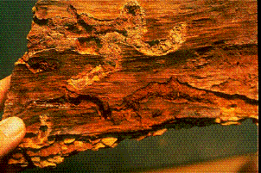

## (15-041) Flathead Fir Borer

|  |  |
| --- | --- |
| Species: | Melanophila drummondi |
| Host: | Douglas-fir, Pacific silver fir, Engelmann spruce, western hemlock, western larch |
| Range: | Western states including Alaska |
| Injury: | Attacks injured, mistletoe infested, dying, fire killed, and recently felled trees. Sometimes it attacks and kills apparently healthy trees on dry sites. The larvae bore in the inner bark forming galleries packed with frass. |
| Description: | The adults are bronzy black and usually have three small yellow spots on each wing cover. |
| Defect: | Mortality but not volume loss. |

Figure : Borer holes

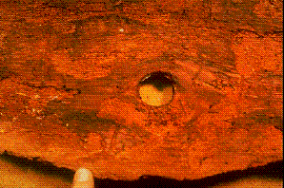

Figure : Adult

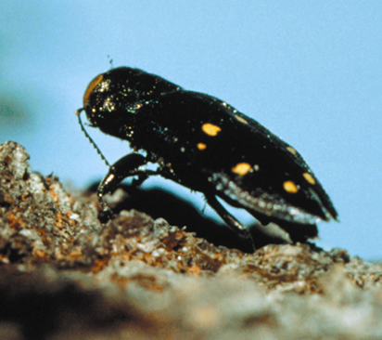

## (15-042) Whitespotted Sawyer

|  |  |
| --- | --- |
| Species: | Monochamus scutellatus |
| Host: | Eastern white pine, western hemlock, Douglas-fir |
| Secondary host: | Jack pine, red pine, balsam fir, white spruce, black spruce, red spruce, Engelmann spruce |
| Range: | Western states including Alaska; northeastern states south to North Carolina and Minnesota |
| Injury: | The adults feed on the needles and tender twig bark of various living conifers. The larvae develop successfully in weakened or recently dead conifers, freshly cut pulpwood, and saw logs. The larvae mine first in the surface, layers of the wood, then into the inner layers. Their mines open the way for wood-destroying fungi resulting in discoloration of the wood and the presence of soft, punky sap rot from the associated fungi. Feeding by the adults on the under surface of twigs causes wounds up to 1 inch long. Death of the twig beyond the wound often occurs if the twig is nearly girdled or if cold weather arrives before the wound can heal. This condition, when on balsam fir, is called "red branch." Although these wounds and the resulting branch "flagging" may appear numerous, they alone seldom kill the host. The danger lies in the possibility of several species of pathogenic fungi entering the tree at these points of injury, and causing some dieback or complete death. |
| Description: | The egg is white, elongate, cylindrical, and slightly flattened; with rounded ends. The average size is nearly 3.0 mm. long by about 0.9 mm. wide. The young larva is dirty white, somewhat flattened, and without legs. It has a light yellow thorax and an amber-brown head, armed with a pair of short stout mandibles. When fully grown, the larva may be 1½ to 2 inches long and ¼ to 3/8 inch wide at the thorax. The pupa, ¾ to 1 inch long, resembles the adult insect superficially. At first, it is white and soft like the larva; and the mouthparts, legs, antennae, and wings, which project externally from the body, are incompletely formed. The adult body is about ¾ to 1 inch long and 3/16 to ¼ inch wide. The male's antennae are twice body length, while those of the female are just slightly longer than the body. Each sex has a small rounded white spot at the base of the wing covers. Except for this spot, males are always completely shiny black. Females may be colored exactly like males, or they may be mottled; the mottling is due to several small white spots scattered over the wing covers. Both sexes have long, robust legs, a spine on each. As the pupa ages, these appendages become more distinct. The long antennae, coiled tightly against each side of the body, resemble watch springs when completely formed. When the pupa has fully developed, it darkens and its outer side of the prothorax and a pair of stout, strong mandibles emerges. |

Figure : Full grown larvae

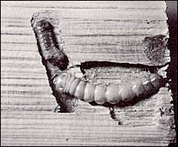

Figure : Female and male adults

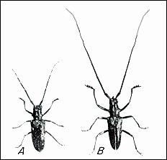

Figure : a: larval entrance hole; b: exit hole; c: larval surface galleries

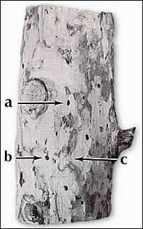

Figure : Adult

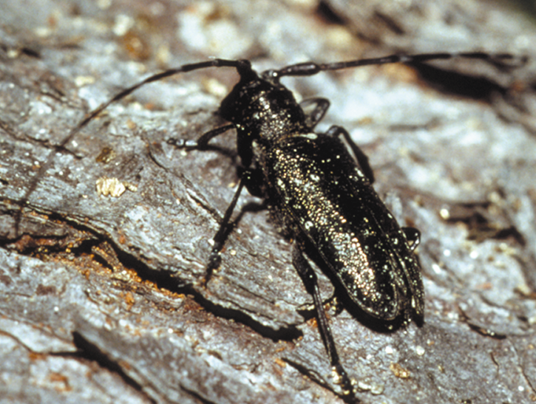

## (15-043) Redheaded Ash Borer

|  |  |
| --- | --- |
| Species: | Neoclytus acuminatus |
| Host: | Ash |
| Secondary host: | Oak, persimmon, black locust, hickory |
| Range: | Eastern states, Colorado, New Mexico, southern Idaho |
| Injury: | Dying trees are attacked, as are logs stored in the woods or mill yards, especially if the bark is left on the logs. The early stage borers feed for several weeks under the bark, tunneling the surface of the wood. In the later stages, they make galleries in the sapwood, especially in the outer layers, completely honeycombing the wood and packing the galleries with granular frass. Generally, the adults emerge the following spring; but when infested logs are sawed and the lumber allowed to season, development may be retarded and the adults will emerge at irregular intervals over a period of years. |
| Description: | Borers are red-dish-brown slender beetles, varying from ¼ to ¾ inch in length. They have yellow cross bands on the wing covers, but none on the thorax. The larvae are dull white, rather hairy, and have minute thoracic legs. When full grown, they are ½ to ¾ inch long. |

## (15-044) Western Ash Borer

|  |  |
| --- | --- |
| Species: | Neoclytus conjunctus |
| Host: | Ash, oak, Pacific madrone |
| Range: | Washington to southern California |
| Injury: | Larvae riddle the sapwood of freshly cut, bark covered, unseasoned wood. |
| Description: | Adult is 7 to 18 mm long, black, and has bold white or yellow “O” like markings at the base of the elytra. |

## (15-045) Oberea Shoot Borers

|  |  |
| --- | --- |
| Species: | Oberea spp. |
| Host: | Aspen, willow, hickory, dogwood, oak, bitter cherry |
| Range: | Mostly in the eastern states |
| Injury: | Longitudinal tunnels in the center of living twigs, usually less than ¾ inch in diameter, of saplings, poles, and larger trees, and in stems and branches of suckers and seedlings. “Push-out” holes are made, through which borings and frass are expelled, thereby keeping the tunnels clean. Black, necrotic areas develop around these holes. Generally, the twigs are not sufficiently weakened to allow wind breakage. |
| Description: | The adults are slender beetles; about 5.8 inch long, with yellowish or black wing covers and four round black spots on the thorax. The full-grown larvae are about ¾ inch long, yellow, and legless. |

## (15-046) Eucalyptus Longhorned Borer

|  |  |
| --- | --- |
| Species: | Phoracantha semipunctata |
| Host: | Eucalyptus |
| Range: | Pacific Islands, Hawaii, California |
| Injury: | Attracted to freshly cut wood, dying limbs, and trees suffering from stress, especially drought stress. Larvae may bore directly into bark after hatching or feed outward from the egg mass, leaving a distinct dark trail ¼ inch or several inches long that scores the bark surface before they bore into the cambial tissue on the inner surface of the bark. Once they bore into the inner bark, the galleries can extend several feet. Holes in the bark and stains or oozing liquid on trunks and limbs result. Foliage may discolor and wilt, and limbs may die back. Trees may be girdled and die. |
| Description: | Adults have shiny, dark brown and yellow to cream colored areas on their wing covers. The antennae are as long or longer than the body, and those of the males have prominent spines. Mature larvae are more than an inch long, cream colored, and legless. |

## (15-047) Northern Pine Weevil

|  |  |
| --- | --- |
| Species: | Pissodes approximates |
| Host: | Red pine, Scotch pine |
| Secondary host: | Eastern white pine, pitch pine, Jack pine, shortleaf pine, Virginia pine, Table Mountain pine, Austrian pine, white spruce, red spruce, black spruce |
| Range: | Northeast states southward to Minnesota and North Carolina |
| Injury: | Adults emerge in the spring and feed on the inner bark of branches and stems of seedlings and small trees. It breeds beneath the bark surface. It breeds on recently cut stumps and logs, and on the main stems or branches of dead or dying trees. Attacks occur on the tree from the roots up to branches as small as ½ inch in diameter. Attacks also occur at the root collar and on the lower stems of apparently healthy young trees. |
| Description: | Adult is 5 to 8 mm long. The beak is large, and the spots on the elytra are uniformly small. |

## (15-048) Pissodes dubius

|  |  |
| --- | --- |
| Species: | Pissodes dubius |
| Host: | Noble fir, balsam fir, red spruce |
| Range: | Noble fir in California, Oregon, Washington, Idaho; balsam fir and red spruce in the northeastern states |
| Injury: | Larvae mine the inner bark. The adults pierce the bark or buds and feed. Attacks and breeds in storm damaged 90-year-old noble fir and attacks nearby intermediate and suppressed trees. Attacks are made in the root crown area. |
| Description: | This is the largest species in the genus. Adults are 7.5 to 10 mm long, and dork brown to black in color. Adults are rough surfaced beetles, usually with spots and patches of white, yellow, of brown scales on the elytra. The head is prolonged into a slender beak or snout, which is used to puncture buds or tender bark for feeding. |

## (15-049) Monterey Pine Weevil

|  |  |
| --- | --- |
| Species: | Pissodes radiatae |
| Host: | Knobcone pine, lodgepole pine, Bishop pine, Monterey pine |
| Range: | California |
| Injury: | Sometimes attacks pine leaders, but characteristically develops in the bole and root collar. Larvae mine the inner bark. The adults pierce the bark or buds and feed. |
| Description: | Adults are 5.0 to 7.5 mm long, and reddish brown. Adults are rough surfaced beetles, usually with spots and patches of white, yellow, of brown scales on the elytra. The head is prolonged into a slender beak or snout, which is used to puncture buds or tender bark for feeding. |

## (15-050) White Pine Weevil

|  |  |
| --- | --- |
| Species: | Pissodes strobi |
| Host: | Eastern white pine, Jack pine, Norway spruce, Englemann spruce, Sitka spruce, lodgepole pine |
| Secondary host: | Foxtail pine, limber pine, western white pine, Scots pine, mugho pine, Jeffrey pine, blue spruce, red spruce, white spruce, Austrian pine, Table Mountain pine, red pine, pitch pine |
| Range: | Western states, south to California and Colorado, and throughout the range of eastern white pine in the northeastern states |
| Injury: | The first evidence of attack in spring is the tiny glistening droplet of resin exuding from the feeding punctures made by the adults on the previous year's growth, just below the terminal buds. Two to three weeks later, eggs are laid in new punctures that do not produce resin droplets. Feeding by larvae effectively girdles the stem, causing the new shoot to wilt and the needles to turn reddish brown. The wilting is noticeable in June in the southern part of the range and progressively later in the North and West. By the end of the season, larval feeding may extend below one or more whorls of branches. In such cases, all whorls above the larval feeding collar die. A successful attack always kills the previous year's growth, although three or even 4 years' growth often is affected. Circular holes, .10 to .12 inch in diameter, on an infested stem indicate that adults have emerged. |

Figure : Larvae

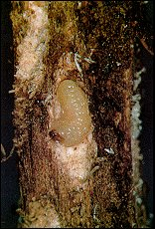

Figure : Adult

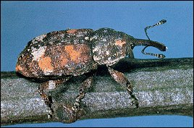

Figure : Damage

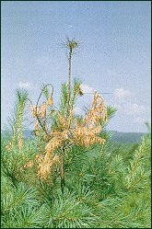

## (15-051) Lodgepole Terminal Weevil

|  |  |
| --- | --- |
| Species: | Pissodes terminalisi |
| Host: | Lodgepole pine, Jack pine |
| Secondary host: | Englemann spruce |
| Range: | Oregon, California, Idaho, Wyoming, South Dakota |
| Injury: | They attack and kill or badly injure terminals on spruce and lodgepole pine reproduction from 1 to 30 feet in height. Leader mortality results in deformity of the main stem or the production of multiple leaders. Wood-chip cocoons are made in the phloem and pith of shoots. Damaged shoots turn reddish and curl; exit holes are usually visible. |

Figure : Damaged shoot

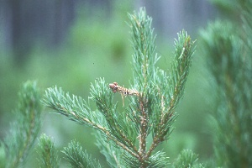

## (15-052) Ambrosia Beetles

|  |  |
| --- | --- |
| Species: | Platypus spp. |
| Host: | Englemann spruce, grand fir, subalpine fir, Douglas-fir, western hemlock, maple, birch, hickory, pecan, persimmon, beech, sweetgum, magnolia, aspen, oak, willow, whitebark pine, lodgepole pine, sugar pine, western white pine, ponderosa pine, and Virginia pine |
| Range: | Transcontinental |
| Injury: | Small-diameter (one-sixteenth inch or les) holes are bored straight into tree, perpendicular to bole. Weakened, dying, or recently cut or killed trees are attacked. Galleries within sapwood cause defect in logs. Some species extend galleries into the heartwood, and freshly cut lumber may be attacked before it has dried. Entrance points are marked by piles of fine, granular, white boring dust in bark crevices. |
| Defect: | The sapwood will be riddled with tiny holes, but can be peeled for plywood or cut into lumber with little strength loss. Generally, the sapwood will be defective. |

Figure : Douglas-fir

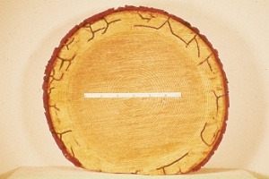

Figure : Stained entrance hole

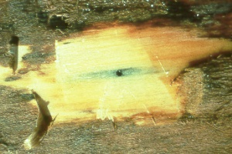

Figure : Galleries

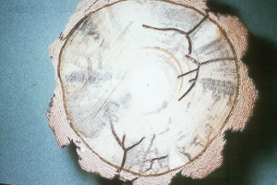

## (15-053) Cottonwood Borer

|  |  |
| --- | --- |
| Species: | Plectrodera scalator |
| Host: | Cottonwood, willow |
| Range: | Southeastern states, but extends westward into Montana and New Mexico |
| Injury: | The adults may cause serious damage in cottonwood nurseries by feeding on the tender shoots of young trees, causing them to shrivel and break off. The larvae bore into the inner bark and wood at the root collar and tunnel downward into the roots. Light brown, fibrous frass is sometimes ejected from bark openings at or slightly above the ground line, accumulating in piles at the base of the tree. The root collar and roots of infested trees may be riddled by larval tunnels. |
| Description: | Adult beetles are 1 to 1 ½ inches long and about ½ inch wide. They are black with lines of cream-colored hair forming irregular black patches. Larvae are seldom seen. |

## (15-054) Balsam Shootboring Sawfly

|  |  |
| --- | --- |
| Species: | Pleroneura brunneicornis |
| Host: | Balsam fir |
| Range: | Northeastern states from Maine to Michigan |
| Injury: | Larvae bore into and kill the new shoots, causing damage similar to that of late frost. Damage is conspicuous, but mortality is rare. |
| Description: | Adults emerge in the spring and eggs are inserted singly into the tightly packed needle clusters shortly after the bud scales have been dropped. Feeding larvae have been found burrowing into shoots from mid-May to early July. The larvae are whitish, 6 mm long when full grown. They drop to the ground, spin a cocoon, and over winter as larva or pupa. |

## (15-055) Pine Gall Weevil

|  |  |
| --- | --- |
| Species: | Podapion gallicola |
| Host: | Red pine, pitch pine, Virginia pine |
| Range: | Eastern states |
| Injury: | Eggs are deposited in niches chewed into the bark of 1-year old twigs. Young larvae feed first on the sides and floor of the egg niches and then bore into the cambium. Galls are formed surrounding each larva. They first appear as slight swellings on one side of the stem. By the time the adults emerge, these swellings are larger, generally ovoid, and taper gradually toward the distal end. Old galls continue to enlarge, even after the insects leave them, some reaching a length of 37 mm. When several galls are formed on a small branch, the branch may be killed. |
| Description: | Adult is black and about 5 mm long. |

## (15-056) Ash Borer

|  |  |
| --- | --- |
| Species: | Podosesia syringae fraxini |
| Host: | Green ash, white ash |
| Range: | Colorado, Montana, North Dakota, South Dakota; Texas north through the Midwestern states |
| Injury: | Tunneling in branches and trunks, young trees are more seriously injured than large trees. The smaller branches break at the point of entry. Attack is usually made evident by the appearance of rough, irregular scar like swellings on the trunks. |
| Description: | A clearwing moth with a wing expanse of about one inch. The forewings are an opaque dark brown with a red crossbar; the hind wings are transparent. The full-grown caterpillar is whitish, with a mahogany colored head, and is about ¾ inch long. |

## (15-057) Lilac Borer

|  |  |
| --- | --- |
| Species: | Podosesia syringae |
| Host: | Ash |
| Range: | Eastern states |
| Injury: | Larvae bore into the main stem causing them to wilt, take on an unhealthy appearance, or break. |
| Description: | Adult has a wingspread of 26 to 38 mm. Southern adults have the thorax and abdominal segments two and three almost entirely chestnut red, only narrowly edged in black. Northern ones have these parts mostly brown black with edgings of yellow or chestnut red. |

## (15-058) Carpenterworm

|  |  |
| --- | --- |
| Species: | Prionoxystus robiniae |
| Host: | Northern red oak, white oak, canyon live oak, green ash, black locust, maple, willow, and cottonwood |
| Range: | Transcontinental |
| Injury: | Earliest signs of attack are sap spots on the trunk. Later, frass is ejected from the entrance holes. Burrows 2 inches in diameter under the bark, and galleries ½ inch in diameter and 5 to 8 inches long in the wood are typical. Galleries are open or loosely plugged with frass. Holes in lumber are dark stained. |
| Description: | Newly hatched larvae are ¼ inch long and reddish pink. They gradually become greenish white and are 2 to 3 inches long at maturity. Brown pupal skins protruding from entrance holes are common in early summer. Adults are grayish, stout bodied moths. The male hind wing has an orange spot. |

Figure : Carpenterworm larva in gallery

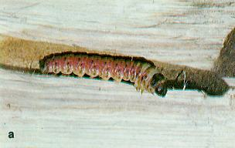

Figure : Carpenterworm female moth

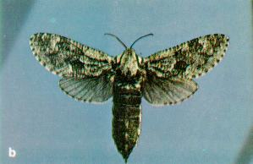

## (15-059) Maple Shoot Borers

|  |  |
| --- | --- |
| Species: | Proterteras spp. |
| Host: | Boxelder, maple |
| Range: | Northern and Midwestern states |
| Injury: | Destroys the dormant buds in the fall and spring, and tunnels in the current season’s shoots. The shoots are killed and terminal growth prevented; forking and occasionally twig breakage result. In heavy infestations, many of the twigs on a single tree will be infested and the trees will become bushy. |
| Description: | The adults are small moths with a wingspread of 5/8 inch; they are white to pale brown. The full-grown caterpillars are about ½ inch long, and are whitish yellow with a dark brown head capsule. |

## (15-060) Western Subterranean Termite

|  |  |
| --- | --- |
| Species: | Reticulitermes hesperus |
| Injury: | This termite often builds earthen like tubes over concrete foundations to get to wood above but must retain contact through them to the ground. |
| Description: | Workers are grayish white and about 5 mm long when full-grown. The soldiers are of similar color, somewhat longer, and have larger heads and mandibles that are more prominent. The winged adults are slender, cylindrical, dark brown to black, and about 4 mm long, exclusive of the wings, which are translucent, and of equal length. |

## (15-061) Coconut Trunk Weevil

|  |  |
| --- | --- |
| Species: | Rhabdoscelus asperipennis |
| Host: | Coconut |
| Range: | Palau |
| Injury: | Larvae tunnel in the interior of their host plants. |
| Description: | Larvae are white, legless grubs. Their tunnel is usually blocked at the entrance by a plug of plant fibers. They pupate inside the cavity they have excavated in a cocoon of fragments of soft bark and fiber. They bore into the base of the trunk and can weaken the tree until it is blown down in high winds. |

## (15-062) New Guinea Sugarcane Weevil

|  |  |
| --- | --- |
| Species: | Rhabdoscelus obscurus |
| Host: | Sugarcane, coconut, betelnut, papaya (occasionally) |
| Range: | Micronesia, Hawaii |
| Injury: | Larvae tunnel in the interior of their host plants. |
| Description: | Larvae are white, legless grubs. Their tunnel is usually blocked at the entrance by a plug of plant fibers. They pupate inside the cavity they have excavated in a cocoon of fragments of soft bark and fiber. They bore into the base of the trunk and can weaken the tree until it is blown down in high winds. |

## (15-063) European Pine Shoot Moth

|  |  |
| --- | --- |
| Species: | Rhyacionia buoliana |
| Host: | Red pine, Scotch pine, mugho pine, Austrian pine |
| Secondary host: | Ponderosa pine, lodgepole pine, eastern white pine, Jack pine, loblolly pine, Virginia pine, longleaf pine |
| Range: | Northeastern states, Washington, Oregon |
| Injury: | Although attacked trees rarely if ever die, their growth is inhibited and many are, deformed.  *Summer and Winter*-The newly hatched larva spin a minute, tent like web coated with resin and debris in the current year's growth between a needle sheath and the stem. The larva then bores through the needle sheath and mines the base of the needle. Needles damaged often turn yellow or brown by late summer. As the larva grows, it moves to a bud for feeding, forms another tent there, and coats it with resin and debris. The fresh resin on tents may make them glisten on bright days. Later, the resin becomes the solidified, yellowish-white mass characteristic of shoot moth infestations in late summer and during the winter. *Spring*-The larva spins still another, but larger, tent upon emerging in the spring after over wintering either in the bud or under a mass of pitch on the bud. The spring tent is spun between the bud to be fed upon and one or more nearby buds or needle sheaths. It also is coated with resin and debris. In early spring, it may glisten in the sunlight and thereby be conspicuous. The resin solidifies by late spring, forming a yellowish-white mass. Other evidences of shoot moth infestation are mined buds, which may remain on the tree for years.  Severe infestation inhibits height growth and causes deformations. In red pine, many trees in time overgrow damage dating from the juvenile period. When the terminal and lateral buds on a tip are killed, a dead spike top may result. Adventious buds often develop from the shoot below this point, forming a dense growth or bush the following season. Sometimes when the terminal bud is killed, several lateral buds develop into competing leaders, resulting a forked stem. When a new shoot is not killed but is weakened to a point where it falls over, yet continues to grow, a crook or posthorn develops. Larval feeding on only one side of a bud can also lead to crook formation. |

Figure : Adult

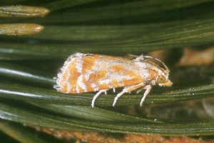

Figure : Entrance hole

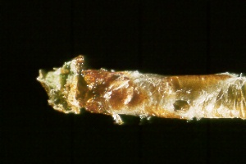

Figure : Damaged shoots

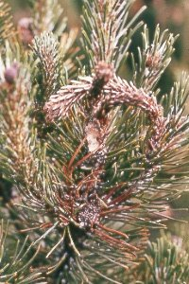

Figure : Damaged shoots

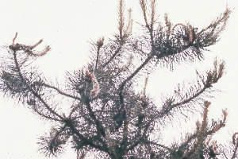

Figure : Distribution

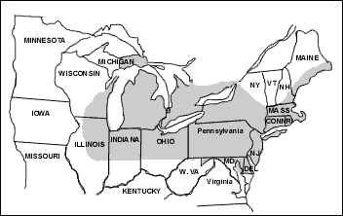

## (15-064) Western Pine Tip Moth

|  |  |
| --- | --- |
| Species: | Rhyacionia bushnelli |
| Host: | Ponderosa pine, red pine, Jack pine, Scotch pine |
| Range: | North Dakota, South Dakota, Nebraska, Montana, California |
| Injury: | Seriously stunted and deformed pine plantations in Montana, the Dakotas, and Nebraska. Also occurs in New Mexico and Arizona. Larvae feed on the needles, buds, and shoots. |
| Description: | Adults moths have a wingspread of 10 to 15 mm. The head, body, and appendages are covered with gray scales, except the forewings, which are mottled yellowish gray and reddish brown. The larvae are yellowish with black heads and when fully grown are 9 to 12 mm long. |

## (15-065) Nantucket Pine Tip Moth

|  |  |
| --- | --- |
| Species: | Rhyacionia frustrana |
| Host: | Monterey pine, slash pine, loblolly pine, shortleaf pine, pitch pine, Virginia pine, Scotch pine |
| Range: | California; eastern, central, and southern states |
| Injury: | Pine species that have multinodal growth in a single season are especially favorable hosts because when shoots are killed by tip moth larvae the tree responds by producing new succulent shoots from the base of the dead shoot. Early feeding is indicated by a small, delicate web constructed by early instar larvae. This web is found in the axil formed by the developing needle and the stem. Later, a more prominent indication of infestation is webbing at the shoot tips, accumulated resin, and fecal material within this webbing. Soon, tips of infested shoots die and turn brown, becoming quite noticeable from a distance. First indications of attack of conelets are the presence of boring frass on the conelet surface and the appearance of dead conelets.  The moth injures the growing shoots of young pines. The larva bores into, feeds on inner tissues of the buds, and shoots. Such feeding severs the conductive tissue and causes death of the shoot. Shoot injury occurs primarily in the first 5 years and decreases as the tree reaches about 10 feet in height and the crown closes. In severe and prolonged infestations, trees less than 3 feet tall may be killed by larvae, but usually the loss or retardation of height growth and deformation of the main stem results. In some areas, every shoot may be killed, and little or no height added to the trees. If tree vigor is poor, deformities such as stem crooks and forks may also develop. In seed orchards and seed production areas, cone and seed production may be reduced by destruction of shoots containing embryonic flower buds and by direct feeding of larvae on pine conelets. Shortleaf pine is particularly susceptible to conelet injury. |

Figure : Adult

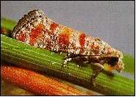

Figure : Distribution

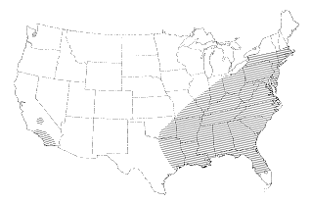

Figure : Pupae

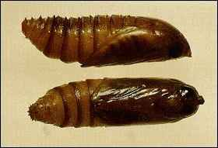

Figure : Dead conelet

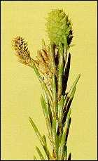

## (15-066) Lodgepole Pine Tip Moth

|  |  |
| --- | --- |
| Species: | Rhyacionia montana |
| Host: | Lodgepole pine |
| Range: | Montana |
| Injury: | Attacks young lodgepole pine. It is most damaging to open grown seedlings and saplings less than 6 feet tall. Repeated heavy attacks retard growth and predispose trees to attacks by other insects. |
| Description: | Adults have a wingspread of 20 mm. The forewings are irregularly banded gray and white on the inner two-thirds and are brick red on the outer third. The hind wings are grayish brown. The larvae are orange and attain a length of 12 to 15 mm. |

## (15-067) Southwestern Pine Tip Moth

|  |  |
| --- | --- |
| Species: | Rhyacionia neomexicana |
| Host: | Ponderosa pine |
| Range: | Arizona, New Mexico, Colorado, North Dakota, South Dakota, Nebraska |
| Injury: | In spring and early summer, larvae mine into buds and under the bark of new shoots but rarely enter the pith. Both lateral and terminal shoots are attacked. Larvae initially mine needles then bore into the shoot. They cover shoots with matted frass, dead needles, and webbing. Infested shoots are shortened and turn yellow, then turn brown. Small trees fewer than six to eight feet are most susceptible. Repeated attacks cause slow growth, crooks, forks, multiple stems, and spike tops. |

Figure : Moth

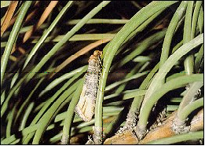

Figure : Distribution

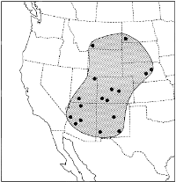

Figure : Tree deformity

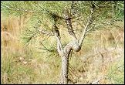

Figure : Eggs on a pine needle

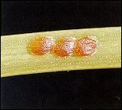

## (15-068) Poplar Borer

|  |  |
| --- | --- |
| Species: | Saperda calcarata |
| Host: | Poplar, quaking aspen, willow |
| Range: | Transcontinental |
| Injury: | The attack is characterized by swollen scars and holes in the trunk and larger branches. “Push-out” holes are made by the feeding larvae through which frass is expelled and sap exudes. The wet areas around these holes are blackened, appearing as if varnished. The borer requires three years to develop, mining deep in the heartwood during this period. Heavily infested trees break at points weakened by this tunneling. |
| Description: | The adult beetles are about one inch long, grayish black, and densely clothed with gray and yellow fine soft hairs; they have yellowish stripes on the thorax and orange-yellow markings on the wing covers. The larvae are creamy white, legless, and about ¼ inch long when full grown. |
| Defect: | Causes serious damage and will destroy wood quality. Their frequent association with decay implies affected trees are cull. |

Figure : Adults (photo by James Solomon)

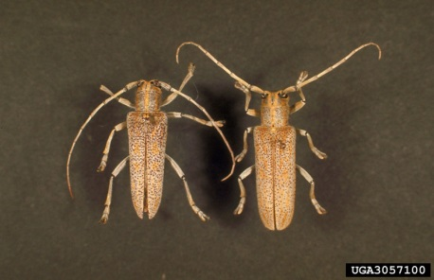

Figure : Lifecycle (photo by James Solomon)

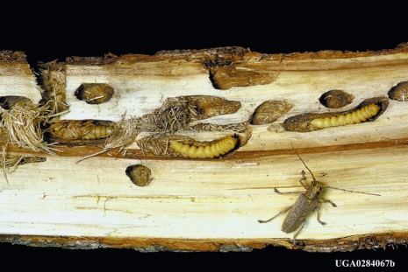

## (15-069) Roundheaded Appletree Borer

|  |  |
| --- | --- |
| Species: | Saperda candida |
| Host: | Hawthorn |
| Range: | Eastern states |
| Injury: | Adults feed on the foliage and sometimes on tender bark. The larvae feed beneath the bark for one year and then bore into the wood, making large excavations and riddling it. Presence of tendrils of frass on the bark or at the base of the tree is evidence of attack. Heavily infested trees may be killed in a single season. |
| Description: | The adult is a brilliant white except for three broad, brown longitudinal stripes extending the full length of the back, and is 15 to 20 mm long. Full-grown larvae are creamy white and about 30 mm long. |

## (15-070) Saperda Shoot Borr

|  |  |
| --- | --- |
| Species: | Saperda spp. |
| Host: | Hickory, hawthorn, butternut, poplar, oak, willow |
| Range: | Eastern states |
| Description: | This family contains about a dozen species, predominantly eastern. All attack broad-leaved trees. Most of them bore in the stems and branches of living trees, some causing galls. Others bore in dying and recently dead trees. The adults feed upon leaves and tender bark of the host. |

## (15-071) Clearwing Moths

|  |  |
| --- | --- |
| Species: | Sesiidae |
| Description: | The clearwing moths are a well-defined family of moderate size. Species in several genera bore in the roots, trunks, and branches of trees. The adults often resemble bees or wasps. They have narrow interlocking wings that usually are transparent and unscale in part, especially the hind pair. The larvae are naked and ivory white, except for brownish markings on the thorax. |

## (15-072) Dogwood Borer

|  |  |
| --- | --- |
| Species: | Synanthedon scitula |
| Host: | Oak, pine, dogwood, pecan |
| Range: | Eastern states |
| Injury | Abnormal growths such as woody galls, fungi, rusts, blight, and bruises and healing wounds are attractive as points of attack. Galls on black and pin oak sometimes occur in the thousands on a single tree, and every single one will be infested by this borer. Larvae feed on the cambial area. Infested areas are sometimes up to 2 feet or more in length and may contain up to 50 larvae each on the larger trees. Single larvae can kill a dogwood tree 4 inches in diameter in one year. |
| Description | The adult is small, blue-black moth with yellow-banded legs and yellow stripes on segments tow and four of the abdomen. The wings are transparent with blue-black margins, and the wingspread is from 14 to 20 mm. The larvae are whitish with brown heads and are up to 14 mm long. |

## (15-073) Roundheaded Fir Borer

|  |  |
| --- | --- |
| Species: | Tetropium abietis |
| Host: | White fir, grand fir, California red fir, Shasta red fir |
| Range: | Washington to California |
| Injury: | This insect will kill weakened trees, but it is not reported as becoming epidemic. |
| Description: | The adult is a typical roundheaded borer, and uniformly brown. |

## (15-074) Western Larch Borer

|  |  |
| --- | --- |
| Species: | Tetropium velutinum |
| Host: | Western larch, Douglas-fir, western hemlock |
| Secondary host: | Spruce, pine, fir |
| Range: | Washington to central California; Montana, Utah |
| Injury: | Drought weakened, insect defoliated, and fire-scorched trees are attached and sometimes killed. |

## (15-075) Western Cedar Borer

|  |  |
| --- | --- |
| Species: | Trachykele blondeli |
| Host: | Western red cedar |
| Secondary host: | Juniper, cedar, hawthorn, incense cedar |
| Range: | Washington to California and New Mexico |
| Injury: | Larval mines cause degrade and cull. The adults feed on the foliage. Larvae bore from the branches into the bole where they mine principally in the heartwood. |
| Description: | The adult is 11 to 17 mm long, bright emerald green with a golden sheen, and has several darker spots on the wing covers. |

## (15-076) Douglas-Fir Pitch Moth

|  |  |
| --- | --- |
| Species: | Vespamima novaroensis |
| Host: | Douglas-fir, Sitka spruce, Englemann spruce, ponderosa pine, lodgepole pine |
| Range: | Washington, Oregon, California, Idaho, Montana |
| Injury: | Larvae bore the cambium region causing masses of pitch to form and often seriously damaging young trees. The pitch masses contribute to the fire hazard. Attacks are commonly made around injuries and at junctions of limbs and bole. Repeated attacks are common and result in the greatest damage. |
| Description: | Adults are black with an orange-banded abdomen. Mature larvae are 25 to 30 mm long. |

## (15-077) Sequoia Pitch Moth

|  |  |
| --- | --- |
| Species: | Vespamima sequoia |
| Host: | Lodgepole pine, ponderosa pine, sugar pine, western white pine, Douglas-fir |
| Range: | Washington, Oregon, California, Idaho, Montana |
| Injury: | Larvae bore beneath bark in phloem and outer layers of wood causing masses of pitch to form around entrance holes. Repeated attacks can girdle and kill young, small-diameter pines or cause them to break. Attack sites are usually near root collar or just above. Pitch masses containing larvae are soft, whitish, and have some reddish boring dust mixed in. These masses may be found in wounds and at junctions of limbs and bole. |
| Description: | Adults are black with a yellow-banded abdomen. Mature larvae are 25 to 30 mm long. |
| Defect: | None |

Figure : Sequoia pitch moth damage

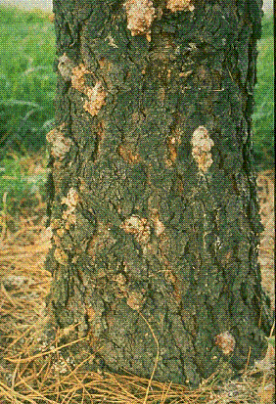

## (15-078) Black Twig Borer

|  |  |
| --- | --- |
| Species: | Xylosandrus compactus |
| Hosts: | Avocado, citrus, turpentine tree, eucalyptus, mahogany |
| Range: | Hawaii and the southeastern states |
| Injury: | Females tunnel into woody twigs, leaving pin sized entry holes. Once inside they excavate galleries and lay eggs. The excavation and introduced pathogens, such as ambrosia fungus, cause the damage. Infestation by 2-3 females may kill a branch or twig. A severe infestation can kill trees. |
| Description: | Adults are initially light brown, turn shiny black in 3-4 days; females are 1.6-1.8 mm long, males are half as long and incapable of flight. Eggs are laid in the galleries, and larvae are white, legless, grubs. |

## (15-079) Pacific Dampwood Termite

|  |  |
| --- | --- |
| Species: | Zootermopsis angusticollis |
| Hosts: | Coastal western forests |
| Range: | Pacific Islands including Hawaii |
| Injury: | Colonizes most dead and down trees and untreated wood products in contact with the ground. Their presence is most significant as an indicator of rot. |
| Description: | The nymphs are dirty white, 3 to 15 mm long and resemble the worker caste of more highly evolved termites. The fully developed soldiers are light brown, 10 to 20 mm long and have a large head armed with a pair of long, black, toothed mandibles. Winged reproductives are light cinnamon brown and have dark brown, heavily veined, leathery wings about 25 mm long, which are readily shed. |

## (15-080) Subtropical Pine Tip Moth

|  |  |
| --- | --- |
| Species: | Rhyacionia subtropica |
| Host: | Slash pine |
| Secondary host: | Longleaf pine, loblolly pine |
| Range: | Throughout the range of slash pine in the south |
| Injury: | Heavy infestations are reported on plantations on poor sites. Serious losses of grafted slash pine scions in tree improvement programs have been incurred. |

## (15-081) Asian Ambrosia Beetle

|  |  |
| --- | --- |
| Species: | Xylosandrus crassiusclus |
| Host: | Oak, elm, sweet gum, persimmon, magnolia, nursery stock |
| Range: | Pacific Islands, Hawaii, North Carolina, South Carolina, Louisiana, Florida, and east Texas |
| Injury: | Females bore into twigs, branches, or small trunks, excavate a system of tunnels in the wood or pith, introduce the ambrosial fungus, and produce a brood. Attacks on living trees are usually near ground level on saplings, or at bark wounds on larger trees. |
| Description: | Minute ambrosia beetle, head is completely hidden by the pronotum, and the body is smooth and shiny. Stout bodies, dark reddish brown, males are flightless, 1.3-2 mm long. Larvae are white, legless; “C” shaped, and has a well-developed head capsule. |

## (15-082) Asian Longhorned Beetle

|  |  |
| --- | --- |
| Species: | Anoplophora glabripennis |
| Host: | Maple, birch, poplar, willow, elm, ash, black locust |
| Range: | Pacific Islands including Hawaii |
| Injury: | Chew in the bark of trees to lay eggs, the larvae tunnel under the bark and feed on living tissue. They create deep, perfectly round exit holes, larger than a pencil diameter, which ooze sap. Yellowing and leaf drooping with eventual death. |
| Description: | 1-1½ inches long, black and shiny with white spots, long antennae that are banded with black and white. |

## (15-083) Cottonwood Twig Borer

|  |  |
| --- | --- |
| Species: | Gypsonoma haimbachiana |
| Host: | Cottonwood, poplar |
| Range: | New York to Michigan and south through the midwestern states of Missouri, Oklahoma, Arkansas to Mississippi, Louisiana, and Texas |
| Injury: | Stunting, forks, crooks, and other malformations. Larvae bore into the terminals and branch ends. They frequently kill the bud and up to 10 inches of the terminal. Often the old dead terminal remains intact on the tree for several months after the larvae have emerged. A stunted, deformed, limby tree is a good indication of this insect. |
| Description: | The adult is ash gray and has a wingspread of ½ to 7/10 inch. The basal portion of the forewing is darker than the apical. Full-grown larvae are pale, with a brown-yellow head. They are from 2/5 to ½ inch long. |

## (15-084) Southern Pine Sawyer

|  |  |
| --- | --- |
| Species: | Monochamus titilator |
| Host: | Shortleaf pine, slash pine |
| Range: | Eastern and southern states |
| Injury: | Mostly attacks logs or snags. The first signs of attack are funnel shaped pits or egg niches in the bark. Removal of the bark from infested wood will reveal coarse, excelsior like wood shavings, and sculptured wood. Elliptical shaped holes tightly packed with frass indicate the larvae have bored into the sapwood to construct the pupal cell. Round, pencil-shaped holes in the wood are exit holes. |
| Description: | Adult beetles are mottled gray and brown from 1 to 1¼ inches in length and have antennae, which are 2 to 3 inches long. Full-grown larvae are legless and whitish yellow in color and up to 2 2/5 inches long. |

## (15-085) Banded Ash Borer

|  |  |
| --- | --- |
| Species: | Neoclytus caprea |
| Host: | Ash, California live oak, hickory |
| Range: | Eastern states west into Utah, Nevada, Arizona |
| Injury: | Dying trees are attacked, but the greatest damage is to logs left in the woods. The early stage borers feed for several weeks under the bark, tunneling the surface of the wood. In the later stages, they make galleries in the sapwood, especially the outer layers, completely honeycombing the wood and packing the galleries with granular frass. |
| Description: | Adults are dark brown beetles, about ½ inch long, with yellowish white, irregularly shaped cross bands on the thorax and wing covers. The larvae are dull white, rather hairy, and have minute thoracic legs. When full-grown they are ½ to ¾ inch long. |

## (15-086) Sitka Spruce Weevil

|  |  |
| --- | --- |
| Species: | Pissodes sitchensis |
| Host: | Sitka spruce |
| Range: | Oregon, Washington |
| Injury: | The most injurious insect attacking Sitka spruce reproduction. It attacks and kills or seriously injures the terminal shoots of trees from about 8-30 years old and up to 50 feet tall. Crooked or bushy trees result. Weevils are most severe on widely spaced trees growing in extensive even-aged stands. In April or May the adults make feeding punctures on terminal growth of the preceding year. And lay eggs. The developing larvae girdle and kill the terminals when the new growth has elongated. In late summer the new growth wilts and the needles on 2 years’ growth turn reddish and fall. |