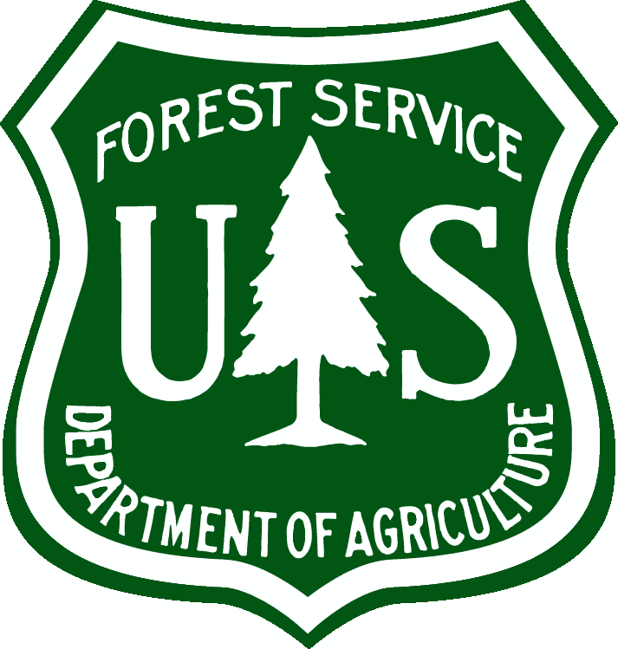United States Department of Agriculture

US Forest Service  
Natural Resource Manager (NRM)

# FSVeg Common Stand Exam User Guide Insect Predators (Category 18)

Version: 2.12  
February 2014

Table of Contents

(18-001) Lacewing 2

(18-002) Blackbellied Clerid 2

(18-003) Redbellied Clerid 2

(18-004) Formica Rufus 3

## (18-001) Lacewing

|  |  |
| --- | --- |
| Description: | Adults are usually bright green and about 15 to 20 mm long to the wingtips. They have gauze like wings and golden eyes. It is a major predator of the balsam woolly aphid. Aphids and other small soft-bodied insects are the prey. |

## (18-002) Blackbellied Clerid

|  |  |
| --- | --- |
| Species: | Enoclerus lecontei |
| Description: | It preys upon Dendroctonus, Ips, Scolytus, and others. In California, it preys upon the western pine beetle. The adults prey upon bark beetle adults, and the larvae feed upon bark beetle larvae and pupae. Adults are 6 to 8 mm long, black with gray markings on the elytra, the most prominent being a broad band at the rear. The larvae are pink, turning purplish near maturity at which time they are 9 to 14 mm long. |

## (18-003) Redbellied Clerid

|  |  |
| --- | --- |
| Species: | Enoclerus sphegeus |
| Description: | It preys upon Dendroctonus, Ips, Scolytus, and others. In California, it preys upon the western pine beetle. The adults prey upon bark beetle adults, and the larvae feed upon bark beetle larvae and pupae. The adult is hairy, blackish with a metallic luster except for the red abdomen, 8.5 to 12 mm long, and has a distinctive wide gray band across the middle of the elytra. The larvae are pink, turning purplish near maturity. |

Figure : A checkered beetle eating a mountain pine beetle adult

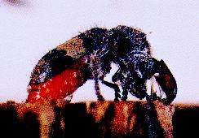

## (18-004) Formica Rufus

|  |  |
| --- | --- |
| Species: | Formica rugus |
| Description: | These ants build large nesting mounds of pine needles, twigs, and other debris. They bite viciously, but do not damage trees. They feed principally on honeydew and other insects. |