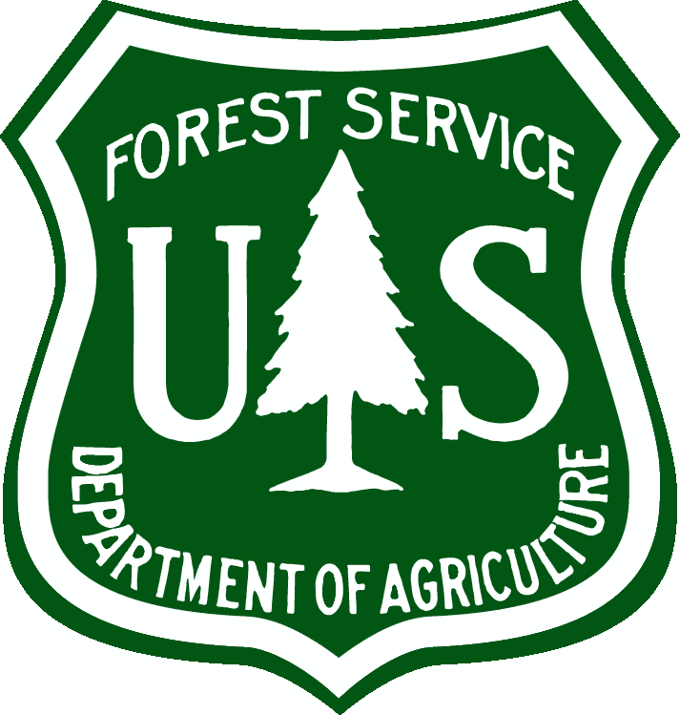United States Department of Agriculture

US Forest Service  
Natural Resource Manager (NRM)

# FSVeg Common Stand Exam User Guide Biotic Damage (Category 20)

Version: 2.12  
February 2014

Table of Contents

(20-001) Damping Off 2

(20-002) Gray Mold 2

(20-003) Cassytha 3

(20-004) Hemlock Fluting 3

## (20-001) Damping Off

|  |  |
| --- | --- |
| Host: | All species of seed and seedlings |
| Range: | Transcontinental |
| Injury: | The fungi that cause damping off produce hardy spores or other structures that rest in the soil until conditions are suitable for germination. Damping off is common in nurseries, where spore concentrations build up. Excessively wet and alkaline soils (pH above 5.5) provide ideal conditions for germination, growth, and movement of fungi through the soil to host seedlings. A seedling may be infected and killed before it can break the surface of the ground (pre-emergence damping off). Usually the seedling emerges and the pathogen then rots the stem at ground level. |

## (20-002) Gray Mold

|  |  |
| --- | --- |
| Species: | Botrytis cinerea |
| Host: | Conifer seedlings found in container tree nurseries, with redwood and giant sequoia most susceptible |
| Secondary host: | Western larch, lodgepole pine, Engelmann spruce, ponderosa pine, western hemlock, Douglas-fir, Scotch pine, blue spruce, mountain hemlock, noble fire, Alaska-cedar |
| Injury: | The fungus commonly exists as a saprophyte on dead or dying plant parts, and readily infects healthy tissues when seedlings are grown in containers in greenhouses or in overstocked nursery-beds where humidity is high and temperatures are cool for prolonged periods. A sunken canker develops after succulent seedling tissues become infected and the portion of the seedling above the canker is killed. |
| Description: | This disease can be identified by the gray, cottony mycelia and spore masses on the surface of affected shoot tissue, especially on senescent needles of the lower shoot. Examination of the fungus with a hand lens will reveal stalked, spore producing structures that produce a fuzzy appearance. As the disease progresses, infected shoot tissue becomes water soaked and brown lesions often develop. The fungus may spread to the main stem, where cankers eventually girdle and kill the shoot. Because the fungus is an aggressive saprophyte, symptoms usually appear first on the shaded, senescent foliage at the base of the shoot. The disease is most common in the fall when the seedling canopy becomes closed, natural light levels are lower and moisture often condenses on seedling foliage. Under favorable conditions, it can spread rapidly from one seedling to another and disease “pockets” can develop within the seedling crowns. |

## (20-003) Cassytha

|  |  |
| --- | --- |
| Species: | Cassytha filiformis |
| Range: | Pacific Islands including Hawaii |
| Description: | Stem parasite that survives by attaching itself to other plants. It has twine-like, orange stems and small round fruits. The stems are sometimes green. The flowers are small with anthers that open by flaps. The anthers are greenish and the flaps are white in this flower. |

## (20-004) Hemlock Fluting

|  |  |
| --- | --- |
| Host: | Western hemlock |
| Range: | Southeast Alaska, close proximity to beaches |
| Injury: | Trees are not injured. Fluting may contribute to survival by making them more windfirm. The degree of fluting varies with tree age. Fluting can begin when trees are about 10 years old and intensify while trees are growing rapidly. Flutes generally initiate below branches that decline in growth from shading. Flutes from vertically aligned branches coalesce and produce long groves that spiral downward. |

|  |  |
| --- | --- |
| Description: | Main stems have deeply incised vertical grooves and ridges. Grooves appear to originate at dead branches and extend vertically down the stem. The occurrence of fluting all the way down the bole to the live crown of trees distinguishes bole fluting from a flared root collar. |

Figure : Hemlock fluting

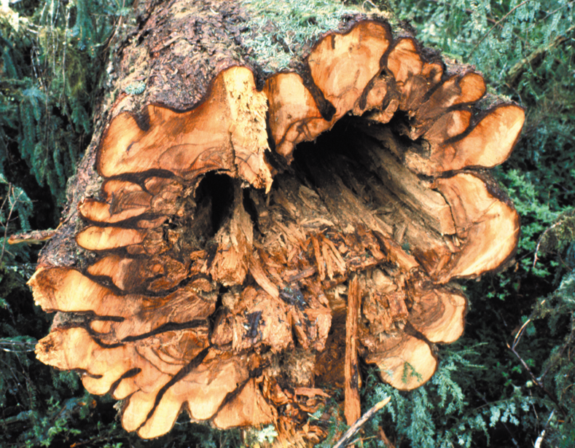

Figure : Hemlock fluting

