United States Department of Agriculture

US Forest Service  
Natural Resource Manager (NRM)

# FSVeg Common Stand Exam User Guide Chapter 4: Collecting and Recording Data

ver. 2.12.6  
March 2015

Table of Contents

Data Collection Levels 4-4

Quick Plot 4-4

Extensive 4-4

Intensive 4-4

Required Fields 4-5

Setting Data 4-7

Entering Setting Data PC Client Forms 4-7

Sample Design 4-28

The Sample Design Process 4-28

Step One 4-28

Step Two 4-28

Step Three 4-29

Step Four 4-29

Step Five 4-30

Step Six 4-30

Step Seven 4-31

Surface Cover Data Example 4-31

Vegetation Data Example 4-32

Brown’s Protocol Example 4-32

Entering Sample Design Data Using PC Client Forms 4-33

Plot Data 4-60

Entering Plot Data Using PC Client Forms 4-60

Witness Tree/Navigation Form 4-68

Tree Data 4-74

Quick Plot 4-74

Extensive 4-74

Intensive 4-74

Vegetation Composition 4-120

Fixed-Area Plots 4-121

Point-Intercept 4-122

Line-Intercept 4-122

Entering Vegetation Composition Data Using PC Client Forms 4-123

Form 1: Total Cover and Cover by Lifeform 4-123

Form 2: Cover by Species and Layer 4-125

Form 3: Cover by Species 4-126

Form 4: Ground Surface Cover 4-127

Form Fields 4-128

Down Woody Material 4-142

Method 1A: Photo Series 4-142

Step 1: Enter the Sample Design Information 4-143

Step 2: Enter the Down Woody Data 4-143

Method 1B: Piece Count on a Fixed Area Plot 4-144

Step 1: Enter the Sample Design Information 4-146

Step 2: Enter the Down Woody Data 4-146

Method 1C: Piece Count on a Transect 4-149

Step 1: Enter the Sample Design Information 4-149

Step 2: Enter the Down Woody Data 4-150

Method 2: Planar Intercept (Brown’s Protocol) 4-153

Sampling Procedures 4-153

The Sampling Planes 4-153

Step 1: Enter the Sample Design Information 4-157

Step 2: Enter the Down Woody Data 4-157

Fire Data 4-162

Fire Weather/Moisture/Behavior Form 4-162

Fire Information Form 4-162

Observation Location Information 4-162

Fire Behavior Form 4-163

Fire Weather Conditions 4-167

Fuel Information 4-170

Relative Humidity Dew Point Tables 4-175

Fine Dead Fuel Moisture Tables 4-199

Probability of Ignition Table 4-202

[Measuring Fuel Moisture Content: Standard Methods   
and Procedures 4-202](#_Toc370395027)

## Data Collection Levels

There are three stand examination data collection levels: quick plot, extensive, intensive.

### Quick Plot

A quick plot exam may group trees by species, diameter, heights, and/or damage classes on both large and small plots. These exams collect stand structural data using measurement tolerances that are relaxed to allow for ocular estimation of many parameters. Diameters of live trees may be estimated in 2-inch DBH classes. Standing dead tree heights are recorded in 10-foot classes. Limited tree defect information is collected; growth data are not collected. Limiting the amount of information gathered and reducing measurement accuracy standards may minimize cost. Quick plot uses include:

* Cover and stand structure estimates by vegetative layer
* Exams in single species or single-storied stands
* Timber stand improvement inspections
* Post treatment examinations
* General surveys such as dwarf mistletoe surveys
* Supplemental cruise plots to reduce costs for timber sale preparation

### Extensive

An extensive exam collects accurate tree measurements to tolerance standards tighter than a quick plot, but not as tight as an intensive exam. Trees on the large plot are recorded individually, but trees on the small plot may be recorded in groups. Diameters are measured to the nearest 1-inch class. Some tree defect information is collected. The main uses of an extensive exam are:

* Minimum data required to execute growth and yield models
* Exams in multi-storied stands
* Silvicultural prescriptions

### Intensive

An intensive exam collects accurate tree measurements to tight tolerance standards. It provides a comprehensive inventory for unique stands. Trees on the large plot are recorded individually, but trees on the small plot may be recorded in groups. Diameters are measured to the nearest 1/10th of an inch. Heights are measured to the nearest foot. Detailed tree defects are collected. The main uses of an intensive exam are:

* Stand volume, defect, and mortality
* Exams in complex stands in terms of species and size
* Tree growth information for use in tree models, as well as growth and yield studies
* Silvicultural prescriptions

### Required Fields

The following fields are “Nationally required” regardless of the examination level. Each Region may specify additional “regionally required” fields. Required fields are designated with an asterisk (*) on the PC client forms.

Required Setting fields:

* Project Name
* Region
* Proclaimed Forest Service
* District
* Location
* Stand Number
* Owner
* Date
* Exam Level
* Precision Protocol

Required Design fields:

* Selection Method
* Expansion Factor
* Selection Criteria Number

Required Plot field:

* Plot Number

The fields noted in Table 1 are Required on the Tree Form, depending on the examination level.

Table 1: Tree form fields

| **Field** | **Quick Plot** | **Extensive Plot** | **Intensive Plot** |
| --- | --- | --- | --- |
| Tag Number | No | Yes | Yes |
| Tree Status | Yes | Yes | Yes |
| Site/GST Tree | No | No | Yes |
| Tree Count | Yes | Yes | Yes |
| Tree Species | Yes | Yes | Yes |
| DBH/DRC | DBH for trees > 4.5 feet tall | DBH for trees > 4.5 feet tall | DBH for trees > 4.5 feet tall |
| Height | Trees < 4.5 feet tall | Trees < 4.5 feet tall | Trees < 4.5 feet tall |
| Height to Crown | No | No | No |
| Radial Growth | No | No | GST only |
| Radial Growth 2 | No | No | No |
| Height Growth | No | No | GST only |
| Age | No | No | GST/Site only |
| Crown Ratio | No | No | Live trees only |
| Crown Class | No | No | No |
| Crown Width | No | No | No |
| Damage Category | No | Yes | Yes |
| Damage Agent | No | No | Yes |
| Damage Part | No | No | No |
| Damage Severity | No | Yes | Yes |
| Wildlife Use | No | No | No |
| Log/Snag Decay | No | If Dead/Down is taken | If Dead/Down is taken |
| Cone Serotiny | No | No | No |
| Number of Stems | DRC only | DRC only | DRC only |
| Remarks | No | No | No |

## Setting Data

A setting is usually a stand, site, watershed, or vegetation polygon where the stand examination is being conducted. The combination of Region, Proclaimed Forest, District, Location, Stand, and Date fields uniquely identifies each setting. The exam date is used to differentiate data taken in the same setting, but at different points in time. The listed accuracy standards are for intensive exams. The accuracy standard is “No Errors” unless otherwise noted.

### Entering Setting Data PC Client Forms

Electronic data forms are available for PC Clients. These electronic forms may be edited to eliminate unissued optional fields. You must complete one setting form for each setting. Required fields are indicated with an asterisk (*) after the field name.

The Tab key moves the cursor forward one field, and Shift-Tab moves the cursor backward one field.

The bottom of the setting screen has two buttons:

* Design button: access the Design Screen that contains sample design information. Access to this screen is not permitted until all of the required fields have been completed and the data saved.
* Plot button: access the Plot Screen that contains plot level information. Access to this screen is not permitted until all of the required fields have been completed and the data saved.

Figure : CSE interface

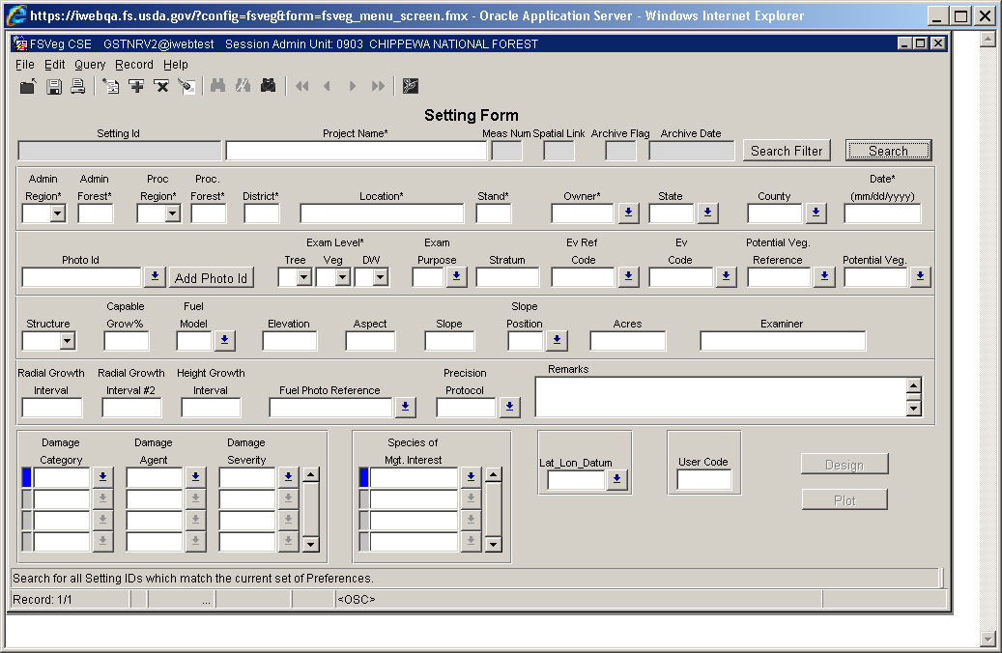

Figure : Record

Description: tmp

The top line in the setting form contains the setting ID which is automatically calculated.

The Search Filter button brings up a screen to limit the search to a subset of the settings. Any setting that does not match the filter parameters will not be shown on the search list.

Figure : Search filter to limit a search to a subset of settings

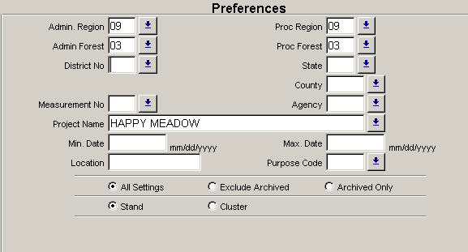

The Search button brings up a list of setting IDs matching the current preferences set under the Search Filter button. When a setting ID is selected from this list, the setting ID, project name, and all additional data for the setting is automatically loaded into the data entry forms. If the list is long, a setting ID can be located using the Find button. Enter in the complete setting ID or use the “%” character as a wild card.

Figure : Search function to locate an existing setting

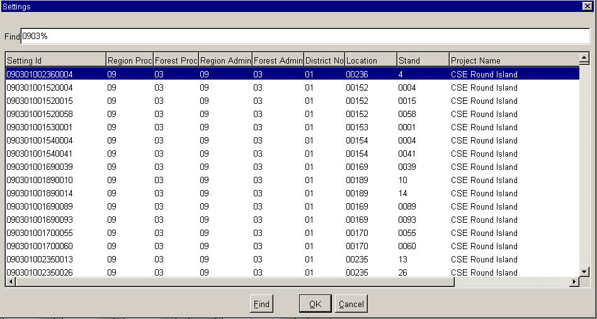

The bottom portion of the Setting form contains fields for damage values and species of management interest. Multiple damage categories, damage agents, damage severities, and species of management interest can be entered for each setting.

#### Project Name (maximum of 25 characters and/or numbers) Required

Multiple settings may use the same project name. A project name is a useful way to group settings. Example project names are “Intermountain FIA,” “Root Rot survey,” and “Owl survey.”

#### Measurement Number (maximum of 4 numbers)

If you enter this form through the Inventory and Monitoring window, you will be able to edit the Measurement Number. If you enter this form through the CSE path, this field is grayed out and defaulted to “1.” This field accepts positive integers up to 9999.

Figure : Inventory and Monitoring

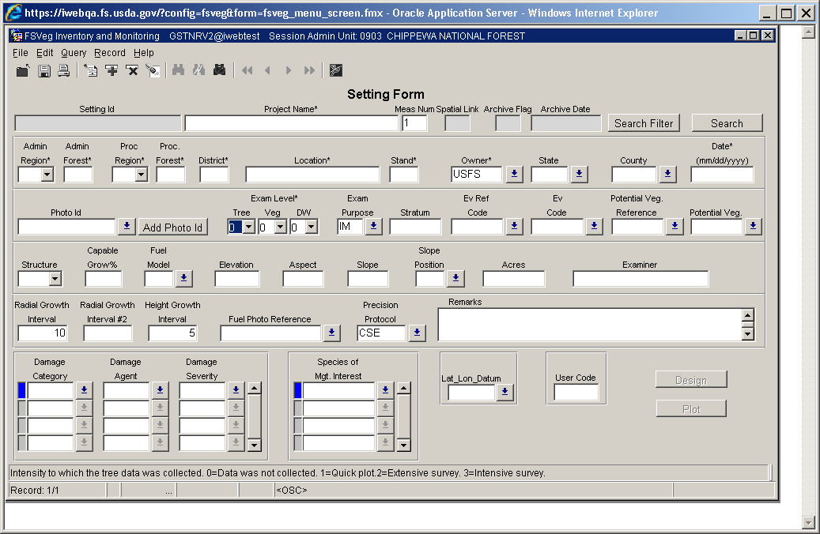

#### Administrative Region (maximum of 2 numbers) Required

This is the administering Region where the setting is located, regardless of which Region the setting is currently located in. The field is automatically zero filled as it is used in the setting ID.

Table 2: Administrative region codes and descriptions

| **Code** | **Region** | **Description** |
| --- | --- | --- |
| 1 | Region One | Northern Region |
| 2 | Region Two | Rocky Mountain Region |
| 3 | Region Three | Southwestern Region |
| 4 | Region Four | Intermountain Region |
| 5 | Region Five | Pacific Southwest Region |
| 6 | Region Six | Pacific Northwest Region |
| 8 | Region Eight | Southern Region |
| 9 | Region Nine | Eastern Region |
| 10 | Region Ten | Alaska Region |

#### Administrative Forest Service (maximum of 2 numbers) Required

Record the administrating National Forest where the setting is located. The database will zero fill this code to match the list of forests. See [Appendix A](http://fsweb.nris.fs.fed.us/products/FSVeg/documentation.shtml) of the User Guide for a complete list of Administrative Forest codes.

#### Proclaimed Region (maximum of 2 numbers) Required

This is the proclaimed Region where the setting is located, regardless of which Region is currently administering the setting. This field is automatically zero filled as it is used in the setting ID.

Table 3: Administrative region codes and descriptions

| **Code** | **Region** | **Description** |
| --- | --- | --- |
| 1 | Region One | Northern Region |
| 2 | Region Two | Rocky Mountain Region |
| 3 | Region Three | Southwestern Region |
| 4 | Region Four | Intermountain Region |
| 5 | Region Five | Pacific Southwest Region |
| 6 | Region Six | Pacific Northwest Region |
| 8 | Region Eight | Southern Region |
| 9 | Region Nine | Eastern Region |
| 10 | Region Ten | Alaska Region |
| 1 | Region One | Northern Region |

#### Proclaimed National Forest (maximum of 2 numbers) Required

This is the proclaimed National Forest where the setting is located, regardless of which Forest is currently administering the setting. The field is automatically zero filled as it is used in the setting ID. See [Appendix A of the User Guide](http://fsweb.nris.fs.fed.us/products/FSVeg/documentation.shtml) for a complete list of Proclaimed National Forest codes.

#### District (maximum of 2 numbers) Required

This is the Ranger District where the setting is located. The field is automatically zero filled as it is used in the setting ID. See [Appendix B of the User Guide](http://fsweb.nris.fs.fed.us/products/FSVeg/documentation.shtml) for a complete list of Ranger District codes.

#### Location (maximum of 16 characters and/or numbers) Required

Only integers, upper or lower case alpha characters, and underscores are allowed in this field. Each Region defines how the location field is to be populated.

Although this field can hold a maximum of 16 characters, each Region has determined the length needed for its purposes, and this is typically less than the full 16 characters. For those Regions that use shorter location numbers, leading zeros are required only up to the length that Region uses; padding with leading zeros beyond that length (up to 16 characters), may not be required.

Table 4: Regional location specifics

| **Region** | **Location specifics** |
| --- | --- |
| Region 1 | 2-digit compartment code plus a 2-digit sub-compartment code |
| Region 2 | R2VEG watershed alias or other partition identification (exactly 6 characters) |
| Region 3 | 6-character location value, padded with leading zeros if necessary |
| Region 4 | 6-character location value, padded with leading zeros if necessary |
| Region 8 | 4-digit compartment number, leading zeros are required |
| Region 9 | A compartment number (no characters) that is a maximum of five digits; leading zeros are REQUIRED to a maximum of five digits |
| Region 10 | 5-digit TM-compartment number |

#### Stand (maximum of 4 numbers) Required

Only integers are allowed. Record the stand number consistent with the current vegetative polygon map layer. The field is automatically zero filled as it is used in the setting ID. For Region 8 and Region 9, the stand number must be a number (no characters) that is a maximum of three digits.

#### Owner (maximum of 4 numbers) Required

This is the Agency which owns or manages the land on which the data is collected. The default is USFS.

Table 5: Owner codes and descriptions

| **Code** | **Description** |
| --- | --- |
| USFS | National Forest lands administered by USFDS (default) |
| BLM | Bureau of Land Management |
| CORP | Corporate |
| OFED | Other Federal owner |
| OPUB | Other public lands, non-federal |
| OTFS | Other Forest Service owner |
| DOD | Department of Defense/Energy |
| LOCL | Local (County, Municipal, etc.) |
| NAGR | National grasslands |
| NATV | Native American (Indian) |
| NGOS | Non-governmental conservation/natural resource organization |
| NPS | National Park Service |
| PVLA | Private landowner |
| STAT | State lands |
| UNIC | Unincorporated local partnerships/associations/clubs |
| UNK | Unknown ownership |
| UPRV | Undifferentiated private ownership |
| USFW | United States Fish & Wildlife Service |

#### State (exactly 2 numbers)

This is the unique code identifying the State where the setting is located. A setting cannot cross state boundaries, and those that do must be subdivided. See [Appendix C of the User Guide](http://fsweb.nris.fs.fed.us/products/FSVeg/documentation.shtml) for a complete list of State codes.

#### County (maximum of 3 numbers)

This is the unique code identifying the County where the setting is located. The database will zero fill this code to match the official list of County codes. See [Appendix D of the User Guide](http://fsweb.nris.fs.fed.us/products/FSVeg/documentation.shtml) for a complete list of County codes.

#### Date (exactly 8 numbers)

The calendar month, day, and year the stand examination was completed. The format is MMDDYYYY. The “/” separator will be automatically inserted if it is not supplied.

For example:

* 01231984 = January 23 1984
* 12/07/1997 = December 7, 1997

#### Photo ID (exactly 14 characters and/or numbers)

This is the Photo ID of the aerial photo where the majority of the setting is located. For example: 61213012890057.

* The first six numbers (612130) represent Photo Symbol/Project ID
* The second four numbers (1289) represent the roll number
* The last four numbers (0057) represent the exposure number

Figure : Photo ID examples

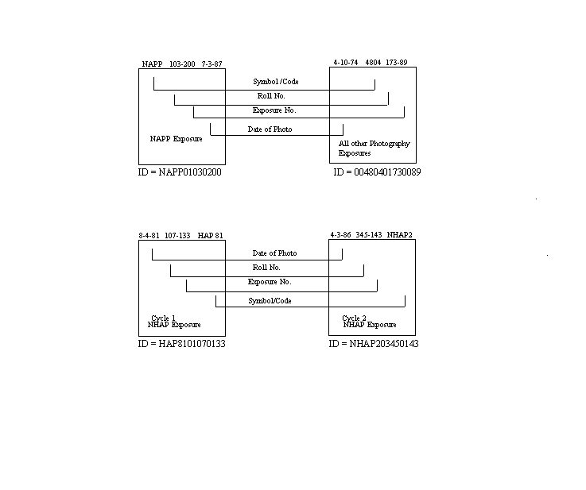

When the photo ID is entered, it is checked against the list in the database. If it is not in the database, an error message is printed. To enter a new photo ID, press the Photo ID button adjacent to the Photo ID field, and use the form shown in Figure 7. Required fields are indicated with an asterisk (*) after the field name.

Figure : Aerial Photo list in form

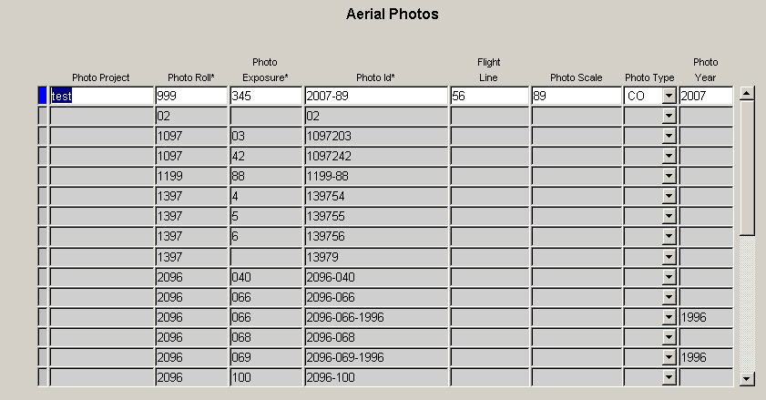

#### Photo Project (maximum of 255 characters and/or numbers)

This is the name of an individual photograph, or set of photographs.

#### Photo Roll (maximum of 4 characters and/or numbers) Required

The ID of the roll of film, which contains the photograph.

#### Photo Exposure (maximum of 4 characters and/or numbers) Required

The number on the film that identifies a specific photograph.

#### Photo ID (exactly 14 characters and/or numbers) Required

This field consists of the first six characters of the photo project, followed by the 4-character photo roll number and the 4-character photo exposure number.

#### Flight Line (maximum of 5 characters and/or numbers)

This is the flight line number of the photograph.

#### Photo Scale (maximum of 20 characters and/or numbers)

The proportion used to determine the relationship of a photograph to the landscape. A common photo scale is 1:2,500.

#### Photo Type (exactly 2 characters)

The type of photograph. Valid values are:

* BW = Black and white photograph
* CO = Color photograph
* CI – Color infrared photograph

#### Photo Year (exactly 4 numbers)

The 4-digit year the photograph was taken.

#### Examination Level - Required

The examination level which includes the scope and range of the information collected. Scope is the breath of information collected (type of form), and range is the precision of information collected (examination level). The intensity implies a measurement standard, standard design, and sample selection criteria. The actual criteria used to sample the stand must be documented on the Sample Design Form.

##### Tree

For the tree data, record one of the codes listed in Table 6.

Table 6: Owner codes and descriptions

| **Code** | **Description** |
| --- | --- |
| 0 | This form was not used |
| 1 | Quick Plot |
| 2 | Extensive Examination |
| 3 | Intensive Examination |

Table 7: Fields and exams

| **Field** | **Quick Plot** | **Extensive Plot** | **Intensive Plot** |
| --- | --- | --- | --- |
| Tag ID | Yes | Yes | Yes |
| Tree Status | Yes | Yes | Yes |
| Tree Class | No | No | No |
| Site/GST Tree | No | No | Yes |
| Tree Species | Yes | Yes | Yes |
| Tree Count | Yes | Yes | Yes |
| DBH/DRC | DBH for trees > 4.5 feet tall | DBH for trees > 4.5 feet tall | DBH for trees > 4.5 feet tall |
| Height | Trees < 4.5 feet tall | Trees < 4.5 feet tall | Trees < 4.5 feet tall |
| Height to Crown | No | No | No |
| Radial Growth | No | No | GST only |
| Radial Growth 2 | No | No | No |
| Height Growth | No | No | GST only |
| Age | No | No | GST/Site only |
| Crown Ratio | No | No | Live trees only |
| Crown Class | No | No | No |
| Crown Width | No | No | No |
| Damage Category | No | Yes | Yes |
| Damage Agent | No | No | Yes |
| Damage Part | No | No | No |
| Damage Severity | No | Yes | Yes |
| Wildlife Use | No | No | No |
| Log/Snag Decay | No | If Dead/Down is taken | If Dead/Down is taken |
| Cone Serotiny | No | No | No |
| Number of Stems | DRC only | DRC only | DRC only |
| Remarks | No | No | No |

##### Vegetation Composition

For the vegetation composition data, record one of the codes listed in Table 8.

Table 8: Vegetation composition codes and descriptions

| **Code** | **Interested in Obtaining** | **Species to Record** | **Subpop. Min.** | **Subpop. Max.** | **Form 1** | **Form 2** | **Form 3** | **Form 4** |
| --- | --- | --- | --- | --- | --- | --- | --- | --- |
| 0 | Forms not used | n/a | n/a | n/a | n/a | n/a | n/a | n/a |
| 1 | Quick estimate | Life form only | 1% | 100 | Required | Optional | Optional | Optional |
| 2 | TES, NOX, and/or the dominant 4 species | Only specific species | User-defined | 100 | Required | Required | Optional | Optional |
| 3 | All species | All species to a specified % | User-defined | 100 | Required | Required | Optional | Optional |
| 4 | All species, including TES and NOX to trace | All species to a specified %, but species on a list to trace | User-defined | 100 | Required | Required | Optional | Optional |

##### Down Woody

For the Down Woody data, record one of the codes presented in Table 9.

Table 9: Down Woody codes and descriptions

| **Code** | **Description** |
| --- | --- |
| 0 | This form was not used |
| 1 | Data was collected, but NOT according to Brown’s Protocol |
| 2 | Data was collected according to Brown’s Protocol |

#### Exam Purpose (exactly 2 characters)

This is the purpose of the exam. The default is “SE.” Examples are included in Table 10.

Table 10: Exam purpose codes and descriptions

| **Code** | **Description** |
| --- | --- |
| CI | Compartment Inventory |
| CP | Control Plot – clusters for Permanent Growth Plots |
| FI | Forest Inventory – standard, statistically |
| FF | Fire and Fuels |
| FL | Fuels Survey |
| ID | Insect & Disease Exams – verify types and severity of infestation as an aid in determining treatment needs |
| IM | Inventory and Monitoring – base level stand exam |
| KW | Kirtland Warbler – exams to identify habitat for the endangered Kirtland warbler |
| LI | Lidar – Lidar exams |
| LP | Line Plots – used in Permanent Growth Studies; for example, Bergenhier plots |
| MC | Marking Check – used to check marking guidelines |
| OG | Old Growth – to aid in identifying areas that may contain elements of old growth |
| PI | Plantation Survey |
| QS | Quick Plot Stand Exam |
| RA | Riparian Areas – used for riparian surveys |
| RE | Regeneration/Stocking – surveys to determine stocking rates of individual area and for certification of regeneration |
| RP | Resource Specialty – resource specified purposes |
| RR | Permanent Root Rot – study cluster plots |
| RS | Research Exams – specific research projects |
| SE | Stand Exam – determine stand composition; this code indicates a “complete” stand examination; this code cannot be used if species or damages are excluded from the sample, or are only included in the sample |
| SO | Spotted Owl |
| TH | Thinning Exam – certify thinning prescription accomplishment at the completion of thinning treatments |
| TI | Tree Improvement – follow Tree Improvement treatments |
| TP | Treatment Plot – treatment cluster plots for Permanent Growth Plots |

#### Stratum (maximum of 6 characters and/or numbers)

This is the current setting stratum. Refer to aerial photo typing or other stratification information done in conjunction with the examination, and Regional or Forest direction for a list of strata definitions and codes.

#### Existing Vegetation Reference (maximum of 8 characters and/or numbers)

This is the dominant existing vegetation reference. Only one existing vegetation reference code may be selected per examination. See Appendix E of the User Guide for a complete list of existing vegetation references.

#### Existing Vegetation (maximum of 8 characters and/or numbers)

This is the dominant existing vegetation code for the setting. Dominance is based on plurality of basal area. Existing vegetation reflects plan species currently present. See [Appendix E of the User Guide](http://fsweb.nris.fs.fed.us/products/FSVeg/documentation.shtml) for a complete list of existing vegetation codes.

#### Potential Vegetation Reference (maximum of 4 numbers)

This is the potential vegetation reference. Only one potential vegetation reference code may be selected per examination. See [Appendix F of the User Guide](http://fsweb.nris.fs.fed.us/products/FSVeg/documentation.shtml) for a complete list of potential vegetation references.

#### Potential Vegetation (maximum of 8 characters and/or numbers)

This is the potential vegetation composition code. Potential vegetation is the plant community that would become established if all successional sequences were completed without interference by man and under the present climatic and edaphic conditions, including those created by man. See [Appendix G of the User Guide](http://fsweb.nris.fs.fed.us/products/FSVeg/documentation.shtml) for a complete list of potential vegetation codes.

#### Structure (exactly 2 characters)

These are the codes that best describe the overall structure of the setting, as detailed in Table 11 below. Structure is the distribution of tree size classes within the stand.

Table 11: Structure codes and descriptions

| **Code** | **Description** |
| --- | --- |
| SS | Single Story: a single even canopy characterizes the setting. The greatest number of trees is in a height class represented by the average height of the setting; there are substantially fewer trees in height classes above and below this mean. |
| TS | Two-Storied: two relatively even canopy levels can be recognized in this setting. The frequency distribution of trees by height class tends to be bimodal. Understory or overtopped trees are common. Neither canopy level is necessarily continuous or closed, but both canopy levels tend to be uniformly distributed across the setting (e.g., overstory with regenerated understory). |
| MS | Multi-Storied: at least three height class sizes are commonly represented in the setting. Generally, the canopy is broken and uneven although multiple canopy levels may be distinguishable. The various size classes tend to be uniformly distributed throughout the setting. |
| MO | Mosaic: at least two different height size classes are represented and these are not uniformly distributed, but are grouped in small repeating aggregations, or occur as stringers less than two chains wide, throughout the setting. Each size class aggregation is too small to be recognized and mapped as an individual setting. |
| UA | Unknown/Un-assessable: a structure classification was attempted, but the stand did not fit into one of the pre-defined categories. Note in the remarks column the reason the stand could not be classified. |

#### Capable Growing Area (maximum of 3 numbers)

Estimate the percent of the setting capable of supporting trees. Deduct areas such as roads, creeks, swamps, rock outcrops, unimproved dirt lanes, small streams, sites with standing or running water, a high water table, a rock outcropping, severe soil compaction (i.e., an old landing), or mass soil movement (slips, slides, or slumps), etc. For example, if an area contains 5% rock outcropping and 10% road, record a capable growing area of 85%. This field is used in the Forest Vegetation Simulator (FVS) as the “stockablity” value. If this field is left null, FVS assumes 100% stockability.

Accuracy Standard: ± 10 percent.

##### Capable Growing Area Example 1

Large, scattered boulders cover 25% of the setting. However, tree roots can fully utilize the space between the boulders. The boulders thus have no effect on potential tree stocking. Capable growing area is thus 100%.

Figure : Capable growing area example 1

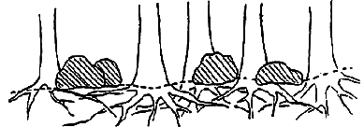

##### Capable Growing Area Example 2

A swampy meadow covers 10% of the setting. Capable growing area is thus 90%.

Figure : Capable growing area example 2

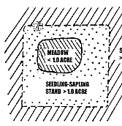

#### Fuel Model (maximum of 2 numbers)

This is the predominant setting fuel model determined by the plurality of sample plot fuel model codes. Refer to [Appendix N of the User Guide](http://fsweb.nris.fs.fed.us/products/FSVeg/documentation.shtml) for more information on the Fuel Models.

#### Elevation (maximum of 5 numbers)

This is the median setting elevation, above mean sea level, in feet.

Accuracy Standard: ± 2 contour intervals

#### Aspect (maximum of 3 numbers)

This is the predominant setting aspect in degrees 0° to 360°. Record true north (i.e., always set the declination on your compass). Aspect may be determined from contour maps Aspect is determined along the direction of slope for land surfaces with at least 5% slope in a generally uniform direction. Aspect is measured with a hand compass along the same direction used to determine slope.

* If aspect changes gradually across the setting, record an average aspect
* If aspect changes across the setting but is predominately of one direction, code predominate direction, rather than average
* If the setting falls on or straddles a canyon bottom or narrow ridge top, code the aspect of the ridgeline or canyon bottom.
* If the setting falls on a canyon bottom or on a narrow ridge top, but most of the area lies on one side hill, code the aspect of the side hill.
* Use a code of zero for flat.
* Use a code of 999 for indeterminate, no predominant aspect, or undulating

Table 12: Aspect codes and descriptions

| **Code** | **Description** |
| --- | --- |
| O | Flat |
| 360 | 360° |
| 72 | 72° |
| 90 | 90° |
| 999 | Indeterminate/no predominant aspect/ undulating |

Accuracy Standard: ± 45 degrees

#### Slope (maximum of 3 numbers)

This is the angle of slope across the setting. Slope is determined by sighting the clinometer along a line parallel to the average incline (or decline). This angle is measured along the shortest pathway down slope before the drainage direction changes. To measure Slope, Observer 1 should stand at the uphill edge and sight Observer 2, who stands at the downhill edge. Sight Observer 2 at the same height as the eye-level of Observer 1. Read the slope directly from the percent scale of the clinometer.

* If the slope change gradually across the setting, record an average slope.
* If slope changes across the setting but the slope is predominantly of one direction, code predominate slope percentage rather than the average.
* If the setting falls directly between two side hills, code the average slope of the side hill(s).
* If the setting falls on a canyon bottom or on a narrow ridge top, but most of the area lies on one side hill, code the slope of the side hill.

Accuracy Standard: ± 10 percent

#### Slope Position (exactly 2 characters)

Record the position of the setting on the landscape. The definitions are from: Soil Survey Staff, 1993. National Soil Survey Handbook (Title 430-VI) USDA Soil Conservation Service.

Table 13: Slope position codes

| **Code** | **Description** |
| --- | --- |
| SU | Summit/Ridgetop/Plateau – the topographically highest hillslope position of a hillslope profile and exhibiting a nearly level surface. |
| SH | Shoulder – the hillside position that forms the uppermost inclined surface near the top of a hillslope. It comprises the transition zone from backslope to summit. |
| BS | Backslope – the hillslope position that forms the steepest inclined surface and principle element of many hillslopes. In profile, backslopes are commonly steep, linear, and bounded by a convex shoulder above and descending to concave footslope. They may or may not include cliff segments. Backslopes are commonly erosive forms produced by mass movement and running water. |
| FS | Footslope – the hillside position that forms the uppermost inclined surface near the top of a hillslope. It comprises the transition zone from backslope to summit. |
| TS | Toeslope – the hillslope position that forms the gently inclined surface at the base of a hillslope. Toeslopes in profile are commonly gentle and linear, and are constructional surfaces forming the lower part of a hillslope continuum which grades to a valley bottom. |
| VB | Valley Bottom – wide valley bottom beyond influence of toeslope. |

Accuracy standard: ± 1 class

#### Acres (maximum of 4 numbers)

This is the total area, in acres, of the setting.

#### Examiner (maximum of 15 characters and/or numbers)

This is the individual(s) responsible for data collection. If the full name is longer than 15 characters, use only the last name.

#### Radial Growth Interval (maximum of 2 numbers)

This is the time period used for measuring radial growth. The default is “10” years. If the tree age is less than the radial growth interval, record the tree age and DBH and leave the radial growth field blank. Values less than 1 are not allowed.

#### Radial Growth Interval #2 (maximum of 2 numbers)

This is the second time period for measuring radial growth if two radial growth measurements are taken. A default value of “0” years is assumed. If the tree age is less than the radial growth interval, record the tree age and DBH, and leave the radial growth field blank. Values less than 1 are not allowed.

#### Height Growth Interval (maximum of 2 numbers)

This is the time period associated with the height growth measurements. Only one time period can be used for each examination. The default is “5” years. If the tree age is less than the height growth interval, record the tree age and height and leave the height growth field blank. Values less than 1 are not allowed.

#### Fuel Photo Reference (maximum of 3 numbers)

This is the fuel photo reference. The corresponding photo is recorded on the plot form in the “residual descriptive” code. See [Appendix H of the User Guide](http://fsweb.nris.fs.fed.us/products/FSVeg/documentation.shtml) for a complete list of Fuel Photo references and codes.

#### Precision Protocol (maximum of 5 letters)

This is the precision protocol used in data collection. The default precision protocol “CSE” follows the CSE guidelines specified in this document for intensive exams. “CSE_Q” is for Quick Plot exams, “CSE_E” is for extensive exams, “Pre” refers to a precision, and “UOM” refers to a unit of measure.

Table 14: Precision protocol variables

| **Variable** | **CSE_Q** | **CSE_E** | **CSE** |
| --- | --- | --- | --- |
| Description | CSE Quick Plot | CSE Extensive protocols | CSE Intensive protocols |
| Cover_Height_Pre | ± 10 percent of height | ± 10 percent of height | ± 10 percent of height |
| Cover_Height_UOM | Feet | Feet | Feet |
| Cover_Percent_Pre | ± 10 percent | ± 10 percent | ± 10 percent |
| Dwood_Depth_Pre | Nearest 1/10th inch, ± ½ inch | Nearest 1/10th inch, ± ½ inch | Nearest 1/10th inch, ± ½ inch |
| Dwood_Depth_UOM | Inches | Inches | Inches |
| Dwood_Depth_2_Pre | Nearest 1/10th inch, ± ½ inch | Nearest 1/10th inch, ± ½ inch | Nearest 1/10th inch, ± ½ inch |
| Dwood_Depth_2_UOM | Inches | Inches | Inches |
| Dwood_Diameter_Pre | ± 1 inch | ± 1 inch | ± 1 inch |
| Dwood_Diameter_UOM | Inches | Inches | Inches |
| Dwood_Fuel_Depth_ Pre | Nearest whole inch, ± 20% | Nearest whole inch, ± 20% | Nearest whole inch, ± 20% |
| Dwood_Fuel_Depth_ UOM | Inches | Inches | Inches |
| Dwood_Length_Pre | ± 20% | ± 20% | ± 20% |
| Dwood_Length_UOM | Feet | Feet | Feet |
| Dwood_Volume_Pre | Undefined | Undefined | Undefined |
| Dwood_Volume_UOM | Cubic feet | Cubic feet | Cubic feet |
| Dwood_Weight_Pre | Undefined | Undefined | Undefined |
| Dwood_Weigh_UOM | Tons per acre | Tons per acre | Tons per acre |
| Elevation_Pre | ± 2 contour intervals | ± 2 contour intervals | ± 2 contour intervals |
| Elevation_UOM | Feet | Feet | Feet |
| Setting_Size_Pre | Undefined | Undefined | Undefined |
| Setting_Size_UOM | Acres | Acres | Acres |
| Slope_Pre | ± 10% | ± 10% | ± 10% |
| Slope_UOM | Percent | Percent | Percent |
| Tree_Age_Pre | 10% if ≤ 299 years old, 15% if ≥ 300 years old | 10% if ≤ 299 years old, 15% if ≥ 300 years old | 10% if ≤ 299 years old, 15% if ≥ 300 years old |
| Tree_Crown_Base_ Height_Pre | ± -10% | ± -10% | ± -10% |
| Tree_Crown_Base_ Height_UOM | Feet | Feet | Feet |
| Tree_Crown_Ratio_ Pre | ± 20% | ± 20% | ± 20% |
| Tree_Crown_Ratio_ UOM | Percent | Percent | Percent |
| Tree_Crown_Width_ Pre | ± 20% | ± 20% | ± 20% |
| Tree_Crown_Width_ UOM | Feet | Feet | Feet |
| Tree_Diameter_Pre | Nearest 2-inch class | Nearest 2-inch class | Nearest 2-inch class |
| Tree_Diameter_UOM | Inches | Inches | Inches |
| Tree_Diameter_Height_Pre | Either 4.5 feet or 0 feet for DRC species | Either 4.5 feet or 0 feet for DRC species | Either 4.5 feet or 0 feet for DRC species |
| Tree_Diameter_Height_UOM | Feet | Feet | Feet |
| Tree_Height_Pre | ± 20 percent of actual height | ± 20 percent of actual height | ± 20 percent of actual height |
| Tree_Height_UOM | Feet | Feet | Feet |
| Tree_Height__Growth_Pre | Nearest 1/10th foot | Nearest 1/10th foot | Nearest 1/10th foot |
| Tree_Height_Growth_UOM | Feet | Feet | Feet |
| Tree_Radial_Growth_Pre | ± 1/20th inch | ± 1/20th inch | ± 1/20th inch |
| Tree_Radial_Growth_UOM | Twentieth inches | Twentieth inches | Twentieth inches |
| Tree_Radial_Growth_2_Pre | ± 1/20th inch | ± 1/20th inch | ± 1/20th inch |
| Tree_Radial_Growth_2_UOM | Twentieth inches | Twentieth inches | Twentieth inches |

#### Damage Category (maximum of 2 numbers)

These are damage categories, seen within the setting but not recorded on individual trees. See [Appendix K of the User Guide](http://fsweb.nris.fs.fed.us/products/FSVeg/documentation.shtml) for a complete list of all damage category codes.

Accuracy Standard: No Errors if found in stand along transect and not represented in tree damage or plot history.

#### Damage Agent (maximum of 3 numbers)

These are the damage agents, seen within the setting, but not recorded on individual trees. Damage agents are NOT required except for category 99, physical effects. See [Appendix K of the User Guide](http://fsweb.nris.fs.fed.us/products/FSVeg/documentation.shtml) for a complete list of all damage agent codes.

Accuracy Standard: Locally specified if found in setting along transect and not represented in tree damage or plot history.

#### Damage Severity (maximum of 3 characters and/or numbers)

These are the damage severities for each damage category/agent combination. Severities are required for all categories except for category 99. See [Appendix K of the User Guide](http://fsweb.nris.fs.fed.us/products/FSVeg/documentation.shtml) for a complete list of damage severity codes.

Accuracy Standard: Locally specified if found in setting and not represented in tree damage.

#### Species of Management Interest (maximum of 8 characters and/or numbers)

This is a “plant species of management interest” that occurs in the setting, but is not recorded on any of the plot records. Species of management interest may include noxious weeds, threatened, endangered, or sensitive plants, or management of indicator species. Multiple species codes may be entered. Note the approximate location of these species in the stand sketch notes or the setting remarks.

Note: This is only an indication of the presence of a species of management interest. To determine the extent of the occurrence, another exam should be conducted.

#### Latitude/Longitude Datum (exactly 4 characters)

Datum is an essential coordinate system component. Datum should always be recorded whenever latitude and longitude is recorded. There are three valid datum values: NAD27, NAD83, and WGS84.

#### User Code (maximum of 4 characters and/or numbers)

The data entered in this field is not a National code and is stored in a generically labeled field. Check with your Region and Forest for specific instructions on using this field.

Region 8 and Region 9 use this field to record the setting Land Class. Refer to the end of the [Region 8 and Region 9 appendices](http://fsweb.nris.fs.fed.us/products/FSVeg/documentation.shtml) for a list of valid Land Class codes.

#### Sketch Map and Traverse Notes

This is a sketch of the setting showing the relative location of the plots. Record azimuth and distance for each transect. Include a North arrow and other notable features such as roads, trails, lakes, and creeks that will assist in relocating the plots. Label each feature. This map is not stored in the database.

#### Setting Remarks (maximum of 242 characters and/or numbers)

These are remarks about specific observations concerning the setting. Setting remarks should not repeat setting information provided elsewhere.

## Sample Design

The sample design contains information about how the data were collected; which trees, shrubs, and down woody pieces are measured; and how the measurements will be converted to per-acre values. The Sample Design describes what types of plots are installed, such as fixed area or variable radius plots, and the size of each plot. It defines what will be collected on variable radius plots and what will be collected on fixed area plots. Each setting requires the completion of one sample design form.

### The Sample Design Process

The sample design describes what was sampled and how it was sampled in order for the data to be correctly analyzed. This process requires a few steps.

#### Step One

Divide the sample population into unique, non-overlapping groups or subpopulations that will be sampled differently. Each subpopulation is described using specific measurable characteristics such as diameter, height, or status (standing live, standing dead, down). A tree cannot be in two subpopulations at the same time. This division is made to increase sampling efficiency. An example is provided in Table 15.

Table 15: Subpopulation types

| **Subpopulation** | **Description** |
| --- | --- |
| Seedling | Standing live trees between 0.5 and 4.49 feet |
| Small tree | Standing live and standing dead trees 0.1 inches DBH to 4.9 inches DBH |
| Large tree | Standing live and standing dead trees larger than 5 inches DBH |
| Down Material | Down dead material 12+ inches at intersection diameter that are also 20+ feet in length |

#### Step Two

Give each subpopulation a unique selection criteria number, starting with “1.” If a subpopulation requires two or more criteria to describe it, give it to the same selection criteria number.

Table 16: Subpopulation criteria

| **Subpopulation** | **Criteria #** | **Description** |
| --- | --- | --- |
| Seedling | 1 | Standing live trees between 0.5 and 4.49 feet |
| Small tree | 2 | Standing live and standing dead trees 0.1 inches DBH to 4.9 inches DBH |
| Large Tree | 3 | Standing live and standing dead trees larger than 5 inches DBH |
| Down Material | 4 | Down dead material 12+ inches at intersection diameter that are also 20+ feet in length |

#### Step Three

Translate the status part of the subpopulation description into the subpopulation filter. For a detailed description of all possible filters, see Subpopulation Filter in Table 17 below.

Table 17: Subpopulation filters

| **Subpopulation** | **Criteria #** | **Filter** | **Description** |
| --- | --- | --- | --- |
| Seedling | 1 | Live | Standing live trees between 0.5 and 4.49 feet |
| Small tree | 2 | All | Standing live and standing dead trees 0.1 inches DBH to 4.9 inches DBH |
| Large tree | 3 | All | Standing live and standing dead trees larger than 5 inches DBH |
| Down material | 4 | Down | Down dead material 12+ inches at intersection diameter that are also 20+ feet in length |

#### Step Four

Translate the measurable characteristic of the subpopulation description into the subpopulation variable. For a detailed description of all possible variables, see Subpopulation variables presented in Table 18.

Table 18: Subpopulation variables

| **Subpopulation** | **Criteria #** | **Filter** | **Variable** | **Description** |
| --- | --- | --- | --- | --- |
| Seedling | 1 | Live | HGT | Between 0.5 and 4.49 feet |
| Small Tree | 2 | All | DBH | 0.1 inches DBH to 4.9 inches DBH |
| Large Tree | 3 | All | DBH | Larger than 5 inches DBH |
| Down Material | 4 | Down | DIA | 12+ inches |
| Down Materials | 4 | Down | LGT | 20+ feet in length |

#### Step Five

Translate the upper and lower limits of the measurable characteristic into the subpopulation minimum and maximum value.

Table 19: Subpopulation minimums and maximums

| **Subpopulation** | **Criteria #** | **Filter** | **Variable** | **Min** | **Max** |
| --- | --- | --- | --- | --- | --- |
| Seedling | 1 | Live | HGT | 0.5 | 4.49 |
| Small Tree | 2 | All | DBH | 0.1 | 4.9 |
| Large Tree | 3 | All | DBH | 5.0 | 999.9 |
| Down Material | 4 | Down | DIA | 12.0 | 999.9 |
| Down Material | 4 | Down | LGT | 20.0 | 999.9 |

#### Step Six

Define the sample selection method type, or how each subpopulation will be sampled. Options include fixed area plot (FRQ), variable radius plot (BAF), or transect (TRN).

Table 20: Sample selection method types

| **Subpopulation** | **Method** | **Criteria #** | **Filter** | **Variable** | **Min** | **Max** |
| --- | --- | --- | --- | --- | --- | --- |
| Seedling | FRQ | 1 | Live | HGT | 0.5 | 4.49 |
| Small Tree | FRQ | 2 | All | DBH | 0.1 | 4.9 |
| Large Tree | BAF | 3 | All | DBH | 5.0 | 999.9 |
| Down Material | TRN | 4 | Down | DIA | 12.0 | 999.9 |
| Down Material | TRN | 4 | Down | LGT | 20.0 | 999.9 |

#### Step Seven

Define the expansion factor, or the size of each method. Examples are the inverse of the fixed radius plot, the basal area factor of variable radius plots, or the transect length in feet. The original subpopulation description from step one can be placed in the Sample Design Remarks.

Table 21: Expansion factor

| **Subpopulation** | **Method** | **Factor** | **Criteria #** | **Filter** | **Variable** | **Min** | **Max** |
| --- | --- | --- | --- | --- | --- | --- | --- |
| Seedling | FRQ | 300 | 1 | Live | HGT | 0.5 | 4.49 |
| Small Tree | FRQ | 300 | 2 | All | DBH | 0.1 | 4.9 |
| Large Tree | BAF | 20 | 3 | All | DBH | 5.0 | 999.9 |
| Down Material | TRN | 27 | 4 | Down | DIA | 12.0 | 999.9 |
| Down Material | TRN | 27 | 4 | Down | LGT | 20.0 | 999.9 |

#### Surface Cover Data Example

On a 1/100 acre fixed area plot, record all surface cover categories:

* An occurrence between .5% and 100%
* Selection criteria number is incremented by one
* Subpopulation filter is blank
* Subpopulation variable must be SVC

Table 22: Surface cover data

| **Subpopulation** | **Method** | **Factor** | **Criteria #** | **Filter** | **Variable** | **Min** | **Max** |
| --- | --- | --- | --- | --- | --- | --- | --- |
| Seedling | FRQ | 300 | 1 | Live | HGT | 0.5 | 4.49 |
| Small Tree | FRQ | 300 | 2 | All | DBH | 0.1 | 4.9 |
| Large Tree | BAF | 20 | 3 | All | DBH | 5.0 | 999.9 |
| Down Material | TRN | 27 | 4 | Down | DIA | 12.0 | 999.9 |
| Down Material | TRN | 27 | 4 | Down | LGT | 20.0 | 999.9 |
| Surface Cover | FRQ | 100 | 5 | n/a | SVC | 0.5 | 100 |

#### Vegetation Data Example

On a 1/100 acre fixed area plot, record all surface cover categories:

* An occurrence between .5% and 100%
* Selection criteria number is incremented by one
* Subpopulation filter is LIVE
* Subpopulation variable is CVR

Table 23: Vegetation data example

| **Subpopulation** | **Method** | **Factor** | **Criteria #** | **Filter** | **Variable** | **Min** | **Max** |
| --- | --- | --- | --- | --- | --- | --- | --- |
| Seedling | FRQ | 300 | 1 | Live | HGT | 0.5 | 4.49 |
| Small Tree | FRQ | 300 | 2 | All | DBH | 0.1 | 4.9 |
| Large Tree | BAF | 20 | 3 | All | DBH | 5.0 | 999.9 |
| Down Material | TRN | 27 | 4 | Down | DIA | 12.0 | 999.9 |
| Down Material | TRN | 27 | 4 | Down | LGT | 20.0 | 999.9 |
| Surface Cover | FRQ | 100 | 5 | n/a | SVC | 0.5 | 100 |
| Vegetation | FRQ | 100 | 6 | Live | CVR | 0.5 | 100 |

#### Brown’s Protocol Example

* On a 7-foot transect, record all downed woody material with an intersection diameter between 0.01” and 0.24”
* On a 7-foot transect, record all downed woody material with an intersection diameter between 0.25” and 0.99”
* On a 7-foot transect, record all downed woody material with an intersection diameter between 1” and 2.99”
* On a 7-foot transect, record all downed woody material with an intersection diameter ≥ 3.0”

Table 24: Brown’s protocol example

| **Subpopulation** | **Method** | **Factor** | **Criteria #** | **Filter** | **Variable** | **Min** | **Max** |
| --- | --- | --- | --- | --- | --- | --- | --- |
| Down Material | TRN | 7 | 1 | Down | DIA | 0.01 | 0.24 |
| Down Material | TRN | 7 | 2 | Down | DIA | 0.25 | 0.99 |
| Down Material | TRN | 7 | 3 | Down | DIA | 1 | 2.99 |
| Down Material | TRN | 7 | 4 | Down | DIA | 3 | 999 |

### Entering Sample Design Data Using PC Client Forms

Complete one Sample Design form for each setting. If data are collected on a paper form, it may be entered into FSVeg using the PC client forms. Required fields are indicated with an asterisk (*) after the field name. The top line contains the setting ID and project name. This information is obtained from the Setting Form and cannot be altered here. Enter one line of sample selection method data first (top block of data). Then, enter the selection criteria data associated with that line of data. Multiple lines of selection criteria data can be associated with each line of sample selection method data.

Figure : Sample Design Form

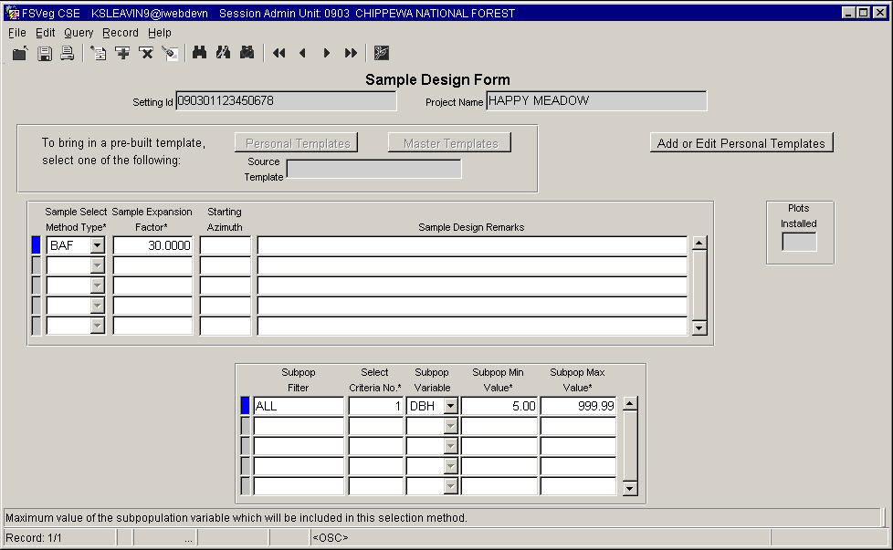

The Add or Edit Personal Templates button allows you to retrieve, create, or modify a Personal Design Template. Pre-built templates can be accessed and used ONLY when existing design data has not already been entered.

#### Sample Selection Method Type (exactly 3 characters) Required

This is the method used to select trees, shrubs, grasses, or down woody material. This field defines the type of each plot—fixed area plot (FRQ), variable radius plot (BAF), transect line (TRN), or a point-intercept (TPT).

Table 25: Sample selection method type

| **Code** | **Description** |
| --- | --- |
| FRQ | Fixed-area plot |
| BAF | Variable radius plot |
| TRN | Fixed-length transect where:   1. Downed woody material is sampled for piece intersections along a planar transect of a specified length, or 2. Percent vegetation cover for taller vegetation (generally, shrubs and trees over 3 feet in height) is sampled in terms of length of canopy relative to the length of the entire transect |
| TPT | Point-intercept is a set of sample points at fixed distances along a transect of a specified length used to sample shorter vegetation (generally, grass, forbs, and shrubs not expected to exceed 3 feet in height during the monitoring timeframe) |

#### Sample Selection Method Type (maximum of 6 numbers; may include one decimal) Required

This field corresponds to the Sample Selection Method Type, and converts tree or piece data to a per-acre basis. This field defines the size of each plot, the BAF used with the variable radius plot, the size of the fixed area plot, the horizontal transect length, or the number of points along a transect of fixed length. Examples are shown in Table 26.

Table 26: Sample selection method type

| **Sample Selection Method Type** | **Expansion Factor** | **Description** |
| --- | --- | --- |
| FRQ | 20 | The inverse of a 1/20th acre plot or strip area |
| FRQ | 3 | The inverse of a 1/3rd acre plot or strip area |
| FRQ | .2 | The inverse of a 5 acre plot or strip area |
| BAF | 40 | 40 basal area factor |
| TRN | 27 | The horizontal length of a transect line to the nearest foot |
| TPT | 25 | The number of points along a point-intercept transect; in this example there are 25 points along the transect |

#### Starting Azimuth (maximum of 3 numbers)

This is the starting azimuth, used for transect lines (selection method type of “TRN”). This field defines the starting azimuth of the transect line on the first plot installed. Write in the remarks column if the azimuth will remain the same for all subsequent plots, or if it will rotate a certain number of degrees on each subsequent plot.

#### Subpopulation Filter (maximum of 8 characters)

This defines the sample subpopulation, and is used to specify that only standing live, only standing dead, only stumps, only down, or both standing live and standing dead vegetation will be sampled. This field is not used for the surface cover type. Use the codes outlined in Table 27.

Table 27: Subpopulation filters

| **Code** | **Description** |
| --- | --- |
| LIVE | Standing live |
| DEAD | Standing dead |
| ALL | Both standing live and standing dead |
| STUMPS | Stumps |
| DOWN | Both down live and down dead |

Note for Vegetation Composition Sampling: When collecting data on Vegetation Composition, one can sample for ALL, LIVE, or DEAD vegetation. Generally, however, only data for LIVE standing vegetation will be collected; rarely will ALL or DEAD be used as Subpopulation Filters for Vegetation Composition.

Note for Tree Sampling: If downed trees are recorded on the Tree form, a Subpopulation Filter value of DOWN must be included in the sample design.

In rare cases, it is necessary to exclude specific species from the sample. In this case, enter the species code, a dash (-), and a standing live (L), standing dead (D), or standing live and standing dead (A) flag in this field. Then, enter SPP in the subpopulation variable, and enter “999.9” in the subpopulation minimum value field.

Examples are shown in Table 28.

Table 28: Sampling codes

| **Code** | **Description** |
| --- | --- |
| POTR5-L | Exclude standing live aspen |
| PIPO-D | Exclude standing dead ponderosa pine |
| LAOC-A | Exclude both standing live and standing dead larch |

In rare cases, it is necessary to exclude vegetation with specific damages from the sample. In this case, enter the damage category in this field. Then, enter “DMG” in the subpopulation variable, and enter “999.9” in the subpopulation minimum value field. Examples are shown in Table 29.

Table 29: Vegetation damages

| **Code** | **Description** |
| --- | --- |
| 21 | Root/butt diseases |
| 11 | Bark beetles |

#### Selection Criteria Number (maximum of 2 numbers) Required

Record a sequential number, starting with “1,” for each line of data within a sample selection method. Do not reuse a number between sample selection methods. Vegetation must meet one of the sequentially numbered criteria in order to be sampled on the plot type. If two or more lines have the same number, they are considered a “set,” and vegetation must meet all of the criteria in the set in order to be sampled by that selection method.

##### Example 1

On a variable radius plot, sample all live and dead trees which are either greater than 5.0 inches DBH or a greater than 2.0 inches DRC. This requires two different selection criteria numbers, as shown in Table 30.

Table 30: Selection criteria, example 1

| **Form Type** | **Sample Selection Method** | **Sample Expansion Factor** | **Subpop. Filter** | **Selection Criteria Number** | **Subpop. Variable** | **Subpop. Min. Value** | **Subpop. Max. Value** |
| --- | --- | --- | --- | --- | --- | --- | --- |
| TREE | BAF | 20 | ALL | 1 | DBH | 5.0 | 999.9 |
|  |  |  |  | 2 | DRC | 3.0 | 999.9 |

##### Example 2

On a 27-foot transect, sample down woody pieces that are greater than 12 inches at the intersection diameter and are at least six feet long. This requires the SAME selection criteria number. This implies that both intersection diameter and piece length must be recorded in order for a piece of vegetation to meet these two criteria.

Table 31: Selection criteria, example 2

| **Form Type** | **Sample Selection Method** | **Sample Expansion Factor** | **Subpop. Filter** | **Selection Criteria Number** | **Subpop. Variable** | **Subpop. Min. Value** | **Subpop. Max. Value** |
| --- | --- | --- | --- | --- | --- | --- | --- |
| DNWDY | TRN | 27 | DOWN | 1 | DIA | 12.0 | 999.9 |
|  |  |  |  | 1 | LGT | 6 | 999.9 |

##### Example 3

If both of the above selection parameters were placed on the same Sample Design form it would look like the data in Table 32.

Table 32: Selection criteria, example 3

| **Form Type** | **Sample Selection Method** | **Sample Expansion Factor** | **Subpop. Filter** | **Selection Criteria Number** | **Subpop. Variable** | **Subpop. Min. Value** | **Subpop. Max. Value** |
| --- | --- | --- | --- | --- | --- | --- | --- |
| TREE | BAF | 20 | ALL | 1 | DBH | 5.0 | 999.9 |
|  |  |  |  | 2 | DRC | 3.0 | 999.9 |

The first two lines have different selection criteria numbers, hence a piece of vegetation would have to meet either one of the criteria to be sampled on the variable radius plot. The next two lines have the same selection criteria numbers, hence a piece of vegetation would have to meet both of the criteria to be sampled on the transect. This implies that both intersection diameter and piece length must be recorded in order for a piece of vegetation to meet these two criteria.

#### Subpopulation Variable (exactly 3 characters) Required

These are the characteristics used to determine the sampled subpopulation. This field defines which characteristic of the vegetation will be measured to see if it meets the sample criteria. For example, “DBH” is the diameter at breast height. “LGT” refers to the length of the piece of vegetation.

Table 33: Subpopulation variables

| **Type of Subpopulation Sampled** | **Code** | **Description** |
| --- | --- | --- |
| Tree | DBH | Diameter at breast height; typically sampled on BAF or FRQ plots |
| Tree | DRC | Diameter at root collar; typically sampled on BAF or FRQ plots |
| Tree | HGT | Height; typically sampled on BAF or FRQ plots |
| Tree | LGT | Length; typically sampled on BAF or FRQ plots |
| Tree | DMG | Tree damage category; typically sampled on BAF or FRQ plots |
| Tree | SPP | Species; typically sampled on BAF or FRQ plots |
| Vegetation Composition | CRV | Percent cover of all vegetation lifeforms/layers; sampled only on FRQ plots; cannot be used if also sampling for one or more of TRE, SHR, FRB, or GRM in the same setting |
| Vegetation Composition | TRE | Percent cover of tree vegetation lifeforms/layers; sampled only on FRQ, TRN, or (rarely) TPT plots; cannot be used if also sampling for CVR in the same setting |
| Vegetation Composition | SHR | Percent cover of shrub vegetation lifeforms/layers; sampled only on FRQ, TRN, or (rarely) TPT plots; cannot be used if also sampling for CVR in the same setting |
| Vegetation Composition | FRB | Percent cover of forb vegetation lifeforms/layers; sampled only on FRQ or TPT plots; cannot be used if also sampling for CVR in the same setting |
| Vegetation Composition | GRM | Percent cover of graminoid vegetation lifeforms/layers; sampled only on FRQ or TPT plots; cannot be used if also sampling for CVR in the same setting |
| Surface Cover | SVC | Percent ground surface cover; sampled only on FRQ or TPT plots |
| Downed Woody Material | DIA | Diameter at midpoint or intersection; sampled only on TRN or FRQ plots |

#### Subpopulation Minimum Value (maximum of 6 numbers, may include 2 decimals) Required

This is the minimum subpopulation value. The default is zero. For example, if the subpopulation variable is set to DBH, this field defines the minimum DBH the vegetation must have in order to be sampled on the plot.

#### Subpopulation Maximum Value (maximum of 6 numbers, may include 2 decimals) Required

This is the maximum subpopulation value. The default is 999.9. For example, is the subpopulation variable is set to LGT, this field defines the maximum length the vegetation must be in order to be sampled on the plot.

#### Subpopulation Variable (exactly 3 characters) Required

This is information about each line in the sample design form.

##### Example Design 1 for Measuring Large Trees

Sample all (standing live and standing dead) trees ≥5.0” and DBH with a 40 BAF, as outlined in Table 34.

Table 34: Design 1 for measuring large trees

| **Sample Selection Method** | **Sample Expansion Factor** | **Subpop. Filter** | **Selection Criteria Number** | **Subpop. Variable** | **Subpop. Min. Value** | **Subpop. Max. Value** |
| --- | --- | --- | --- | --- | --- | --- |
| BAF | 40 | ALL | 1 | DBH | 5.0 | 999.9 |

##### Example Design 2 for Measuring Large Trees

Sample live standing trees ≥5.0” and DBH with a 30 BAF, as outlined in Table 35.

Table 35: Design 2 for measuring large trees

| **Sample Selection Method** | **Sample Expansion Factor** | **Subpop. Filter** | **Selection Criteria Number** | **Subpop. Variable** | **Subpop. Min. Value** | **Subpop. Max. Value** |
| --- | --- | --- | --- | --- | --- | --- |
| BAF | 30 | LIVE | 1 | DBH | 5.0 | 999.9 |

##### Example Design 3 for Measuring Large Trees

Sample standing dead trees ≥10.0” and DBH with a 10 BAF, as outlined in Table 36.

Table 36: Design 3 for measuring large trees

| **Sample Selection Method** | **Sample Expansion Factor** | **Subpop. Filter** | **Selection Criteria Number** | **Subpop. Variable** | **Subpop. Min. Value** | **Subpop. Max. Value** |
| --- | --- | --- | --- | --- | --- | --- |
| BAF | 10 | DEAD | 1 | DBH | 10 | 999.9 |

##### Example Design 4 for Measuring Large Trees

Sample standing live trees ≥5.0” DBH, or ≥3.0” DRC, on a 10th acre plot, as outlined in Table 37.

Table 37: Design 4 for measuring large trees

| **Sample Selection Method** | **Sample Expansion Factor** | **Subpop. Filter** | **Selection Criteria Number** | **Subpop. Variable** | **Subpop. Min. Value** | **Subpop. Max. Value** |
| --- | --- | --- | --- | --- | --- | --- |
| FRQ | 10 | LIVE | 1 | DBH | 5.0 | 999.9 |
|  |  | LIVE | 2 | DRC | 3.0 | 999.9 |

##### Example Design 1 for Measuring Small Trees

Sample standing live and standing dead trees .1-.49” DBH, also sample lie trees .5’-4.4’ in height on a 100th acre plot, as outlined in Table 38.

Table 38: Design 1 for measuring small trees

| **Sample Selection Method** | **Sample Expansion Factor** | **Subpop. Filter** | **Selection Criteria Number** | **Subpop. Variable** | **Subpop. Min. Value** | **Subpop. Max. Value** |
| --- | --- | --- | --- | --- | --- | --- |
| FRQ | 100 | ALL | 1 | DBH | .1 | 4.9 |
|  |  | LIVE | 2 | HGT | .5 | 4.4 |

##### Example Design 2 for Measuring Small Trees

Sample live standing trees 1.0-4.9” DBH, or 1.0-2.0” DRC, on a 50th acre plot, as outlined in Table 39.

Table 39: Design 2 for measuring small trees

| **Sample Selection Method** | **Sample Expansion Factor** | **Subpop. Filter** | **Selection Criteria Number** | **Subpop. Variable** | **Subpop. Min. Value** | **Subpop. Max. Value** |
| --- | --- | --- | --- | --- | --- | --- |
| FRQ | 50 | LIVE | 1 | DBH | 1.0 | 4.9 |
|  |  | LIVE | 2 | DRC | 1.0 | 2.9 |

##### Example Design 3 for Measuring Small Trees

Sample stumps 10.0” in diameter at root collar on a 10th acre plot, as outlined in Table 40.

Table 40: Design 3 for measuring small trees

| **Sample Selection Method** | **Sample Expansion Factor** | **Subpop. Filter** | **Selection Criteria Number** | **Subpop. Variable** | **Subpop. Min. Value** | **Subpop. Max. Value** |
| --- | --- | --- | --- | --- | --- | --- |
| FRQ | 10 | STUMPS | 1 | DRC | 10 | 999.9 |

##### Example Design 4 for Measuring Small Trees

On a 300th acre plot, sample all (standing live and standing dead) trees 3.0-4.9” DBH except aspen, sample standing live trees 0.1-2.9” DBH and .5-4.9” high except aspen, and sample standing live aspen 1.0-4.9’ in height.

Table 41: Design 4 for measuring small trees

| **Sample Selection Method** | **Sample Expansion Factor** | **Subpop. Filter** | **Selection Criteria Number** | **Subpop. Variable** | **Subpop. Min. Value** | **Subpop. Max. Value** |
| --- | --- | --- | --- | --- | --- | --- |
| FRQ | 300 | ALL | 1 | DBH | 3 | 4.9 |
| FRQ | 300 | POTR5-A | 1 | SPP | 999 |  |
| FRQ | 300 | LIVE | 2 | DBH | 0.1 | 2.9 |
| FRQ | 300 | LIVE | 2 | HGT | .5 | 4.4 |
| FRQ | 300 | POTR5-A | 2 | SPP | 999 |  |
| FRQ | 300 | POTR5-L | 3 | HGT | 1.0 | 4.9 |

##### Example Design 1 for Measuring Down Woody Material

Use Brown’s Protocols. Using a 7-foot transect, record the number of pieces on each of the three intersection diameter classes (0.1-.24, .25-.99, and 1.0-2.9). Using a 27-foot transect, record the information on all pieces greater than 3.0” intersection diameter.

Table 42: Design 1 for measuring down woody material

| **Sample Selection Method** | **Sample Expansion Factor** | **Subpop. Filter** | **Selection Criteria Number** | **Subpop. Variable** | **Subpop. Min. Value** | **Subpop. Max. Value** |
| --- | --- | --- | --- | --- | --- | --- |
| TRN | 7 | DOWN | 1 | DIA | 0.1 | .24 |
| TRN | 7 | DOWN | 2 | DIA | .25 | .99 |
| TRN | 7 | DOWN | 3 | DIA | 1.0 | 2.99 |
| TRN | 27 | DOWN | 4 | DIA | 3.0 | 999 |

##### Example Design 2 for Measuring Down Woody Material

Using fuel photos, estimate per acre down material volume and weight values for three size classes.

Table 43: Design 2 for measuring down woody material

| **Sample Selection Method** | **Sample Expansion Factor** | **Subpop. Filter** | **Selection Criteria Number** | **Subpop. Variable** | **Subpop. Min. Value** | **Subpop. Max. Value** |
| --- | --- | --- | --- | --- | --- | --- |
| FRQ | 1 | DOWN | 1 | DIA | 0.1 | 3.0 |
| FRQ | 1 | DOWN | 2 | DIA | 3.1 | 5.0 |
| FRQ | 1 | DOWN | 3 | DIA | 5.1 | 999 |

##### Region 1 Example Design 1

Sample using 40 BAF, 5.0” minimum diameter, 300th acre small-tree, vegetation cover, and surface cover fixed-plot, as outlined in Table 44. Cover plots are measuring vegetation and surface materials with 5% coverage and more.

Table 44: Region 1, example design 1

| **Sample Selection Method** | **Sample Expansion Factor** | **Subpop. Filter** | **Selection Criteria Number** | **Subpop. Variable** | **Subpop. Min. Value** | **Subpop. Max. Value** |
| --- | --- | --- | --- | --- | --- | --- |
| BAF | 40 | ALL | 1 | DBH | 5.0 | 999.9 |
| FRQ | 300 | ALL | 2 | DBH | 0.1 | 4.9 |
| FRQ | 300 | LIVE | 3 | HGT | 0.5 | 4.4 |
| FRQ | 300 | LIVE | 4 | CVR | 5.0 | 100 |
| FRQ | 300 | n/a | 5 | SVC | 5.0 | 100 |

Note: if vegetation and surface cover plot were not installed, the VEGCOV and SURCOV form type would NOT be included in the sample design.

Note: if the small-tree fixed plot is not taken, the small tree form with the FRQ selection method would NOT be included in the sample design.

##### Region 1 Example Design 2

30 BAF, 4.3” minimum diameter, 300th acre small-tree, vegetation cover, and surface cover fixed-plot, as outlined in Table 45. Cover plots are measuring vegetation and surface materials with 5% coverage and more.

Table 45: Region 1, example design 2

| **Sample Selection Method** | **Sample Expansion Factor** | **Subpop. Filter** | **Selection Criteria Number** | **Subpop. Variable** | **Subpop. Min. Value** | **Subpop. Max. Value** |
| --- | --- | --- | --- | --- | --- | --- |
| BAF | 30 | ALL | 1 | DBH | 4.3 | 999.9 |
| FRQ | 300 | ALL | 2 | DBH | 0.1 | 4.2 |
| FRQ | 300 | LIVE | 3 | HGT | 0.5 | 4.4 |
| FRQ | 300 | LIVE | 4 | CVR | 5.0 | 100 |
| FRQ | 300 | n/a | 5 | SVC | 5.0 | 100 |

Note: if vegetation and surface cover plot were not installed, the VEGCOV and SURCOV form type would NOT be included in the sample design.

Note: if the small-tree fixed plot is not taken, the small tree form with the FRQ selection method would NOT be included in the sample design.

##### Region 1 Example Design 3

20 BAF, 5.0” minimum diameter, 300th acre small-tree, vegetation cover and surface cover fixed area plot, as outlined in Table 46. Cover plots are measuring vegetation and surface materials with 5% coverage and more.

Table 46: Region 1, example design 3

| **Sample Selection Method** | **Sample Expansion Factor** | **Subpop. Filter** | **Selection Criteria Number** | **Subpop. Variable** | **Subpop. Min. Value** | **Subpop. Max. Value** |
| --- | --- | --- | --- | --- | --- | --- |
| BAF | 20 | ALL | 1 | DBH | 5.0 | 999.9 |
| FRQ | 300 | ALL | 2 | DBH | 0.1 | 4.9 |
| FRQ | 300 | LIVE | 3 | HGT | 0.5 | 4.4 |
| FRQ | 300 | LIVE | 4 | CVR | 5.0 | 100 |
| FRQ | 300 | n/a | 5 | SVR | 5.0 | 100 |

Note: if vegetation and surface cover plot were not installed, the VEGCOV and SURCOV form type would NOT be included in the sample design.

Note: if the small-tree fixed plot is not taken, the small tree form with the FRQ selection method would NOT be included in the sample design.

##### Region 1 Example Design 4

20 BAF, 3.5” minimum diameter, 300th acre small-tree, vegetation cover, and surface cover fixed area plot, as outlined in Table 47. Cover plots are measuring vegetation and surface materials with 5% coverage and more.

Table 47: Region 1, sample design 4

| **Sample Selection Method** | **Sample Expansion Factor** | **Subpop. Filter** | **Selection Criteria Number** | **Subpop. Variable** | **Subpop. Min. Value** | **Subpop. Max. Value** |
| --- | --- | --- | --- | --- | --- | --- |
| BAF | 20 | ALL | 1 | DBH | 3.5 | 999.9 |
| FRQ | 300 | ALL | 2 | DBH | 0.1 | 3.4 |
| FRQ | 300 | LIVE | 3 | HGT | 0.5 | 4.4 |
| FRQ | 300 | LIVE | 4 | CVR | 5.0 | 100 |
| FRQ | 300 | n/a | 5 | SVC | 5.0 | 100 |

Note: if vegetation and surface cover plot were not installed, the VEGCOV and SURCOV form type would NOT be included in the sample design.

Note: if the small-tree fixed plot is not taken, the small tree form with the FRQ selection method would NOT be included in the sample design.

##### Region 1 Example Design 5

20 BAF, 3.0” minimum diameter, 300th acre small-tree, vegetation cover, and surface cover fixed area plot, as outlined in Table 48. Cover plots are measuring vegetation and surface materials with 5% coverage and more.

Table 48: Region 1, sample design 5

| **Sample Selection Method** | **Sample Expansion Factor** | **Subpop. Filter** | **Selection Criteria Number** | **Subpop. Variable** | **Subpop. Min. Value** | **Subpop. Max. Value** |
| --- | --- | --- | --- | --- | --- | --- |
| BAF | 20 | ALL | 1 | DBH | 3.0 | 999.9 |
| FRQ | 300 | ALL | 2 | DBH | 0.1 | 2.9 |
| FRQ | 300 | LIVE | 3 | HGT | 0.5 | 4.4 |
| FRQ | 300 | LIVE | 4 | CVR | 5.0 | 100 |
| FRQ | 300 | n/a | 5 | SVC | 5.0 | 100 |

Note: if vegetation and surface cover plot were not installed, the VEGCOV and SURCOV form type would NOT be included in the sample design.

Note: if the small-tree fixed plot is not taken, the small tree form with the FRQ selection method would NOT be included in the sample design.

##### Region 1 Example Design 6

15 BAF, 3.0” minimum diameter, 300th acre small-tree, vegetation cover, and surface cover fixed plot area, as outlined in Table 49. Cover plots are measuring vegetation and surface materials with 5% coverage and more.

Table 49: Region 1, sample design 6

| **Sample Selection Method** | **Sample Expansion Factor** | **Subpop. Filter** | **Selection Criteria Number** | **Subpop. Variable** | **Subpop. Min. Value** | **Subpop. Max. Value** |
| --- | --- | --- | --- | --- | --- | --- |
| BAF | 15 | ALL | 1 | DBH | 3.0 | 999.9 |
| FRQ | 300 | ALL | 2 | DBH | 0.1 | 2.9 |
| FRQ | 300 | LIVE | 3 | HGT | 0.5 | 4.4 |
| FRQ | 300 | LIVE | 4 | CVR | 5.0 | 100 |
| FRQ | 300 | n/a | 5 | SVC | 5.0 | 100 |

Note: if vegetation and surface cover plot were not installed, the VEGCOV and SURCOV form type would NOT be included in the sample design.

Note: if the small-tree fixed plot is not taken, the small tree form with the FRQ selection method would NOT be included in the sample design.

##### Region 1 Example Design 7

10 BAF, 5.0” minimum diameter, 300th acre small-tree, vegetation cover, and surface cover fixed area plot, as outlined in Table 50. Cover plots are measuring vegetation and surface materials with 5% coverage and more.

Table 50: Region 1, sample design 7

| **Sample Selection Method** | **Sample Expansion Factor** | **Subpop. Filter** | **Selection Criteria Number** | **Subpop. Variable** | **Subpop. Min. Value** | **Subpop. Max. Value** |
| --- | --- | --- | --- | --- | --- | --- |
| BAF | 10 | ALL | 1 | DBH | 5.0 | 999.9 |
| FRQ | 300 | ALL | 2 | DBH | 0.1 | 4.9 |
| FRQ | 300 | LIVE | 3 | HGT | 0.5 | 4.4 |
| FRQ | 300 | LIVE | 4 | CVR | 5.0 | 100 |
| FRQ | 300 | n/a | 5 | SVC | 5.0 | 100 |

Note: if vegetation and surface cover plot were not installed, the VEGCOV and SURCOV form type would NOT be included in the sample design.

Note: if the small-tree fixed plot is not taken, the small tree form with the FRQ selection method would NOT be included in the sample design.

##### Region 1 Example Design 8

10 BAF, 3.0” minimum diameter, 300th acre small-tree, vegetation cover, and surface cover fixed area plot, as outlined in Table 51. Cover plots are measuring vegetation and surface materials with 5% coverage and more.

Table 51: Region 1, sample design 8

| **Sample Selection Method** | **Sample Expansion Factor** | **Subpop. Filter** | **Selection Criteria Number** | **Subpop. Variable** | **Subpop. Min. Value** | **Subpop. Max. Value** |
| --- | --- | --- | --- | --- | --- | --- |
| BAF | 10 | ALL | 1 | DBH | 3.0 | 999.9 |
| FRQ | 300 | ALL | 2 | DBH | 0.1 | 2.9 |
| n/a | n/a | LIVE | 3 | HGT | 0.5 | 4.4 |
| FRQ | 300 | LIVE | 4 | CVR | 5.0 | 100 |
| FRQ | 300 | n/a | 5 | SVC | 5.0 | 100 |

Note: if vegetation and surface cover plot were not installed, the VEGCOV and SURCOV form type would NOT be included in the sample design.

Note: if the small-tree fixed plot is not taken, the small tree form with the FRQ selection method would NOT be included in the sample design.

##### Region 1 Example Design 9

10 BAF, 2.5” minimum diameter, 300th acre small-tree, vegetation cover, and surface cover fixed area plot, as outlined in Table 52. Cover plots are measuring vegetation and surface materials with 5% coverage and more.

Table 52: Region 1, sample design 9

| **Sample Selection Method** | **Sample Expansion Factor** | **Subpop. Filter** | **Selection Criteria Number** | **Subpop. Variable** | **Subpop. Min. Value** | **Subpop. Max. Value** |
| --- | --- | --- | --- | --- | --- | --- |
| BAF | 10 | ALL | 1 | DBH | 2.5 | 999.9 |
| FRQ | 300 | ALL | 2 | DBH | 0.1 | 2.4 |
| ??? | ??? | LIVE | 3 | HGT | 0.5 | 4.4 |
| FRQ | 300 | LIVE | 4 | CVR | 5.0 | 100 |
| FRQ | 300 | n/a | 5 | SVC | 5.0 | 100 |

Note: if vegetation and surface cover plot were not installed, the VEGCOV and SURCOV form type would NOT be included in the sample design.

Note: if the small-tree fixed plot is not taken, the small tree form with the FRQ selection method would NOT be included in the sample design.

##### Region 1 Example Design 10

20 BAF, 5.0” minimum diameter for all live trees and dead trees, 5-8.9” DBH, 10 BAF for dead trees with DBH 9”+, 100th acre small-tree, vegetation cover, and surface cover fixed area plot, as outlined in Table 53. Cover plots are measuring vegetation and surface materials with 5% coverage and more.

Table 53: Region 1, sample design 10

| **Sample Selection Method** | **Sample Expansion Factor** | **Subpop. Filter** | **Selection Criteria Number** | **Subpop. Variable** | **Subpop. Min. Value** | **Subpop. Max. Value** |
| --- | --- | --- | --- | --- | --- | --- |
| BAF | 20 | LIVE | 1 | DBH | 5.0 | 999.9 |
| ??? | ??? | DEAD | 2 | DBH | 5.0 | 8.9 |
| BAF | 10 | DEAD | 3 | DBH | 9.0 | 999.9 |
| FRQ | 100 | ALL | 4 | DBH | 0.1 | 4.9 |
| ??? | ??? | LIVE | 5 | HGT | 0.5 | 4.4 |
| FRQ | 100 | LIVE | 6 | CVR | 5.0 | 100 |
| FRQ | 100 | ??? | 7 | SVC | 5.0 | 100 |

Note: if vegetation and surface cover plot were not installed, the VEGCOV and SURCOV form type would NOT be included in the sample design.

Note: if the small-tree fixed plot is not taken, the small tree form with the FRQ selection method would NOT be included in the sample design.

##### Region 1 Example Design 11

40 BAF, 5.0” minimum diameter for all live trees. 10 BAF for all dead trees with DBH 10”+, 100th acre small-tree, vegetation cover, and surface cover fixed area plot, as outlined in Table 54. Cover plots are measuring vegetation and surface materials with 5% coverage and more.

Table 54: Region 1, sample design 11

| **Sample Selection Method** | **Sample Expansion Factor** | **Subpop. Filter** | **Selection Criteria Number** | **Subpop. Variable** | **Subpop. Min. Value** | **Subpop. Max. Value** |
| --- | --- | --- | --- | --- | --- | --- |
| BAF | 40 | LIVE | 1 | DBH | 5.0 | 999.9 |
| BAF | 10 | DEAD | 2 | DBH | 5.0 | 999.9 |
| FRQ | 100 | ALL | 3 | DBH | 0.1 | 4.9 |
| ??? | ??? | LIVE | 4 | HGT | 0.5 | 4.4 |
| FRQ | 100 | LIVE | 5 | CVR | 5.0 | 100 |
| FRQ | 100 |  | 6 | SVC | 5.0 | 100 |

Note: if vegetation and surface cover plot were not installed, the VEGCOV and SURCOV form type would NOT be included in the sample design.

Note: if the small-tree fixed plot is not taken, the small tree form with the FRQ selection method would NOT be included in the sample design.

##### Region 1 Example Design 12

Measure all live and dead trees on a 1/100-acre fixed plot, as outlined in Table 55.

Table 55: Region 1, sample design 12

| **Sample Selection Method** | **Sample Expansion Factor** | **Subpop. Filter** | **Selection Criteria Number** | **Subpop. Variable** | **Subpop. Min. Value** | **Subpop. Max. Value** |
| --- | --- | --- | --- | --- | --- | --- |
| FRQ | 100 | ALL | 1 | DBH | 0.1 | 999.9 |
| ??? | ??? | ALL | 2 | HGT | 0.5 | 999.9 |

##### Region 1 Example Design 13

Sample design for Brown’s Protocol material inventory, as outlined in Table 56. Sample occurrence of three different diameter classes of down woody fuels on a 7’ transect, sample down woody fuels that are 3.0” diameter and larger on a 27’ transect. Note: add this unique design on to any of the above examples. Make sure that the selection criteria number is unique throughout all of the sample designs. Note: currently, if down woody information is going to be collected, it must be collected on ALL plots.

Table 56: Region 1, sample design 13

| **Sample Selection Method** | **Sample Expansion Factor** | **Subpop. Filter** | **Selection Criteria Number** | **Subpop. Variable** | **Subpop. Min. Value** | **Subpop. Max. Value** |
| --- | --- | --- | --- | --- | --- | --- |
| TRN | 7 | DOWN | 1 | DIA | 0.00 | 0.24 |
| ??? | ??? | DOWN | 2 | DIA | 0.25 | 0.99 |
| ??? | ??? | DOWN | 3 | DIA | 1.00 | 2.99 |
| TRN | 27 | DOWN | 4 | DIA | 3.0 | 999.9 |

##### Region 1 Example Design 14

Example 1 with down woody material collected, as outlined in Table 57.

Table 57: Region 1, sample design 14

| **Sample Selection Method** | **Sample Expansion Factor** | **Subpop. Filter** | **Selection Criteria Number** | **Subpop. Variable** | **Subpop. Min. Value** | **Subpop. Max. Value** |
| --- | --- | --- | --- | --- | --- | --- |
| BAF | 40 | ALL | 1 | DBH | 5.0 | 999.9 |
| FRQ | 300 | ALL | 2 | DBH | 0.1 | 4.9 |
| ??? | ??? | LIVE | 3 | HGT | 0.5 | 4.4 |
| ??? | 300 | LIVE | 4 | CVR | 0.5 | 4.4 |
| FRQ | 300 | ??? | 5 | SVC | 5.0 | 100 |
| TRN | 7 | DOWN | 6 | DIA | 0.00 | 0.24 |
| ??? | ??? | DOWN | 7 | DIA | 0.25 | 0.99 |
| ??? | ??? | DOWN | 8 | DIA | 1.00 | 2.99 |
| TRN | 27 | DOWN | 9 | DIA | 3.0 | 999.9 |

##### Region 2 Example Design 1

On a 300th acre plot, sample all (standing live and standing dead) trees between 3.0” and 4.9” DBH except Aspen, sample standing live trees between 0.0” and 2.9” DBH and over 0.25’ height except Aspen, and sample standing live Aspen between 1’ and 4.9’ height and greater than .1” DRC, as outlined in Table 58. Using a 30 BAF, sample standing live trees 5.0” DBH and greater. Using a 10 BAF, sample standing dead trees 10” DBH and greater.

Table 58: Region 2, sample design 1

| **Sample Selection Method** | **Sample Expansion Factor** | **Subpop. Filter** | **Selection Criteria Number** | **Subpop. Variable** | **Subpop. Min. Value** | **Subpop. Max. Value** |
| --- | --- | --- | --- | --- | --- | --- |
| BAF | 30 | LIVE | 1 | DBH | 5.0 | 999.9 |
| BAF | 10 | DEAD | 2 | DBH | 10.0 | 999.9 |
| FRQ | 300 | ALL | 3 | DBH | 3.0 | 4.9 |
| ??? | ??? | POTR5-A | 3 | SPP | 999.9 | ??? |
| ??? | ??? | LIVE | 4 | DBH | 0.1 | 2.9 |
| ??? | ??? | POTR5-A | 4 | SPP | 999.9 | ??? |
| ??? | ??? | LIVE | 5 | HGT | 0.25 | 4.4 |
| ??? | ??? | POTR5-L | 5 | SPP | 999.9 | ??? |
| ??? | ??? | POTR5-L | 6 | HGT | 1.0 | 4.9 |
| ??? | ??? | POTR5-L | 6 | DRC | 0.1 | 999.9 |

##### Region 2 Example Design 2

On a 300th acre plot, sample all (standing live and standing dead) trees between 0.1” and 4.9” DBH or between 0.5’ and 4.4’ in height, as outlined in Table 59. Using a 40 BAF, sample standing live trees 5.0” DBH and greater. Using a 10 BAF, sample standing dead trees 10” DBH and greater.

Table 59: Region 2, design sample 2

| **Sample Selection Method** | **Sample Expansion Factor** | **Subpop. Filter** | **Selection Criteria Number** | **Subpop. Variable** | **Subpop. Min. Value** | **Subpop. Max. Value** |
| --- | --- | --- | --- | --- | --- | --- |
| BAF | 40 | LIVE | 1 | DBH | 5.0 | 999.9 |
| BAF | 10 | DEAD | 2 | DBH | 10.0 | 999.9 |
| FRQ | 300 | ALL | 3 | DBH | 0.1 | 4.9 |
| ??? | ??? | ALL | 4 | HGT | 0.5 | 4.4 |

##### Region 3 Example Design 1

Using a 10 BAF, sample standing live trees 5.0” DBH or 3.0” DRC and above, as outlined in Table 60. On a 50th acre plot, sample standing live trees between 0.1” and 4.9” DBH or 0.1” and 2.9” DRC. On a 100th acre plot, sample vegetation with a cover percentage between 0.5% (trace) and 100%.

Table 60: Region 3, design sample 1

| **Sample Selection Method** | **Sample Expansion Factor** | **Subpop. Filter** | **Selection Criteria Number** | **Subpop. Variable** | **Subpop. Min. Value** | **Subpop. Max. Value** |
| --- | --- | --- | --- | --- | --- | --- |
| BAF | 10 | LIVE | 1 | DBH | 5.0 | 999.9 |
| ??? | ??? | LIVE | 2 | DRC | 3.0 | 999.9 |
| FRQ | 50 | LIVE | 3 | DBH | 0.1 | 4.9 |
| ??? | ??? | LIVE | 4 | DRC | 0.5 | 4.4 |
| ??? | ??? | LIVE | 5 | DRC | .01 | 2.9 |
| FRQ | 100 | LIVE | 6 | CVR | 0.5 | 100 |

##### Region 3 Example Design 2

On a 10th acre plot, sample all (standing live and standing dead) trees 5.0” DBH or 3.0” DRC and above, as outlined in Table 61. On a 300th acre plot, sample standing trees between 0.1” and 4.9” DBH or 0.1” and 2.9” DRC. On a 27-foot transect, sample down material 3.0” at intersection diameter and greater. On a 10th acre plot, sample vegetation with a cover percentage between 0.5% (trace) and 100%.

Table 61: Region 3, design sample 2

| **Sample Selection Method** | **Sample Expansion Factor** | **Subpop. Filter** | **Selection Criteria Number** | **Subpop. Variable** | **Subpop. Min. Value** | **Subpop. Max. Value** |
| --- | --- | --- | --- | --- | --- | --- |
| FRQ | 10 | ALL | 1 | DBH | 5.0 | 999.9 |
| ??? | ??? | ALL | 2 | DRC | 3.0 | 999.9 |
| FRQ | 300 | LIVE | 3 | DBH | 0.1 | 4.9 |
| ??? | ??? | LIVE | 4 | DRC | 0.1 | 2.9 |
| ??? | ??? | LIVE | 5 | HGT | 0.5 | 4.4 |
| TRN | 27 | DOWN | 5 | DIA | 3.0 | 999.9 |
| FRQ | 10 | ALL | 6 | CVR | 0.5 | 100 |

##### Region 4 Example Design 1

Using a 30 BAF, sample all (standing live and standing dead) trees 5.0” DBH and above, as outlined in Table 62. A 100th acre plot, sample standing live trees between 0.1” and 4.9” and at least .5’ in height. On a 10th acre plot, sample stumps at least 10” at intersection diameter.

Table 62: Region 4, sample design 1

| **Sample Selection Method** | **Sample Expansion Factor** | **Subpop. Filter** | **Selection Criteria Number** | **Subpop. Variable** | **Subpop. Min. Value** | **Subpop. Max. Value** |
| --- | --- | --- | --- | --- | --- | --- |
| BAF | 30 | ALL | 1 | DBH | 5.0 | 999.9 |
| FRQ | 100 | LIVE | 2 | DBH | 0.1 | 4.9 |
| ??? | ??? | LIVE | 3 | HGT | 0.5 | 4.4 |
| FRQ | 10 | STUMPS | 4 | DIA | 10.0 | 999.9 |

##### Region 4 Example Design 2

Using a 30 BAF, sample all (standing live and standing dead) trees 5.0” DBH and above, as outlined in Table 63. On a 100th acre plot, sample standing live trees between 0.0” and 4.9” and at least .5” in height. On a 10th acre plot, sample stumps at least 10” at intersection diameter. On a 50th acre plot, sample down trees between 3.0’ and 15.9’ at intersection diameter. On a 20th acre plot, sample down trees 16.0” and larger at intersection diameter. On a 10th acre plot, sample vegetation with a minimum of 1%.

Table 63: Region 4, sample design 2

| **Sample Selection Method** | **Sample Expansion Factor** | **Subpop. Filter** | **Selection Criteria Number** | **Subpop. Variable** | **Subpop. Min. Value** | **Subpop. Max. Value** |
| --- | --- | --- | --- | --- | --- | --- |
| BAF | 30 | ALL | 1 | DBH | 5.0 | 999.9 |
| FRQ | 100 | LIVE | 2 | DBH | 0.1 | 4.9 |
| ??? | ??? | LIVE | 3 | HGT | 0.5 | 4.4 |
| FRQ | 10 | STUMPS | 4 | DIA | 10.0 | 999.9 |
| FRQ | 50 | DOWN | 5 | DIA | 3.0 | 15.9 |
| FRQ | 20 | DOWN | 6 | DIA | 16.0 | 999.9 |
| FRQ | 10 | LIVE | 7 | CVR | 1 | 100 |

##### Region 5 Example Design 1

Sample all (live and dead) trees that are less than 5.0” DBH on a 100th acre plot, as outlined in Table 64. Select a Basal Area Factor for live trees greater than 5.0’ DBH. Do NOT vary BAF on plots within the same stand. Record per volume and per acre weight values for 3 size classes using photo series as a guide.

Table 64: Region 5, sample design 1: intensive examination

| **Sample Selection Method** | **Sample Expansion Factor** | **Subpop. Filter** | **Selection Criteria Number** | **Subpop. Variable** | **Subpop. Min. Value** | **Subpop. Max. Value** |
| --- | --- | --- | --- | --- | --- | --- |
| BAF | 20, 30, 40 | LIVE | 1 | DBH | 5.0 | 999.9 |
| FRQ | 8 | ALL | 2 | DRC | 5.0 | 999.9 |
| FRQ | 100 | ALL | 3 | DBH | 1.0 | 4.9 |
| FRQ | 100 | ALL | 4 | DRC | 1.0 | 4.9 |
| FRQ | 8 | DEAD | 5 | DBH | 5.0 | 19.9 |
| FRQ | 4 | DEAD | 6 | DBH | 20.0 | 999.9 |
| FRQ | 8 | DOWN | 7 | DBH | 10.0 | 999.9 |
| FRQ | 1 | DOWN | 8 | DIA | 0.01 | 1.0 |
| ??? | ??? | DOWN | 9 | DIA | 1.1 | 3.0 |
| ??? | ??? | DOWN | 10 | DIA | 3.1 | 9.0 |
| FRQ | 1 | LIVE | 11 | CVR | 1 | 100 |
| FRQ | 1 | ??? | 12 | SVC | 1 | 100 |

##### Region 5 Example Design 2

Extensive exam does not include any sampling of trees less than 5.0” DBH, as outlined in Table 65. Select a Basal Area Factor for live trees greater than 5.0” DBH. Do NOT vary BAF on plots within the same stand. Extensive exam does not include small down woody material.

Table 65: Region 5, sample design 2

| **Sample Selection Method** | **Sample Expansion Factor** | **Subpop. Filter** | **Selection Criteria Number** | **Subpop. Variable** | **Subpop. Min. Value** | **Subpop. Max. Value** |
| --- | --- | --- | --- | --- | --- | --- |
| BAF | 20, 30, 40 | LIVE | 1 | DBH | 5.0 | 999.9 |
| FRQ | 8 | ALL | 2 | DRC | 5.0 | 999.9 |
| FRQ | 8 | DEAD | 3 | DBH | 5.0 | 19.9 |
| FRQ | 4 | DEAD | 4 | DBH | 20.0 | 999.9 |
| FRQ | 8 | DOWN | 5 | DBH | 10.0 | 999.9 |
| FRQ | 1 | LIVE | 6 | CVR | 1 | 100 |
| FRQ | 1 | ??? | 7 | SVC | 1 | 100 |

##### Region 5 Example Design 3

Quick plot exam does not include any sampling of trees less than 5.0” DBH. Select a Basal Area Factor for all trees greater than 5.0” DBH, as outlined in Table 66. Do NOT vary BAF on plots within the same stand. Quick plot exam does not include small down woody material or surface cover.

Table 66: Region 5, sample design 3

| **Sample Selection Method** | **Sample Expansion Factor** | **Subpop. Filter** | **Selection Criteria Number** | **Subpop. Variable** | **Subpop. Min. Value** | **Subpop. Max. Value** |
| --- | --- | --- | --- | --- | --- | --- |
| BAF | 20, 30, 40 | ALL | 1 | DBH | 5.0 | 999.9 |
| FRQ | 8 | ALL | 2 | DRC | 5.0 | 999.9 |
| FRQ | 1 | LIVE | 3 | CVR | 1 | 100 |

##### Region 9 Example Design

Table 67: Region 9 sample design

| **Sample Selection Method** | **Sample Expansion Factor** | **Subpop. Filter** | **Selection Criteria Number** | **Subpop. Variable** | **Subpop. Min. Value** | **Subpop. Max. Value** |
| --- | --- | --- | --- | --- | --- | --- |
| BAF | 10 | LIVE | 1 | DBH | 5.0 | 999.9 |
| FRQ | 100 | LIVE | 2 | DBH | 0.1 | 4.9 |
| ??? | ??? | LIVE | 3 | HGT | 0.5 | 4.49 |
| TRN | 7 | DOWN | 4 | DIA | 0.1 | .24 |
| ??? | ??? | DOWN | 5 | DIA | .25 | .99 |
| ??? | ??? | DOWN | 6 | DIA | 1.0 | 2.99 |
| TRN | 27 | DOWN | 7 | DIA | 3.0 | 999.9 |
| BAF | 5 | DEAD | 8 | DBH | .1 | 999.9 |
| FRQ | 10 | STUMPS | 9 | HGT | 10 | 4.49 |
| ??? | ??? | STUMPS | 9 | DRC | 1 | 999.9 |
| FRQ | 10 | LIVE | 10 | CVR | 1 | 100.00 |
| FRQ | 100 | ??? | 11 | SVC | 1 | 100.00 |

##### Region 10 Tongass Commercial Sale Young-Growth Exams (No GST) (Required Form)

Use 30 BAF, sample standing live trees 9.0”+ DBH and BAF 30 for dead trees 9.0”+ DBH that are at least 20 feet tall, as outlined in Table 68. On 100th acre plot, sample live trees 0.1 to 8.9” DBH in two-inch groups (2”, 4”, etc.; 0.1-2.9” = 2” class; 3.0-4.9” = 4” class; 5.0-6.9” = 6” class; 7.0-8.9” = 8” class). Use 30 BAF, sample standing live trees 9.0”+ DBH and BAF 30 for dead trees 9.0”+ DBH that are at least 20 feet tall.

Note: this template does not sample trees less than .1 inch DBH and it does not sample dead trees less than 9 inches in DBH that are also less than 20 feet tall. Sampling trees less than .1 inch DBH while not required, can be done at the discretion of the district. If seedling data is desired, add another FRQ line to the sampling in Table 68 (sampling = subpop. Filter = LIVE; selection criteria number = 4; subpop filter = HGT; subpop min value = .1; subpop max value = 4.49).

Table 68: Region 10 Tongass Commercial Sale Young-Growth Exams (No GST)

| **Sample Selection Method** | **Sample Expansion Factor** | **Subpop. Filter** | **Selection Criteria Number** | **Subpop. Variable** | **Subpop. Min. Value** | **Subpop. Max. Value** |
| --- | --- | --- | --- | --- | --- | --- |
| BAF | 30 | LIVE | 1 | DBH | 9.0 | 999.9 |
| BAF | 30 | DEAD | 2 | DBH | 9.0 | 999.9 |
| ??? | ??? | DEAD | 3 | HGT | 20.0 | 999.9 |
| FRQ | 100 | LIVE | 4 | DBH | 0.1 | 8.9 |

##### Region 10 Tongass Commercial Sale Young-Growth Exams & GST (Required)

On 100th are lot, sample live trees 0.1 to 8.9” DBH in two-inch groups (2”, 4”, etc.; 0.1-2.9” = 2” class; 3.0-4.9” = 4” class; 5.0-6.9” = 6” class; 7.0-8.9” = 8” class) except for GST and site index trees which will have the actual diameter to the nearest 0.1 inch recorded, as outlined in Table 69. Use 30 BAF, sample standing live trees 9.0”+ DBH and BAF 30 for dead trees 9.0”+ DBH that are at least 20 feet tall.

Note: this template does not sample trees less than .1 inch DBH and it does not sample dead trees less than 9 inches in DBH that are also less than 20 feet tall. Sampling trees less than .1 inch DBH while not required, can be done at the discretion of the district. If seedling data is desired, add another FRQ line to the sampling in Table 69 (sampling = subpop. Filter = LIVE; selection criteria number = 4; subpop filter = HGT; subpop min value = .1; subpop max value = 4.49).

Table 69: Region 10 Tongass Commercial Sale Young-Growth Exams & GST

| **Sample Selection Method** | **Sample Expansion Factor** | **Subpop. Filter** | **Selection Criteria Number** | **Subpop. Variable** | **Subpop. Min. Value** | **Subpop. Max. Value** |
| --- | --- | --- | --- | --- | --- | --- |
| BAF | 30 | LIVE | 1 | DBH | 9.0 | 999.9 |
| BAF | 20 | DEAD | 2 | DBH | 9.0 | 999.9 |
| >>> | >>> | DEAD | 3 | HGT | 20.0 | 999.9 |
| FRQ | 100 | LIVE | 3 | DBH | 0.1 | 8.9 |

##### Region 10 Sample Design Form for Tongass Late Seral (Old-Growth) Exams (Required)

On 100th acre plot, sample live trees 0.1 to 8.9” DBH in two-inch classes (2”, 4”, etc.; 0.1-2.9” = 2” class; 3.0-4.9” = 4” class; 5.0-6.9” = 6” class; 7.0-8.9” = 8” class), as outlined in Table 70. Use 40 BAF, sample standing live trees 9.0”+ DBH and use BAF 40 on standing dead trees 9.0”+ DBH that are also greater than 20 feet tall.

Note: sampling trees less than .1 inch DBH, while not required, can be done at the discretion of the district. If seedling data is desired, add another FRQ 300 line to the sampling in Table 70 (sampling – subpop filter = LIVE; selection criteria number = 5; subpop filter = HGT; subpop min value = .1; and subpop max value = 4.49).

Table 70: Region 10 Sample Design Form for Tongass Late Seral (Old-Growth) Exams

| **Sample Selection Method** | **Sample Expansion Factor** | **Subpop. Filter** | **Selection Criteria Number** | **Subpop. Variable** | **Subpop. Min. Value** | **Subpop. Max. Value** |
| --- | --- | --- | --- | --- | --- | --- |
| BAF | 40 | LIVE | 1 | DBH | 9.0 | 999.9 |
| BAF | 40 | DEAD | 2 | DBH | 9.0 | 999.9 |
| ??? | ??? | DEAD | 2 | HGT | 20.0 | 999.9 |
| FRQ | 100 | LIVE | 3 | DBH | 0.1 | 8.99 |
| FRQ | 300 | LIVE | 4 | CVR | .05 | 100 |

##### Region 10 Tongass Late Seral (Old-Growth) Exams (Required)

Use 300th plot, sample lie trees 0.01 feet to 4.49 feet in height, as outlined in Table 71. Enter data for acceptable regeneration with average height for one class with trees less than 4” (0.33 feet) in height and a second class for trees greater than 4” and less than 4.5 feet.

Table 71: Region 10 Tongass Late Seral (Old-Growth) Exams

| **Sample Selection Method** | **Sample Expansion Factor** | **Subpop. Filter** | **Selection Criteria Number** | **Subpop. Variable** | **Subpop. Min. Value** | **Subpop. Max. Value** |
| --- | --- | --- | --- | --- | --- | --- |
| FRQ | 300 | LIVE | 1 | HGT | 0.01 | 4.49 |

## Plot Data

The Plot Data form contains information about a sample plot or transect. This information is independent of the information collected in other sections. Record plot data for each plot in the setting. Include plots that were installed but do not contain measurable data (i.e., plots without trees).

### Entering Plot Data Using PC Client Forms

If data are collected on a paper form, it may be entered into FSVeg using the PC client forms. Required fields are indicated with an asterisk (*) after the field name. The top line contains all setting ID and project name, obtained from the Setting form, and cannot be altered here. For each line of plot data (upper block), multiple lines of plot history data (lower block) can be entered.

Figure : Plot Data Form

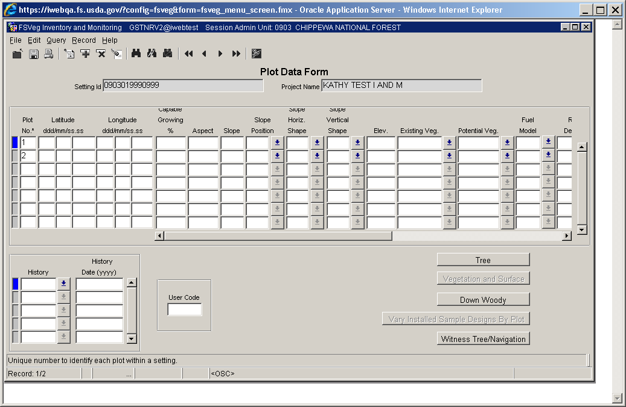

There are five buttons in the lower right corner of the window, as outlined in Table 72.

Table 72: Plot Data Form buttons

| **Button** | **Description** |
| --- | --- |
| Tree | Access the Tree Data form associated with the selected plot |
| Veg and Surface | Access the Understory Vegetation and Surface Cover forms associated with the selected plot |
| Down Woody | Access the Down Woody Material form associated with the selected plot |
| Vary Installed Plot Designs by Plot | This form is used to DESELECT a sample design for a plot. When a new plot is entered ALL sample designs are automatically linked to the plot. And, when a new sample design is created, it is automatically linked to ALL existing plots. If a specific sample design was NOT collected on a plot (i.e., down wood data was not collected on plot 3), change the “installed” column from a “Y” to a “NULL.” |
| Witness Tree/Navigation | This button is only active when you enter through the Inventory and Monitoring screen; if you enter through CSE this button is grayed out. This form allows you to enter data into either the Witness Tree or Navigation sections of this form. |

#### Plot Number (maximum of 3 numbers) Required

This is the plot number for each plot within a setting. Plots do not have to be numbered consecutively.

Use a global positioning system (GPS) unit to determine the plot latitude and longitude of all plots. Collect at least 180 GPS readings at plot center, which will then be averaged by the GPS unit. Each individual reading should have an error of less than 70 feet if possible (the error of all the averaged readings is far less). Soon after arriving at plot center, use the GPS unit to attempt to collect coordinates. If suitable readings (180 readings at error < 70 feet) cannot be obtained, try again before leaving the plot center.

#### Plot Latitude (exactly 8 numbers)

This is the plot latitude as measured by a Global Positioning System (GPS) All Latitude values will be positive (North assumed). Degrees must be from 18-71 inclusive, minutes must be from 0-59 inclusive, and seconds must be from 0-59.99 inclusive.

#### Plot Longitude (exactly 8 numbers)

This is the plot longitude as measured by a Global Positioning System (GPS) All Longitude values will be positive (West assumed). Degrees must be from 44-172 inclusive, minutes must be from 0-59 inclusive, and seconds must be from 0-59.99 inclusive.

#### Capable Growing Area Percent (maximum of 3 numbers)

Estimate the percent of the plot area capable of supporting trees on a 1/20th acre plot. Deduct non-forest inclusions such as roads, creeks, swamps, rock outcrops, unimproved dirt lanes, small streams, sites with standing or running water, a high water table, a rock outcropping, severe soil compaction (i.e., an old landing), or mass soil movement (slips, slides, or slumps), etc. For example, if an area contains 5% rock outcropping and 10% road, record a capable growing area of 85%.

Accuracy Standard: ± 10 percent

##### Example 1

Large, scattered boulders cover 25 percent of the plot. However, tree roots can fully utilize the space between the boulders. The boulders thus have no effect on potential tree stocking. Capable growing area is thus 100%.

Figure : Capable growing area



##### Example 2

A swampy meadow covers 10% of the plot. Capable growing area is thus 90%.

Figure : Capable growing area



#### Plot Aspect (maximum of 3 numbers)

This is the predominant plot aspect in degrees. 0° to 360°. Record true north (i.e., always set the declination on your compass). Aspect may be determined from contour maps. Aspect is determined along with the direction of slope for land surfaces with at least five percent slope in a generally uniform direction. Aspect is measured with a hand compass along the same direction used to determine slope.

* If aspect changes gradually across the plot, record as average aspect
* If aspect changes across the plot but is predominantly of one direction, code predominate aspect, rather than the average
* If the plot falls on or straddles a canyon bottom or narrow ridge top, code the aspect of the ridgeline or canyon bottom
* If the plot falls on a canyon bottom or on a narrow ridge top, but most of the area lies on one side hill, code the aspect of the side hill
* Use a code of zero for flat
* Use a code of 999 for indeterminate, no predominant aspect, or undulating

Examples of plot aspect are provided in Table 73.

Table 73: Example of plot aspect in degrees

| **Code** | **Description** |
| --- | --- |
| 0 | Flat |
| 360 | 360° |
| 72 | 72° |
| 90 | 90° |
| 999 | Indeterminate/No predominant aspect/Undulating |

Accuracy Standard: ± 45 degrees

#### Plot Slope (maximum of 3 numbers)

Record the angle of slope across the plot. Slope is determined by sighting the clinometer along a line parallel to the average incline (or decline). This angle is measured along the shortest pathway down slope before the drainage direction changes. To measure Slope, Observer 1 should stand at the uphill edge and sight Observer 2, who stands at the downhill edge. Sight Observer 2 at the same height as the eye-level of Observer 1. Read the slope directly from the percent scale of the clinometer.

* If slope changes gradually across the plot, record an average slope
* If slope changes across the plot but the slope is predominantly of one direction, code predominate slope percentage rather than average
* If slope falls directly between two side hills, code the average slope of the side hill(s)
* If the slope falls on a canyon bottom or on a narrow ridge top, but most of the area lies on one side hill, code the slope of the side hill

Accuracy Standard: ± 10 percent

#### Slope Position (exactly 2 characters)

This is the plot position on the landscape. Slope definitions are from: National Soil Survey Handbook (Title 430-VI), USDA Soil Conservation Service, 1993.

Accuracy Standard: ± 1 class

Table 74: Example of plot aspect in degrees

| **Code** | **Description** |
| --- | --- |
| SD | Summit/Ridgetop/Plateau. The topographically highest hillslope position of a hillslope profile and exhibiting a nearly level surface. |
| SH | Shoulder. The hillslope position that forms the uppermost inclined surface near the top of a hillslope. It comprises the transition zone from backslope to summit. |
| BS | Backslope. The hillslope position that forms the steepest inclined surface and principal element of many hillslopes. In profile, backslopes are commonly steep, linear, and bounded by a convex shoulder above and descending to concave footslope. They may or may not include cliff segments. Backslopes are commonly erosional forms produced by mass movement and running water. |
| FS | Footslope. The hillslope position that forms the inner, gently inclined surface at the base of a hillslope. In a profile, footslopes are commonly concave. It is a transition zone between upslope sites or erosion and transport. |
| TS | Toeslope. The hillslope position that forms the gently inclined surface at the base of a hillslope. Toeslopes in profile are commonly gentle and linear, and are constructional surfaces forming the lower part of a hillslope continuum that grades to valley bottom. |
| VB | Valley Bottom. Wide valley bottom beyond influence of toeslope. |

Figure : Slope position

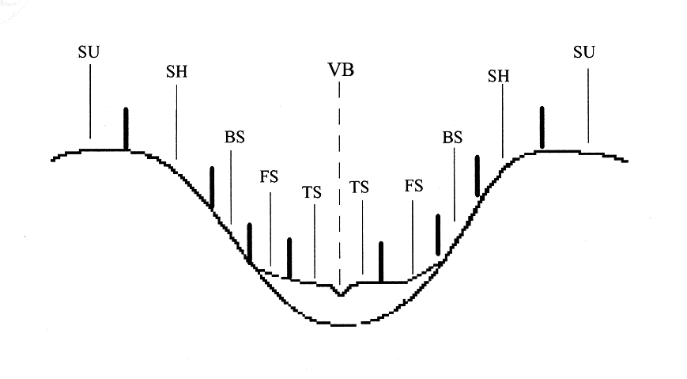

#### Slope Horizontal Shape (exactly 2 characters)

This is the micro-site horizontal shape of the plot. The horizontal shape is oriented across the slope, perpendicular to the vertical shape, or roughly parallel to the contours of the landforms. It goes from side-slope to side-slope. Use 1/10-acre plot for ocular estimated. Valid codes are the same as Slope Vertical Shape as defined below.

#### Slope Vertical Shape (exactly 2 characters)

This is the micro-site vertical shape of the plot. The vertical shape lies perpendicular to the contours, going from up-slope to down-slope, regardless of the slope percentage. See Figure 15 for examples (size 1/10-acre ocular estimate). Note: at hilltops and depression bottoms, all directions are perpendicular to the contours and no direction is parallel. While the above definitions of horizontal and vertical shape really do not apply at these locations, both shapes are considered convex on hilltops and concave in depression bottoms, and their specific direction is irrelevant.

Table 75: Slope codes and descriptions

| **Code** | **Description** |
| --- | --- |
| BR | Broken. Cliffs, knobs, and/or benches interspersed with steeper slopes generally characterized by sharp, irregular breaks. A marked variation of topography, or an irregular and rough piece of ground. |
| CC | Concave. The gradient decreases down the slope. Runoff tends to decelerate as it moves down the slope, and if it is loaded with sediment the water tends to deposit the sediment on the lower parts of the slope. The soil on the lower parts of the slope also tend to dispose of water less rapidly than the soil above it. |
| CV | Convex. The gradient increases down the slope and runoff tends to accelerate as it flows down the slope. Soil on the lower part of the slope tends to dispose of water by runoff more rapidly than the soil above it. The soil on the lower part of a convex slope is subject to greater erosion than that on the higher parts. |
| LL | Linear or Planar. Substantially a straight line when seen in profile at right angles to the contours. The gradient does not increase or decrease significantly with distance (level or little relief). |
| PA | Patterned. A general term for any ground surface exhibiting a discernibly ordered, more-or-less symmetrical, morphological pattern of ground (i.e., micro relief of hummock and swales of several feet). |
| UN | Undulating. One or more low relief ridges or knolls and draws within the plot area. |
| UA | Unable to Access. |

Figure : Vertical and horizontal slope illustrations

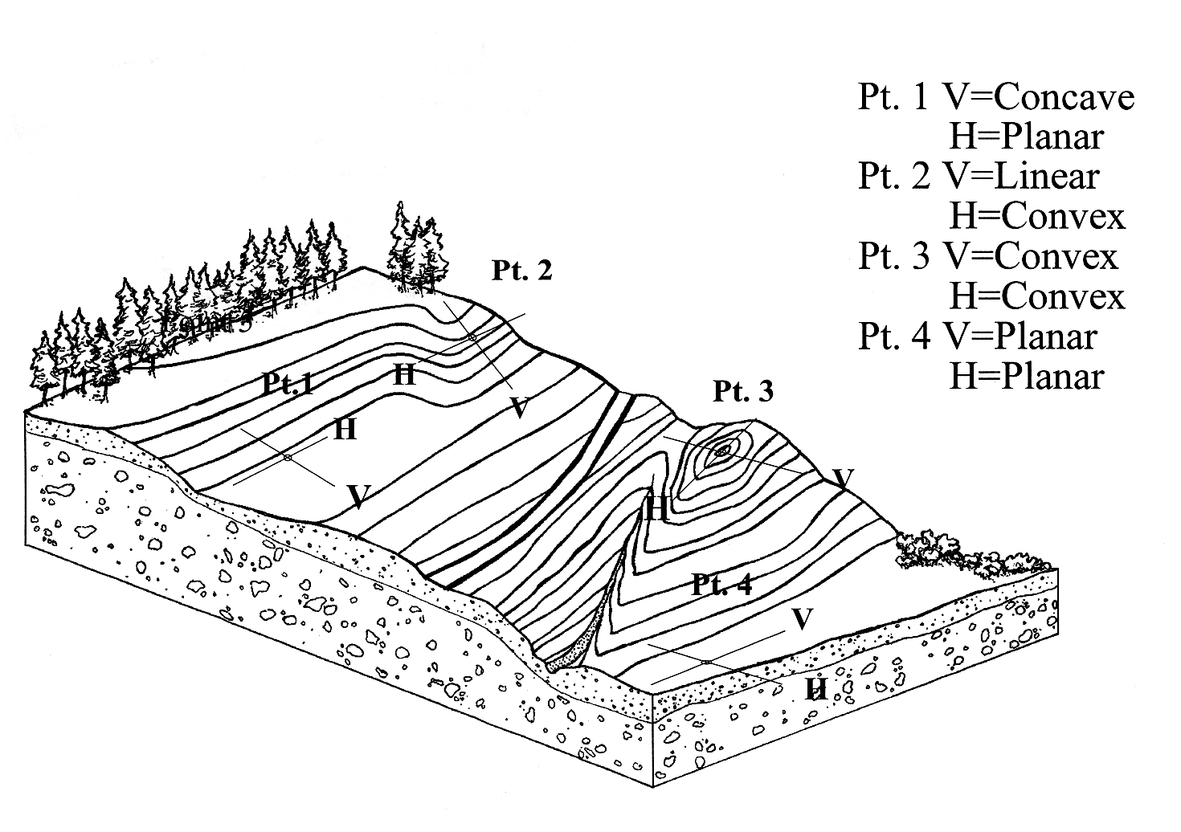

#### Plot Elevation (maximum of 5 numbers)

The setting median elevation, above sea level, in feet:

Accuracy Standard: ± 2 contour intervals on provided maps

#### Plot Existing Vegetation Composition Type (maximum of 8 characters and/or numbers)

This is the dominant existing vegetation composition. Dominance is based on plurality of basal area. Existing vegetation reflects plant species currently present. See [Appendix E of the User Guide](http://fsweb.nris.fs.fed.us/products/FSVeg/documentation.shtml) for a complete list of existing vegetation codes.

#### Plot Potential Vegetation (maximum of 8 characters and/or numbers)

This is the potential vegetation composition code. Potential vegetation is the plant community that would become established if all successional sequences were completed without interference by man and under the present climatic and edaphic conditions, including those created by man. See [Appendix G of the User Guide](http://fsweb.nris.fs.fed.us/products/FSVeg/documentation.shtml) for a complete list of potential vegetation codes. It is assumed that the potential vegetation code for the plot is the same as that referenced for the setting.

Accuracy Standard: accurate to series, understory union, and Forest- or District-specified phases (three possible discrepancies)

#### Fuel Model (maximum of 2 numbers)

This is the predominant fuel model that best describes the plot. Refer to [Appendix N of the User Guide](http://fsweb.nris.fs.fed.us/products/FSVeg/documentation.shtml) for more information on fuel models.

#### Residue Descriptive Code (maximum of 15 characters and/or numbers)

This is the residue descriptive code or photo number of the photo that best represents the residue in the plot. This field is only recorded when a photo series for estimating fire behavior is used to determine Fuel Model. Refer to [Appendix H of the User Guide](http://fsweb.nris.fs.fed.us/products/FSVeg/documentation.shtml) for a complete list of Fuel Photo references and codes.

Since this data is collected at the plot level, it will only be used in the Forest Vegetation Simulator (FVS) when an individual plot is used as the simulation unit. The plot data is not combined to produce a stand-alone value that is sent to FVS. A stand-level value can be hand-entered into the FVS-ready database, however this must be done each time the FVS database is newly created.

#### Distance to Seed Wall (maximum of 3 numbers)

This is the distance, in feet, from the plot center to the boundary of an adjoining stand where there are seed-producing trees, or a seed wall. Typically, this value is recorded where most of the overstory has been removed or destroyed within the last 20 years. If the distance is more than 999 feet, record a value of 999.

Accuracy Standards: ± 100 feet

#### Plot History (maximum of 2 numbers)

These are the activities that occurred on or affected the plot. Multiple codes may be entered if more than one event is observed. For each additional event, record the plot number and history code on the next consecutive line.

Table 76: Plot history codes and descriptions

| **Code** | **Description** |
| --- | --- |
| 1 | Site preparation |
| 2 | Artificial regeneration |
| 3 | Natural regeneration |
| 4 | Stand improvement |
| 5 | Tree cutting |
| 6 | Fire |
| 7 | Other silvicultural treatments |
| 8 | Other human disturbance |
| 9 | Natural disturbance |
| 10 | Land Clearing |
| 11 | Insect/disease outbreak |
| 12 | Animal damage |
| 13 | Type conversion |
| 14 | Mining |
| 15 | Clear cut |
| 16 | Heavy partial cut (≥20% removed) |
| 17 | Light partial cut (≤20% removed) |
| 18 | Firewood or local use cut |
| 19 | Incidental cut |
| 20 | Pre-commercial thin |
| 21 | Improvement cut |
| 22 | Planting throughout the stand |
| 23 | Planting within non-stocked holes in the stand |
| 24 | Under-planting |
| 25 | Clean and release |
| 26 | Chaining |

#### Plot History Date (exactly 4 numbers)

This is the 4-digit year in which a disturbance/activity occurred based on field observations. If a history code is entered, a date is required.

Accuracy Standards: Nearest decade

#### Plot Remarks (maximum of 255 characters and/or numbers)

These are remarks relevant to the plot.

#### User Code (maximum of 4 characters and/or numbers)

The data entered in this field is not managed at the National level, and is stored in a generically labeled field. Before using this field, check with your Region and Forest in case there are specific instructions on using this field.

### Witness Tree/Navigation Form

By default, the Witness Tree Information radio button is selected and the fields in this section are enabled when you open the form. If there is no data entered in the Witness Tree Information section of this form, you can select the Navigation Information radio button to enable the fields in that section of the form. You are not able to enter data into both of these sections.

If there is data entered into one of the sections but you want to enter data into the other section, you will need to delete all of the existing data before you enter any data into the other section. If you try to enter data into both sections, you will receive the following error message:

Figure : Navigation warning

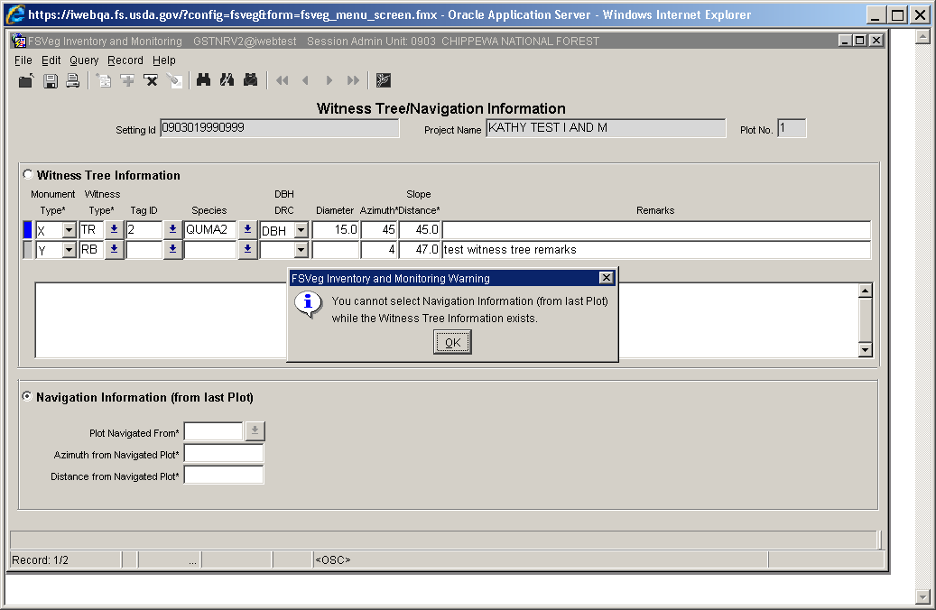

Remember that you can only access this form when you are in the Inventory and Monitoring portion of the application, not CSE.

Figure : Witness Tree/Navigation Information form

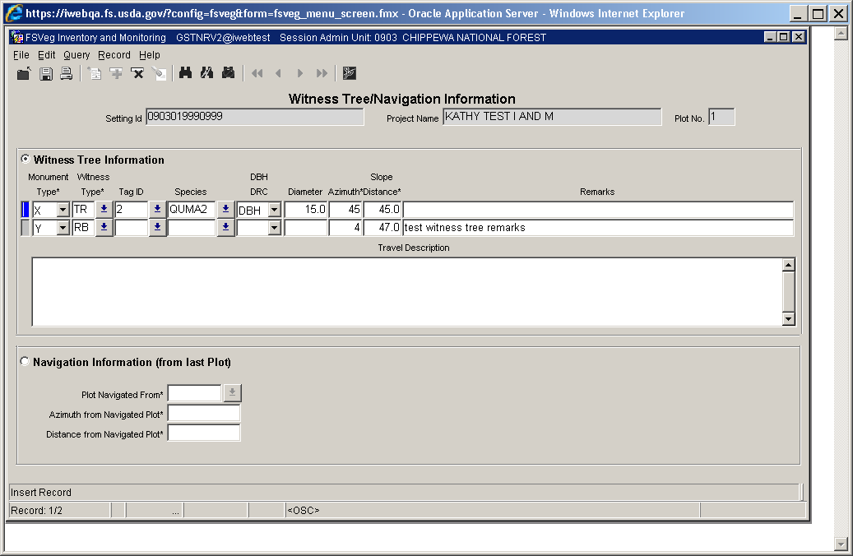

Table 77: Fields and descriptions

| **Field** | **Description** |
| --- | --- |
| Setting ID | This information is automatically filled in based on the data you were working with immediately prior to opening this form. |
| Project Name | This information is automatically filled in based on the data you were working with immediately prior to opening this form. |
| Plot No. | This information is automatically filled in based on the data you were working with immediately prior to opening this form. |

#### Witness Tree Information Section

This section of the form allows you to enter specific details about the Witness Tree of interest.

Figure : Witness Tree Information



Table 78: Witness Tree Information fields and descriptions

| **Field** | **Required?** | **Description** |
| --- | --- | --- |
| Monument Type | Yes | There are only two valid values for this field: X or Y. If you decide to enter data into the Witness Tree Information section of this form, you MUST enter one record in this column with an X and the other with a Y, as shown in Figure 7 below. |
| Witness Type | Yes | This field provides you with a valid list of values to choose from. Only values in this list can be used in this field, as shown in Figure 8 below. |
| Tag ID | No | This field is only activated if you enter “TR” in the Witness Type field. This field provides a valid list of values for you to choose from. This list of values comes from the existing tag IDs in the tree list. Duplicate tag IDs in this field are allowed. If the Witness Tree is initially set to “TR” and you change this to any other type in the drop-down list, the Tag ID field will be nulled out. |
| Species | No | This field provides a drop-down list of valid values. Only values in this list may be used. If a Tag ID is entered, only the species from that specific Tag ID in the tree list can be entered in this field. If the Witness Type is initially set to “TR” and you change this to any other type in the drop-down list, the Species field will be nulled out. |
| DBH/DRC | In some cases | Only values provided in this drop-down list can be used in this field. This field is required if the Witness Type is “TR.” |
| Diameter | In some cases | This is the diameter, in inches, of the witness tree. This field is required if the Witness Type is “TR.” |
| Azimuth | Yes | This field contains the azimuth measurements, in degrees. Valid values are between 0 and 360. |
| Slope Distance | Yes | This field contains the slope distance measurement, in feet. Valid values are 0 to 99999.9 (inclusive). |
| Remarks | No | This field allows you to enter any important notes about the specific plot you are working with. |
| Travel Description | No | It is important that another scientist can find the plots in the database, therefore very specific travel instructions are necessary. This field should include directions from the nearest FS office or Interstate, if possible, to the plot, providing detailed directions (including NSEW information and distances). |

Figure : Monument Type drop-down

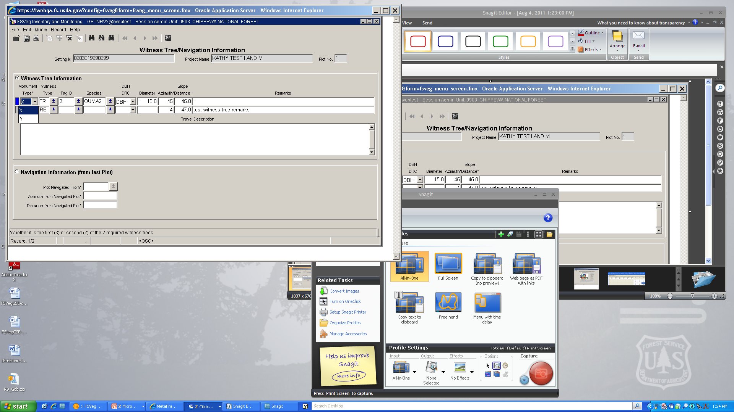

Figure : Witness Type LOV

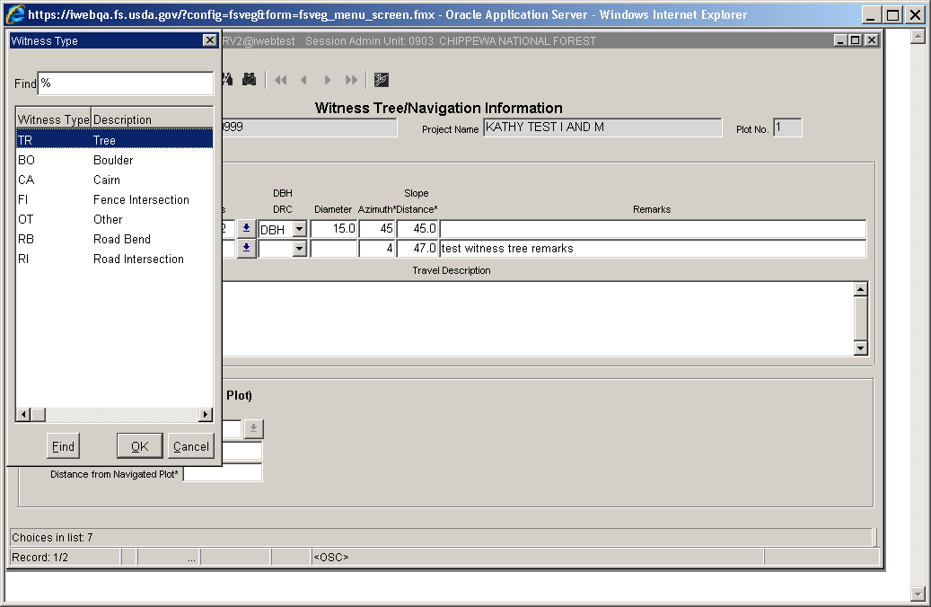

Figure : Tag ID LOV

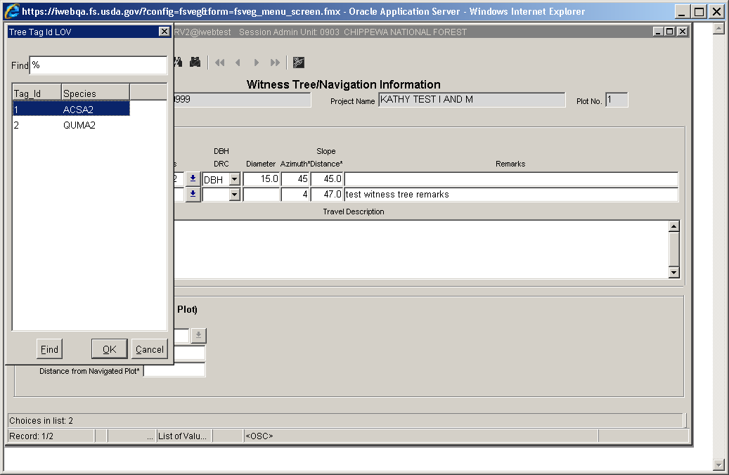

Figure : DBH/DRC drop-down list

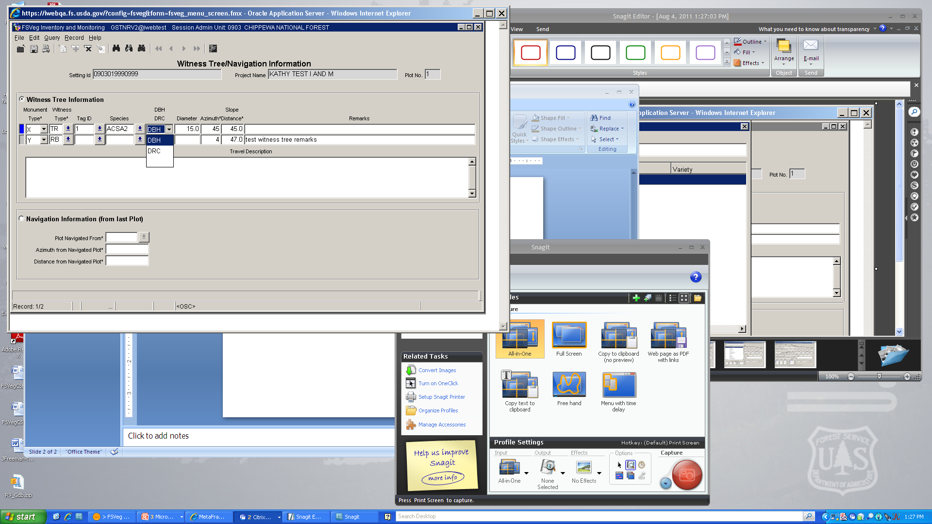

#### Navigation Information (From Last Plot) Section

If you elect to enter information into this section of the form, all of the fields in this section are required.

Figure : Navigation Information



Table 79: Navigation Information section fields and descriptions

| **Field** | **Required?** | **Description** |
| --- | --- | --- |
| Plot Navigated Form | Yes | This drop-down menu provides a list of all plots EXCEPT the one you are currently working on. |
| Azimuth from Navigated Plot | Yes | This field contains the azimuth, in degrees, that the plot you are working with is from the last plot you navigated from. Valid values are between 0 and 360 (inclusive). |
| Distance from Navigated Plot | Yes | This field is the distance, in feet, that the plot you are working on is from the last plot you navigated from. Valid values are 0 to 99999.9 (inclusive). |

## Tree Data

The optional Tree Data form is used to record tree data. Required and optional tree data depends on the exam type. Data are not recorded if the plot does not contain trees or off-plot site trees. DO NOT use this form to collect data on “pieces” of trees, use the down woody form to collect data on pieces of trees. Do not enter any information on this form for plots that do not contain trees.

The accuracy standard is “No Errors” unless otherwise noted.

There are three exam intensities: quick plot, extensive, and intensive.

### Quick Plot

A quick plot exam may group trees by species, diameter, heights, and/or damage classes on both large and small plots. These exams collect stand structural data in an efficient manner. Measurement tolerances are relaxed to allow for ocular estimation of many parameters. The diameters of live trees are taken to the nearest 2 inches; standing dead tree heights are recorded in 10-foot classes. Limited tree damage information is collected, growth data is not collected, and small tree measurements are not made other than a percentage of the understory vegetation. Limiting the information gathered and reducing measurement accuracy standards significantly reduces cost. The main uses of a quick plot are:

* Cover and stand structure estimates by vegetative layer
* Exams in single species or single storied stands
* Timber stand improvement inspections
* Post treatment examinations
* General surveys such as dwarf mistletoe surveys
* Supplemental cruise plots to reduce costs for timber sale preparation

### Extensive

An extensive exam collects accurate tree measurements to tolerance standards tighter than a quick plot, but not as tight as an intensive exam. Tree diameters are taken to the nearest inch. Trees on the large plot are recorded individually; trees on the small plot may be recorded in groups. Some tree damage information is collected. The main uses of an extensive exam are:

* Minimum data required to execute growth and yield models
* Exams in multistoried stands
* Silvicultural prescriptions

### Intensive

An intensive exam collects accurate tree measurements to tight tolerance standards. It provides a comprehensive inventory for unique stands in their entirety. Trees on the large plot are recorded individually, but trees on the small plot may be recorded in groups. Diameters of live trees are measured to the nearest 1/10th of an inch. Heights are measured to the nearest foot. Detailed tree damages are collected. The main uses of an intensive exam are:

* Projecting stand volume, defect, and mortality
* Exams in complex stands in terms of species and size
* Tree growth information for use in tree models, and growth and yield studies
* Silvicultural prescriptions

Table 80: Required fields in different examination levels

| **Field** | **Quick plot** | **Extensive Plot** | **Intensive Plot** |
| --- | --- | --- | --- |
| Plot Number | Yes | Yes | Yes |
| Tag ID | Yes | Yes | Yes |
| Tree Status | Yes | Yes | Yes |
| Tree Class | No | No | No |
| Site/GST Tree | No | No | Yes |
| Tree Species | Yes | Yes | Yes |
| Tree Count | Yes | Yes | Yes |
| Diameter (DBH/DRC) | DBH for trees > 4.5 feet tall | DBH for trees > 4.5 feet tall | DBH for trees > 4.5 feet tall |
| Tree Height | Trees < 4.5 feet tall | Trees < 4.5 feet tall | Trees < 4.5 feet tall |
| Height to Crown | No | No | No |
| Radial Growth | No | No | GST only |
| Radial Growth 2 | No | No | No |
| Height Growth | No | No | GST only |
| Age | No | No | GST/site only |
| Crown Ratio | No | No | Live trees only |
| Crown Class | No | No | No |
| Crown Width | No | No | No |
| Damage Category | No | Yes | Yes |
| Damage Agent | No | No | Yes |
| Damage Part | No | No | No |
| Damage Severity | No | Yes | Yes |
| Wildlife Use | No | No | No |
| Log/Snag Decay | No | If Dead/Down is taken | If Dead/Down is taken |
| Cone Serotiny | No | No | No |
| Number of Stems | DRC only | DRC only | DRC only |
| Remarks | No | No | No |

#### Entering Tree Data Using PC Client Forms

If data are collected on a paper form, it may be entered into FSVeg using the PC client forms. Required fields are indicated with an asterisk (*) after the field name. The top line contains the setting ID and project name obtained from the Setting form, and the plot number obtained from the Plot Data form. This information cannot be altered here. For each line of tree data (upper block), multiple lines of damage data (lower block) can be entered.

Figure : Tree Data Form

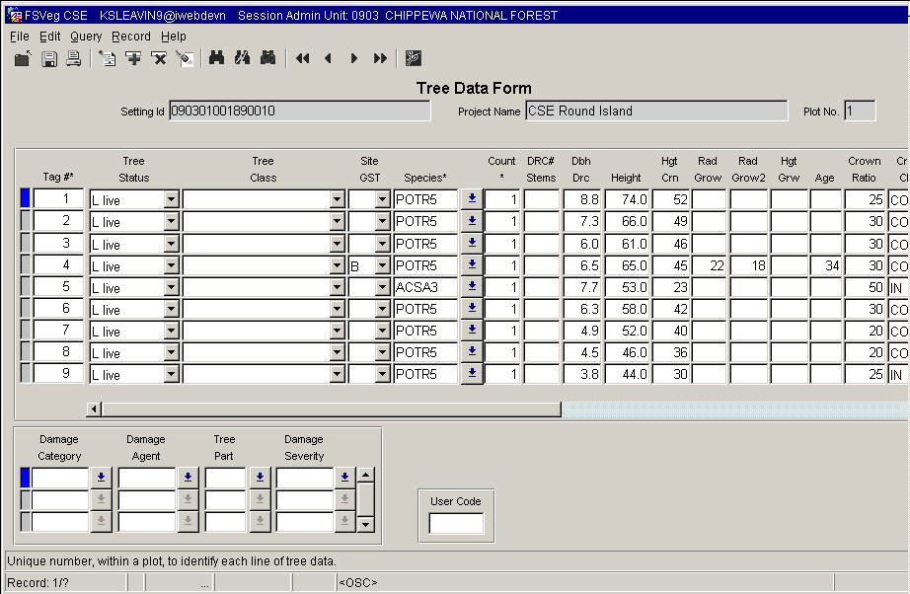

#### Plot Number (maximum of 3 numbers)

Plot numbers should be unique within a setting.

#### Tag ID (maximum of 4 numbers)

This is a number, unique within each plot, for each tree record. On each plot, start with “1” and increment one number for each tree record. The tag ID, in conjunction with the plot number, uniquely identifies each line of tree data in a setting.

#### Tree Status (exactly 1 character) Required

Table 81: Tree Status codes and descriptions

| **Code** | **Description** |
| --- | --- |
| L | Live – includes all standing trees that have at least one green point of growth. This includes deciduous trees that have lost their foliage for the season, and trees that have recently lost their leaves to defoliators, but will re-flush. |
| D | Dead – standing trees 4.5 feet or taller, without a green point of growth. Note: many of the tree fields are not used if the tree is a dead tree. If dead trees are recorded, a snag decay class is required for extensive and intensive exam levels. |
| S | Stump – woody base of a tree left in the ground less than 4.5 feet tall. Note: many tree form fields are not used for stumps. |
| X | Down dead – includes all dead trees that have their main stem lying on the ground, or are supported by branch wood. A tree is considered down if it is not self-supporting. Record any broken trees as one tree. If down dead trees are recorded, a log decay class is required for extensive and intensive exam levels. Only trees in decay class 1 or 2 should be recorded here. |
| Y | Down live – includes all live trees that have their main stem lying on the ground or are supported by branch wood. A tree is considered down if it is not self-supporting. Record broken trees as one tree. |

#### Tree Class (exactly 2 characters)

Tree class is used to describe the condition of each tree in relation to its potential to satisfy silvicultural objectives. Tree Class refers to the tree’s ability to live, grow, and yield commercial products. Each tree is assigned to a tree Class code individually, without regarding other trees in the stand. The assignment of Tree Class does not presume any particular stocking guidelines, cutting cycles, or rotation ages. Tree Class is partly predicted on whether the tree currently or potentially contains a merchantable sawlog. Merchantability standards are defined locally (as opposed to a national standard).

Table 82: Tree class codes

| **Code** | **Tree Class** | **Live** | **Species** | **Vigor** | **Damages or Snag Decay Class** |
| --- | --- | --- | --- | --- | --- |
| DE | Desirable | Y | Commercial | * Relatively vigorous for its age, as evidenced by past growth rate and/or crown condition | * No defects that will reduce merchantable sawlog yields * No damaging agent that affects growth or survival |
| AC | Acceptable | Y | Commercial | * Relatively non-vigorous for its age as evidenced by slow past growth and/or poor crown condition * Still retains the potential to grow and accumulate net merchantable volume | * Has some minor defects which will reduce, but not totally exclude, merchantable sawlog yields * May possess damaging agents in minor amounts that will not affect survival of the tree for the next 10 years |
| UA | Un-acceptable | Y | Commercial | * Expected to die within next 10 years * Not accumulating net volume growth; deteriorating more rapidly than growing * If relieved of competition, it would not release and accumulate net merchantable volume | * Has a severe rating for any damaging agent * Does or will meet minimum merchantability standards |
| RF | Rough | Y | Non-commercial for sawlog yields | * Smaller than the minimum size for sawlog merchantability * Presently does not contain a merchantable live sawlog | * Not expected to yield any sawlog products because of severe damage other than rot * Principle defects are physical defects, including trees culled for multiple forks |
| RN | Rotten | Y | Any | * Presently does not contain a merchantable live sawlog * Smaller than the minimum size for sawlog merchantability | * Principle defect is rot * Not expected to yield any sawlog products because of severe damage by rot |
| SV | Salvable dead | N | Any | * Contains at least one merchantable sawlog | * At least 25% sound |
| US | Non-salvable dead | N | Non-commercial | * Does not contain at least one merchantable sawlog | * Less than 25% sound |
| GS | Growing stock | Y | Commercial | * A live saping (1.0- to 4.9- inches DBH) with minor or no evidence of form defects, insects, or disease, that is expected to become a growing-stock (sound) tree 5.0 inches DBH or larger with good form or vigor * A live tree (5.0 inches DBH or larger) that has less than 67 percent of the merchantable volume cull, and contains at least one solid 8-foot section (now or prospectively for poletimber-sized trees), reasonably free of form defect, on the merchantable bole |  |

Accuracy Standards: (*providing damage/severity is correct and consistent with the tree class definition)

Table 83: Tree Status codes and descriptions

| **Tree Class Code** | **Acceptable Tolerance** |
| --- | --- |
| DE | DE, AC |
| AC | DE, AC, UA |
| UA | AC, UA (RF, RN)* |
| RF | RF (RN)* |
| RN | RN (UA)* |
| SV | SV, US |
| US | SV, US |

#### Site/Growth Trees (exactly 1 character)

Record if a tree is a Site or Growth Sample Tree. If tree is neither, leave blank.

##### Site Tree (S)

A site tree is a tree for which age and height are measured to determine site index and yield capacity for a tree. Some site index tables may require collection of additional data, for example, some Grand fir site index tables also require crown ratio data. Site trees have never experienced any overstory competition or damage that would have reduced height growth during any period of their life. Freedom from height growth suppression is the single most important selection criteria for site trees. A number of descriptive guidelines may be used to indicate this condition. Site trees must be of a species for which site index relationships have been studied. The number of site trees per setting should reflect the setting variation and possible management objective. Productive capability can also be estimated from potential vegetation classification. Following is a summary of site tree selection criteria.

##### Site Selection Criteria

1. Freedom from height growth suppression
   1. Choose dominants or co-dominants depending on the specific site index curves used
   2. No evidence of top damage, past or present
   3. No damage that could influence height growth
   4. No pronounced period of radial growth suppression
2. Select trees from a locally defined species list; species preference is based on the quality of the associated site index-yield study
3. Similar age class, preferably middle-aged, avoiding old growth and young age classes; Typically > 50 years and < 120
4. Select at least one site tree from the sample trees tallied for each sample plot when the sample trees meet site tree criteria.

##### Growth Sample Trees (GST)

A growth sample tree is a tree for which age, growth (radial or height), and height are measured. These GST measurements are the minimum needed to calibrate Forest Vegetation Simulation (FVS) routines for obtaining additional vegetation data. A GST tree requires an age as it is used to age the stand.

If only one tree species is expected to be present in the stand, one large (≥3.0” DBH) GSTs and two small (<3.0” DBH) GSTs will be measured on each plot. The first live standing tree, both large and small, of each species encountered moving clockwise from north, will be measured until two trees of different species are assessed, i.e., four total per plot in a multi-species stand. Do not select the Radial growth trees until you have tallied ALL trees on a plot, both the large and small trees. This will insure ensure that you do not skip the trees greater than 3 inches DBH that may be found on the small tree plot and which may be one of the first trees from Due North required to be a GST tree.

If age cannot be determined due to rot, select the next tree as GST. If the tree has a missing or dead top, select the next tree as a GST.

This minimum GST data collection may not provide sufficient trees for FVS calibration in multiple tree species stands, in stands with fewer than five plots, or where the stand exam is needed for a particular resource management question. Therefore, Regional or Forest project standards may result in requirements for additional GST sampling.

To ensure sufficient trees for FVS calibration, of each stand, the guidelines outlined in Table 84 are suggested, but not required.

Table 84: Required fields in different examination levels

| **Size Class** | **Diameter Range (inches)** | **Height Range (feet)** | **Growth Measurement** |
| --- | --- | --- | --- |
| 1 | <3.0 | 1-4 | 5-year height growth |
| 2 | <3.0 | 5-12 | 5-year height growth |
| 3 | <3.0 | 13+ | 5-year height growth (if feasible) |
| 4 | 3.0 – 4.9 | n/a | 10-year radial growth / 5-year height growth (if feasible) |
| 5 | 5.0 – 9.9 | n/a | 10-year radial growth |
| 6 | 10.0 – 14.9 | n/a | 10-year radial growth |
| 7 | 15.0 – 19.9 | n/a | 10-year radial growth |
| 8 | 20.0+ | n/a | 10-year radial growth |

Select the five live standing sample trees of each species in each size class encountered in the stand. Collect age, height, and the appropriate growth increment on this tree. Select the second tree tallied across the plots, by size class and species, and collect height and growth increment only. In order for the sample trees to be distributed, select the second GST in each class on a different plot than the first. Note: if a second tree is not tallied on a different plot, the second height and growth measurement in the size class are not required.

|  |  |
| --- | --- |
|  | **Note** The objective of the GST guidelines is to obtain an unbiased and representative sample of trees for species of interest across the stand so that FVS growth modelling for both small and large trees can be “calibrated,” or modified, to be closer to the growth that was observed. The best results for a particular species are obtained when a range of size classes in both small and large trees is collected, which is why the above matrix is provided. Also, at least five GST trees in each size category (small or large) must be sampled in order for calibration to occur; any fewer would mean that growth would not be calibrated for that species in that category.  The minimum GST collection guideline in the CSE protocol (two large and two small trees for up to two species per plot) is designed to achieve this for most stands. However, in small stands involving few plots or in stands with multiple species, it may be necessary to select more than that.  It is not necessary to designate GST trees for species in which you are not interested. For example, you may have a multiple-species stand that includes, for example, Gambel oak and your analysis is not particularly concerned with nor would be affected by it, so it’s ok not to sample it for growth.  Similarly, it’s ok to emphasize to your field crews to be sure to collect species of interest, such as Douglas-fir. |

#### Tree Species (maximum of 8 characters and/or numbers) Required

This is the species of each sampled tree. If the species cannot be determined in the field, measure the tree, but bring branch samples, foliage, cones, flowers, bark, etc. to your local biologist for identification. Temporarily use one of the two generic codes (2TE or 2TD) and make a not to correct the species code later.

Examples:

* ABGR – Grand fir (Abies grandis)
* JUOS – Utah juniper (Juniperus osteosperma)
* PIPOS – Ponderosa pine (Pinus ponderosa var. scopulorum)
* 2TREE – tree
* 2TE – tree, evergreen
* 2TD – tree, deciduous

#### Tree Count (maximum of 3 numbers) Required

This is the number of sampled trees represented by each line of tree data. Record growth sample trees and site trees individually. Trees with the same tree status and species, and a DBH/DRC less than 5.0 inches (not a GST or Site tree), may be grouped by height classes. One height grouping method is:

* <0.5 feet
* 0.5 – 4.9 feet
* 5 – 12.9 feet
* 13 – 18.9 feet
* 19+ feet

Record trees ≥5.0 inches DBH/DRC individually for intensive and extensive examinations. Trees may be recorded in groups for quick plot examinations. One possible grouping is tree status, species, and 2” diameter classes. Any seedling forked above ground is counted as one tree.

The height grouping reflects age class distribution. Distinguishing characteristics other than tree status, species, and height may warrant further grouping or individual tree recording. Such characteristics include age, crown ratio, crown class, or tree damage.

Select the median tree to sample tree characteristics, such as DBH, height, etc.

Table 85: Sample tree characteristics

| **Height Range** | **Diameter Range** | **Actual Trees on Point** | **Missed Tree Tolerance** |
| --- | --- | --- | --- |
| All | All | 0 | 0 trees |
| ≤ 0.5 feet | n/a | 1 – 5 | ± 2 trees |
| ≤ 0.5 feet | n.a | 6+ | ± 50% |
| > 0.5 feet | < 0.5 inches | 1 – 5 | ± 1 tree |
| > 0.5 feet | < 0.5 inches | 6+ | ± 20% |
| All | 0.5” – Breakpoint DBH | 1 – 5 | ± 1 tree |
| All | 0.5” – Breakpoint DBH | 6+ | ± 10% |
| All | Breakpoint DBH + | 1+ | 0 trees |

When contracting exams, there is zero tolerance for recording a tree when none are actually present in any of the above size classes. The recording of a fixed plot tree when none are present will result in a single discrepancy. The recording of a variable plot tree when none are present will result in an unacceptable unit.

#### Number of Stems (maximum of 3 numbers)

This is the number of stems for DRC measured species. This is a required field if the diameter of the tree is measured at the root collar.

#### DBH/DRC (maximum of 3 numbers; may include one decimal)

Unless one of the special situations described below is encountered, measure Diameter at Breast Height (DBH) at 4.5 Feet above the ground line on the uphill side of the tree. Measure Diameter at Root Collar (DRC) species at the root collar. DO NOT record a DBH of zro. Select the median tree to record the DBH/DRC for grouped trees.

Table 86: sample DBH/DRC codes and descriptions

| **Code** | **Description** |
| --- | --- |
| .3 | 0.3 inches diameter |
| 9.5 | 9.5 inches diameter |
| 18.7 | 18.76 inches diameter |

* Intensive Exams – record to the nearest 0.1-inch
* Extensive Exams – record to the nearest inch
* Quick Plot Exams – record to the nearest 2 inches

##### DBH

DBH is outside bark diameter at 4.5 feet above the forest floor on the uphill side of the tree. To determine breast height, the forest floor includes the duff layer that may be present, but does not include unincorporated woody debris that may rise above the ground line. If a dead tree (snag) is missing bark, measure the DBH without the bark and record that measurement.

* Forked tree: in order to qualify as a fork, the stem in question must be at least 1/3 the diameter of the main stem and must branch out from the main stem at an angle of 45 degrees or less. Forks originate at the point on the bole where the piths intersect. Forked trees are handled differently depending on whether the fork originates above or below 4.5 feet.
* Trees forked below 4.5 feet are treated as distinctly separate trees. DBH is measured for each stem at 4.5 feet above the ground.
* Trees forked at or above 4.5 feet count as one tree. If a fork occurs at or immediately above 4.5 feet, measure diameter below the fort just beneath any swelling that would inflate DBH.
* Stump sprouts originate between ground level 4.5 feet on the boles of trees that have died or been cut. Stump sprouts are handled the same as forked trees, with the exception that stump sprouts are not required to be 1/3 the diameter of the dead bole. Stump sprouts originating below 1.0 feet are measured at 4.5 feet from ground line. For multi-stemmed woodland species, treat all new sprouts as part of the same new tree.
* Tree with irregularities at DBH: on trees with swellings, bumps, depressions, and branches at DBH, diameter will be measured immediately above the irregularity at the place it ceases to affect normal stem form. If this is not possible, because of the vertical extent of the irregularity, then adjust the DBH measurement to better reflect the diameter of a regular bole.
* Tree on slope: measure diameter at 4.5 feet from the ground along the bole on the uphill side of the tree.
* Leaning tree: measure diameter at 4.5 feet from the ground along the bole.
* Turpentine tree: usually in the Southeast. The tree is scarred to collect sap, mostly for naval products. A “turpentine face” is a result of this scarring. On trees with turpentine face extending above 4.5 feet, estimate the diameter of 10.0 feet above the ground and multiply by 1.1 to estimate DBH outside bark.
* Independent trees that grow together: if two or more independent stems have grown together at or above the point of DBH, continue to treat them as separate trees.
* Missing wood or bark: if 50% or more of the circumference of the bole is intact, reconstruct the diameter at DBH.
* Diameter on stump: use a logger’s tape, cloth tape, or ruler to measure the longest and shortest axis across the top of the stump. Record the diameter as the average of the two measurements.

###### Proper Use of a Diameter Tape

Figure : How to measure tree

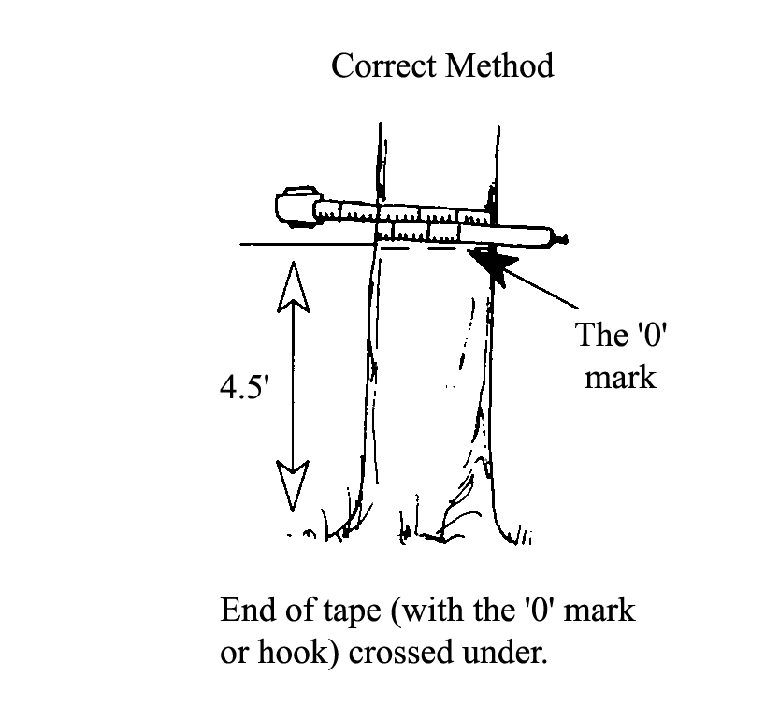

Figure : Left-handed tree measurement

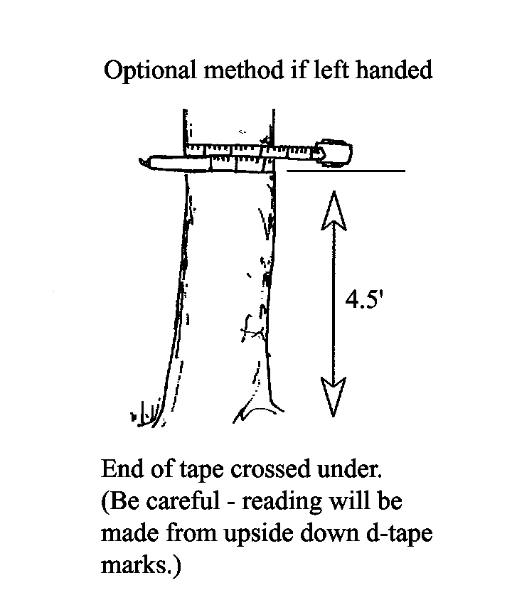

Press the tape firmly against the tree. Do not pull it out at a tangent to the tree at the point of measurement.

Figure : Hold tape against tree

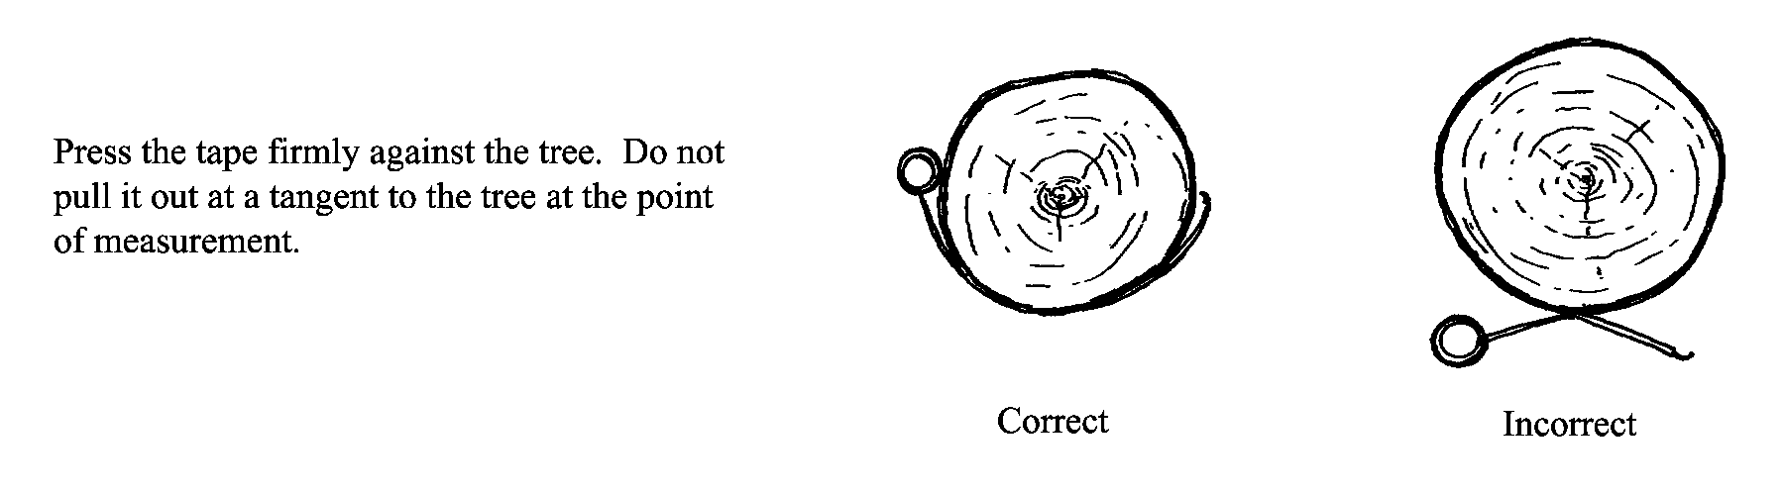

Tape must be at right angles to lean of tree.

Figure : Measure leaning tree correctly

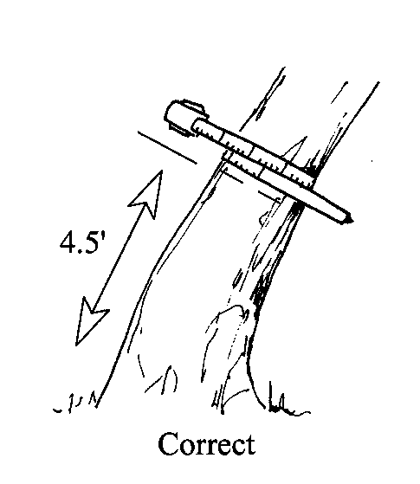

Figure : Incorrect measurement of leaning tree

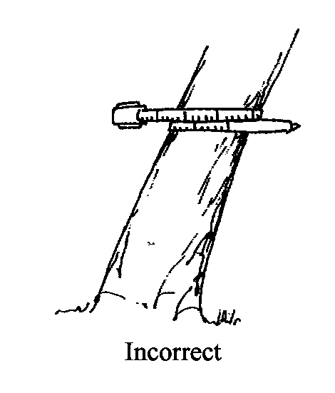

Do not place tape at abnormal location on bole of tree.

Figure : Correct measurement of bole of tree

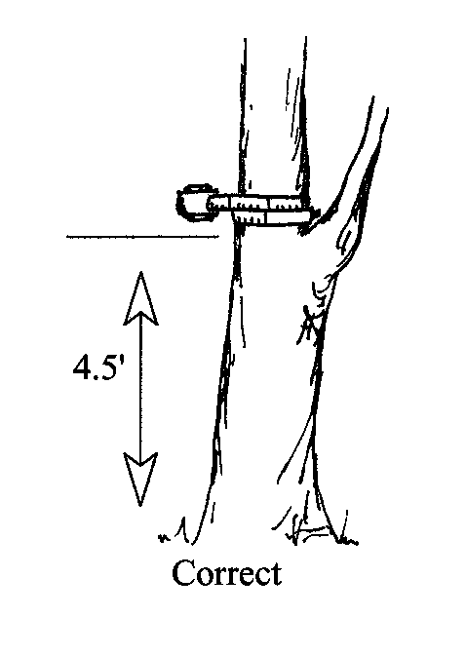

Figure : Incorrect tree measurement

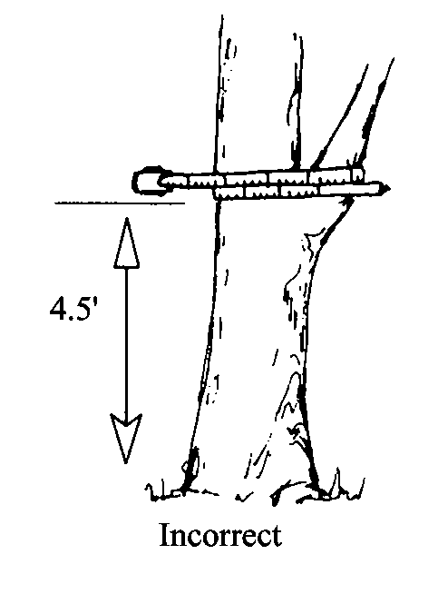

###### Point of Measurement for DBH

Figure : Correct DBH measurement for tree on slope

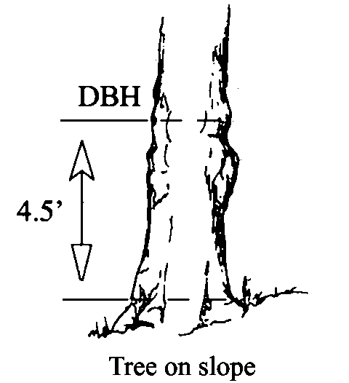

Figure : Correct DBH measurement for tree on level ground

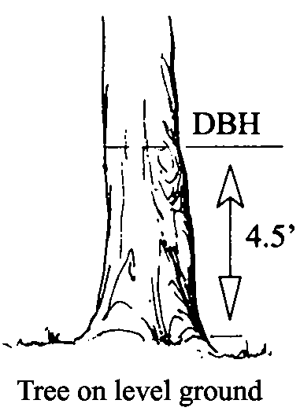

Figure : DBH measurement of deformed tree

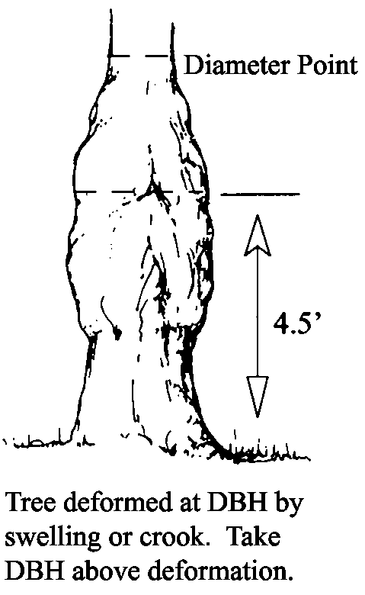

Figure : Diameter point of standing tree

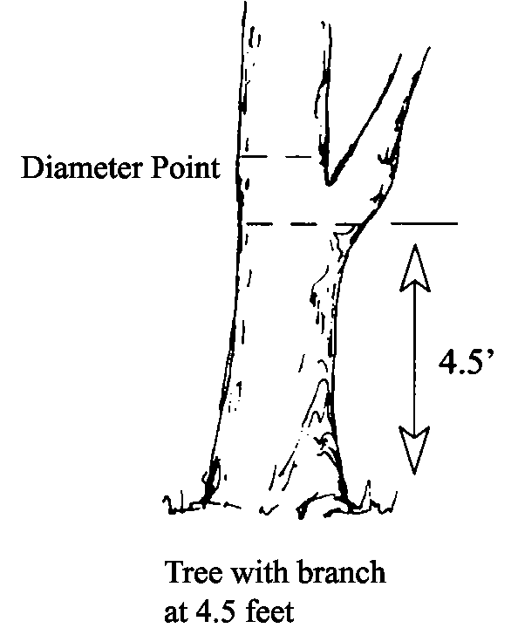

Figure : Diameter point of windthrown tree

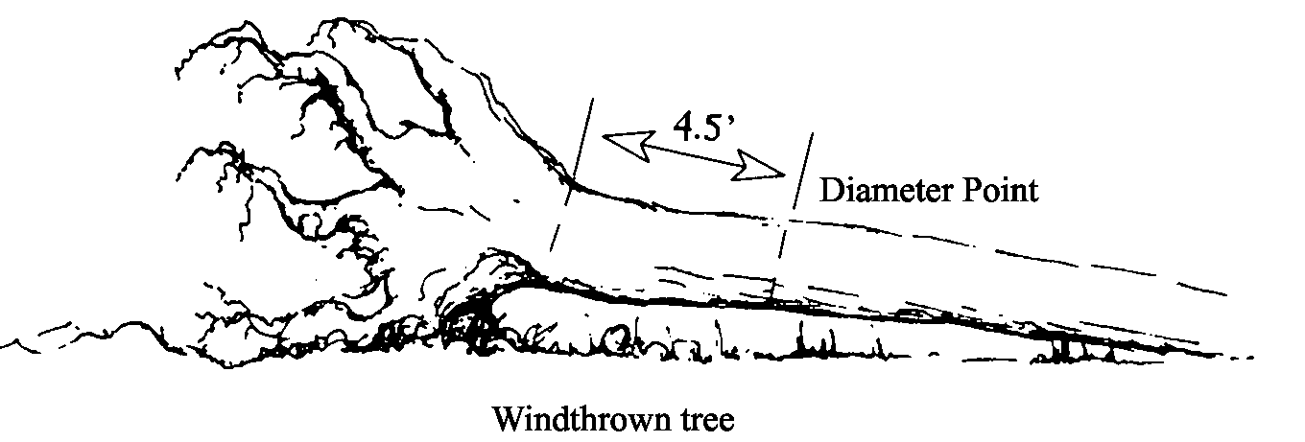

Figure : DBH measurement of leaning tree

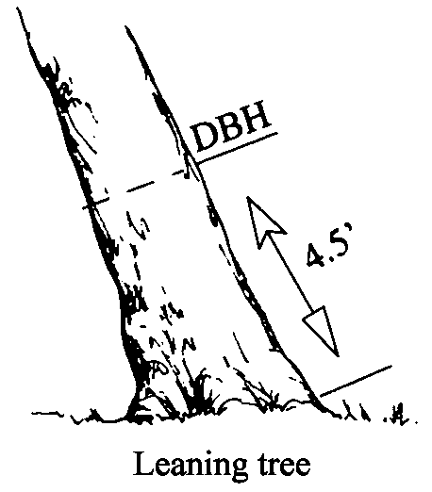

Figure : Measure DBH on bottleneck tree

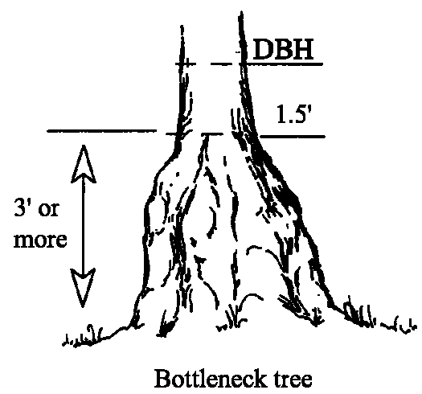

Figure : Measure tree with a catface

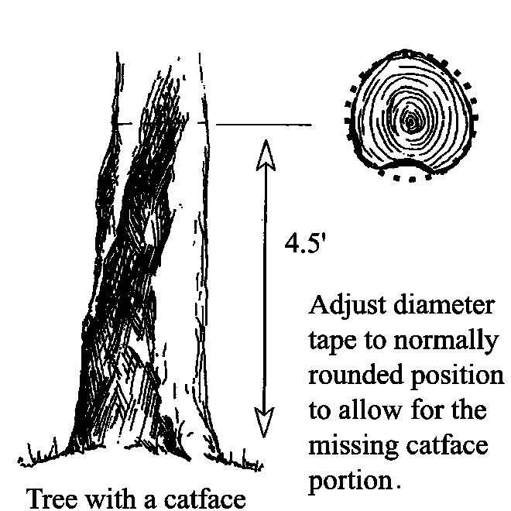

Figure : DBH measurement

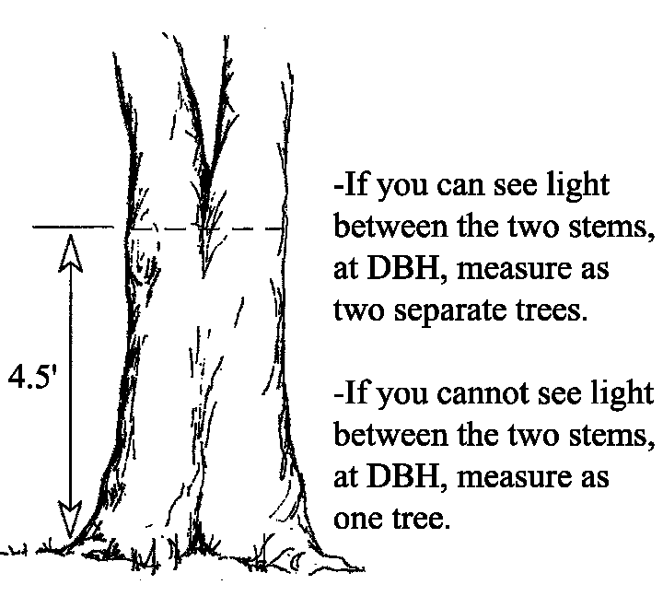

Figure : Forked tree DBH measurement

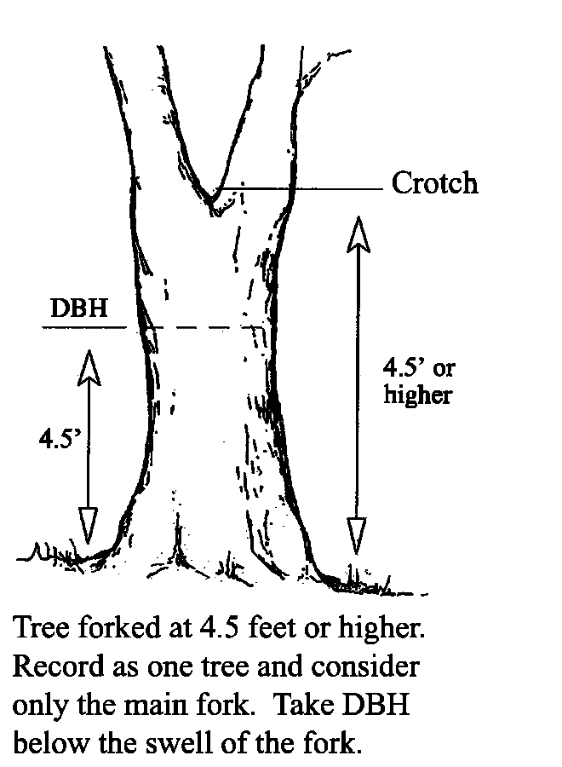

Figure : Diameter point

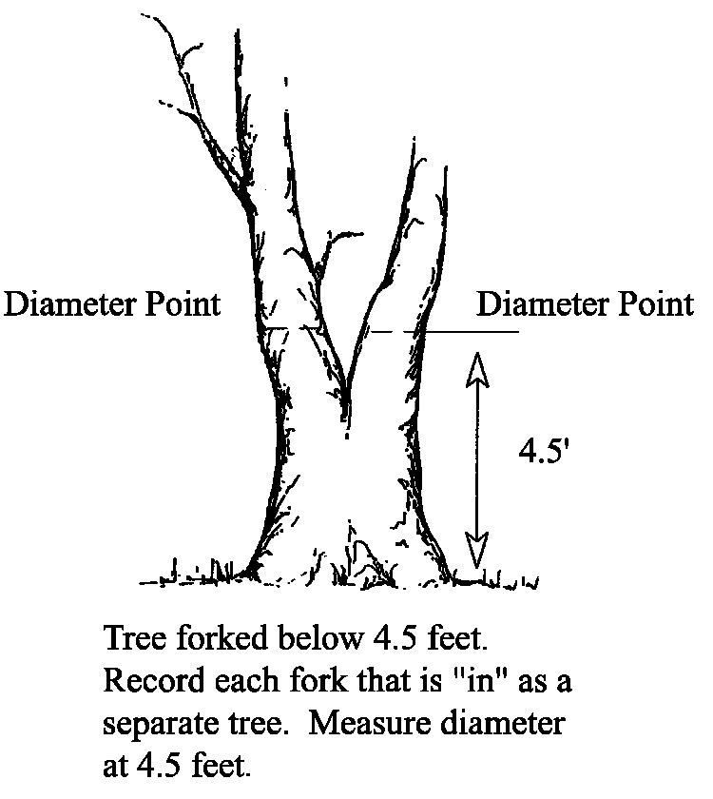

Figure : Diameter point on forked trees

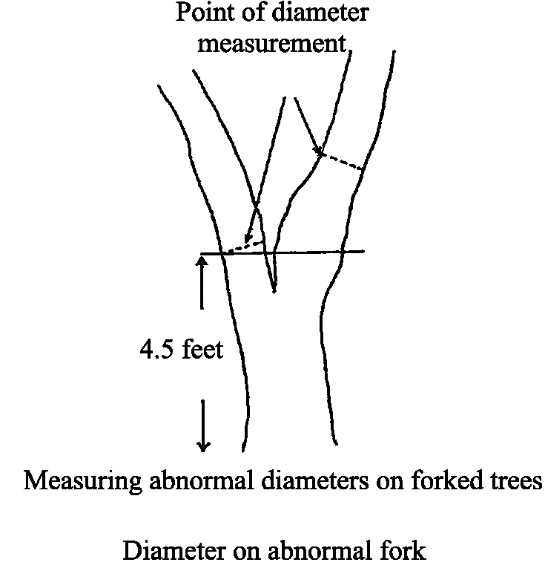

Figure : Measure up bole of tree

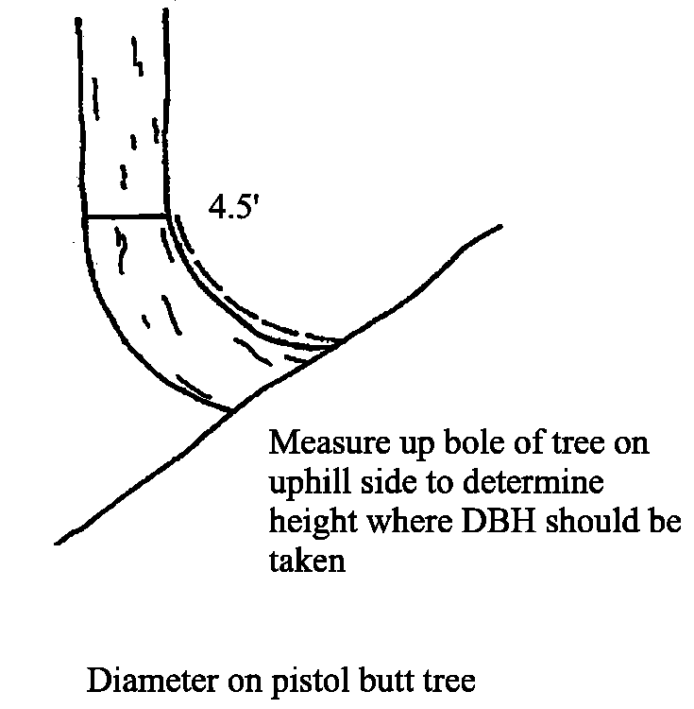

Figure : DBH measurement for pistol butt shaped tree

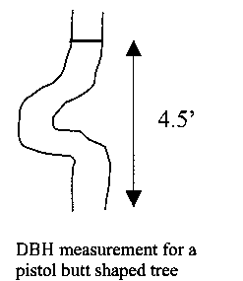

Figure : DBH measurement of forked tree

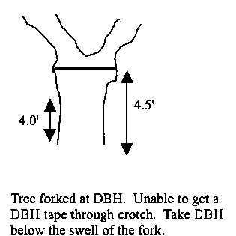

##### DRC

Diameter at Root Collar (DRC) is the diameter measured at the root collar or at the natural ground line, whichever is higher, outside the bark. Measure tree stems only, not branches. A stem generally grows in an upright position and contributes to the main structural support of a tree crown. If the diameter is measured at root collar, the number of stems is required.

DRC-measured trees commonly have multiple stems. DRC-measured trees with stems clumped together and for a unified crown and appearing to be from the same origin are treated as one tree. If necessary for diameter measurement, remove loose material on the ground but not mineral soil. For multi-stemmed DRC-measured trees with at least one stem ≥5.0” at the root collar, DRC is computed as the square root of the sum of the squared stem diameters. For a single-stemmed tree, DRC is equal to the single diameter measured. For a multi-stemmed tree, DRC is calculated from the diameter measurements of all qualifying stems (≥1.5” diameter and at least one foot in length).

Use the following formula to computer DRC. Record individual stem diameters in the tree form “REMARKS” column for future reference.

DRC = n 

Example: Tree #1 has three qualifying stems: 5.9, 2.4, and 1.5.

DRC =  = 6.5

When DRC is impossible or extremely difficult to measure with a diameter tape (e.g., due to thorns, extreme limbs, packrat’s nest), the stem(s) may be estimated to the nearest inch. Note “estimated DRC” in the tree form “REMARKS” column.

Accuracy Standards:

* <0.5 inch – No Errors
* 0.5 – 13.9 inches - ±0.1 inch
* 14.0 – 23.9 inches - ±0.2 inch
* 24.0 – 34.9 inches - ±0.3 inch
* 35.0 inches - ±0.5 inch
* Borderline variable plot trees - ±0.1 inch (for the purpose of determining trees in or out)
* Estimated DRC - ±1 inch

##### DRC Spec (# of Stems) in Common Stand Exam

You can automatically have DRC calculated by making a selection in the ExamsPC software for CSE. In CSE, click on Setup in the main menu, then select Field Selections.

Figure : Setup menu

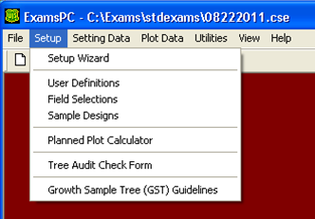

This Field Selection window now opens. Click on “Next” to access the Tree Selection screen. Scroll down until you see the “DRC Spec (# Stems)” line and put an “X” in the Selected column. Repeat this for the Quick, Extensive, and Intensive Tree Selection tabs.

Figure : Quick Tree Selection window

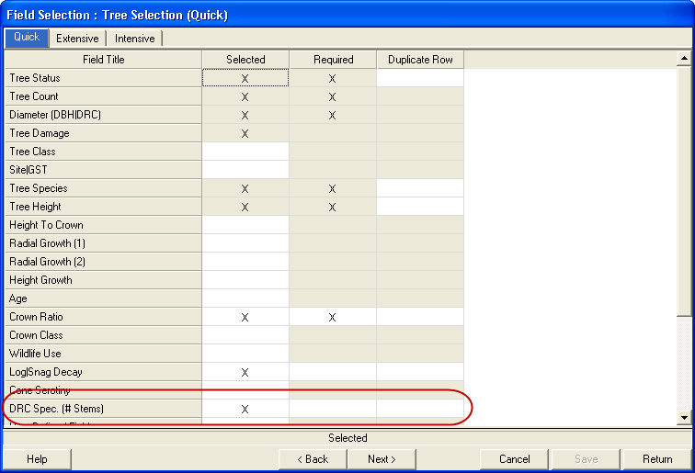

##### Point of Measurement for DRC

Figure : Measure ground line

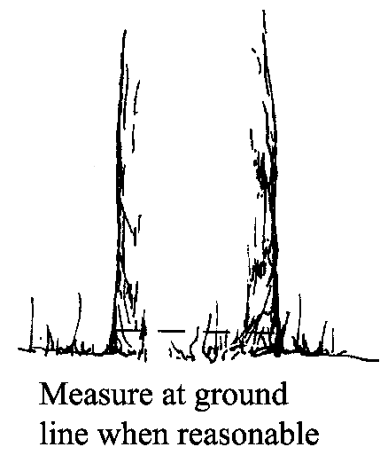

Figure : Measure above butt swell

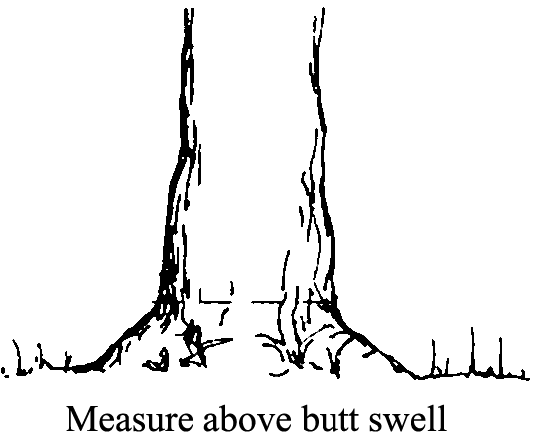

Figure : Excessive diameter below stems

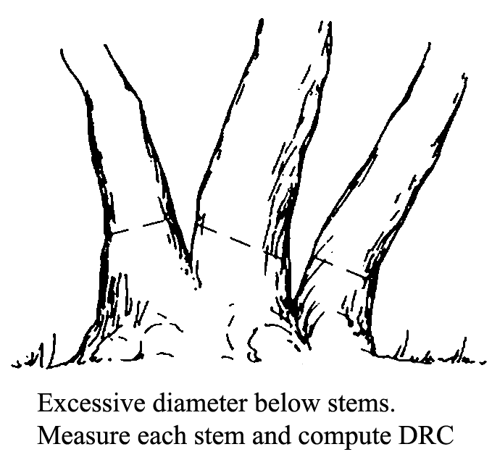

Figure : Multistemmed above diameter

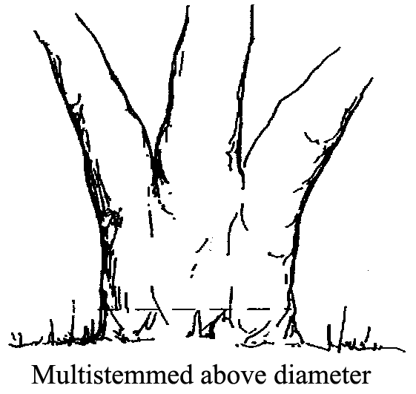

Figure : Measure missing stems

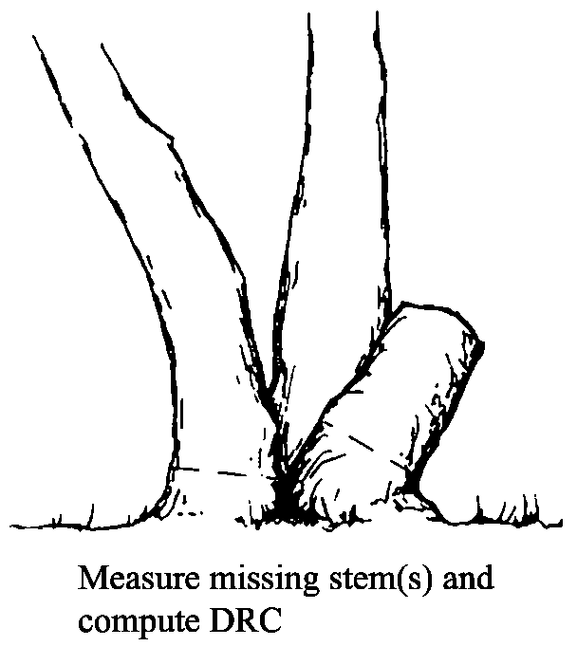

Figure : Multistemmed at or below ground

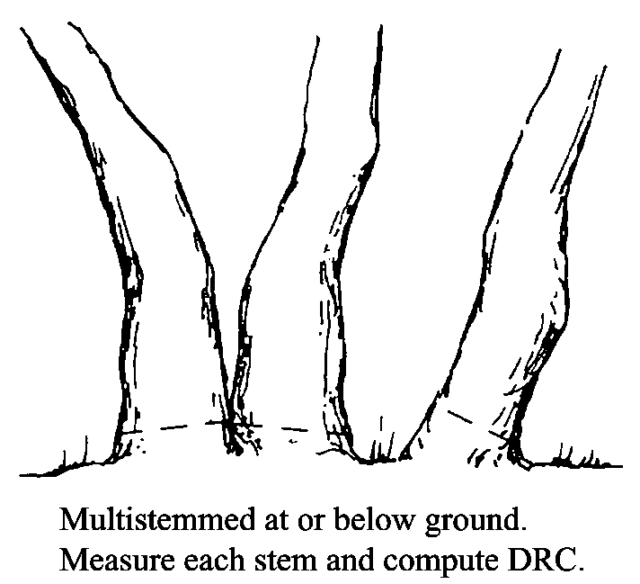

#### Height (maximum of 3 numbers)

This is the tree height, in feet, from ground line on the uphill side to the uppermost tip. If the top is broken or missing, record the height to the break, and record the appropriate physical damage code. Tree heights are required for:

* Site trees
* Growth sample trees
* Trees less than 4.5 feet tall; does not apply to DRC species
* All trees with broken or missing tops

Additional tree height should be measured and recorded when two adjacent sample trees of similar height can be viewed from the same vantage point, and when the height/diameter relationship of a particular tree seems atypical with respect to other trees of the same species.

Accuracy Standard:

* ± 10% for Intensive Exams
* ± 20% for Extensive and Quick Plot Exams

Examples:

Table 87: sample DBH/DRC recorded and actual heights

| **Recorded Height** | **Actual Height (Range)** |
| --- | --- |
| 0.5 | 0.5 feet tall |
| 23 | 22.5 – 23.4 feet tall |
| 151 | 150.5 – 151.4 feet tall |

Note: trees less than ½ foot tall (0.5 feet) can be recorded to the nearest 1/10th foot. All trees over 0.5 feet are recorded to the nearest foot.

##### Total Tree Height

Measure from the base of the tree on the high ground side to the tip of the tree leader. Measure height from a point uphill or on the same contour line as the tree. Record the total tree height to the nearest foot.

Figure : Total tree height

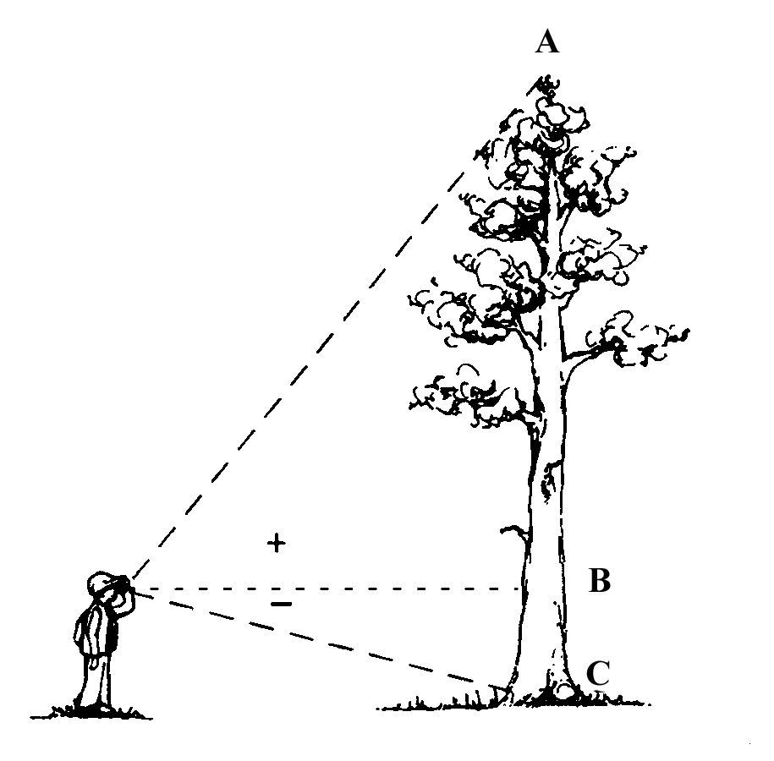

##### Leaning Trees

Trees leaning 25% (about 15”) or more from vertical require the following special height measuring technique.

Figure : Leaning tree

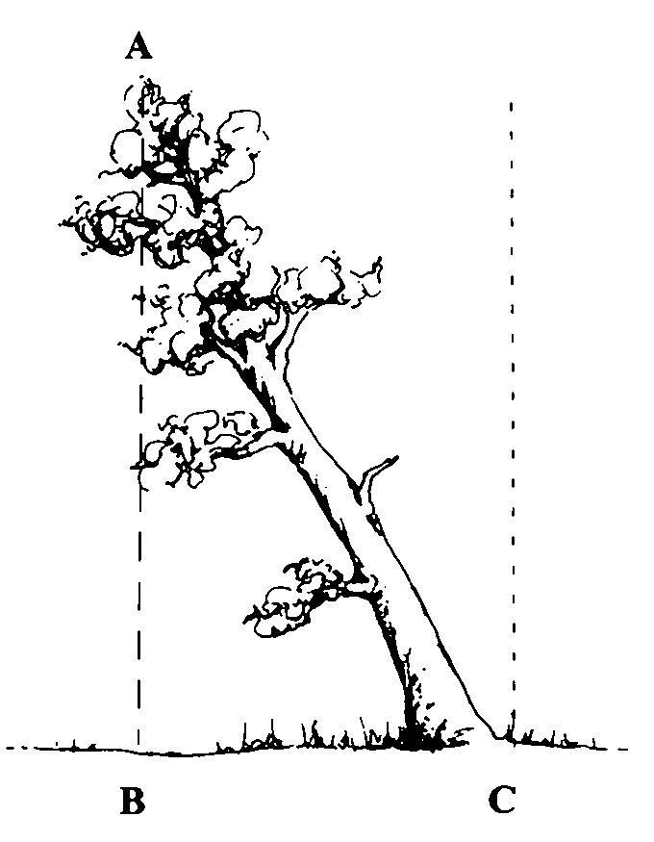

Locate point on ground directly under top of leaning tree. Measure height A-B, then measure horizontal distance B-C. Determine actual tree height (A-C) using one of two methods.

First, you can choose the Pythagorean theory for right triangles where:

Tree Height = 

Example:

* Measured height (A-B) = 120’
* Horizontal distance (B-C) = 40’
* Corrected tree height =  = 126.49

Second, you can use the information in Table 88.

Table 88: Horizontal Distance – tip to center of bole at ground (B-C)

| **MSHT** | **5** | **10** | **15** | **20** | **25** | **30** | **35** | **40** | **45** | **50** | **55** | **60** | **65** | **70** | **75** | **80** | **85** | **90** |
| --- | --- | --- | --- | --- | --- | --- | --- | --- | --- | --- | --- | --- | --- | --- | --- | --- | --- | --- |
| 40 | 40 | 41 | 43 | 45 | n/a | n/a | n/a | n/a | n/a | n/a | n/a | n/a | n/a | n/a | n/a | n/a | n/a | n/a |
| 50 | 50 | 51 | 52 | 54 | 56 | n/a | n/a | n/a | n/a | n/a | n/a | n/a | n/a | n/a | n/a | n/a | n/a | n/a |
| 60 | 60 | 61 | 62 | 63 | 65 | 67 | n/a | n/a | n/a | n/a | n/a | n/a | n/a | n/a | n/a | n/a | n/a | n/a |
| 70 | n/a | 71 | 72 | 73 | 74 | 76 | 78 | n/a | n/a | n/a | n/a | n/a | n/a | n/a | n/a | n/a | n/a | n/a |
| 80 | n/a | 81 | 81 | 82 | 84 | 86 | 87 | 89 | n/a | n/a | n/a | n/a | n/a | n/a | n/a | n/a | n/a | n/a |
| 90 | n/a | 91 | 91 | 92 | 94 | 95 | 97 | 98 | 101 | n/a | n/a | n/a | n/a | n/a | n/a | n/a | n/a | n/a |
| 100 | n/a | 101 | 101 | 102 | 103 | 104 | 106 | 108 | 110 | 112 | n/a | n/a | n/a | n/a | n/a | n/a | n/a | n/a |
| 110 | n/a | n/a | 111 | 112 | 113 | 114 | 116 | 117 | 119 | 121 | 123 | n/a | n/a | n/a | n/a | n/a | n/a | n/a |
| 120 | n/a | n/a | 121 | 122 | 123 | 124 | 125 | 126 | 128 | 130 | 132 | 134 | n/a | n/a | n/a | n/a | n/a | n/a |
| 130 | n/a | n/a | 131 | 131 | 132 | 133 | 135 | 136 | 138 | 139 | 141 | 143 | 145 | n/a | n/a | n/a | n/a | n/a |
| 140 | n/a | n/a | 141 | 141 | 142 | 143 | 144 | 146 | 147 | 149 | 150 | 152 | 154 | 157 | n/a | n/a | n/a | n/a |
| 150 | n/a | n/a | 151 | 151 | 152 | 153 | 154 | 155 | 157 | 158 | 160 | 162 | 164 | 166 | 168 | n/a | n/a | n/a |
| 160 | n/a | n/a | 161 | 161 | 162 | 163 | 164 | 165 | 166 | 168 | 169 | 171 | 173 | 175 | 177 | 179 | n/a | n/a |
| 170 | n/a | n/a | 171 | 171 | 172 | 173 | 174 | 175 | 176 | 177 | 179 | 180 | 182 | 184 | 186 | 188 | 190 | n/a |
| 180 | n/a | n/a | 181 | 181 | 182 | 183 | 183 | 184 | 186 | 187 | 188 | 190 | 191 | 193 | 195 | 197 | 199 | 201 |
| 190 | n/a | n/a | n/a | 191 | 192 | 192 | 193 | 194 | 195 | 196 | 198 | 200 | 201 | 203 | 204 | 206 | 208 | 210 |
| 200 | n/a | n/a | n/a | 201 | 202 | 202 | 203 | 204 | 205 | 206 | 208 | 209 | 211 | 212 | 214 | 215 | 217 | 219 |

MS HT = (A-B) measured height

##### Forked Trees

If tree forks below DBH, treat as two trees and measure height of each stem from base of tree to tip of tree.

Figure : DBH of forked trees

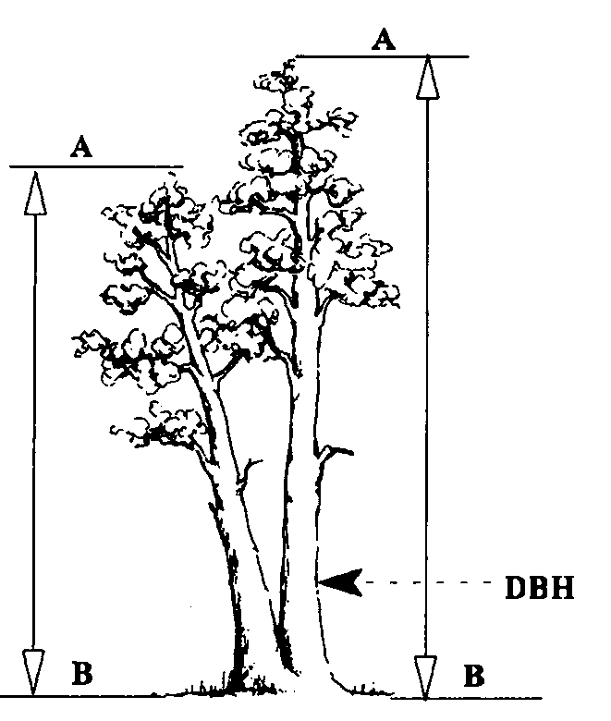

If the form crotch occurs at or above 4.5 feet on high ground side, the tree is treated is a single tree. Measure height of the tallest fork.

Figure : DBH with crotch tree

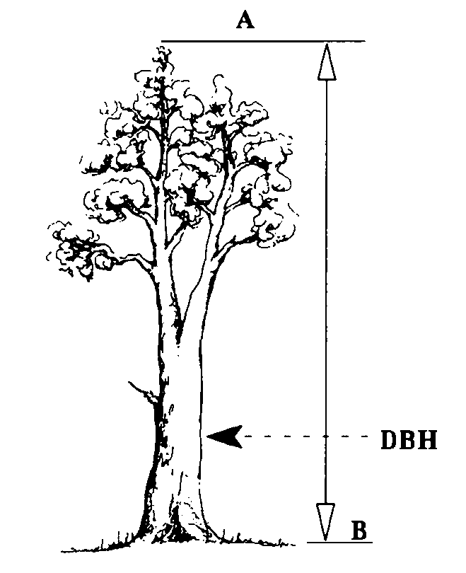

##### Forked Tree With Broken Top

The height of the tallest fork is measured and recorded in the “Total Height” field. Record a tree damage of “broken top.”

Figure : Tree with broken top

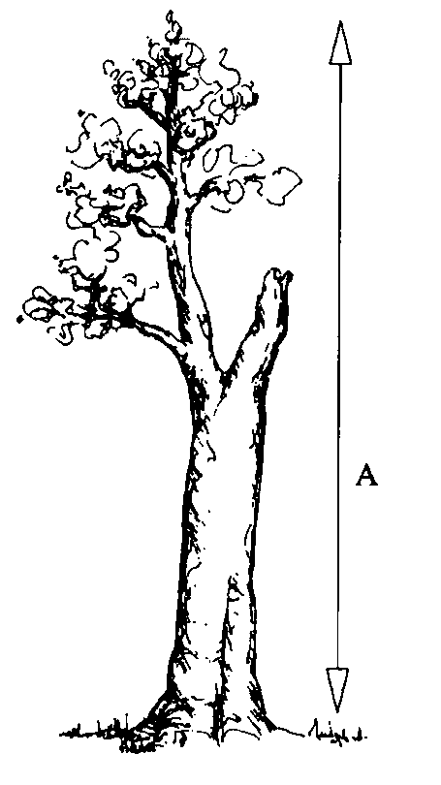

##### Trees With Missing Tops

Measure height of stub and record in the “Total Height” field. Record a tree damage of “missing top.” If the tree is forked, measure the height of the stub of the dominant fork.

Figure : Missing top tree

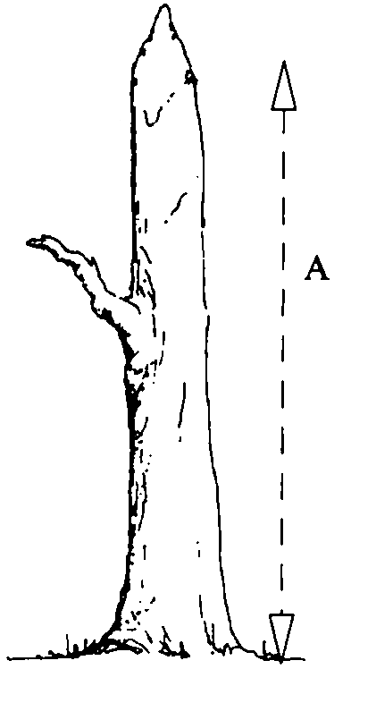

#### Height to Crown (maximum of 3 numbers)

This is the crown height, in feet, on the uphill side of the tree, from the ground line to the base of the live crown (the lowest branch whorl with live branches in at least two quadrants exclusive of epicormic branches and whorls not continuous with the main crown).

Accuracy Standard: ± 10%

Table 89: Sample height to crown recorded and actual heights

| **Recorded Height** | **Actual Height (Range)** |
| --- | --- |
| 1 | 0.1 – 1.4 feet (includes crowns that touch the ground) |
| 23 | 22.5 – 23.4 feet |
| 151 | 150.5 – 151.4 feet |

Figure : Angled trees

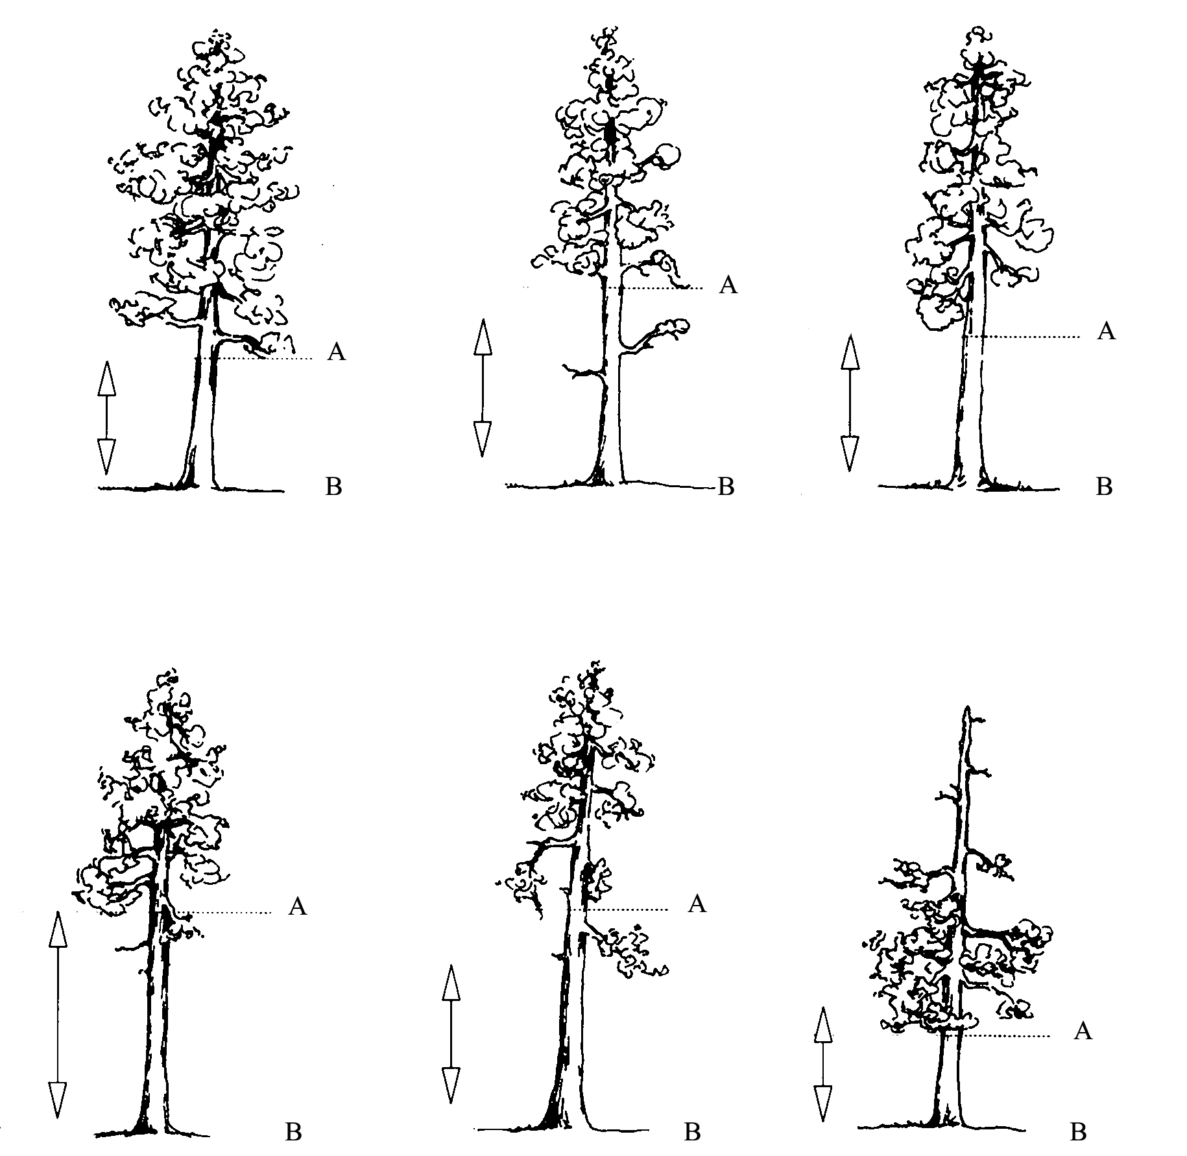

Measure the height from the base of the tree on the uphill side (B) to the base of the live crown (A). Base of the live crown is the lowest branch whorl with live branches in at least two quadrants exclusive of epicormic branching and of whorls not continuous with the main crown.

#### Radial Growth (maximum of 2 numbers)

This is the radial growth increment for Growth Sample Trees ≥ 3.0 inches diameter for DBH measured species to the nearest 1/20th of an inch. The default radial increment period is 10 years. Make the increment boring at breast height facing plot center. Measure the width of the outer complete annual increments up to the number of years equal to the growth period entered on the Setting form with a 1/20th of an inch scale ruler. Enter radial growth using integers only. Caution: some species (like aspen) are very susceptible to increment boring. Check with your Regional Silviculturist.

Accuracy Standard: ± 1/20 inch

#### Radial Growth #2 (maximum of 2 numbers)

This is the radial growth increment as specified above, but based on a second increment period. This default increment period is zero. When this field is used, enter a second increment period on the Setting form.

Accuracy Standard: ± 1/20inch

Table 90: Sample radial growth recorded and actual measurements

| **Recorded Measurements** | **Actual Measurements (Range)** |
| --- | --- |
| 6 | 6/20 radial growth (in 20th inch) |
| 24 | 24/20 radial growth (in 20th inch) |

1. Bore the tree just below the point of diameter measurement, on the side of the tree facing plot center to reduce bias in selecting the radial growth sampling cores. There can be considerable growth difference between the various areas of the same breast height X-section. Slope, aspect, influence from neighboring trees, etc., can affect the width of the growth rings in any given core area.
2. Count back 10 growth rings from the cambium end of the core.
3. Measure the length of this segment of the core to the nearest 1/20th inch to get radial increment. Enter this radial increment as the number of twentieths (e.g., 18/20 is recorded as “18” and 27/20 is recorded as “27”).

Figure : Growth rings

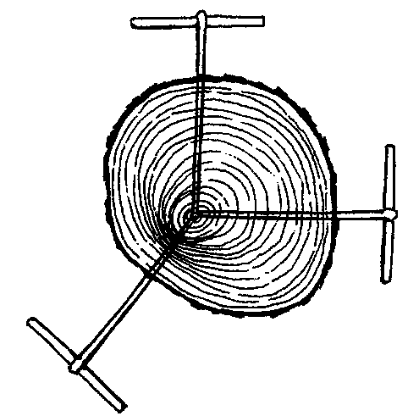

Measure the core from an undamaged side of the tree. It may be difficult or impossible to obtain an increment boring at breast height on very steep slopes when the plot center is downhill from the tree. In this circumstance, obtain the core at breast height on a side of the tree perpendicular to the slope fall line.

Figure : Sloped tree

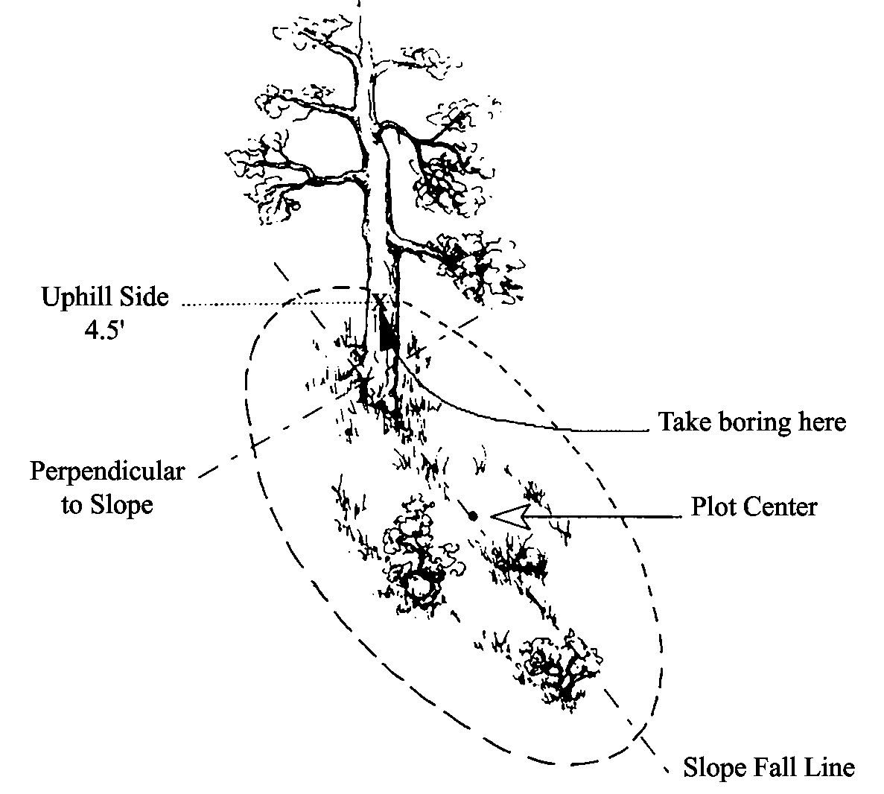

The radial increment growth period is usually 10 years. The measurement is taken from the outside edge of the most current, complete summerwood (denser, dark-colored) ring to the outside edge of the eleventh summerwood ring, so that 10 complete annual increments are included. The last summerwood growth ring is considered complete by September 1 each year.

Figure : Example of a 10-year radial growth increment with the first summerwood ring (a complete growth ring)

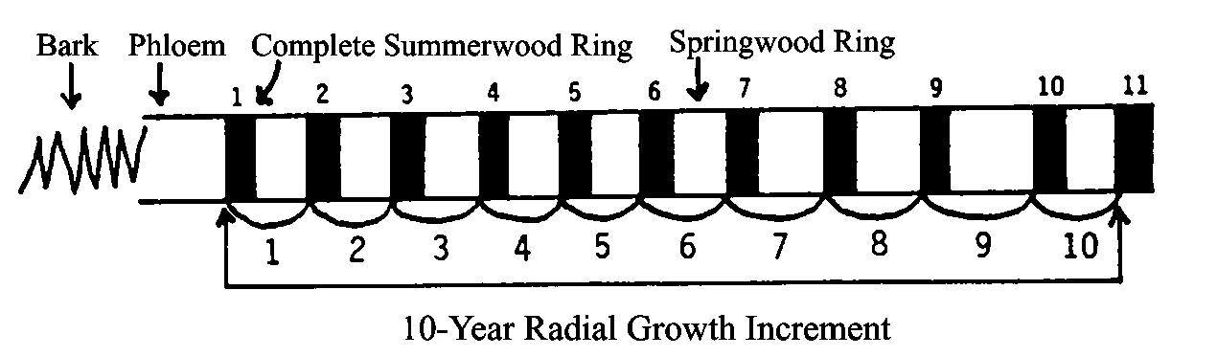

Figure : Example of a 10-year radial growth increment with the first summerwood ring (not a complete ring)

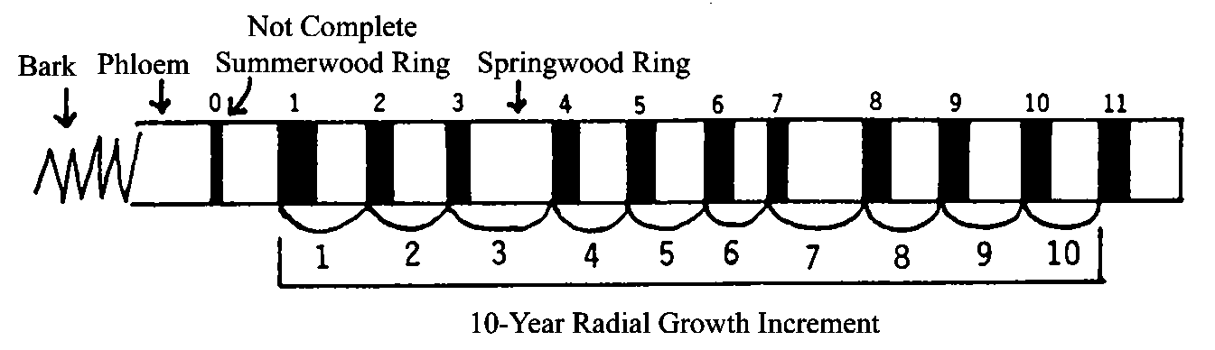

Note that the rulers in Figure 64 and Figure 65 are 20th scale rulers.

#### Height Growth (maximum of 2 numbers; may include one decimal)

Record height growth, to the nearest 1/10th foot. Height growth is required for Growth Sample Trees less than 3.0 inches in diameter and greater than or equal to 5 years old. Measure the five most recent complete height increments of leader growth. The current terminal leader is excluded unless budset has occurred. Height increments are recognized by the presence of budscale scars on the nodes (except Western redcedar) or by dissecting the leader and counting annual rings with a hand lens. The default height growth period is 5 years.

Accuracy Standards:

* Tree height ≥ 6 feet ± 0.5 feet
* Tree height < 6 feet ± 0.1 feet

Figure : The 5-year Height Increment is between lines A and B

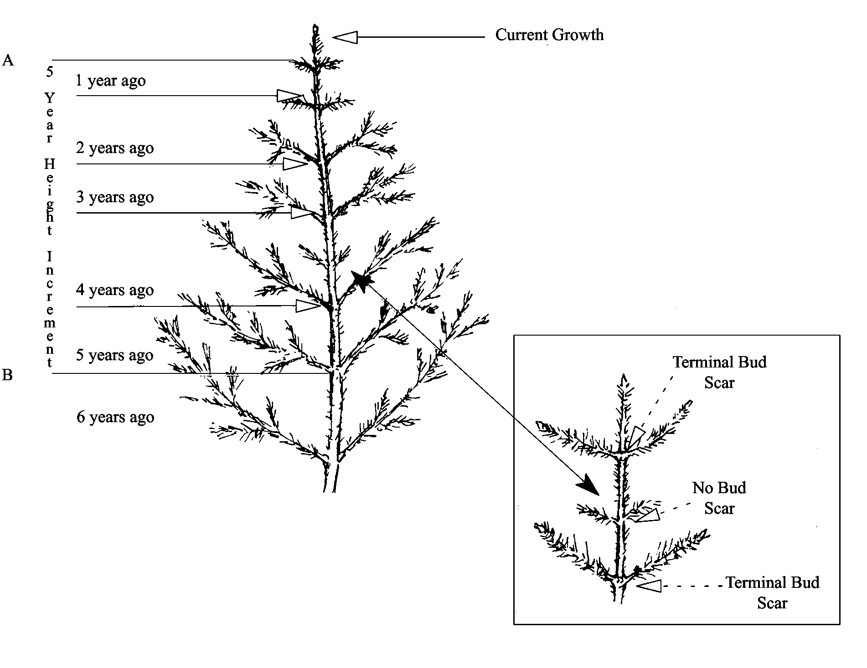

##### Height Growth on Trees Taller Than 6 Feet

One crewmember holds up the height pole to the top of the tree. The other crewmember uses binoculars to locate 5-year growth node and read the length on the height pole.

Figure : Measure tree height

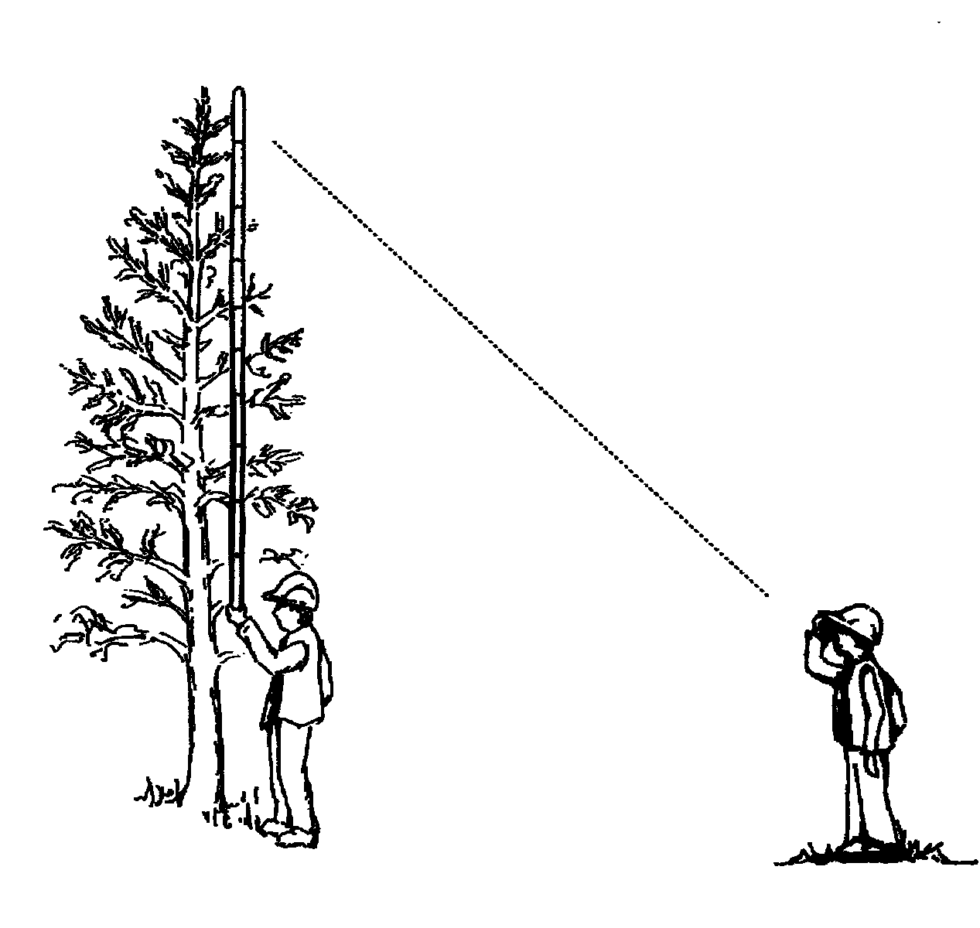

##### Using Destructive Sampling

Cut down the tree and measure the 5-year growth.

Figure : Destructive sampling

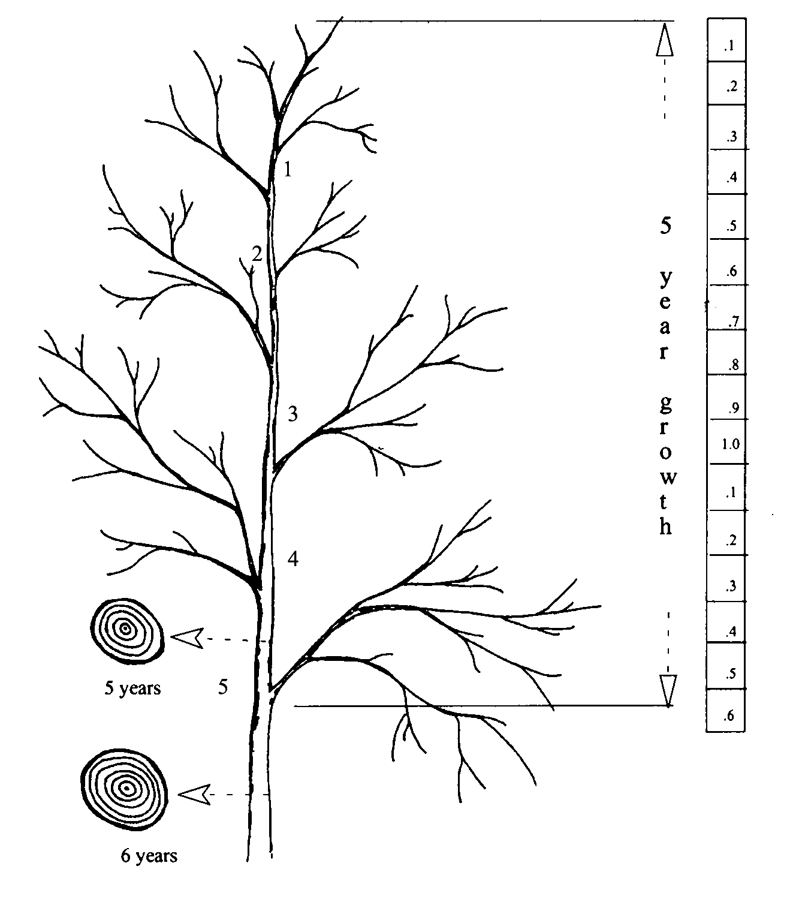

1. Cut at suspected internode between 5 and 6 years.
2. Cut between suspected internode between 4 and 5 years.
3. Measure at the 5th node.

Note: this graphic shows measuring to the top of the tree. If the measurement is taken during the spring or summer when the tree has a partial year’s flush of new growth, do NOT include the partial growth. Measure the five most recent COMPLETE increments of height growth.

#### Tree Age (maximum of 4 numbers)

This is the tree age in years. This is the required Growth Sample trees and Site Index trees. Some species (like aspen) are very susceptible to increment boring, so first check with your Regional Silviculturist before boring.

Record DBH age for trees 3.0 inches DBH and larger. Age is determined from an increment boring made at DBH and is the annual ring count to the pith of the tree. If age cannot be determined because of extensive heartrot, and this is a site tree, select another tree.

Record total age for trees less than 3.0 inches DBH. Total age is determined by counting branch whorls that represent annual height increments, or by severing the tree at the root collar and counting annual rings on the stump, o by taking an increment boring at the root collar. The most efficient and accurate method to use depends largely on the species and size of the sample tree.

Accuracy Standards:

* Based on actual tree ring count at breast height for trees ≥ 3.0” DBH, otherwise based on total age recorded
* ± 10% for trees less than 299 years of age
* ± 15% for trees greater than 299 years of age

##### Age Measurements for Trees

For trees 3.0 inches DBH and larger, age is determined from an increment boring made at breast height. To reduce bias, the increment boring should be made at breast height facing plot center. Usually the boring for measuring radial growth is also used for age measurement. Age is counted from the most current summerwood ring to the pith of the tree. Record the actual age counted; do not add an estimate of the number of years to grow to breast height.

Figure : The ring count is 64 years, so record "64" for the tree age

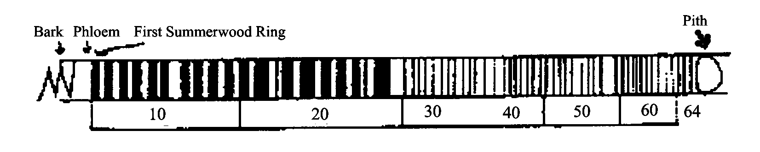

##### Age Measurements for Large Trees

When determining the age of a tree that has a radius greater than the length of the increment borer, bore into the tree as far as possible, extract core and county the rings. Measure the diameter of the tree and divide by two, then subtract the bark thickness. This gives the radius of the wood part of the tree. Measure the length of the core and subtract from the radius of the wood to determine how much longer the core would have to be to reach the pith. Count the number of rings in the innermost inch and extrapolate to the center.

Example:

Determine the age of a 40-inch DBH tree having a bark thickness of 2.0 inches when a core 16 inches long has 200 rings and the innermost inch has 5 rings.

Table 91: Age measurements for large trees

| **Measurement Type** | **Actual Measurement** |
| --- | --- |
| DBH / 2 | 40.0 / 2 = 20.0 |
| Bark thickness | 2 inches |
| Difference | 20.0 – 2 – 18 (radius of wood) |
| Core length | 16 inches |
| Radius of wood – core length | 18 – 16 = 2 |
| Number of rings (innermost inch) | 5 |
| Product (of #5 and #6 above) | 2 x 5 = 10 |
| Number of rings on core + 10 (7) | 200 + 10 = 210 tree age |

##### Age Measurements for Trees < 3 inches DBH

For trees less than 3.0 inches DBH, total tree age may be determined by counting branch whorls that represent annual height increments, by severing the tree at the root collar and counting annual rings, or by taking an increment boring at the root collar.

##### Counting Branch Whorls

Counting branch whorls to determine tree age should only be done on western white pine or other species where the distinction between annual branch whorls and false branch whorls can be clearly recognized. False branch whorls are recognized as whorls that have shorter branches and never have budscale scars at the node. The presence of budscale scars guarantees that the branch whorl represents an annual growth increment, but as a tree ages, budscale scars become masked by bark development. Western red cedar does not have budscale scars and false whorls are common, so counting branch whorls is never appropriate for cedar.

Figure : Counting branch whorls

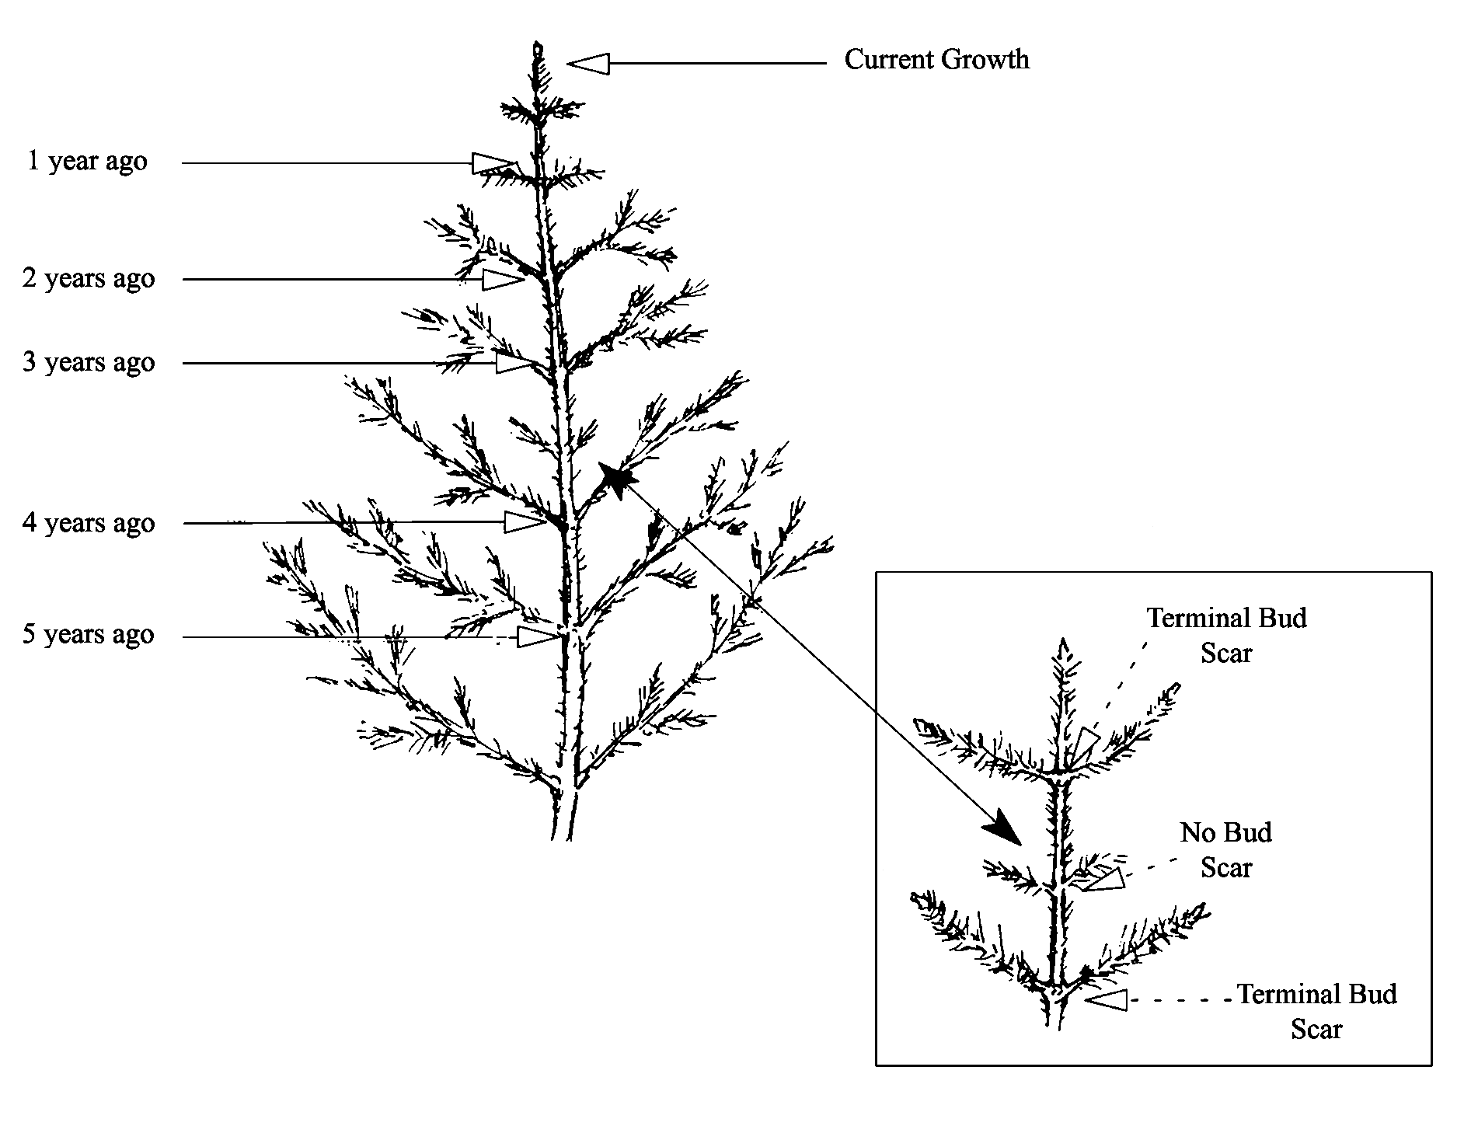

##### Cutting Tree at Root Collar to Count Annual Rings

Sample trees can be severed at the root collar in order to count annual rings. The root collar is the transition zone between the stem and the root and is recognized by the presence of a slight swelling.

Figure : Cut tree at root collar

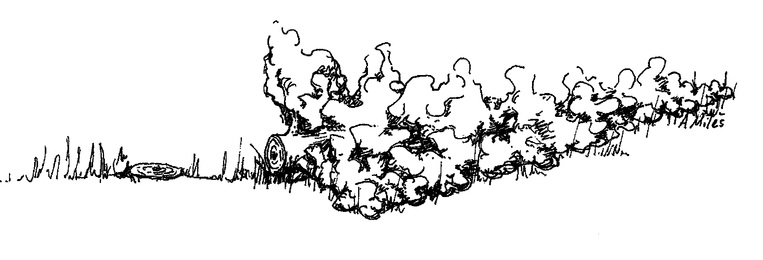

##### Increment Boring at Root Collar

Sample trees can be bored at the root collar to determine age. The same procedures for boring trees at breast height (see above) are used for boring trees at root cellar.

Figure : Increment boring at root collar

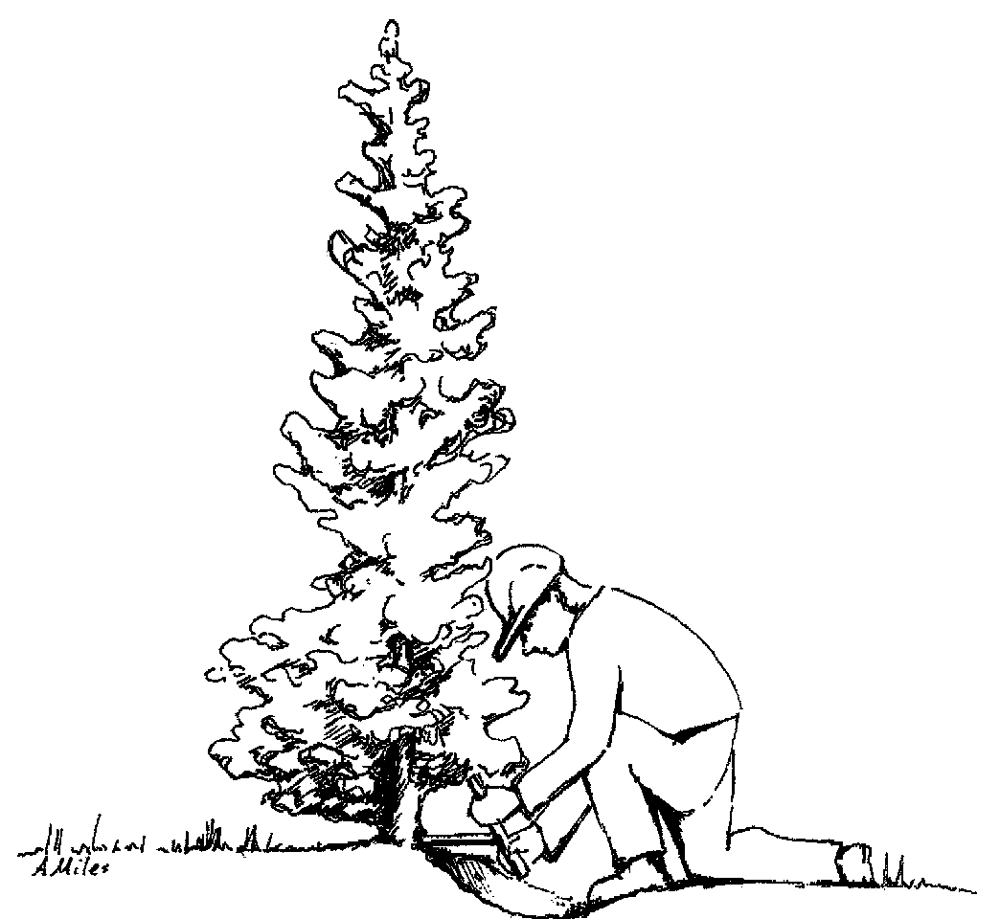

#### Crown Ratio (maximum of 3 numbers)

This is the crown ratio, in percent as the length of the live crown divided by tree height. Live crown length is accessed from the uppermost live leader or branch to the lowest live branch. Visually adjust large openings in the crown or lopsided crowns by transferring lower branches to fill in the holes. Compressing the live crown length because the crown appears “sparse” or contains “unhealthy” foliage is not appropriate. Crown ratio is the portion of the tree bole supporting live, healthy foliage and is expressed as a percent of the actual tree height. The distance between A and B is the existing crown length.

Accuracy Standards:

* ± 10% for Intensive Exams
* ± 20% for Extensive and Quick Plot Exams

Figure : Crown ratio

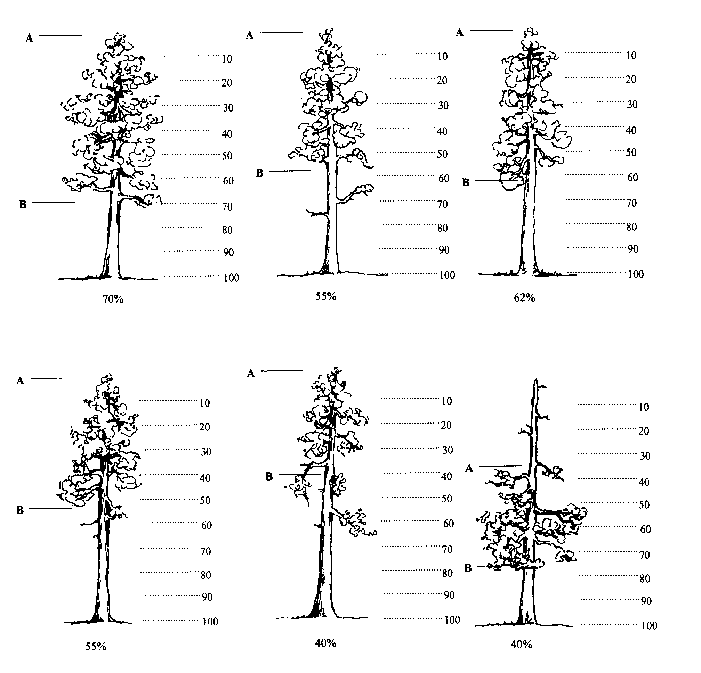

##### Crown Class (exactly 2 characters)

Record the crown class for all live trees. Crown class is the description of the relative position of the tree crown with respect to competing vegetation surrounding the tree. Crown classes are a useful descriptor of competitive status of trees in all structural types of stands. The Crown Class for each tree is determined in the context of competition for sunlight or moisture between the subject tree and its immediate environment, trees, or shrubs.

Classifications are more difficult to assign in uneven-aged stands or in plots where more than one stand is present. In these situations, classify the tree based on its immediate environment. Base your classification on how much light the tree’s crown is receiving, not its position in the canopy. The intermediate and overtopped crown classes are meant to include trees seriously affected by direct competition with adjacent trees. For example, a young, vigorous tree that is considerably shorter than other trees in the stand but not overtopped by other trees, and receives full light from above and partly from the side, is classified as dominant. The same principle applies to two-storied stands: understory trees should only be assigned subordinate crown classes if they are adjacent to overtopping trees. In plots with scattered residual overstory trees over younger trees, a considerable portion of the understory trees will be classified as dominant or codominant.

Table 92: Crown classes

| **Code** | **Name** | **Description** |
| --- | --- | --- |
| OP | Open-grown or Isolated | Tree crowns receive full light from above and from all sides. In even-aged stands, these trees have their crowns well above the general canopy. |
| DO | Dominant | Tree crowns receive full light from above and partly on the sides. Crowns extend above the general level of the crown cover of others of the same stratum and are not physically restricted from above, although possibly somewhat crowded by other trees on the sides. In even-aged stands, dominant trees rise somewhat above the general canopy. |
| CO | Codominant | Tree crowns receive full light from above, but comparatively little from the sides. Crowns form a general level of crown stratum, are not physically restricted from above and are crowded by other trees from the sides. In even-aged stands, codominants form the general canopy. |
| IN | Intermediate | Tree crowns occupy a definitely subordinate position and are subject to strong lateral competition from crowns of dominants and codominants. They receive little direct light from above through small holes in the canopy, but no light from the sides. |
| OV | Overtopped | Tree crowns receive no light from above or from the sides and are entirely below the general level of dominant and codominant trees. |
| RE | Remnant | Trees that remain from a previous management activity or catastrophic event. The tree is significantly older than the surrounding vegetation. Remnant trees do not form a canopy layer and are usually isolated individuals or small clumps. This definition is from the Region 6 Inventory and Monitoring System field procedures for the Current Vegetation Survey. |
| AB | Leader Above Brush | The terminal leader of the tree is above the surrounding brush while the middle or lower crown may be within the brush canopy. |
| IB | Leader Within Brush | The terminal leader and upper crown of the tree is within the brush canopy. |
| UB | Leader Overtopped by Brush | The crown of the tree is completely overtopped by the surrounding brush. Brush cover crown classes only apply to isolated or dominant trees with brush competition; therefore, brush cover crown class codes are used as modifiers for open-grown or dominant trees. Competition from adjacent trees is more important than competition from shrubs if they both occur. Generally, brush cover crown codes are used in stands where overstory tree competition is absent. |

Figure : Crown class illustration

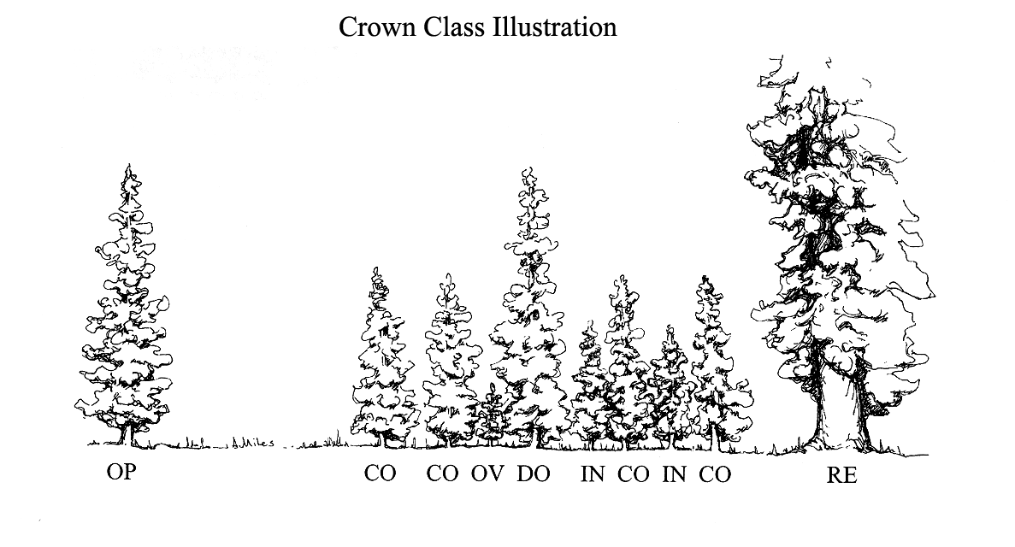

Figure : Brush crown class illustration

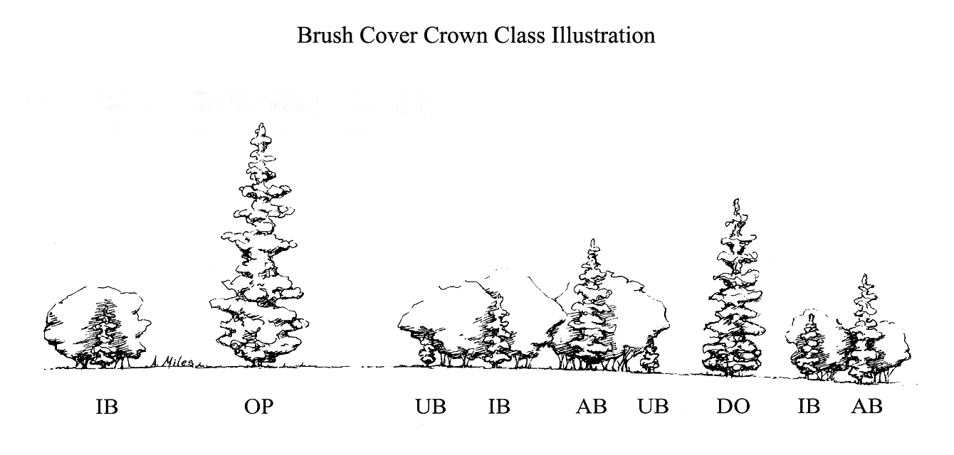

##### Crown Width (maximum of 3 numbers)

This is the average crown width, in feet.

Crown width is the average of two measurements: 1) widest distance anywhere in the crown between the outer ends of two live branches (drip line); and 2) the distance perpendicular to the widest measurement. Abnormally long branches sticking out beyond the edge of the crown are not used in establishing the extent of a crown.

A tree’s widest crown measurement, if viewed from the air, is the diameter of a circle including all foliage. Measure it at the crown’s widest point with a tape held by two crew people standing under opposite drip lines at the crown’s edges. Make the second measurement at 90 degrees to the crown diameter at the widest point using the same procedures.

With shoulders parallel to the tape, determine drop line end points by looking up perpendicular to the tape and projecting where crown edge branch tips would hit the ground if they fell. Occasionally, a branch may protrude abnormally, but the lateral crown line is drawn across the portion of the branch, which includes the “normal outline” of the tree. It is helpful to use a device, such as a clinometer, that allows the observer to measure a line perpendicular to the ground. The clinometer should be used for training and to check estimates made during the operational field season.

If you cannot see the crown edge from directly beneath the drop line, both observers should move an equal distance away from the tree and make your estimate. All measurements are rounded to the nearest foot. Crown width measurements ore estimates can be used to compute crown volume and surface area.

Accuracy Standards:

* ± 10% for Intensive Exams
* ± 20% for Extensive and Quick Plot Exams

##### Wildlife Use (exactly 2 characters)

Record the stem characteristics that may indicate the presence of wildlife.

Table 93: Wildlife use codes

| **Code** | **Description** |
| --- | --- |
| SC | Small cavities less than 3 inches in diameter |
| LC | Large cavities greater than 3 inches in diameter |
| LB | Loose bark |
| FH | Foraging holes/flaked bark; antler rubs, porcupine feeding |
| NE | Nest in tree and not in cavity |
| IB | Indian Bat Habitat tree |

##### Log/Snag Decay (exactly 1 number)

This is the condition of standing dead (snag) or down dead trees (log). Figure 77 and the corresponding descriptions are adapted from “Wildlife Habitats in Managed Forests of the Blue Mountains of Oregon and Washington,” by Jack Ward Thomas, Agriculture Handbook No. 553, USDA Forest Service, September 1979.

###### Snag Decay

Table 94: Snag decay codes and descriptions

| **Code** | **Bark** | **Heartwood Decay** | **Sapwood Decay** | **Limbs** | **Top Breakage** | **Bole Form** | **Time Since Death** |
| --- | --- | --- | --- | --- | --- | --- | --- |
| 1* | Tight, intact | Minor | None to incipient | Mostly present | May be present | Intact | ≤5 years |
| 2 | 50% loose or missing | None to advanced | None to incipient | Small limbs missing | May be present | Intact | >5 years |
| 3 | 75% missing | Incipient to advanced | None to 25% | Few remain | Approx. 1/3 | Mostly intact | >5 years |
| 4 | 75% missing | Incipient to advanced | 25%+ | Few remain | Approx. 1/3 to 1/2 | Losing form, soft | >5 years |
| 5 | 75%+ missing | Advanced to crumbly | 50%+ advanced | Absent | Approx. 1/2+ | Form mostly lost | >5 years |

* Implies recent mortality, within the last 5 years

###### Snag Decay Classes

Figure : Snag decay classes

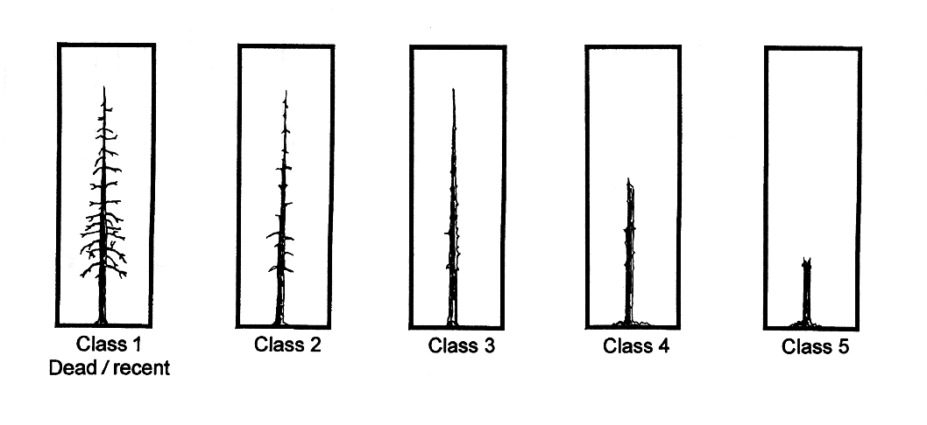

###### Log Decay

Table 95: Log decay codes and descriptions

| **Code** | **Bark** | **Twigs** | **Texture** | **Shape** | **Wood Color** | **Portion of log on ground** |
| --- | --- | --- | --- | --- | --- | --- |
| 1* | Intact | Present | Intact | Round | Original | None, elevated on supporting points |
| 2 | Intact | Absent | Intact to soft | Round | Original | Parts touch, still elevated, sagging slightly |
| 3** | Trace | Absent | Hard large pieces | Round | Original to faded | Bole on ground |
| 4** | Absent | Absent | Soft blocky pieces | Round to oval | Light brown to faded brown | Partially below ground |
| 5** | Absent | Absent | Soft, powdery | Oval | Faded light yellow or gray | Mostly below ground |

*Implies recent mortality, within the last 5 years

**Only down trees in decay class 1 or 2 should be recorded on the tree form. Logs in decay classes 3-5 should be recorded on the down woody material form.

Figure : Log decomposition classes

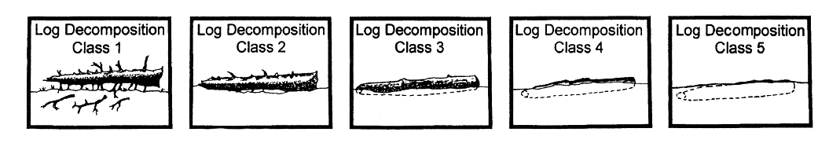

##### Cone Serotiny (exactly 1 number)

This is the open or closed condition of the majority of a tree’s viable cones for lodgepole pine and jack pine. Only consider the cones on the tree, not cones on the ground. Trees have closed cones (serotinous) if more than 50% of the cones are closed.

Table 96: Cone serotiny codes

| **Code** | **Description** |
| --- | --- |
| 0 | No cones |
| 1 | Open/opening cones |
| 2 | Closed cones |
| 3 | Intermediate – both open and closed cones |

##### Treatment Option (maximum of 1 number)

Cut and leave treatment option. Legal values are 1-9. A “1” is automatically interpreted as “cut” in the Forest Vegetation Simulator (FVS) program.

##### Azimuth

If you are accessing the Tree Data Form through the Inventory and Monitoring form, you will be able to enter Azimuth information—if you access the Tree Data Form through the CSE form, this field is grayed out. Data entered is the azimuth, in degrees, of the tree from plot center. This field only allows positive integer values between 0 and 360, inclusive.

Figure : Tree Data Form

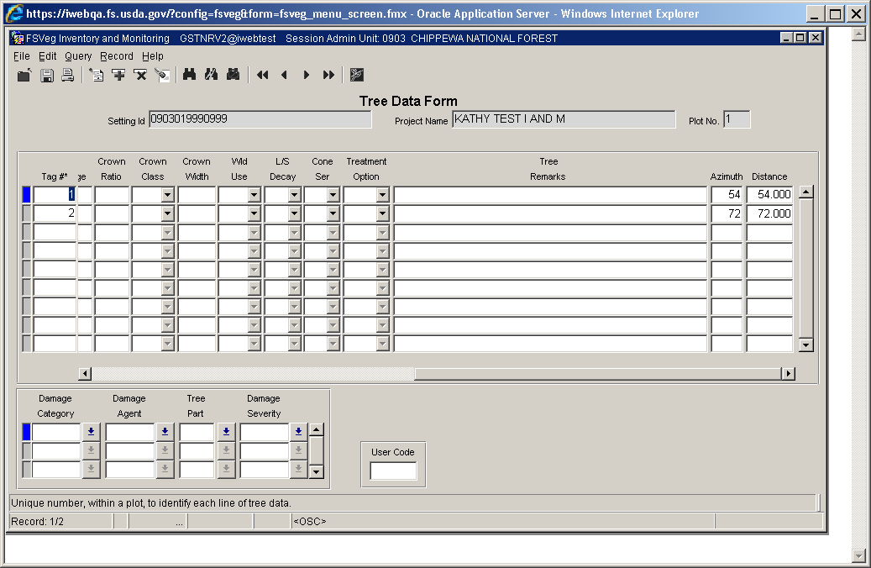

##### Distance

If you are accessing the Tree Data Form through the Inventory and Monitoring form, you will be able to enter Distance information—if you access the Tree Data Form through the CSE form, this field is grayed out. Data entered is the distance, in feet, of the tree from plot center. This field only allows positive values fr5om 0.000 to 999.999.

Figure : Tree Data Form



##### Damage Category (maximum of 2 numbers)

This is the damage category, for both live and dead trees, based on physical evidence. Multiple damage categories may be recorded for each tree. See [Appendix K of the User Guide](http://fsweb.nris.fs.fed.us/products/FSVeg/documentation.shtml) for a complete listing of damage categories.

##### Damage Agent (maximum of 3 numbers)

This is the damage agent for each damage category. If the actual agent is not known, record an agent code of “000” for unknown agent within a category. See [Appendix K of the User Guide](http://fsweb.nris.fs.fed.us/products/FSVeg/documentation.shtml) for a complete listing of damage agents.

##### Tree Part (exactly 2 characters)

This is the tree part where the damage occurs. See [Appendix K of the User Guide](http://fsweb.nris.fs.fed.us/products/FSVeg/documentation.shtml) for a complete listing of tree parts.

##### Damage Severity (exactly 2 characters)

This is the damage severity for each category. If category is recorded, severity is required. See [Appendix K of the User Guide](http://fsweb.nris.fs.fed.us/products/FSVeg/documentation.shtml) for a complete listing of damage severity codes.

##### Accuracy Standards

Table 97: Accuracy Standards categories, descriptions, and tolerances

| **Category** | **Category Description** | **Tolerance** |
| --- | --- | --- |
| 11 | Bark beetles | No misses on live trees with a severity of 2 or greater |
| 12 | Defoliators | No misses on live trees with a severity of 3 or greater |
| 13-17 | Other insects | No misses of shoot moths or weevils on live trees |
| 21 | Root/butt diseases | No misses on live trees with a severity of 2 or greater |
| 22 | Stem decays/cankers | No misses on live trees with a severity of 3 or greater |
| 25 | Foliage diseases | No misses on Elytroderma on live trees |
| 41-42 | Animal damage | No misses on live trees with terminal leader damager or with greater than ¼ of bole circumference affected |
| 50 | Abiotic damage | No misses on wind, snow, or ice bending, breakage, or bole cracks and frost damage to shoots on trees less than 1-inch diameter and lightning |
| 70 | Human damage | No misses on live trees for logging damage or fire if the damage affects greater than ¼ of the bole circumference or if an open wound is in contact with the ground |

For damage agent 99, both “board volume loss” (code 013) and “cubic foot volume loss (code 014) must be recorded to obtain net volume values which reflect total defect. If these columns are NULL, net volume and gross volume will be the same.

##### Tree Remarks (maximum of 30 characters and/or numbers)

This is information unique to each tree.

##### User Code (maximum of 4 characters and/or numbers)

The data entered in this field is not managed at a National level and is stored in a generically labeled field. Check with your Region and Forest for specific instructions on using this field.

## Vegetation Composition

The optional Vegetation Composition protocol is used to collect ocular estimates of cover by lifeform and layers for trees, shrubs, forbs, and grass species within a fixed area. It provides a fast and practical sampling method to collect information on plant composition and structure to meet a variety of vegetation composition purposes.

There are five levels of exam intensity to record vegetation composition, as shown in Table 98.

Table 98: Five levels of exam intensity

| **Exam Level Code** | **Interested in Obtaining** | **Species to Record** | **Subpop. Min.** | **Subpop. Max.** | **Form 1** | **Form 2** | **Form 3** | **Form 4** |
| --- | --- | --- | --- | --- | --- | --- | --- | --- |
| 0 | Data not collected | n/a | n/a | n/a | n/a | n/a | n/a | n/a |
| 1 | Quick estimate | Life form only | 1% | 100 | Required | Optional | Optional | Optional |
| 2 | TES, NOX, and/or the dominant four species | Only specific species | User defined | 100 | Required | Required | Optional | Optional |
| 3 | All species | All species to a specified % | User defined | 100 | Required | Required | Optional | Optional |
| 4 | All species, including TES and NOX to trace | All species to a specified % but species on a list to trace | User defined | 100 | Required | Required | Optional | Optional |

Exam Level 0 indicates that no data was collected.

Exam Level 1 is about life form. Individual species are not recorded. Percent cover is recorded by life form, and layers within the tree and shrub life forms. Only Form 1 is required, all others are optional.

Exam Level 2 means that only species provided in a list are recorded if they occur above the user-specified minimum cover level. A list of species could include threatened, endangered, and sensitive (TES) species, noxious (NOX) species, invasive plants, management indicator species, the dominant four species, etc. If only the dominant four species are being recorded, enter “DOM4” in the Sample Design remarks field. The sample design subpopulation minimum value is set to the minimum cover percent a species must have to be recorded. To record all species on a list to a “trace” level, set the subpopulation minimum to 0.1%. A reference to the list is placed in the Sample Design Form remarks column. If only the dominant four species are being recorded, enter “DOM4” in the Sample Design Remarks field.

Exam Level 3 indicates that all species are recorded if they occur above the user-specified minimum cover level. The sample design subpopulation minimum value is set to the minimum cover percent a species must have to be recorded. To record all species to a “trace” level, set the subpopulation minimum to 0.1%.

Exam Level 4 records all species, if they occur above the user-specified minimum cover level, as well as any species on a “list” that is recorded if it occurs at trace amounts. A list of species could include threatened, endangered, and sensitive (TES) species, noxious (NOX) species, invasive plants, management indicator species, the dominant four species, etc. The sample design subpopulation minimum value is set to the minimum cover percent a species must have to be recorded. A reference to the list is placed in the Sample Design Form remarks column.

#### Fixed-Area Plots

##### Plot Location

If tree and/or down woody material are being sampled, use the same plot center for the vegetation composition plots. If data other than vegetation composition is being collected, the order in which the data is collected may be important. Vegetation composition and down woody material data may be more accurate if collected prior to collecting tree data due to the effects of trampling.

##### Plot Size

Vegetation plots should be small enough to be efficient, large enough to include most of the species present within the setting, and must all be the same size within a setting. The sample design, plot size, and number of plots depend upon the purpose of the survey and the characteristics of the vegetation being sampled. Larger plots are better at capturing overstory and trace species. If surface cover plots are being installed, they should be the same size as the vegetation composition plots. Several common plot sizes are shown in Table 99. Plots smaller than 1/100th of an acre should not be used to sample vegetation composition.

Table 99: Plot sizes

| **Plot Size (acres)** | **Vegetation Types** |
| --- | --- |
| 1/100 | Regeneration areas |
| 1/50 | Riparian shrubland, riparian herbland, alpine vegetation, grassland |
| 1/10 | Low-diversity forest, shrubland, grassland, riparian forest and woodland, riparian large shrubland. Good plot size for broad vegetation composition inventories. |
| 1/5 | Forests with widely spaced large trees |
| 1/4 | High-diversity forests |
| 3/5 | Old growth forests with very large trees |

##### Plot Shape

Circular plots are easiest to install, but the actual plot shape (square, rectangular, or circular) can be decided upon on a setting-by-setting basis. For example, if sampling in riparian areas only, a long, narrow, rectangular plot may be appropriate. If square or rectangular plots are used, record the length and width of the plots in the sample design remarks field and include a sketch in the setting sketch: map. Like plot size, all plots must be the same shape within a setting to avoid bias.

##### Training

Conduct calibration of ocular estimates at the outset of the examination. Calibrate ocular estimates by using cover, line intercept transect methods, or other sampling. The accuracy of the data depends on the training and ability of the examiners. If species data are collected, examiners must be knowledgeable in plant identification. Plant identification skills are critical to accurately assess plant communities and categorize ocular estimates. Estimating canopy cover to the nearest 10% cover is relatively easy to learn. Quick comparisons of cover estimates can be made independently estimating cover for a few species or life form in a plot and comparing results. Repeat the process until all personnel produce acceptably similar results.

#### Point-Intercept

The point-intercept method uses a transect of fixed length and a set of sample points at fixed distances along it to tally surface or vegetation presence at each point. Perfect cover is then calculated by dividing the number of points in each surface cover class or species or lifeform by the total number of points collected on the transect. This method is used on shrubs if they are not expected to extend more than 3 feet in height. This method should be used whenever accurate surface cover or short (<3 feet) vegetation cover estimates are needed and as such is suitable for monitoring charges over time.

#### Line-Intercept

The line-intercept method uses a transect of fixed length along which the canopy of shrubs or trees that intersect it are measured. Percent cover is then calculated by dividing the cumulative distance in each layer class or species or lifeform by the total length of the transect. This method should be used whenever accurate tree canopy cover estimates are needed and as such is suitable for monitoring changes over time.

### Entering Vegetation Composition Data Using PC Client Forms

Requiring fields are indicated with an asterisk (*) after the name. The top line contains the setting ID and project name obtained from the Setting Form, and the plot number obtained from the Plot Data Form. This information cannot be altered here.

#### Form 1: Total Cover and Cover by Lifeform

This form is required for all exam levels. It provides information on horizontal and vertical distribution and diversity of these attributes for all vegetation, by lifeform (grass, forb, shrub, and tree) and by height classes for shrubs and trees. This information may be used for assigning plots to the upper levels of the Federal Government Data Classification (FGDC) Physiognomic Hierarchy, which is required by the Forest Service vegetation mapping protocol and is needed to crosswalk plots to NatureServe Alliances. The Forest Service vegetation mapping protocol also requires total vegetation cover for interpreting remotely sensed imagery and description of vegetation polygons. The FGDC Vegetation Classification Standard (1997) specifically requires total herbaceous cover.

Microscopic soil surface algae and fungi are difficult to evaluate. Hence, total vegetation cover does not typically include non-vascular plants. If you plan to enter values for the optional fields of “total fungus,” “total algae,” and “total non-vascular” plant cover, consult with your local ecologist for guidelines on collecting this data.

For the tree and shrub lifeforms, canopy cover is recorded by lifeform and by defined layers within those lifeforms. The canopy cover of these layers describes the horizontal structure of a setting in more detail. Predominant height is optional, and is used to describe the vertical structure. The optional tree diameters by layer can be used to further describe horizontal structure.

On this form, cover percent is always taken to the nearest 1%.

Figure : Example of Form 1, Cover by Lifeform

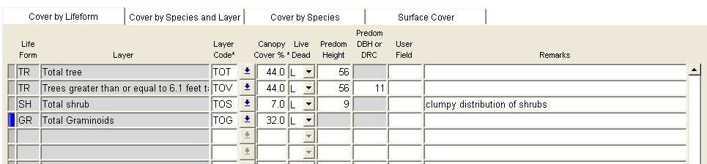

Table 100: Required and optional fields in Form 1, total cover and total by lifeform

| **Life Form** | **Layer** | **Layer Code** | **Canopy Cover (%)** | **Live / Dead** | **Predom. Height** | **Predom. DBH or DRC** | **User-Defined Data** | **Remarks** |
| --- | --- | --- | --- | --- | --- | --- | --- | --- |
| ??? | Total Vegetation | TV | Required | Required | Not allowed | Not allowed | Optional | Optional |
| Total Tree | ??? | TOT | Required | Required | Optional | Not allowed | Optional | Optional |
|  | Trees ≥ 6.1’ TOV | TOV | Required | Required | Optional | Optional | Optional | Optional |
|  | Trees ≤ 6.0’ TSA | TSA | Required | Required | Optional | Optional | Optional | Optional |
| Total Shrub |  | TOS | Required | Required | Optional | Not allowed | Optional | Optional |
|  | Shrubs ≥ 6.1’ | ST | Required | Required | Optional | Not allowed | Optional | Optional |
|  | Shrubs 1.6 – 6.0’ | SM | Required | Required | Optional | Not allowed | Optional | Optional |
|  | Shrubs < 1.6’ | SL | Required | Required | Optional | Not allowed | Optional | Optional |
| Total Forbs |  | TOF | Required | Required | Not allowed | Not allowed | Optional | Optional |
| Total Graminoids |  | TOG | Required | Required | Not allowed | Not allowed | Optional | Optional |
| Total Herbs |  | TOH | Optional | Required | Not allowed | Not allowed | Optional | Optional |
| Total Algae |  | TAL | Optional | L* | Not allowed | Not allowed | Optional | Optional |
| Total Lichen |  | TLC | Optional | L* | Not allowed | Not allowed | Optional | Optional |
| Total Fungus |  | TFU | Optional | L* | Not allowed | Not allowed | Optional | Optional |
| Total Woody Liana |  | TLI | Optional | L* | Not allowed | Not allowed | Optional | Optional |
| Total Wood Subshrub |  | TSS | Optional | L* | Not allowed | Not allowed | Optional | Optional |
| Total Herbaceous Vine |  | TVI | Optional | L* | Not allowed | Not allowed | Optional | Optional |
| Total Nonvascular Plant |  | TNP | Optional | L* | Not allowed | Not allowed | Optional | Optional |
| Total Unknown |  | TUN | Optional | L* | Not allowed | Not allowed | Optional | Optional |

L*: Autofiled as Live; Dead is not allowed for these lifeforms

#### Form 2: Cover by Species and Layer

This form is required by exam levels 2-4. It describes the distribution of each tree and shrub species within the layers. It can be used to describe the species composition and diversity. It also provides the means to estimate habitat, biomass, forage availability, and forest ecosystem health. Cover of each tree species by layer can also be used for floristic analysis. The ages of each species within each layer can be used to describe seral tree species and successional pathways. Differences in seral trees and successional sequence may also be used to distinguish (classify) ecological types.

If an unbiased sample (not just growth sample and site trees) of trees have heights and ages collected on the tree form, the predominant height and predominant age does not need to be collected on this form. Only species that have a canopy cover above the minimum canopy cover percent recorded in the Sample Design Form, and species occurring on a list (or Exam Levels 2 or 4) are recorded on this form.

Figure : Example of Form 2, Cover by Species and Layer

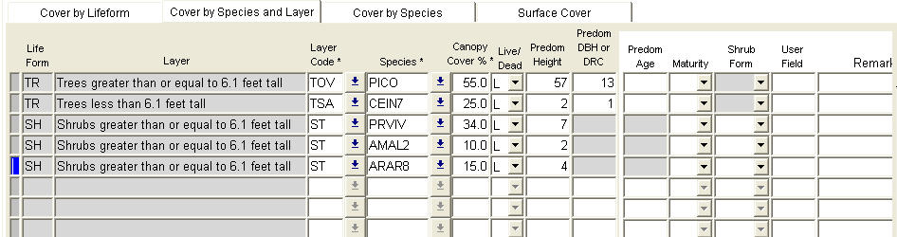

Table 101: Plot sizes

| **Step** | **Directions** |
| --- | --- |
| 1 | Record the canopy cover and live/dead status for each tree species over 6.1 feet tall |
| 2 | Record optional height, DBH, age, and maturity data for each tree species over 6.1 feet tall |
| 3 | Record the canopy cover and live/dead status for each tree species less than 6.1 feet tall |
| 4 | Record optional height, DBH, age, and maturity data for each tree species less than 6.1 feet tall |
| 5 | Record the canopy cover and live/dead status for each shrub species over 6.1 feet tall |
| 6 | Record optional height, maturity, and shrub form data for each shrub species over 6.1 feet tall |
| 7 | Record the canopy cover and live/dead status for each shrub species between 1.6 and 6.0 feet tall |
| 8 | Record optional height, maturity, and shrub form data for each shrub species between 1.6 and 6.0 feet tall |
| 9 | Record the canopy cover and live/dead status for each shrub species less than 1.6 feet tall |
| 10 | Record optional height, maturity, and shrub form data for each shrub species less than 1.6 feet tall |

#### Form 3: Cover by Species

This form is optional for all exam levels. It describes the canopy cover of each plant species on the plot. The values for shrub, grass, and forb species are often used with tree species cover by layer for classification of PNV types. Total tree species cover is sometimes used for classification instead of cover by species by layer. If this data is used as part of a floristic classification process, specific plot level attributes, such as slope, aspect, and ground cover, must be collected in addition. Recommended additional plot attributes include slope position, landform, slope shape, plot history, and geologic parent material that can be recorded in the plot user-defined field or plot remarks.

All species that have a canopy cover above the minimum canopy cover percent recorded in the sample design form, and species occurring on a list (if using exam levels 2 or 4) are recorded.

Figure : Example of Form 3, Cover by Species

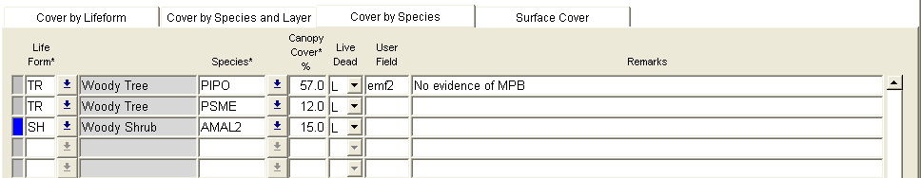

Table 102: Plot sizes

| **Step** | **Directions** |
| --- | --- |
| 1 | Record canopy cover and live/dead status for each tree species |
| 2 | Record canopy cover and live/dead status for each shrub species |
| 3 | Record canopy cover and live/dead status for each forb species |
| 4 | Record canopy cover and live/dead status for each graminoid species |

#### Form 4: Ground Surface Cover

This form is optional for all exam levels. It is used to collect ground surface cover data that is not a specific PLANTS species. Ground surface cover data describes the ground surface. Interpretations regarding soil surface protection, erosion probability, organic matter contribution, and effects of use such as recreation, grazing, and mechanical activity can be made from this data.

The “Ground Surface Cover Type” and “Cover %” fields are required. The sum of ground surface cover of all features **must equal 100% (+/- 0.5%)**. Note that foliar canopy cover above the soil surface plane is not considered to be ground surface cover.

Figure : Example of Form 4, Ground Surface Cover

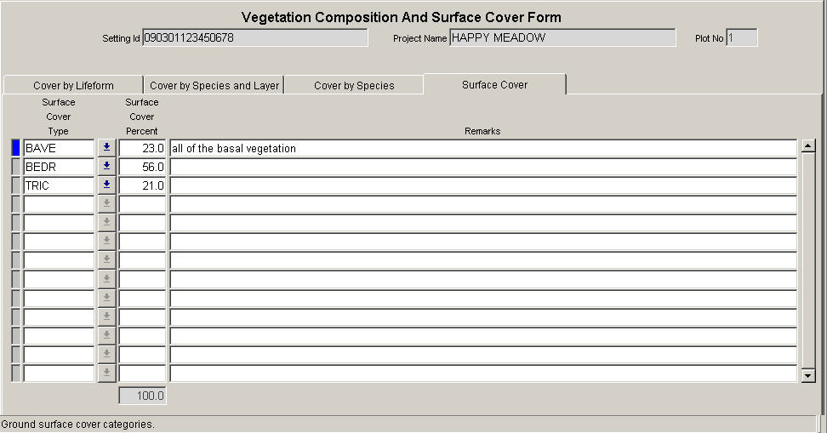

#### Form Fields

##### Life Form Definitions (exactly 2 characters)

These definitions are consistent across all of the NRIS models, and are approved national codes.

Table 103: Crown classes

| **Code** | **Description** | **Definition** |
| --- | --- | --- |
| TR | Woody tree | Perennial, woody plant with a single stem (trunk), normally greater than 4 to 5 meters or 13 to 16 feet in height; under certain environmental conditions, some tree species may develop a multi-stemmed or short growth form (less than 4 meters or 13 feet in height) |
| SH | Woody shrub | Perennial, multi-stemmed woody plant that is usually less than 4 to 5 meters or 13 to 16 feet in height; shrubs typically have several stems arising from or near the ground, but may be taller than 5 meters or single-stemmed under certain environmental conditions |
| FB | Herbaceous forb/herb | Vascular plant without significant woody tissue above or at the ground; forbs and herbs may be annual, biennial, or perennial but always lack significant thickening by secondary woody growth and have perennating buds borne at or below the ground surface |
| GR | Herbaceous graminoid | Grass or grass-like plant, including grasses (Poaceae), sedges (Cyperacea), rushes (Juncaceae), arrow-grasses (Juncaginaceae), and quillworts (Isoetes) |
| HB | Herbs | Combination of all graminoids and forbs; this is required for FGDC Vegetation Classification Standard (1997) |
| AL | Algae | A general name for the single-celled plant plankton, sea weeds, and their freshwater allies |
| LC | Lichen | Organism generally recognized as a single plant that consists of a fungus and an alga or cyanobacterium living in symbiotic association; often attached to solid objects such as rocks or living or dead wood rather than soil |
| FU | Fungus | A non-flowering plant of the kingdom Fungi, all lacking chlorophyll |
| LI | Woody Liana | Climbing plant found in tropical forests wiith long, woody rope-like stems of anomalous anatomical structure |
| SS | Woody subshrub / half-shrub | Low-growing shrub usually under 0.5 meters or 1.5 feet tall (never exceeding 1 meter or 3 feet tall) at maturity |
| VI | Herbaceous Vine | Twining/climbing plant with relatively long stems can be woody or herbaceous |
| NP | Nonvascular plant | Nonvascular, terrestrial green plant, including mosses, hornworts, and liverworts; always herbaceous, often attached to solid objects such as rocks or living or dead wood rather than soil |
| UN | Unknown | Growth form is unknown |
| VP | All vascular plants |  |

##### Layer Code Definitions (exactly 2 characters) Required

Table 104: Layer code definitions

| **Code** | **Description** |
| --- | --- |
| TV | Total cover of all vegetation |
| TOT | Total cover of all trees |
| TOV | Total cover of trees greater than or equal to 6.1 feet tall |
| TSA | Total cover of trees less than or equal to 6.0 feet tall |
| TOS | Total cover of all shrubs |
| ST | Total cover of all shrubs greater than or equal to 6.1 feet tall |
| SM | Total cover of all shrubs between 1.6 and 6.0 feet tall |
| SL | Total cover of all shrubs less than 1.6 feet tall |
| TOF | Total cover of all forbs |
| TOG | Total cover of all graminoids |
| TOH | Total cover of all herbs |
| TAL | Total cover of all algae |
| TLC | Total cover of all lichens |
| TPU | Total cover of all fungi |
| TLI | Total cover of all woody lianas |
| TSS | Total cover of all subshrubs |
| TVI | Total cover of all herbaceous vines |
| TNP | Total cover of all unknown lifeforms |
| TVP | Total cover of all vascular plants |

##### Species (maximum of 8 characters and/or numbers)

Record the plant species using the NRCS PLANTS database codes. Do not repeat species codes within a layer and live/dead status. Identify plants to species, if possible, otherwise identify to the genus level. Identification of vascular plants to the subspecies or variety level may be required for some projects. Certain projects may require only a listing of indicator of dominant species growing on the main substrate. Include plants if their crowns overhang the plot area, even though their root systems may not be within the plot area, except when sampling small narrow riparian communities. In such riparian communities, overhanging trees rooted outside the community (across an ecotone) should not be included in the species list.

Floristic classification requires accurate plant identification. Correct species identification is more important than accuracy in cover estimates. Overlooking or misidentifying a species is a more serious error than estimating cover as 5% when a measurement should show it to be 3%. It is vital that field employees are well-qualified and/or trained in species identification, use of accepted scientific floras, and proper collection of unknown species for later identification. Any plant that cannot be identified to the species level should be collected for later identification.

Table 105: Examples of species codes

| **Code** | **Scientific Name** | **Common Name** |
| --- | --- | --- |
| VAGL | Vaccinium globulare | Blue Huckleberry |
| AGROP2 | Agropyron spp. | Wheatgrass |

Accuracy Standards: No Error in species level identification for dominant, common, or community indicator plants.

##### Canopy Cover (maximum of 3 numbers; may include one decimal) Required

Canopy cover is “the percentage of ground covered by a vertical projection of the outermost perimeter of the natural spread of foliage of plants. Small openings within the canopy are included (SRM 1989, NRCS 1997).” For woody plants, canopy cover is synonymous with crown cover (NRCS 1997, Helms 1998).

###### Fixed-Area Plots

Do not include cover by a dead tree or shrub, or portion of a dead tree or shrub (that will not recover) in cover estimates. However, cover should be estimated for the current season’s annual forb and graminoid species that have already died. Perennial forbs and graminoids may also appear dead, but are actually in an inactive or dormant stage—these plants should also be included in the cover estimates. If included in the sample design or exam level, use 0.1 as “trace” for items present but clearly less than 1% cover.

Do not record species whose canopy does not intersect the plot. Information about species that occur outside the plot can be recorded in the plot remarks, but cannot be included in the plot data or used in data analysis. If sampling is consistently missing important species, then a larger plot size should be used throughout the entire sampling area.

Canopy cover can be estimated consistently by walking through the plot and counting the number of 1% or 5% units present within the plot. Estimates should be crosschecked with other crewmembers for consistency, and will help account for overlap between layers within a lifeform or species, species within a layer, etc.

###### Point-Intercept

The point-intercept method uses a transect of fixed length and a set of sample points at fixed distances along it to tally surface or vegetation presence at each point. Perfect cover is then calculated by dividing the number of points in each surface cover class or species or lifeform by the total number of points collected on the transect. This method is used on shrubs if they are not expected to extend more than 3 feet in height. This method should be used whenever accurate surface cover or short (<3 feet) vegetation cover estimates are needed and as such is suitable for monitoring charges over time.

###### Line-Intercept

The line-intercept method uses a transect of fixed length along which the canopy of shrubs or trees that intersect it are measured. Percent cover is then calculated by dividing the cumulative distance in each layer class or species or lifeform by the total length of the transect. This method should be used whenever accurate tree canopy cover estimates are needed and as such is suitable for monitoring changes over time.

###### Accuracy Standards

* ± 1% for cover between 1-10%
* ± 5% for cover between 10-30%
* ± 10% for cover over 30%

##### Live/Dead (exactly 1 character) Required

The Live/Dead status of vegetation is required on the first three forms.

Table 106: Layer code definitions

| **Code** | **Description** |
| --- | --- |
| L | Live – use this code for live vegetation. This includes deciduous vegetation that has lost its foliage for the season, and vegetation that has recently lost its leaves to defoliators, but will re-flush. |
| D | Dead – use this code for dead vegetation. Note: many of the tree fields are not used if the tree is a dead tree. If dead trees are recorded, a snag decay class is required for extensive and intensive exam levels. |

When your Subpop Variable is “CVR”:

1. Where Layer = Total Veg or Lifeform = Trees, Shrubs, Forbs, Graminoids, or Herbs: whether you can collect data for live or dead vegetation (or both) is determined by your choice of sample design – if you selected “LIVE” as your Subpop Filter, then you can collect data on only live vegetation; if you selected “DEAD,” you can collect only dead vegetation; if you selected “ALL,” you can collect both.
2. Where Lifeform = Algae, Lichen, Fungi, Woody Liana, Woody Subshrubs, Herbaceous Vines, Nonvascular Plants, Unknown, or All Vascular Plants, you may only collect data for live vegetation.

When your Subpop Variable is “TRE,” “SHR,” “FRB,” or “GRM”: whether you can collect data for live or dead vegetation (or both) is determined by your choice of sample design—if you selected “LIVE” as your Subpop Filter, then you can collect data on only live vegetation; if you selected “DEAD,” you can collect only dead vegetation; if you selected “ALL,” you can collect both.

##### Predominant Height (maximum of 3 numbers)

The predominant height of trees and shrubs is optional on Form 2. This value is redundant if detailed tree data are collected on each plot. Record in feet to the nearest foot. Heights less than two feet can be recorded to the nearest 1/10th foot. Predominant height is the distance from the base of the plant on the high side at ground level to the tip of the plant. Determine predominant height by selecting a representative individual plant and estimating its height using a clinometer and/or measuring tape. Predominant height is optional for the life forms other than trees and shrubs. Predominant height for each species within each layer is useful, but optional. Maximum height allowed is 500.99 feet; minimum height allowed is 0.1 feet.

Accuracy standards: ± 10% of height

##### Predominant Diameter (maximum of 3 numbers)

The predominant diameter for the tree (TR) lifeform is optional on Form 2. If tree data are collected on the tree form, this value is redundant, and can be more accurately computed from the Tree form data. Estimate diameter at either height (DBH) or at root collar (DRC) depending on the species. Record the predominant diameter to the nearest inch. Valid values are 1-999.

##### Predominant Age (maximum of 3 numbers)

The predominant age for tree lifeforms is optional on Form 2. If tree data are collected on the tree form, this value is redundant. Age data collected on the tree form, according to growth sample tree selection protocol, provides an unbiased and more accurate estimate of age. Record the age in years. Core samples may be used. Take a sample core(s) at the same height as the diameter either DRC or DBH. Count the actual number of rings. If diameter and age are measured at DBH, do not add additional years for the plant to reach 4.5 feet.

##### Maturity (maximum of 2 characters)

Tree maturity is optional in Form 2. Indicate relative maturity or physiological age, rather than actual age. Differences in site, elevation, moisture, and other environmental factors influence the age at which a tree reaches maturity. Trees generally reach maturity earlier on poor sites than on good sites. The maturity class descriptions are most related to conifer species. Look at stem form, bark color, and age to determine similar relationships for hardwoods. Maturity may be a substitute for boring trees to determine age.

Table 107: Log decay codes and descriptions

| **Code** | **Tree Maturity Class** | **Description** | **Crowns** | **Branches** | **Bark** |
| --- | --- | --- | --- | --- | --- |
| YO | Young | Tree appears young | Pointed | Distinct whorls, upturned, small in comparison with the main stem | Generally smooth but not platey |
| MA | Mature | Tree slightly showing age | Pyramidial or rounded, occasionally pointed | Flattened lower branches | Rough, somewhat platey or furrowed |
| DE | Overmature or Decadent | Tree shows age | Flattened or rounded, but never pointed | Open, large, gnarled, or misshaped upper branches | Platey or deeply furrowed |

Use the picture below to assist in determining maturity for conifer species. Recognize the change in crown shape from young to over-mature. As the tree matures, the top becomes flat, branches appear flat to drooping, giving a more cylindrical rather than conical shape, and branches become larger. For ponderosa pine, the amount of needles growing along the length of each branch decreases. In over-mature trees, the branches show tufts of needles at the end.

Figure : Tree maturity classes

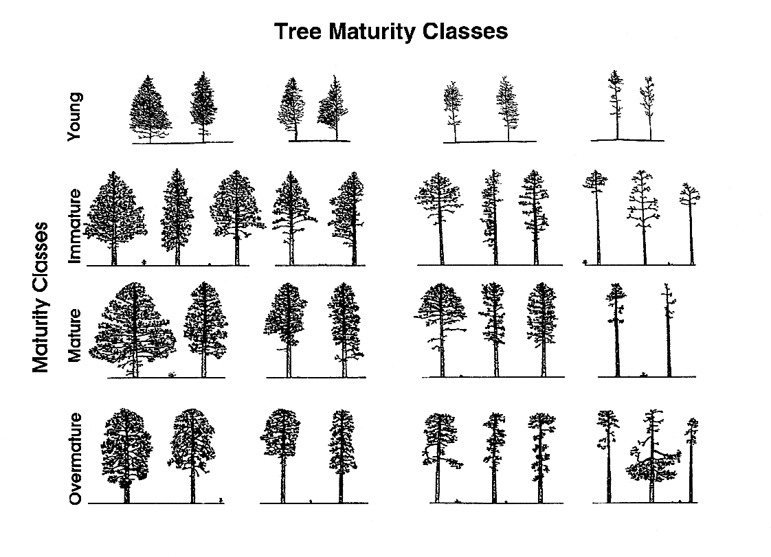

##### Shrub Form Class (maximum of 4 characters)

The shrub form class is optional on Form 2. Shrub form class is based on the availability of browse plants and the degree of hedging. These factors, along with age structure, can assist in determining the relative health of a browsed stand and can aid in evaluating trend. Availability represents the relative amount of twig growth that is within reach of grazing animals. Snow depth or duration has no bearing on availability. Hedging is the result of repeated utilization and is one of the factors that effects availability of shrubs. The general appearance of the plant is a primary criterion in determining degree of hedging.

Table 108: Crown classes

| **Code** | **Abbreviation** | **Description** |
| --- | --- | --- |
| HIMV | Mostly/highlined | Mostly available, highlined |
| HIUN | Unavailable/highlined | Unavailable, highlined |
| LIAV | All/little | All available, little or no hedging |
| LIHE | Little or no hedging | 2-year wood is relatively long/unaltered or slightly altered |
| MOAV | All/moderate | All available, moderate hedging |
| MOHE | Moderately hedged | 2-year wood is fairly long but altered from normal growth form |
| MOPA | Partial/moderate | Partially available, moderately hedged |
| SEHE | Severely hedged | 2-year wood is relatively short and/or strongly altered |
| SEPA | Partial/severe | Partially available, severely hedged |
| SOAV | All/severely | All available, severely hedged |

##### User Code (maximum of 4 characters and/or numbers)

This is optional, locally defined code for this field. These codes will be stored in a generic FSVeg database field and will not be accessible via the nationally supported reports. Contact your Regional representative to determine the use, if any, for this field in your Region.

##### Remarks (maximum of 20 characters and/or numbers)

These are optional notes about a species or layer record in Form 3 or 4. Use this space to record the scientific name of the species if the correct NRCS Plant Code is unknown.

##### Ground Surface Cover Type (exactly 4 characters)

This is the major ground surface cover categories. Select ground cover categories that are visible when looking down. At times items will overlay each other. When this occurs the portions of each item that are viewed from above is what will be selected and recorded.

Table 109: Rock ground surface cover types

| **Code** | **Description** | **Definition** |
| --- | --- | --- |
| ROCK | Rock | Relatively hard, naturally formed mineral or petrified matter >1/8 inch in diameter appearing on soil surface as small to large fragments or as relatively large bodies, cliffs, outcrops, or peas. Includes bedrock. |
| GRAV | Gravel (2-75 mm) | Rock fragments between 2 and 75 mm in diameter |
| FIGR | Fine gravel (2-5 mm) | Rock fragments between 2 and 5 mm in diameter |
| MEGR | Medium gravel (5-20 mm) | Rock fragments between 5 and 20 mm in diameter |
| COGR | Course gravel (20-75 mm) | Rock fragments between 20 and 250 mm in diameter |
| COBB | Cobbles (70-250 mm) | Rock fragments between 75 and 250 mm in diameter |
| STON | Stones (round and flat) |  |
| ROST | Round stone (250-600 mm) | Rock fragments between 250 and 600 mm in diameter |
| BOUL | Boulders (round and flat) | Rock >600 mm in diameter or length. Generic term for use when boulders are not differentiated by round and flat. |
| ROBO | Round boulder (>600 mm) | Round rock fragments >600 mm in diameter |
| CHAN | Channers (2-150 mm long) | Long, thin rock fragments up to 150 mm in length, as determined by National Cooperative Soil Survey |
| FLAG | Flag stones (150-380 mm long) | Flag rock fragments 150-380 mm long |
| FLBO | Flat boulders (>600 mm long) | Flat rock fragments >600 mm long |
| FLST | Flat stone (380-600 mm long) | Flat rock fragments between 380 and 600 mm long |
| BEDR | Bedrock | A general term for the rock, usually solid, that underlies soil or other unconsolidated, superficial material |
| PAVE | Pavement | A national concentration of closely packed and polished stones at the soil surface in a desert (may or may not be an erosional lag) |
| RROC | Rock fragments | Rock fragments >19.1 mm (3/4 inch) in diameter |

Table 110: Water, snow, and ice ground surface cover types

| **Code** | **Description** | **Definition** |
| --- | --- | --- |
| WATE | Water | Where the water table is above the ground surface during the growing season, such as streams, bogs, swamps, marshes, and ponds (FIA definition) |
| TRIC | Transient ice | Ice covering the surface; the ice melt during the growing season |
| TRSN | Transient snow | Snow covering the surface; the snow will melt during the growing season |
| TRIS | Transient ice and snow | Surface area covered by ice and snow at the time of plot measurement, considered transient; for use when permanent ice and snow are not differentiated |
| PEIC | Permanent ice | Ice covering the surface; does not melt during the growing season; the surface is ice-covered for the entire year (i.e., glaciers) |
| PESN | Permanent snow | Snow covering the surface; does not melt during the growing season; the surface is snow-covered for the entire year |
| PEIS | Permanent ice and snow | Surface area covered with ice and snow at the time of plot measurement; considered permanent ice and snow are not differentiated |

Table 111: Woody pieces ground surface cover types

| **Code** | **Description** | **Definition** |
| --- | --- | --- |
| WOOD | Wood | Woody material, slash and debris; any woody material small and large woody debris, regardless of depth; litter and non-continuous litter are not included (for example, scattered needles over soil is classified as BARE) |

Table 112: Moss, lichen, fungi ground surface cover types

| **Code** | **Description** | **Definition** |
| --- | --- | --- |
| CRYP | Cryptogam | Thin, biotically dominated ground or surface crusts on soil in dry rangeland conditions such as cryptogamic crust (algae, lichen, mosses, or cyanobacteria) |
| CML | Cyptogams, mosses, and lichens | For situations where information is not further differentiated |
| LICH | Lichen, fungi, algae | Lichens, an organism generally recognized as a single plant that consists of a fungus and an alga or cyanobacterium living in a symbiotic association; for lichen growing on bare soil in dry rangeland conditions, see cryptogamic crusts. |
| MOSS | Moss | Nonvascular, terrestrial green plants including mosses, hornworms, and liverworts—always herbaceous; this code does not apply to moss growing on bare soils in dry rangeland conditions; for rangeland conditions, see cryptogamic crusts |

Table 113: Duff and litter ground surface cover types

| **Code** | **Description** | **Definition** |
| --- | --- | --- |
| LITT | Litter and duff | Leaf and needle litter, and duff not yet incorporated into the decomposed top humus layer; non-continuous litter is not included (for example, scattered needles over soils is classified as BARE) |

Table 114: Basal vegetation ground surface cover types

| **Code** | **Description** | **Definition** |
| --- | --- | --- |
| BAVE | Basal vegetation | Basal vegetation not differentiated by life form; for use when basal vegetation is not separated into more detailed codes (BAFO, etc.) |
| BATR | Basal tree | Basal (cross-sectional area at or near the ground level) cover of trees (definition adapted from definition of basal area in National Range & Pasture Handbook |
| BASH | Basal shrub | Basal (cross-sectional area at or near the ground level) cover of shrubs |
| BAFO | Basal forb | Basal (cross-sectional area at or near the ground level) cover of forbs |
| BAGR | Basal graminoid | Basal (cross-sectional area at or near the ground level) cover of grasses or grass-like plants |

Table 115: Other ground surface cover types

| **Code** | **Description** | **Definition** |
| --- | --- | --- |
| ASH | Ash (organic, from fire) | Remaining residue after all combustible material has been burned off |
| BARE | Bare soil (soil particles <2 mm) | Bare soil, not covered by rock, cryptogams or organic material; does not include any part of a road (see definition for Road) |
| BARR | Barren | Areas naturally devoid of vegetation, such as intermittent lakebeds and saline flats; does not include areas denuded of veg |
| DEVP | Developed surface (other than road), i.e., buildings or other structures | Surface area occupied or covered by any man-made structure other than a road, such as a building, dam, parking lot, electronic site/structure |
| ROAD | Road | Improved roads, paved roads, gravel roads, improved dirt roads and off-road vehicle trails regularly maintained or in long-term continuing use; generally constructed using machinery; includes cutbanks and fills |
| TEPH | Tephra volcanic | A general term for all material formed by volcanic explosion or aerial expulsion (as opposed to flow) from volcanic vent |
| UNKN | Unknown | Other covers not defined elsewhere |

Note: Basal Vegetation is the cumulative area of live basal or root crown portions of vascular plants that intersect the plane of the soil surface. This includes live trees. It is not the foliar cover of plants. Typical basal plant cover ranges between 3-7 percent; 15 percent is very high and rarely encountered.

Figure : Ground Surface Cover Categories

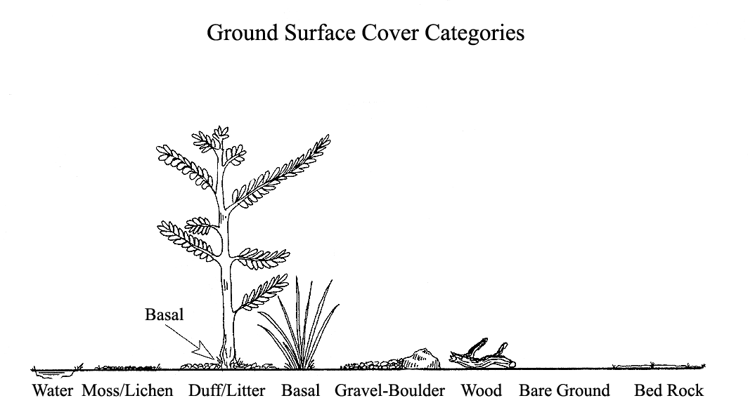

##### Ground Surface Cover Percent (maximum of 3 numbers; may include one decimal)

This is the estimated percent ground cover at the soil surface plane for each ground surface cover type. Cover is defined as that portion of the horizontal surface layer intersected by ground surface features. Total ground surface cover of all features must equal 100% (+/- 0.5%). Note that foliar canopy cover above the soil surface plane is not considered to be ground surface cover.

Whether moss covering a rock is recorded as “moss” or “rock” depends on the exam objective. Record the code that describes the soil surface and meets the exam objective. Record moss that is growing directly on the soil surface as “moss.”

Table 116: Layer code definitions

| **Code** | **Description** |
| --- | --- |
| 10 | 10% |
| 18 | 18% |
| 0.5 | ½ of 1% |

Accuracy Standards: ±10%

## Down Woody Material

Downed wood material is the dead twigs, branches, stems, boles of trees, and brush that have fallen and lie on or above the ground. This data is used to provide quantitative estimates of downed woody material and duff. The accuracy standard for all three protocols is “No Errors” unless otherwise noted.

For Down Woody Material, the examination level is set to one of the following on the setting form:

Table 117: Layer code definitions

| **Code** | **Description** |
| --- | --- |
| 10 | 10% |

If down woody material is collected, but not according to Brown’s Protocol, there are three separate methods that data can be collected. These methods and Brown’s Protocol will be discussed in detail.

* Method 1A - Photo series
* Method 1B - Piece count on a fixed area plot
* Method 1C - Piece count on a transect

### Method 1A: Photo Series

This method involves making visual comparisons between the on-site fuel condition and the conditions depicted on the photos. The Photo Series is intended to allow fast, easy, and inexpensive quantifications of forest residues. Before using a particular Photo Series, become thoroughly familiar with the photo series book. To best understand how the photo series works, conduct several samples utilizing James K. Brown’s Handbook for Inventorying Downed Woody Material. Hands-on sampling using the Brown method provides the ability to fine-tune ocular estimates. The photo series relies heavily on one’s ability to visually compare the actual on the ground conditions against representative photos and it characteristics. Note: this data is not used in the Forest Vegetation Simulator (FVS) model.

Enter the weight (tons/acre) and volume (MBF/acre) by size class by selecting the representative photo based on the instructions found within the photo series. Compare photos to best match the ground conditions being evaluated. Only the dead and downed woody material (twigs, stems, branches, and bolewood) from trees and shrubs is evaluated. Do not allow the live species in the sample are to skew the visual estimate. Since the photo series requires an interpolation of photos to actual conditions, it is helpful to begin by estimating mid-size fuels first before moving to the finer fuels. The size classes used for this protocol are:

* 0.00 – 0.25
* 0.26 – 1.00
* 1.10 – 3.00
* 3.10 – 9.00
* 9.10 – 20.00
* 21.00+

#### Step 1: Enter the Sample Design Information

In the Exams sample design form, select the Down Woody Material tab. Set the Selection method to FRQ and the Expansion Factor (ExpFac) to 1.00 for 1 acre. Set the minimum and maximum intersection diameters to the different piece sizes that correspond with the photo series being used.

Figure : Down Woody Material tab

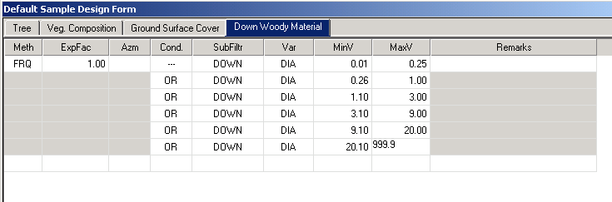

#### Step 2: Enter the Down Woody Data

From the Exams plot menu, select Down Woody Material and enter the data for the duff, fuel depth, and weight and volume of each piece class.

Figure : Entering Down Woody data

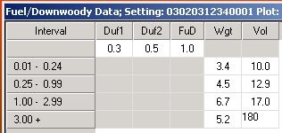

#### First Duff and Second Duff (maximum of 2 numbers; may include one decimal)

Record the duff, in inches, to the nearest 0.1-inch. Duff is the fermentation and humus layers of the forest floor. It does not include the freshly cast material in the litter layer. The top of the duff is where needles, leaves, and other castoff vegetative material have noticeably begun to decompose. Individual particles usually will be bound by fungal mycelium. When moss is present, the top of the duff is just below the green potion of the moss. The bottom of the duff layer is the start of the mineral soil.

Carefully expose a profile of the forest floor for the measurement. A knife or hatchet helps but is not essential. Avoid compacting or loosening the duff where the depth is measured. Measure the duff along a transect that starts at plot center. Rotate the direction of the transect about 30 degrees from plot to plot. Record the transect direction in the remarks section. Take the first duff measurement at one foot from the sample plot center and record it in the “First Duff” column. Take the second duff at six feet from sample plot center and record it in the “Second Duff” column. When stumps, logs, and trees occur at the plot of measurement, offset one foot perpendicular to the right of the sampling plane. Measure through rotten logs when the central axis is the duff layer.

Accuracy Standard: plot average duff depth ±1/2 inch

#### Fuel Depth (maximum of 2 numbers; may include one decimal)

This is the total vertical dead fuel depth, in inches, to the nearest whole inch. Take three equally spaced measurements, along the longest transect, and record the average depth. The fuel bed is the accumulation of dead, woody residue on the forest floor. It begins at the top of the duff layer and includes litter, dead branches, and boles from trees, and dead material from shrubs, herbs, and grasses. Dead branches on trees, and dead stems and branches still attached to the ground (i.e., standing dead plant) are not included. Measure (to the nearest tenth inch) from the top of the duff layer to the highest dead particle above the point. On suspended logs (e.g., spanning a ravine), enter the distance between the top of the duff layer and the top of the log.

Accuracy Standard: ±20%

#### First Litter and Second Litter

If you enter through the Inventory and Monitoring form, you will be able to enter First Litter and Second Litter information. If you enter through the CSE form, these fields will be grayed out. These fields list the depth of the first and second litters, in inches, to the nearest 0.1 inch. Only null values and positive numbers are allowed.

Figure : Down Woody Material form

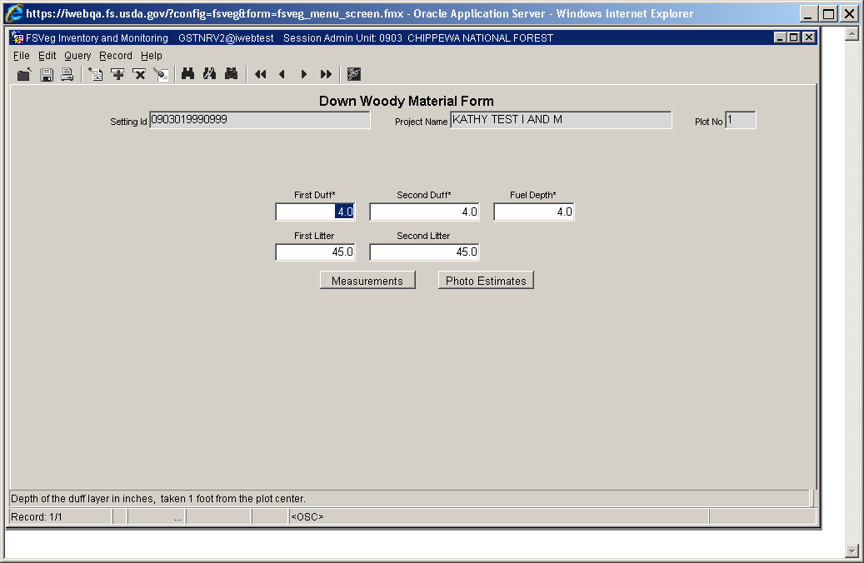

#### Volume (maximum of 8 numbers; may include one decimal) Required

This is the average volume per acre in each diameter class as determined by the fuel photos.

#### Weight (maximum of 5 numbers; may include one decimal) Required

This is the average tons per acre in each diameter class as determined by the fuel photos.

### Method 1B: Piece Count on a Fixed Area Plot

When collecting down woody data on a fixed area plot, the piece is tallied if the point on the upper most surface of the cylinder, the large end, is within the fixed area plot.

Figure : Measure for tally

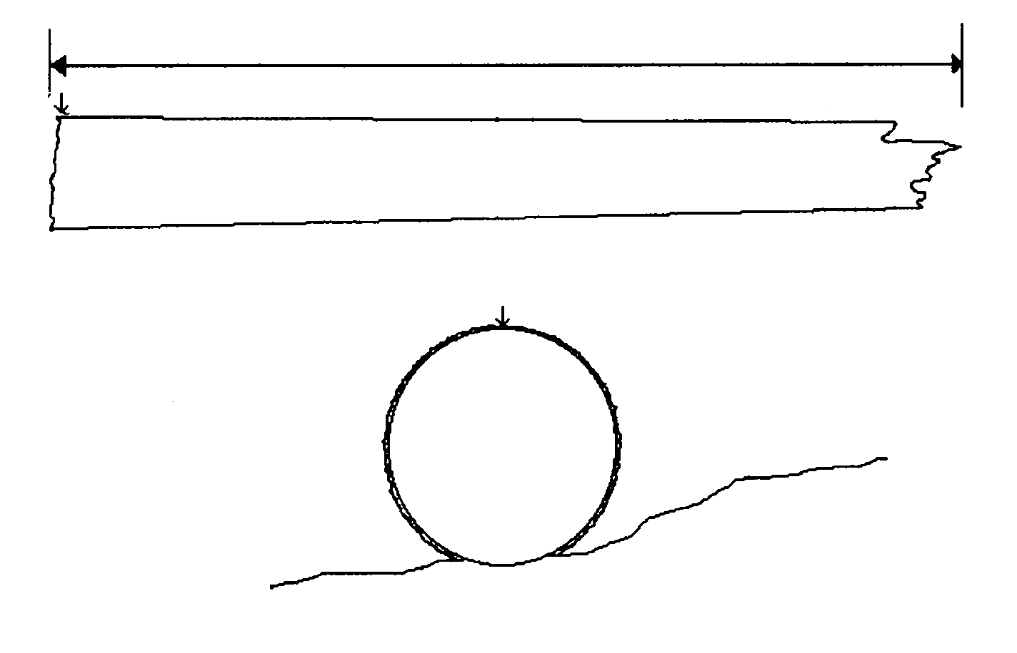

Figure : Portion of large end of piece on the plot determines tally

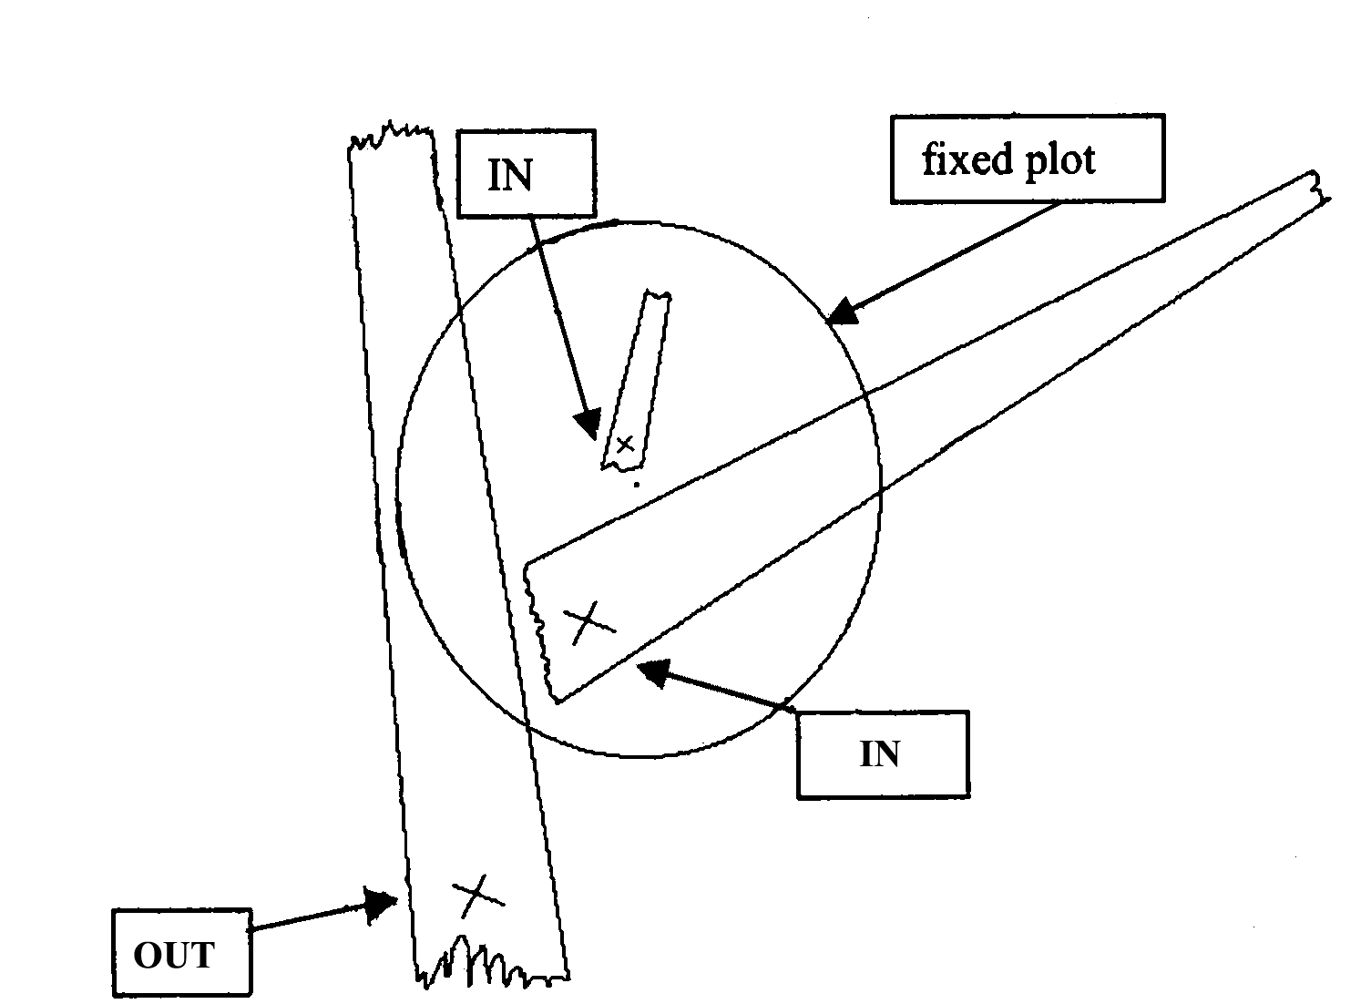

A down log may be broken into more than one piece. If a log is cracked, broken, or partially cut, but the two parts are still physically touching, then the log shall be considered one piece.

Figure : Large end on a one-piece log

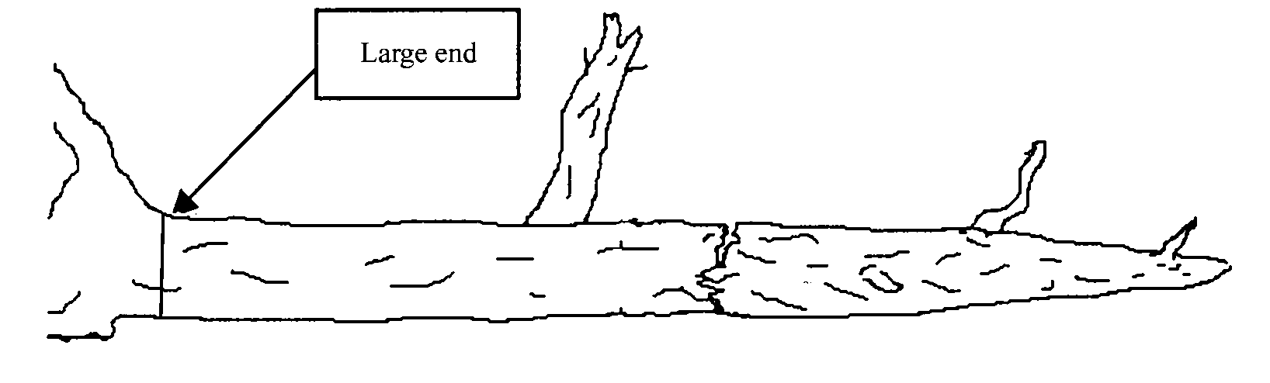

If two or more parts are not physically touching, then they are considered separate pieces, each having their own large end. This may affect whether all parts of the down log are within the fixed radius plot.

Figure : Broken pieces not touching are measured separately

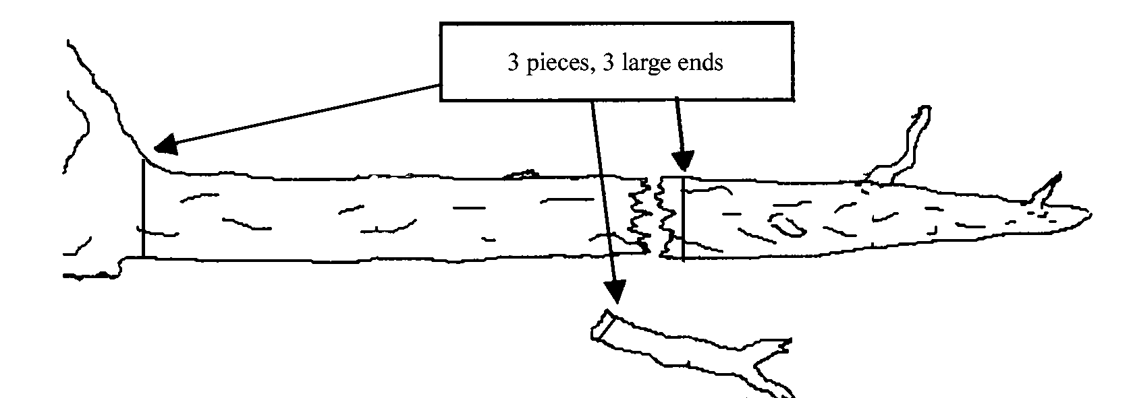

Figure : Broken pieces have separate large ends that can affect which pieces are tallied

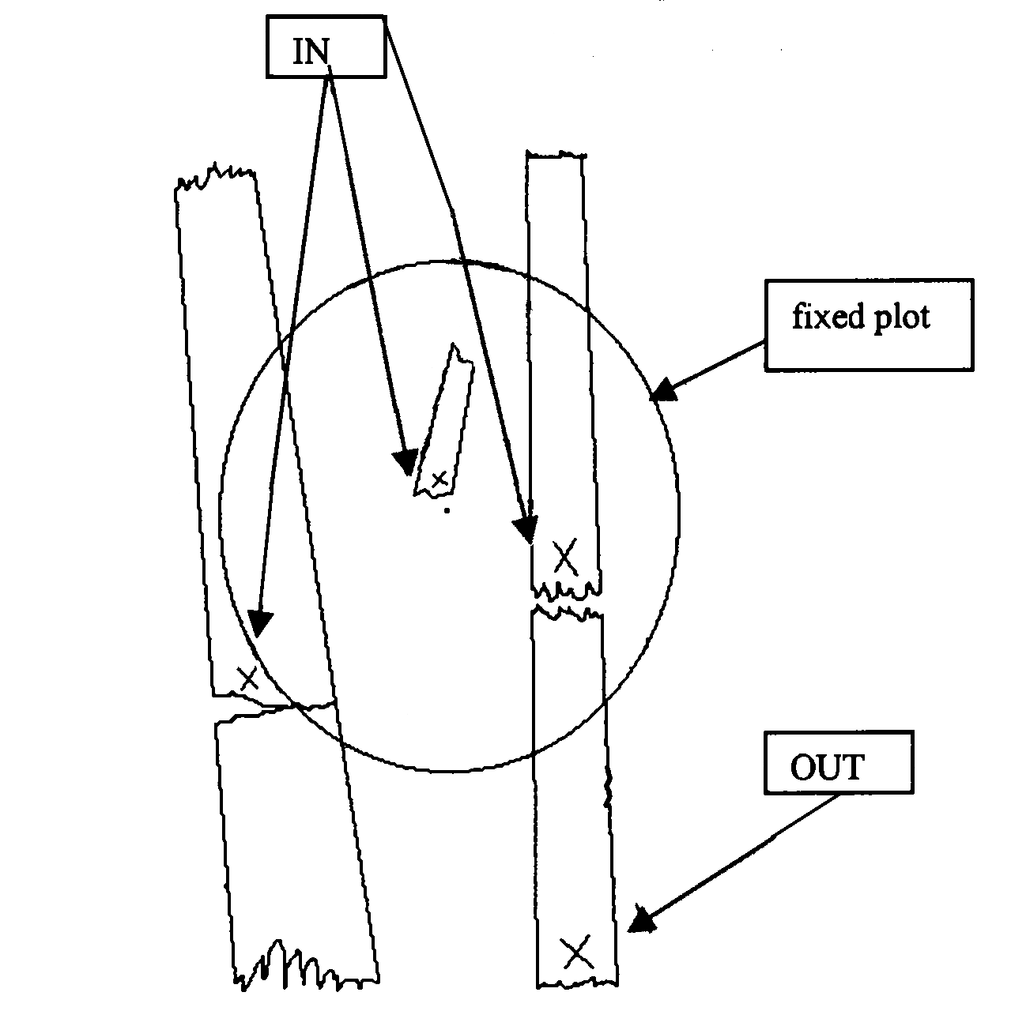

#### Step 1: Enter the Sample Design Information

In the Exams sample design form, select the Down Woody Material tab. Set the Selection method to “FRQ” and the Expansion Factor (ExpFac) to the inverse of the fixed acre plot size. Set the minimum intersection diameter to the smallest piece size to be tallied.

Figure : Enter Sample Design information

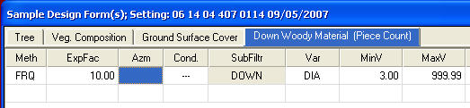

#### Step 2: Enter the Down Woody Data

From the Exams plot menu, select Down Woody Material and enter the data for the duff and fuel depth. Then tally each piece in the fixed area plot larger than the minimum intersection diameter.

Figure : Enter Down Woody data

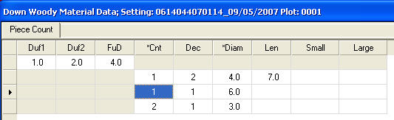

#### First Duff and Second Duff (maximum of 2 numbers; may include one decimal)

This is the duff, in inches, to the nearest 0.1-inch. Duff is the fermentation and humus layers of the forest floor. It does not include the freshly cast material in the litter layer. The top of the duff is where needles, leaves, and other castoff vegetative material have noticeably begun to decompose. Individual particles usually will be bound by fungal mycelium. When moss is present, the top of the duff is just below the green portion of the moss. The bottom of the duff layer is the start of the mineral soil.

Carefully expose a profile of the forest floor for the measurement. A knife or hatchet helps but is not essential. Avoid compacting or loosening the duff where the depth is measured.

Take the first duff measurement at one foot from the sample plot center and record it in the “First Duff” column. Take the second duff at six feet from sample plot center and record it in the “Second Duff” column. When stumps, logs, and trees occur at the plot of measurement, offset one foot perpendicular to the right of the sampling plane. Measure through rotten logs when the central axis is in the duff layer.

Accuracy Standard: Plot average duff depth ±1/2 inch.

#### Fuel Depth (maximum of 2 numbers; may include one decimal)

This is the total vertical dead fuel depth, in inches, to the nearest whole inch. Take three equally spaced measurements, along the longest transect, and record the average depth. The fuel bed is the accumulation of dead, woody residue on the forest floor. It begins at the top of the duff layer and includes litter, dead branches, and boles from trees, as well as dated material from shrubs, herbs, and grasses. Dead branches on trees, and dead stems and branches still attached to the ground (i.e., standing dead plants) are not included. Measure from the top of the duff layer to the highest dead particle above the point to the nearest tenth inch. On suspended logs (e.g., spanning a ravine), enter the distance between the top of the duff layer and the top of the log.

Accuracy Standard: ±20%

#### First Litter and Second Litter

If you enter through the Inventory and Monitoring form, you will be able to enter First Litter and Second Litter information. If you enter through the CSE form, these fields will be grayed out. These fields list the depth of the first litter and second litter, in inches, to the nearest 0.1 inch. Only null values and positive numbers are allowed.

Figure : Down Woody Material form



#### Piece Count (maximum of 3 numbers) Required

This is the number of large pieces (three inches or larger in diameter or as stated on the Sample Design form). Tally each decay class separately. If pieces are touching, it is considered one piece.

Accuracy Standard: No missed pieces

#### Decay Class (exactly 1 number) Optional

This is the decay class (1-5) for the pieces three inches in diameter and larger.

#### Log Decay Class

Table 118: Required and optional fields in Form 1, total cover and total by lifeform

| **Code** | **Bark** | **Twigs** | **Texture** | **Shape** | **Wood Color** | **Portion of Log on Ground** |
| --- | --- | --- | --- | --- | --- | --- |
| 1 | Intact | Present | Intact | Round | Original | None, elevated on supporting points |
| 2 | Intact | Absent | Intact to soft | Round | Original | Parts touch, still elevated, sagging slightly |
| 3 | Trace | Absent | Hard large pieces | Round | Original to faded | Bole on ground |
| 4 | Absent | Absent | Soft blocky pieces | Round to oval | Light brown to faded brown | Partially below ground |
| 5 | Absent | Absent | Soft, powdery | Oval | Faded light yellow or gray | Mostly below ground |

Figure : Log decomposition classes



#### Diameter (maximum of 3 numbers; may include one decimal)

This is the diameter of each intersected piece three inches in diameter and larger.

Accuracy Standard: ±1 inch

#### Diameter Large End (maximum of 3 numbers; may include one decimal)

This is the large end diameter of the intersected piece,

Accuracy Standard: ±1 inch

#### Diameter Small End (maximum of 3 numbers; may include one decimal)

This is the small end diameter of the intersected piece.

Accuracy Standard: ±1 inch

#### Piece Length

This is the piece length, in feet, of each piece three inches in diameter or larger. Record the diameter of the intersected piece.

Accuracy Standard: ±20%

### Method 1C: Piece Count on a Transect

When collecting down woody data on a transect, the piece is tallied if the diameter of the piece that falls along the transect meets the “intersection diameter” criteria specified on the sample design.

#### Step 1: Enter the Sample Design Information

In the Exams sample design form, select the Down Woody Material tab. Set the Selection method to “TRN” and the Expansion Factor (ExpFac) to the length of the various transects you intend to use. Set the minimum and maximum intersection diameter for each transect length.

Figure : Enter Sample Design information

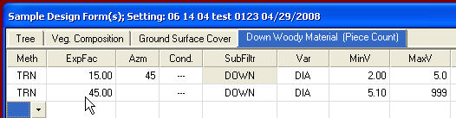

#### Step 2: Enter the Down Woody Data

From the Exams plot menu, select Down Woody Material and enter the data for the duff and fuel depth. Then tally each piece that intersects each transect and that meets the minimum and maximum diameter requirements for that transect.

Figure : Enter Down Woody data

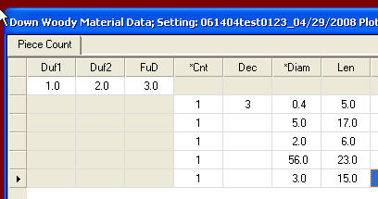

#### First Duff and Second Duff (maximum of 2 numbers; may include one decimal)

This is the duff, in inches, to the nearest 0.1-inch. Duff is the fermentation and humus layers of the forest floor. It does not include the freshly cast material in the litter layer. The top of the duff is where needles, leaves, and other castoff vegetative material have noticeably begun to decompose. Individual particles usually will be bound by fungal mycelium. When moss is present, the top of the duff is just below the green portion of the moss. The bottom of the duff layer is the start of the mineral soil.

Carefully expose profile of the forest floor for the measurement. A knife or hatchet helps but is not essential. Avoid compacting or loosening the duff where the depth is measured.

Take the first duff measurement at one foot from the sample plot center and record it in the “First Duff” column. Take the second duff at six feet from sample plot center and record it in the “Second Duff” column. When stumps, logs, and trees occur at the plot of measurement, offset one foot perpendicular to the right of the sampling plane. Measure through rotten logs when the central axis is in the duff layer.

Accuracy Standard: Plot average duff depth ±1/2 inch

#### Fuel Depth (maximum of 2 numbers; may include one decimal)

This is the total vertical dead fuel depth, in inches, to the nearest whole inch. Take three equally spaced measurements, along the longest transect, and record the average depth. The fuel bed is the accumulation of dead, woody residue on the forest floor. It begins at the top of the duff layer and includes litter, dead branches, and boles from trees, as well as dead material from shrubs, herbs, and grasses. Dead branches on trees, and dead stems and branches still attached to the ground (i.e., standing dead plants) are not included. Measure from the top of the duff layer to the ground dead particle above the point to the nearest tenth inch. On suspended logs (e.g., spanning a ravine), enter the distance between the top of the duff layer and the top of the log.

Accuracy Standard: ±20%

#### First Litter and Second Litter

If you enter though the Inventory and Monitoring form, you will be able to enter First Litter and Second Litter information. If you enter through the CSE form, these fields will be grayed out. These fields list the depth of the first litter and second litter, in inches, to the nearest 0.1 inch. Only null values and positive numbers are allowed.

Figure : Down Woody Material form



#### Piece Count (maximum of 3 numbers) Required

This is the number of large pieces (three inches or larger in diameter or as stated on the Sample Design form). Tally each decay class separately. If pieces are touching, it is considered one piece.

Accuracy Standard: No missed pieces

#### Decay Class (exactly 1 number)

This is the decay class (1-5) for the pieces three inches in diameter and larger.

#### Log Decay Class

Table 119: Required and optional fields in Form 1, total cover and total by lifeform

| **Code** | **Bark** | **Twigs** | **Texture** | **Shape** | **Wood Color** | **Portion of Log on Ground** |
| --- | --- | --- | --- | --- | --- | --- |
| 1 | Intact | Present | Intact | Round | Original | None, elevated on supporting points |
| 2 | Intact | Absent | Intact to soft | Round | Original | Parts touch, still elevated, sagging slightly |
| 3 | Trace | Absent | Hard large pieces | Round | Original to faded | Bole on ground |
| 4 | Absent | Absent | Soft blocky pieces | Round to oval | Light brown to faded brown | Partially below ground |
| 5 | Absent | Absent | Soft, powdery | Oval | Faded light yellow or gray | Mostly below ground |

Figure : Log decomposition classes



#### Diameter (maximum of 3 numbers; may include one decimal)

This is the diameter of each intersected piece three inches in diameter and larger.

Accuracy Standard: ±1 inch

#### Diameter Large End (maximum of 3 numbers; may include one decimal)

This is the larger end diameter of the intersected piece.

Accuracy Standard: ±1 inch

#### Diameter Small End (maximum of 3 numbers, may include one decimal)

This is the small end diameter of the intersected piece.

Accuracy Standard: ±1 inch

#### Piece Length (maximum of 3 numbers, may include one decimal)

This is the piece length, in feet, of each piece three inches in diameter or larger. Record the diameter of the intersected piece.

Accuracy Standard: ±20%

### Method 2: Planar Intercept (Brown’s Protocol)

#### Sampling Procedures

For average amounts of downed material, about 5 to 6 minutes per sample point is required for the measurements. More time is usually spent in traveling and locating sample points than in making the measurements. If only downed woody material is inventoried, a two-person crew can complete 20 to 40 plots per day, depending on how much material is present.

#### The Sampling Planes

The inventory is based on the planar intersect technique which has the same theoretical basis as the line intersect technique. The planar intersect technique involves counting intersections of woody pieces with vertical sampling planes that resemble guillotines dropped through the downed material. Review the following literature for more information:

* Brown, James K. 1974. Handbook for inventorying downed woody material. USDA For. Serv. Gen. Tech. Rep. INT-16, 24p. Intermt. For. And Range Exp. Stn., Ogden, Utah.
* Brown, James K., and Peter J. Roussopoulos. 1974. Eliminating biases in the planar intersect method for estimating volumes of small fuels. For. Sci. 20(4): 350-356.
* Van Wagner, C.E. 1968. The line intersect method in forest fuel sampling. For. Sci. 14(1): 20-26.

#### Sampling Plane Height

The sampling plane height (vertical height) is undefined so that all intersections of dead down material are tallied regardless of their height above the ground. Tree boles are considered down if they lean greater than 45 degrees from the perpendicular. Sampling plane lengths vary by size and amount of downed woody material.

#### Sampling Plane Length

Length of sampling plane can be varied by users to obtain desired sampling precision. Generally, as fewer sample points are taken, sampling plane lengths should be longer to achieve desired sampling precision.

Sampling plane lengths are horizontal lengths. Slope distance will need to be adjusted to a horizontal distance. If a sampling plane extends beyond the border of the stand, truncate the plane at the stand boundary.

The table that follows suggests sampling plane lengths and number of sample points needed to obtain specified percent errors (standard error of estimate divided by the mean, expressed as percentage). These recommendations are based on average distributions of naturally fallen downed woody material sampled in the northern Rocky Mountains. The sampling plane lengths can vary from one-half of the table values for heavy fuels that are uniformly distributed to twice the table values for light and unevenly distributed fuels. For heavy slash, the sampling plane lengths recommended for naturally fallen fuels could be cut in half.

A standard error of estimate within 20 percent of the mean is often considered adequate for fuel appraisal. A smaller percent error may be desirable for planning utilization of downed woody material. Percent errors greater than 35 percent afford poor reliability. If sampling cannot provide at least this level of reliability, it may not be worthwhile.

#### Fuel Estimate

Decide whether an estimate of fuels is needed for an individual stand or for several stands together. If fuel quantities are believed to be similar in several stands, then a single estimate is appropriate for appraising fuels in these stands. This is often the case of several adjacent stands in a timber sale area. If fuel estimates are desired for individual stands, then choose a sampling plane length appropriate for the number of sample points planned for the stand. The same sampling plane length should be used throughout each stand or group of stands for which fuel estimates are sought.

#### Length of Sampling Plane for Percent Errors and Number of Sample Points

Table 120: Sampling plane lengths in feet based on diameter, percent error and number of sample plots

| **Diameter** | **Percent Error** | **5 Sample Points** | **6 Sample Points** | **7 Sample Points** | **8 Sample Points** | **10 Sample Points** | **15 Sample Points** | **20 Sample Points** | **30 Sample Points** |
| --- | --- | --- | --- | --- | --- | --- | --- | --- | --- |
| 0.1 – 1 inch | 15 | 34 | 28 | 24 | 21 | 17 | 11 | 8 | 6 |
| 0.1 – 1 inch | 20 | 19 | 16 | 14 | 12 | 10 | 6 | 8 | 4 |
| 0.1 – 1 inch | 25 | 12 | 10 | 9 | 8 | 6 | 4 | 3 | 2 |
| 0.1 – 1 inch | 30 | 8 | 7 | 6 | 5 | 4 | 3 | 2 | 2 |
| 0.1 – 1 inch | 35 | 6 | 5 | 5 | 4 | 3 | 2 | 2 | 1 |
| 1 – 3 inches | 15 | 85 | 70 | 60 | 55 | 45 | 30 | 22 | 14 |
| 1 – 3 inches | 20 | 50 | 40 | 35 | 30 | 24 | 16 | 12 | 8 |
| 1 – 3 inches | 25 | 30 | 25 | 22 | 20 | 16 | 10 | 8 | 5 |
| 1 – 3 inches | 30 | 22 | 18 | 15 | 14 | 11 | 7 | 5 | 4 |
| 1 – 3 inches | 35 | 16 | 13 | 11 | 10 | 8 | 5 | 4 | 3 |
| 3+ inches | 15 | 380 | 315 | 270 | 235 | 190 | 123 | 95 | 65 |
| 3+ inches | 20 | 210 | 175 | 150 | 130 | 105 | 70 | 50 | 35 |
| 3+ inches | 25 | 140 | 115 | 100 | 90 | 70 | 50 | 35 | 25 |
| 3+ inches | 30 | 100 | 80 | 70 | 60 | 50 | 35 | 25 | 15 |
| 3+ inches | 35 | 70 | 60 | 50 | 45 | 35 | 25 | 18 | 12 |

Record each Sampling Plane Length once per setting, on the Sample Design form. For example, if the number of sample points is 20 and desired percent of error is 20%, then record:

* 8 foot length for 0.1 – 1 inch class
* 12 foot length for 1 – 3 inch class
* 50 foot length for 3+ inch class

In medium fuel situations, these sampling planes should provide percent errors of about 20 percent with 20 sample points and 30 percent with 10 sample points.

#### Tally Rules for the Downed Fuel Inventory

1. Particles qualifying for tally include downed, dead woody material (twigs, stems, branches, and bolewood) from trees and shrub. Dead branches attached to boles of standing trees are omitted because they are not downed vegetation. Consider a particle “downed” if it has fallen to the ground, or is severed from its original source of growth. Cones, bark flakes, needles, leaves, grass, and forbs are not counted. Dead woody stems and branches still attached to standing brush and trees are not counted.
2. Twigs or branches lying in the litter layer and above are counted. However, they are not counted when the intersection between the central axis of the particle and the sampling plane lies in the duff (forest floor below the litter).
3. If the sampling plane intersects the end of a piece, tally only if the central axis is crossed. If the plane exactly intersects the central axis, tally every other such piece.
4. Don’t tally any particle having a central axis that coincides perfectly with the sampling plane.
5. If the sampling plane intersect a curved piece more than once, tally each intersection.
6. Tally uprooted stumps and roots not encased in dirt. For tallying, consider uprooted stumps as tree boles or individual roots, depending on where the sampling planes intersect the stumps. Do not tally undisturbed stumps.
7. Tally all intersections of dead tree boles that lean greater than 45 degrees from the perpendicular regardless of the height of these intersections. Do not tally intersections of any standing dead trees that do not lean greater than 45 degrees from the perpendicular even if the point of intersection is within six feet of the ground.

#### Explanatory Figures

When stumps, logs, and trees occur at the point of duff measurement, offset one foot perpendicular to the right of the sampling plane. Measure through rotten logs whose central axis is in the duff layer.

Figure : Log in/above duff layer

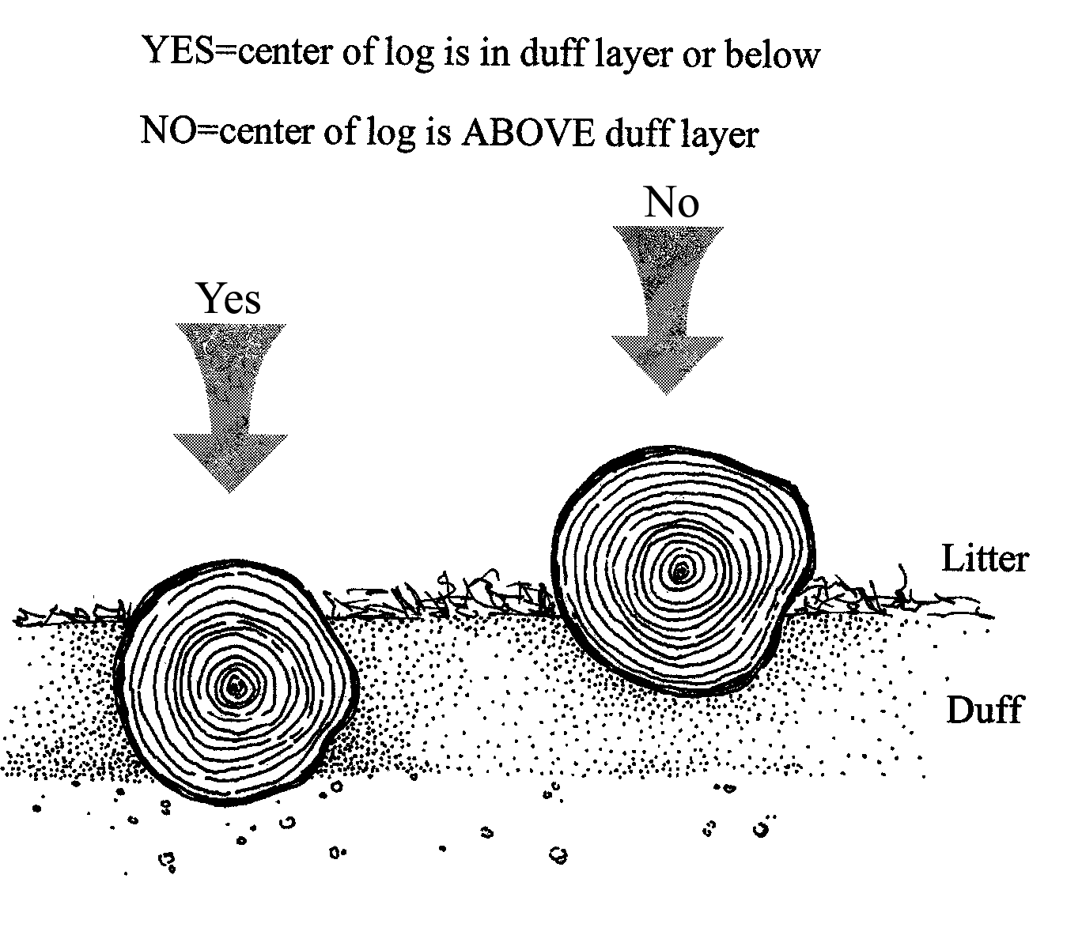

Twigs or branches lying in the litter layer and above are counted. They are not counted when the intersection between the central axis of the particle and the sampling plane lies in the duff (forest floor before the litter).

Figure : Litter versus Duff

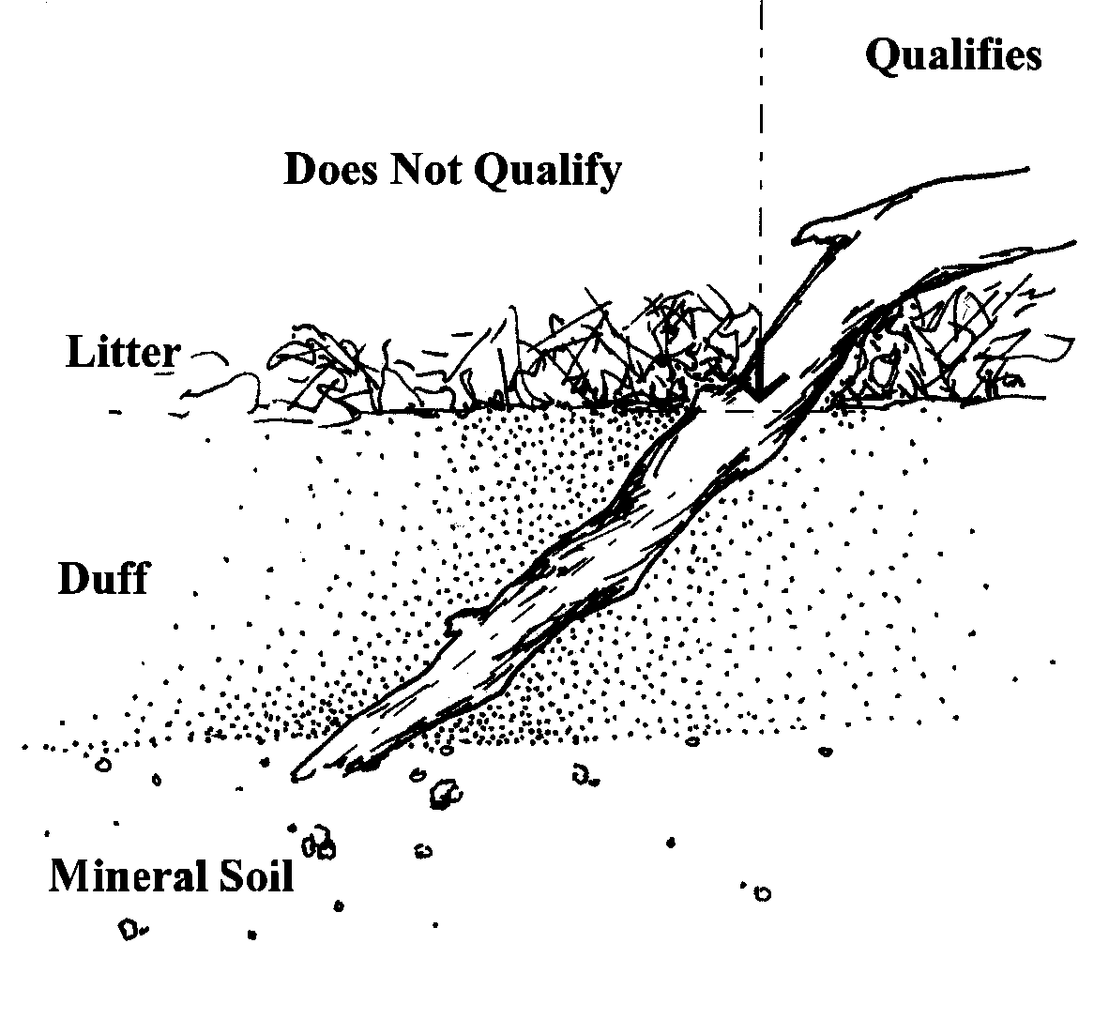

If the sampling plane intersects the end of a piece, tally only if the central axis is crossed. If the plane exactly intersects the central axis, tally every other such piece.

Figure : Sampling planes

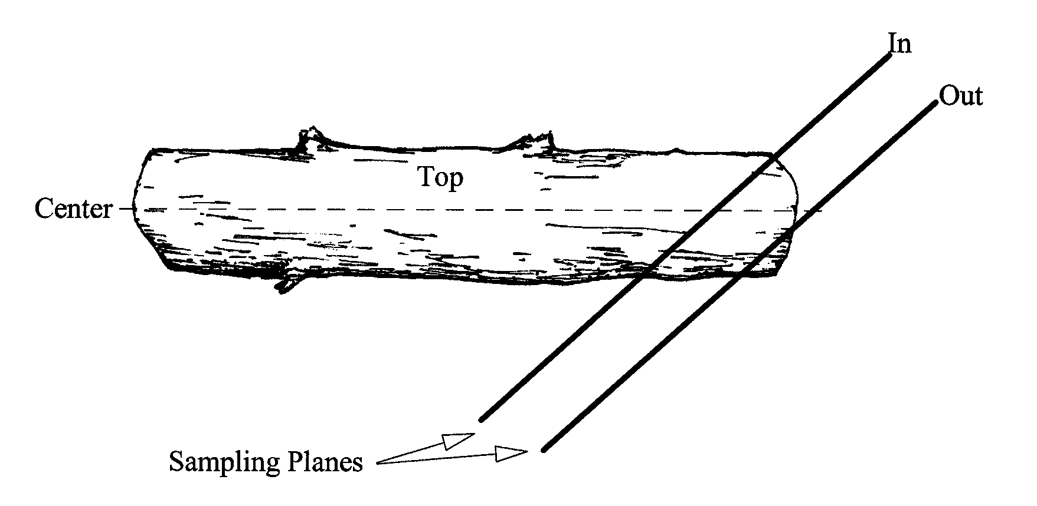

If the sampling plane intersects a curved piece more than once, tally each intersection.

Figure : Sampling plane intersections

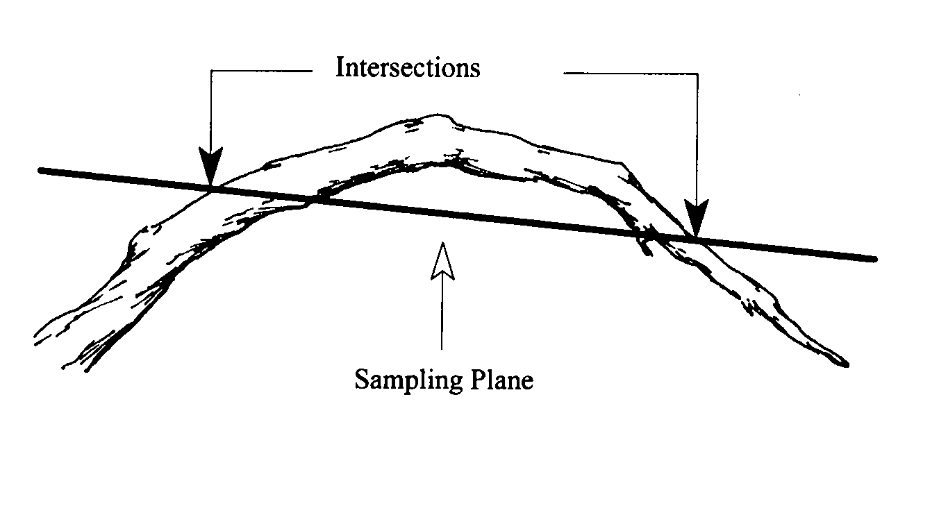

#### Step 1: Enter the Sample Design Information

In the Exams sample design form, select the Down Woody Material tab. Set the Selection method to “TRN” and the Expansion Factor (ExpFac) to the various transect lengths for each fuel class (1, 10, 100, and 1000 hour fuel classes). Set the minimum and maximum intersection diameters to correspond with those of each fuel class.

Figure : Enter Sample Design information

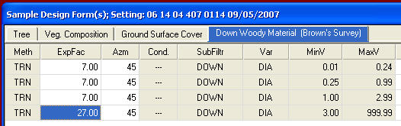

#### Step 2: Enter the Down Woody Data

From the Exams plot menu, select Down Woody Material and enter the data for the duff, fuel depth, and the first three fuel classes. Then tally each piece in the 1000 hour fuel class (3 inches and larger) separately.

Figure : Enter Down Woody data

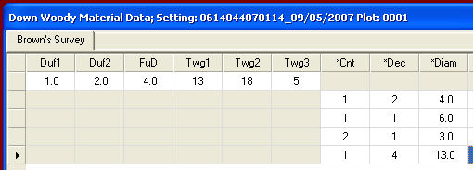

#### First Duff and Second Duff (maximum of 2 numbers; may include one decimal)

This is the duff, in inches, to the nearest 0.1-inch. Duff is the fermentation and humus layers of the forest floor. It does not include the freshly cast material in the litter layer. The top of the duff is where needles, leaves, and other castoff vegetative material have noticeably begun to decompose. Individual particles usually will be bound by fungal mycelium. When moss is present, the top of the duff is just below the green potion of the moss. The bottom of the duff layer is the start of the mineral soil.

Carefully expose a profile of the forest floor for the measurement. A knife or hatchet helps but is not essential. Avoid compacting or loosening the duff where the depth is measured.

Measure the duff along a transect that starts at plot center. Rotate the direction of the transect about 30 degrees from plot to plot. Record the transect direction in the remarks section. Take the first duff measurement at one foot from the sample plot center and record it in the “First Duff” column. Take the second duff at six feet from sample plot center and record it in the “Second Duff” column. When stumps, logs, and trees occur at the plot of measurement, offset one foot perpendicular to the right of the sampling plane. Measure through rotten logs when the central axis is in the duff layer.

Accuracy Standard: Plot average duff depth ±1/2 inch

#### Fuel Depth (maximum of 2 numbers; may include one decimal)

This is the total vertical dead fuel depth, in inches, to the nearest whole inch. Take three equally spaced measurements, along the longest transect, and record the average depth. The fuel bed is the accumulation of dead, woody, residue on the forest floor. It begins at the top of the duff layer and includes litter, dead branches, and boles from trees, and dead material from shrubs, herbs, and grasses. Dead branches on trees, and dead stems and branches still attached to the ground (i.e., standing dead plants) are not included. Measure from the top of the duff layer to the highest dead particle above the point to the nearest tenth inch. On suspended logs (e.g., spanning a ravine), enter the distance between the top of the duff layer and the top of the log.

Accuracy Standard: ±20%

#### First Litter and Second Litter

If you enter through the Inventory and Monitoring form, you will be able to enter First Litter and Second Litter information. If you enter through the CSE form, these fields will be grayed out. These fields list the depth of the first litter and second litter, in inches, to the nearest 0.1 inch. Only null values and positive numbers are allowed.

Figure : Down Woody Material form



#### Twig 1 (0 - .24) 1-hour fuels (maximum of 3 numbers) Required

This is the number of small twig intersections for each sampling plot. Small twigs are defined as pieces that have a cross section diameter of less than 1/4 inch at the point of intersection with the sampling plane. The horizontal length of the sampling lane for recording twig intersections is specified on the Sampling Criteria/Design form.

Accuracy Standard: ±40%

#### Twig 2 (.25 - .99) 10-hour fuels (maximum of 3 numbers) Required

This is the number of large twig intersections for each sampling plot. Medium sized twigs are defined as pieces which have a cross-section diameter of between .25 and .99 inches inclusive at the point of intersection with the sampling plane. The horizontal length of the sampling plane, being the same as that used for tallying small twigs, is specified on the Sampling Criteria/Design form.

Accuracy Standard: ±30%

#### Twig 3 (1.0 – 2.99) 100-hour fuels (maximum of 3 numbers) Required

This is the number of branch intersections for each sampling plot. Large twigs are defined as pieces with a cross section diameter of between 1.0 and 2.99 inches inclusive at the point of intersection with the sampling plane. The length of the sampling plane for tallying branch intersections is specified on the Sampling Criteria/Design form.

#### Piece Count (maximum of 3 numbers) Required

This is the number of large pieces (three inches or larger in diameter or as stated on the Sample Design form). Tally each decay class separately. If pieces are touching, it is considered one piece.

Accuracy Standard: No missed pieces

#### Decay Class (exactly 1 number) Required

This is the decay class (1-5) for the pieces three inches in diameter and larger.

Table 121: Required and optional fields in Form 1, total cover and total by lifeform

| **Code** | **Bark** | **Twigs** | **Texture** | **Shape** | **Wood Color** | **Portion of Log on Ground** |
| --- | --- | --- | --- | --- | --- | --- |
| 1 | Intact | Present | Intact | Round | Original | None, elevated on supporting points |
| 2 | Intact | Absent | Intact to soft | Round | Original | Parts touch, still elevated, sagging slightly |
| 3 | Trace | Absent | Hard large pieces | Round | Original to faded | Bole on ground |
| 4 | Absent | Absent | Soft blocky pieces | Round to oval | Light brown to faded brown | Partially below ground |
| 5 | Absent | Absent | Soft, powdery | Oval | Faded light yellow or gray | Mostly below ground |

Figure : Log decomposition classes



#### Diameter (maximum of 3 numbers; may include one decimal)

This is the diameter of each intersected piece three inches in diameter and larger.

Accuracy Standard: ±1 inch

#### Diameter Large End (maximum of 3 numbers; may include one decimal)

This is the larger end diameter of the intersected piece.

Accuracy Standard: ±1 inch

#### Diameter Small End (maximum of 3 numbers, may include one decimal)

This is the small end diameter of the intersected piece.

Accuracy Standard: ±1 inch

#### Piece Length (maximum of 3 numbers, may include one decimal)

This is the piece length, in feet, of each piece three inches in diameter or larger. Record the diameter of the intersected piece. Piece length is useful data for wildlife specialists. If the length is recorded, total pieces per acre can be calculated in the reports and views.

Accuracy Standard: ±20%

## Fire Data

### Fire Weather/Moisture/Behavior Form

Currently there are certain attributes collected in FFI that were not collected in Firemon and therefore are not in NRM FSVeg NRV_Fire_info table. (See [Appendix A of the user Guide](http://fsweb.nris.fs.fed.us/products/FSVeg/documentation.shtml) for more information.) These will be added to the FSVeg tables.

If the exam purpose code is FF then the Weather/Fuel/Fire form becomes enables but may not be populated.

#### Fire Information Form

These fields are set at the setting level in the Weather/Fuel/Fire form and cannot be modified.

* Fire Name – the name of the wildlife or prescribed burn project and/or unit
* Fire Reference ID – the FACTS SUID number if prescribed burn or wildlife number; the wildlife number on fire report 5100-29 (in Firestat or NIFMID database) given by dispatch
* Fire Information Remarks – section to record more on fire location, etc.
* Datum – datum of lat/long; no error
* Declination – the azimuth correction used to adjust magnetic north to true north

#### Observation Location Information

The following designate individual observation sites and are assigned for each unique combination of weather/fuel moisture/behavior observations.

* Observation Location Remarks – location description of where observations are made
* Date – the date of the fire, 8 digit number in MM/DD/YYYY format
* Time – the time of day that the observations were recorded in military time; tolerance: ±5 minutes
* Aspect – general direction of downslope in degrees azimuth, which the plot faces; 0 = flat, 360 = north, 999 = indeterminate, undulating, or no predominant slope; tolerance: no error
* Elevation – elevation of the area that is burning, in feet; integer; tolerance: ±100 feet
* Slope – ratio of vertical rise to horizontal distance for the setting, stored in percent; tolerance: ±5 percent
* Latitude Degrees – degree portion of the angular distance, north or south, of the equator, stored in degrees; *tolerance ±0.000001*
* Latitude Minutes – minute portion of the angular distance, north or south, of the equator, stored in minutes; *tolerance: ±0.000001*
* Latitude Seconds – second portion of the angular distance, north or south, of the equator; stored in seconds and tenths of seconds; *tolerance: ±0.000001*
* Longitude Degrees – degree portion of the angular distance, east or west, of the equator, stored in degrees; *tolerance:±0.000001*
* Longitude Minutes – minute portion of the angular distance, east or west, of the equator; *tolerance: ±0.000001*
* Longitude Seconds – second portion of the angular distance, east or west of the equator; *tolerance: ±0.000001*

### Fire Behavior Form

#### Fire Activity (2 characters)

Record at the time and date recorded in the Observation Location Information section. Tolerance: no error.

Table 122: Fire activity codes and descriptions

| **Code** | **Name** | **Description** |
| --- | --- | --- |
| SM | Smoldering | Occurs after the flaming combustion phase of a fire; often characterized by large amounts of smoke |
| S | Slow/creeping | Fire burning with a low flame and spreading slowly |
| R | Running | Behavior of a fire spreading rapidly with a well-defined head |
| T | Torching | The burning of the foliage of a single tree or a small group of trees, from the bottom up |
| C | Crowning | A fire that raises from ground into the tree crowns and advances from tree top to tree top; to intermittently ignite crowns as a surface fire advances |
| UA | Unable to access | Unable to access the fire for observation |

#### Fire Spread Type (2 characters)

Tolerance: ±1 class.

Table 123: Fire spread type codes and descriptions

| **Code** | **Name** | **Description** |
| --- | --- | --- |
| F | Flanking | Fire spread in parts of a fire’s perimeter that are roughly parallel to the main direction of spread |
| B | Backing | Fire spreading, or ignited to spread, into (against) the wind or downslope; a fire spreading on level ground in the absence of wind is a backing fire |
| H | Head | A fire spreading or set to spread with the wind |
| UA | Unable to access | Unable to access fire to make observation |

#### Flame Length (2 digits)

Flame length at the time and date recorded in the Observation Location Information section. The distance between the flame tip and the midpoint of the flame depth at the base of the flame (generally the ground surfaces), an indicator of fire intensity. Round to the nearest foot. Use height or known objects to help estimate height, make observations at 30-second intervals. Tolerance: ±20.

#### Flame Height (2 digits)

Flame height at the time and date recorded in the Observation Location Information section. The average maximum vertical extension of flames at the leading edge of the fire front. Occasional flashes that rise above the general level of flames are not considered. This distance is less than the flame length if flames are tilted due to wind or slope. Use height of known objects to help estimate height, make observations at 30-second intervals. Tolerance: ±20% of flame height, round to nearest foot.

#### Flame Depth (2 digits)

Tolerance: ±20% of flame depth, round to nearest whole number.

Table 124: Flame depth unit codes and descriptions

| **Units** | **Description** | **Method** |
| --- | --- | --- |
| Feet | The depth of the fire front or the part of a fire within which continuous flaming combustion is taking place | Flame depth, in feet, at the time and date recorded in the Observation Location Information section; use size of known objects to help estimate size and make observations at 30-seconds intervals |

#### Spread Rate (2 digits)

Tolerance: ±10% of spread rate, round to nearest whole number.

Table 125: Spread rate units and descriptions

| **Unit** | **Description** | **Method** |
| --- | --- | --- |
| Feet per minute | Rate of increase of the total perimeter of the fire, as rate of forward spread of the fire front, or as rate of increase in area, for a specific period in the fire’s history | The average speed of the fire, at the time and date recorded in the Observation Location Information section; in feet per minute; markers can be placed at known intervals, perpendicular to the flame front, to help estimate |

#### Spread Azimuth (3 digits)

The azimuth direction, in degrees, of fire spread, at the time and date recorded in the Observation Location Information section. Tolerance: ±45 degrees.

#### Spotting Observations (2 characters)

Tolerance: ±1 class.

Table 126: Spotting observation codes and descriptions

| **Code** | **Description** | **Method** |
| --- | --- | --- |
| SD | Spotting downslope or downwind | Estimate to best of ability referencing off of geographic features at the time and date recorded in the Observations Location Information section |
| SU | Spotting upslope or upwind | Estimate to best of ability referencing off of geographic features |
| SE | Spotting is erratic and very random | Estimates to best of ability at the time and date recorded in the Observation Location Information section |
| NS | No spotting observed | Estimate to best of ability |
| NA | Difficult to determine spotting due to smoke or obstruction | Estimate to best of ability |

#### Spotting Distance Minimum (4 digits)

Distance estimated to best of ability, reference off of nearby geographic features, at the time and date recorded in the Observation Location Information section. Tolerance: ±500 feet.

#### Spotting Distance Maximum (4 digits)

Distance estimated to best of ability, reference off of nearby geographic features, at the time and date recorded in the Observation Location Information section. Tolerance: ±500 feet.

#### Plume Behavior (2 characters)

A convection column generated by combustion (of wildland fuel). Tolerance: ±1 class.

Table 127: Plume behavior codes and descriptions

| **Code** | **Name** | **Description** |
| --- | --- | --- |
| WV | Plume well ventilated, rising, and dispersing high above the burn | Estimate to best of ability, at the time and date recorded in the Observation Location Information section |
| US | Plume unstable with erratic behavior | Estimate to best of ability, at the time and date recorded in the Observation Location Information section |
| PD | Plume is dropping and going downhill into the valleys | Estimate to best of ability, at the time and date recorded in the Observation Location Information section |
| IN | Inversion | Estimate to best of ability, at the time and date recorded in the Observation Location Information section |

#### Plume Direction Azimuth (3 digits)

Tolerance: ±45 degrees.

Table 128: Plume direction units and descriptions

| **Units** | **Description** | **Method** |
| --- | --- | --- |
| Degrees azimuth | The direction of the fire plume, in degrees, to the nearest 45 degrees | Estimate to best of ability referencing off of geographic features, at the time and date recorded in the Observation Location Information section |

#### Plume Height (2 digits)

Tolerance: ±1,000 feet.

Table 129: Plume height units and descriptions

| **Units** | **Description** | **Method** |
| --- | --- | --- |
| Feet | The height of the plume in feet | Estimate to best of ability referencing off of geographic features |

### Fire Weather Conditions

#### Wind Direction (3 digits)

Tolerance: ±45 degrees.

Table 130: Wind direction units and descriptions

| **Units** | **Description** | **Method** |
| --- | --- | --- |
| Azimuth degrees | Compass direction from which typical wind at the fire is blowing from true north | At the time and date recorded in the Observation Location Information section |

#### Windspeed (3 digits)

Tolerance: ±10 percent of wind speed, round to nearest whole number

Table 131: Wind direction units and descriptions

| **Units** | **Description** | **Method** |
| --- | --- | --- |
| Miles per hour | Wind speed is the AVERAGE or typical speed of the wind at the fire | Wind measured at eye level above open, level ground or as adjusted to meet this standard to compensate for height of ground cover, uneven ground, and nearby obstructions; the longer your monitoring time (up to 10 minutes), the more accurate your average; measured at the time and date recorded in the Observation Location Information section |

#### Wind Gust Speed (3 digits)

Tolerance: ±10 percent of wind gust speed, round to nearest whole number.

Table 132: Wind gust speed units and descriptions

| **Units** | **Description** | **Method** |
| --- | --- | --- |
| Miles per hour | A GUST is the highest wind speed outside your average | Recorded at the time and date recorded in the Observation Location Information section |

#### Dry Bulb (3 digits)

Tolerance: no error.

Table 133: Dry bulb units and descriptions

| **Units** | **Description** | **Method** |
| --- | --- | --- |
| Degrees F | The temperature of the air measured in the shade 4-8 feet above the ground | Dry bulb temperature, at the time and date recorded in the Observation Location Information section |

#### Wet bulb (3 digits)

Tolerance: no error.

Table 134: Wet bulbs units and descriptions

| **Units** | **Description** | **Method** |
| --- | --- | --- |
| Degrees F | The lowest temperature to which are can be cooled by evaporating water into it at a constant pressure when the heat required for evaporation is supplied by the cooling of the air; it is measured by the wet bulb thermometer, which usually employs wetted wicking on the bulb as a cooling (through evaporation) device | Wet bulb temperature taken with wick over thermometer, at the time and date recorded in the Observation Location Information section |

#### Dew Point (3 digits)

Tolerance: no error.

Table 135: Dew point units and descriptions

| **Units** | **Description** | **Method** |
| --- | --- | --- |
| Degrees F | Temperature to which a parcel of air must cool, at constant pressure and water-vapor content, in order for saturation to occur | Dew point may be determined from tables with dry and wet bulb temperatures, at the time and date recorded in the Observation Location Information section; the dew point is always lower than the wet-bulb temperature, which is always lower than the dry-bulb temperature, except when the air is saturated and all three values are equal |

#### Relative Humidity (2 digits)

Tolerance: no error.

Table 136: Relative humidity units and descriptions

| **Units** | **Description** | **Method** |
| --- | --- | --- |
| Percent | The ratio of the amount of moisture in the air, to the maximum amount of moisture that air would contain if it were saturated; the ratio of the actual vapor pressure to the saturated vapor pressure | Relative humidity estimated using dry and wet bulb with charts (see Relative Humidity Dew Point Tables section below), at the time and date recorded in the Observation Location Information section; tables also available at the [National Weather Service website](http://www.wrh.noaa.gov/firewx/tools/rht.php?wfo=tfx) |

#### Percent Cloudy (2 digits)

Tolerance: ±25 percent.

Table 137: Percent cloudy units and descriptions

| **Units** | **Description** | **Method** |
| --- | --- | --- |
| Percent | Estimate of cloud cover | Cloud Cover estimated to best of ability, at time and date recorded in the Observation Location Information section |

#### Haines Index (1 digit)

The Lower Atmosphere Severity Index (often called the Haines Index) describes the above-surface air mass as it affects large and/or erratic wildland fires and is most important when the surface fire danger is high. An atmospheric index used to indicate the potential for wildfire growth by measuring the stability and dryness of the air over a fire. Also called the Lower Atmosphere Stability Index. Calculated for different elevation ranges. Tolerance: ±1 class.

Table 138: Haines Index codes and methods

| **Codes** | **Method** |
| --- | --- |
| 2 to 6 | Record what the Haines Index or other local fire growth predictions are estimated; daily forecast maps are available at the [Northern Rockies Coordination Center’s Predictive Services page](http://gacc.nifc.gov/nrcc/predictive/weather/weather.htm)  Orange will indicate Haines Index of 4 (low), dark orange shows Haines Index of 5 (moderate), and red depicts Haines Index values of 6 (highest potential for large fires); values of 4 and above are plotted on each map even though the overall index is from 2 to 6 |

#### Days Since Wetting Rain (3 digits)

Number of days since last wetting rain. Tolerance: ±1 day.

### Fuel Information

#### Fire Behavior Fuel Model Number (3 digits)

Anderson 13 and Scott and Burgan 40 models. See Table 139 below. Tolerance: ±1 class.

#### Fire Behavior Fuel Model Code (3 characters)

Anderson 13 and Scott and Burgan 40 models. See Table 139 below. Tolerance: ±1 class.

Table 139: Fire behavior fuel model numbers, codes, and descriptions

| **Fuel Model Number** | **Fuel Model Code** | **Description** |
| --- | --- | --- |
| 1 | NFFL1 | 1, short gr. (1 foot) |
| 2 | NFFL2 | 2, tim. (gr. and undrstry) |
| 3 | NFFL3 | 3, tall gr. (2.5 feet) |
| 4 | NFFL4 | 4, chaparral (6 feet) |
| 5 | NFFL5 | 5, brush (2 feet) |
| 6 | NFFL6 | 6, dormant brush, HW slash |
| 7 | NFFL7 | 7, southern rough |
| 8 | NFFL8 | 8, closed tim. litter |
| 9 | NFFL9 | 9, hardwood litter |
| 10 | NFFL10 | 10, tim. (litter and undrstry) |
| 11 | NFFL11 | 11, light logging slash |
| 12 | NFFL12 | 12, med. logging slash |
| 13 | NFFL13 | 13, heavy logging slash |
| 91 | NB1 | 91, urban/developed |
| 92 | NB2 | 92, snow/ice |
| 93 | NB3 | 93, agricultural |
| 98 | NB8 | 98, open water |
| 99 | NB9 | 99, bare ground |
| 101 | GR1 | 101, shrt sprc. dry clim, gr. (dyn.) |
| 102 | GR2 | 102, lo. ld. dry clim. gr. (dyn.) |
| 103 | GR3 | 103, lo. ld. v. crse. hum. clim. gr. (dyn.) |
| 104 | GR4 | 104, mod. ld., dry clim. gr. (dyn.) |
| 105 | GR5 | 105, lo. ld., hum. clim. gr. (dyn.) |
| 106 | GR6 | 106, mod. ld., hum. clim. gr. (dyn.) |
| 107 | GR7 | 107, hi. ld. dry clim. gr. (dyn.) |
| 108 | GR8 | 108, hi. ld. v. crse, hum. clim. gr. (dyn.) |
| 109 | GR9 | 109, v. hi. ld., hum. clim. gr. (dyn.) |
| 121 | GS1 | 121, low ld., dry clim. gr.-shrb (dyn.) |
| 122 | GS2 | 122, mod. ld., dry clim. gr.-shrb (dyn.) |
| 123 | GS3 | 123, mod. ld., hum. clim. gr.-shrb (dyn.) |
| 124 | GS4 | 124, hi. ld., hum. clim. gr.-shrb (dyn.) |
| 141 | SH1 | 141, low ld., dry clim. shrb. (dyn.) |
| 142 | SH2 | 142, mod. ld., dry clim. shrb. |
| 143 | SH3 | 143, mod. ld., hum. clim. shrb. |
| 144 | SH4 | 144, low ld., hum. clim. tim.-shrb. |
| 145 | SH5 | 145, hi. ld., dry clim. shrb. |
| 146 | SH6 | 146, low ld., hum clim. shrb. |
| 147 | SH7 | 147, v. hi. ld., dry clim. shrb. |
| 148 | SH8 | 148, hi. ld., hum. clim. shrb. |
| 149 | SH9 | 141, v. hi. ld., hum. clim. shrb. (dyn.) |
| 161 | TU1 | 161, lo. ld., dry clim. tim.-gr.-shrb. (dyn.) |
| 162 | TU2 | 162, mod. ld., hum. clim. tim.-shrb. |
| 163 | TU3 | 163, mod. ld., hum. clim. tim.-gr.-shrb. (dyn.) |
| 164 | TU4 | 164, dwarf conifer with undrstry |
| 165 | TU5 | 165, v. hi. ld., dry clim. tim.-shrb. |
| 181 | TL1 | 181, low ld., compact conifer litter |
| 182 | TL2 | 182, low ld., broadleaf litter |
| 183 | TL3 | 183, mod. ld., conifer litter |
| 184 | TL4 | 184, small downed logs |
| 185 | TL5 | 185, hi. ld., conifer litter |
| 186 | TL6 | 186, mod. ld., broadleaf litter |
| 187 | TL7 | 187, large downed logs |
| 188 | TL8 | 188, long-needle litter |
| 189 | TL9 | 189, v. hi. ld., broadleaf litter |
| 201 | SB1 | 201, low ld. activity fuel |
| 202 | SB2 | 202, mod. ld. activity fuel or lo. ld. blwdwn |
| 203 | SB3 | 203, hi. ld. activity fuel or mod. ld. blwdwn |
| 204 | SB4 | 204, hi. ld. blwdwn |

#### Primary Fire Carrier (2 characters)

Tolerance: ±1 class.

Table 140: Primary fire carrier codes and descriptions

| **Code** | **Description** |
| --- | --- |
| GS | Grass/shrub |
| SH | Shrub |
| TU | Timber understory |
| TL | Timber litter |
| SB | Slash/blowdown |
| NB | Nonburnable |
| US | Unable to assess |

#### Fuel Continuity (25 characters)

Description of fuel continuity described at multiple scales and in both horizontal and vertical directions. The degree or extent of continuous or uninterrupted distribution of fuel particles in a fuel bed thus affecting a fire’s ability to sustain combustion and spread. This applies to aerial fuels as well as surface fuels. Tolerance: none.

#### Probability of Ignition (3 digits)

0 to 100 percent. Based on the Fine Fuel Shading percent (> or < 50%), Dry Bulb Temperature, and Fine Dead Fuel Moisture percent. See also the Probability of Ignition Table, below. Tolerance: ±10%.

#### Fuel Moisture 1-Hour (3 digits)

Fuel moisture, in percent, of the 1-hour downed dead woody fuel class (less than .25 inches in diameter). See also the Fine Dead Fuel Moisture Tables and Fine Dead Fuel Moisture Tables, below, and fuel sample collection methods and procedures in Measuring Fuel Moisture Content: Standard Methods and Procedures section below. When using the dead fuel moisture correction tables, you need to take into account the month, time of day, aspect, slope, and fuel dead shading, to accurately calculate the fine dead fuel moisture. Tolerance: no error.

#### Fuel Moisture 10-Hour (3 digits)

Fuel moisture, in percent, of the 10-hour downed dead woody fuel class (.25-1.0 inches in diameter). See also fuel sample collection methods and procedures in Measuring Fuel Moisture Content: Standard Methods and Procedures section below. Tolerance: no error.

#### Fuel Moisture 100-Hour (3 digits)

Fuel moisture, in percent, of the 100-hour downed dead woody fuel class (1-3 inches in diameter). See also fuel sample collection methods and procedures in Measuring Fuel Moisture Content: Standard Methods and Procedures section below. Tolerance: no error.

#### Fuel Moisture 1000-Hour Sound (3 digits)

Fuel moisture, in percent, of the sound 1000-hour downed dead woody fuel class (greater than 3.0 inches in diameter). See also fuel sample collection methods and procedures in Measuring Fuel Moisture Content: Standard Methods and Procedures section below. Tolerance: no error.

#### Fuel Moisture 1000-Hour Rotten (3 digits)

Fuel moisture, in percent, of the rotten 1000-hour downed dead woody fuel class (greater than 3.0 inches in diameter). See also fuel sample collection methods and procedures in Measuring Fuel Moisture Content: Standard Methods and Procedures section below. Tolerance: no error.

#### Fuel Moisture Litter (3 characters)

Moisture, in percent, of litter layer. This layer contains the recognizable needles, cones, scales, and leaves. See also fuel sample collection methods and procedures in Measuring Fuel Moisture Content: Standard Methods and Procedures section below. Tolerance: no error.

#### Fuel Moisture Duff (3 characters)

Moisture, in percent, of the duff layer. This layer contains the unrecognizable decomposing organic material. See also fuel sample collection methods and procedures in Measuring Fuel Moisture Content: Standard Methods and Procedures section below. Tolerance: no error.

#### Fuel Moisture Soil (3 characters)

Moisture, in percent, of the uppermost soil layer. This layer contains the top 10 cm of mineral soil just below the duff layer. See also fuel sample collection methods and procedures in Measuring Fuel Moisture Content: Standard Methods and Procedures section below. Tolerance: no error.

#### Fuel Moisture Shrub Live and Dead Moisture Mixed (3 characters)

Moisture, in percent, of the live and dead shrubs proportional to the species on site. See also fuel sample collection methods and procedures in Measuring Fuel Moisture Content: Standard Methods and Procedures section below. Tolerance: no error.

#### Fuel Moisture Herb Live and Dead Moisture Mixed (3 characters)

Moisture, in percent, of the live and dead herbaceous plants, proportional to the species on site. See also fuel sample collection methods and procedures in Measuring Fuel Moisture Content: Standard Methods and Procedures section below. Tolerance: ±1 class.

#### Fuel Moisture Moss (3 characters)

Moisture, in percent, of moss. See also fuel sample collection methods and procedures in Measuring Fuel Moisture Content: Standard Methods and Procedures section below. Tolerance: no error.

#### Fuel Moisture Crown Live and Dead Moisture Mixed (3 characters)

Moisture, in percent, of the live and dead, young and old crown foliage from as many parts of the crown as possible, proportional to the species and live/dead on site. See also fuel sample collection methods and procedures in Measuring Fuel Moisture Content: Standard Methods and Procedures section below. Tolerance: no error.

#### Fine Dead Fuel Shading Percent (3 characters)

The shaded and unshaded evaluations are done at the observation site that the fire behavior/weather observations are made. The percent shading for the site (envision a 0.1 are > circle around you) takes into account both the shading from a forest canopy, clouds, or topographic features. Percent shading (determining whether it’s > or < 50%) is recorded every time weather observations are taken to calculate the fine dead fuel moisture and probability of ignition. Tolerance: ±25%.

Table 141: Fine dead fuel shading percents and descriptions

| **Percents** | **Description** |
| --- | --- |
| <50% (less than 50%) | FINE DEAD fuel shading percent of fine fuels ahead of the projection point; determine if they are exposed (<50%) |
| >50% (greater than 50%) | FINE DEAD fuel shading percent of fine fuels ahead of the projection point; determine if they are shaded (>50%) |

### Relative Humidity Dew Point Tables

From the 2005 Interagency Fire Use Model, Field Guide by NWCG (National Wildfire Coordinating Group). Consider NWCG Course S-290, Intermediate Wildland Fire Behavior, and S-390 Introduction to Fire Behavior Calculations, to acquire skills in this area.

Figure : Relative humidity table: elev 0-500, dry bulb (41-60°F), wet bulb (23 to 59°F)

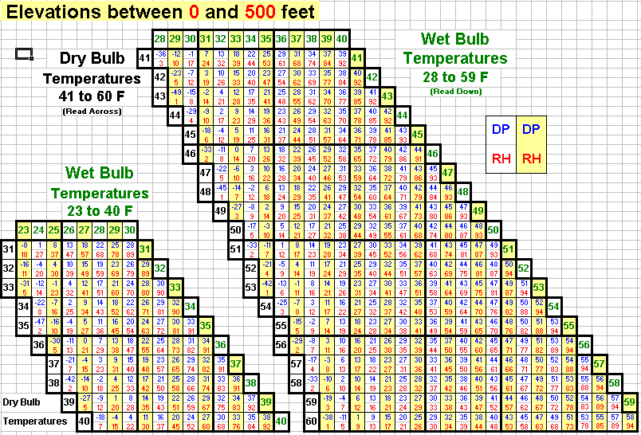

Figure : Relative humidity table: elev 0-500, dry bulb (61-80°F), wet bulb (40 to 79°F)

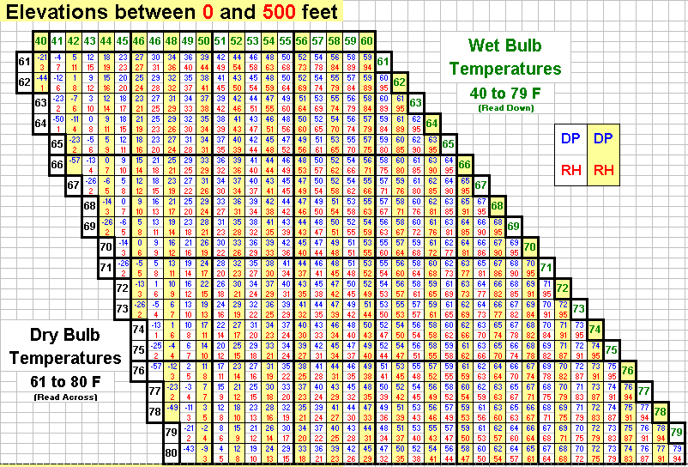

Figure : Relative humidity table: elev 0-500, dry bulb (81-100°F), wet bulb (50 to 90°F)

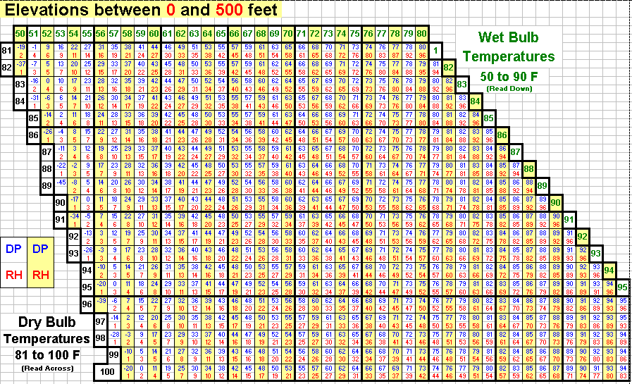

Figure : Relative humidity table: elev 0-500, dry bulb (101-119°F), wet bulb (58 to 95°F)

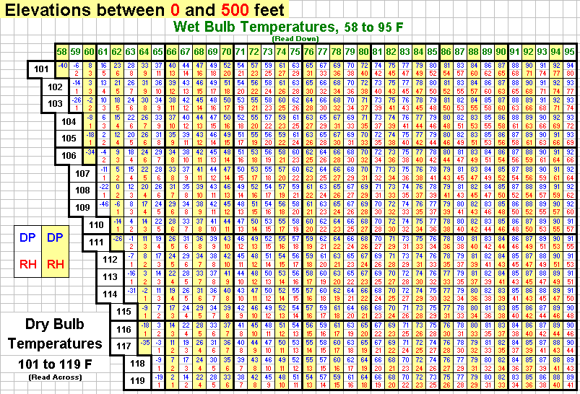

Figure : Relative humidity table: elev 501-1,900, dry bulb (41-60°F), wet bulb (28 to 59°F)

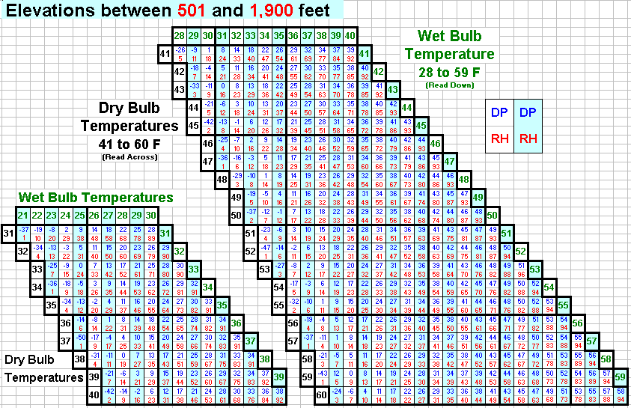

Figure : Relative humidity table: elev 501-1,900, dry bulb (61-80°F), wet bulb (39 to 80°F)

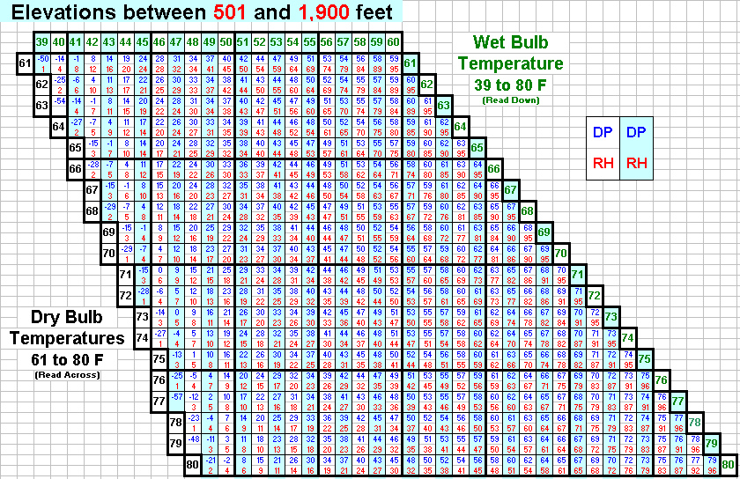

Figure : Relative humidity table: elev 501-1,900, dry bulb (81-100°F), wet bulb (49 to 91°F)

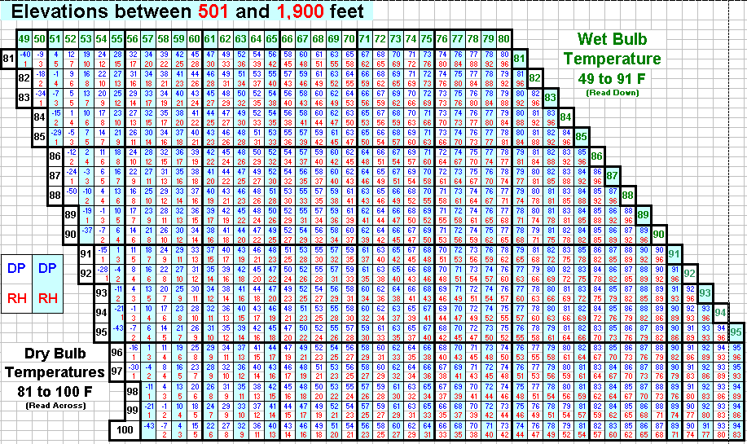

Figure :Relative humidity table: elev 501-1,900, dry bulb (101-119°F), wet bulb (58 to 95°F)

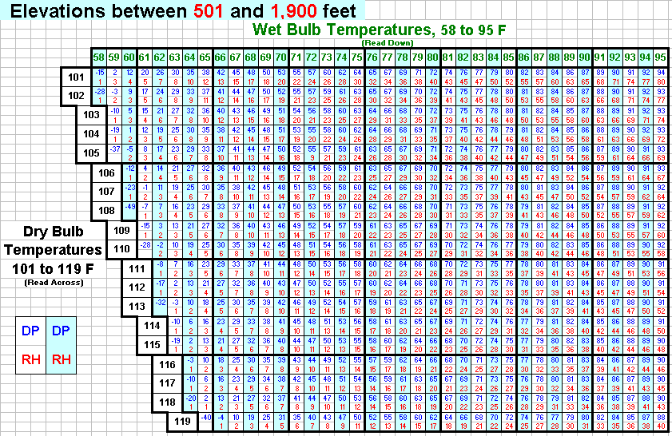

Figure : Relative humidity table: elev 1,901-3,900, dry bulb (41-60°F), wet bulb (27 to 57°F)

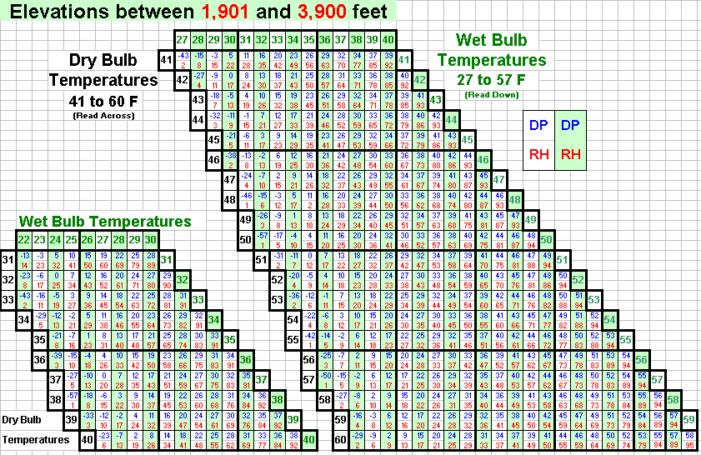

Figure : Relative humidity table: elev 1,901-3,900, dry bulb (61-80°F), wet bulb (39 to 79°F)

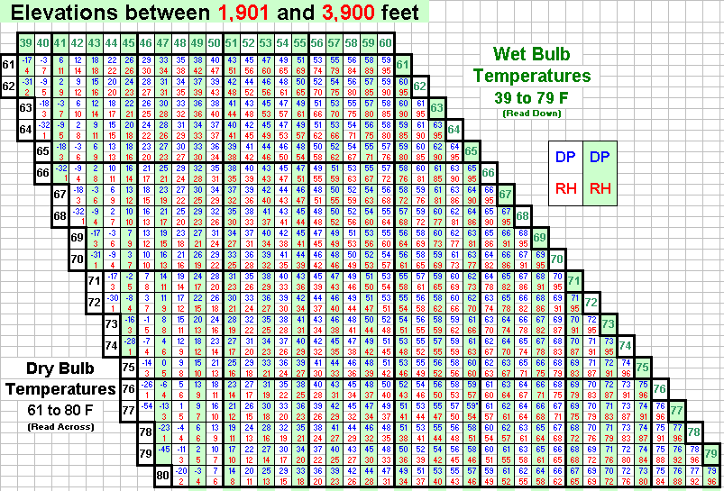

Figure : Relative humidity table: elev 1,901-3,900, dry bulb (81-100°F), wet bulb (49 to 89°F)

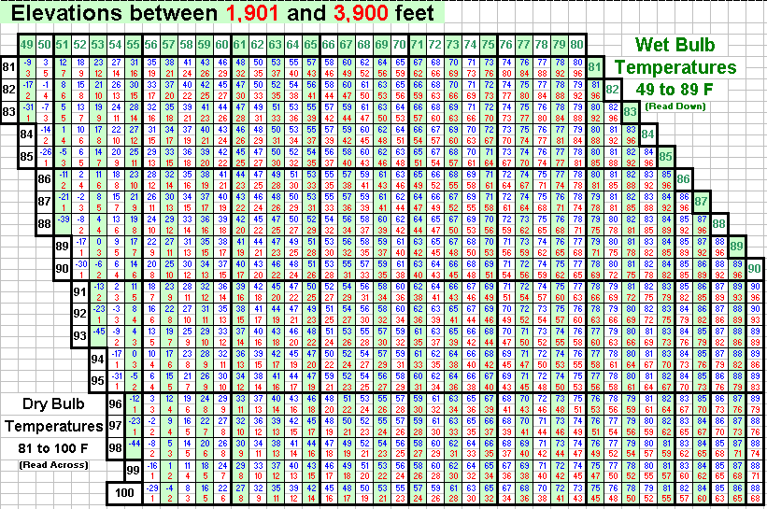

Figure : Relative humidity table: elev 1,901-3,900, dry bulb (101-119°F), wet bulb (57 to 90°F)

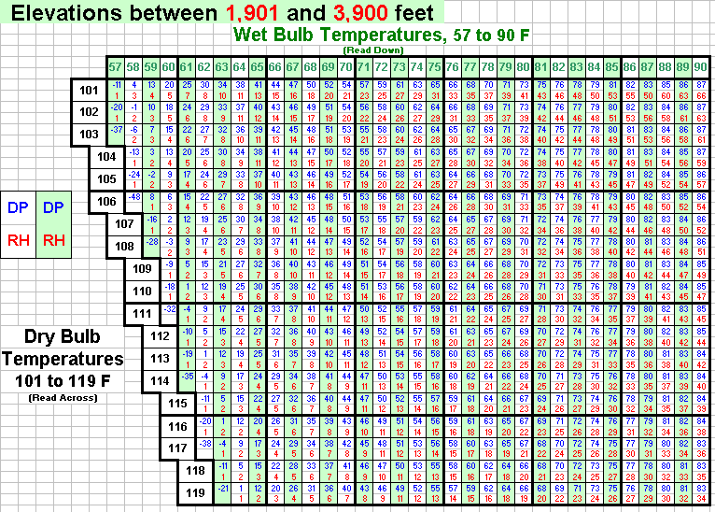

Figure : Relative humidity table: elev 3,901-6,100, dry bulb (41-60°F), wet bulb (27 to 56°F)

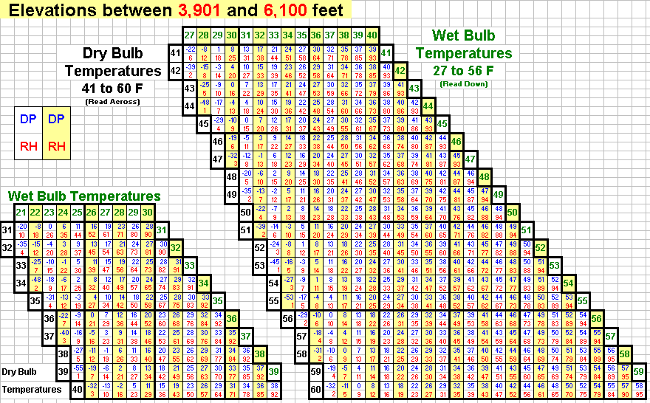

Figure : Relative humidity table: elev 3,901-6,100, dry bulb (61-0°F), wet bulb (38 to 79°F)

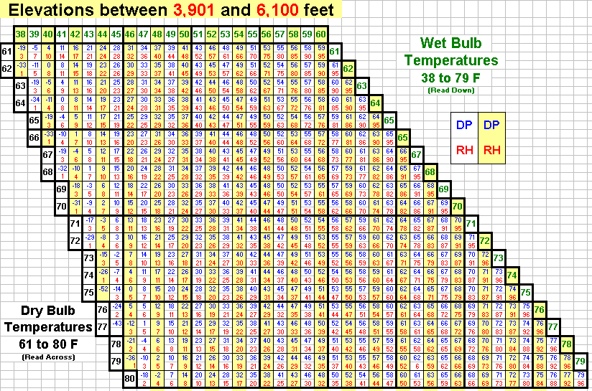

Figure : Relative humidity table: elev 3,901-6,100, dry bulb (81-100°F), wet bulb (48 to 89°F)

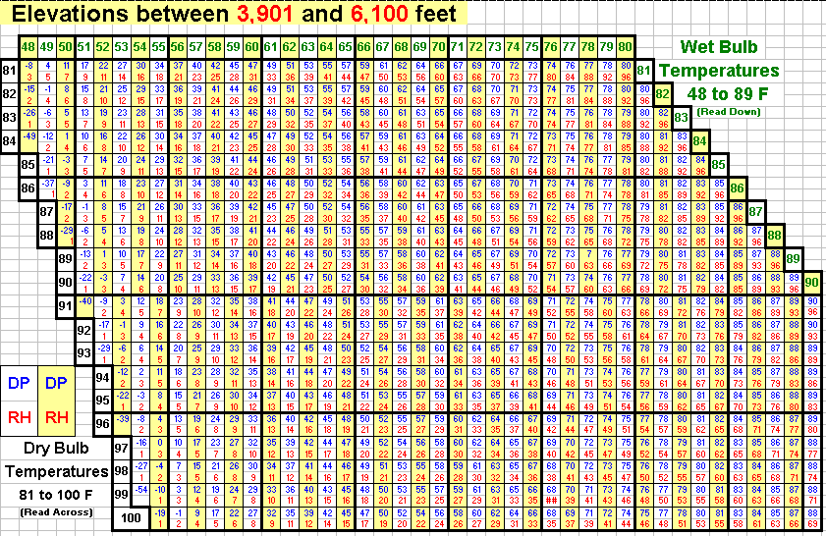

Figure : Relative humidity table: elev 3,901-6,100, dry bulb (101-119°F), wet bulb (55 to 90°F)

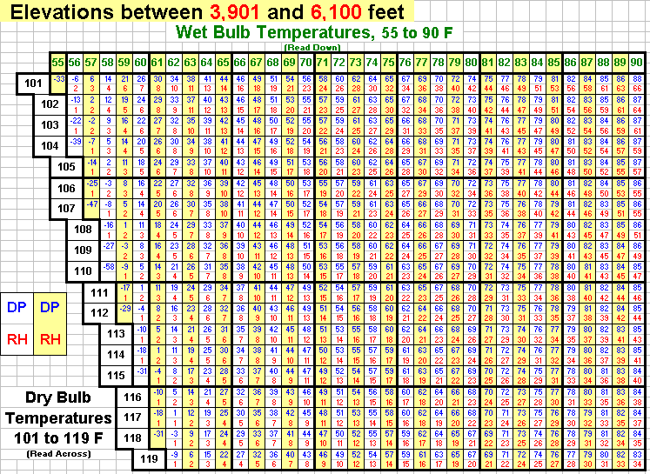

Figure : Relative humidity table: elev 6,101-8,500, dry bulb (31-50°F), wet bulb (20 to 50°F)

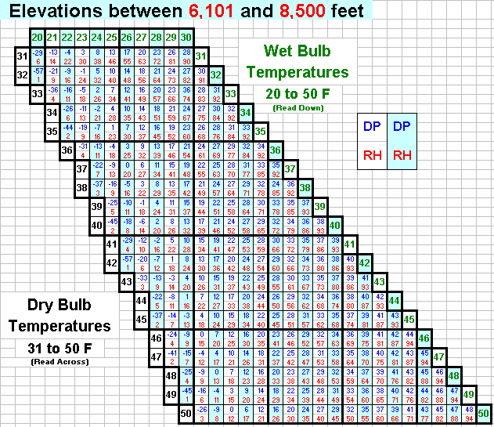

Figure : Relative humidity table: elev 6,101-8,500, dry bulb (51-70°F), wet bulb (31 to 70°F)

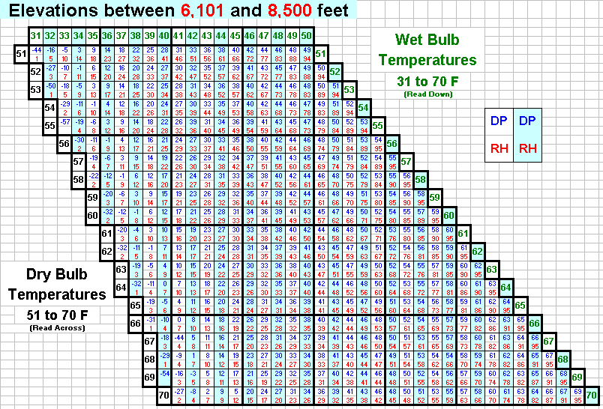

Figure : Relative humidity table: elev 6,101-8,500, dry bulb (71-90°F), wet bulb (42 to 81°F)

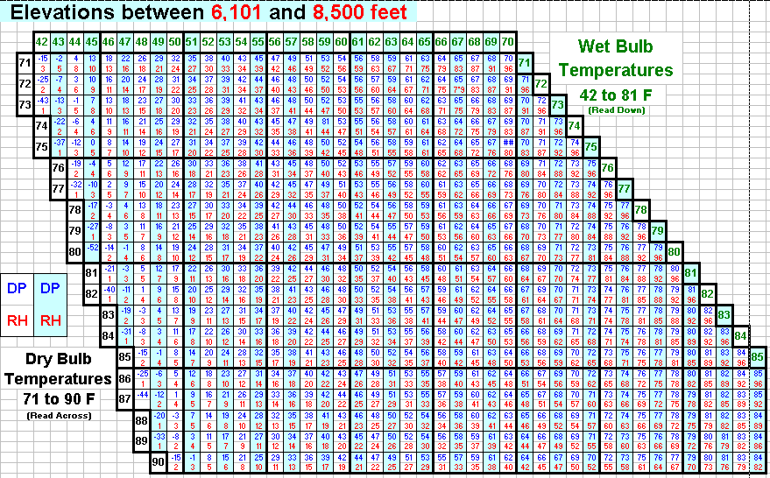

Figure : Relative humidity table: elev 6,101-8,500, dry bulb (91-109°F), wet bulb (50 to 85°F)

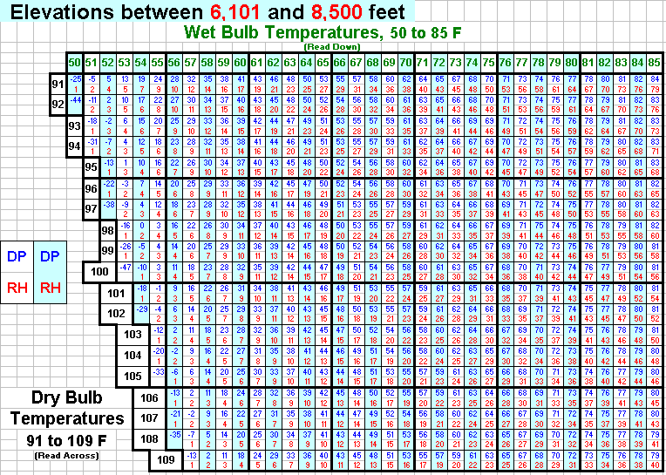

Figure : Relative humidity table: elev 8,501-11,000, dry bulb (31-50°F), wet bulb (19 to 50°F)

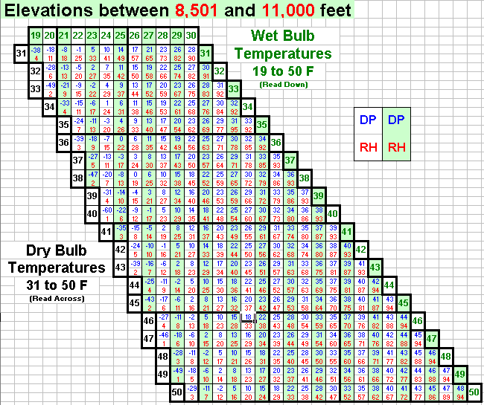

Figure : Relative humidity table: elev 8,501-11,000, dry bulb (51-70°F), wet bulb (31 to 70°F)

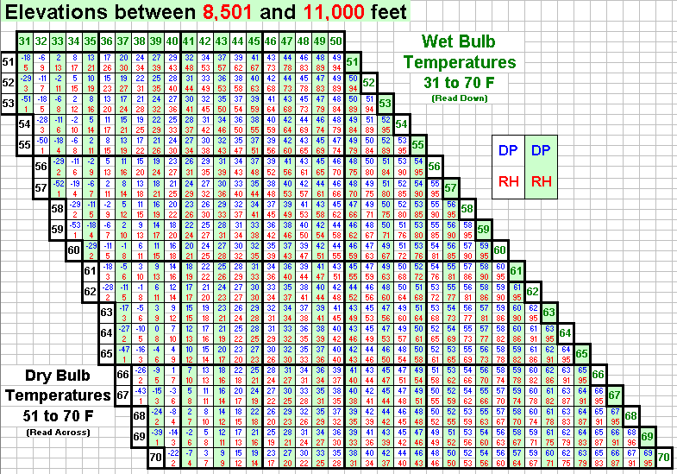

Figure : Relative humidity table: elev 8,501-11,000, dry bulb (71-00°F), wet bulb (41 to 82°F)

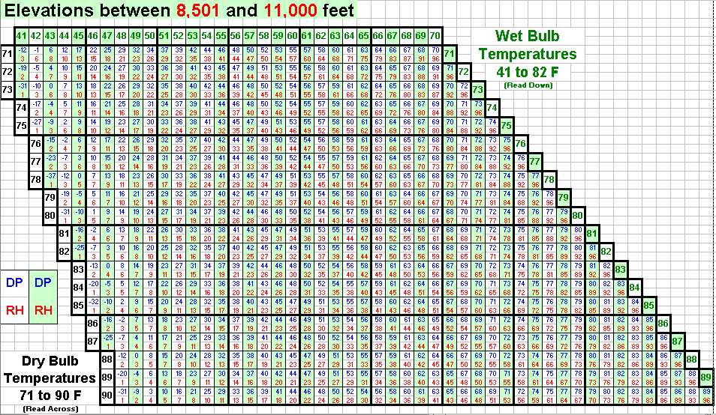

### Fine Dead Fuel Moisture Tables

Table : Reference fuel moisture, day time, 0800-1959



Table : Dead fuel moisture content corrections, May-June-July



Table : Dead fuel moisture content corrections, Feb-Mar-Apr/Aug-Sep-Oct



Table : Dead fuel moisture content corrections, Nov-Dec-Jan



Table : Reference Fuel Moisture, night time, 2000-0759

reference fuel moisture, night time, 2000-0759

Table : Reference fuel moisture, night time, 2000-0759

reference fuel moisture chart, night time, 2000-0759

Table : Dead fuel moisture corrections, night time, 2000-0759



### Probability of Ignition Table

Table : Probability of ignition



### Measuring Fuel Moisture Content: Standard Methods and Procedures

Adapted from Firemon and Rodney A. Norum and Melanie Miller, 1984.*

There are two common methods of measuring fuel moistures: oven dry and probes. The oven-dry method requires that multiple samples of all the fuels class sizes be collected in the field, weighed, dried, and weighed again.

#### When Samples Should Be Collected

Sample fuels before and during the period planned for the burn until prescribed fuel moisture conditions are met. The frequency of sampling should be increased from weekly early in the season to daily as the proposed date of the fire approaches, or when the set of required moisture conditions are met and it’s time to burn.

#### Where Samples Should Be Collected

The number of samples collected is less important than their quality and how well they represent the sampled area and should span the range of conditions, elevations, positions, and situations in the burn area. Live and dead fuel samples should be collected from herbs, shrubs, and trees, in proportion to the species and the amount of live and dead material present on site, as well as wet and dry locations, shaded and exposed spots, greater and lesser concentrations and depths of fuel, older and younger stands along with the areas between them. In addition, live samples from tree crowns should have an equal sample from old to new foliage and from as many parts of the crown as possible. There is high variability in live fuel moisture so capture as many samples as possible (personal communication, Matt Jolly, Missoula Fire Lab).

#### Processing the Samples

Samples should be stored in airtight containers (zip-close bags work well), and brought back promptly to be weighed and dried. The mass of the individual samples is measured first, then the samples are put in an over at 100 degrees C. The 1- and 10-hour fuels, and litter and duff, should be dry in 24 hours. Weigh a few selected samples of the larger fuels every 24 hours until they reach equilibrium. When the piece weights of a class (for example, the 100-hour fuel class) reach equilibrium, then you can make a final weight of all of the pieces in the class. Calculate the percent moisture (gravimetric) for each piece using the following equation, then average the moistures for each class.

Equation: 

Where:

* M = gravimetric moisture content of the class, in percent
* WW = wet weight of all pieces in the class
* DW = dry weight of all pieces in the class

The fuel moisture for a class is the average moisture needed across all of the samples. When cutting pieces off logs for fuel samples, you do not need to cut them thicker than 3 inches (7.6 cm). Thicker pieces will unnecessarily extend the drying time. If you use the oven-dry method, you will not be able to enter the fuel moisture data the day of the fire.

The second method involves indirect measurements of fuel moisture using probes or other instrumentation. The moisture estimates using these methods are generally not as accurate as the oven-dry method but they allow quick moisture estimates and, depending on the project objectives, may be sufficiently accurate.

Record the method of fuel moisture measurement in the Fire Information Remarks field.

*References:

* Norum, R.A., and M. Miller, 1984. Measuring fuel moisture content in Alaska: Standard methods and procedures.
* Firenom: Fire Effects Monitoring and Inventory System