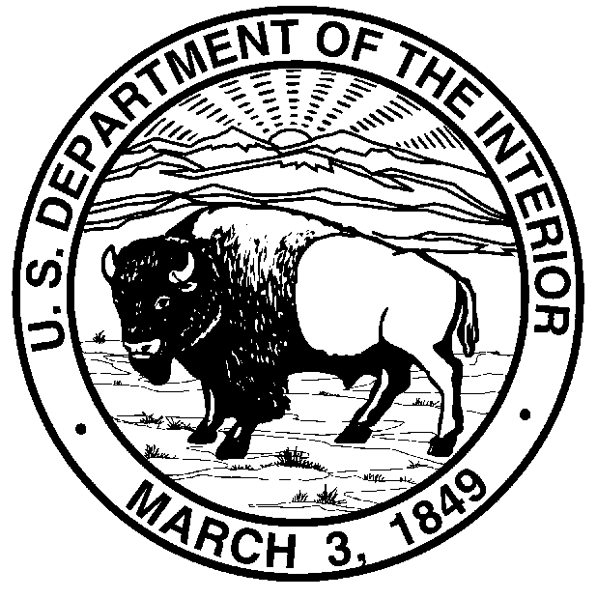

United States Department of the Interior

BUREAU OF LAND MANAGEMENT

Idaho State Office
1387 South Vinnell Way
Boise, Idaho 83709-1657
http://www.id.blm.gov

In Reply Refer To:
1782 (931) March 8, 2006

Mr. Dave Allen, Regional Administrator Mr. Bob Lohn, Regional Administrator
US Fish & Wildlife Service NOAA – National Marine Fisheries Service
911 NE 11th Avenue 7600 Sand Point Way NE
Portland, Oregon 97232-4181 Seattle, Washington 98115-6349

Ms. Elaine Brong, State Director Ms. Linda Goodman, Regional Forester
USDI Bureau of Land Management USDA Forest Service – Region 6
333 SW 1st Avenue P.O. Box 3623
Portland, Oregon 97204 Portland, Oregon 97208-3623

Mr. Kurt Kotter, Acting State Director Mr. Jack Troyer, Regional Forester
USDI Bureau of Land Management USDA Forest Service – Region 4
3387 S. Vinnell Way 324 25th Street
Boise, Idaho 83709-1657 Ogden, Utah

Dear Regional Executive Team Members:

The Regional Technical Team (RTT) members that have been facilitating the Prineville elevation have completed their report dealing with the Central Oregon Consultation Streamlining Level 2 Team related to NOAA’s National Marine Fisheries Service (NOAA Fisheries) July 27, 2004 biological opinion for the Bureau of Land Management’s (BLM’s) Central Oregon Resource Area Upper John Day grazing program for 2004-2008. Working with the Interagency Coordinating Subgroup (ICS), the RTT members reviewed the elevation package, assessed the issues, and then met with the local Level 1 and 2 Teams along with agency managers and specialists to come to a collective resolution that carried the support of all participants. The RTT’s recommendations that are included in the report have been endorsed by the agency representatives at the local level as well as the ICS and serve as a basis for addressing ongoing and future management issues.

The RTT Report which documents each of the three elevation issues and their responses is attached. Additionally, a series of Questions & Answers (attached) that deal with the specific issues addressed in this elevation was prepared to help share the lessons learned from this effort. Both the Report and the Q&As will be shared with the other ICS and RTT members to help ensure a common understanding and wide distribution to Level 1 and Level 2 Teams throughout the Region. Also, the ICS and RTT are working with the Columbia River Basin Deputies to
2

further enhance the Interagency ESA website. The information from this elevation will be posted on the website as a resource for others dealing with similar issues.

The work of Tim Burton (BLM), Alison Beck Hass (FWS), Bill Lind (NOAA-Fisheries), and Scott Woltering (FS) along with the support of Joe Moreau of the BLM Oregon State Office is to be commended. The active involvement and encouragement from Barron Bail, BLM’s Prineville Field Office Manager and Spencer Hovencamp, NOAA Fisheries Eastern Oregon Branch Chief and their respective staff specialists along with the participation of the Level 1 and 2 Teams were critically important to bringing this elevation to the productive resolution that was achieved.

Although finding common schedules to bring participants together throughout this elevation proved to be a challenge, the eventual successful result was worth the wait and did not hinder any ongoing on-the-ground efforts. Scheduling will likely continue to be an issue on elevations but I can assure you that both the ICS and RTT will strive to be as responsive as possible as we work with the local Level 1 and 2 Teams.

If you have any questions regarding this elevation, please do not hesitate to call me at (208) 373-3813.

Sincerely,

/s/ Jonathon S. Foster

Jonathon S. Foster
Chair, Interagency Coordinating Subgroup
Branch Chief, Resources and Sciences

Attachments:
- Regional Technical Team Report
- Questions & Answers Regarding ESA Section 7 Consultation & Livestock Unauthorized Use

cc: Level 2 Team
Barron Bail, BLM
Spencer Hovekamp, NOAA Fisheries
Nancy Gilbert, FWS
Larry Timchak, USFS
Leslie Weldon, USFS

