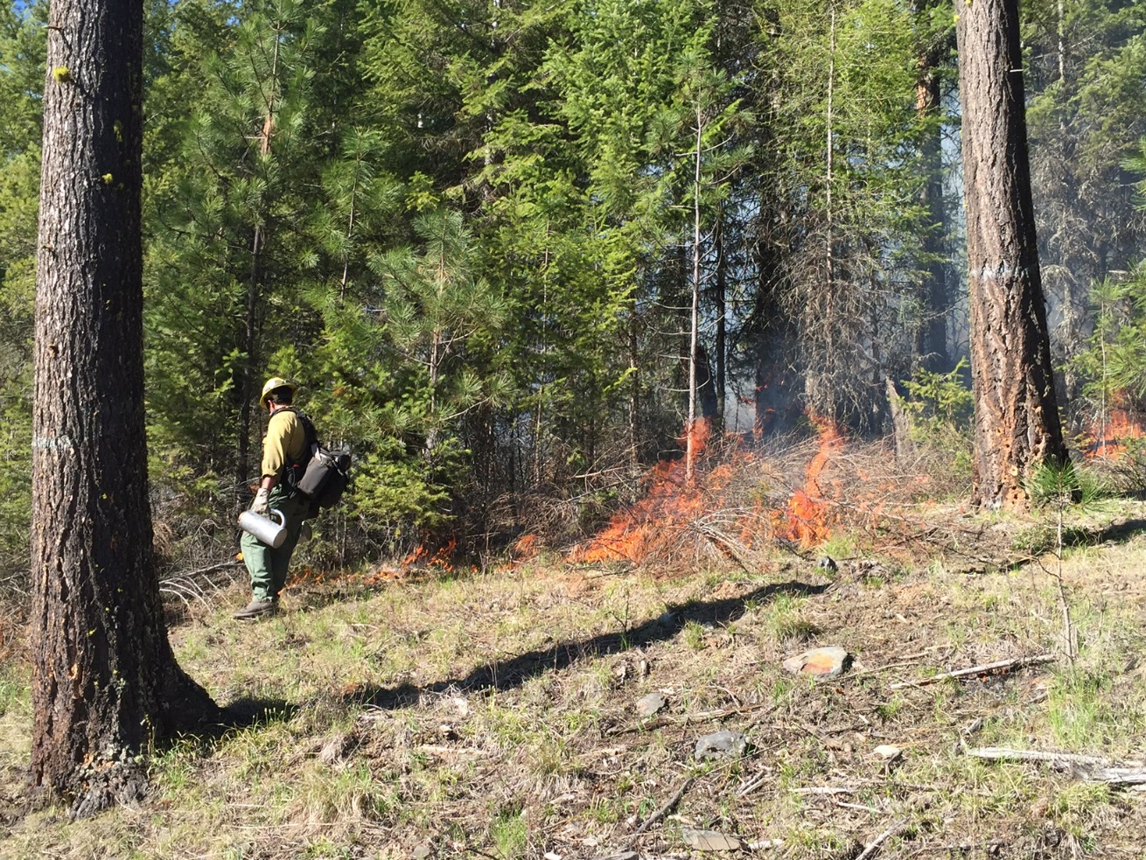
  - Wildfire Risk Reduction

CFLRP 10 Year Results and Lessons Learned Summary Series

Kootenai Valley Resource Initiative, ID

The purpose of this document is to summarize the results and lessons learned from the “Wildfire Risk Reduction” theme in the comprehensive Collaborative Forest Landscape Restoration Program (CFLRP) 10 Years of Results and Lessons Learned report. Please review the report for details and resources.

Overview
Wildland fire management is a common and complex challenge across public and private lands. CFLRP results illustrate the benefit of multi-year, multi-partner, landscape-scale investments to make meaningful progress in reducing wildfire risk.

Key Results and Lessons Learned

Project accomplishments
From 2010 through 2019 CFLR projects treated 3.8 million acres of hazardous fuels. Of the 3.8 million acres, projects treated 3.2 million acres of CFLRP landscapes using prescribed fire and mechanical treatments (1.6 million acres each). Between FY 2013 and FY 2019, CFLRP Projects comprised 11% of the NFS treatable acreage and 9% of restoration-related spending while they accomplished 19% of the agency’s total hazardous fuels treatments. In 2019, CFLR projects provided 15% of the agency totals for prescribed fire treatments.

While there was fluctuation between years and variation across projects, in general projects reported the value of CFLRP in building increased capacity for their treatments and increased community support for prescribed fire overtime. This increased capacity led to the increase in annual accomplishments over time. At the same time, many projects also reported a need to expand the scale of their prescribed fire treatments further, apply improved spatial planning to strategically placed treatments, and improve their ability to utilize wildfire for resource benefit.

Measuring impacts on wildfire risk
A variety of data sources and monitoring approaches indicate CFLR treatments reduced wildfire risk. In a survey of CFLRP practitioners, 80% of respondents reported treatments reduced the threat of fire and improved ecological conditions. Annual project reports document how treatments created and maintained fire resilient stands to enable more successful management of wildfires. Fuel treatment effectiveness monitoring showed wildfires impacted treated areas with dramatically less intensity than untreated areas. CFLR projects also developed quantifiable desired conditions for restoring natural fire regimes and reducing the risk of uncharacteristic wildfire at both project and landscape scales. At the ten-year mark, over 80% of projects achieved their objectives for fire regimes.

In 2019, Forest Service researchers did a deeper analysis of fuel treatments on five CFLR projects. Analysts performed wildfire simulations and risk calculations on pre-treatment (2012) and post-treatment (2019) landscape conditions for these five areas. In general, all study sites showed a decrease in average burn probability and expected annual area burned, a decrease in predicted flame lengths, and decrease in flame lengths greater than 6 feet and 8 feet. From 2010 to 2014 the Forest Service used Risk and Cost Analysis Toolkit (R-CAT) to improve our understanding of cost savings using fire modeling. The initial R-CAT results indicated the potential for CFLR fuel treatments to reduce various fire management cost components.

While these results indicate a meaningful reduction in wildfire risk, the diverse monitoring approaches used led to difficulty in comparing results across projects and characterizing impacts beyond individual projects. Moving forward, the CFLRP program is working to implement common standards for quantifying reductions in wildfire risk at landscape scales.

Prioritizing approaches and treatment techniques
Projects prioritized treatments in both high or very high fire hazard areas and in maintaining desired conditions in low fire hazard areas. High priorities listed by projects include hazardous fuels reduction, projects in wildland urban interface and forest restoration, areas of high crown fire potential and watersheds, infrastructure, readiness for implementation, and alignment with other existing restoration and community strategies. CFLRP projects offer many examples of prioritization approaches and how projects designed their treatments to reach project goals. See examples of scale and techniques of treatment in the wildfire risk appendix of the full 10-year report and in CFLR Project Data.

Role of community engagement
Coordinated efforts with partners were key to the success of fuels reduction treatments. Treatments were coordinated with state agencies, federal agencies, tribes and other organizations. Some examples of projects’ community engagement and partnership strategies, including challenges and strategies for dealing with smoke in communities, are provided in the wildfire risk appendix of the full 10-year report. Further examples are in the projects’ annual reports.

Expanding prescribed fire and the use of wildfire for resource benefit
CFLRP projects expanded the scale of prescribed fire on their units and also noted the need to expand this work even further. Best practices for prescribed fire noted by CFLRP projects include:
- Building a long-term and mixed program of work to support a diverse contractor pool
- Strong community outreach and education campaigns
- Collaborative involvement in implementation – from zones of agreement to contract specifications
- Prioritizing staff resources for critical burn windows
- Learning and training networks for prescribed fire, such as Prescribed Fire Training Exchanges (TREX).
- Detailed descriptions are these approaches, along with case studies, are available in the wildfire risk section of the full 10-year report.

In general, projects reported that managing wildfires for resource benefit can be incredibly helpful for a landscape from an ecological standpoint and also can lead to increased fire fighter safety and effectiveness. To achieve this requires extensive and advanced land management planning, building community understanding of the technique and (often) involving changes in Forest Service business practices. See the wildfire risk appendix of the full 10-year report for specific project successes and challenges in using wildfire use for resource benefit. These examples illustrate both the potential benefits of this tool and the challenges of aligning all the needed factors for it to be feasible.

What questions emerged needing more investigation?
There are many questions around wildfire risk reduction that need further investigation; see the full report for a comprehensive list. Issues requiring the most attention include:
- Further analysis is needed on the strategic placement of treatments across the landscape – are treatments occurring in the highest priority places for the biggest impact at the landscape scale?
- What role can spatial planning tools like Potential Operational Delineations (PODs) or scenario investment planning play in promoting strategic treatments?
- There is a broad community working on this challenge; how can CFLRP best add to this effort?
- More work is needed to fully understand benefits and avoided costs achieved from fuel treatments.

Where to Learn More (selected resources from CFLRP Results and Lessons Learned)
- CFLRP Project Accomplishments: see Annual Project Reports
- Restoring natural fire regimes: see 2019 and 2014 Ecological Indicator Reports, including a spreadsheet summary of 2019 Ecological Indicator Report Responses. A summary of the wildfire risk components of these reports is also available in the wildfire risk section of the full 10-year report.
- A more detailed description of the wildfire risk reduction pilot is available in the wildfire risk section of the full 10-year report. For further information on Risk and Cost Analysis Toolkit visit the Reporting section of the CFLRP website.
- Impacts, approaches to expanding the use of prescribed fire, and successes and challenges in the using wildfire for resource benefit are available in the wildfire risk section of the full 10-year report.

Next Steps:
CFLRP results illustrate the benefit of multi-year, multi-partner, landscape-scale investments to make meaningful progress in reducing wildfire risk. Community participation and engagement, supported by multi-party monitoring, have been key factors for success in this work. While projects expanded the scale of treatments, most reported a need to further expand the footprint of their work. Promising approaches include better use and implementation of strategic placement of treatments, coupled with appropriate management of wildland fire for resource benefit. More work is also needed to have common standards for quantifying reductions in wildfire risk at landscape scales.

“Strategies for Success Under Forest Service Restoration Authorities” https://ewp.uoregon.edu/sites/ewp.uoregon.edu/files/WP_81.pdf

