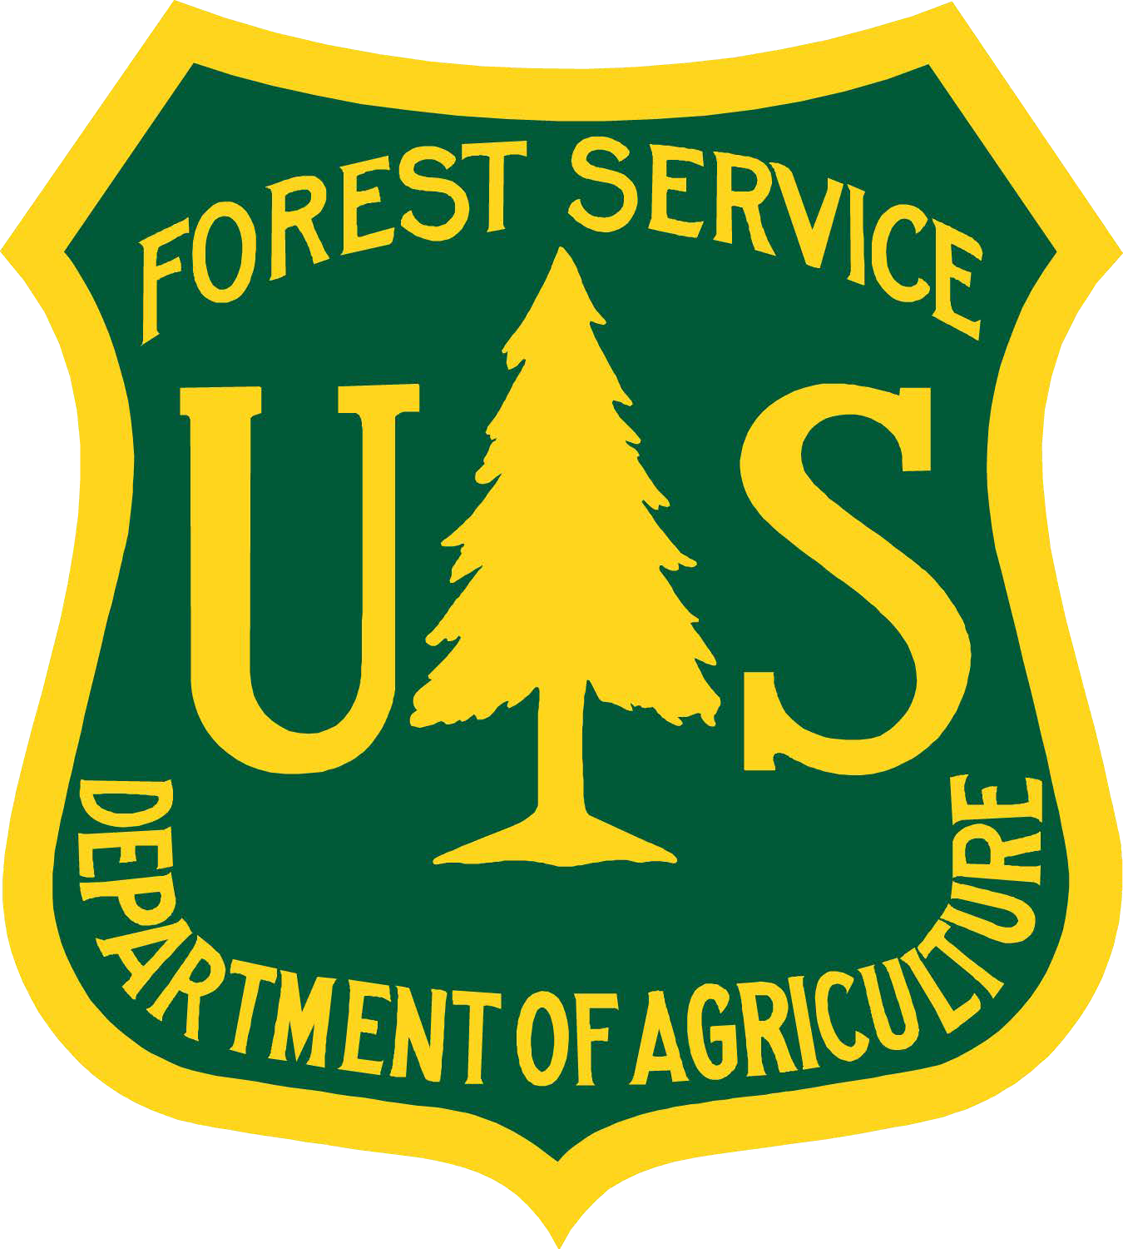UNITED STATES DEPARTMENT OF AGRICULTURE FOREST SERVICE

APPLICATION FOR PALEONTOLOGICAL RESOURCES RESEARCH OR COLLECTION

Authorities: Paleontological Resources Preservation Act of 2009 (16 U.S.C. 470aaa-aaa11); Federal Cave Resources Protection Act of 1988 (as amended, 16 U.S.C. 4301-4309); Organic Administration Act June 4, 1897 (16 U.S.C. 551); 36 CFR § 291.13-291.23

FS-2800-0022A (REV. 11/2024)

OMB No. 0596-0081

Exp. 08/31/2027

|  |  |
| --- | --- |
| 1a. Name of Applicant  Click here to enter text. | 1b. Applicant Affiliation  Click here to enter text. |
| 2. Professional Contact Information  Click here to enter text. | 3. Contact Information in the Field  Click here to enter text. |
| 4. Nature of paleontological fieldwork proposed: Describe project, including methodology and scope of work:  Click here to enter text. | |
| 5. Location of proposed paleontological fieldwork (attach 1:24,000 scale topographic map with project boundaries and provide UTM coordinates for known areas of proposed collection or other land surface disturbance)  Click here to enter text. | |
| 6. Anticipated start date: (MM/DD/YYYY)  Click here to enter text. | 7. Anticipated end date: (MM/DD/YYYY)  Click here to enter text. |
| 8. Name(s) of individuals responsible for planning, supervising, and carrying out fieldwork  Click here to enter text. | |
| 9. Name and address of repository for paleontological resources collected under the proposal, and contact information for authorized official of repository.  Click here to enter text. | |
| 1. Additional materials required (should be attached to this application as separate pages):    1. resume for each individual named in line 1a and line 8    2. summary of organizational capabilities    3. summary of organizational history    4. written certification, signed by a properly authorized official (who is NOT named in line 1a or line 8 of this form) of the approved repository named in line 9. This certification will attest that the repository will accept any collections, and as applicable, records, data, photographs, and other documents generated during the proposed work at no cost to the Forest Service, and that the repository will assume permanent curatorial responsibility for such materials on behalf of the United States Government. | |

FS-2800-0022A (REV. 11/2024 )

PAPERWORK REDUCTION ACT STATEMENT

According to the Paperwork Reduction Act of 1995, an agency may not conduct or sponsor, and a person is not required to respond, to a collection of information unless it displays a valid OMB control number. The valid OMB control number for this information collection is 0596-0081. Response to this collection of information is mandatory. The authority to collect the information is the Omnibus Public Land Management Act of 2009, Paleontological Resources Preservation, 16 U.S.C. 470aaa through 470aaa-11. The time required to complete this information collection is estimated to average 5.5 hours per response, including the time for reviewing instructions, searching existing data sources, gathering and maintaining the data needed, and completing and reviewing the collection of information.

NONDISCRIMINATION STATEMENT

In accordance with Federal civil rights law and U.S. Department of Agriculture (USDA) civil rights regulations and policies, the USDA, its agencies, offices, and employees, and institutions participating in or administering USDA programs are prohibited from discriminating based on race, color, national origin, religion, sex, disability, age, marital status, family/parental status, income derived from a public assistance program, political beliefs, or reprisal or retaliation for prior civil rights activity, in any program or activity conducted or funded by USDA (not all bases apply to all programs). Remedies and complaint filing deadlines vary by program or incident.

Persons with disabilities who require alternative means of communication for program information (e.g., Braille, large print, audiotape, American Sign Language, etc.) should contact the responsible agency or USDA’s TARGET Center at (202) 720-2600 (voice and TYY) or contact USDA through the Federal Relay Service at (800) 877-8339. Additionally, program information may be made available in languages other than English.

To file a program discrimination complaint, complete the USDA Program Discrimination Complaint Form, AD-3027, found online at [How to File a Program Discrimination Complaint](https://www.usda.gov/sites/default/files/documents/ad-3027.pdf) and at any USDA office or write a letter addressed to USDA and provide in the letter all of the information requested in the form. To request a copy of the complaint form, call (866) 632-9992. Submit your completed form or letter to USDA by: (1) mail: U.S. Department of Agriculture, Office of the Assistant Secretary for Civil Rights, 1400 Independence Avenue, SW, Washington, D.C. 20250-9410; (2) fax: (202) 690-7442; or (3) email: [program.intake@usda.gov](mailto:program.intake@usda.gov).

USDA is an equal opportunity provider, employer, and lender.

The Privacy Act of 1974 (5 U.S.C. 552a) and the Freedom of Information Act (5 U.S.C. 552) govern the confidentiality to be provided for information received by the Forest Service.

Click here to enter text.

Signature of Applicant*

Date (MM/DD/YYYY)

*by signing this application, the applicant agrees to abide by all Forest Service policies and regulations that apply to Forest Service employees and partners which may allow the permittee access to some agency records, including paleontological locality information, but restrict the permittee from public disclosure of paleontological locality information discovered while conducting work under this permit.

**INSTRUCTIONS:**

**Completing the *Application for Authorization for Paleontological Resources Research or Collection***

Applicants for a permit to conduct paleontological research and/or collection on Forest Service land should complete Form FS-2800-22A, “Application for Authorization…,” following the instructions below. The completed Form FS-2800-22A should be signed and dated by the applicant where indicated, and returned for agency review to the Forest Service Administrative unit in which the proposed project area is located. Additional information may be requested by the Forest Service in order to complete evaluation of the proposal. The applicant should be aware that proposals entailing land surface disturbance may require NEPA analysis by agency specialists in order to evaluate potential environmental impacts related to the proposal. **The proposal is not considered authorized until form FS-2800-0022B (The Permit) has been returned to the applicant and has been signed and dated by the applicant and the Forest Service Authorized Officer.**

1a. **Name of Applicant:** Enter the name of the individual who will have primary management responsibility for implementing the proposal and adhering to all terms and conditions.

1b. **Applicant Affiliation:** Enter the institution or organization with which the individual identified in line 1a is professionally affiliated.

1. **Professional contact information:** Enter the complete mailing address, telephone number, fax, and email address by which the individual named in line 1a may be contacted at the institution identified in line 1b.
2. **Contact information in the field:** Describe means by which individuals identified in line 1a and/or line 8 may be contacted while in the field conducting authorized field work
3. **Nature of paleontological fieldwork proposed and perceived need for other authorizations (off-road vehicle use, drone photography, media events).** Describe the proposed activity in detail, including objective(s), scope of work and methodology. The description should contain sufficient detail for an agency reviewer to evaluate the extent of potential land surface impacts related to the proposed work.
4. **Location of proposed paleontological fieldwork:** Provide an accurate description of the area where field activities are proposed. Location should be depicted on an attached 1:24,000 scale topographic map showing complete project boundaries. A suggested online resource for generating maps is Topo View offered by the U.S. Geological Survey (<https://ngmdb.usgs.gov/topoview/>). GPS coordinates of known areas proposed for collection or other type of surface disturbance should be provided separately from the map. Alternatively, the project location description may be transmitted in a digital format which is compatible with existing Forest Service software and which must be approved in advance by the FS project reviewer.
5. **Anticipated start date:** Enter anticipated start date of proposed field activities. If proposed activities will encompass more than one field season, enter anticipated start dates of each field season.
6. **Anticipated end date:** Enter anticipated end date of field activities. If proposed activities will encompass more than one field season, enter anticipated end dates of each field season.
7. **Name(s) of individuals responsible for planning, supervising, and carrying out fieldwork:** Enter the names of other individuals anticipated to participate in the proposed field activities.
8. **Name and address of approved repository, and contact information for authorized official of repository:** Enter the name and address, including phone number and e-mail contact information, for the institution which has agreed to accept and provide appropriate long term curation of all paleontological resources collected under the authorized proposal (such collections remain Federal property). Enter N/A if no collecting is proposed. Applicant’s selection of a repository institution is subject to Forest Service approval.
9. **Additional materials required (should be attached to the application as separate pages):**
   1. **resume for each individual named in line 1a and line 8:** Provide a resume or curriculum vitae for all individuals identified in lines 1a and 8. These will be used to determine the qualifications and eligibility of the identified individuals to carry out the proposed activity.
   2. **summary of organizational capabilities:** Describe the capabilities of the individuals identified in lines 1a and 8 and the organization identified in line 1b to provide required logistical/infrastructure support for the proposed activity.
   3. **summary of organizational history:** Describe the experience of the individuals identified in lines 1a and 8 and the organization identified in line 1b pertaining to management of prior activities similar to the proposal. If collection is proposed, also describe the experience of the institution identified in line 9 in curating paleontological collections similar to the proposed collection.
   4. **written certification, signed by a properly authorized official (who is NOT named in line 1a or line 8 of this form) of the repository named in line 9, attesting to the repository’s willingness to accept any collections, and as applicable, records, data, photographs, and other documents generated during the proposed work, and to assume permanent curatorial responsibility for such materials on behalf of the United States Government:** The repository institution identified in line 9 must provide a written document, signed by an authorized representative of that institution not otherwise named in the permit application, certifying that the institution agrees to accept and curate all of the paleontological resources and associated data collected under the authorized proposal, and acknowledges that such collections remain Federal property. The Forest Service may request documentation from the institution that bears on its capability to provide appropriate curatorial services for the proposed collection. Such documentation could include, but not be limited to, a description of the institution’s scope of collections, collections management plan, staff résumés, and institutional accreditation documents.