National Winter Recreation Opportunity Spectrum (ROS) Inventory Mapping Protocol

Send Feedback and Comments to:
Nicole R. Hill
Enterprise Program
for:
Washington Office
USDA Forest Service
August 2019


The U.S. Department of Agriculture (USDA) prohibits discrimination against its customers, employees, and applicants for employment on the bases of race, color, national origin, age, disability, sex, gender identity, religion, reprisal, and where applicable, political beliefs, marital status, familial or parental status, sexual orientation, or all or part of an individual's income is derived from any public assistance program, or protected genetic information in employment or in any program or activity conducted or funded by the Department. (Not all prohibited bases will apply to all programs and/or employment activities.)

Contents
Introduction 1
Seasonal ROS maps 1
How is the Protocol Used? 2
Who is the Intended Audience? 2
What is the Recreation Opportunity Spectrum? 2
Winter Recreation Opportunity Spectrum mapping criteria summary 4
How are the Above ROS Mapping Criteria Applied in the Protocol? 6
What Data is Needed? 8
Data Quality 8
Documentation and Key Data Management Recommendations 8
Geoprocessing 9
ROS Inventory Mapping Steps for Winter (snow) season 9
Pre-work 9
Step 1. Categorize travel routes 10
Step 2. Buffer motorized routes and areas 15
Step 3. Apply remoteness criteria to non-motorized areas 17
Step 4. Apply remoteness criteria to motorized areas 17
Step 5. Apply size criteria 18
Step 6. Conduct adjacency assessment 20
Step 7. Apply evidence of humans criteria 24
Step 8. Apply other considerations and recreation subject matter expertise 25
Step 9. Review wilderness settings 26
Step 10. Map Inconsistencies with Inventoried ROS Settings 27
Optional Step 11. Identify and map issues, concerns, and opportunities 31
References 34
Glossary 35
Appendix A. ROS Class Characteristics 37
Appendix B. Modeling Winter ROS Using Travel Routes and Terrain 42

Tables
Table 1. General application of ROS physical, social, and managerial characteristics and mapping criteria for each ROS class 4
Table 2. ROS Link to Winter Maintenance 10
Table 3. Over snow modes of travel (Snow Trail: Motorized and Non-Motorized Use) in the ATM module 11
Table 4. Evidence of Humans Criteria for Roaded Natural, Rural, and Urban ROS classes. For other ROS classes, see the 1982 ROS User Guide. 25
Table 5. Social Characteristics Criteria 29
Table 6. Managerial Characteristics Criteria 30
Table 7. ROS Assessment/Inventory Unique Opportunities Documentation 32
Table 8. Raster math for impedance of cells containing improved roads 43
Table 9. Raster math for impedance of cells containing motorized routes 43
Table 10. Cost distance Reclassification 44
Table 11. Matrix for assigning ROS setting from cost distance maps 44
Table 12. Size criteria by ROS setting 45
Table 13. Route Categories and Values for ROS Model 45

Figures
Figure 1. A graphic showing the spectrum of ROS classes. The level of access, development, and social encounters increase when moving from primitive (P) to urban (U) on the spectrum. Level of remoteness decreases when moving from primitive (P) to urban (U) on the spectrum. 3
Figure 2. ROS inventory mapping protocol steps infographic 7
Figure 3. Base map example showing data needed to complete the ROS mapping. 10
Figure 4. Screen capture of a portion of the Trail_Visitor_Info_Map_V table 12
Figure 5. Screen capture of a portion of the Trail_Visitor_Info_Map_V table 13
Figure 6. Step 1. Categorize travel routes flowchart 15
Figure 7. Step 1 Result Example. Categorize travel routes for ROS mapping 15
Figure 8. Step 2. Buffer motorized routes and areas flowchart 16
Figure 9. Step 2 Result Example. Buffer motorized routes and areas which identifies initial division between motorized and non-motorized ROS settings 17
Figure 10. Step 3. Apply remoteness criteria to non-motorized areas flowchart 17
Figure 11. Step 4. Apply remoteness criteria to motorized buffers flowchart 18
Figure 12. Step 3 and 4 Result Example. Apply remoteness criteria to non-motorized and motorized areas to identify initial P, SPNM, SPM and RN ROS settings. 18
Figure 13. Step 5. Apply size criteria to Primitive, Semi-primitive Non-motorized and Semi-primitive Motorized buffers flowchart 19
Figure 14. Step 5 Result Example. Apply size criteria to Primitive, Semi-primitive Non-motorized and Semi-primitive Motorized areas 20
Figure 15. Adjacency assessment to refine “smallP” areas flowchart 21
Figure 16. Adjacency assessment to refine “smallSPNM” areas flowchart 22
Figure 17. Adjacency assessment to refine “smallSPM” areas flowchart 23
Figure 18. Step 6 Result Example. Conduct adjacency assessment to refine P, SPNM, and SPM settings 24
Figure 19. Step 7 Result Example. Apply subject matter knowledge and additional information to differentiate between RN, Rural and Urban settings 25
Figure 20. Steps 8 and 9 Result Example. Apply other considerations and recreation subject matter knowledge and Review wilderness settings 27
Figure 21. Step 10 Result Example. Map inconsistencies with inventoried ROS settings 31
Figure 22. Screen capture of ArcMap Project for running ROS models 46
Figure 23. Screen capture of Starting Menu from ROS toolbox 47
Figure 24. Example Area where the criteria for RN, R, or U is met (cost distance <= 8000 and within the ½ mile buffer) but the area is not actually connected to a road 48

Revision History
Description | Author/Editor | Date
National ROS Inventory Mapping Protocol 07/01/2003 |  | July 2003
[Release of the Revised Protocol - Replaces National ROS Inventory Mapping Protocol 07/01/2003]  National Winter Recreation Opportunity Spectrum (ROS) Inventory Mapping Protocol, 2018, Version 1. | Forest Service, Washington Office Staff | April 2018
[First Revision]  National Winter Recreation Opportunity Spectrum (ROS) Inventory Mapping Protocol, 2019, Version 1.2  - Adds Revision History Table, page iii  - References updated Terrain-based GIS ROS Model designed to assist with completing a Recreation Opportunity Spectrum inventory that aligns with Steps 2 through 8 of the National ROS Inventory Mapping Protocol, pages 6, 15, and 26  - Updates Appendix B. Modeling Winter ROS Using Travel Routes and Terrain  - Minor edits throughout to provide consistency with Forest Service Manuals and Handbooks | Forest Service, Washington Office staff | August 2019

Introduction
This National inventory protocol identifies mapping criteria and provides repeatable instructions to inventory, map, and classify existing winter Recreation Opportunity Spectrum (ROS) settings based on forest recreation opportunities and off-forest influences (e.g. motorized routes of other jurisdiction). This winter mapping protocol is a supplement to the National Recreation Opportunity Spectrum (ROS) Inventory Mapping Protocol developed in 2017 for year-round or summer seasons when a seasonal variation exists. This supplement is focused solely on mapping winter ROS settings. The product is an existing condition inventory of winter or over-snow ROS settings, mapped inconsistencies with those winter settings, and mapped unique or special over-snow opportunities occurring. The settings mapped in this inventory protocol reflect travel management decisions. Inconsistencies with the mapped winter recreation opportunities may occur due to unauthorized or administrative uses. Inconsistencies with the existing ROS settings are documented in this process, but do not change the overall ROS settings mapped and identified. Rather the inconsistencies are used with the ROS settings mapped in this process to provide an overall existing condition for ROS and help identify places that may need management actions to improve consistency with desired conditions.

Seasonal ROS maps
When transportation or infrastructure changes with seasons and a Forest can provide different recreation opportunities during different seasons of the year, a seasonal variation in setting occurs. Most commonly, a seasonal variation occurs when there is a difference between summer (non-snow) recreation opportunities and winter (snow) recreation opportunities. Forests that offer winter (snow dependent) recreation opportunities should inventory and classify a winter (snow) season ROS, as well as a summer (non-snow) season ROS. It may also be desirable to distinguish spring or fall recreation settings if drastic changes in the physical, social and/or managerial components of the landscape occur. Considerations for determining the need for a winter ROS layer include:
- Physical setting changes such as presence of infrastructure (e.g. roads, trails, structures and other facilities) may not be useable, accessible, or even visible due to seasonal changes (e.g. snow depths or water levels).
- Snow accumulations in winter may result in the closure of facilities used in summer. Settings may change from more developed in summer to less developed in winter
- Impassable, snow covered roads are often less noticeable on the landscape
- Managerial changes such as shifts in motorized and non-motorized travel opportunities and restrictions
- In January 2015, the USDA amended subpart C of the Travel Management Rule to require the Responsible Official to designate NFS roads, NFS trails, and areas on NFS lands where over-snow vehicle use is allowed, where snowfall is adequate for over snow vehicle use to occur. These designations may cause motorized and non-motorized settings to differ from other seasons.
- Closed roads, trails or facilities in winter may change areas from motorized to non-motorized settings
- In contrast, management actions may allow motorized use on roads or in areas in winter but not in summer, changing from non-motorized to motorized settings
- Winter wildlife closures reflect another seasonal managerial restriction
- Social setting changes such as changes in use levels or group sizes
- Use may be higher or lower in the winter (snow) season than in other seasons
- Areas with high visitor interaction and encounters may occur in different areas than in other seasons
The above list is not inclusive. Forests should evaluate the need for developing a seasonal ROS map based on the extent and duration of setting changes, as well as specific issues that seasonal ROS maps may address. Where specific issues require a more detailed look at existing ROS settings for a particular season of use, a season-specific ROS map may be warranted. If seasonal ROS maps are developed, the methodology used and the classification criteria will be critical to document. Although all six ROS classes may not be presented on seasonal maps, it is suggested that at a minimum, differentiations between motorized and non-motorized settings be delineated.

How is the Protocol Used?
Forests may use this protocol to map existing condition winter ROS settings for forest planning, site specific project planning and analysis, or monitoring. Forests may map the physical, social and managerial characteristics as separate layers or feature classes. However, this protocol combines physical and managerial characteristics to incorporate authorized uses throughout the mapping process. If a Forest wishes to map the physical, social, and managerial characteristics as separate feature classes, they should work with their Regional Office. As a minimum requirement, each Forest must produce a GIS data dictionary-compliant ROS feature class reflecting existing ROS settings based on recreation opportunities on all NFS lands, off-forest influences, and the physical, social, and managerial characteristics that may be inconsistent with those recreation opportunities and settings. The ROS inventory mapping protocol provides a better connection to the managerial characteristics, by incorporating travel management decisions from subparts B and C of the Travel Management Rule at the beginning of the inventory process.
It is understood that ROS mapping is not an exact science and some flexibility is necessary at the forest level to deal with site-specific conditions and anomalies which are not exact matches with specific ROS class criteria and definitions. Site-specific situations requiring field expertise and professional judgement are too numerous to list and address within the context of a National protocol.

Who is the Intended Audience?
The intended audience to for the winter ROS inventory mapping protocol is Forest and District recreation planners and specialists, landscape architects, and geographic information system (GIS) specialists. These are the primary staff who will complete the ROS inventory mapping. Coordination with forest engineering staff is critical in determining data quality and accuracy of the Forest’s transportation system and Infra attributes. Forest planners may also be involved in various steps when the inventory is completed for forest planning. The existing condition ROS inventory may be used by Forest employees including those listed above, contractors hired for NEPA planning, partners and the general public.

What is the Recreation Opportunity Spectrum?
Since the early 1980s, the Recreation Opportunity Spectrum (ROS) has been used as a framework to identify, classify, plan, and manage a range of recreation settings for both existing and desired conditions. ROS remains the best available framework for recreation planning. Six distinct settings: urban, rural, roaded natural, semi-primitive motorized, semi-primitive non-motorized, and primitive are defined using specific physical, social, and managerial criteria. The National Recreation Opportunity Spectrum (ROS) Inventory Mapping Protocol includes more background information on the Recreation Opportunity Spectrum, the physical, social, managerial characteristics and mapping criteria for each of these settings. The following graphic displays the spectrum of ROS classes. For detailed information and characteristics of each of the ROS classes refer to Appendix A. For additional information on applications, refer to FSH 1900 and FSM 2300 directives.
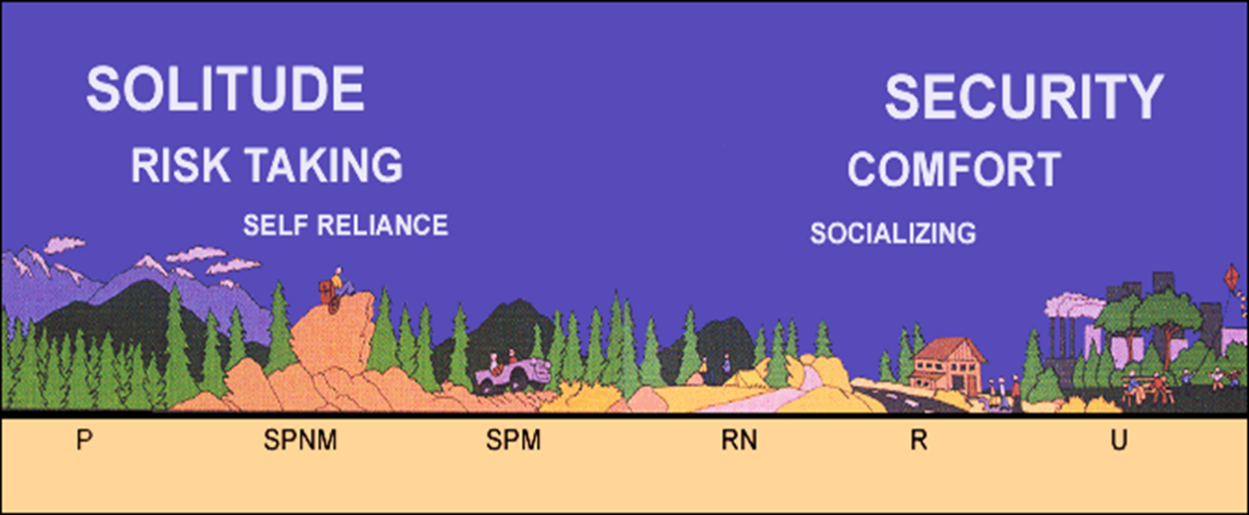
Figure 1. A graphic showing the spectrum of ROS classes. The level of access, development, and social encounters increase when moving from primitive (P) to urban (U) on the spectrum. Level of remoteness decreases when moving from primitive (P) to urban (U) on the spectrum.

Winter Recreation Opportunity Spectrum mapping criteria summary
Table 1. General application of ROS physical, social, and managerial characteristics and mapping criteria for each ROS class
Setting | Mapping Criteria | Primitive (P) | Semi-primitive Non-motorized (SPNM) | Semi-primitive Motorized (SPM) | Roaded Natural (RN) | Rural (R) | Urban (U)
Physical | 1. Remoteness | 3 or more miles from designated motorized routes | ½ mile or more from designated motorized routes and areas | ½ mile or more from plowed roads and within ½ mile of ungroomed/ unmaintained routes | Within ½ mile from groomed/ maintained routes | Within ½ mile from groomed/ maintained routes. Often near other (non-FS) rural settings and communities. | Within ½ mile from groomed/ maintained routes. Often close to towns and cities.
Physical | 2. Size | 5,000 + acres | 2,500 + acres | 2,500 + acres | n/a | n/a | n/a
Physical | 3. Evidence of Humans | No roads or motorized trails. User-created ski and snow shoe routes, No motorized over-snow vehicles are present. No mechanized travel within designated Wilderness  Predominately unmodified, naturally evolving, vast and remote | Ungroomed non-motorized trails with some trail markers, user created routes and areas for ski or snow shoe use. No over-snow vehicles are present  Predominately natural/natural appearing; rustic improvements to protect resources | Ungroomed but marked over-snow vehicle routes and areas. Ungroomed ski trails. Over snow vehicle use on designated routes/areas.  Predominately natural, natural appearing; motorized use visible and audible. | Some plowed roads and groomed over-snow vehicle routes. Groomed ski trails may also exist. Warming huts, cabins, and rustic facilities may be present.  Natural appearing with nodes and corridors of development (e.g. campgrounds, trailheads, boat launches, and small-scale resorts) | Groomed over-snow vehicle routes, groomed cross-country and skate skiing, and downhill ski/snowboard trails.  Altered landscapes with cultural emphasis (e.g. rural, pastoral, and agricultural). Administrative sites and moderately developed resorts are typical. | Groomed over-snow vehicle routes, groomed cross-country and skate skiing and downhill ski/snowboard trails.  Highly developed site modifications and facilities (e.g. Regionally significant ski areas, destination resorts, large visitor centers).
Managerial | 5. Visitor Management | Little to no on-site regimentation. Visitor use management is largely off-site. | Minimum or subtle signing, regulations, or other on-site regimentation. | Minimum, subtle on-site controls; Designated routes and areas for over-snow vehicles. | Signs and regulations present but typically subordinate to the setting. | Obvious signing (regulation and information), education and law enforcement staff. | Intensive on-site management, obvious signs; staffing, education, law enforcement available.
Social | 4. Visitor Density | Little evidence of people. Typically 6 or less parties encountered on trails and less than 3 parties visible at campsites. | High probability of solitude, closeness to nature, self-reliance. Usually 6-15 parties encountered on trails and 6 or less visible at campsites. | Moderate to high probability of solitude. Usually 6-15 encounters with other parties on trails. 6 or less parties visible from campsites. | Moderate evidence of human sights and sounds; Moderate concentrations of users at developed sites. Opportunities to socialize. | High interaction among users is common. Other people in constant view. Little challenge or risk associated with being outdoors. | High degree of interaction with people. People are in constant view. Challenge and risk are unimportant except for competitive sports.

How are the Above ROS Mapping Criteria Applied in the Protocol?
Eleven ROS inventory mapping steps are outlined in this mapping protocol. Each step addresses one or more of the mapping criteria described in the previous sections. The protocol maps an existing condition ROS inventory for the winter (snow) season.
Travel management decisions (subpart C) are considered at the beginning of the inventory mapping process and incorporated into all subsequent mapping steps. The result of each mapping step reflects managerial considerations from travel management decisions (subpart C). The steps, as outlined below, are intended to create an efficient mapping process with each step building upon previous steps.
- Step 1 describes all data needed and how to categorize and display motorized and non-motorized routes and areas to inform: the physical characteristics (evidence of humans criteria) and managerial characteristics by incorporating travel management decisions.
- Step 2 buffers roads and areas to produce initial division between non-motorized and motorized settings based on the physical characteristics, remoteness criteria.
- Step 3 makes the initial distinction between P and SPNM from non-motorized areas based on the physical characteristics, remoteness criteria.
- Step 4 makes the initial distinction between SPM and RN from motorized areas based on the physical characteristics, remoteness criteria.
- Step 5 applies the physical characteristics, size criteria and flags areas not meeting size criteria for further evaluation.
- Step 6 applies the physical characteristics, size criteria along with other considerations of the adjacent ROS classes for areas not meeting size criteria.
- Step 7 applies other knowledge and available information to differentiate between RN, Rural and Urban settings within the initially mapped ROS classes by considering the physical characteristics, evidence of humans criteria.
Remaining steps (steps 8 through 10) adjust the initial ROS settings. Although resource specialists and District personnel should be involved throughout the mapping process, their involvement is particularly critical in these last steps to apply subject matter expertise and determine and document inconsistencies.
- Step 8 applies other considerations for steep topography or other physical characteristics based on recreation subject matter expertise and professional judgement to adjust initial ROS settings.
- Step 9 reviews wilderness settings with recreation subject matter expertise and professional judgement to potentially adjust initial ROS settings.
- Step 10 identifies additional physical, social, and additional managerial characteristics information using subject matter expertise and professional judgement about the landscapes and use patterns in order to identify and document inconsistencies with the inventoried ROS settings.
- An optional Step 11 is also outlined that identifies and maps special activities or unique opportunities within the existing ROS settings.
Either apply the protocol step by step or use the terrain-based GIS ROS Model documented in Appendix B to accomplish GIS mapping from Steps 2 through 8 described above. The terrain-based GIS ROS Model determines where steep terrain affects recreation settings and resolves limitations previous versions had in areas with gentle terrain. Modeling results still require a detailed review by unit recreation staff or staff with subject matter expertise to verify results and complete the remaining protocol mapping steps.
The following graphic displays the mapping steps outlined in this protocol and their link to the five mapping criteria used to define the physical, social, and managerial characteristics of each landscape.
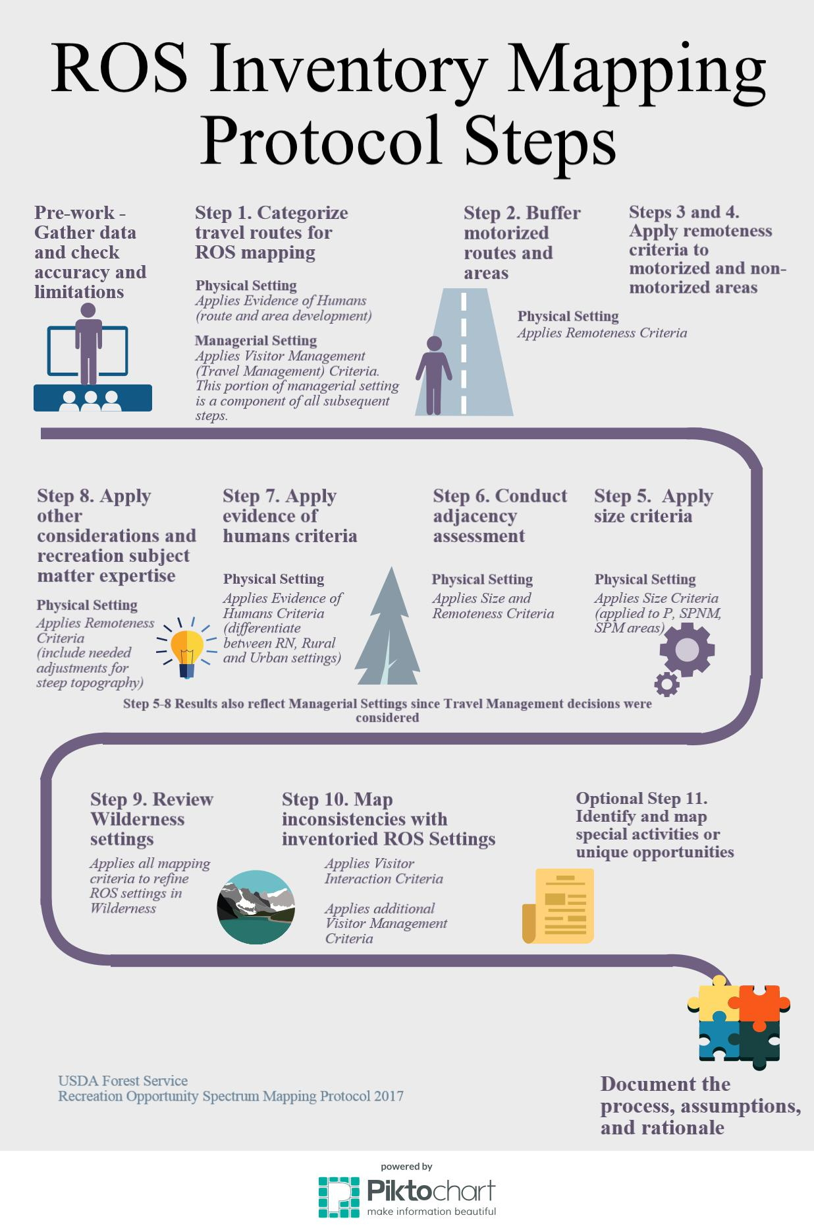
Figure 2. ROS inventory mapping protocol steps infographic

What Data is Needed?
To complete the inventory the following is needed: Forest transportation system, other jurisdiction transportation system within 3 miles of the Forest boundary, and any routes or areas with motorized use. Three miles is a distance used in the ROS system for determining ROS classes; therefore, routes within 3 miles of the Forest boundary are needed in order to consider off-forest influences on recreation settings within the Forest boundary.
- Over Snow Vehicle Use Map (OSVUM) route and area designations or other winter or over snow travel plan maps and decisions. Check if OSVUM reflects all travel management decisions. Some routes need additional mitigations before being shown on the OSVUM.
- Roads, trails and areas designated for Over-Snow Vehicle Use
- Seasonal restrictions identified in other travel management decisions
- Forest SDE Transportation system corporate data (roads, trails, and areas) and Access and Travel Management Infra modules. Trail feature class and Infra Travel Modules, Trail_Visitor_Info_Map_V table
- Transportation system under other jurisdiction within the administrative Forest boundary and within 3 miles of the Forest boundary
- FS administrative boundaries within the inventory area
- Lakes, reservoirs and other water bodies
- Land ownership and private inholdings throughout the planning area
- Specially designated areas such as designated wilderness, national recreation areas, etc.

Data Quality
The winter ROS inventory mapping relies heavily on the OSVUM, Forest’s transportation system and Infra attributes. Before existing condition winter ROS mapping begins, coordinate with needed staff on the quality and accuracy of the Forest transportation system data layers, Infra attributes, and how travel management decisions have been incorporated into both. Confirm that the OSVUM reflects all travel management decisions.
Corporate data layers are updated regularly and the data used to complete the ROS inventory mapping may change over time. The ROS inventory can be updated at any time if discrepancies with corporate data occur. See the Key Data Management Recommendations section on next page.
Since the OSVUM is reviewed and potentially updated each year, Forest/District GIS coordinators can identify the most up to date data layers to use for the exercise.

Documentation and Key Data Management Recommendations
Documentation of the entire winter ROS inventory process and data sources used is needed so that the process is repeatable and can be filed in the planning record.
The following recommendations are critical to the accuracy, compatibility, and future applications of the ROS inventory:
- Use the data sources the rest of the interdisciplinary planning team is using for assessment and analysis
- Document the date of data sources used
- “Freeze” the data being used, so as not redo work every time a corporate data update is completed
- Document the date the inventory is completed
- Conduct edge matching with adjacent National Forests and Grasslands
- Ensure final data feature classes match the winter ROS GIS data dictionary
- Determine a schedule for updating the winter ROS inventory mapping with the interdisciplinary team as a part of monitoring

Geoprocessing
This inventory mapping protocol outlines the framework and parameters for completing the ROS inventory using GIS applications. A variety of appropriate GIS tools can be used. Geoprocessing can be completed in vector or raster environments as long as the basic framework and parameters outlined in the protocol are followed (distances, size, and assumptions outlined throughout the protocol).

ROS Inventory Mapping Steps for Winter (snow) season
The following section outlines the steps to map existing ROS classes for winter (snow) season. The steps were developed using definitions and processes outlined in National Recreation Opportunity Spectrum (ROS) Inventory Mapping Protocol developed in 2017.
In January 2015, the USDA amended subpart C of the Travel Management Rule (TMR) to require the Responsible Official to designate NFS roads, NFS trails, and areas on NFS lands where over-snow vehicle use is allowed, where snowfall is adequate for OSV use to occur. The Travel Management Rule defines an over-snow vehicle is a motor vehicle that is designed for use over-snow and that runs on a track and/or a ski or skis, while used over-snow (TMR subpart A, as amended). An over-snow vehicle use map is a map reflecting roads, trails, and areas designated for over-snow vehicle use on an administrative unit or a Ranger District of the National Forest System (36 CFR Parts 212 and 261 Use By Over-Snow Vehicles (Travel Management Rule)).
This section outlines the steps to map existing ROS classes for the winter (snow) season. The steps were developed using definitions and processes in the Travel Management Rule Subpart C. Appendix A displays typical examples of the physical, social and managerial attributes contained in each of the ROS classes for winter (snow) season.

Pre-work
A base map is needed for applying subsequent mapping steps and applying additional criteria in later steps. Review the following sections in this protocol to make a base map showing all data to be used in the inventory:
- What Data is Needed? (page 6 of this document)
- Data Quality (page 6 of this document)
- Documentation and Key Data Management Recommendations (pages 6 and 7 of this document)
TO BE ADDED WHEN AN EXAMPLE IS AVAILABLE
Figure 3. Base map example showing data needed to complete the ROS mapping.

Step 1. Categorize travel routes
The Forest transportation system is the primary basis for determining remoteness from the sights and sounds of humans and for identifying the initial division between non-motorized settings (P and SPNM) and motorized settings (SPM and RN). The map developed in this step also provides an over-all orientation to the forest boundary and areas adjacent to the forest boundary.
Using GIS and Infra, identify the forest transportation and access system and include all roads, trails, water bodies (lakes, rivers, reservoirs) and other areas within or adjacent to NFS lands that are used by motorized vehicles in the winter. Identify and map all motorized travelways within 3 miles of the Forest boundary to ensure consideration of off-Forest influences.
Distinguish which routes are motorized and which are non-motorized. All motorized routes will be further categorized as either “ungroomed/unmaintained” or “groomed/maintained.” “Ungroomed/unmaintained” routes are routes designated for use by vehicles not primarily intended for highway use, such as over-snow vehicles. “Groomed/maintained” routes are routes constructed or maintained for the use by over-snow vehicles (i.e., groomed) or use by highway type vehicles having more than two wheels. “Ungroomed/unmaintained” routes are similar to primitive routes and “groomed/maintained” routes are similar to better than primitive routes defined in the 1982 ROS User Guide (USDA Forest Service 1982, page 16).

Over-Snow Vehicle Use Map (OSVUM)
An over-snow vehicle use map is a map reflecting roads, trails, and areas designated for over-snow vehicle use on an administrative unit or a Ranger District of the National Forest System. If the Forest has an OSVUM or other winter travel management decisions, the route feature classes used to make the OSVUM are the starting point for developing a travel routes feature class to map winter ROS classes.
The type of maintenance the route receives is an indicator to make an “ungroomed/unmaintained” or “groomed/maintained” determination. The maintenance considered is based on whether a route is plowed, groomed or ungroomed. Identify a category for all motorized snow routes based on the known winter maintenance in the below table.
Table 2. ROS Link to Winter Maintenance
OSVUM or Winter Maintenance | Winter ROS Route Category
Non-motorized routes (Ungroomed or Groomed) | non-motorized
Ungroomed and Unmarked or Marked OSV Route | motorized – ungroomed/unmaintained
Groomed OSV Route | motorized – groomed/maintained
Plowed or Winter Maintained Road | motorized – groomed/maintained *
* OSVs may not be allowed on plowed roads or a road drivable by conventional motorized vehicles. Refer to the OSVUM for such designations.

Access and Travel Management (ATM) module
Refer to the Access and Travel Management (ATM) module if categories cannot be derived from the OSVUM. The ATM module stores the results of forest decisions and management objectives regarding motorized and non-motorized uses of its roads, trails and areas. Query the modes of travel, travel management strategies, or allowed/restricted uses and codes to identify all routes used in the winter (snow) season. Below are specific modes of travel and strategy information applicable to over snow travel from the ATM data dictionary. See the ATM data dictionary for examples on how to use Allowed Use Templates and Restricted Use Codes (USDA Forest Service 2009a).

Modes of Travel
The ATM module includes a hierarchical list that includes all motorized and non-motorized land, snow, water, and air types of travel on roads, trails, and areas. Over snow modes of travel include:
Table 3. Over snow modes of travel (Snow Trail: Motorized and Non-Motorized Use) in the ATM module
Code and Hierarchy | Description
3 Over Snow Travel
3.1 MTR OVER-SNOW VEHICLE | Motor vehicles designed for over-snow that run on a track or tracks and/or a ski(s), while in use over snow. The same vehicle would be a Standard/Terra OHV (1.2) when not in use over snow. 36 CFR 212.1
3.1.1 Over-Snow Vehicle > 50” | Over-snow vehicles greater than 50” in width, including snow coaches, snow cats, and sport utility vehicles (SUVs) with track conversion kits.
3.1.2 Over-Snow Vehicle < 50” | Motorized over-snow vehicles less than or equal to 50” in width
3.1.2.1 Snowmobile | Motorized over-snow vehicles that operate on a track, use one or more skis for steering, have handle-bar steering, and a seat designed to be straddled by the operator.
3.1.2.2 Other OSV<= 50” | Other over-snow vehicles less than or equal to 50” in width, including ATVs with track conversion kits.
3.2 NON-MTR SNOW TRAFFIC | All non-motorized uses specifically designed for travel over snow and ice.
3.2.1 Cross country ski | Cross-country skis. Includes ski mountaineering and hike-in downhill skiing/snowboarding when not supported by mechanized vehicles.
3.2.2 Snow shoe | Snow shoes.
3.2.3 Dog sled | Snow sleds pulled by dogs.
3.2.4 Other NON-MTR Snow Traffic | Other non-mechanized vehicles, including vehicles pulled by animals other than dogs, as well as vehicles propelled by wind or gravity, such as ice-boats or bobsleds.
(USDA Forest Service 2009a, page 11-4).

Travel Management Strategy
The travel management strategy is an indication of how and to what extent the uses of the road, trail, or area are managed. Strategies or combination of strategies may be used to allow or restrict any mode of travel. There are six national strategies: encourage (roads), manage (trails), accept, discourage, eliminate, and prohibit. The ATM module is not used to record: short term conditions such as when roads are seasonally blocked by snow or the “drive-ability” or condition of the route as it is a time or season related factor and can vary daily.
There are two options for managing and recording motorized over-snow vehicle use in the ATM module. 1) Over-Snow Vehicle Use Map or 2) Orders issued under 36 CFR 261.50 Subpart B.
- When an Over-Snow Motor Vehicle Use Map is published, ATM data is populated in Allowed Uses.
- The ATM data dictionary states that a “manage,” “accept,” or “discourage” strategy must be recorded for all motorized over-snow vehicle designations. If no motorized over-snow vehicle use is recorded, it is assumed that the route or area has not been designated and the use is prohibited.
- The ATM data dictionary states that motorized over-snow vehicle use can be recorded as an “accept” or “discourage” strategy on a Maintenance Level 2-5 road without having to designate the route as a system trail. A road designated for over-snow vehicle use, should at a minimum be labeled as motorized and “ungroomed/unmaintained.” Further guidance for assigning “ungroomed/unmaintained” and “groomed/maintained” categories based on known winter maintenance are found in the Table 2 on page 9.
- It is assumed, based on the ATM data dictionary, that if a route has an “encourage” strategy for motorized over-snow vehicle use, the road must also be designated as a trail and added to the trail inventory (USDA Forest Service 2009a, 1-9). See the section on NFS Trails for overlapping uses.
- When a Forest has prohibited OSV use by issuing orders, ATM data is populated in Restricted Uses.
- When use is restricted by an order, “prohibit” strategies on motorized over-snow vehicles are recorded. When access is denied through means other than an order, such as physical barriers or access made unavailable due to an order on another road or trail, “eliminate” strategies are recorded.
- Assume that all motorized over-snow use on a road is allowed unless specifically recorded as a “prohibit” or “eliminate” strategy.

NFS Trails – another data option
If an OSVUM is not available, another data option to identify all trails designated for motorized use during the snow season is the corporate GIS Trail feature class, Trail_Visitor_Info_Map_V table.
Compare the corporate GIS Trail feature class allowed uses and Motor Vehicle Use Map to ensure all designated motorized trails are included on the corporate GIS Trail feature class.
Query snow_motorized attribute in the corporate GIS Trail feature class linked with Infra Travel Modules, Trail_Visitor_Info_Map_V table.
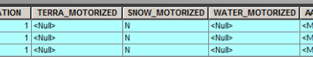
Figure 4. Screen capture of a portion of the Trail_Visitor_Info_Map_V table
Query allowed uses (Allowed_Snow_Use) in the Trail_Visitor_Info_Map_V table linked to corporate GIS Trail feature class and determine if the trail is motorized or non-motorized.
- Common motorized use in Allowed_Snow_Use attribute includes:
- 3 = snowmobile
- Common non-motorized use in Allowed_Snow_Use attribute includes:
- 2= cross-country ski
- 1= snow-shoe
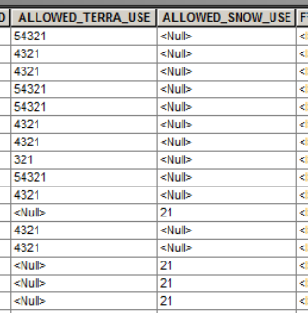
Figure 5. Screen capture of a portion of the Trail_Visitor_Info_Map_V table

Over Snow Use Areas
In the 2015 TMR amendment, the definition of area is a discrete, specifically delineated space that is smaller, and, except for over-snow vehicle use, in most cases much smaller, than a Ranger District (§ 212.1 Definitions, 2015)
Use any available GIS feature classes, OSVUM, or subject matter expertise to identify areas that allow over-snow vehicle use cross-country in designated areas. If an OSVUM is not available, corporate feature class TravelManagementArea is not likely to have this information (the ATM data dictionary states that cross-country motorized use by ‘Over-Snow’ vehicles, while traveling over-snow, is not intended to be depicted in the Designated Motor Vehicle Use Areas in the MVUM). Use GIS to heads-up digitize over-snow areas as necessary.
Label these cross-country motorized use areas as “ungroomed/unmaintained” at this point. These areas will not be part of the initial buffering of routes, but will be utilized in later mapping steps when applying remoteness criteria.

Restricted Use Routes
Roads and trails not open to the public but used by motorized vehicles for administrative purposes should be labeled as “motorized restricted use.” Restricted use routes will not be buffered in initial mapping steps, but will be labeled in this step and discussed in Step 10 when identifying inconsistencies with the mapped ROS settings.

Over Water Use (Streams and Waterbodies)
It is assumed that over water use by OSVs will have been previously identified in Trail corporate data or areas designated for OSV use in previous steps. Do not include any areas or routes previously identified in the above steps.
If areas are not identified on an OSVUM, use corporate GIS waterbody data (NHDWaterbodies). Label and identify water bodies as motorized or non-motorized based designated motorized access in winter for over-snow vehicle use or wheeled vehicle access for activities such as ice-fishing. Identify water bodies (i.e., lakes and reservoirs) which receive motorized use during the winter (snow) season and label as either “ungroomed/unmaintained” or “groomed/maintained” based on subject matter expertise or professional judgement. When making an “ungroomed/unmaintained” or “groomed/maintained” determination, consider the type of motorized use on the waterbody, type of vehicle being used, size of waterbody, shoreline developments and roads accessing the waterbody. Document assumptions and rationale for making “ungroomed/unmaintained” or “groomed/maintained” determinations. These categories are used to later determine ROS settings. An “ungroomed/unmaintained” determination indicates a Semi-primitive Motorized setting, while a “groomed/maintained” indicates a more developed setting, such as Roaded Natural.

Other Jurisdiction Roads and Trails
This section addresses highways, roads and trails administered by other jurisdictions, such as other federal agencies, the state, counties, and tribes, as well as privately owned roads and trails. Identify and map all motorized travelways on other ownerships within the Forest boundary and within a 3 mile radius of the Forest boundary to ensure consideration of off-Forest influences on recreation settings.
Identify other jurisdiction motorized routes from the corporate GIS data layer Transportation: TravelRoute_ln feature class if possible. Include roads from this feature class that are not on the corporate Transportation: Road feature class.
If queries result in any routes on NFS lands that are not on corporate road or trail data layers, remove them and do not buffer them in this analysis. These routes may be user created or decommissioned routes. Rely on corporate Road and Trail data for any routes on NFS lands as the most accurate data available.
No nationally consistent attributes occur on the TravelRoute_ln feature class to assign the “ungroomed/unmaintained” and “groomed/maintained” categories. In most cases subject matter expertise and professional judgement will be needed to assign the correct category to the other jurisdiction roads and trails. When in doubt or if no additional data is available, other jurisdiction roads and motorized trails categories should be based on adjacent and/or connecting NFS roads and trails.

Alternate data sources
There may be no data or inadequate available data in the FS corporate GIS to support analysis of other jurisdiction roads and trails. The following data may be helpful in those instances: Topologically Integrated Geographic Encoding and Referencing, or TIGER, a format used by the United States Census Bureau to describe land attributes such as roads, buildings, rivers, and lakes, as well as, census tracts. (http://www.census.gov/geo/maps-data/data/tiger.html)
Another potential data source to be considered, if available, would be individual state department of transportation system data layers.

Do Not Include
Roads and trails within the Forest boundary that are not managed as part of the National Forest transportation system (such as decommissioned roads, user created routes, unplanned roads, abandoned travelways, and off-road vehicle tracks that have not been designated on the Forest’s Motor Vehicle Use Map). Those roads no longer under permit or authorization are not buffered for the analysis, but they may be considered when identifying inconsistencies within the mapped ROS settings in Step 10.

Result
A series of feature classes that display the transportation system is created, including the forest transportation system, other jurisdiction routes, and routes within three miles of the Forest boundary. An ArcMap project can display the forest boundary, year-round or winter (snow) motorized and non-motorized roads, trails and areas. It also shows the “ungroomed/unmaintained” and “groomed/maintained” year-round or winter (snow) motorized routes and areas. Data sources, data limitations, and assumptions and rationale for “ungroomed/unmaintained” and “groomed/maintained” categories are documented. Managerial settings influenced by travel management decisions have also been incorporated.

Mapping tips
It is recommended to place all route feature classes created or edited in this step on one ROS travel routes feature class prior to starting the next mapping steps. Tools in GIS to combine route feature classes include, but are not limited to, the merge command, erase and copy/paste, or other referencing tools such as ‘overlay route events’.
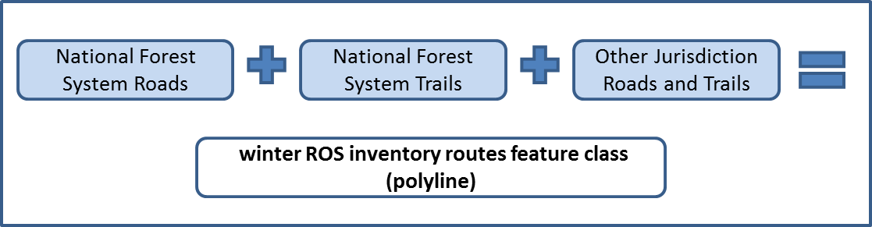
Figure 6. Step 1. Categorize travel routes flowchart
It is recommended to add a field on the combined ROS travel routes feature class. This may be called ROS_category with values of non-motorized, motorized ungroomed/unmaintained, motorized groomed/maintained and motorized restricted use assigned to each route. Another helpful field would be data_source that documents the route's data layer source. A comment field may also helpful to document assumptions or rationale for “ungroomed/unmaintained” and “groomed/maintained” categories.
Ensure no routes are duplicated when merging feature classes. If queries result in duplicated routes, give priority to corporate Road and Trail data over other data sources.
TO BE ADDED WHEN AN EXAMPLE IS AVAILABLE
Figure 7. Step 1 Result Example. Categorize travel routes for ROS mapping

Step 2. Buffer motorized routes and areas
Either apply the protocol step by step or use the terrain-based GIS ROS Model documented in Appendix B to accomplish GIS mapping from Steps 2 through 8. The terrain-based GIS ROS Model determines where steep terrain affects recreation settings. Modeling results still require a detailed review by unit recreation staff or staff with subject matter expertise to verify results and complete the remaining protocol mapping steps.
This step results in the initial division between motorized and non-motorized settings. Motorized ROS settings are areas within ½ mile of motorized travel routes (i.e., roads and OSV trails) identified in previous steps. Further refinement of motorized areas occurs in Steps 4 and 7. “Ungroomed/unmaintained” and “groomed/maintained” routes identified during Step 1 should be buffered separately.
Apply ½ mile and 3 mile buffers to “ungroomed/unmaintained” and “groomed/maintained” winter (snow) motorized routes. Areas will be considered in subsequent mapping steps
- Buffer all winter (snow) “ungroomed/unmaintained” motorized routes and areas identified in Step 1 by ½ miles and by 3 miles. (mapping tip: consider using Multiple Ring Buffer)
- Buffer all winter (snow) “groomed/maintained” motorized routes and areas identified in Step 1 by ½ miles and by 3 miles. (mapping tip: consider using Multiple Ring Buffer)
- Combine “ungroomed/unmaintained” and “groomed/maintained” buffers. (mapping tip: use a combining tool that does not allow overlapping polygons)
- Add a field for initial ROS setting (such as InitialSetting). Add a field for initial ROS codes for use starting in Step 3 (such as step3ROS_code).
- For initial ROS setting, label areas outside the ½ mile buffer as non-motorized. (mapping tip: query and select first)
- For initial ROS setting, label areas within the ½ mile buffer as motorized. (mapping tip: query and select second to override previous calculations)
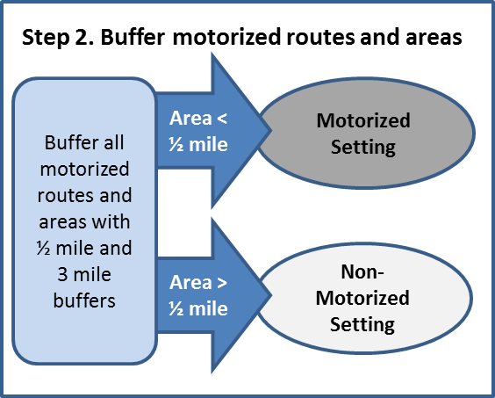
Figure 8. Step 2. Buffer motorized routes and areas flowchart

Result
At this point, the feature class and draft example map would show polygons that display an initial division between motorized and non-motorized winter ROS settings.
These buffers can be further refined for steep topography in Step 8. Motorized settings may overlap with designated wilderness and other special areas. This protocol applies the same ROS criteria independently of any area designation, as described in the 1982 User Guide (page IV-3). Wilderness settings will be reviewed in Step 9.
TO BE ADDED WHEN AN EXAMPLE IS AVAILABLE
Figure 9. Step 2 Result Example. Buffer motorized routes and areas which identifies initial division between motorized and non-motorized ROS settings

Step 3. Apply remoteness criteria to non-motorized areas
This step identifies the initial Primitive and Semi-primitive Non-motorized settings by applying the remoteness criteria to non-motorized areas from Step 2.
Identify and label all areas 3 miles or farther away from motorized routes as Primitive (P). (mapping tip: query and select first)
Identify and label all areas less than 3 miles and more than ½ mile from all motorized routes as Semi-primitive Non-motorized (SPNM). (mapping tip: query and select second to override previous calculations)
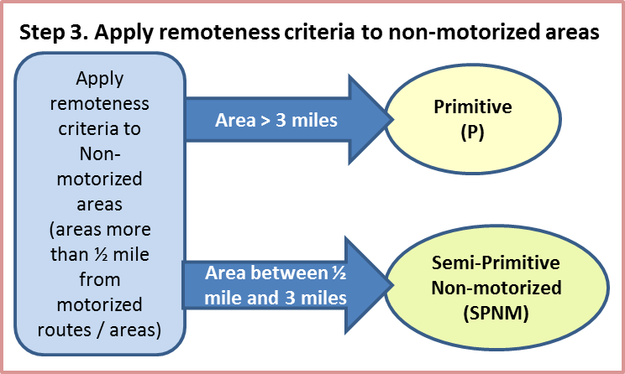
Figure 10. Step 3. Apply remoteness criteria to non-motorized areas flowchart

Result
At this point, an initial division between Primitive and Semi-primitive Non-motorized ROS settings is now delineated based on remoteness criteria.
Mapping tip: If you have overlapping polygons, results may not display correctly.

Step 4. Apply remoteness criteria to motorized areas
This step identifies the initial Semi-primitive Motorized and Roaded Natural settings by applying the remoteness criteria to motorized areas from Step 2. Before further editing of attributes, also combine the over snow motorized use areas identified in step 1 with the previous Step 3 result.
Identify and label areas within the ½ mile buffers of “ungroomed/unmaintained” motorized routes as Semi-primitive Motorized (SPM). (mapping tip: query and select third to override previous calculations)
Identify and label over snow motorized use areas (“ungroomed/unmaintained” areas) as Semi-primitive Motorized (SPM). (mapping tip: query and select fourth to override previous calculations). This is done because areas previously labeled as P or SPNM may overlap with over snow motorized areas. Over snow motorized use areas will be reviewed again in Step 7 and Step 10 for social and managerial considerations.
Identify and label areas within ½ mile buffers of “groomed/maintained” motorized routes and areas as Roaded Natural (RN). (mapping tip: query and select last to override previous calculations)
Initially-mapped RN settings are confirmed or changed to Rural or Urban in Step 6 by applying other ROS inventory criteria.
These will be reviewed again in Step 7 and Step 10 for social and managerial setting considerations.
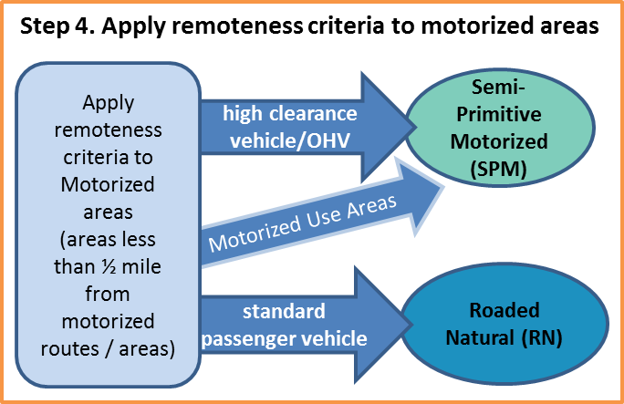
Figure 11. Step 4. Apply remoteness criteria to motorized buffers flowchart

Result
An initial division between SPM and RN areas is now delineated based on remoteness criteria along with initial division of P and SPNM from Step 3. Over snow motorized used areas have also been incorporated. These settings are analyzed in later steps to ensure other ROS inventory criteria are fully considered.
Motorized settings may overlap with designated wilderness and other special areas. This protocol applies the same ROS criteria independently of any area designation, as described in the 1982 User Guide (page IV-3). Wilderness settings will be reviewed in Step 9.
Mapping tip: If you have overlapping polygons, results may not display correctly.
TO BE ADDED WHEN AN EXAMPLE IS AVAILABLE
Figure 12. Step 3 and 4 Result Example. Apply remoteness criteria to non-motorized and motorized areas to identify initial P, SPNM, SPM and RN ROS settings.

Step 5. Apply size criteria
This step refines Primitive, Semi-primitive Non-motorized, and Semi-primitive Motorized areas meeting size criteria as well as identifying (flagging and coding) areas that do not meet the size criteria. The flagged areas will be analyzed in subsequent steps to ensure other criteria are fully considered before eliminating the area due strictly to remoteness and size.
Use GIS to calculate the size in acres of P, SPNM and SPM areas identified in Step 4.
- Within initially mapped Primitive (P) areas:
- Select areas greater than or equal to 5,000 acres and label these as P. These areas meet all criteria for Primitive.
- Select areas smaller than 5,000 acres and label them as “smallP” to allow for further analysis. These areas will be further analyzed in Steps 6, 8, 9, and 10.
- Within initially mapped Semi-primitive Non-motorized (SPNM) areas:
- Select areas greater than or equal to 2,500 acres and label them as SPNM. These areas meet all criteria for SPNM.
- Select areas smaller than 2,500 acres and label them as "smallSPNM" to allow for further analysis. These areas will be further analyzed in Steps 6, 8, 9, and 10.
- Within initially mapped Semi-Primitive Motorized areas:
- Select areas greater than or equal to 2,500 acres and label them as SPM. These areas meet all criteria for SPNM.
- Select areas smaller than 2,500 acres and label them as "smallSPM" to allow for further analysis. These areas will be further analyzed in Steps 6, 8, 9, and 10. If analysis does not support a SPM setting, they should be coded RN.
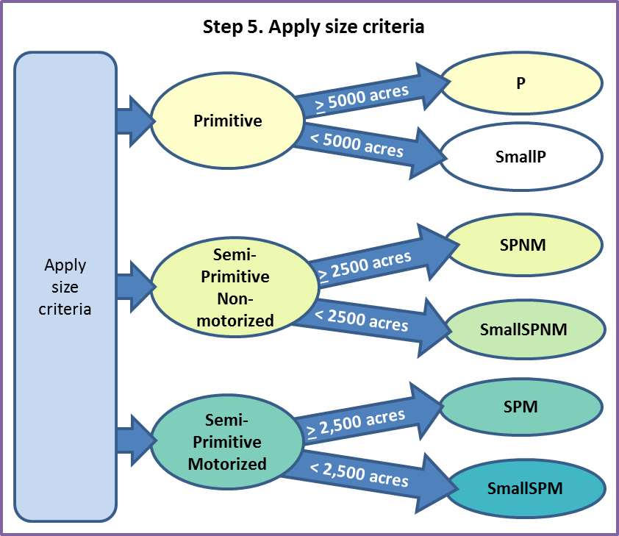
Figure 13. Step 5. Apply size criteria to Primitive, Semi-primitive Non-motorized and Semi-primitive Motorized buffers flowchart

Result
At this point, the feature class and draft map display initial P, SPNM and SPM settings that meet remoteness and size criteria and small P, SPNM, and SPM settings flagged for further analysis. The map also displays initial RN settings which are further differentiated in Step 7. All settings are analyzed in subsequent steps to ensure other ROS inventory criteria are fully considered.
TO BE ADDED WHEN AN EXAMPLE IS AVAILABLE
Figure 14. Step 5 Result Example. Apply size criteria to Primitive, Semi-primitive Non-motorized and Semi-primitive Motorized areas

Step 6. Conduct adjacency assessment
This step conducts an adjacency assessment to refine the P, SPNM, and SPM settings that do not meet size criteria. Use subject matter expertise of recreation specialists and other program specialists to refine “smallP,” “smallSPNM,” and “smallSPM” areas that do not meet ROS size criteria by considering adjacency to other settings.
Not all “small” polygons need to be resolved in this step. Some polygons may continue to be flagged for further analysis in Step 8 when considering potential adjustments for steep topography.

Further assess and refine “smallP” areas
For those areas initially mapped as “smallP” (Primitive but smaller than 5,000 acres), consider adjacent ROS determinations and settings.
- If the “smallP” area is within or adjacent to a designated wilderness area or wilderness study area, then map it as P. Consider wilderness areas on adjacent federal lands.
- If the “smallP” area is adjacent to SPNM areas, then flag the area for further assessment by recreation specialists. Determine if the area can still provide a primitive setting. The determination requires subject matter expertise and informed professional judgement of the area and its features, such as topography.
- If the “smallP” area is isolated from other P, SPNM or wilderness settings, then flag the area for further review by recreation specialists. Subject matter expertise and informed professional judgement is necessary when considering isolated situations that don’t meet the size or adjacency criteria identified above but may still meet the over-all ROS characteristics for P and SPNM.
Document rationale for any areas not meeting size or adjacency criteria, but still mapped as P based on subject matter expertise or professional judgement. If recreation specialists feel that the “smallP” area does not provide a primitive setting, the area should be labeled as SPNM.
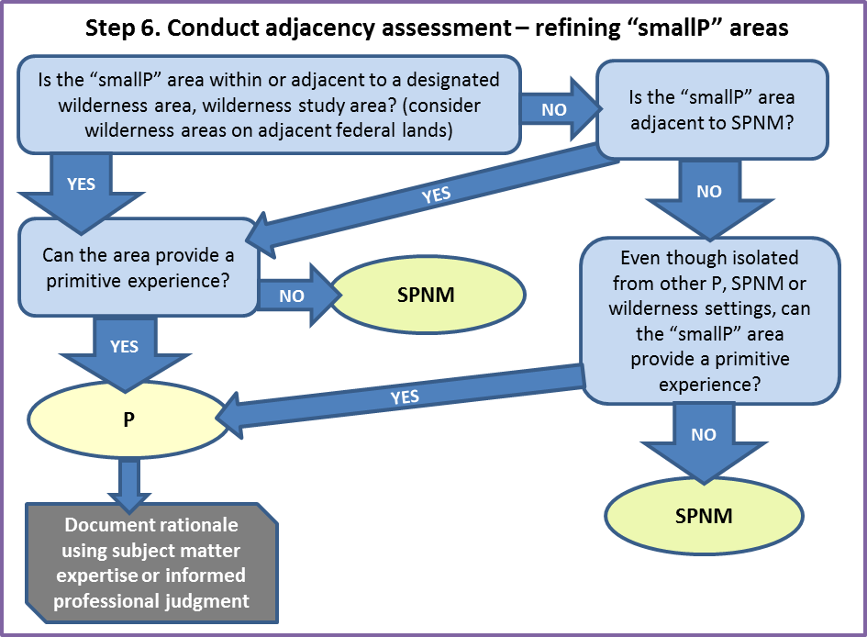
Figure 15. Adjacency assessment to refine “smallP” areas flowchart

Further assess and refine “smallSPNM” areas
For those areas initially mapped as “smallSPNM” (Semi-primitive Non-motorized but smaller than 2,500 acres), consider adjacent ROS determinations.
- If the “smallSPNM” area is adjacent to P, then flag the area for review by recreation specialists. The polygon may still provide a SPNM setting and be mapped as SPNM. The determination requires subject matter expertise and informed professional judgement of the area and its features such as topography.
- If the “smallSPNM” area is contiguous to a designated wilderness area or wilderness study area, then the “smallSPNM” area may be identified as SPNM, even though it does not meet the size criteria. Consider wilderness areas on adjacent federal lands.
- If the “smallSPNM” area is isolated due to topography or other permanent landscape features, then the “smallSPNM” area, even though not 2,500 acres, may be mapped as SPNM. Subject matter expertise and informed professional judgement will be necessary to make the determination.
- If the “smallSPNM” area is engulfed by or adjacent to a SPM setting and does not meet any of the above bulleted statements, then the SPNM setting becomes part of the SPM polygon. Although motorized use does not occur in this portion of the setting, it contributes to the semi-primitive character.
- Flag areas that provide a unique or special opportunity for Step 11. (Example: smallSPNM areas 1,000 to 2,499 acres may provide a unique, non-motorized opportunity in otherwise motorized ROS settings). A subclass may be appropriate when determining desired ROS.
- If the “smallSPNM” area(s) and adjacent “smallSPM” area(s) total 2,500 acres and no previous bulleted statements are met, then the SPNM setting becomes part of the, then map the area as SPM. Although motorized use does not occur in all portions of the setting, all portions contribute to the semi-primitive character.
- Flag areas that provide a unique or special opportunity for Step 11. (Example: smallSPNM areas 1,000 to 2,499 acres may provide a unique non-motorized opportunity in otherwise motorized ROS settings) A subclass may be appropriate when determining desired ROS.
Document rationale for any areas not meeting size or adjacency criteria, but still mapped as SPNM based on subject matter expertise or professional judgement.
If none of the above conditions occur, then the area would be mapped as RN.
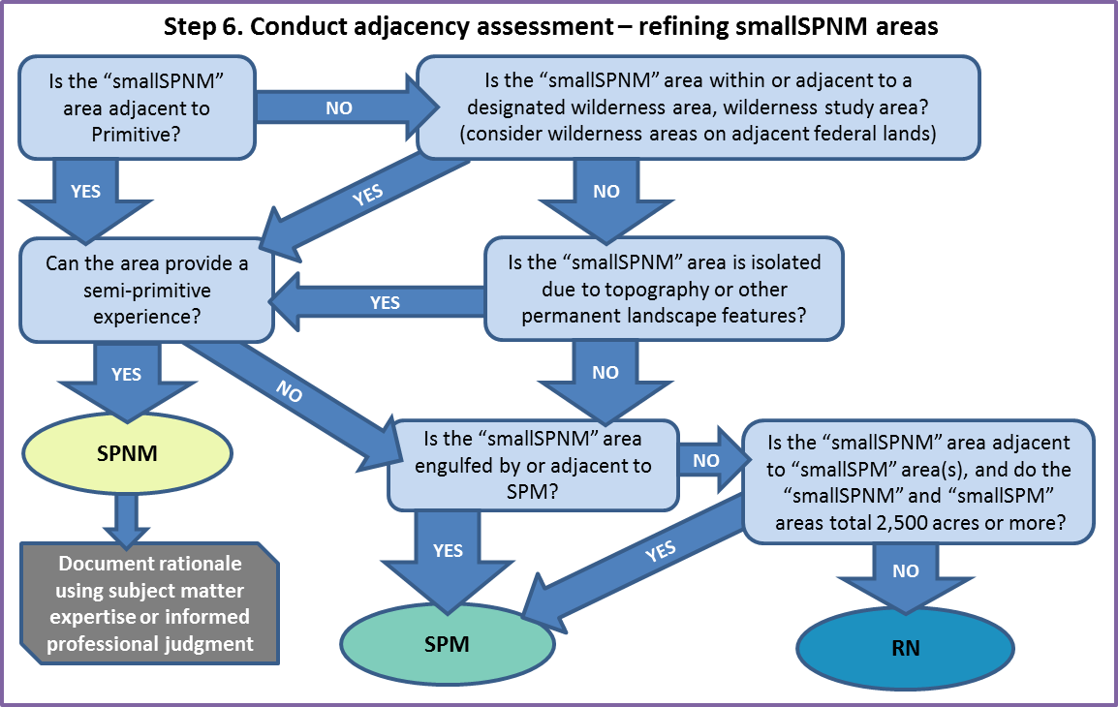
Figure 16. Adjacency assessment to refine “smallSPNM” areas flowchart

Further assess and refine “smallSPM” areas
For those areas initially mapped as “smallSPM” (Semi-primitive Motorized but smaller than 2,500 acres), consider adjacent ROS determinations.
- If the “smallSPM” area is contiguous to a designated wilderness area or wilderness study area, then “smallSPM” areas may be identified as SPM, even though they do not meet the size criteria. Consider wilderness areas on adjacent federal lands.
- If the area is isolated due to topography or other permanent landscape features, then the “smallSPM” area, even though not 2,500 acres, may be mapped as SPM. Subject matter expertise and informed professional judgement will be necessary to make these determinations.
- If the “smallSPM” area(s) and adjacent “smallSPNM” areas total 2,500 acres and no previous bulleted statements are met, then map the area as SPM. Although motorized use does not occur in the SPNM portion of the setting, it contributes to the semi-primitive character.
- Flag areas that provide a unique or special opportunity for Step 11. (Example: smallSPM areas 1,000 to 2,499 acres may provide a unique semi-primitive opportunity in otherwise RN ROS settings) A subclass may be appropriate when determining desired ROS.
Document rationale for any areas not meeting size or adjacency criteria, but still mapped as SPM based on subject matter expertise or professional judgement.
If none of these above conditions occur, the area would be mapped as RN.
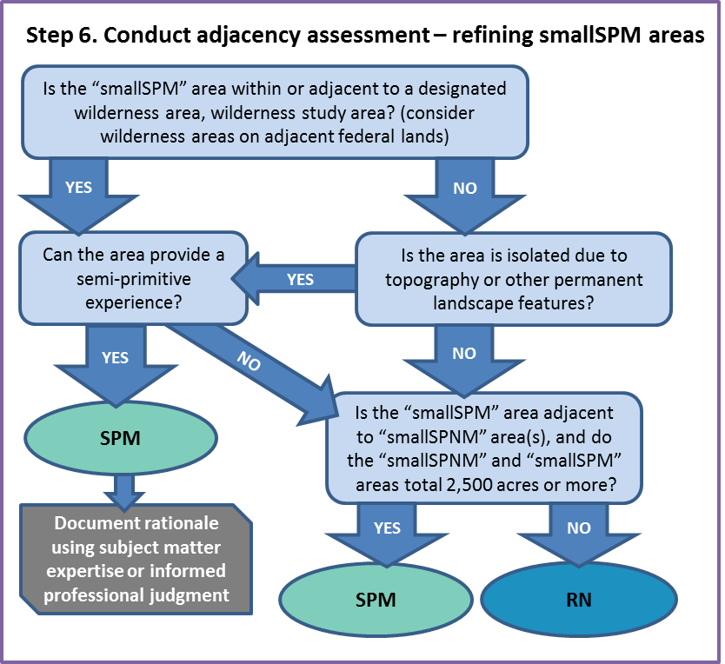
Figure 17. Adjacency assessment to refine “smallSPM” areas flowchart

Result
At this point, the feature class and draft map display initial P, SPNM and SPM settings that meet remoteness and size criteria. The map may still include small P, SPNM, and SPM areas that need further consideration by recreation subject matter experts and further analysis in Step 8 when considering potential adjustments for steep topography. The map also displays initial RN settings which are further differentiated in the next step. All settings are analyzed in subsequent steps to ensure other ROS inventory criteria are fully considered.
Assumptions and rationale have been documented for any areas not meeting size or adjacency criteria, but still mapped as P, SPNM, or SPM based on subject matter expertise or professional judgement.
In the mapping example below, some “smallSPNM” and “smallSPM” areas were retained for further consideration in Step 8. The following example does not have any areas initially mapped as P.
TO BE ADDED WHEN AN EXAMPLE IS AVAILABLE
Figure 18. Step 6 Result Example. Conduct adjacency assessment to refine P, SPNM, and SPM settings

Step 7. Apply evidence of humans criteria
This step applies subject matter expertise and additional information to differentiate between Roaded Natural, Rural and Urban settings by applying the evidence of humans criteria, including authorized uses and associated infrastructure. Evidence of humans criteria is used to indicate varying degrees of modifications to the natural landscape as one moves across the spectrum. Modifications may be caused by past vegetation management, mineral extraction, road construction, facilities/structures, or any activity that creates distinct alterations in the natural or natural-appearing setting.
No size criteria apply to Roaded Natural, Rural, or Urban ROS classes. Remaining areas within ½ mile of “groomed/maintained” routes should have been identified as RN in Step 4. Objective and consistent criteria that measure and assess naturalness based on an amount or degree of vegetation management, mineral extraction or other activities is difficult to determine on a national scale. Following are data options for the evidence of humans criteria that can be used to differentiate between Roaded Natural, Rural and Urban ROS classes.
Review the polygons mapped as RN in steps 4 and 6 and use the evidence of humans criteria to make initial divisions between Roaded Natural, Rural and Urban settings. Document all assumptions and rationale based on subject matter expertise or informed professional judgement used to differentiate Roaded Natural, Rural, or Urban ROS classes.

Level of Development
Look at any available past ROS inventories as a starting point for Rural and Urban areas and determine its accuracy. Other data that may be useful to differentiate between these three ROS classes is the level of development. Use official boundaries of the following data options when available, such as a polygon feature class in GIS. Boundaries can be created solely for use in this inventory. Information that may be useful includes:
- Administrative site boundaries (e.g. office complexes, visitor center sites, work compounds, maintenance yards, housing areas, etc.) may exhibit Rural or even Urban ROS class characteristics. Rural may include historic administrative sites and work centers, whereas Urban may include more contemporary office complexes and visitor centers.
- Developed recreation sites – highly developed recreation sites may exhibit Rural or even Urban ROS class characteristics.
- Permit boundaries (e.g. lodges, dude ranches, ski areas, marinas, and highly developed recreation complexes, communication sites, and utility lines, may meet characteristics for a Rural or Urban ROS classification)
- Other potential data sources include but are not limited to: active mineral extraction, housing density studies and wildland urban interface mapping.

Subject matter expertise and Professional Judgement
If route density is not a desired data option for the unit or in cases where level of development boundaries are not mapped, subject matter expertise and professional judgement should be used along with the criteria from the 1982 ROS User Guide. Document rationale for any areas changed to Rural or Urban based on subject matter expertise and professional judgement. Existing scenic integrity and other scenery management system (SMS) inventories can be used to inform these determinations.
Review Designated Motor Vehicle Use Areas identified in Step 1 if the Forest has any designated areas (areas where motor vehicle use is permitted off of designated routes). Since these areas were initially identified in Step 1 as “ungroomed/unmaintained” they should be labeled as SPM at this point. Use subject matter expertise and professional judgement and determine the appropriate ROS setting of the area based on the evidence of humans criteria below. The evidence of humans criteria will be reviewed again in Step 10 to determine inconsistencies within all ROS classes.
Table 4. Evidence of Humans Criteria for Roaded Natural, Rural, and Urban ROS classes. For other ROS classes, see the 1982 ROS User Guide.
Roaded Natural | Rural | Urban
Natural setting may have modification which range from being easily noticed to strongly dominant to observers within the area. However from sensitive* travel routes and use areas these alterations would remain unnoticed or visually subordinate  There is strong evidence of designed roads and/or highways  Structures are generally scattered, remaining visually subordinate or unnoticed to the sensitive* travel route observer. Structures may include power lines, microwave installations and so on | Natural setting is culturally modified to the point that it is dominant to the sensitive* travel route observer. May include pastoral, agricultural, intensively managed wildland resource landscapes or utility corridors. Pedestrian or other slow moving observers are constantly within view of culturally changed landscape  There is strong evidence of designed roads and/or highways  Structures are readily apparent and may range from scattered to small dominant clusters including power lines, microwave installations, local ski areas, minor resorts and recreation sites. | Setting is strongly structure dominated. Naturally or naturally-appearing elements may play an important role but be visually subordinate. Pedestrian and other slow moving observers are constantly within view of artificial enclosure of spaces.  There is strong evidence of designed roads and/or highways and streets  Structures and structure complexes are dominant and may include major resorts and marinas, national and regional ski areas, towns, industrial sites, condominiums or second home developments.
* Concern Level 1 and 2 travel routes from Landscape Aesthetics Handbook 701

Result
At this point, the feature class and draft map displays the inventoried settings for up to six ROS classes, which reflect the physical characteristics and managerial characteristics based on travel planning decisions, TMR subpart B. No primitive ROS class was mapped in the existing condition ROS inventory example below due to the remoteness criteria and proximity of motorized routes in the area.
Assumptions and rationale have been documented for any areas differentiated as Rural or Urban based on subject matter expertise or professional judgement.

TO BE ADDED WHEN AN EXAMPLE IS AVAILABLE
Figure 19. Step 7 Result Example. Apply subject matter knowledge and additional information to differentiate between RN, Rural and Urban settings

Step 8. Apply other considerations and recreation subject matter expertise
Other available information, such as topography and other physical attributes, may be used to further refine polygons. If refinement of polygons is identified in this step, it is critical to coordinate with the Regional Office to ensure regional and national consistency. Vegetation should not be used to refine polygons because vegetation can change drastically with natural disturbances. Vegetative screening or density is important for short-term detailed planning at the project level. However, vegetative screening or density is inappropriate to consider in long-term, broad-scale planning, such as forest planning.
Where roads are contained within steep canyons or mountainous terrain, the “influence” zone of those routes may be less than ½ mile. It is recommended to refine ROS class boundaries in mountainous landscapes where terrain has a substantial effect on remoteness. These types of adjustments will require recreation subject matter expertise and professional judgement to determine.
Recreation subject matter expertise and professional judgement can be used to identify specific locations where the “influence” zone of a motorized route is less than ½ mile and determine the appropriate buffer or distance.
Another alternative is an ArcGIS model available for optional use that utilizes travel routes and terrain (specifically slope) to model ROS classes based on the difficulty in reaching a particular point. A summary of the model documentation is included in Appendix B of this protocol. This ROS model was developed to account for the increased difficulty of traveling over rough terrain. Slope was used to measure the difficulty; the steeper the slope, the tougher it is to cross the landscape. Therefore, the model uses the assumption that in steep topography, Primitive areas could be less than 3 miles from a motorized route and Semi-primitive Non-motorized areas may be less than ½ mile from a motorized route. In areas with flat or gentle terrain the standard ½ mile and 3 mile buffers are applied.
The terrain-based GIS ROS Model documented in Appendix B resolves limitations previous terrain based models had in areas with flat or gentle terrain. Modeling results still require a detailed review by unit recreation staff or staff with subject matter expertise to verify results and complete the remaining protocol mapping steps.

Result
If this step is applied, it is used to refine ROS class boundaries through the use of topography and other physical attributes. If applied, the feature class and draft map would display up to six ROS classes with adjustments for physical characteristics, considerations for steep topography, and managerial characteristics based on TMR subpart B decisions.
Assumptions and rationale have been documented for changes made based on other considerations such as topography based on subject matter expertise or professional judgement.

Step 9. Review wilderness settings
Designated wilderness areas typically prohibit motorized and mechanized use, do not contain facilities or recreation developments, and are managed for a primitive recreation setting. Although designated wilderness areas have a desired condition of Primitive ROS, the existing conditions vary from that due to their proximity of motorized routes and remoteness criteria (1/2 mile buffer) applied to them.
Some designated wilderness areas are composed largely of the primitive type of recreation opportunity; however, many designated wilderness areas also include semi-primitive or roaded natural settings. Therefore, the Primitive ROS class is not synonymous with designated wilderness when mapping existing conditions. This protocol applies the same ROS criteria independently of any area designation, as described in the 1982 User Guide (page IV-3).
Overlay initial ROS classes mapped in previous steps with designated wilderness boundaries, where applicable. Review all polygons initially mapped as SPM and RN ROS settings within designated wilderness boundaries. The initial ROS determinations may need to be refined. RN and SPM settings within designated wilderness should only occur in isolated situations, under limited circumstances:
- where an adjacent road or development has a profound effect on the wilderness recreation experience
- where language within the enabling legislation permits motorized transportation
- where the motorized use is frequent enough to influence the typical wilderness experience
Motorized ROS determinations are typically limited to narrow corridors (e.g. along cherry stem roads and water ways) and small, isolated areas (e.g. air strips). Levels and frequency of motorized use can be considered prior to automatically mapping an area SPM or RN.
In cases where motorized use is infrequent and not a significant impact to the otherwise SPNM or P recreation setting, the area is mapped as P or SPNM. Site-specific departures or inconsistencies (e.g. an airstrip that is used for emergencies or occasional administrative use) to the overall ROS class determination are simply documented in the attribute table of that ROS polygon in the next step.

Result
At this point, the feature class and draft map would show the inventoried winter (snow) ROS settings. Up to six ROS classes are displayed on an attribute field WINTER_ROS_CODE based on physical characteristics, managerial characteristics based on TMR subpart C decisions, other considerations such as adjustments for steep topography, and considerations for wilderness settings.
Assumptions and rationale have been documented for changes made for wilderness settings based on subject matter expertise or professional judgement.

TO BE ADDED WHEN AN EXAMPLE IS AVAILABLE
Figure 20. Steps 8 and 9 Result Example. Apply other considerations and recreation subject matter knowledge and Review wilderness settings

Step 10. Map Inconsistencies with Inventoried ROS Settings
The previous mapping steps show the inventoried ROS settings, which reflect the physical characteristics and managerial characteristics based on travel planning, TMR subpart C decisions. Additional managerial information to consider in this step is current plan direction, seasonal closures, or other forest orders and subject matter expertise about on-site regulations, controls, or restrictions in the area.
This step applies physical, social, and additional managerial characteristics to identify corrections or inconsistencies with the inventoried ROS settings mapped in previous steps. The additional physical, social, and managerial criteria, in most cases, do not drive the delineation of one ROS class over another. Rather, they are helpful in identifying an inconsistency. When the physical, social, and/or managerial criteria of an ROS class are not fully met, this is considered a setting inconsistency within the overall inventoried ROS setting.
Social characteristics and additional managerial characteristics can be mapped on a separate feature class from the ROS settings mapped in previous steps. Forests without complex social or managerial characteristics may record their information on the ROS settings feature class mapped in previous steps rather than a separate feature class.
Identify inconsistencies by comparing the ROS settings mapped at the end of Step 9 with any other physical, social and managerial characteristics identified in this step. Identify and document inconsistencies using a systematic analysis and an exercise of professional judgement.
The setting inconsistency should be identified on the ROS inventory feature class and documented in an additional attribute field on the feature class (attribute: ROS_INCONSISTENCY). The area with the inconsistency may need to be digitized. If multiple setting inconsistencies occur, document the most dominant inconsistency in the feature class. Resolving of the inconsistency takes place in the plan development process potentially through creation of a subclass or plan components (desired conditions, objectives, standards or guidelines).

Physical Characteristic
In previous mapping steps, the evidence of humans criteria was only applied to differentiate between Roaded Natural, Rural, and Urban ROS settings. In this step, the evidence of humans criteria may also be applied to Primitive, Semi-primitive Non-motorized and Semi-primitive Motorized settings to identify inconsistences with those settings. The overall inventoried ROS setting will not be changed in Primitive, Semi-primitive Non-motorized and Semi-primitive Motorized settings, but will be mapped as an inconsistency.
Examples of physical setting inconsistencies that may be mapped include:
- Areas that have been heavily altered by vegetation management, timber harvest, or mineral extraction making the physical characteristics inconsistent with the mapped ROS class. These areas can be identified with the existing scenic integrity inventory from the scenery management system, place-based mapping, or review with aerial imagery to name a few options.
- Unauthorized uses (such as illegal OHV/OSV use) which alters the physical characteristics, making the physical characteristics inconsistent with the mapped ROS class
- Areas with roads or motorized trails which are closed to public, but may receive some administrative use or permitted use. This use may affect the remoteness criteria, since users may encounter administrative motorized use in an otherwise non-motorized setting. This can be determined by considering previously identified “motorized restricted use” routes from Step 1. Those “motorized restricted use” routes can be buffered with a ½ mile distance. If that ½ mile distance occurs in P or SPNM mapped ROS class, a setting inconsistency is occurring and can be documented.
Document physical setting inconsistencies in another attribute field: ROS_INCONSISTENCY. Document physical setting inconsistencies as ROS_INCONSISTENCY = PSI

Social Characteristics
The social characteristics reflect the amount and type of contact between individuals or groups. It indicates opportunities for solitude and interactions with a few individuals or large groups of visitors as one moves across the spectrum. The mapping criteria used is visitor density. The visitor density criteria refers to the number of people encountered and visitor interaction. Visitor encounters commonly occur when individuals or groups of people recreating see each other on a trail, road, at a campsite or other location within the landscape.
Apply social characteristics criteria below to determine if social characteristics are inconsistent with the mapped ROS classes. These determinations are often based on subject matter expertise, field knowledge, and professional judgement based on number of encounters. If data is not available on number of encounters or special considerations are needed (e.g. urban forest influences or a published article on a trail causes an influx of visitors occurs for a time), qualitative criteria may be a helpful consideration in determining the social characteristics.
Table 5. Social Characteristics Criteria
ROS Class | Social Criteria
Primitive | Very high probability of solitude; closeness to nature; self-reliance, high challenge and risk; little evidence of people.  Typically 6 or less encounters with other parties on trails, and less than 3 parties visible from camping sites.
Semi-primitive Non-motorized | High probability of solitude, closeness to nature, self-reliance. High to moderate challenge and risk.  Usually 6-15 encounters with other parties on trails. 6 or less parties visible from camping sites.
Semi-primitive Motorized | Low to moderate contact frequency. Typically 6-15 encounters with other parties/day on trails. 6 or less parties visible from camping sites. High to moderate degree of risk/challenge
Roaded Natural | Moderate evidence of human sights and sounds; moderate to high concentrations of use on roads; Moderate to low concentrations of use at developed sites and on trails; little challenge or risk is expected in these outdoor settings due to nearby amenities and management controls. Opportunities to socialize.
Rural | Moderate to High interaction among users is common on roads, trails, and in developed sites. Other people in constant view. Little challenge or risk associated with being outdoors.
Urban | High degree of interaction with people. People are in constant view. Challenge and risk are unimportant except for competitive sports.
These criteria apply during the typical recreation use season. Peak days may exceed these limits.
If the inconsistency occurs within RN, then change the mapped ROS class, consistent with Step 7 of the mapping protocol. If the inconsistency occurs in P, SPNM, or SPM mapped ROS class, then map the area as an inconsistency.
Examples of social setting inconsistencies that may be mapped include:
- A heavily used hiking trail in a Primitive ROS class physical or managerial characteristics may meet the criteria for a Semi-primitive or Roaded Natural social characteristics due to amount of use
- A heavily used wilderness portal which meet the criteria for RN or R social characteristics due to amount of use
- Designated over snow motorized use areas which receive a high amount of use. Review designated over snow motorized use areas identified in Step 1 if the Forest has any designated areas (areas where motor vehicles use is permitted off of designated routes). Since these areas were initially identified in Step 1 as “ungroomed/unmaintained” they should be labeled as SPM or adjusted for other ROS settings in Step 7. Use subject matter expertise and professional judgement and determine in an inconsistency is occurring based on the social characteristics.
Document social setting inconsistencies in another attribute field: ROS_inconsistency. Document social setting inconsistencies as ROS_INCONSISTENCY = SSI

Managerial Setting
The managerial characteristics reflect the amount and kind of restrictions placed on people actions by the administering agency or private landowner which affects recreation opportunities. The mapping criteria used is visitor management. Visitor management criteria refers to the level of regulations, controls, or restrictions placed on visitors’ actions. Controls can be regulatory (e.g. designated uses on motor vehicle use maps or permits) or physical (e.g. barriers).
The best source of managerial information, Travel Management decisions, has been incorporated into Step 1 of this protocol and all subsequent steps. At this point, current plan direction, seasonal closures, or other forest orders should be checked to ensure that all managerial characteristics are incorporated, including subject matter expertise about on-site regulations, controls, or restrictions in the area. On-site regulations, controls, or restrictions can either be visible (barriers, signs, etc.) or invisible (such as permits, etc.). The managerial regimentation and noticeability criteria from the 1982 ROS User Guide in the table below can also be used to determine managerial characteristics.
Table 6. Managerial Characteristics Criteria
ROS Classes | Managerial Criteria
Primitive | On-site regimentation is low with controls* primarily off-site  Little to no on-site regimentation, few encounters with Forest Service personnel or partners/ volunteers working on behalf of the agency. Visitor use management is largely off-site and accomplished through regulation, permitting, and other visitor use management techniques.
Semi-primitive Non-motorized | On-site regimentation and controls* present but subtle  Minimum or subtle signing, regulations, or other on-site regimentation. Low encounters with Forest Service personnel or partners/volunteers working on behalf of the agency.
Semi-primitive Motorized | On-site regimentation and controls* present but subtle  Minimum, subtle on-site controls; Designated routes and areas for over-snow vehicles.
Roaded Natural | On-site regimentation and controls* are noticeable but harmonize with the natural environment  Signs and regulations present but typically subordinate to the setting. Moderate likelihood of encountering Forest Service personnel or volunteers/partners working on behalf of the agency.
Rural | On-site regimentation and controls* obvious and numerous, largely in harmony with the human environment  Obvious signing (regulation and information), education and law enforcement staff. Motorized and mechanized travel common and often separated.
Urban | On-site regimentation and controls* obvious and numerous.  Intensive on-site management, obvious signs, and staffing, education and law enforcement available. Motorized and mechanized travel restricted to designated routes.
* Criteria from the 1982 ROS User Guide (USDA Forest Service 1982). Controls can be physical (such as barriers) or regulatory (such as permits).
If the inconsistency occurs within RN, then change the mapped ROS class, consistent with Step 7 of the mapping protocol. If the inconsistency occurs in P, SPNM, or SPM mapped ROS class, then map the area as an inconsistency.
Examples of managerial setting inconsistencies that may be mapped include:
- A heavily used wilderness portal which meet the criteria for a RN or R managerial characteristics due the amount of regulations and controls
- An area mapped as SPM, but has a high amount of on or off site restrictions (e.g. permit system), regulations, or controls which would meet the criteria for a RN or R managerial characteristics
- Roads or areas with special management direction, for example a “quiet area” that is closed to motorized use during hunting seasons
Document managerial setting inconsistencies in another attribute field: ROS_INCONSISTENCY. Document social setting inconsistencies as ROS_INCONSISTENCY = MSI

Result
A final ROS feature class has now been completed showing the existing, inventoried ROS classes for the Forest in the winter (snow) season. The ROS settings for up to six distinct settings are identified: urban, rural, roaded natural, semi-primitive motorized, semi-primitive non-motorized, and primitive. However, not all distinct settings may be present on a particular unit. Physical, social, and managerial setting inconsistencies with the inventoried ROS classes have been identified and documented in an additional attribute (ROS_INCONSISTENCY). If more than one inconsistency occurs in an area, the attribute may have any of the following values: PSSI (physical and social setting inconsistent), PMSI (physical and managerial setting inconsistent), SMSI (social and managerial setting inconsistent) or PSMSI (physical, social, and managerial setting inconsistent).
Ensure the final GIS feature class is compliant with the National GIS data dictionary. Complete any needed edge matching with adjacent National Forests and Grasslands. Compile all documentation, assumptions, and rationale used throughout the ROS inventory mapping process. Complete all needed metadata for the ROS inventory feature class. The inventory feature classes should be dated in the metadata and any needed updates tracked through a consistent documentation process coordinated with the Regional Office.
TO BE ADDED WHEN AN EXAMPLE IS AVAILABLE
Figure 21. Step 10 Result Example. Map inconsistencies with inventoried ROS settings

Optional Step 11. Identify and map issues, concerns, and opportunities

Issues or Concerns
A forest may want to identify and document issues and concerns with regards to recreation settings as part of this process. Issues and concerns may be mapped or identified and described in the inventory documentation for use in subsequent planning phases. Examples may include:
- Conflicts in seasonal use such as areas open year round in Subpart B travel planning, but also designated for OSV use in Subpart C travel planning. Conflicts may occur between OSV and wheeled vehicle use
- Avalanche prone areas
- Conflicts with other resource values such as motorized settings in sensitive riparian areas or motorized settings conflicting with wildlife habitat management
- Areas requiring more protection and/or maintenance for cultural resources
- Areas of conflict between permitted uses and general public use
- Opportunities to alter or expand existing recreation settings to better meet identified demands
Issues or concerns should be identified on the ROS inventory feature class and documented in an additional attribute field on the feature class (ROS_ISSUES).

Special or Unique Settings and Opportunities
A forest may want to identify and document settings with unique physical attributes (natural and/or constructed features) and/or special or unique opportunities as part of this process. Identify the special or unique settings and opportunities that currently exist, not desired conditions. Information identified in this step may be useful during the assessment phase of plan revision or inform distinctive roles and contributions, potential desired ROS subclasses and/or other LMP decisions. Examples may include:
- Popular ice climbing areas
- Guided ski dog sledding opportunities
- Skate skiing trails
- Trails connected to a yurt system (or other overnight facilities) that accommodate multi-day back-country opportunities
- Off leach dog areas adjacent to communities, etc.
The special setting or opportunity should be identified on the ROS inventory feature class and documented in an additional attribute field on the feature class (ROS_OPPORTUNITY). The area may need to be digitized. Following are categories for documenting the opportunity in the proposed ROS data dictionary.
Table 7. ROS Assessment/Inventory Unique Opportunities Documentation
ROS Class | Opportunity  Category | Purpose | Mapping
P  SPNM | Unique Non-motorized Opportunity | Identify a special or unique activity or type of non-motorized use | Review and map the special opportunities that may exist such as ice climbing, caving, cross-country skiing, snow shoeing or dog-sledding
SPM  or  RN | Unique Motorized Opportunity | Identify a special or unique activity or type of motorized use | Review special motorized opportunities that may exist
SPM  or  RN | Non-motorized | Identify areas managed only for non-motorized uses or quiet settings that occur in more developed ROS settings to identify a special or unique opportunity, activity, or type of use | Review “smallSPNM” areas identified in Step 6 of the inventory mapping protocol and determine if Non-motorized or quiet is an appropriate category.  Review areas where managerial setting (closures) may result in “small” non-motorized areas in otherwise Roaded Natural settings.
RN  R  U | Scenic | Identify a special or unique opportunity for viewing scenery in ROS settings that are otherwise more developed. | Identify scenic areas which are very sensitive to modification such as those settings along scenic byways or nationally designated trails
All ROS classes | Urban Influenced | Identify a special or unique opportunity in an area neighboring urban or rural communities | These areas are typically adjacent to or very close to urban areas.
All ROS classes | National Significance Interface | Identify a special or unique opportunity in an area neighboring other unique ownerships such as a national park or national monument | Review adjacent ownerships to determine this category is appropriate for any settings.
All ROS classes | Cultural Interface | Identify a special or unique opportunity in areas that have high importance to visitors or communities due to their cultural and heritage values. Often these areas are very sensitive to modification. | Use interdisciplinary subject matter expertise to determine if this category is appropriate for any settings.

Result
The final ROS feature class now has an additional attribute field (ROS_OPPORTUNITY) that documents any special or unique settings and opportunities. The final ROS feature class shows the existing, inventoried ROS classes for the Forest in the winter (snow) season or year-round if no seasonal variation exists. Physical, social, and managerial setting inconsistencies with the inventoried ROS classes have been identified and documented in an additional attribute (ROS_INCONSISTENCY). Special activities or unique opportunities that currently exist have been identified and documented. The ROS settings for up to six distinct settings are identified: urban, rural, roaded natural, semi-primitive motorized, semi-primitive non-motorized, and primitive. However, not all distinct settings may be present on a particular unit.
Ensure the final GIS feature class is compliant with the National GIS data dictionary. Complete any needed edge matching with adjacent National Forests and Grasslands. Compile all documentation, assumptions, and rationale used throughout the ROS inventory mapping process. Complete all needed metadata for the ROS inventory feature class. The inventory feature classes should be dated in the metadata and any needed updates tracked through a consistent documentation process coordinated with the Regional Office.

References
McCool, Stephen F., Clark, Roger N., Stankey, George, H. 2007. An assessment of frameworks useful for public land recreation planning. Gen. Tech Rep. PNW-GTR-705. Portland, OR: U.S. Department of Agriculture, Forest Service, Pacific Northwest Research Station. 125 p.
Recreation Opportunity Spectrum (ROS) Classes. (not dated). 11 p. Available Online. [http://a123.g.akamai.net/7/123/11558/abc123/forestservic.download.akamai.com/11558/www/nepa/55209_FSPLT2_091815.pdf]
U.S. Department of Agriculture, Forest Service. 1982. 1982 ROS Users Guide. Available Online. [http://www.fs.fed.us/cdt/carrying_capacity/rosguide_1982.pdf]
U.S. Department of Agriculture, Forest Service. 1986. 1986 ROS Book. Washington, DC: U.S. Department of Agriculture, Forest Service. n.p. Available Online. [http://www.fs.fed.us/cdt/pdf_documents/ros_1986_book_excerpts.pdf]
U.S. Department of Agriculture, Forest Service. 1990. ROS Primer and Field Guide. R6-REC-021-90. n.p. Available Online. [http://www.fs.fed.us/cdt/carrying_capacity/rosfieldguide/ros_primer_and_field_guide.htm]
U.S. Department of Agriculture, Forest Service. 1990. Forest Service Manual 2300 – Recreation, Wilderness, and Related Resource Management. Chapter FSM 2310 – Planning and Data Management.
U.S. Department of Agriculture, Forest Service. 2003a. Final ROS Mapping Protocol.
U.S. Department of Agriculture, Forest Service. 2003b. Recreation Opportunity Spectrum for River Management. Version December 8, 2003. 19 p. Available Online. [http://www.fs.fed.us/eng/documents/rivers_ros.pdf]
U.S. Department of Agriculture, Forest Service. 2006. Forest Service Manual 2300 – Recreation, Wilderness, and Related Resource Management. Chapter FSM 2330 – Publicly Managed Recreation Opportunities.
U.S. Department of Agriculture, Forest Service. 2009a. Access and Travel Management National Data Dictionary for Roads Trails and Areas. Version 1.0
U.S. Department of Agriculture, Forest Service. 2009b. Forest Service Handbook (FSH) 7709.59 – Road System Operations and Maintenance Handbook, Chapter 60 – Road Maintenance.
U.S. Department of Agriculture, Forest Service. 2009c. Forest Service Manual 7700 – Travel Management. FSM Chapter 7710 – Travel Planning.
U.S. Department of Agriculture, Forest Service. 2010. A Framework for Sustainable Recreation: Connecting People with America’s Great Outdoors.
U.S. Department of Agriculture, Forest Service. 2013a. Modeling Summer ROS Using Travel Routes and Terrain. Chip Fisher unpublished.
U.S. Department of Agriculture, Forest Service. 2013b. Modeling Winter ROS Using Travel Routes and Terrain. Chip Fisher unpublished.

Glossary
Area – A discrete, specifically delineated space that is smaller, and, except for over-snow vehicle use, in most cases much smaller, than a Ranger District (TMR subpart A, as amended in 2015).
Designation of over-snow vehicle use – Designation of a National Forest System road, a National Forest System trail, or an area on National Forest System lands where over-snow vehicle use is allowed pursuant to § 212.81. (TMR subpart A, as amended in 2015).
Evidence of Humans - The evidence of past and present management activities is used to indicate the opportunity to recreation in settings having varying degrees of influence or modification by people. Naturalness is another way to describe this criteria.
Groomed/maintained routes - routes constructed or maintained for the use by over-snow vehicles (i.e., groomed) or use by of highway type vehicles having more than two wheels. Groomed/maintained” routes are similar to better than primitive routes defined in the 1982 ROS User Guide (USDA Forest Service 1982, 16).
Managerial Characteristics - reflects the amount and kind of restrictions placed on people actions by the administering agency or private landowner which affects recreation opportunities.
MVUM – Motor vehicle use map published as a result of implementing subpart B of the Travel Management Rule
OSVUM – Over snow vehicle use map published a result of implementing subpart C of the Travel Management Rule
Over snow vehicle - The Travel Management Rule defines an over-snow vehicle is a motor vehicle that is designed for use over-snow and that runs on a track and/or a ski or skis, while used over-snow (TMR subpart A, as amended).
Over-snow vehicle use map – a map reflecting roads, trails, and areas designated for over-snow vehicle use on an administrative unit or a Ranger District of the National Forest System (TMR subpart A, as amended in 2015).
Physical Characteristics - the absence or presence of the sights and sounds of people, size, and the amount of environmental modification caused by management activity.
Remoteness - Remoteness from the sights and sounds of people is used to indicate the opportunity to experience greater or lesser amounts of social interaction and primitive to urban influences as one moves across the spectrum. Motorized use on roads and trails is a primary information source to map remoteness.
Site management - Site Management refers to the amount or degree of on-site modification (vegetation manipulation, landscaping, etc.) and the level or scale of development of constructed features (e.g. access sites, parking areas, campgrounds, trails, administrative facilities, buildings and other structures).
Size - The size of an area is used to indicate the opportunity to experience self-sufficiency as related to the sense of vastness of a relatively undeveloped area.
Social Characteristics - reflects the amount and type of contact between individuals or groups. It indicates opportunities for solitude and interactions with other visitors.
Travel Management Rule Subpart C - In January 2015, the USDA amended subpart C of the TMR to require the Responsible Official to designate NFS roads, NFS trails, and areas on NFS lands where over-snow vehicle use is allowed, where snowfall is adequate for OSV use to occur.
Ungroomed/unmaintained routes - routes constructed or maintained for use by vehicles not primarily intended for highway use, such as over-snow vehicles “Ungroomed/unmaintained” routes are similar to primitive defined in the 1982 ROS User Guide (USDA Forest Service 1982, 16).
Visitor Interaction - The visitor interaction criteria refers to the number of people encountered and level of interaction or contact between individual visitors or groups. Visitor interaction commonly occurs when individuals or groups of people recreating see each other on a trail, road, at a campsite or other location within the landscape.
Visitor Management - Visitor management criteria refers to the level of regulations, controls, or restrictions placed on visitors’ actions. Controls can be regulatory (e.g. designated uses on motor vehicle use maps or permits) or physical (e.g. barriers).

Appendix A. ROS Class Characteristics
Additional information and references can be found on the TIPS website (http://www.fs.fed.us/TIPS), FSM 2310, FSH 2309.13 Chapter 10, the 1982 ROS User Guide, and the ROS Primer and Field Guide (USDA Forest Service 1982, 1990).
 |  | SUMMER CHARACTERISTICS |  | WINTER CHARACTERISTICS
Primitive (P) ROS Class | Physical | Theme: Predominately unmodified, naturally evolving, vast, and remote
Primitive (P) ROS Class | Physical | Remoteness: 3 miles or more from designated motorized routes and areas
Primitive (P) ROS Class | Physical | Size: 5,000 or more acres
Primitive (P) ROS Class | Physical | Infrastructure access and facilities:  Access – Non-motorized trails, class 1; Travel  on foot and horse, no motorized travel, no  mechanized travel within designated  Wilderness  Rec sites – Development scale 0 typical, no  improvements  Sanitation – no facilities, leave no trace;  Water supply – undeveloped natural;  Signing – minimal, constructed of rustic,  natural materials;  Interpretation - through self-discovery  Water crossing – minimal, pedestrian only,  made of natural materials |  | Infrastructure access and facilities:  Access – No roads or motorized trails.  User-created ski and snow shoe routes,  No motorized over-snow vehicles  are present  No mechanized travel within designated  Wilderness is present  No other infrastructure or facilities typically present
Primitive (P) ROS Class | Physical | Vegetation: Natural, no treatments except for fire use.
Primitive (P) ROS Class | Physical | Scenic Integrity: Very High
Primitive (P) ROS Class | Managerial | Little to no on-site regimentation, few encounters with Forest Service personnel or partners/ volunteers working on behalf of the agency. Visitor use management is largely off-site and accomplished through regulation, permitting, and other visitor use management techniques.
Primitive (P) ROS Class | Social | Very high probability of solitude; closeness to nature; self-reliance, high challenge and risk; little evidence of people. Typically 6 or less encounters with other parties on trails, and less than 3 parties visible from camping sites.
Row intentionally left blank
Semi-Primitive Non-Motorized (SPNM) ROS Class | Physical | Theme: Predominately natural/natural appearing; rustic improvements to protect resources.
Semi-Primitive Non-Motorized (SPNM) ROS Class | Physical | Remoteness: ½ mile or more from designated motorized routes and areas.
Semi-Primitive Non-Motorized (SPNM) ROS Class | Physical | Size: 2,500 or more acres
Semi-Primitive Non-Motorized (SPNM) ROS Class | Physical | Infrastructure (access and facilities)  Access - Non-motorized routes, trail classes 1-2  typical. Foot/horse/mountain bike use –  no motorized travel. Closed and  temporary roads may be present.  Rec sites – Typically Development Scale 0-1,  sometimes 2; minor investments to  protect resources  Sanitation – no facilities, leave no trace  Water supply – undeveloped, natural  Signing – rustic, natural materials.  Interpretation - typically self-discovery  Water crossing – rustic structures for  foot/horse and bicycle traffic |  | Infrastructure access and facilities:  Access – Ungroomed non-motorized trails with  some trail markers, user created routes  and areas from ski or snow shoe use. No  over-snow vehicles are present  No other infrastructure or facilities typically available
Semi-Primitive Non-Motorized (SPNM) ROS Class | Physical | Vegetation: Treatments enhance forest health and mimic natural vegetation patterns.
Semi-Primitive Non-Motorized (SPNM) ROS Class | Physical | Scenic Integrity: Typically High
Semi-Primitive Non-Motorized (SPNM) ROS Class | Managerial | Minimum or subtle signing, regulations, or other on-site regimentation. Low encounters with Forest Service personnel or partners/volunteers working on behalf of the agency.
Semi-Primitive Non-Motorized (SPNM) ROS Class | Social | High probability of solitude, closeness to nature, self-reliance. High to moderate challenge and risk. Usually 6-15 encounters with other parties on trails. 6 or less parties visible from camping sites.
Row intentionally left blank
Semi-Primitive Motorized (SPM) ROS Class | Physical | Theme: Predominately natural appearing, motorized use visible and audible.
Semi-Primitive Motorized (SPM) ROS Class | Physical | Remoteness: ½ mile or more from maintenance level (ML) 3-5 roads but containing ML 2 roads and motorized trails and/or designated motorized areas | Remoteness: ½ mile or more from plowed road
Semi-Primitive Motorized (SPM) ROS Class | Physical | Size: 2,500 or more acres
Semi-Primitive Motorized (SPM) ROS Class | Physical | Infrastructure (access and facilities)  Access - Motorized routes: maintenance level  2 roads and trail class 2 typical; Off-  highway vehicles allowed on designated  routes and areas  Rec sites – Typically Development scales 0-2;  infrastructure to protect resources  Sanitation – limited facilities, outhouses may  be in areas of concentrated use.  Water supply - undeveloped natural  Signing – rustic, made of natural materials;  Interpretation – self-discovery, some located  on site or at trailheads;  Water crossing - rustic structures or bridges |  | Infrastructure access and facilities:  Access – ungroomed but marked over-snow  vehicle routes and areas.  Ungroomed ski trails.  Over snow vehicles on designated  routes/areas.  Few, if any, facilities or services available
Semi-Primitive Motorized (SPM) ROS Class | Physical | Vegetation: treatment improve forest health and mimic natural vegetation patterns.
Semi-Primitive Motorized (SPM) ROS Class | Physical | Scenic Integrity: Typically High to Moderate
Semi-Primitive Motorized (SPM) ROS Class | Managerial | Minimum, subtle on-site controls; designated motorized routes/areas |  | Minimum, subtle on-site controls; designated routes and areas for over-snow vehicles.
Semi-Primitive Motorized (SPM) ROS Class | Social | Moderate to high probability of solitude. High to moderate degree of risk/challenge. Typically 6-15 encounters with other parties on trails. 6 or less parties visible from camping sites.
Row intentionally left blank
Roaded Natural (RN) ROS Class | Physical | Theme: Natural appearing with nodes and corridors of development such as campgrounds, trailheads, boat launches, and rustic, small-scale resorts.
Roaded Natural (RN) ROS Class | Physical | Remoteness: Within ½ mile of maintenance level 3-5 roads. Maintenance level 2 roads may also be present.
Roaded Natural (RN) ROS Class | Physical | Size: NA
Roaded Natural (RN) ROS Class | Physical | Infrastructure (access and facilities):  Access – Typically: maintenance level 3-5  roads. Maintenance level 2 roads may also  be present.  Typically trail classes 3-4,  Highway vehicles, off-highway vehicles,  and other motorized travel on designated  routes  Rec sites – Typically Development scales 0-3,  sometimes 4  Sanitation –typically vault toilets  Water supply – often developed  Signing – variety of materials, blend with  natural setting  Interpretation – simple roadside signs, some  interpretive displays  Water crossings – bridges, natural materials. |  | Infrastructure access and facilities:  Access – Some plowed roads and groomed  over-snow vehicle routes. Groomed ski  trails may also exist.  Warming huts, cabins, and rustic facilities may be present.
Roaded Natural (RN) ROS Class | Physical | Vegetation: Vegetation treatment are evident but in harmony with the scenic character.
Roaded Natural (RN) ROS Class | Physical | Scenic Integrity: High to Low. Note that low scenic integrity is typically in highly manipulated settings where the evidence of mining, extensive timber harvest, or other management activities are dominant on the landscape.
Roaded Natural (RN) ROS Class | Managerial | Signs and regulations present but typically subordinate to the setting. Moderate likelihood of encountering Forest Service personnel or volunteers/partners working on behalf of the agency.
Roaded Natural (RN) ROS Class | Social | Moderate evidence of human sights and sounds; moderate concentration of users at developed recreation sites; little challenge or risk is expected in these outdoor settings due to nearby amenities and management controls (see above physical and managerial characteristics). Opportunities to socialize.
Row intentionally left blank
Rural (R) ROS Class | Physical | Theme: Altered landscapes with cultural emphasis such as: rural, pastoral, and/or agricultural. Administrative sites, historic complexes, and moderately developed resorts such as local ski areas, are typical.
Rural (R) ROS Class | Physical | Remoteness: not remote, often near other (non-FS) rural settings and communities.
Rural (R) ROS Class | Physical | Size: n/a but typically small parcels within larger roaded natural settings.
Rural (R) ROS Class | Physical | Infrastructure (access and facilities):  Access – typically maintenance level 3-5 roads  and trail classes 3-5, mass transit  sometimes available  Rec sites – Typically Development scale 4-5  Sanitation – Flush toilets  Water supply – developed, showers common  Signing – natural and synthetic materials  Interpretation –roadside exhibits, Interpretive  programs, etc.  Water crossings – bridges that accommodate:  highway vehicles, recreation vehicles, and  heavy equipment | Infrastructure access and facilities:  Access – Groomed over-snow vehicle routes,  groomed cross-country skiing, skate skiing,  and downhill ski/snowboard trails.  Over-snow vehicle use limited to designated routes and areas,  Full service facilities: and resorts often present
Rural (R) ROS Class | Physical | Vegetation: treatments often visible, blend with landscape
Rural (R) ROS Class | Physical | Scenic Integrity: High to Low.
Rural (R) ROS Class | Managerial | Obvious signing (regulation and information), education and law enforcement staff. Motorized and mechanized travel common and often separated.
Rural (R) ROS Class | Social | High interaction among users is common. Other people in constant view. Little challenge or risk associated with being outdoors.
Urban (U) ROS Class | Physical | Theme: Highly developed site modifications and facilities. Regionally significant ski areas and other destination resorts as well as large, highly developed visitor centers are examples of urban nodes within NF System lands.
Urban (U) ROS Class | Physical | Remoteness: often close to towns and cities.
Urban (U) ROS Class | Physical | Size: n/a but typically small nodes
Urban (U) ROS Class | Physical | Infrastructure (access and facilities):  Access – Typically maintenance level 4-5  roads and trail classes 4-5, mass transit  often available  Rec sites – Typically Development scale 5  Sanitation – flush toilets  Water supply – Hot water, showers  Signing – extensive  Interpretation –exhibits in staffed visitor  centers, highly developed and formalized  exhibits  Water crossings - bridges for: highway  vehicles, buses, recreation vehicles, heavy  equipment | Infrastructure access and facilities:  Access – Groomed over-snow vehicle routes,  groomed cross-country skiing, skate skiing  and downhill ski/snowboard trails  Full service facilities: visitor centers, resorts and lodging often present
Urban (U) ROS Class | Physical | Vegetation: often planted, manicured and maintained
Urban (U) ROS Class | Physical | Scenic Integrity: The full range (high to low) is typical in urban settings
Urban (U) ROS Class | Managerial | Intensive on-site management, obvious signs, and staffing, education and law enforcement available. Motorized and mechanized travel on designated routes.
Urban (U) ROS Class | Social | High degree of interaction with people. People are in constant view. Challenge and risk are unimportant except for competitive sports.

Appendix B. Modeling Winter ROS Using Travel Routes and Terrain

Summary
This tool is designed to assist with completing a Recreation Opportunity Spectrum inventory that aligns with Steps 2 through 8 of the National ROS Inventory Mapping Protocol. Previous versions of a terrain based ROS model were revised to complement the National ROS Inventory Mapping Protocol and resolve limitations previous terrain based models had in areas with flat gentle terrain. The ROS model completes Steps 2 through 8 of the National ROS Inventory Mapping Protocol, relying on slope and cost distance calculations to determine the difficulty of reaching a particular point.
Since the cost distance calculations assume less difficulty traveling over flat or gentle terrain, initial terrain modeling may indicate motorized settings for semi-primitive could be further than ½ mile from a motorized route and primitive areas could be farther than three miles from a motorized route. The cost distance calculations should not be used to determine where influence zones are more than ½ mile as little documentation exists on the appropriate distance to use in such cases. Therefore, in addition to the terrain based calculations, the tool incorporates a ½ mile buffer where initial terrain modeling may indicate motorized settings beyond ½ mile from a motorized route so that the model can be applied to landscapes with both gentle and steep terrain.
The general ROS model process is described below and then some detailed GIS processing instructions follow that section. The ROS model process requires a travel routes (road and trails) feature class that identifies “high clearance vehicle/OHV” or “standard passenger vehicle” categories for ROS mapping as directed in Step 1 (Categorize travel routes) of the National ROS Inventory Mapping Protocol. It also requires a 30 meter digital elevation model (DEM) and a project area boundary (typically a forest administrative boundary). Modeling results require review by unit recreation staff or staff with subject matter expertise to verify results and complete the remaining steps outlined in the National ROS Inventory Mapping Protocol.
This documentation was created in 2018 by Michelle Hawks (GIS Specialist) and Nicole R. Hill (Landscape Architect) of the Enterprise Program (Washington Office, USDA Forest Service)
Current Forest Service National GIS Data Dictionary Standard for ROS and the National ROS Inventory Mapping Protocol can be found at: http://fsweb.datamgt.fs.fed.us/current_data_dictionary/index.shtml

Credits
Michelle Hawks – Forest Service Enterprise Program, Technology and GIS, GIS Specialist
Nicole R. Hill – Forest Service Enterprise Program, Recreation and Landscape Architecture, Landscape Architect

Previous Versions of the ROS models
Dave McMorran, Humboldt-Toiyabe Forest (retired)
Chip Fisher, Forest Service Region 1 Geospatial Group

General Process
Recreation Settings are primarily determined by motorized travel routes and terrain (specifically slope). There are six primary ROS classes in order of highest to lowest solitude or undeveloped level: Primitive, Semi-Primitive Non-Motorized, Semi-Primitive Motorized, Roaded Natural, Rural, and Urban (abbreviated in the models as follows: P, SPNM, SPM, RN, R, U).
To model recreation settings using terrain, ROS zones are based on the difficulty in reaching a particular point. In general these are applied to zones ½ mile and 3 miles around motorized roads and trails. In earlier ROS modeling ½ mile and 3 mile buffers were used to define three ROS zones: 0 to ½ mile, ½ to 3 miles, and greater than 3 miles. Urban, Rural, Roaded Natural, or Semi-Primitive Motorized were defined in the 0 to ½ mile zone; Semi-Primitive Non-Motorized in the ½ to 3 mile zone; and Primitive areas in the greater than 3 mile zone. Additional criteria (road density level and improved vs. unimproved roads/trails), were used to separate Urban, Rural, Roaded Natural, or Semi-Primitive Motorized areas. Size criteria were applied to reclassify small Primitive and small Semi-Primitive areas to other ROS settings.
In 2010 a new ROS model was developed to account for the increased difficulty of traveling over rough terrain. Slope was used to measure the difficulty; the steeper the slope, the tougher it is to cross the landscape. Thus, in steep areas Primitive areas could be less than 3 miles from a motorized route and in flat areas farther than 3 miles.
Slopes, in percent, can be calculated from the digital elevation model. This slope raster is then used to assign a cost or impedance to crossing each cell in the raster. Human modifications, like roads and trails can mitigate the slope impedance. Raster math is used to modify the impedance for cells containing roads and trails using the following tables.
Table 8. Raster math for impedance of cells containing improved roads
Type of route | Impedance
Improved Roads | 0
Unimproved Roads, Motorized Trails | slope / 3
Closed Roads, Non-Motorized Trails, | slope / 3
Unimproved terrain | slope

Table 9. Raster math for impedance of cells containing motorized routes
Type of route | Impedance
Improved Roads | 0
Unimproved Roads, Motorized Trails | 0
Closed Roads, Non-Motorized Trails, | If slope < 10 assigned a value of 10, otherwise slope
Unimproved terrain | If slope < 10 assigned a value of 10, otherwise slope

Cost Distance mapping computes the accumulative cost of crossing the raster. For every cell, the impedance (slope) and distance (cell size) are combined to develop a map of the relative costs of getting from every cell to the nearest source cell. The cost distance function uses two raster inputs: a source cell raster based on improved roads only or motorized routes; and a cost raster based on the impedance value assigned above.
Two cost distance paths are mapped, once for the improved roads (cost distance 2 as referenced in the model) and again using all motorized routes (cost distance 1 as referenced in the model) as a source cell.
Each cost distance map is reclassified into three zones (1, 2, 3) where zone 3 is the equivalent of the ½ mile zone, 2 is the equivalent of the ½ to three mile zone and zone 1 represents everything over three miles Region 1 recreation staff working with Dave McMorran developed the following reclassification table of cost distances based on ROS modeling of forests in Region 1.
Table 10. Cost distance Reclassification
Cost distance Reclass
0-8,000 | 0 to ½ mile
8,000-60,000 | ½ to 3 mile
60,000+ | Greater than 3 mile

When the two reclassified cost distance maps are combined, a matrix table can be used to assign ROS setting. The difference between the two maps determines the SPM settings. For example, if a cell in the improved roads cost distance is 2 and the same cell in all roads cost distance is 3 then it is a Semi-Primitive Motorized (SPM) setting.
Table 11. Matrix for assigning ROS setting from cost distance maps
Improved / All Roads | 3 | 2 | 1
3 | Roaded Natural (RN) (or above) | Roaded Natural (RN) | Roaded Natural (RN)
2 | Semi-Primitive Motorized (SPM) | Semi-Primitive Non-Motorized (SPNM) | Semi-Primitive Non-Motorized (SPNM)
1 | Semi-Primitive Motorized (SPM) | Semi-Primitive Motorized (SPM) | Primitive (PR)

In addition to the terrain based calculations, the tool incorporates a ½ mile buffer where initial terrain modeling may indicate motorized settings beyond ½ mile from a motorized route so that the model can be applied to landscapes with both gentle and steep terrain.
Road density is used to determine Urban or Rural settings within the Roaded Natural areas delineated above. Road densities are computed for all roads, using the line density tool. Roaded Natural areas have road densities < 2.5 miles/square mile, Rural areas have road density from 2.5 to 8 miles/square mile, and Urban areas have road densities above 8 miles/square mile. At this point there is a draft raster ROS classification with up to six ROS settings (P, SPNM, SPM, RN, R, and U).
In the last step, the draft raster is converted to polygons and the ROS units are then checked for minimum sizes as defined in the ROS handbook (USDA Forest Service 1986). ROS units smaller than the minimum size are reclassified into other ROS settings. Recreation staff should review all ROS settings and Urban and Rural settings identified using route densities to verify modeling results and complete the steps remaining in the National ROS Inventory Mapping Protocol.
Table 12. Size criteria by ROS setting
Setting | Minimum Size (Acres)
Primitive | 5,000 (can consider adjacent to Semi-Primitive Non-Motorized)
Semi-Primitive Non-Motorized | 2,500 (can consider adjacent to Primitive
Semi-Primitive Motorized | 2,500
Roaded Natural | no minimum
Rural | no minimum
Urban | no minimum

GIS Processing Instructions

Assigning road and trail motorized use levels (ROS_type)
The model requires a travel routes feature class created by combining roads and trails into a single feature class. Non-National Forest System roads (State/County/Other Federal/Private) within the project boundary and up to 3 miles outside the project boundary need to be added to the final travel routes feature class (ROS inventory classification is based on all motorized routes in an area). Forest Service personnel should complete the initial mapping of motorized and non-motorized travel routes following Step 1 of the National ROS Inventory Mapping Protocol. Motorized routes have a category of “high clearance vehicle/OHV” or “standard passenger vehicle” following Step 1 of the National ROS Inventory Mapping Protocol. Document data sources, assumptions, and rationale for “high clearance vehicle/OHV” and “standard passenger vehicle” categories. This is often the most difficult and time consuming part of the ROS model process.
The model requires assigning values to an attribute called: ROS_type (short). The categories described above are used to assign ROS_type (see table 6).
Table 13. Route Categories and Values for ROS Model
Route Category | Value for ROS Model
motorized standard passenger vehicle | 10
motorized high clearance vehicle/OHV | 3
non-motorized | 1

Running ArcGIS 10 Models in ROS Toolbox
In the ROS_Models_vers1-1.tbx ArcGIS 10.5 toolbox, there is a script that is run to create a draft Summer ROS classification polygon layer. The script completes initial draft ROS classes complementing Steps 2 through 8 of the National ROS Inventory Mapping Protocol. It is assumed the draft Summer ROS classification layer may require some edits after review by a unit’s recreation staff. In particular areas classified as Rural or Urban in the model could be reclassified as Roaded Natural or as a setting inconsistency (Step 10 of the National ROS Inventory Mapping Protocol) based on the physical setting (this is because timber production areas tend to have high road density that get classified as Rural or Urban in the ROS model).

Step 0 – Open ArcMap and add input layers and toolbox
Open an ArcMap document and add the toolbox. The following layers are used as input: combined travel routes layer of roads and trails with ROS_type assigned a 1, 3, or 10 following instructions above; a forest admin boundary or other project area polygon; and a digital elevation model (DEM) (30 meter recommended but not required). An ROS model creates output file geodatabases to store all of the model outputs (there will be over 20 feature classes created during the process). Two geodatabases will be created for outputs: one with intermediate outputs (name + ‘_intermediate’) and one with final outputs (name + ‘_Final’). The ‘_Final’ gdb will contain the output from each processing step: ROSclass; rosCompareIdentity2; and ROS (which is the final output feature class created). The input layers can be in the project at the start, or navigated to using the browse icon. At least one layer should be added to give the project a starting extent and coordinate system.
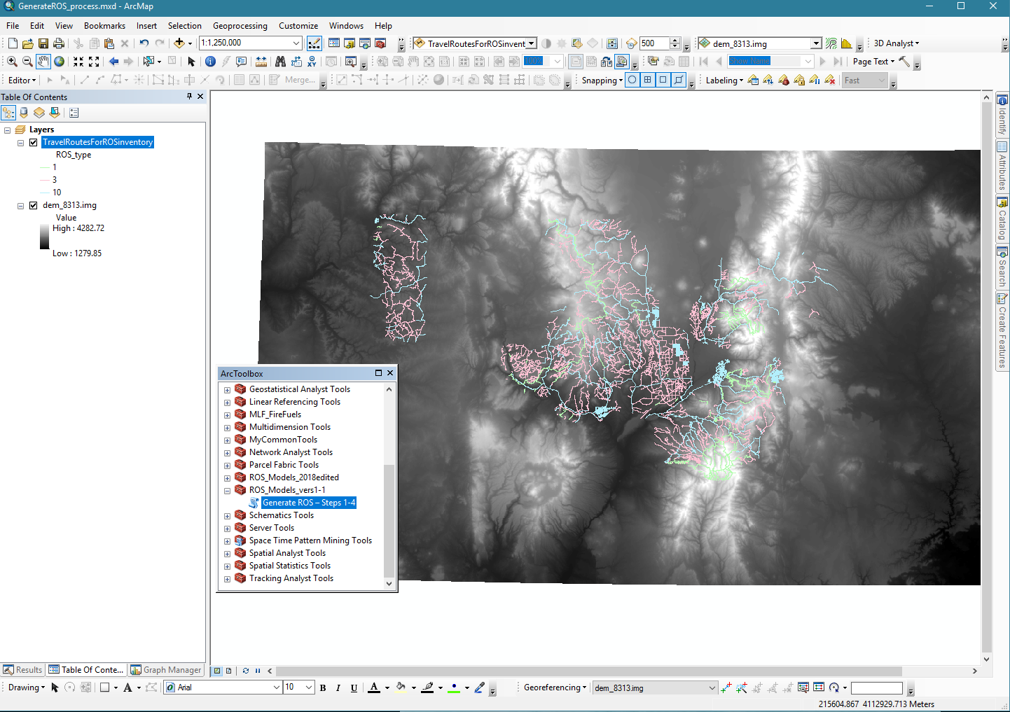
Figure 22. Screen capture of ArcMap Project for running ROS models

Step 1 – Prepare Input Datasets
In this step a 30 meter percent slope raster is created and the travel routes layer is converted to a 30 meter raster layer based on the ROS_type attribute. This script has four required inputs: 30 meter DEM, travel routes line layer with ROS_type attribute filled in from step 1 above, project area boundary polygon layer (Administrative Forest boundary for most units), and the name of an output geodatabase to store output GIS layers. The travel routes line feature class and the percent slope raster are clipped to the project area boundary to reduce the processing time in future steps. In the slope raster, cells with slope < 1 are set to 1. This is done to simplify the cost distance function. This script produces the following outputs:
- ProjectBdy_Buffer: project area buffered by 3 miles
- Project_Raster: 30m raster of buffered project area
- Slope_pct: 30m percent slope raster
- Route_StandardRoad : selection from transportation layer where ROS_type = 10 (standard motorized vehicle)
- Route_MotorizedRoutes: selection from transportation layer where ROS_type >= 3 (any motorized route)
- routeRaw: raster of transportation layer where motorized (ROS_type >= 3)
- Routebuff: buffer of routeRas by ½ mile
- DissBuff: dissolve of routebuff, gets rid of interior polygon breaks
- routeBuff_STND: buffer of standard motorized routes by ½ mile
- DissBuff_STND: dissolve of routeBuff_STND, gets rid of interior polygon breaks
- Routebuff_rst: raster of routeBuff
- BuffRST: null areas of Routebuff_rst set to 0
- routeGRD: null areas of routeRaw set to 0

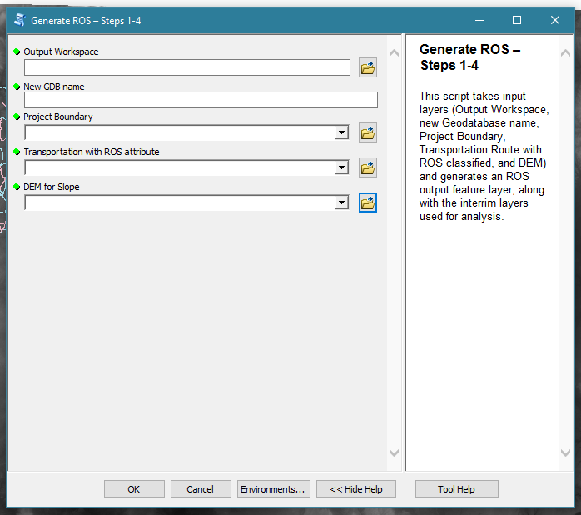
Figure 23. Screen capture of Starting Menu from ROS toolbox

Step 2 – Initial ROS Classification
This step has five main processes: A) create a cost distance raster for all motorized routes; B) create a cost distance raster for improved roads only; C) reclassify the cost rasters and identify potential “U”, “R”, and “P” areas; D) create a route density raster and reclassifies it; and E) combine the three rasters from steps A through D. This step uses the output geodatabase generated previously. From within that it uses the 30 meter route raster (routeGRD), the 30 meter slope raster (Slope_pct), the 30 meter ½ mile buffered route raster (BuffRST), the standard motorized vehicle routes (Route_MotorizedRoutes), and the project area raster (Project_Raster).
In process A, two rasters are created for cost distance mapping of all motorized routes: a source raster with all motorized route cells recoded to 1 and all other cells set to nodata, and a cost raster based on slope with source cells set to 0 and cells having slope < 10 set to 10. The two input rasters are then used in the cost distance function to produce a cost distance raster with values from 0 to 500,000+ (remember it is slope * 30 meters summed over many cells going away from motorized routes).
In process B the same two rasters are created as in step A except only improved roads are recoded to 1 and all other cells set to nodata, and other motorized cells have cost adjustment of (slope / 3). Step B also produces a cost distance raster with values from 0 to 500,000+.
During process C each of the cost distance rasters are reclassed. For all motorized routes, if the cost distance is <= 8000 the value is set to 3, or else if it is <= 60000 to 2, or else to 1. For the standard routes, if the cost distance is <= 8000 and the cell is within the ½ mile buffer raster then it is coded to 3, or else if the distance is <= 8000 and outside the ½ mile, the value is 2, if the cost distance is between 8000 and 60000 the value is also 2, otherwise it is set to 1. A selection of only value = 3 is then made from the reclass of the standard routes. This is the potential U, R, and RN areas. A process is run to remove areas from this collection where the criteria for RN, R, or U is met (cost distance <= 8000 and within the ½ mile buffer) but the area is not actually connected to a road. The result is a raster called RNArea with value = 1.
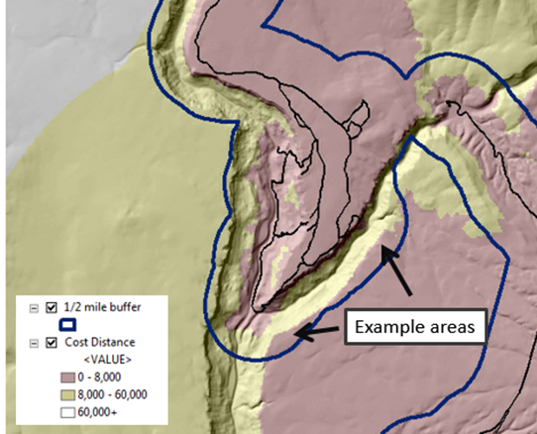
Figure 24. Example Area where the criteria for RN, R, or U is met (cost distance <= 8000 and within the ½ mile buffer) but the area is not actually connected to a road
Process D uses the Motorized Routes feature class and runs a Line Density analysis, resulting in a 30 meter raster of roads / square mile. This is then re-classified by density: 0 – 2.5 = 1; 2.5 – 8 = 2; 8+ = 3.
Process E combines the RNArea raster, the two cost distance rasters, and the road density raster into a recoded draft ROS classification raster called ROSclass. If the cell is in the RNArea raster, U, R, and RN are broken out by road density. Otherwise, if SPM, SPNM, and P are attributed based on combinations of cost distance. The ROSclass raster has values: 1 (U), 2 (R), 3 (RN), 4 (SPM), 5 (SPNM), and 6 (P). The
This script produces the following outputs:
- SingleOutput1: is RouteGrd cells where any value below 3 (non-motorized areas) is set to null.
- SingleOutput2: is RouteGrd cells where any value below 10 (standard motorized vehicle) is set to null.
- Cost1: is where RouteGrd cell values >= 3 (all motorized routes) are set to 0 cost, otherwise cost is set to Slope (if slope < 10, it is set to 10)
- Cost2: is where RouteGrd cell values > 3 (where 10 is standard routes) are set to 0 cost, other motorized route costs are set to Slope / 3, and non-motorized areas are set to Slope.
- CostDist1: is the costdistance from the SingleOutput1 (motorized routes) using Cost1 as the cost grid, across the project area
- CostDist2: is the costdistance from the SingleOutput2 (standard routes) using Cost2 as the cost grid, across the project area
- Reclass_cost1: is a reclassification of motorized route cost distances based on the reclassification breakdown above. If the cost is less than 8000, about ½ mile adjusted and reduced by steep slope, the value is 1, less than 60000, the value is 2, otherwise 3.
- Reclass_cost2: is a reclassification of standard route cost distances based on the reclassification breakdown above. If the cost is less than 8000, about ½ mile adjusted and reduced by steep slope, the value is 1, less than 60000, the value is 2, otherwise 3.
- CostRN: selects those cells from the standard route cost distance reclassification where the value = 3 (less than 8000 cost) and makes it into a separate raster, this is used to mask the explicit ½ mile buffer for RN classification.
- RGN_GRP: is the result of a region group analysis is run on the CostRN raster. This makes each contiguous group of cells within the ½ mile buffer that meet the RN or higher (R, U) criteria a uniquely numbered set. The field “RNArea” is added set to default 0 (to avoid issues with a “null” value).
- RGN_Combine: uses the Combine function to merge the region group raster with the SingleOutput2 (standard motorized vehicle) raster. An AddJoin joins the tables of the region group raster with the region group / SingleOutput2 combined raster based on the region group unique ID. Areas where RGN_GRP > 0 in the combine raster (areas where a region group coincides with a motorized route, as areas that do not coincide will not find a match in the combine grid) are selected and the RNArea value is calculated to 1.
- RN_Area: is where RNArea is selected into a separate raster (the areas that are within CostDist2 < 8000, within the ½ mile buffer, and touching a standard motorized vehicle route).
- RoadDens: is the result of a Line Density analysis, based on square miles.
- RoadDensClass: reclassifies RoadDens where density < 2.5 = 1; 2.5 – 8 = 2, and more than 8 = 3
- ROSclass: uses the following logic to assign a gridcode 1 – 6:
- If RNArea = 1 (true), then if Road Density is 1, ROS = 3(RN), if Road Density is 2, ROS = 2(R), otherwise it’s 1(U)
- Else If Reclass_Cost2 (standard routes) = 2 OR Reclass_Cost2 = 3 (area of low density, inside ½ mile buffer, but not connected to a Roaded Area), then if Reclass_Cost1 is 3, ROS = 4(SPM), otherwise ROS = 5(SPNM)
- Else If Reclass_Cost2 = 1, then if Reclass_Cost1 is 1, ROS = 6(P), otherwise ROS = 4(SPM)

Step 3 - look for contributing areas model
In this step the script converts the draft ROS classification into two polygon layers based on the draft ROS: higher developed areas (U, R, and RN); and lower areas (SPM, SPNM, and P). Donut holes are filled and areas less than 100 acres are eliminated in each grouping. This allows small inclusions to be found and removed, especially within the Roaded ½ mile buffer. Then the two layers are updated back together. Areas of preliminary P and SPNM are selected out and dissolved together and the attribute ‘acres2’ is added and calculated. Then SPNM and SPM areas are selected out and dissolved together, with ‘acres3’ being added and calculated. The two layers are then unioned back into the ROS layer. This prepares for reclassification based on contiguous area size and adjacency. This step uses the output raster ROSclass from step 2. This step produces a draft ROS classification polygon layer (rosCompareIdentity2).
- Draft1Poly: ROSclass converted to a polygon.
- RN_Up: ROS class {1,2,3}
- RN_Down: ROS class in {4,5,6}
- RN_union: Union RN_Up with itself to fill in holes resulting from selection
- RNgrp_un: union of selection from RN_union where polys are completely within DissBuff_STND from stage 2 and less than 100 acres.
- RN_10ac: RNgrp_un polygons less than 10 acres eliminated
- RN_100ac: RN_10ac polygons less than 100 acres eliminated
- NRN_10ac: RN_Down polygons less than 10 acres eliminated
- NRN_100ac: NRN_10ac polygons less than 100 acres eliminated
- ROS100: NRN_100ac updated with RN_100ac (RN_100ac overwrites coincident areas in NRN_100ac)
- rosPR_SPNM: areas where gridcode is 5 or 6, dissolved together and acres2 added and calculated
- rosSPM_SPNM: areas where gridcode is 4 or 5, dissolved together and acres3 added and calculated
- rosCompareIdentity1: Identity of ROS100 and rosPR_SPNM
- rosCompareIdentity2: Identity of rosCompareIdentity1 and rosSPM_SPNM

Step 4 - classify results
This step reclassifies undersize ROS settings (Primitive, Semi-Primitive Non-Motorized, etc.) into other ROS settings based on criteria supplied by the Region 1 recreation staff and 1986 ROS documentation (USDA Forest Service 1986) and the National ROS Inventory Mapping Protocol (USDA Forest Service 2018). The output polygon (ROS) is the final ROS classification for review by recreation staff. Remember to evaluate areas classified as Urban or Rural based on route density and consider overall level of development, evidence of humans criteria.
ROS class is determined based on the following criteria:
- When gridcode = 1 (U), the result is “U”. When the gridcode = 2(R), the result is “R”. When the gridcode = 3(RN), the result is “RN”.
- When the gridcode = 4(SPM), if the acres >= 2500, the result is “SPM”. If the acres are < 400, the “SPM” becomes “RN”. If the acres are < 2500, then if SPNM/SPM areas are >= 2500, result is “SPM”, and if smaller than 2500, the result is “RN”
- When the gridcode = 5(SPNM), if the acres >= 2500, the result is “SPNM”. If the acres are < 400, then if the SPM/SPNM areas are >= 2500, then the “SPNM” becomes “SPM”, or else it becomes “RN”. Otherwise, if the SPNM/P areas >= 5000, the value stays “SPNM”. If not, if the SPM/SPNM areas >= to 2500, the result is “SPM”, if less than 2500, it becomes “RN”.
- When the gridcode = 6(P), ), if the acres >= 5000, the result is “P”. If the acres are < 1000, then if the SPNM/P areas are >= 2500, then the “P” becomes “SPNM”, or else it becomes “RN”. Otherwise, if the SPNM/P areas>= 5000, the value stays “P”. If not, if the SPNM/P areas >= to 2500, the result is “SPNM”, if less than 2500, it becomes “RN”.
The following layers are created:
- rosAttributed: rosCompareIdentity2 ROS attributed based on size and adjacency, then dissolved on ROS
- ROS_RNfix: after dissolve, check for SPM areas less than 2500 which are changed to RN
- ROS_org: dissolve on ROS_RNfix
- ROS: final ROS attributed, clipped to Admin Boundary

Final step – Review by recreation subject matter experts including forest and district recreation staff
The draft ROS setting classifications need to be reviewed by recreation subject matter experts including forest and district recreation staff. The accuracy of all ROS setting classifications, in particular classification of Rural and Urban areas based on route density should be reviewed in addition to classifications in the context of social and managerial settings, wilderness criteria, and other subject matter expertise or professional judgement as described in the remaining steps of the National ROS Inventory Mapping Protocol.
Interim output of Step 3 (draft ROS classification polygon layer (rosCompareIdentity2)) should be reviewed to determine if all areas meeting size and adjacency criteria were carried forward or if there are some areas that may still meet the over-all ROS characteristics for P, SPNM or SPM. Document rationale for any areas not meeting size or adjacency criteria, but still mapped as P, SPNM or SPM based on subject matter expertise or professional judgement.
ROS model documentation states to evaluate areas classified as Urban or Rural. Some areas may meet Roaded Modified, which has been used as a subclass of Roaded Natural by several Forests and Regions for many years. These areas may also be Roaded Natural if other Rural and Urban criteria are not met and if a forest is not planning to use this subclass in the future. Some areas may also be mapped as a setting inconsistency (Step 10 of the National ROS Inventory Mapping Protocol) based on the physical setting.
Areas classified as Rural or Urban due to high road densities need review by recreation staff to determine if Roaded Natural, Rural or Urban was the most accurate ROS setting. If “high clearance vehicle/OHV” routes road density appeared to be affecting the Rural rating, the rating should be changed to Roaded Natural.
Once all adjustments identified by forest recreation staff are made, the ROS classification can be clipped with the planning unit boundary. If only National Forest ownership is wanted, the ROS classification can be intersected with the basic surface ownership layer (from forest corporate SDE database) and only polygons in USDA Forest Service ownership have the WINTER_ROS_CODE attribute filled in (i.e., removing ROS classification from lands in other ownerships).

