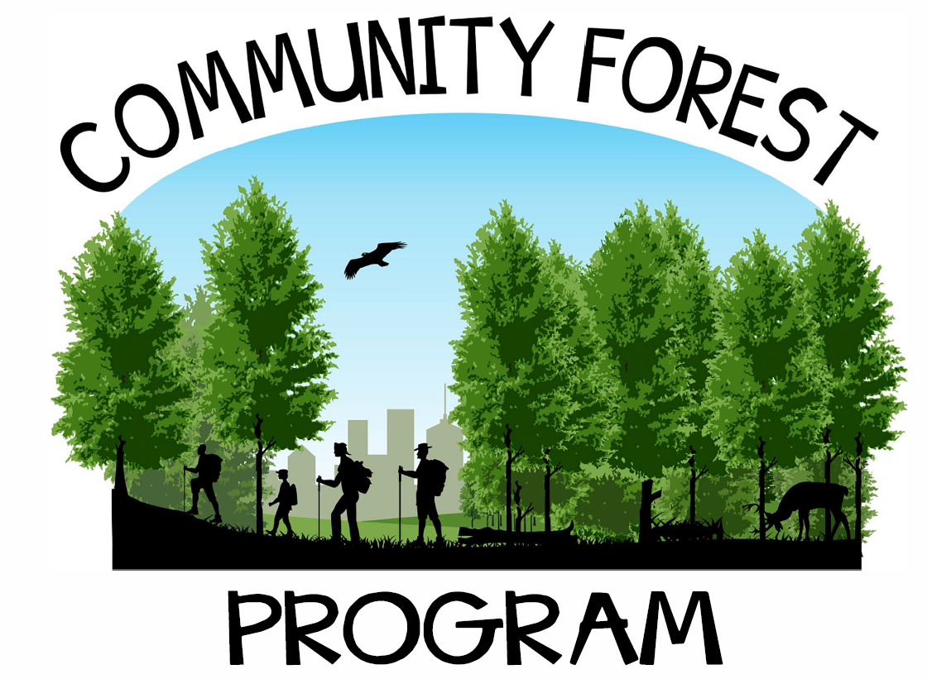

An Invitation: Establishing a Community Forest with the U.S. Forest Service
The 2008 Farm Bill (Public Law 110-234) established the Community Forest and Open Space Conservation Program to provide financial resources to tribal entities, local governments, and conservation non-profit organizations to acquire and establish community forests through fee simple acquisitions. This document provides detailed information and resources to potential program applicants or grant recipients to participate effectively with the Community Forest and Open Space Conservation Program. Successful participation is multi-faceted and will require strong ongoing coordination with U.S. Forest Service personnel beyond the pages of this document.
CHAPTER A

Section 1 Background and Purpose
Appendices A. Authorizing Language
B. Revised Final Rule
Section 2 Eligibility: Entities, Land, Expenses

Section 3 Application Process Overview
Appendices C. 2024 Request for Applications
D. Panel Scoring Guidance
E. Application Guidance
F. Map Guidance
CHAPTER B

Section 4 Award Process: Federal Grant Management
Appendices G. Sample Civil Rights Compliance
H. Sample Annual Reporting Form
I. Sample SF425 Annual Financial Accomplishment Report Form
J. SF270 Advance Reimbursement Instructions
K. Sample Grant Award Package Section 5 Acquisition Management Appendices L. Appraisal Pre-Work Discussion
- Sample Appraisal Instructions
- Sample Scope of Work for CFP Review Appraisal Services
- Sample Technical Appraisal Review Report
- Sample Amicable Agreement
- 26 CFR 1.170A-14 sec. g4 Mineral Determination
- Sample Remoteness Determination acceptable to the Community Forest Program
- Sample Notice of Grant Requirement Language

Section 6 Post-acquisition Management
Appendices T. GIS Data Standard
- Required Components of a Community Forest Plan
- Sample CFP Close Out Report
- Landowner 5-year Questionnaire

Chapter A

1 Background and Purpose
Authorization
Establishment of the Community Forest and Open Space Conservation Program (Community Forest Program or CFP) was authorized by Section 8003 of the Food, Conservation, and Energy Act of 2008 (Public Law 110- 234); which amends the Cooperative Forestry Assistance Act of 1978. The authorizing language is available as Appendix A.
Establishment
On April 2nd, 2021, the revised final rule for the Community Forest Program was published in the Federal Register. The final rule revision allows grant recipients to convey or encumber an interest in community forest land to other eligible entities with approval of the Forest Service, clarify program-specific terms, and implements the Office of Management and Budget’s Uniform Administrative Requirements, Cost Principles, and Audit Requirements for Federal Awards (2 CFR parts 200 and 400). The revised final rule also streamlines the application process by no longer requiring the SF424s and a draft Community Forest Plan be submitted with the application. The final rule published in the Federal Register is available as Appendix B.
Community Forest Program Purposes
In establishing the Community Forest Program, Congress cited rapid development of private forest lands across the nation, declining public access supporting outdoor recreational opportunities, rising obesity rates linked to decreased outdoor recreation, the essential role of forest land in protecting public water supplies, importance of forest management demonstration opportunities, financial and community benefits derived from local government management of forest lands for timber and other products, and a lack of financial resources available to local governments for purchasing important private forest land available for sale. To address these findings, CFP established authority for the Secretary of Agriculture to award grants for acquiring private forest land threatened by conversion to non-forest uses in order to provide communities with:
•Economic benefits
•Environmental benefits
•Educational benefits
•Forest Management Demonstration benefits
•Recreational benefits


Appendix A. Community Forest and Open Space Program Authorizing Language
SEC. 8003. COMMUNITY FOREST AND OPEN SPACE CONSERVATION PROGRAM.
- FINDINGS.—Congress finds that—
  - the Forest Service projects that, by calendar year 2030, approximately 44,000,000 acres of privately-owned forest land will be developed throughout the United States;
  - public access to parcels of privately-owned forest land for outdoor recreational activities, including hunting, fishing, and trapping, has declined and, as a result, participation in those activities has also declined in cases in which public access is not secured;
  - rising rates of obesity and other public health problems relating to the inactivity of the citizens of the United States have been shown to be ameliorated by improving public access to safe and attractive areas for outdoor recreation;
  - in rapidly-growing communities of all sizes throughout the United States, remaining parcels of forest land play an essential role in protecting public water supplies;
  - forest parcels owned by local governmental entities and nonprofit organizations are providing important demonstration sites for private landowners to learn forest management techniques;
  - throughout the United States, communities of diverse types and sizes are deriving significant financial and community benefits from managing forest land owned by local governmental entities for timber and other forest products; and
  - there is an urgent need for local governmental entities to be able to leverage financial resources in order to purchase important parcels of privately-owned forest land as the parcels are offered for sale.
- COMMUNITY FOREST AND OPEN SPACE CONSERVATION PROGRAM.—The Cooperative
Forestry Assistance Act of 1978 is amended by inserting after section 7 (16 U.S.C. 2103c) the following new section:
SEC. 7A. COMMUNITY FOREST AND OPEN SPACE CONSERVATION PROGRAM.
- DEFINITIONS.—In this section:
- ELIGIBLE ENTITY.—The term ‘eligible entity’ means a local governmental entity, Indian tribe, or nonprofit organization that owns or acquires a parcel under the program.
- INDIAN TRIBE.—The term ‘Indian tribe’ has the meaning given the term in section 4 of the Indian Self-Determination and Education Assistance Act (25 U.S.C. 450b).
- LOCAL GOVERNMENTAL ENTITY.—The term ‘local governmental entity’ includes any municipal government, county government, or other local government body with jurisdiction over local land use decisions.
- NONPROFIT ORGANIZATION.—The term ‘nonprofit organization’ means any organization that—

Appendix A. Community Forest and Open Space Program Authorizing Language
    - is described in section 170(h)(3) of the Internal Revenue Code of 1986; and
    - operates in accordance with 1 or more of the purposes specified in section 170(h)(4)(A) of that Code.
  - PROGRAM.—The term ‘Program’ means the community forest and open space conservation program established under subsection (b).
  - SECRETARY.—The term ‘Secretary’ means the Secretary of Agriculture, acting through the Chief of the Forest Service.
- ESTABLISHMENT.—The Secretary shall establish a program, to be known as the ‘community forest and open space conservation program’.
- GRANT PROGRAM.—
  - IN GENERAL.—The Secretary may award grants to eligible entities to acquire private forest land, to be owned in fee simple, that—
    - are threatened by conversion to nonforest uses; and
    - provide public benefits to communities, including—
      - economic benefits through sustainable forest management;
      - environmental benefits, including clean water and wildlife habitat;
      - benefits from forest-based educational programs, including vocational education programs in forestry;
      - benefits from serving as models of effective forest stewardship for private landowners; and
      - recreational benefits, including hunting and fishing.
  - FEDERAL COST SHARE.—An eligible entity may receive a grant under the Program in an amount equal to not more than 50 percent of the cost of acquiring 1 or more parcels, as determined by the Secretary.
  - NON-FEDERAL SHARE.—As a condition of receipt of the grant, an eligible entity that receives a grant under the Program shall provide, in cash, donation, or in kind, a non- Federal matching share in an amount that is at least equal to the amount of the grant received.
  - APPRAISAL OF PARCELS.—To determine the non-Federal share of the cost of a parcel of privately-owned forest land under paragraph (2), an eligible entity shall require appraisals of the land that comply with the Uniform Appraisal Standards for Federal Land Acquisitions developed by the Interagency Land Acquisition Conference.
  - APPLICATION.—An eligible entity that seeks to receive a grant under the Program shall submit to the State forester or equivalent official (or in the case of an Indian tribe, an equivalent official of the Indian tribe) an application that includes—

Appendix A. Community Forest and Open Space Program Authorizing Language
    - a description of the land to be acquired;
    - a forest plan that provides—
      - a description of community benefits to be achieved from the acquisition of the private forest land; and
      - an explanation of the manner in which any private forest land to be acquired using funds from the grant will be managed; and
    - such other relevant information as the Secretary may require.
  - EFFECT ON TRUST LAND.—
    - INELIGIBILITY.—The Secretary shall not provide a grant under the Program for any project on land held in trust by the United States (including Indian reservations and allotment land).
    - ACQUIRED LAND.—No land acquired using a grant provided under the Program shall be converted to land held in trust by the United States on behalf of any Indian tribe.
  - APPLICATIONS TO SECRETARY.—The State forester or equivalent official (or in the case of an Indian tribe, an equivalent official of the Indian tribe) shall submit to the Secretary a list that includes a description of each project submitted by an eligible entity at such times and in such form as the Secretary shall prescribe.
- DUTIES OF ELIGIBLE ENTITY.—An eligible entity shall provide public access to, and manage, forest land acquired with a grant under this section in a manner that is consistent with the purposes for which the land was acquired under the Program.
- PROHIBITED USES.—
- IN GENERAL.—Subject to paragraphs (2) and (3), an eligible entity that acquires a parcel under the Program shall not sell the parcel or convert the parcel to nonforest use.
- REIMBURSEMENT OF FUNDS.—An eligible entity that sells or converts to nonforest use a parcel acquired under the Program shall pay to the Federal Government an amount equal to the greater of the current sale price, or current appraised value, of the parcel.
- LOSS OF ELIGIBILITY.—An eligible entity that sells or converts a parcel acquired under the Program shall not be eligible for additional grants under the Program.
- STATE ADMINISTRATION AND TECHNICAL ASSISTANCE.—The Secretary may allocate not more than 10 percent of all funds made available to carry out the Program for each fiscal year to State foresters or equivalent officials (including equivalent officials of Indian tribes) for program administration and technical assistance.
- AUTHORIZATION OF APPROPRIATIONS.—There are authorized to be appropriated such sums as are necessary to carry out this section.’’.


Appendix B. Community Forest Program Revised Final Rule Published in Federal Register, April 2nd, 2021

Federal Register

Vol. 86, No. 62 / Friday, April 2, 2021 / Rules and Regulations

17302-17311

17302 Federal Register / Vol. 86, No. 62 / Friday, April 2, 2021 / Rules and Regulations

direct final rule or publish a notice of proposed rulemaking, providing an opportunity for public comment.
- Regulatory Flexibility Act
The Regulatory Flexibility Act (RFA; 5 U.S.C. 601–612) generally requires agencies to review proposed and final rules for their potential economic impact on small entities, including small businesses, and prepare regulatory flexibility analyses. 5 U.S.C. 603, 604.
The RFA applies to any rule that is subject to notice and comment procedures under section 553 of the APA. Id. As discussed in section VI. Direct Final Rule Process of this preamble, the Commission has determined that notice and the opportunity to comment are unnecessary for this rule. Therefore, the RFA does not apply. The Commission also notes the limited nature of this document, which merely updates the incorporation by reference to reflect the mandatory CPSC standard that takes effect under section 104 of the CPSIA.
- Paperwork Reduction Act
The current mandatory standard for highchairs includes requirements for marking, labeling, and instructional literature that constitute a ‘‘collection of information,’’ as defined in the Paperwork Reduction Act (PRA; 44 U.S.C. 3501–3521). The revised mandatory standard for highchairs does not alter these requirements. The Commission took the steps required by the PRA for information collections when it adopted 16 CFR part 1231, including obtaining approval and a control number. Because the information collection is unchanged, the revision does not affect the information collection requirements or approval related to the standard.
- Environmental Considerations
The Commission’s regulations provide a categorical exclusion for the Commission’s rules from any requirement to prepare an environmental assessment or an environmental impact statement where they ‘‘have little or no potential for affecting the human environment.’’ 16 CFR 1021.5(c)(2). This rule falls within the categorical exclusion, so no environmental assessment or environmental impact statement is required.
- Preemption
Section 26(a) of the CPSA provides that where a consumer product safety standard is in effect and applies to a product, no state or political subdivision of a state may either
establish or continue in effect a requirement dealing with the same risk of injury unless the state requirement is identical to the Federal standard. 15
U.S.C. 2075(a). Section 26(c) of the CPSA also provides that states or political subdivisions of states may apply to CPSC for an exemption from this preemption under certain circumstances. Section 104(b) of the CPSIA deems rules issued under that provision ‘‘consumer product safety standards.’’ Therefore, once a rule issued under section 104 of the CPSIA takes effect, it will preempt in accordance with section 26(a) of the CPSA.
- Effective Date
Under the procedure set forth in section 104(b)(4)(B) of the CPSIA, when a voluntary standards organization revises a standard that the Commission adopted as a mandatory standard, the revision becomes the CPSC standard within 180 days of notification to the Commission, unless the Commission determines that the revision does not improve the safety of the product, or the Commission sets a later date in the Federal Register. 15 U.S.C.
2056a(b)(4)(B). The Commission is
taking neither of those actions with respect to the revised standard for highchairs. Therefore, ASTM F404–20 automatically will take effect as the new mandatory standard for highchairs on July 3, 2021, 180 days after the Commission received notice of the revision on January 4, 2021. As a direct final rule, unless the Commission receives a significant adverse comment within 30 days of this document, the rule will become effective on July 3, 2021.
- Congressional Review Act
The Congressional Review Act (CRA; 5 U.S.C. 801–808) states that before a rule may take effect, the agency issuing the rule must submit the rule, and certain related information, to each House of Congress and the Comptroller General. 5 U.S.C. 801(a)(1). The CRA
submission must indicate whether the rule is a ‘‘major rule.’’ The CRA states that the Office of Information and Regulatory Affairs (OIRA) determines whether a rule qualifies as a ‘‘major rule.’’
Pursuant to the CRA, this rule does not qualify as a ‘‘major rule,’’ as defined in 5 U.S.C. 804(2). To comply with the CRA, CPSC will submit the required information to each House of Congress and the Comptroller General.
List of Subjects in 16 CFR Part 1231
Consumer protection, Imports, Incorporation by reference, Imports, Infants and children, Law enforcement, Safety, Toys.
For the reasons discussed in the preamble, the Commission amends 16 CFR chapter II as follows:
PART 1231—SAFETY STANDARD FOR HIGH CHAIRS
- 1. Revise the authority citation for part 1231 to read as follows:
Authority: Sec. 104, Pub. L. 110–314, 122
Stat. 3016 (15 U.S.C. 2056a); Sec 3, Pub. L.
112–28, 125 Stat. 273.
- 2. Revise § 1231.2 to read as follows:
§ 1231.2 Requirements for High Chairs.
Each high chair shall comply with all applicable provisions of ASTM F404– 20, Standard Consumer Safety Specification for High Chairs, approved on October 1, 2020. The Director of the Federal Register approves this incorporation by reference in accordance with 5 U.S.C. 552(a) and 1 CFR part 51. You may obtain a copy from ASTM International, 100 Barr Harbor Drive, P.O. Box C700, West Conshohocken, PA 19428–2959; phone: (610) 832–9585; ASTM home page A read- only copy of the standard is available for viewing on the ASTM website ASTM Reading Room You may inspect a copy at the Division of the Secretariat,
U.S. Consumer Product Safety
Commission, Room 820, 4330 East West Highway, Bethesda, MD 20814, telephone (301) 504–7479, email: cpsc- os@cpsc.gov, or at the National Archives and Records Administration (NARA).
For information on the availability of this material at NARA, email fedreg.legal@nara.gov, or go to: Office of the Federal Register, IBR in regulations.
Alberta E. Mills,
Secretary, Consumer Product Safety Commission.
[FR Doc. 2021–06419 Filed 4–1–21; 8:45 am]
BILLING CODE 6355–01–P
DEPARTMENT OF AGRICULTURE
Forest Service
36 CFR Part 230
RIN 0596–AD23
Community Forest Program
AGENCY: Forest Service, U.S. Department of Agriculture (USDA

17303 Federal Register / Vol. 86, No. 62 / Friday, April 2, 2021 / Rules and Regulations

ACTION: Final rule.
SUMMARY: The United States Department of Agriculture has revised the final rule for the Community Forest and Open Space Program (Community Forest Program). The revisions included in this final rule will allow grant recipients to convey conservation easements to funding entities and, in some circumstances when consistent with the program’s purposes, convey community forest land to other eligible entities. The final rule also clarifies the definitions of program-specific terms, streamlines the application process, and implements the Office of Management and Budgets (OMB)’s Uniform Administrative Requirements, Cost Principles, and Audit Requirements for Federal Awards.
DATES: This final rule is effective May 3, 2021.
ADDRESSES: For more information, including a copy of the final rule, refer to the World Wide Web/internet at: Forest Service, Community Forest Program.
More information may be obtained by written request to the Director, Cooperative Forestry Staff, Forest Service, USDA, Mail Stop 1123, 1400 Independence Avenue SW, Washington, DC 20250–1123.
FOR FURTHER INFORMATION CONTACT:
Scott Stewart, Program Manager, State and Private Forestry, Cooperative Forestry Staff, (202) 205–1618.
Individuals who use telecommunication devices for the deaf (TDD) may call the Federal Information Relay Service (FIRS) at (800) 877–8339 between 8:00
a.m. and 8:00 p.m., Eastern Standard Time, Monday through Friday.

SUPPLEMENTARY INFORMATION:

I. Background
The Community Forest Program is authorized by Section 8003 of the Food, Conservation, and Energy Act of 2008 (Pub. L. 110–246; 122 Stat. 2043). On
October 20, 2011, the Forest Service
issued regulations (36 CFR part 230, subpart A) implementing the program. After selecting and awarding the first round of grants under the current 36 CFR part 230, subpart A, the Agency identified some inconsistencies and inefficiencies in the regulation that hinders the Agency’s ability to efficiently and effectively implement the program.
One of the critical inconsistencies can be found in § 230.8, which specifies the acquisition requirements for this program. Section 230.8(a)(5) lists the documents and statements that must be recorded with the deed as part of the Notice of Grant Requirement. It states
that, ‘‘. . . the grant recipient will not convey or encumber the interest in real property, in whole or in part, to another party . . .’’. This language is more restrictive than necessary and inconsistent with the grant assurances (OPM Form 424D), which allows a grant recipient to convey or encumber the interest in real property with prior approval from the granting Agency.
Furthermore, the restrictive language prevents eligible entities from using funding mechanisms that require establishment of a conservation easement, even though this arrangement could be compatible with Community Forest Program requirements. This provision also prevents the transfer of ownership interest in a Community Forest to another eligible entity if the original owner becomes unable to hold or maintain the parcel.
Additionally, the Agency seeks to
reduce the burden of paperwork and information collections on applicants. Currently, the Agency requests an eight- page application, a map of the parcel in question, all forms required for issuance of a Federal grant, and a draft community forest plan. The current application process is overly burdensome, and all elements of the current process are not necessary to ensure the selection of high-quality community forest projects that meet the intent of the program.
The Agency also seeks to clarify
definitions and refine provisions regarding the use of technical assistance funds. The language clarifies how technical assistance should be determined and requested. Some of the definitions in the current regulation are unclear and confuse the intent of the program. The Agency seeks to provide clarification and reduce the amount of confusion caused by the unclear definitions.
Lastly, the Agency is eliminating the
separate cost share and grant requirements for non-profit organizations, Tribal governments, and local governments in (§§ 230.6(c) and 230.7(a)(2)). The Agency will follow the guidance outlined in the OMB Uniform Administrative Requirements, Cost Principles, and Audit Requirements for Federal Assistances (2 CFR part 400).

Need for the Final Rule
The Forest Service is revising this regulation to correct inconsistencies and inefficiencies, to clarify confusing language, reduce the paperwork collection burden for applicants, and to update grant requirements to comply with grant regulations and OMB circulars. These changes will help ensure that the regulations align with
the intent and purposes of the authorizing legislation.

Project Compliance With the National Environmental Policy Act
Project grants are subject to the National Environmental Policy Act (NEPA) and must comply with the Agency’s NEPA implementing procedures as described in 36 CFR part 220, as well as the Council on Environmental Quality’s NEPA procedures at 40 CFR parts 1500–1508. Community Forest Program grants are used to transfer title and ownership of private lands to third parties and will not fund any ground-disturbing activities. The Forest Service has concluded that Community Forest Program grants fall under the categorical exclusion provided in the Forest Service’s NEPA procedures for ‘‘acquisition of land or interest in land’’ 36 CFR 220.6(d)(6); 73 FR 43084 (July
24, 2008). As a result, Community Forest Program project grants are excluded from documentation in an environmental assessment or impact statement.

Uniform Relocation Assistance and Real Property Acquisition for Federal and Federally-Assisted Programs
The Uniform Relocation Assistance and Real Property Acquisition Policy Act of 1970 (‘‘Uniform Act’’) (42 U.S.C. 4601, et. seq.) provides guidance and procedures for the acquisition of real property by the Federal Government, including relocation benefits to displaced persons. Department of Transportation regulations implementing the Uniform Act (49 CFR part 24) have been adopted by the Department of Agriculture (7 CFR part 21). However, the Community Forest Program is deemed exempt from the Uniform Act because it meets the exemption criteria stated at 49 CFR 24.101(b)(1).

Federal Appraisal Standards
Section 7A(c)(4) of the Cooperative Forestry Assistance Act (16 U.S.C. 2103d(c)(4)), requires that land acquired under Community Forest Program be appraised in accordance with the Uniform Appraisal Standards for Federal Land Acquisitions (Federal Appraisal Standards) in order to determine the non-Federal cost share of a parcel of privately-owned forest land. The Federal Appraisal Standards are contained in a readily available public document, which is well known to professional appraisers (see: Uniform Appraisal Standards PDF.). A grant recipient is responsible for assuring that the appraisal of the

17304 Federal Register / Vol. 86, No. 62 / Friday, April 2, 2021 / Rules and Regulations

Community Forest Program tract is done in conformance with the Federal Appraisal Standards. The Federal Appraisal Standards shall be used to determine reimbursement for non- Federal cost share. However, separate tracts donated for the purpose of providing the non-Federal cost share may be appraised using the Uniform Standards of Professional Appraisal Practice (USPAP) or the IRS regulations for a donation in land. The Forest Service may be available to assist applicants with the appraisal and associated appraisal review and will conduct spot checks to assure compliance with Federal Appraisal Standards.
- Formal Government-to-Government Consultation With Federally Recognized Tribes
Indian Tribes were invited to government-to-government consultation (consultation) on the CFP proposed rule prior to review and comment by the general public. The consultation process was initiated September 29, 2015. The Deputy Chief for State and Private Forestry sent a letter to the Forest Service regional leadership requesting that they initiate consultation with federally recognized Tribes. Each unit then initiated consultation with Indian Tribes, providing them with information about the CFP, the proposed rule, how to request government-to government consultation, and where to send comments. Consultation concluded September 30, 2016. Forest Service incorporated the input received through consultation and the public comment process into the development of this final rule.
Indian Tribal Input and Agency Responses
36 CFR 230.2—Definitions
Comment: A definition of cultural resources should be included in the regulation. A simple reference to ‘‘cultural resources’’ will have varying meanings to the different eligible entities involved with a Community Forest Plan. If a definition is not included, a reference to consideration of Traditional Cultural Places/Properties (TCPs) should be provided. TCPs play an important role in Tribal community traditions, beliefs and activities and thus need to be protected.
Response: The final rule includes additional language to clarify the meaning of cultural resources to include tangible and intangible resources.
Eligible Lands
Comment: Section 230.2 Definition: Expand the definition of item 2 to expressly refer to ‘‘Indian Trust Assets’’ (ITAs) and ‘‘non-trust Indian lands’’.
ITAs are defined in the implementation regulations for Public Law 93–638 as an interest in land, water, minerals, funds or other assets or property which is held by the United States in trust for an Indian Tribe or an individual Indian or which is held by an Indian Tribe or Indian subject to a restriction on alienation impacted by the United States (25 CFR 900.6). A simple reference to ‘‘lands held in trust by the United States’’ will have varying meanings to the different eligible entities involved in the development of a proposed Community Forest Plan.
Response: The final rule expressly refers to Indian reservations and allotment land when defining eligible and non-eligible lands. Since ITAs are defined as ‘‘. . . an interest in land, water, minerals, funds or other assets or property . . .’’ this would not be applicable in determining if the land was eligible or non-eligible for the Community Forest Program; no change made to final rule.
Comment: Provide clarity that it is the governing body of the Indian Tribe that designates or authorizes an individual to represent the Tribe.
Response: Clarifying language was added to the definition for Equivalent officials of Indian Tribes in the final rule.
- Summary of Comments and Agency Responses to Public Comments
On December 8, 2015, the Forest Service published in the Federal Register (80 FR 76251) a proposed rule revision to allow Community Forest and Open Space Program grant recipients to issue conservation easements to funding entities, convey or encumber an interest in community forest land to other eligible entities, clarify program-specific terms, streamline the application process, and implement the Office of Management and Budget’s Uniform Administrative Requirements, Cost Principles, and Audit Requirements for Federal Awards (2 CFR parts 200 and 400).
The Forest Service solicited comments on the proposed rule for 90 days ending March 7, 2016. The Forest Service received comments from ten individuals contributing 32 total comments, overwhelmingly in favor of the rule revision, with a few suggestions for clarification and one party opposed with comments not germane to the rule. One response was from an individual
member of the public, two respondents represented local municipalities, two responses were from regional coalitions, four respondents were regional representatives of national non-profit organizations, and one response was received from a Forest Service regional program manager. Responses from Indian Tribes, the agencies that work with them and government-to- government consultations were also received and analyzed separately (see Government-to-Government Consultation with Indian Tribes above and Consultation and Coordination with Indian Tribes in Regulatory Certification).
Comments on the Proposed Rule Revision 36 CFR Part 230, Subpart A
General Comments
Comments in favor: Two commenters commended the Agency on its flexibility in allowing conveyances of land holdings should the need arise.
§ 230.2: Definitions Comments in favor: Three
commenters commended the Forest Service for including the addition of ‘‘cultural resources’’ to the definition of ‘‘environmental benefits.’’ It helps promote the range of resource values that CFP is helping to protect.
Comments suggesting modifications: Two commenters requested that the Forest Service clarify the range of permissible commercial activities on a community forest. As currently read, the exception for ‘‘compatible commercial uses’’ is not specific beyond its description as ‘‘limited.’’
Agency Response: The rule is not intended to be unnecessarily prescriptive. Future commercial uses could arise that may be reasonable, and the language as written allows for a future dialogue between a grant recipient and the Forest Service rather than excluding them prescriptively without deliberation. The Agency determined that the language as written provides reasonable guidelines for a discussion of compatible uses, so long as those uses do not conflict with the community values provided by the community forest.
§ 230.4 Application Requirements Comments in favor: Nine commenters
expressed favor that the revised rule would allow for the draft plan to be submitted only after a project has been selected and a grant awarded. This is a common-sense change that will reduce the administrative burden for CFP applicants, and will not reduce the number of high-quality project applications.

17305 Federal Register / Vol. 86, No. 62 / Friday, April 2, 2021 / Rules and Regulations

§ 230.6 Project Costs and Cost Share Requirements
Comments suggesting modifications: Requesting that the Agency provide clarity with respect to the prohibition on the use of ‘‘other Federal funds unless specifically authorized by Federal statute.’’ To the extent practicable, the Agency should clarify that the Gulf Coast Restoration Trust Fund and the Department of Defense Readiness and Environmental Protection Program are eligible as non- Federal cost share for the purposes of the Community Forest Program.
Agency Response: If law, or regulations promulgated to implement a law, indicate that Federal funds may be treated as non-Federal, the Community Forest Program will adhere to that direction. The Agency is not in a position to make explicit determinations on the nature of all possible funding mechanisms contributed for cost-share. Therefore, leaving the language in its current form allows program managers to follow existing law and policy while retaining the opportunity to evaluate emerging situations and opportunities.
§ 230.8 Acquisition Requirements Comments in favor: Seven
commenters in favor of the proposed
revision would amend existing regulations to allow encumbrances on the land, as long as they are not contrary to the purposes of the program. This is
a change from the current language, which states that grant recipients may not ‘‘encumber the interest in real property, in whole or in part, to another party.’’ This revision is a common-sense change that will make it easier to develop partnerships in acquiring and managing community forests and ultimately broaden participation in the program.
Comments suggesting modifications: The Forest Service should require a new Notice of Grant Requirement be recorded if an eligible transfer to another entity occurs.
Agency Response: The Forest Service agrees with this suggestion and has expanded upon the language to ensure that any new entity receiving the community forest land holdings will subsume all responsibilities required of the original grant recipient. The language has also been modified to reflect the need to document land conveyances through a new Notice of Grant Requirement.
§ 230.9 Ownership and Use Requirements
Comments suggesting modifications:
Four commenters suggested the revised
rule states that a community forest plan be submitted within 120 days of the acquisition and periodically updated to guide the management and use of the forest. We request that the deadline for submitting a plan be extended past the 120-day limit. We expect that in many cases, the 120 day deadline will be more than enough to gather feedback to draft a community forest plan. However, in such instances where more input is needed, an extension to the deadline would be useful in order to ensure meaningful public input.
Agency Response: The Agency maintains that the 120-day deadline should remain in order to encourage
timely deliberation and efficient communication between stakeholders. In order to provide appropriate flexibility to address unforeseen circumstances, the Forest Service has modified the rule to ensure that regional managers have the discretion to extend the planning process for an additional 60 days if there is sufficient justification for why the deadline cannot be met.
Comment: The Forest Service should provide greater clarification regarding the ‘‘periodic updating’’ of the plan. It should be clearer how often the plan should be updated, and what elements of the plan need updating.
Agency Response: The Agency concurs with this suggestion, and has modified the language to require periodic updating of the community forest plan in the event of new threats of encroachment, significant changes to forest health threats requiring alterations in proposed treatments, or when a significant lapse in time has occurred since the initial plan was created.
Comment: ‘‘Grant recipients’’ should be replaced with ‘‘Community Forest Holders/Owners’’. If an allowed transfer
to another eligible entity occurs, the owner of the community forest is no longer the Grant Recipient. This could make the initial grantee ineligible for future funding opportunities through the program.
Agency Response: The Agency has
modified the language to clarify that if lands are conveyed voluntarily by a recipient who had adhered to the stipulations of both the grant agreement and the Agency instructions for conveyance as outlined in the rule and grant agreement, then that original grant recipient would be eligible for future program funding.
§ 230.10 Technical Assistance Funds Comments suggesting modifications:
As written, the rule requires State Foresters or equivalent officials of Indian Tribes to indicate the financial
need and purpose of technical assistance in their Community Forest application. Because the application comes from the eligible entity and not the state, the commenter suggests amending the language to assert that financial need and purpose should be indicated ‘‘in the project budget and formally requested by the State when forwarding the applications received by the applicants to the Forest Service.’’
Agency Response: The Agency emphasizes coordination between the grant applicant and the State or Tribal representative to ensure that technical assistance needs are already adequately characterized in the budget. Section 230.3 clearly requires that the State Forester or equivalent official must clarify technical assistance funding needs for any services rendered upon submission of the application to the Forest Service.
Regulatory Certifications Regulatory Planning and Review
This final rule has been reviewed under USDA procedures and Executive Order 12866. The Office of Management and Budget (OMB) has determined that this rule is non-significant for purposes of Executive Order 12866.
This final rule does not regulate the private use of land or the conduct of business. It is a grant program for local governments, Tribal governments, and qualified nonprofit organizations for purposes of acquiring land for resource conservation and open space preservation. By providing funding to eligible entities for land acquisition, the Federal Government will promote the non-monetary benefits of sustainable forest management. These benefits include: Improved air and water quality, wildlife and fish habitat, forest-based educational programs including vocational education programs in forestry, replicable models of effective forest stewardship for private landowners, open space preservation, carbon sequestration, and enhanced recreational opportunities including hunting and fishing.
Proper Consideration of Small Entities
This final rule has been considered in light of Executive Order 13272 regarding property considerations of small entities and the Small Business Regulatory Enforcement Fairness Act of 1996.
Voluntary participation in the Community Forest Program does not impose significant direct costs on small entities. This final rule imposes no additional requirements on the affected public. Entities most likely affected by this final rule are the local governments,

17306 Federal Register / Vol. 86, No. 62 / Friday, April 2, 2021 / Rules and Regulations

qualified nonprofit organizations, and Tribal governments eligible to receive a grant through the Community Forest Program. The minimum requirements imposed on small entities by this final rule are necessary to protect the public interest and should be within the capabilities of small entities to perform, and should not be administratively burdensome or costly to meet. The final rule would not materially alter the budgetary impact of entitlements, user fees, loan programs, or the rights and obligations of program participants. It does not compel the expenditure of
$100 million or more by any State, local or Indian Tribal government, or anyone in the private sector. Under these circumstances, the Forest Service has determined that this action would not have a significant economic impact on a substantial number of small entities.

Unfunded Mandates
Pursuant to Title II of the Unfunded Mandates Reform Act of 1995 (2 U.S.C. 1531–1538), which the President signed into law on March 22, 1995, the Agency has assessed the effects of this rule on State, local, and Indian Tribal governments and the private sector.
This final rule does not compel the expenditure of $100 million or more by any State, local or Indian Tribal governments, or anyone in the private sector. Therefore, a statement under section 202 of that Act is not required.
Federalism
The Forest Service has considered this final rule under the requirements of Executive Order 13132, Federalism, and Executive Order 12875, Government Partnerships. The Forest Service has determined that the rule conforms to the federalism principles set out in these Executive orders. The rule would not impose any compliance costs on the States other than those imposed by statute, and would not have substantial direct effects on the States, on the relationship between the Federal Government and the States, or on the distribution of power and responsibilities among the various levels of government.
Controlling Paperwork Burdens on the Public
In accordance with the Paperwork Reduction Act of 1995 [44 U.S.C. Chapter 35], the Forest Service requested and received an approval of an extension without change of a currently approved information collection.
Title: Community Forest and Open Space Conservation Program.
OMB Number: 0596–0227.
Expiration Date of Approval: 12/31/ 2021.
Type of Request: Revision of a Currently Approved Information Collection.
Abstract: The purpose of Community Forest Program is to achieve community benefits through grants to local governments, Tribal Governments, and qualified nonprofit organizations to establish community forests by acquiring and protecting private forestlands. This rule includes information requirements necessary to implement the Community Forest Program and comply with grants regulations and OMB Circulars. The information requirements will be used to help the Forest Service:
    - Determine that the applicant is eligible to receive funds under the program,
    - Determine if the proposal meets
the qualifications in the law and regulations,
    - Evaluate and rank the proposals
based on a standard, consistent information, and
    - Determine if the projects costs are
allowable and sufficient cost share is provided.
Local governmental entities, Tribal
Governments, and qualified nonprofit organizations are the only entities eligible for the program and therefore are the only organizations from which information will be collected.
The information collection currently
required for a request for proposals and grant application is approved and has been assigned the OMB Control No.
0596–0227.
Comments were sought on the information collection aspect of this rule; none were received.
Consultations and Coordination With Indian Tribal Governments
This final rule has Tribal implications as defined in Executive Order 13175. Section 7A(a)(1) of the Cooperative Forestry Assistance Act establishes that federally recognized Indian Tribes are eligible to participate in the Community Forest Program. In accordance with the President’s memorandum of April 29, 1994, ‘‘Government-to-Government Relations With Native American Tribal Governments’’ (59 FR 22951); the
Executive Order of November 6, 2000, ‘‘Consultation and Coordination With Indian Tribal Governments’’ (E.O.
13175); and with the directives of the Department of Agriculture (DR 1350– 001); we have determined that this change will not have an adverse effect on Indian Tribes. Tribal consultation was conducted through local and regional processes in coordination with
requirements set out by the USDA, Forest Service.
No Takings Implications
This final rule has been analyzed in accordance with the principles and criteria contained in Executive Order 12630 and it has been determined that the rule does not pose the risk of a taking of constitutionally protected private property. This final rule implements a program to assist eligible entities in acquiring land from willing sellers. Any land use restrictions on Community Forest Program parcels are agreed to voluntarily by program participants.
Environmental Impact
The Forest Service has determined that this final rule falls under the categorical exclusion provided in Forest Service regulations on National Environmental Policy Act procedures. Such procedures exclude from documentation in an environmental assessment or environmental impact statement ‘‘rules, regulations, or policies to establish service wide administrative procedures, program processes, or instructions.’’ 36 CFR 220.6(d)(2); 73 FR
43084 (July 24, 2008). This final rule outlines the programmatic implementation of the CFP and has no direct effect on Forest Service decisions for its land management activities or on ground disturbing activities conducted by third-party entities.
Energy Effects
This final rule has been reviewed under Executive Order 13211 of May 18, 2001, Actions Concerning Regulations That Significantly Affect Energy Supply, Distribution, or Use. It has been determined that this final rule does not constitute a significant energy action as defined in the Executive Order.
Civil Justice Reform
This final rule has been reviewed under Executive Order 12988, Civil Justice Reform. The Forest Service has not identified any State or local laws or regulations that are in conflict with this final rule or that would impede full implementation of this rule.
Nevertheless, in the event that such a conflict is identified, the final rule would not preempt the State or local laws or regulations found to be in conflict. However, in that case, no retroactive effect would be given to this rule and the Forest Service would not require the use of administrative proceedings before parties could file suit in court challenging its provisions.

17307 Federal Register / Vol. 86, No. 62 / Friday, April 2, 2021 / Rules and Regulations

List of Subjects in 36 CFR Part 230
Grant programs, Grants administration, State and local governments, Tribal governments, Nonprofit organizations, Conservation, Forests and forest products, Land sales.
For the reasons set forth in the preamble, the Forest Service hereby amends part 230 of title 36 of the Code of Federal Regulations by revising subpart A to read as follows:

PART 230—STATE AND PRIVATE FORESTRY ASSISTANCE
- 1. The authority citation for part 230 is revised to read as follows:
Authority: 16 U.S.C. 2103(d) & 2109(e).
- 2. Revise subpart A to read as follows:

Subpart A—Community Forest and Open Space Conservation Program
Sec.
  - Purpose and scope.
  - Definitions.
  - Application process.
  - Application requirements.
  - Ranking criteria and proposal selection.
  - Project costs and cost share requirements.
  - Grant requirements.
  - Acquisition requirements.
  - Ownership and use requirements.
  - Technical assistance funds.

Subpart A—Community Forest and Open Space Conservation Program

§ 230.1 Purpose and scope.
- The regulations of this subpart govern the rules and procedures for the Community Forest and Open Space Conservation Program (Community Forest Program), established under Section 7A of the Cooperative Forestry Assistance Act of 1978 (16 U.S.C.
2103d). Under the Community Forest Program, the Secretary of Agriculture, acting through the Chief of the Forest Service, awards grants to local governments, Indian Tribes, and qualified nonprofit organizations to establish community forests for community benefits by acquiring and protecting private forestlands. This subpart is designed to allow Community Forest and Open Space Program (Community Forest Program) grant recipients to grant conservation easements to funding entities, and, in some circumstances, purposes.
- This subpart applies to grants awarded prior to and after May 3, 2021.
(b) The Community Forest Program applies to eligible entities within any of the 50 States, the District of Columbia,
the Commonwealth of Puerto Rico, the Virgin Islands of the United States, the Commonwealth of the Northern Mariana Islands, the Federated States of Micronesia, the Republic of the Marshall Islands, the Republic of Palau, and the territories and possessions of the United States.

§ 230.2 Definitions.
The terms used in this subpart are defined as follows:
Borrowed funds. Funds used for the
purpose of cost share which would encumber the subject property, in whole or in part, to another party.
Community benefits. One or more of the following:
- Economic benefits such as timber and non-timber products resulting from sustainable forest management and tourism;
- Environmental benefits, including clean air and water, stormwater
management, wildlife habitat, and cultural resources;
- Benefits from forest-based
experiential learning, including K–12 conservation education programs; vocational education programs in disciplines such as forestry and environmental biology; and environmental education through individual study or voluntary participation in programs offered by organizations such as 4–H, Boy or Girl Scouts, Master Gardeners, etc.;
- Benefits from serving as replicable
models of effective forest stewardship for private landowners; and
- Recreational benefits such as
hiking, hunting, and fishing secured with public access.
Community forest. Forest land owned in fee-simple by an eligible entity that provides public access and is managed to provide community benefits pursuant to a Community Forest Plan.
Community Forest Plan. A tract- specific plan developed with community involvement that guides the management and use of a community forest and includes the following components:
- A description of all purchased
tracts and cost share tracts, including acreage and county location, land use, forest type, and vegetation cover;
- Objectives for the community
forest and strategies to implement those objectives;
- A description of the long-term use and management of the property;
- Community benefits to be achieved from the establishment of the community forest;
- A description of ongoing activities
that promote community involvement in the development and implementation of the Community Forest Plan;
- Plans for the utilization or demolition of existing structures and proposed needs for further improvements;
- A description of public access and
the rationale for any limitations on public access, such as protection of cultural (including tangible and intangible resources) or natural resources or public health and safety concerns; and
- Maps of sufficient scale to show
the location of the property in relation to roads, communities, and other improvements as well as nearby parks, refuges, or other protected lands and any additional maps required to display planned management activities.
Eligible entity. An organization that is
qualified to acquire and manage land, limited to the following:
- Local governmental entity. Any
municipal government, county government, or other local government body with jurisdiction over local land use decisions as defined by Federal or State law.
- Indian Tribe. Defined by Section 4
of the Indian Self-Determination and Education Assistance Act (25 U.S.C. 450b); includes federally recognized Indian Tribes and Alaska Native Corporations.
- Qualified nonprofit organization.
As defined by the Community Forest Program authorizing statute (16 U.S.C. 2103d(a)(4)), any organization that is described in Section 170(h)(3) of the Internal Revenue Code of 1986 (26
U.S.C. 170(h)(3)) and operates in accordance with one or more of the conservation purposes specified in Section 170(h)(4)(A) of that Code (26
U.S.C. 170(h)(4)(A)). Conservation purposes include:
- The preservation of land areas for outdoor recreation by, or for the
education of, the general public;
- The protection of a relatively natural habitat for fish, wildlife, or plants, or similar ecosystem;
- The preservation of open space (including farmland and forest land) for the scenic enjoyment of the general public or pursuant to a clearly delineated Federal, State, or local governmental conservation policy, where such preservation will yield a significant public benefit; or
- The preservation of a historically
important land area or a certified historic structure.
Eligible lands. Private forest lands that:
  - Are threatened by conversion to nonforest uses;
  - Are not lands held in trust by the United States, including Indian reservations and allotment land; and

17308 Federal Register / Vol. 86, No. 62 / Friday, April 2, 2021 / Rules and Regulations

  - Can provide defined community benefits under the Community Forest Program and allow public access if acquired by an eligible entity.
Equivalent officials of Indian Tribes. Individual(s) designated and authorized by the governing body of the Indian Tribe to manage the forest proposed for acquisition.
Federal appraisal standards. The current Uniform Appraisal Standards for Federal Land Acquisitions developed by the Interagency Land Acquisition Conference (also known as the yellow book).
Fee-simple. Absolute interest in real property, versus a partial interest such as a conservation easement.
Forest lands. Lands that are at least five acres in size, suitable to sustain natural vegetation, and at least 75 percent forested. Forests are determined both by the presence of trees and the absence of incompatible nonforest uses.
Grant recipient. An eligible entity that receives a grant from the Forest Service through the Community Forest Program.
Landscape conservation initiative. A conservation or management plan or activity that identifies conservation needs and goals of a locality, state, or region. Examples of initiatives include community green infrastructure plans, a community or county land use plan, Indian Tribes’ area of interest/ homelands plans, a Statewide Forest Action Plan, etc. The conservation goals identified in the plan must correspond with the community and environmental benefits outlined for the Community Forest Program project.
Nonforest uses. Uses other than forest management that may be compatible or incompatible with maintaining community forest purposes.
- Nonforest uses that may be compatible with a community forest may include:
- Cultivated farmland, pasture, grassland, shrubland, open water, and wetlands; and
- Low-impact structures or facilities that supports the purposes of the community forest and the Community Forest Program, such as recreational facilities, trails, concession and educational kiosks, energy development for onsite use, facilities associated with appropriate forest management, and parking areas.
- Incompatible nonforest uses are activities that threaten forest cover and are inconsistent with the Community Forest Plan. These uses may include, but are not limited to:
  - Subdivision;
  - Residential development, except for a caretaker building;
  - Mining and nonrenewable resource extraction, except for activities that would not require surface disturbance of the community forest such as directional drilling for oil and gas development or onsite use of gravel from existing gravel pits;
  - Industrial use, including the
manufacturing of products;
  - Commercial use, except for sustainable timber or other renewable resources, and limited compatible commercial activities to support cultural, recreational and educational use of the community forest by the public; and
  - Structures, facilities, or organized,
continuous, or recurring activities that disturb or compact the surface and/or impact forest and water resources in a manner that threatens the benefits and objectives of the community forest.
Public access. Access that is provided on a non-discriminatory basis at reasonable times and places, but may be limited to protect cultural (including tangible and intangible resources) and natural resources or public health and safety.
State Forester. The State employee who is responsible for administration and delivery of forestry assistance within a State, or equivalent official.

§ 230.3 Application process.
    - The Forest Service will issue a national request for applications (RFA) for grants under the Community Forest Program. The RFA will be posted to Grant application as well as other venues. The RFA will include the following information:
      - The process and timeline for submitting an application;
      - Application requirements
(§ 230.4);
      - Review process and criteria that will be used by the Forest Service
(§ 230.5); and
      - Additional information as the Forest Service determines appropriate.
    - Pursuant to the RFA, interested eligible entities will submit an application for program participation to:
      - The State Forester or equivalent official, for local governments and qualified nonprofit organizations; or
      - The equivalent officials of the Indian Tribe, for applications submitted by an Indian Tribe.
    - Interested eligible entities will also notify the Forest Service, pursuant to the RFA, when submitting an application to the State Forester or equivalent officials of the Indian Tribe.
    - The State Forester or equivalent official of the Indian Tribe will forward all applications to the Forest Service and, as time and resources allow,
provide a review of each application to help the Forest Service determine:
- That the applicant is an eligible entity;
- That the land is eligible;
- That the proposed project has not been submitted for funding consideration under the Forest Legacy Program; and
- Whether the project contributes to a landscape conservation initiative.
    - If an applicant seeks technical assistance from the State Forester, nontribal applicants should contact the State Forester to discuss what technical assistance is needed and confirm that the State Forester is willing to provide that assistance. Tribal applicants should work with their equivalent officials
(§ 230.2) to discuss and arrange similar technical assistance needs. Applicants must include a separate budget that outlines the financial needs associated with technical assistance activities
(§ 230.10).
    - A proposed application cannot be submitted for funding consideration simultaneously for both the Community Forest Program and the Forest Service’s Forest Legacy Program (16 U.S.C. 2103c).

§ 230.4 Application requirements.
- Documentation verifying that the applicant is an eligible entity and that the proposed acquisition is of eligible lands.
- Applications must include details of the property proposed for acquisition:
  - A description of the property, including acreage and county location;
  - A description of current land uses, including improvements and plans for utilization or demolition of existing structures;
  - A description of forest type and vegetative cover;
  - A map of sufficient scale to show the location of the property in relation to roads and other improvements as
well as parks, refuges, or other protected lands in the vicinity;
  - A description of applicable zoning and other land use regulations affecting the property;
  - Relationship of the property within and its contributions to a landscape conservation initiative; and
  - A description of any threats of conversion to nonforest uses.
- Information regarding the proposed establishment of a community forest, including:
  - Objectives of the community forest;
  - A description of the benefiting community, including demographics, and the associated benefits provided by the proposed land acquisition;

17309 Federal Register / Vol. 86, No. 62 / Friday, April 2, 2021 / Rules and Regulations

  - A description of the community involvement to date in the planning of the community forest and of the community involvement anticipated in its long-term management;
  - Description of the planned public access and the rationale for any proposed limitations such as protection of cultural (including tangible and intangible resources) or natural resources, or public health and safety concerns;
  - An identification of persons and
organizations that support the project and their specific role in acquiring the land and establishing and managing the community forest;
  - If the project is within the designated boundary of a Federal management unit, a letter of support for the project from the Federal land manager; and
  - A description of the resources that will be used to maintain and manage the property as a community forest in perpetuity.
- Information regarding the proposed land acquisition, including:
  - A proposed project budget including a table and/or narrative detailing the source/type of non-Federal cost share and all allowable expenses associated with the project (§ 230.6);
  - Requests for State Forester, or
equivalent official of Indian Tribes, technical assistance in Community Forest Plan preparation should be listed separately in the budget, along with their estimated costs of providing assistance (§ 230.10);
  - The status of due diligence, as
documented by a signed option or purchase and sale agreement, title search, minerals determination, and appraisal;
  - Description and status of cost
share (secure, pending, commitment letter, etc.) (§ 230.6);
  - The status of negotiations with
participating landowner(s) including purchase options, contracts, and other terms and conditions of sale;
  - The proposed timeline for
completing the acquisition and establishing the community forest; and
  - Long term management costs and funding source(s).
- Applications must comply with the Uniform Federal Assistance Regulations (7 CFR part 3015).
§ 230.5 Ranking criteria and proposal selection.
The Forest Service will evaluate all applications received by the State Foresters or equivalent officials of the Indian Tribes and award grants based on the following criteria:
- Type and extent of community
benefits provided (§ 230.2);
- Extent and nature of community engagement in the establishment and long-term management of the community forest;
- Extent to which the community forest contributes to a landscape conservation initiative;
- Likelihood that, unprotected, the property would be converted to nonforest uses;
- Amount of cost share leveraged;
- Extent of due diligence completed on the project, including cost share committed and status of appraisal;
- Costs to the Federal Government; and
- Additional considerations as may be outlined in the RFA.
§ 230.6 Project costs and cost share requirements.
- The Community Forest Program Federal contribution cannot exceed 50 percent of the total project costs.
- Allowable project and cost share costs will include the purchase price and the following transactional costs associated with the acquisition:
  - Appraisals and appraisal reviews;
  - Land surveys;
  - Legal and closing costs;
  - Development of the Community Forest Plan; and
  - Title examination.
- The principles and procedures for determining allowable costs for grants are outlined in 2 CFR part 400, Uniform Administrative Requirements, Cost Principles, and Audit Requirements.
- Project costs do not include the following:
  - Long-term operations, maintenance, and management of the land;
  - Construction of buildings or recreational facilities;
  - Research;
  - Existing liens or taxes owed; and
  - Costs associated with preparation of the application, except any allowable project costs specified in paragraph (b) of this section completed as part of the application.
- Cost share contributions can include cash, in-kind services, or donations and must:
  - Be supported by grant regulations described in paragraphs (a) through (d) of this section;
  - Not include other Federal funds unless specifically authorized by Federal statute;
  - Not include non-Federal funds used as cost share for other Federal programs;
  - Not include funds used to satisfy mandatory or compensatory mitigation requirements under a Federal regulation, such as the Clean Water Act,
the River and Harbor Act, or the Endangered Species Act;
  - Not include borrowed funds, as defined in § 230.2; and
  - Be accomplished within the grant period.
- Cost share contributions may include the purchase or donation of other lands located within the community forest as long as it is provided by an eligible entity and legally dedicated to perpetual land conservation consistent with Community Forest Program and community forest objectives; such donations need to meet the acquisition requirements specified under
§ 230.8(a)(1)(ii).
- For purposes of calculating the cost share contribution, the grant recipient may request inclusion of project due diligence costs, such as title review and appraisals, incurred prior to issuance of the grant. These pre-award costs may have been incurred up to one year prior to the issuance of the grant, but cannot include the purchase of Community Forest Program land, including cost share tracts.
§ 230.7 Grant requirements.
- Once an application is selected, funding will be obligated to the grant recipient through a grant.
  - The following grant forms and supporting materials must be completed after project selection in order to receive the grant:
    - An Application for Federal Assistance (Standard Form 424);
    - Budget information (Standard Form 424c—Construction Programs);
    - Assurances of compliance with all applicable Federal laws, regulations, and policies (Standard Form 424d—
Construction Programs); and
    - Additional forms, as may be required to award the grant.
  - The grant paperwork must adhere to the requirements outlined in 2 CFR part 400, Uniform Administrative Requirements, Cost Principles, and Audit Requirements for Federal Awards.
- The initial grant period will be two years, and acquisition of lands should occur within that timeframe. The grant may be reasonably extended by the Forest Service when necessary to accommodate unforeseen circumstances in the land acquisition process.
- Forest Service must approve any amendment to a proposal or request to reallocate funding within a grant
proposal.
- The grant recipient must comply with the requirements in § 230.8(a) before funds will be released.
- After the grant has closed, grant recipients must provide the Forest

17310 Federal Register / Vol. 86, No. 62 / Friday, April 2, 2021 / Rules and Regulations

Service with a Geographic Information System (GIS) shapefile: A digital, vector- based storage format for storing geometric location and associated attribute information, of Community Forest Program project tracts and cost share tracts, if applicable.
- Any funds not expended within
the grant period must be de-obligated and revert to the Forest Service for redistribution.
- All media, press, signage, and
other documents discussing the creation of the community forest must reference the partnership and financial assistance by the Forest Service through the Community Forest Program.

§ 230.8 Acquisition requirements.
- Prior to closing on an acquisition, grant recipients participating in the Community Forest Program must complete the following, which applies to all tracts, including cost share tracts:
  - Complete an appraisal:
    - For lands purchased with Community Forest Program funds, the appraisal must comply with Federal appraisal standards prior to the release of the grant funds. The grant recipient must provide documentation that the appraisal and associated appraisal review were conducted in a manner consistent with the Federal appraisal standards.
    - For donated cost share tracts, the
market value must be determined by an independent appraiser. The value needs to be documented by a responsible official of the party to which the property is donated.
  - Notify the landowner in writing of
the appraised value of the property and that the sale is voluntary. If the grant recipient has a voluntary option for less than appraised value, they do not have to renegotiate the agreement.
  - Purchase all surface and
subsurface mineral rights whenever possible. However, if severed mineral rights cannot be obtained, the grant recipient must follow the retention of qualified mineral interest requirements outlined in the Internal Revenue Service regulations (26 CFR 1.170A–14(g)(4)), which address both surface and subsurface minerals.
  - Ensure that title to lands acquired
conforms to title standards applicable to State land acquisitions where the land is located:
    - Title to lands acquired using
Community Forest Program funds must not be subject to encumbrances or agreements of any kind that would be contrary to the purpose of the Community Forest Program.
    - Title insurance must not be a
substitute for acceptable title.
  - The grant recipient must provide all necessary due diligence documentation to regional Forest Service program managers and allow at least 60 days for review and acceptance.
- At closing, record a Notice of
Grant Requirement with the deed in the lands record of the local county or municipality. This document must:
- State that the property (including
cost share tracts) was purchased with Community Forest Program funds;
- Provide a legal description;
- Identify the name and address of the grant recipient who is the authorized title holder;
- State the purpose of the Community Forest Program;
- Reference the Grant Agreement with the Forest Service (title and agreement number) and the address where it is kept on file;
- State that the grant recipient
confirms its obligation to manage the interest in real property pursuant to the grant, the Community Forest Plan, and the purpose of the Community Forest Program;
- State that the community forest
may not be sold and will not be conveyed or transferred to another eligible entity or encumbered in whole or in part, to another party without permission and instructions from the Forest Service; and
- State that the grant recipient will manage the interest in real property consistent with the purpose of the Community Forest Program.

§ 230.9 Ownership and use requirements.
  - Grant recipients shall submit a final Community Forest Plan for Forest Service review within 120 days of the land acquisition and update the plan periodically to guide the management and use of the community forest.
  - Grantees are encouraged to work with their State Forester or equivalent official of their Indian Tribe for technical assistance when developing or updating the Community Forest Plan. In addition, eligible entities are encouraged to work with technical specialists such as professional foresters, recreation specialists, wildlife biologists, and outdoor education specialists when developing Community Forest Plans.
  - Grant recipients shall provide
public access in accordance with the Community Forest Plan.
  - Recipients must manage the property in a manner consistent with the purposes of the Community Forest Program. In the event that a grant recipient sells or converts a parcel of land acquired under the Community Forest Program to nonforest uses or any
use inconsistent with the purposes of the Community Forest Program, the grant recipient shall:
- Pay the United States an amount equal to the current sale price or the current appraised value of the parcel,
whichever is greater. For the purposes of the calculation in this paragraph (d)(1), the parcel’s appraised value will be the parcel’s full fair market value. The impact of subsequent encumbrances, such as the imposition of conservation easements consistent with the purposes of the Community Forest Program, will not be considered in appraising the parcel’s fair market value; and
- Not be eligible for additional
grants under the Community Forest Program.
  - For Indian Tribes, land acquired
using a grant provided under the Community Forest Program must not be sold, converted to nonforest uses or a use inconsistent with the purpose of the Community Forest Program, or converted to land held in trust by the United States on behalf of any Indian Tribe.
  - Every five years, grant recipients
shall submit a self-certifying statement to the regional Forest Service Program Manager confirming that the property has not been sold or converted to nonforest uses or a use inconsistent with the purpose of the Community Forest Program.
  - Grant recipients are subject to
periodic spot checks conducted by the Forest Service to verify that property acquired under the Community Forest Program has not been sold or converted to nonforest uses or any use inconsistent with the purpose of the Community Forest Program and that the current Community Forest Plan complies with defined minimum requirements in
§ 230.2.

§ 230.10 Technical assistance funds.
Community Forest Program technical assistance funds may be provided to State Foresters or equivalent officials of Indian Tribes through an administrative grant to help implement projects funded through the Community Forest Program. These funds do not have a cost share requirement. Section 7A(f) of the authorizing statute limits the funds allocated to State Foresters or equivalent officials of Indian Tribes for program administration and technical assistance to no more than 10% of all funds made available to carry out the program for each fiscal year. Funds will only be provided to States or Indian Tribes that:
- Have a Community Forest Program
project funded within their jurisdiction; and

17302 Federal Register / Vol. 86, No. 62 / Friday, April 2, 2021 / Rules and Regulations

- Indicate the financial need and purpose of technical assistance in their Community Forest Program application.
Dated: March 29, 2021.
Chris French,
Acting Deputy Under Secretary, Natural Resources and Environment.
[FR Doc. 2021–06757 Filed 4–1–21; 8:45 am]
BILLING CODE 3411–15–P
FEDERAL COMMUNICATIONS COMMISSION
47 CFR Part 25
[GN Docket Nos. 18–122; FCC 20–22; FRS 18976]
Expanding Flexible Use of the 3.7 to
4.2 GHz Band
AGENCY: Federal Communications Commission.
ACTION: Final rule; announcement of compliance date.
SUMMARY: In this document, the Commission announces that the Office of Management and Budget (OMB) has approved information collection requirements associated with the transition of operations in one frequency band to another, adopted in the Federal Communications Commission’s (Commission) 3.7 GHz Report and Order, FCC 20–22, and that compliance with the new rules is now required. This document is consistent with the 3.7 GHz Report and Order, FCC 20–22, which states that the Commission will publish a document in the Federal Register announcing a compliance date for the new rule sections and revise the Commission’s rules accordingly.
DATES: Compliance with 47 CFR 25.138(a) and (b) and 25.147(a) through (c), published at 85 FR 22804 on April 23, 2020, is required on April 2, 2021. FOR FURTHER INFORMATION CONTACT:
Kerry Murray, Satellite Division, International Bureau, at (202) 418–0734 or Kerry.Murray@fcc.gov.
SUPPLEMENTARY INFORMATION: This
document announces that OMB approved the information collection requirements in 47 CFR 25.138(a) and
(b) and 25.147(a) through (c), on March 24, 2021. These rules were adopted in the 3.7 GHz Report and Order, FCC 20– 22, published at 85 FR 22804 on April
23, 2020. The Commission publishes this document as an announcement of the compliance date of these new rules.
If you have any comments on the
burden estimates listed below, or how the Commission can improve the collections and reduce any burdens

caused thereby, please contact Cathy Williams, Federal Communications Commission, Room 1–C823, 445 12th Street SW, Washington, DC 20554, regarding OMB Control Number 3060– 0678. Please include the OMB Control Number in your correspondence. The Commission will also accept your comments via email at PRA@fcc.gov.
To request materials in accessible
formats for people with disabilities (Braille, large print, electronic files, audio format), send an email to fcc504@fcc.gov or call the Consumer and Governmental Affairs Bureau at (202) 418–0530 (voice), (202) 418–0432 (TTY).
Synopsis: As required by the Paperwork Reduction Act of 1995 (44 U.S.C. 3507), the FCC is notifying the public that it received final OMB approval on March 24, 2021, for the information collection requirements contained in 47 CFR 25.138 and 25.147. Under 5 CFR part 1320, an agency may not conduct or sponsor a collection of information unless it displays a current, valid OMB Control Number. No person shall be subject to any penalty for failing to comply with a collection of information subject to the Paperwork Reduction Act that does not display a current, valid OMB Control Number.
The OMB Control Number for the information collection requirements in 47 CFR 25.138 and 25.147, is 3060–
0678. The foregoing notice is required by the Paperwork Reduction Act of 1995, Public Law 104–13, October 1,
1995.
The total annual reporting burdens and costs for the respondents are as follows:
OMB Control Number: 3060–0678. OMB Approval Date: March 24, 2021. OMB Expiration Date: March 31,
2024.
Title: Part 25 of the Federal Communications Commission’s Rules Governing the Licensing of, and Spectrum Usage By, Commercial Earth Stations and Space Stations.
Form Number: FCC Form 312— Schedule A, FCC Form 312—Main, FCC Form 312—Schedule B, FCC Form 312– R, FCC Form 312–EZ.
Respondents: Business or other for- profit entities and Not-for-profit institutions.
Number of Respondents and Responses: 6,524 respondents; 6,573 responses.
Estimated Time per Response: 0.5–80 hours.
Frequency of Response: On occasion, one time, and annual reporting requirements; third-party disclosure requirement; recordkeeping requirement.
Obligation to Respond: Required to obtain or retain benefits. The Commission has statutory authority for the information collection requirements under 47 U.S.C. 154, 301, 302, 303, 307,
309, 310, 319, 332, 605, and 721.
Total Annual Burden: 44,988 hours.
Total Annual Cost: $16,612,586.
Privacy Impact Assessment: No impact(s).
Nature and Extent of Confidentiality: There is no need for confidentiality pertaining to the information collection requirements in this collection, in accordance with the Commission’s rules, 47 CFR 0.459.
Needs and Uses: On March 3, 2020, the Commission released a Report and Order and Order of Proposed Modification, FCC 20–22, GN Docket No. 18–122, titled ‘‘Expanding Flexible Use of the 3.7 to 4.2 GHz Band.’’ In this Report and Order and Order of Proposed Modification, the Commission updated its rules by reforming the use of the 3.7–
4.2 GHz band, also known as the C- Band. The new rules repack existing satellite operations into the upper 200 megahertz of the band (and reserve a 20 megahertz guard band), making a significant amount of spectrum—280 megahertz or more than half of the band—available for flexible use throughout the contiguous United States. The relevant rule revisions for purposes of this information collection are the addition of §§ 25.138 and 25.147 of the Commission’s rules. In updating this information collection, we are not accounting for any changes to the number of respondents, burden hours, and annual cost related to these rule revisions since the addition of §§ 25.138 and 25.147 set forth rules for transition of operations from one frequency band to another.
Federal Communications Commission.
Marlene Dortch,
Secretary, Office of the Secretary.
[FR Doc. 2021–06868 Filed 4–1–21; 8:45 am]
BILLING CODE 6712–01–P

2 Eligibility: Entities, Land, Expenses
Community Forest Program Eligible Entities

Local governments
Any municipal government, county government, or other local government with jurisdiction over local land use decisions as defined by Federal or State law.

Indian Tribes
Federally recognized Indian tribes and Alaska Native Corporations, as defined by Section 4 of the Indian Self-Determination and Education Assistance Act (U.S.C. 450b).

Qualified nonprofit organizations
Consistent with Section 170(h) (3) of the Internal Revenue Code, and existing primarily for one or more of the following conservation purposes:
The preservation of land areas for outdoor recreation by, or for the education of, the general public,
The protection of a relatively natural habitat of fish, wildlife, or plants, or similar ecosystem,
The preservation of open space (including farmland and forest land) where such preservation is for the scenic enjoyment of the general public, or
The preservation of a historically important land area or certified historic structure.
Community Forest Program Eligible Land (definitions specific to CFP)

Private forest lands
Lands that are threatened by conversion to nonforest uses, are not lands held in trust by the United States and can provide defined community benefits and allow public access.
Forest lands
Lands that are at least five acres in size, suitable to sustain natural vegetation, and at least 75 percent forested. Forests are determined by both the presence of trees and the absence of nonforest uses.
Full Fee Purchase
Land conveyance where a purchaser acquires all rights, title, and interest in a property from a seller or owner. Also known as fee simple or fee acquisition. (Only fee simple acquisitions are eligible under the Community Forest Program. The use of CFP funds for purchase of Conservation Easements is not supported under the Community Forest Program.)

Community Forest Program Eligible Grant Expenses

Community Forest
Program Eligible Grant Expenses
CFP Federal
Contribution

Allowable project & cost-share expenses
- Full Appraised Value of Tract (based on Yellow Book appraisal)
- Yellow Book appraisal/ Appraisal review
- Land survey
- Legal & closing costs
- Title examination
- Development of Community Forest Plan

Not to exceed 50%
Remaining cost supported with non-federal funds.

Costs not allowed as reimbursable or cost-share expenses
- Conservation Easement Purchases
- Long-term operation, maintenance, and land management
- Construction of buildings or recreational facilities
- Research
- Existing liens or taxes owed
- Costs associated with preparation of the application, except any allowable project costs specified in 36 CFR 230.6(b)

Cost share contribution
- Can include cash, in-kind services, or donations and must meet the following requirements:
  - Be supported by Federal grant regulations as described in the CFP Rule § 230.6 (a)(b)(c)(d);
  - Be accomplished within the grant period;
  - Not include other Federal funds unless specifically authorized by Federal statute;
  - Not include non-Federal funds used as cost share for other Federal programs;
  - Not include funds used to satisfy mandatory or compensatory mitigation requirements under a Federal regulation, such as the Clean Water Act, the River and Harbor Act, or the Endangered Species Act; and
  - Not include borrowed funds (Community Forest Program Final Rule defined Borrowed Funds as funds which would encumber subject property, in whole or in part, to another party).
  - Cost share contributions may include the purchase or donation of lands located within the community forest as long as it is provided by an eligible entity and legally dedicated to perpetual land conservation consistent with CFP program objectives.
  - For the purposes of calculating the cost share contribution, the grant recipient may request the inclusion of project due diligence costs, such as title review and appraisals that were incurred prior to issuance of the grant. These pre-award costs may occur up to one year prior to the issuance of the grant, but cannot include the purchase of CFP land, including cost share tract.

3 Application Process Overview
To implement the Community Forest Program, the U.S. Forest Service issues a Request for Applications (RFA). Typically, the RFA is announced in the fall, with applications due in mid-January from eligible nonprofit and local government entities to the State Forester with jurisdiction over the project location. Tribal applicants submit applications to the appropriate Tribal government official at this time. All applicants must also send an email to SM.FS.CFP@usda.gov to confirm an application has been submitted for funding consideration. The RFA provides details on the specific annual application process, key contact information, due dates, and other pertinent information. It is important to consult the RFA for the given program year of your application.
A sample Request for Applications is available as Appendix C. If developing a Community Forest Program application, be sure to consult the Community Forest Program home page to access the current Request for Applications.
After an eligible entity submits an application to the State Forester or equivalent Tribal government official, the CFP timeline allows for one month to review the application and determine applicant and project eligibility. After the one-month period for review, ALL applications are submitted to the U.S. Forest Service entity with jurisdiction over the project location, which will be specified in the annual RFA, but generally will be Forest Service Regions or International Institute of Tropical Forestry (IITF). The
U.S. Forest Service has one month to review applications and confirm applicant and project eligibility, then officially submit ALL applications for consideration in the national Community Forest Program competition.
A national selection panel is recruited annually to consider applications. The panel typically consists of
U.S. Forest Service national and regional subject matter experts, and evaluates projects based on the following criteria, as published in the RFA:
- Type and extent of community benefits (economic, environmental, educational, demonstration, recreational) provided.
- Extent and nature of community engagement in the establishment and long-term management.
- Amount of cost share leveraged.
- Extent to which the community forest contributes to a landscape conservation initiative.
- Extent of due diligence completed on the project.
- Likelihood that, unprotected, the property would be converted to nonforest uses.
- Costs to the Federal government.
- Each panel member is instructed to score each project application according to consistent scoring guidance. The Community Forest Program Panel Review Guidance provided to the national selection panel is available as Appendix D.
- Selected CFP projects are announced after the national panel scores and ranks applications, typically in the spring or summer.

CFP Application Process. (Dates illustrative and subject to change)

September
January
February
March
April
May
Request for
Proposals
announced
CFP Project
Applications
due to State Foresters or equivalent Tribal Government officials
Forest Service or equivalent Tribal Government official forward
for national
consideration
National CFP
Panel considers and ranks CFP project applications
Potential CFP Project Applicants
work closely with FS Region/IITF, and State Forester’s office, as appropriate, to develop competitive projects and application materials
National CFP
project selections announced; FS Region/IITF begins working on grant forms with successful applicants
State Forester or equivalent Tribal Government official forward CFP applications to FS Region/IITF
Community Forest Program Application and Maps.
An Application Guidance document is included as Appendix E, and Appendix F provides helpful hints for creating CFP project application maps.
Community Forest Program Application Components.
Currently (as of 2021) CFP applications must be accompanied by documentation verifying that the applicant is an eligible entity (such as articles of nonprofit incorporation, IRS 501(c)3 determination letter) and that the land proposed for acquisition is eligible.
As published in the annual RFA, a CFP project application narrative can be no longer than eight pages plus no more than two maps (eight and a half inches by eleven inches in size), and include the following information about the proposed community forest:

Property Information
  - Description of the property proposed for acquisition, including acreage and county location
  - Description of current land uses, including improvements
  - Description of forest type and vegetative cover
  - Map showing property location in relation to roads, improvements, and other protected lands
  - Description of applicable zoning and land use regulations
  - Description of types and extent of community benefits, including to underserved communities
  - Description of relationship to landscape conservation initiatives
  - Description of any threats of conversion to non-forest uses, including any encumbrances that prevent conversion to non-forest uses

Community Forest Establishment Information
  - Description of the benefiting community
  - Description of community involvement to date and anticipated in long-term management
  - List of supporting individuals and organizations, and their specific roles

Acquisition Information
  - Proposed project budget
  - Status of due diligence, including landowner negotiations, title search, minerals determination, and appraisal
  - Description of required 50% cost share
  - Proposed timeline for acquisition and establishment of the community forest
  - Long-term management costs and funding sources

Technical Support Needs
  - CFP technical assistance funds may be provided to State Foresters or equivalent officials of Indian tribes through an administrative grant to help implement community forest projects funded through the CFP. These technical assistance funds are not available to reimburse CFP proposal development costs.
  - These funds do not have a cost share requirement. Section 7A(f) of the authorizing statute limits the funds allocated to State Foresters or equivalent officials of Indian Tribes for program administration and technical assistance to no more than 10% of all funds made available to carry out the program for each fiscal year. Funds will only be provided to States or Indian Tribes that:
  - Have a Community Forest Program project funded within their jurisdiction; and
  - Indicate the financial need and purpose of technical assistance in their Community Forest Program application.


Appendix C. 2024 Request for Applications


USDA Forest Service Community Forest and Open Space Conservation Program

Fiscal Year 2024 Request for Applications
Submit proposals to applicable State Foresters or equivalent Tribal officials by January 12, 2024.

Table of Contents
Summary 1
Legislative Authority 1
Eligibility 1
Application Requirements 2
Program Requirements 4
Additional Information 5
Resources 7
Contact for Further Information 7

Summary
The U.S. Department of Agriculture (USDA), Forest Service, State, Private & Tribal Forestry, is requesting applications for the Community Forest and Open Space Conservation Program (Community Forest Program or CFP). CFP is a competitive grant program that provides financial assistance to Indian Tribes, local governments, and qualified conservation non-profit organizations to establish community forests through the fee simple acquisition of private forest land.
The purpose of the program is to establish community forests by protecting forestland from conversion to non-forest uses and provide community benefits including public recreation, environmental and economic benefits, and forest-based educational programs. Public access is required for all projects.
To apply, interested local government and nonprofit applicants must submit applications to the State Forester where the property is located. Tribal applicants must submit applications to equivalent Tribal government officials. All applications must be received by State Foresters or Tribal governments by January 12th, 2024.
State Foresters or Tribal government officials must forward applications to the appropriate Forest Service Regional office or International Institute of Tropical Forestry by February 9th, 2024.
Legislative Authority
Projects must conform to laws and authorities in Section 7A of the Cooperative Forestry Assistance Act ([16 U.S.C. 2103d] Community Forest and Open Space Conservation Program) as amended.
Eligibility
Who Can Apply:
Federally Recognized Indian Tribes (including Alaska Native Corporations), local governmental entities, or qualified nonprofit organizations that are qualified to acquire and manage land. Individuals are not eligible to receive funds through this program.

Eligible Land:
Eligible land for grants funded under this program are private forest that provides defined community benefits under CFP and is:
- At least five acres in size;
- Suitable to sustain natural vegetation;
- At least 75 percent forested;
- Threatened by conversion to non-forest uses;
- Not held in trust by the United States on behalf of any Indian Tribe and not Tribal allotment lands;
- Offered for sale by a willing seller.
Public access is required for all CFP projects. A proposed project cannot be submitted for funding consideration simultaneously for both the Community Forest Program and the Forest Legacy Program.
Eligible Uses of Funding:
Allowable project costs include the purchase price for the property as well as transactional costs related to its acquisition. This includes:
- Appraisals and appraisal reviews;
- Land surveys;
- Legal and closing costs;
- Development of the Community Forest Plan;
- Title examination
Project costs cannot include:
  - Long-term operations, maintenance, and management of the land;
  - Construction of buildings or recreational facilities;
  - Research;
  - Existing liens or taxes owed;
  - Costs associated with preparing this application (except for any of the allowable project costs specified above)
Costs must conform to 2 CFR 200 Uniform Administrative Requirements, Cost Principles, and Audit Requirements for Federal Awards.
Application Requirements
The following section outlines grant application requirements. To assist applicants, a number of resources can be found on the CFP website, including: application guidance (with suggested template), scoring guidance, a Community Forest Road Map, map recommendations, and more. The CFP website is located at: FS.USDA. See ‘Resources’ section of this document.
Applicants are strongly encouraged to contact and work with the appropriate Forest Service Region/Institute contact during the application process before submission.
- The application must be no more than eight pages long, plus up to two maps. Each map should fit within a single page (eight and half inches by eleven inches in size).

- Documentation verifying that the applicant is an eligible entity and that the land proposed for acquisition is eligible (see §230.2 of the final rule).
  - Eligible Entities include local governmental entities, federally recognized Indian Tribes, and qualified nonprofit organizations.
  - Eligible lands are private forest lands that are threatened by conversion to non-forest use; not held in trust by the United States; provide defined community benefits; and are at least five acres in size, suitable to sustain natural vegetation, and at least 75 percent forested.
- Contact information for the project lead (name, title, phone number, email).
- Applications must include the following, regarding the property proposed for acquisition:
  - A description of the property, including acreage and county location;
  - A description of current land uses, including improvements and plans for utilization or demolition of existing structures;
  - A description of forest type and vegetative cover;
  - A map of sufficient scale to show the location of the property in relation to roads and other improvements as well as parks, refuges, green/open space, urban natural areas, or other protected lands in the vicinity;
  - A description of applicable zoning and other land use regulations affecting the property;
  - A description of the type and the extent of community benefits that the property will provide, including to underserved communities (see Project Selection Criteria);
  - A description of the relationship of the property within and its contributions to landscape conservation initiatives, as well as any environmental justice initiatives, if applicable; and
  - A description of any threats of conversion to non-forest uses, including any encumbrances on the property that prevent conversion to non-forest uses.
- Information regarding the proposed establishment of a community forest, including:
  - A description of the benefiting community, including:
    - Demographics, such as race or socioeconomic status;
    - Availability of and access to green spaces, and other vulnerabilities including health, economic, environmental and climate impacts faced by the community;
    - A description of how the project benefits the community and the associated benefits.
  - A description of community involvement, including underrepresented communities, to-date in the planning of the community forest acquisition, including determining access and use of the forest, and the participation of different community groups anticipated in long-term management.
  - An identification of persons and organizations that support the project, a description of how they represent the greater population of the community benefiting from the establishment and management of the community forest, their specific role in establishing and managing the community forest;
  - A description of the resources that will be used to maintain and manage the property as a community forest in perpetuity; and
- Information regarding the proposed land acquisition, including:
  - A proposed project budget not exceeding $600,000 and technical assistance needs as coordinated with the State Forester or equivalent Tribal government official (section §230.6 of the final program rule);
  - The status of due diligence, including signed option or purchase and sale agreement, title search, minerals determination, and appraisal;
  - Description and status of cost share (secure, pending, commitment letter, etc.) (section §230.6 of the final rule);

  - The status of negotiations with participating landowner(s) including purchase options, contracts, and other terms and conditions of sale;
  - The proposed timeline for completing the acquisition and establishing the community forest; and
  - Long term management costs and funding source(s).
Applications must comply with the Uniform Administrative Requirements, Cost Principles, and Audit Requirements for Federal Awards also referred to as the Omni Circular (2 CFR part 200).
Letters of support may accompany the application but are not required.
Program Requirements

Amount of Awards:
Individual grant applications may not exceed $600,000 in requested federal funding, which does not include technical assistance requests. Grant applications must also include at least 50 percent non- federal cost share.
No legal liability on the part of the Government shall be incurred until funds are obligated by the grant officer for this program to the applicant in writing. The initial grant period shall be for two years, and acquisition of lands should occur within that timeframe. Lands acquired prior to the grant award are not eligible for CFP funding. The grant may be reasonably extended by the Forest Service when necessary to accommodate unforeseen circumstances in the land acquisition process.
As funding allows, applications submitted through this request may be funded in future years, subject to the availability of funds and the continued feasibility and viability of the project. If an application is successful, it may be shared as a replicable model with future interested applicants.
The Federal Government’s obligation under this program is contingent upon the availability of funds.
Technical Assistance:
If technical assistance will be requested as part of the application, applicants must consult with the State Forester or equivalent Tribal government official and confirm that they are willing to provide that assistance before the application is submitted. If awarded, technical assistance funds are allocated to State Foresters or equivalent officials of Indian Tribes. The State Forester’s member roster may be found on State Foresters.
Match:
All applicants must demonstrate a 50 percent cost share of the total project cost or greater. The cost share can include cash, in-kind services, or donations, which must be from a non-Federal source.
A non-Federal entity’s in-kind match must meet the following criteria:
- Verifiable from the non-Federal entity's records
- Not included as contributions for any other Federal award.
- Necessary and reasonable for accomplishment of project or program objectives.
- Allowable under subpart E of 2 CFR 200. 6 04.12.2023
- Not paid by the Federal Government under another Federal award, except where the Federal statute authorizing a program specifically provides that Federal funds made available for such program can be applied to matching or cost sharing requirements of other Federal programs.
- Provided for in the approved budget when required by the Federal awarding agency; and

- Conform to other provisions of 2 CFR 200, as applicable.
For additional information, please see 36 C.F.R. §230.6 Project costs and cost share requirements.
Grant Requirements:
- Once an application is selected, funding will be obligated to the grant recipient through a grant adhering to the Uniform Administrative Requirements, Cost Principles, and Audit Requirements for Federal Awards also referred to as the Omni Circular (2 CFR part 200).
- Forest Service must approve any amendments to a proposal or request to reallocate funding within a grant proposal. If negotiations on a selected project fail, the applicant cannot substitute an alternative site.
- The grant recipient must comply with the requirements in section § 230.8 in the final rule before funds will be released.
- After the project has closed, as a requirement of the grant, grant recipients will be required to provide the Forest Service with a Geographic Information System (GIS) shapefile: a digital, vector- based storage format for storing geometric location and associated attribute information, of CFP project tracts and cost share tracts, if applicable.
- Any funds not expended within the grant period must be de-obligated and revert to the Forest Service.
- All media, press, signage, and other documents discussing the creation of the community forest must reference the partnership and financial assistance by the Forest Service through the CFP.
Grant Reporting Requirements:
Written annual financial performance reports and project performance reports will be required and submitted to the appropriate grant officer.

Additional Information
Detailed information regarding what to include in the application, definitions of terms, eligibility, and necessary prerequisites for consideration can be found in the final program rule, published April 2, 2021 (86 FR 17302), which is available at the Forest Service Community Forest Program Website. See list of Forest Service Regional Contacts.
Key Submission Dates for Fiscal Year (FY) 2024:
  - Final applications must be submitted to either the State Forester or equivalent official of Indian Tribes where the property is located by January 12, 2024.
  - All applicants must also send an e-mail to SM.FS.CFP@usda.gov for confirmation that an application has been submitted to the State Forester or equivalent Tribal official for funding consideration.
  - State Foresters or Tribal government officials must forward applications to the appropriate Forest Service Regional office or International Institute of Tropical Forestry by February 9th, 2024.
Assistance Listing:
This program is listed in the Assistance Listings on SAM under 10.689 Community Forest and Open Space Conservation Program.

Registration in System for Award Management (SAM):
All applicants shall be registered in the System for Award Management (SAM) prior to award, during performance, and through final payment of any grant resulting from this solicitation. A registered unique entity identifier (UEI) is also required. Further information regarding SAM and UEI registration can be found at: SAM.
For assistance, contact the Federal Service Desk at 866-606-8220. Please allow at least two (2) weeks to process a new registration or renew an existing registration in SAM.
Informational Webinar:
The Forest Service will host an upcoming informational webinar on Wednesday, September 20th 2023. Please visit the Forest Service Community Forest Program Website for more details.
Proposal Submission and Review:
All local government and qualified nonprofit organization applications must be submitted to the State Forester of the State where the property is located. All Tribal applications must be submitted to the equivalent Tribal government official. All applicants must also send an e-mail to SM.FS.CFP@usda.gov for confirmation that an application has been submitted to the State Forester or equivalent Tribal official for funding consideration.
Applications may be submitted either electronically (preferred) or in hardcopy to the appropriate official. The State Forester’s contact information may be found at: State Foresters.
Applicants are strongly encouraged to contact and work with a Forest Service Region/Institute during the application process and before submission. Regional staff can assist with navigating program requirements, determining eligibility, providing guidance on allowable costs and cost-sharing, and other questions. A list of Forest Service regional staff is included below under Contact for Further Information.
To ensure the application review process is transparent and fair, the Forest Service will establish a national review panel that consists of Forest Service representatives from the Washington Office and the Regions.
Proposal Evaluation:
The Forest Service will give priority to applications that maximize the delivery of community benefits, as defined in the final rule (see section §230.2 of the final rule) and will evaluate all applications based on the following criteria:
- Type and extent of community benefits provided, including to disadvantaged communities. Community benefits are defined in the final program rule as:
  - Economic benefits, such as timber and non-timber products resulting from sustainable forest management, recreation and tourism;
  - Environmental benefits, including clean air and water, stormwater management, wildlife habitat, and cultural resources.
  - Benefits from forest-based experiential learning, including K-12 conservation education programs; vocational education programs in disciplines such as forestry and environmental science; Traditional Ecological Knowledge; and environmental education through individual study or voluntary participation in programs offered by organizations such as 4-H, Boy or Girl Scouts, Master Gardeners, etc.;

  - Benefits from serving as replicable models of effective forest stewardship for private landowners; and
  - Recreational benefits such as hiking, hunting, and fishing secured through public access.
- Extent and nature of community engagement, including participation by disadvantaged communities, in the establishment and long-term management of the community forest;
- Amount of other funds leveraged;
- Costs to the Federal Government;
- Extent to which the community forest contributes to any landscape conservation initiatives, as well as any applicable environmental justice initiatives;
- Extent of due diligence completed on the project, including cost share committed and status of appraisal and other due diligence costs;
- Likelihood that, unprotected, the property would be converted to non-forest uses.
Resources
- USDA Forest Service Community Forest Program Website: home to many resources for applicants, including:
  - Community Forest Program Application Guidance
  - Community Forest Program Scoring Guidance: The scoring instructions provided to national panel members who review and rank submitted CFP applications.
  - Community Forest Program Roadmap: Provides an overview of the Community Forest Program, including information about eligibility and the application process.
  - Map recommendations and examples: Guidance for applicants regarding maps submitted as part of a CFP application.
- Contact information for State Foresters (National Association of State Foresters)
- Contact information for Community Forest Program Regional Coordinators (Forest Service)
- The Principal Laws Relating to USDA Forest Service State and Private Forestry Programs
- Code of Federal Regulations Part 200—Uniform Administrative Requirements, Cost Principles, and Audit Requirements for Federal Awards
Contact for Further Information
National CFP Email Inbox: SM.FS.CFP@usda.gov
For questions regarding the grant application or administrative regulations, contact Scott Stewart, 202- 465-5038, scott.stewart@usda.gov or Margee Haines 202-384-7192, margaret.haines@usda.gov.
Additional information about the Community Forest and Open Space Conservation Program may be obtained at FS.USDA.
Applicants are strongly encouraged to contact and work with the appropriate Forest Service Region/Institute contact during the application process before submission. Please contact the appropriate Forest Service Region/Institute if you would like review and feedback on your application and maps before submitting the final application. Individuals who use telecommunication devices for the deaf (TDD) may call their state’s telecommunications relay service (TRS) by dialing 711.
The final application is due to State Foresters or equivalent official of Tribal governments by January 12th, 2024.

The Forest Service will host an informational webinar about the program and how to apply. For more information, please see the national webpage at the link above.
Community Forest Program – Regional CFP Managers
Eastern Region (CT, DC, DE, IA, IL, IN, MA, MD, ME, MI, MN, MO, NH, NJ, NY, OH, PA, RI, VT, WI, WV)
- Neal Bungard: neal.bungard@usda.gov, 603-833-3287
Northern (MT, ND) and Intermountain Regions (ID, NV, UT)
- Kris Tempel: kris.tempel@usda.gov, 406-210-1412
Rocky Mountain Region (CO, KS, NE, SD, WY)
- Laura Wagner: Laura.Wagner@usda.gov, 970-295-5849
Southwestern Region (AZ, NM)
- Kathy Moore: kathleen.moore@usda.gov, 970-732-1734
Pacific Southwest Region (CA, HI)
- Dana Walsh (CA): dana.walsh@usda.gov, 530-450-5555
- Katie Friday (HI): Kathleen.Friday@usda.gov, 808-785-5197
Pacific Northwest (OR, WA) and Alaska (AK) Regions
- Candice Washington: Candice.Washington@usda.gov, 971-710-2346
Southern Region (AL, AR, FL, GA, KY, LA, MS, NC, OK, SC, TN, TX, VA)
- Michael Middlebrook: Michael.Middlebrook@usda.gov, 470-426-0697
International Institute of Tropical Forestry (PR, VI)
- Magaly Figueroa: magaly.figueroa@usda.gov, 787-309-9565


Appendix D. Community Forest Program Panel Scoring Guidance
Community Forest and Open Space Conservation Program Panel Scoring Guidance
Score each application based on the information provided in the application materials. The scores shall be based on the four criteria described below. If there are additional notes or justifications for your score specific to the project, please include that feedback on each criterion, or the project as a whole, in your score sheet/notes. Our intent is to share general and specific feedback with applicants to develop interest and the size and quality of the future applicant pool.
Additional consideration will be given to projects that provide direct benefits to disadvantaged communities. The National Review Panel will be provided information on community demographics such as socioeconomic status. The panel will also consider climate resiliency for each proposed project. Tools used during project evaluation may include the Council on Environmental Quality’s Climate and Economic Justice Screening Tool, or The Nature Conservancy’s Resilient Land Mapping Tool.
Additional resources, including the application guidance, can be found at https://www.fs.usda.gov/ managing-land/private-land/community-forest/program. Comments regarding the process should be directed to Margaret Haines at 202-384-7192.
- Community Benefits: Use a score of 0-20 to rate community benefits, where 20 is reserved for projects that have all the attributes (economic, environmental, educational, recreational) and provide exceptional benefits that are specific to the lands to be acquired, planned for in each attribute, and supported by data, evidence and/or local knowledge. It may be easier to think of the scale as 0-5 for each of the suggested benefit attributes of a community forest including, but not limited to:
  - Economic benefits
    - Timber
    - Non-timber forest products resulting from sustainable forest management
    - Other economic benefits such as recreation, tourism, cultural resources, public health, and other activities that accrue benefits to the community.
  - Environmental benefits
    - Clean air and water
    - Stormwater management
    - Wildlife habitat including for threatened and endangered species
    - Protection of culturally important plants and wildlife
  - Forest-based learning
    - K-12 conservation education programs
    - Vocational forestry/environmental science education programs
    - Replicable model of effective forest stewardship for private landowners
    - Traditional Ecological Knowledge
    - Connection to other environmental, cultural, or historical education programs or experiential learning opportunities
  - Recreational benefits through public access including but not limited to:
    - Hiking
    - Fishing
    - Hunting
    - Enhanced recreational opportunities through connection to other publicly accessible conserved lands

Appendix D. Community Forest Program Panel Scoring Guidance
- Community Engagement: Use a scale of 0-10 to rate the community engagement currently being undertaken and planned for the life of the community forest. A score of 10 is reserved for projects that show meaningful and inclusive community engagement including underrepresented groups through the planning and long-term management of the project. The description should be supported by data and/or specific examples.
  - Consider who from the community is being engaged, and how inclusive the applicant’s engagement process is. This may include engagement with public agencies, such as federal, state, and local governments, tribes, environmental, recreation, and outdoors-based organizations, other community groups or organizations, the general public, and others.
  - Consider how the community is being engaged. What strategies were used by the applicant to engage the community and ensure broad participation? E.g. public meetings, informational booths, public surveys. Do these strategies allow for meaningful input from the community?
  - Consider the level of community input in various stages of the project. Reference the Spectrum of Public where the most participatory community is “Empowered,” meaning the public is directly involved in the ﬁnal decision, followed by collaboration, involvement, and consultation, as lesser forms of engagement. The least participatory status is “informed,” which means providing the public with information about the project so that they understand what was decided. Engagement may occur at diﬀerent stages include planning the project, management of the project, and/or determining access and use of the forest.
- Strategic Contribution and Connection: Use a score of 0-5 to rate the community forest’s strategic contribution and connection to broader landscape initiative(s), which may include:
  - Being an integral part of a comprehensive management plan at the locality, state, Tribal or regional level
  - Identifying connections to landscape conservation initiatives as well as environmental justice initiatives such as creating access to green/open space where there is none, providing critical green infrastructure or contributing to local food production.
- Threat: On a scale of 0-5, rate the threat or likelihood that the project land would be subdivided or converted to non-forest use, where ﬁve is exceptionally threatened and 0 is no immediate threat. Pressure of conversion to non-forest use may be driven by residential or industrial development, agricultural expansion, installation of wind or solar technology, or other uses that substantially remove or fragment forest cover. Attributes to consider when evaluating threat include adjacent land use characteristics, landowner circumstances, lack of temporary or permanent protections, and attributes of the property that may facilitate development.


Appendix E. Community Forest Program Application Guidance
Community Forest Program Project Application Guidance
Revised July 2023
Application narrative, including the project budget, shall not exceed eight pages. In addition to the 8-page application, veriﬁcation of applicant’s eligibility and two maps must be submitted with the application. The maps must be of suﬃcient scale showing the location of the property in relation to roads and other improvements as well as parks, refuges, or other protected lands in the vicinity.
The application should clearly describe the land to be acquired with CFP funds. If the proposed project is an expansion of existing conserved lands (including a phase or addition to an existing community forest) or part of a larger land acquisition eﬀort occurring at the site, the application should be speciﬁc to the community forest portion of the eﬀort proposed for funding.
Please review section 230.4 of the Final Community Forest Program Rule and Section 4 of the current Request for Applications for additional information regarding application requirements. The current RFA, scoring guidance, map guidance, and other resources are available on the CFP website at: Forest Service
If you are interested in applying to this program, please contact your regional program manager:
Forest Service
Application Requirements List
This list may be used to assist with the preparation of your CFP application to ensure that all required elements are addressed and easily identiﬁed by reviewers.
- About the proposed Community Forest:
  - Description of the Property
(Include acreage and county location)
  - Description verifying that the applicant is an eligible entity. Include an explanation of the capacity of the organization to acquire the property and plan for long-term management (e.g., similar responsibilities and ﬁnancial resources).
  - Verify that the land proposed for acquisition is eligible and describe how it meets the deﬁnition of eligible land
(as deﬁned in the Final Community Forest Program Rule).
  - Contact information for the project lead (name, title, phone number, email).
  - Description of Current Land Use
(Include any existing improvements and plans for utilization or demolition of existing structures)
  - Description of current forest type and vegetative cover
  - Description of the type and extent of community beneﬁts, including to disadvantaged communities, in the following categories: economic, environmental, recreational, and educational
    - Economic beneﬁts, such as timber and non-timber products resulting from sustainable forest management, recreation, and tourism;
    - Environmental beneﬁts, including clean air and water, stormwater management, wildlife habitat, and cultural resources.
    - Recreational beneﬁts such as hiking, hunting, and ﬁshing secured through public access.
    - Educational beneﬁts including K-12 conservation education programs, vocational forestry/environmental science education programs, replicable model of effective forest

Appendix E. Community Forest Program Application Guidance
stewardship for private landowners, Traditional Ecological Knowledge, and connection to other environmental, cultural, or historical education programs or experiential learning opportunities.
    - Description of the planned public access (Include limitations to protect cultural or natural resources, or public health and safety)
  - Description of the relationship of the property within, and its contributions to a landscape conservation initiative well as any environmental justice initiatives.
  - Description of any threats of conversion to non-forest uses.
    - Pressure of conversion to non-forest use may be driven by residential or industrial development, agricultural expansion, installation of wind or solar technology, or other uses that substantially remove or fragment forest cover. Attributes to consider when evaluating threat include adjacent land use characteristics, landowner circumstances, lack of temporary or permanent protections, and attributes of the property that may facilitate development
  - Description of applicable zoning and other land use regulations aﬀecting the property
- Establishing the Community Forest: Note: Would a reviewer of this application understand the importance of this project to the community and to disadvantaged parts of the community?
  - Objectives of the Community Forest
  - Description of beneﬁting Community
(Include demographics or vulnerabilities such as health, economic, environmental or climate impacts faced by a community, associated beneﬁts of the proposed Community Forest to the Community, and intentional engagement of diverse, underrepresented groups.)
  - Description and documentation of community engagement in the proposed community forest, including outreach to disadvantaged communities.
(Community engagement may occur at diﬀerent stages of the project, from initial planning and development of the proposal to long-term management and can include public agencies, local nonproﬁt organizations, community groups, members of the public, and others. Describe community engagement in the planning of the community forest acquisition to date, including determining access and use of the forest, and anticipated engagement of the community in the long-term management. Identify what has occurred, what is planned, who has been engaged, and strategies used to engage the community.)
  - Identiﬁcation of persons and organizations that support the project.
(Include their speciﬁc role in acquiring the land and establishing and managing the community forest)
- Acquiring the Community Forest:
  - Status of due diligence
(Including signed option or purchase sale agreement, title search, minerals determination, and appraisal)
  - Proposed timeline for completing the acquisition and establishing the community forest

Appendix E. Community Forest Program Application Guidance
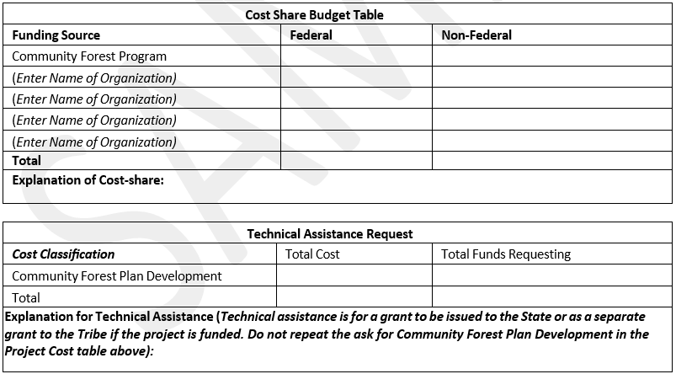
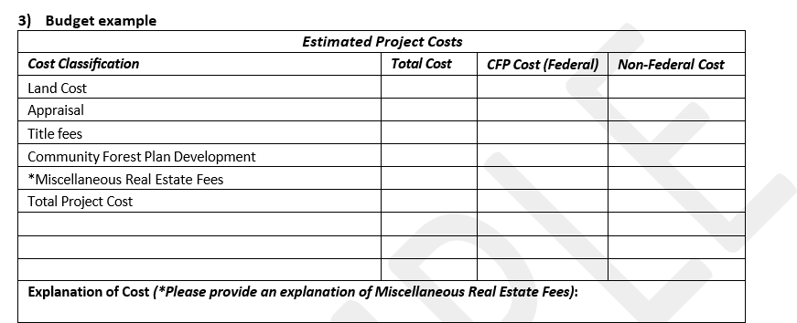



Appendix F. Community Forest Program Project Map Guidance
Map Enclosure
Recommendations for Community Forest Program Application Maps
Introduction: Community Forest and Open Space Program (CFP) applicants may submit two maps showing the location of the property in relation to roads and other improvements as well as parks, conserved open space or other protected lands in the vicinity. The following are observations and recommendations related to the two maps that are part of a CFP project application. These recommendations are the result of feedback from previous selection panels from other federally funded forest land conservation programs including CFP. Following these recommendations is not a requirement, nor are they a guarantee of successful project selection; these are suggestions to help in the development of a competitive application.
Recommendations:
- Utilize both maps effectively: The CFP application allows for two full page maps (eight and a half inches by eleven inches in size) to be submitted in addition to the eight-page narrative. It is highly recommended the application contain two maps. A successful approach used by applicants is described below:
  - One map is at a landscape scale, showing how the project fits in with other conserved lands and supports the project's strategic contribution and connection to broader landscape conservation initiative(s) described in the application narrative. This map can include green/open spaces, parks, refuges, urban natural areas or any other protected lands.
  - The second map is at a scale that shows the property’s public benefits described in the application narrative such as existing and proposed trails and access points. Unique wildlife habitats and corridors, significant natural communities, water protection zones (e.g., wetlands, streams and rivers, green infrastructure) and other environmental benefits that can be displayed on the map should also be included.
- First impressions matter: Many reviewers have indicated that the maps were the first item they reviewed on a project application. If the maps were difficult to read, reviewers became confused from the outset about how the project would provide public benefits, was threatened, or fits within a larger conservation initiative.
- Tell the same story: It is important to ensure that the project application narrative and the map tell the same story and that the story is accurate.
  - For example, if a proposed tract is being highlighted for its public recreation amenities such as a trail head, picnic area and trail network and these amenities are not identified on the map, then it is difficult for reviewers to give the project full points for that attribute.
  - If the proximity of features are highlighted in the application, make sure the features also appear on the map.
- Style suggestions: The information portrayed on the maps should be clear, concise, and easy to read. Some map style suggestions are below:
  - Reserve bright colors for proposed Community Forest area(s) and other conserved lands (e.g. highlight the proposed CFP tract/s in a bright color with a clear delineation of boundaries if more than one tract.).
  - Other protected lands are easy to spot as saturated earth tones (e.g. gradient shades of green to differentiate federal, state and privately conserved land).

Appendix F. Community Forest Program Project Map Guidance
Map Enclosure

- The map is easier to analyze if the base map is light gray or a neutral color, so it does not distract from the map message.
- Include a legend to decode the symbols and colors used to represent features on the map and a scale to explain the relationship of the map to the real world.
- Label other federal, state, county and local land conservation projects and areas on the map with the name and program or agency, (e.g. Forest Legacy Program; National Forest; Wild and Scenic Rivers; National Scenic Trails; state, county and local government parks, conserved open space, land trust conserved lands etc.).
- Do not clutter the map with unnecessary labels (e.g. labeling local roads that don't pertain to navigation to the property, or labeling other minor features that are not referenced to in the narrative).
Examples: While there are many examples of successful CFP maps, we have provided three examples in this enclosure. These maps are pulled from funded CFP applications and successfully utilize the recommendations and style suggestions identified above.
  - Birch Ridge Community Forest
  - Milan Community Forest Gateway Project
  - Ragged Mountain Community Forest

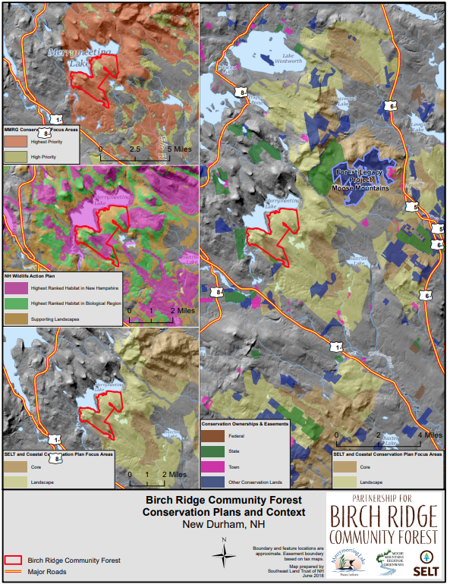

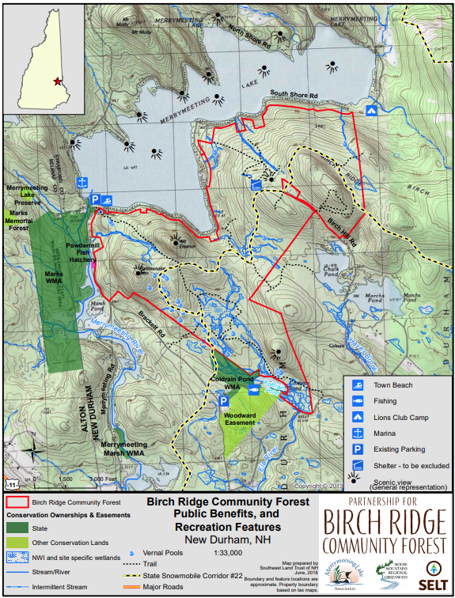

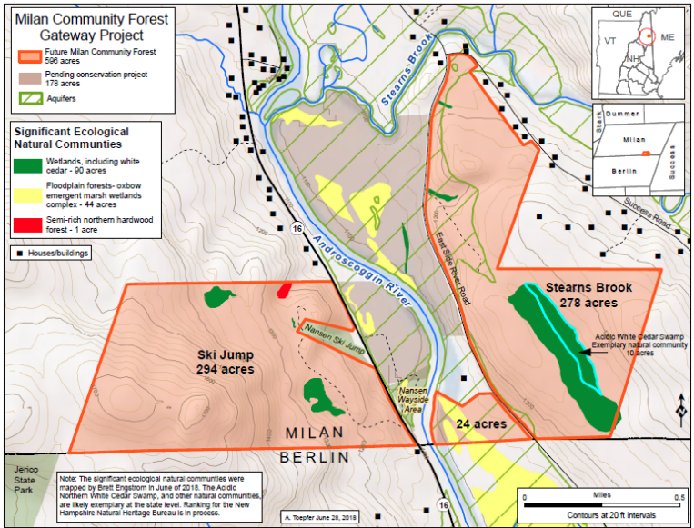
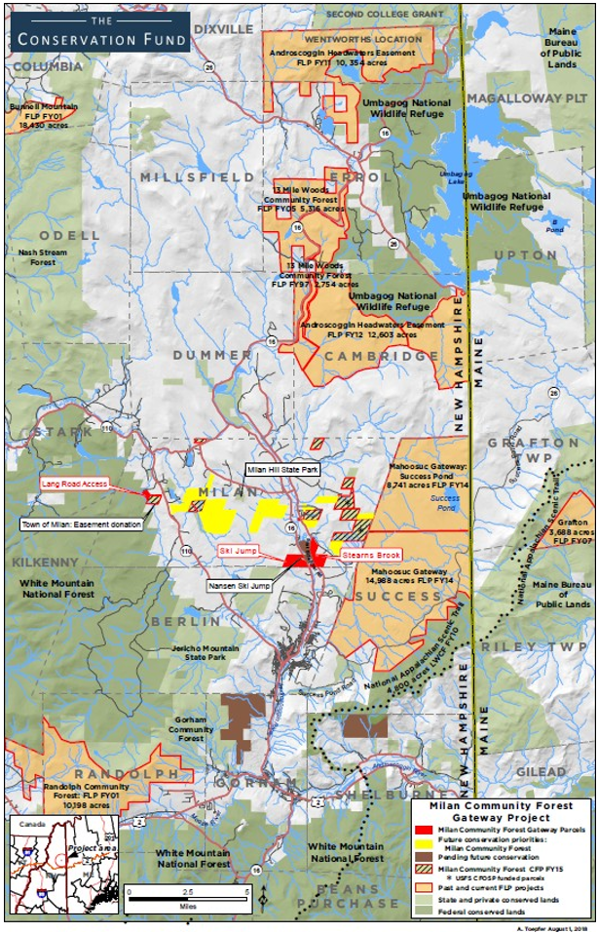

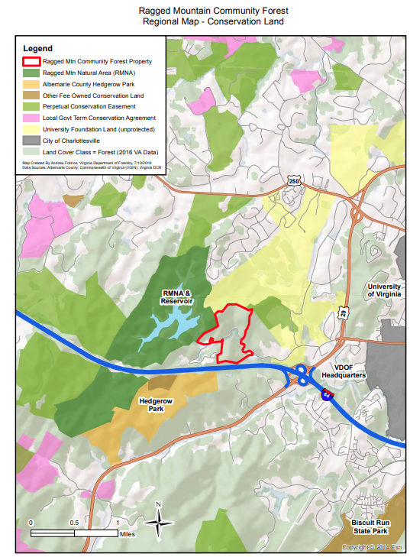

Chapter B

4 Award Process Federal Grant Management
If your project is selected by the national panel to receive a CFP grant, the next task will be to work closely with your Forest Service CFP program manager and grants and agreements staff to submit and process forms to receive federal financial assistance.
Federal Grant Forms
Federal grant forms are only necessary for projects selected by the CFP national panel. The Application for Federal Assistance SF-424 can be found on Grants.gov and consists of the forms found in the table below (current as of 2021). Please check the website for an accurate list as these forms may change from year to year.

Form | Name
Standard Form 424 | Application for Federal Assistance
Standard Form 424C— Construction Programs | Budget information
Standard Form 424D— Construction Programs | Assurances of compliance with all applicable Federal laws, regulations, and policies
AD-1047 | Certification Regarding Debarment and Suspension
AD-1049 | Certification Regarding Drug-Free Workplace
FS-1500-35 | Certification Regarding Lobbying (if FS $ are >$100,000)
AD-3030-FS | Felony Conviction and Tax Delinquent Status for Corporate Applicants (if your organization is a corporation)
FS-1500-22 | Financial Capability Questionnaire
Civil Rights Review
In addition to the SF-424 suite of forms, the Forest Service will conduct a Civil Rights Review of your organization, unless you can share evidence that another federal agency has conducted such a review in the last 12 months. Appendix G provides the questions that your Forest Service CFP program manager will be asking your organization during the Civil Rights Compliance Review. Please do not fill out this form in advance of the interview conducted by the Forest Service program manager.
System for Award Management (SAM)
All applicants shall be registered in the System for Award Management (SAM) prior to award, during performance, and through final payment of any grant resulting from this solicitation. A registered unique entity identifier (UEI) is also required. Further information regarding SAM and UEI registration can be found at: SAM.gov.

Grant Performance Period
Community Forest Program grants must start within the fiscal year that the project was awarded funding (10/1 – 9/30). The initial grant period for CFP grants will be two years. If there is a need, the grant may be extended up to five years from the start date. Grant extensions are done at the discretion of the Forest Service and will only be granted if there are circumstances outside of the recipient’s control that have prevented acquisition and if there is a high likelihood of success if the grant is extended. Extensions must be formally requested by the grant recipient to the Forest Service.
Annual Reporting
During the life of the federal grant (the identified start date and end date of the grant) the recipient will be required to submit annual project performance narrative and financial reports detailing progress on the project. See Appendix H for a sample CFP annual narrative reporting form. See Appendix I for a blank SF-425 annual financial reporting form. Generally, the reporting period for these reports ends on December 31, and the reports are due by the following March 31, but specific requirements will be negotiated with your Forest Service region and included in the award documentation.
Program Income
Federal grant regulations define program income as “gross income earned by a recipient that is directly generated by a sponsored activity or earned as a result of the award.” Such income must be accounted for in the submitted project budget and handled uniquely. For the purposes of the Community Forest Program, if a timber sale or other revenue-generating activity is planned on the Community Forest property during the grant, with income accruing to the CFP grantee, that income must be projected in the project budget initially submitted with your grant paperwork. If revenue is generated from the Community Forest after the CFP grant period, program income rules do not come into effect. Please work closely with your Forest Service program manager and grants and agreements staff if you anticipate any revenue generating activities during the grant period, since addressing program income in a federal grant can be complicated
Reimbursement or Advance Payment
When you submit your grant application, you will need to decide if you will request reimbursement for the costs of your CFP acquisition after providing the purchase funds from your own organization’s resources, or advance payment of the grant funds so they can be included in escrow for closing.
Appendix J provides sample SF-270 forms for reimbursement or advance payment. Please be aware that completed acquisition due diligence documentation must be submitted to the Forest Service at least
60 days prior to the acquisition closing date for reimbursement or advance payment requests. Specifics on submission dates are outlined in the attachments to the grant instrument.
Grant Award Package.
After receipt and approval of all federal grant forms, your organization will receive a grant award package, a sample of which is included as Appendix K. This package includes specific Federal Government, Forest
Service, and Community Forest Program administrative provisions for which your organization will be accountable.
A list of documentation required to close the federal grant after completion of the project is included in the CFP Post-Acquisition Requirements section of this document.


Appendix G. Sample Civil Rights Compliance Review

Civil Rights Compliance Review Record -
Federally Assisted Programs (Ref. FSH 1709.11) Internal Use Only
FS-1700-0006A (REV. 08/2012) OMB 0596-0215 (EXP. 11/2018)

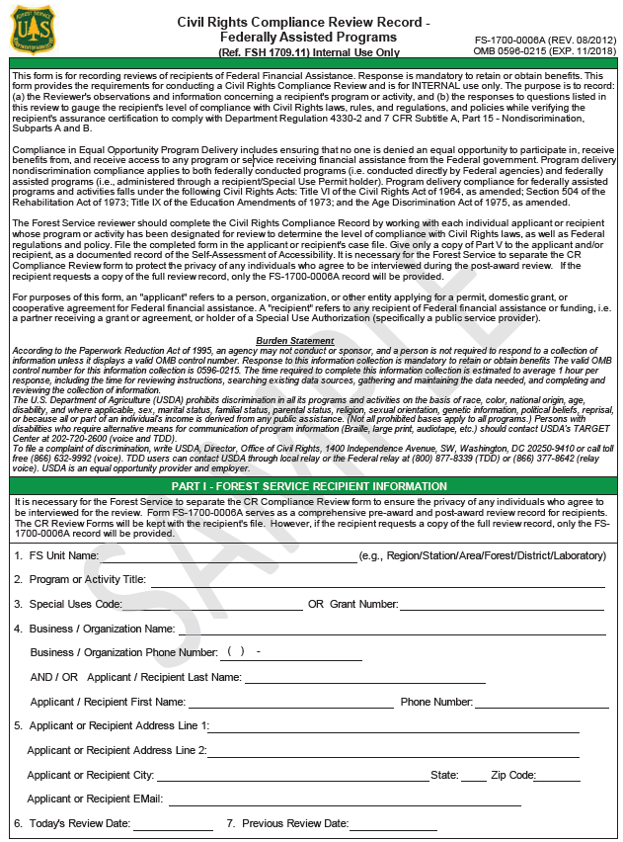
( ) -

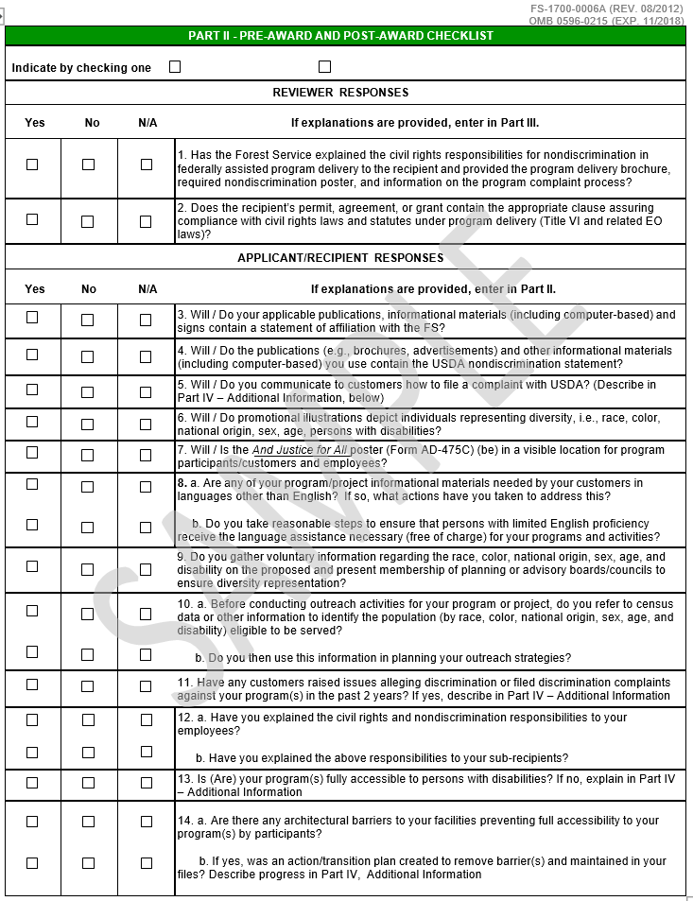
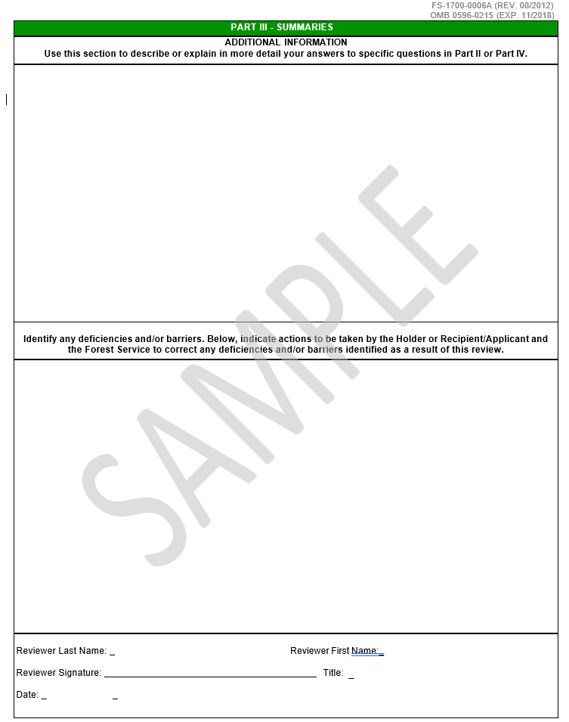

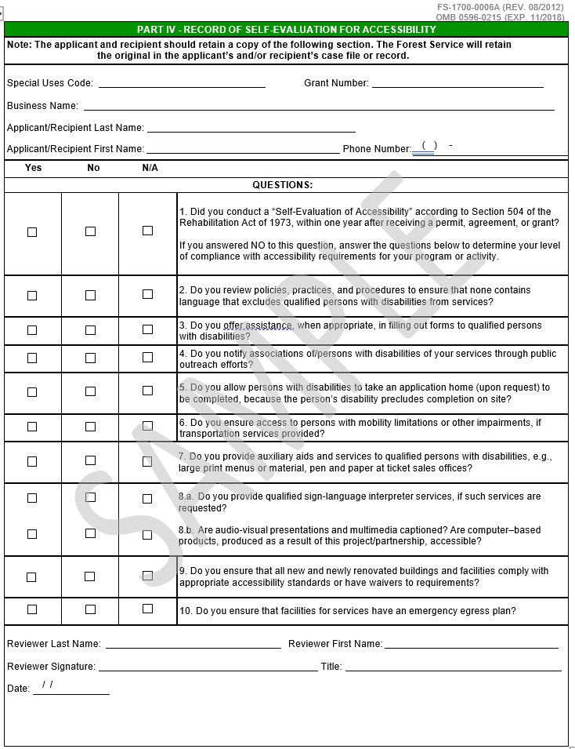

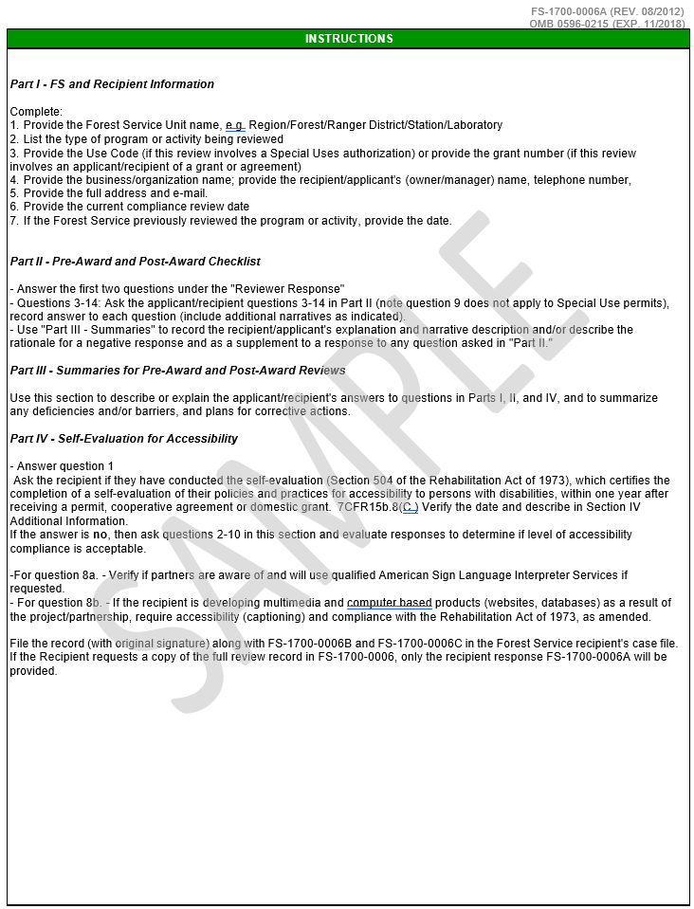
INSTRUCTIONS


Appendix H. Sample CFP Annual Narrative Grant Accomplishment Report Form

Community Forest Program Interim Grant Accomplishment Report
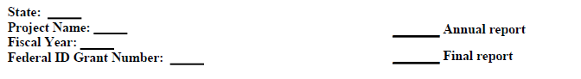
Authority
The Cooperative Forestry Assistance Act (CFAA) of 1978, as amended, (16 U.S.C. 2101 et. seq.) provides authority for the U.S. Secretary of Agriculture (Secretary) to provide financial, technical, educational, and related assistance to States, communities, and private forest landowners. Section 8003 of the Food, Conservation, and Energy Act of 2008 (Public Law 110‐234) further amended the Cooperative Forestry Assistance Act of 1978 and authorized the Forest Service to establish the Community Forest and Open Space Conservation Program. Through the Community Forest and Open Space Conservation Program (Community Forest Program or CFP), the Forest Service is authorized to provide financial assistance grants to local governments, Indian tribes, and qualified nonprofit organizations to establish community forests. Communities and Indian tribes can sustainably manage these community forests for many public benefits, including recreation, income, wildlife habitat, stewardship demonstration sites, and environmental education.
Purpose
The purpose of CFP is to achieve community benefits by establishing community forests through 50/50 financial assistance competitive grant awards to local governments, Indian tribes, and nonprofit organizations. Grant funds are used by successful applicants to acquire and protect private forestlands. Community forest benefits are specified in the authorizing statute (16 U.S.C. 2103(d) & 2109(e)), and include economic benefits from sustainable forest management, natural resource conservation, forest- based educational programs, model forest stewardship activities, and recreational opportunities. Public access to the community forests is required and intended to enhance public health and well-being. In addition, the program authorizes funds to State Foresters and equivalent Indian tribe officials for technical assistance to implement community forest projects.
Community Forest Program General Provisions
Community Forest Program Description
Discuss your CFP accomplishments (acquisition and due diligence) utilizing federal funds for the calendar year ending 12/31 in the field below.
Enter narrative comments in relation to the grant here

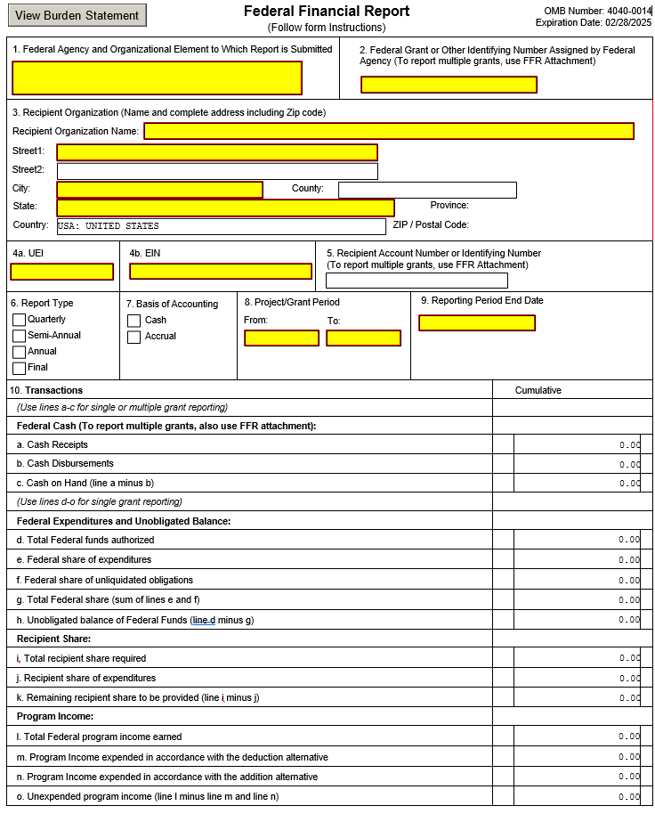

Appendix I. Sample SF425 Annual Financial Reporting Form

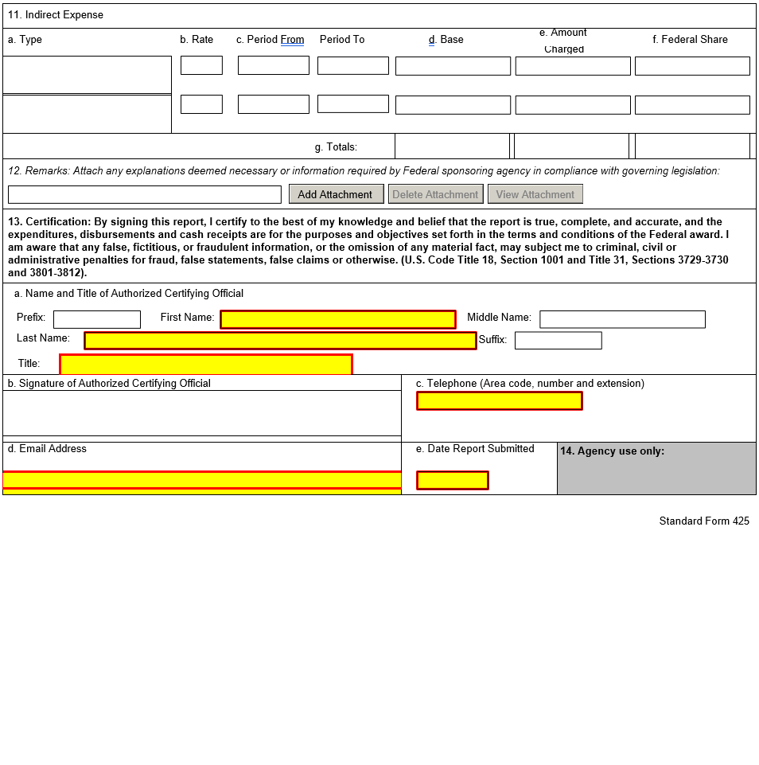
Appendix I. Sample SF425 Annual Financial Reporting Form

Appendix I. Sample SF425 Annual Financial Reporting Form
Federal Financial Report Instructions
Report Submissions
- Recipients will be instructed by Federal agencies to submit the Federal Financial Report (FFR) to a single location, except when an automated payment management reporting system is utilized. In this case, a second submission location may be required by the agency.
- If recipients need more space to support their FFRs, or FFR Attachments, they should provide supplemental pages. These additional pages must indicate the following information at the top of each page: Federal grant or other identifying number (if reporting on a single award), recipient organization, Unique Entity Identifier (UEI) number, Employer Identification Number (EIN), and period covered by the report.
Reporting Requirements
- The submission of interim FFRs will be on a quarterly, semi-annual, or annual basis, as directed by the Federal agency. A final FFR shall be submitted at the completion of the award agreement. The following reporting period end dates shall be used for interim reports: 3/31, 6/30, 9/30, or 12/31. For final FFRs, the reporting period end date shall be the end date of the project or grant period.
- Quarterly and semi-annual interim reports shall be submitted no later than 30 days after the end of each reporting period. Annual reports shall be submitted no later than 90 days after the end of each reporting period. Final reports shall be submitted no later than 90 days after the project or grant period end date.
Note: For single award reporting:
  - Federal agencies may require both cash management information on lines 10(a) through 10(c) and financial status information lines 10(d) through 10(o).
  - 10(b) and 10(e) may not be the same until the final report.
Line-Item Instructions for the Federal Financial Report
Cover Information
FFR Number | Reporting Item | Instructions
1 | Federal Agency and  Organizational Element to Which Report is Submitted | Enter the name of the Federal agency and organizational element  identified in the award document or as instructed by the agency.
2 | Federal Grant or Other Identifying Number Assigned by Federal  Agency | For a single award, enter the grant number assigned to the award by the Federal agency. For multiple awards, report this information on the FFR Attachment. Do not complete this box if reporting on multiple awards.
3 | Recipient Organization | Enter the name and complete address of the recipient organization  including zip code.
4a | UEI | Enter the recipient organization's Unique Entity Identifier  (UEI) or Central Contract Registry UEI.
4b | EIN | Enter the recipient organization's Employer Identification Number (EIN).
5 | Recipient Account Number  or Identifying Number | Enter the account number or any other identifying number assigned by the  recipient to the award. This number is for the recipient's use only and is not required by the Federal agency. For multiple awards, report this information on the FFR Attachment. Do not complete this box if  reporting on multiple awards.
6 | Report Type | Mark appropriate box. Do not complete this box if reporting on multiple  awards.
7 | Basis of Accounting (Cash/Accrual) | Specify whether a cash or accrual basis was used for recording transactions related to the award(s) and for preparing this FFR. Accrual basis of accounting refers to the accounting method in which expenses are recorded when incurred. For cash basis accounting, expenses are recorded when they are paid.
8a | Project/Grant Period,  From: (Month, Day, Year) | Indicate the period established in the award document during which  Federal sponsorship begins and ends.  Note: Some agencies award multi-year grants for a project period that is funded in increments or budget periods (typically annual increments).  Throughout the project period, agencies often require cumulative  reporting for consecutive budget periods. Under these circumstances, enter the beginning and ending dates of the project period not the budget period.  Do not complete this line if reporting on multiple awards.
8b | Project/Grant Period, To:  (Month, Day, Year) | See the above instructions for "Project/Grant Period, From: (Month, Day,  Year)."
9 | Reporting Period End Date: (Month, Day, Year) | Enter the ending date of the reporting period. For quarterly, semi-annual,  and annual interim reports, use the following reporting period end dates: 3/31, 6/30, 9/30, or 12/31. For final FFRs, the reporting period end date shall be the end date of the project or grant period.
10 | Transactions | Enter cumulative amounts from date of the inception of the award through the end date of the reporting period specified in line 9.  Use Lines 10a through 10c, Lines 10d through 10o, or Lines 10a through 10o, as specified by the Federal agency, when reporting on single grants.  Use Line 12, Remarks, to provide any information deemed necessary to support or explain FFR data.
Federal Cash (To report multiple grants, also use FFR Attachment)
FFR Number | Reporting Item | Instructions
10a | Cash Receipts | Enter the cumulative amount of actual cash received from the Federal  agency as of the reporting period end date.
10b | Cash Disbursements | Enter the cumulative amount of Federal fund disbursements (such as cash  or checks) as of the reporting period end date. Disbursements are the sum of actual cash disbursements for direct charges for goods and services, the amount of indirect expenses charged to the award, and the amount of cash advances and payments made to subrecipients and contractors.  For multiple grants, report each grant separately on the FFR Attachment. The sum of the cumulative cash disbursements on the FFR Attachment must equal the amount entered on Line 10b, FFR.
10c | Cash On Hand (Line 10a  Minus Line 10b) | Enter the amount of Line 10a minus Line 10b. This amount represents immediate cash needs. If more than three business days of cash are on hand, the Federal agency may require an explanation  on Line 12, Remarks, explaining why the drawdown was made  prematurely or other reasons for the excess cash.

Federal Expenditures and Unobligated Balance: Do not complete this section if reporting on multiple awards.
FFR  Number | Reporting Item | Instructions
10d | Total Federal Funds Authorized | Enter the total Federal funds authorized as of the reporting period end  date.
10e | Federal Share of Expenditures | Enter the amount of Federal fund expenditures. For reports prepared on a cash basis, expenditures are the sum of cash disbursements for direct charges for property and services; the amount of indirect expense charged; and the amount of cash advance payments and payments made to subrecipients. For reports prepared on an accrual basis, expenditures are the sum of cash disbursements for direct charges for property and services; the amount of indirect expense incurred; and the net increase or decrease in the amounts owed by the recipient for (1) goods and other property received; (2) services performed by employees, contractors, subrecipients, and other payees; and (3) programs for which no current services or performance are required. Do not include program income expended in accordance with the deduction alternative, rebates, refunds, or other credits. (Program income expended in accordance with the deduction alternative should be reported separately on Line 10o.)
10f | Federal Share of Unliquidated Obligations | Unliquidated obligations on a cash basis are obligations incurred, but not yet paid. On an accrual basis, they are obligations incurred, but for which an expenditure has not yet been recorded. Enter the Federal portion of unliquidated obligations. Those obligations include direct and indirect expenses incurred but not yet paid or charged to the award, including amounts due to subrecipients and contractors. On the final report, this line should be zero unless the awarding agency has provided other instructions.  Do not include any amount in Line 10f that has been reported in Line 10e. Do not include any amount in Line 10f for a future commitment of funds (such as a long-term contract) for which an obligation or expense has not  been incurred.
10g | Total Federal Share (Sum  of Lines 10e and 10f) | Enter the sum of Lines 10e and 10f.
10h | Unobligated Balance of  Federal Funds (Line 10d Minus Line 10g) | Enter the amount of Line 10d minus Line 10g.
Recipient Share: Do not complete this section if reporting on multiple awards
FFR  Number | Reporting Item | Instructions
10i | Total Recipient Share Required | Enter the total required recipient share for reporting period specified in  line 9. The required recipient share should include all matching and cost sharing provided by recipients and third-party providers to meet the level required by the Federal agency. This amount should not include cost sharing and match amounts in excess of the amount required by the Federal agency (for example, cost overruns for which the recipient incurs additional expenses and, therefore, contributes a greater level of cost sharing or match the level required of the Federal agency).
10j | Recipient Share of Expenditures | Enter the recipient share of actual cash disbursements or outlays (less any  rebates, refunds, or other credits) including payments to subrecipients and contractors. This amount may include the value of allowable third party in-kind contributions and recipient share of program income used to finance the non-Federal share of the project or program. Note: On the final report this line should be equal to or greater than the amount of Line 10i.
10k | Remaining Recipient Share  to be Provided (Line 10i Minus Line 10j) | Enter the amount of Line 10i minus Line 10j. If recipient share in Line  10j is greater than the required match amount in Line 10i, enter zero.

Program Income: Do not complete this section if reporting on multiple awards.
FFR  Number | Reporting Item | Instructions
10l | Total Federal Program Income Earned | Enter the amount of Federal program income earned. Do not report any program income here that is being allocated as part of the recipient's cost sharing amount included in Line10j.
10m | Program Income Expended  in Accordance With the Deduction Alternative | Enter the amount of program income that was used to reduce the Federal  share of the total project costs.
10n | Program Income Expended  in Accordance With the Addition Alternative | Enter the amount of program income that was added to funds committed  to the total project costs and expended to further eligible project or program activities.
10o | Unexpended Program  Income (Line 10l Minus Line 10m or Line 10n) | Enter the amount of Line 10l minus Line 10m or Line 10n. This amount  equals the program income that has been earned but not expended, as of the reporting period end date.
11 | Indirect Expense: | Complete this information only if required by the awarding agency. Enter  cumulative amounts from date of the inception of the award through the end date of the reporting period specified in line 9.
11a | Type of Rate(s) | State whether indirect cost rate(s) is Provisional, Predetermined, Final, or  Fixed.
11b | Rate | Enter the indirect cost rate(s) in effect during the reporting period.
11c | Period From; Period To | Enter the beginning and ending effective dates for the rate(s).
11d | Base | Enter the amount of the base against which the rate(s) was applied.
11e | Amount Charged | Enter the amount of indirect costs charged during the time period specified. (Multiply 11b. x 11d.)
11f | Federal Share | Enter the Federal share of the amount in 11e.
11g | Totals | Enter the totals for columns 11d, 11e, and 11f.
Remarks, Certification, and Agency Use Only
FFR  Number | Reporting Item | Instructions
12 | Remarks | Enter any explanations or additional information required by the Federal  sponsoring agency including excess cash as stated in line 10c.
13a | Typed or Printed Name and Title of Authorized  Certifying Official | Enter the name and title of the authorized certifying official.
13b | Signature of Authorized  Certifying Official | The authorized certifying official must sign here.
13c | Telephone (Area Code,  Number and Extension) | Enter the telephone number (including area code and extension) of the  individual listed in Line 13a.
13d | E-mail Address | Enter the e-mail address of the individual listed in Line 13a.
13e | Date Report Submitted  (Month, Day, Year) | Enter the date the FFR is submitted to the Federal agency using the  month, day, year format.
14 | Agency Use Only | This section is reserved for Federal agency use.


Appendix J. Sample SF270 Forms for Reimbursement or Advance Payment
Section 1, Blocks 1 through 10
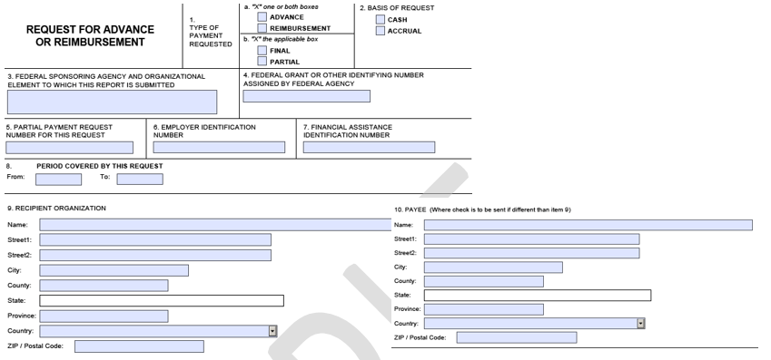
Block 1a.
“Advance” block may only be checked if the award letter or subsequent modifications to the grant authorize it. Otherwise, the “Reimbursement” will be checked. Both blocks may be checked if the request includes both reimbursement and an authorized advance.
Block 1b.
Unless this is the final payment, the “Partial” box must be checked. If marked “Final”, please make sure that (11g) is less than or equal to the Federal amount listed on Application for Federal Assistance (SF-424), Block 15a.
Block 2.
Check as appropriate. Check with your financial department to determine accounting method.
Block 3.
USDA Forest Service
Block 4.
Same as grant number identified in award letter and on SF-424.
Block 5.
Will be next in sequence, based on previous payment; for example, #1 for the first payment, #2 for second payment, etc.
Block 6.
Should be same as Block 8b, SF-424.

Appendix J. Sample SF270 Forms for Reimbursement or Advance Payment
Block 7.
The recipient’s accounting code used to track all expenditures for this grant. Auditors often use the code in this Block to search for expenditures related to this grant in the recipient’s accounting records. The block may be left blank (recipient use only).
Block 8.
“From” should be day after the “To” date on previous SF-270, Request for Reimbursement.
For first requests, “From” date must be greater than or equal to the start date of the grant shown in Block 17a, SF-424. “To” must be less than or equal to date that form is signed, Block 13, SF-270.
In all cases, the period covered by this request should be within the approved start and ending date of the grant (see block 17, SF-424), unless otherwise authorized by the award letter or modifications.
Block 9.
Recipient Address. This address should match the address shown on the SF-424.
Block 10.
Leave blank.
Section 2, Blocks 11 and 12
Block 11
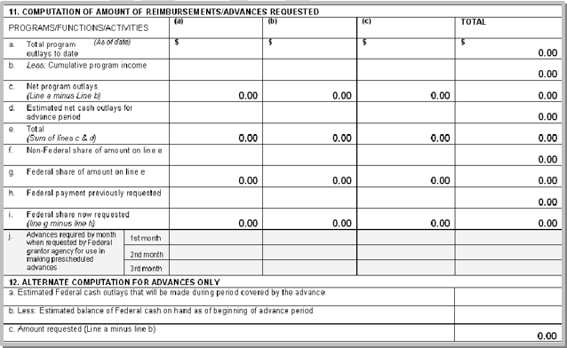
Column (a)
Use this column for accounting of cash expenditures to be paid by Forest Service funds.

Appendix J. Sample SF270 Forms for Reimbursement or Advance Payment
Column (b):
Use this column for optional tracking of other non-Forest Service cash expenditures. This column can be used for optional tracking of “other federal’ partnership contributions that cannot be used to meet matching requirements.
Column (c):
Use this column for non-FS in-kind valuation of donated time, services or material.
Note: More than one SF-270 may be used if you wish to show individual partner contributions and need additional columns. The totals will be shown only on the final page.
Block 11a.
Row (a) (As of date): Should match date covered by the ending date of this request (same as “To” in block 8). Dollar amount is always cumulative for all expenditures to date.
Block 11b.
Leave blank unless otherwise instructed.
Block 11c.
The difference of Block (11a) and (11b).
Block 11d.
See discussion of Block (1a) for appropriate uses of advance. Costs estimated to be spent for the period of time identified in Block 8.
Block 11e.
The sum of Block (11c) and (11d).
Block 11f.
Should be greater than or equal to previous payment. Check to make sure that:
1) all cash match is accounted for in Column b., 2) in-kind valuation is listed in Column c., 3) that all costs are allowable, 4) occurs within appropriate time frames, and 5) cumulative budget changes remain within 10% of the total project expenditures (See Budget Information SF-424a.) You may need to check with the Forest Service Principal Contact to determine if expectations for match are being met.
Block 11g
Forest Service funding should be shown in Column a, and should be greater than or equal to previous payment. Ensure costs are allowable and occur within appropriate time frames. The total amount must not exceed Block 18a, SF-424. Refer to the award letter or any modifications to the grant that discuss match requirements. The sum of Block (11f) and (11g) should equal (11e).
Block 11h.
Total of Federal payments paid to date including any advances.

Appendix J. Sample SF270 Forms for Reimbursement or Advance Payment
Block 11i.
Difference of (11g) and (11h).
Block 11j.
Leave blank. See discussion of block (1a).
Block 12.
For advances only.
Block 12a.
See discussion of Block (1a). Leave blank for first advance. Subsequent advances will match figure in Block (11d).
Block 12b.
Complete only if Forest Service funds from previous advance have not been fully expended by the last day of the outlay period.
Block 12c.
Difference of (12a) and (12b).
Section 3, Block 13
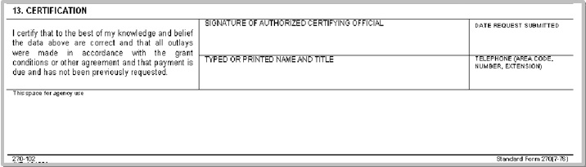
Block 13.
Sign and date by same person who signed SF-424 or who has delegated authority.
Space for Agency Use:
May be used by grantee to indicate which Budget Categories (SF-424A) are being used as the basis for the request with corresponding amounts identified.


Appendix K. Sample Grant Award Package
ENTER NAME OF LOCAL GOVERNMENT, INDIAN TRIBE OR NONPROFIT ORGANIZATION
COMMUNITY FOREST AND OPEN SPACE CONSERVATION PROGRAM
PROGRAM NARRATIVE FISCAL YEAR 2016
- LEAD CONTACTS: Community Forest Program Project Contact: ENTER COMMUNITY FOREST PROJECT CONTACT LEAD; financial activity Contact: ENTER FINANCIAL OR GRANT SPECIALIST
- BACKGROUND: Section 7A of the Cooperative Forestry Assistance Act (CFAA) of 1978, as amended, (16 U.S.C. 2103d.) provides authority for the U.S. Secretary of Agriculture acting through the Chief of the Forest Service to establish the Community Forest and Open Space Conservation Program (Community Forest Program) for the purposes of establishing community forests that provide community benefits by acquiring and protecting private forestlands. This authority continues indefinitely. Program delivery is guided by the Community Forest Program regulations (36 CFR Part 230 Subpart A) (published 10/20/2011; 76 FR 65121).
- PURPOSE: Through the Community Forest Program the Forest Service is authorized to provide financial assistance grants to local governments, Indian tribes, and qualified nonprofit organizations to establish community forests. ENTER NAME OF LOCAL GOVERNMENT, INDIAN TRIBE OR NONPROFIT ORGANIZATION requests a grant to acquire in fee ENTER NAME OF COMMUNITY FOREST PROJECT, in ENTER LOCATION OF COMMUNTIY FOREST. Communities and Indian tribes can sustainably manage these community forests for many public benefits, including recreation, income, wildlife habitat, stewardship demonstration sites, and environmental education. Through acquisition of lands through the Community Forest Program the grantee shall ensure the lands are:
  - protected from nonforest uses
  - promote defined community benefits
  - provide public access
  - be managed in a manner that is consistent with the purposes for which the land was acquired
  - be managed through a community forest plan.
Specifically, the public values being protected by this project are: ENTER SPECIFIC PUBLIC VALUES TO BE PROTECTED.
The Federal role is to promote Community Forests through collaborating with ENTER NAME OF LOCAL GOVERNMENT, INDIAN TRIBE OR NONPROFIT ORGANIZATION to establish community forests that provide community benefits by acquiring private forestlands and managing said community forests for community benefits. This acquisition contributes to the national State and Private Forestry Priority to “Conserve and Manage Working Forest Landscapes for Multiple Values and Uses” and the Northeastern Area Strategic Plan for FY2013- 2018 objective to “contribute to conservation of important forest landscapes across the urban to rural continuum.”
- SCOPE OF WORK: The ENTER NAME OF LOCAL GOVERNMENT, INDIAN TRIBE OR NONPROFIT ORGANIZATION will enter into a contract for the purchase of lands for the Community Forest Program. The Community Forest project includes ENTER NUMBER OF TRACTS tract/s that encompass ENTER NUMBER OF ACRES acres in ENTER TRACT LOCATION SELECT 'COUNTY' OR 'TOWNSHIP'. The transfer of lands to ENTER NAME OF LOCAL GOVERNMENT, INDIAN TRIBE OR NONPROFIT ORGANIZATION will occur by ENTER DATE (< 2-years).
- METHODOLOGY:
- The ENTER NAME OF LOCAL GOVERNMENT, INDIAN TRIBE OR NONPROFIT ORGANIZATION will use funds under this grant award for
  - The acquisition of lands, title to which will be held in the name of the ENTER NAME OF LOCAL GOVERNMENT, INDIAN TRIBE OR NONPROFIT ORGANIZATION. Said lands shall be administered by ENTER NAME OF LOCAL GOVERNMENT, INDIAN TRIBE OR NONPROFIT ORGANIZATION;
  - Real estate transaction costs limited to appraisals and appraisal reviews, land surveys, legal and closing costs, development of the community forest plan, and title examination.

Appendix K. Sample Grant Award Package
- The Grantee ENTER NAME OF LOCAL GOVERNMENT, INDIAN TRIBE OR NONPROFITORGANIZATION will ensure that in acquiring the lands that the Community Forest Program Final Rule and the conditions of the Grant Award Letter Attachment C: Community Forest Program Award Provisions are followed.
- TIMETABLE OF ACTIVITIES
Acquisition Activities Consistent with 36 CFR 230.8
Grant recipients participating in the Community Forest Program must complete the following, which applies to all tracts, including cost share tracts: The specific tasks of this project are tentatively scheduled to occur as follows:
Item to be completed Tentative date of completion
- Complete an appraisal and review appraisal consistent with Federal Appraisal Standards: Month/Year
  - For lands purchased with CFP funds, the appraisal must comply with Federal Appraisal Standards prior to the release of the grant funds. The grant recipient must provide documentation that the appraisal and associated appraisal review were conducted in a manner consistent with the Federal appraisal standards.
  - For donated cost share tracts, the market value must be determined by an independent appraiser. The value needs to be documented by a responsible official of the party to which the property is donated.
- Prior to closing, notify the landowner in writing of the appraised value of the property and that the sale is voluntary. If the grant recipient has a voluntary option for less than appraised value, they do not have to renegotiate the agreement. Month/Year
- Purchase all surface and subsurface mineral rights, whenever possible. However, if severed mineral rights cannot be obtained, then the grant recipient must follow the retention of qualified mineral interest requirements outlined in the Internal Revenue Service regulations (26 CFR 1.170A–14 (g)(4)), which address both surface and subsurface minerals Month/Year
- Ensure that title to lands acquired conforms to title standards applicable to State land acquisitions where the land is located: Month/Year
  - Title to lands acquired using CFP funds must not be subject to encumbrances or agreements of any kind that would be contrary to the purpose of the CFP.
  - Title insurance must not be a substitute for acceptable title.
- Record with the deed in the lands record of the local county or municipality, a Notice of Grant Requirement, which includes the following: Month/Year
  - States that the property (including cost share tracts) was purchased with CFP funds;
  - Provides a legal description;
  - Identifies the name and address of the grant recipient who is the authorized title holder;
  - States the purpose of the CFP;
  - References the Grant Agreement with the Forest Service (title and agreement number) and the address where it is kept on file;
  - States that the grant recipient confirms its obligation to manage the interest in real property pursuant to the grant, the Community Forest Plan, and the purpose of the CFP;
  - States that the grant recipient will not convey or encumber the interest in real property, in whole or in part, to another party without permission and instructions from the awarding agency; and
  - States that the grant recipient will manage the interest in real property consistent with the purpose of the CFP.

Appendix K. Sample Grant Award Package
Ownership Requirements Consistent with 36 CFR 230.9
Item to be completed Tentative date of completion
  - Complete the final community forest plan within 120 days of the land acquisition, and must update the plan periodically to guide the management and the community benefits of the community forest.
Month/Year
- ACCOMPLISHMENT AND REPORTING
- Upon completion of this Community Forest project, the ENTER NAME OF LOCAL GOVERNMENT, INDIAN TRIBE OR NONPROFIT ORGANIZATION agrees that all media, press, signage, and other documents discussing the creation of the community forest must reference the partnership and financial assistance by the U.S. Forest Service through the Community Forest Program.
- After the project has closed, ENTER NAME OF LOCAL GOVERNMENT, INDIAN TRIBE OR NONPROFIT ORGANIZATION provide the Forest Service with a Geographic Information System (GIS) shapefile: a digital, vector based storage format for storing geometric location and associated attribute information, of CFP project tracts and cost share tracts, if applicable.
- Every five years, ENTER NAME OF LOCAL GOVERNMENT, INDIAN TRIBE OR NONPROFIT
ORGANIZATION will submit to the Forest Service (Northeastern Area or subsequent unit) a self- certifying statement that the property has not been sold or converted to non-forest uses or a use inconsistent with the purpose of the CFP.
- As a condition of this grant, ENTER NAME OF LOCAL GOVERNMENT, INDIAN TRIBE OR NONPROFIT ORGANIZATION will be subject to a spot check conducted by the Forest Service to verify that property acquired under the CFP has not been sold or converted to non-forest uses or a use inconsistent with the purpose of the CFP

Appendix K. Sample Grant Award Package
- BUDGET INFORMATION
Acquisition of lands
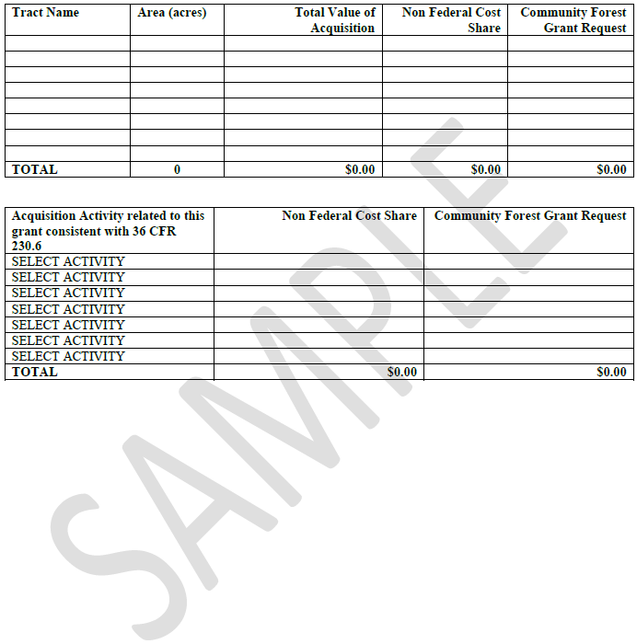

OMB 0596-0217
Expiration Date: 11/30/2017
Rev. (12-13)

Appendix K. Sample Grant Award Package
FEDERAL FINANCIAL ASSISTANCE AWARD OF DOMESTIC GRANT
Between The
[Insert Name]
And The
USDA, FOREST SERVICE
select from the drop-down Title:
Upon execution of this document, an award to [insert name], hereinafter referred to as “[insert name],” in the amount of [insert amount], is made under the authority of [insert name]. The Catalog of Federal Domestic Assistance (CFDA) number and name are [insert number and name]. [Insert name] accepts this award for the purpose described in the application narrative. Your application for Federal financial assistance, dated[insert date]., and the attached Forest Service provisions, ‘Forest Service Award Provisions,’ are incorporated into this letter and made a part of this award.
This authority requires a match of [insert amount], which your organization has agreed to meet, as shown in the attached application, financial plan and narrative.
This is an award of Federal financial assistance. Prime and sub-recipients to this award are subject to the OMB guidance in subparts A through F of 2 CFR Part 200 as adopted and supplemented by the USDA in 2 CFR Part 400. Adoption by USDA of the OMB guidance in 2 CFR 400 gives regulatory effect to the OMB guidance in 2 CFR 200 where full text may be found.
Electronic copies of the CFRs can be obtained at the following internet site: ECFR If you are unable to retrieve these regulations electronically, please contact your Grants and Agreements Office at .
The following administrative provisions apply to this award:
- LEGAL AUTHORITY. [insert name] shall have the legal authority to enter into this award, and the institutional, managerial, and financial capability to ensure proper planning, management, and completion of the project, which includes funds sufficient to pay the non-Federal share of project costs, when applicable.
- PRINCIPAL CONTACTS. Individuals listed below are authorized to act in their respective areas for matters related to this award.



Caring for the Land and Serving People Printed on Recycled Paper
OMB 0596-0217
Expiration Date: 11/30/2017
Rev. (12-13)

Appendix K. Sample Grant Award Package
Principal Cooperator Contacts:
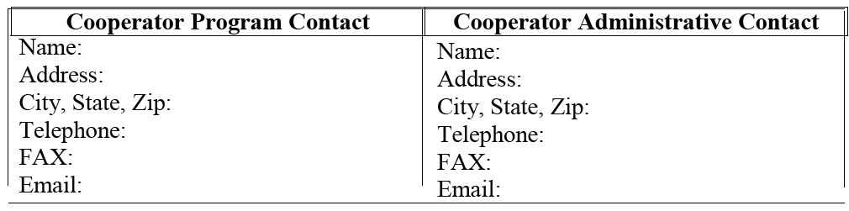
Principal Forest Service Contacts:
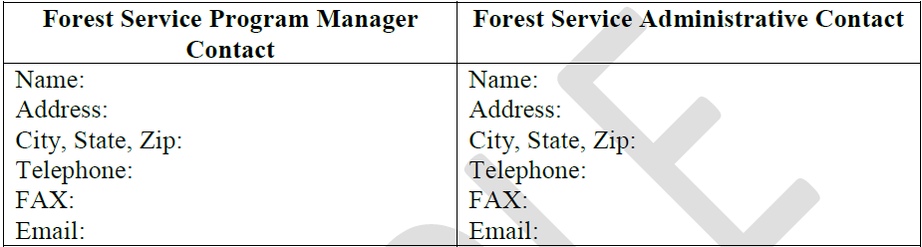
- ASSURANCE REGARDING FELONY CONVICTION OR TAX DELINQUENT STATUS FOR CORPORATE APPLICANTS. This award is subject to the provisions contained in the Department of the Interior, Environment, and Related Agencies Appropriations Act, 2012, P.L. No. 112-74, Division E, Section 433 and 434 as continued by Consolidated and Further Continuing Appropriations Act, 2013, P.L. No. 113-6, Division F, Title I, Section 1101(a)(3) regarding corporate felony convictions and corporate Federal tax delinquencies. Accordingly, by entering into this award acknowledges that it: 1) does not have a tax delinquency, meaning that it is not subject to any unpaid Federal tax liability that has been assessed, for which all judicial and administrative remedies have been exhausted or have lapsed, and that is not being paid in a timely manner pursuant to an award with the authority responsible for collecting the tax liability, and (2) has not been convicted (or had an officer or agent acting on its behalf convicted) of a felony criminal violation under any Federal law within 24 months preceding the award, unless a suspending and debarring official of the U.S. Department of Agriculture has considered suspension or debarment is not necessary to protect the interests of the Government. If [Insert name] fails to comply with these provisions, the Forest Service will annul this award and may recover any funds [Insert name] has expended in violation of sections 433 and 434.
- SYSTEM FOR AWARD MANAGEMENT REGISTRATION REQUIREMENT (SAM) [Insert Name] shall maintain current information in the System for Award Management (SAM) until receipt of final payment. This requires review and update to the information at least annually after the initial registration, and more frequently if required by changes in information or award term(s). For purposes of this award, System for Award Management (SAM) means the Federal repository into which an entity must provide information required for the conduct of business as a Cooperative. Additional information about registration procedures may be found at the SAM Internet site at SAM.
OMB 0596-0217
Expiration Date: 11/30/2017
Rev. (12-13)

Appendix K. Sample Grant Award Package
- LIMITATION OF FUNDS. Forest Service funds in the amount of $[ insert amount] are currently available for performance of this award through [insert name]. The Forest Service’s ability to provide additional funding is contingent upon the availability of appropriated funds from which payment can be made. There is no legal liability on the part of the Forest Service for any payment above this amount until [insert name] receives notice of availability confirmed in a written modification by the Forest Service.
- PAYMENTS – FINANCIAL ASSISTANCE. [insert number] payments are approved under this award. Only costs for those project activities approved in (1) the initial award, or (2) modifications thereto, are allowable. Requests for payment must be submitted on Standard Form 270 (SF-270), Request for Advance or Reimbursement, and must be submitted no more than monthly. In order to approve a Request for Advance Payment or Reimbursement, the Forest Service shall review such requests to ensure advances or payments for reimbursement are in compliance and otherwise consistent with OMB, USDA, and Forest Service regulations.
Advance payments must not exceed the minimum amount needed or no more than is needed for a 30-day period, whichever is less. If the Recipient receives an advance payment and subsequently requests an advance or reimbursement payment, then the request must clearly demonstrate that the previously advanced funds have been fully expended before the Forest Service can approve the request for payment. Any funds advanced, but not spent, upon expiration of this award must be returned to the Forest Service.
The Program Manager reserves the right to request additional information prior to approving a payment.
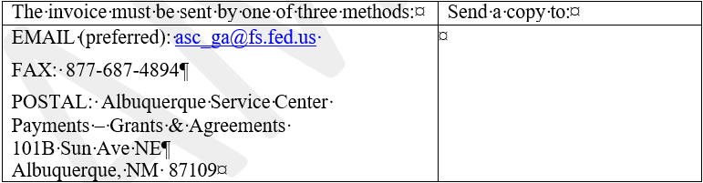
- HEALTH & HUMAN SERVICES PAYMENT MANAGEMENT SYSTEM (HHSPMS). [Insert Text] identified for use of this payment system shall designate a financial institution or an authorized payment agent through which a direct deposit may be made in accordance with current HHS PMS system requirements. The Albuquerque Service Center is responsible for soliciting initial enrollment in the HHS PMS. Any questions concerning payments should be addressed to the Albuquerque Service Center at (877) 372-7248. Please ask for the Grants and Agreements Payments section. Any subsequent changes to banking information are made by [insert text] through the HHS PMS.

Caring for the Land and Serving People Printed on Recycled Paper

OMB 0596-0217
Expiration Date: 11/30/2017
Rev. (12-13)

Appendix K. Sample Grant Award Package
The HHS sub-account number(s) for this award is/are: 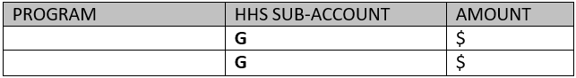
- INDIRECT COST RATES. The approved indirect cost rate at the time of execution is XX% as shown in the NICRA provided by the Cooperator.
Indirect cost rates must be formalized in a written agreement between the cognizant agency and Recipient. Requirements are set forth in appendices to 2 CFR 200.
(1) If [Insert name]does not have a previously established indirect cost rate with a Federal agency, [insert name] shall follow the requirements and timeframes unique to their organization found in the appendices to 2 CFR 200. [Insert name] will be reimbursed for indirect costs at the tentative rate reflected in the budget until the rate is formalized in a negotiated indirect cost rate agreement (NICRA) at which time, reimbursements for prior indirect costs may be subject to adjustment.
(2) As new NICRAs are agreed to between [Insert name]and their cognizant audit agency, the revised provisional or final rate(s) are automatically incorporated into this award, as appropriate, and must specify (1) the agreed upon rates, (2) the bases to which the rates apply, (3) the fiscal year for which the rates apply, and (4) the items treated as direct costs. The award obligation will not increase as a result of indirect cost rate increases. Updates to NICRAs will not affect the total funds available for this award unless documented in a formally executed modification.
(3) If the NICRA is for a provisional rate, [Insert name]shall be reimbursed at the established provisional rate(s), subject to appropriate adjustment when the final rate(s) for the fiscal year are established.
(4) Failure to provide a revised provisional or final NICRA could result in disallowed costs and repayment to the Forest Service.
- ELECTION OF DE MINIMIS INDIRECT RATE. [Insert Name] has elected to use the de minimis indirect cost rate of 10% of modified total direct costs (MTDC) as allowed under 2 CFR 200.414 (f). This rate must be used consistently for all Federal awards until such time as [Insert name]chooses to negotiate for a rate, which they may apply to do at any time. If a new rate is negotiated and utilized the de minimis rate can no longer be utilized.
- PRIOR WRITTEN APPROVAL. [Insert Name] shall obtain prior written approval pursuant to conditions set forth in 2 CFR 200.407.
- MODIFICATIONS. Modifications within the scope of this award must be made by mutual consent of the parties, by the issuance of a written modification signed and

OMB 0596-0217
Expiration Date: 11/30/2017
Rev. (12-13)

Appendix K. Sample Grant Award Package
dated by all properly authorized signatory officials, prior to any changes being performed. Requests for modification should be made, in writing, at least [insert number] days prior to implementation of the requested change. The Forest Service is not obligated to fund any changes not properly approved in advance.
- PERIOD OF PERFORMANCE. This agreement is executed as of the date of the Forest Service signatory official signature.
The start date of this award is the date of the Forest Service signatory official signature. OR
The start date of this award is XX/XX/20XX), pre-award costs are authorized pursuant to 2 CFR 200.458. (Use when pre-award costs are authorized) OR
The start date of this award is XX/XX/20XX (use when start date is after signature date)
The end date, or expiration date is XX/XX/20XX. This instrument may be extended by a properly executed modification. See Modification Provision above.

- AUTHORIZED REPRESENTATIVES. By signature below, each party certifies that the individuals listed in this document as representatives of the individual parties are authorized to act in their respective areas for matters related to this award. In witness whereof the parties hereto have executed this award as of the last date written below.

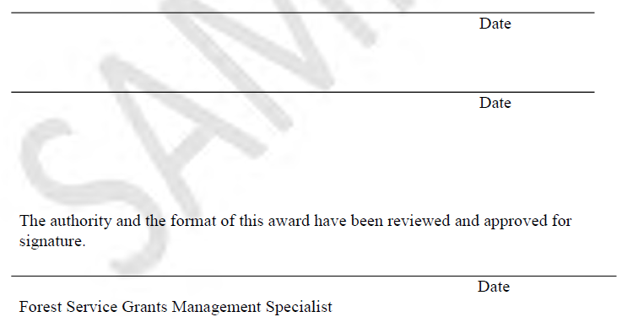
OMB 0596-0217
Expiration Date: 11/30/2017
Rev. (12-13)

Appendix K. Sample Grant Award Package

ATTACHMENT A: FOREST SERVICE AWARD PROVISIONS
- COLLABORATIVE ARRANGEMENTS. Where permitted by terms of the award and Federal law, [Insert name] may enter into collaborative arrangements with other organizations to jointly carry out activities with Forest Service funds available under this award.
- FOREST SERVICE LIABILITY TO THE RECIPIENT. The United States shall not be liable to [Insert name] for any costs, damages, claims, liabilities, and judgments that arise in connection with the performance of work under this award, including damage to any property owned by[Insert name]or any third party.
- NOTICES. Any notice given by the Forest Service or[Insert name] will be sufficient only if in writing and delivered in person, mailed, or transmitted electronically by e-mail or fax, as follows:
To the Forest Service Program Manager, at the address specified in the award.
To [Insert Name], at the address shown in the award or such other address designated within the award.
Notices will be effective when delivered in accordance with this provision, or on the effective date of the notice, whichever is later.
- SUBAWARDS. [Insert Name] shall notify Subrecipients under this award that they are subject to the OMB guidance in subparts A through F of 2 CFR Part 200, as adopted and supplemented by the USDA in 2 CFR Part 400. Any sub-award must follow the regulations found in 2 CFR 200.330 through .332.
- USE OF FOREST SERVICE INSIGNIA. In order for [Insert name] to use the Forest Service insignia on any published media, such as a Web page, printed publication, or audiovisual production, permission must be granted by the Forest Service’s Office of Communications (Washington Office). A written request will be submitted by Forest Service, Program Manager, to the Office of Communications Assistant Director, Visual Information and Publishing Services prior to use of the insignia. The Forest Service Program Manager will notify [Insert name] when permission is granted.
- BUILDING AND COMPUTER ACCESS BY NON-FOREST SERVICE PERSONNEL. [Insert Name] may be granted access to Forest Service facilities and/or computer systems to accomplish work described in the Operating Plan or Statement of Work. All non-government employees with unescorted access to Forest Service facilities and computer systems must have background checks following the procedures established by USDA Directives 3800 series. Those granted computer access must fulfill all Forest Service requirements for mandatory security awareness and role-based advance security training, and sign all applicable Forest Service statements of responsibilities.
- MEMBERS OF CONGRESS. Pursuant to 41 U.S.C. 22, no member of, or delegate to, Congress shall be admitted to any share or part of this award, or benefits that may arise therefrom, either directly or indirectly.

OMB 0596-0217
Expiration Date: 11/30/2017
Rev. (12-13)

Appendix K. Sample Grant Award Package
- TRAFFICKING IN PERSONS.
  - Provisions applicable to a Recipient that is a private entity.
    - You as the Recipient, your employees, Subrecipients under this award, and Subrecipients’ employees may not:
      - Engage in severe forms of trafficking in persons during the period of time that the award is in effect;
      - Procure a commercial sex act during the period of time that the award is in effect; or
      - Use forced labor in the performance of the award or subawards under the award.
    - We as the Federal awarding agency may unilaterally terminate this award, without penalty, if you or a Subrecipient that is a private entity:
      - Is determined to have violated a prohibition in paragraph a.1 of this award term; or
      - Has an employee who is determined by the agency official authorized to terminate the award to have violated a prohibition in paragraph a.1 of this award term through conduct that is either:
        - Associated with performance under this award; or
        - Imputed to you or the subrecipient using the standards and due process for imputing the conduct of an individual to an organization that are provided in 2 CFR part 180, ‘‘OMB Guidelines to Agencies on Government wide Debarment and Suspension (Non-procurement),’’.
  - Provision applicable to a Recipient other than a private entity. We as the Federal awarding agency may unilaterally terminate this award, without penalty, if a subrecipient that is a private entity:
    - Is determined to have violated an applicable prohibition in paragraph a.1 of this award term; or
    - Has an employee who is determined by the agency official authorized to terminate the award to have violated an applicable prohibition in paragraph a.1 of this award term through conduct that is either—
      - Associated with performance under this award; or
      - Imputed to the subrecipient using the standards and due process for imputing the conduct of an individual to an organization that are provided in 2 CFR part 180, ‘‘OMB Guidelines to Agencies on Governmentwide Debarment and Suspension (Non-procurement),’’
  - Provisions applicable to any recipient.
    - You must inform us immediately of any information you receive from any source alleging a violation of a prohibition in paragraph a.1 of this award term.
    - Our right to terminate unilaterally that is described in paragraph a.2 or b of this section:
      - Implements section 106(g) of the Trafficking Victims Protection Act of 2000 (TVPA), as amended (22 U.S.C. 7104(g)), and
      - Is in addition to all other remedies for noncompliance that are available to us under this award.
    - You must include the requirements of paragraph a.1 of this award term in any subaward you make to a private entity
OMB 0596-0217
Expiration Date: 11/30/2017
Rev. (12-13)

Appendix K. Sample Grant Award Package
  - Definitions. For purposes of this award term:
    - ‘‘Employee’’ means either:
      - An individual employed by you or a subrecipient who is engaged in the performance of the project or program under this award; or
      - Another person engaged in the performance of the project or program under this award and not compensated by you including, but not limited to, a volunteer or individual whose services are contributed by a third party as an in-kind contribution toward cost sharing or matching requirements.
    - ‘‘Forced labor’’ means labor obtained by any of the following methods: the recruitment, harboring, transportation, provision, or obtaining of a person for labor or services, through the use of force, fraud, or coercion for the purpose of subjection to involuntary servitude, peonage, debt bondage, or slavery.
    - ‘‘Private entity’’:
      - Means any entity other than a State, local government, Indian tribe, or foreign public entity, as those terms are defined in 2 CFR 175.25.
      - Includes:
        - A nonprofit organization, including any nonprofit institution of higher education, hospital, or tribal organization other than one included in the definition of Indian tribe at 2 CFR 175.25(b).
        - A for-profit organization.
    - ‘‘Severe forms of trafficking in persons,’’ ‘‘commercial sex act,’’ and ‘‘coercion’’ have the meanings given at section 103 of the TVPA, as amended (22 U.S.C. 7102).
- DRUG-FREE WORKPLACE.
  - agree(s) that it will publish a drug-free workplace statement and provide a copy to each employee who will be engaged in the performance of any project/program that receives federal funding. The statement must
    - Tell the employees that the unlawful manufacture, distribution, dispensing, possession, or use of a controlled substance is prohibited in its workplace;
    - Specify the actions will take against employees for violating that prohibition; and
    - Let each employee know that, as a condition of employment under any award, the employee
OMB 0596-0217
Expiration Date: 11/30/2017
Rev. (12-13)

Appendix K. Sample Grant Award Package
      - Shall abide by the terms of the statement, and
      - Shall notify in writing if they are convicted for a violation of a criminal drug statute occurring in the workplace, and shall do so no more than 5 calendar days after the conviction.
  - agree(s) that it will establish an ongoing drug-free awareness program to inform employees about
    - The dangers of drug abuse in the workplace;
    - The established policy of maintaining a drug-free workplace;
    - Any available drug counseling, rehabilitation and employee assistance programs; and
    - The penalties that you may impose upon them for drug abuse violations occurring in the workplace.
  - Without the Program Manager’s expressed written approval, the policy statement and program must be in place as soon as possible, no later than the 30 days after the effective date of this instrument, or the completion date of this award, whichever occurs first.
  - agrees to immediately notify the Program Manager if an employee is convicted of a drug violation in the workplace. The notification must be in writing, identify the employee’s position title, the award number of each award on which the employee worked. The notification must be sent to the Program Manager within 10 calendar days after learns of the conviction.
  - Within 30 calendar days of learning about an employee’s conviction, must either
    - Take appropriate personnel action against the employee, up to and including termination, consistent with the requirements of the Rehabilitation Act of 1973 (29 USC 794), as amended, or
    - Require the employee to participate satisfactorily in a drug abuse assistance or rehabilitation program approved for these purposes by a Federal, State or local health, law enforcement, or other appropriate agency.
- PROHIBITION AGAINST USING FUNDS WITH ENTITIES THAT REQUIRE CERTAIN INTERNAL CONFIDENTIALITY AGREEMENTS.
  - The recipient may not require its employees, contractors, or subrecipients seeking to report fraud, waste, or abuse to sign or comply with internal confidentiality agreements or statements prohibiting or otherwise restricting them from lawfully reporting that waste, fraud, or abuse to a designated investigative or law enforcement representative of a Federal department or agency authorized to receive such information.

OMB 0596-0217
Expiration Date: 11/30/2017
Rev. (12-13)

Appendix K. Sample Grant Award Package
  - The recipient must notify its employees, contractors, or subrecipients that the prohibitions and restrictions of any internal confidentiality agreements inconsistent with paragraph (1) of this award provision are no longer in effect.
  - The prohibition in paragraph (1) of this award provision does not contravene requirements applicable to any other form issued by a Federal department or agency governing the nondisclosure of classified information.
  - If the Government determines that the recipient is not in compliance with this award provision, it;
    - Will prohibit the recipient’s use of funds under this award in accordance with sections 743, 744 of Division E of the Consolidated Appropriations Act, 2016, (Pub. L. 114-113) or any successor provision of law; and
    - May pursue other remedies available for the recipient’s material failure to comply with award terms and conditions.
- ELIGIBLE WORKERS. [Insert name] shall ensure that all employees complete the I-9 form to certify that they are eligible for lawful employment under the Immigration and Nationality Act (8 USC 1324a). [Insert Name] shall comply with regulations regarding certification and retention of the completed forms. These requirements also apply to any contract or supplemental instruments awarded under this award.
- PROGRAM INCOME – FINANCIAL ASSISTANCE.
  - [Insert text] shall apply the standards set forth in this Provision to account for program income earned under the award.
  - If any program income is generated as a result of this award, the income shall be applied using the [Insert text] alternative as described in 2 CFR 200.307; the deductive alternative is the default if no other method is selected.
  - Unless the terms and conditions of the award/agreement provide otherwise, Recipients shall have no obligation to the U.S. Government regarding program income earned after the end of the project period.
  - Costs incident to the generation of program income may be deducted from gross income to determine net program income, provided these costs have not been charged to the award and they comply with 2 CFR 200.307.
  - Unless the terms and conditions of the award provide otherwise, [Insert name] shall have no obligation to the U.S. Government with respect to program income earned from license fees and royalties for copyrighted material, patents, patent applications, trademarks, and inventions produced under an award. However, Patent and Trademark Amendments (35 U.S.C. 18) apply to inventions made under an experimental, developmental, or research awards.
- FINANCIAL STATUS REPORTING. A Federal Financial Report, Standard Form SF- 425(and Federal Financial Report Attachment, SF-425A, if required for reporting multiple awards), must be submitted select from the drop-down. These reports are due Select from dropdown days after the reporting period ending [Insert date]. The final SF-425 (and SF-425A, if applicable) must be submitted either with the final payment request or no later than 90 days from the expiration date of the award. These forms may be found at White House web page

OMB 0596-0217
Expiration Date: 11/30/2017
Rev. (12-13)

Appendix K. Sample Grant Award Package
- PROGRAM PERFORMANCE REPORTS. The recipient shall perform all actions identified and funded in application/modification narratives within the performance period identified in award.
In accordance with 2 CFR 200 301, reports must relate financial data to performance accomplishments of the federal award.
[Insert Name] shall submit select from drop-down performance reports. These reports are due select from drop-down days after the reporting period. The final performance report shall be submitted either with [Insert name]’s final payment request, or separately, but not later than 90 days from the expiration date of the award.
-Additional pertinent information:
- NOTIFICATION. [Insert Name] shall immediately notify the Forest Service of developments that have a significant impact on the activities supported under this award. Also, notification must be given in case of problems, delays or adverse conditions that materially impair the ability to meet the objectives of the award. This notification must include a statement of the action taken or contemplated, and any assistance needed to resolve the situation.
- CHANGES IN KEY POSITIONS AND PERSONNEL RESEARCH AWARDS. Any revision to key positions and personnel identified in the application for this award require prior, written approval from the Forest Service Program Manager. All technical positions are considered Key Personnel by the Forest Service. Failure on the part of to obtain prior, written approval when required may result in the disallowance of costs.
- FREEDOM OF INFORMATION ACT (FOIA). Public access to award or agreement records must not be limited, except when such records must be kept confidential and would have been exempted from disclosure pursuant to Freedom of Information regulations (5 U.S.C. 552). Requests for research data are subject to 2 CFR 315(e).
Public access to culturally sensitive data and information of Federally-recognized Tribes may also be explicitly limited by P.L. 110-234, Title VIII Subtitle B §8106 (2009 Farm Bill).
- TEXT MESSAGING WHILE DRIVING. In accordance with Executive Order (EO) 13513, “Federal Leadership on Reducing Text Messaging While Driving,” any and all text messaging by Federal employees is banned: a) while driving a Government owned vehicle (GOV) or driving a privately owned vehicle (POV) while on official Government business; or b) using any electronic equipment supplied by the Government when driving any vehicle at any time. All Cooperatives, their Employees, Volunteers, and Contractors are encouraged to adopt and enforce policies that ban text messaging when driving company owned, leased or rented vehicles, POVs or GOVs when driving while on official Government business or when performing any work for or on behalf of the Government.
OMB 0596-0217
Expiration Date: 11/30/2017
Rev. (12-13)

Appendix K. Sample Grant Award Package
- PUBLIC NOTICES. It is Forest Service's policy to inform the public as fully as possible of its programs and activities. [Insert name] is encouraged to give public notice of the receipt of this award and, from time to time, to announce progress and accomplishments.
[Insert name]may call on Forest Service's Office of Communication for advice regarding public notices. [Insert name] is requested to provide copies of notices or announcements to the Forest Service Program Manager and to Forest Service's Office Communications as far in advance of release as possible.
- FUNDING EQUIPMENT. Federal funding under this award is not available for reimbursement of [Insert name]’s purchase of equipment. Equipment is defined as having a fair market value of $5,000 or more per unit and a useful life of over one year. Supplies are those items that are not equipment.
- PURCHASE OF EQUIPMENT WITH RIGHT TO TRANSFER. Equipment approve for purchase under this award is available only for use as authorized. Title to the equipment rests with the Recipient as long as the equipment is used for its intended purpose. The Forest Service reserves the right to transfer title to the Federal Government or to an eligible third party of any equipment where the Forest Service’s proportionate share of the per-unit value is $5,000 or greater, and the equipment is no longer needed for its intended purpose. Valuation is based on current fair-market value. The equipment may not be used as collateral, sold, or otherwise transferred to another party without the written permission of the Forest Service.
The Recipient shall inventory equipment acquired in part or in whole with Forest Service funds annually/biannually (select one) and shall submit a copy of the inventory to the Program Manager. A final inventory must be submitted for closeout. The Recipient may use Tangible Personal Property Report Standard Forms (SF) 428 and SF-428-S, Supplemental Sheet, or Recipient’s equivalent inventory report. The annual/biannual (select one) report must be filed December 31, due within 90 days, but no later than March 31 of the following year. The final report must be due within 90 days from the expiration date of the award.
The Recipient shall use the Tangible Personal Property Report Standard Forms (SF) 428 and SF-428-C, Disposition Request, should the Recipient determine any item of equipment is no longer needed or has been lost, destroyed or stolen. After receipt of the SF-428-C, the Forest Service shall issue disposition instructions within 120 days.
- PURCHASE OF EQUIPMENT. Equipment approved for purchase under this award is available only for use as authorized. Title to the equipment rests with the Recipient as long as the equipment is used for its intended purpose.
The Forest Service reserves an interest in any equipment where the Forest Service’s proportionate share of the per-unit value is $5,000 or greater. Valuation is based on current fair-market value. To ensure that the federal interest is properly recorded, the recipient shall file a UCC1 form with the applicable State government agency and provide evidence of the filing to the Forest Service Program Manager at the time payment is requested for the equipment purchase, or within 30 days of an advance of funds for the purchase. The recipient is expected to maintain the UCC filing until the equipment has a fair market value of less than $5,000 or is otherwise disposed of following instructions from the Forest Service. The equipment may not be used as collateral, sold, or otherwise transferred to another party without the written permission of the Forest Service.
The Recipient shall inventory equipment acquired in part or in whole with Forest Service funds annually/biannually (select one) and shall submit a copy of the inventory to the Program Manager. A final inventory shall be submitted for closeout. The Recipient may use Tangible Personal Property Report Standard Forms (SF) 428 and SF-428-S, Supplemental Sheet, or Recipient’s equivalent inventory report. The annual/biannual (select one) report must be filed December 31, due within 90 days, but no later than March 31 of the following year. The final report must be due within 90 days from the expiration date of the award.

OMB 0596-0217
Expiration Date: 11/30/2017
Rev. (12-13)

Appendix K. Sample Grant Award Package
The Recipient shall use the Tangible Personal Property Report Standard Forms (SF) 428 and SF-428-C, Disposition Request, should the Recipient determine any item of equipment is no longer needed or has been lost, destroyed, or stolen. After receipt of the SF-428-C, the Forest Service shall issue disposition instructions within 120 days.
- FUNDING EQUIPMENT FOR STATE RECIPIENTS. Federal funding under this award is available for reimbursement of the State’s purchase of equipment. Equipment is defined as having a fair market value of $5,000 or more per unit and a useful life of over one year. States will adhere to State laws and procedures regarding purchase, use, and disposition of equipment.
- USE OF GOVERNMENT OWNED VEHICLE. Forest Service vehicles may be used for official Forest Service business only in accordance with FSH 7109.19, ch. 60, the requirements established by the region in which performance of this award takes place, and the terms of this award.
- FOREST SERVICE ACKNOWLEDGED IN PUBLICATIONS, AUDIOVISUALS, AND ELECTRONIC MEDIA. [Insert name] shall acknowledge Forest Service support in any publications, audiovisuals, and electronic media developed as a result of this award. Follow direction in USDA Supplemental 2 CFR 415.2.
- COPYRIGHTING.[Insert name] is/are granted sole and exclusive right to copyright any publications developed as a result of this award. This includes the right to publish and vend throughout the world in any language and in all media and forms, in whole or in part, for the full term of copyright and all renewals thereof in accordance with this award.
No original text or graphics produced and submitted by the Forest Service shall be copyrighted. The Forest Service reserves a royalty-free, nonexclusive, and irrevocable right to reproduce, publish, or otherwise use, and to authorize others to use the work for federal government purposes. This right shall be transferred to any sub-awards, sub- awards or subcontracts.
This provision includes:
  - The copyright in any work developed by [Insert name] under this award.
  - Any right of copyright to which [Insert name] purchase(s) ownership with any federal contributions.

OMB 0596-0217
Expiration Date: 11/30/2017
Rev. (12-13)

Appendix K. Sample Grant Award Package
- NONDISCRIMINATION STATEMENT – PRINTED, ELECTRONIC, OR AUDIOVISUAL MATERIAL. [Insert name] shall include the following statement, in full, in any printed, audiovisual material, or electronic media for public distribution developed or printed with any Federal funding.
In accordance with Federal law and U.S. Department of Agriculture policy, this institution is prohibited from discriminating on the basis of race, color, national origin, sex, age, or disability. (Not all prohibited bases apply to all programs.)
To file a complaint of discrimination, write USDA, Director, Office of Civil Rights, Room 326-W, Whitten Building, 1400 Independence Avenue, SW, Washington, DC 20250-9410 or call (202) 720-5964 (voice and TDD). USDA is an equal opportunity provider and employer.
If the material is too small to permit the full statement to be included, the material must, at minimum, include the following statement, in print size no smaller than the text:
“This institution is an equal opportunity provider.”
- AWARD CLOSEOUT. The Recipient must submit, no later than 90 calendar days after the end date of the period of performance, all financial, performance, and other reports as required by the terms and conditions of the Federal award.
Any unobligated balance of cash advanced to [Insert Name] must be immediately refunded to the Forest Service, including any interest earned in accordance with 2 CFR 200.343(d).
If this award is closed without audit, the Forest Service reserves the right to disallow and recover an appropriate amount after fully considering any recommended disallowances resulting from an audit which may be conducted later.

OMB 0596-0217
Expiration Date: 11/30/2017
Rev. (12-13)

Appendix K. Sample Grant Award Package
- TERMINATION. This award may be terminated, in whole or part pursuant to 2 CFR 200.339.
- DISPUTES.
- Any dispute under this award shall be decided by the [Insert name]. The [Insert name] shall furnish a written copy of the decision.
- Decisions of the shall be final unless, within 30 days of receipt of the decision of the [Insert name], [Insert name]appeal(s) the decision to the Forest Service's Director, Acquisition Management (AQM). Any appeal made under this provision shall be in writing and addressed to the Director, AQM, USDA, Forest Service, Washington, DC 20024. A copy of the appeal shall be concurrently furnished to the .
- In order to facilitate review on the record by the Director, AQM, [Insert name] shall be given an opportunity to submit written evidence in support of its appeal. No hearing will be provided.
- A decision under this provision by the Director, AQM is final.
- The final decision by the Director, AQM does not preclude [Insert name] from pursuing remedies available under the law.
- DEBARMENT AND SUSPENSION. [Insert Name] shall immediately inform the Forest Service if they or any of their principals are presently excluded, debarred, or suspended from entering into covered transactions with the federal government according to the terms of 2 CFR Part 180. Additionally, should[Insert name]or any of their principals receive a transmittal letter or other official federal notice of debarment or suspension, then they shall notify the Forest Service without undue delay. This applies whether the exclusion, debarment, or suspension is voluntary or involuntary. The Recipient shall adhere to 2 CFR Part 180 Subpart C in regards to review of sub-recipients or contracts for debarment and suspension.
All subrecipients and contractors must complete the form AD-1048, Certification Regarding Debarment, Suspension, Ineligibility and Voluntary Exclusion, Lower Tier Covered Transactions. Blank forms are available electronically. Completed forms must be kept on file with the primary recipient.
- INTERNATIONAL TRAVEL. When Forest Service funds are used, and no Federal, statutory exceptions apply, [Insert name] shall ensure that any air transportation of passengers and property is provided by a carrier holding a United States government issued certificate in compliance with the International Air Transportation Fair Competitive Practices Act of 1974, 49 U.S.C. 40118 (Fly American Act).

OMB 0596-0217
Expiration Date: 11/30/2017
Rev. (12-13)

Appendix K. Sample Grant Award Package
- PATENT RIGHTS. Each award made to a small business firm, non-profit organization, or university which is to be performed in the United States, its possessions, or Puerto Rico and has as a purpose the performance of experimental, development, or research work, shall contain the Patents Rights Provision.
- Definitions:
  - Invention. Any invention or discovery which is or may be patentable, or otherwise protectable under Title 35 of the United States Code (U.S.C.), or any novel variety of plant which is or may be protected under the Plant Variety Protection Act (7 U.S.C. 2321 et seq.).
  - Subject Invention. Any invention of conceived or first actually reduced to practice in the performance of work under this award, provided that in the case of a variety of plant, the date of determination (as defined in section 41(d) of the Plant Variety Protection Act, 7 U.S.C. 2401(d) must also occur during the period of the award performance.
  - Practical Application. To manufacture in the case of a composition or product, to practice in the case of a process or method, or to operate in the case of a machine or system and, in each case, under such conditions as to establish that the invention is being utilized and that its benefits are, to the extent permitted by law or Government regulations available to the public on reasonable terms.
  - Made. When used in relation to any invention, the conception or first actual reduction to practice of such invention.
  - Small Business Firm. A small business concern as defined at section 2 of Public Law 85-536 (15 U.S.C. 632) and implementing regulations of the administrator of the Small Business Administration. For the purpose of this provision, the size standard for small business concerns involved in Government procurement and sub-granting as 13 CFR 121.3-8 and 13 CFR 121.3-12, respectively, will be used.
  - Non-Profit Organization. A university or other institution of higher education or an organization of the type described in section 501 (c) (3) of the Internal Revenue Code of 1954 Internal Revenue Code (26 U.S.C. 501c) and exempt from taxation under section 501(a) of the Internal Revenue Code (26 U.S.C. 501(a)) or any nonprofit scientific or educational organization qualified under a State nonprofit organization statute.
- Allocation of Principal Rights. [Insert name] may retain the entire right, title, and interest throughout the world to each subject invention, subject to this provision and 35 U.S.C. 203. With respect to any subject invention in which [Insert name] retain(s) title, the Federal government shall have a nonexclusive, nontransferable, irrevocable, paid- up license to practice or have practiced for or on behalf of the United States any subject invention throughout the world.

OMB 0596-0217
Expiration Date: 11/30/2017
Rev. (12-13)

Appendix K. Sample Grant Award Package
- Invention Disclosure, Election, of Title and Filing of Patent Applications by .
  - [Insert name] shall disclose each subject invention to the Forest Service within two months after the inventor discloses it in writing to personnel responsible for patent matters. The disclosure to the Forest Service shall be in the form of a written report and shall identify the award under which the invention was made and the inventor(s). It shall be sufficiently complete in technical detail to convey a clear understanding, to the extent known at the time of the disclosure, of the nature, purpose, operation, and the physical, chemical, biological or electric characteristics of the invention. The disclosure shall also identify any publication, on sale of public use of the invention, and whether a manuscript describing the invention has been submitted for publication and, if so, whether it has been accepted for publication at the time of disclosure. In addition, after disclosure to the Forest Service, [insert name] shall promptly notify the Forest Service of the acceptance of any manuscript describing the invention for publication or of any on sale or public use planned by .
  - [Insert name] shall elect in writing whether or not to retain title to any such invention by notifying the Forest Service within 2 years of disclosure by [Insert name] ; provided that in any case where publication, on sale or public use has initiated the 1 year statutory period wherein valid patent protection can still be obtained in the United States, the period for election of title may be shortened by the Forest Service to a date that is no more than 60 days prior to the end of the statutory period.
  - [Insert Name] shall file its initial patent application on an elected invention within 1 year after election or, if earlier, prior to the end of any statutory period wherein valid protection can be obtained in the United States after publication, on sale, or public use. [Insert name] shall file patent applications in additional countries within either 10 months from the corresponding initial patent application or 6 months from the date permission is granted by the Commissioner of Patents and trademarks to file foreign patent applications where such filing has been prohibited by a Secrecy Order.
  - Requests for extension of the time for disclosure to the Forest Service, election, and filing may, at the discretion of the Forest Service, be granted.
- Conditions when the Government May Obtain Title. [Insert name] shall convey to the Forest Service, upon written request, title to any subject invention:
  - If [Insert name] fail(s) to disclose or elect the subject invention within the times specified in item c herein or elects not to retain title; provided that the Forest Service may only request title within 60 days after learning of the failure of [Insert name] to disclose or elect within the specified times.
  - In those countries in which [Insert name] fail(s) to file patent applications within the times specified in item 3C herein; provided, however, that if the[Insert name] has/have filed a patent application in a country after the times specified in item 3C but prior to its receipt of the written request of the Forest Service, [Insert name] shall continue to retain title in that country.

OMB 0596-0217
Expiration Date: 11/30/2017
Rev. (12-13)

Appendix K. Sample Grant Award Package
  - In any country in which [Insert name] decide(s) not to continue the prosecution of any application for, to pay the maintenance fees on, or defend in reexamination or opposition proceeding on, a patent on a subject invention.
- Minimum Rights to [Insert name] and Protection of the Contractor Right to File.
  - [Insert name]shall retain a nonexclusive, royalty-free license throughout the world in each subject invention to which the Government obtains title, except if fail(s) to disclose the subject invention within the times specified in item c herein. [Insert name]'s license extends to its domestic subsidiaries and affiliates, if any, within the corporate structure of [Insert name] is/are a party and includes the right to grant sublicenses of the same scope to the extent [Insert name]was/were legally obligated to do so at the time of the award. The license is transferable only with approval of the Forest Service, except when transferred to the successor of that party of [Insert name]’s business to which the invention pertains.
  - [Insert Name]’s domestic license may be revoked or modified by the Forest Service to the extent necessary to achieve expeditious practical application of the subject invention, pursuant to an application for an exclusive license submitted in accordance with applicable provisions at 37 CFR Part 404. This license will not be revoked in that field of use or the geographical areas in which has/have achieved practical application and continues to make the benefits of the invention reasonably accessible to the public. The license in any foreign country may be revoked or modified at the discretion of the Forest Service to the extent [Insert name], its licensees, or its domestic subsidiaries or affiliates have failed to achieve practical application in that foreign country.
  - Before revocation or modification of the license the Forest Service shall furnish a written notice of its intention to revoke or modify the license, and shall be allowed 30 days (or such other time as may be authorized by the Forest Service for good cause shown by [Insert name]) after the notice to show cause why the license should not be revoked or modified. The has/have the right to appeal, in accordance with applicable regulations in 37 CFR Part 404 concerning the licensing Government-owned inventions, any decision concerning the revocation or modification of its license.
- Cooperator Action to Protect the Government's Interest
  - [Insert name] agree(s) to execute, or to have executed, and promptly deliver to the Forest Service all agreements necessary to (a) establish or confirm the rights the Government has throughout the world in those subject inventions to which elect(s) to retain title, and (b) convey title to the Forest Service when requested under paragraph (c) herein and to enable the Government to obtain patent protection throughout the world in that subject invention.

OMB 0596-0217
Expiration Date: 11/30/2017
Rev. (12-13)

Appendix K. Sample Grant Award Package
  - [Insert Name]agree(s) to require, by written agreement, its employees, other that clerical and non-technical employees, to disclose promptly in writing to personnel identified as responsible for the administration of patent matters and in a format suggested by [Insert name ]each subject invention made under the disclose provisions of paragraph c herein and to execute all papers necessary to file patent applications on subject inventions and to establish the Government's rights in the subject invention. This disclosure format should require, as a minimum, the information required by paragraph (c) above, and to execute all papers necessary to file patent applications on subject inventions and to establish the government's rights in the subject inventions. This disclosure format should require, as a minimum, the information required by paragraph (c)(1). [Insert name] shall instruct such employees' agreements or other suitable educational programs on the importance of reporting inventions in sufficient time to permit the filing of patent applications prior to United States or foreign statutory bars.
  - [Insert name] shall notify the Forest Service of any decision not to continue the prosecution of a patent application, pay maintenance fees, or defend in a reexamination or opposition proceeding on a patent, in any country, not less than 30 days before the expiration of the response period required by the relevant patent office.
  - [Insert name] agree(s) to include, within the specification of any United States patent application and any patent issuing thereon covering a subject invention, the following statement: This invention was made with the Government support under [Insert text]awarded by the Forest Service. The Government has certain rights in this invention.
- Subcontracts
  - [Insert name] shall include this provision, suitably modified to identify the parties, in all subcontracts, regardless of tier, for experimental, developmental, or research work to be performed by a small business firm or domestic nonprofit organization. The subcontractor shall retain all rights provided for [Insert name] in this provision, and shall not, as part of the consideration for awarding the subgrant or subcontract under the award, obtain rights in the sub-recipients’ or subcontractor's subject inventions.
  - [Insert name] shall include in all other subcontracts the patent rights clause, regardless of tier, for experimental, developmental, or research work.
  - In the case of subcontracts, at any tier, when the prime award with the Federal agency was a contract (but not a grant or cooperative agreement), the agency, Subcontractors, and the Contractor agree that the mutual obligations of the parties created by this clause constitute a contract between the Subcontractor and the Federal agency with respect to those matters covered by this clause; provided, however, that nothing in this paragraph is intended to confer any jurisdiction under the Contract Disputes Act in connection with proceedings under paragraph 10 of this clause.

OMB 0596-0217
Expiration Date: 11/30/2017
Rev. (12-13)

Appendix K. Sample Grant Award Package
- Reporting on Utilization of Subject Invention. [Insert name] agrees to submit, on request, periodic reports no more frequently than annually on the utilization of a subject invention or on efforts at obtaining such utilization that are being made by [Insert name]or its Licensees or Assignees. Such reports must include information regarding the status of development, date of first commercial sale or use, gross royalties received by [Insert name] , and such other data and information as the Forest Service may reasonably specify. [Insert name] also agrees to provide additional reports as may be requested by the Forest Service in connection with any march-in proceeding undertaken by the Forest Service in accordance with paragraph 10 of this clause. As required by 35U.S.C. 202(c)(5), the Forest Service agrees it shall not disclose such information to persons outside the government without permission of the [Insert name].
- Preference for United States Industry. Notwithstanding any other provision of this clause, [Insert name] agrees that neither it nor any assignee shall grant to any person the exclusive right to use or sell any subject invention in the United States unless such person agrees that any product embodying the subject invention will be manufactured substantially in the United States. However, in individual cases the requirement for such an agreement may be waived by the Forest Service upon a showing by [Insert name] or its assignee that reasonable but unsuccessful efforts have been made to grant licenses on similar terms to potential licensees that would be likely to manufacture substantially in the United States, or that under the circumstances, domestic manufacture is not commercially feasible.
- March-in-Rights. [Insert name] agrees that with respect to any subject invention in which it has acquired title, the Forest Service has the right in accordance with the procedures in 37 CFR 401.6 and any supplemental regulations of the Forest Service to require [Insert name], an assignee or exclusive licensee of a subject invention to grant a nonexclusive, partially exclusive, or exclusive license in any field of use to a responsible applicant or applicants, upon terms that are reasonable under the circumstances, and if [Insert name] Assignee, or exclusive Licensee refuses such a request, the Forest Service has the right to grant such a license itself if the Forest Service determines that:
  - Such action is necessary because [Insert name] or assignee has not taken, or is not expected to take within a reasonable time, effective steps to achieve practical application of the subject invention in such field of use;
  - Such action is necessary to alleviate health or safety needs which are not reasonably satisfied by [Insert name], assignee, or their licensees;
  - Such action is necessary to meet requirements for public use specified by Federal regulations and such requirements are not reasonably satisfied by assignee, or licensees;
  - Such action is necessary because the agreement required by paragraph i of this provision has not been obtained or waived, or because a licensee of the exclusive right to use or sell any subject invention in the United States is in breach of such agreement

OMB 0596-0217
Expiration Date: 11/30/2017
Rev. (12-13)

Appendix K. Sample Grant Award Package
- Special Provisions for Contracts with Non-profit Organizations. If the recipient/contractor is a non-profit organization, it agrees that:
  - Rights to a subject invention in the United States may not be assigned without the approval of the Forest Service, except where such assignment is made to an organization which has as one of its primary functions the management of inventions provided that such assignee shall be subject to the same provisions as
  - [Insert name] shall share royalties collected on a subject invention with the Inventor, including Federal employee Co-Inventors (when the agency deems it appropriate) when the subject invention is assigned in accordance with 35 U.S.C. 202(e) and 37 CFR 401.10.
  - The balance of any royalties or income earned by [Insert name] with respect to subject inventions, after payment of expense (including payments to inventor) incidental to the administration of subject inventions will be utilized for the support of scientific research or education; and
  - It shall make efforts that are reasonable under the circumstances to attract Licensees of subject invention that are small business firms, and that it shall give preference to a small business firm when licensing a subject invention if determines that the small business firm has a plan or proposal for marketing the invention which, if executed, is equally as likely to bring the invention to practical application as any plans or proposals from applicants that are not small business firms; provided, that [Insert name] is also satisfied that the small business firm has the capability and resources to carry out its plan or proposal. The decision whether to give preference in any specific case will be at the discretion of [Insert name]. However,[Insert name] agrees that the Secretary may review[Insert name] licensing program and decisions regarding small business applicants, and[Insert name] shall negotiate changes to its licensing policies, procedures, or practices with the Secretary when the Secretary's review discloses that [Insert name]could take reasonable steps to implement more effectively the requirements of this paragraph.
- Communication
  - Communications relating to the administration of this provision and disclosure statements should be directed to:
Patent Advisor
National Patent Program
USDA, Forest Service
One Gifford Pinchot Drive
Madison, WI 53705-2398
  - Practice statements are also made to the Patent Advisor
NOTE: Exceptions for Not Using the Patent Rights Provision:
- When the award is for the operation of a federally funded research and development center of a government-owned production facility;
- In exceptional circumstances when it is determined by the Forest Service that restriction or elimination of the right to retain title to any subject invention shall better promote the policy and objective of Title 35, Chapter 18 of the United States Code; or
OMB 0596-0217
Expiration Date: 11/30/2017
Rev. (12-13))

Appendix K. Sample Grant Award Package
- When it is determined by a Government authority which is authorized by statute or Executive order to conduct foreign intelligence or counter intelligence activities that the restriction or elimination of the right to retain title to any subject invention is necessary to protect the security of such activities
Any determination under this section shall be in writing and accompanied by a written statement of facts and shall contain such information as the Forest Service field office deems relevant and, at a minimum, must:
- Identify the small business firm or nonprofit organization involved.
- Describe the extent to which Forest Service action restricted or eliminated the right to retain title to a subject invention.
- State the facts and rationale supporting the Forest Service action.
- Provide supporting documentation for those facts and rationale.
- Indicate the nature of any objections to the Forest Service action and provide any documentation in which those objections appear. A copy of each such determination and written statement of facts must be sent to the Washington Office Director, Fiscal and Public Safety, for review and forwarded to the Comptroller General of the United States within 30 days after the award of the applicable grant or cooperative agreement. In some cases of determinations applicable to agreements with small business firms, copies must also be sent to the Chief Counsel for advocacy of the Small Business Administration.
OMB 0596-0217
Expiration Date: 11/30/2017
Rev. (12-13)

Appendix K. Sample Grant Award Package

ATTACHMENT B: 2 CFR PART 170

Appendix A to Part 170—Award Term
- Reporting Subawards and Executive Compensation.
  - Reporting of first tier subawards.
    - Applicability. Unless you are exempt as provided in paragraph d. of this award term, you must report each action that obligates $25,000 or more in Federal funds that does not include Recovery funds (as defined in section 1512(a)(2) of the American Recovery and Reinvestment Act of 2009, Pub. L. 111–5) for a subaward to an entity (see definitions in paragraph e. of this award term).
    - Where and when to report.
      - You must report each obligating action described in paragraph a.1. of this award term to fsrs.
      - For subaward information, report no later than the end of the month following the month in which the obligation was made. (For example, if the obligation was made on November 7, 2010, the obligation must be reported by no later than December 31, 2010.)
    - What to report. You must report the information about each obligating action that the submission instructions posted at fsrs.
  - Reporting Total Compensation of Recipient Executives.
    - Applicability and what to report. You must report total compensation for each of your five most highly compensated executives for the preceding completed fiscal year, if—
      - the total Federal funding authorized to date under this award is $25,000 or more.
      - in the preceding fiscal year, you received—
        - 80 percent or more of your annual gross revenues from Federal procurement contracts (and subcontracts) and Federal financial assistance subject to the Transparency Act, as defined at 2 CFR
170.320 (and subawards); and
        - $25,000,000 or more in annual gross revenues from Federal procurement contracts (and subcontracts) and Federal financial assistance subject to the Transparency Act, as defined at 2 CFR
170.320 (and subawards); and
      - The public does not have access to information about the compensation of the executives through periodic reports filed under section 13(a) or 15(d) of the Securities Exchange Act of 1934 (15 U.S.C. 78m(a), 78o(d)) or section 6104 of the Internal Revenue Code of 1986. (To determine if the public has access to the compensation information, see the U.S. Security and Exchange Commission total compensation filings at SEC
    - Where and when to report. You must report executive total compensation described in paragraph b.1. of this award term:
      - As part of your registration profile at SAM
      - By the end of the month following the month in which this award is made, and annually thereafter.
OMB 0596-0217
Expiration Date: 11/30/2017
Rev. (12-13)

Appendix K. Sample Grant Award Package
  - Reporting of Total Compensation of Subrecipient Executives.
- Applicability and what to report. Unless you are exempt as provided in paragraph of this award term, for each first-tier subrecipient under this award, you shall report the names and total compensation of each of the subrecipient’s five most highly compensated executives for the subrecipient’s preceding completed fiscal year, if—
- in the subrecipient’s preceding fiscal year, the subrecipient received—
  - 80 percent or more of its annual gross revenues from Federal procurement contracts (and subcontracts) and Federal financial assistance subject to the Transparency Act, as defined at 2 CFR
170.320 (and subawards); and
  - $25,000,000 or more in annual gross revenues from Federal procurement contracts (and subcontracts), and Federal financial assistance subject to the Transparency Act (and subawards); and
- The public does not have access to information about the compensation of the executives through periodic reports filed under section 13(a) or 15(d) of the Securities Exchange Act of 1934 (15 U.S.C. 78m(a), 78o(d)) or section 6104 of the Internal Revenue Code of 1986. (To determine if the public has access to the compensation information, see the U.S. Security and Exchange Commission total compensation filings at SEC
- Where and when to report. You must report subrecipient executive total compensation described in paragraph c.1. of this award term:
  - To the recipient.
  - By the end of the month following the month during which you make the subaward. For example, if a subaward is obligated on any date during the month of October of a given year (i.e., between October 1 and 31), you must report any required compensation information of the subrecipient by November 30 of that year.
- Exemptions If, in the previous tax year, you had gross income, from all sources, under
$300,000, you are exempt from the requirements to report:
- Subawards, and
- The total compensation of the five most highly compensated executives of any subrecipient.
- Definitions. For purposes of this award term:
- Entity means all the following, as defined in 2 CFR part 25:
  - A Governmental organization, which is a State, local government, or Indian tribe.
  - A foreign public entity.
  - A domestic or foreign nonprofit organization.
  - A domestic or foreign for-profit organization.
  - A Federal agency, but only as a subrecipient under an award or subaward to a non-Federal entity.
- Executive means officers, managing partners, or any other employees in management positions.

OMB 0596-0217
Expiration Date: 11/30/2017
Rev. (12-13)

Appendix K. Sample Grant Award Package
- Subaward:
  - This term means a legal agreement to supply support for the performance of any portion of the substantive project or program for which you received this award and that you as the recipient award to an eligible subrecipient.
  - The term does not include your procurement of property and services needed to carry out the project or program (for further explanation, see Sec. II .210 of the attachment to OMB Circular A–133, ‘‘Audits of States, Local Governments, and Non-Profit Organizations’’).
  - A subaward may be provided through any legal agreement, including an agreement that you or a subrecipient considers a contract.
- Subrecipient means an entity that:
- Receives a subaward from you (the recipient) under this award; and
- Is accountable to you for the use of the Federal funds provided by the subaward.
- Total compensation means the cash and noncash dollar value earned by the executive during the recipient’s or subrecipient’s preceding fiscal year and includes the following (for more information see 17 CFR 229.402(c)(2)):
- Salary and bonus.
- Awards of stock, stock options, and stock appreciation rights. Use the dollar amount recognized for financial statement reporting purposes with respect to the fiscal year in accordance with the Statement of Financial Accounting Standards No. 123 (Revised 2004) (FAS 123R), Shared Based Payments.
- Earnings for services under non-equity incentive plans. This does not include group life, health, hospitalization or medical reimbursement plans that do not discriminate in favor of executives and are available generally to all salaried employees.
- Change in pension value. This is the change in present value of defined benefit and actuarial pension plans.
- Above-market earnings on deferred compensation which is not tax- qualified. vi. Other compensation, if the aggregate value of all such other compensation (e.g., severance, termination payments, value of life insurance paid on behalf of the employee, perquisites or property) for the executive exceeds $10,000.
END OF ATTACHMENT B: 2 CFR PART 170

Appendix K. Sample Grant Award Package
ATTACHMENT C: COMMUNITY FOREST PROGRAM AWARD PROVISIONS
- BACKGROUND. Section 7A of the Cooperative Forestry Assistance Act (CFAA) of 1978, as amended, (16 U.S.C. 2103d.) provides authority for the U.S. Secretary of Agriculture acting through the Chief of the Forest Service to establish the Community Forest and Open Space Conservation Program (Community Forest Program or CFP) for the purposes of establishing community forests that provide community benefits by acquiring and protecting private forestlands. This authority continues indefinitely. Program delivery is guided by the Community Forest Program regulations (36 CFR Part 230 Subpart A) (published 04/02/2021; 86 FR 17302).
- SUPPORT PROGRAM GOALS: The Grant Recipient must ensure that all acquisitions conducted under this grant meets the program objectives and goals of the Community Forest Program, which can be found in the Community Forest Program’s authorization and the Community Forest Program regulations (36 CFR Part 230 Subpart A).
- FUNDING:
  - Consistent with 36 CFR 230.6, funds under this Community Forest Program grant award can only be used for the purchase price and the following transactional costs associated with the acquisition, including appraisals and appraisal reviews, land surveys, legal and closing costs, development of the Community Forest Plan, and title examination.
  - Community Forest Program funds are prohibited from being used on (1) operations, maintenance, and management of the land(s); (2) construction of buildings or recreational facilities; (3) research; (4) existing liens or taxes owed; and (5) costs associated with preparation of the application, except any allowable project costs specified in C.1. above and completed as part of the application. In addition, Community Forest Program funds cannot be used to pay for appraisals of donated tracts when the donation represents the full and total value.
  - Funds can be either requested in advance or reimbursed. The grant recipient must notify and provide all necessary due diligence documentation to regional Forest Service program managers and allow at least 60 days for review and acceptance. Advanced payments must be approved by the Forest Service’s Community Forest Program Manager and the funds cannot be made available to the Grant Recipient more than 30 days in advance of the acquisition closing date. For reimbursements, funds will only be released once all necessary documentation has been reviewed and concurred.
- COST SHARE:
  - Community Forest Program Federal contribution cannot exceed 50 percent of the total project costs. The non-federal cost share contributions can include cash, in-kind services, or donations and must meet the following requirements:
    - Be supported by grant regulations.
    - Not include other Federal funds unless specifically authorized by Federal statute;
    - Not include non-Federal funds used as cost share for other Federal programs;
    - Not include funds used to satisfy mandatory or compensatory mitigation requirements under a Federal regulation, including but not limited to the Clean Water Act, the River and Harbor Act, or the Endangered Species Act;
    - Not include borrowed funds which would encumber the subject property, in whole or in part, to another party; and
    - Be accomplished within the grant period and cannot include funds that will be expended after the grant has closed, such as endowment funds

Appendix K. Sample Grant Award Package
  - Cost share contributions may include the purchase or donation of lands and that meet the following requirements:
    - Located within the community forest, which is defined as “forest land owned in fee-simple by an eligible entity that provides public access and is managed to provide community benefits pursuant to a Community Forest Plan” in 36 CFR 230.2;
    - Held by an eligible entity as defined in F (11) below;
    - Legally dedicated to perpetual land conservation consistent with CFP program objectives; and,
    - The market value must be determined by an independent appraiser and the value needs to be documented by a responsible official of the party to which the property is donated.
- APPROVAL OF PROJECT CHANGES. The Grant Recipient must submit in writing any changes to the project configuration as described in the grant narrative to the Forest Service for approval by the Forest Service’s Community Forest Program Manager. Such changes could include, but are not limited to: changes in type or location of public access, change in acreage, and change in benefits provided to the community. If negotiations on a selected project fail, the Grant Recipient cannot substitute an alternative site and remaining acquisition funds and technical assistance funds will be de-obligated.
- ACQUISITION REQUIREMENTS: Consistent with 36 CFR Part 230 Subpart A, the Grant Recipient must ensure the following:
  - The funds paid to the landowner(s) must be no more than the value determined by an appraisal that conforms to the most current version of the Uniform Appraisal Standards for Federal Land Acquisitions. The appraisal must be completed by an appraiser licensed in the State, reflect the current market conditions as of the effective date of the acquisition, and be documented by a qualified review appraiser who will attest to Federal Appraisal Standard conformance. The Grant Recipient may be asked to consult with a Forest Service qualified review appraiser prior to or during the appraisal process.
    - For lands purchased with CFP funds, the appraisal must comply with Uniform Appraisal Standards for Federal Land Acquisitions prior to the release of the grant funds. The grant recipient must provide documentation that the appraisal and associated appraisal review were conducted in a manner consistent with the Federal appraisal standards.
    - For donated cost share tracts, the market value must be determined by an independent appraiser. The value needs to be documented by a responsible official of the party to which the property is donated.
  - Ensure that the land(s) acquired under this grant be no less than five acres in size and be no less than seventy-five percent forested.
  - Purchase all surface and subsurface mineral rights, whenever possible. However, if severed mineral rights cannot be obtained, then the grant recipient must follow the retention of qualified mineral interest requirements outlined in the Internal Revenue Service regulations (26 CFR 1.170A–14 (g)(4)), which address both surface and subsurface minerals.
  - Ensure that title to lands acquired conforms to title standards applicable to State land acquisitions where the land is located:
    - Title to lands acquired using CFP funds must not be subject to encumbrances or agreements of any kind that would be contrary to the purpose of the CFP.
    - Title insurance must not be a substitute for acceptable title.

Appendix K. Sample Grant Award Package
  - Ensure that the land(s) acquired under this grant provide appropriate public access to the Community Forest Program land(s) and must be provided on a non-discriminatory basis at reasonable times and places, but may be limited to protect cultural (including tangible and intangible resources) and natural resources or public health and safety
  - Ensure that the land(s) acquired under this grant be managed in a manner that is consistent with the purposes for which the land was entered in the Community Forest Program and provides defined community benefits outlined in the Community Forest Plan.
  - Prior to closing, notify the landowner in writing of the appraised value of the property and that the sale is voluntary. If the grant recipient has a voluntary option for less than appraised value, they do not have to renegotiate the agreement.
  - The Grant Recipient shall ensure that the community forest excludes non-forest uses that threaten forest cover and are inconsistent with the Community Forest Plan. Non-forest uses include the followings:
    - Subdivision;
    - Residential development, except for a caretaker building;
    - Mining and nonrenewable resource extraction, except for activities that would not require surface disturbance of the community forest such as directional drilling for oil and gas development or onsite use of gravel from existing gravel pits;
    - Industrial use, including the manufacturing of products;
    - Commercial use, except for sustainable timber or other renewable resources, and limited compatible commercial activities to support cultural, recreational and educational use of the community forest by the public; and
    - Structures, facilities, or organized, continuous, or recurring activities that disturb or compact the surface and/or impact forest and water resources in a manner that threatens the benefits and objectives of the community forest.
  - The Grant Recipient shall record with the deed(s) for all land(s) acquired a Notice of Grant Requirement, this document must:
    - State that the property (including cost share tracts) was purchased with Community Forest Program funds;
    - Provide a legal description;
    - Identify the name and address of the grant recipient who is the authorized title holder;
    - State the purpose of the Community Forest Program;
    - Reference the Grant Agreement with the Forest Service (title and agreement number) and the address where it is kept on file;
    - State that the Community Forest will be managed pursuant to the grant, the Community Forest Plan, and the purpose of the Community Forest Program;
    - State that the Community Forest will not be conveyed or encumbered, in whole or in part, to another party without permission and instructions from the U.S. Forest Service; and
    - State that the Community Forest will be managed consistent with the purpose of the Community Forest Program.

Appendix K. Sample Grant Award Package
  - Consistent with the SF424d Assurance #3 of this grant award, include a statement in the recorded deed(s) for all land(s) acquired stating that in the event that the Community Forest was sold or converted to non-forest uses or a use inconsistent with the purpose of the CFP, the grant recipient or subsequent Community Forest landowner shall: (1) Pay the United States an amount equal to the current sale price or the current appraised value of the parcel, whichever is greater. For the purposes of the calculation in this paragraph, the parcel’s appraised value will be the parcel’s full fair market value. The impact of subsequent encumbrances, such as the imposition of conservation easements consistent with the purposes of the Community Forest Program, will not be considered in appraising the parcel’s fair market value ; and (2) not be eligible for additional grants under the Community Forest Program.
  - The Grant Recipient shall ensure that the recorded deed(s) for all land(s) acquired is held by an eligible entity in perpetuity. Eligible entity is defined as:
    - A local governmental entity (any municipal government, county government, or other local government body with jurisdiction over local land use decisions as defined by Federal or State law),
    - Indian tribe (defined by Section 4 of the Indian Self-Determination and Education Assistance Act (25 U.S.C. 450b)); includes federally recognized Tribes and Alaska Native Corporations, or
    - A qualified nonprofit organization (an organization that is described in Section 170(h)(3) of the Internal Revenue Code of 1986 (26 U.S.C. 170(h)(3)) and operates in accordance with one or more of the conservation purposes specified in Section 170(h)(4)(A) of that Code (26 U.S.C. 170(h)(4)(A))) that is qualified to acquire and manage land.
  - For Indian tribes, land(s) acquired under this grant must not be sold, converted to non-forest uses or a use inconsistent with the purpose of the Community Forest Program, or converted to land held in trust by the United States on behalf of any Indian tribe.
- PROJECT CONCLUSION: The Grant Recipient shall complete the following actions upon acquiring ownership of the community forest tracts:
  - Complete the final Community Forest Plan within 120 days of the land(s) acquisition, and must update the plan periodically to guide the management and the community benefits of the community forest.
  - All media, press, signage, and other documents discussing the creation of the community forest must reference the partnership and financial assistance by the Forest Service through the CFP.

Appendix K. Sample Grant Award Package
  - Provide the Forest Service with a Geographic Information System (GIS) shapefile: a digital, vector-based storage format for storing geometric location and associated attribute information, of CFP project tracts and cost share tracts, if applicable.
Any funds not expended must be de-obligated and revert to the Forest Service for redistribution.
- POST-GRANT REQUIREMENTS: The Grant Recipient or subsequent Community Forest landowner shall complete the following actions:
  - Every five years, submit to the regional Forest Service Program Manager a self- certifying statement that the property has not been sold or converted to non-forest uses or a use inconsistent with the purpose of the CFP.
  - Will be subject to periodic spot checks conducted by the Forest Service to verify that property acquired under the CFP has not been sold or converted to non-forest uses or a use inconsistent with the purpose of the CFP.


5 ACQUISITION MANAGEMENT
A Community Forest Program acquisition entails completion of specific requirements, and associated review and acknowledgement by the Forest Service prior to payment of grant funds.
As outlined in Section 4, CFP acquisition funds can be either requested in advance of the acquisition (up to 30 days) or reimbursed after the acquisition has occurred. The Grant Recipient must notify the Forest Service’s Community Forest Program Manager and submit all necessary documentation for final review and concurrence at least 60 days in advance of the acquisition closing date.
As noted in the CFP Final Rule § 230.7 Grant requirements, the CFP funds are unavailable to the grant recipient to acquire the property by the grantee, until all items in § 230.8 Acquisition Requirements are met.
Consult the Figure 1. on the following page for the Acquisition Requirements, with citations from the CFP Final Rule, which must be met and documented prior to the release of acquisition funding.
The following Appendices provide crucial guidance on the appraisal process and other technical components of a successful CFP acquisition:
Appendix L CFP Appraisal Pre-work Discussion
Appendix M Sample CFP Appraisal Instructions
Appendix N Sample Scope of Work for CFP Review Appraisal Services
Appendix O Sample Technical Appraisal Review Report
Appendix P Sample Amicable Agreement landowner notification letter
Appendix Q 26 CFR 1.170A-14. Section (g)(4), contains information relevant to mineral remoteness determination
Appendix R Sample Mineral Remoteness Determination acceptable to the Community Forest Program
Appendix S Sample Notice of Grant Requirement Language to be inserted into the recorded deed Community Forest
Note: CFP grant recipients should anticipate working closely with their Forest Service program manager to ensure the full list of acquisition requirements outlined above are acceptable and adequate for the Community Forest Program

Figure 1.
CFP ACQUISITION REQUIREMENTS
Completed appraisal AND a technical appraisal review of the subject property must conform to Federal Appraisal (Yellow Book) Standards as contained in the Uniform Appraisal Standards for Federal Land Acquisitions (UASFLA). Available as a public document at: (Department of Justice)
  - Appraisers and Review Appraisers must be certified as a general appraiser in the state where the appraised property is located or have obtained reciprocity or a temporary practice permit in the state where the appraised property is located.
  - Appraisers and Review Appraisers must certify in the appraisal report that they meet the requirements of the ‘Competency Rule’ as stated in the current edition of the Uniform Standards of Professional Appraisal Practice (USPAP) published by the Appraisal Standards Board of The Appraisal Foundation.
Documentation of value by independent appraisal | § 230.8 (a)(1)(ii) Final Amicable Agreement/Landowner Letter | § 230.8 (a)(2)
Under the Community Forest Program, a grant recipient must notify the landowner in writing of the market value of the property, that eminent domain will not be used, and that the property will not be acquired if negotiations fail to result in an amicable agreement.
- The consideration paid to any landowner from CFP funds must not be any more than the ‘market value’ of the conveyed lands as determined by an appraisal prepared and reviewed in compliance with UASFLA as noted in item #1 above.
- If the grant recipient has a voluntary option for less than the appraised value, they do not have to renegotiate the purchase agreement.
Final Minerals determination or letter stating minerals have not been severed from surface rights | § 230.8 (a)(3)
Ensure that the purchase included all surface and subsurface mineral rights whenever possible. However, if severed mineral rights cannot be obtained, then the grant recipient must follow the retention of qualified mineral interest requirements outlined in the Internal Revenue Service regulations that address both surface and subsurface minerals as outlined in 26 CFR 1.170A-14(g)(4).
Final Title ensuring no liens, restrictions, or rights-of-way that are incompatible with the CFP | § 230.8 (a)(4)
Ensure that the title to land acquired conforms to title standards applicable to the State land acquisition where the land is located.
- Title must not be subject to encumbrances or agreements of any kind that would be contrary to the purpose of the CFP.
- Title insurance cannot be used as a substitute for acceptable title.
Final Deed language, including Notice of Grant Requirement | § 230.8 (b)(1-8)
Ensure that the deed is recorded in the lands record of the local county or municipality along with a ‘Notice of Grant Requirement’ that contains the following provisions:
- that the property (including cost share tracts) was purchased with CFP funds.
- provides a complete legal description.
- identifies the name and address of the grant recipient who is the authorized title holder.
- states the purpose of the CFP.
- references by title and agreement number, the Grant Agreement with the Forest Service and the address where such is kept on file.
- states that the grant recipient confirms its obligation to manage the interest in real property pursuant to the grant, the Community Forest Plan, and the purpose of the CFP.
- states that the community forest may not be sold and will not be conveyed or transferred to another eligible entity or encumbered in whole or in part, to another party without permission and instructions from the Forest Service; and
- further states that the grant recipient will manage the interest in the real property consistent with the purposes of the CFP.


Appendix L. CFP Appraisal Pre-work Discussion
COMMUNITY FOREST PROGRAM (CFP) APPRAISAL PREWORK DISCUSSION
The following comments are offered as guidance to CFP grant recipients, state agencies, appraisers, and review appraisers in performing appraisal services for the U.S. Forest Service Community Forest Program. Participants are encouraged to consult with the Community Forest Program Manager for answers to any questions and/or concerns.
UASFLA (Yellow Book) Compliance Comments
FINAL RULE: 36 CFR Part 230 “Federal Appraisal Standards”
Section 7A(c)(4) of the Cooperative Forestry Assistance Act (16 U.S.C. 2103d(c)(4)), requires that land acquired under the CFP be appraised in accordance with the current Uniform Appraisal Standards for Federal Land Acquisitions developed by the Interagency Land Acquisition Conference (also known as the Yellow Book), hereafter referred to as the Federal Appraisal Standards, in order to determine the non- Federal share of the cost of a parcel of privately-owned forest land. A grant recipient will be responsible for assuring that the appraisal of the CFP tract is done in conformance with the Federal Appraisal standards. The Federal Appraisal Standards will be used to determine the market value for the purpose of determining CFP contribution and reimbursement for the non-Federal cost share.
§230.8(a)(1)(I). “Acquisition requirements”: For lands purchased with CFP funds, the appraisal must comply with Federal Appraisal Standards prior to the release of the grant funds. The grant recipient must provide documentation that the appraisal and associated appraisal review were conducted in a manner consistent with the Federal appraisal standards.
The Forest Service will be available to advise applicants with the appraisal and associated appraisal review and will conduct spot checks to assure compliance with Federal Appraisal Standards.
Property Inspection (required)
The appraiser selected for the assignment shall make a detailed field inspection of the subject property and shall make such investigations and studies as are necessary to derive sound conclusions and to prepare the appraisal report. Inspection must be adequate to have a good understanding of the property – particularly of those elements of value important in the market within which it would compete.
Inspection Notice (required)
The appraiser shall provide the property owner advance notice of the site visit date and shall give the owner or the designated representative an opportunity to accompany the appraiser during the inspection of the property. These notices shall be documented in the appraiser's transmittal letter of the appraisal report. The appraiser shall certify that the signer of the report has personally visited the appraised property(ies) and all of the comparable transactions used in the comparative analyses. The key point is giving the landowner opportunity to accompany the appraiser, and the opportunity to provide info he thinks important. This must include within appraiser’s Certification.
Definition of Terms
Unless specifically defined herein or in either USPAP or UASFLA, definitions of all terms are the same as those found in The Dictionary of Real Estate Appraisal (Appraisal Institute). UASFLA shall take precedence in any differences among definitions.

Appendix L. CFP Appraisal Pre-work Discussion
TECHNICAL SPECIFICATIONS
Application
These technical specifications reflect the minimum standards for the appraisal of property to be acquired as part of the Community Forest Program. The specifications require the appraiser to analyze and determine the larger parcel. If it is determined that the estate to be appraised is a part of a larger parcel, or constitutes multiple parcels, the appraiser shall consult with the assigned Review Appraiser for additional direction.
Federal Law Controls
Federal law differs in some important aspects from the law of some states. Accordingly, it is incumbent upon the appraiser to understand the applicable Federal law as it affects the appraisal process in the estimation of market value.
The Federal law is reflected in the Uniform Appraisal Standards for Federal Land Acquisitions (UASFLA). These specifications follow the UASFLA format, with emphasis on issues of special concern to the Forest Service. It should not be construed that the appraiser is to consider only the emphasized items.
Appraisal reports shall be prepared in compliance with UASFLA standards.
One aspect of the UASFLA that the appraiser should be aware of is the “unit rule.” The unit rule requires valuing property as a whole rather than by the sum of the values of the various interests into which it may have been carved. A second aspect of the unit rule is that different elements or components of a tract of land are not to be separately valued and added together. Follow direction in UASFLA, Section B-
13. For example, it is inappropriate to simply add a forester’s opinion of timber value to an appraiser’s opinion of land value. The assignment is to reflect how the market would treat the land and timber selling together as a unit. PLEASE NOTE: U.S. Treasury Regulations applicable to charitable contributions do not necessarily apply to Community Forest Assignments.
UASFLA and USPAP Conflicts
Conflicts between UASFLA and the Uniform Standards of Professional Appraisal Practice (USPAP) are minimal. When there is conflict, UASFLA takes precedence. It may be necessary to invoke the Jurisdictional Exception Rule to USPAP to meet certain standards of the UASFLA. Invocation of the Jurisdictional Exception Rule should never be invoked lightly and must include citation of the over-riding Federal policy, rule, or regulation that requires it. Any jurisdictional exceptions not specifically cited in the UASFLA shall be discussed with the assigned Review Appraiser.
Comprehensive Review
Federal law requires a comprehensive technical review for compliance with Federal law, which is reflected in UASFLA and these specifications. Compliance with USPAP will also be reviewed. Findings of inadequacy shall be discussed, and corrections requested once the appraisal report has been delivered. A value estimate is acceptable for program use only after the assigned Review Appraiser has approved the appraisal report.

Appendix L. CFP Appraisal Pre-work Discussion
Freedom of Information Act
Freedom of Information Act provisions may result in the release of all or part of the appraisal report to the public. Prepare the report accordingly:
- Analytical methods and techniques shall be explained (as far as possible) in a manner understandable to the public, as well as the reviewer.
- If providers of information request confidentiality, such information shall not be included in the report. It shall be made available to the reviewer upon request.
Suggested Report Format
The report shall be typewritten on bond paper sized 8 1/2 by 11 inches with all parts of the report legible and shall be bound with a durable cover. The face of the report shall be labeled to identify the appraised property and to show the contract number, appraiser's name and address, and the date of the appraisal. All pages of the report, including the exhibits, shall be numbered.
Suggested Report Contents
Following is a suggested format, based on UASFLA. Although it is not required that the appraiser strictly adhere to it, all items must be addressed. It should be noted that in most instances, these specifications reference UASFLA without reprinting them here. Important items are noted below but are not all- inclusive. It is incumbent upon the appraiser to read, understand, and comply with UASFLA.

PART I – INTRODUCTION
- Title Page
- Letter of Transmittal
- Table of Contents
- Appraiser’s Certification: Follow the UASFLA (A-4) and USPAP guidelines making sure to include the following:
  - "I have made a personal inspection of the appraised property which is the subject of this report and all comparable sales used in developing the estimate of value. (If more than one person signs the report, this certification must clearly specify which individuals did and which individuals did not make a personal inspection of the appraised property.)
  - "The property owner, or his/her designated representative, was given the opportunity to accompany the appraiser on the property inspection.
  - "In my opinion, the market value (or other value as required) is $[Insert amount] as of [Insert date]." (Please note - partial acquisitions MUST include the appraiser’s opinion of market value of the whole property as of the effective date of the appraisal, and the appraiser’s opinion of the remainder property’s market value after the acquisition, as of the effective date of the appraisal. STOP HERE! Any other reported value is inconsistent with the purpose of the appraisal and is, therefore, not acceptable)
- Summary of Salient Facts and Conclusions: Partial acquisitions must include particulars for both before (larger parcel) and after (remainder).

Appendix L. CFP Appraisal Pre-work Discussion
- Photographs of Subject: Provide original color photographs or high-quality color copies of photographs of the appraised property. Photographs may be a separate exhibit in the addenda or included with the narrative description of the appraised property and comparable sales. Show the following information with each photograph:
  - Identify the photographed scene. Indicate direction of view, vantage point, and other pertinent information. A map may be used to show some of this information.
  - The name of the photographer
  - The date the photograph was taken
  - Sometimes, woods are woods…. but an attempt should be made to get a photo that captures the character of the property….same thing for comps
- Statement of Assumptions and Limiting Conditions: Note the following:
  - It is unacceptable to state that the property has been appraised as if free and clear of all encumbrances, except as stated in the body of the report; the encumbrances must be identified in this section of the report, even preferably, in a section entitled Estate Appraised.
  - It is unacceptable for the report to include a limiting condition precluding copying for legitimate government purposes.
  - The adoption of an uninstructed assumption or hypothetical condition that results in other than “as is” market value will invalidate the appraisal. Include only factors relating to the appraisal problem (Avoid boilerplate). Assumptions and limiting conditions that are speculative in nature are inappropriate. Do not include limiting conditions that significantly restrict the application of the appraisal.
  - In this section of the specifications, or in separate written instructions, the appraiser must be instructed by the assigned Review Appraiser as to necessary hypothetical conditions or extraordinary assumptions.
  - “An appraiser cannot make an assumption or accept an instruction that is unreasonable or misleading. Appraiser instructions and/or legal instructions must have a sound foundation, must be in writing, and must be included in the appraisal report.” (UASFLA D-3)
- Scope of the Appraisal:
  - This section shall fully describe the extent of investigation and analysis. The scope of work should be consistent with the intended use of the appraisal.
- Purpose of the Appraisal: Note the following:
  - Conservation Easements acquisitions are not allowed for the Community Forest Program.
  - Estate to appraise: All rights, title, and interest in and to the property owned by XXX, thought to contain XXX acres, subject to (list all easements, restrictions, encumbrances). List all reservations, outstanding rights, and other encumbrances. It is inappropriate to simply say that the appraisal is of the fee simple, unless it really is. Reference the title work relied on and include in the addenda. For partial acquisitions the remainder estate after the acquisition would be the same as the larger parcel.
  - Intended Use and Intended User: The intended use of the appraisal will be for acquisition purposes consistent with the Community Forest Program (CFP). The U.S. Forest Service should be included as an intended user. Do not confuse this assignment with one you may have for a charitable contribution with the IRS as an intended user.
  - For acquisition appraisals, use the following Market Value definition:

Appendix L. CFP Appraisal Pre-work Discussion
  - “Market value is the amount in cash, or terms reasonably equivalent to cash, for which in all probability the property would have sold on the effective date of the appraisal, after a reasonable exposure time on the open competitive market, from a willing and reasonably knowledgeable seller to a willing and reasonably knowledgeable buyer, with neither acting under any compulsion to buy or sell, giving due consideration to all available economic uses of the property at the time of the appraisal.” (UASFLA A-9)
  - This definition makes no linkage between the estimated market value and exposure time. A specific exposure time shall not be cited in an appraisal report prepared under UASFLA standards. Invoke the Jurisdictional Exception Rule to avoid a violation of USPAP standards, which require a specific exposure time.
- Summary of Appraisal Problems:
  - The appraiser should briefly describe the principal problems presented in estimating the market value of the property under appraisal and describe the estate to be taken. As applicable, identify the appraisal as a total or partial acquisition appraisal. If a partial acquisition, describe the part being conveyed, and the principal differences in the property in the before and after condition including any changes in the highest and best use of the subject property. Describe the before and after methodology to be used. (Refer to UASFLA Section A-10 for additional guidance.)

Part II - FACTUAL DATA – BEFORE ACQUISITION (Larger Parcel)
- Legal Description
  - Note the following: The legal description is provided to the appraiser in the appraisal assignment. If a lengthy description would disrupt the narrative flow, it may be placed in the addenda and referenced in the text.
- Area, City and Neighborhood Data
  - The use of boilerplate demographic and economic data is unnecessary and undesirable. Report only those data that directly impact the market analysis.
  - Area Map - Include a small-scale map showing the general location of the appraised property. It can be placed here or in the addenda.
  - Neighborhood Map - Show the appraised property and its immediate neighborhood. The map may be placed here or in the addenda.
- Property Data - Include the following:
  - Site Description: Dimensions, size, shape, vegetative cover, soil types, topography, elevations, wetlands, flood plains, view, timber (TALK ABOUT THE BENEFIT TO THE COMMUNITY – THIS IS THE COMMUNITY FOREST PROGRAM), water rights, effect of encumbrances, livestock forage, access, road frontage, utilities, location, or other characteristics that may affect value. A statement must be made concerning the existence or nonexistence of mineral deposits having a commercial value. Evidence, if any, of hazardous substances shall be described by the appraiser.
  - Improvements
  - Fixtures
  - Use History: Ten-year history required.
  - Sales History: Include a ten-year record of all sales of the appraised property and, if the information is available, offers to buy or sell. If no sale has occurred in the past ten years, the appraiser shall report the last sale of the property, irrespective of date.

Appendix L. CFP Appraisal Pre-work Discussion
  - Rental History: A three-year rental history is required. An unsupported statement that the rent does not represent market or economic rent is unacceptable.
  - Assessed Value and Annual Tax Load
  - Zoning and other land-use restrictions: The appraiser shall identify, in addition to zoning, all other land-use and environmental regulations, outstanding rights, and reservations that have an impact on the highest and best use and value of the property.
  - Appraised Property Map or Plat: Show the dimensions and topography of the appraised property in detail on a large-scale topographic map, at least 2 inches to the mile. The map may be placed here or in the addenda. The scale of the map may vary depending on property appraised. The map should adequately convey important information.
For some property types, an aerial photo or soil map may be more appropriate or provided in addition to a topo map.

Part III – DATA ANALYSES AND CONCLUSIONS (Larger Parcel)
- Analysis of Highest and Best Use
  - For acquisition appraisals, Section B-3 of UASFLA defines highest and best use as, “The highest and most profitable use for which the property is adaptable and needed or likely to be needed in the reasonably near future.” The appraiser may also refer to definitions as found in The Dictionary of Real Estate Appraisal.
  - A determination of the larger parcel is required in every appraisal assignment. Apply the tests provided in UASFLA to determine the larger parcel(s) (UASFLA Sections A-14, B-3, and B-11). If the property rights being acquired constitute two or more larger parcels, UASFLA requires an appraisal of each, concluding an independent opinion of value for each. If the property rights being appraised are a portion of a larger parcel, as determined by the appraiser, normally a before and after appraisal will be required. If the appraiser is uncertain as to the larger parcel determination, confer with the assigned Review Appraiser. If the larger parcel conclusion is different from the specific parcel assigned to be appraised, the appraiser shall inform the assigned Review Appraiser.
  - The highest and best use conclusion must be clearly supported by market evidence and consider the four tests.
  - Sale or exchange to the United States or other public entity is not an acceptable highest and best use. The use to which the government will put the property after it has been acquired is, as a general rule, an improper highest and best use. A non-economic highest and best use, such as “conservation,” “natural lands,” “preservation,” or any use that requires the property to be withheld from economic production in perpetuity, is not a valid use upon which to base an estimate of market value.
  - If the highest and best use is for assemblage, describe and explain the relationship of the appraised property to the property to which it would be joined.
  - If speculation or investment is the highest and best use of the property, describe and explain its interim and most probable ultimate use.
  - When there is a claim that the highest and best use of a property is something other than the property’s existing use, the burden of proof is on the appraiser.
  - Market value cannot be predicated upon potential uses that are speculative and conjectural.

Appendix L. CFP Appraisal Pre-work Discussion
  - The appraiser's opinion of a reasonable probability of a zoning change must have a factual foundation. The appraisal report shall include a description of the investigation undertaken to determine the probability of rezoning. The investigation shall include thorough research of the use(s) and zoning of properties situated similarly to the subject property within the area covered by the zoning authority. The stated rezoning conclusion shall be supported by facts surfaced in the research. A property cannot be valued as if it were already rezoned for a different use. The property must be valued only in light of the probability of obtaining a zone change.
- Land Valuation
  - The appraiser shall estimate the value of the land for its highest and best use, as if vacant and available for such use. In doing so, the appraiser’s opinion of value shall be supported by confirmed sales of comparable or nearly comparable lands having like optimum uses. Differences shall be weighed and explained to show how they indicate the value of the land being appraised. Items of comparison shall include property rights conveyed, financing terms, conditions of sale, market conditions, location, and physical characteristics. The appraiser shall provide adequate information concerning each comparable sale used and the comparative analysis to enable the reader of the report to follow the appraiser’s logic.
- Value Estimate by the Cost Approach
  - Estimate the value of the land as though vacant and available for its highest and best use. Estimating land value by the use of confirmed sales of comparable, or nearly comparable, lands having like optimum uses is the preferred method.
  - If the appraiser will place considerable weight on the cost approach to value in reaching a final value estimate, consideration should be given to retaining the services of a contractor or professional cost estimator to assist in developing the reproduction or replacement cost estimate.
  - Estimating depreciation by the use of published tables or age-life computation is to be avoided. The appraiser must substantiate that it is not possible to abstract depreciation rates from the market if tables or age-life methodologies are used to compute depreciation. If this is the only method used, the weakness resulting from the lack of market support is to be addressed and considered in the reconciliation.
- Value Estimate by the Sales Comparison Approach
  - Nearby arm’s length transactions, comparable to the land under appraisement, reasonably current, are the best evidence of market value. The Federal courts recognize the sales comparison approach as being normally the best evidence of market value.
  - Analyze the last sale of the subject property if relevant. If not used, explain why. An unsupported claim that a sale of the subject property was a forced sale, or is not indicative of its current value, is unacceptable. (UASFLA B-5)
  - When supportable by market evidence, the use of quantified adjustments is preferred. Percentage and dollar adjustments may, and often should, be combined. Resort to qualitative adjustments only when there is inadequate market data to support quantitative adjustments. Factors that cannot be quantified are dealt with in qualitative analysis. When quantitative and qualitative adjustments are both used in the adjustment process, all quantitative adjustments should be made first.
  - Include a sales adjustment chart summarizing the adjustments and showing the final adjusted sale prices and how the sales compare with the subject property.

Appendix L. CFP Appraisal Pre-work Discussion
  - The documentation of each comparable sale shall include:
    - Parties to the transaction
    - Date of transaction
    - Confirmation of the transaction with buyer, seller, broker, or other person having knowledge of the price, terms, and conditions of sale
    - Buyer motivation
    - Location
    - Size
    - Legal description
    - Property rights conveyed
    - Consideration
    - Financing terms
    - Sale conditions, such as arm’s length or distressed
    - Improvements
    - Physical description (topography, vegetative cover, water influence, and other characteristics.)
    - Non-realty items
    - Economic characteristics
    - Zoning
    - Current use
    - Topographic map
    - Photographs
  - In order to make meaningful comparisons between the sales and the appraised property, a personal inspection should be made of all sales directly compared with the appraised property. Unusual circumstances that preclude on-the-ground inspection or make inspection unreasonably difficult shall be discussed with the assigned review appraiser prior to completion of the appraisal report. Waiver of the comparable sale inspection requirement must be made in writing by the assigned review appraiser in the form of a supplemental appraisal instruction. There shall be no waiver of the requirement for inspection of the appraised property.
  - The appraiser shall adhere to UASFLA direction pertaining to comparable sales requiring extraordinary verification and weighting considerations. These include sales to governmental agencies, sales to environmental organizations, sales to parties desiring to exchange the land to the government, distressed sales, and other atypical or non-arm’s length sales. (UASFLA Sections B-4, D-9)
- The Income Capitalization Approach
  - All data shall be market supported. Built-up rates, competing investment rates, industry surveys and the like should only be used as supporting data. Rates and income/expense statements should be based on subject data or similar properties.
  - The Development Approach

Appendix L. CFP Appraisal Pre-work Discussion
- The development approach should not be relied upon as the primary indicator of value when comparable sales are available with which to accurately estimate the property’s market value. The appraiser shall adhere to UASFLA direction pertaining to this highly sensitive and complex method of valuation. (UASFLA Sections a-15, B-8) As in the income capitalization approach, all data shall be market supported. Built-up rates, competing investment rates, industry surveys and the like should only be used as supporting data. Rates and income/expense statements should be based on subject data or similar properties.
- Correlation and Final Value Estimate (Larger Parcel or Whole Acquisition)
  - The appraiser must avoid making a summation appraisal. Appraisers are responsible for the final opinion of value even if it relies upon estimates developed by others (e.g., timber cruisers, mineral appraisers, cost estimators).

Part IV – FACTUAL DATA – AFTER ACQUISITION (Remainder)
- Legal Description
  - Since this is a partial physical acquisition, the legal description would not be the same as the larger parcel.
  - Provide a detailed summary of the proposed partial acquisition.
- Neighborhood Factors
- Property Data

Part V – DATA ANALYSIS & CONCLUSIONS – (Remainder)
These analysis and valuation sections relating to the remainder property constitute a new appraisal. Appraisers must take a good hard look at the highest and best use of the property in the after condition and develop a value analysis based on the best market data available.
- Analysis of Highest and Best Use
  - A complete 4 step analysis of the Highest & Best Use of the remainder parcel.
- Land Valuation
- Value Estimate by Cost Approach
- Value Estimate by Sales Comparison Approach – Consider sales that exhibit the same highest and best use characteristics as the subject. This may include property with similar use limitations due to other legal, physical, or locational constraints. Consult with the assigned review appraiser before considering some other valuation methodology.
- Value Estimate by Income Capitalization Approach – Same issues as larger parcel.
- Correlation and Final Value Estimate

Part VI – ACQUISITION ANALYSIS
- Recapitulation
  - Show the difference between the value of the whole property and the value of the remainder by deducting the properties after value from it’s before value. (UASFLA – A-29)
- Allocation and Explanation of Damages
  - Not required for Community Forest Program acquisitions.
- Explanation of Special Benefits
  - Not required for Community Forest Program acquisitions.
Part VII – EXHIBITS AND ADDENDA
Include the following items as applicable to the appraisal problem if not included in the body of the report:

Appendix L. CFP Appraisal Pre-work Discussion
  - Maps shall clearly identify the properties and be of sufficient quality to enable the reviewer to locate the properties on the ground. Maps shall be dated, include a legend, scale, and north arrow. The original copy of the report MUST contain original maps or vivid color copies.
  - Area Map - Small scale map showing the general location of the subject market area.
  - Neighborhood Map - This map shall show the appraised property and its immediate neighborhood.
  - Tract Map or Plat - This shall be a large-scale (2-inch/mile) USGS or similar quality map that clearly shows the appraised property and pertinent physical features such as roads, streams, and improvements. If portions of the appraised property are assigned separate values, such as in an assembled exchange, these areas shall be delineated on this map, or a separate map.
  - Comparable Sales Location Map - This map shall show the location of the appraised property and the sales. Delineate the boundaries of the appraised properties and comparable sales when the map is of sufficient scale to be meaningful. If all pertinent comparable sales cannot be shown on the same map as the appraised property, a smaller-scale map (such as a state road map) may be included in addition to the larger scale map.
  - Comparable Sale Write-Ups - Include a completed form showing all information for each comparable transaction used in the appraisal. Include a plat (if available), a USGS topographic map (if appropriate), and color photo(s) of each sale. The transaction number must match the number of the transaction listed in the report.
  - Legal Description - Include a full legal description of the property appraised if not shown in the narrative section of the report.
  - Title Information - Include a copy of the preliminary title report for non-Federal land and a statement of interest (status report) for the Federal land, as applicable.
  - Photographs - Provide quality color photographs of the appraised property and all comparable in the original and all copies of the final report. Photographs may be a separate exhibit in the addenda or included with the narrative description of the appraised property and comparable sales. Show the following information with each photograph:
  - Identify the photographed scene. Indicate direction of view, vantage point, and other pertinent information. A map may be used to show some of this information.
  - The name of the photographer.
  - The date the photograph was taken.
  - Other Pertinent Exhibits - Present additional data such as documents and charts pertinent to the valuation and referred to in the body of the appraisal. It could include:
  - A copy the property’s deed.
  - A copy of technical reports from specialists. This may include a timber cruise summary signed by a timber cruiser, a road plan signed by an engineer, or a mineral report signed by a geologist.
  - Property owner permission to appraise or documentation.
  - References - List sources of data, including documents and individuals.
  - Qualifications of the Appraiser - Include the qualifications of all appraisers or technicians who made significant contributions to the completion of the appraisal assignment. The appraiser(s) must provide evidence of compliance with the certification requirements of the state(s) where the properties are located.


Appendix M. Sample CFP Appraisal Instructions
SAMPLE
Community Forest Program Appraisal Instructions from Contracting Client
Purpose of Appraisal (Partial Interest): The purpose of the appraisal is to estimate the market value of the subject property owned by (Property Owner) (Seller), prior to the conveyance of their property and/or a portion of their property to the (Land Trust/Community/Tribe) (Buyer). The intended use of the appraisal is to assist the (Land Trust/Community/Tribe) in their negotiations to purchase the subject property, and to document an appraisal analysis meeting the Uniform Appraisal Standards for Federal Land Acquisitions (UASFLA) for the purpose of obtaining grant funds through the Community Forest Program (CFP) of the USDA Forest Service. The intended users of the appraisal report include appropriate officials of the Land Trust/Community/Tribe, and of the USDA Forest Service.
For this appraisal, “Market value is defined as the amount in cash, or on terms reasonably equivalent to cash, for which in all probability the property would have sold on the effective date of the appraisal, after a reasonable exposure time on the open competitive market, from a willing and reasonably knowledgeable seller to a willing and reasonably knowledgeable buyer, with neither acting under any compulsion to buy or sell, giving due consideration to all available economic uses of the property at the time of the appraisal.” The appraiser should note that this definition of market value, required by the Uniform Appraisal Standards for Federal Land Acquisition (UASFLA), is not “linked” to a specific “exposure time” estimate as discussed in the Uniform Standards of Professional Appraisal Practice (USPAP). “Such estimates are inappropriate for, and must not be included in, appraisal reports prepared for federal land acquisitions under these standards.” The appraiser should therefore invoke the Jurisdictional Exception Rule and not include an opinion of reasonable exposure time.
Legal Description: (Insert brief description and/or reference an attachment)
Estate to be Appraised: The appraisal should specifically describe the property rights held (in reality and hypothetically) by _____, before the proposed conveyance. A generic statement such as the estate to be appraised is the “fee simple” should be avoided. The report should consider the estate actually (or hypothetically) owned by ____ , i.e., the fee simple subject to ______ (list the specific encumbrances on the property). If the list of encumbrances is long, the report can reference a title commitment in the addenda, but the analysis should consider the specific estate owned and the specific estate to be conveyed.
The analysis must conform to the UASFLA and USPAP. If any of the provisions of USPAP conflict with those of UASFLA, the latter will take precedence under the Jurisdictional Exception rule of USPAP. In accordance with UASFLA, the appraiser must offer the landowner the opportunity to accompany him during his property inspection.
The appraiser should note the requirement of the Standards to analyze the larger parcel to be appraised within the highest and best use analysis. Often it is appropriate for the appraiser to discuss this analysis with the assigned review appraiser before completing the balance of the report.
The appraiser should make careful note of the requirements for sale documentation and verification. Comparable sales should be delineated on a topographic map to allow for field review if necessary. In the sales comparison approach, the appraiser should pay close attention to UASFLA requirements as to proper treatment of sales. Quantified adjustments are preferred, if they can be supported with data. If it is

Appendix M. Sample CFP Appraisal Instructions
necessary to employ qualitative analysis, the appraiser must include sales that are superior and inferior to the subject property in order to bracket the subject’s value.
The appraiser should also note the requirements of USPAP and UASFLA on appropriate treatment of recent sales of the subject property. The use of sales to governmental entities and non-profit organizations should be utilized only if verified according to the requirements of UASFLA.
For further guidance, I have attached a copy of typical contract appraisal specifications for the appraiser’s use. Note that UASFLA provides primary direction. The specifications attempt to clarify and highlight certain areas of the UASFLA. (Note some of the requirements may not be appropriate in all contracts)


Appendix M. Sample CFP Appraisal Instructions
BASIC SPECIFICATIONS FOR REAL PROPERTY APPRAISALS
Application of These Specifications: These technical specifications reflect the standards for the appraisal of property to be acquired or conveyed by the Community Forest Program. Unless otherwise defined for the appraiser in the assignment, the specifications require the appraiser to analyze and determine the larger parcel. If it is determined that the estate to be appraised is a portion of a larger parcel, or constitutes multiple parcels, the appraiser shall consult with the assigned review appraiser for possible additional direction.
Federal Law Controls: Federal law differs in some important aspects from the law of some states. Accordingly, it is incumbent upon the appraiser to understand the applicable Federal law as it affects the appraisal process in the estimation of market value. The Federal law is reflected in UASFLA. These specifications follow the UASFLA report format, with emphasis on issues of special concern to the Community Forest Program. It should not be construed that the appraiser is to consider only the items emphasized herein. Appraisal reports shall be prepared in compliance with UASFLA standards and appraisal instructions provided by the assigned review appraiser and/or their client.
One aspect of the UASFLA that the appraiser should be aware of is the “unit rule.” The unit rule requires valuing property as a whole rather than by the sum of the values of the various interests into which it may have been carved. A second aspect of the unit rule is that different elements or components of a tract of land are not to be separately valued and added together.
UASFLA and USPAP Conflicts: Conflicts between UASFLA and USPAP are minimal. When there is conflict, UASFLA takes precedence. It may be necessary to invoke the Jurisdictional Exception Rule of USPAP to meet certain standards of the UASFLA. Invocation of the Jurisdictional Exception Rule should never be invoked lightly and must include citation of the over-riding Federal policy, rule, or regulation that requires it. Any jurisdictional exceptions not specifically cited in the UASFLA shall be discussed with the assigned Review Appraiser.
Comprehensive Review: Federal law requires review of all appraisals by a qualified review appraiser to assure they meet applicable appraisal requirements, including those in UASFLA, Community Forest Program, and these specifications. Compliance with USPAP will also be reviewed. Findings of deficiency shall be discussed and corrections requested once the appraisal report has been delivered. A value estimate is acceptable for client use only after the assigned Review Appraiser has approved the appraisal report.
Freedom of Information Act: Freedom of Information Act provisions may result in the release of all or part of the appraisal report to the public. Prepare the report accordingly:
- Analytical methods and techniques shall be explained (in so far as possible) in a manner understandable to the public, as well as the reviewer.
- If providers of information request confidentiality, such information shall not be included in the report. Confidential information shall be made available to the reviewer upon request, but shall not be incorporated in the official record.

SECTION 1 – GENERAL SPECIFICATIONS
- Scope of Service. The Contractor shall furnish all materials, supplies, tools, equipment, personnel, travel (except those to be furnished by the Contracting Client (Client) as listed herein Section I) and shall complete all requirements of this contract including performance of the professional services listed herein.
The project consists of one (or more) self-contained appraisal report(s) per bid item for the specified property(ies). For the purposes of these specifications, any appraisal report, whether identified by the appraiser as a self-contained report or a summary report, will be considered as meeting the USPAP requirements for a ‘self-contained’ report if it has been prepared in accordance with standards listed in Section ‘A’ of the UASFLA. The report shall provide an estimate of market value for the estate to be appraised and shall conform to the editions of USPAP, published by The Appraisal Foundation, current as of the date of the report, as well as UASFLA.

Appendix M. Sample CFP Appraisal Instructions
The Contractor may be provided a pre-determined date of value for the entire project; otherwise, the date of the value estimate shall be the last date the appraiser inspected the appraised property.
If clarification of these specifications is needed, and/or to arrange for the site inspection and pre- work meeting, the appraiser shall contact the assigned review appraiser.
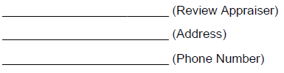
- Appraisal Report. The appraiser selected for the assignment shall make a detailed field inspection of the subject property as identified in Exhibit __ , and shall make such investigations and studies as are necessary to derive sound conclusions and to prepare the appraisal report.
- – Pre-Work Conference. At the request of the assigned review appraiser, the appraiser may be required to attend a pre-work conference for discussion and understanding of these instructions. The pre- work conference may be held in conjunction with the property examination [1(d)].
- – Examination Notice. The Contractor shall provide the property owner and the Client 10 days advance notice of the examination date and shall give the owner, or the designated representative, and the Client an opportunity to accompany the Contractor during the inspection of the property. These notices shall be documented in the Contractor's transmittal letter of the appraisal report. The Contractor shall certify that the signer of the report has personally visited the appraised property(ies) and all of the comparable transactions used in the comparative analyses.
- – Updating of Report. Upon the request of the Client, the Contractor shall, during a (XX)-year period following the valuation date of the appraisal report, update the value as of a specified date. The updated report shall be submitted in original and ___ copies (number of copies to be determined) and shall include sales data or other evidence to substantiate the updated conclusion of value. Suggested format shown herein under Section 3.
- – Testimony. Upon the request of the United States Attorney or the Department of Justice, the Contractor shall, in any judicial proceedings, testify as to the value of any and all property included in the appraisal report as of the valuation date.
- – Definition of Terms. Unless specifically defined herein or in either USPAP or UASFLA, definitions of all terms are the same as those found in “The Dictionary of Real Estate Appraisal” (Appraisal Institute), current edition. UASFLA shall take precedence in any differences among definitions.

SECTION 2 – APPRAISAL REPORT
  - – Format. The report shall be typewritten on bond paper sized 8 1/2 by 11 inches with all parts of the report legible and shall be bound with a durable cover. The face of the report shall be labeled to identify the appraised property and to show the contract number, appraiser's name and address, and the date of the appraisal. All pages of the report, including the exhibits, shall be numbered.
- Contents. Following is a suggested format, based on UASFLA. Although it is not required that the appraiser strictly adhere to it, all items must be addressed. It should be noted that in most instances, these specifications reference UASFLA without reprinting them here. Important items are noted below, but are not all-inclusive. It is incumbent upon the appraiser to read, understand, and comply with UASFLA and these specifications.
2(b)(1) – Part 1 – Introduction. Follow the UASFLA format.
- Title Page
- Letter of Transmittal
- Table of Contents

Appendix M. Sample CFP Appraisal Instructions
- Appraiser’s Certification: Follow the UASFLA and USPAP guidelines, but include the following:
“I have made a personal inspection of the appraised property which is the subject of this report and all comparable sales used in developing the estimate of value. The date(s) of inspection was [Insert Date].” (If more than one person signs the report, this certification must clearly specify which individuals did and which individuals did not make a personal inspection of the appraised property.)
“In my opinion, the market value (or other value as required) is $[Insert Amount] as of [Insert Date].”
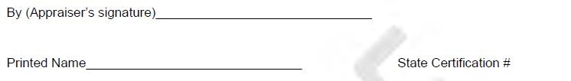
- Summary of Salient Facts and Conclusions
- Photographs of Subject. Provide original color photographs or high quality color copies of photographs of the appraised property. Photographs may be a separate exhibit in the addenda or included with the narrative description of the appraised property and comparable sales. Show the following information with each photograph:
  - Identify the photographed scene. Indicate direction of view, vantage point, and other pertinent information. A map may be used to show some of this information.
  - The name of the photographer.
  - The date the photograph was taken.
- Statement of Assumptions and Limiting Conditions. Note the following:
All appraisal reports submitted to the Community Forest Program may become the property of the United States and may be used for any legal and proper purpose. Therefore, a condition that limits distribution of the report is not permitted.
If the appraisal has been made subject to any encumbrances against the property, such as easements, liens, deed restrictions, etc., these shall be stated. It is unacceptable to state that the property has been appraised as if free and clear of all encumbrances, except as stated in the body of the report; the encumbrances must be identified in this section of the report.
The use of an uninstructed assumption or hypothetical condition that results in other than “as is” market value will invalidate the appraisal. Include only factors relating to the appraisal problem. Assumptions and limiting conditions that are speculative in nature are inappropriate. Do not include limiting conditions that significantly restrict the application of the appraisal.
In this section of the specifications, or in separate written instructions, the contractor should be instructed as to any necessary hypothetical conditions or extraordinary assumptions.
An appraiser cannot make an assumption or accept an instruction that is unreasonable or misleading. Client instructions and/or legal instructions must have a sound foundation, must be in writing, and must be included in the appraisal report.
- Scope of the Appraisal: This section shall fully describe the extent of investigation and analysis. The scope of work should be consistent with the intended use of the appraisal.
- Purpose of the Appraisal: Note the following:
A description of the property rights appraised is to be included under factual data rather than in the Purpose section.

Appendix M. Sample CFP Appraisal Instructions
Intended Use and Intended User: This section shall include a statement as to the intended use and intended user of the report. This information should be contained within the instructions given the appraiser. If the appraisal instructions do not include this information, the appraiser shall ask the assigned review appraiser to supply it.
Utilize the following definition of value: “Market value is the amount in cash, or terms reasonably equivalent to cash, for which in all probability the property would have sold on the effective date of the appraisal, after a reasonable exposure time on the open competitive market, from a willing and reasonably knowledgeable seller to a willing and reasonably knowledgeable buyer, with neither acting under any compulsion to buy or sell, giving due consideration to all available economic uses of the property at the time of the appraisal.”
This definition makes no linkage between the estimated market value and exposure time. A specific exposure time shall not be cited in an appraisal report prepared under UASFLA standards. Invoke the Jurisdictional Exception Rule to avoid a violation of USPAP standards, which may require a specific exposure time.
- Summary of Appraisal Problem: Identify the appraisal as a total acquisition appraisal. The appraiser should briefly describe the principal problems presented in estimating the market value of the property under appraisal and describe the estate to be taken. (Refer to UASFLA Section A-10 for additional guidance.)
2(b)(2) – Part 2 – Factual Data
Legal Description. (Note the following: The legal description should be provided to the appraiser at the time of initiating the appraisal assignment.) If a lengthy description would disrupt the narrative flow, it may be placed in the addenda and referenced in the text.
Property Rights. The property rights to be appraised will be provided to the appraiser in this section of the specifications or in the appraisal instructions.
Identify the property rights to be appraised as instructed. List all reservations, outstanding rights, and other encumbrances. For multiple parcel properties, list by appraised parcel. If investigation reveals differences from property rights cited in the assignment, confer with the assigned review appraiser. Discuss the effect on value of identified reservations, outstanding rights, and other encumbrances.
Area, City and Neighborhood Data. The use of boilerplate demographic and economic data is unnecessary and undesirable. Report only those data that directly impact the market analysis.
  - Area Map. Include a small-scale map showing the general location of the appraised property. It can be placed here or in the addenda.
  - Neighborhood Map. Show the appraised property and its immediate neighborhood. The map may be placed here or in the addenda.
Property Data. Include the following:
- Site Description: Dimensions, size, shape, vegetative cover, soil types, topography, elevations, wetlands, flood plains, view, timber, water rights, effect of encumbrances, livestock forage, access, road frontage, utilities, location, or other characteristics that may affect value. A statement must be made concerning the existence or absence of mineral deposits having a commercial value. Evidence, if any, of hazardous substances shall be described by the appraiser.
- Improvements
- Fixtures

Appendix M. Sample CFP Appraisal Instructions
- Use History: Ten-year history required.
- Sales History: Include a ten-year record of all sales of the appraised property and, if the information is available, offers to buy or sell. If no sale has occurred in the past ten years, the appraiser shall report the last sale of the property, irrespective of date.
- Rental History: A three-year rental history is required. An unsupported statement that the rent does not represent market or economic rent is unacceptable.
- Assessed Value and Annual Tax Load
- Zoning and Other Land-use Restrictions: The appraiser shall identify, in addition to zoning, all other land-use and environmental regulations, outstanding rights, and reservations that have an impact on the highest and best use and value of the property.
- Appraised Property Map or Plat: Show the dimensions and topography of the appraised property in detail on a large-scale topographic map, at least 2 inches to the mile. The map may be placed here or in the addenda.
2(b)(3) – Part 3 – Data Analysis and Conclusions
- Analysis of Highest and Best Use. UASFLA defines highest and best use as, “The highest and most profitable use for which the property is adaptable and needed or likely to be needed in the reasonably near future.” The appraiser may also refer to definitions as found in “The Dictionary of Real Estate Appraisal.”
A determination of the larger parcel is required in every appraisal assignment. Apply the tests provided in UASFLA to determine the larger parcel(s). If the property rights being acquired constitute two or more larger parcels, UASFLA requires an appraisal of each, concluding an independent opinion of value for each. If the property rights being appraised are a portion of a larger parcel, as determined by the appraiser, normally a before and after appraisal will be required. If the appraiser is uncertain as to the larger parcel determination, confer with the assigned Review Appraiser. If the larger parcel conclusion is different from the specific parcel assigned to be appraised, the appraiser shall inform the assigned Review Appraiser. The Review Appraiser shall, upon concurrence with the appraiser, provide the appraiser with written amended appraisal instructions and/or supplemental specifications for the appraisal of partial acquisitions.
The highest and best use conclusion must be clearly supported by market evidence.
Sale or exchange to the United States or other public entity is not an acceptable highest and best use. The use to which the buyer will put the property after it has been acquired is, as a general rule, an improper highest and best use. A non-economic highest and best use, such as “conservation,” “natural lands,” “preservation,” or any use that requires the property to be withheld from economic production in perpetuity, is not a valid use upon which to base an estimate of market value.
If the highest and best use is for assemblage, describe and explain the relationship of the appraised property to the property to which it would be joined.
If speculation or investment is the highest and best use of the property, describe and explain its interim and most probable ultimate use.
When there is a claim that the highest and best use of a property is something other than the property’s existing use, the burden of proof is on the appraiser.
Market value cannot be predicated upon potential uses that are speculative and conjectural.
The appraiser's opinion of a reasonable probability of a zoning change must have a factual foundation. The appraisal report shall include a description of the investigation undertaken to determine the probability of rezoning. The investigation shall include thorough research of the use(s) and zoning of properties situated

Appendix M. Sample CFP Appraisal Instructions
similarly, to the subject property within the area covered by the zoning authority. The stated rezoning conclusion shall be supported by facts surfaced in the research. A property cannot be valued as if it were already rezoned for a different use. The property must be valued only in light of the probability of obtaining a zone change.
- Value Estimate by the Cost Approach. Estimate the value of the land as though vacant and available for its highest and best use. Estimating land value by the use of confirmed sales of comparable, or nearly comparable, lands having like optimum uses is the preferred method. If the appraiser will place considerable weight on the cost approach to value in reaching a final value estimate, consideration should be given to retaining the services of a contractor or professional cost estimator to assist in developing the reproduction or replacement cost estimate.
Estimating depreciation by the use of published tables or age-life computation is to be avoided. The appraiser must substantiate that it is not possible to abstract depreciation rates from the market if tables or age-life methodologies are used to compute depreciation. If this is the only method used, the weakness resulting from the lack of market support is to be addressed and considered in the reconciliation.
- Value Estimate by the Sales Comparison Approach. Nearby arm’s length transactions, comparable to the land under appraisement, reasonably current, are the best evidence of market value. The Federal courts recognize the sales comparison approach as being normally the best evidence of market value.
Analyze the last sale of the subject property if relevant. If not used, explain why. An unsupported claim that a sale of the subject property was a forced sale, or is not indicative of its current value, is unacceptable.
When supportable by market evidence, the use of quantified adjustments is preferred. Percentage and dollar adjustments may, and often should, be combined. Resort to qualitative adjustments only when there is inadequate market data to support quantitative adjustments. Factors that cannot be quantified are dealt with in qualitative analysis. When quantitative and qualitative adjustments are both used in the adjustment process, all quantitative adjustments should be made first.
Include a sales adjustment chart summarizing the adjustments and showing the final adjusted sale prices and how the sales compare with the subject property.
The documentation of each comparable sale shall include:
  - Parties to the transaction
  - Date of transaction
  - Confirmation of the transaction with buyer, seller, broker, or other person having knowledge of the price, terms, and conditions of sale
  - Buyer motivation
  - Location
  - Size
  - Legal description
  - Property rights conveyed
  - Consideration
  - Financing terms
  - Sale conditions (such as arm’s length or distressed)
  - Improvements
  - Physical description (topography, vegetative cover, water influence, and other characteristics.)

Appendix M. Sample CFP Appraisal Instructions
  - Non-realty items
  - Economic characteristics, Zoning
  - Current use
  - Topographic map
  - Photographs
In order to make meaningful comparisons between the sales and the appraised property, a personal inspection should be made of all sales directly compared with the appraised property. Unusual circumstances that preclude on-the-ground inspection or make inspection unreasonably difficult shall be discussed with the assigned review appraiser prior to completion of the appraisal report. Waiver of the comparable sale inspection requirement must be made in writing by the assigned review appraiser in the form of a supplemental appraisal instruction. There shall be no waiver of the requirement for inspection of the appraised property.
The appraiser shall adhere to UASFLA direction pertaining to comparable sales requiring extraordinary verification and weighting considerations. These include sales to governmental agencies, sales to environmental organizations, sales to parties desiring to exchange the land to the government, distressed sales, and other atypical or non-arm’s length sales.
- The Income Capitalization Approach. All data shall be market supported. Built-up rates, competing investment rates, industry surveys and the like should only be used as supporting data. Rates and income/expense statements should be based on subject data or similar properties.
- The Development Approach. The development approach should not be relied upon as the primary indicator of value when comparable sales are available with which to accurately estimate the property’s market value. The appraiser shall adhere to UASFLA direction pertaining to this highly sensitive and complex method of valuation.
- Correlation and Final Conclusion of Market Value. The appraiser must avoid making a summation appraisal.
Appraisers are responsible for the final opinion of value even if it relies upon estimates developed by others (e.g., timber cruisers, mineral appraisers, cost estimators).
2(b)(4) – Part 4 – Exhibits and Agenda
Include the following items as applicable to the appraisal problem if not included in the body of the report:
- Maps. Maps shall clearly identify the properties and be of sufficient quality to enable the reviewer to locate the properties on the ground. Maps shall be dated, include a legend, scale, and north arrow. The original copy of the report MUST contain original maps or vivid color copies.
  - Area Map – Small scale map showing the general location of the subject market area.
  - Neighborhood Map – This map shall show the appraised property and its immediate neighborhood.
  - Tract Map or Plat – This shall be a large-scale (2-inch/mile) United States Geological Survey (USGS) or similar quality map that clearly shows the appraised property and pertinent physical features such as roads, streams, and improvements. If portions of the appraised property are assigned separate values, such as in an assembled exchange, these areas shall be delineated on this map, or a separate map.
  - Comparable Sales Location Map – This map shall show the location of the appraised property and the sales. Delineate the boundaries of the appraised

Appendix M. Sample CFP Appraisal Instructions
properties and comparable sales when the map is of sufficient scale to be meaningful. If all pertinent comparable sales cannot be shown on the same map as the appraised property, a smaller-scale map (such as a state road map) may be included in addition to the larger scale map.
- Sale Transaction Forms. Include a completed form showing all information for each comparable transaction used in the appraisal. Include a plat (if available), a USGS topographic map (if appropriate), and color photo(s) of each sale. The transaction number must match the number of the transaction listed in the report.
- Legal Description. Include a full legal description of the property appraised if not shown in the narrative section of the report.
- Title Information. Include a copy of the preliminary title report for the subject property.
- Photographs. Provide quality color photographs of the appraised property and all comparable in the original and all copies of the final report. Photographs may be a separate exhibit in the addenda or included with the narrative description of the appraised property and comparable sales. Show the following information with each photograph:
  - Identify the photographed scene. Indicate direction of view, vantage point, and other pertinent information. A map may be used to show some of this information.
  - The name of the photographer.
  - The date the photograph was taken.
- Other Pertinent Exhibits. Present additional data such as documents and charts pertinent to the valuation and referred to in the body of the appraisal. It could include:
  - A copy of an easement or other deed.
  - A copy of technical reports from specialists. This may include a timber cruise summary signed by a timber cruiser, a road plan signed by an engineer, or a mineral report signed by a geologist.
  - Property owner permission to appraise.
- References. List sources of data, including documents and individuals.
- Qualifications of the Appraiser. Include the qualifications of all appraisers or technicians who made significant contributions to the completion of the appraisal assignment. The appraiser(s) must provide evidence of compliance with the certification requirements of the state(s) where the properties are located.

SECTION 3 – SUPPLEMENTAL APPRAISAL REPORTS
3(a) – Format for Supplemental Appraisal Reports. Supplements or amendments to appraisal reports, such as for updating value estimates, changes in acreage, additional support or explanation, or to correct a previous appraisal report, shall be referenced for incorporation with the original report. The following format is recommended. All items must be addressed.
- Title Page. Include the same information as on the original appraisal report. Label the report as "Supplemental" or "Updated" appraisal report.
- Summary of Facts. Include (a) owner's name or other identification of the property, (b) size, (c) highest and best use, (d) new estimate of value, and (e) new valuation date.
- Summary of Original Appraisal. Cite the date and value estimate from the original appraisal. If previous updates have been made since the original appraisal, cite value estimates and value dates from all updates as well as the original appraisal.

Appendix M. Sample CFP Appraisal Instructions
- Changes. Explain the reason for the appraisal supplement, e.g., to update an estimate of value, amend a previous appraisal report, add additional support or explanation, or other.
- New Estimate of Value. Discuss the changes and market activity that have occurred since the original appraisal (or previous update). Discuss the method used to update the estimate of value and cite the evidence and/or analysis of trends that support the updated value estimated. Conclude with a statement of the new estimate of value and the valuation date, followed by the appraiser's signature.
- Appraiser’s Certification Statement.
- Addenda. Include sales data detail for new sales cited, summaries of data and trend analyses, maps of sales analyzed, and any other information relied upon but not included in the text.
- Binding. If the Supplemental Appraisal Report comprises more than four pages, it shall be bound in a durable report cover with appropriate identification.

Appendix M. Sample CFP Appraisal Instructions
SUPPLEMENTAL SPECIFICATIONS for PARTIAL ACQUISITIONS
These specifications are supplemental to the Basic Specifications for Real Property Appraisal listed above. The following instructions replace or amend portions of the Basic Specifications. They are intended for use in partial ‘physical’ acquisition appraisal. For the purpose of the CFP, a portion of a larger parcel would be the subject property. (NOTE: Partial interest acquisitions (i.e., conservation easements) are not allowed for the CFP.)
- – Contents
2(b)(1) Part I – Introduction
- Appraiser’s Certification: The appraiser must recognize that in a before and after appraisal, the property being appraised is the larger parcel, before and after the conveyance of the property being acquired. Therefore, the last statement in the Certification must be changed from that found in the Basic Specifications to the following:
"In my opinion, as of [Insert date], the market value of the larger parcel before conveyance is $[Insert amount] , and the market value of the remainder parcel is $[Insert Amount]. Therefore, the market value of the acquisition parcel is $[Insert the difference].
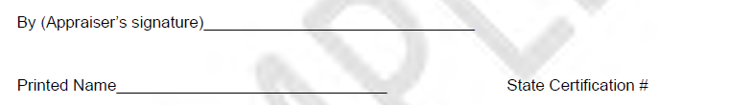
- Summary of Appraisal Problem. Identify the appraisal as a partial acquisition appraisal. The appraiser should briefly describe the principal problems presented in estimating the market value of the property under appraisal and describe the estate to be taken. Describe the before and after methodology to be used. Describe the part being conveyed, and the principal differences in the property in the before and after condition including any changes in the highest and best use of the subject property. (Refer to UASFLA Section A-10 for additional guidance.)
2(b)(2) – Part 2 – Factual Data ~ Before Acquisition
Legal Description. The legal description is generally provided to the appraiser in the appraisal assignment. If a larger parcel determination by the appraiser differs from what was assumed in the assignment, consult with the assigned Review Appraiser.
2(b)(3) – Part 3 – Data Analysis and Conclusions – Before Acquisition 2(b)(4) – Part 4 – Factual Data ~ After Acquisition
Legal Description. Since this is a partial physical acquisition, the legal description would not be the same as the larger parcel. Only a portion of the larger parcel is being acquired and this section should describe only the real estate being retained in the after condition.
Property Rights. The appraisal should specifically describe the property rights remaining with the property being acquired. NOTE: Since this is a partial physical acquisition of the larger parcel, some encumbrances (i.e. r/w easements) might not still be present on the acquired parcel.
2(b)(5) – Part 5 – Data Analysis and Conclusions – After Acquisition
The analysis and valuation sections relating to the remainder property constitute a new appraisal which

Appendix M. Sample CFP Appraisal Instructions
should follow the same format as utilized in the determination of market value for the larger parcel. The appraiser must determine the highest and best use of the property in the after condition, and develop a value analysis based on the best market data available.
2(b)(6) – Part 6 – Acquisition Analysis
Recapitulation. Show the difference between the value of the whole property and the value of the remainder by deducting the properties after value from it’s before value. This is the market value of the property being acquired.
Allocation and Explanation of Damages. (DOES NOT APPLY TO CFP ACQUISITIONS.)
Explanation of Special Benefits. (DOES NOT APPLY TO CFP ACQUISITIONS.)



Appendix N. Sample Scope of Work for CFP Review Appraisal Services
COMMUNITY FOREST PROGRAM
SAMPLE SCOPE OF WORK FOR REVIEW APPRAISAL SERVICES
Scope of Services to be provided by the Review Appraisal Firm
The appraiser and identified review appraiser will engage in an initial consultation before the project appraisal takes place. The review appraiser will develop project specific appraisal instructions for the appraiser as a result of this consultation. The Review appraiser will verify the accuracy of the appraisal report findings and conduct any Optional Services that (client name) may choose to have provided.
- Base Services: Review of Appraised Property
Contracted review appraisal firm shall complete a technical review of the subject property appraisal and prepare a review report in compliance to the Uniform Appraisal Standards for Federal Land Acquisitions (UASFLA) Standard C. The subject property is (describe subject property).
The intended use of the review is to assist the (client name) with the acquisition of the subject property in compliance with the U.S. Forest Service Community Forest Program (CFP). The intended users of the review report include the (client), (others as necessary), and the U.S. Forest Service.
- Optional Services: Other Review Appraisal Services
Contracted review appraisal firm may provide any other review appraisal services that the (client) may require within a (XXXXX) period of the date of the award.
Credentials
In order to be a qualified review appraiser for purposes of CFP appraisals, the individual contracted appraiser must meet the review appraiser requirements stated as follows:
  - The Review Appraiser should be certified as a general appraiser in the state where the appraised property is located or have obtained reciprocity or a temporary practice permit in the state where the appraised property is located.
  - The Review Appraiser must certify in the appraisal report that they meet the requirements of the ‘Competency Rule’ as stated in the current edition of the Uniform Standards of Professional Appraisal Practice (USPAP) published by the Appraisal Standards Board of The Appraisal Foundation.
Review Appraisal Firm’s Obligations
Contracted review appraisal firm shall:
  - Have demonstrated credentials, capabilities, and experience in the same or similar services as those requested.
  - Have competence, and relevant and specific knowledge and experience in same geographic locations, similar ecological terrain, and UASFLA appraisal requirements.
  - Shall engage in an initial consultation with the identified appraiser before the project appraisal takes place. The review appraiser will develop project specific appraisal instructions for the appraiser as a result of this consultation.
  - Shall prepare a technical appraisal review report that includes a determination of whether the appraisal report under review complies with the Uniform Appraisal Standards for Federal Land Acquisitions.


Appendix O. Sample Technical Appraisal Review Report
COMMUNITY FOREST PROGRAM
SAMPLE TECHNICAL APPRAISAL REVIEW REPORT
This sample Community Forest Program appraisal review report should follow the review appraiser’s ‘letter of transmittal’ for the subject review assignment. The ‘letter of transmittal’ should typically include the items stated in the UASFLA Section A-2 that would be relevant and applicable for a review appraisal report.
Technical Appraisal Review Report
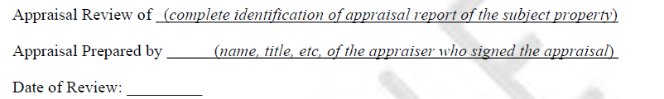
This technical appraisal review report is presented in four sections: (1) Appraisal Report Summary, (2) Appraisal Review Purpose, Scope, and Intended Use, (3) Reviewer’s Analysis, Comments, and Conclusions, and (4) Reviewer’s Certification.
As a result of my review, I (approve), (disapprove) the appraisal report that concludes an opinion of Market Value of the subject property as of (date of value), in the amount of ($ amount). (Note: If this is a partial acquisition, state the ‘difference’ between the before and after values. Also, conservation easements are not permitted for the Community Forest Program. )
If applicable, identify and state any estimated contributory value(s) for major components such as land, timber, minerals, etc.
Any jurisdictional exception, extraordinary assumption and/or hypothetical condition of the appraisal report or the appraisal review report shall be recited here. If an item is not applicable, then also include a statement to that effect.
Section 1: Appraisal Report Summary
Each item below shall be completed from information in the appraisal report.
- Owner of Record.
- Estate Appraised.
State the applicable ownership interest and reference the specific title document or client instructions. If the estate appraised is subject to any reservations, outstanding rights, or other encumbrances, state them briefly here and fully in Section 3.a.
- Legal Description.
Identify the survey and land description as applicable.
- Property Characteristics. Provide a brief overview of the significant physical, legal, and location characteristics of the property.
- Larger Parcel (& Remainder Parcel). State the size of the larger parcel. If a partial ‘physical’ acquisition; also state, the size of the remainder parcel and the resulting ‘acquisition’ parcel size (i.e. the difference). NOTE: A partial ‘interest’ acquisition (i.e., Conservation Easement) is not permitted for the Community Forest Program.
- Extraordinary Assumption and/or Hypothetical Conditions. Identify the source of the written instructions, including your pre-work instructions. If none, so state.

Appendix O. Sample Technical Appraisal Review Report
- Highest and Best Use or Permitted Use. (If a partial acquisition, then state both the H&B Use ‘Before the Taking’ and ‘After the Taking’.)
- Date of the Appraisal Report.
- Date of Appraisal.
- Appraiser.
- Value(s). (State the Market Value of the subject property. If a partial acquisition, state both the market value of the larger parcel, remainder parcel, and then state the ‘difference’ between the two values as the ‘value of the acquisition’.)
Section 2: Appraisal Review Process
- Client and Intended Users. (The U.S. Forest Service Community Forest Program (CFP) MUST be listed as one of the intended users.)
- Intended Use. (Include a reference to the CFP and federal compliance. Example: The intended use of this review report is to provide documentation that the subject appraisal developed for Community Forest Program acquisition purposes meets federal standards.)
- Purpose of the Review Assignment.
For example: The purpose of this appraisal review is to determine if the content, analysis, and conclusions contained within the appraisal report being reviewed are in compliance with the Uniform Appraisal Standards for Federal Land Acquisitions (UASFLA) and the Uniform Standards of Professional Appraisal Practice (USPAP), subject to the required invocation of USPAP’s Jurisdictional Exception Rule, as described in Section D-1of UASFLA. The purpose does not include the development of an opinion of value of the property which is the subject of the work under review.
- Scope of Work.
Describe any work you did with the appraiser before and during the appraisal. Describe any other appraisals that you returned or reviewed, subject property and comparable property inspections you made, sale verifications, additional data and information procured, analytical methods applied, and what standards were followed (i.e., USPAP Standard 3 and UASFLA Section C). If the appraiser revised the appraisal during this review, at your request, describe the extent of the revision process. Any analytical work or support documents shall be retained in the reviewer’s work file.

Appendix O. Sample Technical Appraisal Review Report
Section 3: Reviewer’s Analysis, Comments, and Conclusions
The purpose of this section is to describe the reasons and provide support for the reviewer’s conclusions and explain discrepancies and disagreements. This section should be written in a detailed narrative format that clearly achieves the standards found in UASFLA Section C and USPAP Standard 3. If the appraisal assignment involved a ‘before’ and ‘after’ analysis, then describe your review of both analyses. What follows is an outline of items to be considered for the narrative, as applicable for the content of a particular appraisal assignment.
- Present your opinion of the adequacy to which the appraiser followed appraisal instructions, cited the correct value definition, sales verification, extraordinary assumptions and hypothetical conditions, hazardous material conditions, estate appraised, legal description used, analysis of proposed acquisition, etc.
- Analyze and describe adequacy and appropriateness of appraiser’s larger parcel determination.
- Analyze and describe adequacy and appropriateness of appraiser’s highest and best use determination. Comment whether an economic analysis was appropriate and carried out correctly. Compare subject and sales for consistency of highest and best use; compare subject zoning and land use regulations with appraiser’s analysis of legal property uses; explain reasons of agreement or disagreement with highest and best use conclusion.
- Analyze and describe adequacy of appraiser’s analysis of previous sale of subject property. (Not applicable for ‘after’ analysis.)
- Review and describe adequacy and appropriateness of valuation approaches selected.
- Review and describe adequacy of treatment of contributory values of minerals, water rights, timber, improvements, personal property, and intangibles.
- Review and describe appropriateness of sale data stratification, review methods and accurateness of sales analysis, adjustments to sales, and value indications obtained from sales.
- Review for reasonableness and accuracy all assumptions and data in the cash flow analysis of the income approach and analyze for appropriateness the market extracted rate applied to the subject cash flow. Ensure the appropriateness of computer software used in sales, income, and statistical analysis.
- Explain and conclude as to the reasonableness and appropriateness of the overall appraisal methods used and support presented.

Appendix O. Sample Technical Appraisal Review Report
Repeat the above steps as applicable for the remainder parcel.
State your recommendation of approval or disapproval of the report. For example:
Recommendation:
In my opinion, the appraisal report is reasonably complete. The report cites adequate and relevant data to support an opinion of value. The report utilizes appropriate appraisal methods and techniques, and the conclusions are reasonably supported.
Therefore, it is my opinion that the appraisal adequately meets the Uniform Standards of Professional Appraisal Practice and the Uniform Appraisal Standards for Federal Land Acquisitions.
The reader should note that the report is only appropriately used if there is no change in the acreage or the estate to be conveyed. If there are any changes, this information should be submitted to the appraiser for consideration as to whether the changes would require a re-analysis of the market value of the subject property. Any such decision by the appraiser resulting from this re-analysis should be submitted in writing by the appraiser to the undersigned review appraiser for written concurrence. Please refer to the following assumptions and limiting conditions that pertain to this report.
Note: If the appraisal is not approved, then summarize the principal reasons for your action. State the reviewer’s assumptions and limiting conditions. For example:
Reviewer’s Assumptions and Limiting Conditions
- This review is based on the information in the appraisal report, and other data as noted in the Scope of the review.
- Unless otherwise stated, all assumptions and limiting conditions contained in the appraisal report, which is the subject of this review, are also conditions of this review.
- It is assumed that such data, assumptions and information are factual and accurate. If it is found that any of the reported information or assumptions in the original appraisal report is false, this may affect my opinions and conclusions.
- I reserve the right to consider any new or additional data or information that may subsequently become available.
- The Community Forest Program does not require approval or concurrence of the value estimate.

Appendix O. Sample Technical Appraisal Review Report
Section 4: Reviewer Certification (Must comply with current USPAP & UASFLA.)
I certify that, to the best of my knowledge and belief:
  - The facts and data reported by the reviewer and used in the review process are true and correct.
  - The analysis, opinions, and conclusions in this review report are limited only by the assumptions and limited conditions stated in this review report and are my own personal, impartial, and unbiased professional analysis, opinions, and conclusions.
  - I have no present or prospective interest in the property that is the subject of this report and no personal interest with respect to the parties involved.
  - I have no bias with respect to the property that is the subject of this report or to the parties involved in this assignment.
  - My engagement on this assignment was not contingent upon developing or reporting predetermined results.
  - My compensation is not contingent on an action or event resulting from the analyses, opinions, and conclusions in this review or from its use.
  - My analysis, opinions, and conclusions were developed, and this review report was prepared in conformity with the Uniform Standards of Professional Appraisal Practice and to the Uniform Appraisal Standards for Federal Land Acquisitions.
  - My report preparation and presentation conform to the requirements of the Code of Professional Ethics and Standards of (applicable professional organizations).
  - I am a member of the (applicable professional organizations) and am current on all continuing education requirements through (date).
  - I have (have not) made a personal inspection of the subject property under review.
  - (Name of professional or No one) provided significant appraisal and appraisal review assistance to the person signing this certification.
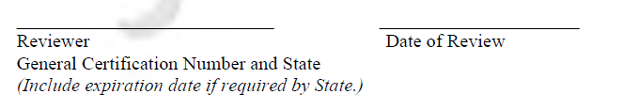
Qualifications of Review Appraiser
Attach the Qualifications Summary of the reviewer.


Appendix P. Sample Amicable Agreement landowner notification letter
COMMUNITY FOREST PROGRAM SAMPLE AMICABLE AGREEMENT LETTER
[NOTE: The CFP regulations state that: “Prior to closing, notify the landowner in writing of the appraised value of the property and that the sale is voluntary. If the grant recipient has a voluntary option for less than appraised value, they do not have to renegotiate the agreement.” Grant recipients (purchasers) should be careful with the wording in their purchase contract and/or option agreement so that the Seller cannot ‘opt out’ of the acquisition if the appraisal is higher than the sales price already negotiated.]
SAMPLE LETTER:
Re: CFP Federal Grant #xxxxxxxx: Notification of Appraised Value &
Confirmation of Amicable Agreement
Dear (Landowner and/or their representative):
Pursuant to the requirements of the above referenced U.S. Forest Service ~ Community Forest (CFP) federal grant, I am writing to inform you of the appraised value of the Fee Simple Interest of xxx.xx acres of your property designated as the XXXX tract located in XXXXXX County, and to confirm our amicable agreement for the sale of your property at the agreed price of $xxxxx. xx as stipulated in our (Date) Option Agreement (or Purchase Contract). A portion of the funds used to purchase your property were provided by the above reference grant.
The Market Value of the fee simple interest in your property, as based on an appraisal conforming to UASFLA (Yellow Book) federal appraisal standards with an effective date of XXXX XX, XXXX, is $XXX, XXX. The pending sale of your property is the result of our amicable negotiations for an agreed upon price as stipulated in our Option Agreement (or Purchase Contract). Your decision to sell your property at the agreed price is entirely voluntary on your part free from any duress, undue influence, or threat of eminent domain.
Please acknowledge receipt of this letter by signing below and returning before (select a date prior to closing). I look forward to assisting you as we work through the final stages of acquiring your property. Please contact me if you have questions or need further information.
Sincerely,
{Grant Recipient ~ Purchaser or Authorized Representative}


Appendix Q. 26 CFR 1.170A-14. Section (g)(4)—Page 13 contains information relevant to mineral remoteness determination
§ 1.170A-14 Qualified conservation contributions.
- Qualified conservation contributions. A deduction under section 170 is generally not allowed for a charitable contribution of any interest in property that consists of less than the donor's entire interest in the property other than certain transfers in trust (see § 1.170A-6 relating to charitable contributions in trust and § 1.170A-7 relating to contributions not in trust of partial interests in property). However, a deduction may be allowed under section 170(f)(3)(B)(iii) for the value of a qualified conservation contribution if the requirements of this section are met. A qualified conservation contribution is the contribution of a qualified real property interest to a qualified organization exclusively for conservation purposes. To be eligible for a deduction under this section, the conservation purpose must be protected in perpetuity.
- Qualifies real property interest
  - Entire interest of donor other than qualified mineral interest.
    - The entire interest of the donor other than a qualified mineral interest is a qualified real property interest. A qualified mineral interest is the donor's interest in subsurface oil, gas, or other minerals and the right of access to such minerals.
    - A real property interest shall not be treated as an entire interest other than a qualified mineral interest by reason of section 170(h)(2)(A) and this paragraph (b)(1) if the property in which the donor's interest exists was divided prior to the contribution in order to enable the donor to retain control of more than a qualified mineral interest or to reduce the real property interest donated. See Treasury regulations § 1.170A-7(a)(2)(I). An entire interest in real property may consist of an undivided interest in the property. But see section 170(h)(5)(A) and the regulations thereunder (relating to the requirement that the conservation purpose which is the subject of the donation must be protected in perpetuity). Minor interests, such as rights-of-way, which will not interfere with the conservation purposes of the donation, may be transferred prior to the conservation contribution without affecting the treatment of a property interest as a qualified real property interest under this paragraph (b)(1).
  - Perpetual conservation restriction. A “perpetual conservation restriction” is a qualified real property interest. A “perpetual conservation restriction” is a restriction granted in perpetuity on the use which may be made of real property - including, an easement or other interest in real property that under state law has attributes similar to an easement (e.g., a restrictive covenant or equitable servitude). For purposes of this section, the terms easement, conservation restriction, and perpetual conservation restriction have the same meaning. The definition of perpetual conservation restriction under this paragraph (b)(2) is not intended to preclude the deductibility of a donation of affirmative rights to use a land or water area under § 1.170A-13(d)(2). Any rights reserved by the donor in the donation of a perpetual conservation restriction must conform to the requirements of this section. See e.g., paragraph (d)(4)(ii), (d)(5)(I), (e)(3), and (g)(4) of this section.
- Qualified organization
  - Eligible donee. To be considered an eligible donee under this section, an organization must be a qualified organization, have a commitment to protect the conservation purposes of the donation, and have the resources to enforce the restrictions. A conservation group organized or operated primarily or substantially for one of the conservation purposes specified in section 170(h)(4)(A) will be considered to have the commitment required by the preceding sentence. A qualified organization need not set aside funds to enforce the restrictions that are the subject of the contribution. For purposes of this section, the term qualified organization means:

Appendix Q. 26 CFR 1.170A-14. Section (g)(4)—Page 13 contains information relevant to mineral remoteness determination
- A governmental unit described in section 170(b)(1)(A)(v);
- An organization described in section 170(b)(1)(A)(vi);
- A charitable organization described in section 501(c)(3) that meets the public support test of section 509(a)(2);
- A charitable organization described in section 501(c)(3) that meets the requirements of section 509(a)(3) and is controlled by an organization described in paragraphs (c)(1) (I), (ii), or (iii) of this section.
  - Transfers by donee. A deduction shall be allowed for a contribution under this section only if in the instrument of conveyance the donor prohibits the donee from subsequently transferring the easement (or, in the case of a remainder interest or the reservation of a qualified mineral interest, the property), whether or not for consideration, unless the donee organization, as a condition of the subsequent transfer, requires that the conservation purposes which the contribution was originally intended to advance continue to be carried out. Moreover, subsequent transfers must be restricted to organizations qualifying, at the time of the subsequent transfer, as an eligible donee under paragraph (c)(1) of this section. When a later unexpected change in the conditions surrounding the property that is the subject of a donation under paragraph (b)(1), (2), or (3) of this section makes impossible or impractical the continued use of the property for conservation purposes, the requirement of this paragraph will be met if the property is sold or exchanged and any proceeds are used by the donee organization in a manner consistent with the conservation purposes of the original contribution. In the case of a donation under paragraph (b)(3) of this section to which the preceding sentence applies, see also paragraph (g)(5)(ii) of this section.
- Conservation purposes -
  - In general. For purposes of section 170(h) and this section, the term conservation purposes mean-
- The preservation of land areas for outdoor recreation by, or the education of, the general public, within the meaning of paragraph (d)(2) of this section,
- The protection of a relatively natural habitat of fish, wildlife, or plants, or similar ecosystem, within the meaning of paragraph (d)(3) of this section,
- The preservation of certain open space (including farmland and forest land) within the meaning of paragraph (d)(4) of this section, or
- The preservation of a historically important land area or a certified historic structure, within the meaning of paragraph (d)(5) of this section.
  - Recreation or education -
- In general. The donation of a qualified real property interest to preserve land areas for the outdoor recreation of the general public or for the education of the general public will meet the conservation purposes test of this section. Thus, conservation purposes would include, for example, the preservation of a water area for the use of the public for boating or fishing, or a nature or hiking trail for the use of the public.

Appendix Q. 26 CFR 1.170A-14. Section (g)(4)—Page 13 contains information relevant to mineral remoteness determination
- Access. The preservation of land areas for recreation or education will not meet the test of this section unless the recreation or education is for the substantial and regular use of the general public.
  - Protection of environmental system -
- In general. The donation of a qualified real property interest to protect a significant relatively natural habitat in which a fish, wildlife, or plant community, or similar ecosystem normally lives will meet the conservation purposes test of this section. The fact that the habitat or environment has been altered to some extent by human activity will not result in a deduction being denied under this section if the fish, wildlife, or plants continue to exist there in a relatively natural state. For example, the preservation of a lake formed by a man-made dam, or a salt pond formed by a man-made dike would meet the conservation purposes test if the lake or pond were a nature feeding area for a wildlife community that included rare, endangered, or threatened native species.
- Significant habitat or ecosystem. Significant habitats and ecosystems include, but are not limited to, habitats for rare, endangered, or threatened species of animal, fish, or plants; natural areas that represent high quality examples of a terrestrial community or aquatic community, such as islands that are undeveloped or not intensely developed where the coastal ecosystem is relatively intact; and natural areas which are included in, or which contribute to, the ecological viability of a local, state, or national park, nature preserve, wildlife refuge, wilderness area, or other similar conservation area.
- Access. Limitations on public access to property that is the subject of a donation under this paragraph (d)(3) shall not render the donation nondeductible. For example, a restriction on all public access to the habitat of a threatened native animal species protected by a donation under this paragraph (d)(3) would not cause the donation to be nondeductible.
  - Preservation of open space -
- In general The donation of a qualified real property interest to preserve open space (including farmland and forest land) will meet the conservation purposes test of this section if such preservation is
    - Pursuant to a clearly delineated Federal, state, or local governmental conservation policy and will yield a significant public benefit, or
    - For the scenic enjoyment of the general public and will yield a significant public benefit.
An open space easement donated on or after December 18, 1980, must meet the requirements of section 170(h) in order to be deductible.
- Scenic enjoyment -
- Factors. A contribution made for the preservation of open space may be for the scenic enjoyment of the general public. Preservation of land may be for the scenic enjoyment of the general public if development of the property would impair the scenic character of the local rural or urban landscape or would interfere with a scenic panorama that can be enjoyed from a park, nature preserve, road, waterbody, trail, or historic structure or land area, and such area or transportation way is open to, or utilized by, the public. “Scenic enjoyment” will be evaluated by considering all pertinent facts and circumstances germane to the contribution. Regional variations in topography, geology, biology, and cultural and economic conditions require flexibility in the application of this test, but do not lessen the burden on the taxpayer to demonstrate the scenic characteristics of a donation under this paragraph. The application of a particular objective factor to help define a view as scenic in one setting may in fact be entirely inappropriate in another setting. Among the factors to be considered are:

Appendix Q. 26 CFR 1.170A-14. Section (g)(4)—Page 13 contains information relevant to mineral remoteness determination
        - The compatibility of the land use with other land in the vicinity.
        - The degree of contrast and variety provided by the visual scene.
        - The openness of the land (which would be a more significant factor in an urban or densely populated setting or in a heavily wooded area);
        - Relief from urban closeness.
        - The harmonious variety of shapes and textures.
        - The degree to which the land use maintains the scale and character of the urban landscape to preserve open space, visual enjoyment, and sunlight for the surrounding area.
        - The consistency of the proposed scenic view with a methodical state scenic identification program, such as a state landscape inventory; and
        - The consistency of the proposed scenic view with a regional or local landscape inventory made pursuant to a sufficiently rigorous review process, especially if the donation is endorsed by an appropriate state or local governmental agency.
- Access. To satisfy the requirement of scenic enjoyment by the general public, visual (rather than physical) access to or across the property by the general public is sufficient. Under the terms of an open space easement on scenic property, the entire property need not be visible to the public for a donation to qualify under this section, although the public benefit from the donation may be insufficient to qualify for a deduction if only a small portion of the property is visible to the public.
- Governmental conservation policy -
- In general. The requirement that the preservation of open space be pursuant to a clearly delineated Federal, state, or local governmental policy is intended to protect the types of property identified by representatives of the general public as worthy of preservation or conservation. A general declaration of conservation goals by a single official or legislative body is not sufficient. However, a governmental conservation policy need not be a certification program that identifies particular lots or small parcels of individually owned property. This requirement will be met by donations that further a specific, identified conservation project, such as the preservation of land within a state or local landmark district that is locally recognized as being significant to that district; the preservation of a wild or scenic river, the preservation of farmland pursuant to a state program for flood prevention and control; or the protection of the scenic, ecological, or historic character of land that is contiguous to, or an integral part of, the surroundings of existing recreation or conservation sites. For example, the donation of a perpetual conservation restriction to a qualified organization pursuant to a formal resolution or certification by a local governmental agency established under state law specifically identifying the subject property as worthy of protection for conservation purposes will meet the requirement of this paragraph. A program need not be funded to satisfy this requirement, but the program must involve a significant commitment by the government with respect to the conservation project. For example, a governmental program according to preferential tax assessment or preferential zoning for certain property deemed worthy of protection for conservation purposes would constitute a significant commitment by the government.

Appendix Q. 26 CFR 1.170A-14. Section (g)(4)—Page 13 contains information relevant to mineral remoteness determination
- Effect of acceptance by governmental agency. Acceptance of an easement by an agency of the Federal Government or by an agency of a state or local government (or by a commission, authority, or similar body duly constituted by the state or local government and acting on behalf of the state or local government) tends to establish the requisite clearly delineated governmental policy, although such acceptance, without more, is not sufficient. The more rigorous the review process by the governmental agency, the more the acceptance of the easement tends to establish the requisite clearly delineated governmental policy. For example, in a state where the legislature has established an Environmental Trust to accept gifts to the state which meet certain conservation purposes and to submit the gifts to a review that requires the approval of the state's highest officials, acceptance of a gift by the Trust tends to establish the requisite clearly delineated governmental policy. However, if the Trust merely accepts such gifts without a review process, the requisite clearly delineated governmental policy is not established.
- Access. A limitation on public access to property subject to a donation under this paragraph (d)(4)(iii) shall not render the deduction nondeductible unless the conservation purpose of the donation would be undermined or frustrated without public access. For example, a donation pursuant to a governmental policy to protect the scenic character of land near a river requires visual access to the same extent as would a donation under paragraph (d)(4)(ii) of this section.
- Significant public benefit -
- Factors. All contributions made for the preservation of open space must yield a significant public benefit. Public benefit will be evaluated by considering all pertinent facts and circumstances germane to the contribution. Factors germane to the evaluation of public benefit from one contribution may be irrelevant in determining public benefit from another contribution. No single factor will necessarily be determinative. Among the factors to be considered are:
    - The uniqueness of the property to the area.
    - The intensity of land development in the vicinity of the property (both existing development and foreseeable trends of development);
    - The consistency of the proposed open space use with public programs (whether Federal, state or local) for conservation in the region, including programs for outdoor recreation, irrigation or water supply protection, water quality maintenance or enhancement, flood prevention and control, erosion control, shoreline protection, and protection of land areas included in, or related to, a government approved master plan or land management area;
    - The consistency of the proposed open space use with existing private conservation programs in the area, as evidenced by other land, protected by easement or fee ownership by organizations referred to in § 1.170A-14(c)(1), in close proximity to the property.
    - The likelihood that development of the property would lead to or contribute to degradation of the scenic, natural, or historic character of the area.
    - The opportunity for the general public to use the property or to appreciate its scenic values.
    - The importance of the property in preserving a local or regional landscape or resource that attracts tourism or commerce to the area.

Appendix Q. 26 CFR 1.170A-14. Section (g)(4)—Page 13 contains information relevant to mineral remoteness determination
    - The likelihood that the donee will acquire equally desirable and valuable substitute property or property rights.
    - The cost to the donee of enforcing the terms of the conservation restriction.
    - The population density in the area of the property; and
    - The consistency of the proposed open space use with a legislatively mandated program identifying particular parcels of land for future protection.
- Illustrations. The preservation of an ordinary tract of land would not in and of itself yield a significant public benefit, but the preservation of ordinary land areas in conjunction with other factors that demonstrate significant public benefit or the preservation of a unique land area for public employment would yield a significant public benefit. For example, the preservation of a vacant downtown lot would not by itself yield a significant public benefit, but the preservation of the downtown lot as a public garden would, absent countervailing factors, yield a significant public benefit. The following are other examples of contributions which would, absent countervailing factors, yield a significant public benefit: The preservation of farmland pursuant to a state program for flood prevention and control; the preservation of a unique natural land formation for the enjoyment of the general public; the preservation of woodland along a public highway pursuant to a government program to preserve the appearance of the area so as to maintain the scenic view from the highway; and the preservation of a stretch of undeveloped property located between a public highway and the ocean in order to maintain the scenic ocean view from the highway.
- Limitation. A deduction will not be allowed for the preservation of open space under section 170(h)(4)(A)(iii), if the terms of the easement permit a degree of intrusion or future development that would interfere with the essential scenic quality of the land or with the governmental conservation policy that is being furthered by the donation. See § 1.170A-14(e)(2) for rules relating to inconsistent use.
- Relationship of requirements -
- Clearly delineated governmental policy and significant public benefit. Although the requirements of “clearly delineated governmental policy” and “significant public benefit” must be met independently, for purposes of this section the two requirements may also be related. The more specific the governmental policy with respect to the particular site to be protected, the more likely the governmental decision, by itself, will tend to establish the significant public benefit associated with the donation. For example, while a statute in State X permitting preferential assessment for farmland is, by definition, governmental policy, it is distinguishable from a state statute, accompanied by appropriations, naming the X River as a valuable resource and articulating the legislative policy that the X River and the relatively natural quality of its surrounding be protected. On these facts, an open space easement on farmland in State X would have to demonstrate additional factors to establish “significant public benefit.” The specificity of the legislative mandate to protect the X River, however, would by itself tend to establish the significant public benefit associated with an open space easement on land fronting the X River.
- Scenic enjoyment and significant public benefit. With respect to the relationship between the requirements of “scenic enjoyment” and “significant public benefit,” since the degrees of scenic enjoyment offered by a variety of open space easements are subjective and not as easily delineated as are increasingly specific levels of governmental policy, the significant public benefit of preserving a scenic view must be independently established in all cases.

Appendix Q. 26 CFR 1.170A-14. Section (g)(4)—Page 13 contains information relevant to mineral remoteness determination
- Donations may satisfy more than one test. In some cases, open space easements may be both for scenic enjoyment and pursuant to a clearly delineated governmental policy. For example, the preservation of a particular scenic view identified as part of a scenic landscape inventory by a rigorous governmental review process will meet the tests of both paragraphs (d)(4)(I)(A) and (d)(4)(i)(B) of this section.
- Historic preservation -
        - In general. The donation of a qualified real property interest to preserve an historically important land area or a certified historic structure will meet the conservation purposes test of this section. When restrictions to preserve a building or land area within a registered historic district permit future development on the site, a deduction will be allowed under this section only if the terms of the restrictions require that such development conform with appropriate local, state, or Federal standards for construction or rehabilitation within the district. See also, § 1.170A-14(h)(3)(ii).
        - Historically important land area. The term historically important land area includes:
- An independently significant land area including any related historic resources (for example, an archaeological site or a Civil War battlefield with related monuments, bridges, cannons, or houses) that meets the National Register Criteria for Evaluation in 36 CFR 60.4 (Pub. L. 89-665, 80 Stat. 915);
- Any land area within a registered historic district including any buildings on the land area that can reasonably be considered as contributing to the significance of the district; and
- Any land area (including related historic resources) adjacent to a property listed individually in the National Register of Historic Places (but not within a registered historic district) in a case where the physical or environmental features of the land area contribute to the historic or cultural integrity of the property.
        - Certified historic structure. The term certified historic structure, for purposes of this section, means any building, structure or land area which is -
- Listed in the National Register, or
- Located in a registered historic district (as defined in section 48(g)(3)(B)) and is certified by the Secretary of the Interior (pursuant to 36 CFR 67.4) to the Secretary of the Treasury as being of historic significance to the district.
A structure for purposes of this section means any structure, whether or not it is depreciable. Accordingly, easements on private residences may qualify under this section. In addition, a structure would be considered to be a certified historic structure if it were certified either at the time the transfer was made or at the due date (including extensions) for filing the donor's return for the taxable year in which the contribution was made.
        - Access.
- In order for a conservation contribution described in section 170(h)(4)(A)(iv) and this paragraph (d)(5) to be deductible, some visual public access to the donated property is required. In the case of an historically important land area, the entire property need not be visible to the public for a donation to qualify under this section. However, the public benefit from the donation may be insufficient to qualify for a deduction if only a small portion of the property is so visible. Where the historic land area or certified historic structure which is the subject of the donation is not visible from a public way (e.g., the structure is hidden from view by a wall or shrubbery, the structure is too far from the public way, or interior

Appendix Q. 26 CFR 1.170A-14. Section (g)(4)—Page 13 contains information relevant to mineral remoteness determination
characteristics and features of the structure are the subject of the easement), the terms of the easement must be such that the general public is given the opportunity on a regular basis to view the characteristics and features of the property which are preserved by the easement to the extent consistent with the nature and condition of the property.
- Factors to be considered in determining the type and amount of public access required under paragraph (d)(5)(iv)(A) of this section include the historical significance of the donated property, the nature of the features that are the subject of the easement, the remoteness or accessibility of the site of the donated property, the possibility of physical hazards to the public visiting the property (for example, an unoccupied structure in a dilapidated condition), the extent to which public access would be an unreasonable intrusion on any privacy interests of individuals living on the property, the degree to which public access would impair the preservation interests which are the subject of the donation, and the availability of opportunities for the public to view the property by means other than visits to the site.
- The amount of access afforded the public by the donation of an easement shall be determined with reference to the amount of access permitted by the terms of the easement which are established by the donor, rather than the amount of access actually provided by the donee organization. However, if the donor is aware of any facts indicating that the amount of access that the donee organization will provide is significantly less than the amount of access permitted under the terms of the easement, then the amount of access afforded the public shall be determined with reference to this lesser amount.
        - Examples. The provisions of paragraph (d)(5)(iv) of this section may be illustrated by the following examples:
Example 1.
A and his family live in a house in a certified historic district in the State of X. The entire house, including its interior, has architectural features representing classic Victorian period architecture. A donates an exterior and interior easement on the property to a qualified organization but continues to live in the house with his family. A's house is surrounded by a high stone wall which obscures the public's view of it from the street. Pursuant to the terms of the easement, the house may be opened to the public from 10:00 a.m. to 4:00 p.m. on one Sunday in May and one Sunday in November each year for house and garden tours. These tours are to be under the supervision of the donee and open to members of the general public upon payment of a small fee. In addition, under the terms of the easement, the donee organization is given the right to photograph the interior and exterior of the house and distribute such photographs to magazines, newsletters, or other publicly available publications. The terms of the easement also permit persons affiliated with educational organizations, professional architectural associations, and historical societies to make an appointment through the donee organization to study the property. The donor is not aware of any facts indicating that the public access to be provided by the donee organization will be significantly less than that permitted by the terms of the easement. The 2 opportunities for public visits per year, when combined with the ability of the general public to view the architectural characteristics and features that are the subject of the easement through photographs, the opportunity for scholarly study of the property, and the fact that the house is used as an occupied residence, will enable the donation to satisfy the requirement of public access.
Example 2.
B owns an unoccupied farmhouse built in the 1840's and located on a property that is adjacent to a Civil War battlefield. During the Civil War the farmhouse was used as quarters for Union troops. The battlefield is visited year-round by the general public. The condition of the farmhouse is such that the safety of visitors

Appendix Q. 26 CFR 1.170A-14. Section (g)(4)—Page 13 contains information relevant to mineral remoteness determination
will not be jeopardized and opening it to the public will not result in significant deterioration. The farmhouse is not visible from the battlefield or any public way. It is accessible only by way of a private road owned by B. B donates a conservation easement on the farmhouse to a qualified organization. The terms of the easement provide that the donee organization may open the property (via B's road) to the general public on four weekends each year from 8:30 a.m. to 4:00 p.m. The donation does not meet the public access requirement because the farmhouse is safe, unoccupied, and easily accessible to the general public who have come to the site to visit Civil War historic land areas (and related resources) but will only be open to the public on four weekends each year. However, the donation would meet the public access requirement if the terms of the easement permitted the donee organization to open the property to the public every other weekend during the year and the donor is not aware of any facts indicating that the donee organization will provide significantly less access than that permitted.
- Exclusively for conservation purposes -
  - In general. To meet the requirements of this section, a donation must be exclusively for conservation purposes. See paragraphs (c)(1) and (g)(1) through (g)(6)(ii) of this section. A deduction will not be denied under this section when incidental benefit inures to the donor merely as a result of conservation restrictions limiting the uses to which the donor's property may be put.
  - Inconsistent use. Except as provided in paragraph (e)(4) of this section, a deduction will not be allowed if the contribution would accomplish one of the enumerated conservation purposes but would permit destruction of other significant conservation interests. For example, the preservation of farmland pursuant to a State program for flood prevention and control would not qualify under paragraph (d)(4) of this section if under the terms of the contribution a significant naturally occurring ecosystem could be injured or destroyed by the use of pesticides in the operation of the farm. However, this requirement is not intended to prohibit uses of the property, such as selective timber harvesting or selective farming if, under the circumstances, those uses do not impair significant conservation interests.
  - Inconsistent use permitted. A use that is destructive of conservation interests will be permitted only if such use is necessary for the protection of the conservation interests that are the subject of the contribution. For example, a deduction for the donation of an easement to preserve an archaeological site that is listed on the National Register of Historic Places will not be disallowed if site excavation consistent with sound archaeological practices may impair a scenic view of which the land is a part. A donor may continue a pre-existing use of the property that does not conflict with the conservation purposes of the gift.
- Examples. The provisions of this section relating to conservation purposes may be illustrated by the following examples.
Example 1.
State S contains many large tract forests that are desirable recreation and scenic areas for the general public. The forests' scenic values attract millions of people to the State. However, due to the increasing intensity of land development in State S, the continued existence of forestland parcels greater than 45 acres is threatened. J grants a perpetual easement on a 100-acre parcel of forestland that is part of one of the State's scenic areas to a qualifying organization. The easement imposes restrictions on the use of the parcel for the purpose of maintaining its scenic values. The restrictions include a requirement that the parcel be maintained forever as open space devoted exclusively to conservation purposes and wildlife protection, and that there be no commercial, industrial, residential, or other development use of such parcel. The law of State S recognizes a limited public right to enter private land, particularly for

Appendix Q. 26 CFR 1.170A-14. Section (g)(4)—Page 13 contains information relevant to mineral remoteness determination
recreational pursuits, unless such land is posted or the landowner objects. The easement specifically restricts the landowner from posting the parcel, or from objecting, thereby maintaining public access to the parcel according to the custom of the State. J's parcel provides the opportunity for the public to enjoy the use of the property and appreciate its scenic values. Accordingly, J's donation qualifies for a deduction under this section.
Example 2.
A qualified conservation organization owns Greenacre in fee as a nature preserve. Greenacre contains a high-quality example of a tall grass prairie ecosystem. Farmacre, an operating farm, adjoins Greenacre and is a compatible buffer to the nature preserve. Conversion of Farmacre to a more intense use, such as a housing development, would adversely affect the continued use of Greenacre as a nature preserve because of human traffic generated by the development. The owner of Farmacre donates an easement preventing any future development on Farmacre to the qualified conservation organization for conservation purposes. Normal agricultural uses will be allowed on Farmacre. Accordingly, the donation qualifies for a deduction under this section.
Example 3.
H owns Greenacre, a 900-acre parcel of woodland, rolling pasture, and orchards on the crest of a mountain. All of Greenacre is clearly visible from a nearby national park. Because of the strict enforcement of an applicable zoning plan, the highest and best use of Greenacre is as a subdivision of 40-acre tracts. H wishes to donate a scenic easement on Greenacre to a qualifying conservation organization, but H would like to reserve the right to subdivide Greenacre into 90-acre parcels with no more than one single-family home allowable on each parcel. Random building on the property, even as little as one home for each 90 acres, would destroy the scenic character of the view. Accordingly, no deduction would be allowable under this section.
Example 4.
Assume the same facts as in example (3), except that not all of Greenacre is visible from the park and the deed of easement allows for limited cluster development of no more than five nine-acre clusters (with four houses on each cluster) located in areas generally not visible from the national park and subject to site and building plan approval by the donee organization in order to preserve the scenic view from the park. The donor and the donee have already identified sites where limited cluster development would not be visible from the park or would not impair the view. Owners of homes in the clusters will not have any rights with respect to the surrounding Greenacre property that are not also available to the general public. Accordingly, the donation qualifies for a deduction under this section.
Example 5.
In order to protect State S's declining open space that is suited for agricultural use from increasing development pressure that has led to a marked decline in such open space, the Legislature of State S passed a statute authorizing the purchase of “agricultural land development rights” on open acreage. Agricultural land development rights allow the State to place agricultural preservation restrictions on land designated as worthy of protection in order to preserve open space and farm resources. Agricultural preservation restrictions prohibit or limit construction or placement of buildings except those used for agricultural purposes or dwellings used for family living by the farmer and his family and employees; removal of mineral substances in any manner that adversely affects the land's agricultural potential; or other uses detrimental to retention of the land for agricultural use. Money has been appropriated for this program and some landowners have in fact sold their “agricultural land development rights” to State S. K

Appendix Q. 26 CFR 1.170A-14. Section (g)(4)—Page 13 contains information relevant to mineral remoteness determination
owns and operates a small dairy farm in State S located in an area designated by the Legislature as worthy of protection. K desires to preserve his farm for agricultural purposes in perpetuity. Rather than selling the development rights to State S, K grants to a qualified organization an agricultural preservation restriction on his property in the form of a conservation easement. K reserves to himself, his heirs and assigns the right to manage the farm consistent with sound agricultural and management practices. The preservation of K's land is pursuant to a clearly delineated governmental policy of preserving open space available for agricultural use and will yield a significant public benefit by preserving open space against increasing development pressures.
- Enforceable in perpetuity -
- In general. In the case of any donation under this section, any interest in the property retained by the donor (and the donor's successors in interest) must be subject to legally enforceable restrictions (for example, by recordation in the land records of the jurisdiction in which the property is located) that will prevent uses of the retained interest inconsistent with the conservation purposes of the donation. In the case of a contribution of a remainder interest, the contribution will not qualify if the tenants, whether they are tenants for life or a term of years, can use the property in a manner that diminishes the conservation values which are intended to be protected by the contribution.
- Protection of a conservation purpose in case of donation of property subject to a mortgage. In the case of conservation contributions made after February 13, 1986, no deduction will be permitted under this section for an interest in property which is subject to a mortgage unless the mortgagee subordinates its rights in the property to the right of the qualified organization to enforce the conservation purposes of the gift in perpetuity. For conservation contributions made prior to February 14, 1986, the requirement of section 170 (h)(5)(A) is satisfied in the case of mortgaged property (with respect to which the mortgagee has not subordinated its rights) only if the donor can demonstrate that the conservation purpose is protected in perpetuity without subordination of the mortgagee's rights.
- Remote future event. A deduction shall not be disallowed under section 170(f)(3)(B)(iii) and this section merely because the interest which passes to, or is vested in, the donee organization may be defeated by the performance of some act or the happening of some event, if on the date of the gift it appears that the possibility that such act or event will occur is so remote as to be negligible. See paragraph of § 1.170A-1. For example, a state's statutory requirement that use restrictions must be rerecorded every 30 years to remain enforceable shall not, by itself, render an easement nonperpetual.
- Retention of qualified mineral interest -
- In general. Except as otherwise provided in paragraph (g)(4)(ii) of this section, the requirements of this section are not met and no deduction shall be allowed in the case of a contribution of any interest when there is a retention by any person of a qualified mineral interest (as defined in paragraph (b)(1)(i) of this section) if at any time there may be extractions or removal of minerals by any surface mining method. Moreover, in the case of a qualified mineral interest gift, the requirement that the conservation purposes be protected in perpetuity is not satisfied if any method of mining that is inconsistent with the particular conservation purposes of a contribution is permitted at any time. See also § 1.170A-14(e)(2). However, a deduction under this section will not be denied in the case of certain methods of mining that may have limited, localized impact on the real property but that are not irremediably destructive of significant conservation interests. For example, a deduction will not be denied in a case where production facilities are concealed or compatible with existing topography and landscape and when surface alteration is to be restored to its original state.

Appendix Q. 26 CFR 1.170A-14. Section (g)(4)—Page 13 contains information relevant to mineral remoteness determination
- Exception for qualified conservation contributions after July 1984.
- A contribution made after July 18, 1984, of a qualified real property interest described in section 170(h)(2)(A) shall not be disqualified under the first sentence of paragraph (g)(4)(i) of this section if the following requirements are satisfied.
      - The ownership of the surface estate and mineral interest were separated before June 13, 1976 and remain so separated up to and including the time of the contribution.
      - The present owner of the mineral interest is not a person whose relationship to the owner of the surface estate is described at the time of the contribution in section 267(b) or section 707(b), and
      - The probability of extraction or removal of minerals by any surface mining method is so remote as to be negligible.
Whether the probability of extraction or removal of minerals by surface mining is so remote as to be negligible is a question of fact and is to be made on a case-by-case basis. Relevant factors to be considered in determining if the probability of extraction or removal of minerals by surface mining is so remote as to be negligible include Geological, geophysical or economic data showing the absence of mineral reserves on the property, or the lack of commercial feasibility at the time of the contribution of surface mining the mineral interest.
- If the ownership of the surface estate and mineral interest first became separated after June 12, 1976, no deduction is permitted for a contribution under this section unless surface mining on the property is completely prohibited.
- Examples. The provisions of paragraph (g)(4)(i) and (ii) of this section may be illustrated by the following examples:
Example 1.
K owns 5,000 acres of bottomland hardwood property along a major watershed system in the southern part of the United States. Agencies within the Department of the Interior have determined that southern bottomland hardwoods are a rapidly diminishing resource and a critical ecosystem in the south because of the intense pressure to cut the trees and convert the land to agricultural use. These agencies have further determined (and have indicated in correspondence with K) that bottomland hardwoods provide a superb habitat for numerous species and play an important role in controlling floods and purifying rivers. K donates to a qualified organization his entire interest in this property other than his interest in the gas and oil deposits that have been identified under K's property. K covenants and can ensure that, although drilling for gas and oil on the property may have some temporary localized impact on the real property, the drilling will not interfere with the overall conservation purpose of the gift, which is to protect the unique bottomland hardwood ecosystem. Accordingly, the donation qualifies for a deduction under this section.
Example 2.
Assume the same facts as in Example 1, except that in 1979, K sells the mineral interest to A, an unrelated person, in an arm's-length transaction, subject to a recorded prohibition on the removal of any minerals by any surface mining method and a recorded prohibition against any mining technique that will harm the bottomland hardwood ecosystem. After the sale to A, K donates a qualified real property interest to a qualified organization to protect the bottomland hardwood ecosystem. Since at the time of the transfer, surface mining and any mining technique that will harm the bottomland hardwood ecosystem are completely prohibited, the donation qualifies for a deduction under this section.

Appendix Q. 26 CFR 1.170A-14. Section (g)(4)—Page 13 contains information relevant to mineral remoteness determination
- Protection of conservation purpose where taxpayer reserves certain rights -
- Documentation. In the case of a donation made after February 13, 1986, of any qualified real property interest when the donor reserves rights the exercise of which may impair the conservation interests associated with the property, for a deduction to be allowable under this section the donor must make available to the donee, prior to the time the donation is made, documentation sufficient to establish the condition of the property at the time of the gift. Such documentation is designed to protect the conservation interests associated with the property, which although protected in perpetuity by the easement, could be adversely affected by the exercise of the reserved rights. Such documentation may include:
- The appropriate survey maps from the United States Geological Survey, showing the property line and other contiguous or nearby protected areas;
- A map of the area drawn to scale showing all existing man-made improvements or incursions (such as roads, buildings, fences, or gravel pits), vegetation and identification of flora and fauna (including, for example, rare species locations, animal breeding and roosting areas, and migration routes), land use history (including present uses and recent past disturbances), and distinct natural features (such as large trees and aquatic areas);
- An aerial photograph of the property at an appropriate scale taken as close as possible to the date the donation is made; and
- On-site photographs taken at appropriate locations on the property. If the terms of the donation contain restrictions with regard to a particular natural resource to be protected, such as water quality or air quality, the condition of the resource at or near the time of the gift must be established. The documentation, including the maps and photographs, must be accompanied by a statement signed by the donor and a representative of the donee clearly referencing the documentation and in substance saying “This natural resources inventory is an accurate representation of [the protected property] at the time of the transfer.”.
- Donee's right to inspection and legal remedies. In the case of any donation referred to in paragraph (g)(5)(i) of this section, the donor must agree to notify the donee, in writing, before exercising any reserved right, e.g. the right to extract certain minerals which may have an adverse impact on the conservation interests associated with the qualified real property interest. The terms of the donation must provide a right of the donee to enter the property at reasonable times for the purpose of inspecting the property to determine if there is compliance with the terms of the donation. Additionally, the terms of the donation must provide a right of the donee to enforce the conservation restrictions by appropriate legal proceedings, including but not limited to, the right to require the restoration of the property to its condition at the time of the donation.
- Extinguishment.
- In general. If a subsequent unexpected change in the conditions surrounding the property that is the subject of a donation under this paragraph can make impossible or impractical the continued use of the property for conservation purposes, the conservation purpose can nonetheless be treated as protected in perpetuity if the restrictions are extinguished by judicial proceeding and all of the donee's proceeds (determined under paragraph (g)(6)(ii) of this section) from a subsequent sale or exchange of the property are used by the donee organization in a manner consistent with the conservation purposes of the original contribution.

Appendix Q. 26 CFR 1.170A-14. Section (g)(4)—Page 13 contains information relevant to mineral remoteness determination
- Proceeds. In case of a donation made after February 13, 1986, for a deduction to be allowed under this section, at the time of the gift the donor must agree that the donation of the perpetual conservation restriction gives rise to a property right, immediately vested in the donee organization, with a fair market value that is at least equal to the proportionate value that the perpetual conservation restriction at the time of the gift, bears to the value of the property as a whole at that time. See § 1.170A-14(h)(3)(iii) relating to the allocation of basis. For purposes of this paragraph (g)(6)(ii), that proportionate value of the donee's property rights shall remain constant. Accordingly, when a change in conditions give rise to the extinguishment of a perpetual conservation restriction under paragraph (g)(6)(i) of this section, the donee organization, on a subsequent sale, exchange, or involuntary conversion of the subject property, must be entitled to a portion of the proceeds at least equal to that proportionate value of the perpetual conservation restriction, unless state law provides that the donor is entitled to the full proceeds from the conversion without regard to the terms of the prior perpetual conservation restriction.
- Valuation -
- Entire interest of donor other than qualified mineral interest. The value of the contribution under section 170 in the case of a contribution of a taxpayer's entire interest in property other than a qualified mineral interest is the fair market value of the surface rights in the property contributed. The value of the contribution shall be computed without regard to the mineral rights. See paragraph (h)(4), example (1), of this section.
- Remainder interest in real property. In the case of a contribution of any remainder interest in real property, section 170(f)(4) provides that in determining the value of such interest for purposes of section 170, depreciation and depletion of such property shall be taken into account. See § 1.170A-12. In the case of the contribution of a remainder interest for conservation purposes, the current fair market value of the property (against which the limitations of § 1.170A-12 are applied) must take into account any pre-existing or contemporaneously recorded rights limiting, for conservation purposes, the use to which the subject property may be put.
- Perpetual conservation restriction -
- In general. The value of the contribution under section 170 in the case of a charitable contribution of a perpetual conservation restriction is the fair market value of the perpetual conservation restriction at the time of the contribution. See § 1.170A-7(c). If there is a substantial record of sales of easements comparable to the donated easement (such as purchases pursuant to a governmental program), the fair market value of the donated easement is based on the sales prices of such comparable easements. If no substantial record of market-place sales is available to use as a meaningful or valid comparison, as a general rule (but not necessarily in all cases) the fair market value of a perpetual conservation restriction is equal to the difference between the fair market value of the property it encumbers before the granting of the restriction and the fair market value of the encumbered property after the granting of the restriction. The amount of the deduction in the case of a charitable contribution of a perpetual conservation restriction covering a portion of the contiguous property owned by a donor and the donor's family (as defined in section 267(c)(4)) is the difference between the fair market value of the entire contiguous parcel of property before and after the granting of the restriction. If the granting of a perpetual conservation restriction after January 14, 1986, has the effect of increasing the value of any other property owned by the donor or a related person, the amount of the deduction for the conservation contribution shall be reduced by the amount of the increase in the value of the other property, whether or not such

Appendix Q. 26 CFR 1.170A-14. Section (g)(4)—Page 13 contains information relevant to mineral remoteness determination
property is contiguous. If, as a result of the donation of a perpetual conservation restriction, the donor or a related person receives, or can reasonably expect to receive, financial or economic benefits that are greater than those that will inure to the general public from the transfer, no deduction is allowable under this section. However, if the donor or a related person receives, or can reasonably expect to receive, a financial or economic benefit that is substantial, but it is clearly shown that the benefit is less than the amount of the transfer, then a deduction under this section is allowable for the excess of the amount transferred over the amount of the financial or economic benefit received or reasonably expected to be received by the donor or the related person. For purposes of this paragraph (h)(3)(i), related person shall have the same meaning as in either section 267(b) or section 707(b). (See Example 10 of paragraph (h)(4) of this section.)
- Fair market value of property before and after restriction. If before and after valuation is used, the fair market value of the property before contribution of the conservation restriction must take into account not only the current use of the property but also an objective assessment of how immediate or remote the likelihood is that the property, absent the restriction, would in fact be developed, as well as any effect from zoning, conservation, or historic preservation laws that already restrict the property's potential highest and best use. Further, there may be instances where the grant of a conservation restriction may have no material effect on the value of the property or may in fact serve to enhance, rather than reduce, the value of property. In such instances no deduction would be allowable. In the case of a conservation restriction that allows for any development, however limited, on the property to be protected, the fair market value of the property after contribution of the restriction must take into account the effect of the development. In the case of a conservation easement such as an easement on a certified historic structure, the fair market value of the property after contribution of the restriction must take into account the amount of access permitted by the terms of the easement. Additionally, if before and after valuation is used, an appraisal of the property after contribution of the restriction must take into account the effect of restrictions that will result in a reduction of the potential fair market value represented by highest and best use but will, nevertheless, permit uses of the property that will increase its fair market value above that represented by the property's current use. The value of a perpetual conservation restriction shall not be reduced by reason of the existence of restrictions on transfer designed solely to ensure that the conservation restriction will be dedicated to conservation purposes. See § 1.170A-14 (c)(3).
- Allocation of basis. In the case of the donation of a qualified real property interest for conservation purposes, the basis of the property retained by the donor must be adjusted by the elimination of that part of the total basis of the property that is properly allocable to the qualified real property interest granted. The amount of the basis that is allocable to the qualified real property interest shall bear the same ratio to the total basis of the property as the fair market value of the qualified real property interest bears to the fair market value of the property before the granting of the qualified real property interest. When a taxpayer donates to a qualifying conservation organization an easement on a structure with respect to which deductions are taken for depreciation, the reduction required by this paragraph (h)(3)(ii) in the basis of the property retained by the taxpayer must be allocated between the structure and the underlying land.
- Examples. The provisions of this section may be illustrated by the following examples. In examples illustrating the value or deductibility of donations, the applicable restrictions and limitations of § 1.170A- 4, with respect to reduction in amount of charitable contributions of certain appreciated property, and § 1.170A-8, with respect to limitations on charitable deductions by individuals. must also be taken into account.

Appendix Q. 26 CFR 1.170A-14. Section (g)(4)—Page 13 contains information relevant to mineral remoteness determination
Example 1.
A owns Goldacre, a property adjacent to a state park. A wants to donate Goldacre to the state to be used as part of the park, but A wants to reserve a qualified mineral interest in the property, to exploit currently and to devise at death. The fair market value of the surface rights in Goldacre is $200,000 and the fair market value of the mineral rights in $100.000. In order to ensure that the quality of the park will not be degraded, restrictions must be imposed on the right to extract the minerals that reduce the fair market value of the mineral rights to $80,000. Under this section, the value of the contribution is $200,000 (the value of the surface rights).
Example 2.
In 1984 B, who is 62, donates a remainder interest in Greenacre to a qualifying organization for conservation purposes. Greenacre is a tract of 200 acres of undeveloped woodland that is valued at $200,000 at its highest and best use. Under § 1.170A-12(b), the value of a remainder interest in real property following one life is determined under § 25.2512-5 of this chapter (Gift Tax Regulations). (See § 25.2512-5A of this chapter with respect to the valuation of annuities, interests for life or term of years, and remainder or reversionary interests transferred before May 1, 2009.) Accordingly, the value of the remainder interest, and thus the amount eligible for an income tax deduction under section 170(f), is $55,996 ($200,000 × .27998).
Example 3.
Assume the same facts as in Example 2, except that Greenacre is B's 200-acre estate with a home built during the colonial period. Some of the acreage around the home is cleared; the balance of Greenacre, except for access roads, is wooded and undeveloped. See section 170(f)(3)(B)(i). However, B would like Greenacre to be maintained in its current state after his death, so he donates a remainder interest in Greenacre to a qualifying organization for conservation purposes pursuant to section 170 (f)(3)(B)(iii) and (h)(2)(B). At the time of the gift the land has a value of $200,000 and the house has a value of $100,000. The value of the remainder interest, and thus the amount eligible for an income tax deduction under section 170(f), is computed pursuant to § 1.170A-12. See § 1.170A-12(b)(3).
Example 4.
Assume the same facts as in Example 2, except that at age 62 instead of donating a remainder interest B donates an easement in Greenacre to a qualifying organization for conservation purposes. The fair market value of Greenacre after the donation is reduced to $110,000. Accordingly, the value of the easement, and thus the amount eligible for a deduction under section 170(f), is $90,000 ($200,000 less $110,000).
Example 5.
Assume the same facts as in Example 4, and assume that three years later, at age 65, B decides to donate a remainder interest in Greenacre to a qualifying organization for conservation purposes. Increasing real estate values in the area have raised the fair market value of Greenacre (subject to the easement) to $130,000. Accordingly, the value of the remainder interest, and thus the amount eligible for a deduction under section 170(f), is $41,639 ($130,000 × .32030).
Example 6.
Assume the same facts as in Example 2, except that at the time of the donation of a remainder interest in Greenacre, B also donates an easement to a different qualifying organization for conservation purposes. Based on all the facts and circumstances, the value of the easement is determined to be $100,000. Therefore, the value of the property after the easement is $100,000 and the value of the remainder interest, and thus the amount eligible for deduction under section 170(f), is $27,998 ($100,000 × .27998).

Appendix Q. 26 CFR 1.170A-14. Section (g)(4)—Page 13 contains information relevant to mineral remoteness determination
Example 7.
C owns Greenacre, a 200-acre estate containing a house built during the colonial period. At its highest and best use, for home development, the fair market value of Greenacre is $300,000. C donates an easement (to maintain the house and Green acre in their current state) to a qualifying organization for conservation purposes. The fair market value of Greenacre after the donation is reduced to $125,000. Accordingly, the value of the easement and the amount eligible for a deduction under section 170(f) is $175.000 ($300,000 less $125,000).
Example 8.
Assume the same facts as in Example 7 and assume that three years later, C decides to donate a remainder interest in Greenacre to a qualifying organization for conservation purposes. Increasing real estate values in the area have raised the fair market value of Greenacre to $180.000. Assume that because of the perpetual easement prohibiting any development of the land, the value of the house is $120,000 and the value of the land is $60,000. The value of the remainder interest, and thus the amount eligible for an income tax deduction under section 170(f), is computed pursuant to § 1.170A-12. See § 1.170A-12(b)(3).
Example 9.
D owns property with a basis of $20,000 and a fair market value of $80,000. D donates to a qualifying organization an easement for conservation purposes that is determined under this section to have a fair market value of $60,000. The amount of basis allocable to the easement is $15,000 ($60,000/$80,000 = $15,000/$20,000). Accordingly, the basis of the property is reduced to $5,000 ($20,000 minus $15,000).
Example 10.
E owns 10 one-acre lots that are currently woods and parkland. The fair market value of each of E's lots is
$15,000 and the basis of each lot is $3,000. E grants to the county a perpetual easement for conservation purposes to use and maintain eight of the acres as a public park and to restrict any future development on those eight acres. As a result of the restrictions, the value of the eight acres is reduced to $1,000 an acre. However, by perpetually restricting development on this portion of the land, E has ensured that the two remaining acres will always be bordered by parkland, thus increasing their fair market value to $22,500 each. If the eight acres represented all of E's land, the fair market value of the easement would be $112,000, an amount equal to the fair market value of the land before the granting of the easement (8 × $15,000 = $120,000) minus the fair market value of the encumbered land after the granting of the easement (8 × $1,000 = $8,000). However, because the easement only covered a portion of the taxpayer's contiguous land, the amount of the deduction under section 170 is reduced to $97,000 ($150,000- $53,000), that is, the difference between the fair market value of the entire tract of land before ($150,000) and after ((8 × $1,000) (2 × $22,500)) the granting of the easement.
Example 11.
Assume the same facts as in example (10). Since the easement covers a portion of E's land, only the basis of that portion is adjusted. Therefore, the amount of basis allocable to the easement is $22,400 ((8 × $3,000) × ($112,000/$120,000)). Accordingly, the basis of the eight acres encumbered by the easement is reduced to $1,600 ($24,000-$22,400), or $200 for each acre. The basis of the two remaining acres is not affected by the donation.

Appendix Q. 26 CFR 1.170A-14. Section (g)(4)—Page 13 contains information relevant to mineral remoteness determination
Example 12.
F owns and uses as professional offices a two-story building that lies within a registered historic district. F's building is an outstanding example of period architecture with a fair market value of $125,000. Restricted to its current use, which is the highest and best use of the property without making changes to the facade, the building and lot would have a fair market value of $100,000, of which $80,000 would be allocable to the building and $20,000 would be allocable to the lot. F's basis in the property is $50,000, of which $40,000 is allocable to the building and $10,000 is allocable to the lot. F's neighborhood is a mix of residential and commercial uses, and it is possible that F (or another owner) could enlarge the building for more extensive commercial use, which is its highest and best use. However, this would require changes to the facade. F would like to donate to a qualifying preservation organization an easement restricting any changes to the facade and promising to maintain the facade in perpetuity. The donation would qualify for a deduction under this section. The fair market value of the easement is $25,000 (the fair market value of the property before the easement, $125,000, minus the fair market value of the property after the easement, $100,000). Pursuant to § 1.170A-14(h)(3)(iii), the basis allocable to the easement is $10,000 and the basis of the underlying property (building and lot) is reduced to $40,000.
- Substantiation requirement. If a taxpayer makes a qualified conservation contribution and claims a deduction, the taxpayer must maintain written records of the fair market value of the underlying property before and after the donation and the conservation purpose furthered by the donation and such information shall be stated in the taxpayer's income tax return if required by the return or its instructions. See also § 1.170A-13(c) (relating to substantiation requirements for deductions in excess of $5,000 for charitable contributions made after 1984), and section 6659 (relating to additions to tax in the case of valuation overstatements).
- Effective date. Except as otherwise provided in § 1.170A-14(g)(4)(ii), this section applies only to contributions made on or after December 18, 1980.
[T.D. 8069, 51 FR 1499, Jan. 14, 1986; 51 FR 5322, Feb. 13, 1986; 51 FR 6219, Feb. 21, 1986, as amended
by T.D. 8199, 53 FR 16085, May 5, 1988; T.D. 8540, 59 FR 30105, June 10, 1994; T.D. 8819, 64 FR 23228,
Apr. 30, 1999; T.D. 9448, 74 FR 21518, May 7, 2009]


Appendix R. Sample Remoteness Determination acceptable to the Community Forest Program
Cascadia Technical Services
P. 0. Box 128
Spokane, WA 99210
Tel/Fax: 509-487-4399
December 18, 2013
Mike Kaputa, Director
Chelan County Natural Resource Department 316 Washington Street, Suite 401
Wenatchee, WA 98801
RE: Minerals Assessment - Longview Stemilt Property Chelan County, Washington
I have reviewed the minerals development potential for parcels identified as the Longview Stemilt Property acquisition within Section 1, Township 21 North, Range 19 East W.M. and Sections 7, 23, 26,
27, 29, and 33 of Township 21 North, Range 20 East W.M.
A Minerals Assessment Report is provided as an attachment to this letter and documents the nature of the mineral rights severed from surface ownership, the likelihood of recoverable minerals occurring on the property, and feasibility factors that affect the potential of developing the severed mineral rights.
Based upon the remote location of the Subject parcels, geologic setting, and the occurrence and extent of current and historic mining activity in the area, [pursuant to 26 CFR l.170A-14(g)(4}] the probability of extraction or removal of minerals by any surface mining method is so remote as to be negligible. •
Please feel free to contact me, if you have questions or need additional information related to this assessment.
Prepared by:
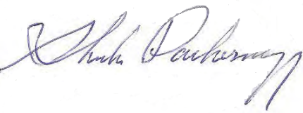
Sheila Pachernegg, P.E.
Hydrogeologist
Attachments:
- Minerals Assessment Rf port (December 18, 2013)
- Title Report
- Mineral Reservations recorded documents

Appendix R. Sample Remoteness Determination acceptable to the Community Forest Program
CHELAN COUNTY LONGVIEW STEMILT ACQUISITION PROPERTY
MINERALS ASSESSMENT REPORT
December 18, 2013
Prepared for: Chelan County Natural Resource Department
Prepared by: Sheila Pachernegg, P.E., Hydrogeologist Cascadia Technical Services
Tel/Fax: 509-487-4399
Email: sheilap@icehouse.net
SUBJECT PROPERTY DESCRIPTION
The Subject Property encompasses all (or portions) of Sections 7, 23, 26, 27, 29, and 33, in Township 21 North, Range 20 East W.M., and all of Section 1, Township 21 North, Range 19 East W.M. Located south and west of Wenatchee Heights and near Mission Ridge Ski Area and Squilchuck State Park within the Squilchuck and Stemilt Watersheds, the area is locally known as the Stemilt Basin, and Beehive Mountain Area.
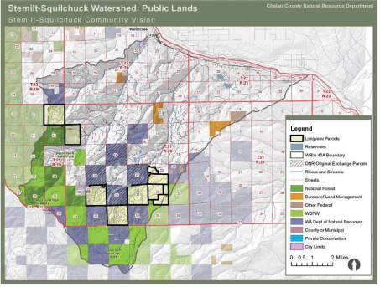
Chelan County - Longview Stemilt Minerals Assessment Report 12/18/2013

Appendix R. Sample Remoteness Determination acceptable to the Community Forest Program
Parcel Summary (Chelan County Assessor Information)
Title Report ParcelID | Chelan County Assessor Parcel Number (APN) | Legal Description Parcel 1-Township 21 North, Range 19 East W.M. Parcel 2-10- Township 21 North, Range 20 East W.M. | Acres
Parcel 1 | 211901000000 | Section 1: All except road | 643.04
Parcel 2 | 212007000050 | Section 7: W1/2 and W1/2 of the E1/2 | 496.42
Parcel 3 | 212023000050 | Section 23: Admin Seg by Tax Code Pt S1/2 | 314.71
Parcel 4 | 212026000050 | Section 26: W1/2NE1/4, NW1/4, N1/2SW1/4 | 320.0
Parcel 5 | 212026100050 | Section 26: SE1/4, SE1/4SW1/4 | 200.0
Parcel 6 | 212026100250 | Section 26: E1/2NE1/4 | 80.0
Parcel 7 | 212027000000 | Section 27: All, except right-of way | 640.0
Parcel 8 | 212029000050 | Section 29: All less part NE1/4NE1/4 | 589.0
Parcel 9 | 212033000000 | Section 33: All | 640.0
Parcel 10 | 212023230100 | Section 23: Lot B CE 2009-023, Pt. NW1/4 | 87.29
Mineral Rights Reservations
Attachments:
- First American Title Insurance Company (Wenatchee) – File No.: 4441-2154933, Commitment 4, October 30, 2013
- Mineral Rights Reservations recorded documents from Chelan County Auditor
Title Report Exception | Chelan Co. Auditor File Number (AFN) | Affected Sections/Parcels | Mineral Reservation Ownership
18 | 9022049 / Deed No. 11682  (1903) Grantee: Lake Irrigation Co. | Sections 23 and 27  Township 21 North, Range 20 East W.M. APN: 212023000050, 212023230100,  and 212027000000 | Northern Pacific Railway Company
19 | 17651 / Deed No. 15757  (1906) Grantee: Inland Lumber and Timber Company | Sections 23, 27, 29, and 33  Township 21 North, Range 20 East W.M. APN: 212023000050, 212023230100, 212027000000, 212029000050, and  212033000000 | Northern Pacific Railway Company
24 | 265488 (1935)  Grantee: Scheble & Wright Lumber & Box Company | Section 1  Township 21 North, Range 19 East W.M. APN: 211901000000 | Northern Pacific Railway Company
28 | 461854 (1952)  Grantee: Northern Pacific Railway Company | Section 1  Township 21 North, Range 19 East W.M. APN: 211901000000 | Bureau of Land Management (BLM
35 | 735747 (1973)  Grantee: The Pack River Company | Sections 7, 23, 26, 27, 29, and 33 Township 21 North, Range 20 East W.M. APN: 212007000050, 212023230100,  212026000050, 212026100050,  212026100250, 212027000000,  212029000050, and 212033000000 | Joseph L. Hughes and Pacific National Bank of Washington  (Trustees for E. L. and Corinne H. Sawyer)
43 | 9404050097 (1994)  Grantee: Longview Fibre Company | Section 26  Township 21 North, Range 20 East W.M. APN: 212026100250 | Washington State Dept. of Natural Resources

Chelan County – Longview Stemilt Property Minerals Assessment Report – 12/18/2013

Appendix R. Sample Remoteness Determination acceptable to the Community Forest Program
PHYSIOGRAPHIC SETTING
Topography and Access
The Subject Property is at least 2,000 to 4,000 feet higher in elevation than the Columbia River Valley at Wenatchee, ranging from approximately 3,000 feet of elevation along the Stemilt Loop Road to almost 5,000 feet of elevation in the southernmost section at the Chelan-Kittitas County line. The area is generally described as a transition zone between ponderosa pine shrub-steppe and mountain forest. Areas have been selectively logged, some recently. The area has some unimproved access roads for timber management and reservoir operations/maintenance. Roads are heavily used by local recreationalists (camping, ORV, fishing, foraging, and snowmobile access in the winter), with a coded sign system identifying roads with allowable passage and bar gates for access control.
Northwest Parcels:
    - Section 1 (T21N, R19EWM): Access off southwest corner with partially improved Beehive Road past reservoirs and unimproved switch road through section center. North-south ridge section with moderate slopes (20% to 30%) across section center and steep (40% to 90%) east- and west-facing side slopes.
    - Section 7 (T21N, R20EWM): Limited access with one unimproved spur road briefly crossing the west boundary. Out of section on near southeast corner is the paved Squilchuck Road. Very steep mostly east-facing slopes (40-90% range) on east side of Beehive Mountain. Elevations from approximately 3,950 to 3,000 feet.
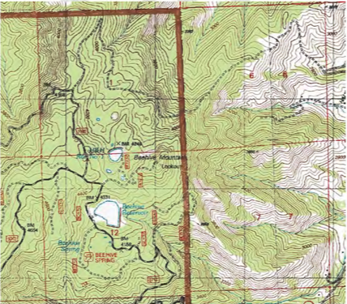
USGS 7.5’ Quadrangle Maps: Wenatchee Heights, WA (2003) and Mission Peak, WA (1987)
Chelan County – Longview Stemilt Property Minerals Assessment Report – 12/18/2013

Appendix R. Sample Remoteness Determination acceptable to the Community Forest Program
Southeast Parcels:
    - Section 23 (T21N, R20EWM): Improved (paved) Stemilt Basin Loop Road travels through the north portion and unimproved Upper Basin Loop Road through the section center. Topography is mostly north-facing slopes, many in the 30-40% range, with elevations ranging from 2,780 feet to 4,130 feet.
    - Section 26 (T21N, R20EWM): Unimproved Rock Ridge Road through section center. Slopes to the
northwest at 30-40% common, with some near 100% below road and elevations ranging from about 3,800 to 5,050 feet.
    - Section 27 (T21N, R20EWM): Unimproved Upper Basin Loop Road through the section center with intersection leading to Rock Ridge Road.
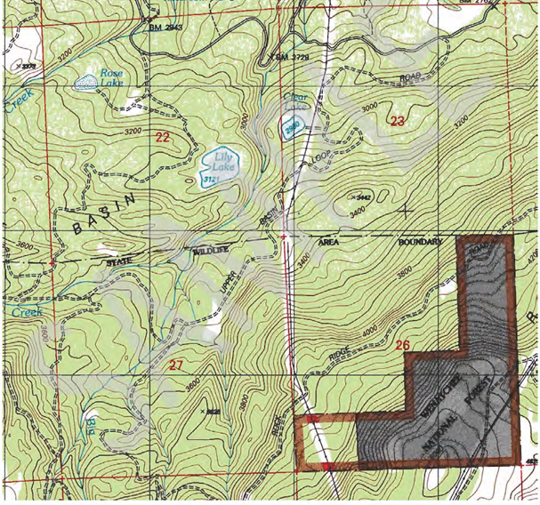
USGS 7.5’ Quadrangle Map: Wenatchee Heights, WA(2003)
Chelan County – Longview Stemilt Property Minerals Assessment Report -12/18/2013

Appendix R. Sample Remoteness Determination acceptable to the Community Forest Program
- Section 29 (T21N, R20EWM): Unimproved West Basin Road and intersecting spur roads. Slopes north in the 20-30% range but with very steep slopes on the southwest corner. Elevations ranging from 4,800 feet at southwest to less than 3,800 feet on northeast corner.
- Section 33 (T21N, R20EWM): Unimproved Pole Flat Road to the south boundary and additional unimproved access to the north boundary. Slopes to the north at 30-40% with steeper locations along a north-south ridge through center of section. Elevations on the south line at almost 5,000 feet and 4,200 feet on the north line.
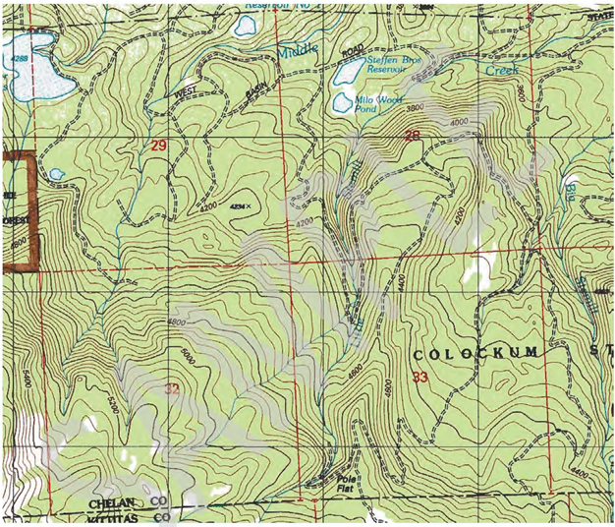
USGS 7.5’ Quadrangle Map: Wenatchee Heights, WA (2003)
Chelan County – Longview Stemilt Property Minerals Assessment Report – 12/18/2013

Appendix R. Sample Remoteness Determination acceptable to the Community Forest Program
Soils
Reference:
  - Soil Survey Staff, Natural Resources Conservation Service, United States Department of Agriculture. Official Soil Series Descriptions [Online WWW]. Available URL: Web Soil Survey [Accessed December 9, 2013].
The soils in the five southeast sections in Stemilt Basin, almost entirely consist of Stemilt Silt Loam, described as silty sand and considered by USDA-NRCS to be limited for roads, paths, trail use, and camps (due to erosion potential and slope). Parent material is loess, colluvium and residuum from basalt, andesite or tuff with some volcanic ash. Soils are shallow (a couple feet deep), with much coarser soils below and a depth to groundwater of over 5 feet. Bedrock outcrops and water bodies (reservoirs) are present in this area as well.
The soils in the northwest two sections next to Beehive Mountain are mapped with a different soil series. Majority of the soils are described as two types, with properties that mirror Stemilt Silt Loam soils. On the east-facing slopes is the Cle Elum Loam, from parent material residuum and colluvium from sandstone mixed with minor amounts of loess and volcanic, sandstone from continental sedimentary rock. Ridges have soils Loneridge Stoney Loam with similar parent material residuum and colluvium from basalt or andesite mixed with loess and volcanic ash. The west face of the Section 1 Subject Property also has minor amounts of soils derived from loess mixed with residuum and colluvium weathered from sandstone, schist, or conglomerate. These soils exhibit similar soil horizons, groundwater depths and use properties to the Stemilt soils. These are not rangeland or farmland soils, but coarser shallower forest soils.
Geology
The regional geologic setting is described as a transition zone between Cascade metamorphic and volcanic rocks and Columbia Plateau Basalts. In terms of regional tectonics, the Subject is located within the Eocene age Chiwahkum Graben (bound by the northwest-southeast trending Leavenworth and Entiat Faults) formed by a part of the North Cascades subcontinent colliding with the volcanic basalt rocks of the Columbia Plateau. The faulting associated with the division between the Columbia Plateau and the Chiwahkum Graben is located immediately west of the study area. The majority of the surface geology consists of young mass-wasting (landslide) deposits, with exposed outcrops of both continental sedimentary rock and basalts. Refer to the following Geologic Map.
Chelan County – Longview Stemilt Property Minerals Assessment Report – 12/18/2013

Appendix R. Sample Remoteness Determination acceptable to the Community Forest Program
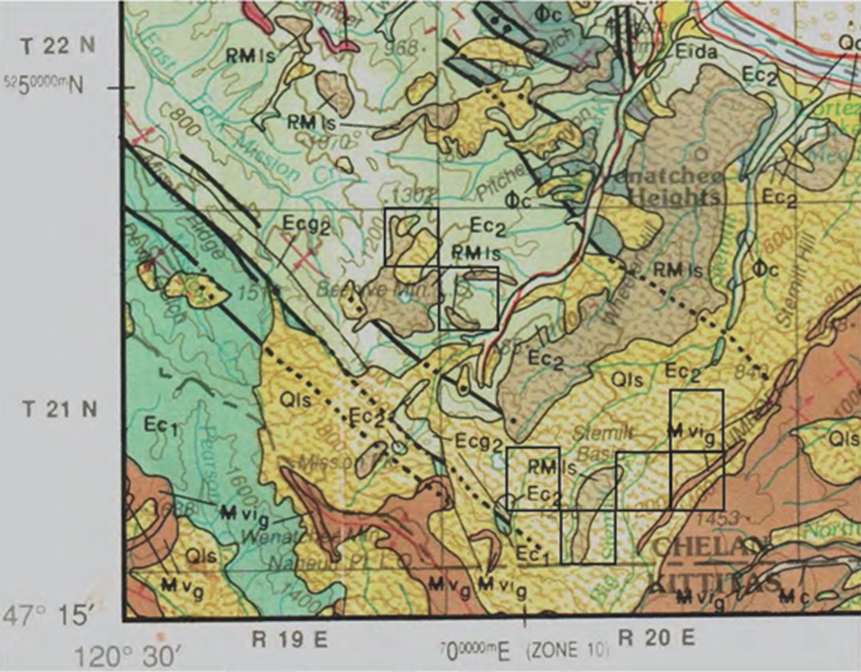
Reference:
  - Geologic Map of Washington – Northeast Quadrant, Geologic Map GM-39, Washington Division of Geology and Earth Resources, 1991.
Qls Quaternary (up to 1.6 million years) nonglacial mass-wasting (landslide) deposits, talus, and colluvium composed of unsorted debris derived from either Quaternary sediments or bedrock.
P_{L}M ls Pliocene and Miocene (1.6 to 23.7 million years) mass-wasting (landslide) deposits, poorly sorted, angular granule- to boulder size clasts derived from the Columbia River Basalt Group.
Mv_{g}, Miocene (5.3 to 23.7 million years) volcanic Grande Ronde Basalt, invasive flows (Mvi_{g}), fine to medium grained, aphyric and sparsely plagioclase-phyric basalt, forms in sills in continental sedimentary rock, locally includes chaotic mixture of basalt and sedimentary rocks (peperite), hyaloclastite, and pillow basalts.
ɸc Oligocene continental sedimentary rocks consisting of micaceous quartzose sandstone, variegated tuffaceous shale, and conglomerate that is composed of clasts of felsic volcanic rocks and vein quartz; minor silicic tuff
Ec₂ Middle to Upper Eocene (47 to 57.8 million years) and Ec₁ (Lower to Middle Eocene), continental sedimentary rocks, white and gray, medium- to coarse-grained, micaceous feldspathic sandstones, siltstones, and minor shale.
Chelan County – Longview Stemilt Property Minerals Assessment R eport – 12/18/2013

Appendix R. Sample Remoteness Determination acceptable to the Community Forest Program
AREA MINERAL EXPLORATION and DEVELOPMENT
Sources:
  - Directory of Surface Mining Reclamation Sites – 2010 Washington State DNR, Division of Geology and Earth
  - Resources, Open file Report 2010-7, June 17, 2010
  - US Bureau of Land Management, Mining Claim Geographic Index Reports.
  - Bulletin No. 37, Inventory of Washington Minerals, Part II Metallic Minerals, Marshall T. Huntting, State of Washington Dept. of Conservation and Development, Division of Mines and Geology, 1956. Mineral Resources Online Spatial Data
Washington State Department of Natural Resources Surface Mining Permits in Chelan County (revised June 17, 2010)
Commodity | Operator/Permit  Holder | Site Name | Location | Permitted  Acres | Permitted  Depth | Permit  Number
sand & gravel | Chelan Concrete Inc. | Chelan | T27N, R23EWM  Section17 | 7 | 43 | 11774
sand & gravel | Morrill Asphalt & Paving Co. | Edwards Pit  Staples Pit | T23N, R20EWM  Section 10 | 10  16 | 100  50 | 12459  12695
sand & gravel | Pipkin Construction | Entiat  Mill Pond | T25N, R21EWM  Sections 4 and 9  T25N, R21EWM  Section 19 and 30 | 44.10  16.92 | 43  70 | 12932  13133
rock & stone | R&P Rock, LLC | Blewett Pass | T23N, R17EWM  Sections 19 and 30 | 11.40 | 160 | 12975
sand & gravel | Ram Ridge, LLC | Ram Ridge | T23N, R20EWM  Sections 10 and 15 | 28.50 | 110 | 13015
sand & gravel  rock & stone | Two Rivers, Inc. | Two Rivers, Inc.  Two Rivers  Quarry | T27N, R16EWM  Section 15 | 135  12 | 30  100 | 12311  12967
sand & gravel | Wash. St. Dept of Transportation | PS-K-79 | T28N, R21EWM  Section 25 | 8.50 | 25 | 11659
rock & stone | Wash. St. Dept of Transportation | QS-K-163 | T25N, R17EWM  Section 5 | 11.93 | 350 | 11463
rock & stone | Wash. St. Dept of Transportation | QS-K-37 | T23N, R17EWM  Section 25 | 64 | 300 | 12230
sand & gravel | Wenatchee Rock Products, LLC | Wenatchee Rock Pit | T24N, R20EWM  Section 24 | 55.50 | 60 | 13034
Chelan County – Longview Stemilt Property Minerals Assessment Report – 12/18/2013

Appendix R. Sample Remoteness Determination acceptable to the Community Forest Program
Bureau of Land Management (BLM) Records
(Also refer to following map)
Township 21 North, Range 19 East W.M.:
Oil/gas leases: Lots 1-4, 15, 18, and 34 (1982-3), terminated in 1983-84, closed in 1986 No active mining claims
Closed mining claims: Sections 1 through 22, 24, 27, 28, and 30.
Section 1 Claimants: Snowbird Resources, Pecos Resources Ltd, Harvey Guerin, Joe C. Meissner, Tim Williams, James R. Siechert, Midnight Oil Project, William Gartz, R. Oborny, Alex D. Estes, Charles Moses, Allen J. Conboy, Norman Nielsen, O.F. Bell.
Location dates in 1983 and 1989. Last assessments from 1985 to 2000 for Section 1 claims, last assessments in the 1980s for most of the claims within the remaining sections

Township 21 North, Range 20 East W.M.:
Oil/gas leases noted in Sections: 2, 26, and 30 in 1982-83 and terminated in 1984-1989
Active lode mining claims in Section 2: Shaft #1 - #19. Claimant Shoshone Silver Gold Mining (Spokane, WA). Located in 2004, and transfer of interest filed in 2009 from Kimberley Gold Mines to Shoshone. Assessments filed for 2014.
Closed mining claims: Section 2 (Althouse Placers Inc., Asamera Minerals, Peter W. Laczay, Summit Silver Inc, and Wilbur Hallauer), Section 11 (Asamera Minerals), and Section 30 (Snowbird Resources)
Location dates 1983 – 1993. Last assessments from 1991 – 2000 (Sections 2 and 11 claims) and in 1988
(Section 30 claims)

Township 22 North, Range 19 East W.M.:
Oil/gas leases noted in Sections 8, 14, 22, 30, 32, and 34 in 1982, terminated in 1985 and closed in 1986 No active mining claims
Closed mining claims in Sections: 2, 4 through 12, 17 through 24, 27, 28, 29, 30, 32, 33, and 34
Location dates from 1983 to 1990 and last assessments from 1984 – 2000

Township 22 North, Range 20 East W.M.:
Coal Entry Patent recorded in 1891 for the NE1/4 of Section 28
Mineral Entry (ME) Patents filed in 1908, 1940, and 1961 for Sections 21 and 22
Oil/gas leases noted in Sections 8, 18, 22, and 28 in 1982-83 and terminated in 1986 No active mining claims
Closed mining claims in Sections: 6 (Teck Resources), 18 (Pedersen, Hemminger, Crial, St. Joe American Corp., Snedegar, Norexco Petroleum Co., Midnight Oil Project, snowbird Resources, Breadwater Mining Co.), 28 (Althouse Placers, Inc., Pedersen), and 35 (Althouse Placers, Inc., Asamera Minerals)
Location dates from 1981 to 1992 and last assessments in 1984, 1991-1994, and 2000

Township 20 North, Range 20 East W.M.:
Oil/gas leases noted in Section 12 in 1982, terminated in 1987 and 1990 No active or closed mining claims
Chelan County – Longview Stemilt Property Minerals Assessment Report – 12/18/2013

Appendix R. Sample Remoteness Determination acceptable to the Community Forest Program
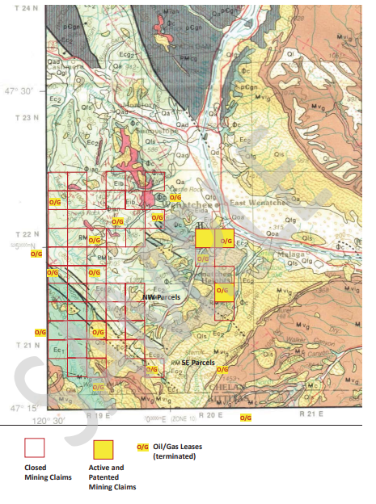
Chelan County – Longview Stemilt Property
Minerals Assessment Report – 12/18/2013

Appendix R. Sample Remoteness Determination acceptable to the Community Forest Program
Historical Lode Gold Mining Sites (Huntting)
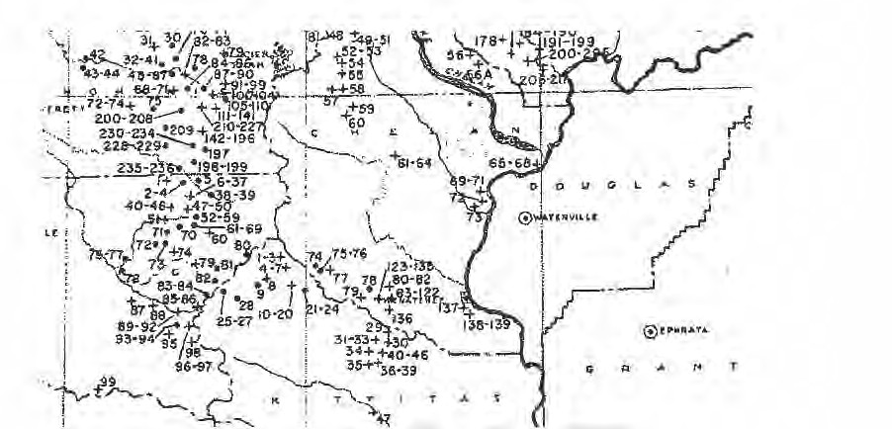
CONCLUSIONS
Sand/Gravel/Rock Quarry Development
  - The location of the Subject Property, several thousand feet above the Wenatchee Valley, renders the parcels remote (from commercial centers) and difficult to access on unimproved roads that are often steep, and used only seasonally. The commonly used areas for sand/ gravel resources are removed from the area and derived from glacial outwash deposits further to the north from the Subject. Although basalt rock is present in the area, quarry site development is economically infeasible due to the difficult access and quantities of more readily accessible basalt available in the populated Columbia River Valley.
  - Soils may be suitable for typical borrow uses but quantity and location preclude use beyond immediate area embankment fill for unimproved roads.
  - Sedimentary Continental bedrock is poor quality for use as aggregate or armor (lack of durability).
Chelan County – Longview Stemilt Property Minerals Assessment Report – 12/18/2013

Appendix R. Sample Remoteness Determination acceptable to the Community Forest Program
Mineral (Metals) Development
  - Geologic conditions, which are generally consistent with mineral development, include: presence of
intrusive rock bodies, extensive faulting, high grade metamorphism, and skarn or hydrothermal alteration. While these conditions may exist to the north and west, mapped surface geology does not extend onto the nearest Subject Sections 1 and 7; and the surface geologic setting for the remaining Subject parcels to the southeast is entirely within the Grande Ronde Basalt flows.
  - Significant exploration occurred in the area in the 1980s. Large scale mineral prospecting focused on metamorphic and northwest trending structural features to the west and further north/northeast towards Wenatchee. All claims were closed by 2000. Oil/gas leases were also scattered throughout the area and terminated in the late 1980s. In spite of all the exploration, the only active lode mining claims exist in Section 2 of Township 21 North, Range 20 East W.M., suggesting that the area was evaluated and determined to either lack mineralization or not be economic for development.
  - Historic mining in the area, primarily for lode gold, copper, and chromium, followed the same metamorphic bedrock and structural features.
  - No rare earth deposits (current commodity trends) are recorded within the state of Washington.
  - Successful mine development is initially dependent upon commodity prices and reserves but still requires access to a large amount of capital to explore and develop the site. Development requires all weather high load haul roads, large amounts of power and water, sites for shaft, mill, stockpiles, and tailing that comply with
Chelan County – Longview Stemilt Property
Minerals Assessment Report – 12/18/2013


Appendix S. Sample Notice of Grant Requirement Language to be inserted into the recorded deed for the Community Forest
NOTICE OF GRANT—REQUIRED DEED LANGUAGE OVERVIEW.
All deeds for Community Forest Program (CFP) acquired properties must contain certain language that states the purpose of the CFP and should contain language addressing the reversion of the grant funds in the event that a grant recipient sells or converts the acquired property to nonforest uses or a use inconsistent with the purpose of the CFP.
This is known as the purpose and reversion requirement as referenced in the Final Rule at §230.8(b)(4) and §230.9(d), respectively. Community Forest Program grant recipients must also comply with the Notice of Grant Requirement listed in the CFP Final rule at §230.8(b)(1-8).
Purpose language sample.
The purpose of this acquisition is to effect the U.S. Forest Service Community Forest Program authorized by Section 8003 of the Food, Conservation, and Energy Act of 2008 (16 U.S.C. 2103d) for the purposes of establishing community forests that provide community benefits by acquiring and protecting private forestlands. This authority continues indefinitely. Program delivery is guided by the Community Forest Program regulations (36 CFR Part 230 Subpart A) (published 10/20/2011; 76 FR 65121).
Reversion language sample.
This property was acquired with Federal funds under the U.S. Forest Service, Community Forest Program, in accordance with the Community Forest Program Project Grant #-DG-11420004- In the event the property conveyed herein is sold or converted to nonforest uses or a use inconsistent with the purpose of the U.S. Forest Service Community Forest Program, the grant recipient or subsequent owner of the property shall: (1) pay the United States an amount equal to the current sale price or the current appraised value of the parcel, whichever is greater; and (2) not be eligible for additional grants under the U.S. Forest Service Community Forest Program.
EXAMPLE 1. Stand-alone Notice of Grant Requirement. This document should be filed with the deed at the recording office of the county or municipality.
EXAMPLE 2. Embedded language requirements that would be found within the warranty deed—either in the body, or as an exhibit to the deed.

Appendix S. Sample Notice of Grant Requirement Language to be inserted into the recorded deed for the Community Forest
EXAMPLE 1.
The following is an example of a ‘stand-alone’ Notice of Grant Requirement that would be recorded in the land records of the local county or municipality where the Property is located. Refer to 36 CFR Part 230, Subpart A, Sec. 230.8(b)(1-8). Seek professional legal advice before using
NOTICE OF GRANT REQUIREMENT
The property described herein (Property) was acquired pursuant to a monetary grant awarded to the (name of grant recipient and title holder), (Grant Recipient). The purpose of this acquisition is to effect the goals of the U.S. Department of Agriculture (USDA) Forest Service’s Community Forest and Open Space Conservation Program (Community Forest Program or CFP) in accordance with the provisions of Section 7A of the Cooperative Forestry Assistance Act (CFAA) of 1978 as amended. Such purposes are to provide public benefits to communities including economic benefits through sustainable forest management, environmental benefits including clean air, water, and wildlife habitat; benefits from forest-based educational programs; benefits from serving as models of effective forest stewardship; and recreational benefits secured with public access; and to acquire private forest lands that are threatened by conversion to nonforest uses. Program delivery is guided by the Community Forest Program regulations (36 CFR Part 230 Subpart A) (published 10/20/2011; 76 FR 65121). In accordance with these regulations the Grant Recipient acknowledges that:
- This Property was purchased with Federal funds in accordance with the Community Forest Program (36 CFR Part 230 Subpart A) (published 10/20/2011; 76 FR 65121);
- The legal description for the Property is as set forth below in Exhibit ‘A’;
- The address of the Grant Recipient and authorized title holder listed above is [Insert Address] .
- This Property is designated as a ‘Community Forest’ pursuant to the requirements of the Community Forest Program (CFP);
- The Grant Agreement with the USDA Forest Service is agreement number [Insert Number] and it is kept on file at [Insert location]
- The Grant Recipient shall ensure that for all land(s) acquired pursuant to this grant is held in perpetuity by an eligible entity as defined by 36 CFR Part 230 (published 10/20/2011; 76 FR 65121) and that the Community Forest will be (i) managed pursuant to the grant, the Community Forest Plan, and the purpose of the CFP; (ii) will not be conveyed or encumbered, in whole or in part, to another party without written permission and instructions from the awarding agency; (iii) will be managed consistent with the purpose of the CFP;

Appendix S. Sample Notice of Grant Requirement Language to be inserted into the recorded deed for the Community Forest
EXAMPLE 1.
For Tribes, substitute the following for item #6:
The Grant Recipient shall ensure that for all land(s) acquired pursuant to this grant is held in perpetuity by an eligible entity as defined by 36 CFR Part 230 (published 10/20/2011; 76 FR 65121) and that the Community Forest will be (i) managed pursuant to the grant, the Community Forest Plan, and the purpose of the CFP; (ii) will not be conveyed or encumbered, in whole or in part, to another party without written permission and instructions from the awarding agency; (iii) will be managed consistent with the purpose of the CFP; and (iv) that land(s) acquired under this grant must not be sold, converted to nonforest uses or a use inconsistent with the purpose of the Community Forest Program, or converted to land held in trust by the United States on behalf of any Indian tribe.
- In the event that the Community Forest is sold or converted to nonforest uses or a use inconsistent with the purpose of the CFP, the Grant Recipient or subsequent Community Forest landowner shall: (1) pay the United States an amount equal to the current sale price or the current appraised value of the parcel, whichever is greater. For the purposes of the calculation in this paragraph, the parcel’s appraised value will be the parcel’s full fair market value. The impact of subsequent encumbrances, such as the imposition of conservation easements consistent with the purposes of the Community Forest Program, will not be considered in appraising the parcel’s fair market value; and (2) not be eligible for additional grants under the CFP.

Appendix S. Sample Notice of Grant Requirement Language to be inserted into the recorded deed for the Community Forest

EXAMPLE 1.
IN WITNESS WHEREOF, (Grant Recipient), has caused this NOTICE OF GRANT REQUIREMENT to be recorded on its behalf by its duly authorized representative:


Appendix S. Sample Notice of Grant Requirement Language to be inserted into the recorded deed for the Community Forest
EXAMPLE 1.
EXHIBIT A
(Insert legal description of subject property.)

Appendix S. Sample Notice of Grant Requirement Language to be inserted into the recorded deed for the Community Forest
EXAMPLE 2.
The following language could be embedded in the warranty deed after the declaration section and legal description sections, and before the closing and signature sections. Or it could be included as a separate exhibit to the deed. Refer to 36 CFR Part 230, Subpart A, Sec. 230.8(b)(1- 8). Seek professional legal advice before using.
Grantee further joins in the execution of this deed to acknowledge the following terms and conditions:
Notice of Grant Requirement
Pursuant to a monetary grant awarded to the Grantee, the purpose of this acquisition is to effect the goals of the U.S. Department of Agriculture (USDA) Forest Service’s Community Forest and Open Space Conservation Program (Community Forest Program or CFP) in accordance with the provisions of Section 7A of the Cooperative Forestry Assistance Act (CFAA) of 1978 as amended. Such purposes are to provide public benefits to communities including economic benefits through sustainable forest management, environmental benefits including clean air, water, and wildlife habitat; benefits from forest-based educational programs; benefits from serving as models of effective forest stewardship; and recreational benefits secured with public access; and to acquire private forest lands that are threatened by conversion to nonforest uses. Program delivery is guided by the Community Forest Program regulations (36 CFR Part 230 Subpart A) (published 10/20/2011; 76 FR 65121). In accordance with these regulations the Grantee (grant recipient) acknowledges that:
- This property was purchased with Federal funds in accordance with the Community Forest Program (36 CFR Part 230 Subpart A) (published 10/20/2011; 76 FR 65121);
- The legal description for the property is as set forth (above, herein, or in exhibit (x));
- The address of the grant recipient and authorized title holder listed above as Grantee, is [Insert address]
- This property is designated as a ‘Community Forest’ pursuant to the requirements of the Community Forest Program (CFP);
- The Grant Agreement with the USDA Forest Service is agreement number [Insert number] and it is kept on file at [Insert address];
- The grant recipient shall ensure that for all land(s) acquired pursuant to this grant is held in perpetuity by an eligible entity as defined by 36 CFR Part 230 (published 10/20/2011; 76 FR 65121) and that the Community Forest will be (i) managed pursuant to the grant, the Community Forest Plan, and the purpose of the CFP; (ii) will not be conveyed or encumbered, in whole or in part, to another party without written permission and instructions from the awarding agency; (iii) will be managed consistent with the purpose of the CFP;

Appendix S. Sample Notice of Grant Requirement Language to be inserted into the recorded deed for the Community Forest
EXAMPLE 2.
For Tribes, substitute the following for item #6:
The grant recipient shall ensure that for all land(s) acquired pursuant to this grant is held in perpetuity by an eligible entity as defined by 36 CFR Part 230 (published 10/20/2011; 76 FR 65121) and that the Community Forest will be (i) managed pursuant to the grant, the Community Forest Plan, and the purpose of the CFP; (ii) will not be conveyed or encumbered, in whole or in part, to another party without written permission and instructions from the awarding agency; (iii) will be managed consistent with the purpose of the CFP; and (iv) that land(s) acquired under this grant must not be sold, converted to nonforest uses or a use inconsistent with the purpose of the Community Forest Program, or converted to land held in trust by the United States on behalf of any Indian tribe.
- In the event that the Community Forest is sold or converted to nonforest uses or a use inconsistent with the purpose of the CFP, the grant recipient or subsequent Community Forest landowner shall: (1) pay the United States an amount equal to the current sale price or the current appraised value of the parcel, whichever is greater. For the purposes of the calculation in this paragraph, the parcel’s appraised value will be the parcel’s full fair market value. The impact of subsequent encumbrances, such as the imposition of conservation easements consistent with the purposes of the Community Forest Program, will not be considered in appraising the parcel’s fair market value; and (2) not be eligible for additional grants under the CFP.
This conveyance is together with and subject to all regulations, easements and restrictions of record.
Other deed clauses and signatures will follow here.

6 Post-Acquisition Requirements
Post-acquisition requirements due 120-days after the Community Forest is acquired:
§ 230.7 (e) GIS shapefile of the lands acquired with CFP funds OR used as cost share.
Appendix T provides GIS data standards required for the Community Forest Program.
§ 230.9 (a) Final Community Forest Plan.
Appendix U outlines required components of a Community Forest Plan.
Grant Close-out Documentation.
Prior to community forest program acquisition, all acquisition requirements outlined above must be approved by the Forest Service, which meets the bulk of grant close out documentation needs. In addition to documents already provided, a CFP grant recipient will need to submit a letter requesting the grant be closed, the final recorded deed (if acquisition occurred with an FS Advance Payment), a Request for Payment (SF-270) marked ‘final’, a Final Financial Status Report (SF-425), and a final Performance Report.
Appendix V provides a sample CFP Grant Close-out Report template. Please work with the Forest Service CFP program manager to ensure you have the latest template.
Perpetual Community Forest Requirements.
Maintain the community forest consistent with the program and application purposes. If a grant recipient sells or converts the acquired community forest to nonforest uses or a use inconsistent with the purposes of the CFP, the grant recipient shall:
Pay the United States an amount equal to the current sale price or the current appraised value of the parcel whichever is greater. For the purposes of the calculation in this paragraph, the parcel’s appraised value will be the parcel’s full fair market value. The impact of subsequent encumbrances, such as the imposition of conservation easements consistent with the purposes of the Community Forest Program, will not be considered in appraising the parcel’s fair market value; and
Not be eligible for additional grants under the CFP.
Provide appropriate public access.
Submit every 5 years a self-certifying statement that the property has not been sold or converted to nonforest uses.
Be subject to a spot check conducted to verify that Community Forest has not been sold or converted to nonforest uses.
Periodically review and update the Community Forest Plan as necessary.



Appendix T. GIS Data Standards Required for the Community Forest Program
Standards for Community Forest Program Tracts Geographic Information System (GIS) Data
This document describes the data standards required for the Community Forest and Open Space Conservation Program (CFP) GIS database.
Data Requested
As per the CFP final rule, please provide a GIS layer that contains the boundary of all the completed CFP tracts that are part of the CFP grant within 120-days of the acquisition of the Community Forest.
Data Format
GIS data MUST be provided in digital format as a polygon (not a line or point.) Data may be stored in an ESRI shapefile, coverage, or geodatabase. The projection of the data must be defined (see projection parameters.)
Scale and Accuracy
Data should be collected at a scale of 1:100,000 or larger (e.g., 1:24,000) for the continental United States. Data for Alaska may be at a scale of 1:250,000. If collected with GPS, please follow the National Map Accuracy Standard (NMAS) for horizontal accuracy.
Horizontal accuracy. For maps on publication scales larger than 1:20,000, not more than 10 percent of the points tested shall be in error by more than 1/30 inch, measured on the publication scale; for maps on publication scales of 1:20,000 or smaller, 1/50 inch.
(U.S. Bureau of the Budget June 17, 1947 rocky web
For example:
For a 1:12,000 map1/30 inch (.033) is 33 feet (10.1meters)
For a 1:24,000 map1/50 inch (.02) is 40 feet (12.2meters)
NMAS Standards (90% Accuracy)
Scale 1:X | Feet ± | Meters ±
1:100 | 0.3 | 0.08
1:500 | 1.4 | 0.42
1:1000 | 2.8 | 0.84
1:2000 | 6 | 1.68
1:5000 | 14 | 4.19
1:10000 | 28 | 8.38
1:12000 | 33 | 10.06
1:20000 | 55 | 16.76
1:24000 | 40 | 12.19
1:63360 | 106 | 32.19
1:100000 | 167 | 50.80
1:250000 | 417 | 127.00

Appendix T. GIS Data Standards Required for the Community Forest Program
Attributes
At minimum, each CFP Tract GIS layer (coverage, shapefile or geodatabase) must include the following attributes:
Field Name | Description | Type | Length | Precision | Scale
PROJECTNAM | Project Name | Text | 100 | - | -
TRACTNAME | Tract Name | Text | 100 | - | -
YEAR | Fiscal Year tracts is completed | Short Integer | 4 | 4 | -
CFPACRES | Reported Acres in DEED | Double | 8 | 12 | 1
CFPSTATECO | State Abbreviation | Text | 2 | - | -
SOURCE | Source of Data | Text | 50 | - | -
NOTES | Text | Text | 250 | - | -
ACRES | GIS Calculated Acres | Double | 8 | 0 | 0
Projection Parameters
All data should be in Geographic Projection, North American Datum 1983 (GCS_North_American_1983 or NAD 83) using the following parameters:
Angular Unit: Degree (0.017453292519943295)
Prime Meridian: Greenwich (0.000000000000000000) Datum: D_North_American_1983
Spheroid: GRS_1980
Semimajor Axis: 6378137.000000000000000000
Semi minor Axis: 6356752.314140356100000000
Inverse Flattening: 298.257222101000020000


Appendix U. Required Components of a Community Forest Plan
Required Components of a Community Forest Plan
(copied directly from the Community Forest and Open Space Program Final Rule)
Community forest plan. A tract specific plan that guides the management and use of a community forest, was developed with community involvement, and includes the following components:
  - A description of the property, including acreage and county location, land use, forest type and vegetation cover;
  - Objectives for the community forest;
  - Community benefits to be achieved from the establishment of the community forest;
  - Mechanisms promoting community involvement in the development and implementation of the community forest plan;
  - Implementation strategies for achieving community forest plan objectives;
  - Plans for the utilization or demolition of existing structures and proposed needs for further improvements;
  - Planned public access, including proposed limitations to protect cultural or natural resources, or public health and safety. In addition, local governments and qualified nonprofits need to provide a rationale for any proposed limitations; and
  - A description for the long-term use and management of the property


Appendix V. Sample CFP Grant Close-out Report template
COMMUNITY FOREST PROGRAM (CFP) PROJECT GRANT CLOSE-OUT REPORT
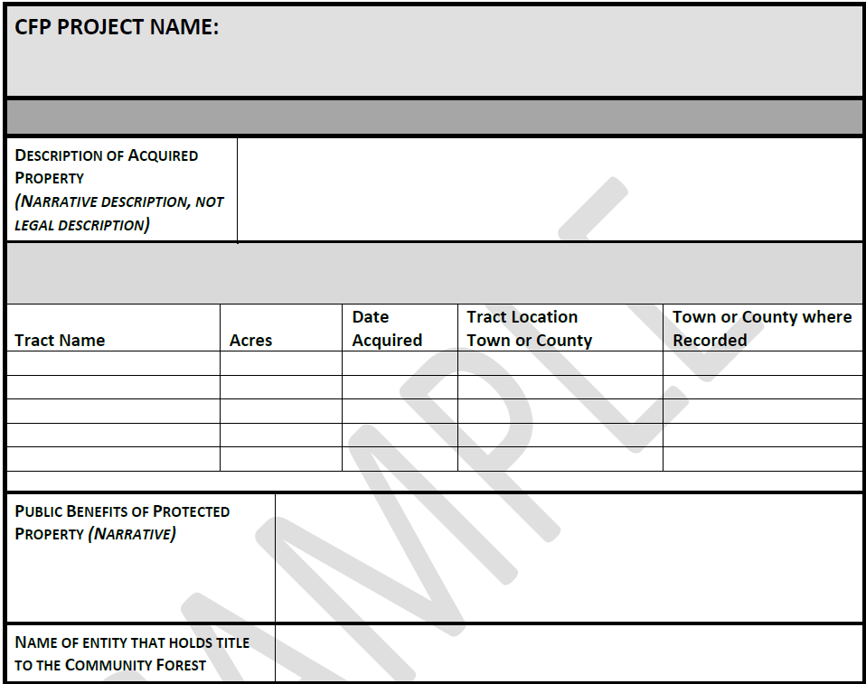
CFP Project Close Out Form Version 10/23/2015

Appendix V. Sample CFP Grant Close-out Report template
COMMUNITY FOREST PROGRAM (CFP) PROJECT GRANT CLOSE-OUT REPORT
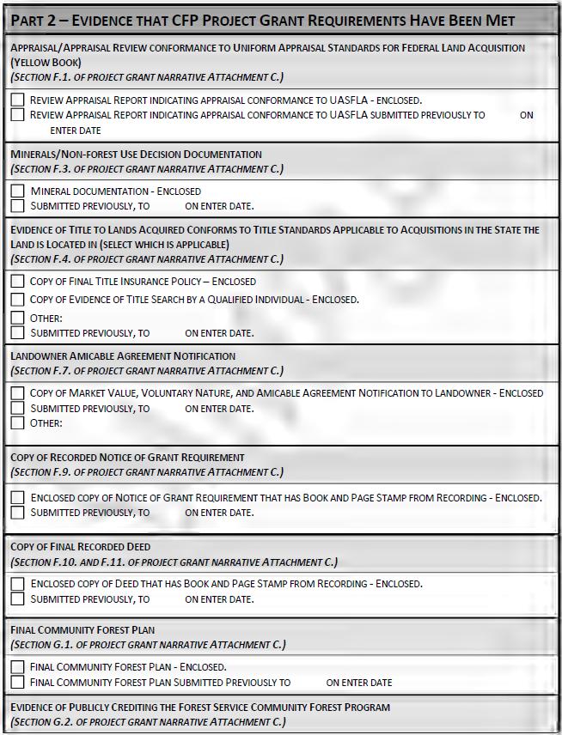

Appendix V. Sample CFP Grant Close-out Report template
COMMUNITY FOREST PROGRAM (CFP) PROJECT GRANT CLOSE-OUT REPORT
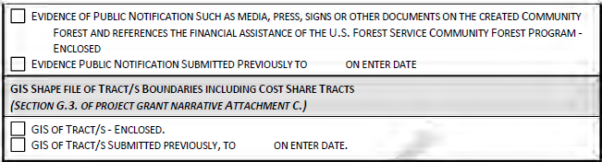
CFP Project Close Out Form Version 10/23/2015

Appendix V. Sample CFP Grant Close-out Report template
COMMUNITY FOREST PROGRAM (CFP) PROJECT GRANT CLOSE-OUT REPORT
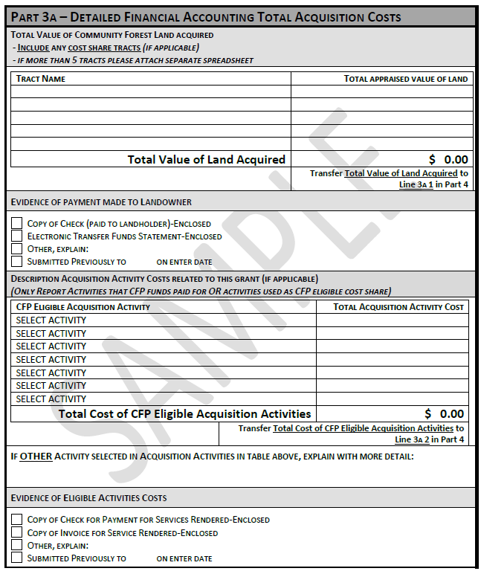
CFP Project Close Out Form Version 10/23/2015

Appendix V. Sample CFP Grant Close-out Report template
COMMUNITY FOREST PROGRAM (CFP) PROJECT GRANT CLOSE-OUT REPORT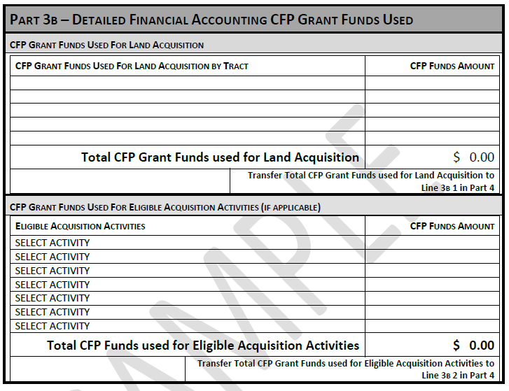
CFP Project Close Out Form Version 10/23/2015

Appendix V. Sample CFP Grant Close-out Report template
COMMUNITY FOREST PROGRAM (CFP) PROJECT GRANT CLOSE-OUT REPORT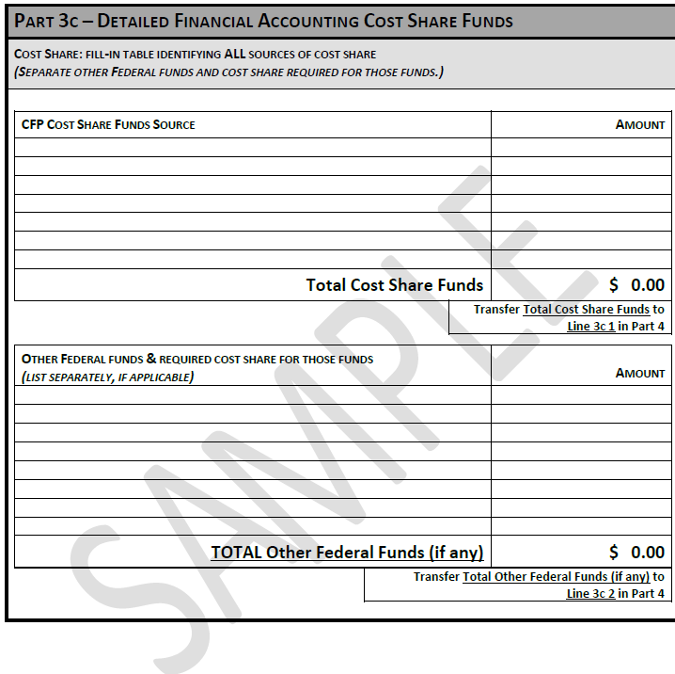
CFP Project Close Out Form Version 10/23/2015

Appendix V. Sample CFP Grant Close-out Report template
COMMUNITY FOREST PROGRAM (CFP) PROJECT GRANT CLOSE-OUT REPORT
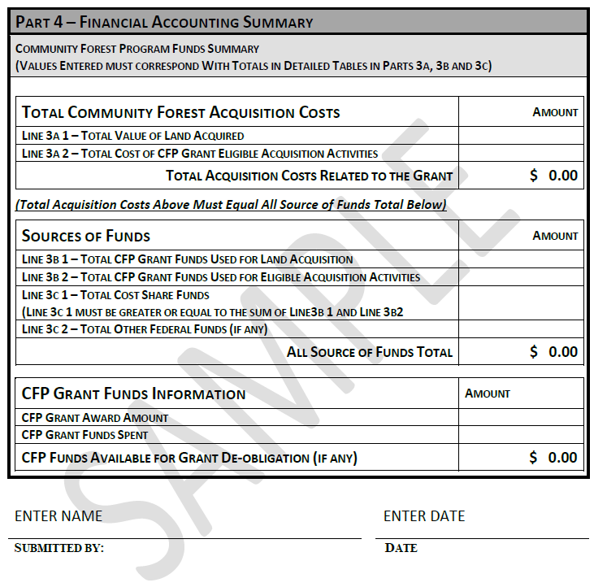
CFP Project Close Out Form Version 10/23/2015



Appendix W. Landowner 5-year Questionnaire
CFP Landowner 5-Year Questionnaire
Required reporting by CFP Rule § 230.9 Ownership and use requirements: (e) Every five years, the grant recipients will submit to the Forest Service a self-certifying statement that the property has not been sold or converted to non-forest uses or a use inconsistent with the purpose of the CFP.
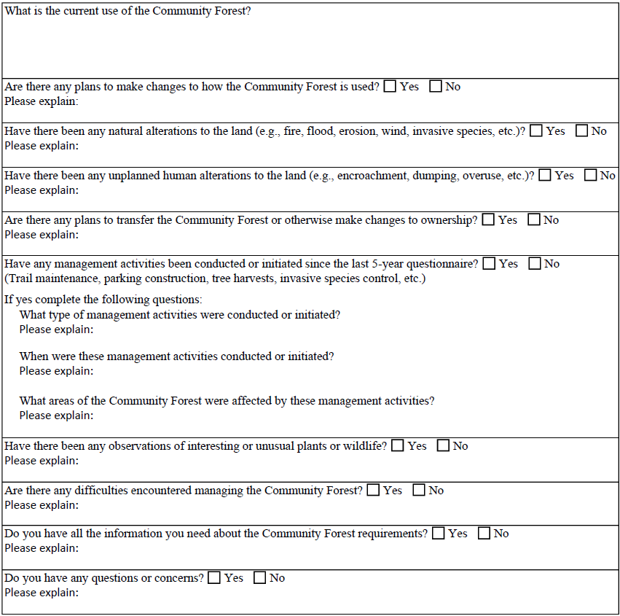
Return completed questionnaire to: U.S Forest Service

List of Appendices
- Community Forest & Open Space Program Authorizing Language
- Community Forest Program revised final rule published in Federal Register, April 2, 2021
- Community Forest Program FY2024 Request for Applications
- Community Forest Program Panel Scoring Guidance
- Community Forest Program Application Guidance
- Community Forest Program Project Map Recommendations
- Sample Civil Rights Compliance Review
- Sample CFP Annual Narrative Grant Accomplishment Report Form
- Sample SF425 Annual Financial Reporting Form
- Sample SF270 Forms for Reimbursement or Advance Payment
- Sample Grant Award Package
- CFP Appraisal Pre-work Discussion
- Sample CFP Appraisal Instructions
- Sample Scope of Work for CFP Review Appraisal Services
- Sample Technical Appraisal Review Report
- Sample Amicable Agreement landowner notification letter
- 26 CFR 1.170A-14. Section (g)(4)—Page 13 contains information relevant to mineral remoteness determination
- Sample Remoteness Determination acceptable to the Community Forest Program
- Sample Notice of Grant Requirement Language to be inserted into the recorded deed for the Community Forest
- GIS data standards required for the Community Forest Program
- Required components of a Community Forest Plan
- Sample CFP Grant Close-out Report template
- Landowner 5-year Questionnaire

Uniform Appraisal Standards for Federal Land Acquisitions
Interagency Land Acquisition Conference, Uniform Appraisal Standards for Federal Land Acquisitions (2000) page 13.
The Appraisal Foundation ~ Appraisal Standards Board, Uniform Standards of Professional Appraisal Practice (2012-2013), SR 1-2(c).
Interagency Land Acquisition Conference, Uniform Appraisal Standards for Federal Land Acquisitions (2000), page 13.
A hypothetical condition is contrary to what exists, but is supposed for the purpose of analysis. Such a condition is generally inappropriate, but there are situations where it may be necessary for reasonable analysis. An appraiser must be instructed to assume a hypothetical condition. If thought to be necessary, the appraiser should seek guidance from the assigned review appraiser.
Interagency Land Acquisition Conference, Uniform Appraisal Standards for Federal Land Acquisitions (2000), page 17.
Interagency Land Acquisition Conference, Uniform Appraisal Standards for Federal Land Acquisitions (2000), page 88.

