Highlights & Tips from Forest Service FY16 Green Events

Green events, small and large, are planned and hosted in an environmentally-responsible way. When the Forest Service Greening Your Events web site was rolled out in April 2016, employees were encouraged to fill out the Green Event Feedback Form to share successes and lessons learned from green event efforts.

Green Events Reported in FY16
In FY16, there were 12 forms submitted for events across the country. Of the submissions: 9 events were hybrid meetings or trainings (some participants gathered onsite and others were remote); 2 events were onsite meetings (all participants in one location); and 1 event was virtual (all participants attended remotely).

Benefits from the 10 Hybrid/Virtual Events
- Engaging: Virtual teams were able to meet more often, helping to develop close working relationships.
- Climate-Friendly: 2,320 metric tons of greenhouse gas emissions were avoided.
- Reduced Cost: $237,070 travel cost savings.
- Safety: Providing for virtual participation keeps people off the road in inclement weather.
- Time-Savings: Less time spent traveling allows for more time for work-life balance.

Share Your Successes and Lessons in FY17!
Check out the Greening Your Events web site for resources to help make your events green and fill out the Green Event Feedback Form afterward to share your successes and/or lessons learned. (Note: this form also supports unit-reporting on the FS Climate Action Card.)

Practices and Tips:
- Plan events well in advance for success!
- To improve events, ask participants to evaluate and offer suggestions.

For Onsite Green Events
- Use washable plates, mugs, and utensils.
- Provide for recycling and compost food waste.
- Minimize paper handouts, but when needed, print double-sided on 100% post-consumer recycled paper.

For Virtual and Hybrid Events
- Set-up outlook invites in advance and send a reminder the day before.
- Use webcams to make meetings and presentations more personable.
- Ensure the microphone or phone is close to presenters so audio comes through clear.
- When using VTC, participants can hold up a sheet of paper to alert the facilitator when they want to speak. In Adobe Connect, participants can use the “raise hand” button.
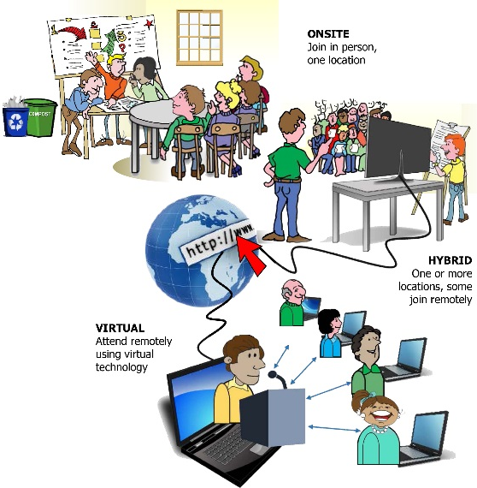

Metric tons of CO2 equivalents are estimated for CO2, CH4, and N2O emissions, using conversion factors from Department of Energy Federal Energy Management Program reporting workbook Version 6.1.

