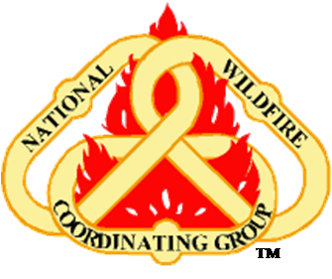 | National Wildfire Coordinating Group (NWCG)  Preparedness Branch  Incident Business Committee (IBC)

LIMITED CONTROL FLIGHTS – HAZARD PAY May 10, 2018

TO: Incident Business Personnel

FROM: NWCG Interagency Incident Business Committee

In collaboration with the Interagency Helicopter Operations Subcommittee, IBC has revised the 2017 memo outlining the flight profiles which qualify for hazard pay. The following two criteria were removed:

- Elevated platform, vessel, snow, or water landings (helicopter).
- Ski-landings, water-landings, backcountry airstrip- landings (fixed-wing).
After further research with field level personnel, it was determined the above criteria were common occurrences in project work and have mitigation measures in place. There may be non-routine situations that qualify for hazard and in those circumstances, employees should work with unit aviation personnel to make a determination.

This information can be found on the NWCG Incident Business Committee website and on the USDA Forest Service Incident Business Practices website.

/s/ Jamie Parker
Jamie Parker, Chair IBC
Date: May 10, 2018

May 2018

Limited Control Flights: Individuals, except GS-2181 pilots, who are onboard the aircraft during limited control flights. This will include air crewmembers participating in wildland fire and all-hazard aviation missions.

  - Flight profiles that will warrant the consistent approval of hazard pay differential include the following:
    - Plastic Sphere Dispenser missions. (Helicopter)
    - Toe-In, One-Skid, Step-Out, Hover-Exit missions. (Helicopter)
    - Rappel, Short-Haul, Hoist, Fast Rope, External Sling Load. (Helicopter)
    - Para-Cargo, Cargo Freefall, Cargo Letdown missions. (Helicopter or Fixed-Wing)
    - Wheeled operations on unprepared landing areas. (Fixed-Wing)
    - Low-Level flight (Search & Rescue, GPS, Mapping, Infrared, Intelligence Gathering, etc.). (Helicopter or Fixed-Wing)
      - To be considered a low-level flight, the mission must require performance of a substantial part of the flight, other than landing or taking off, at altitudes of less than 500 feet AGL (above ground level) in daylight, or at less than 1000 feet at night.
    - Landing at unimproved landing area when hazardous conditions exist. (Helicopter)
Examples: Uneven/sloped touchdown pad, Hover Out-Of-Ground Effect conditions, maximum performance take-off/landing, etc.
    - Other flight profiles that inadvertently encounter, extreme weather, maximum load, limited visibility, moderate turbulence(as defined by the FAA in AIM 7-1-23), or low level flights involving fixed or tactical patterns. (Helicopter or Fixed-Wing)

