2018 FOREST SERVICE CASUAL HIRE TRAVEL EXPENSE REIMBURSEMENT CLAIMED ON THE INCIDENT TIME REPORT (OF-288)

All temporary duty travel for casual hired employees will be processed in accordance with GSA Federal Regulations, Department of Agriculture Travel Regulations, and Forest Service Travel Direction:

- Federal Travel Regulations (FTR) Chapters 300–General and 301–Temporary Duty (TDY) Travel Allowances
- Agriculture Travel Regulations (ATR) Department Manual 2300-001
- Forest Service Handbook (FSH) 6509.33, Chapters 300 and 301

Non-compliance with these regulations may result in a bill for collection issued to the casual employees.

TRAVEL REIMBURSEMENT METHODS
There are two methods for casual employees to claim allowed travel expenses; on the Incident Time Report, also call OF-288 or, the official electronic travel vouchering system.

Incident Management Teams (IMTs), or hiring units, should process casual travel for incident assignments utilizing the OF-288 whenever possible (this process does not apply for travel associated with casual’s attending training). Only the following items should be reimbursed utilizing the OF-288:

- Privately Owned Vehicle (POV) Mileage
- Per Diem (lodging and M&IE)
- Travel related baggage fees, parking, tolls, and laundry expenses
- Gas for rental cars leased under IBPA and EERA with receipts
- Travel reimbursement for assignments of 30 days or less

Receipts for lodging, baggage fees, rental car gas, and airport parking must be attached to the OF- 288 when submitted to ASC-IF.

Casual Employee Pay on OF-288, Incident Time Report, will not be held for more than seven
- days in Incident Finance for pending travel reimbursement issues. When travel issues cannot be resolved after initial contact and one follow up by Incident Finance; travel claims will be removed from the OF-288 and payment for work time will be processed. Home/hiring units will be notified in writing and travel will need to be reclaimed through one of the two systems when resolved by hiring unit.

The official electronic travel system must be used for casual reimbursement under the following circumstances:
  - Lodging exceeds the local GSA per diem allowance
  - Rental Car leased by Casual Employee
  - All training and non-emergency related travel that can be planned and Authorized in advance
  - Extended incident assignments (over 30 days excluding travel days)
  - Other expenses not allowed for reimbursement via the OF-288 (car wash, supplies, etc.)
  - Any unusual or complex travel reimbursement claims (privately owned airplane mileage, RV rental space fees, extended duration, etc.)

A copy of the employee’s OF-288 (Time Report) is required to be uploaded, with other documents and receipts, into the official electronic travel system for the period of travel.

When a casual has reimbursable expenses that are not approved for reimbursement on the OF-288 the entire travel reimbursement should be processed through the electronic travel system. Travel reimbursement cannot be split between the two systems; one or the other must be utilized for the complete trip, or assignment.

RATES OF REIMBURSEMENT

Rates of reimbursement for per diem [lodging and meals and incidental expenses (M&IE)] will correspond to the current rates posted on the GSA website at www.gsa.gov/perdiem. The location of the incident determines the maximum per diem reimbursement rate. Use the Standard Rate for Incident Camps located in unlisted counties. First and last day reimbursements will be made at 75% of the applicable M&IE rate, and must be adjusted for meals furnished to the casual by the Government.
The following table shows the calculation of 75% amounts for all of the per diem rates, as well as examples of calculating first and last day when meals are provided.
2018 M&IE Breakdown - STANDARD CONUS RATES
M&IE Total | $51.00 | $54.00 | $59.00 | $64.00 | $69.00 | $74.00
Breakfast | $11.00 | $12.000000 | $13.00 | $15.00 | $16.00 | $17.00
Lunch | $12.00 | $13.00 | $15.00 | $16.00 | $17.00 | $18.00
Dinner | $23.00 | $24.00 | $26.00 | $28.00 | $31.00 | $34.00
Incidentals | $5.00 | $5.00 | $5.00 | $5.00 | $5.00 | $5.00
75% M&IE Total (first and last day) | $38.25 | $40.50 | $44.25 | $48.00 | $51.75 | $55.50

First Day - less dinner provided EXAMPLES
M&IE Total | $38.25 | $40.50 | $44.25 | $48.00 | $51.75 | $55.50
Dinner | $23.00 | $24.00 | $26.00 | $28.00 | $31.00 | $34.00
REVISED PER DIEM | $15.25 | $16.50 | $18.25 | $20.00 | $20.75 | $21.50

Last Day - less breakfast provided
M&IE Total | $38.25 | $40.50 | $44.25 | $48.00 | $51.75 | $55.50
Breakfast | $11.00 | $12.00 | $13.00 | $15.00 | $16.00 | $17.00
REVISED PER DIEM | $27.25 | $28.50 | $31.25 | $33.00 | $35.75 | $38.50

First Day - less lunch & dinner provided
M&IE Total | $38.25 | $40.50 | $44.25 | $48.00 | $51.75 | $55.50
Lunch | $12.00 | $13.00 | $15.00 | $16.00 | $17.00 | $18.00
Dinner | $23.00 | $24.00 | $26.00 | $28.00 | $31.00 | $34.00
REVISED PER DIEM | $5.00 | $5.00 | $5.00 | $5.00 | $5.00 | $5.00
Note: Cannot be less than Incidental Rate of $5.00

Last Day - less breakfast & lunch provided
M&IE Total | $38.25 | $40.50 | $44.25 | $48.00 | $51.75 | $55.50
Breakfast | $11.00 | $12.00 | $13.00 | $15.00 | $16.00 | $17.00
Lunch | $12.00 | $13.00 | $15.00 | $16.00 | $17.00 | $18.00
REVISED PER DIEM | $15.25 | $15.50 | $16.25 | $17.00 | $18.75 | $20.50
***NOTE: Revised per diem rates in tables above INCLUDE the $5.00 incidental rate.
Lodging will be reimbursed at actual expenditure rates, not to exceed current GSA rates, and must be accompanied by a receipt.

PROCEDURES
The type of expenses incurred will determine how the employee will be reimbursed for travel costs and who will process the travel. If the casual has only travel expenses not requiring a receipt, it is mandatory for the reimbursement to be made through the OF-288. IMTs should process travel reimbursement requests on OF-288 whenever possible. An IMT may process travel expenses that require a receipt (lodging). The receipts must be attached to the casual’s OF-288 and forwarded to ASC-IF. Additional casual travel expenses not processed by the IMT will be submitted by the hiring unit.

Processing Travel When NO Receipts Are Required
When a casual incurs only M&IE and/or POV mileage, the travel will be processed by the IMT. Reimbursement will be included with the payment of the Incident Time Report (OF-288) for salary. This process also applies when other travel costs were incurred during the assignment but paid by a purchasing official (such as a rental vehicle or lodging).

Reimbursable expenses will be documented by the IMT when submitting the final OF-288 for payment. If an IMT is not present, the payment will be processed by the unit submitting the final OF-288 to ASC- IF for payment.

  - Rates of reimbursement for POV mileage must correspond to the current posted GSA rate at www.gsa.gov/mileage. 2018 Mileage rates are 0.545 (subject to change)

  - Rates of reimbursement for meals and incidental expenses (M&IE) will correspond to the current rates posted on the GSA website at www.gsa.gov/perdiem. The location of the incident determines the maximum per diem reimbursement rate. First and last day reimbursements will be made at 75% of the applicable M&IE rate, and all days must be adjusted for meals furnished to the casual by the Government. (See the above tables for examples calculating first and last day when meals are provided.)

  - When meals are available at government expense, such as from a caterer, they must be deducted whether consumed or not including first and last days at 75%).

Casuals, away from point of hire, will document daily POV mileage on the Crew Time Report. Reimbursable miles driven during the assignment should be posted to appropriate calendar dates. Return mileage will be posted to the last date of the assignment at the same number of miles as arrival unless the casual is reassigned to a different incident. If the casual is not reassigned and plans to deviate from the previous travel route, reimbursement will be made at the same number of miles as for arrival. The return mileage will be documented on the casual’s final Crew Time Report. If necessary, miles can be determined using MapQuest or other mapping software.

Incidental expense allowances, separate from meals, may be posted as an individual entry for each calendar day, or as a lump sum combination of days. Incidental expense included in the M&IE total allowance (Meals and Incidental Expenses), do not need to be posted as a separate entry.

When e-ISuite is used to create the payment document, the TIME Unit or local office will utilize the TIME Module to post adjustments for each of the items above as appropriate.

Scenario #1 – Camp Assignment – Mileage, First & Last Day Per Diem (dinner provided first day & breakfast provided last day), and Daily Incidentals

POV Mileage
Date: Actual date the mileage occurred Categories: Travel-Add
Commodity: Mileage #miles @rate using current GSA rate, e.g., MILEAGE 100 @ .545 Amount: Enter the dollar amount, e.g., 54.50
Per Diem
Date: First or last date of assignment Categories: Travel-Add
Commodity: Enter first day per diem, e.g., FIRST DAY PER DIEM Amount: Enter per diem rate, e.g., 15.25
Or
Commodity: Enter last day per diem, e.g., LAST DAY PER DIEM Amount: Enter per diem rate, e.g., 27.25
Incidentals
(Post a Range of Days)
Date: Enter date of posting Categories: Travel-Add
Commodity: Enter incidental start date – end date, e.g., INCIDENTAL 3/02/18 – 3/09/18 Amount: Enter total dollar amount using current GSA incidental rate, e.g., 40.00

e-ISuite Adjustment Screen

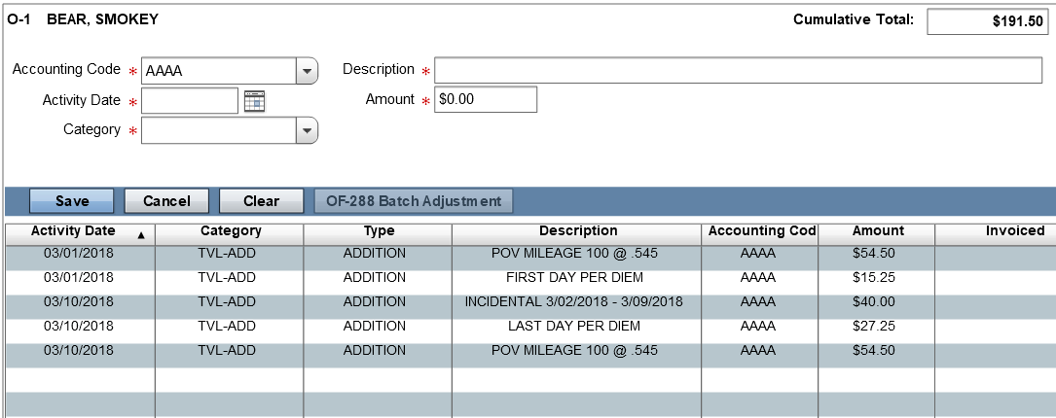

(Post each day of entitlement)
Date: Enter date of entitlement Categories: Travel-Add
Commodity: Enter incidental, e.g., INCIDENTAL Amount: Enter current GSA incidental rate, e.g., 5.00

e-ISuite Adjustment Screen

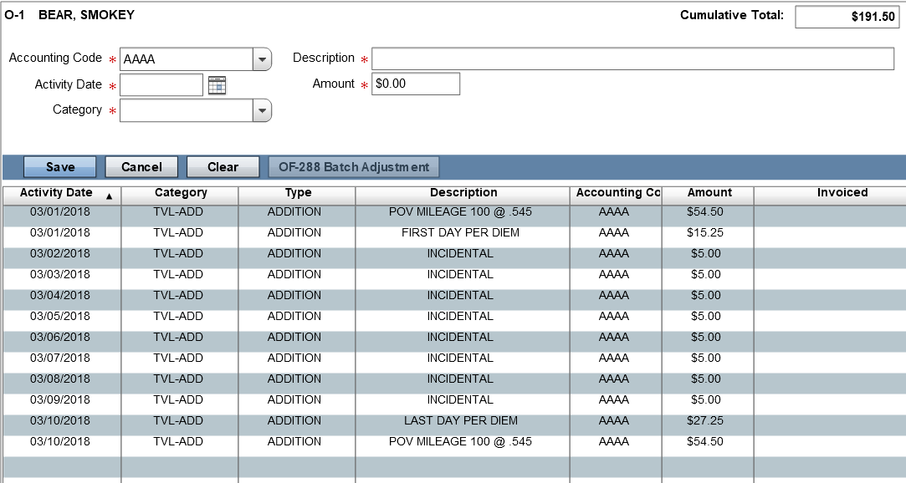

Scenario #2 – Assignment with Mileage & No Meals Provided

Per Diem (includes daily incidentals)
Date: First or last date of assignment Categories: Travel-Add
Commodity: Enter first or last day per diem, e.g. FIRST DAY PER DIEM Amount: Enter current GSA per diem rate at 75%, e.g., 38.25

Date: Enter date of posting Categories: Travel-Add
Commodity: Enter range of full per diem dates, e.g., PER DIEM 03/02/18 – 03/09/18 Amount: Enter total dollar amount using current GSA per diem rate, e.g., 408.00

e-ISuite Adjustment Screen

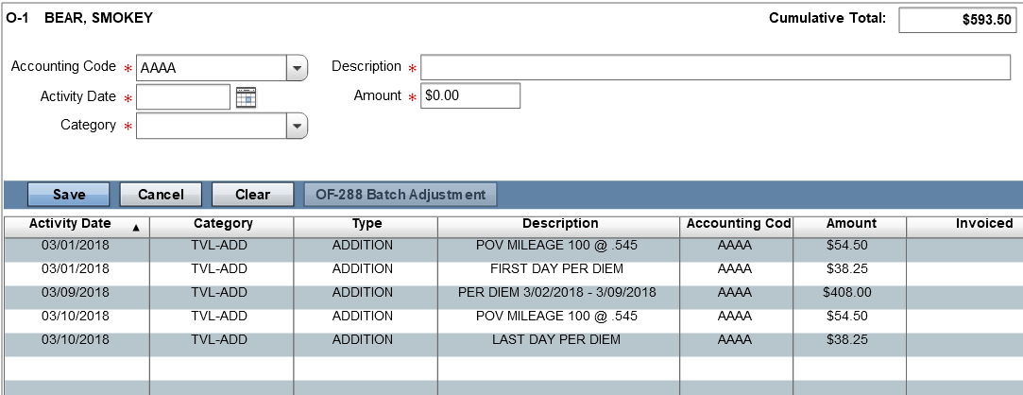

When e-ISuite is NOT used to record time and adjustments for a casual the hard copy form OF-288 should be completed to include reimbursement for these expenses in the “Commissary Record” section. Strikethrough the title “Commissary Record” and notate “Travel Reimbursement”. When an e-ISuite Incident Time Report Commissary Record is not generated, it is recommended to use a calculation spreadsheet for backup documentation. Go to www.fs.fed.us/fire/ibp for samples.

If the original OF-288 was sent directly from the incident to ASC-IF for the salary payment, the casual’s copy of the original timesheet will be used to prepare a supplemental for travel reimbursement. On the copy write “Travel Supplement” across the top and add the travel reimbursement as outlined below. Hiring unit will sign off as the Time Officer.

Scenario #1 – Camp Assignment – Mileage, First & Last Day Per Diem (dinner provided first day & breakfast provided last day), and Daily Incidentals

Travel Reimbursement
Date | Item | Amount
3/01/2018 | POV Mileage 100 miles @ .545 | $54.50
3/01/2018 | First Day Per Diem | $15.25
3/10/2018 | Incidentals 3/02 – 3/09/2018 | $40.00
3/10/2018 | Last Day Per Diem | $27.25
3/10/2018 | POV Mileage 100 miles @ .545 | $54.50
TOTAL |  | $191.50
Scenario #2 – Assignment with No Meals Provided

Travel Reimbursement
Date | Item | Amount
3/01/2018 | POV Mileage 100 miles @ .545 | $54.50
3/01/2018 | First Day Per Diem | $38.25
3/10/2018 | Per Diem 3/02 – 3/09/2018 | $408.00
3/10/2018 | Last Day Per Diem | $38.25
3/10/2018 | POV Mileage 100 miles @ .545 | $54.50
TOTAL |  | $593.50

If travel reimbursement was not included by the IMT on the original OF-288, upon return or completion of assignment, hiring units will be responsible for processing travel for casuals using the electronic travel system or the OF-288. IMTs will continue to submit all original OF-288s for FS casuals direct from the incident to ASC-IF for salary payments (copies to casuals). Travel reimbursement will be made as a supplement upon return to the hiring unit and submitted to ASC-IF, or processed through the electronic travel system.

When e-ISuite is used by the hiring unit to create the payment document the local office will utilize the TIME Module to post adjustments for each of the items above as appropriate. The following guidelines apply:

Scenario – Assignment with Mileage, Lodging Expenses and No Meals Provided (See “Processing Travel When No Receipts Are Required” section for calculations when meals are provided.)

Per Diem
Date: First or last date of assignment Categories: Travel-Add
Commodity: Enter first or last day meals, e.g. FIRST DAY PER DIEM Amount: Enter current GSA per diem rate at 75%, e.g., 38.25

Date: Enter date of posting Categories: Travel-Add
Commodity: Enter range of full per diem dates, e.g., PER DIEM 03/02/18 – 03/09/18 Amount: Enter total dollar amount using current GSA per diem rate, e.g., 408.00
Lodging
Date: Enter date of posting Categories: Travel-Add
Commodity: Enter range of lodging expenses,
e.g., LODGING 03/01/18 – 03/09/18
Amount: Enter total dollar amount, e.g., 702.00* (using $70.00 & $8.00 tax per night as example)
*Ensure lodging rate falls within allowable amount based on per diem location

e-ISuite Adjustment Screen
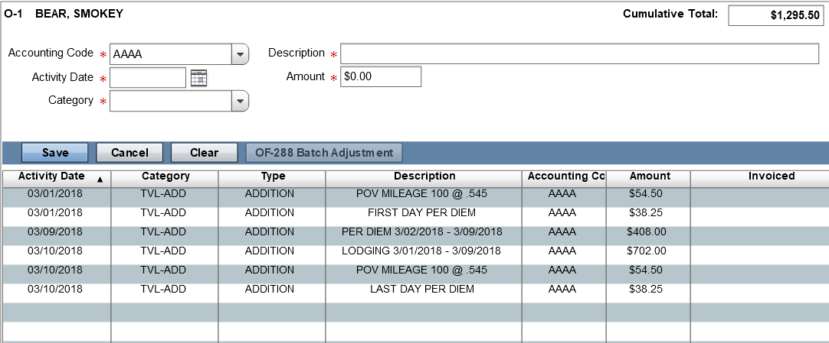

When e-ISuite is NOT used to record time and adjustments for a casual the hard copy form OF-288 should be completed to include reimbursement for these expenses in the “Commissary Record” section. Strikethrough the title “Commissary Record” and notate “Travel Reimbursement”.

If the original OF-288 was sent directly from the incident to ASC-IF for the salary payment, the casual’s copy of the original timesheet will be used to prepare a supplemental for travel reimbursement. On the copy write “Travel Supplement” across the top and add the travel reimbursement as outlined below.

Scenario – Assignment with Lodging Expenses and No Meals Provided (See “Processing Travel When No Receipts Are Required” section for calculations when meals are provided)

Travel Reimbursement
Date | Item | Amount
3/01/2018 | POV Mileage 100 miles @ .545 | $54.50
3/01/2018 | First Day Per Diem | $38.25
3/10/2018 | Per Diem 3/02 – 3/09/2018 | $408.00
3/10/2018 | Last Day Per Diem | $38.25
3/10/2018 | Lodging 3/01 – 3/09/2018 | $702.00
3/10/2018 | POV Mileage 100 miles @ .545 | $54.50
TOTAL |  | $1295.50

