MIX-TRANSFER SYSTEM INSPECTION CHECKLIST

Company Name: _________________________________________________

System Identification: ________________________________________

Inspection Location: ______________________________________________

Date: _________________________

Inspector: _____________________

Drums
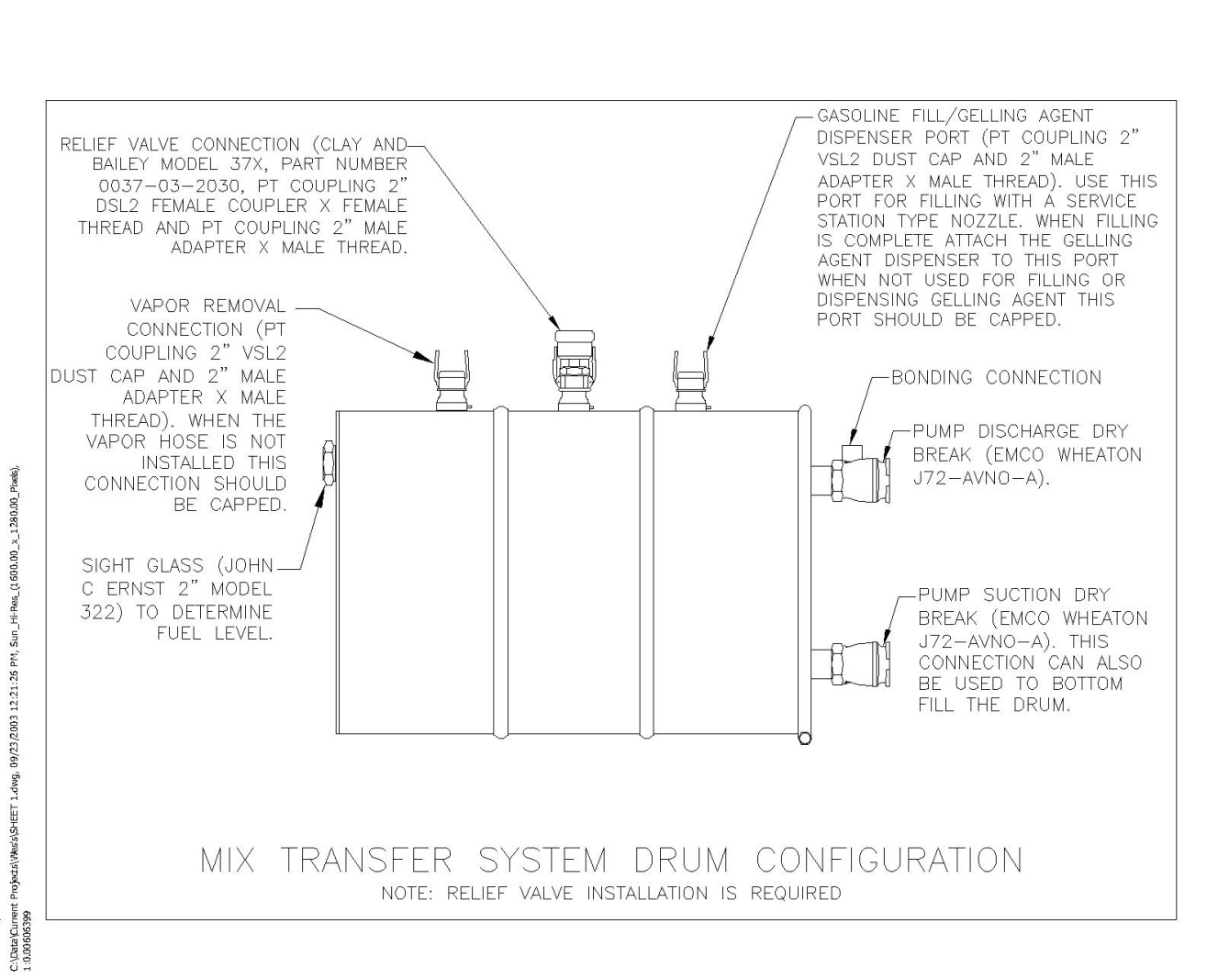

MIX-TRANSFER SYSTEM INSPECTION CHECKLIST (Continued)

DOT Specification Drums
“Flammable Liquid” Label, “UN 1203” Marking, “Gasoline” marking and Exemption Number
(As Required) Applied to Each Drum
2” Male Cam & Groove Fitting Installed for Vapor Removal/Recovery (Per Sketch, Vapor Removal/Recovery hoses minimum of 50 foot sections)
2” Male Cam & Groove Fitting Installed for Gelling Agent Dispenser and Gasoline Fill Port
(Per Sketch)
Relief Valve Installed and Mounted on Cam and Groove Fittings to Prevent Clogging of Valve by Gel (Per Sketch)
Cam and Groove Fitting Levers Secured With Safety Pins or Self Locking Levers Installed
2” Emco Wheaton Dry Break Adapter Installed for Pump Discharge and Pump Suction Connections (Per Sketch)
Bonding Lugs Installed on Pump Discharge Dry Breaks
Sight Glass Installed to Determine Fuel Level in Drum (Per Sketch)
Drum is Not Damaged and No Leakage is Visually Detectable

Comments:

Engine Installation
Shielding Installed Between Pump and Engine to Prevent Leaks From Contacting Hot Engine

Comments:

MIX-TRANSFER SYSTEM INSPECTION CHECKLIST (Continued)

Hoses
Hoses Designed for Use With Gasoline (Hose Make & Model ____________________________)
Vapor Recovery/Removal Hose Designed for Use With Gasoline
Vapor (Vapor Removal/Recovery hoses minimum of 50 foot sections)
(Hose Make & Model ______________________________________________________)
Swaged Hose Ends
Electrically Conductive

Comments:

Pump

Pump Internals are Non-Sparking (Pump Make and Model _______________________________)
Pump Seals are Compatible With Gasoline (Viton or Buna N)

Comments:

Misc

Pressure Gauge Isolated From Gel
Valves Labeled As To Function and Flow Direction

Comments:

