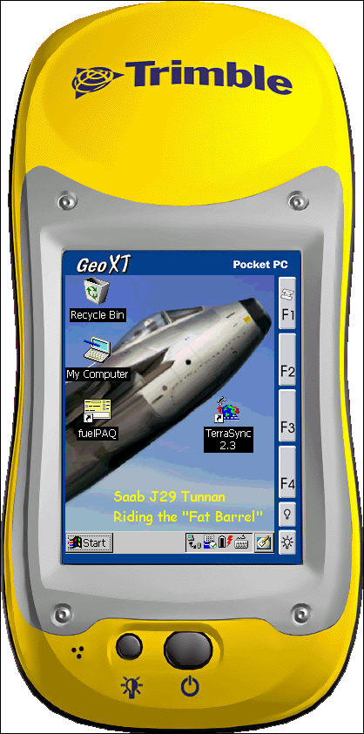

Basic GPS Data Capture
Using TerraSync

A Quick Start Guide

Carl Beyerhelm
GIS, GPS, and Data Management
Coconino National Forest

Revised 14-June-2004


What Is TerraSync

TerraSync is Trimble Navigation’s GPS data capture software, designed for use on WindowsCE devices such as the Trimble GeoXT or GeoXM. All materials in this Quick Start Guide were prepared using a GeoXT and TerraSync 2.30.

What Is The Purpose Of This Quick Start Guide

This Quick Start Guide is a set of very basic instructions designed to introduce new users to the fundamentals of GPS data capture using TerraSync software.

No advice is offered on advanced techniques, installation, recovery, or troubleshooting.

It is not intended to replace comprehensive guidance found in the 560-page TerraSync Operation Manual. The TerraSync Operation Manual is available on-line (in .pdf format) at http://www.trimble.com/terrasync_ts.asp?Nav=Collection-4573.

Turn The GeoXT On And Off

To turn the GeoXT on or off, quickly press and release the ON / OFF button.

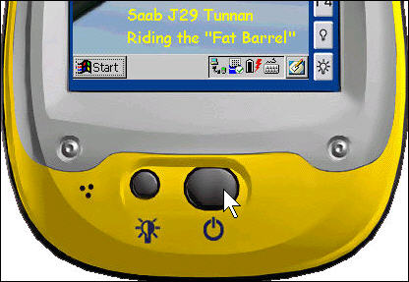

Start TerraSync

Tap Start – Programs – TerraSync, or double-tap the TerraSync 2.3 desktop icon.

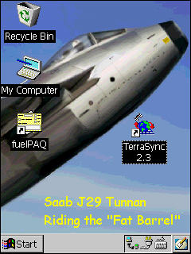
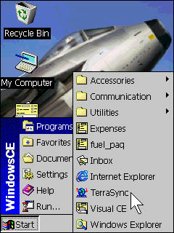

TerraSync Sections

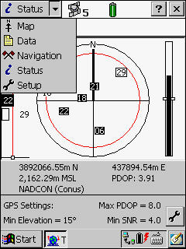
As illustrated at left, TerraSync’s functionality is divided into five sections: Map, Data, Navigation, Status, and Setup.

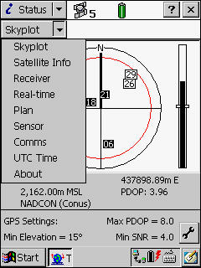
Each section contains a number of subsections, or other options.

For instance, the Status section contains the nine subsections shown at right.

Setup Section

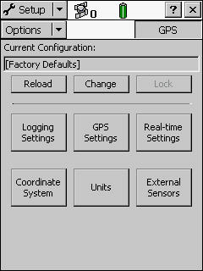
To open the Setup section, tap the section list button and select Setup.

Use the Setup section (as illustrated at right) to configure the TerraSync software.

Current Configuration – The GeoXT’s configuration may be reset to factory default settings by tapping the button.

If desired, users may create customized configurations by clicking Utilities – Other – Configuration Manager… in Pathfinder Office.

Transfer these customized configurations to the GeoXT by clicking Utilities – Data Transfer… in Pathfinder Office.

Load customized configurations in TerraSync by tapping the button, and selecting the desired configuration from a list of those available.

Logging Settings - Logging settings control what data are stored, and how. Generally, default settings are adequate, but set Filename Prefix as needed to avoid potential filename duplication, and set Between Feature Logging Interval to Off.

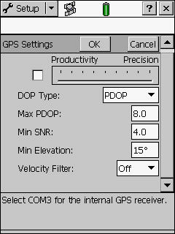
GPS Settings – GPS settings affect the quality of GPS positions. The settings illustrated at right generally provide accuracy sufficient to meet National Map Accuracy Standards, a requirement for Primary Base Series map features.

Real-time Settings – Real-time differential correction offers little benefit (use post-processing instead), except when accurate navigation to difficult targets is planned. Select Use Uncorrected GPS if difficult navigation is not required.

External Sensors – External sensors include items like laser range finders and bar code wands. If none are in use, uncheck all sensor items.

Units – Units affect on-screen display of various data items. Set units as desired.
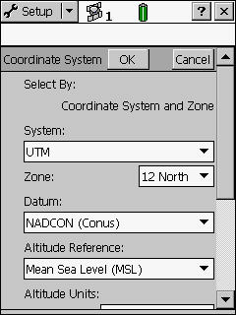
Coordinate System – All GPS positions are captured and stored as WGS84 latitude/longitude decimal degrees.

The coordinate system settings selected here affect only the on-screen display of GPS position coordinates, but have no effect on how GPS positions are actually captured or stored.

As an example, the settings illustrated at right are appropriate for the Coconino National Forest in north-central Arizona.

If background image files, MRSID DRGs or DOQs for instance, are to be displayed on-screen, the coordinate system settings selected here must match those of the image files.

Status Section

To open the Status section, tap the section list button and select Status.

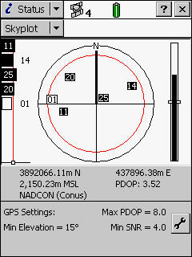
The most useful of the Status section’s nine subsections is the Skyplot. Its elements are described below.
Satellites 11, 14, 20, and 25 satisfy the SNR mask.

Satellite 01 does not satisfy the mask.
This circle represents the horizon (0°).
This circle represents the current elevation mask (15°). See GPS Settings.
This line represents the current SNR mask. See GPS Settings.

These are the current GPS Settings.
These are the current GPS position coordinates, altitude, PDOP, and datum.
This is the current PDOP mask, see GPS Settings.
This is the current PDOP. It satisfies the PDOP mask.
Satellites represented by filled boxes meet all requirements and are used to compute GPS positions.

Other satellites are tracked, but not used.
Battery is fully charged.
Four satellites are available to compute GPS positions

Data Section

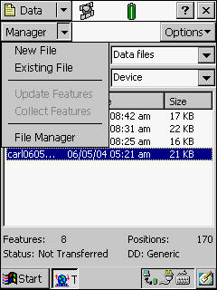
To open the Data section, tap the section list button and select Data. All basic data capture functions are found in this section.

Data subsections are illustrated at left, and their availability is described below.

Subsection | Availability
New File | No files are open.
Existing File | No files are open.
Update Features | A data file is open.
Collect Features | A data file is open.
File Manager | Always.

Create A New GPS Data File

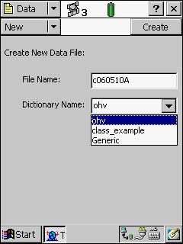
Select New from the Data section’s subsection list.

A default file name in standard pmmddhha format is provided. If desired, use the keyboard to modify the file name.

Select the desired data dictionary from the Dictionary Name dropdown list.

Tap when file name and dictionary name are satisfactory.
Tap this icon to reveal the keyboard.

Create, Attribute, Capture, And Close A GPS Feature

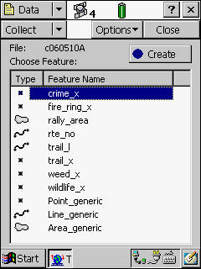
The data dictionary’s available features are displayed when a new GPS data file is created.

Select the feature that is to be captured. For example, the feature crime_x (crime point) was selected in the illustration at right.

Tap when the feature selection is as desired.

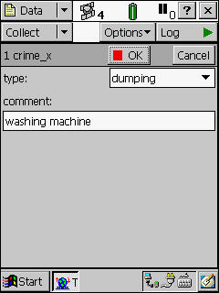

Complete the feature’s attribution. In the example at left, the feature’s type was selected from a dropdown menu list, and the text comment was input from the keyboard.

Tap when feature attribution is satisfactory.

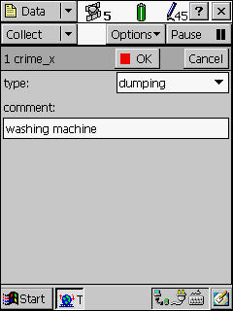

Position capture will commence for the current feature if all GPS settings are satisfied (PDOP mask, SNR mask, number of satellites, etc.).

In the example at right, 45 positions have been captured to the crime_x feature.

When the feature’s position, alignment, or perimeter has been captured, tap to close the feature.

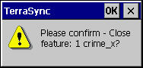
Tap OK to confirm that feature closure is desired.

Repeat the process of creating, attributing, capturing, and closing features as needed. Many point, line, and polygon features may be contained in a single GPS data file.

The basic procedure for capturing point, line, and polygon features is the same, except as described below.

- Point features - Remain on station while contributory positions are captured.

- Line features – Move directly along the feature’s complete alignment as positions are captured.

- Polygon features – Move directly along the feature’s complete perimeter as positions are captured.

When all desired features have been captured, tap to close the GPS data file.

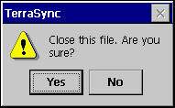
Tap Yes to confirm file closure.

The Log Now / Log Later Option

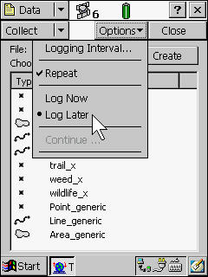
Two data capture options are available prior to creating a new GPS feature.

Log Now will begin capturing GPS positions immediately upon tapping a selected feature’s button. Generally, this is undesirable, because an annoying knot of GPS positions will be captured during the feature attribution period.

Log Later will open a feature in a paused state, allowing users to complete feature attribution prior to commencement of GPS position capture.

In Log Later mode, users tap when ready to proceed with data capture.

Segmenting A Line Feature

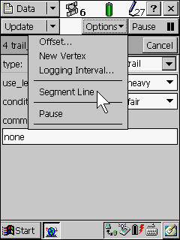
Rather than opening and closing a series of separate line features along an alignment, it is possible to segment a line feature at any point where its attributes change.

Instead of creating two separate, disconnected trail features, for instance, a single connected trail feature could be segmented at the point where it transitions from an ATV trail to a single-track trail.

To segment a line feature, tap Options – Segment Line during capture of a line feature.

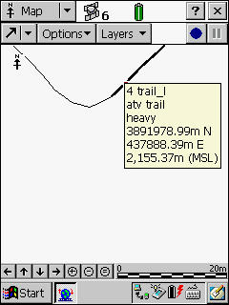

The trail feature at left has been segmented. The selected (highlighted) portion was an ATV trail with heavy use.

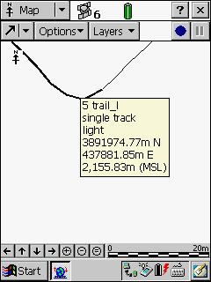

The selected (highlighted) portion at right was a single-track trail with light use.

Note that no gap occurs between the two segments as would have occurred had two separate trail features been created.

A gap will develop, however, if the vertex separating two segments is deleted during edit in Pathfinder Office.

Continuing A Line Or Polygon Feature

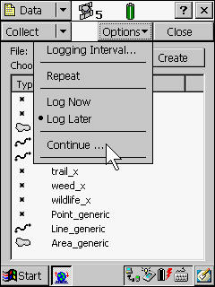
Line or polygon features may be continued after having been closed.

For example, a trail line feature may have been closed in order to capture a fire ring point feature near its alignment. After capturing the fire ring point feature, the trail line feature may be continued (appended), starting from the position at which it was closed.

To continue a line or polygon feature, close any open feature, and tap Options – Continue….

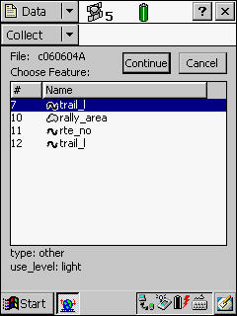

Next, select the desired line or polygon feature from the list of those available for continuance, and tap the button.

GPS positions will be captured to the continued feature, just as if it had never been closed.

Once a GPS data file has been closed, its line or polygon features cannot be continued.

Creating Line Or Polygon Features With Averaged Vertices

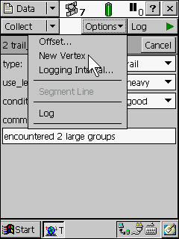
Line or polygon features can be captured as a series of averaged-position vertices, one vertex for each station along a feature’s alignment or perimeter. Although it is slightly more time-consuming to acquire, a vertex resulting from averaged GPS positions is more accurate than a vertex resulting from a single GPS position.

To capture a feature using averaged vertices, open and attribute a line or polygon feature while in Log Later mode. Then, tap Options – New Vertex.

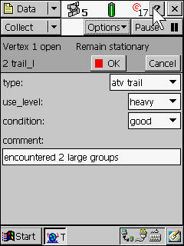
GPS positions will immediately begin contributing to the averaged position that will become the vertex. In the illustration at left, note that 17 positions have been captured so far, the vertex is still open, and the user is reminded to remain stationary.

When sufficient contributory positions have been captured, tap to close the vertex.

Repeat the process of opening, capturing, and closing a vertex at each station along a feature’s alignment or perimeter.

Tap when all vertices have been captured, and the feature is to be closed.
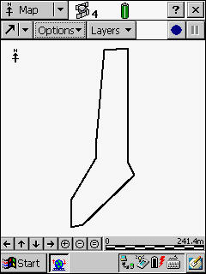
The polygon feature at right is composed of nine averaged-position vertices.

Offsets

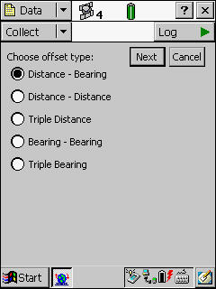
Offsets can be used to capture features that are unapproachable (a hazardous material spill or an endangered bird’s nest), or that have poor GPS conditions (bridge abutment or rock art panel).

Point features may be offset using five different methods, as shown at right. An example of a Bearing – Bearing offset is illustrated below.

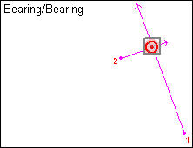
Here, the point feature’s position is established by the intersection of bearings from 2 different points. Bearings that intersect at a more nearly perpendicular angle create a more accurate position than bearings intersecting at a more oblique angle.

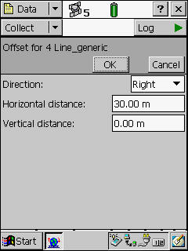
Line or polygon features may be offset to the left or right of a traveled alignment or perimeter by the distance specified.

In the example at right, a fence reliably known to lie 30 meters right of a highway’s travel lane could be captured while driving the highway with the illustrated offset in effect.

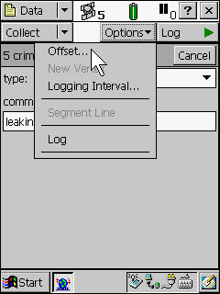
To apply an offset, open and attribute a feature as per normal procedure.

Then tap Options – Offset…, and proceed as per procedures for that type of offset.

File Manager

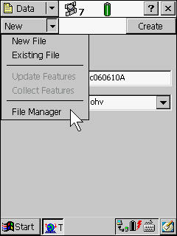
Users may gain access to the File Manager by selecting File Manager from the Data section’s subsection list.

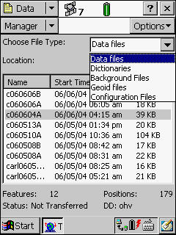

Select a file category from the Choose File Type list, and then select a file of interest.

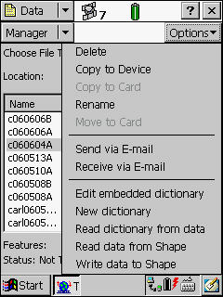

Once a file is selected, tap to reveal file-related actions that may be taken.

Map Section

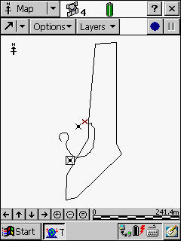
To open the Map section, tap the section list button and select Map. This section permits users to view all features in the current GPS data file, as well as the user’s current position (the little red x at right).

The illustrations below demonstrate that the Map section facilitates many options, which include:
- Zoom
- Pan
- Select
- Digitize
- Filter
- Set navigation target
- Add background files like DRGs or DOQs (in MRSID format)
- Format layers

The comprehensive TerraSync Operation Manual (see page 2) describes these features in detail.

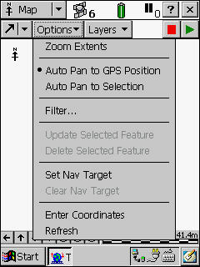
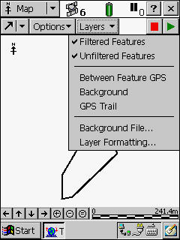

Navigation Section

To open the Navigation section, tap the section list button and select Navigation. The Navigation section permits users to navigate from their current position to a selected target or feature.

As an example, assume that a user wants to navigate from their current position (little red x at right) to a point feature.

First, select the desired point feature in Map view. The selected feature will be displayed as the boxed point feature symbol at right.

Next, tap Options – Set Nav Target in Map view.

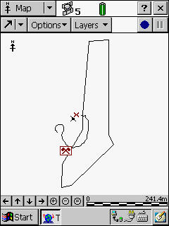

The selected feature will now be displayed as a red crossed flags navigation target symbol.

Select Navigation from the section list.

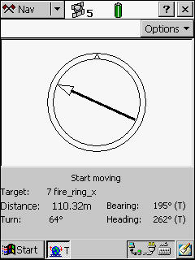

The resulting screen displays these items.
- Target’s feature ID and type (7 fire_ring_x).
- Distance to target (110.32 meters).
- Bearing to target (195°). The arrow pointer indicates the bearing graphically.
- User’s current heading (262°). The pointer on top the dial indicates the user’s current heading graphically.

Follow the arrow pointer until the target feature is reached.
Device / System Settings

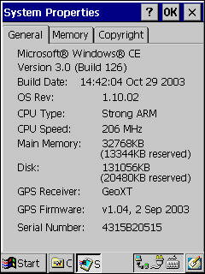
To view device and system information, tap Start – Settings – Control Panel – System. The illustration at right is an example of available device and system information.

Back Up Main Memory

Main memory is volatile, and subject to loss if power or system failures occur. To back up the main memory, tap Start – Programs – Utilities – Back Up Main Memory.

