SUMMARY
This support note advises users of an issue that may be encountered after reinstalling GPS Pathfinder Office (any version) onto a newly setup Forest Service computer.

PROBLEM
Two or more of following errors are encountered with Pathfinder Office:

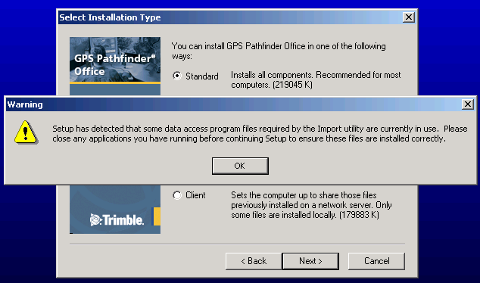
-- Warning during re-installation of Pathfinder Office

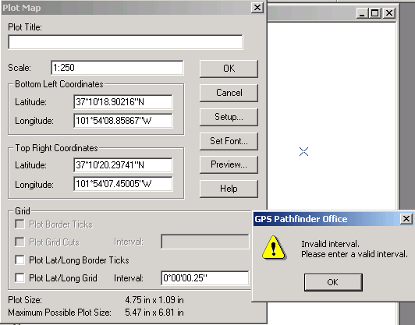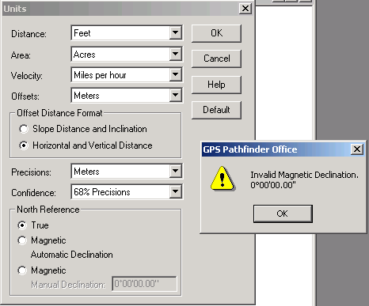
-- When trying to plot Lat/Long on the map in Plot Map -- When trying to adjust the units in the Units window

CAUSE
The user profile has been improperly setup by contractors using instructions from EUSC causing something (unknown at this time) in that profile to become corrupted or invalid. This may be a result of a drag-and-drop (or Copy-Paste) of the Documents and Settings folder from a previous PC configuration.

SOLUTION
The User’s Profile needs to be deleted and recreated. This requires Administrative Rights and can only be done by a profile with administrative privileges other than the user profile to be removed.

REQUIRED
- Back up the following directories found in the user’s Documents and Settings folder to another directory on the PC (i.e. C:\fsfiles\fstmp). Do not drag and drop or copy the entire Documents and Settings folder.
  - Desktop
  - Favorites
  - My Documents
- Log off and log back on using an administrative profile (like FSSETUP).
- Access the user profiles in Start → Settings → Control Panel → Users and Passwords
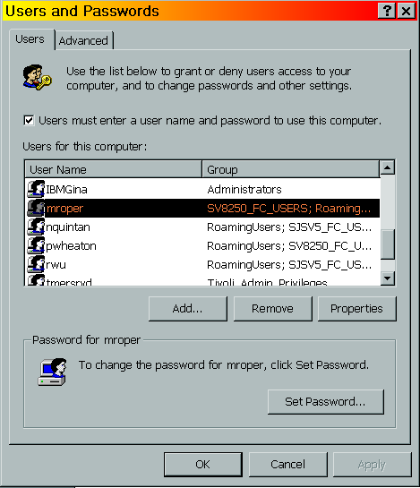
- Select the correct user profile to remove and click Remove.
- Confirm the profile to be deleted, and then click Yes.
- Click OK.
- Right-click on Start and select Explore. This will open Windows Explorer.
- In C:\Documents and Settings, locate the username folder for the profile that was removed and delete this folder. Right-click on the folder name and select Delete and then OK.
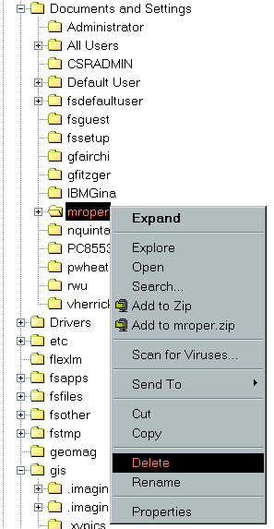
- Log off as administrator.
- Have the individual log onto the PC using a FastConnect server to create the new user profile.
- If still installed, start Pathfinder Office and verify the Units and Plot Map features work correctly without errors. Otherwise, verify these features after Pathfinder Office has been reinstalled.
- Copy and paste the folders that were backed up (Desktop, Favorites, My Documents) to their appropriate location in the new user profile in Documents and Settings.
- Verify the documents have been copied and are accessible. Verify the Internet favorites are functional.
- Delete the Desktop, Favorites and My Documents from the backup folder location (i.e. C:\fsfiles\fstmp).

OPTIONAL
It does not appear necessary, but if desired, to do a clean and complete uninstall and reinstall of
Pathfinder Office, the administrator can reference the following support notes:

http://trl.trimble.com/docushare/dsweb/Get/Document-153896/SprtNote_PFOffice_UninstallingPFO.pdf

http://trl.trimble.com/docushare/dsweb/Get/Document-153876/MGIS_SprtNote_PFO_AdminPermissions.pdf

