16 - LIVESTOCK HANDLING. Animals that display dangerous characteristics, such as uncontrollable bucking, shall not be accepted for service. If dangerous habits are discovered, remove the animal from service. Select appropriate livestock for the specific work project or activity.

16.04 - Responsibility. Supervisors shall ensure that personnel assigned to break, train, and ride pack/saddle livestock are competent in these tasks.

16.06 - Reference. U.S. Department of Agriculture, Forest Service. Driver-Operator Guide. EM-7130-2. Engineering Staff, 201 14th Street S.W., Washington, DC.

16.1 - General Livestock Transportation. Equip livestock vehicles with the following:

1. Secure footing for livestock, such as nonslip rubber matting or cleats. If cleats are used, inspect them frequently for loose or rotten boards and protruding nails. Sand or other absorbent or abrasive substances may be applied to floor as needed.

2. Racks or sideboards.

3. Trailer brakes for trailers 1,500 pounds (680 kg) gross trailer weight and over. Ensure that the trailer brake system is designed to be applied when the driver in the towing vehicle applies the normal truck service brakes (sec. 13.64, para. 6).

A round metal or rubber bumper is recommended for the rear of the vehicle.

16.11 - Transporting Livestock in Trailers. Ensure the trailer selected has the appropriate height and length clearance for the livestock. The trailer shall be free of sharp edges that might injure livestock during transport. Personnel hauling livestock in trailers shall have the proper trailer endorsement.

16.11a - Loading.

1. Never ride livestock into a trailer.

2. Load/unload livestock at previously identified loading ramps.

3. Do not exceed the load carrying capacity of the vehicle.

4. Do not carry loose gear, personnel, and animals together.

5. If it is necessary to lead an animal into a two-stall trailer, do not get into the same stall with or in front of the animal. Do not wrap the lead rope around your hand or any part of your body.

6. Rest the tailgate evenly on the loading ramp or surface level with the bed of the vehicle.

7. Stand to one side when raising or lowering the ramp tailgate.

16.11b - Securing Livestock.

1. Halter livestock and fasten the animal's head securely.

2. Use a rolling slipknot or hitching rack-tie to secure livestock.

3. Secure excess rope away from livestock so it does not drag on the ground.

4. When hauling one animal in a two-stall trailer, secure the animal on the left side to keep its weight near the center of the road (ex. 01).

16.11b - Exhibit 01

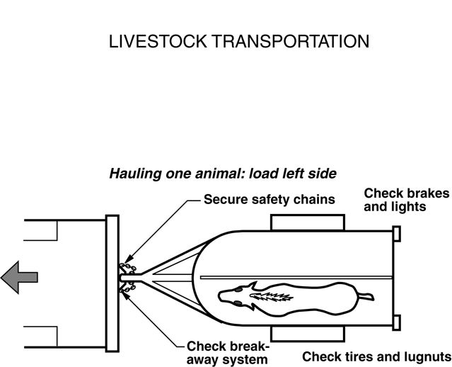

5. Hook divider chains on two-stall trailers.

6. Close the tailgate immediately.

16.11c - Unloading.

1. Always untie the animal before opening the tailgate.

2. Open the tailgate from the side and stand clear.

3. Unhook divider chains on two-stall trailers. The animal may rapidly back out of trailer.

4. Unload livestock before jacking up a vehicle to change a tire.

16.12 - Transporting Livestock in Trucks. Personnel hauling livestock in trucks shall have the proper truck endorsement. Sites used to load and unload livestock shall be carefully selected.

16.12a - Loading.

1. Never ride livestock into the truck.

2. Load livestock to maintain balance, stability, and vehicle control.

3. Alternate the facing of each animal when hauling more than three animals.

4. Position them crosswise so each animal faces the side of the truck.

5. Secure divider ropes between each animal.

6. Coil and tie divider ropes to the sides of the truck when not in use.

7. Position ropes so they can be secured.

8. Close the tailgate and secure the locking mechanism.

16.2 - Safe Driving Practices.

1. Conduct a pre-trip safety inspection of trailer/truck.

2. Avoid quick starts and stops.

3. Remember, livestock may shift from side to side and back to front, making the load unstable.

16.3 - Personal Protective Equipment. The JHA shall identify PPE specific to the task to be performed. Standard PPE includes:

1. First aid kit (refer to the Glossary).

2. Riding boots, field boots, or work shoes that will not hang up in stirrups. Only experienced riders may wear spurs. Appropriate footwear shall be worn for specific work projects or activities after arrival.

3. Protective head gear designed for livestock riding is recommended for inexperienced riders and should be available to employees on request. Head gear shall meet American Society for Testing and Materials (ASTM) and Safety Equipment Institute (SEI) standards.

16.4 - Riding Livestock. The packer or individual assigned for pack/saddle livestock handling shall:

1. Match livestock with employee(s) according to riding skills.

2. Instruct employees that all livestock can be dangerous.

3. Before riding, hold tailgate safety sessions addressing livestock habits and characteristics.

16.41 - Riding Practices. Basic safety practices:

1. When working around stock, always speak to an animal when approaching from any direction.

2. Check the animal's shoes for excessive wear and looseness. Hooves should be checked and cleaned, if needed, at the beginning and end of each day.

3. Inspect the saddle and equipment (tack) to ensure it is in good condition. Bridle stock before mounting.

4. Always lead an animal around after being saddled and before being mounted or packed.

5. Be alert for insects, animals, and people that may spook livestock.

6. Do not wrap or tie reins around the saddle horn.

7. Do not tie the lead rope around the lead horse's saddle horn or wrap the rope around your hand.

8. Never ride an animal when a lightning storm is nearby or in progress. Dismount and seek shelter (sec. 54.23).

9. Keep excessive slack out of the lead rope.

10. Watch out for low-hanging obstacles, such as branches and wires.

11. Do not run the animal.

12. Always carry a cutting tool, such as a multi-purpose tool.

13. Ensure that the JHA addresses riding alone.

14. Do not secure tools or equipment on livestock being ridden or carry them in your hands while riding.

15. Ensure that only competent riders ride bareback.

16.42 - Securing Livestock. Do not use bridle reins to tie livestock.

1. When tying livestock, clear away debris and tie the lead rope at least 4 feet (2 m) above the ground to prevent entanglement.

2. Tie the animal to an object using a rolling slipknot. Where possible, tie the rope to an object that the animal cannot walk completely around.

3. After tying livestock, do not cross under the lead rope.

4. Do not tie the animal to a wire fence.

5. Do not position yourself in front of tied livestock.

6. Halter all animals under the bridle.

7. Use cotton rope at least 1/2-inch (12-3/4 mm) diameter for picketing.

8. Unless picketing or hobbling livestock, do not tie stock to movable objects.

9. When near the rear of livestock, stay close, maintain contact, and talk to the animal.

16.43 - Packing Livestock. Only persons competent in packing and unpacking livestock shall be allowed to perform these tasks.

1. Keep the animal's back clean, saddle pad straight, saddle blanket smooth, saddle properly fitted and tight, and side packs as equal in weight as possible.

2. Use breakaways to tie pack string together.

3. As a courtesy, generally yield to uphill pack strings in the morning; yield to downhill pack strings in the evening. There are exceptions where it may be safer to yield to larger or less experienced pack strings.

4. Hikers should yield to stock traffic. When encountering hikers who are unfamiliar with stock, ask them to stand on the downhill side of the trail and wait quietly for the stock to pass. If the stock spooks, having the hikers standing downhill will encourage the stock to go uphill and lessen the chance of an accident.

16.44 - Leading Livestock. Use lead rope approximately 10 feet (3 m) in length, with smooth braid at the free end and no knots or loops.

1. Avoid excess rope that may become entangled.

2. Do not wrap coils around your hand or the saddle horn.

16.45 - Feeding Livestock. Take these precautions:

1. Do not feed or water a sweaty animal until it has cooled off.

2. When feeding or salting animals, exercise caution as even gentle animals may become aggressive and dangerous.

16.5 - Other Livestock Handling Concerns.

16.51 - Draft Stock. When using draft horses, mules, or other livestock for work projects or activities, refer to the JHA for specific requirements.

16.52 - Private Livestock. When it is necessary to impound private livestock on Federal lands, only competent (refer to the Glossary) personnel shall be assigned to round up and herd animals.

1. Exercise extreme caution in the presence of bulls or stallions.

2. Keep alert when in a corral with livestock.

16.53 - Shoeing. Only competent personnel shall be assigned to perform farrier duties.

